 Keck Adaptive Optics Note 670

Keck Next Generation Adaptive Optics
Preliminary Design Phase Project Report #14

P. Wizinowich, the NGAO Team
July 21, 2009

Narrative

This report is the fourteenth monthly project report for the Preliminary Design (PD) phase in the development of the W. M. Keck Observatory’s (WMKO) Next Generation Adaptive Optics (NGAO) facility. This report covers the PD phase work performed in June 2009.

Summary
Management efforts have been focused on proposal writing and collaboration on laser preliminary designs. The technical team is making good progress on the requirements, software architecture, opto-mechanical design and real-time control design.

Management Status
The PD phase plan presented at the SDR included work under the following management WBS elements through June. The progress in each of these areas is discussed below.

WBS 1.3.2.1 Planning

WBS 1.3.2.2 Project Management and Meetings

WBS 1.3.2.4 Proposals
Work has continued on an MRI-R² proposal for the implementation of a new Keck II laser which will be submitted by WMKO. The MRI-R² proposal concepts for an IR tip-tilt sensor for Keck II and an AO corrected IR tip-tilt sensor for Keck I did not receive MRI-R² proposal slots at Caltech or UCSC, respectively.

WBS 1.3.2.5 Programmatic Risk Assessment and Mitigation
TOPTICA’s second progress meeting was held in June. FASORtronics provided a revised risk reduction work package since risk reduction is no longer required on packaging due to their new and simpler packaging approach.

Technical Status
The PD phase plan presented at the SDR included work under the following technical WBS elements in June. The progress in each of these areas is discussed below.

WBS 1.3.3.1 Science Case Requirements
In May the science team worked on getting the OOCD ready for its first release, including finishing the remaining few incomplete sections and cleaning up the document. We also worked with the IRIS team for TMT in order to put together a collection of images and spectra that we can share and use to simulate various science cases, especially the high-z galaxies science case and the AGN BH mass measurement case.

In June we met with the NGAO Science Advisory Team (NSAT) for the first time. We had useful discussions with this group about how we should proceed with the science case development and we look forward to further input from them regarding prioritization of science goals, NGAO’s competitive landscape, advice on design trades, and help with specifying science requirements related to PSF stability and knowledge. We also are very close to releasing the first version of the OOCD, and are waiting primarily on feedback from one group regarding a Key Science Driver observing scenario. We anticipate release 1 of this document will occur early in July. We have begun to review and (when necessary) modify the science requirements in the Contour database for the Functional Requirements Document. This review process will continue next month. Next month we will also be refining science requirements that were defined during SD-phase and making sure that the requirements reflect the build-to-cost changes.

WBS 1.3.3.2 Requirements
The System Requirements Document was reviewed in light of the build-to-cost changes. Overall requirements review work continued.

WBS 1.3.3.3 Systems Engineering Analysis
Science wavefront error budget flow down budgets: Tabulated, but have not confirmed content of, all outstanding error budget flow downs, including those containing updated optical parameters from the AO optical design team. The next steps will be to consolidate these flow downs into a self-consistent set and post back to the TWiki under version control.

High contrast error budget: Calculations were performed using v1.1 of the high-contrast error budget Excel tool in the J, H, and K bands, including comparisons of the achievable sensitivity to companions before and after the build-to-cost directive. Modifications to the dominant error terms, namely, WFS measurement noise, servo-lag, tomography, LGS focal anisoplanatism, science instrument non-common-path, and uncorrectable telescope errors, result in a factor of ~2 loss in contrast for separations inside the AO control region in each band, based on the numerical values and assertions outlined in KAON's 642 and 644. Changes in the LGS spot size contribute most to the scattered light noise floor in the J-band whereas photon-noise dominates in K, for a 30-minute exposure. A transition between these two limiting cases occurs in the H-band.

Observing uptime budget: An excel tool has been developed for computing observing uptime.

Heat dissipation budget: More terms added to the static thermal load budget. Performance curves are needed for the proposed cooling system to build a dynamic model to determine cooling and warm-up time for the NGAO enclosure.

Additional performance modeling: Evaluating the potential cost savings / risk mitigation of an alternative hybrid Rayleigh LGS plus sodium LGS tomography system. Initial exploration of parameter space in this period established several possible (noise-free) asterism configurations that could meet NGAO performance goals. Additional evaluation of photon and read noise impact and of practical considerations is needed.

Integrated modeling: Work began on the code modifications to add MOAO capabilities to the LAOS simulation tool.

WBS 1.3.3.4 System Architecture
Significant progress has been made on developing a software architecture for the NGAO control system. We have adopted a modified version of the Common Services Framework designed for the Advanced Technology Solar Telescope. The design is based on a container-component model which is independent of the underlying communications middleware that is used. A proof of concept for the architecture has been successfully implemented and we are working on the design of the common services used to support it.

We have developed an architecture to support the various electronics systems for NGAO and are working to document this architecture. We are also updating the motion control architecture document based on feedback and additional motion control requirements from the design team.

WBS 1.3.3.5 External Interface & 1.3.3.6 Internal Interface Control
Progress was made on the AO to telescope opto-electro-mechanical ICD and AO to Keck Interferometer ICDs. The bulk of the effort was spent on organizing and linking existing system, and functional, interface requirements into interface collections in the NGAO contour database.

WBS 1.3.3.9 Technical Risk Assessment and Mitigation
Good progress continues to be made on preparing for the summit installation of the MASS/DIMM equipment.

WBS 1.3.4.2.3 Optical Relays
The AO relay optical design and the definitions of its interfaces to science instruments, wavefront sensor packages, and acquisition system are largely complete. There has been substantial progress on developing the mechanical layout of optical components on the Nasmyth platform.
As of the end of June:
- The tolerance analysis for the baseline design is nearly complete and will be appended to the posted design document (link). The results of the tolerancing will be to formulate part of the static wavefront error budget allocation (input to the system engineering team), guide specification of optics, and guide specification and alignment requirements for mounting.
- The mechanical layout and design began in earnest this month. The AO relays and mounts are done and the UCO, Caltech and WMKO teams have been working closely to connect the wavefront sensor and instrument mechanical designs.

WBS 1.3.4.2.5 LGS Wavefront Sensor Assembly
LGS WFS design nearing completion; both refractive and partially reflective designs are being evaluated.

WBS 1.3.4.2.7 Low Order Wavefront Sensor Assembly
.Motion control needs identified. Preliminary pick off arm design presented and discussed. Refinements are being made based on the resultant feedback.

WBS 1.3.4.2.8.1 Tip-tilt Vibration Mitigation Analysis
A Simulink (MATLAB) model of the parametric oscillator (PO) and low order wavefront sensor (LOWFS) systems was built. The NGAO PO model is consistent with the as-built interferometer PO modified to compensate for the differences between the interferometer angle tracker and LOWFS control loops. The model has been used to estimate frequency response for the LOWFS and PO system. Realistic noise disturbances need to be added. Note that the Simulink tool is flexible and the LOWFS model could be modified to simulate other AO control loops including focus control, MEMS to PZT woofer-tweeter control and offloading loops to the telescope.

WBS 1.3.4.3 Alignment, Calibration and Diagnostics
Reviewed method for calibrating non-common path wavefront errors, including consulting with JPL about high order phase retrieval algorithms used at Palomar and on the Terrestrial Planet Finder test bench.

1.3.4.4 Non-real-time Control

WBS 1.3.4.5 Real-Time Control
Progress has been made on refining the RTC design:
- The real-time parts of the software code design are largely complete. This includes wavefront phase reconstruction from Hartmann slopes and volume tomography. Considerable progress has been made on defining the hardware needed to implement the DM drivers, including the system for open-loop control of MEMS and woofer/tweeter division of commands.
- We have completed the design specification for the methods of code and parameter loading to the FPGA system and for the method of streaming out diagnostics/telemetry to RAID disk.
- We are still carrying the two options for the front-end video processors. These perform the basic image processing and centroiding for each wavefront sensor ahead of the tomography engine. The GPU appears to be the favorable option at this time for several reasons, the most important of which is avoiding the need to design a custom board, as GPU boards are commercially available.
- Cabling and volume issues have not been addressed for the most part, although power usage requirements have. As the design comes together, we will be working closely with the Keck non-RTC and enclosure design teams to specify the necessary interfaces.
- Although some important progress has been made on the physical FPGA board layout at a high level (the design has been posted), Michael Peck is still occupied with LowRes follow-on work and has not been available to do detailed FPGA board design for NGAO. We hope to remedy this manpower issue this month.

WBS 1.3.5 Laser System Design
The beam generation optical design (laser beamsplitters and asterism generator) was summarized in a powerpoint presentation and a meeting was held to review the design. The number of motion devices was defined along with their characteristics. The next step is to verify that the optical model meets the performance specifications before proceeding to the mechanical design.

The Laser Clearing House registration form was submitted for the NGAO lasers.

WBS 1.3.8.1 Old AO/Laser Removal

WBS 1.3.9 Operations Transition

Science Instruments

Keck Adaptive Optics Notes
All of the NGAO KAONs can be found at:
http://www.oir.caltech.edu/twiki_oir/bin/view/Keck/NGAO/NewKAONs.

The following KAONs were produced in June:
KAON 665 NGAO Preliminary Design Report #13

Schedule and Budget Status

Milestones
All of the milestones through May have been completed. The OCD release milestone will be achieved in July. The requirements PD release 1 will be delayed to August.

Table 1: NGAO PD Phase Milestones

Schedule
A high level snapshot of the tracked version of the new schedule through June is shown in Figure 1 with 37% of the total PD phase work complete (versus 27% complete at the end of April 2009).

A tracked version of the Instrument MS Project plan, with a start date of May 1, 2009, is shown in Figure 2 with 2% of the total PD phase work complete (this was not updated for June). This schedule shows the tasks that are planned for completion in the months of June and July.

Budget
The total NGAO PD phase budget (from the SEMP) is $3030k excluding contingency; the contingency is $449k. A total of $937k has been spent through May or 31% of the budget excluding contingency (compared to 37% of work completed).

Anticipated Accomplishments in the Next Period
All of the previously anticipated accomplishments through April have been completed and we have chosen not to list them here (see the April report for this list).

The anticipated accomplishments for May along with their status in italics:
- Complete functional requirements release 1. This will be delayed to July.
- Complete observing operations concept document release 1. This will be delayed to July.
- Complete the post build to cost replan and start tracking versus this plan. Complete.

The anticipated accomplishments for June along with their status in italics:
- Hold first NGAO Science Advisory Team meeting. Complete.

The anticipated accomplishments for July are the following:
- Document evaluation of fixed pupil mode design options.
- Document vibration mitigation work.
- Complete laser MRI-R2 proposal.

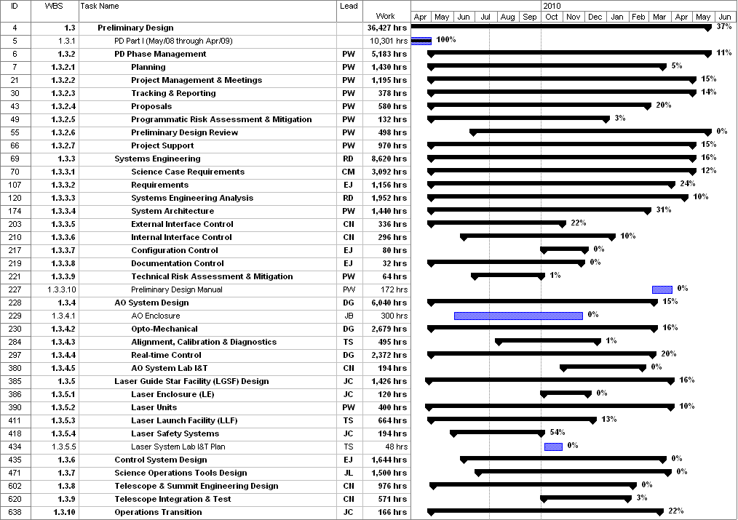
Figure 1: Tracked version of the new PD phase schedule through June 2009

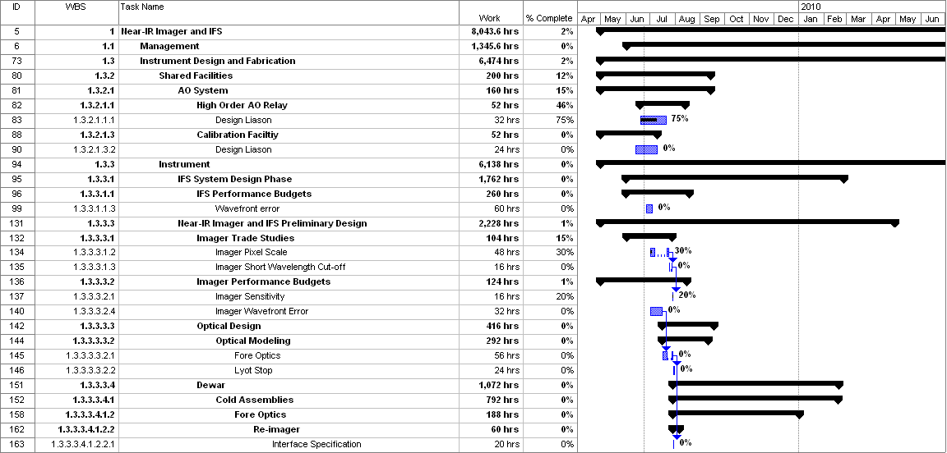
Figure 2: Tracked version of the NGAO Science Instruments schedule through June 2009

Financial Summary

The budget and expenditures to date for year 1 of the NGAO project were provided in KAON 665 (Project Report 13; the year 1 expenditures totaled $729k). The budget, expenditures to date and estimate to completion for year 2 of the NGAO project, which began in May 2009, is shown in Table 2.
Table 2: NGAO PD Phase Expenditure Summary for Year 2 through June 2009

