 Keck Adaptive Optics Note 665

Keck Next Generation Adaptive Optics
Preliminary Design Phase Project Report #13

P. Wizinowich, the NGAO Team, and Sean Adkins
June 24, 2009

Narrative

This report is the thirteenth monthly project report for the Preliminary Design (PD) phase in the development of the W. M. Keck Observatory’s (WMKO) Next Generation Adaptive Optics (NGAO) facility. This report covers the PD phase work performed in May 2009.

Summary
Management efforts have continued to involve activities related to re-planning based on the design and build to cost requirement, and collaboration on laser preliminary designs.

Management Status
The PD phase plan presented at the SDR included work under the following management WBS elements through May. The progress in each of these areas is discussed below.

WBS 1.3.2.1 Planning
A new project plan has been developed based on the build to cost changes and other changes since the SDR. This new plan covers activities from May 1, 2009 through the completion of the PD phase. Starting with this report we have begun tracking against this new plan. A tracked version of the new plan is shown in Figure 1.

A separate MS project plan for the combined imager and IFS was also completed in May. A tracked version of this plan, focusing on the tasks planned for June and July, is shown in Figure 2. The development of the science instrument plan included the allocation of work to resources at UCLA, CIT, UCSC, and WMKO. We are finalizing the timing and personnel at the UCLA IR Lab and at CIT, but based on the completion of that we anticipate that the NGAO science instruments team will consist of scientific leadership from the UCLA IR Lab (James Larkin and Ian McLean) and engineering participation from all four collaborators.

WBS 1.3.2.2 Project Management and Meetings
A team meeting was held on May 27 to review the new plan with the team and to work on the performance budgets flow down.

WBS 1.3.2.4 Proposals
A draft MRI proposal for the implementation of a new Keck II laser was prepared and work began on the schedule and costing. Discussions and analysis took place on the concepts of MRI proposals for an IR tip-tilt sensor for Keck II and an AO corrected IR tip-tilt sensor for Keck I.

WBS 1.3.2.5 Programmatic Risk Assessment and Mitigation
One of the activities planned for the FASORtronics laser risk reduction work was related to the proposed packaging of the laser. FASORtronics has now developed a new packaging concept that appears to reduce the need for risk reduction work in that area, and as a consequence we are discussing revisions to the planned risk reduction activities.

Technical Status
The PD phase plan presented at the SDR included work under the following technical WBS elements in May. The progress in each of these areas is discussed below.

WBS 1.3.3.1 Science Case Requirements

WBS 1.3.3.2 Requirements
The observation planning and LGS AO acquisition sections of the Observing Operations Concept Document (OOCD) have been completed. This includes an eight phase LGS-AO acquisition process broken down into a total of 37 individual steps based on the build to cost system architecture.

The re-writing of the LGS WFS requirements to implement build to cost changes was completed and work started work on the LOWFS requirements.

The LTCS and laser safety system requirements were updated, and additional interfaces were identified that will need to be defined.

WBS 1.3.3.3 Systems Engineering Analysis
The error budget flow down budget master summary list was updated to include several driving parameters not captured in the initial list. The key challenges in meeting the initial flow downs were reviewed at a full team meeting to illuminate potential challenges for the various subsystems.

Initial flow downs of various wavefront error parameters resulting from pupil registration errors, non-common path errors during long exposures, non-common path errors during non-sidereal tracking, wavefront error terms due to internal aberrations to the LOWFS and wavefront errors associated with dithers were developed. A detailed HOWFS transmission budget was also created. Work was also started on uncorrectable aberrations, and detailed transmission and emissivity budgets for various beam paths in the NGAO system.

Draft versions of the LGS-AO and NGS-AO acquisition time budgets were completed based on time estimates for the acquisition steps detailed in the OOCD. This included defining which steps can be performed in parallel, and which must be performed in series. More work needs to be done to quantify typical slew times for various science cases as many of the acquisition steps can be performed in parallel with the slew to the next target.

Work was started on the thermal modeling of the NGAO enclosure. Details were identified that may be useful to establish some of the input parameters for the model. The model includes the effect of radiation, conduction loss, and heat from motors and motion control equipment. The models will also try to predict the time constant of the system in order to estimate the time required to cool the system from ambient to operating temperature.

A basic excel spreadsheet tool for calculating uptime was drafted after reviewing standard methods for mean time between failure calculations and uptime analysis.

A new version of the AO simulation tool released by Luc Gilles (TMT) was ported to computers at Caltech and WMKO in support of the upcoming NGAO integrated modeling tasks. Issues with the version of the GNU c compiler used to link c code into MATLAB were largely resolved.

WBS 1.3.3.4 System Architecture
A system level schematic was developed with emphasis on the WFS subsystems, including various components, beam paths, and mechanism in order to pictorially represent constraints, interfaces, and requirements.

Progress was also made on the software and control systems architectures.

WBS 1.3.3.5 External Interface & 1.3.3.6 Internal Interface Control
The N² diagram was revised for the new Product Breakdown Structure and system software organization. N² diagrams were completed for NGAO intersystem, the AO system and the LGS facility.

Draft ICD’s completed for telescope and acquisition camera interfaces to the LGS facility software and for the AO system to LGS facility. The context of the data is provided. All three ICD’s will need system engineering review.

WBS 1.3.3.9 Technical Risk Assessment and Mitigation
Good progress continues to be made on preparing for the summit installation of the MASS/DIMM equipment.

WBS 1.3.4.2.3 Optical Relays
The AO relay optical design and the definitions of its interfaces to science instruments, wavefront sensor packages, and acquisition system are largely complete. There has been substantial progress on defining motion control requirements in coordination with the non-real time control system team.
As of the end of May our general status is:
- A tolerance analysis for the baseline design is being generated (which will be appended to the posted design document). The tolerancing results will provide input to the wavefront error budget allocation being done by the system engineering team.
- The throughput and emissivity analysis tool has been used to generate a throughput and emissivity budget. Preliminary versions of this budget have been submitted to the system engineering team.
- The mechanical layout and design continued to be on hold due to the unavailability of Chris Lockwood up through May. Chris will begin full-time NGAO work in June.

WBS 1.3.4.2.5 LGS Wavefront Sensor Assembly
Work has started on understanding the effect of pupil distortions and aberrations due to LGS focus on the performance of the LGS wavefront sensor.

A trade study of the probe arm assembly R/θ versus φ/θ design options was initiated, including researching options for commercially available linear and rotary actuators and controllers.

WBS 1.3.4.2.7 Low Order Wavefront Sensor Assembly
Motion control needs for the LOWFS subsystem were identified and compared to TMT IRIS, in particular the pick-off mechanism for the LOWFS. A new LOWFS motion control KAON is being drafted.

WBS 1.3.4.2.8.1 Tip-tilt Vibration Mitigation Analysis
Work continued on tip-tilt vibration analysis as a background task in May.

WBS 1.3.4.3 Alignment, Calibration and Diagnostics
Some methods used for calibrating AO systems were reviewed, in particular methods used at the UCSC Laboratory for Adaptive Optics in their MOAO experiment.

1.3.4.4 Non-real-time Control

WBS 1.3.4.5 Real-Time Control
Progress has been made on both hardware and software aspects of the RTC. Highlights included:
- The baseline tomography engine hardware design is now the horizontal voxel communication architecture. This has advantages in hardware and computational simplicity over the previously considered vertical voxel architecture, and uses the minimum number of boards.
- Substantial progress has been made on determining the wavefront error budget associated with RTC latency and accuracy. We have determined that a latency goal within the current system error budget can be met with the horizontal voxel communication architecture.
- Two options are still being carried for the front end video processors that perform the basic image processing and centroiding for each wavefront sensor ahead of the tomography engine. The two options, based on FPGA and GPU implementation respectively, are undergoing evaluation.
- Peck continued to work on LRIS in May, but will become full-time available to NGAO in June. He will focus on the hardware design while Reinig will focus on the RTC software and overall system issues.

WBS 1.3.5 Laser System Design
A meeting was held on May 18 with Major Riter at the Laser Clearing House (LCH) to discuss the ramifications of NGAO’s seven laser asterism and the impact on LCH safety requirements. It is likely that we will be able to treat the lasers as one large cone. Major Riter suggested we submit a registration form to determine if the NGAO lasers can be waived since they will be CW; a draft registration form was prepared for review.

A draft Laser Safety System Integration and Test Plan document was posted.

WBS 1.3.8.1 Old AO/Laser Removal
The Laser Removal Plan was updated for completeness.

WBS 1.3.9 Operations Transition
The following draft documents were prepared: LGSF Training Plan, Operations Support Plan, and Operations Maintenance Plan.

Science Instruments
The tasks that we expect to complete in June and July are related to the areas of finalizing the interfaces between the AO system and the science instruments, establishing initial performance budgets for the imager and IFS, and trade studies related to the pixel scale for the imager and extension of the imager’s short wavelength cut-off below 800 nm; both of these trade studies are follow up to questions raised at the NGAO build to cost review. The definition of the interfaces has made good progress through the participation in the NGAO opto-mechanical design team meetings. The trade studies will involve similar collaborations with the NGAO science team.

Keck Adaptive Optics Notes
All of the NGAO KAONs can be found at:
http://www.oir.caltech.edu/twiki_oir/bin/view/Keck/NGAO/NewKAONs.

The following KAONs were produced in May:

KAON 656 NGAO Preliminary Design Report #12

Schedule and Budget Status

Milestones
A new set of major preliminary design phase milestones has been identified based on the replan. These milestones are shown in Table 1. All of the milestones through May have been completed.

Table 1: NGAO PD Phase Milestones

Schedule
Beginning with this report we will be tracking against the new, post build to cost, schedule. This schedule covers the period from May 1, 2009 through the end of the PD phase. A high level snapshot of the tracked version of the new schedule through May is shown in Figure 1 with 32% of the total PD phase work complete.

A tracked version of the Instrument MS Project plan, with a start date of May 1, 2009, is shown in Figure 2 with 2% of the total PD phase work complete. This schedule shows the tasks that are planned for completion in the months of June and July.

Budget
The total NGAO PD phase budget (from the SEMP) is $3030k excluding contingency; the contingency is $449k. A total of $828k has been spent through May or 27% of the budget excluding contingency (compared to 32% of work completed).

Anticipated Accomplishments in the Next Period
All of the previously anticipated accomplishments through April have been completed and we have chosen not to list them here (see the April report for this list).

The anticipated accomplishments for May along with their status in italics:
- Complete functional requirements release 1. This will be delayed to July.
- Complete observing operations concept document release 1. This will be delayed to June.
- Complete the post build to cost replan and start tracking versus this plan. This was delayed to June but the result, including tracking versus this new plan is shown in this report.

The anticipated accomplishments for June are the following:
- Hold first NGAO Science Advisory Team meeting.

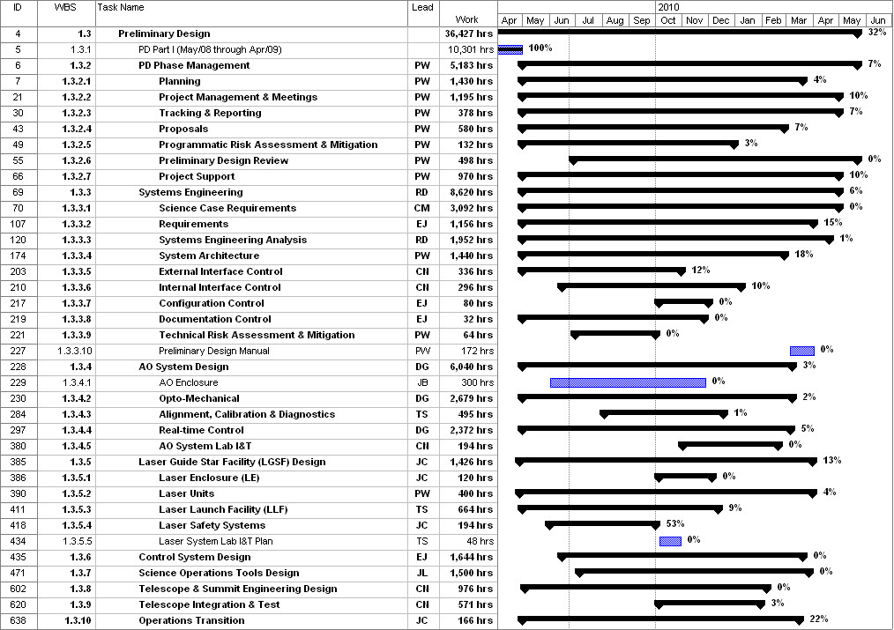
Figure 1: Tracked version of the new PD phase schedule through May 2009

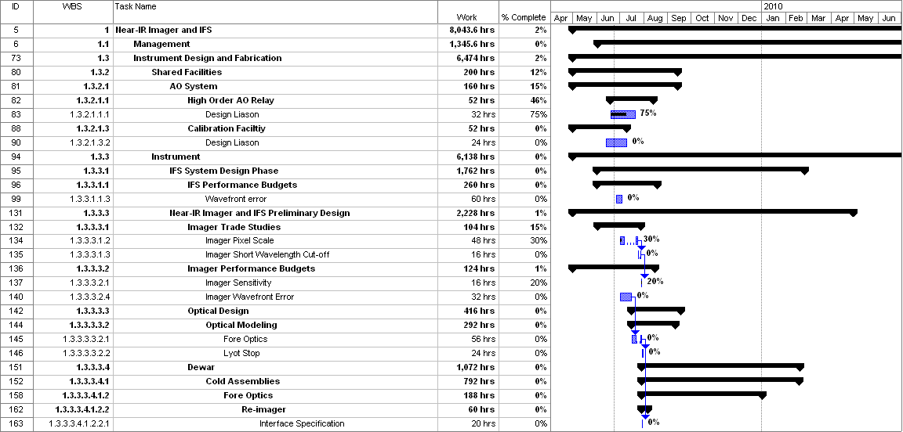
Figure 2: Tracked version of the NGAO Science Instruments schedule through May 2009

Financial Summary

The budget and expenditures to date for year 1 of the NGAO project is shown in Table 2 (this is a revised version of the year 1 summary provided in the last project report; the estimates to complete have been removed). The budget, expenditures to date and estimate to completion for year 2 of the NGAO project, which began in May 2009, is shown in Table 3.
Table 2: Revised NGAO PD Phase Expenditure Summary for Year 1 through April 2009
Table 3: NGAO PD Phase Expenditure Summary for Year 2 through May 2009

