 Keck Adaptive Optics Note 656

Keck Next Generation Adaptive Optics
Preliminary Design Phase Project Report #12

P. Wizinowich, the NGAO Team, and Sean Adkins
May 21, 2009

Narrative

This report is the twelfth monthly project report for the Preliminary Design (PD) phase in the development of the W. M. Keck Observatory’s (WMKO) Next Generation Adaptive Optics (NGAO) facility. This report covers the PD phase work performed in April 2009.

Summary
Management efforts have continued to involve activities related to re-planning based on the design and build to cost requirement, and collaboration on laser preliminary designs.

Management Status
The PD phase plan presented at the SDR included work under the following management WBS elements through April. The progress in each of these areas is discussed below.

WBS 1.3.2.1 Planning
The results of the build-to-cost concept review were presented at the April SSC meeting, where they were well received.

A new project plan has been developed based on the build-to-cost changes and other changes since the SDR. The new plan will be provided in the next project report and we will begin tracking against this new plan effective May 1, 2009.

WBS 1.3.2.2 Project Management and Meetings

WBS 1.3.2.4 Proposals
Three proposal ideas were generated in anticipation of a second MRI call and these were presented at the April SSC meeting. These ideas were ranked as follows by the Directors and SSC: a new 25 W CW laser for Keck II (the first NGAO laser), an AO-corrected near-IR tip-tilt sensor for Keck I (NGAO prototyping and risk reduction) and a PSF-calibration facility for existing Keck AO (NGAO prototyping and risk reduction – this last idea was not deemed appropriate for the second MRI call).

WBS 1.3.2.5 Programmatic Risk Assessment and Mitigation
The FASORtronics risk reduction contract was issued in April and the purchase order for the TOPTICA risk reduction was submitted for approval on April 30. FASORtronics first progress meeting was held on April 28. The first WMKO quarterly report for the AURA sub-award was submitted to AURA on April 30.

Technical Status
The PD phase plan presented at the SDR included work under the following technical WBS elements in April. The progress in each of these areas is discussed below.

WBS 1.3.3.1 Science Case Requirements
Several incomplete sections of the Observing Operations Concept Document were worked on in preparation for the first release of the document. We are still awaiting input on one of the Key Science Driver observing scenarios, but we should be able to release the first version of the OOCD by the end of next month or shortly thereafter. In addition to the OOCD, we also spent some time working on the science requirements for fixed pupil mode and re-planning the work required for this WBS during the balance of the PD phase and beyond.

Next month we will continue to work on the OCCD. Once the few remaining incomplete sections are finished a general clean up pass will be made to prepare the document for its first release. We will also be working with the TMT IRIS team to put together a collection of images and spectra that we can share and use to simulate various science cases, especially the high-z galaxies science case.

WBS 1.3.3.2 Requirements
A major review of the functional requirements started in March and will continue into June. Good progress was made in April. The product breakdown structure (PBS) was updated prior to the start of this review and two people (the person responsible for this item and a member of the systems engineering team) were assigned to review the functional requirements associated with each PBS element. The approximately 400 initial requirements in the Contour requirements database are being revised and missing requirements are being added. Requirements are being approved as this review process proceeds.

WBS 1.3.3.3 Systems Engineering Analysis
A significant effort to establish the flowdown of system-level to subsystem performance requirements was initiated in April. Based primarily upon the wavefront error / encircled energy error budgets models, approximately 35 quantities (wavefront error allocations, input parameters such as laser launch telescope quality, etc.) were identified as requiring additional engineering analysis. In the coming months we expect to develop these flowdowns further, including rebalancing of subsystem requirements as the engineering difficulty and risk issues for key subsystems are better understood. Ultimately, these flowdown budgets will be placed under version control and will represent an important repository of traceability to the on-line Contour functional requirements database.

WBS 1.3.3.4 System Architecture
The WBS for the control system architecture was considerably reworked to better represent the work that must be done and the deliverables (this will be reflected in the Microsoft project plan that represents NGAO replan).

Feedback was received on the draft motion control architecture KAON including telecons with optical relay and wavefront sensor personnel.

WBS 1.3.3.5 External Interface & 1.3.3.6 Internal Interface Control

WBS 1.3.3.9 Technical Risk Assessment and Mitigation
Good progress continued to be made on preparing the summit installation of the MASS/DIMM equipment.

WBS 1.3.4.2.3 Optical Relays
There has been continuing progress in defining the AO relay interfaces to science instruments, wavefront sensor packages, acquisition system, and non-real time control system, including two interface meetings.
As of the end of April our general status is:
- The single-tier 100 mm beam relay has a performance-optimized Zemax design which has been posted to the Twiki site along with a draft of the PD report document (Link).
- A tolerance analysis is being performed which will be appended to the design document. The results of this analysis will provide input to the error budget allocation process.
- The assignment of instrument and LOWFS volumes in the pickoff-switchyard configuration has been refined in coordination with the Instruments and LOWFS task leaders. The LOWFS volume restrictions (to allow the second relay optics) are now well understood and appear to be sufficient for the wavefront sensor team to work with.
- The mechanical layout and design has been basically on hold this month because of Chris Lockwood being pulled away to work on the completion of the LRIS Red Detector Upgrade project. He will ramp up his time on NGAO upon shipment of the LRIS upgrade in mid-May. Chris did contribute to the two interface meetings this month (as well as all of the weekly opto-mechanical meetings).

WBS 1.3.4.2.5 LGS Wavefront Sensor Assembly
A functional diagram was created indicating the motorized degrees of freedom, division of optical wavelengths, and active feedback control to augment the development of the optical bench Zemax layout representation of light reaching the LGS wavefront sensor assembly.

WBS 1.3.4.2.7 Low Order Wavefront Sensor Assembly
A meeting was held at UCO to understand the new volume allocation for the LOWFS and review the options to implement LOWFS pick-offs.

WBS 1.3.4.2.8.1 Tip-tilt Vibration Mitigation Analysis
Work continued on tip tilt vibration as a background task in April. Neyman and Johansson attended Don Wiberg’s class on System Identification and Optimal Control at UCSC by video. Don is assigning his class the testing of his preferred method of vibration cancellation for Keck as an academic-quarter-long project (the quarter ends in June).

WBS 1.3.4.4 Non-real-time Control
A design document describing the Environmental and Power Control/Monitoring System for the AO and laser systems has been written. This document outlines the type of controls and monitoring expected from the systems, and also provides recommendations for hardware and interfaces.

WBS 1.3.4.5 Real-Time Control
Progress has been made on both hardware and software aspects of the RTC with the following highlights:
  - A KAON describing the RTC model volume discretization error is in progress. We are suggesting a choice and scaling of the RTC so as to keep this error minimal, about 5 nm, but this is subject to final error allocations as part of the overall wavefront error budget.
  - We are still carrying two options for horizontal and vertical voxel communication in the RTC tomography engine, and are evaluating the options as they impact number of boards, size of boards, board interconnect wiring, frame rate, and latency.
  - We are also considering two options for the “front-end” processors to perform the basic image processing and centroiding for each wavefront sensor ahead of the tomography engine. An analysis of the benefits and cost trades of these options is work in progress. A draft write-up of these analyses will be posted shortly on the RTC web page.
  - We’ve had a second walk-through of all the RTC algorithms to verify they are still practical to program on the now more refined RTC hardware approaches we are carrying forward. We remain confident that the full NGAO RTC algorithm can be implemented and that the algorithms’ compute-timings are well understood.
  - Michael Peck remains underutilized due to residual commitments to the LRIS project, while Mark Reinig was heavily utilized this month to compensate. Michael will ramp up his NGAO time starting mid-May.

WBS 1.3.5 Laser System Design
The first draft of a Zemax optical design for the beam steering, asterism generator, LGS rotator and optical interface to the launch telescope has been completed. The first draft of laser safety system and laser traffic control system preliminary designs has also been completed. The draft for the laser safety system draft includes interface requirements.

WBS 1.3.8.1 Old AO/Laser Removal

WBS 1.3.9 Operations Transition
A draft PD document design describing the success criteria for the operations handover has been completed and is awaiting review.

Science Instruments
Re-planning of the instrument development activities was carried out in April with a final version of the plan established by May 4. An important aspect of this plan is the combining of all work related to preliminary design of the imager portion of the NGAO science instrument and the system design phase of the IFS development. The IFS development work was planned ahead of the imager work, and the system design and preliminary design phases of the IFS (with anticipated funding from the NSF ATI program) will be managed as a single plan. The IFS system design phase completes at the same time as the imager preliminary design phase, with the goal of completing these two design phases in time to be reported on at the overall NGAO preliminary design review. We may hold an earlier review for the instrument, depending on schedule and the overlap of appropriate reviewers with the main NGAO reviewers.

The first activities for the instrument are the completion of brief trade studies for the imager plate scale, and to address the issues of a single combined instrument vs. two separate instruments. This will be followed by the initial optical design and opto-mechanical layout for the imager. The more extensive trade studies for the IFS, particularly the consideration of image slicer design options will continue in parallel. We anticipate completing the initial optical design of the imager in August, and this will be followed by detailed optical modeling with parallel work to develop preliminary mechanical, electronic, and software designs. The IFS trade studies will complete in December and a down select of the slicer design will be made in January 2010.

Keck Adaptive Optics Notes
All of the NGAO KAONs can be found at:
http://www.oir.caltech.edu/twiki_oir/bin/view/Keck/NGAO/NewKAONs.

The following KAONs were produced in March:

KAON 653 NGAO Preliminary Design Report #11

Schedule and Budget Status

Milestones
The Systems Engineering Management Plan (SEMP; KAON 574) for the preliminary design phase identified the milestones shown in Table 1. The May 2008 milestone has been completed. The functional requirements milestone has been delayed as a result of changes to the plan, including the build to cost guidelines and is now expected to complete in June (2 month delay with respect to the last report). Please note that the date for the internal interface document release 1 was mistakenly listed as February; this has been changed to April. Several drafts of the Observing Operations Concept Document have been released, but we would like to complete the last remaining science case (i.e., the Galactic Center) before making an official version 1 release.

Year | Month | NGAO Project Milestone | Status
2008 | May | Preliminary Design phase begins | Completed
2008 | October | Functional Requirements PD Release 1
2009 | March | Operations Concept Document Release 1
2009 | April | External Interface Document Release 1
2009 | April | Internal Interface Document Release 1
2009 | May | Software & Controls Architectures PD complete
2009 | May | LGS WFS Assembly PD complete
2009 | June | Laser vendor identified & contract ready
2009 | June | Optical relay/switchyard PD complete
2009 | September | RTC Processing Requirements complete
2009 | November | Laser Launch Facility PD complete
2009 | December | LOWFS Assembly PD complete
2010 | February | Preliminary Design Review
Table 1: NGAO PD Phase Milestones

Schedule
A high level snapshot of the tracked version of the schedule through April is shown in Figure 1 with 27% of the work complete. This can be compared to the expected work complete in Figure 2 of 57% that we originally planned to achieve through March at the SDR. Some detail on the discrepancies between the 27% complete and the plan can be seen by comparing Figure 1 and Figure 2. The primary reasons behind the schedule delay were listed in Project Report #9.

Work according to the new schedule resulting from the NGAO replan work will begin in May, now that the build to cost choices are complete and we are in a position to refocus and significantly ramp up our activities. Starting with the May report we will begin reporting against this new plan.

Budget
The total NGAO PD phase budget is $3030k excluding contingency; the contingency is $449k. A total of $730k has been spent through April or 24% of the budget excluding contingency (compared to 27% of work completed).

Anticipated Accomplishments in the Next Period
The anticipated accomplishments from the June report along with their status in italics:
- Submission of a collaborative (GMT, TMT, WMKO and ESO) white paper to the NSF for commercial laser development. Complete.
- Completion of the tip-tilt sharpening study. Complete.

The anticipated accomplishments from the July report along with their status in italics:
- Good progress (preferably complete) on the replan. No progress in Nov.
- Startup of NGAO controls group responsible for all non-real-time control software and hardware. Complete, including replan of controls tasks.

The anticipated accomplishments from the August report along with their status in italics:
- Hold build to cost team meeting and identify next steps in this process. Complete.
- Identify success criteria for NFIRAOS cost comparison and internal build to cost review. Complete.

The anticipated accomplishments from the September report along with their status in italics:
- Understand laser tomography noise propagator behavior. Complete.
- Complete the NFIRAOS cost comparison report. Complete.

The anticipated accomplishments for November along with their status in italics:
- Submit ATI proposal. Complete.

The anticipated accomplishments for December along with their status in italics:
- Produce a baseline set of cost savings possibilities to fit within the cost cap. Complete.
- Document single relay optical design (cost savings) evaluation. Complete.
- Complete the tip/tilt sharpening study report. Complete.
- Complete the ESO laser preliminary design proposal review/recommendation process. Complete.

The anticipated accomplishments for January along with their status in italics:
- Submit a NSF MRI proposal for a Keck II LGS AO center launch telescope, as part of NGAO. Complete.
- Set up regular meetings of a systems engineering team and begin to address requirements and interface issues. Complete.

The anticipated accomplishments for February along with their status in italics:
- Issue requests for quote for laser risk reduction contracts. Complete.
- Post a working copy of the Observing Operations Concept Document as a KAON. Complete.
- Complete a KAON defining the requirements control and review process. Complete.

The anticipated accomplishments for March along with their status in italics:
- Complete the laser preliminary design kick-off-meetings including risk reduction discussions. Complete.
- Complete a KAON defining the build to cost design changes. Complete.
- Complete a KAON describing the build to cost performance analysis. Complete.
- Complete the build-to-cost review presentation and meeting. Complete.

The anticipated accomplishments for April along with their status in italics:
- Receive & assess the build to cost reviewer report. Complete.
- Present build to cost summary at April SSC meeting. Complete.

The anticipated accomplishments for May are the following:
- Complete functional requirements release 1. This will be delayed to June.
- Complete observing operations concept document release 1. This will be delayed to the first week of June.
- Complete the post-build-to-cost replan and start tracking versus this plan.
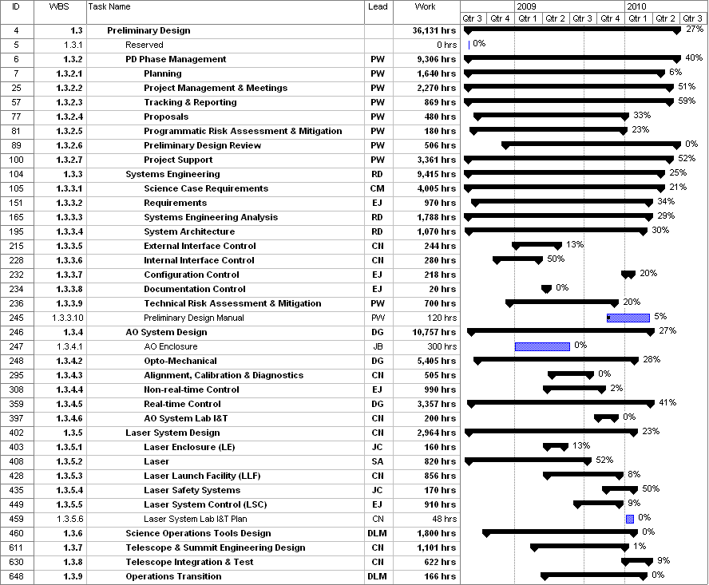
Figure 1: Tracked version of the PD phase schedule through April 2009

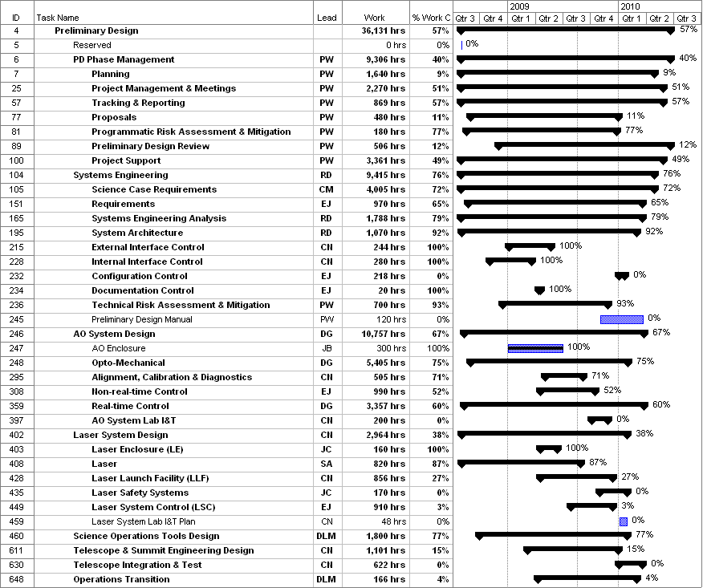
Figure 2: Planned % complete through April 2009 from the plan presented at SDR

Financial Summary

The budget, expenditures to date and estimate to completion for year 1 of the NGAO project are shown in Table 2.
Table 2: NGAO PD Phase Expenditure Summary through April 2009

