 Keck Adaptive Optics Note 653

Keck Next Generation Adaptive Optics
Preliminary Design Phase Project Report #11

P. Wizinowich, the NGAO Team, and Sean Adkins
April 22, 2009

Narrative

This report is the eleventh monthly project report for the Preliminary Design (PD) phase in the development of the W. M. Keck Observatory’s (WMKO) Next Generation Adaptive Optics (NGAO) facility. This report covers the PD phase work performed in March 2009.

Summary
Management efforts have continued to involve activities related to the design and build to cost requirement, and collaboration on laser preliminary designs.

Management Status
The PD phase plan presented at the SDR included work under the following management WBS elements through March. The progress in each of these areas is discussed below.

WBS 1.3.2.1 Planning
The build-to-cost concept review was held on March 18. The reviewers were Brent Ellerbroek, Mike Liu and Jerry Nelson. Additional attendees included the Observatory Directors: Armandroff, Bolte, and Lewis with Kulkarni represented by Soifer, and SSC co-chair Martin also in attendance. All materials for this review are posted at http://www.oir.caltech.edu/twiki_oir/bin/viewauth/Keck/NGAO/BuildtoCostReview including the build-to-cost report/presentation (KAON 648), the build-to-cost excel spreadsheet tool, KAON 642 describing the design changes, KAON 644 describing the performance analysis and the reviewer report (KAON 650).

The reviewer report (dated April 6) states: “The Committee strongly congratulates the NGAO team for a concise, convincing presentation which demonstrates that the above criteria for further development of the system have been very effectively met. We recommend that the project is now ready to proceed with the Preliminary Design Phase to continue the development of the updated system concept, with no further changes in overall scope or basic architecture either necessary or desirable.”

WBS 1.3.2.2 Project Management and Meetings
A team meeting was held on March 19 to discuss the next steps in the NGAO preliminary design. The initial priorities will be on re-planning and completing the review and release of the updated functional requirements.

WBS 1.3.2.4 Proposals
A NGAO activity report was submitted to the Astro 2010 Programs subcommittee on April 1 (this is not a proposal but it does have the potential to help set the stage for future proposals).

WBS 1.3.2.5 Programmatic Risk Assessment and Mitigation
FASORtronics provided a risk reduction proposal to WMKO in late March. The TOPTICA kick-off meeting was held on March 16, which included a discussion of their recommended risk reduction activity (which was well received). We plan to issue risk reduction contracts to both vendors in April.

Technical Status
The PD phase plan presented at the SDR included work under the following technical WBS elements in March. The progress in each of these areas is discussed below.

WBS 1.3.3.1 Science Case Requirements
This month we prepared for the build to cost review by evaluating the science impact of design changes required to meet the cost cap and revised our black hole mass measurement requirements which were overly restrictive and not met by the design even at the SDR. The resulting NGAO build to cost design meets or exceeds most of our science requirements from the SDR. Having eliminated the d-IFU, we are still able to provide very good performance over a narrower field of view, with improved ensquared energy and Strehl on-axis. While we lose the multiplicity gains of the d-IFU for the Galaxy Assembly science, we gain some in performance and sensitivity with the new single fixed IFU, which will increase observing efficiency and/or increase the number of suitable targets (by allowing the observation of galaxies with fainter line fluxes, and therefore lower star formation rates).

We also spent time developing the science cases for NGAO’s activity report to the National Research Council’s astronomy and astrophysics decadal survey, in order to describe the science capabilities of NGAO and publicize the impact that NGAO will have on astronomy in the next decade.

Next month we plan to release the first version of the Observing Operations Concept Document, so we will focus on finishing up many of the draft sections of this document and getting it ready for release. In connection with the OOCD, we will be performing simulations of companion sensitivity and will come back to the issue of PSF stability for a range of science cases.

WBS 1.3.3.2 Requirements
The approach to the functional requirements review and review assignments were discussed at the March 19 team meeting. All functional requirements are currently scheduled to be reviewed and updated by the end of April (although this will be a challenging schedule). The requirements review guidelines were documented as KAON 645.

The requirements from the final system design phase system requirements document were input into the project requirements database. Relationship links (traceability) were also added between the science and system requirements. Placeholder requirements were add for science flow down to the AO system. The system level requirements need additional text and review.

WBS 1.3.3.3 Systems Engineering Analysis
The method currently used for computing the NGS guide star probability and sky coverage was reviewed. The formulation of nearest-neighbor distance for the sky coverage calculation appears inconsistent with previous calculations for a locally uniform and random distribution of guide stars, but this may be a result of the overall implementation. This needs further discussion and better documentation.

WBS 1.3.3.4 System Architecture
Some additional alternative LGS asterisms (irregular asterism, plus asterisms at different zenith angles and radii) were evaluated in support of the build to cost study and the results were posted to the NGAO Twiki page (http://www.oir.caltech.edu/twiki_oir/bin/view/Keck/NGAO/LGSAsterismStudy). A spectrum of potential asterisms having decreased complexity (and increasing residual wavefront error) has been tabulated. The current “3+1” science asterism combined with a reconfigurable 3 beacon NGS-sharpening asterism supports the science goal of maximizing the performance over a large sky coverage fraction.

The evaluation computers for the software and controls system architecture are now in use. Continued progress has been made on the motion control architecture documentation.

WBS 1.3.3.5 External Interface & 1.3.3.6 Internal Interface Control
Internal AO system interfaces were reviewed. A report on interface requirements was prepared for review.

WBS 1.3.3.9 Technical Risk Assessment and Mitigation
The TMT MASS/DIMM equipment is in Hawaii and has been setup for I&T at CFHT. Data collection has been demonstrated. Preparatory work is occurring for the summit installation which is currently planned to begin at the start of June with the system live for on-sky operation by the end of July.

WBS 1.3.4.2.3 Optical Relays
We are now baselining the 100 mm beam version of the single-tier cascaded relay, carried forward from the build to cost review. With the smaller field (120" instead of the prior 150"), we have a smaller K-mirror structure and smaller opening angles, so it all fits on one tier, and is likely to fit on a standard optical table without having to cut a notch in the table to allow K-mirror rotation. There has been significant progress in defining the AO relay interfaces to science instruments, wavefront sensor packages, and the acquisition camera. As of the end of March:

The single-tier 100 mm beam relay has a performance-optimized Zemax design published on the Twiki site and a draft of the PDR design document. Link

The assignment of instrument and LOWFS volumes in the pickoff-switchyard configuration is ongoing in coordination with instruments and LOWFS task leaders.

The design of the new mechanical layout for the one-tier cascaded relay architecture has proceeded slowly this month. Some work has been performed on the instrument and wavefront sensor interfaces.

WBS 1.3.4.2.5 LGS Wavefront Sensor Assembly
The LGS WFS team and AO Opto-Mechanical team worked together to identify the system architecture changes that flow down from the build to cost design decisions. Two key design decisions were made in order to reduce costs compared to the design at the SDR.

First, we have elected to implement the LGS tip/tilt stabilization on the downlink path, using high-speed tip/tilt mirror(s) in front of the LGS wavefront sensor(s). By providing a ”tighter” servo loop on the LGS tip/tilt signal we expect to both better stabilize the individual Shack-Hartman spots on each sensor by better rejecting image motion (improving the linearity of the sensor to atmospheric signals). Moreover, we expect this to reduce system I&T time as this eliminates one of the major interfaces between the AO system and the LGSF. We will be able to test this tip/tilt loop as part of the WFS development itself, minimizing use of telescope time. We have not yet decided on the number or specific location of these tip/tilt mirror(s).

Second, based on the KAON 644 analysis we have adopted a single 64 x 64 lenslet sampling scale for the science asterism channels (the inner four, fixed beacons). This is based on our assumptions of laser return (which in fact were reduced for the build to cost exercise). This simplifies the LGS WFS assembly.

The WFS team also prepared for and attended team meeting 6 on March 19. A conclusion was the need to build an integrated Zemax optical design of the AO system and WFS. Some progress has been made with respect to this, but fine tuning and version control issues remain. The WFS team also identified the need to understand and characterize the LGS focal spots at the LGS focal plane to simulate Shack-Hartman WFS performance with realistic spot images. The opto-mechanical team is leading the analysis using their IDL based Shack-Hartman WFS simulation tool with inputs from the WFS team. New conceptual models for the WFS opto-mechanical design along with changes to the architecture were presented at the team meeting.

WBS 1.3.4.2.7 Low Order Wavefront Sensor Assembly
An April meeting will be held at UCO to understand the new volume allocation for the LOWFS and review the options to implement LOWFS pick-offs.

WBS 1.3.4.2.8.1 Tip-tilt Vibration Mitigation Analysis

WBS 1.3.4.4 Non-real-time Control

WBS 1.3.4.5 Real-Time Control
Incremental progress has been made on all aspects of the RTC. Highlights:
- The radial versus rectilinear voxel approach has now been vetted with the advantages and disadvantages quantified. With radial voxels, the sample spacing in the RTC model volume increases with altitude so that the total voxels across the field remain fixed for all layers. We have identified the processor cost, volume, and power savings in using the radial voxel approach and also developed a method for quantifying wavefront errors introduced by RTC model volume discretizations. After more careful reflection, we realized that additional fitting error in fact does get introduced as we reduce the sampling at upper layers below the spatial frequency sampled by the wavefront sensors, but it has been quantified and made very small in our baseline architecture. This error can now be traded readily with any other error in the AO wavefront error budget. A KAON explaining the analysis is in progress.
- We are still carrying two options for horizontal and vertical voxel communication in the RTC tomography engine. We are also carrying two options for the “front-end” processors which perform the basic image processing and centroiding for each wavefront sensor. In each of these cases there is a frontrunner that appears to score better in terms of number of processors and ease of programming and maintenance and we are likely to chose and document in April.

A woofer DM and several alternatives for tip/tilt stage have vendor supplied ROM costs. We received ROM costs of tip/tilt stages from three potential vendors. One of these is proposing a multi-stage development project that looks expensive, a second is proposing a piezo driven mechanism that may not meet requirements, and a third is proposing a voice coil actuated system. The latter is presently the preferred option since they are also the preferred supplier for the woofer DM (Cilas) and a combined package will probably mean lower cost and lower risk with interface issues. We continue to work with the MEMS vendor to get ROM costs for the tweeter DMs.

WBS 1.3.5 Laser System Design
The ESO laser requirements and the build to cost design were reviewed for impact on the design of the NGAO laser facility. Optical design of laser transport optics and optical interface to the launch telescope has begun. A review of the laser facility and safety requirements was completed. Procedures for the installation of the launch telescope and its support structure in the secondary mirror module were documented.

WBS 1.3.8.1 Old AO/Laser Removal

Science Instruments
A major part of the work in the past month was focused on arriving at a more detailed cost estimate, and comparing that cost estimate to other projects, particularly OSIRIS, and the future TMT IRIS instrument. The constraints imposed by design/build to cost have caused efforts to focus on finding the minimum feature set that will meet the science requirements, seeking ways to reuse existing, proven designs, and exploiting redundancies such as the dewar, fore optics, controls, and cryogenic system that exist between the NGAO imager and integral field spectrograph (IFS). The result is an approach that proposes reuse of a number of designs from MOSFIRE, in particular the dewar design because of its size and proven thermal and vacuum performance (with a different optical bench and a side looking window, no rotator is required), filter wheel, rotating adjustable pupil stop, detector head, and many electronics and software components. Many aspects of the IFS design will be anchored to the OSIRIS design, but the image slicer in particular may be a different or hybrid design depending on the outcome of the work planned for advanced IFS development in the ATI proposal submitted last November.

A design concept has developed for a single instrument combining the imager and IFS capabilities with a wavelength range of 0.818 to 2.4 microns, and detailed labor and materials cost estimates were made. An initial schedule was also developed which suggests that the instrument can be ready in time for lab integration with the AO system in the third calendar quarter of 2013 subject to funding availability. The instrument would use Teledyne Hawaii-4RG detectors which offer reasonable QE over the required wavelength range.

At the build to cost review three main issues raised with respect to this concept. The first is the straightforward cost/benefit trade of having both instruments in one dewar. Clearly doing this will cause service or maintenance to have a greater impact since both capabilities will be down even if service is only required on one of them. This has a well identified cost benefit of ~$3M saved by not duplicating the easily shared systems and the dewar. However, work will be done over the coming months to better establish the feasibility of the proposed single instrument, and also to evaluate both the operational risks and to verify the cost benefit.

The second issue raised was the short wavelength cut-off. It appears that NGAO’s competitive edge might be enhanced by extending wavelength coverage to below the H-alpha line at 653.8 nm. However, this has impact on the AO system coating choices, as well as possible challenges for the instrument's optical design. Further work on this will be required to determine the performance possible and its scientific potential.

The third issue was the planned single plate scale for the imager. This is proposed because of its much lower risk and its positive cost benefits. However, there may be applications at the longer wavelengths that would benefit from a larger plate scale. Analysis of performance in terms of representative science cases will be required to resolve this issue.

During the coming month final planning for the instrument work will be completed and work will begin on developing a preliminary design for the imager. We also look forward to hearing positive news on the ATI proposal for the IFS and having that work begin in May or June of this year.

Keck Adaptive Optics Notes
All of the NGAO KAONs can be found at:
http://www.oir.caltech.edu/twiki_oir/bin/view/Keck/NGAO/NewKAONs.

The following KAONs were produced in March:
KAON 642 Build-to-Cost Design Changes
KAON 643 Motion Control Architecture Study v1.1
KAON 644 Build-to-Cost Architecture Performance Analysis
KAON 645 Requirements Review Guidelines
KAON 646 NGAO Preliminary Design Report #10
KAON 648 Build-to-Cost Report
KAON 649 Astro2010 NGAO Activity Report

Schedule and Budget Status

Milestones
The Systems Engineering Management Plan (SEMP; KAON 574) for the preliminary design phase identified the milestones shown in Table 1. The May 2008 milestone has been completed. The functional requirements milestone has been delayed as a result of changes to the plan, including the build to cost guidelines and is now expected to complete in April (1 month delay with respect to the last report). Please note that the date for the internal interface document release 1 was mistakenly listed as February; this has been changed to April. Several drafts of the Operations Concept Document have been released, but we would like to complete the last remaining science case (i.e., the Galactic Center) before identifying this as release 1.

Year | Month | NGAO Project Milestone | Status
2008 | May | Preliminary Design phase begins | Completed
2008 | October | Functional Requirements PD Release 1
2009 | March | Operations Concept Document Release 1
2009 | April | External Interface Document Release 1
2009 | April | Internal Interface Document Release 1
2009 | May | Software & Controls Architectures PD complete
2009 | May | LGS WFS Assembly PD complete
2009 | June | Laser vendor identified & contract ready
2009 | June | Optical relay/switchyard PD complete
2009 | September | RTC Processing Requirements complete
2009 | November | Laser Launch Facility PD complete
2009 | December | LOWFS Assembly PD complete
2010 | February | Preliminary Design Review
Table 1: NGAO PD Phase Milestones

Schedule
A high level snapshot of the tracked version of the schedule through March is shown in Figure 1 with 25% of the work complete. This can be compared to the expected work complete in Figure 2 of 53% that we originally planned to achieve through March at the SDR. Some detail on the discrepancies between the 25% complete and the plan can be seen by comparing Figure 1 and Figure 2. The primary reasons behind the schedule delay were listed in Project Report #9.

We have begun to redo the plan now that the build to cost choices are complete and are now in a position to refocus and significantly ramp up our activities. Once this replan is complete we will be in a better position to determine if we will need to delay the February 2010 PDR date; to the extent possible we would like to maintain an early 2010 PDR.

Budget
The total NGAO PD phase budget is $3030k excluding contingency; the contingency is $449k. A total of $616k has been spent through March or 20% of the budget excluding contingency (compared to 25% of work completed).

Anticipated Accomplishments in the Next Period
The anticipated accomplishments from the June report along with their status in italics:
- Submission of a collaborative (GMT, TMT, WMKO and ESO) white paper to the NSF for commercial laser development. Complete.
- Completion of the tip-tilt sharpening study. Complete.

The anticipated accomplishments from the July report along with their status in italics:
- Good progress (preferably complete) on the replan. No progress in Nov.
- Startup of NGAO controls group responsible for all non-real-time control software and hardware. Complete, including replan of controls tasks.

The anticipated accomplishments from the August report along with their status in italics:
- Hold build to cost team meeting and identify next steps in this process. Complete.
- Identify success criteria for NFIRAOS cost comparison and internal build to cost review. Complete.

The anticipated accomplishments from the September report along with their status in italics:
- Understand laser tomography noise propagator behavior. Complete.
- Complete the NFIRAOS cost comparison report. Complete.

The anticipated accomplishments for November along with their status in italics:
- Submit ATI proposal. Complete.

The anticipated accomplishments for December along with their status in italics:
- Produce a baseline set of cost savings possibilities to fit within the cost cap. Complete.
- Document single relay optical design (cost savings) evaluation. Complete.
- Complete the tip/tilt sharpening study report. Complete.
- Complete the ESO laser preliminary design proposal review/recommendation process. Complete.

The anticipated accomplishments for January along with their status in italics:
- Submit a NSF MRI proposal for a Keck II LGS AO center launch telescope, as part of NGAO. Complete.
- Set up regular meetings of a systems engineering team and begin to address requirements and interface issues. Complete.

The anticipated accomplishments for February along with their status in italics:
- Issue requests for quote for laser risk reduction contracts. Complete.
- Post a working copy of the Observing Operations Concept Document as a KAON. Complete.
- Complete a KAON defining the requirements control and review process. Complete.

The anticipated accomplishments for March along with their status in italics:
- Complete the laser preliminary design kick-off-meetings including risk reduction discussions. Complete.
- Complete a KAON defining the build to cost design changes. Complete.
- Complete a KAON describing the build to cost performance analysis. Complete.
- Complete the build-to-cost review presentation and meeting. Complete.

The anticipated accomplishments for April are the following:
- Receive & assess the build to cost reviewer report.
- Present build to cost summary at April SSC meeting.

The anticipated accomplishments for May are the following:
- Complete functional requirements release 1.
- Complete observing operations concept document release 1.
- Complete the post-build-to-cost replan and start tracking versus this plan.
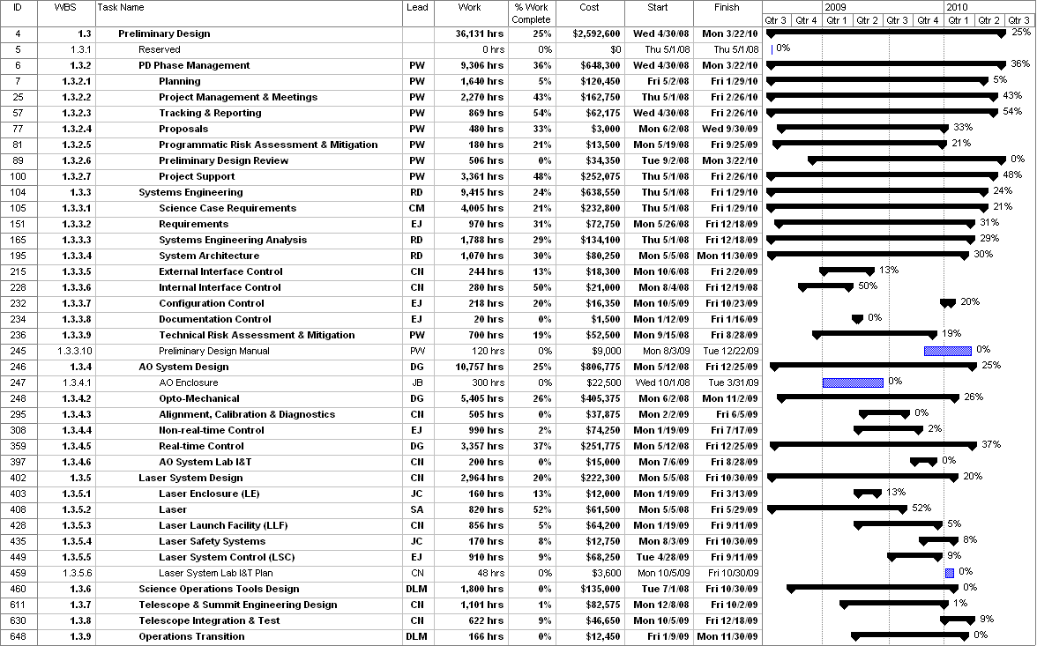

Figure 1: Tracked version of the PD phase schedule

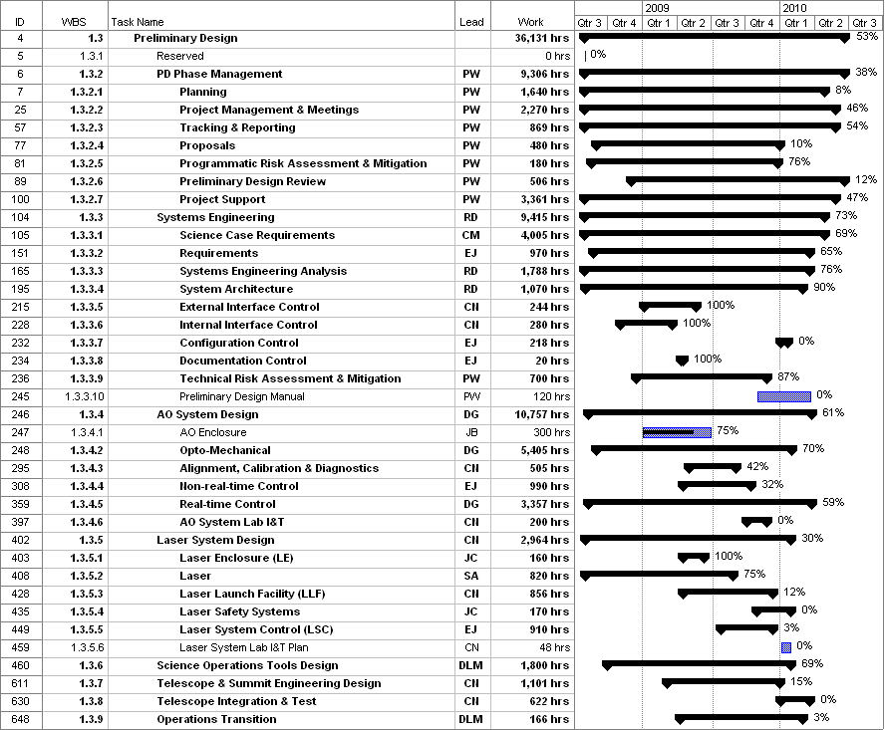
Figure 2: Planned % complete through March 2009 from the plan presented at SDR

Financial Summary

The budget, expenditures to date and estimate to completion for year 1 of the NGAO project are shown in Table 2.
Table 2: NGAO PD Phase Expenditure Summary through March 2009

