 Keck Adaptive Optics Note 646

Keck Next Generation Adaptive Optics
Preliminary Design Phase Project Report #10

P. Wizinowich, the NGAO Team, and Sean Adkins
March 24, 2009

Narrative

This report is the tenth monthly project report for the Preliminary Design (PD) phase in the development of the W. M. Keck Observatory’s (WMKO) Next Generation Adaptive Optics (NGAO) facility. This report covers the PD phase work performed in February 2009.

Summary
Management efforts have continued to involve activities related to the design and build to cost requirement, and collaboration on laser preliminary designs.

Management Status
The PD phase plan presented at the SDR included work under the following management WBS elements through February. The progress in each of these areas is discussed below.

WBS 1.3.2.1 Planning
A second build-to-cost team meeting to review and recommend cost savings items was held on February 5. The draft build-to-cost presentation for the build-to-cost concept review was further developed.

The build-to-cost concept review will be held March 18 near the LA airport. The reviewers will be Brent Ellerbroek, Mike Liu and Jerry Nelson. The Observatory directors will also attend (or have a representative).

WBS 1.3.2.2 Project Management and Meetings
The next team meeting will be held on March 19.

We have been unable to proceed with the open AO scientist position pending completion of the Observatory’s FY10 plan.

WBS 1.3.2.4 Proposals

WBS 1.3.2.5 Programmatic Risk Assessment and Mitigation
On February 18 the ESO Finance Committee approved the technical review team’s recommendation to negotiate preliminary design contracts with FASORtronics and TOPTICA. Laser preliminary design risk reduction request for quote packages were sent to the two ESO selected preliminary design vendors by February 20. Both companies responded positively to these requests.

Representatives from WMKO, GMT and TMT attended ESO’s kick-off meeting with FASORtronics on February 27. FASORtronics had provided a draft list of risk reduction activities prior to the kick off meeting and the last hour of the meeting was spent discussing these activities. FASORtronics will provide a risk reduction proposal to WMKO in March.

The TOPTICA kick-off meeting will be held on March 16.

Technical Status
The PD phase plan presented at the SDR included work under the following technical WBS elements in February. The progress in each of these areas is discussed below.

WBS 1.3.3.1 Science Case Requirements
This month we worked on expanding the Key Science Driver Observing Scenarios, as well as providing feedback and edits to the Observing Operations Concept Document. We also provided input for an updated science performance analysis based on our build-to-cost design, and evaluated the science impact of design changes required to meet our build-to-cost mandate. In collaboration with the instrument team we reached the conclusion that a single fixed-IFU with higher throughput and wider FOV can provide the science capabilities needed without requiring that we simultaneously support OSIRIS for use with NGAO. This frees up OSIRIS to be used with the Keck 1 AO system, and has additional cost benefits for NGAO.

Next month we will be focused on our build-to-cost review and in developing a white paper on the scientific and technical merits of NGAO for the NSF decadal survey.

WBS 1.3.3.2 Requirements
Significant effort was spent on the functional requirements in February. Work was done to establish and documented the review and change approval process. The product breakdown structure (PBS) was revised and the functional requirement definitions (FRDs) were organized around the new PBS numbers. Preliminary assignments were made for review the various requirement sections.

Good progress has been made on the Observing Operations Concept Document (OOCD) and a first release has been posted as a KAON. Work is continuing with bi-weekly telecons of the participants.

WBS 1.3.3.3 Systems Engineering Analysis

WBS 1.3.3.4 System Architecture
More work has been performed on the degraded laser power trade study. A large number of LGS asterism tomography simulations were performed in support of this study (the resulting plots are posted at http://www.oir.caltech.edu/twiki_oir/bin/view/Keck/NGAO/LGSAsterismStudy). The TMT modeling team provided support and assistance in finding and resolving a few bugs in their LAOS code. TMT and WMKO plan to collaborate on including more MOAO features in LAOS.

Progress has been made on the software and control system architectures. Most of the architecture definition is complete pending the results of the middleware testing evaluation. Progress has also been made on the motion control trade study and the overall sequencer designs for the AO and laser systems.

WBS 1.3.3.5 External Interface & 1.3.3.6 Internal Interface Control
Interface work has been performed in support of reviewing the science, systems, and functional requirements.

WBS 1.3.3.9 Technical Risk Assessment and Mitigation
The TMT MASS/DIMM equipment will arrive in Hawaii in early March. Preparations for its arrival are underway.

WBS 1.3.4.2.3 Optical Relays
We are now carrying the 100 mm and 140 mm beam versions of single-tier cascaded relay. Previously the 100 mm beam option didn’t seem feasible in a one-tier layout because of the 150" field requirement, which forced large opening angles on the parabolas which in turn caused collision of their mounts with the K-mirror de-rotator. Now with the smaller field (120" instead of 150"), we have a smaller K-mirror structure and smaller opening angles, so it all fits on one tier. The 100 mm beam is the most favored at this point for the reason that the woofer DM is likely to be 15% lower cost than in the 140 mm case and the tip/tilt stage is also likely to be less costly to meet requirements. The baseline is now to use only one tip/tilt stage, which holds the woofer DM.
As of the end of February:
- The single-tier 100 mm beam relay has a performance-optimized Zemax design published on the Twiki site.
- The assignment of instrument and LOWFS volumes in the pickoff-switchyard configuration is ongoing in coordination with Instruments and LOWFS task leaders.
- We continue to interact with multiple vendors on the specifications and ROM costs of tip/tilt stages. Right now the plan is for one stage holding the woofer DM.
- Working on a new mechanical layout for the one-tier cascaded relay architecture, with pickoff switchyard, modifying the already posted two-tier design. The choice of single-tier layout and 120" FOV eliminates the need for additional costly structure for holding the K-mirror or for a second-tier support.
- Gathering the information and bringing up the tools to do quantitative evaluation of the flexure, temperature, and vibration stability of the optical bench, and the system as it sits on the Nasmyth platform and feeds an instrument that also sits on the Nasmyth platform.

WBS 1.3.4.2.5 LGS Wavefront Sensor Assembly
Some potential LGS WFS mechanical designs were explored.

WBS 1.3.4.2.7 Low Order Wavefront Sensor Assembly

WBS 1.3.4.2.8.1 Tip-tilt Vibration Mitigation Analysis
Vendor information (CILAS) obtained on frequency response of DM on gimbals. Baseline values for vibration, wind and atmospheric tip-tilt levels were reviewed.

WBS 1.3.4.4 Non-real-time Control

WBS 1.3.4.5 Real-Time Control
Michael Peck’s LRIS upgrades commitments have allowed him to work ~20% of his time on NGAO over the past two months. Reinig has been filling in on the tasks so we are not falling behind on progress to PDR.
- Continued work on the hardware and algorithm documentation.
- Incremental progress has been made on all aspects of the RTC.
- Significant progress has been made in assessing the radial versus rectilinear voxel approach. With “radial” voxels, the sample spacing increases with altitude so that the total voxels across the field remain fixed for all layers. With the proper balance, this introduces no additional fitting error, as all layers are sampled fine enough relative to each layer’s r0 so that the total fitting error budget is maintained. However, the approach saves considerably on total number of voxels, lowering total number of processors needed, and thus lowering the cost of the RTC. Indications are that this approach is feasible within the structure of the RTC’s systolic array architecture.
- Horizontal voxel communication is needed in the Fourier transform and scale and shift operations in WFS reconstruction, tomography, and DM fitting steps of the RTC process. Vertical voxel communication is needed in the forward and back propagation steps of tomography and in collapse onto DMs. There has been considerable progress in evaluating the consequent high-speed communication requirements between processors and between boards and comparison with respect to available design rules for board traces and inter-board cables. Initial evaluation shows such requirements are within reasonable bounds for the present technology and detail work is proceeding in this area.

WBS 1.3.5 Laser System Design
Work has begun on personnel availability for the laser system design tasks. Some review of the laser facility and safety requirements has been performed.

Draft documents have been produced on the following topics:
- Review of the laser enclosure requirements.
- For the laser launch facility the infrastructure installation plan for the laser launch telescope in the f/15 secondary mirror module, the physical constraints at the f/15 module, and an installation plan for the launch telescope.
- Five documents for the safety system design including the laser to safety system interface, the safety system interfaces, the safety system interface signals, the safety system interlocks (permissives, alarms and warnings) and the safety system shutter layout.
- The laser system control sequencers from a hardware perspective.

WBS 1.3.8.1 Old AO/Laser Removal
A draft removal plan with cost estimates was produced for the existing Keck II laser system.

Science Instruments
Work on the science instruments has focused on establishing a science driven set of instrument capabilities while resolving the key issue of balance between capability and the design/build to cost constraints. We were able to collaborate with the science team to identify a satisfactory regime of operation in narrow band (~5% bandpass) mode for most of the the integral field spectrograph (IFS) science. This allows a potentially beneficial FOV/spectral coverage trade where larger FOVs are important for the science. We have also established a set of baseline capabilities for this instrument, and identified a concept for a single instrument providing both IFS and imaging capability.

Keck Adaptive Optics Notes
All of the NGAO KAONs can be found at:
http://www.oir.caltech.edu/twiki_oir/bin/view/Keck/NGAO/NewKAONs.

The following KAONs were produced in February:
KAON 636 Observing Operations Concept Document
KAON 637 NGAO Preliminary Design Report #9
KAON 638 Functional Requirements Approval and Change Process

Schedule and Budget Status

Milestones
The Systems Engineering Management Plan (SEMP; KAON 574) for the preliminary design phase identified the milestones shown in Table 1. The May 2008 milestone has been completed. The functional requirements milestone has been delayed as a result of changes to the plan, including the build to cost guidelines and is now expected to complete in April (1 month delay with respect to the last report). Please note that the date for the internal interface document release 1 was mistakenly listed as February; this has been changed to April.

Year | Month | NGAO Project Milestone | Status
2008 | May | Preliminary Design phase begins | Completed
2008 | October | Functional Requirements PD Release 1
2009 | March | Operations Concept Document Release 1
2009 | April | External Interface Document Release 1
2009 | April | Internal Interface Document Release 1
2009 | May | Software & Controls Architectures PD complete
2009 | May | LGS WFS Assembly PD complete
2009 | June | Laser vendor identified & contract ready
2009 | June | Optical relay/switchyard PD complete
2009 | September | RTC Processing Requirements complete
2009 | November | Laser Launch Facility PD complete
2009 | December | LOWFS Assembly PD complete
2010 | February | Preliminary Design Review
Table 1: NGAO PD Phase Milestones

Schedule
A high level snapshot of the tracked version of the schedule through January is shown in Figure 1 with 21% of the work complete. This can be compared to the expected work complete in Figure 2 of 46% that we originally planned to achieve through January at the SDR. Some detail on the discrepancies between the 21% complete and the plan can be seen by comparing Figure 1 and Figure 2. The primary reasons behind the schedule delay were listed in Project Report #9.

We will be able to redo the plan once the build-to-cost choices are complete in March and will be in a position to refocus and significantly ramp up our activities. We will then be in a better position to determine if we will need to delay the February 2010 PDR date; to the extent possible we would like to maintain an early 2010 PDR.

Budget
The total NGAO PD phase budget is $3030k excluding contingency; the contingency is $449k. A total of $516.6k has been spent through February or 17% of the budget excluding contingency (compared to 21% of work completed).

Anticipated Accomplishments in the Next Period
The anticipated accomplishments from the June report along with their status in italics:
- Submission of a collaborative (GMT, TMT, WMKO and ESO) white paper to the NSF for commercial laser development. Complete.
- Completion of the tip-tilt sharpening study. Complete.

The anticipated accomplishments from the July report along with their status in italics:
- Good progress (preferably complete) on the replan. No progress in Nov.
- Startup of NGAO controls group responsible for all non-real-time control software and hardware. Complete, including replan of controls tasks.

The anticipated accomplishments from the August report along with their status in italics:
- Hold build to cost team meeting and identify next steps in this process. Complete.
- Identify success criteria for NFIRAOS cost comparison and internal build to cost review. Complete.

The anticipated accomplishments from the September report along with their status in italics:
- Understand laser tomography noise propagator behavior. Complete.
- Complete the NFIRAOS cost comparison report. Complete.

The anticipated accomplishments for November along with their status in italics:
- Submit ATI proposal. Complete.

The anticipated accomplishments for December along with their status in italics:
- Produce a baseline set of cost savings possibilities to fit within the cost cap. Complete.
- Document single relay optical design (cost savings) evaluation. Complete.
- Complete the tip/tilt sharpening study report. Complete.
- Complete the ESO laser preliminary design proposal review/recommendation process. Complete.

The anticipated accomplishments for January along with their status in italics:
- Submit a NSF MRI proposal for a Keck II LGS AO center launch telescope, as part of NGAO. Complete.
- Set up regular meetings of a systems engineering team and begin to address requirements and interface issues. Complete.

The anticipated accomplishments for February along with their status in italics:
- Issue requests for quote for laser risk reduction contracts. Complete.
- Post a working copy of the Observing Operations Concept Document as a KAON. Complete.
- Complete a KAON defining the requirements control and review process. Complete.

The anticipated accomplishments for March are the following:
- Complete the laser preliminary design kick-off-meetings including risk reduction discussions.
- Complete a KAON defining the build-to-cost design changes.
- Complete a KAON describing the build-to-cost performance analysis.
- Complete the build-to-cost review presentation and meeting.

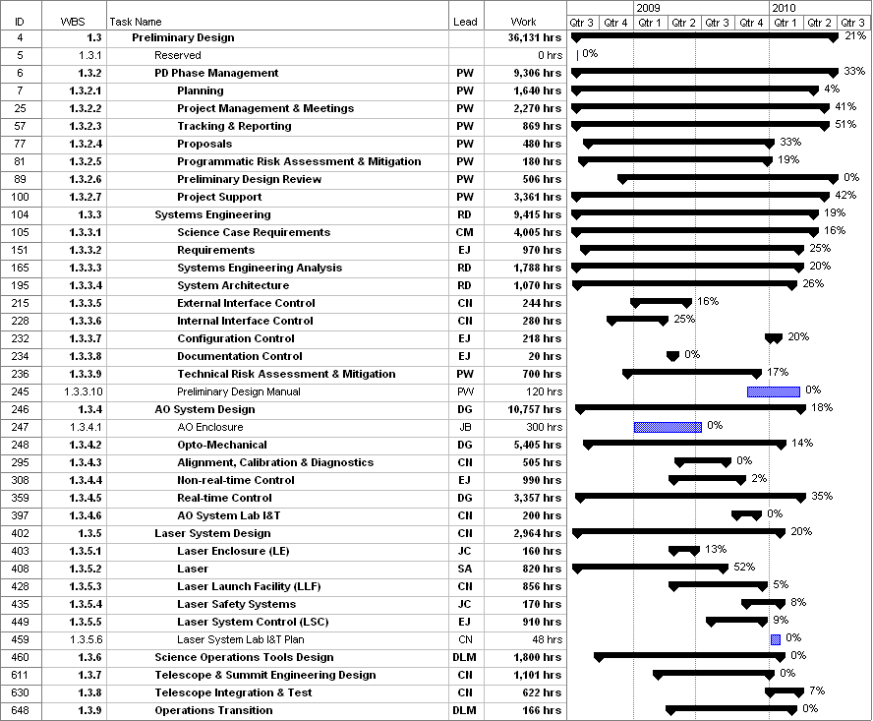
Figure 1: Tracked version of the PD phase schedule

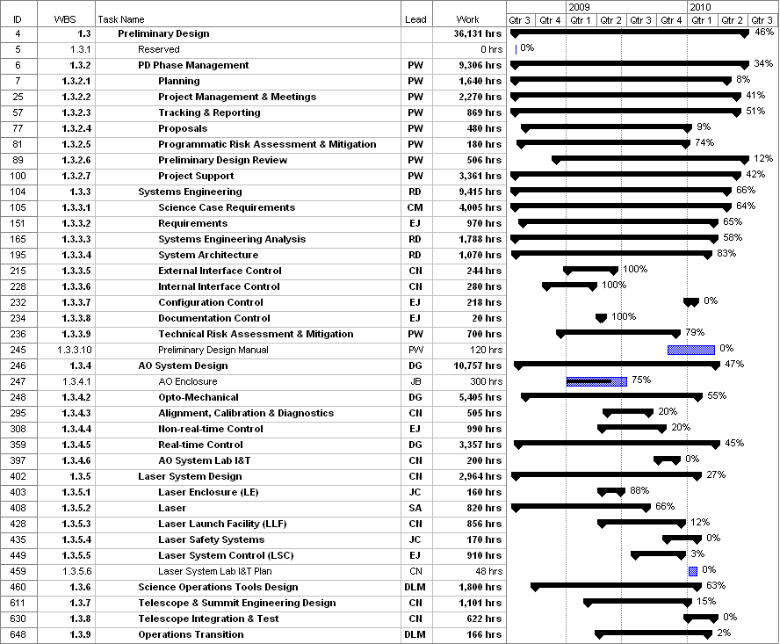
Figure 2: Planned % complete through February 2009 from the plan presented at SDR

Financial Summary

The budget, expenditures to date and estimate to completion for year 1 of the NGAO project are shown in Table 2.
Table 2: NGAO PD Phase Expenditure Summary through February 2009

