 Keck Adaptive Optics Note 600

Keck Next Generation Adaptive Optics
Preliminary Design Phase Project Report #1

P. Wizinowich, the NGAO Team, Sean Adkins
June 20, 2008

Narrative

This report is the first monthly project report for the Preliminary Design (PD) phase in the development of the W. M. Keck Observatory’s (WMKO) Next Generation Adaptive Optics (NGAO) facility. The System Design Review (SDR) was held on April 21 and 22, 2008. Based on the SDR Panel Report the Directors (the “Directors” refers to the Directors of WMKO (Armandroff and Lewis), Caltech Optical Observatories (Kulkarni) and UC Observatories (Bolte)) approved the start of the PD phase beginning May 1, 2008. This report covers the PD work performed in May.

Summary
The primary focus of our activities during this period has been on responding to the recommendations from the SDR and refining the plans for the PD phase.

Management Status
The PD phase plan presented at the SDR included work under the following management WBS elements in May. The progress in each of these areas is discussed below.

WBS 1.3.2.1 Planning
A response to the SDR Panel Recommendations was completed and approved by the Directors. The SDR panel recommendations are documented as Keck Adaptive Optics Note (KAON) 588 and the response is documented as KAON 593.

An overview of the SDR report was discussed at the April 30, 2008 WMKO Science Steering Committee (SSC) meeting. The subsequent SSC meeting minutes included the SSC’s recommendations for the NGAO project. A draft response to the SSC recommendations was prepared in May 2008 (and completed in June 2008).

A PD phase replan based on the SDR recommendations and other changes, including the completion of WMKO’s fiscal year 2009 (FY09) planning process, was begun in May. For WMKO staff the FY09 plan defines how many hours of each individual will be available to NGAO in FY09 and the NGAO plan needed to be adjusted accordingly. Another change is that two planned Caltech personnel will not be available; one of these positions is in the process of being filled with a new hire at Caltech and the other will initially be replaced by redistribution of other personnel.

One of the major SDR panel recommendations was to develop a phased implementation plan for NGAO, including descope options, in order to accommodate the possibility of restricted or incremental funding. A draft plan for developing such a phased implementation was completed in May and submitted to the Directors for their review. A draft report on this phased implementation plan has also been started. Producing a phased implementation plan is a significant new activity that will need to be integrated into the PD phase replan.

WBS 1.3.2.2 Project Management and Meetings
A meeting was held with the Directors as planned on May 1. Our plans to proceed with the PD phase were confirmed. We discussed our draft responses to the SDR panel recommendations and the plan to develop a phased implementation approach. A follow-up meeting was scheduled for June.

Our first team meeting was held at Caltech on April 30 and May 1, 2008 in conjunction with a WMKO SSC meeting. The focus was on responding to the SDR panel report.

WBS 1.3.2.3 Tracking and Reporting
Several NGAO related technical papers and presentations are being prepared for the Marseille SPIE meeting. Two of these papers were completed in May and submitted to SPIE for inclusion in their proceedings: an overview of NGAO (KAON 597) and an overview of the NGAO science operations (KAON 599).

Monthly budget tracking for the PD phase has begun and budget updates showing expenditures to date and projected expenditures will be produced monthly as part of the project reports.

WBS 1.3.2.5 Programmatic Risk Assessment and Mitigation
Initial discussions began with ESO and TMT on possible collaborative efforts for laser procurement.

WBS 1.3.2.7 Project Support
Draft statements of work and budgets were prepared for the work to be done at Caltech and UCO and sent to these Institutions for review. Project effort tracking by WBS was implemented at the three Institutions.

Technical Status
The PD phase plan presented at the SDR included work under the following technical WBS elements in May. The progress in each of these areas is discussed below.

WBS 1.3.3.1 Science Case Requirements
At the request of the NGAO team and the Directors a NGAO Science Advisory Team (SAT) will be formed to assist the project in refining and maintaining the science case requirements. This team will consist of scientific users of WMKO, and in particular experienced AO observers from the WMKO community. Establishing the SAT is considered a high priority, and the goal is to complete recruitment of the team membership and hold a first meeting before the start of the fall university semester. The Directors hold responsibility for organization of the SAT and the definition of its charter.

The NGAO Project Scientist, Claire Max, took the opportunity to visit with several Caltech scientists (Cohen, Djorgovski, Steidel and Matthews) on May 1, 2008 to discuss NGAO and their scientific needs.

WBS 1.3.3.2 Requirements
The first scheduled requirements task was to prepare an outline for the Operations Concept Document (OCD). An initial outline has been prepared.

WBS 1.3.3.3 Systems Engineering Analysis
The first planned modeling activity was to perform a study to better understand the benefits of tip-tilt sharpening. This work was started and will be presented at the Marseille SPIE meeting.

WBS 1.3.4.2.5 LGS Wavefront Sensor Assembly
The first scheduled opto-mechanical task was to review the concept design for this assembly. This review was started during a meeting on May 1.

WBS 1.3.4.2.7 Low Order Wavefront Sensor Assembly
Some work in reviewing the concept for this assembly has been performed ahead of schedule.

Keck Adaptive Optics Notes
All of the NGAO KAONs can be found at:

http://www.oir.caltech.edu/twiki_oir/bin/view/Keck/NGAO/NewKAONs.

KAONs that have been produced during the first month of the PD phase include the following:

588 System Design Review Panel Report.
593 Response to System Design Review Panel Recommendations.

Schedule and Budget Status

Milestones
The Systems Engineering Management Plan (SEMP; KAON 574) for the preliminary design phase identified the milestones shown in Table 1. The May 2008 milestone has been completed.

Year | Month | NGAO Project Milestone | Status
2008 | May | Preliminary Design phase begins | Completed
2008 | October | Functional Requirements PD Release 1
2009 | March | Operations Concept Document Release 1
2009 | April | External Interface Document Release 1
2009 | February | Internal Interface Document Release 1
2009 | May | Software & Controls Architectures PD complete
2009 | May | LGS WFS Assembly PD complete
2009 | June | Laser vendor identified & contract ready
2009 | June | Optical relay/switchyard PD complete
2009 | September | RTC Processing Requirements complete
2009 | November | Laser Launch Facility PD complete
2009 | December | LOWFS Assembly PD complete
2010 | February | Preliminary Design Review
Table 1; NGAO PD Phase Milestones

Schedule
A high level snapshot of the tracked version of the schedule through January is shown below with 1% of the work complete.

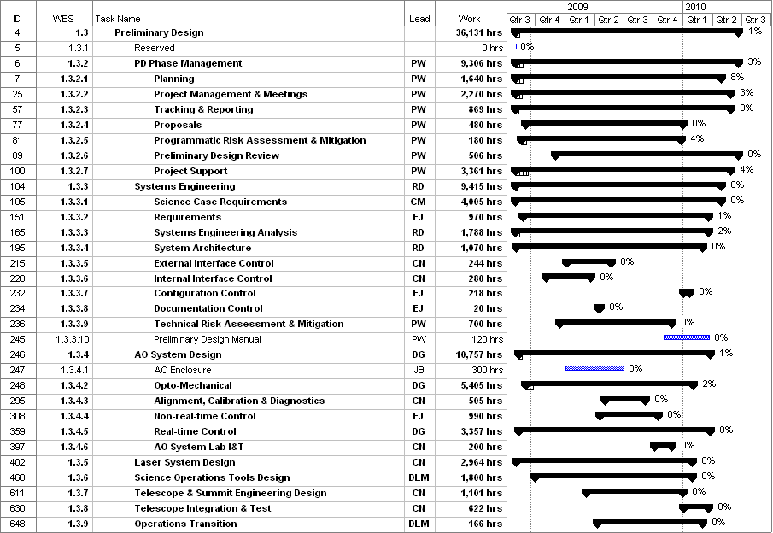
Figure 1: Tracked version of the PD phase schedule

There have been some minor delays in the project schedule. This is primarily due to the more significant than planned activity associated with incorporating the SDR panel recommendations and other changes, especially the need for a phased implementation plan, into the PD phase replan. To a lesser extent there has also been some delay in ramping up people. The replanning effort will likely extend into July (versus the original planned May completion).

Budget
The total NGAO PD phase budget is $3030k excluding contingency; the contingency is $449k. A total of $28k has been spent through May or ~1% of the budget excluding contingency. This is roughly consistent with the 1% of the work completed shown in the previous section.

Anticipated Accomplishments in Next Period
- Completion and approval of the plan to develop a phased implementation approach, as well as progress on this plan.
- Completion and approval of the response to the SSC recommendations.
- Development of a draft charter for the NGAO Science Advisory Team.
- Completion and presentation of the NGAO SPIE papers.

Financial Summary

The budget, expenditures to date and estimate to completion for year 1 of the NGAO project are shown in Table 2. The preliminary design phase contracts are not yet in place at COO and UCO, and actual expenditures were not available from UCO. The Table 2 budget does include the post doctoral researcher at UCO, but some corrections may need to be made once other UCO expenditures are known.

Table 2: NGAO PD Phase Expenditure Summary through May 2008

