W.M. Keck Observatory’s Next Generation Adaptive Optics Facility

P. Wizinowichª, R. Dekany^{b}, D. Gavel^{c}, C. Max^{c}, S. Adkinsª, B. Bauman^{c},
J. Bellª, A. Bouchez^{b}, M. Britton^{b}, J. Chinª, R. Flickerª, E. Johanssonª,
R. Kupke^{c}, D. Le Mignantª, C. Lockwood^{c}, D. Medeirosª, E. McGrath^{c},
A. Moore^{b}, C. Neymanª, M. Reinig^{c}, V. Velur^{b}
ªW.M. Keck Observatory, 65-1120 Mamalahoa Hwy., Kamuela, HI 96743.
^{b}Caltech Optical Observatories, California Institute of Technology, Pasadena, CA 91125.
^{c}University of California Observatory, Santa Cruz, 1156 High St., Santa Cruz, CA 95064.

ABSTRACT
W. M. Keck Observatory (WMKO) is currently engaged in the design of a powerful new Adaptive Optics (AO) science capability providing precision correction in the near-IR, good correction in the visible, and faint object multiplexed integral field spectroscopy. Improved sensitivity will result from significantly higher Strehl ratios over narrow fields (< 30" diameter) and from lower backgrounds. Quantitative astronomy will benefit from improved PSF stability and knowledge. Strehl ratios of 15 to 25% are expected at wavelengths as short as 750 nm. A multi-object AO approach will be taken for the correction of multiple science targets over modest fields of regard (< 2' diameter) and to achieve high sky coverage using AO compensated near-IR tip/tilt sensing. In this paper we present the conceptual design for this system including discussion of the requirements, system architecture, key design features, performance predictions and implementation plans.
Keywords: Adaptive Optics, Laser Guide Star, MOAO, Keck Observatory

INTRODUCTION
The current Keck II and Keck I AO systems, commissioned in 1999 and 2001 respectively, have been very successful and scientifically productive [1],[2],[3],[4]. Figure 1 shows the number of refereed science publications by year (160 papers through 2007) from the Keck II NGS and LGS AO system, as well as from the Interferometer [5] that combines the AO-corrected light from both telescopes. A successful recent upgrade to the ageing wavefront control computers and cameras will allow these systems to remain productive for some time [6]. An upgrade of the Keck I AO system to an LGS facility is currently underway which will provide improved LGS performance and facilitate LGS AO-assisted Interferometer operation [7].
The importance of achieving the full potential of the Keck telescopes is recognized in the Observatory’s Strategic Plan, which identifies continued leadership in high angular resolution astronomy as a key long-term goal. In support of this goal, and the strong and growing community demand for LGS AO, we successfully completed the first design phase, System Design, for WMKO’s Next Generation AO (NGAO) facility in April, 2008.

REQUIREMENTS
We are examining a broad range of key science goals to identify the most compelling high angular resolution science priorities of our community, and to determine what new AO characteristics are needed to realize these goals [8]. Our Science Case Requirements Document defines and analyzes two classes of science cases: “key science drivers” and “science drivers”. Key science drivers are those science cases that place the strongest or most technologically challenging demands on the performance of the NGAO system and its science instruments. These are the science cases that we have used to drive the performance requirements for the AO system and instruments. Science drivers are included to assure that the NGAO system is sufficiently flexible to deal with the broad range of science that users will demand over the lifetime of the NGAO system. The five key science drivers and nine science drivers were selected because they represented important astrophysics that would clarify the requirements on the NGAO system from different perspectives. The key science drivers include galaxy assembly and star formation history; nearby active galactic nuclei; precision astrometry for measurement of general relativity effects at the Galactic Center; imaging and characterization of extrasolar planets around low-mass stars; and multiplicity of minor planets in our solar system. The science drivers include quasar host galaxies; gravitational lensing; astrometry science in sparse fields; resolved stellar populations in crowded fields; debris disks and young stellar objects; the size, shape and composition of minor planets; the characteristics of gas giant planets, their satellites and rings; the characteristics of ice giant planets and their rings; and backup science.
Figure 1: Publication history for Keck AO refereed science papers.
The key elements of the selected architecture flowed directly from the key science drivers and science drivers, and some additional system requirements imposed by the Observatory. At the highest level these can be summarized as follows:
- Dramatically improved performance at near infrared wavelengths.
- Improved IR sensitivity.
- High Strehls (≥ 80% at K-band) are required over narrow fields. The flowed down requirements are derived from the wavefront error performance budget and assumptions about how these error terms can be met. These flowed down requirements include number of actuators in the narrow field, required system bandwidth, number of LGS, number of NGS, required laser power, etc.
- Lower backgrounds. This is particularly driven by the high-redshift galaxy science. This requirement has driven the need for a cooled AO system and its required operating temperature.
- Improved astrometric, photometric and companion sensitivity performance.
- Improved IR sensitivity is required (see item 1.a.).
- It will also be critical to improve the PSF stability and knowledge.
- Increased sky coverage.
- Wide field required in order to find suitable NGS for tip-tilt sensing.
- Ability to use faint NGS. This requirement drove us to an architecture where we provide AO correction of the tip-tilt stars.
- Efficient extragalactic target surveys.
- Science instrument.
- The need for efficient acquisition of spectral and imaging data drove us to an integral field spectrograph.
- The availability of multiple targets over a modest (2′ diameter field) and the need to perform surveys efficiently drove us to a multiplexed instrument.
- The need to adapt to the observation field drove us to deployable heads.
- Sensitivity.
- The required image resolution allowed us to work to an encircled energy requirement that required fewer actuators than for the narrow field science.
- This requirement, and the requirement to AO correct the tip-tilt NGS over a wide field, drove us to a choice between multi-conjugate (MC) and multi-object (MO) AO to achieve good correction over a wide field. Maximizing the performance over narrow non-contiguous fields, within a field of regard of two arcminutes, led to the selection of MOAO.
- The need for low backgrounds drove the need for a cooled AO enclosure.
- AO correction in the red portion of the visible spectrum.
- This drove the need to transmit these wavelengths to the visible science instruments and to share visible light with the LGS and NGS wavefront sensors via appropriate dichroics.
- Science instruments that will facilitate the range of science programs.
- This drove the selection and conceptual design of the science instruments including diffraction-limited imagers in the visible and near-infrared, a narrow field integral field spectrograph, and a multi-object deployable integral field spectrograph (d-IFS), as well as the existing Keck Interferometer.
- This drove the providing of locations for these science instruments in the optical and mechanical design.

SYSTEM DESIGN

System Overview
The requirements flow down described in the previous section led us to the following key architectural features:
- Multiple sodium laser guide star tomographic wavefront sensing to overcome the cone effect.
- A variable radius LGS asterism to maximize the performance for each science field and with changing atmospheric turbulence profiles.
- LGS projection from behind the telescope secondary mirror to minimize perspective elongation.
- Location of the AO system on one of the Keck telescope Nasmyth platforms to have sufficient space for the AO system and science instruments in a gravity constant environment.
- A cooled AO system to meet the infrared background requirements. Alternate approaches such as an adaptive secondary mirror were considered.
- A K-mirror rotator at the input to the AO system to keep either the field or pupil fixed. The AO system would need to be cooled even without a rotator and this approach allows the most stability for the AO system and instruments.
- A wide-field (150" diameter) relay to feed light to the LGS wavefront sensors, tip-tilt sensors, and d-IFS science instrument.
- A conventional (5 mm pitch) Deformable Mirror (DM) to transmit a wide field in the wide-field relay.
- A low-order (20 actuators across the pupil) DM for the wide-field relay to limit the size of the relay, to permit closed loop AO correction on the LGS wavefront sensors, and to keep the LGS wavefront sensors in their linear range, reducing the requirement on downstream open-loop correction.
- Open loop MOAO-corrected near-IR tip-tilt sensors to maximize sky coverage [9]. The MOAO approach (versus MCAO) maximizes the delivered Strehl over narrow non-contiguous fields with a wide field of regard. The open-loop correction applies the result of the tomographic reconstruction to that point in the field. In principle this is better than closed loop on a single LGS since focus anisoplanatism is also reduced. Near-IR tip-tilt sensing is used since the AO correction will sharpen the NGS image and thereby provide better tip-tilt information. We have determined that two tip-tilt (TT) sensors and one tip-tilt-focus-astigmatism (TTFA) sensor provides the optimum correction.
- Open loop MOAO-corrected deployable Integral Field Spectrograph (d-IFS) heads.
- Open loop MOAO-correction to the narrow field science instruments.
- MEMS DM’s for the MOAO-correction. These are very compact devices and have been lab demonstrated to accurately go where they are commanded. Small, modest cost 32x32 element MEMS DM’s provide the required correction for the tip-tilt sensors and d-IFS heads. A 64x64 element MEMS, similar to that under development for the Gemini Planet Imager, is needed to provide the required AO correction to the narrow field science instruments.
- A high-order, narrow-field (30" diameter) AO relay to feed light to the narrow field science instruments (with a larger, 60" diameter, field to the NGS wavefront sensor). The science instruments fed by this relay only require a narrow-field and the narrow field facilitates the use of a single MEMS DM for all narrow field instruments. These science instruments include near-IR and visible imagers and OSIRIS (the existing Keck AO-fed near-IR Integral Field Spectrograph).
The resultant architecture is shown schematically in Figure 2 (more details can be found in reference [10]). Starting at the lower left side of the figure, an environmental enclosure is provided to house lasers generating a total of 100 to 150 W in a CW format (or a pulse format with comparable sodium layer return flux). The output from these lasers is transferred to a multiple beam pattern generator and controller located at the top end of the telescope. The output of this beam pattern generator is projected onto the mesospheric sodium layer by a laser launch telescope located behind the telescope secondary mirror as shown just to the left of center in the figure.
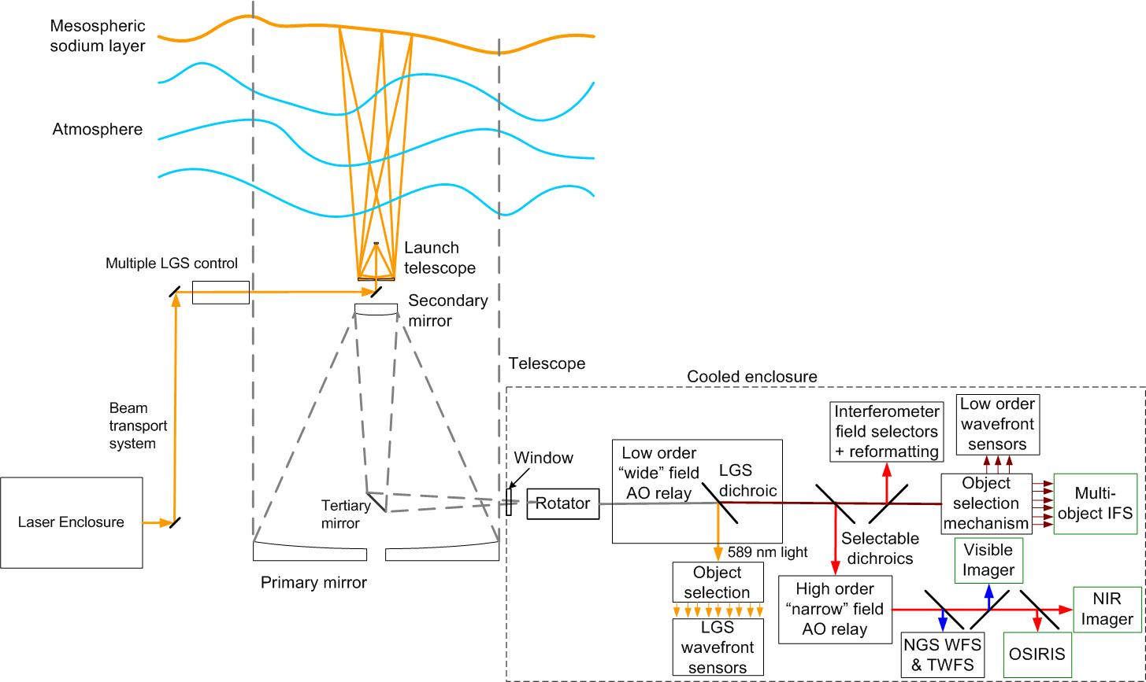

Figure 2: NGAO Block diagram.
Light collected by the Keck telescope is directed to the AO system shown in the lower right of Figure 2. The AO system and instruments are located on the telescope’s left Nasmyth platform at the f/15 focus. The AO system is enclosed in an enclosure cooled to about -15 ºC below ambient (~260 K) to reduce the thermal emissivity of the optical surfaces. A double window is provided to isolate the enclosure from the dome environment.
Within the cooled enclosure, the light from the telescope passes through an image de-rotator. A “moderate” field low order AO relay incorporating a single DM provides low order AO correction (where low-order refers to the order of AO correction provided by the existing Keck AO systems). This DM operates in a closed loop in conjunction with the LGS wavefront sensors. Just after the DM, a dichroic beamsplitter is used to send the 589 nm light from the LGS asterism to the LGS wavefront sensor assembly, which includes an object selection mechanism. In the absence of a selectable dichroic the light from the low-order relay is then transmitted directly to the object selection mechanism for the d-IFS and the low order wavefront sensors (i.e., the NIR TT and TTFA sensors and a NIR truth wavefront sensor (TWFS)). A fold mirror or dichroic can be inserted to feed light to the Keck Interferometer.
To use the “narrow” field science instruments a selectable dichroic is inserted to send the light through a “narrow” field high-order AO relay. High-order refers to three times the DM actuator linear density of the low-order DM. This relay provides AO corrected light to a visible-light NGS wavefront sensor and TWFS assembly, and three science instruments.
For NGS AO observations only the NGS WFS is required. For LGS AO observations, the LGS wavefront sensors, three tip-tilt sensors and one of the TWFS are required. A schematic representation of the location of the LGS beacons and the various sensors for both narrow and wide field science is shown in Figure 3. A variable LGS asterism with one LGS on-axis and five LGS in a pentagon is shown. This asterism can be expanded or contracted for the particular science case and atmospheric conditions. Three additional LGS are used to point near the tip-tilt (TT) NGS to maximize their image sharpening.
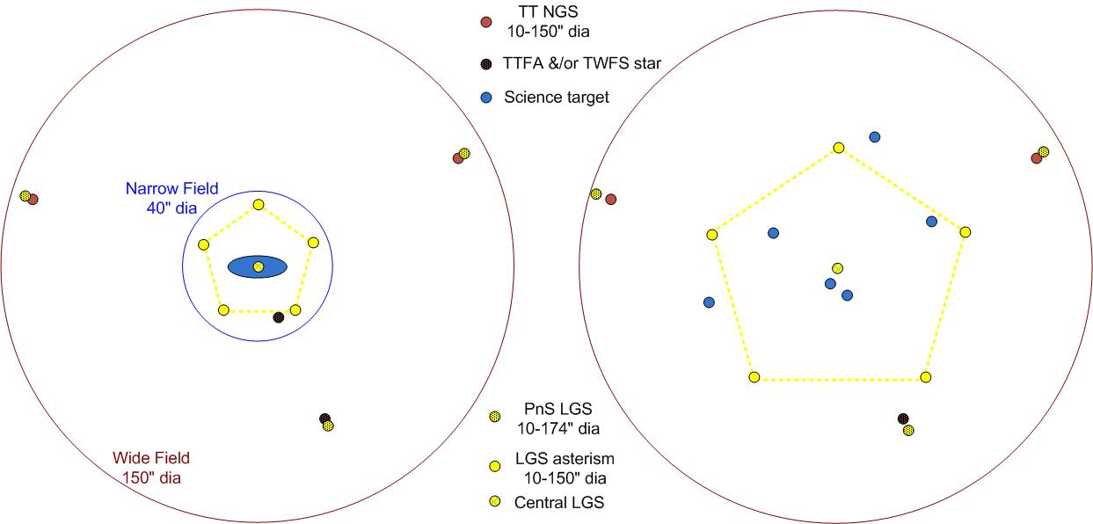

Figure 3: Narrow-field (left) and wide-field (right) LGS asterisms.

Opto-mechanics
A perspective view of the NGAO opto-mechanics, including science instruments is shown in Figure 4. The image rotator and first relay are shown in more detail in Figure 5. The light from the telescope passes through the image rotator to the first Off-Axis Parabola (OAP1). OAP1 collimates the light which is folded by a flat to the “Woofer” DM, which is conjugate to the telescope primary mirror. The 589 nm light is then picked off by a dichroic to the LGS WFS. The rest of the light proceeds to OAP2 which reconverges the beam, at the input focal ratio, toward the d-IFS. A choice of dichroics can be inserted into the beam between OAP2 and the d-IFS to send light to the narrow field relay. The narrow field beam (shown in purple in Figure 4) consists of two OAPs with a “Tweeter” DM in between to provide a higher level of AO correction and a slower f/# to the remaining science instruments.
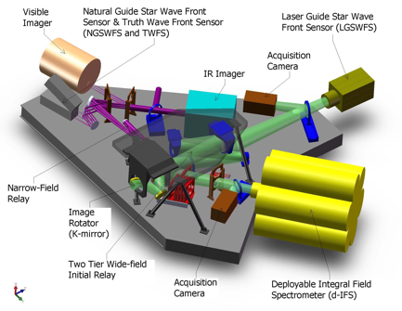
Figure 4: Perspective view of the opto-mechanical layout. Light from the telescope enters the bench
through the image rotator. The bench plus instrument dimensions are 3.8 x 4.8 x 1.3 m.

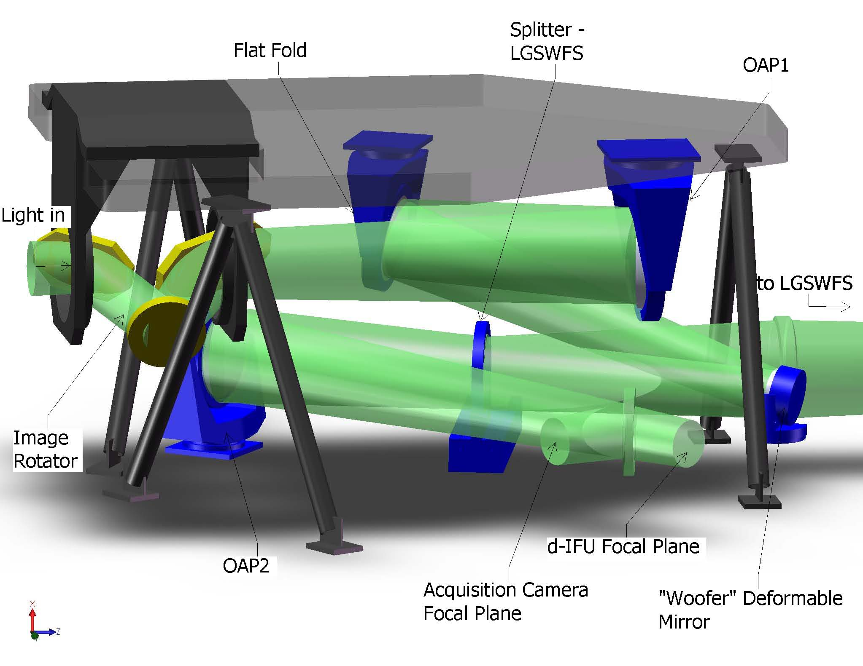
Figure 5: The image rotator and low order relay.
A key part of the opto-mechanical design will be object selection mechanisms to feed the multiple NGS and LGS wavefront sensors as well as the d-IFS heads. Our baseline object selection mechanism shown in Figure 6 utilizes a pickoff mirror that can be positioned on the NGS, LGS or science target via two rotary arms. The NGS and science target probes arms will include atmospheric dispersion correctors (ADCs) and 32x32 MEMS.
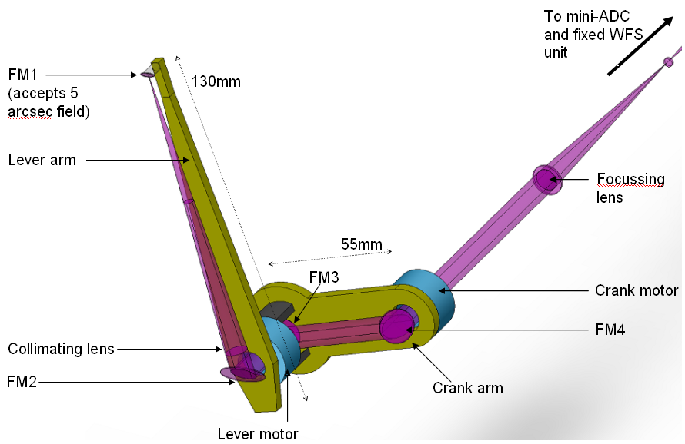
Figure 6: Object selection probe arm. The lever and crank motors rotate to acquire objects.

AO Controls
The AO control system is integrated with the telescope’s overall control system and has its own hierarchy for controlling the operation of the AO system in coordination with the instruments. Lessons learned from prior AO control system development have been taken advantage of in the design of the NGAO system, with particular attention paid to operations planning, efficient observations, and data archiving.
The NGAO control architecture is distributed among several subsystems: science instruments, AO system, telescope interface, laser system, data server, atmospheric tools and laser traffic control system. The overall system is operated through the science operations tools box at the topmost layer of control. This toolbox consists of a user interface and operations tools (pre-observing, operation control tools and post-observing tools).
Figure 7 shows a block diagram of the AO infrastructure where the control systems are represented by a hierarchy. At the top level are the main interfaces to the various subsystems. The science operations tools control the AO facility through a high level sequencer (the multi-system sequencer) as shown at the top of Figure 7. The multi-system sequencer sends parallel commands to each of subsystem sequencer. The sequencing is performed at the lowest possible levels allowing for parallel (time efficient) observing sequences. The middle level of the hierarchy represents the basic control functions for that subsystem. Some users will access the system at this middle level for engineering or troubleshooting purposes, but observing operations will occur via the topmost layer. Shown at the lowest level of the hierarchy are the controlled devices themselves.
The Real-Time Control (RTC) element of Figure 7 is central to the success of the NGAO system. The multi-guide-star tomography data flow and the required parallel processing are shown in Figure 8. The RTC is a specialized computer system designed to perform all of the wavefront sensing, tomography calculations, and deformable mirror control processing at rates that keep up with atmospheric turbulence induced optical aberrations. The RTC data flow and computer architectures have been designed to achieve the tomography precision, noise suppression, and bandwidth requirements implied by the science-case driven wavefront error budgets.
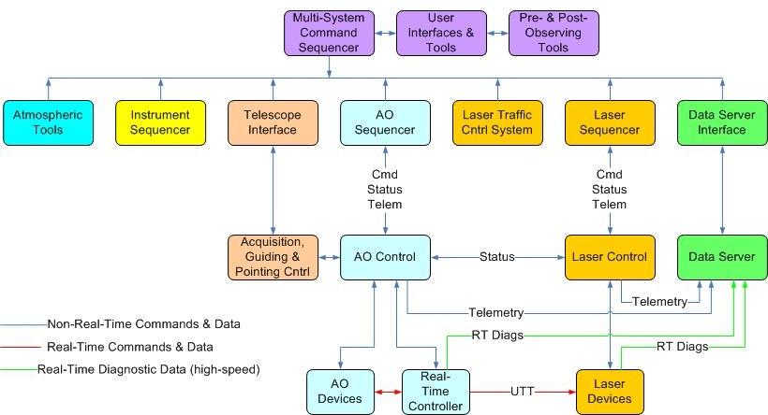

Figure 7: NGAO system distributed control system block diagram.
A key consideration in the RTC design is the need to keep the cost and complexity manageable given the demands of real-time tomography. Simply scaling earlier implementations of single conjugate AO RTC reconstructors using traditional central processing units (CPUs) is infeasible because of the multiplying effect of multiple guide stars and multiple deformable mirrors on computer speed requirements. To address this issue, we have taken advantage of the high degree of parallelization of wavefront reconstruction and tomography algorithms and mapped them on to a massively-parallel processing (MPP) compute architecture. This architecture scales in size and complexity much more favorably than doing the same calculations on conventional CPUs, and can be readily implemented using MPP building blocks (i.e., field programmable gate arrays) available on the market today.
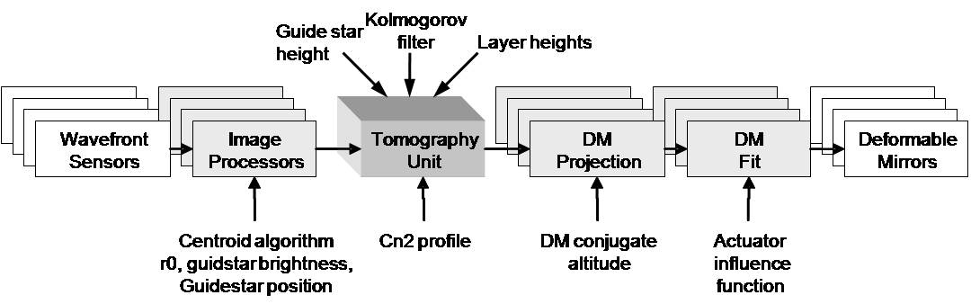
Figure 8: Multi-guide star tomography data flow and parallel processing.
As shown in the Figure 8 schematic, large chunks of compute tasks are associated with either wavefront sensors or DMs and thus are parallelized across them. Furthermore, algorithms within the subunits, as well as within the tomography unit itself, are themselves highly parallelizable and thus will all map onto the MPP architecture.
The RTC algorithm computes the statistical minimum variance solutions for wavefronts at each science instrument, given the measured wavefront data from the guide stars. The minimum variance solution depends on certain a-priori data, which the RTC accepts as parametric input, including C_{n}² profile discretized at layers, number of layers of turbulence, brightness of guide stars and wind speeds at layers. Truth wavefront sensors will provide long-term average wavefront data to normalize out systematic biases due to either non-common path optical aberration or Hartmann sensor biases due to variations in the sodium layer thickness and altitude. In a like manner, prior measurements will have determined calibration set points for each wavefront sensor, giving the definition of a “flat” wavefront for each sensor. The set points for LGS wavefront sensors will depend on field position and zenith angle. Thus the multi-system command sequencer, with knowledge of the telescope and AO system configuration, will periodically update the RTC wavefront sensor sub-processors as to which parameter set to apply to the wavefront reconstruction.

Science operations
The science operations for NGAO are presented in Le Mignant et al. [11].
The NGAO facility will provide an extensive set of pre-observing tools to be used from the proposal preparation phase to the execution of the observing sequences, including: a NGS guide star finder tool coupled with AO performance simulation tools, exposure time calculators, an observing sequences preparation tool and an observing efficiency estimator.
The NGAO control architecture is designed to optimize the observing efficiency via parallel sub-system command sequencers, built-in flexible operation modes between NGS and LGS modes, built-in diagnostics and auto-recovery scripts, quick-switch to different science instruments, dithering/nodding on the science field without opening the AO loops, etc.
We are also developing the requirements for the science calibrations along with the science cases in terms of photometry, astrometry and PSF calibrations. The calibration of the PSF in the science field of view is a challenge for current AO systems. One method to calibrate the PSF in the science data is to reconstruct it from the WFC telemetry. The Observatory is currently developing, testing and integrating PSF reconstruction tools for the Keck II AO system in NGS and LGS mode [12]. We plan to apply this experience to the design of the NGAO PSF reconstruction tools.

PERFORMANCE BUDGETS
The quantitative budgets for background radiation and transmission, wavefront error and ensquared energy, and high-contrast performance along with the key drivers for photometric precision, astrometric accuracy, and polarimetric stability, have all played a central role in the NGAO architecture selection and functional requirements flow down.

Wavefront Error and Ensquared Energy
Residual wavefront error and ensquared energy budgets have been developed in detail for a number of NGAO science cases, allowing us to better understand the science impact across a range of realistic observing scenarios. These error budgets have been validated against on-sky measurements using the Keck II LGS AO system.
Based on these tools, we expect the NGAO system design will deliver the system performance shown in Table 1. The first column of the table indicates the observing scenario. The second column indicates the integration time assumed for the science exposure. The third column indicates the tip-tilt reference used, and the fourth column gives the diameter of the LGS variable radius constellation. The fifth column indicates the tip-tilt error that results from the assumed angular offset of the tip-tilt star. The sixth column gives the sky coverage fraction over which the tip-tilt error will be less than or equal to the error given in column five. This estimate results from the use of common sky coverage models.[13],[14] The last four columns give the high order wavefront error without tip-tilt, the total wavefront error with tip-tilt errors, the H-band Strehl and the K-band Strehl. For the high-redshift galaxy case, the appropriate figure of merit is ensquared energy rather than residual wavefront error; for the 50 mas spatial sampling of each head of the multi-object d-IFS the ensquared energy is 55% in H-band, assuming full 150 W of power and a total of nine LGS beacons. All the other science cases in Table 1 only assume 100 W of laser power.
These results show that the variable radius LGS constellation and the performance levels assumed for the tomographic wavefront reconstruction, LGS wavefront sensors and near-IR tip-tilt sensors are capable of providing performance that is generally at the level required by the science cases. Initial estimates of NGAO system performance based on laser tomography AO resulted in the adoption of three representative values of residual wavefront error for the science case simulations: 140 nm, 170 nm and 200 nm. This has led to further work to develop additional techniques for performance improvement including the additional three freely positionable LGS and the additional tip-tilt sensors.
The sky coverage fractions required by the extragalactic and galactic science cases requires optimizing the offset and brightness of the tip-tilt stars. This is accomplished by increasing the faint magnitude limit for tip-tilt stars through the use of tip-tilt sensors operating at near-IR wavelengths combined with MOAO correction using deployable LGS beacons specifically for tip-tilt reference sharpening [9], and by providing a 150" field of view for tip-tilt star selection.

Table 1: Performance summary for six science cases. The last two columns show the Strehl ratio for all but one science case; in the high-redshift galaxies case the performance is expressed in terms of ensquared energy with a 50x50 mas spaxel.
Science  Observation | Integ  time (sec) | TT refer-ence | LGS asterism dia. (") | TT error (mas) | Sky cover-age | High order wavefront error (nm) | Effective wavefront error (nm) | Strehl /  EE  (1.65 μm) | Strehl / EE  (2.2 μm)
Io | 10 | Science target | NGS | 2.7 | NGS | 104 | 112 | 83% | 90%
KBO Companion Survey | 300 | Field star | 11 | 4.7 | 10% | 154 | 175 | 64% | 78%
Exo-Jupiters | 300 | Science target | 11 | 2.4 | N/A | 152 | 157 | 69% | 82%
Lensing - Galaxy by a Galaxy | 1200 | Field star | 11 | 9.5 | 30% | 159 | 226 | 47% | 66%
High-Redshift Galaxies | 1800 | Field star | 51 | 9.3 | 30% | 204 | 257 | 55% | 63%
Galactic Center | 30 | IRS 7 | 11 | 3.0 | N/A | 177 | 184 | 61% | 76%

Based on these collected analyses, we have determined our NGAO system design capable of satisfying all of the Science Case requirements using, almost exclusively, existing component technologies and architecture combinations that have or will be proven within two years by ESO MAD, Palomar PALM-3000, Gemini GPI, and Lick VILLAGES [15].

Companion Sensitivity
Another important area for NGAO science is high contrast observations. The Strehl proposed for NGAO is lower than extreme AO systems such as the Gemini Planet Imager (GPI) or ESO SPHERE, but at the same time, NGAO will provide higher sensitivity and sky coverage that greatly exceeds that of an NGS-only extreme AO system. This will be particularly valuable for planets around low-mass stars since these systems are too faint for instruments like GPI. An example of the high-contrast simulation capability is shown in Figure 9. Our analysis indicates that a conventional occulting spot coronagraph with an apodized Lyot stop will meet the requirements of the majority of the NGAO high contrast science cases.
The level of contrast achieved with NGAO will ultimately depend on the control of systematic errors such as non-static, non-common path aberrations, servo lag error and various sources of speckle. Speckle suppression techniques including spatially resolved spectroscopy will be available for NGAO observations and to the extent possible we intend to incorporate the calibration “best practices” discovered by the GPI project.

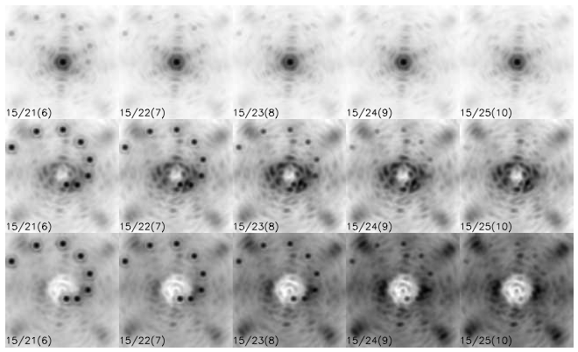
Figure 9: Simulated NGAO J-band science observations with secondary objects inserted.
Top row: AO without coronagraph. Middle row: AO + coronograph with 6 λ/D occulation.
Bottom row: AO + coronagraph with 10 λ/D occulation. The numbers in the lower left corner of
each image indicate the primary / secondary / delta magnitudes, i.e. the format is J₁ / J₂ (ΔJ).
The images are stretched (asinh) and individually scaled.

Photometric and Astrometric Precision
Science requirements for photometric measurements require ≤ 0.05 magnitudes for relative photometry. The most demanding astrometric requirements are for observations of the Galactic Center where a precision of 100 µas is required (versus the current Keck II LGS AO best-case precision of 150 µas).
Photometric and astrometric error budgets have not yet been developed for NGAO, however we have looked into the physical effects that degrade their precision. In particular, NGAO will need to provide detailed and reliable information regarding the NGAO point spread function (PSF) on an exposure-by-exposure basis. The ~3 times higher NGAO Strehl versus the current Keck II LGS AO system will make a significant contribution to improved Galactic Center astrometric accuracy by reducing source confusion.

SCHEDULE
The Preliminary Design phase of the project is currently underway with financial support from the Telescope Systems Instrumentation Program, funded by the National Science Foundation, as well as WMKO development funding. The preliminary design review is planned for February 2010. Depending on the availability of future funding we are anticipating first light for NGAO in 2014.

CONCLUSIONS
We have embarked on the design of a Next Generation AO facility for the W.M. Keck Observatory that should enable a broad spectrum of new and cutting-edge science through improved sensitivity, higher Strehls, improved PSF knowledge and stability, increased sky coverage, performance at shorter wavelength and new science instrument capabilities. In this paper we have presented elements of the conceptual design for this system.

ACKNOWLEDGEMENTS
The W. M. Keck Observatory is operated as a scientific partnership among the California Institute of Technology, the University of California, and the National Aeronautics and Space Administration. The Observatory was made possible by the generous financial support of the W. M. Keck Foundation.

REFERENCES
- P. Wizinowich et al., “Adaptive Optics Developments at Keck Observatory,” SPIE Proc. 6272, (2006).
- P. Wizinowich et al., “The W.M. Keck Laser Guide Star Adaptive Optics System: Overview,” PASP 118, 297-309 (2006).
- R. Campbell et al., “AO Operations at the W.M. Keck Observatory,” SPIE Proc. 7016, (2008).
- I. McLean, S. Adkins, “Instrumentation at the W.M. Keck Observatory,” SPIE Proc. 7014, (2008).
- S. Ragland et al., “Recent Progress at the Keck Interferometer: Operations and V2 Science,” SPIE Proc. 7013, (2008).
- E. Johansson et al., “Updating the Keck AO Systems with a Next Generation WaveFront Controller,” SPIE Proc. 7015, (2008).
- J. Woillez et al., “ASTRA: The astrometric and phase-referencing astronomy upgrade for the Keck Interferometer,” SPIE 7013, (2008).
- C. Max et al., “The Science Case for the Next Generation AO System at W.M. Keck Observatory,” SPIE Proc. 7015, (2008).
- R. Dekany et al., “Sharpening low-order NGS using patrolling laser guide stars,” SPIE Proc. 7015, (2008).
- D. Gavel et al., “Concept for the Keck next-generation adaptive optics system,” SPIE Proc. 7015, (2008).
- D. Le Mignant et al., “Science Operations for NGAO at the System Design Phase,” SPIE Proc. 7015, (2008).
- R. Flicker, D. Le Mignant, “Adaptive Optics PSF reconstruction at the W.M. Keck Observatory,” SPIE Proc. 7015, (2008).
- A. Spagna, “Guide Star Requirements for NGST: Deep NIR Starcounts and Guide Star Catalogs,” STScI-NGST-R-0013B, (2001).
- J. Bahcall, R. Soneira, “The universe at faint magnitudes: I – Models for the galaxy and the predicted star counts,” Ap.J.S. 44, 73-110 (1980).
- D. Gavel et al., “Visible light laser guidestar experimental system (Villages): on-sky tests of new technologies for visible wavelength all-sky coverage adaptive optics systems,” SPIE Proc. 7015, (2008).

