Keck Adaptive Optics Note 748

NGAO and the Keck Interferometer

Peter Wizinowich
(with input from M. Colavita, R. Kupke, S. Ragland, V. Velur, E. Wetherell, J. Woillez)
May 18, 2010

Introduction

This note is intended to summarize the issues related to the use of the Keck Interferometer with the preliminary design version of NGAO.

- Interferometer Modes

The current and planned Keck Interferometer science modes are summarized in Table 1 (from the observing operations concept document, KAON 636, Table 15).

Observing Mode | Science λ | Stabilization | AO Modes | Optical Interface with AO |  |  | Status
Visibility (V²) | H,K,L | J,H | NGS R=12 | Coude | Single Star | Focus | Operational
Visibility (V²) | H,K,L | J,H | LGS R=14 | Coude | Single Star | Focus | 2011
Nulling | N | H | NGS R=12 | Coude | Dual Pupil | Collimated | Operational
Self Phase Referencing V² | H,K | J,H | NGS R=12 LGS R=14 |  | Single Star | Focus | Operational
 |  |  |  |  |  |  | 2011
Dual Field Phase Referencing V² | H,K | J,H | NGS R=12 LGS R=14 | Coude | Dual Star | Focus | 2010 Demo
 |  |  |  |  |  |  | 2011
Astrometry | H,K | J,H | NGS R=12  LGS R=14 | Coude | Dual Star | Focus | 2010 Demo
 |  |  |  |  |  |  | 2011
OHANA V² | H,K | NA | NGS | Fiber Optics | Single Star | Focus | Demonstrated
Table 1: Current and planned Keck Interferometer science modes
(nulling is crossed out since it need not be supported by NGAO)

The NGAO configuration and control loops in Interferometer mode are provided in KAON 550 and KAON 705, respectively. Chopping and raster scans (±5 PSF at ~1Hz) with the AO loops closed will also be needed for ‘OHANA and L-band support.

- Opto-Mechanical Layout

Figure 1 shows the current opto-mechanical layout of the AO benches on the Keck I and II telescopes for a focused output to the interferometer. Note that the optical path to the Interferometer shown in this figure, the “ASTRA” mode, is the only one required to be supported by NGAO (the collimated output that has been used for V2 and nulling observations will not be supported). The light path to the interferometer follows the path through the rotator (1), off a fold mirror (2), off-axis parabola (OAP1; 3), deformable mirror (4) and a second off-axis parabola (5) before passing through an IR transmissive dichroic (6) to a fold (9) that sends the beam to a pair of object selection mirrors (23 & 24) that pass the on-axis target and potentially reflect an off-axis target.

Figure 2 shows the preliminary design for the NGAO bench. The systems are intentionally similar in layout and the Interferometer dual star module (DSM) is located at the same position on the Nasmyth platform, although this figure does show adjustments to the positions of the opto-mechanical elements on the DSM. In particular the OAPs on the DSM had to be moved toward the AO bench. This layout will need to be further refined during the NGAO detailed design to ensure that all the elements fit and that the beams are not vignetted.

There are a number of differences between the Keck AO and NGAO layouts that are summarized in Table 2.
Figure 1: Current Keck I and II AO bench layout.
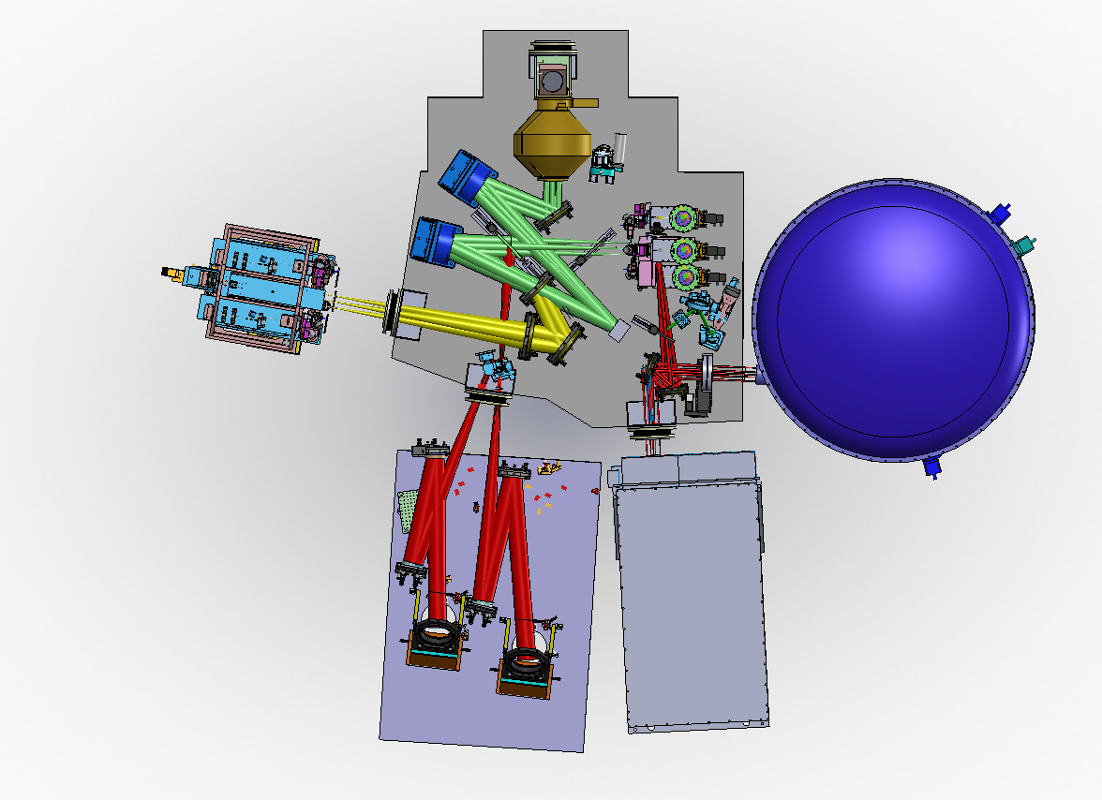
Figure 2: NGAO layout.
Item | Keck AO | NGAO | Notes
Entrance window | None | Double window in converging beam | The NGAO entrance window pushes the nominal telescope focus out & this is accounted for in the positioning of the rotator.
Rotator | Telescope focus before M1 | Telescope focus after M1 | Same incidence angles  The mirror coatings will need to match on K1&2
Fold mirror | 30° | 34.5°
OAP1 |  |  | Same 25° off-axis angle
DM | 7 mm actuator spacing  56.25 cm/subaperture | 5 mm actuator spacing  54.75 cm/subaperture | Same incidence angle
Sodium transmissive dichroic | Not in science beam | In collimated space between DM & OAP2 (t=25mm, AOI=19°). Ideally same material & thickness as Keck AO science transmissive dichroic.
OAP2 |  |  | Same 25° off-axis angle.  Same output focal ratio.
Science transmissive dichroic | CaF2 (t=25mm, AOI=15°) | None
Interferometer fold | Mirror at 42.5° | Reflective dichroic at 45° AOI | Could look at changing this angle
Object field selectors |  |  | Same angles, separation
Exit window | None | Separate double windows, orthogonal to beam, for the on-axis & off-axis objects in diverging beam | The NGAO exit window pushes the nominal AO focus out & this is accounted for in the positioning of the dual star module
Temperature of AO bench | Ambient or ~5°C warmer | -15°C
Table 2: Opto-mechanical comparison of Keck AO and NGAO.
Overall the angles and geometry of Keck AO and NGAO are similar enough that we should therefore only have to be concerned about material dispersion and dichroic phase.

In terms of matching optical paths (dispersion) the main difference between the two AO systems is the addition of two double windows and a visible transmissive/sodium reflective dichroic and the removal of one near-IR transmissive/visible reflective dichroic in the NGAO design. The existing dichroic is CaF2 and it is likely that the NGAO windows will be as well. The combined impact of these dispersive elements would need to be addressed by adding a corresponding element(s) in the Keck I AO/interferometer path.

It may be necessary to have the Keck I fold (9) be the same reflective dichroic as on NGAO to match the phase characteristics. We will need to confirm that the NGAO sodium transmissive dichroic will not have any phase properties in the near-IR.

‘OHANA needs access to a corrected AO output. These can be different on the two Keck telescopes (as they are different between Mauna Kea telescopes. The ‘OHANA injection module would need to be placed either at the dual star module location (with the dual star module removed) with some optics to reimage the NGAO output focal plane onto the fiber or alternatively at the I2 (i.e., Instrument 2) location in Figure 2 which is intended for a future science instrument.

- Interferometer Metrology Support on the AO Bench

Table 3 summarizes the metrology support that is needed on the AO bench. All of these items need to be added to the SolidWorks model. All of these items that will be placed within the AO bench cold enclosure need to be capable of operating reliably and remotely at the -15C operating temperature. These items must also not degrade the clean environment in this enclosure and must not add significant heat loads.

Item | Keck AO | NGAO | Notes
Accelerometers | Located near telescope input & interferometer output
IR metrology corner cube | ~25 mm diameter | ~18 mm diameter | Same size on telescope.  Located in front of DM.
Interferometer Baseline Monitor (IBM-T) camera | Requires blue reflective dichroic in front of acquisition camera | Requires extra acquisition fold optic (<500nm reflective) | Mounted on acquisition camera with insertable periscope
Boresite on acquisition camera | Beam reaches acquisition camera off ~25 mm diameter corner cube inserted (on DFB stage) between DM and OAP2 (facing OAP2) | Requires corner cube behind interferometer fold (with collimating lens & shutter) + some fold reflectivity at boresite wavelength
Alignment target on object field selector (OFS) & alignment camera | Target located on OFS with camera to view target | Similar setup desired but it is not clear that there is sufficient space | Paper targets to be replaced for operation in clean environment
Hardware behind M2 (met CC, shear sensor dichroic, etc.) | Located at edge of dual star module (DSM) between DSM & AO bench | Similar setup desired but it is not clear that there is sufficient space
Table 3: Interferometer metrology opto-mechanics on the AO bench.
We must be conscious of not having any of the interferometer light sources degrade the NGAO performance by increasing the background on the various wavefront sensors via direct illumination of these sensors or through scattered light. Table 4 lists the interferometer metrology sources.

Interferometer Source Name | Wavelength (nm) | Path through AO
IBM-T LED on primary mirror | 430 or 470 (broad) | From primary mirror through AO to acquisition camera
IBM-T LED at IR metrology corner cube | 430 or 470 (broad) | From corner cube in front of LODM to acquisition camera
Coude metrology | 633 | Stops before AO (leakage possible)
Interferometer boresite laser diode | 670 | From interferometer, off a corner cube, to acquisition camera
TT metrology laser diode | 690 | Stops before AO (leakage possible from TT metrology source to AO through beam train or indirectly
IR metrology laser | 1319 | From interferometer to AO corner cube and back on itself
Table 4: Interferometer metrology sources.
- Wavefront Sensing & AO Performance

In LGS AO mode the NGAO system should easily outperform the Keck I AO system.

In NGS AO mode currently the NGAO NGS WFS has ~60x60 subapertures versus ~20x20 for Keck AO. Without considering detector performance improvements this corresponds to a 2.4 magnitude loss in limiting magnitude. There are also throughput losses in NGAO due to more optics in the NGAO NGS WFS path. We will plan to add a ~20x20 NGS WFS subaperture mode during the NGAO detailed design. The NGS WFS already has two modes so opto-mechanically it should be straightforward to have a 3rd mode (the only significant opto-mechanical change will be a 3rd lenslet array).

