

Keck Adaptive Optics Note ___

Next Generation Adaptive Optics:

Preliminary Design Manual

Version 0.3
July 15, 2009

Author List

Name | Function
Peter Wizinowich | Project Manager
Richard Dekany | Senior Manager (COO)
Don Gavel | Senior Manager (UCO)
Claire Max | Project Scientist (UCO)
Sean Adkins | Instrument Manager (WMKO)
From Caltech Optical Observatories (COO):  Viswa Velur  Alex Delacroix  Antonin Bouchez | Optical system engineer  Mechanical engineer  AO scientist
From University California Observatories (UCO):  Elizabeth McGrath  Renate Kupke  Marco Reinig  Chris Lockwood | Astronomer  Optical system engineer  AO software engineer  Mechanical engineer
From W. M. Keck Observatory (WMKO):  Chris Neyman  Erik Johansson  Jason Chin  Jim Bell  Drew Medeiros  Doug Morrison  Jimmy Johnson  Ed Wetherell | AO system scientist  AO software engineer  Laser & electronics engineer  Mechanical engineer  Mechanical engineer  Software engineer  Software engineer  Electronics engineer

Approval Control
Control | Name | Function
Revised by:

Approved by:
Authorized by:

Document Change Record
Version | Date | Change Description
0.1 | April 14, 2009 | Initial update of the SDM by P. Wizinowich
0.2 and 0.3 | July 15, 2009 | Updated by R. Dekany

1 Introduction 1
2 References 1
3 Design Overview 1
3.1 AO System Overview 1
3.2 Telescope and Facilities 5
3.2.1 Telescope Model 5
3.2.2 Facilities 6
3.2.3 Interfaces 6
3.3 AO System Description 6
3.3.1 AO Opto-Mechanical Design 6
3.3.1.1 Rotator and Wide Field Relay 6
3.3.1.2 LGS Wavefront Sensor Assembly 8
3.3.1.3 Interferometer Pickoff 8
3.3.1.4 Acquisition Camera and Pickoff 9
3.3.1.5 Low-Order Wavefront Sensor Assembly 9
3.3.1.6 Narrow-Field Relay 9
3.3.1.7 Natural Guide Star Pickoff 10
3.3.1.8 Narrow Field Science Instrument Pickoffs 10
3.3.1.9 Summary of Required Dichroics and Mirrors 10
3.3.1.10 Atmospheric Dispersion Correctors 11
3.3.1.11 Optics Bench Structure 11
3.3.2 Wavefront Sensor Opto-Mechanical Design 11
3.3.2.1 Low-Order Wavefront Sensor Object Selection Mechanism 13
3.3.2.2 Tip-Tilt (Focus and Astigmatism) Sensors 17
3.3.2.3 Truth Wavefront Sensors 18
3.3.2.4 LGS Wavefront Sensor Object Selection Mechanism 19
3.3.2.5 LGS Wavefront Sensors 21
3.3.2.6 NGS Wavefront Sensors 22
3.3.3 AO Optical Performance 22
3.3.3.1 Wide Field Relay Optical Performance 22
3.3.3.1.1 Optical Performance to the Low Order Wavefront Sensors 22
3.3.3.1.2 Optical Performance to the Interferometer Field Selectors 22
3.3.3.1.3 Optical Performance to the Laser Guide Star Wavefront Sensors 23
3.3.3.2 Narrow Field Relay Optical Performance 23
3.3.3.3 Atmospheric Dispersion Correction 25
3.3.3.4 Pupil Distortion 25
3.3.4 AO Enclosure 25
3.3.5 Alignment, Calibration, Diagnostics, Metrology and Monitoring 26
3.3.5.1 Instrument Calibration Source 26
3.3.5.2 Astrometric Calibration Source 26
3.3.5.3 NGS and LGS Simulated Sources 27
3.3.5.4 Atmospheric Simulator 27
3.3.5.5 Science Instrument Wavefront Measurement 28
3.3.5.6 Metrology 29
3.3.5.7 Atmospheric Profiler 29
3.4 Laser Facility Description 30
3.4.1 Laser Facility Optical Design 30
3.4.1.1 Laser Facility Optical Requirements 30
3.4.1.2 Laser Facility Optical Design 31
3.4.2 Lasers 35
3.4.3 Laser Enclosure and Beam Transport Mechanical Design 35
3.4.4 Laser Safety System 38
3.4.5 Laser Upgrades and Advanced Technology 39
3.5 Control Electronics and Software 39
3.5.1 AO Controls Infrastructure 39
3.5.2 Non-real-time Control 41
3.5.2.1 Electronics 41
3.5.2.1.1 Motion Control Electronics 41
3.5.2.1.2 Device Control Electronics 42
3.5.2.2 Software 43
3.5.2.2.1 AO System Software 43
3.5.2.2.1.1 Sequencer 43
3.5.2.2.1.2 Motion Control Software 44
3.5.2.2.1.3 Device Control Software 46
3.5.2.2.2 Laser System Software 47
3.5.2.2.2.1 Laser Sequencer 48
3.5.2.2.2.2 Laser Motion Control (Beam Transport Control) 48
3.5.2.2.2.3 Laser Device Control 50
3.5.2.3 Acquisition, Guiding and Pointing Control 50
3.5.2.4 Data Server 51
3.5.3 Real Time Control 52
3.5.3.1 Introduction 52
3.5.3.2 RTC Tasks 52
3.5.3.3 Parametric Input, Optimization, and Reconfigurability 54
3.5.3.3.1 Minimum Variance Reconstruction Optimization 54
3.5.3.3.2 Calibration Parameters 54
3.5.3.3.3 Reconfiguration 55
3.5.3.4 Interfaces 55
3.5.3.4.1 Offloading 55
3.5.3.4.2 Diagnostics and Telemetry 55
3.5.3.4.3 Command State 56
3.5.3.5 Implementation 56
3.5.3.5.1 Algorithms 56
3.5.3.5.2 Hardware 57
3.5.3.5.3 Hardware Interfaces 57
3.5.3.5.4 Programming and Design Process 57
3.5.3.5.5 Physical Implementation 58
3.5.3.6 References 58
3.6 Science Operations 58
3.6.1 Science Operation Model 58
3.6.1.1 Observing Model: classical with built-in flexibility tools 59
3.6.1.2 Science Operation Requirements: Observing Efficiency 59
3.6.2 Conceptual Design for System Operations 62
3.6.2.1 Operation Control Infrastructure 62
3.6.2.2 System Configurations Matrix 63
3.6.2.3 System Calibration: Routine and Maintenance Calibrations 64
3.6.2.4 System Operations: Acquisition 64
3.6.2.5 System Operations: Dithering and Offsetting 67
3.6.3 System Control 68
3.6.3.1 Multi-System Command Sequencer 68
3.6.3.2 Operation Control (Graphical) User Interfaces 69
3.6.4 Pre and Post-Observing Tools 70
3.6.4.1 Pre-Observing Tools 70
3.6.4.2 Post-observing Tools 73
3.7 Science Instruments 74
3.7.1 Overview 74
3.7.2 Imager 76
3.7.2.1 Requirements 76
3.7.2.2 Instrument Concept 78
3.7.3 Integral Field Spectrograph 79
3.7.4 Interferometer 79
3.7.5 ‘OHANA 79
3.7.6 Thermal NIR Imager 80
3.7.7 References 80
4 Performance Budgets 81
4.1 Background and Transmission 81
4.2 Wavefront Error and Ensquared Energy 82
4.2.1 Key Flowdowns from the Wavefront Error Budget 84
4.2.2 Laser Power considerations 85
4.2.3 Performance Summary 85
4.3 Photometric Precision 86
4.4 Astrometric Precision 86
4.5 Companion Sensitivity 87
4.6 Polarimetric Precision 89
4.7 Observing Efficiency and Uptime 89
5 Requirements Development and Compliance 89
6 Alternate System Architectures 92
7 Trade Studies (Suggest replacing this entire section…) 92
7.1 MOAO and MCAO Trade Study 93
7.2 NGAO versus Keck Upgrade Trade Study 95
7.3 Adaptive Secondary Mirror Options Trade Study 96
7.4 Keck Interferometer Support Trade Study 96
7.5 Telescope Wavefront Errors Trade Study 97
7.6 Observing Model Trade Study 97
7.7 Rayleigh Rejection Trade Study 98
7.8 Instrument Reuse Trade Study 98
7.9 Up-link AO Trade Study 99
8 Glossary 100
9 Appendix: NGAO SD Phase Detailed Wavefront Error Budgets 101

Figure 1. LGS “3+1” asterism for tomography of the science field, plus three point and shoot lasers for image sharpening of the tip-tilt stars 2
Figure 2. NGAO Block Diagram 3
Figure 3. Telescope Solidworks model. 5
Figure 4. View from below of the telescope Nasmyth platform. 6
Figure 5. The image rotator and low order “wide” field relay. 8
Figure 6. Laser Guide Star Wavefront Sensor and Interferometer Pickoffs. 8
Figure 7. Narrow Field Relay. 9
Figure 8. Optics Bench Structure. 11
Figure 9. The LOWFS assembly. 14
Figure 10. LOWFS OSM probe arm. 14
Figure 11. Four configurations of the LOWFS OSM arms. 15
Figure 12. (a) Zemax model of LOWFS probe arm. (b) Probe arm patrol field. 16
Figure 13. Tip, tilt, focus and astigmatism (TTFA) sensor schematic. 18
Figure 14. Truth wavefront sensor (TWFS) schematic. 19
Figure 15. Plan view of the LGS object selection θ/φ pickoff scheme. 20
Figure 16. LGS WFS assembly enclosure. 20
Figure 17. Schematic of a single LGS WFS channel. 21
Figure 18. Spot diagrams delivered to the LOWFS focal plane. 22
Figure 19. Spot diagrams delivered to the LGS WFS at 180 km conjugate. 23
Figure 20. Spots at the on-axis and extreme field angles to the NGS WFS. 24
Figure 21. RMS wavefront error to the NGS WFS versus field. 25
Figure 22. Grid distortion at the woofer DM location, magnified by 100. 25
Figure 23. Spot diagrams for 5 locations on the primary mirror imaged onto the woofer DM. 25
Figure 24. Pupil grid distortion at the tweeter DM position, magnified by 100. 25
Figure 25. Spot diagrams for 5 positions on primary mirror imaged onto the tweeter DM. 25
Figure 26. Schematic of a combination atmospheric simulator, LGS and NGS source simulator, and radiometric calibration source. 28
Figure 27. Seeing monitor at Mauna Kea seeing monitor site. Replace with actual photo. 30
Figure 28. Laser facility optical schematic. 32
Figure 29. Secondary mirror module and the NGAO laser launch telescope. 34
Figure 30. Existing Keck II Telescope and laser location case 1. 36
Figure 31. Glycol cooling for the laser system. 37
Figure 32: Safety system. 38
Figure 33. A distributed controls system block diagram of the NGAO system. 40
Figure 34. AO controls infrastructure block diagram. 40
Figure 35. AO systems control hierarchy block diagram. 43
Figure 36. Motion control software architecture block diagram. 45
Figure 37. Generic device control paradigm block diagram. 46
Figure 38. Laser system controls hierarchy block diagram. 48
Figure 39. Laser motion control software architecture block diagram. 49
Figure 40. Acquisition, guiding and pointing control software architecture block diagram. 50
Figure 41. Data server architecture block diagram. 51
Figure 42. Multi-guide star tomography data flow and parallel processing. 53
Figure 43. Tomography algorithm. 54
Figure 44. Efficiency estimate for the high-z galaxies science case. 61
Figure 45. Science operations tools block diagram. 63
Figure 46. NGAO system configurations. 64
Figure 47. AO guide star tool workflow. 71
Figure 48. NGAO performance estimation tool and exposure time calculator workflow. 72
Figure 49. Observation preparation tool workflow. 73
Figure 50: NGAO Passbands 75
Figure 51: Detector QE cut-on and cut-off characteristics 76
Figure 52: Imager FOV options 77
Figure 53: Near-IR imager block diagram 78
Figure 54. Science target wavefront error budget for the Kuiper Belt Object Companion Survey Key Science Case. (TBR) 85
Figure 55. LOWFS NGS wavefront error budget for the KBO Companion Survey Science Case. 85
Figure 56. Simulated NGAO J-band science observations with secondary objects inserted. 88
Figure 57. NGAO project V-diagram including the design and development process. 90
Figure 58. Science target wavefront error budget for Io Science Case. (TBR) 102
Figure 59. Science target wavefront error budget for Galactic Center Science Case. (TBR) 103
Figure 60. Science target wavefront error budget for ExoJupiter LGS Case. (TBR) 104
Figure 61. Science target wavefront error budget for Galaxy/Galaxy Lensing Science Case. (TBR) 105
Figure 62. LOWFS NGS wavefront error budget for the Galaxy / Galaxy Lensing Survey Science Case. 106
Figure 63. Science target Ensquared Energy error budget for High-Redshift Galaxies. 107

Table 1. Summary of Required Dichroics and Mirrors. 11
Table 2. Baseline design parameters for the NGAO wavefront sensors. 12
Table 3. Required WFS detector characteristics. 13
Table 4. Performance to the narrow field instruments. 24
Table 5. Characteristics of the pupil image on the deformable mirrors. 25
Table 6. NGAO asterisms. 33
Table 7. Acquisition conceptual design level specifications. 64
Table 8. Generic NGAO Acquisition Scenario. 65
Table 9: Narrow field relay optical characteristics 74
Table 10: NGAO system passband and observing band characteristics 75
Table 11: Summary of the near-IR imager science driven requirements 76
Table 12: Summary of the single object near-IR IFU science driven requirements 79
Table 13. NGAO error budget tool anchoring to Keck II AO performance. 83
Table 14. The NGAO error budget tools accurately models the upgraded Keck II AO performance. 84
Table 15. Wavefront error budget summary for several NGAO science cases. 85
Table 16. Science case mapping to NGAO configurations. 92
Table 17. List of trade studies performed. 92
Table 18. Glossary of Terms 100

Introduction
This document describes the preliminary design for the Next Generation Adaptive Optics (NGAO) system to be built for the W. M. Keck Observatory (WMKO). This document is one of the key preliminary design phase deliverables as discussed in the Preliminary Design Report (KAON ___). It is intended to provide an overview of the preliminary design, while referencing the appropriate documents which contain the details. This document replaces the system design phase manual (KAON 511) which was updated with the build-to-cost design changes (KAON 642).

We begin with an overview of the preliminary design that includes major sections on the AO system, laser facility, controls hardware and software and science operations. An overview of the science instruments and their interface with NGAO is provided in this document. The system design of the NGAO imager and IFU science instrument is presented in KAON ___.

The performance budgets are addressed in Section 4. Eight system performance metrics were identified in the Science Requirements Document. For three of these metrics, background and transmission, wavefront error and ensquared energy, and high-contrast performance, we have produced associated quantitative performance budgets to identify key performance drivers. For photometric precision, astrometric accuracy, polarimetry and observing efficiency we have identified key drivers and documented these in technical reports that have informed the NGAO design..

Section 5 provides an overview of the requirements flow down and a discussion of compliance. Detailed requirements have largely not been included in the design discussions in this document because of the length of this information. The detailed requirements can be found in most of the referenced design KAONs as well as in the Functional Requirements Document (KAON 573).

References
A list of all Keck Adaptive Optics Notes for NGAO can be found in an Appendix to the Preliminary Design Report (KAON ___). These documents are available at http://www.oir.caltech.edu/twiki_oir/bin/view/Keck/NGAO/NewKAONs.

Design Overview

AO System Overview
All of the NGAO science cases require essentially diffraction-limited performance (Strehl > 0.6) in the near-IR. A number of Solar System and Galactic science cases have requirements for at least modest Strehl at visible wavelengths. All of the science cases also require high sensitivity with most of the targets of interest being too faint to use as references for wavefront sensing in the AO system. This high Strehl, faint object performance is required with reasonable (≥ 30%) sky coverage.

The requirements for sky coverage and high sensitivity are both met by using a laser of 589 nm wavelength to illuminate the mesospheric sodium layer, producing an artificial laser guide star (LGS) for AO wavefront sensing. Achieving the desired level of Strehl performance leads directly to a requirement for an AO system that can overcome the effect of focus anisoplanatism (the “cone effect”), a requirement that is met through use of multiple laser beacons forming a two-component asterism of LGS as shown in Figure 1. Wavefront information from four central LGS is combined to produce a three dimensional description of the atmospheric turbulence over the telescope aperture using tomographic reconstruction techniques. We have concluded that a fixed diameter LGS asterism with one in the center and three equally spaced around a circle provides the optimal sampling of the atmosphere above the telescope with respect to tomography error for the science field. The radius of the circle is set at 10".

Three additional LGS, WFS , and DM’s are utilized as three independently controlled AO systems to provide image sharpening for three natural guide stars (NGS), which are required to overcome limitations imposed by the science tomography sensing system. In particular, the NGS provide measurement of the atmospheric tip and tilt modes, as well as modes unsensed by the multiple-LGS asterism. Operating at near-IR wavelengths, two of NGS sensors measure tip and tilt (TT) only, while a third additionally measures focus and astigmatism (TTFA). Each NGS sensor arm contains it’s own high-order deformable mirror to allow optimal sharpening of NGS spread over a wide field of view, thereby maximizing sky coverage.

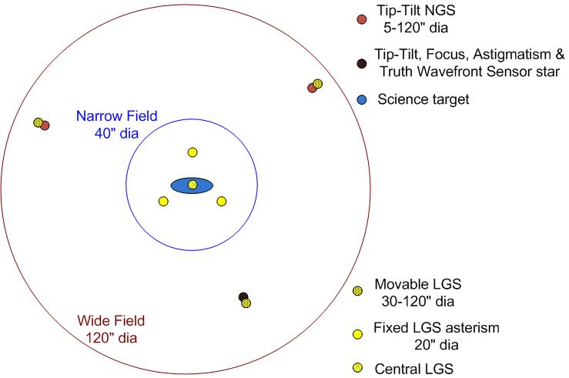
Figure 1. LGS “3+1” asterism for tomography of the science field, plus three point and shoot lasers for image sharpening of the tip-tilt stars

The Solar System and Galactic science cases all require single object observations over modest to narrow fields of view, ranging from 2" to 30". This single line of sight could be AO corrected using a single deformable mirror (DM). Based on a combination of limiting magnitude and off-axis distance for natural tip-tilt stars, an object selection mechanism (OSM) is required for these stars. A block diagram of the AO system architecture that we have selected to deliver both high Strehl and good sky coverage is shown in Figure 2. We refer to this design as the “cascaded relay” because it uses two AO relays in series.

Starting at the lower left hand side of the figure, an enclosure on the elevation ring of the telescope is provided to house three ~25W CW format lasers. Laser output is sent via a free space beam transfer system to a multiple beam pattern generator and controller located at the top end of the telescope. The output of this beam pattern generator is projected onto the mesospheric sodium layer by a laser launch telescope located behind the telescope secondary mirror as shown just to the left of center in Figure 2.

Light collected by the Keck telescope is directed to the AO system shown in the lower right in Figure 2. The AO system and instruments are located on the telescope’s left Nasmyth platform at the f/15 focus. The AO system science path is enclosed in an enclosure cooled to about -15C below ambient (~260 K) to reduce the thermal emissivity of the optical surfaces. A window is provided to isolate the enclosure from the dome environment. Another window is provided to feed the LGS WFS. The science instrument forms a seal with the cooled enclosure.

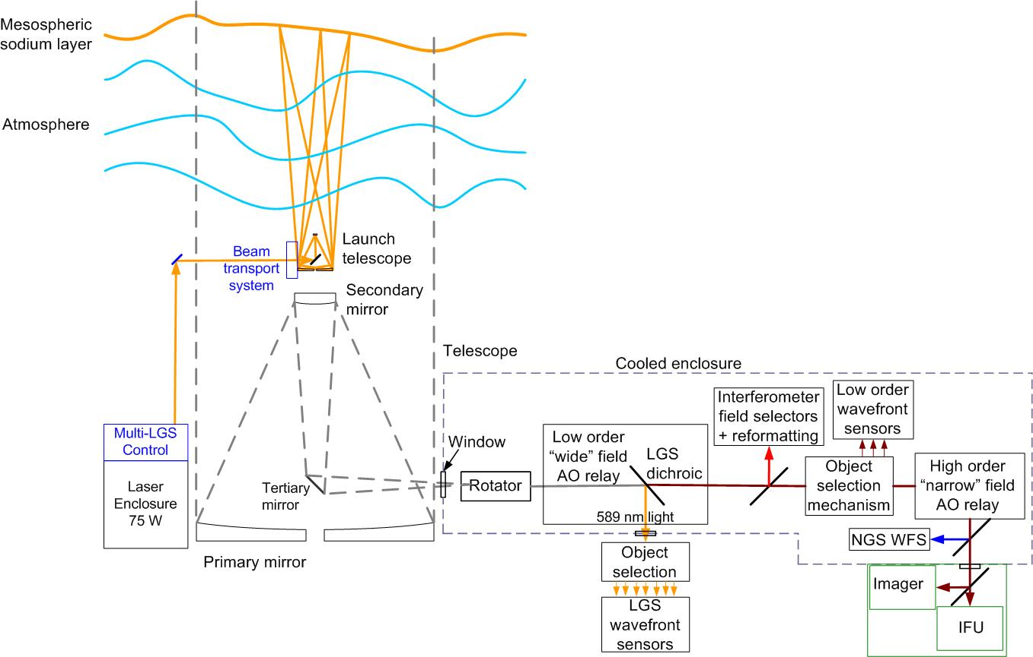
Figure 2. NGAO Block Diagram

Within the cooled enclosure, the light from the telescope passes through an image de-rotator. A “moderate” field, moderate-order AO relay incorporating a single DM provides moderate spatial order AO correction (comparable to the correction provided by the existing Keck AO systems). This DM operates in a closed loop in conjunction with the LGS wavefront sensors. Just after the DM, a dichroic beamsplitter is used to send the 589 nm light from the asterism of LGS to the LGS wavefront sensor assembly, which includes both a fixed sensor assembly and an object selection mechanism for the three movable LGS. The light from the moderate-order relay is transmitted directly to the object selection mechanism for the low-order wavefront sensors (LOWFS; i.e., the near-IR TT and TTFA sensors and a visible truth wavefront sensor (TWFS)). A dichroic can be inserted to feed light to the Keck interferometer.

The light then passes through a “narrow” field, high-order AO relay. High-order corresponds to approximately ten times the DM actuator areal density of the moderate-order DM. This relay provides AO corrected light to a visible light NGS wavefront sensor and a science instrument(s). Another instrument port will be provided for a future instrument capability.

For NGS AO observations only the NGS WFS is required. For LGS AO observations, the LGS wavefront sensors, three low-order NGS sensors, and the NGS TWFS are required.

The following is a brief summary of the key architectural features of NGAO and why they were selected (i.e., flowed down from the science requirements):

- Laser tomography to measure wavefronts and overcome the cone effect over the science field. This is supported by the fixed “3+1” LGS asterism and LGS WFS.
- LGS projection from behind the telescope secondary mirror to minimize perspective elongation.
- Location of the AO system on the Keck II telescope left Nasmyth platform to have sufficient space for the AO system and science instruments in a gravity constant environment.
- A cooled AO system to meet the infrared background requirements.
- A K-mirror rotator at the input to the AO system to keep either the field or pupil fixed. The AO system would need to be cooled even without a rotator and this approach allows the most stability for the AO system and instruments.
- A wide-field (120" diameter) relay to feed light to the LGS wavefront sensors and the three LOWFS.
- A conventional (5 mm pitch) DM was chosen to transmit a wide field in the wide-field relay.
- A moderate-order (20 actuators across the pupil) DM was chosen for the wide-field relay to limit the size of the relay, to permit closed loop AO correction on the LGS wavefront sensors and to keep the LGS wavefront sensors in their linear range, reducing the requirement on downstream open loop correction.
- Open loop AO-corrected near-IR tip-tilt sensors to maximize sky coverage. This is supported by three movable laser beacons and LGS WFS.
- Open loop MOAO-correction to the narrow field science instruments.
- MEMS DM’s for the AO-correction. These are very compact devices and have been lab demonstrated to accurately go where they are commanded. Small, modest-cost 32x32 element MEMS DM’s provide the required correction for the tip-tilt sensors. A 64x64 element MEMS, similar to that under development for GPI, is needed to provide the required AO correction to the narrow field science instruments.
- A high order, narrow-field (30" diameter) AO relay to feed light to the narrow field science instruments (with a larger, ~60" diameter, field to the high-order NGS wavefront sensor). The science instruments fed by this relay only require a narrow-field and the narrow field facilitates the use of a single MEMS DM for all narrow-field instruments.

Telescope and Facilities
The NGAO systems must utilize and interface to the existing Observatory infrastructure. This infrastructure includes the telescope and related control systems as well as mechanical and electrical services. In some cases this existing infrastructure may need to be modified.

The NGAO design and plan currently assumes implementation on the Keck II telescope, although it would be relatively straightforward to modify the design for implementation on Keck I. The design and plan also assume that the existing Keck II AO and laser systems will be removed from the summit facility to make room for the NGAO system. In addition to providing physical space for the system this will also free up power and cooling capacity, as well as cable wrap space.

Telescope Model
A Solidworks model of the Keck II telescope has been generated in order to clearly define the available space and interfaces for the NGAO system. A perspective view of this model is shown in Figure 3, with a possible AO enclosure on the left Nasmyth platform. This tool can be used to provide the details of areas like the Nasmyth platform or secondary mirror socket, as shown in Figure 4, which the NGAO system will need for interface purposes. The details of this model are suitable for preliminary design. Critical dimensions will need to be field verified before detailed design.

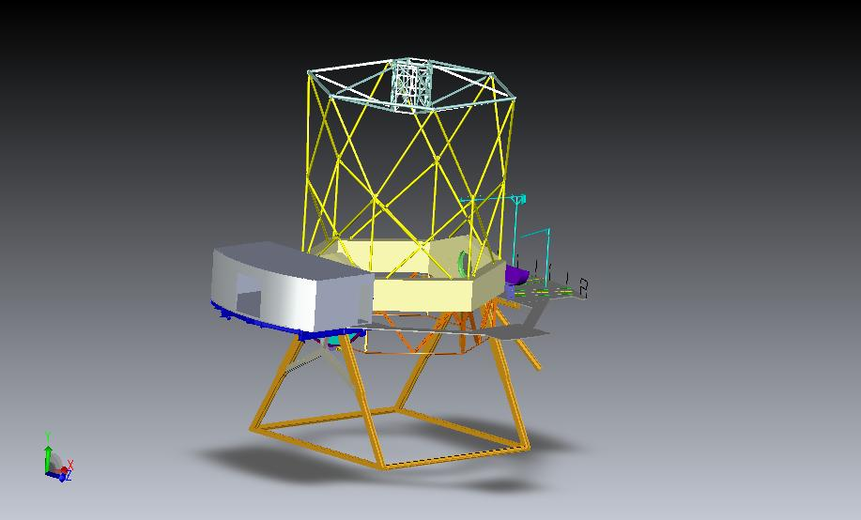
Figure 3. Telescope Solidworks model.

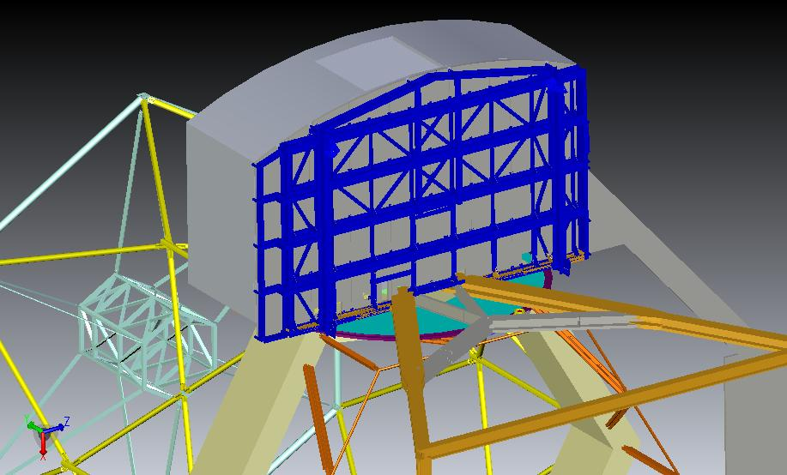
Figure 4. View from below of the telescope Nasmyth platform.

Facilities
The total required facility power and cooling is TBD, but several elements of these requirements have had some initial determination.

Interfaces
The AO system must interface to the existing telescope Drive and Control System (DCS); for example, to offload pointing and focus corrections or to request a telescope move.

AO System Description

AO Opto-Mechanical Design
The opto-mechanical design for the cascaded relay (see KAON ___) is summarized in this section.

Rotator and Wide Field Relay
The rotator and first relay are shown in shown in Figure 5. The rotator and first relay are intended to pass a wide field for the NGS and corresponding movable LGS. The relay includes a DM to provide low order wavefront correction.

The rotator is a K-mirror that can be used to either keep the field or pupil fixed. The Keck telescope’s f/15 Nasmyth focal plane is located ~270 mm past the telescope’s elevation bearing. It is still to be determined to what degree having a focal plane close to these two mirrors will add thermal background effects or performance issues and how it would impact the high-contract science goals (for reference the first mirror of the existing Keck AO rotator is located 110 mm after the telescope focus). The 3-mirror rotator is sized to accommodate a 120" diameter NGS field of view (FOV) and a __" diameter LGS FOV (for the case of an LGS at 80 km). The first and third mirrors are at 60º angles of incidence while the second mirror lies parallel to the rotation axis of the K-mirror with an incidence angle of 30º.

The first relay is a one-to-one magnification relay consisting of an off-axis parabola (OAP) to collimate the light and reimage the primary mirror onto the DM, a flat fold mirror, the DM and a second identical OAP to converge the light with the same focal ratio as the telescope and a telecentric pupil.

The third-order optical aberrations can be minimized by two approaches using a collimated beam between two identical OAPs. Of these the off-centered pupil approach was chosen since it maintains a non-tilted focal plane (Korsch, Reflective Optics, p. 171, 1991).

The focal length of the OAP was selected to map the primary mirror to a 5 mm (d_{DM}) pitch DM with 20x20 actuators. The OAP off-axis angle of __º was chosen as the minimum angle to provide adequate space for the subsequent optics.

The beam is parallel to the surface of the AO bench at a height of ~ __ mm above the AO bench. The angle of incidence on both the fold mirror and the DM is __º.

The DM is placed at an optical conjugate to the primary mirror and is mounted on a fast tip-tilt controllable mount. The second OAP is located its focal length from the DM in order to project the pupil to infinity and hence generate a telecentric output beam.

The output of the first relay goes directly to the object selection mechanism (OSM) that feeds the low order wavefront sensors (LOWFS). Dichroics and fold mirrors can be inserted into this beam to feed the NGS acquisition camera and the interferometer.

Some key design numbers:
- Telescope parameters (from KOTN 163 or KAON 107).
  - Telescope focal length, f_{Tel} = 149.583 m.
  - Telescope entrance pupil diameter D_{Tel} = 10.949 m
  - Telescope exit pupil diameter, D_{EP} = 1460 mm.
  - Distance from telescope exit pupil to focus, t_{EP} = 19948 mm.
  - Telescope f/#_{Tel} = f_{Tel}/D_{Tel} = 13.66.
  - Telescope plate scale, PS = 0.727 mm/".
- Chosen design parameters.
  - LOWFS NGS field of view diameter, Φ_{NGS} = 120".
  - Telescope primary mirror subaperture size, d_{PM} = 562.5 mm (the same as for the existing Keck AO system).
  - Rotator mirror angles of incidence are 60º for mirrors 1 and 3, and 30º for mirror 2.
  - OAP1 and OAP2 off-axis angle = __º (corresponding to a decenter of ___ mm from the parent parabola) to provide adequate space for subsequent optics.
  - Fold mirror distance from OAP1, t_{fold} = __ mm.
  - Fold mirror and DM angles of incidence are α_{DM} = α_{Fold} =__º.
  - DM conjugate to the telescope primary mirror.
  - DM subaperture size, d_{DM} = 5 mm.
  - Output pupil from 1st relay at infinity.
- 1st order calculated parameters.
  - LGS field of view diameter, Φ_{LGS} = __" (for the case of an LGS at 80 km).
  - OAP focal length, f_{OAP} = (d_{DM}/d_{PM}) f_{Tel} = 1329.6 mm
  - Required OAP diameter to accept the pupil and field, d_{OAP} = (f_{OAP}/t_{EP})d_{EP} + (f_{OAP}+t_{EP})Φ_{NGS}*PS/t_{EP} = 214 mm.
  - Distance of DM from OAP1 in order to be conjugate to the primary, t_{DM} = [1/f_{OAP} – 1/(t_{EP}+f_{OAP})]⁻¹ = 1418 mm.
  - Pupil distortion on the DM due to the angle of incidence, % distortion = [1-cos(α_{DM})]*100% = 1.3%.
  - Distance of OAP2 from the DM in order to project the pupil to infinity, t_{OAP2} = f_{OAP} = 1329.6 mm.

Figure 5. The image rotator and low order “wide” field relay.
Light from the telescope enters from the left and travels through the rotator to OAP1, the flat fold, the “woofer” DM. A dichroic splitter reflects the 589 nm light to the LGS WFS and transmits the remainder of the light to OAP2. A retractable mirror to feed the NGS acquisition camera is shown just before the focus.

LGS Wavefront Sensor Assembly
A sodium reflective dichroic is located in the collimated beam between the DM and OAP2 to send the sodium wavelength light to the LGS wavefront sensor as shown in Figure 6. Describe relay optics. The LGS WFS must translate in focus to be conjugate to the sodium layer.

Figure 6. Laser Guide Star Wavefront Sensor and Interferometer Pickoffs.

The LGS WFS assembly consists of four fixed and three movable LGS WFS.

Interferometer Pickoff
Figure 6 also shows a dichroic pickoff to the Keck interferometer.

The dichroic sends a 60" diameter field to a pair of field selector mirrors. The first of these mirrors is located near the focus and has a hole in it to transmit a small on-axis field. The first field selector steers the desired off-axis point to the center of the second field selector mirror, which in turn steers the off-axis field along the desired axis (parallel to the on-axis field). Similar field steering mirrors are used in the existing Keck AO system and this approach has been selected for the ASTRA upgrade to the Interferometer (ASTRA-0017).

Two options are being considered for transporting the interferometer beam to the basement. The first is to use a dual star module where OAPs are used to collimate the light and fold mirrors are used to steer the beam to the existing coude train. The second and preferred option is to insert both the on-axis and off-axis objects into single mode fibers for transport to the basement.

Acquisition Camera and Pickoff
A removable 45º incidence angle mirror folds the entire 120" diameter wide field relay output to the acquisition camera. We have determined (KAON 567 and section 3.6.2.4) that a visible camera is adequate (versus a NIR camera) and that this camera can therefore be used for both NGS and LGS acquisition. The camera will need to be on a focus translation stage to go between the NGS and LGS foci as is done with the acquisition camera for the current Keck AO system. A simple focal reducer can be used to obtain the required plate scale on the new Keck standard MAGIQ acquisition camera.

Low-Order Wavefront Sensor Assembly
The light reflected by OAP2 goes directly to the low-order wavefront sensors (LOWFS) in the absence of the interferometer or acquisition camera folds. The LOWFS assembly is located directly in front of the narrow-field relay and consists of an Object Selection Mechanism (OSM) and three LOWFS. Two arms of the OSM feed tip-tilt (TT) sensors. A third arm feeds a tip-tilt-focus-astigmatism (TTFA) sensor and a truth wavefront sensor (TWFS). A dichroic beamsplitter splits the light between the TTFA and TWFS.

Narrow-Field Relay
The narrow-field relay is intended to provide a high order of correction for the narrow-field science instrument(s). It also provides a magnification of ~3 in order to provide separation between the instruments and an optimal plate scale for the science instruments.

Figure 7. Narrow Field Relay.

The light from the first relay is folded before passing through focus to OAP3 which collimates the light and reimages the telescope primary mirror onto a 64x64 MEMS DM. The DM is mounted on a slow, large-stroke tip-tilt stage in order to facilitate science instrument dithering (TBC). OAP4 is chosen to provide a factor of three magnification and is located its focal length from the MEMS in order to project the pupil to infinity.

- Chosen design parameters.
  - NGS field of view diameter, Φ_{NGS,narrow} = 60" for NGS WFS and 30" for science instruments.
  - OAP3 off-axis angle = 13º.
  - Telescope primary mirror subaperture size, d_{PM2} = 176.0 mm.
  - MEMS angle of incidence, α_{MEMS} = 10º.
  - MEMS conjugate to the telescope primary mirror.
  - MEMS subaperture size, d_{MEMS} = 0.40 mm.
  - 3x magnification (f/15 input becomes f/45 out).
  - OAP4 off-axis angle = 43º.
  - Output pupil from 2nd relay at infinity.
- 1st order calculated parameters.
  - OAP focal length, f_{OAP3} = (d_{MEMS}/d_{PM2}) f_{Tel} = 340.0 mm
  - Required OAP3 diameter to accept the pupil and field, d_{OAP3} = f_{OAP3}/f/#_{Tel} + Φ_{NGS,narrow}*PS = 69 mm.
  - Distance of MEMS from OAP3 in order to be conjugate to the primary, t_{DM} = f_{OAP3}.
  - Pupil distortion on the DM due to the angle of incidence, % distortion = [1–cos(α_{MEMS})]*100% = 1.5%.
  - Focal length of OAP4 for a 3x magnification, f_{OAP4} = 3f_{OAP3} = 1020 mm.
  - Distance of OAP4 from the DM in order to project the pupil to infinity, t_{OAP4} = f_{OAP4}.
  - Required OAP4 diameter to accept the pupil and field, d_{OAP4} = f_{OAP3}/f/#_{Tel} + Φ_{NGS,narrow}*3PS = 134 mm.

Natural Guide Star Pickoff
The dichroic pickoff immediately following OAP4 feeds the NGS WFS. The dichroic is at an angle of incidence of __º. The nominal 30" diameter field required for the science instruments was deemed to be scientifically inadequate for the NGS WFS. The current design has a slightly offset field that extends 57" perpendicular to the bench and 54" parallel to the bench due to vignetting by the tweeter and OAP4.

A pair of field selector mirrors, similar to those discussed in section 3.3.1.3 will be used. In this case the first mirror will not have a hole in it and the second mirror is mounted on a two position rotation stage in order to provide light to one of either the NGS WFS or TWFS.

Narrow Field Science Instrument Pickoffs
Three potential science instruments can be fed by the narrow field relay as shown in Figure 7. The light reflected by OAP4 goes directly to the combined imager and IFU (in the absence of any fold mirrors or dichroics between OAP4 and this instrument). A fold can be inserted in this path to feed a future science instrument.

Summary of Required Dichroics and Mirrors
The above sections only described the location of the required pickoffs. Table 1 provides a summary of the required dichroics and mirrors and their properties. The numbers in the NGS and LGS columns refer to the system configurations that will be discussed in a later section. The LGS acquisition camera and fold are not required due to our decision to use a single visible wavelength acquisition camera for both NGS and LGS acquisition.

Table 1. Summary of Required Dichroics and Mirrors.

Atmospheric Dispersion Correctors
An atmospheric dispersion corrector (ADC) is provided for the narrow field science instrument over the full wavelength range of this instrument. Ideally the full wavelength range can be provided by a single ADC. The ADC must be removal for science near the zenith or IFS science where the higher throughput or lower emissivity are preferred.

Optics Bench Structure
The optics bench structure is shown in Figure 8. A typical honeycomb core optical table is used. The optimal thickness is __.

Figure 8. Optics Bench Structure.

Attachment of the optics bench to the Nasmyth platform is TBD, but will likely be similar to the mounting of the existing Keck AO benches. The clearance between the bottom of the bench and the Nasmyth platform is ~ 500 mm less than for the existing AO benches, which will make access under the bench more challenging (than for the existing benches).

Wavefront Sensor Opto-Mechanical Design
Two wavefront sensor assemblies are fed by the wide field optical relay: the LGS wavefront sensor assembly and the low-order wavefront sensor (LOWFS) assembly. The NGS wavefront sensor assembly is fed by the narrow-field relay. Each of these assemblies includes an object selection mechanism that selects the appropriate NGS or LGS and feeds the light to the appropriate wavefront sensor(s). Two versions of the same multi-target mechanism have been chosen for the LGS and LOWFS object selection mechanisms, while a different single-object selection approach has been taken for the NGS wavefront sensor assembly as described in section 3.3.1.7. The LGS wavefront sensor assembly includes a total of seven LGS wavefront sensors. The LOWFS assembly includes two NIR tip-tilt sensors, a NIR tip-tilt-focus-astigmatism sensor and a visible truth wavefront sensor. The design reports for the multi-target object selection mechanism and all of the wavefront sensors can be found in KAONs ___.

The design parameters for the wavefront sensors and detectors are summarized in Table 2 and Table 3.

Table 2. Baseline design parameters for the NGAO wavefront sensors.
WFS type | Location | Sensing wavelength (µm) | Input PS (µm/") | # of sub-apertures | Detector PS ("/pixel) | Filters | Field of regard (") | Object Selection
Fixed LGS WFS | in WF relay | 0.589 | 727 | 64x64 | 1.45 | none | __ | Fixed
Movable LGS WFS | in WF relay | 0.589 | 727 | 32x32 | TBD | None | ~120  (TBC) | θφ pickoff
TT | after WF relay | 1.16 – 1.33 | 727 | 1x1 | 0.03 | J+H | 120 | θφ pickoff
TTFA | after WF relay | 1.16 – 1.33 | 727 | 2x2 | 0.03 | J+H | 120 | shared θφ pickoff
TWFS | after WF relay | (0.40- or) 0.60-0.90 | 727 | 5x5 | 0.2 | none | 120 | shared θφ pickoff
NGS WFS | after NF relay | (0.40- or) 0.60-0.90 | 2254 | 32x32 64x64 | 1.5 | none | 50 | shared field steering mirrors

Table 3. Required WFS detector characteristics.
Detector | Characteristics | # of units | Comments
CCD | 256x256 pixels. RON ≤ 3e- at 2 kHz frame rate  & DN ≤ 500 e-/sec @ operating temp. | 8 | 7 LGS WFS + 1 NGS WFS
CCD | 240x240 pixels. RON ≤ 3e- at 0.01-200 Hz  & DN ≤ 0.001 e-/pix/sec DN | 1 | WF TWFS
IR detector | Small regions. RON ≤ 7e- with 8 Fowler samples & 500 Hz data rate for the entire chip; DN ≤ 0.001 e-/sec @ 73K. | 3 | 2 TT and 1 TTFA sensors

Low-Order Wavefront Sensor Object Selection Mechanism
A design for a LOWFS OSM has been developed in KAON 562. The LOWFS assembly is located at the focus of the first relay and contains two TT WFS, one TTFA WFS and one TWFS WFS. The NGAO LOWFS assembly is a critical part of the NGAO system as it provides the required centering accuracy and stability for acquisition and observing modes such as off-chip dithering and non-sidereal tracking.

The LOWFS assembly shown in Figure 9 attaches directly to the AO bench. The assembly can be viewed as two separate entities: the OSM consisting of a stable structural plate that supports the three roaming probe arms and the three beam-fed units located behind the structural plate that are fixed during an observation.

The LOWFS OSM probe arm is a compact 2-motor device shown in Figure 10. The 2 degrees of freedom probe arm consists of 2 individual arms: a crank arm and a lever arm, driven by 2 corresponding rotation motors: the crank and lever motors. The crank motor is secured to the main structural plate. It rotates the crank arm, and all hardware attached to it that includes the lever arm and lever arm motor, precisely about the rotation axis of the crank motor (θ rotation). The lever arm motor provides the necessary second degree of freedom by rotating the lever arm and all associated optics (φ rotation).

The lengths of the crank and lever arms were chosen to provide full coverage of the LOWFS OSM field of view. Any position in the LOWFS OSM field of view can be acquired by calculating appropriate values for θ and φ, noting that due to a mirror reflection there are always two possible solutions. Four basic configurations of the LOWFS OSM probe arms are shown in Figure 11, including (a) the non-LGS observing mode; (b) a probe arm at full range; (c) “home position” where all probe arms are outside the field and (d) a random configuration for LGS mode. The probe arm tips can be designed to approach very closely; this design allows the positioning of two probe arms on two NGS with only 5" separation.

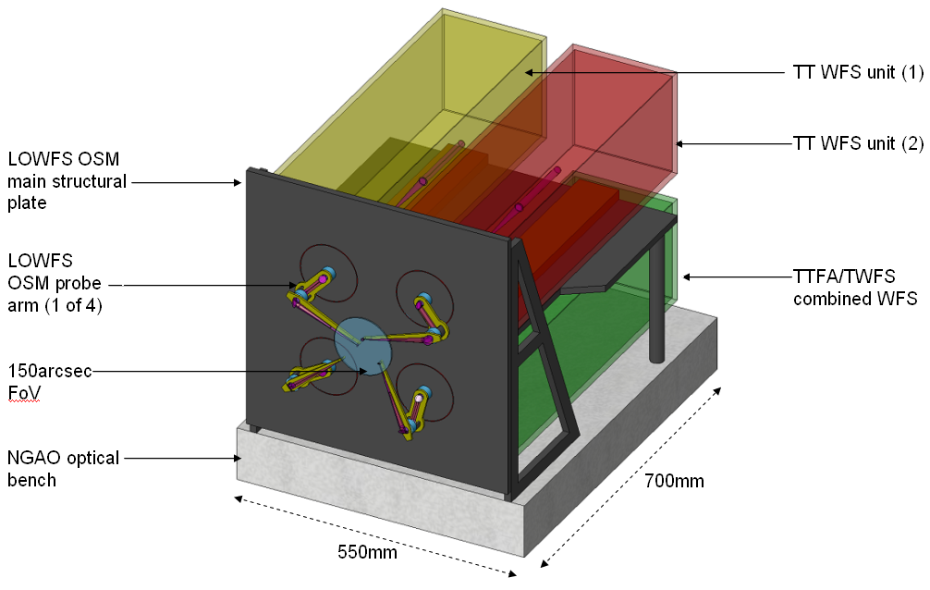
Figure 9. The LOWFS assembly.

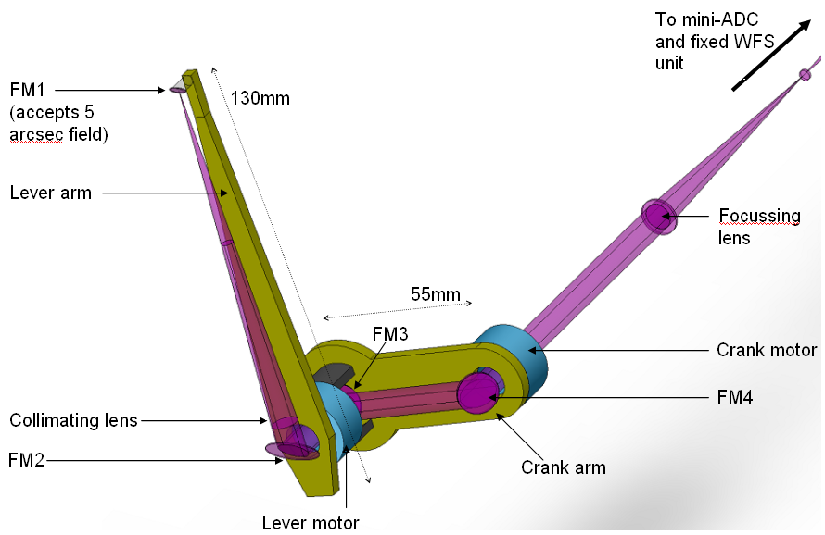
Figure 10. LOWFS OSM probe arm.

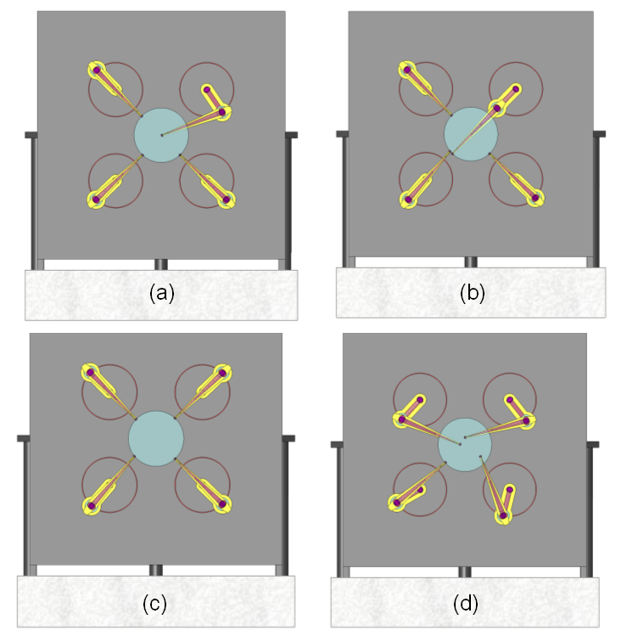
Figure 11. Four configurations of the LOWFS OSM arms.
(a) one TT on-axis with the remaining 3 probes unused; (b) one probe arm fully extended; (c) all probe arms at the home position at the edge of the 150" diameter field; and (d) a random field with all 4 probes in operation.

The telecentric feed from the AO system makes the LOWFS optical design relatively simple. The immediate benefit of this to a focal surface probe arm design is that the probe arms can patrol a flat field and not require any tilt of the optics to compensate for changing angle. [Comment: reword to not confuse a flat field and a telecentric pupil. RGD 7/7/09].

The LOWFS OSM focal surface is curved with a radius of -1320 mm. As the probe arm moves from the center to edge of the field, this results in a defocus of approximately 1 mm. The broadening of the beam at the probe arm is negligible however the focus position of the re-imaged star at the WFS unit will change by a corresponding amount. Note that this focus change is a smaller issue than the ~7 mm of focus change when a dichroic is inserted or removed from in front of the LOWFS assembly.
A solution to the focus issue is to position all three LOWFS units on linear slides. The units are moved to the correct focus position at the start of an acquisition procedure and do not need to be tracking devices. An alternative solution is to keep the LOWFS units completely fixed and to place the probe arm focusing lenses on linear stages. This may be preferable and will be evaluated during preliminary design.

Optically the probe arm could be a simple relay, as shown in Figure 12, with a collimator, to produce a pupil, and a focusing lens. The design to incorporate a MEMS DM, and possibly a pupil stop, at the reimaged pupil is TBD.

A 5" diameter field of view was chosen as a reasonable size of field to be large enough to always hit the target, but small enough to allow close positioning of the probe arms. The field can be stopped at the WFS if required. The focal length of the focusing lens will be determined as part of the WFS design.
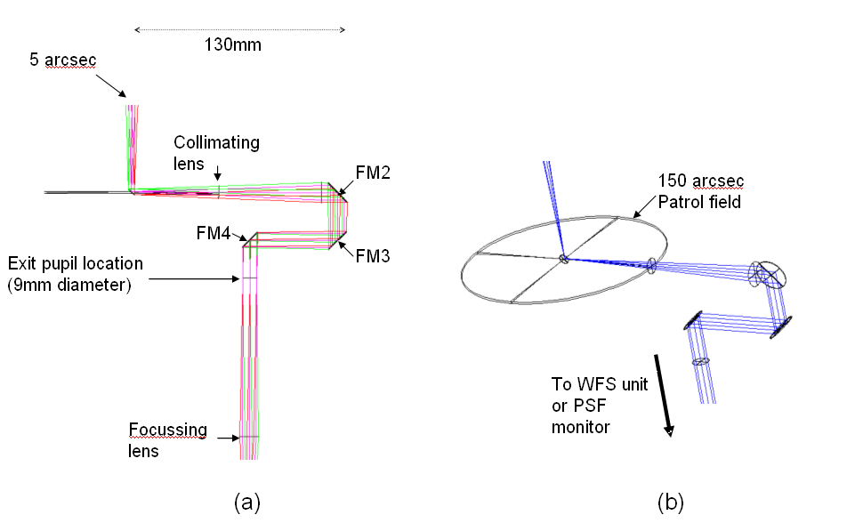
Figure 12. (a) Zemax model of LOWFS probe arm. (b) Probe arm patrol field.

The advantages of a θ/φ probe arm design for this application are:

- The optical pathlength is naturally and accurately preserved as a function of field position.
- As only four pick-offs are required one can allow larger mechanisms than otherwise allowed, resulting in readily available off-the-shelf rotary mechanisms using conventional worm gears rather than custom piezo or hybrid devices.
- The theta/phi arm naturally allows for a fixed feed to the non-tracking WFS unit.
- The arms can be balanced about the center of mass for each arm if this is needed for fine positioning.

There are two disadvantages of a theta/phi mechanism:

- The pupil rotates as a function of field position, by ±180º. This creates a varying rotation of the woofer DM with respect to the DM and lenslet arrays inside the TTFA and TWFS unit. The TT and PSF monitor units contain no lenslet arrays and the effect can be calibrated in software. A solution to this is to include an extra non-tracking rotation mechanism in the WFS unit that rotates the entire unit about the z axis as a function of field position. However, the low order nature of the TTFA and TWFS units is most likely sufficient that this mechanism is not required in the LOWFS assembly, and we therefore propose the effect to be calibrated in software.
- In general, linear motors are more accurate than rotary.

Tip-Tilt (Focus and Astigmatism) Sensors
The three LOWFS operate at near-IR wavelengths to improve the availability of suitable stars of sufficient brightness. Optimal performance is obtained using combined J and H band light. At least one sensor will be of at least order 2 x 2 subapertures to provide sensing of focus and astigmatism as shown schematically in Figure 13. Each tip-tilt star will be AO corrected using a MEMS DM with a pointable LGS beacon positioned near each tip-tilt star to maximize this correction.

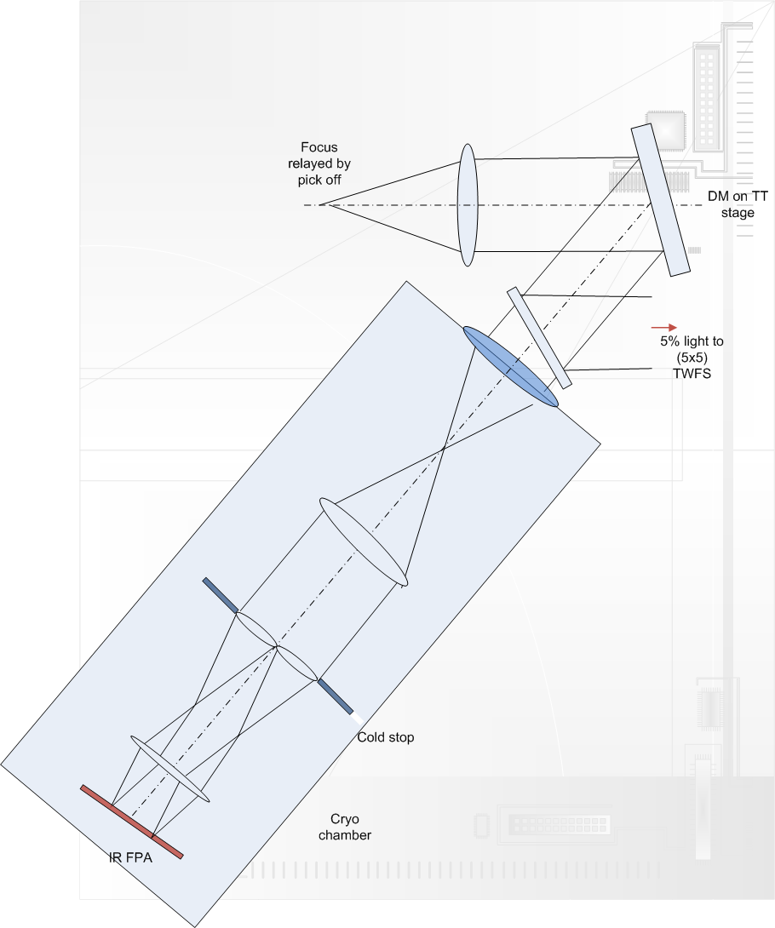
Figure 13. Tip, tilt, focus and astigmatism (TTFA) sensor schematic.

Truth Wavefront Sensors
The TWFS is used to calibrate biases that arise when using LGS in an AO system; in the existing Keck AO system we refer to this as the Low Bandwidth Wavefront Sensor. The biases are principally caused by the elongated nature of the LGS when viewed by sub-apertures of the LGS wavefront sensor and the changing sodium layer density profile. The truth wavefront sensor measures these biases by sensing the time-average wavefront from a NGS. These biases are slowly varying and are of a low spatial order. So, a NGS WFS using long exposures and only measuring the lowest spatial wavefront error is sufficient.

The TWFS has been estimated to be a 5x5 sensor (Figure 14) with a visible sensor.
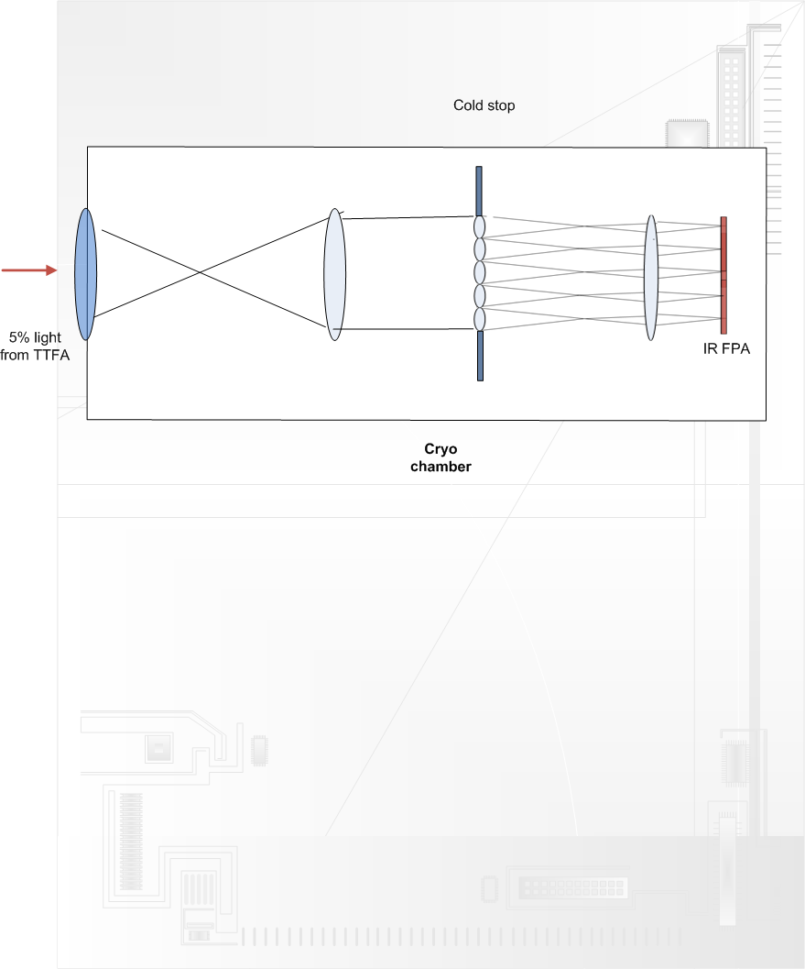
Figure 14. Truth wavefront sensor (TWFS) schematic.

The TWFS will use the visible NGS light while the TTFA uses the NIR light from the same NGS, typically the brightest NGS in the field of regards. The plate scale for this TWFS is __"/pixel.

The visible TWFS plate scale was chosen based on a median seeing limited spot size of 0.65". Current estimates suggest that the visible TWFS can go down to 21.5 mag with a 10 second integration time and achieve 35 nm of total TWFS error.

LGS Wavefront Sensor Object Selection Mechanism
There are a total of seven LGS wavefront sensors in the baseline NGAO design. The asterism is novel in the sense that there is a fixed component, consisting of four guide stars (three on the verticies of an equilateral triangle and one at the triangle’s center), and a movable component, consisting of three guide stars that can be pointed anywhere in the field of regard in order to MOAO sharpen the three TT(FA) stars. The movable asterism diameter can be varied between 30" and 120", and can accept guide stars separated from each other by as little as 10”.

Figure 15 is a schematic view of one of the three LGS θ/φ pickoff probe arms. These pickoffs are intended to be very similar to the LOWFS object selection mechanisms described in section 3.3.2.1. A conceptual mechanical enclosure for the LGS WFS is shown in Figure 16.

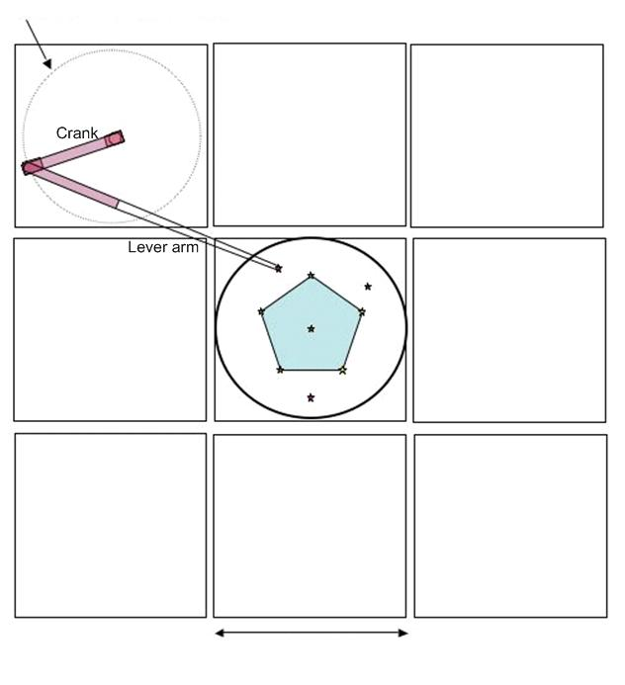
Figure 15. Plan view of the LGS object selection θ/φ pickoff scheme.

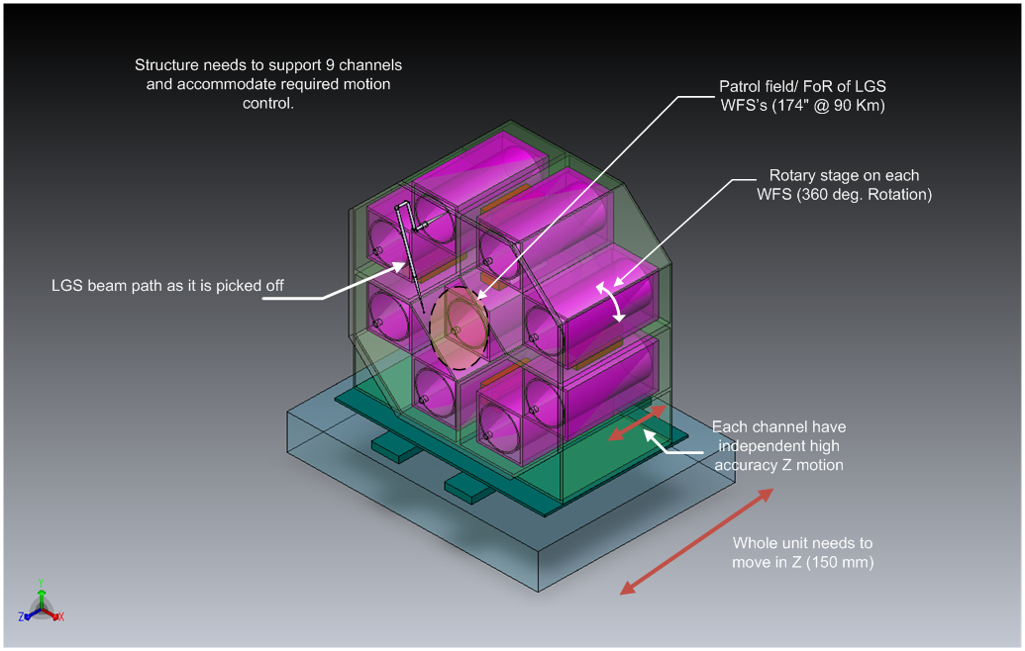
Figure 16. LGS WFS assembly enclosure.

Note that the LGS are always maintained fixed with respect to the LGS WFS OSM. When the AO rotator is used in fixed field mode this is accomplished by the laser launch facility maintaining the LGS asterism fixed on the sky via its own rotator. When the AO rotator is used in fixed pupil mode this is accomplished by not having the LGS asterism rotate on the sky.

LGS Wavefront Sensors
The fixed asterism LGS wavefront sensors are Shack-Hartmann (SH) sensors with 64 x 64 subaperture sampling of the pupil. For the LGS wavefront sensor detectors we anticipate using a very low noise CCD based on the CCID-56 to minimize the laser power required in each beacon. This detector is nominally 256x256 pixels with 3 electrons read noise at 2 kHz frame rates and < 500 electrons/sec of dark current at the operating temperature. A descope to an existing 240x240 pixel CCD and 60x60 subapertures is a potential fallback option.

The movable asterism LGS WFS are similar, but sample their lower photoflux return wavefronts using only 32 x 32 subapertures.

A single LGS WFS channel is shown schematically in Figure 17. This is very similar to the existing Keck AO WFS design (the existing optical design is documented in KAONs 137 and 375) and a preliminary optical design has been performed. The WFS is positioned such that the LGS image is located at the field stop. The entire mechanism, including object selection mechanism, must translate in focus to remain conjugate to the sodium layer. Pupil reimaging optics reimage the telescope pupil (i.e., woofer DM) onto the lenslet array and relay optics relays the images produced by the lenslet onto the camera with the required magnification. A lenslet switching mechanism allows multiple pupil sampling scales and a translation stage allows the relay lens and camera to refocus for different lenslets.

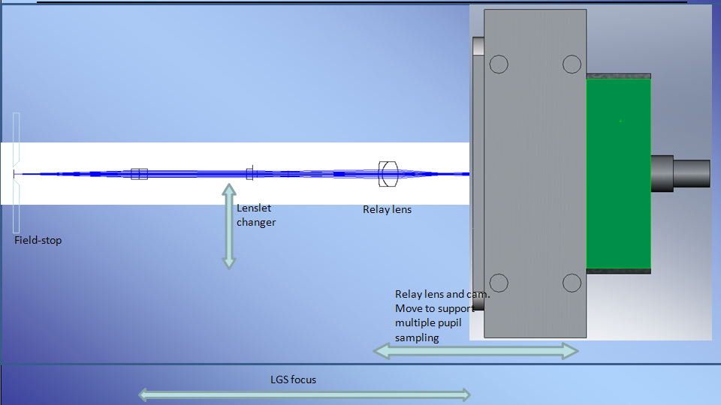
Figure 17. Schematic of a single LGS WFS channel.

NGS Wavefront Sensors
The NGS WFS pickoff is performed with a pair of field steering mirrors as discussed in section 3.3.1.7. The NGS WFS opto-mechanical design will likely be similar to that of the LGS WFS and will use the same CCD.

AO Optical Performance
To determine the performance of the optical system, several sources of optical degradation were analyzed using Zemax in the wavelength passbands used by the individual science instruments and wavefront sensors. The passbands are defined in KAON 530.

The optical relay was modeled in conjunction with the Keck primary and secondary mirrors, to ascertain the combined effects of the two optical systems.

Field points used were the maximum off-axis fields defined for each instrument. The wavefront errors and RMS spot radii quoted are the worst-case for the field points analyzed.

According to Zemax, the working f/# of the wide-field relay is f/13.66 and of the narrow-field relay is f/46.89. Airy disk sizes are defined by
and the depth of focus (DOF ) is defined by.

In Zemax, both the woofer and tweeter DM’s were defined as “Zernike Fringe” surfaces. This allowed a placement of Zernike terms on the mirror surface, to mimic the correction capabilities of an actual DM and derive an “uncorrectable” wavefront error (errors which could not be corrected with a DM). Examination of the Zernike Fringe Coefficients and spot diagrams indicated that the bulk of the wavefront error was due to astigmatism and coma, therefore the Zernike fringe surfaces were optimized only for those coefficients (optimizing in Zemax with too many variables is slow and sometimes fails to converge in a realistic fashion).

Wide Field Relay Optical Performance

Optical Performance to the Low Order Wavefront Sensors

Figure 18. Spot diagrams delivered to the LOWFS focal plane.

Optical Performance to the Interferometer Field Selectors

Optical Performance to the Laser Guide Star Wavefront Sensors
The LGS WFS dichroic pick-off is located in the collimated space between the woofer DM and OAP2. The current simple design reimages the LGS, over their 150" diameter field, using __.

Figure 19. Spot diagrams delivered to the LGS WFS at 180 km conjugate.

Narrow Field Relay Optical Performance
It is assumed for the narrow-field instruments that the tweeter DM applies correction across the entire 30" diameter field of view. The performance values in Table 7 assume that the NGS dichroic is in place. RMS spot radius takes lateral color into account but this can be minimized by putting a wedge angle on the second surface of the NGS dichroic.

Table 4. Performance to the narrow field instruments.

Figure 20. Spots at the on-axis and extreme field angles to the NGS WFS.

Figure 21. RMS wavefront error to the NGS WFS versus field.

Atmospheric Dispersion Correction

Pupil Distortion
Pupil distortion in the NGAO cascaded relay manifests itself in several ways. The first two of these are evaluated in this section: the degree to which a grid of points on the primary mirror maps to a square grid on the DM on axis and the field dependent pupil aberrations.

Two other factors are: pupil tilt on the DM’s (this manifests itself not only as an uncertainty in the conjugate height of the correction, but also in plate scale errors that can degrade the astrometric accuracy) and DM-to-lenslet misregistration and scale errors (these are dependent on the pupil reimaging optics chosen for the wavefront sensors).

In the analysis, the telescope primary became the “object”, and field points were defined on the edges of the primary mirror. Observed field angle was set by adjusting the “stop” size placed at the Nasmyth focus to accommodate a 120" diameter field for the woofer, and a 30" diameter field for the tweeter in the narrow-field relay. Results are shown in Table 5. Figure 22 and Figure 23 and display grid distortion and the pupil PSFs for the woofer DM. Figure 24 and Figure 25 show the same things for the tweeter DM.

Table 5. Characteristics of the pupil image on the deformable mirrors.

Figure 22. Grid distortion at the woofer DM location, magnified by 100.

Figure 23. Spot diagrams for 5 locations on the primary mirror imaged onto the woofer DM.
Field considered is 150" diameter. Chief rays from the on-axis field angles make up the point of the comatic pattern, while chief rays for75" off-axis field angles make up the outer “radius” of comatic points.

Figure 24. Pupil grid distortion at the tweeter DM position, magnified by 100.

Figure 25. Spot diagrams for 5 positions on primary mirror imaged onto the tweeter DM.

AO Enclosure
The AO enclosure conceptual design is documented in KAON __. The 3D model shown in Figure 3 was developed to support this design. The current design makes full use of the entire left Nasmyth platform and covers an area of 6.1 x 9.1 m. A working height of 2.59 m is provided with an overall working height of 3.35 m.

The cold enclosure requirements include up to -20º C operating temperature, a normal operating temperature of -15 º C, class 10,000 clean room and humidity ≤ 50%.

Entrance to the main room will be via an ante-room (2.4x2.4x3.35m).

Alignment, Calibration, Diagnostics, Metrology and Monitoring
KAON 568 outlines the requirements and a design concept for alignment, calibration, diagnostics, metrology and monitoring. The following systems are envisioned to provide these types of information for NGAO:

- Standard sources for flux (flat field) and wavelength (spectral line) calibration of instruments.
- Astrometric source for instrument field distortion calibration.
- Simulated NGS and LGS sources for calibration, optical testing, and alignment.
- Atmospheric simulator.
- Wavefront measurement capability in each science instrument.
- Metrology (TBD).
- Atmospheric profiler.

Instrument Calibration Source
The standard sources for instrument calibration would likely be an integrating sphere with white light and spectral sources. These could be placed at an entrance of the AO bench as a facility that could be shared by all the instruments and provide calibration of the AO system detectors and instrument flat field correction simultaneously.

Based on the Keck OSIRIS experience, it is suggested that a flat field source can be constructed from an integrating sphere and optics that project the sphere’s output port onto the telescope exit pupil. Both a white light and spectral lamps could be used with the same sphere.

Astrometric Calibration Source
The current Keck NIRC2 instrument is equipped with a precision grid of small holes at a focus inside the instrument. This point spread function (PSF) grid is used to map the optical distortion of the instrument across its field of view. A similar gird would likely be placed at the NGAO input focus for astrometric calibration of the AO and the instrument. Each astrometric instrument may also have its own internal grid source like the current NIRC2 instrument.

NGS and LGS Simulated Sources
Simulated NGS and LGS sources would be located at the input focus at the front of the AO bench. These simulated sources are used for:

- Checking optical alignment (registration) between the AO system and instruments
- Point spread function and field aberration verification and calibration
- Testing atmospheric dispersion compensators (ADC)
- Calibrating chromatic aberrations
- Measure DM-to-lenslet registration
- Measure DM influence functions
- Non-common path aberration calibration
- Closed loop AO tests

The simulator discussed in the next section would be designed to have several diffraction limited and seeing limited NGS sources. The LGS sources would attempt to mimic the elongation of laser guide stars, as closely as possible. These sources would be used in combination with the wavefront measurement capability of the AO system to calibrate each deformable mirror and each wavefront sensor. The point source is also used to verify the registration between wavefront sensors and deformable mirrors. The point source would also be used the measure instrument non-common path aberrations.

The NGS and LGS source simulators will be located on the telescope side of the AO rotator. The current design places the infinity focus inside the K-mirror between the first and second mirrors. The location of the LGS focus is even further inside the K-mirror. If single mode fibers or pinholes are used to generate a reference wavefront for the AO system, some means will be needed to relay these optical “clean beams” from their source to the AO focus. This optical design task may prove challenging with regards to the requirements for RMS wavefront error for the NGS sources. Non diffraction limited sources will have somewhat relaxed requirements. If the same optical relay is used for both NGS and LGS sources then some means will be needed to correct the focal difference between LGS and NGS sources. A schematic is shown in Figure 26. This relay is shown as two lenses similar to the existing Keck AO system simulator. However, the need to operate across both visible and NIR wavelengths and over a wide field will likely require a reflective optical design. Since the aberrations resulting from the LGS source passing through the 1-to-1 optical relay is static, predictable, and of relatively low spatial order, small optical correctors could be built into each LGS source. A novel method used at the Gemini telescope, is inclusion of a low cost 19 channel deformable mirror inside the point source generator used to calibrate its active optics wavefront sensors.

Atmospheric Simulator
A simulator is needed to test the AO system’s ability to correct atmospheric turbulence, especially tomographic reconstruction over the NGAO field. In current AO practice, turbulence simulators pass a reference beam through a distorted optical surface that mimics atmospheric turbulence or through a turbulent fluid (mixing cold and hot air). Both these aberrating media could be used in a source simulator which would be placed close to the input focus of the AO system.

The point source simulator can serve as an atmospheric simulator if rotating phase plates are inserted into the system as shown in Figure 26. In order to meet the requirement on operation to a wavelength of 2.5 μm the phase plates will need to be made of etched IR grade fused silica similar to those made by Silios in France. If transmission to 1.6 μm is acceptable then plastic materials may be used, at a considerable cost savings, similar to phase screens made by Lexitek in Massachusetts.

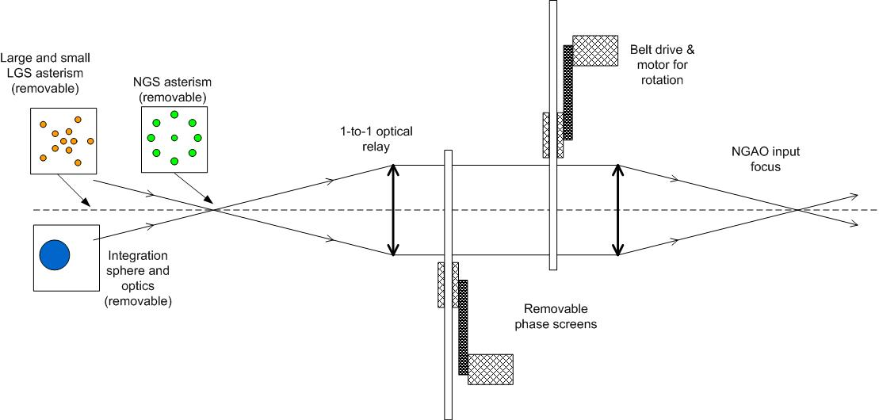
Figure 26. Schematic of a combination atmospheric simulator, LGS and NGS source simulator, and radiometric calibration source.

Science Instrument Wavefront Measurement
The instrument should be able to determine the aberration differences between the AO system and the instrument optical trains, the so-called “non-common path” aberrations. At present, AO systems meet their performance specifications by placing a shape on the deformable mirror that cancels instrument aberrations; this shape is the “zero point’ for dynamic correction of the atmospheric distortion. An alternative would be to require much tighter tolerance on the optical quality of the instrument. The measurement of these wavefront errors and correction by the AO system has proven adequate in present AO systems and appears to work at tolerances typical of extreme AO systems (see references in KAON 568). A number of techniques are available for measuring these aberrations including, phase diversity algorithms, fiber optic interferometers, point-diffraction interferometers, and ‘on-instrument’ wavefront sensors. Most of these techniques would make use of an optical source located at the input focus of the AO optical system.

Metrology
A metrology system could potentially be needed to monitor and correct for the alignments between the NGAO system and the science instruments, especially given the tight tip/tilt requirements and the significant non-common path between the LOWFS and the narrow field science instruments. A “metrology like” alignment system (KAON 35) was proposed originally for the Keck AO system. Some parts were installed in the NIRC2 camera but it was later decided not to be needed. A laser metrology system for the Palomar AO system was also considered but was not installed.

Atmospheric Profiler
The initial requirements and design for an atmospheric profiler are KAON 552. A profiler was deemed to be useful for NGAO for the following reasons:

- Acceptance testing and performance verification (in order to know the performance versus the current conditions).
- Diagnostic tool during observing.
- Aid to planning observations.
- Improve accuracy or speed up the convergence of the laser tomography algorithm.
- Useful as an aid in estimating the AO PSF across the instrument field of view.

The highest level requirements were determined to be (detailed requirements can be found in the functional requirements):

- Measure atmospheric profile at low resolution in six or more altitude bins between 1 km and 20 km altitude.
- Measure the profile once every 2 minutes.
- Measurement accuracy of 10% or better for r₀.
- Operate automatically when conditions are suitable for operating the Keck telescopes.
- Small physical size.

A brief overview of the available technologies for optical measurement of atmospheric turbulence is given in KAON 552. A MASS/DIMM system was recommended as the best system to meet the NGAO requirements. The NGAO team has significant experience utilizing and interpreting the data from the TMT MASS/DIMM that is located on Mauna Kea (KAONs 415, 420 and 496). A TMT MASS/DIMM was donated to WMKO and installed by CFHT and UH at the CFHT weather tower site between CFHT and Gemini as shown in Figure 27.

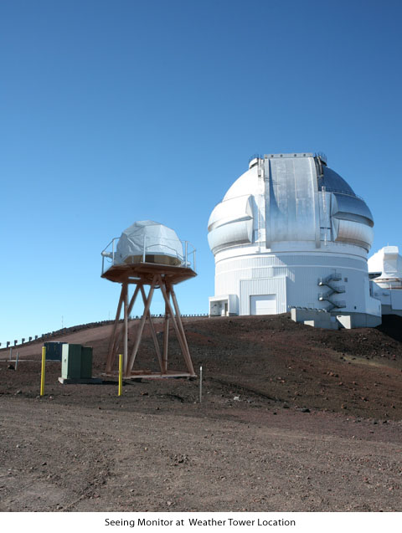
Figure 27. Seeing monitor at Mauna Kea seeing monitor site. Replace with actual photo.

Laser Facility Description

Laser Facility Optical Design

Laser Facility Optical Requirements
The NGAO error budget modeling assumes that sodium laser returns typical of what has been demonstrated at Starfire Optical Range (SOR), scaled to Hawaii, can also be achieved for NGAO. During the development of the NGAO preliminary design, the various factors affecting the rms measurement noise and the rms temporal error on the wavefront sensor were analyzed and a combined specification for the LGS wavefront sensor and LGS facility were developed. The NGAO error budget WFS measurement noise accounts for the standard photon and read noise sources. In addition, it also includes errors from the spot elongation of LGS beacons, lenslet diffraction, lateral diffusion in the CCD, and the level of AO correction provide by the deformable mirror in the first relay of the NGAO system. The error budget also accounts for the optical and atmospheric transmission, the beam quality of the laser, and the wavefront error of the entire laser transport optics. The NGAO laser system requirements are based on an assumed return efficiency from the sodium layer of 100 photons/cm²/s/W. The FWHM of the resulting spot at the sodium layer must correspond to 1.1 arcseconds (TBC) in standard NGAO seeing conditions (r₀ = 16.0 cm, θ₀ = 2.7 arc seconds). The laser launch telescope must be 50 cm in diameter and the laser transport optical system must have a rms wavefront error of 40 nm rms or less.

As part of the system design process, the NGAO team made a detailed trade study of the tomography error associated with various arrangements or asterisms of LGS. The results of this study are documented in KAON 429 and the results were confirmed in another study (KAON 475) by comparison to two other AO computer simulations. Based on these earlier studies and the build-to-cost performance analysis (KAON 644) a 7 LGS system was adopted for NGAO. This includes a fixed “3+1” LGS asterism and 3 movable LGS to point at three LOWFS NGS.

Another design decision was to have the LGS constellation projected such that the orientation of the central asterism and the movable LGS remains fixed with respect to the sky during most observational scenarios. Most observations occur in a “field-fixed” mode with the AO K-mirror keeping natural stars fixed in the AO field of view (FOV). In this mode, the LGS projection system must rotate the LGS asterism as it is projected in order for the asterism to appear stationary in the AO FOV. A lesser used mode of the AO system is a “pupil-fixed” mode, where the AO K-mirror keeps the telescope pupil fixed in the AO FOV. The projected LGS are also kept fixed with respect to the telescope in this mode. However, as seen in the AO FOV the natural stars will appear to rotate relative to the LGS asterism. The movable LGS will not remain fixed relative to the LOWFS stars; this is acceptable because the science cases requiring “pupil-fixed” mode are narrow field and, in most cases, the science object is bright enough to use as a tip-tilt reference source using the NGS WFS instead of a LOWFS (TBC). In the “pupil-fixed” mode, the projected LGS and the LGS wavefront sensors maintain the same orientation during an observation; therefore the LGS wavefront sensors can remain fixed with respect to the AO FOV in both observing modes. This design choice requires that the LGS projector rotate the uplink laser beams in either mode as needed.

Laser Facility Optical Design
An overview diagram of the laser facility optics is provided in Figure 28. Three major blocks are shown: the laser enclosure, the beam transport optics and the top end beam transfer optics located behind the telescope’s secondary mirror. The laser output is first divided into the desired number of LGS by a switchyard shown within the AO enclosure.

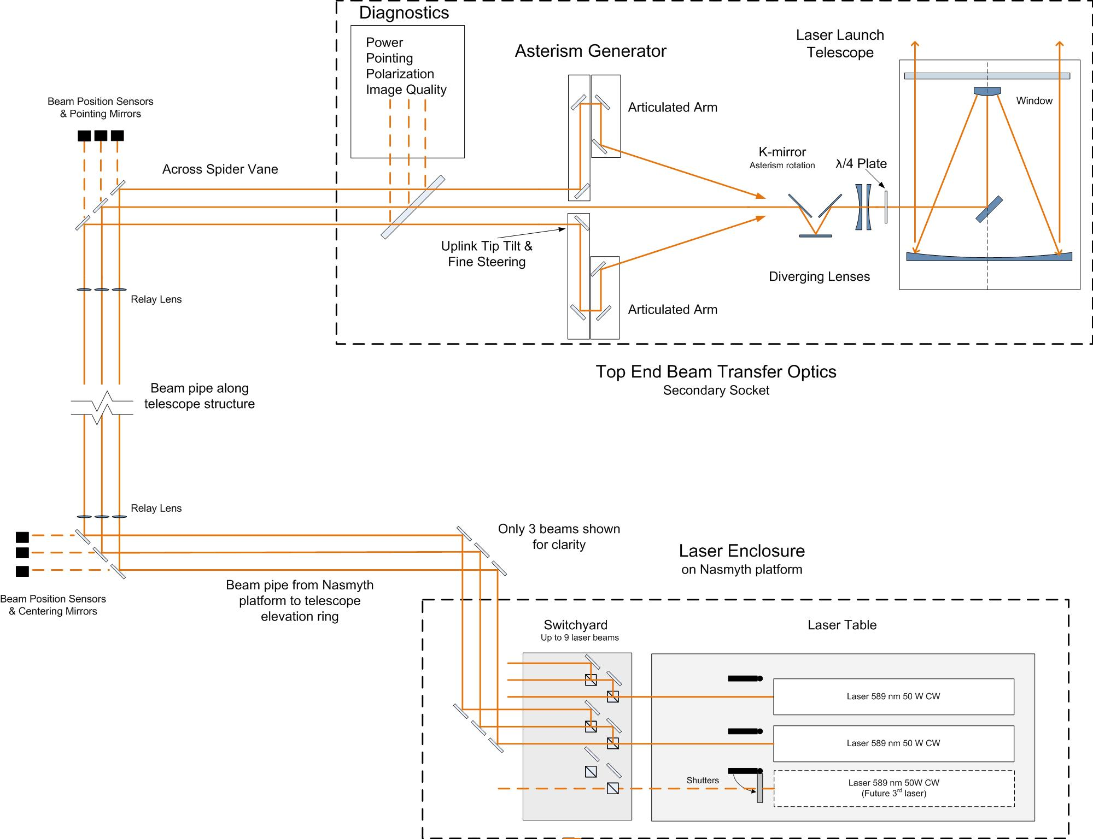
Figure 28. Laser facility optical schematic.

The required asterisms, and the corresponding number of LGS, are summarized in Table 6. The formatting of the laser beams is accomplished by motorized beamsplitters and mirrors that accept the 50 W input beams from the two laser systems and direct them to the proper outputs at the desired power. One can generate four 12.5 W beams using two sets of three 50/50 beamsplitter to produce the central fixed asterism. A second set of beam splitters can be used to produce the movable LGS using a 33/66 beamsplitter followed by a 50/50 beamsplitter which will produce three 8.3 W beams. Shutters on each beam are used to permit diagnostic measurements of any individual output beam. The switchyard will also have a modest-power HeNe “surrogate” lasers that can be switched into the optical path to provide 594.1 nm laser beams, an inexpensive wavelength that is close enough to 589 nm, to permit testing of the beam transfer optics without requiring the high power laser systems.

Table 6. NGAO asterisms.
 | Fixed Central Asterism | Movable LGS
Total laser power | 50 W | 25 W
Lasers | 2 x 25 W | 1 x 25 W
Asterism | Center LGS + Triangle | Movable
Total number LGS | 4 | 3
Watts per guide star | 12.5 | 8.3
Beam splitters | 50/50 per laser | 33/66 + 50/50 per laser

After the laser beams are reformatted to produce the desired asterism, they will transported from the elevation ring enclosure up the side of the telescope structure. For both safety and cleanliness, the entire optical train of the laser facility must be enclosed in a light and dust proof mechanical structure. The proposed location for these fold optics and the beam pipes are shown in the figures of section 3.4.3. The tube structure is outside the footprint of the primary mirror and crosses behind the secondary mirror support structure. The Keck telescope top end is significantly larger than the primary mirror, which affords space for location of fold optics at the top end of the telescope.

After the folds at the top end of the telescope the beams will travel over the top of one of the secondary mirror supports or “spiders” in order to reduce scattered light entering the AO system and science instrument. Next, the beams will travel down into the secondary mirror structure and into the launch telescope. Relay lenses along the path will maintain the beam diameter and exit pupil. Two of the mirrors in each beam will be controllable in tip and tilt to maintain the centering and pointing of the beams. A slow update control loop will be responsible for correcting for the flexure of the telescope structure with elevation. The update may be done exclusively with look-up tables or with feedback from position sensitive photo-diodes or imaging cameras.

In order to produce the required movable LGS, three of the laser beams must be steerable about the field of view of the laser launch telescope in a flexible way. In particular, the concept requires the laser beams to be pointed at arbitrary locations about the field of view. Given the small image (plate) scale of the laser launch telescope the laser beams must be positioned fairly close to each other if they are brought to focus before being transmitted out of the launch telescope. Although a steering mirror array, similar to a MEMS deformable mirror, was proposed as an asterism generator its location close to focus makes it susceptible to laser damage. In addition bringing the laser beams to focus can produce problems with air breakdown unless the optics work at slow focal ratios or the area around focus is evacuated. As a means of avoiding these problems the laser launch telescope is used in combination with a diverging lens so that the laser beams do not go through focus.

We propose using a series of steering arms to position the laser beams about the field of view; the steering arm would be similar to the probe arms proposed for the laser guide star wavefront sensor. The asterism generator would have 3 arms using θ-φ mechanisms. These mechanisms can be made to achievable mechanical tolerances by using a magnification for the laser launch telescope of about 60. The down side of this arrangement is that the asterism generator and the laser launch telescope must be separated by about 2 m (TBC). This will likely require folding the beam inside the secondary socket in order to make the optical system fit in the available space.

The diagnostic system directs a small fraction (e.g. 1%) of each of the laser beams through a beamsplitter into a diagnostics package that will include power meters, polarization sensor, point diagnostics. and laser wavefront quality diagnostics.

The linearly polarized output of the lasers is converted to circularly polarized light prior to projection by the laser launch telescope to maximize the efficiency of exciting the sodium in the atmosphere. This is accomplished by quarter-wave plates in each beam. The wave plate rotation must be adjustable to account for variations in polarization as the laser beams are directed through the optical elements in the beam train.

The laser launch telescope is a commercially-developed Cassegrain reflecting telescope. When used in combination with the diverging lenses in Figure 28 it functions as a Keplerian afocal telescope with a magnification of about 60. This high total magnification allows reasonable packaging of the asterism generator optics.

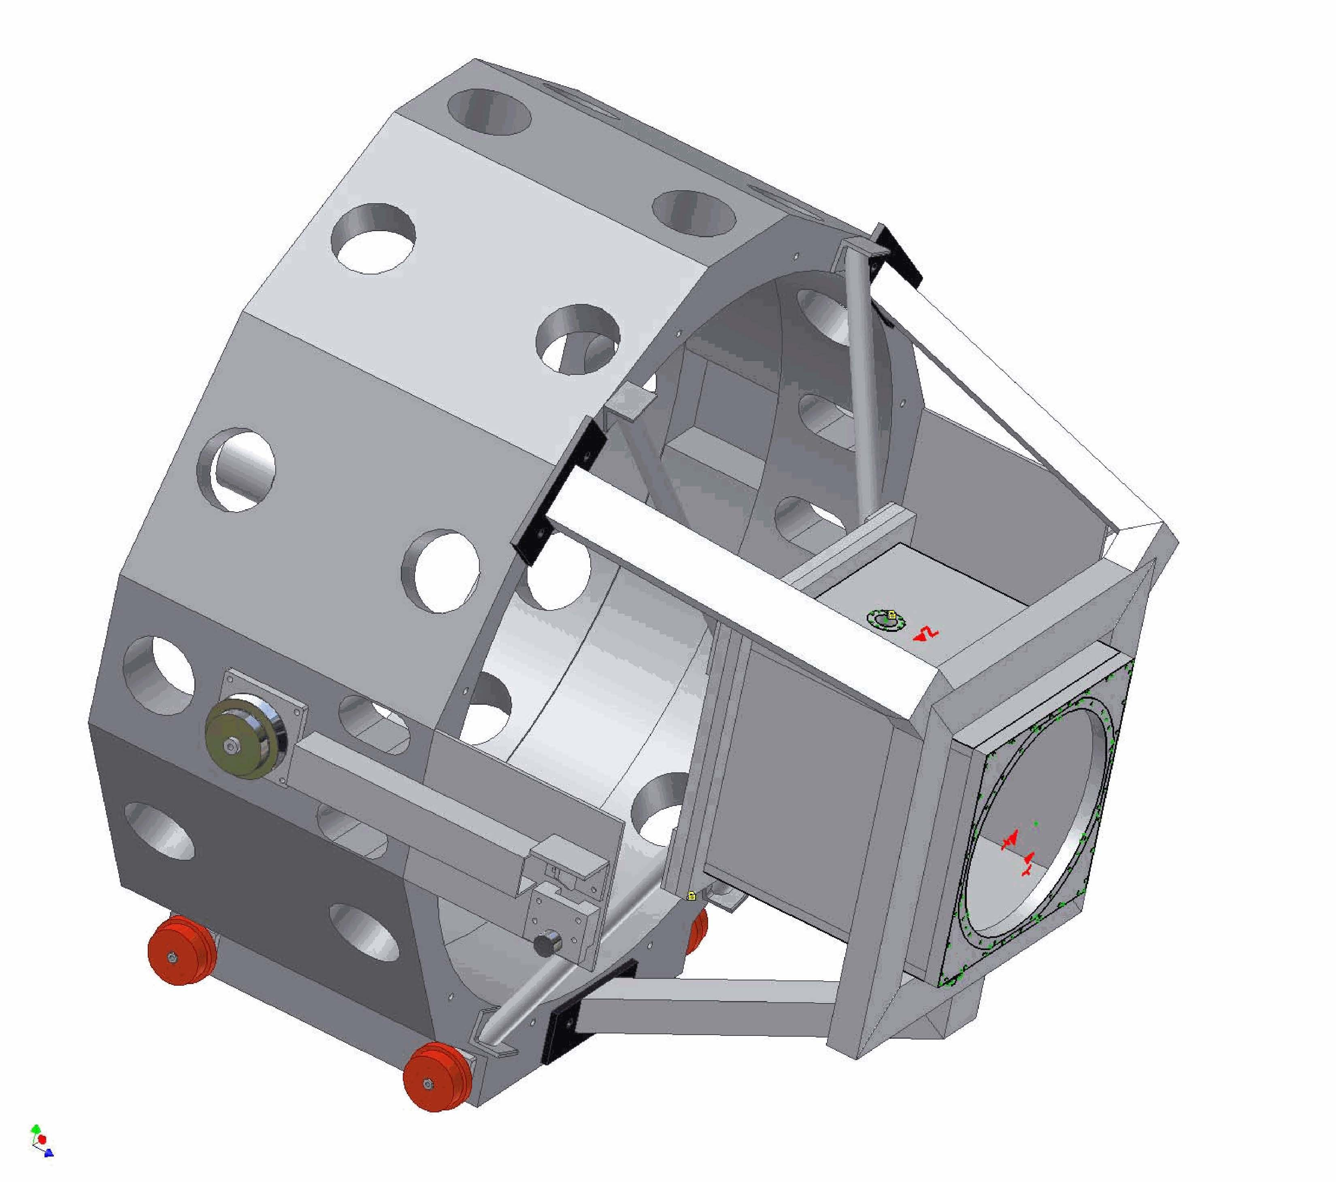
Figure 29. Secondary mirror module and the NGAO laser launch telescope.

An evaluation of the benefits of uplink compensation was reported in KAON 509. Despite the potential advantages, we have decided to proceed without uplink compensation in order to reduce system complexity.

Lasers
Laser power estimates for NGAO have converged around the need for a total power of 75W for the purpose of generating multiple laser guide stars to support tomographic reconstruction of the atmospheric turbulence. In this discussion we will focus on the two laser systems that have undergone preliminary designs using a combination of ESO preliminary design funds and WMKO, GMT, TMT and AURA risk reduction funds.

Laser Enclosure and Beam Transport Mechanical Design
The choice of laser significantly impacts the location of the laser on the telescope and the approach to laser beam transport. The favored location for beam transport simplicity and for maximizing the laser power delivered to the sky is on the elevation moving portion of the telescope, or even behind the telescope secondary mirror, if the laser could be compact enough and could accept a changing gravity vector. Alternatively the laser would be located on the azimuth moving portion of the telescope. A third option of locating the laser off the telescope, as done for the majority of the Keck II laser, would be the option of last resort.

The laser enclosure conceptual design is discussed in KAON 570 and KAON 564. Three cases were considered during the system design. All three cases include beam transport concepts that do not rely on fibers. For reference, the Keck II telescope including the existing AO and laser enclosures and laser launch tube are shown in Figure 30.

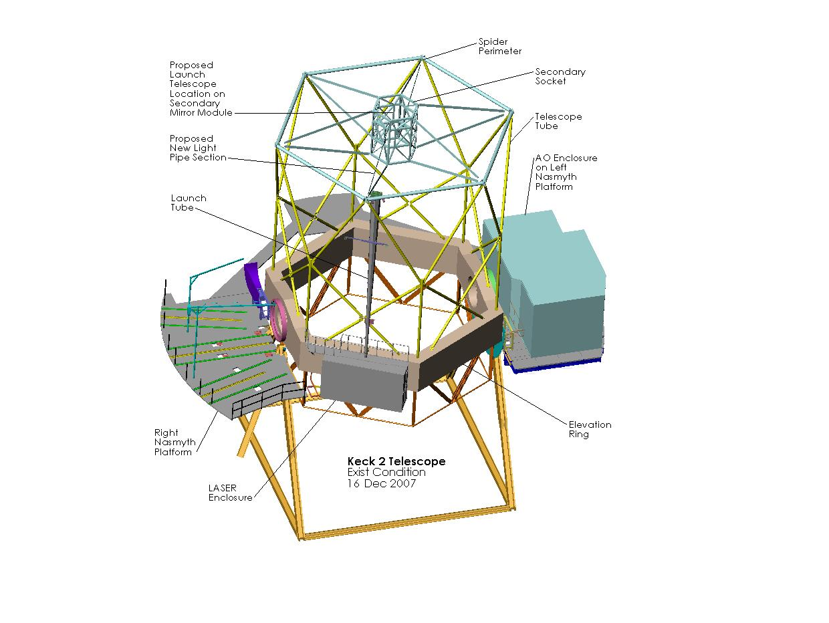
Figure 30. Existing Keck II Telescope and laser location case 1.

The first case considered is for a laser that can operate with a changing gravity vector. In this case the laser could be mounted on the elevation ring of the telescope. One option would be to house the laser in the existing laser enclosure on the right-front wall of the elevation ring (assuming it meets the size and weight restrictions). The laser electronics that do not have to be co-located with the laser could be housed in an electronics enclosure on or below the left Nasmyth platform, similarly to the existing auxiliary laser electronics and cabling would run through one of the existing elevation cable wraps. The laser transport optics and beam path could be enclosed in a tube running up the telescope tube to the perimeter of the spider (similar to the existing launch tube) and across to the launch telescope behind the secondary mirror.

The laser enclosure will also house heat exchangers and power supply racks for the laser, optics for the beam transport system, the safety system and the beam transport control system electronics. Estimated sizes of the components in the laser enclosure are given in KAON __. Since the heat exchangers, electronics rack, and the beam control system will put sizeable amounts of heat into the environment, the laser enclosure will need to be thermally isolated and temperature controlled. Provisions must also be made for personnel to operate in this environment. With the heat exchangers and electronics rack, provisions will be necessary for vibration isolation of these units. The heat exchangers will have pumps and motors while the electronics system will contain fans for cooling. Vibration must be controlled since these components will be on the telescope. From a safety point of view, the interior of this room will be exposed to laser radiation. This enclosure must be light tight with proper engineering controls to not allow laser radiation to escape.

A second enclosure will reside within the telescope secondary module. The laser launch telescope will interface to this module for mechanical support and receive the laser beams and project them to the sky. The enclosure’s functions are to provide a suitable environment for the beam splitters and beam steering systems that format the beams into the appropriate LGS asterism. The enclosure also provides a mechanism to contain the laser light from these subsystems. This enclosure will need to be thermally isolated since it is in the secondary module and is likely to produce more than the allowed 100 W radiated into the dome environment. This heat can be reduced via glycol cooling. Vibration mitigation is not expected to be needed at this location since liquid cooling is expected to be the primary heat removal element.

Glycol cooling will be the primary heat removal medium for this system. Figure 31 shows the components requiring glycol. Glycol will be pumped from the mechanical room through the telescope to laser enclosure, the secondary of the telescope. The bulk of the cooling will be needed to operate the two laser heat exchangers. Estimates of the heat capacities are provided in KAON 570.

Figure 31. Glycol cooling for the laser system.

Laser Safety System
The safety system will assure the entire laser system and its components will operate to maintain a safe environment for personnel, as well as equipment. The safety system is shown in Figure 33. To make the determination to shutter laser light, the safety system will sense environmental changes or user commands from the Laser System Interface (see section 3.5.2.2.2). Termination of laser radiation will be done at different locales depending on the threat of laser radiation. At the laser, it will close the laser shutters prior to the beam relay system or turn off power to the entire laser system. At the beam steering system, it will close a final shutter prior to launching of the beam into the beam telescope. To make proper determination, the safety system will sense inputs from the laser, beam steering system, glycol system, laser enclosures, aircraft detection and spotter system, and user inputs via the Laser System Interface.

In addition to terminating laser radiation, the safety system will also provide laser status for personnel entering laser zones that may be hazardous. This will ensure laser or summit personnel will not accidentally walk into exposed laser radiation. The safety system controller is expected to be a programmable logic device. It will sense inputs from multiple subsystems on and off the telescope, as well as commands via the network from the Laser System interface.

Figure 32: Safety system.

The increase in power from current systems with 10-20 W to a system with three 25W lasers means that the potential for property damage and personnel injury by 589nm light is increased. In addition, the power of IR pump beams will also be increased over corresponding beams in the current lasers, increasing the risk of invisible radiation. Still, the NGAO lasers will be class 4 lasers, the same as the current Keck lasers. As such, the laboratory engineering controls and procedures are the same as any class 4 laser controlled area. Measures include door interlocks, lighted signs, laser protective eyewear, written procedures, and training. For the large diameter beams leaving the laser launch telescope, the Nominal Hazard Zone (NHZ) for diffuse reflections is essential zero. In contrast, specular reflections would have a very long Nominal Ocular Hazard Distance (NOHD) for the NGAO lasers. As with any sodium Laser Guide Star in navigable airspace, the beam(s) are a threat to aircraft. This will require safety observers and annual request to the FAA for a letter of no-objection. These are currently the standard practices at the observatory for LGS operations. A complete safety analysis would be completed as part of the planning for the laser installation.

Aircraft safety for Keck LGS AO observations is currently provided by aircraft spotters as recommended by the FAA. WMKO has been working with the G10-T Laser Safety Hazards subcommittee of the Society of Automotive Engineers that sets the relevant aircraft safety standards used by the FAA. This committee is addressing the issue of facilitating a consistent approach to approving control measures. This opens the door to approval of automated aircraft detection systems that do not require spotters or radar. Gemini Observatory is developing an all sky camera for aircraft detection that will be implemented as a shared resource on Mauna Kea.

We will use the same procedures for satellite avoidance and for not interfering with the observations of other Mauna Kea telescopes as are currently used for Keck LGS AO observations. A discussion of the impact on observing efficiency of these items, and potential changes, are discussed in section 3.6.1.2.

Laser Upgrades and Advanced Technology
KAON 570 also briefly discusses the following technologies that could potentially provide large performance gains for NGAO including dual wavelength lasers, fiber lasers and fiber transport, pulsed laser formats and uplink AO. Because of the uncertain or unproven performance of these technologies they have not been selected in our baseline design. We will continue to follow these technologies to determine if they may become appropriate.

Control Electronics and Software
This part of the design manual, derived from KAON 569, is broken into three sections: the overall controls infrastructure, the non-Real Time Control (RTC) control and the RTC control.

AO Controls Infrastructure
The entire NGAO system can be viewed as a distributed controls system, in which many different components communicate with each other in various client/server or master/slave relationships using possibly several communication networks and protocols. Figure 33 shows a high-level abstraction of the NGAO system control.

Figure 33. A distributed controls system block diagram of the NGAO system.

Each block in the diagram represents a set of control functions peculiar to a particular system or subsystem that can logically be grouped together. The grouping is an abstraction, as the various functions represented by each block may actually be implemented using multiple software and hardware components that are also distributed. The primary data communications paradigm used by the NGAO system components has not yet been specified however, it is likely that it will be the keyword system already employed at the observatory.

Figure 34. AO controls infrastructure block diagram.

A more detailed block diagram of the AO infrastructure is shown in Figure 34 where the control systems are represented by a hierarchy. At the top level are the main interfaces to the various subsystems (some of these interfaces are referred to as sequences in the diagram). All user commands to the subsystems pass through these top level interfaces. The middle level of the hierarchy represents an abstraction of more complex lower level control tasks, namely the basic control functions for that subsystem. Users do not access the system at this level except for engineering or troubleshooting purposes. Finally, at the bottom level of the hierarchy are the devices controlled by the control system themselves. These three levels of hierarchy will be discussed in more detail.

Non-real-time Control

Electronics
Two categories of electronics are discussed: motion control and device control electronics.

Motion Control Electronics
A spreadsheet has been developed to document the motion control devices. The devices requiring motion control listed in the spreadsheet are organized according to the following breakdown (degrees of freedom required shown in parentheses):

- Vibration sensor (4 DOF)
- Calibration source (3 DOF)
- Rotator (1 DOF)
- LGS WFS assembly (31 DOF)
- Interferometer pickoff, pointing and centering (5 DOF)
- Acquisition camera pickoff, focus (2 DOF)
- LOWFS assembly (14 DOF)
- NGS WFS (8 DOF)
- Science ADC (3 DOF)
- Laser switchyard (13 DOF)
- Laser beam transport (28 DOF)
- Laser shutters (7 DOF)
- Laser top end steering + launch telescope (11 DOF)

The total current number of degrees of freedom requiring motion control is 130. The existing Keck AO optics bench has on the order of 40 devices requiring motion control, compared to 71 for the NGAO optics bench.

Another key preliminary design task will be to develop a comprehensive motion control philosophy and architecture for the system, which will include:

- Selection of a motion control architecture (i.e., distributed vs. centralized servo control)
- Standardization of motors and servo amplifiers
- Specification of the motion control electronics to be used
- Location of the electronics relative to the AO system components and the cold room
- Motion control system reliability

Standardization of the motion control architecture will greatly simplify the design and implementation of such a large number of motion control devices.

Device Control Electronics
The remaining electronics in the AO system can be characterized as device control electronics. This consists of detector, mirror, real-time controller and environmental control. This basic device control includes power control, initialization, basic parameter control, etc.

The devices to be controlled are as follows:

- Detectors
  - Vibration sensor
  - LGS WFS cameras (7)
  - NGS acquisition camera
  - LOWFS tip-tilt sensors (2)
  - LOWFS TWFS camera
  - LOWFS TTFA camera
  - NGS WFS camera
- Mirrors
  - Woofer DM/TT
  - Tweeter DM/TT
  - LOWFS DM/TT (3)
  - UTT mirror (1 or 7)
- RTC control
- Environmental control
  - Power
  - Temperature
  - Humidity
  - Particulates
  - Instrument glycol or other cooling
- Laser system control
  - Diagnostics cameras
  - Power and environmental control

Based on past experience, we expect that two or three hard-real-time controllers (e.g., VxWorks VME crates) will be required for the AO system, and one or two for the laser system. We also expect that one or two soft-real-time controllers (e.g., Unix workstations) will be required for the AO system and at least one for the laser system. A number of miscellaneous analog and digital IO cards will be required to interface the various electronics devices to the control systems. One or more Unix workstations or VxWorks VME crates may be required for camera control.

Software

AO System Software
Figure 35 shows a block diagram of the AO system control hierarchy. The top level of the hierarchy is the AO sequencer, which is the main interface between the AO controls and the rest of the NGAO system. The intermediate level shows the main control functions grouped by control type and the bottom layer shows the devices that are to be controlled.

Figure 35. AO systems control hierarchy block diagram.

Sequencer
The AO sequencer is the main interface between the AO controls functions and the rest of the NGAO system. The sequencer has four main components: a command interface, a set of coordination sequences, a data interface and a system health monitor. The grouping of these functions into a “sequencer” is an abstraction, as they may be implemented using multiple software and hardware components that are distributed. Those tasks requiring only soft-real-time control will most likely be implemented on Unix workstations, while those tasks requiring hard-real-time control will likely be implemented using VME crates and CPUs running VxWorks and EPICS (or some similar controls architecture). The use of the term “hard-real-time” refers to the type of control where timing and response times are critical to correct control and operation of a particular device.

The functions of these four main components are as follows:

      - Command interface. The command interface represents the main interface for the AO controls. In the current AO system, it consists of the basic interfaces to the devices to be controlled (e.g., keywords, EPICS). This is the most basic command interface for parameter updates and commands not requiring any kind of complex coordination or monitoring.
      - Coordination sequences. The coordination sequences are a collection of state machines which implement complex sequences of commands for the underlying control systems. A coordination sequence allows the user to send a simple command to the sequencer, while it performs the many tasks required by this command and returns the status to the user. Examples are: the main AO sequence that is used to startup, initialize, standby, and shutdown the system; and a setup sequence that sets up the AO bench devices, WFS cameras, and the RTC for a particular observing mode (see KAON 550: System Configurations Spreadsheet).
      - Data interface. The data interface is the interface between the rest of the NGAO system and data produced by the AO system, primarily in the form of low bandwidth telemetry and system status data (high bandwidth telemetry data and diagnostic data are available through the data server, discussed later in this document).
      - System health monitor. The system health monitor is a task that monitors the status of all the important AO system functions and initiates alarms or other fault indications to the rest of the NGAO system if problems are detected.

Motion Control Software
The motion control software functions are organized as shown in Figure 36. They consist of two main components: the low-level and high-level motion control sequences.

Figure 36. Motion control software architecture block diagram.

The low level motion control functions consist of one or more device drivers that implement an API for interacting with the motion control system to provide the most basic level of motion control. This device driver will most likely be supplied by the manufacturer of the motion control electronics. Layered on top of the manufacturer’s device driver will be another driver providing an interface to the AO control system (e.g., EPICS). At the top of this control block is a generic state machine that implements the basic coordinated functions required for controlling a motion control device with an arbitrary number of degrees of freedom. This concept is used in the existing Keck AO system.

The high-level motion control sequences are a set of state machines that implement the complex coordinated control required by many of the assemblies in the AO system. They accept high level commands from the AO sequencer and issue the appropriate commands to the low-level motion control block described above. The sequences will be implemented using a state machine compiler (e.g., EPICS State Notation Language, or the generic state machine compiler developed at Keck). The high level motion control sequences identified thus far are:

- LGS WFS: Coordinated control of the LGS WFS assembly housing 9 wavefront sensors and their associated optics.
- ADC: Generic control for the ADC used in the AO system.
- FSM control: high-level control for the NGS WFS and interferometer field steering mirrors used in coordination for target offsets and dithers.
- LOWFS: Coordinated control of the LOWFS assembly housing the various TT, TTFA, and TWFS sensors and their associated optics.
- Focus Manager: Coordinated control of focus throughout the AO system.

The LGS, LGS WFS and LOWFS motion control sequences will be the most difficult due to the large amount of motion control and present some level of risk. The arms must be prevented from colliding with one another, which implies that the motors cannot move through their entire range of motion during startup, as is done with devices in the current AO system.

Device Control Software
The device control software functions implement the remaining control blocks in the intermediate control level shown in Figure 35. The main control functions are: camera control, DM/TT control, environmental control, and RTC control. A block diagram illustrating the generic control paradigm for a number of devices is shown in Figure 37. At the bottom level are device drivers that implement a low-level application programmer interface (API) allowing basic control of each device. These device drivers are usually provided by the manufacturer. Layered on top of these device drivers, also at the same low level, are drivers for the AO control system (e.g., EPICS). If control system drivers do not exist for the device drivers or cameras, they will have to be written. The upper level consists of one or more control sequences (state machines) for each device that provide a high-level of control to implement coordination of complex tasks and sequences of commands.

Figure 37. Generic device control paradigm block diagram.

At a minimum, all devices will require some generic functions: start up, initialize, stand by, shut down, etc. The specific devices to be controlled and the control functions we have identified thus far are listed below.

- Camera control
  - Devices: Vibration sensor, wavefront sensors, tip-tilt sensor, acquisition camera
  - Control functions: Frame rate, exposure time, program select, background recording, flat field recording
- Mirror control
  - Devices: Woofer and tweeter DM/TT, LOWFS DM, LGS UTT
  - Control functions: voltage control for mirror drive amplifiers (ramp up/down, relay control, etc.)
- Environmental control
  - Devices: controllers for power, temperature, humidity, particulates, instrument cooling, etc.
  - Control functions: Basic parameter control
- RTC control. RTC control RTC device control refers to basic control and parameter passing for the RTC itself. Low level communication will be provided by a device driver which will implement the RTC command set. Any higher level coordination required will be implemented using state machines. Commands similar to the following are expected:
- Loading DSP & FPGA code
- Setting scalar parameters (e.g., loop gains)
- Setting array parameters (reconstruction matrix, centroid origins, servo control laws, etc.)
- Compute interaction (system) matrix

Laser System Software
A block diagram of the laser system control hierarchy is shown in Figure 38. The functions of the various levels are similar to those described earlier for the AO system. The laser system controls are responsible for controlling the laser optical devices (beam transport control), the laser device itself, the laser cameras, environmental and power control, and possibly, depending on its architecture, the laser safety system as well.

Figure 38. Laser system controls hierarchy block diagram.

Laser Sequencer
The laser sequencer is similar in design to the AO sequencer discussed above and is not discussed in detail here. A key task during the preliminary design will be to identify all of the coordination sequences required for the laser sequencer and their requirements.

Laser Motion Control (Beam Transport Control)
The laser motion control software functions are organized as shown in Figure 39.

Figure 39. Laser motion control software architecture block diagram.

The low-level motion control functions are similar to the ones discussed earlier for the AO system and are not discussed further here. The same low-level software developed for the AO low-level motion control functions will likely be reused here.

The high-level motion control sequences are a set of state machines that implement the complex coordinated control required by some of the assemblies in the laser system. They accept high level commands from the laser sequencer and issue the appropriate commands to the low-level motion control block. The sequences will be implemented using a state machine compiler (e.g., EPICS State Notation Language, or the generic state machine compiler developed at Keck). The high level motion control sequences identified thus far are:

- Pointing and centering: coordinated control of the 9 laser beams to compensate for flexure due to the changing gravity vector when the telescope moves in elevation.
- Constellation generator: coordinated control of the 9 laser beams to position the lasers as required in the asterism.
- Constellation rotator: coordinated control of the overall rotation of the asterism to keep it fixed on the sky or stationary as required by the particular observing mode.
- Polarization waveplate control: coordinated control of the polarization waveplates to provide polarization control for each of the 9 laser beams.
- Shutter control: coordinated control of the many shutters in the laser switchyard.

Laser Device Control
The laser device control software functions implement the remaining control blocks shown in Figure 38. The main control functions are laser control (control of the laser device), camera control, environmental control, and control of the laser safety system. The device control paradigm and camera and environmental control functions are similar to those described for the AO system. Wherever possible, common camera and environmental control software will be used to support the AO and laser systems. The remaining functions are laser control and laser safety system control:

- Laser control. We assume that the laser will be provided with a software interface that allows for the basic passing of commands and return of status data. We may have to provide a driver to interface the laser to our controls system architecture (e.g., keywords, EPICS). We will also develop coordination sequences (state machines) to coordinate complex sequences of commands to simplify the command and user interface to the laser.
- Laser safety system control. Control of the laser safety system refers to basic control and parameter passing for the laser safety system itself. The control interface consists of a device driver to provide a control interface to the safety system (e.g., EPICS), and possibly some high-level coordination sequences that will be part of the laser sequencer to coordinate sequences of complex safety system commands.

Acquisition, Guiding and Pointing Control
A block diagram for the Acquisition, Guiding, and Pointing Control function is shown in Figure 40. The control consists of two main functions: acquisition and guiding, and pointing control. The functions will be implemented in some combination of hard-real-time and soft-real-time control applications.

Figure 40. Acquisition, guiding and pointing control software architecture block diagram.
The acquisition and guiding control block is the interface between the AO system and the new Keck standard MAGIQ guider. It represents the hardware and software “glue” required to connect the acquisition camera to the MAGIQ guider system used at the observatory. Some upgrades to the MAGIQ system may be required to support all of the NGAO acquisition requirements. See section 3.6.2.4 for more details on acquisition.

The pointing control function is the interface between the AO system and the pointing functions of the telescope. This includes pointing offsets for tip-tilt and coma offloading, secondary offsets for focus and coma offloading, and an offset control that interfaces to the AO loop commands to control the AO system during telescope offsets and dithers. The offload functions take the appropriate AO telemetry as inputs and compute the required pointing and secondary offsets.

Data Server
A block diagram of the data server is shown in Figure 41. The server consists of a dedicated server-class CPU and RAID storage system and data recording and server tasks. The data recording hardware interfaces are expected to be similar to those of the existing AO system telemetry server, which uses a fiber channel interface for high speed data and GBit ethernet for the moderate and slow speed data. The data recording task receives data from the recording interfaces and stores it directly into a database on the RAID storage system. The server task supports remote connections and near-real-time query capability of the database through the data server interface.

The data storage requirements for the system are expected to include the following:

- High speed telemetry and diagnostics data from the real time controller
- WFS, acquisition, and truth sensor camera data
- TT sensor data
- System configuration and parameter data

Figure 41. Data server architecture block diagram.

The tools that will make requests to the data server are the NGAO diagnostic tools, the performance and system monitoring tools, the PSF reconstruction tools, and the data storage and delivery tool (tool that sorts out and manages the data that will be stored and the data the observer will take home).

Real Time Control

Introduction
The Real Time Controller (RTC) is a specialized computer system designed to perform all of the wavefront sensing, tomography calculations, and deformable mirror control processing at rates that keep up with atmospheric turbulence induced optical aberrations. The RTC data flow and computer architectures have been designed to achieve the tomography precision, noise suppression, and bandwidth requirements implied by the science-case driven wavefront error budgets.
An equally important consideration in the RTC design is the need to keep the cost and complexity manageable. Simply scaling earlier implementations of single conjugate AO RTC reconstructors using traditional central processing units (CPUs) is infeasible because of the multiplying effect of multi-guidestars and multiple deformable mirrors on computer speed requirements. To address this issue, we have taken advantage of the parallelizability of wavefront reconstruction and tomography algorithms and mapped them on to a massively-parallel processing (MPP) compute architecture. This architecture scales in size and complexity much more favorably than doing the same calculations on CPUs, and can be readily implemented with commercial off the shelf technology building blocks called field programmable gate arrays (FPGAs). Additional details of this design approach are given in a later section on implementation later in this report, and given in still greater detail in KAON 553.
We first describe the main line real-time tasks that the RTC must perform. Then we describe the essential ancillary support tasks relevant to the RTC such as communicating with the supervisory controller configuration and calibration information, providing offload signals, and providing diagnostic data. In the final section we explain the MPP implementation, describing processor hardware, interface hardware, and software development methodology.

RTC Tasks
The RTC, at the core, performs the following tasks in LGS mode:
- Accept digitized pixel data from the LGS WFS and LOWFS, and perform basic image processing (dark and bias subtraction, flat-fielding).
- Calculate wavefront tilts from the LGS WFS and LOWFS using a choice of noise-optimal centroiding algorithms, and compensate for non-linearities in the centroiding methods.
- Reconstruct wavefront phase at each sensor and transmit this information to the tomography processor.
- Use cone-beam projection tomography techniques to reconstruct the three-dimensional volume of atmospheric index-of-refraction variations above the telescope and over the field of view of interest, given the wavefronts from various directions as measured by each wavefront sensor. This algorithm also takes inputs from the tip/tilt and tip/tilt/focus/astigmatism sensors to break volume solution ambiguities inherent in laser wavefront measurements.
- Integrate through the volume of index estimates along the path to the science instrument – either on-axis for the narrow field science modes, or across a modest FoV (sacrificing peak on-axis performance for more uniform AO correction.)
- Compensate for deformable mirror influence functions and nonlinearities, deriving voltage commands for the DM’s given desired wavefront distortion corrections to be placed on them. Split the control between commands to the tip/tilt mirror, moderate-order (woofer) DM, and high-order (tweeter) DMs.
- Incorporate control compensation dynamics to keep the system stable and achieving a given temporal bandwidth.
In LGS mode the RTC also computes high-order wavefront control commands for DMs in the tip/tilt sensors, sharpening the IR tip/tilt stars.
In NGS mode, the RTC acts as a traditional single conjugate AO system. It takes inputs from one NGS sensor, reconstructs the wavefront, and computes commands to be split up amongst the tip/tilt mirror, woofer DM, and tweeter DM in the narrow field science path.
All these RTC tasks take place at the frame rate of the fastest wavefront sensor camera, up to 2,000 frames per second.
As shown in the Figure 42 schematic, large chunks of compute tasks are associated with either wavefront sensors or DM’s and thus can be parallelized across them. Thus some of the dedicated processing units will be assigned specifically to hardware. Furthermore, algorithms within the subunits, as well as within the tomography unit itself (Figure 43), are highly parallelizable when implemented in the Fourier domain, and thus will each map onto an MPP architecture as described earlier.
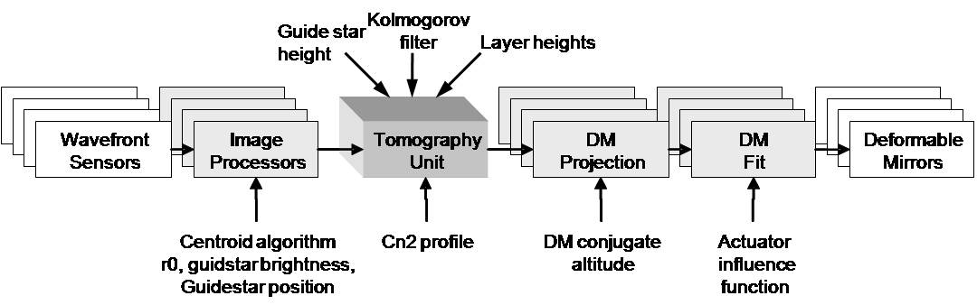
Figure 42. Multi-guide star tomography data flow and parallel processing.

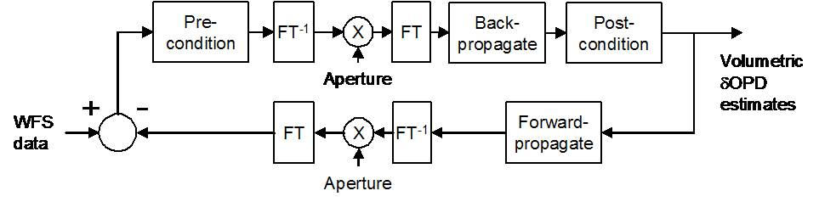
Figure 43. Tomography algorithm.

Parametric Input, Optimization, and Reconfigurability

Minimum Variance Reconstruction Optimization
The RTC algorithm computes the statistical minimum variance solutions for wavefronts at each science instrument, given the measured wavefront data from the guide stars. The minimum variance solution depends on certain a-priori data, which the RTC accepts as parametric input. These include:
- Volumetric turbulence strength (Cn2 profile, discretized at layers)
- Number of layers of turbulence
- Brightness of guide stars
- Wind speeds at layers
C_{n}² can be provided either as a-priori input, or as derived from external measurements, for example, from a MASS/DIMM sensor. The preparation and processing of this data is left to the external supervisory control system; the RTC simply takes in a set of normalized C_{n}² strength numbers, one per layer, at a rate that is slow (e.g. once per second) with respect to the real-time tasks. As an option, the RTC’s tomography engine will provide statistical average rms aberrations resolved by layer, which can be used to adjust C_{n}² profile numbers dynamically.
Similarly, wind speeds can be incorporated from external data or deduced internally from past histories of estimates.

Calibration Parameters
The truth wavefront sensor will provide long-term average wavefront data designed to normalize out systematic biases due to either non-common path optical aberration or Hartmann sensor biases due to variations in the sodium layer thickness and altitude. The RTC will process these wavefront sensor data like any other wavefront sensor and use the results to adjust zero-set points in the overall reconstructor.
In a like manner, prior measurements will have determined calibration set points for each wavefront sensor, giving the definition of a “flat” wavefront for each sensor. The set points for LGS wavefront sensors will depend on field position and zenith angle. Thus the multi-system command sequencer, with knowledge of the telescope and AO system configuration, will periodically update the RTC wavefront sensor sub-processors as to which parameter set to apply to the wavefront reconstruction.

Reconfiguration
The processing units and algorithm will be made reconfigurable to allow for each of the observing modes envisioned for NGAO. Configuration parameters include:
- Number and field-positions of laser guide stars.
- Number and field-positions of tip-tilt guide stars.
- Field position of TTFA (tip/tilt/focus/astigmatism) sensor.
Furthermore, the scalloped pupil of the Keck primary mirror will rotate with respect to the wavefront sensors and DMs in some science observing scenarios. The wavefront and tomography reconstructors utilizes a model pupil as a “valid data” mask, so this model will be set and updated at the appropriate rate within the RTC.

Interfaces

Offloading
The RTC will provide offload signals to the telescope so that the high speed wavefront controllers don’t saturate. The offload signals flow to the non-RTC supervisory controller at a relatively low data rate, on the order once per second. Offloading signals include:
- Tip-tilt to the telescope guider.
- Focus to the secondary piston.
- Other low order modes TBD to the telescope primary segment control system.

Diagnostics and Telemetry
Diagnostic data is defined as data intended for monitoring the health of the RTC and AO system, and for display to the operator. Centroid data from wavefront sensors, signals going to DMs, and other indicators are transmitted at relatively low, human readable, data rates to the external systems.
Telemetry data is defined as up to full-frame rate streaming of portions or all of the intermediate data to high-speed data capture units. This data is useful for a number of post processing tasks such as
- Debugging or tuning of parameters.
- Analysis of seeing conditions and performance of the AO system.
- Point spread function determination.
Data that would be streamed for data capture include:
- All wavefront sensor centroids, intensities, and wavefront sensor reconstructed phases.
- All tip-tilt and TTFA sensor centroids and intensities.
- All commands to the DMs and tip/tilt mirrors.
- All tomography volume estimate data.
- Ancillary information associated with the operations so as to be able to reconstruct the state of the RTC at the time, including internal data tables, C_{n2} numbers, wind numbers, calibration sets etc.
Additional data storage capability will be needed to record full frame rate raw pixel data from the wavefront and tip/tilt sensors.

Command State
The RTC at any time will be operating in one of a number of possible states. Examples of such states include:
- Narrow field science LGS AO control (hybrid closed loop on the woofer and open loop on the narrow field tweeter and tip-tilt and TTFA tweeters).
- Narrow field science NGS AO control (closed loop on the woofer and tweeter).
- Control on tip-tilt only.
- Calibration modes (for alignment/registration, push matrix generation, linearity calibrations).
- Uncontrolled or idle, with static values as loaded for the DMs and tip/tilt mirrors.
The supervisory control system will transmit the state transitions to the RTC which will configure accordingly (and also report back its state on demand). The maintenance of state transition rules will be the responsibility of the multi-system command sequencer.
Additional flags will be maintained for turning on and off various diagnostic and telemetry streams.

Implementation

Algorithms
Algorithms for wavefront phase reconstruction from Hartmann slope data have been analyzed since the beginning days of AO. We anticipate using a modern fast-iterative technique such as the ones described in references 1 and 2. Such techniques can take advantage of parallelism if they are implemented in the Fourier domain. Regularizations taking into account the signal-to-noise of the measurement and filters for suppressing the waffle mode can also be implemented in the Fourier domain. The pupil boundary conditions (outside of which the measurements must not be assumed as zero but allowed to be free variables) force the algorithm to be iterative as described in the above references, but 3-5 iterations using a Fourier-domain pre-conditioned conjugate gradient (FD-PCG) method have been shown to be adequate for meeting our error budget.
Inverse tomography algorithms using wavefront measurements from multiple directions have been developed recently (see references 2 and 3). These methods are also made parallel through the use of the Fourier domain but again must be iterated because of the finite spatial extent of the pupil-apertured data. Again, the FD-PCG method has proven adequately stable and rapidly converging in simulation studies (KAON 475).
Finally, fitting the deformable mirror to the desired wavefront correction can be accomplished with parallel processor implementations that carry an inverse model of each DM.
- MEMS open loop control is decoupled into a linear cross-coupling, which is solvable in the Fourier domain, and independent nonlinear functions for each actuator, solvable with nonlinear lookup tables in parallel. The MEMS are repeatable go-to devices and this open-loop model has been proven to be quite accurate (see reference 5).
- The woofer DM, likely a piezo-actuator device with cross-coupling and hysteretic effects, will be controlled via a linear Fourier domain deconvolution only. We will rely on the fact that this mirror is in “closed loop” (upstream of the wavefront sensors) and so any residual mis-fitting will be measured and sent to the more accurately responding tweeters. Bandwidth shouldn’t suffer because the woofer is correcting the lower order, and hence slower evolving, atmospheric modes.
More details on algorithm implementation are given in KAON 553.

Hardware
The multi-processor units are implemented as banks of field-programmable gate arrays (FPGAs) arranged on custom circuit boards. The technology of FPGA programming has advanced to the point that the design and configuration of these boards, intimately coupled to the algorithm distribution on the processor chips themselves and data flow needs, is accomplished entirely using standardized computer aided design and simulation tools. The details of distributing the NGAO RTC architecture onto these processor units are given in KAON 533, sections 4 and 5.
The processor units end up being many repetitions of identical processing elements, making them interchangeable and therefore easy to spare. Except for specialized I/O interfaces, the boards can be configured to process wavefront sensor data, do a piece of the inverse tomography, or process DM commands.

Hardware Interfaces
High throughput I/O must be used to get data from wavefront sensors to processor units and DM command data to the D/A converter hardware associated with each DM or tip/tilt mirror. Similarly, high throughput I/O must be used to get telemetry data to data storage units. For the most part, industry standard hardware is now commonly available that will handle our anticipated data rates, and an industry standard protocol (LVDS) is called out in the conceptual design. These data interconnects will be implemented on reliable high speed interconnects, such as fiber optic links.

Programming and Design Process
There are a number of FPGA manufacturers and each has commercial design packages to aid in the design of the programming and interconnections. MPP programming is in common practice today in industry and the required skills are taught in university computer and electrical engineering courses.

Physical Implementation
Space, power usage, and thermal load considerations are taken into account in the design. We have estimates of these for the conceptual NGAO RTC implementation (KAON 533 Table 5-6) which will be refined as we make trades and design choices in the later system design phases. The physical parameters are expected to be compatible with locating the RTC in a separate electronics enclosure located on the Nasmyth platform.

References
- Vogel, C. R.; Yang, Q., Multigrid algorithm for least-squares wavefront reconstruction, Applied Optics IP, vol. 45, Issue 4, pp.705-715, (2006).
- Gilles, Luc; Ellerbroek, Brent L.; Vogel, Curtis R., Preconditioned conjugate gradient wave-front reconstructors for multiconjugate adaptive optics, Applied Optics, Volume 42, Issue 26, pp. 5233-5250, (2003).
- Gavel, Donald T, Tomography for multiconjugate adaptive optics systems using laser guide stars, Advancements in Adaptive Optics, Proceedings of the SPIE, Volume 5490, pp. 1356-1373 (2004)
- Gavel, Donald; Reinig, Marc; Cabrera, Carlos, Fast hardware implementation of tomography for multi-guidestar adaptive optics, Astronomical Adaptive Optics Systems and Applications II, Proceedings of the SPIE, Volume 5903, pp. 138-147 (2005).
- Morzinski, Katie M.; Gavel, Donald T.; Norton, Andrew P.; Dillon, Daren R.; Reinig, Marco R., Characterizing MEMS deformable mirrors for open-loop operation: high-resolution measurements of thin-plate behavior, MEMS Adaptive Optics I,. Proceedings of the SPIE, Volume 6888, pp. 68880S-68880S-12 (2008).

Science Operations
This section discusses the hardware and software needed to control the overall NGAO facility for science operations at both the operator and astronomer levels and the pre- and post-observing support tools.

Science Operation Model
The overall goal of NGAO science operations is to maximize the science return from the allocated observing time, given i) the science cases, ii) a performance budget for the instrument suite, iii) an operation-cost for the Observatory and iv) a scientific skill set for the astronomers. There exists a wide range of science operations models to accomplish this overall goal, as a function of the instrument functionalities, the Observatory budget and the modus operandi and size of the scientific community.

Observing Model: classical with built-in flexibility tools
A trade study of possible observing models was performed in KAON 476: it recommended that NGAO science operations be following the Keck classical observing model. NGAO nights, particularly LGS nights are scheduled and allocated 6-month in advance. Astronomers, assisted by Keck Observatory support personnel, are performing the observations remotely either from Keck HQ or from a partner institution: the astronomers-observers are therefore fully engaged in their observations and can make on-the-fly decisions for the observing strategy.

The suite of NGAO pre-observing tools including simulation and observations planning tools should allow the astronomer to easily and quickly assess the feasibility of a scientific program during the observing proposal submission phase or any phase prior to the observations, and make the best use of the allocated time. Astronomers will want to adapt the scientific program with the observing conditions for the scheduled observing night(s). Using the planning tools, they can make on-the-fly decision on the observing strategy and take advantage of the various observing configurations with NGAO: NGS/LGS switch, AO science instrument switch, non-AO instrument switch during any night.

One of the risks encountered with the classical observing model is that the data collected be incomplete (e.g., due to bad weather or low observing efficiency) preventing the astronomers from fully exploiting the data and publishing, resulting in a lower science return and visibility for the AO instruments. Our model trade study proposes a scenario that can be phased in with NGAO science operations with low impact on the Observatory support: Each TAC may decide to encourage its astronomers’ pool to collaborate for a subset of TAC-allocated nights: the scientific programs could be ranked as a function of required observing conditions, and be given observing priorities till the data is complete. This level of schedule flexibility would likely benefit the overall science return while maintaining Observatory operation costs. The flexibility and scheduling burden would be distributed among the astronomers within the partner institutions. The experiment could be stop at any time should it be not satisfying.

Science Operation Requirements: Observing Efficiency
The requirements from the NGAO science cases (KAON 455) and the observing scenarios for these science cases (KAON 571) led to a set of requirements for the science operations from the astronomer point-of-view that are detailed in the System Requirement Document - SRD (Sect. 6.1.4 in KAON 456). In addition, we have reported on the lessons learned from the LGS science operations at Keck (KAON 463) including weather impact on LGS and observing efficiency budget. From this report and other sources, we have developed a second set of Observatory Operational requirements for the science operations in the SRD (Sect. 6.2.5 in KAON 456).

One of the most important requirements is the percent of time collecting science quality data. Our goal is to achieve at least 80% open shutter science time for “faint field” observing program (programs requiring 1 to 4 hours of total integration time with individual integration time of > 20 min) and 70 % for “bright field” observing programs (programs requiring less than an hour of total integration time and including many fields through the observing night).

In accounting for the open shutter science time, we make the following assumptions:
- Weather impact is not included in the calculation of the open shutter science time. Time loss due to weather in LGS mode accounts for ~25% of the total allocated time (KAON 463). We will track the statistics from time losses due to weather in both LGS and NGS mode. Yet given the Observatory option for the classical observing model, this loss cannot be accounted against the NGAO science operation efficiency. The weather statistics will be included in more general discussion on observing model.
- Open shutter time spent on science acquisition, centering the object, checking the SNR, etc is considered overhead.
- Open shutter time spent for on-sky telluric, photometry, astrometry, PSF calibration is considered science time but we will keep track of its contribution to the total time.

While developing the observing scenarios (KAON 571), we have created a simple efficiency budget tool (http://www.oir.caltech.edu/twiki_oir/bin/view/Keck/NGAO/NGAOObservingScenarios) that can be used for each science case and provide a preliminary assessment on the observing efficiency. A snapshot of the tool is presented in Figure 44. The estimates for the overhead during the course of an observing program are detailed in KAON 571 for the general observing sequence and in KAON 567 for the acquisition sequence. We have considered minimum, median and maximum estimate for each of these contributions and calculate a weighted average equivalent to (min + 4*med + max) / 6. We estimate for the current study that the maximum values represent instances of technical difficulties. Therefore we have not allocated any additional time for technical problems. These estimates have also been checked against current performance.

We can reach ~83% observing efficiency on the high-z galaxies science case, including calibrators. There are still a few contributors to the total overhead whose impact is difficult to mitigate. Any dedicated time for calibration standards has a strong impact on observing efficiency since these objects are “bright field” observed for a few minutes (< 5 to 10 min), with ~100% time overheads (slew, acquisition, SNR check, etc). In the Figure 44 example we have estimated ~27 min for any overhead due to the Laser Traffic Control System (LTCS). LTCS interrupts are due to either 1) a plane flying in the vicinity of the beam, 2) beam collision with other telescopes, 3) planned request for no-propagation (closure event) from the Laser Clearinghouse (LCH), and 4) on-the-fly phone call request for no-propagation at all from the LCH. A recent change in the LCH operations could lead to additional time losses.

The number of interrupts due to planes is estimated to ~2 per year, making it a non-issue. The number of interrupts due to beam collision with other telescopes will be reduced once the new “first on target” LTCS rule is agreed upon and applied for all Mauna Kea telescopes (currently the new rule is used between the Keck telescopes). Under this rule, the first telescope on target gets priority to keep observing (currently telescopes projecting a laser have lower priority and the laser is shuttered for any collision). One gets the most benefit from this rule if it used in parallel with the collision preview tool that can predict the collisions before the telescope slew to a new target, hence allowing the observer to select a target that is clear of “planned” collisions. The benefit from this new rule has yet to be fully assessed.
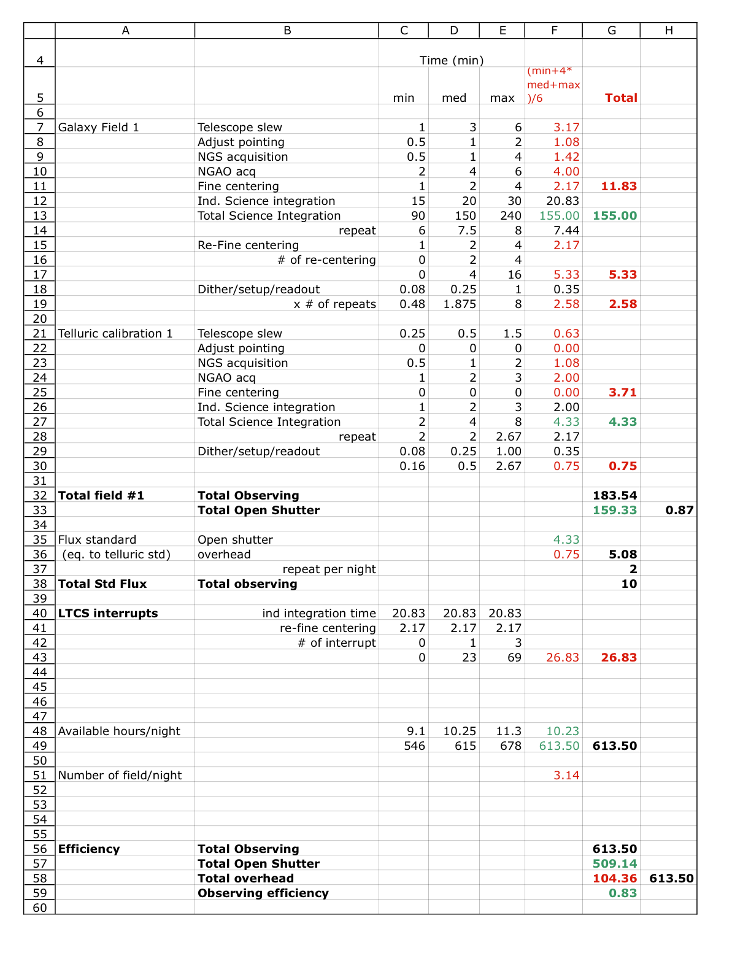
Figure 44. Efficiency estimate for the high-z galaxies science case.

The planned LCH requests for closure on a specific target direction can be included the observing planning tool and can result in minimal impact on the observing time losses as long as they are less than 10 min and rare. LCH closure requests were rare and insignificant from 2003 to 2007. LCH has recently released its new “SPIRAL 3” software that uses new rules for possible laser impact (not documented), a half-cone angle of 1.5º for the no-propagation zone and estimates no-propagation time windows for a particular direction. This has resulted in a dramatic increase of up to hundreds of events per night. The preliminary assessment of the new operation mode for the LCH is documented in KAON 578. Tools have been developed by the WMKO AO operations team to minimize the impact. As it stands, this new LCH closures rate would significantly impact NGAO observing efficiency for extragalactic targets. This issue is being addressed by WMKO in collaboration with other Observatories and will require more attention for NGAO.

Last minute phone call request for no-propagation from LCH have a huge impact on efficiency for the given night since this stops all LGS operations for a certain time period. This happens ~ 5 times per year when using LGS 140 nights/year. Last but not least, the ability to abort a science exposure quickly and either get ready for a new exposure or move to a new target faster should contribute to reduce the impact from LTCS events.

Conceptual Design for System Operations

Operation Control Infrastructure
For a given observing model, the observing efficiency is the important design requirement for the individual components (e.g., reading out the camera) nut mostly for the integrated system (e.g., offset to sky). The current Keck II LGS system feeding NIRC2 or OSIRIS performs routinely with ~ 30 - 50% overhead depending on the science program (KAON 463). Its limited efficiency as an integrated system is primarily due to the serial architecture for the command interfaces between subsystems (AO/laser/telescope/science instruments) and the lack of multi-system coordination sequences.

To address the efficiency requirement with NGAO as an integrated system, we are proposing a new integrated design. Our conceptual design includes 1) a multi-system sequencer for commanding the sub-systems in parallel (e.g., offset the telescope as the science instrument write the FITS file to disk) and 2) a sequencer for each subsystem (AO, laser, science instrument) to quickly and reliably handle complex command for a given subsystem (e.g., set AO subsystem for NGS field acquisition).

The overall control infrastructure is documented in KAON 569. The three main components of the NGAO science operations are:
- The Pre- and Post- Observing Tools
- The Operation Control GUIs
- The Multi-system Command Sequencer

In Figure 45, we present a block diagram for the science operations architecture using a view that complements the architecture information from KAON 569. The configuration for the NGAO and the science instrument depends on the science program and the observing strategy and is determined during the pre-observing phases. Using a set of planning tools, the astronomer will develop the detailed observing plan and save all relevant parameters in configuration files. These configuration files can be loaded by the Operation Control GUIs. From the Operation Control GUIs, the operator and the observer will command & control the observation sequences: AO & science acquisition, system tune-up, observing sequences (snapi, dither, offset, filter, etc). The observation sequences are managed by the Multi-system Command Sequencer (MCS): complex sequences for one subsystem are handled by the subsystem sequencer (e.g., “setup AO bench for NGS” is performed by the AO sequencer) or executed directly from the MCS for simple command.

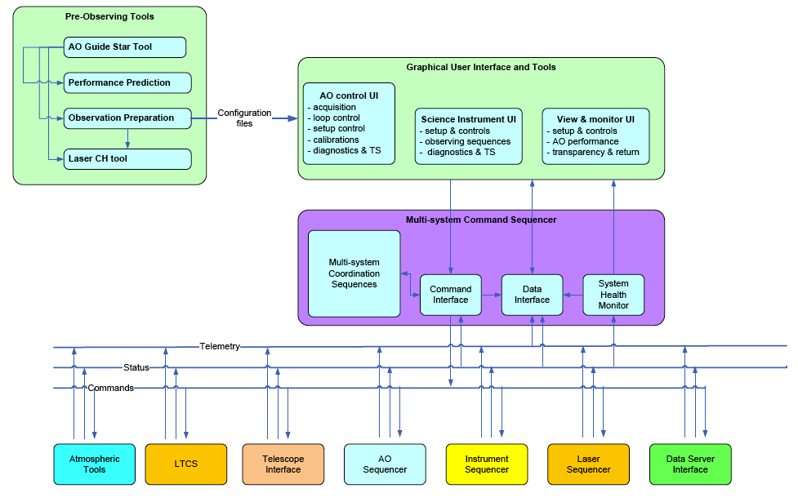
Figure 45. Science operations tools block diagram.

The post-observing tools have been omitted in Figure 45. The pre- and post- observing tools are described in more detail in the next section.

System Configurations Matrix
The purpose of the system configuration matrix is to help map requirements to components. The NGAO system configuration is shown in Figure 46. It represents a total of 5 different configurations in NGS mode and 6 in LGS mode for acquisition, calibrations and science observations with the science instruments (interferometer, imager, IFS). Some of the configurations include more options (e.g., rotator mode in fixed field or fixed pupil). This matrix is also key to the design the sequences of commands to the subsystems and individual components during calibrations, setup and observing sequences.
Figure 46. NGAO system configurations.

System Calibration: Routine and Maintenance Calibrations
The calibrations include 1) routine calibrations, and 2) maintenance calibrations. The routine calibrations are calibrations that are required on run-to-run or night-to-night basis such as fine laser alignment and power calibrations, DM to lenslet registration, non-common path aberrations, etc. The maintenance calibrations are performed following a schedule and may include detector response, noise and offsets calibrations, TT and DM interaction matrices (poke matrices), motion control tune-ups, throughput, etc.

We anticipate that the daily calibrations will be performed by the observing support team using the high-level science operation tools. The maintenance calibrations may be implemented at the sub-sequencer level when applicable. The corresponding calibration sequences will be coded and implemented at the MCS and/or at the subsystem sequencer level. Note that the use of the keyword architecture as currently implemented at Keck will allow the scientists to easily prototype and validate the calibration algorithm using their programming language of choice during the I&T phases.

System Operations: Acquisition
The NGS and LGS acquisition requirements and conceptual design are discussed in KAON 567. This includes a trade study between near-IR and visible detector technologies that found that a commercial CCD is sufficient for the NGS acquisition task. The NGS acquisition will also rely on data retrieval from multi-color astronomical catalogs (USNO-B, GCS-II and SDSS). KAON 567 lists and studies the possible risks during the acquisition process. The specifications for the acquisition conceptual design are presented in Table 7.

Table 7. Acquisition conceptual design level specifications.
Title | Specifications
Field of view | ≥ 120"
IR field identification | a) Image sources in the near-IR (1.0-2.0 µm)  b) Image sources in the visible (0.5-1.0 µm)  In both cases, use supplementary information about target locations from catalogs and surveys
Point source sensitivity | V=22 or J=19, exposure ≤ 10 s, SNR ≥ 10
Position accuracy | ≤ 0.050" rms, random errors in determining source positions in an acquisition camera image
Minimal time overheads | Total acquisition process time typically < 50 s, worst case < 120 s. Includes time for telescope moves, camera exposure, and analysis.
Photometric imagery | Photometric error of 0.2 magnitudes, in standard astronomical bands such as Johnson, UKIDDS, or SDSS
Registration accuracy | ≤ 0.020" rms, random error in determining positions of acquisition camera with respect to telescope optical axis
Diagnostics and troubleshooting tools | Report metrics for automatic acquisition and to aid observer decision-making, including manual override by astronomer or observing assistant
Data products | Store acquisition images as FITS files, and appropriate diagnostics, in the NGAO data server
Interface to observer planning tools | Acquisition software will receive target information from the NGAO observer planning tools
Guiding mode | Used for testing when wavefront sensors not available

The telescope pointing accuracy is currently the largest risk for the observing efficiency. The observing efficiency budget depends on the brightness of the NGS and acknowledges the difficulty of acquiring fainter stars. A single camera design is feasible for LGS and NGS acquisition using a CCD sensor. High level requirements and interfaces to other NGAO subsystems are also discussed in KAON 567.

Table 8 presents a generic description for the acquisition sequence for NGAO with an emphasis on the parallel steps. The NGAO planning tools will assist the astronomer to select the next science target. All relevant configuration information will be loaded by the Operation Control (OC) tools.

Table 8. Generic NGAO Acquisition Scenario.
Step | Observing Step | Parallel Steps | Remarks
0 | Select next target:  - assess science priority  - check target elevation range  - check observing conditions  - check LTCS conditions | Complete integration on current science target or calibrator. When target selected from Planning Tools, then information is loaded in OC tools. | It is not clear yet whether the astronomer will have to run these checks manually or whether it will be automated.
1 | Upon completion of readout of science array, LGS is shuttered, AO loops open and key-system feedback parameters are saved then the operation control tools trigger the telescope slew. | OC tools parses information, and get ready for execution:  - NGS parameters for acquisition  - AO configuration  - Instrument configuration
2 | Telescope slews | The OC tools send commands to the multi-system sequencer. Setup sequences are executed as appropriate by the AO, laser & science instrument sequencers.
3 | Telescope Pointing Adjustment on one of the NGS (brightness allowing). This step is automatically performed by the NGS acquisition subsystem with the visual check of the Observing Assistant (OA). Upon success, pointing corrections are applied and next telescope slew is commanded from the OC tools. | There is no need to use the acquisition camera for the LGS acquisition: LGS pointing model is accurate enough to get all laser spots centered within the capture range for the HO WFS. | This step may be required only when the NGS V>18 mag. (TBC) or when the telescope slews by more than xº in elevation/azimuth range.
4 | Telescope coarse registration on the science field. NGS acquisition subsystem runs an automated routine to record and process image, ID the NGS in the field with respect to catalog data then compute required offset. Visual check of process by OA. Upon success, position offsets are applied to telescope. | LGS propagation and acquisition steps initiated.  Laser pointing correction and uplink TT correction loops closed with very low gain.  Pickoff mirror positioning and LOWFS setup complete including background. | Need to implement the acquisition for the vibration/wind shake reference. Need additional study for telescope guiding. Not clear if the HOWFS will require a background.
5 | Telescope fine registration on the science field: If photons not detected at the expected SNR on the LOWFS (or NGS not on Pointing Origin), then NGS acquisition subsystem runs a 2nd iteration. Visual check of process by OA. Iterate if necessary (to be detailed). Upon completion adjust telescope pointing model. | Pick-off mirrors for science and TWFS in position | Need to check the conditions for the dichroic during this step. Need to be able to adjust pointing model for telescope even though PO != REF.
6 | AO subsystem control:  1) low gain on woofer & MEMs,  2) increase gain on UT,  3) start telescope guiding,  4) adjust woofer & MEMs gain,  5) initiate TWFS + tomography optimization | Science instrument is setup: optics and read modes are set and confirmed.  May record first exposure to check centering with point-source and expected SNR/coadd.  Monitor image quality and assess optimization progress. | UTT acquisition requires more design. Assuming redundant information from USNO-B, GSC-II & SDSS uncertainty in field centering should be < 0.2".
7 | Science integration starts

The main contributions to the centering error budget during NGAO acquisition in LGS mode are:

- The accuracy for the knowledge of the separation distance and position angle between the stars and the galaxies from the literature. This information is provided by the astronomer, and can be < 0.01" if the field has been observed (recently) with HST cameras. The USNO-B on-line catalog provides an astrometric accuracy of 0.2", and the astrometric solution for the USNO-B, GSC-II and SDSS catalogs are improved as the proper motions are being calibrated using GSC-I (KAON 467).
- The pickoff arm positioning accuracy for each science target with respect to the TT closed-loop reference position for the LOWFS, which is the total of:
  - The internal positioning accuracy and position stability for each individual pick-off arm (science and LOWFS) – the requirement is ≤ 0.005" (KAON 548)
  - Registration accuracy and stability between LOWFS and science arms including TT stage positioning accuracy.
- The differential atmospheric refraction between the LOWFS and the science instrument.
- The total contribution from the optical distortions due to thermal gradient, alignment error, woofer and MEMs positioning between the science array and the LOWFS.

The LOWFS and LGS object selection mechanism study (KAON 559) shows that the positioning accuracy requirement can be met.

System Operations: Dithering and Offsetting
Several approaches to dithering and offsetting were proposed and discussed in KAON 558. The rationale for reviewing the dithering and offsetting scenarios comes from the important overhead (~30 seconds per move) it currently takes to perform these important observing steps.

The selected approach recommends avoiding any telescope move and AO pause/resume sequence, unless necessary. Most field repositioning on the science array is performed to account for pixel/spaxel response, background emission or super-sampling and are of relatively small amplitude (< 2"). They could be performed by a tilt on the second-relay MEMS. This implementation would leave the LOWFS, TWFS and LGS WFS closed during the entire observing sequence, and would allow for maximum flexibility and efficiency for centering the science target, tracking, correcting for DAR, etc. We believe that these internal optics have the required pointing accuracy and could result in minimal overhead (< 5 second).

An alternate scenario that still does not require the telescope to move would require a global tilt on the woofer, and a counter motion for the LOWFS/TWFS, LGS WFS probe arms. This requires pausing and resuming the AO operations and may require ~ 5 to 10 seconds.

Alternatively, offsets of larger amplitude are performed by requesting a telescope offset, repositioning the probe arms at a different field location and re-acquiring the guide stars on the AO sensors. This may take about ~ 15 to 30 seconds depending on the detailed implementation.

We are confident that the combination of these three scenarios with the possibility of parallel commands to different subsystems will address the efficiency requirement for dithers and offset for the key science cases.

System Control
The high-level control of the system is performed through the Operation Control GUIs and executed by the Multi-system Command Sequencer (MCS). A schematic view for these controls was presented in Figure 45.

Multi-System Command Sequencer
The MCS is the main interface between the Operation Control GUIs (configured and controlled the by AO operator, the expert user and the observer) and the control of each subsystem. The important design concept we have opted for, is to have all complex observing sequences under a central supervisory control system that will send and coordinate commands with the AO, Laser, science instrument(s) and other subsystems. The architecture for the MCS follows the design for the subsystem sequencer (see KAON 569 and section 3.5.2.2.1.1).

The MCS has four main components: a library of multi-system coordination sequences, a command interface, a data interface and a system health monitor. The functions of these four main components are as follows:
      - Multi-system coordination sequences. The multi-system coordination sequences are a collection of functions which implement complex sequences of commands for the underlying control subsystems (AO, Laser, etc). A multi-system coordination sequence allows the user to send a simple command to the MCS, while it commands and coordinates all of the many tasks required by this command and returns the status to the user. The coordination sequence receives a command from the user and then sends multiple commands appropriate for the task to be accomplished to the underlying multi-systems using the main command interface discussed below. Examples are: the LGS setup sequence that is used during slew to startup, initialize and setup AO, Laser and science instrument for the next LGS acquisition sequence. A key task during the PD phase will be to identify all of the coordination sequences required for the MCS and to specify their requirements. Note that we will likely require some flexibility in the management of this sequence library as we plan to add sequences to the library, mostly diagnostic and troubleshooting sequences, during the I&T and early operation phases of the system. The reliability and efficiency of the NGAO operations strongly rely on the successful implementation of the multi-system coordination sequences.
      - Command interface (see Section 3.5.2.2.1.1).
      - Data interface (see Section 3.5.2.2.1.1).
      - System health monitor. The system health monitor is a task that monitors the status of the MCS functions and tasks.

Operation Control (Graphical) User Interfaces
The operation control GUI is the main interface between the Users (AO operator, expert user and observer) and the control of components and execution of sequences with the NGAO and science instrument.

The detailed design for the operation control GUIs for the science instruments will be defined in the science instrument manual. We will work with the science instrument teams to define a common design for the interface between the NGAO science operations GUI and the science instrument GUIs.

We have opted for the following preliminary set of design choices:
- The GUIs will be modular (as shown in Figure 45) and include three main parent components: 1) NGAO controls, 2) science instrument controls and views, and 3) system-view and performance monitoring displays.
- The implementation of these tools should be fully compatible with the pre- and post- observing tools.
- The standard practice in the observatories (Gemini, ESO, STScI, Keck) for the implementation of these operation tools is to use Java and XML programming languages. We would recommend using these standard practices and other similar ones being developed in the context of Virtual Observatories (VO) and National VO.
- Several GUIs may be required during the operations per parent component. We will attempt to limit the total numbers of GUIs. Due to the limited integrated software development, our current LGSAO control includes as many as 30 displays and leads to some confusion during LGS operations.
- The control GUIs will include two types of command controls: controls for direct commands with no parameters e.g., open AO loops, (re-)close AO loops and controls for more complex commands requiring some parameters e.g., an acquisition sequence using a configuration file.
- The operation control GUIs will be designed to be users-friendly and include/display the minimal complexity. All complex commands will be implemented at the lower levels in the MCS and subsystem sequencers. Additional complex commands could be controlled using from specific call to a different set of GUIs (e.g., a somewhat complex calibration widget could be called from the NGAO GUI).
- The user can select the parameters for complex command either by loading a previously saved configuration file (these configuration files are also the outputs of the planning tools) or by manually entering values in the configuration fields.

Pre and Post-Observing Tools

Pre-Observing Tools
The pre-observing tools will allow the observer to simulate, evaluate and plan for an observing program using the NGAO and the science instrument(s) any time prior to the observations, particularly during the observing time proposal submission process. The astronomer will likely go through a second phase of observation planning in the month prior to, and days leading to the observations. During the observing night, the observer may use the same sets of tools to check and refine the observing strategy, if necessary.

The pre-observing tools are:
- The AO Guide Star Tool to search adequate astronomical catalogs for natural guide sources, identify and select them, and save all relevant information on the NGS and the science field required to simulate and acquire the target.
- The NGAO Simulation tool to estimate the NGAO performance in terms of Strehl ratio, encircled energy, full-width at half-maximum, etc as a function of the NGAO mode and setup.
- The Exposure Time Calculator to estimate the SNR / seconds and dominant noise regime for the science instruments.
- The Observation Preparation tool to prepare, review and save the observing sequences and estimate the observing efficiency.
- The Laser Clearinghouse Planning tool to automate the coordination tasks with the laser clearinghouse.

The requirements for these tools are a combination of derived-requirements from the science cases (KAON 456) and operational requirements (KAON 456). A block diagram for the pre-observing tools architecture design was shown in Figure 45. KAON 577 presents the System Design Report for the pre-observing tools.

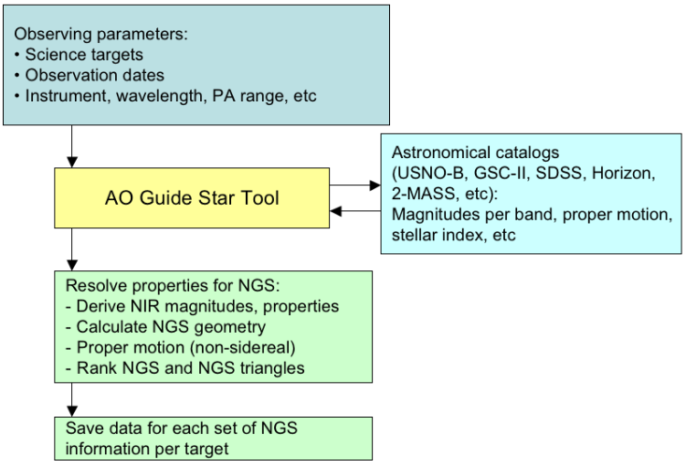
Figure 47. AO guide star tool workflow.

During the proposal phase, the AO Guide Star, the Performance Estimator, the Exposure Time Calculator and the Observation Preparation tools needs to assist the astronomer in identifying suitable Guide Stars and providing a first order estimate for the image quality, the exposure time and expected SNR and the observing strategy, given a basic science instrument setup. The information saved by the user might be inserted in the technical justification of the proposal. The tools need to be user friendly and easily portable on most computer’s OS.

During the detailed observation planning, the same tools will be used to evaluate, optimize and prepare the observations sequences. The output parameters for the guide stars and instrument configurations will be saved in a format shared by the NGAO observing tools. The information will be loaded by the observing tools during night time operations.

Finally, during the observations, these tools may be used to preview and assist the on-going observations and for any on-the-fly change to the observing strategy.

Figure 47, Figure 48 and Figure 49 succinctly present the workflow for the AO guide star tool, the performance simulation and exposure time calculator, and the observation preparation tools, respectively.

The AO Guide Star Tool is used for both LGS and NGS cases. It is a versatile tool that will make request to astronomical catalogs, resolve target names, find and select AO guide stars for the NGAO science cases based on their derived NIR brightness and save the results. It is required to find a single star for NGS and sets of triplets for LGS. The sets of triplets will be ranked according to the estimated total residual error on the estimation of the TT mode and quadratic null modes. The results will be saved in the valid format for the telescope and the tools.

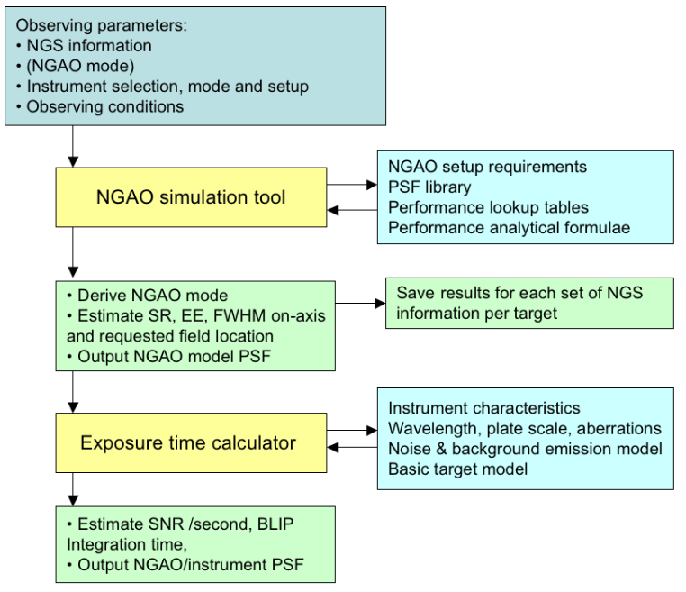
Figure 48. NGAO performance estimation tool and exposure time calculator workflow.

The NGAO performance estimation tool will take as inputs the AO Guide Star(s) information, the AO mode, the selected instrument and the (anticipated) observing conditions. As it will run on the host computer, or through a web-server, it will not be able to (re-)run a full NGAO simulation for each new observing program. Instead, it will make use of a combination of PSF libraries, performance lookup tables and analytical formulae to estimate AO quantities such as SR, EE, FWHM and possibly a 2-D NGAO model PSF for the science field(s). The tool will allow the user to compare performance results from different AO Guide Star(s) and different LGS asterisms configuration. The output results and the parameters used for the simulation will be saved in a file. The parameters and the algorithm for the simulation tools are yet to be defined.

Once the AO performance has been estimated it is then possible to calculate the exposure time to achieve a desired SNR given the instrument selection and setup, the detector read mode, a model for the noise and background emission, as well as a (simple) flux distribution model for the target. The tool will also estimate the background limited performance time and check that the detector is used in its linear range.

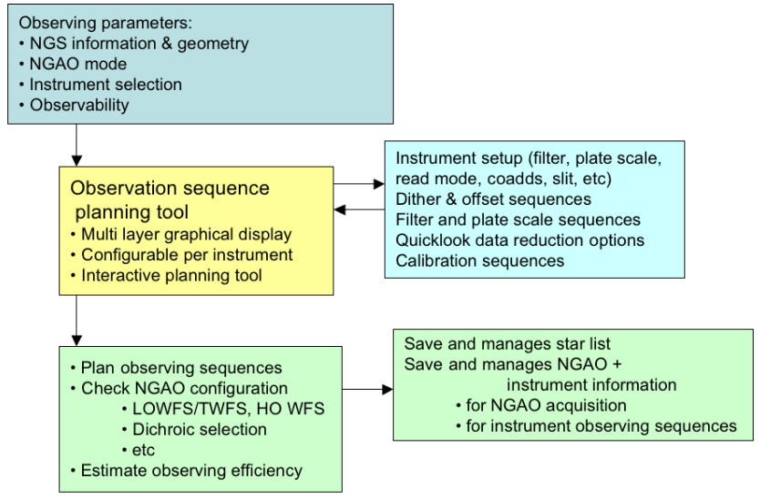
Figure 49. Observation preparation tool workflow.

The observation preparation tool will take as inputs the information from the selected AO guide star(s), the NGAO mode, the instrument selection and when required, the observability of the target. The astronomer will define the parameters for the observing sequences that are possible for this observing mode. The tool will check the NGAO configuration e.g., dichroic configuration and expected NGS flux on the LOWFS compatible with the selected observing wavelength. The parameters to be set for the observing sequences are yet to be defined. The tools are anticipated to allow for flexible and versatile use of the instrument. The configuration for the observing sequences will be saved in files that will be loaded at the time of the observations. We have yet to define how these files will be managed. A manual management for these various configuration files (guide star and science targets information, NGAO configuration, instrument configuration, observing sequence information, etc) could lead to confusion. We will consider implementing an automated file management from the observing proposal phase to the final execution at the telescope.

Post-observing Tools
The post-observing tools and interfaces are:
- Data quality metrics: the purpose of this tool is to reduce and analyze data collected during the observations and output quantities such as total residual wavefront error, seeing, photometric stability, Na return, observing efficiency, etc. These quantities have yet to be defined during the PD and DD phases. The results will be saved and stored with the final data product.
- Data product management tool: the observer and the support staff will use this tool to define which data needs to be saved and stored with the science data. This data product management may also help manage the data that does not need to be stored and can be deleted.
- PSF reconstruction tool: based on the WFC data stored on the data server, the C_{n}² information, and other system parameters the PSF reconstruction tool will provide an estimate for the PSF in specific locations in the science field. The algorithms for the PSF reconstruction are yet to be defined. We have started the development of a prototype algorithm for the current NGS and LGS system for the on-axis and off-axis cases.

Science Instruments

Overview
The observing capabilities identified in the NGAO science cases are understood to result in the need for low background moderate resolution (R~ 3000 to 5000) spectroscopy and well sampled diffraction limited imaging over the full NGAO wavelength range.

While some science cases can be satisfied with a slit spectrograph, it appears that IFU spectroscopy with spatial sampling scales down to the diffraction limit can satisfy those science cases as well as meet a common need for spatially resolved spectroscopy to support velocity determinations in various kinds of kinematic studies.

The key impacts of the NGAO system design on instrumentation are the wide wavelength coverage offered by the system, and the availability of two AO corrected science fields. The high order AO relay offers a 30" FOV (referred to as the “narrow field” or “second” relay) with essentially diffraction-limited performance in the near-IR. The basic optical characteristics for the narrow field relay are defined in Table 9. Additional details on the instrument interface definitions may be found in KAON-555.

NGAO is expected to support science observations over the wavelength range of 0.8 to 2.4 μm. In addition there is a goal of reaching the Hα line at ~656.3 nm with useful Strehl (>10%) and reasonable throughput.

Table 9: Narrow field relay optical characteristics
Parameter | Min. | Typ. | Max. | Units | Notes
FOV (diameter) | 30 | - | - | " | 1
Focal ratio | - | ƒ/46.5 | - | N/A
Plate scale | - | 0.4436 | - | "/mm
Focal plane radius of curvature | - | -277.53 | - | mm | 2
Wavelength range | 0.680 | - | 2.40 | μm | 3,4
Transmission | 75 | - | - | % | 5
Pupil telecentricity | 100 | - | - | % | 6

Notes:
- Unvignetted field of view.
- Positive radius of curvature describes an AO relay output focal plane where a given point in the AO relay output focal plane not located on the optical axis is displaced in the +z direction away from the AO relay focal plane. This value is correct for the NGAO Zemax model “KNGAO_2-tier_folded-2nd-relay_v4_wtelescope.ZMX”.
- Goal range of 0.620 μm to 2.40 μm.
- This definition is consistent with KAON-530.
- From the output of the telescope (Nasmyth focus) to the output of the high order AO relay.
- At all field points over the unvignetted FOV.

The proposed instruments for the narrow field relay are an imager and an IFS.

As discussed in the following sections, performance improvements in both CCDs and IR arrays allows some interesting and potentially useful overlap in wavelength coverage in the vicinity of 1 μm. As a consequence the narrow field relay passbands defined for near-IR and visible wavelength observing are specified with an overlap to allow instruments to take advantage of the opportunities in this wavelength range.

The resulting NGAO system passbands are shown in Figure 50 along with the NGAO nominal observing bands. The cut-on and cut-off (50% points) wavelengths are summarized in Table 10. Additional details on the NGAO passband definitions may be found in KAON-530.
NGAO near-IR
NGAO visible
NGAO rl
NGAO i'
NGAO z'
NGAO
z spec
K
Y
J
H

Figure 50: NGAO Passbands

Table 10: NGAO system passband and observing band characteristics
Passband name | Cut-on λ (μm) | Cut-off λ (μm) | Notes
NGAO Visible | 0.68 (0.62 goal) | 1.07 | Goal is useful Strehl at Hα
NGAO rl | 0.620 | 0.689 | rl = “r band long”, cut-on may be set higher depending on filter characteristics
NGAO i' | 0.702 | 0.853 | SDSS i' band
NGAO z' | 0.818 | 0.922 | SDSS z' band
NGAO z spec | 0.855 | 1.050 | Custom NGAO z band for spectroscopy
NGAO Near-IR | 0.97 | 2.40
NGAO Y | 0.970 | 1.07 | UKIDSS photometric
NGAO Y spec | 0.970 | 1.120
NGAO J | 1.170 | 1.330 | UKIDSS/Mauna Kea photometric
NGAO J spec | 1.100 | 1.400
NGAO H | 1.490 | 1.780 | UKIDSS/Mauna Kea photometric
NGAO H spec | 1.475 | 1.825
NGAO K | 2.030 | 2.370 | UKIDSS/Mauna Kea photometric
NGAO K spec | 2.000 | 2.400

The narrow field instruments will address a wide range of science cases, including extragalactic science (quasar host galaxies, galaxy scale lensing, nearby AGNs), Galactic science (Galactic center, extrasolar planets,) and planetary science. Accommodating this diverse range of observations necessitates some compromises, but throughout the development of the narrow field instruments the primary goal will be to balance and optimize each of the science driven requirements for these instruments in order to best serve all of the science cases.

Performance improvements in both CCDs and IR arrays have resulted in the possibility of using substrate removed IR arrays into the upper part of the visible wavelength range, and thick substrate CCDs allow exceptional QE in the 800 to 1000 nm range without detectable fringing. As a consequence we have selected as the baseline detectors for instrumentation HgCdTe infrared arrays.

Specifically the current instrument concepts employ the following detector: Teledyne Scientific & Imaging MBE processed substrate-removed HgCdTe Hawaii-2RG (H2RG) 2k x 2k and Hawaii-4RG (H4RG) 4k x 4k infrared arrays.

For the purposes of this discussion the portion of the QE curve that we are concerned with is the cut-on and cut-off wavelengths of the near-IR detectors. Cut-on wavelength is defined here as the wavelength where the detector’s QE rises to 50% of the mean detector QE. Cut-off wavelength is defined here as the wavelength where the detector’s QE drops to 50% of the mean detector QE. The QE curve is shown in Figure 51. The substrate-removed versions of the H2RG have useful QE throughout our wavelength range of interest.

Figure 51: Detector QE cut-on and cut-off characteristics

Imager

Requirements
The science driven requirements for the imager are summarized in Table 11.

Table 11: Summary of the near-IR imager science driven requirements
Performance requirements | Value(s)
Wavelength range | 0.97 to 2.45 μm (Y, J, H, K bands)
FOV | 30"
Pixel scales | 10 mas (2 pixel sampling in Y band)  6.7 mas (3 pixel sampling in Y band)
Background | <30% over the unattenuated background from sky+telescope, goal of <20%
Observing modes
Imaging | Adjustable Lyot stop
Coronagraphy | 6λ/D apodized pupil Lyot coronagraph
Filters | Photometric Y, J, H, K, also K', Ks, narrow band TBD

The imager is intended to provide well sampled diffraction limited imaging over the NGAO narrow field FOV of 30" diameter. For simplicity and stability there is a strong goal to have a fixed plate scale. While many science cases are satisfied by 2 pixel sampling, the minor planets science cases have a preference for 3 pixel sampling. Since the available detectors have square areas, and the narrow field FOV is circular, we have the usual choice of an inscribed or exscribed detector area. Two options are illustrated in Figure 52, one using a H2RG, and the other using a H4RG.

Figure 52: Imager FOV options
(All dimensions in arc seconds)

As can be appreciated the choice of 3 pixel sampling at the Y band cut off is just one of the possibilities in the trade space of sampling and FOV. For example, selecting the J band cut off results in a 33" x 33" FOV for 3 pixel sampling, and is a little more than 2 pixel sampling at the Y band cut off. This is clearly an area where a trade study involving further simulations to optimize the sampling will be required.

The high contrast science cases, primarily extrasolar planets, require a standard performance coronagraph. A study of NGAO high-contrast and companion sensitivity (KAON-497) examined the apodized pupil Lyot coronagraph over a range of occulting spot sizes from 6λ/D to 14 λ/D. The study was not optimistic for some of the more demanding extrasolar planet cases, but concluded that with excellent control of static non-common path aberrations, as well has highly precise PSF subtraction at least 50% of the science cases were achievable at the 6 to 8 σ confidence level.

Instrument Concept
The imager concept is illustrated in Figure 53. The imager is fully cryogenic instrument with refractive optics.

Figure 53: Near-IR imager block diagram

The NGAO focal plane is located inside the dewar where a focal plane baffle is followed by a refractive relay that images the focal plane on a deployable apodized occulting spot. The beam is then collimated and passes through an adjustable Lyot stop located at the pupil plane, followed by the filter wheels. The pupil image is ~68 mm in diameter, with the filters slightly oversize at 70 mm clear aperture. A filter wheel ~260 mm in diameter will accommodate six filters, allowing 2 wheels to support a total of 12 filters. Although the Lyot stop is currently envisioned as circular, it is also possible to provide a hexagonal mask with serrations to match the Keck telescope pupil.

Assuming a H4RG detector with 10 micron pixels, the camera will operate at ~ ƒ/31.

Additional features of the design will include a pupil imaging mode to ensure accurate registration to the AO pupil image, and provisions for calibration of instrument wavefront error to aid in optimizing non-common path errors.

Locating the instrument on the NGAO bench optimizes the stability with respect to the AO system, but places additional demands on the performance of vibration isolation for the closed cycle cooling system. This requirement can be met by a pulse tube cooler.

With the exception of the tolerances for the coronagraph, the instrument is relatively straightforward and can make use of heritage designs from earlier WMKO instruments, particularly OSIRIS and MOSFIRE. Both OSIRIS and MOSFIRE use the same basic mechanism design for filter wheels (although MOSFIRE’s are much larger), and MOSFIRE also has an adjustable pupil mask. MOSFIRE uses a H-2RG detector with the Teledyne Sidecar ASIC for readout, and the complete mounting and interconnection design should be able to be reused with minor adjustments for the H-4RG in the NGAO near-IR imager.

Similarly, software based on the MOSFIRE heritage can be used for keyword level control of the near-IR imager, and existing tools are available for image display. A number of science cases have specialized data reduction needs, and further consideration of the optimal way to provide data reduction tools will be required.

Integral Field Spectrograph
Studies of the Galactic center and several of the planetary science cases have a requirement for a near-IR IFS operating at the diffraction limit provided by the narrow field relay. The science driven requirements for this instrument are summarized in Table 12.

Table 12: Summary of the single object near-IR IFU science driven requirements
Performance requirements | Value(s)
Wavelength range | 0.97 to 2.45 μm (Y, J, H, K bands)
Spatial Sampling | 20 mas (λ/D in Y band)  35 mas (λ/D at ~mid-H band)
Field of view | 1" x 1" up to 4" x 4"
Background | <30% over the unattenuated background from sky+telescope, goal of <20%
Observing modes
Spectroscopy
Spectral resolution | R ~ 3,000 to 4,000, goal of R ~ 15,000
Sampling | ~2000 pixels per spectra
Filters | Spectrometer Y, J, H, K, narrow band TBD

Interferometer
It is a requirement for the Interferometer to be supported by AO on both telescopes in the NGAO era. This could be a direct feed from NGAO, most likely after the first relay, or by a separate AO system, which imposes a requirement on being able to exchange AO systems. A trade study was performed on the issue of Keck Interferometer support that is documented in KAON 483. The primary requirements are to achieve at least the current level of performance while maintaining a common field orientation and polarization from both telescopes.

‘OHANA
Both existing Keck AO systems accommodate an ‘OHANA fiber injection module at the output of the AO systems. NGAO should provide an output port where this or a similar fiber injection module could be located, and whose output could be successfully interfered with the light from another telescope.

Thermal NIR Imager
A thermal NIR imager has not been given a high priority and therefore no significant evaluation has occurred for this instrument. An evaluation of the reuse of NIRC2, which extends out to L and M-bands, was performed as part of KAON 493.

References
- Hewett, P. C.; Warren, S. J.; Leggett, S. K.; Hodgkin, S. T., “The UKIRT Infrared Deep Sky Survey ZY JHK photometric system: passbands and synthetic colours,” MNRAS, Volume 367, Issue 2, pp. 454-468, 2006 RAS.

- Tokunaga, A. T.; Simons, D. A.; Vacca, W. D., “The Mauna Kea Observatories Near-Infrared Filter Set II. Specifications for a New JHKL'M' Filter Set for Infrared Astronomy,” PASP, Volume 114, Issue 792, pp. 180-186, 2002 The Astronomical Society of the Pacific.

- Robert J. Thornton, Jr., Jeffrey Douglass, Klaus Hodapp, Tony Young, and Hubert Yamada “Gemini near-infrared imager on-instrument wavefront sensor gimbal tilt stage,” Proceedings of the SPIE Volume 3354, Infrared Astronomical Instrumentation, pp. 187-200, SPIE 1998.

- Sharples, Ray; Bender, Ralf; Bennett, Richard; Burch, Keith; Carter, Paul; Casali, Mark; Clark, Paul; Content, Robert; Davies, Richard; Davies, Roger; Dubbeldam, Marc; Finger, Gert; Genzel, Reinhard; Haefner, Reinhold; Hess, Achim; Kissler-Patig, Markus; Laidlaw, Ken; Lehnert, Matt; Lewis, Ian; Moorwood, Alan; Muschielok, Bernard; Förster Schreiber, Natascha; Pirard, Jeff; Ramsay Howat, Suzanne; Rees, Phil; Richter, Josef; Robertson, David; Robson, Ian; Saglia, Roberto; Tecza, Matthias; Thatte, Naranjan; Todd, Stephen; Wegner, Michael, “Design of the KMOS multi-object integral-field spectrograph,” Proceedings of the SPIE Volume 6269, Ground-based Instrumentation for Astronomy, pp. 62691C, SPIE 2006.

- Dowling, M.; McMahon, P.; Ramsay Howat, S.; Robertson, D. J.; Parr-Burmann, P.; Sharples, R.; Cunnigham, C.; Dickson, C.; Schmoll, J.; Hastings, P.; Lee, D.; Luke, P.; Phillips, N.; Wells, M.; Dipper, N., “A prototype cryogenic pickoff arm for multi-IFU spectrometers,” Proceedings of the 11th European Space Mechanisms and Tribology Symposium, ESA SP-591, pp. 289 – 297, 2005.

- Sharples, Ray M.; Bender, Ralf; Lehnert, Matthew D.; Ramsay Howat, Suzanne K.; Bremer, M. N.; Davies, Roger L.; Genzel, Reinhard; Hofmann, Reiner; Ivison, Rob J.; Saglia, R.; Thatte, Niranjan A., “KMOS: an infrared multiple-object integral field spectrograph for the ESO VLT,” Proceedings of the SPIE, Volume 5492, Ground-based Instrumentation for Astronomy, pp. 1179-1186, SPIE 2004.

- Content, Robert, “New design for integral field spectroscopy with 8-m telescopes,” Proceedings of the SPIE Volume 2871, Optical Telescopes of Today and Tomorrow, pp. 1295-1305, SPIE 1997.
- Allington-Smith, J. R.; Content, R.; Dubbeldam, C. M.; Robertson, D. J.; Preuss, W., “New techniques for integral field spectroscopy - I. Design, construction and testing of the GNIRS IFU,” MNRAS, 371, 1, pp. 380-394, 2006.

- Content, Robert, “Optical design of the KMOS slicer system,” Proceedings of the SPIE Volume 6269, Ground-based Instrumentation for Astronomy, pp. 62693S, SPIE 2006.

- Figer, Donald F.; Rauscher, Bernard J.; Regan, Michael W.; Morse, Ernie; Balleza, Jesus; Bergeron, Louis; Stockman, H. S., “Independent testing of JWST detector prototypes,” Proceedings of the SPIE, Volume 5167, pp. 270-301, SPIE 2004.

- McClean, I.S., private communication, 2007.

- Stover, R., private communication 2007.

Performance Budgets
In support of the flowdown of requirements from the Science Case and high-level Functional Requirements to component specification, eight system performance metrics were identified in the Science Requirements Document. For three of these metrics, background and transmission, wavefront error and ensquared energy, and high-contrast performance, we have produced associated quantitative performance budgets to identify key performance drivers. For photometric precision, astrometric accuracy, and polarimetry we have identified key drivers and documented these in technical reports that have informed the NGAO design. The final two metrics, observing efficiency and observing uptime, have been given only preliminary consideration and will be further developed in the preliminary design phase.

A concise summary of the various performance budgets developed during the SD phase is presented in KAON 491. The wavefront error / encircled energy budget summary, as modified by the 2009 ‘build-to-cost’ design changes, is documented in KAON 644.

Background and Transmission
The background and transmission performance budget is developed in KAON 501.

Both AO relays must efficiently transmit the science wavelength light from 0.8 to 2.4 μm (with a goal of 0.656 to 2.4 μm, so as to include Hα). The first relay must also efficiently transmit sodium wavelength light (589 nm) and the additional L-band light (3.4 to 4.2 µm) for the interferometer. This wavelength range must be efficiently divided between the various sensors (LGS and tip-tilt) and the instruments.

The transmission budgets developed in TBD take into account all surface counts in the various NGAO system paths. As some resultant NGAO (only) transmissions are:

- K-band Narrow-Field Science Transmission TBD%

Where the science path considered is from before the telescope M1 to the interior of an instrument entrance window, including atmospheric dispersion corrector surfaces. For the high-order LGS wavefront sensor path, we have NGAO (only) transmission:

- 589 nm LGS WFS Transmission TBD%

based on TBD. Excellent coatings and cleanliness will be required for all surfaces.

TBD also contains a detailed analysis of thermal background, particularly for K-band science where the current Keck AO system is known to contribute detrimentally to overall background. The basic result in TBD is that all of the architectures considered for NGAO required approximately the same system cooling, between TBD and TBD to meet science requirements. The design choice we have adopted to achieve the K-band background requirement is to cool the AO optics to TBD K.

The sensitivity delivered by the NGAO system is significantly affected by the total background seen by the instruments. In the present Keck telescope AO systems background is recognized as a significantly limiting sensitivity, particularly for the K-band.

Part of the solution to reducing background is the control of scattered light through careful design and implementation, and the use of hexagonal, rotating cold stops matched to the shape of the telescope pupil in the near-IR instruments. However, thermal emission is a significant factor for near-IR observations, particularly longward of 2 µm. Using data from the current Keck II telescope AO system we have developed a model of the background contributed by sky + telescope + AO system that indicates the AO system optics should be cooled to TBDK.

Wavefront Error and Ensquared Energy
A wavefront error budget for NGAO has been developed using Excel spreadsheet tools developed over several years for the engineering evaluation of AO system performance. The primary purpose of the spreadsheet is to compute AO and instrumental wavefront error budgets for different architectures and science cases, along with Strehl ratios computed using the Marechal approximation. The spreadsheet also computes ensquared energy fractions using a core/halo model for the point spread function, and calculates sky coverage estimates for tip-tilt guide stars employed in LGS architectures from common star density models. The spreadsheet has been validated by comparing the spreadsheet predictions to the current performance of the Keck II LGS AO system with good agreement.

The wavefront error budget is described in KAON 644. The primary tool is an excel spreadsheet. This budget is supported and anchored by a number of KAONs. The atmospheric assumptions summarized in KAON 503 are based on previous seeing studies (KAON 303) and new TMT site monitoring data (KAON 415 and 496). The sodium return assumptions are based on sodium density from Keck LGS photometry (KAON 416), long term LIDAR measurements on Haleakala (KAON 417) and comparisons to measured returns from Gemini and Keck (KAON 419). The wavefront error budget tool has been anchored to the performance of the existing Keck AO system in KAON 461. The contribution of Keck telescope segment figure errors is determined in KAONs 468 and 469, and the overall contribution of the telescope to the wavefront errors is determined in KAON 482. Finally, several tomography codes were compared (KAON 475) in order to validate the tomography assumptions used in the wavefront error budget and the null and quadratic mode tomography errors were evaluated (KAON 492).

Related analyses include sky coverage modeling (KAON 470) and performance versus field of view for low order wavefront sensor guide stars (KAON 504).

In order to test and anchor the NGAO error budget tool, a detailed assessment of the Keck II AO performance was performed in KAON 461. Table 13 from this KAON demonstrates the capability of the NGAO tool to model the Keck II AO performance, albeit under somewhat different conditions and with some unknowns (such as d₀). More recently we have demonstrated that the NGAO tool can be used to accurately model the demonstrated performance of the Keck II AO system after the Next Generation Wavefront Controller upgrade as shown in Table 14. The NGAO tool has also been used in this Table to support predictions of the performance of the Keck I LGS AO upgrade that is currently underway.

 | NGS bright star |  |  | LGS (10th mag) |  |  |  | LGS (18th)
 |  | Meas-ured | NGAO tool |  | Meas-ured | NGAO tool |  | Meas-ured | NGAO tool
Atmospheric fitting |  | 139 | 110 |  | 128 | 110 |  | 128 | 110
Telescope fitting |  | 60 | 66 |  | 60 | 66 |  | 60 | 66
Camera |  | 113 | 110 |  | 113 | 110 |  | 113 | 110
DM bandwidth |  | 103 | 115 |  | 157 | 146 |  | 157 | 146
DM measurement |  | 17 | 16 |  | 142 | 150 |  | 142 | 150
TT bandwidth |  | 75 | 91 |  | 109 | 94 |  | 300 | 243
TT measurement |  | 9 | 5 |  | 23 | 11 |  | 300 | 349
LGS focus error |  | 0 | 0 |  | 36 | 36 |  | 36 | 91
Focal anisoplanatism |  | 0 | 0 |  | 175 | 208 |  | 175 | 208
LGS high-order error |  | 0 | 0 |  | 80 | 80 |  | 80 | 80
Miscellaneous |  | 120 | 0 |  | 120 | 0 |  | 120 | 0
Miscellaneous (NGAO) |  | 0 | 106 |  | 0 | 72 |  | 0 | 72
Calibrations |  | 0 | 30 |  | 0 | 30 |  | 0 | 30
Total wavefront error |  | 258 | 250 |  | 378 | 372 |  | 557 | 563
K-band Strehl |  | 0.58 | 0.57 |  | 0.31 | 0.30 |  | 0.08 | 0.08
Percentile Seeing |  | 75% | 65% |  | 75% | 65% |  | 75% | 65%

Table 13. NGAO error budget tool anchoring to Keck II AO performance.

Error Term | KII NGWFC upgrade | K I (linear pol.) | KI (circular pol.)
Atm. Fitting | 118 | 118 | 118
Tel. Fitting | 66 | 66 | 66
Camera | 110 | 110 | 110
DM Band | 125 | 96 | 88
DM Measure | 152 | 104 | 96
TT band | 102 | 102 | 102
TT measurement | 23 | 23 | 23
LGS focus error | 46 | 19 | 19
Focus Aniso. | 164 | 164 | 164
LGS HO error | 80 | 50 | 50
Miscellaneous | 70 | 70 | 70
Calibrations | 30 | 30 | 30
Total Wavefront Error | 348 | 312 | 306
K band Strehl | 0.37 | 0.45 | 0.46

Table 14. The NGAO error budget tools accurately models the upgraded Keck II AO performance.

Key Flowdowns from the Wavefront Error Budget
The AO system architecture is driven by the required wavefront error and related performance budgets to incorporate a number of innovative subsystems that work together to achieve NGAO science goals for optimized cost and technological risk. Key new features of NGAO include multiple LGS beacons and a corresponding number of LGS wavefront sensors, multiple tip-tilt stars, a tomographic wavefront reconstructor and high order correction.

Although a shallow optimization, we find that TBD actuators are required across the telescope pupil diameter to overcome both atmospheric turbulence and residual figure errors in the Keck telescope primary mirror (see, for example, KAON’s 468 and 469). We believe this is most practically achieved using a small MEMS deformable mirror to correct over a narrow field of view. (A comparison with a large classical DM architecture is presented in KAON 499.) Our requirement for high sky coverage fraction leads us to require a large technical field of view. We considered an entirely open-loop control architecture wherein the LGS beams would see no correction, but determined this to be too risky as we would require extremely linear LGS WFS’s possessing a very large dynamic range To address the problem we adopted a two-stage correction architecture, with a first DM with 20 x 20 actuators providing low order correction for the LGS in a closed loop. A second, MEMS DM is operated in a feed forward or “go to” control mode. We have allocated 40 nm rms to residual go-to control errors (driven primarily by imperfect knowledge of the woofer mirror position). To meet sky coverage goals, we further employ separate, lower order MEMS in each of the tip-tilt sensors.

Our study of the performance of the selected AO system architecture shows that it is quite robust, permitting optimization of the residual wavefront error for a wide range of observing conditions. The spreadsheet tool was configured to optimize the H band Strehl ratio, and certain parameters such as LGS constellation radius, high order update rate, and tip-tilt update rate were allowed to vary within appropriate constraints in order to optimize the Strehl ratio. By allowing for reconfigurable science and LOWFS star laser asterism, we find performance reductions can be mitigated even in poor seeing, low sodium abundance, or in the event of sub-optimal laser power output. An example report from our wavefront error budget tool is shown in Figure 54. Additional examples are provided as an Appendix to this report (section 9).

Figure 54. Science target wavefront error budget for the Kuiper Belt Object Companion Survey Key Science Case. (TBR)

In addition the science target WFE budget, we also maintain a separate WFE error budget for the sharpening of the LOWFS NGS stars. An example of this budget, corresponding to the science case in Figure 54 is shown in Figure 55.

Figure 55. LOWFS NGS wavefront error budget for the KBO Companion Survey Science Case.
The NGS is 35" off-axis. We expect such a star to be sharpened to about 35% J-Strehl using MOAO correction based on multi-LGS tomography. (TBR)

Laser Power considerations
Our error budget analysis indicates that an equivalent of 75W of sodium laser power (assuming an SOR-type laser return per Watt) is sufficient to meet the narrow-field science performance objectives. This power will be divided to form between 7 laser beacons (4 science beacons and 3 point-and-shoot LOWFS beacons).

Performance Summary
A summary of wavefront error performance is presented in Table 15.

Table 15. Wavefront error budget summary for several NGAO science cases.
The performance metric for the high-redshift Galaxies science cases is ensquared energy in a 70 x 70 mas spaxel. For all other cases, it is Strehl ratio. (TBR)

The first column of the table indicates the observing scenario. The second column indicates the integration time assumed for the science exposure. The third column indicates the tip-tilt reference used, and the fourth column gives the diameter of the LGS variable radius constellation. The fifth column indicates the tip-tilt error that results from the assumed angular offset of the tip-tilt star. The sixth column gives the sky coverage fraction over which the tip-tilt error will be less than or equal to the error given in column five. This estimate results from the use of common sky coverage models (Spagna and Bachall-Soneira). The last three columns give the high order wavefront error, the total wavefront error with tip-tilt errors, and the H band Strehl. For the extragalactic case, the figure of merit is ensquared energy rather than residual wavefront error, for the 50 mas spatial sampling of the IFU the ensquared energy is TBD % in K-band.

These results show that the fixed radius LGS constellation and the performance levels assumed for the tomographic wavefront reconstruction, LGS wavefront sensors and near-IR tip-tilt sensors are capable of providing performance that is generally at the level required by the science cases. Initial estimates of NGAO system performance based on laser tomography AO resulted in the adoption of three representative values of residual wavefront error for the science case simulations: 140 nm, 170 nm and 200 nm. This has led to further work to develop additional techniques for performance improvement including the additional three freely positionable LGS and the additional tip-tilt sensors.

The sky coverage fractions required by the extragalactic and Galactic science cases requires optimizing the offset and brightness of the tip-tilt stars. This is accomplished by increasing the faint magnitude limit for tip-tilt stars through the use of tip-tilt sensors operating at near-IR wavelengths combined with MOAO correction using deployable LGS beacons specifically for tip-tilt reference sharpening, and by providing a 120" field of view for tip-tilt star selection.

Photometric Precision
Requirements for photometric measurements in the NGAO science cases range from 0.05 to 0.1 magnitudes in relative photometry, and ≤ 0.05 magnitudes for absolute photometry. The fundamental condition for high photometric accuracy is stability of the PSF. Because of the high Strehl delivered by the NGAO system, a more stable PSF is expected. Many of the science cases that require the highest photometric accuracy are observing a science target of sufficient brightness (H < 16) to permit use of the science target as an on-axis tip-tilt reference, further improving Strehl performance.

Detailed consideration of the physical effects that can degrade NGAO system photometric precision is documented in KAON 474, including AO system performance, stellar crowding, scintillation, atmospheric attenuation, and detector non-uniformities. The key result of KAON 474 is that in order to meet the scientifically required photometric precision, NGAO will need to provide the astronomical user with detailed and reliable information regarding the NGAO point spread function (PSF) on an exposure-by-exposure basis.

We envision ‘on-axis’ PSF information provide by AO system control and sensing telemetry, in the absence of an appropriate stellar point source reference (which if known will always provide a more accurate, direct measure of the PSF). NGAO will also provide an estimate of the field-dependent PSF based upon integrated recording of C_{n}²(h,t) information from the called-for atmospheric profilometer on the Mauna Kea summit ridge. Work at Palomar (Britton 2006) has shown that real time turbulence monitoring giving C_{n}² data during the observation is also useful in improving the results of PSF post processing. This post processing will also be supported by facility PSF deconvolution software.

Astrometric Precision
Astrometry is important for a number of the Galactic and Solar System science cases. The most demanding requirements are for observations of the Galactic Center where precision of 100 μas is required. The current Keck II LGS AO system with the NIRC2 instrument is able to achieve best-case precision of 200 μas. The high Strehl of the NGAO system (~3 times that of the current LGS AO system under similar conditions) will make a significant contribution to improved accuracy of astrometric measurements by reducing source confusion. In addition, studies of the astrometric precision of the current Keck II LGS AO system indicate that geometric distortion, differential tilt anisoplanatism between the science target and off axis tip-tilt stars (increasing with increasing distance between the two), and differential atmospheric refraction all contribute to the error in astrometric measurements.

Detailed consideration of the physical effects degrading astrometric accuracy for NGAO was documented in KAON 480, including differential atmospheric tilt jitter, geometric distortion, atmospheric refraction, and stellar confusion. Better Strehl ratio and point source contrast from NGAO will help overcome astrometric errors due to stellar confusion in crowded fields, as well as improving point source sensitivity for all observations, thus providing a richer reference field for astrometric calibration.

The same features provided to monitor the PSF and monitor atmospheric turbulence for photometric accuracy would contribute to NGAO astrometric precision. Geometric distortion in the AO system and instruments will be minimized during design and facilities will be incorporated for mapping residual distortion during commissioning. The optical design choice of having mutual optical conjugation of the 1st and 2nd relay DM’s is an intention strategy of mitigating NGAO-inducing plate scale distortions into the science focal planes. (Because the systematic error floor will be rapidly reached, we are more concerned about long-term stability and place less emphasis on the potential correction of differential atmospheric tilt jitter afforded by MCAO architectures.) Improved mechanical stability is also a fundamental part of the design of the NGAO system and instruments.

The NGAO system will also incorporate an ADC to reduce the effects of atmospheric refraction, and differential tilt anisoplanatism will be reduced by the use of multiple, optimally located tip-tilt stars. Alignment tools for these multiple tip-tilt stars will minimize plate scale changes due to the AO correction.

Companion Sensitivity
Another important area for NGAO science is high contrast observations. The Strehl proposed for NGAO is lower than extreme AO systems such as the Gemini Planet Imager, but at the same time, NGAO will provide higher sensitivity and sky coverage that greatly exceeds that of an NGS-only extreme AO system.

Details of the high-contrast error budget development are presented in detail in KAON 497. One product of this effort is a preliminary numerical budgeting tool (similar in some ways to the wavefront error spreadsheet tool) that allocates contributions to the residual high-contrast ‘dark hole’ halo to various physical effects, such as atmosphere fitting error, spatial aliasing, control servo lag, measurement noise, and residual tip/tilt errors. In addition, numerical simulations were performed to evaluate the impact of segment gaps (using the grey pixel approximation), segment vibrations, telescope wind-shake, and coronagraph residual diffraction effects. Partial consideration has been made of the residual spatial power spectrum of tomography error, quasi-static LGS calibration errors, telescope static residual errors, and instrument static errors. By taking separate account of the expected residual speckle lifetimes associated with each physical effect, we can predict the achievable contrast for a certain observation in a given integration time.

An example of the high-contrast simulation capability employed in KAON 497 is shown in Figure 56.
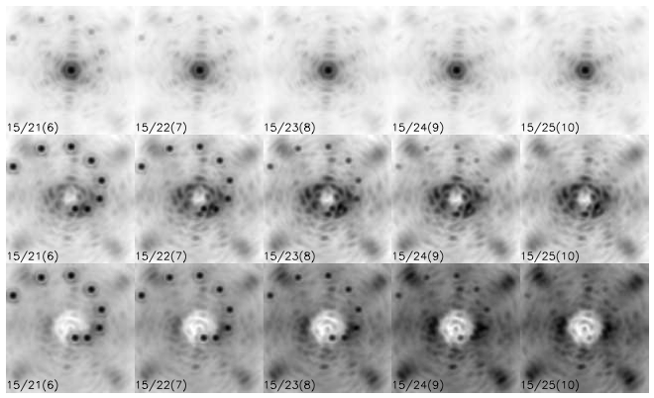
Figure 56. Simulated NGAO J-band science observations with secondary objects inserted.
Top row: AO without coronagraph; middle row: AO + coronagraph with 6 λ/D occulation; bottom row: AO + coronagraph with 10 λ/D occulation. The numbers in the lower left corner of each image indicate the primary /secondary / delta magnitudes, i.e. the format is J₁ / J₂ (ΔJ). The images are stretched (asinh) and individually scaled.

The fundamental conclusion of KAON 497 is that NGAO can indeed serve as a powerful high-contrast science engine, particularly in the uniqueness space associated with faint science targets (where the NGS-only GPI system will not be usable and where NGAO surpasses in contrast (by an order of magnitude) the LGS-capable PALM-3000 system.)

We found that even with the high-order 64x64 actuator NGAO deformable mirror, residual telescope figure errors lead to speckles with troublesome spatial and temporal scales with the greatest contribution to the high-contrast error budget.

While our analysis of the contrast performance needed indicates that a conventional occulting spot coronagraph with an apodized (hexagonal, rotating) Lyot stop will meet the needs of the majority of the NGAO high contrast science cases, we will also in the preliminary design phase investigate the use of more advanced techniques such as non-redundant aperture masking. To help address specific needs identified in our high-contrast error budget initial analysis, we are expecting further analysis in the preliminary design phase of a variable diameter spatial filter as the field stop for the NGAO NGS WFS.

The level of contrast achieved with NGAO will ultimately depend on the control of systematic errors such as non-static, non-common path aberrations, servo lag error and various sources of speckle. Speckle suppression techniques including spatially resolved spectroscopy will be available for NGAO observations and we intend to incorporate to the extent possible the calibration “best practices” discovered by the GPI project.

Polarimetric Precision
Polarimetric precision was considered only superficially in the system design phase. We identified the K-mirror rotator as a potential detriment to polarimetric precision, but adopted this in our architecture for its other system advantages (simplicity and cost).
We do not yet know how stable or calibratable polarimetry will be with NGAO.

One potential strategy for polarimetry for further consideration is the use of the K-mirror rotator in a fixed orientation, allowing the science image to rotate on the sky. For high-contrast polarimetry, this may be an acceptable observing mode, but this will require more careful analysis of all the system implications.

Observing Efficiency and Uptime
KAON 463 discusses the observing efficiency and uptime of the existing Keck LGS AO system for reference. Observing efficiency has already been discussed in section 3.6.1.2. More detailed efficiency and uptime budgets will be produced in the preliminary design phase. (TBR)

Requirements Development and Compliance
The requirements development process is discussed in KAON 573 and is illustrated schematically in Figure 57. The process began by understanding the goals that the Keck community had for a next generation AO capability at WMKO. This was followed by the development of science cases to understand the science drivers and requirements on this NGAO capability. The Science Case Requirements Document (KAON 455) discusses and documents this process and the resultant science requirements. These requirements were developed in parallel with initial performance budgets and analysis to determine feasibility. The science requirements and additional observatory and user requirements were subsequently documented in the System Requirements Document (KAON 456). Both of these documents were intended to be architecture independent. As the team developed an architecture and subsystem designs to satisfy the system requirements the next level of implementation dependent requirements were documented in the Functional Requirements Document (KAON 573). Appendix B of KAON 573 is a printout from the requirements database. The Operations Concept Document and Interface Control Documents will be developed during the Preliminary Design. The document you are currently reading is the System Design Manual shown in the V-diagram as a product of the subsystem architecture definition.

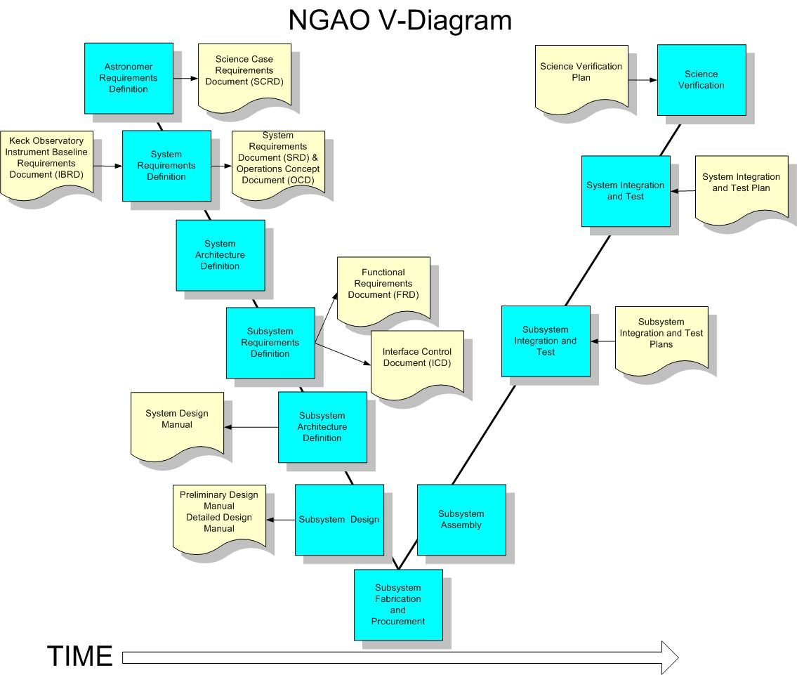
Figure 57. NGAO project V-diagram including the design and development process.
Processes are shown in blue and associated documentation in tan.

In all levels of the requirements documents, steps were taken to assure that each documented specification is traceable back to its origin or driver. The most relevant sources are the top level NGAO science requirements and essential observatory standards but in many cases requirements are generated based on architectural design decisions, engineering best judgments, or for other reasons. Maintaining requirements traceability enables reasonable change control, so that the systems engineer is able to understand and manage the impact of descopes, engineering “push backs,” error budget redistribution, etc.

The science case requirements were summarized in a spreadsheet that was used in the architecture selection process (KAON 499 describes this selection process). The current version of this spreadsheet can be found in KAON 548 or as an Appendix to the System Design Report (KAON 575). The cascaded relay architecture we have selected and developed has been demonstrated in our performance budget analyses (see section 4) to meet the background, wavefront error, encircled energy and sky coverage science case requirements.
Although not yet demonstrated by performance budgets or analysis we are developing the functional requirements and designs to ensure that the astrometric and photometric requirements will be met. A major element of meeting these requirements will be providing a good calibration of the PSF.

The key elements of the selected architecture flowed directly from the science case requirements. At the highest level these can be summarized as follows:

- Dramatically improved performance at near infrared wavelengths.
- Improved IR sensitivity.
- High Strehls (≥ 80% at K-band) are required over narrow fields. The flowed down requirements are derived from the wavefront error performance budget and assumption about how these error terms can be met. These flowed down requirements include number of actuators in the narrow field, required system bandwidth, number of LGS, number of NGS, required laser power, etc.
- Lower backgrounds. This is particularly driven by the high redshift galaxy science. This requirement has driven the need for a cooled AO system and the required temperature.
- Improved astrometric, photometric and companion sensitivity performance.
- Improved IR sensitivity is required (see above).
- It will also be critical to improve the PSF stability and knowledge. The requirements on the PSF stability and knowledge to achieve the astrometric, photometric and companion sensitivity requirements will be developed during the Preliminary Design. The astrometric error budget and PSF reconstruction tools will be developed during the Preliminary Design.

- Increased sky coverage.
- Wide field required. This requirement drove us to the 120" diameter field needed to find suitable NGS for tip-tilt sensing. The field requirement was determined via the analysis documented in KAON 504.
- Ability to use faint NGS. This requirement drove us to the architecture where we provide AO correction of the tip-tilt stars.

- AO correction in the red portion of the visible spectrum.
- This drove the need to transmit these wavelengths to the visible science instruments and to share visible light with the LGS and NGS wavefront sensors via appropriate dichroics.

- Science instruments that will facilitate the range of science programs.
- This drove the selection and conceptual design of the science instruments described in section 3.7.
- This drove the providing of locations for these science instruments in the design.

We have also mapped each science case to a configuration of the NGAO system as shown in Table 16 to ensure that the NGAO architecture and subsystems can operationally support each science case (the configurations are maintained in KAON 550). The numbers in the NGS and LGS configuration columns refer to NGAO system configurations. A partial view of the configuration spreadsheet is provided in Figure 46.

Table 16. Science case mapping to NGAO configurations.

Alternate System Architectures
During the selection of the system architecture described in this document several alternate architectures were also evaluated and ranked. Each of these architectures, along with our adopted cascaded relay, are described and evaluated in KAON 499.

- Split relay. The LOWFS, NIR deployable IFU and LGS wavefront sensor are fed directly from the telescope (and therefore must rotate). The narrow field science instruments are fed by a refractive AO relay including a K-mirror and ADC. Some technical evaluation details for this architecture are discussed in KAON 506.
- Adaptive secondary mirror. All of the science instruments and wavefront sensors are fed directly by the telescope. An adaptive secondary trade study was performed in KAON 485. The existence of an adaptive secondary could potentially improve the performance on seeing limited instruments, and would offer the optimal approach to a ground layer AO system (see KAON 472).
- Large relay. A large rotator and AO relay feed all of the science instruments and wavefront sensors. This is the architecture that was described in the NGAO proposal (KAON 400).
- Keck I upgrade. Quite similar to the selected cascaded relay approach. The NIR deployable IFU and LGS WFS both follow the existing AO relay. A second, higher order relay feeds the narrow field science instruments. The difference is that this is an upgrade to the existing system, rather than a fresh start. KAONs 500 and 502 describe this upgrade in some detail. During preliminary design, we will look more closely at interim benefits to the Keck I LGS system that could be realized as part of our NGAO risk mitigation.

Trade Studies (Suggest replacing this entire section…)
A number of trade studies were performed early in the system design phase to inform the system architecture down select and design choices. A list of these trade studies is provided in Table 17.

Table 17. List of trade studies performed.
Trade Study Title | KAON #
MOAO & MCAO | 452
NGAO Versus Keck AO Upgrades | 462
Adaptive Secondary Mirror Option | 485
Keck Interferometer Support | 483 (& 428)
GLAO for non-NGAO Instruments | 472
Instrument Reuse | 493
Telescope Wavefront Errors | 482
Observing Model | 476
Rayleigh Rejection | 490
LGS Wavefront Sensor Type & number of subapertures | 465
Low Order Wavefront Sensor number & type | 470
Low Order Wavefront Sensor Architecture | 487
LGS Asterism Geometry and Size | 429
Variable Versus Fixed LGS Asterism Geometry | 427
Uplink Compensation | 509

These trade studies were key inputs to the architecture downselection process described in KAON 499.

MOAO and MCAO Trade Study
This trade study lists the following top-level conclusions.

The science advantages of MCAO are:
1) Contiguous AO-corrected field of view
a. Choice of PSF stars in the field
b. Higher packing density of IFU pickoffs
c. Very extended objects: Jupiter, Saturn, Uranus rings
d. Long exposure of hi-Z field galaxies
2) DMs in closed loop, eliminating DM calibration error and drift

The science disadvantages of the MCAO architecture are:
1) Higher field-dependent anisoplanatic error than a MOAO system
2) Extra surfaces in the relay contribute to background emission and reduce throughput.
3) DMs in series could distort the contiguous field randomly resulting in higher astrometric error.
4) Front-end relay adds field and zenith dependent distortion and aberration into the LGS beams, which even if pre-calibrated, will introduce some amount of wavefront error to the science beams via the closed loop.

The science advantages of MOAO are:
1) Lower isoplanatic error at the science field points
2) MOAO units are deployable on a wider field of regard than MCAO, sky coverage is enhanced by correcting tip/tilt stars with their own MOAO units, allowing dimmer tip/tilt stars than with MCAO.
3) Reduced number of optical surfaces for AO correction that minimizes emissivity and optimizes throughput
4) No field distortion introduced by DMs in series.

Science disadvantages of the MOAO architecture are:
1) Discontinuous field of view hampers crowded field studies, e.g. contamination by nearby stars’ seeing halos, which are not imaged and so, cannot be PSF subtracted.
2) Cannot image large extended objects
3) DMs are open loop controlled and are thus subject to calibration and drift error.

The MCAO architecture has the following implementation advantage:
1) AO control of DMs is closed-loop, allowing feedback of mirror shape to the control system.

MCAO has the following implementation disadvantages:
1) Powered relay optics and DMs not conjugate to the ground must be larger diameter than a DM at a pupil.
2) The AO relay introduces non-common-path aberration and pupil distortion and may force custom design of the wavefront sensor optics to compensate. The custom optics may need to have moving components in order to track sodium layer distance change with zenith angle.
3) Pupil size has a lower limit set by physical optics. This size is larger than MEMS DMs produced today
The implementation advantages of MOAO are:
1) MEMS are small, enabling the AO systems to be tucked into instruments, making them ideally suited for compact MOAO units.
2) MEMS are low cost. The marginal cost of scaling to high actuator counts is considerably lower than that for large DMs. For the BMC devices, this number today appears to be around $200-300 per actuator as compared to about $1500 per actuator on a piezoelectric deformable mirror. The low cost makes it practical to have a spare on hand.
3) “Go-to” repeatability – A major advantage of an electrostatic actuation over piezoelectric actuation is the absence of hysteretic effects in the displacement to voltage response curves. This implies that the devices could be driven open loop to given surface deflections.
4) The low cost and small size of MEMS DMs opens up the possibility of “ubiquitous MEMS,” i.e. devices sprinkled throughout the system to elegantly solve tough optical problems.
a. MEMS DM in each wavefront sensor: This creates a mini closed loop AO system in which the wavefront detector is kept near null, where its linearity properties are best. The predictable voltage response of the MEMS allows it to be used as the probe of the grosser portion of the wavefront shape, which would be added to the wavefront sensor’s residuals to complete the wavefront measurement. A variant of this is to use MEMS DMs to correct for the slowly varying but known non-common path aberrations of LGS wavefronts.
b. MEMS in the tip/tilt sensors: If there are enough degrees of freedom to form diffraction limited cores at the sensing wavelength, fainter guide stars can be used to sense tip/tilt to a given accuracy because centroid error is proportional to the spot size and inversely proportional to square root of brightness. The ability to use fainter guide stars would give us higher sky coverage.

Practical disadvantages of MOAO are:
1) MEMS stroke dynamic range may not be adequate to correct the whole atmosphere, leading to a requirement for dual-mirror “woofer-tweeter” MOAO units. The latest generation of MEMS mirrors under development (a 4000 actuator mirror for the Gemini Planet Imager AO system) should have just enough mechanical stroke to cover 5-σ wavefront variation for the Keck 10 meter tip/tilt removed wavefront.
2) MEMS mirrors have not been shown to work yet in astronomical instruments (this is a risk issue)
3) High-order MEMS are presently available from only one manufacturer (another risk issue)

NGAO versus Keck Upgrade Trade Study
The authors concluded that a Keck AO upgrade was worth further consideration. Implementation options range from an incremental approach, delivering new science capabilities along the way, to a single implementation effort without the interim disruptions to science.

The pros and cons for a Keck AO upgrade include:

1) Pro - Potentially a lower cost. However, as the costs are further evaluated, they would likely increase.
2) Pro - The interferometer’s needs are addressed. This will be a difficult problem for NGAO and might require a complete reconfiguration or AO systems.
3) Con - Likely lower performance ultimately than NGAO
4) Con - Only two science instruments (possibly 3) could be available at any one time, unless the other telescope is also upgraded. Unclear yet how many simultaneous instruments could be offered by NGAO.

A Keck AO upgrade would allow for an incremental approach. The pros and cons for an incremental approach include the following.

1) Pro - Some performance improvements could be available sooner.
2) Pro - The system could be improved as funds became available.
3) Pro - It also might allow for and address the need for periodic replacement and maintenance (and the funds to support these) that could be done as the same time as the upgrades.
4) Pro - This approach doesn’t require as much of an all or nothing risk. Although this risk could be mitigated for NGAO, there is the risk that we would not have the funds to complete the system.
5) Con - Periodic shutdowns would be required which would make the system unavailable for science, although a one-time shutdown might take a substantial amount of time if NGAO is installed in one step.
6) Con - Increases the risk to operations due to a system always under development.
7) Con - Increases the risk to the development team schedule from potentially needing to support an operational system.
8) Con - Adds a constant stress to the development team.

Adaptive Secondary Mirror Options Trade Study
The author of this study noted the following points regarding the use of an adaptive secondary mirror.

1) An ASM offers the lowest emissivity and highest throughput option to the science instrument since it is no longer necessary to have a separate tip/tilt mirror or to re-image the telescope pupil onto a deformable mirror (at least 4 reflections are saved).
2) An ASM combines the tip/tilt, DM, and chopping roles all on the same mirror and therefore provides a more stable thermal background that is easier to subtract.
3) An ASM could potentially be used to replace one or more of the tip/tilt mirror, chopping, and DM roles for the existing AO systems (replace the DM with a flat?) if a Keck AO upgrade path were chosen.
4) There will still be the issue of picking off light for wavefront sensing and dealing with field rotation. A new issue is that the DM (ASM) will be rotating with respect to the wavefront sensing.
5) Space for a laser launch telescope behind the secondary mirror could be built into the ASM design, as opposed to design it into the existing secondary mirror module.
6) The use of an ASM could also allow the AO system to be physically smaller which might allow small field AO systems and science instruments to be placed at Cassegrain. This could also allow the existing AO systems to be left at Nasmyth to feed the Interferometer. Cassegrain would also be the best location for the near-IR deployable IFU since low emissivity is a critical requirement for the extragalactic science.

Keck Interferometer Support Trade Study
The authors of this study state that no ideal solution has been found for supporting the interferometer with NGAO. The following points are noted about each option:

1) Swapping Keck I/II with NGAO
a. Hardware costs relatively low, compared to building new AO systems
b. Cost of moving NGAO is higher than fixed NGAO. This assumes the final design is similar to the proposal design.
2) Matching NGAO to Keck
a. Challenging to match polarization states
b. Likely requires NGAO relay with K-mirror and in plane optics
c. No broad wavelength solution found
d. Lower cost compared to other options, approximately 100K compared to millions
3) Two AO systems
a. AO secondary on each telescope
Elegant solution, but costly
Utility of a shared capability could offset higher costs
b. MEMs AO for each IF arm
Relatively inexpensive
Small footprint allows more mounting/packaging options

The lowest cost option but perhaps the most technically challenging will be matching NGAO to a legacy AO system. A more formal consultation with the Keck Interferometer team was recommended as a next step.

Telescope Wavefront Errors Trade Study
The main results of this trade study can be summarized as:
1) Full aperture tip tilt errors could dominate the tip/tilt error budget.
a. Resulting in poor sky coverage
b. “Encircled Energy Science” might be impacted less
2) Segment motion
Acceptable error, comparable to NGAO June 2006 proposal and current error budget
3) Segment figures
Acceptable error, comparable to NGAO June 2006 proposal and current error budget
4) Segment phasing
Small, needs to be added to NGAO budget, interaction with figure errors not tested
5) Fast guiding on stars outside NGAO corrected field of view appears feasible

The trade study authors’ recommendations would be
1) Perform additional analysis of the gains in tracking beyond the simple PI controller considered in this study. Examples would be parametric oscillator and Kalman filters.
2) Understand what might be done to reduce 29 Hz vibrations in telescope segments, secondary, and tertiary.
3) Continue to investigate ways to improve the segment figures. NGAO should leverage information from the TMT study of warping harness at Keck.

Based on this study, it appears that full aperture tilt needs to be given higher priority in the NGAO design and in mitigation efforts with the current Keck AO system. Other telescope wavefront errors appear to be accounted for correctly in the NGAO error budget. It would be advantageous to reduce 29 Hz vibration drivers such as pumps and motors even further, as this is cost effective compared to the cost of an additional “fast guider” for NGAO. The possibility of using seeing limited guide stars outside the corrected field of NGAO appears feasible and should be studied further than the simple scaling law analysis included in this report.

Observing Model Trade Study
The authors presented a trade study for the NGAO observing models by first defining top-level goals for NGAO science operations. They then reviewed and discussed the existing classical and queue-service models from the published data. They have presented three case-study observing models to further assess a range of possibilities for NGAO. The authors recommend that the NGAO observing model be neither the lean-classical observing model nor the queue-service observing model and they recommend working with the Keck science community to develop a new flexible observing model (possibly phased) for NGAO.

The authors further recommend that the NGAO science operations strongly support the top-level goals that emphasize the need for high quality data products and our given estimate for that effort. They note that this will require designing and building an extensive suite of simulation and observing tools for the AO and the science instruments. It additionally requires the development of reliable and accurate calibrations methods for photometry and astrometry. This implies knowledge of the PSF across the science field of view. The authors note that a great deal of potential synergy exists between the Observatory and the community to support the science goals and minimize the implementation costs of observational tools.

Rayleigh Rejection Trade Study
The authors of this study note that fratricide due to Rayleigh scatter is a serious issue for a 5 laser beacon AO system. It is ideal to use a 1-3 micro-sec pulsed laser to mitigate this problem. In the event of this not being available, and mode-locked CW laser being the only option, appropriate background subtraction, projection location, baffles, and stops are to be chosen. The authors note that the effect of fratricide still needs to be quantified more accurately via detailed simulations, though the current study has developed a preliminary model of this effect. The authors advise that NGAO use a center projection method for the LGS. The authors recommend that a safety margin must be included in the error budget to account for the short and long term fluctuations in Rayleigh scatter caused by variations in the atmosphere. Although laser collisions, which is observing through the laser beam projected from another telescope, are to be avoided, it does not actually render the data useless. The effect of a collision is comparable to the sky background at Mauna Kea in the V-band.

Instrument Reuse Trade Study
The authors made the following conclusions from their study.

NIRC-2 as the NGAO Near-IR imager:

1) This NGAO instrument requires excellent RWFE leading to exquisite imaging quality across the field of view. The NIRC-2 camera optics for all plate scales are not sufficiently high enough quality for this application.
2) Upgrading one or all of the camera channels is not sufficient or cost effective over designing a fixed plate scale imager from scratch.
3) The OSIRIS offset imager is an intriguing alternative and may be suitable for a first light Near-IR imager, especially in J and H, where the oversized pupil stop has less detrimental effect to sensitivity.

NIRC-2 as the L/M band imager:

1) With an approximate 500k optics upgrade to the middle channel of NIRC-2, in addition to upgraded detector electronics, NIRC-2 could satisfy the requirements for the NGAO L and M band imager.
2) The optimum solution for this specific instrument is to incorporate a deformable secondary mirror feeding a Cassegrain mounted imager, designed from scratch.
3) The current M band performance of the Keck telescope combined with the AO system, including K-mirror de-rotator, is poor.

OSIRIS as the Near-IR IFU:
1) As it currently stands OSIRIS does not fulfill the maximum field of view requirements of this instrument, nor the K band background performance requirements at any of the pixel scales, nor the required resolution especially at the largest pixel scale (100mas).
2) If only the fine scales are required for OSIRIS it is possible to consider pupil stop improvements that reduce the amount of contaminating radiation that increases the measured sky background. A replacement of the grating may help increase throughput.
3) Designing an IFU spectrograph offering the large range of plate scales that is found in OSIRIS is technically quite challenging. Considering the incorporation of the coarse scale in the d-IFS instrument, the science team is asked to justify the requirement of both the fine and coarse scales for the Near-IR IFU and therefore clarify the maximum field of view. If the 100mas scale is not required, or does not need to satisfy the requirements of background and resolution stated, then OSIRIS can be considered as a candidate for this NGAO instrument.
4) There may be some issue with implementing OSIRIS without a K-mirror de-rotator in NGAO.

Up-link AO Trade Study
The purpose of this trade study was to explore the advantages and disadvantages of adaptive optics wavefront control of the outgoing laser in order to correct for atmospheric aberrations on the laser uplink path. The main advantage of uplink correction is the possibility of obtaining a LGS that is smaller in angular extent than one without compensation. Since the wavefront sensor is to first order dependent only on surface brightness of the guide star, the smaller spot needs less total brightness which in turn implies less laser power is required to create it. With each Watt of laser power having a high marginal cost in the overall AO system, improvements that reduce the required power must be taken seriously.

It appears that if one takes pains to use the type of wavefront sensor that can take advantage of it, there is a potential for a very significant reduction of required laser power if the uplink beam is AO corrected. However, the total package, which involves the success of more than one untested technology, is of reasonably high technical risk. Still the benefit potential suggests that even if the more conservative approach is taken during initial design phases, development testing of the new technologies should proceed.

Glossary
Table 18. defines the acronyms and specialized terms used in this document.

Table 18. Glossary of Terms
Term | Definition
ACS | Active Control System
ADC | Atmospheric Dispersion Corrector
AO | Adaptive Optics
API | Application Programmer Interface
DCS | Drive and Control System
DM | Deformable Mirror
DOF | Degrees Of Freedom
EPICS | Experimental Physics Industrial Control System
FAA | Federal Aviation Administration
FOV | Field Of View
FPGA | Field Programmable Gate Array
FRD | Functional Requirements Document
FWHM | Full Width at Half Maximum
HOWFS | High Order WaveFront Sensor
IBRD | Instrument Baseline Requirements Document
IFU | Integral Field Unit
KAON | Keck Adaptive Optics Note
KI | Keck Interferometer
KOTN | Keck Observatory Technical Note
LGS | Laser Guide Star
LOWFS | Low Order WaveFront Sensor
mas | milli-arcsecond
MEMS | Micro Electro-Mechanical System
MTBF | Mean Time Between Failures
NGAO | Next Generation Adaptive Optics
NGS | Natural Guide Star
NIR | Near InfraRed
NIRC2 | NIR Camera 2
NIRSPEC | NIR SPECtrometer
OA | Observing Assistant
OAP | Off-Axis Parabola
‘OHANA | Optical Hawaiian Array for Nanoradian Astronomy
OMU | Opto-Mechanical Unit
OSIRIS | OH-Suppression InfraRed Integral field Spectrograph
OSM | Object Selection Mechanism
PSF | Point Spread Function
rms | root mean square
SCRD | Science Case Requirements Document
SRD | System Requirements Document
TBC | To Be Completed
TBD | To Be Determined
WFE | WaveFront Error
WFS | WaveFront Sensor
WMKO | W. M. Keck Observatory

Appendix: NGAO SD Phase Detailed Wavefront Error Budgets
The following are detailed wavefront error / ensquared energy budgets developed using the median turbulence condition Mauna Kea Ridge C_{n}²(h) model (KAON 503). This model has:

r₀ (0.5 microns) = 16 cm
θ₀ (0.5 microns) = 2.7 arcseconds
d₀ (0.5 microns) = 4.85 m
L₀ = 50 m

with a C_{n}²(h) distribution given by:

Altitude  (m) | Mauna Kea Ridge Cn2 Fractional Turbulence
0 | 0.517
500 | 0.119
1000 | 0.063
2000 | 0.061
4000 | 0.105
8000 | 0.081
16000 | 0.054

KAON 503 also defines a wind velocity model for the Mauna Kea Ridge resulting in:

Greenwood frequency = 27.91 Hz

Figure 58. Science target wavefront error budget for Io Science Case. (TBR)

Figure 59. Science target wavefront error budget for Galactic Center Science Case. (TBR)

Figure 60. Science target wavefront error budget for ExoJupiter LGS Case. (TBR)

Figure 61. Science target wavefront error budget for Galaxy/Galaxy Lensing Science Case. (TBR)

Figure 62. LOWFS NGS wavefront error budget for the Galaxy / Galaxy Lensing Survey Science Case.
NGS 54” off-axis. We expect such a star to be sharpened to about TBD% J-Strehl using MOAO correction based on multi-LGS tomography. (TBR)

Figure 63. Science target Ensquared Energy error budget for High-Redshift Galaxies.
Extended Groth Strip Science Case (TBR)

