 Keck Adaptive Optics Note 500

Next Generation Adaptive Optics:
Keck Adaptive Optics Upgrade Programmatic Feasibility

P. Wizinowich
August 7, 2007

Introduction

The trade study documented in KAON 462 evaluated whether an upgrade of one of the Keck AO systems is a viable option to achieve the NGAO science requirements. This was supported by KAON 461 which provided the expected wavefront error budget for the Keck I LGS AO system and various stages of an NGAO upgrade to this system. The conclusion from these two KAONs was that an upgrade could potentially achieve the NGAO requirements. KAON 462 also included a start at a potential upgrade plan and some of the pros and cons for an upgrade approach.

Five system architectures were evaluated during the July/07 system architecture retreat as documented in KAON 499. The Keck I upgrade architecture was ranked second technically and third programmatically as a result of this retreat.

The relatively low programmatic ranking was the result of low rankings in three of the six categories: facilitation of pre-telescope I&T (4th overall), implementation impact on AO operations during development (5th) and development tied to observing schedule (5th). The upgrade ranked high in the other three categories: match to strategic goals (excellent for all), early science/phasing flexibility (1st) and dNIRI only AO costs (2nd).

Action items were identified at the retreat that might significantly change an architecture’s ranking. The purpose of this KAON is to address one of these action items, specifically whether a convincing upgrade plan can be developed.

We begin by discussing the three low ranked programmatic categories.

Programmatic Issue

Facilitation of Pre-Telescope I&T

A completely new AO system has the potential advantage of a more complete pre-telescope I&T period. The purpose of this phase is to demonstrate and characterize the full system off the telescope, thereby reducing the I&T period and the risk at the telescope. In this case we are only considering the AO system (and not the laser system).

This negative for the upgrade approach could be substantially mitigated with a lab development system. The additional costs associated with the development system should be recovered by reduced telescope I&T time and reduced risk at the telescope. This approach does require duplicates of some key systems such as the real-time control system; some of these duplicates could act as spares. Having a long term lab development system would greatly help with trouble shooting and upgrades.

Implementation Impact on AO Operations during Development
A completely new system only impacts AO operations once it is brought to the telescope. An upgrade to the existing AO system will impact AO operations each time that an upgrade is made and the development team will need to respond to any subsequent problems until the upgrade is officially handed over to the operations team.

This negative could be substantially mitigated by minimizing the number of implementations at the telescope. In the minimal case this could all be done in one install. However, it is likely that we would prefer a few installs in the upgrade architecture case or in other cases like the cascaded relay in order to get capabilities to the telescope earlier and in order to minimize the unavailability of the AO system for science. The assumption could again be that the systems are fully tested in the lab prior to moving to the telescope.

2.3 Development tied to Observing Schedule
Development is not tied to the observing schedule to any greater extent with the upgrade approach than for other approaches if we assume a significant lab I&T system and phase. The ties to the observing schedule are only an issue when we transition a capability to the telescope. Again we have the flexibility to minimize this.

Potential Upgrade Plan

A rough project plan for a potential upgrade architecture approach has been developed. This plan has been developed to minimize the three concerns raised in the previous section. This plan is only intended to be at a level to demonstrate feasibility as opposed to representing a truly workable plan. The author believes that this plan does not look a lot different than a potential plan for say the cascaded architecture implementation. We will walk through this plan in the following sections.

Design, Funding, Science Instruments and Related Development
This section of the plan is likely to be similar for any architecture. The pace of the design effort will likely be determined by funding availability. In the figure below it is assumed that the PDR will occur by the end of CY09 and the DDR will occur at the end of Jun/11.

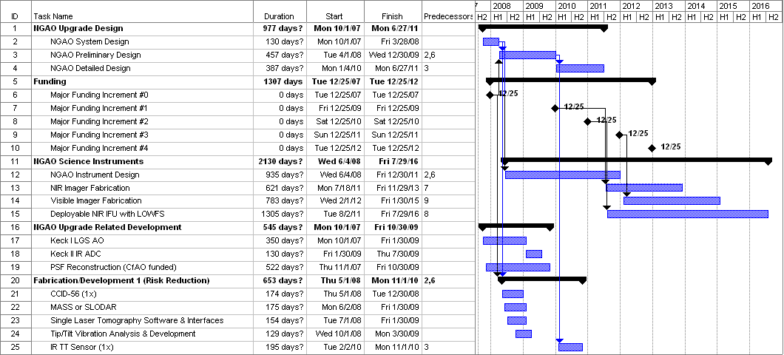

An incremental funding profile has been assumed with various development phases tied to these funding milestones. However, this plan could easily be updated if the funding came in fewer or more increments. The funding increments in this plan fund the following (more detail can be found in section 3.2):

Funding Increment | AO Capabilities | Science Instruments | Lasers
0 | Design  Some risk reduction | Design | Design
1 | Lab dev system,  2x DM, RTC, 3x LGS WFS, NGS WFS, 3x LOWFS  Replacement hardware | NIR camera | 1st 50W laser
2 |  | Deployable NIR IFU | 2nd 50W laser
3 |  | Visible camera
4 | + 6x LGS WFS  Cascade relay |  | 3rd 50W laser

NGAO related development is shown on lines 15 to 18 of the above figure. This includes the implementation of the Keck I LGS AO system which would act as the base for this upgrade architecture, the implementation of an IR ADC on Keck II (a risk reduction item for NGAO), and the CfAO-funded PSF reconstruction activity.

The final category shown in the above figure is fabrication/development phase 1 which is intended to act as a risk reduction for NGAO and also to allow some performance improvements on the existing AO systems. The result from these activities should be included in the NGAO design process. Two of the items are intended to test out hardware that we plan to use (the CCID-56 and the IR TT sensor). Two others are intended to support the CfAO-funded PSF reconstruction activity. Implementation of single laser tomography would significantly reduce the largest term, focal anisoplanatism, in the K1 LGS AO error budget. The last is intended to significantly reduce the impact of telescope vibrations at the output of the AO system.

3.2 Fabrication and Development
The fabrication phase for the major AO system components are shown in the following figure. Note that for the purposes of this KAON some elements were not included such as the AO operations tools (although these clearly need to be developed and included in the lab and telescope I&T phases).

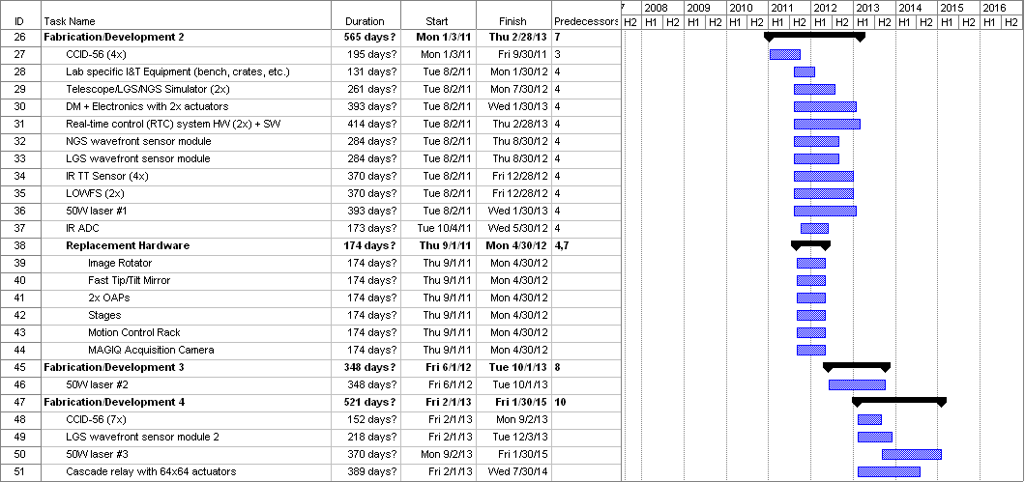

3.3 Laboratory Integration and Test
All of the lab I&T phases are shown in the following figure. The laser lab I&T will likely be in a different lab space. The lab I&T phase 1 is performed with the existing NGWFC lab development system which primarily includes the real-time control system and motion control.

In lab I&T phase 2 a lab system will be setup that duplicates the final summit system to the extent practical and useful. All of the hardware that will be moved to the telescope in the first NGAO implementation will be tested as a system during this phase, including the NIR science camera. At the end of this phase all of the systems that were used during this phase will be moved to the summit.

To start lab I&T phase 3 the second real-time control system, second telescope simulator and spare sensors would be set-up in the lab. It will be important to have at least the real-time system fully operational in the lab prior to the commencement of the telescope I&T of the lab I&T phase 2 hardware. As components are removed from the existing AO system they may be added to this lab system. The second lab system should be essentially complete to support the lab I&T phase 3 activities, as well as those in lab I&T phase 4.

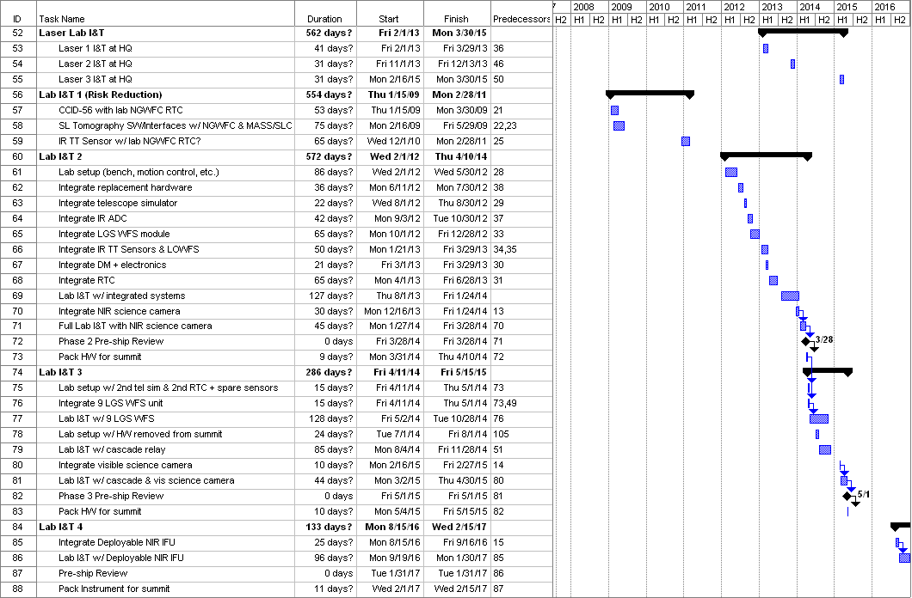

3.4 Telescope Integration and Test
As shown in the following figure Telescope I&T is broken into four AO I&T phases and a laser I&T category. The first telescope I&T phase is associated with the risk reduction development discussed in section 3.1. The other three telescope I&T phases starts at the conclusion of the corresponding lab I&T phase.

Release of each new capability includes integration of the components at the telescope, daytime testing, nighttime testing including science verification, shared-risk science and a handover to AO operations. In many cases, except for a significant portion of telescope I&T phase 2 (tasks 104 to 106), science observations with the previously available science capabilities may be practical during the daytime and nighttime testing periods.
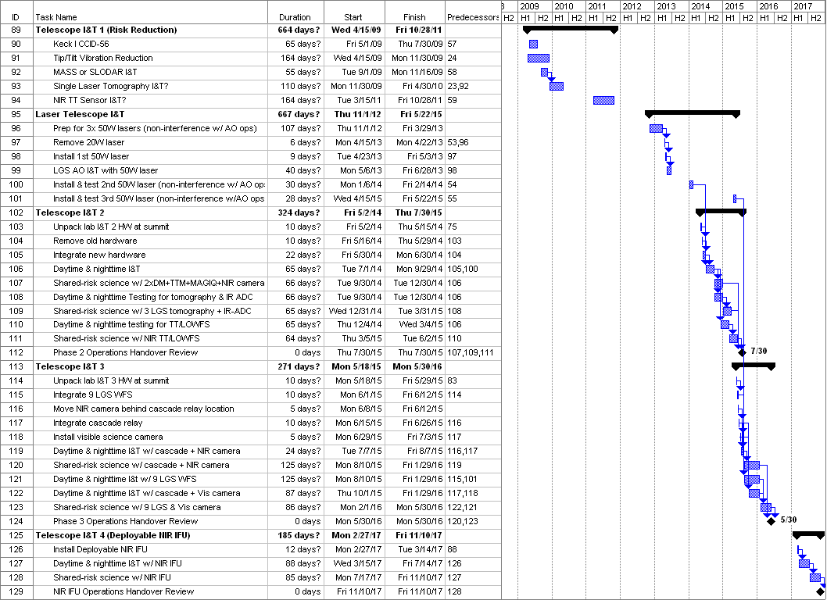

3.5 Performance Improvement Milestones
The key performance milestones associated with the above developments are shown in the following figure. The wavefront error budget reduction associated with most of these can be found in KAON 461. In this particular plan three NGAO risk reduction items are added to the Keck I LGS AO system every 4-6 months after the science availability of the Keck I LGS system. There is then a three year gap before the implementation of the 50W laser. The NGAO system performance improvements then occur every few months over a period slightly longer than CY15. The last new science capability occurs with the implementation of the deployable NIR IFU in 2017.

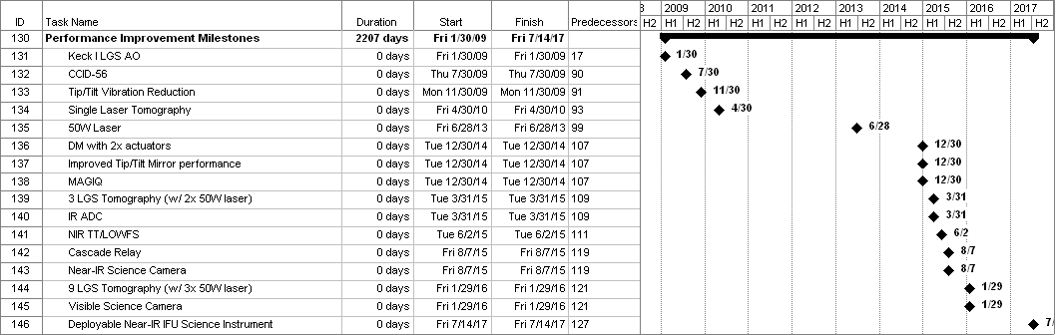

Conclusion

This KAON has attempted to address the programmatic concerns with the Keck AO upgrade architecture raised at the July/07 system architecture meeting. These concerns have been substantially addressed by developing a potential plan that 1) has a significant and complete lab I&T phase and 2) takes NGAO to the telescope in a small number of phases in order to minimize the impact on AO operations and the ties to the observing schedule. The bottom line is that the Keck AO upgrade approach could be done in such a way that gives it similar programmatic rankings to other favored architectures.

References

Wizinowich, P. et al., Wavefront Error Budget Predictions and Measured Performance for Current and Upgraded Keck AO, KAON 461 (Mar., 2007).

Wizinowich, P., NGAO Trade Study: Keck Adaptive Optics Upgrade, KAON 462 (Mar., 2007).

Dekany, R. et al., NGAO System Architecture Definition, KAON 499 (July, 2007).

