Keck Adaptive Optics Note 732

Keck Next Generation Adaptive Optics:
Data Server Preliminary Design

Version 1.0
Date: 7/31/2026

Authors:
Jimmy Johnson

Contributors:
Kevin Tsubota

W. M. Keck Observatory
California Association for Research in Astronomy
65-1120 Mamalahoa Highway
Kamuela, Hawaii 96743
808-885-7887

Table of Contents

1 Introduction 3
2 Glossary 3
3 Project Description 3
3.1 Clients 5
3.1.1 Viewers 5
3.1.2 NGAO Components/Controllers/Applications (via services) 5
3.1.3 Other 5
3.2 Databases 5
3.2.1 Configuration Database 5
3.2.2 Logging Database 5
3.2.3 Telemetry Database 5
3.2.4 Alarm Database 6
3.2.5 Ad-hoc Archive Database 6
4 Hardware 6
4.1 Optimal Solution 6
4.1.1 Specifications 7
4.2 Traditional solution 8
5 Software 10
5.1 Relational database 10

List of Figures
Figure 1 Data Server Overview 4
Figure 2 Data Server Hardware Architecture 9
Figure 3 Sun Fire X4140 9
Figure 4 SurfRaid Triton 14FA4 10

List of Tables
Table 1 MySql and Postgres comparison 11

Introduction
The Data Handling System for the AO Controls has been called the “Data Server”. The NGAO Data Server is defined as a computer in the network, with associated software, that is dedicated to the data storage and retrieval needs required by the AO Controls System. It holds the database management system , the databases and is part file server capable of housing non-database files such as FITS. In addition to providing data persistence, retrieval and data management there will be a telemetry data recorder, an ad-hoc data recorder, an alarm recorder, general logger, and configuration. High speed RTC data will be stored in its own data recording system.

Glossary
The following terms and acronyms will be used throughout this document:
Acronym | Definition
AO | Adaptive Optics
ATA | AT (Advance Technology) Attachment
ATST | Advance Technology Solar Telescope
CPU | Central Processing Unit
DRAM | Dynamic Random Access Memory
FITS | Flexible Image Transport System
GB | Gigabyte (1024^3)
HDD | Hard Disk Drive
KAON | Keck Adaptive Optics Note
MB | Megabyte (1024^2 Bytes)
NGAO | Next Generation Adaptive Optics
NGWFC | Next Generation Wavefront Controller
RAID | Redundant Array of Independent Disks
RAM | Random Access Memory
RPM | Revolutions Per Minute
RTC | Realtime Control
SATA | Serial ATA
SSD | Solid State Drive
TB | Terabyte (1024^4 Bytes)
TRS | Telemetry Recording System
ZFS | Sun Microsystems’ Z file system

Project Description
Figure 1 shows a high level overview of the data server. The data server hardware consists of expandable and reliable (RAID) hardware capable of supporting multiple databases and file formats.

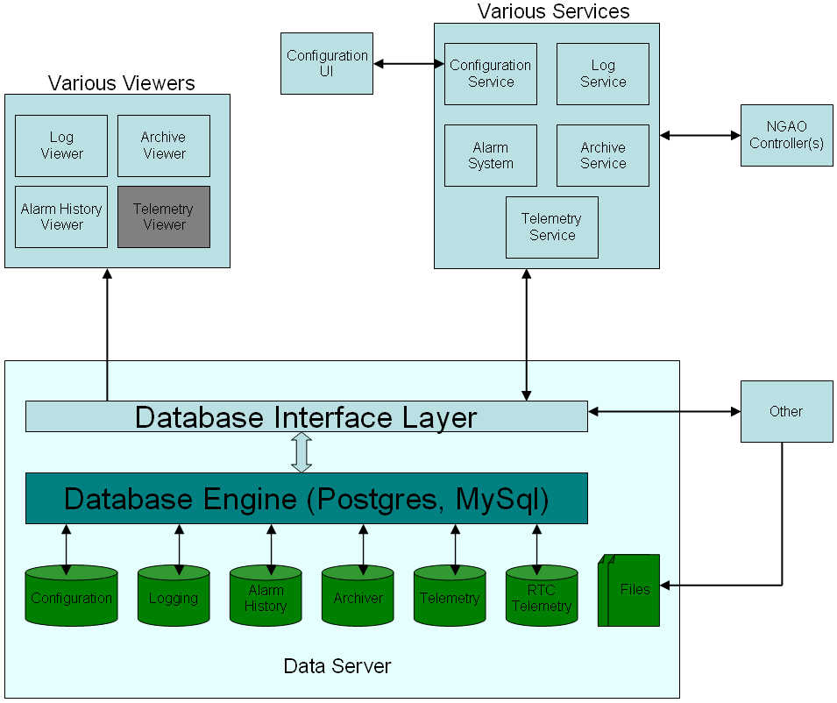
Figure 1 Data Server Overview
The database engine is expected to be either PostgreSQL or MySql. Both are fairly comparable at this stage though some analysis should be done to compare the two in detail. As a frame of reference the telemetry server in NGWFC uses PostgreSQL as does the Advanced Technology Solar Telescope. Regardless of which database engine is used there will be a database interface layer to provide a suitable abstraction to the database clients.

Three distinct sets of clients have been identified:
- Viewers
- NGAO Components/Controllers/Applications (via services)
- Other

Five (possibly six) distinct databases have been identified:
- Configuration
- Logging
- Telemetry (polled RTC data may go here or may go to its own database)
- Alarm
- Ad-hoc archive

Clients

Viewers
It is expected that there will be user interfaces (viewers) to allow easy viewing of logged information, archived data, alarm history and possible telemetry. KCSF will provide viewers for logged and archived data as well as alarm history. The need for a standardized telemetry viewer is TBD.

NGAO Components/Controllers/Applications (via services)
KCSF will provide services to all components, controllers and applications that use to framework. Many of these services interact with the data server. Each component will have the ability to retrieve its configuration from the configuration database. A configuration user interface will provide the ability to configure and re-configure the overall system. The log, archive and telemetry service will allow components to write appropriately formatted data to the corresponding service databases.

Other
It is TBD as to what these clients will be but it is expected that applications will be developed outside of the framework that want the ability to read and write to one or more databases and to be able to store and retrieve files form the server.

Databases

Configuration Database
The configuration database and associated support will be provided by KCSF. The database is quite complex and is covered in detail under KAON xxxxx.

Logging Database
The log database and associated support will be provided by KCSF. The log database is simple and will have the following schema:
Field | Type | Description
Time_Stamp | timestamp | UT Timestamp
Mode | VCHAR | Message type: e.g. Warning, Info, Error ....
Source | VCHAR | Who generated the message
Message | TEXT | The actual message

Field | Type | Description
Time_Stamp | timestamp | UT Timestamp
Source | VCHAR | Source of the archived data
Name | VCHAR | Attribute/Variable name
Value | Text | Archived value

Telemetry Database
The telemetry database schema is dynamic in that each telemetry topic will have its own table with column/field information specific to that specific telemetry item.

Alarm Database
The alarm database and associated support will be provided by KCSF. The alarm history schema is still TBD.

Ad-hoc Archive Database
The archive database and associated support will be provided by KCSF. The archive database is simple and will have the following schema: TBD

Hardware
Two hardware solutions are presented. The first is what is considered to be the optimal solution allowing for great performance, easy growth and a wide range of configuration options. The down side is that we are unfamiliar with the product and the potential increased initial cost. Option two is more a tried and tested solution that can do the job but is not quite a flexible or expandable. Regardless of the solution the expectation would be that the hardware will be located in the telescope computer room and will, most likely, be mounted in a standard 19” rack.

Optimal Solution
The optimal solution is to use Suns (Oracles) Unified Storage Solution which is a family of storage solutions designed for high performance and high availability. The solution uses an optimized storage hierarchy with Hybrid Storage Pools containing DRAM, SSD, and HDD drives. To deliver high performance using cost-effective components, the Sun Storage 7000 series file system, ZFS, seamlessly optimizes access to the different types of media in the Hybrid Storage Pools. ZFS was designed to automatically recognize different I/O patterns and place data in the best storage media for optimal performance.

ZFS transparently executes writes to low-latency SSD media so that writes can be quickly acknowledged, allowing the application to continue processing. ZFS then automatically flushes the data to high-capacity drives as a background task. Another type of SSD media acts as a cache to reduce read latency, and ZFS also transparently manages the process of copying frequently accessed data into this cache to seamlessly satisfy read requests from clients.

The systems can be scaled as needed by adding additional RAM, SSD or hard disks. Scalability is available in multiple dimensions by increasing compute power, storage capacity, or performance independently. As application requirements change, it is possible to
- Increase computational power by adding more CPUs and cache
- Expand total capacity by adding enterprise-class SATA drive expansion units
- Increase performance using additional SSD to buffer storage reads or writes

The system is touted as having very low energy consumption with up to 75 percent less than the cost of competitive solutions. This is due to the reduced power consumption of SSD and HDD disk drives rather than the use of high RPM drives.

All systems come with a management interface that guides installation, configuration and tuning as well as DTrace Analytics software to identify and diagnose and issues. Real-time analysis and monitoring is supported.

To meet a variety of needs for capacity, price, and performance, the Sun Storage 7000 series family comes in three different configurations plus a cluster configuration that offers maximum availability. These are known as Sun Storage 7110, 7210, 7310 and 7410.
All non-clustered systems come bundled with the same software including data protocols, replication, compression, and DTrace Analytics software for system troubleshooting and performance optimization. Clustered systems include an additional software module for cluster software features.

Specifications

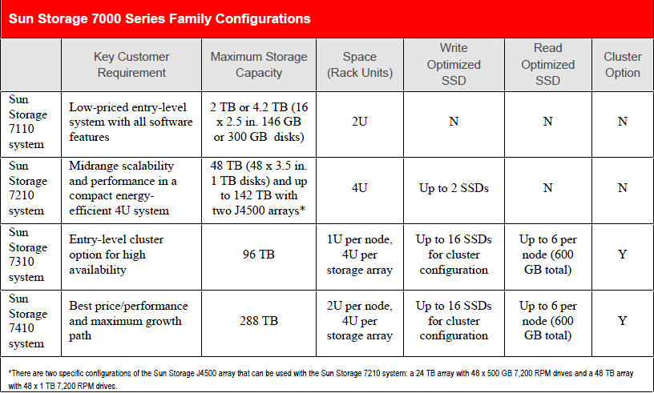

Product | Key Benefits | Availability
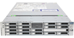  Sun Storage 7110  Unified Storage  System Updated! | - Enterprise-class storage features at entry-level prices  - Up to 4 TB capacity, one of the most dense in its class  - Easy-to-use management interface and DTrace Analytics reduce management costs  - Enterprise-class data services with no additional fees | From $10,995
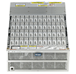  Sun Storage 7210  Unified Storage  System | - High-density unified storage solution  - 46 TB in energy-efficient 4U, scales up to 142 TB  - Optimize performance with DTrace Analytics for increased productivity  - Hybrid Storage Pool and Enterprise Flash technology deliver breakthrough performance while reducing power, cooling, and rack space | From $34,995
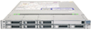  Sun Storage 7310  Unified Storage  System Updated! | - Entry-level cluster option for high availability  - Easy-to-use management interface and DTrace Analytics reduce management costs  - Hybrid Storage Pool and Enterprise Flash technology deliver breakthrough performance while reducing power, cooling, and rack space  - Scale up to 96 TB to grow with your business | From $40,140
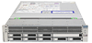  Sun Storage 7410  Unified Storage  System Updated! | - Highest performance with highly available cluster option  - Easy-to-use Dtrace Analytics increases uptime while maximizing performance  - Hybrid Storage Pool and Enterprise Flash improve application response times  - Scales up to 288 TB (576 TB when 2 TB drive is available) | From $73,165

Traditional solution
A more traditional approach (similar to what is used for NGWFC TRS) is to use a rack-mounted server such as the Sun Fire X4140 and a RAID storage solution such as the SurfRaid Triton 16FA4 RAID controller. They will be located in the telescope computer room and will be mounted in a standard 19” rack.

This proposes two main components, a storage server and a disk array. The storage server can be linked to the rest of the system through Fibre Channel or Gbit Ethernet. The preferred way to connect the disk array to the storage server will be through Fibre Channel, with the Fibre Channel configured as a point-to-point topology.
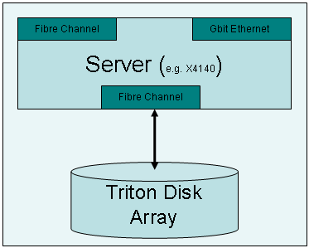
Figure 2 Data Server Hardware Architecture

TRS uses the discontinued Sun Fire X4100 and SurfRaid Triton 16FA (2Gb Fibre Channel). The Sun Fire x4140 and SurfRaid Triton 16FA4 are the current equivalents. For reference the performance tests carried out by Microgate achieved a sustained rate of 35.4 MB/sec on the TRS hardware.

Without a more detailed analysis of the AO Controls data handling needs these may not meet the requirements though there are other similar more performant hardware options. For example there are a complete line of servers with AMD in the Sun Fire X4x50 range and Intel in the Sun Fire X4x70 range. Likewise there are alternatives to the Triton offering 8 Gb Fibre Channel and greater storage capacity. If additional processor performance was needed a blade solution such as the Sun Blade X6270 could be used instead of the Sun Fire X4140.

The Sun Fire X4140 supports two 6 core Opteron processors (older model supported quad core) and significantly more RAM and the Triton 16FA4 supports up to 32 TB (older model supported 6 TB).

Pictures of the Sun Fire X4140 and the Triton 16FA4 are shown in Figure 3 and Figure 4 respectively. The maximum power dissipation is 650 watts for the X4140 and 460 watts for the Triton 16FA, for a total of 1100 watts maximum. This power will be dissipated in the telescope computer room, which is air conditioned.

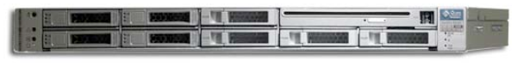
Figure 3 Sun Fire X4140
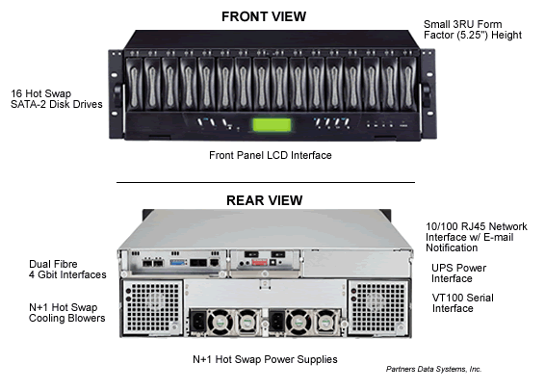
Figure 4 SurfRaid Triton 14FA4

Software

Relational database
The following shows a high level comparison between MySql and Postgres.

Feature | MySQL 5.x | PostgreSQL
SubSelects | Yes | Yes
Views | Yes | Yes
Foreign Key relationships | Yes | Yes
Foreign Key constraints | Yes | Yes
Triggers | Yes | Yes
Indexing on non trivial types | Yes | Yes
Sequences | Some¹ | Yes
Transactions | Yes | Yes
Transactional DDL statements | No | Yes
OO (Inheritance of tables) | No | Yes
Async Notifications | No | Yes
Constraints | Yes | Yes
INSERT ... SELECT | Yes | Yes
Stored Procedures | Yes | Yes
Row level locking | Yes² | Yes
Table level locking | Yes | Yes
Geospatial Datatypes (ie WKT) | Yes | No³
Error! Hyperlink reference not valid. | No | Yes⁴
Native replication (M/M, M/S, Ring) | Yes | No⁵
Table 1 MySql and Postgres comparison
In general the performance of the two databases is now comparable. Each has unique areas that they are stronger in. Postgres has better transaction support, MySql has better large text area support.

