 Keck Adaptive Optics Note 666

NGAO Fixed Pupil Mode

P. Wizinowich, E. McGrath
July 8, 2009

Introduction
NGAO is required to operate in fixed pupil mode for on-axis science targets with both NGS and LGS AO. The purpose of this KAON is to address how this mode will be supported in the LGS AO case in light of the NGAO build-to-cost design changes. Note that fixed pupil mode with NGS AO is supported by NGAO because the NGS WFS can use the science target.

LGS Fixed Pupil Mode Science Requirements
To our knowledge fixed pupil mode has not been used with LGS AO because the Strehl ratios are not high enough to detect faint companions within the PSF structure. LGS AO with NGAO will however provide Strehl ratios high enough to make fixed pupil mode a very rewarding scientific capability.

Laird Close points out that even if an object is too faint in the visible to use NGS AO it can be very bright in the near-IR. For example, all objects later than M5 (V-K>6) with 13<V<21 are too faint for high Strehl NGS. High Strehl and therefore high contrast LGS AO observations of these objects will be a new regime offered by NGAO.

An assumption is that fixed pupil mode with a coronagraph will only be required (or useful) for very narrow field (< 5" radius) science targets positioned on the optical axis (i.e., the axis of the rotator). Fixed pupil mode without a coronagraph could be used with the science target positioned anywhere on the science camera. In general the purpose of fixed pupil mode is to maintain the structure of the PSF in a fixed location on the science camera in order to be best able to detect faint sources (e.g., a companion or an extended disk) next to a brighter source. The high-contrast imaging techniques of “roll subtraction” (Liu 2004) and angular differential imaging (ADI; Marois et al. 2006) use this mode to obtain good PSF subtraction and detect faint source flux between the PSF structure. Since an off-axis source will rotate in fixed pupil mode it must be close to the brighter on-axis source and the exposures must be short enough not to reduce the SNR of the faint source by the resultant image blur.

In principle, fixed pupil mode should be more sensitive to detecting faint companions than coronagraphic observations alone (note that this mode could also be used without a coronagraphic mask and on- or off-axis if that was deemed scientifically useful). However, the resulting sensitivity of this mode will depend largely on the stability of the PSF over long periods of time. The closer an object is to the optical axis, the longer it will take to track a significant distance across the instrument field of view. For the Extrasolar Planets Around Nearby Stars science case, most companions will be located at separations of ≤0.2” from their parent star. At this separation, under typical parallactic rates it takes ~30 min. or more for an object to move a distance of 1 λ/D (at H-band) in order to identify it amidst stable PSF speckles. Smaller separations will require even longer PSF stability. Bruce Macintosh points out that there will also be lots of companion science with separations of 0.2 to 1.0” (for companions to brown dwarfs, etc. there is some evidence that they tend to have 20 to 40 AU separations).

High Strehls will improve contrast ratios and increase sensitivity, thereby helping to keep required exposure times short to reduce image blurring. High angular resolution will allow for smaller required image rotation. High throughput and low background will further aid in these observations by reducing the required exposure times and improving faint source detection limits.

Design Change Impacting LGS Fixed Pupil Mode
In the system design the low order wavefront sensor (LOWFS) object selection mechanisms (OSM) were in transmission through a dichroic that reflected light to the narrow field science instruments. For fixed pupil mode we assumed that only one of the LOWFS would be used and that it would use the on-axis science target for tip, tilt, focus and astigmatism (TTFA) and truth wavefront sensing (TWFS). In the build-to-cost design pictured in Figure 1 the LOWFS object selection mechanisms are in the path to the science instruments and therefore can vignette the science field if they are moved too close to the optical axis. The on-axis science target can therefore not be used by a LOWFS.

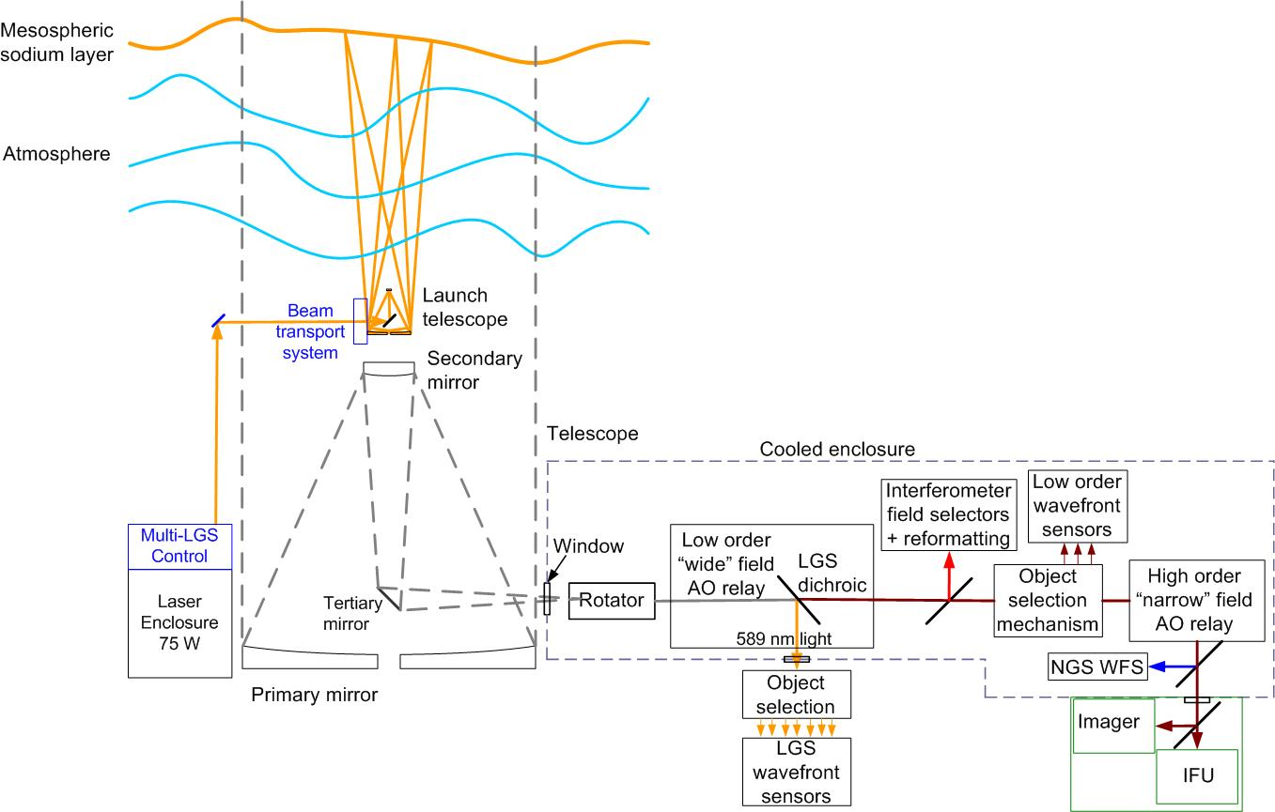
Figure 1 Conceptual schematic of the new NGAO architecture

Note that fixed pupil mode can still be supported with NGS AO since the NGS WFS is in reflection off a dichroic that transmits the science light.

Figure 2 shows the central “3+1” LGS science asterism and three movable LGS for AO-correcting the tip-tilt stars. In fixed field mode the laser asterism is rotated prior to the laser launch telescope to keep the LGS beacons fixed on the sky; the AO rotator then keeps the sky fixed with respect to the rest of the AO system. In fixed pupil mode the laser asterism rotation prior to the launch telescope is turned off; the AO rotator then keeps the pupil fixed with respect to the rest of the AO system. In both cases the LGS WFS can remain fixed.

The requirement of a stable PSF particularly favors a fixed science laser asterism with respect to the pupil. We will therefore assume that the projected science asterism lasers are not rotated and the corresponding LGS WFS remain fixed.

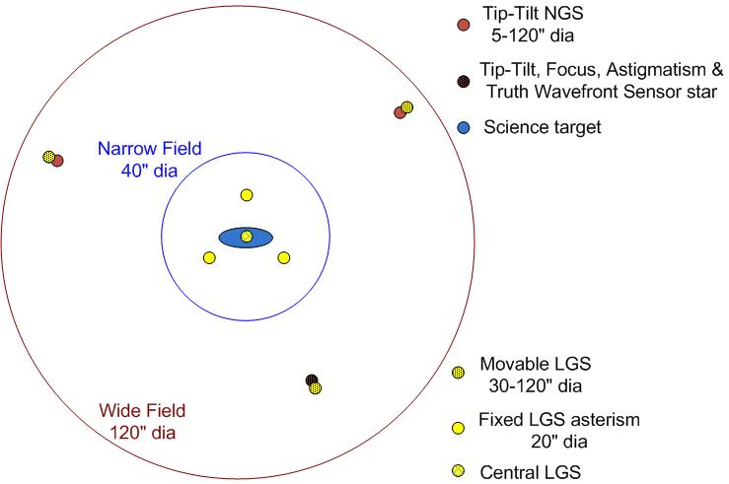
Figure 2 LGS “3+1” asterism for tomography of the science field, plus three point and shoot lasers for image sharpening of the tip-tilt stars

LGS Fixed Pupil Mode Options
The following are some identified options for providing LGS fixed pupil mode:
- Use one, two or three off-axis LOWFS.
  - This would require that the LOWFS tracked the field rotation.
      - The LOWFS already need to track for differential atmospheric dispersion between the LOWFS and science wavelength and for non-sidereal science objects. However, the speed and range of tracking would likely be higher for pupil rotation compensation.
    - If the exposures were short enough you could imagine re-pointing the LOWFS, LGS and LGS WFS between exposures.
  - If AO-corrected tip-tilt stars were also required in this mode then both the movable lasers and LGS WFS would have to track the field rotation as well.
      - The tracking LGS WFS requirement would be a significant cost item.
- Use one on-axis LOWFS.
  - One option would be to use a LOWFS on-axis but to transmit a narrow science field. This would require that the first element of the object selection mechanism for this LOWFS (this would be the TTFA & TWFS unit) be a dichroic that transmits the science wavelength. Currently the TWFS uses visible light and the TTFA uses J&H light and a changeable dichroic would be undesirable for cost reasons. So, the best we might be able to do is to use a dichroic that transmitted the H&K light which would be quite limiting to the science options.
  - Using a LGS beacon for this LOWFS would not be necessary since the AO-correction is already largely provided by the woofer DM controlled by the “3+1” LGS WFS. If slightly higher order correction is necessary then the tomography RTC would need an output to this LOWFS which could be an additional cost item.
- Use the on-axis NGS WFS as a LOWFS/TWFS.
  - This option is viable since a dichroic already splits the light between the NGS WFS and science instrument so that both can use an on-axis source. The NGS WFS would need a low order mode to act as a TTFA-type or perhaps higher order LOWFS.
  - In this scenario the NGS WFS would have to be well aligned with the center of the focal-plane mask so that we can use it to monitor the centering of the field.
      - There is no ADC for the NGS WFS in the new design so we would need to think through the differential atmospheric refraction; perhaps this can be supported by the science instrument ADC.
      - Centering needs to be very accurate (and stable to 0.5 – 2 mas over 10 min) for this science since you can’t see the central PSF (unless the coronagraph design lets through a small percentage of light)..
  - The NGS WFS operates in the visible and it would therefore not have as much AO-correction as an IR sensor, however some of this performance would be gained back by the fact that the NGS WFS is after the high order relay.
  - Since there is no TWFS at this location it might be necessary to run the NGS WFS in a ~5x5 mode instead of a 2x2 mode in order to provide the truth information and this would hurt the tip-tilt limiting magnitude by at least 2 magnitudes.
  - This NGS WFS mode also offers the option of using the on-axis science target, or a target within the narrow science field, for LOWFS/TWFS sensing even in fixed image mode.

Recommendation and Further Work
Based on consideration of the above three options the recommended approach is to further investigate using the NGS WFS as a LOWFS/TWFS for fixed pupil mode.

Some performance analysis is needed to determine the scientific utility and limitations of the recommended approach. For example, Bruce Macintosh felt that there should be a calculation of the sensitivity hit from using a visible wavefront sensor for tip-tilt since many planet-search targets are red (brown and M dwarfs). Bruce also points out that the ADI trade space is complicated; it helps when the target star is bright however on the fainter science targets like brown dwarfs ADI may not be needed as much.

References
Liu, M. 2004, Science, 305, 1442
Marois, C., Lafreniere, D., Doyon, R., Macintosh, B., and Nadeau, D. 2006, ApJ. 641. 556

