 Keck Adaptive Optics Note 628

Next Generation Adaptive Optics:
Optical Relay Redesign Evaluation

D. Gavel, R. Kupke, C. Lockwood, P. Wizinowich
December 2, 2008

1. Introduction

New NGAO build-to-cost guidelines have necessitated a fresh look at the NGAO optical requirements and design choices. The purpose of this note is to support and document the evaluation of single relay options in comparison to the baseline design cascaded relay architecture. The primary motivation is to determine if there is significant cost savings to be had by moving to a simpler architecture and in relaxing some of the initial requirements. The key differences in terms of performance, risk, cost, and conformance to requirements are presented.

2. Optical Relay Design Requirements

The 2-tier optical relay that was presented at the NGAO SDR used a 20x20 actuator deformable mirror with 5 mm actuator spacing following by a second higher order relay with a 64x64 actuator DM. This design was referred to as a 2-tier relay since a second tier was used to ease the packaging constraints as well as providing a fold mirror at an ~ 10 km altitude conjugate.

The high order relay was our answer to the need to provide sufficient correction to correct for segment figure errors. One option to help fit within the build-to-cost budget is to relax the high contrast science requirement and therefore the need for a 64x64 actuator DM. By relaxing this requirement to 40x40 or 48x48 actuators we have been able to reconsider whether this level of correction can be provided in a single relay.

In this note we compare the pros and cons of implementing this level of correction using a MEMs or a more traditional large DM.

Before performing the comparison we list below the basic functionality that must be provided in the AO system science path:

- Field of view. The relay must pass sufficient field to support the sky coverage requirements. This requirement is open to review but is currently a field of 150” diameter.
- Field rotation correction. Our design choice has been to use a K-mirror. Alternatives would be to not provide any rotation prior to science instrument rotators (this is the NFIRAOS approach) or to provide a mechanical rotator.
- Reimaging the desired conjugate onto a DM. Our design choice has been to use an OAP to collimate the beam and reimage the primary mirror onto the DM.
- DM. We are considered a 64x64 MEMS or a 48x48 DM with ~ 4 mm actuator spacing.
- Reimaging the science field onto the science instruments. Our design choice has been to use a second OAP. For the DM case our design choice is to use an identical OAP to the first OAP in order to minimize aberrations. For the MEMS case it is necessary to use a longer focal length OAP to provide enough distance to allow the feeding of multiple science instruments.
- LGS wavefront sensor pickoff. Our design choice has been to use a sodium reflective dichroic beamsplitter in the collimated space after the DM.
- LGS wavefront sensor. 48x48 subapertures are assumed for all relay options.
- NGS wavefront sensor pickoff.
- NGS truth wavefront sensor pickoff.
- NGS and LGS acquisition camera pickoff.
- Low order wavefront sensor pickoffs (3).
- Science instrument pickoffs (3?).
3. Optical Relay Designs

Figure 1 shows a MEMS-based single relay and Figure 2 shows a DM-based single relay. These figures are shown roughly at the same scale.
The MEMS-based relay uses a pair of off-axis parabolas producing a 25 mm diameter collimated beam at the MEMS DM that illuminates 64 actuators across (spaced at 0.4 mm) the DM. The OAPs are mismatched in the sense that the input beam is at the telescope’s f/13.5 and the output beam is at f/48. The 25mm MEMS DM is a device constructed by the Boston Micromachines Corporation for the Gemini Planet Imager and is currently the baseline tweeter DM in the NGAO cascaded relay architecture.
The large DM-based relay shown is actually one of two considered, one with a 200mm beam illuminating 48 actuators across at 4 mm spacing, and one with 168 mm diameter beam illuminating 48 actuators across at 3.5 mm spacing. The later option was added late in this exercise upon finding that the CILAS Corporation was constructing such a DM for the VLT that would be ready for testing in 2009. A 4 mm spacing DM with sufficient stroke for NGAO has not been demonstrated.
We compared these two options to the cascaded relay architecture, where the first relay has a 100mm beam illuminating 20 actuators across a woofer and the second relay that has a 25 mm beam on the MEMS.
Another option was considered for completeness: that of reusing the current 140 mm Keck AO DM in the first relay of a cascaded relay design.
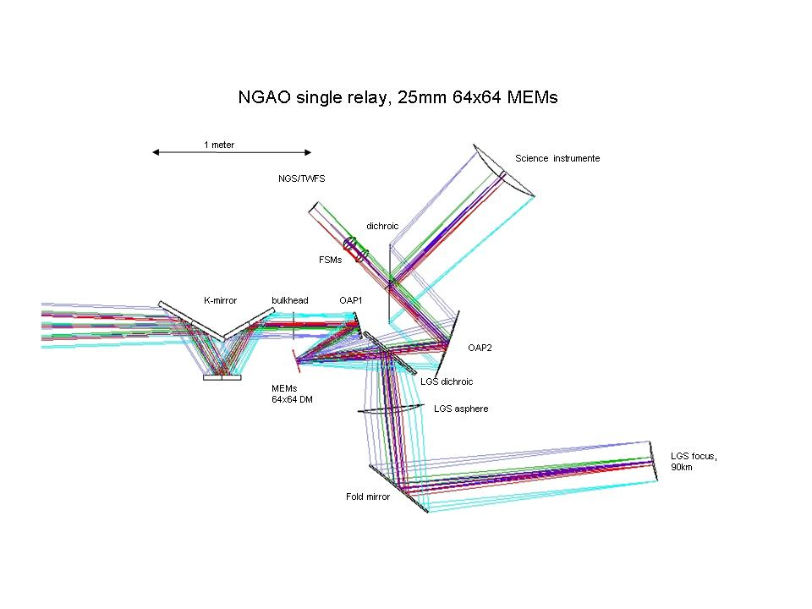
Figure 1. MEMS-based single relay.

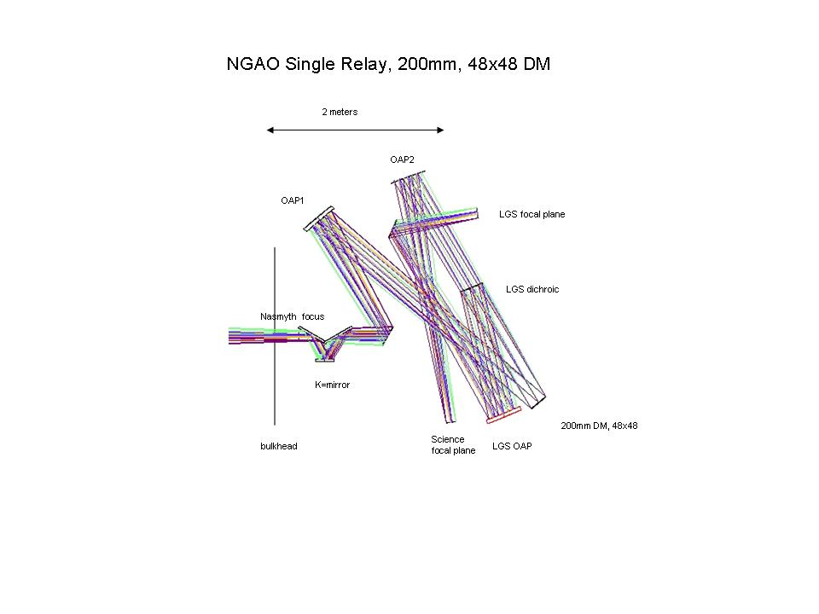
Figure 2. Large DM based single relay.
4. Optical Relay Comparison

The table at the end of this document provides a comparison of the options considered in this study (note that this Excel spreadsheet is also available as a separate file).

5. Conclusion
A comparison of performance metrics, risk, and conformance to the original specification requirements of NGAO clearly favor a large relay, or large first relay, design with a conventional large-pitch piezo-DM in the first relay.
The potential advantages of the single MEMS relay are compactness and cost, as well as tip/tilt performance. The compactness advantage and some of the cost advantage appear to be lost in the subsequent impact on the science instruments. In addition the MEMS relay introduces design and access challenges with its requirement to insert the K-mirror inside of the elevation bearing. The MEMS relay optical performance is consistently worse than that of the DM relay.
Given this comparison, it appears that the potential for approximately $300k savings does not sufficiently justify the additional risk and requirements push-back incurred with a MEMS-based single relay. It is also clear that using a large high-order piezo DM in a single relay would dramatically increase cost (by $1.3M) over the present cascade relay design. Therefore, none of the single relay designs appear to be viable options that meet the objective of reducing cost by simplifying the design. The concluding recommendation is therefore to continue with the baseline cascaded relay architecture, possibly carrying a “back-burner” option of re-using the 140 mm DM from the Keck AO system as the woofer in a cascaded relay.

