

Keck Adaptive Optics Note 575

Keck Next Generation Adaptive Optics
System Design Report

Authors: P. Wizinowich, R. Dekany, D. Gavel, C. Max
on behalf of the NGAO team

March 28, 2008

Keck Adaptive Optics Note 575

Keck Next Generation Adaptive Optics
System Design Report

Table of Contents

Table of Acronyms Used in This Report 3
1. Introduction 4
2. Recommended Reading and Background Information 4
3. Motivation for the Development of NGAO 4
4. System Design Phase Proposal and Management 7
4.1 Proposal and Executive Committee Formation 7
4.2 System Design Phase Plan 7
4.3 System Design Phase Objectives and Deliverables 7
4.4 Project Reports 8
5. Requirements 8
5.1 Science Case Requirements Document 9
5.1.1 “Key Science Drivers” and “Science Drivers” 9
5.1.2 Derivation of Requirements from Science Cases: Illustrative Examples 9
5.2 Science Case Requirements Summary 13
5.2.1 Physical Requirements 13
5.2.2 Performance Requirements 13
5.2.3 Operational Requirements 14
5.3 System Requirements Document 15
5.4 Functional Requirements 15
6. System Design Manual 15
6.1 Requirements Flowdown 16
6.2 System Overview 17
6.3 AO Controls 20
6.4 Performance Budgets 23
7. Systems Engineering Management Plan 23
8. Conclusion 25
Appendix A. NGAO Keck Adaptive Optics Notes (KAONs) 26
Appendix B. Science Case Requirements Summary 28

Table of Acronyms Used in This Report

AO Adaptive Optics
EC Executive Committee
FRD Functional Requirements Document
IBRD Instrument Baseline Requirements Document
IFU Integral Field Unit, a spectrograph that is spatially resolved in two dimensions
KAON Keck Adaptive Optics Note
LGS Laser Guide Star
NGAO Keck Next Generation Adaptive Optics
NGS Natural Guide Star
PSF Point Spread Function
SSC W. M. Keck Observatory Science Steering Committee
SD System Design
SDM System Design Manual
SEMP Systems Engineering Management Plan
SCRD Science Case Requirements Document
SDR System Design Report (this document)
SRD System Requirements Document
UC University of California
UCO University of California Observatories
WFE Wavefront Error
WMKO W. M. Keck Observatory

Introduction
This document provides an overview of the work accomplished during System Design phase for the Keck Next Generation Adaptive Optics System. The System Design phase is the initial design phase for all W. M. Keck Observatory development projects. Successful completion of this phase will allow the project to move into the Preliminary Design phase.

Recommended Reading and Background Information
The current document provides a high-level overview. We recommend that the System Design Phase reviewers also read the following key Keck Adaptive Optics Notes (KAONs):

- Science Case Requirements Document (KAON 455)
- System Requirements Document (KAON 456)
- Functional Requirements Summary (KAON 573)
- System Design Manual (KAON 511)
- Summary of NGAO Trade Studies (KAON 495)
- Technical Risk Evaluation (KAON 510)
- Programmatic Risk Evaluation (KAON 566)
- Systems Engineering Management Plan (KAON 574)

A list of all the NGAO-related KAONs produced through the system design phase can be found in Appendix A or at http://www.oir.caltech.edu/twiki_oir/bin/view/Keck/NGAO/NewKAONs. This web page is located within a Twiki shared website
(http://www.oir.caltech.edu/twiki_oir/bin/view.cgi/Keck/NGAO/WebHome) that we established early in the System Design phase to serve the functions of management, information exchange, document sharing and document maintenance. The NGAO Twiki site is very actively used by the project team, and has been an important factor in uniting researchers from the W. M. Keck, UC Observatories, and Caltech Optical Observatories.

Motivation for the Development of NGAO
Keck I and Keck II are the world’s largest optical and infrared telescopes. Because of their 10-m apertures, they offer the highest potential sensitivity and angular resolution currently available on the ground. WMKO has demonstrated true scientific leadership in high angular resolution astronomy. Keck deployed the first natural guide star and laser guide star (Figure 2) AO systems on 8-10 meter diameter telescopes. The two Keck AO systems have amassed an impressive series of refereed science publications whose number is still growing strongly from year to year (Figure 1). The importance of achieving the full potential of the Keck telescopes is recognized in the Observatory’s Strategic Plan, which identifies continued leadership in high angular resolution astronomy as a key long-term goal.

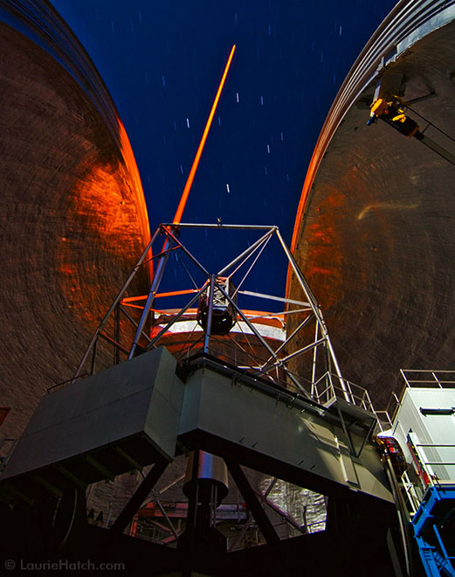

Figure 2 The Keck II laser guide star. Photo by Laurie Hatch.
Figure 1 Publication history of Keck AO systems. The annual rate of growth remains high.

The current Keck AO systems on Keck 1 and Keck 2 are more than 9 years old (commissioned in 1999 and 2001, respectively). They are functioning well. Their ageing wavefront control computers and cameras recently underwent a successful upgrade, and Keck’s record of scientific publications with AO continues to be excellent. However, it has been more than a decade since these systems were originally designed. Dramatic progress had been made in AO concepts and implementation since then. Concepts for tomographic wavefront reconstruction have been strongly developed. Integral field spectroscopy (spatially resolved in two dimensions) has made major strides. MEMS deformable mirrors have been built and thoroughly tested in the laboratory and recently in on-sky demonstrations. Further, the rest of the world has ambitious plans to implement new AO systems, many of which take advantage of multi-laser-guide-star tomography. To maintain leadership we must pursue new AO systems and the science instruments to exploit them.

We have examined, and are continuing to examine, a broad range of key science goals to identify the most compelling high angular resolution science priorities of our community, and to determine what new AO characteristics are needed to realize these goals. We have determined that Keck’s Next Generation AO (NGAO) system should provide the following capabilities:

- Dramatically improved performance at near infrared wavelengths.
  - Significantly higher Strehls (≥ 80% at K-band, shown in Figure 3) and lower thermal backgrounds will result in improved infrared sensitivity.
  - Improved point spread function (PSF) stability and knowledge will result in more precise photometry and astrometry, and in higher companion sensitivity.
- Increased sky coverage and a multiplexing capability, enabling a broader range of science programs.
  - AO correction of infrared tip/tilt stars will result in improved sky coverage than possible otherwise.
  - Multiplexing via a deployable integral field spectrograph will provide dramatic improvements in science throughput for applications such as high-redshift galaxies and research on dense star clusters such as the one in the Galactic Center.
- AO correction in the red portion of the visible spectrum, 0.7-1.0 µm (Figure 3).
  - Strehls of 10 to 25% at 750 nm will result in the highest angular resolution of any existing filled aperture telescope, and are adequate for some very interesting applications.
- A suite of science instruments that will facilitate the powerful range of astronomical programs envisioned for NGAO.
  - The instrument suite will include diffraction-limited imagers in the visible and near-infrared, a narrow-field integral field spectrograph similar to OSIRIS, a unique multiplexed imaging spectroscopy instrument with half a dozen deployable integral field units, each fed by its own MEMS AO system, and the Keck Interferometer.
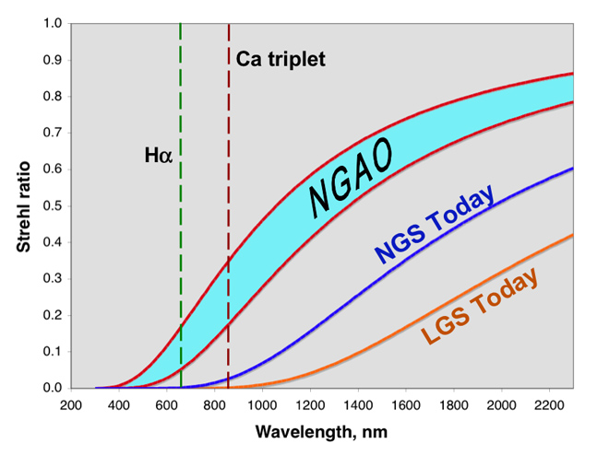
Figure 3 Predicted Strehl ratio versus observing wavelength for NGAO, compared with current Keck AO.
The turquoise NGAO range shown here is bounded by curves with wavefront errors of 140 and 180 nm. Current Keck NGS and LGS curves are shown with 260 nm and 340 nm of wavefront error respectively. The predicted NGAO Strehl at the calcium triplet lines (850 nm) is approximately equal to today’s NGS Strehl at H band and today’s LGS Strehl at K band.

To meet these goals we have developed an innovative AO architecture, the cascaded relay, and an opto-mechanical implementation shown in Figure 4 that we believe is indeed feasible and can meet the science NGAO requirements. We have analyzed NGAO’s computer software and hardware needs, and find them feasible as well. Details will be discussed in the sections to follow, where references to the relevant KAONs will also be found.

NGAO will be a broad and powerful facility with the potential to achieve major advances in astrophysics. It will provide dramatic gains in high-Strehl Solar System and Galactic science, where narrow-field AO has already demonstrated a strong scientific impact. Furthermore, NGAO introduces AO-corrected wide field multiplexing capability that will facilitate extraordinary advances in extragalactic science, e.g. for extragalactic astronomy of multiple high-redshift objects, which will extend far beyond the initial gains made with the Observatory’s current AO systems.

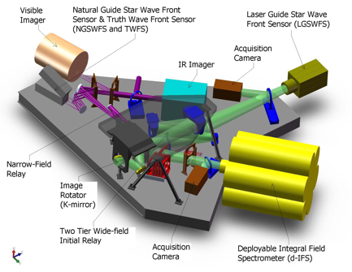

Figure 4 AO system optical layout, perspective view (SolidWorks).
The optical path through the low order “wide” field relay and the high order “narrow” field relay are shown in green and purple, respectively. Light from the telescope enters through the image rotator.

The NGAO proposal (KAON 400) and its Executive Summary (KAON 399) provide more background on the motivation for the development of NGAO. Further scientific motivation is provided in the NGAO Science Case Requirements Document (KAON 455).

System Design Phase Proposal and Management

Proposal and Executive Committee Formation
A proposal (KAON 399 and 400) for NGAO was presented at the June 2006 Keck Science Steering Committee meeting. This proposal was approved to proceed through System Design (SD) phase. The Directors of W. M. Keck Observatory (T. Armandroff and H. Lewis), Caltech Optical Observatories (S. Kulkarni), and the University of California Observatories (M. Bolte) subsequently set up an Executive Committee (EC) to manage the NGAO SD phase. The EC consists of P. Wizinowich (chair), R. Dekany, D. Gavel and C. Max (Project Scientist).

System Design Phase Plan
Subsequent to the approval of the NGAO proposal, the Executive Committee prepared a Systems Engineering Management Plan (SEMP) for the NGAO System Design Phase (KAON 414). This plan was approved by the Directors and work began on the System Ddesign phase in October, 2006. Two scheduled re-planning activities were included in the System Design phase plan. The results of the two re-plans are documented in KAONs 481 and 516.

System Design Phase Objectives and Deliverables
The objectives and deliverables for the System Design phase are defined in KAON 414. The primary objective of the System Design phase is to establish a design approach that meets the scientific and user requirements established for the system.

The four major System Design phase deliverables are: the System Requirements Document, the System Design Manual, the Systems Engineering Management Plan for the remainder of the project, and the System Design Report (SDR – this document). The purpose and status of the first three of these deliverables is discussed in sections of this document to follow.

Project Reports
The Executive Committee issued NGAO progress reports versus our project plans prior to each Keck Science Steering Committee meeting (KAONs 459, 473, 494, 512, 514 and 557).

Requirements

There are three main requirements documents:
- The Science Case Requirements Document (SCRD): KAON 455.
- A 1-page summary of the science case requirements (KAON 548) is attached here as Appendix B.
- The System Requirements Document (SRD): KAON 456.
- The Functional Requirements Document (FRD): KAON 573 and the Contour Database.

There is a fourth requirements document that is referenced by the SRD. This is the Instrument Baseline Requirements Document (KAON 572) which contains Observatory standard requirements for any instrument.

The requirements process can be summarized as follows:

- The science case requirements are developed in the SCRD.

- The science case requirements from the SCRD, and additional requirements imposed by the Observatory, are tabulated in the Overall Requirements section of the SRD. These overall requirements are then flowed down to discipline based requirements in the SRD. The requirements are divided between performance, implementation and design requirements. The disciplines are Optical, Mechanical, Electronic/Electrical, Safety, Software, Interface, Reliability, Spares, Service and Maintenance, and Documentation. Note that the SRD avoids prescribing specific design or implementation solutions.

- The FRD flows down the requirements from the design-independent SRD to requirements on a few high level subsystems. The flow down of the SRD requirements to the FRD requirements is frequently a design choice that could be revisited. The subsystems are chosen to divide the NGAO system into functions that would be required independent of the selected architecture. At minimum these subsystems include the AO system, laser facility, science operations facility, and science instruments, with further subdivision as appropriate. For each subsystem there is a section in the FRD describing the architectural assumptions, followed by a breakdown of the requirements by the same disciplines as used in the SRD.

The FRD provides the criteria against which the subsystems will be evaluated. The SRD provides the criteria against which the NGAO system as a whole will be evaluated.

In the remainder of this section we give an overview of the science case requirements and of the requirements for the NGAO system that flow down from the science requirements.

Science Case Requirements Document

“Key Science Drivers” and “Science Drivers”
The Science Case Requirements Document (SCRD) defines and analyzes two classes of science cases: “Key Science Drivers” and “Science Drivers. “Key Science Drivers” are those science cases that place the strongest or most technologically challenging demands on the performance of the NGAO system and its science instruments. These are the science cases that we have used to drive the performance requirements for the AO system and instruments. “Science Drivers” (not “Key”) are included to assure that the NGAO system is sufficiently flexible to deal with the broad range of science that users will demand over the lifetime of the NGAO system. Typically, “Science Drivers” do not strongly push the state of the art of the AO system itself; rather they require specific types of coordination between the AO system, the instruments, and the telescope, or they help define parameters such as the full wavelength range or the required field of view of the instruments. The SCRD defines and analyzes 5 “Key Science Drivers” and 9 “Science Drivers.” These cases were selected because they represented important astrophysics that would clarify the requirements on the NGAO system from different perspectives.

The “Key Science Drivers” that we analyzed are as follows, in order of distance from Earth:
- Galaxy Assembly and Star Formation History
- Nearby Active Galactic Nuclei
- Precision Astrometry: Measurement of General Relativistic Effects at the Galactic Center
- Imaging and Characterization of Extrasolar Planets around Nearby Stars
- Multiplicity of Minor Planets in our Solar System

The additional “Science Drivers” that we analyzed are as follows:
- Quasar Host Galaxies
- Gravitational Lensing
- Astrometry Science in Sparse Fields
- Resolved Stellar Populations in Crowded Fields
- Debris Disks and Young Stellar Objects
- Size, Shape, and Composition of Minor Planets
- Characteristics of Gas Giant Planets, their Satellites, and Rings
- Characteristics of Ice Giant Planets and their Rings
- Backup Science

Derivation of Requirements from Science Cases: Illustrative Examples
For each science case, the SCRD contains a description of the scientific goals, the proposed target set, and the observing methods and preferred instruments. From these are derived a set of more formal science requirements which are complied in a Table customized for each science case. The items in these Tables are then incorporated into the System Requirements Document and the Functional Requirements database.

In the remainder of this section we shall highlight requirements derived from two “Key Science Drivers”, to illustrate the thought processes used to define NGAO Science Requirements. Full details of the origin of these and other requirements will be found in the Science Case Requirements Document.

“Galaxy Assembly and Star Formation History:” Requirements on Thermal Background and on the Deployable IFU Instrument

At redshifts z ~ 1 – 3, galaxies are thought to have accumulated the majority of their stellar mass, the rate of major galaxies mergers appears to peak, and instantaneous star formation rates and stellar masses range over two decades in value. Given the major activity at these redshifts transforming irregular galaxies into the type of galaxies familiar in the local universe, it is of strong interest to study high-redshift galaxies in an attempt to understand the overall processes of galaxy formation and evolution.

Major rest-frame optical emission lines such as Hα, [N II], and [O III] are redshifted into the observed-frame near-infrared, for galaxies at redshifts z = 1 - 3. In order to study the evolution of galaxies across this range of cosmic times, it is thus important to have spectroscopic wavelength coverage extending from 1 to 2.4 microns. Hα line emission from the well-studied redshift z ~ 2 - 3 galaxy sample falls in the K band, emphasizing the importance of optimizing observations at these wavelengths by reducing thermal backgrounds and increasing system throughput. The requirement agreed upon is as follows: the total background seen at the focal plane of all spectrographs being fed by NGAO shall be less than 130% of the current unattenuated sky plus telescope background (at 2209 nm and at a spectral resolution λ/Δλ = 5000, which falls between OH emission lines from the sky).

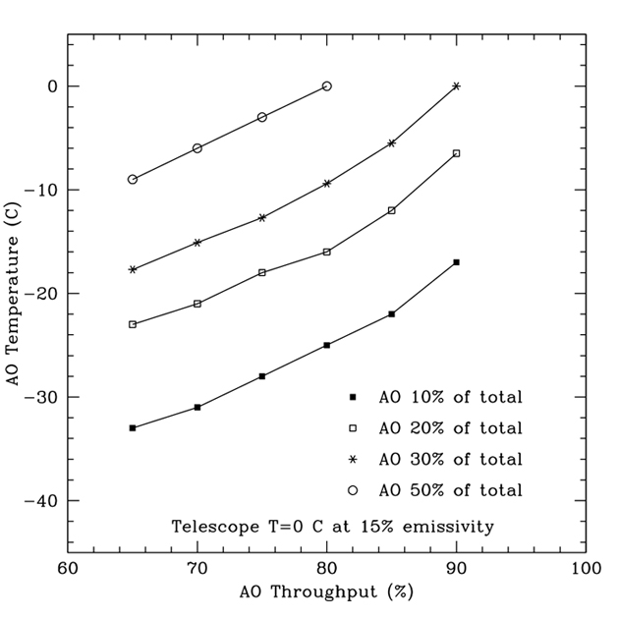
This requirement was derived by asking what thermal background in K band was needed in order to reduce the integration time for integral field spectroscopy of a redshift 2.6 galaxy to 3 hours, from the current > 6 hr integration time required with the OSIRIS spectrograph and the existing AO system. Figure 5 shows that for an NGAO system throughput of 70%, this will require cooling the AO system to about -18C. Our design of the AO enclosure and operations is taking this cooling requirement into account.
Figure 5. Required cooling of the NGAO system for varying values of its throughput.

A second consideration is what the requirements should be for NGAO’s deployable integral field spectrograph instrument. The spectrograph concept is illustrated schematically in Figure 6.
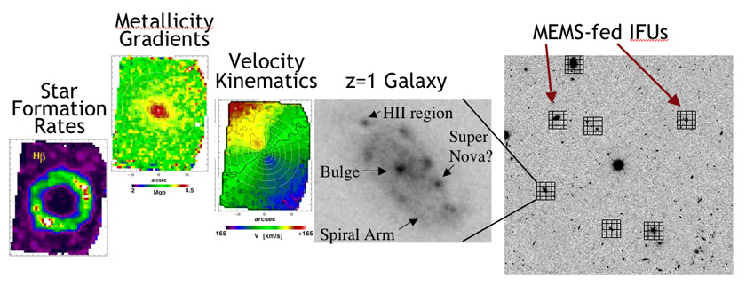
Figure 6 Schematic operation of a multiplexed deployable integral field spectrograph.

High-redshift galaxies have areal densities on the sky ranging up to ~20 galaxies per square arc minute. If light from each galaxy is sent into a MEMS-AO-fed spatially resolved spectrograph, one can obtain crucial information about internal galaxy morphology, kinematics, metallicity gradients, and star formation rates for many galaxies simultaneously. If one had 20 deployable “arms” one would effectively be observing with 20 Keck telescopes at a time! Realistically, however, this would be an entirely new kind of instrument, using several technologies for the first time “on the sky.” Considerations of both risk and cost have lead us to specify a requirement of at least 6 independently deployable “arms” patrolling a 5 square arc minute field on the sky for this pathfinding instrument. Potential follow-on instruments such as IRMOS on the Thirty Meter Telescope will benefit from the experience of the NGAO system with this type of instrument.

One must then specify the field of view of each individual spectrograph unit. High-redshift galaxies are typically about an arc second in size, though some sub-classes are larger. They are not true point sources and hence do not fully benefit from the so-called D⁴ scaling of sensitivity with telescope diameter D. Additionally, at the long-wavelength end of K band the sensitivity is decreased due to thermal background, and once must measure the “sky background” accurately in order to subtract its spectrum from that of the galaxy. Balancing all of these considerations has led to a required field of view of 1” x 3” for each spectrograph unit, so that the spectrum of the “sky background” can be measured on one end of the field while the spectrum of the galaxy is measured on the other end. This assures that valuable telescope time will not be wasted by teh requirement to nod off to “blank sky” in order to perform adequate background subtraction. For the high-redshift galaxy science case, the optimum spatial sampling is larger than the diffraction limit (e.g. of order 0.07 arc sec up to 0.1 arc sec, depending on the galaxy’s surface brightness and internal structure). We have specified 70 mas spaxels for each spectrograph unit.

Next one must ask what fraction of a given field of high-redshift galaxies can be observed with the required AO correction and hence spatial resolution. For the high-z galaxy science case, the sky coverage at a given level of AO performance is limited by the availability of tip-tilt stars. Given the distribution of infra-red tip-tilt stars on the sky, our calculations indicate that the as-designed NGAO system should be able to put 50% of the energy of a point source within a 0.07 arc sec region, with 30% or more sky coverage fraction. This is sufficient, for example, to perform a survey of 200 galaxies in 3 years or less, assuming a realistic telescope time allocation for the project and 4 galaxies observed per square arc minute over a 5 square arc minute patrol field.

“Measurement of General Relativistic Effects at the Galactic Center”: Requirements on Astrometric and Radial Velocity Accuracy
The proximity of our Galaxy's center presents a unique opportunity to study a massive black hole and its environs at much higher spatial resolution than can be brought to bear on any other galaxy. In the last decade, near-infrared observations with astrometric precisions of < 1 mas and radial velocity precision of 20 km/s have enabled the measurement of orbital motions for several stars in orbit around the black hole near the Galactic center, revealing a central dark mass of 3.7 x 10⁶ M_{Sun} These observations provide the most definitive evidence for the existence of massive black holes in the centers of galaxies. Due to the crowded stellar environment at the Galactic Center and the strong line-of-sight optical absorption, tracking stellar orbits requires the high angular resolution, near-infrared imaging and spectroscopy capabilities of adaptive optics on telescopes with large primary mirrors, such as Keck. Though the current orbital reconstructions are consistent with pure Keplerian motion, with improved astrometric and radial velocity precision deviations from pure Keplerian motion are expected, due in part to the effects of General Relativity.
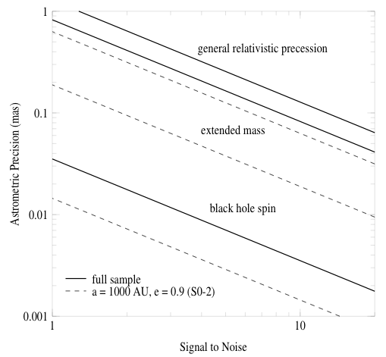

Figure 7 Required astrometric precision for detecting General Relativistic effects at the Galactic Center.
The lines indicate (top to bottom) effects due to prograde precession, extended mass, and frame-dragging due to black-hole spin. Radial velocity measurement errors of 10 km/s are assumed. The precession effect can be measured with signal-to-noise of 10 if astrometric accuracies of 0.12 mas can be achieved with NGAO.

With Keck NGAO, stellar orbits can be monitored with sufficient precision to enable a measurement of post-Newtonian General Relativistic effects associated with the black hole. This includes the prograde precession of orbits. As Figure 7 illustrates, the General Relativistic prograde precession can be measured even for single orbits of already-known stars if we have an astrometric precision of ~ 100 μas coupled with radial velocity precision of 10 km/s. This sets the science requirements for the Galactic Center General Relativity science case. Calculations to date indicate that NGAO can meet the required spatial resolution if it delivers a wavefront error of 170 nm at the position of the Galactic Center. In the PDR phase we will analyze the implications of the radial velocity and astrometry requirements for the AO system and instrument suite.

Science Case Requirements Summary
A summary table of the science requirements can be found in Appendix B. This summary table groups the requirements by three categories: physical, performance, and operational. Requirements are reported for each science instrument: visible imager, visible spectrograph, near-IR imager, near-IR spectrograph, near-IR deployable IFU, and the Keck Interferometer. The science cases that drive each requirement are listed at the bottom of each column; these are defined in the table at the lower left of the page. In the current section, a high-level overview of the requirements is provided.

Physical Requirements
- Wavelength range.
  - Visible instruments require a transmitted wavelength range of 0.7 to 1.0 µm, with a goal of rest-frame Hα (0.6563 µm).
  - Near-IR instruments require a transmitted wavelength range from 1.0 to 2.4 µm, with a goal of including the Y and z-bands (0.98-1.20 µm).
  - The interferometer requires a transmitted wavelength range from J through L-band, with a goal to N-band.
- Field of view diameter
  - Based on the specific science cases considered to date, the field of view requirement (15" field diameter) for the narrow-field instruments is relatively modest. A decision was made, in consultation with the Keck AO Working Group, to require a 30" diameter field to allow for science cases not considered, as well as for dithering and for finding a point source to use as a PSF reference.
  - The field of view requirement for each deployable IFU unit is 1"x3".
  - The interferometer’s field of view requirement is ≥ 1" diameter.
- Field of regard diameter
  - The requirement for the deployable IFU heads is ≥ 120" diameter.
  - The requirement for the interferometer is ≥ 60" diameter, for simultaneous observation of an on-axis phase referencing star and an off-axis science target.
- Minimum number of IFUs
  - Six or more independently positionable IFUs heads.
- AO background
  - The total background seen at the focal plane of all spectrographs being fed by NGAO shall be less than 130% of the current unattenuated sky plus telescope background (at 2209 nm and at a spectral resolution λ/Δλ = 5000, which falls between OH emission lines from the sky).

Performance Requirements
Performance requirements must be met under median seeing conditions (defined in KAON 503 and summarized in the bottom right corner of the spreadsheet): r₀ = 18 cm and θ₀ = 2.9".

- Sky coverage
  - In all cases with the exception of the interferometer, the following performance criteria are required to be met over ≥ 30% of the sky.
- High order wavefront error (WFE) for ≤ 5" field of view
  - The requirement on residual rms WFE after correction is ≤ 170 nm as delivered to the science focal plane of the narrow field imagers and spectrographs. High order refers to all terms higher than tip and tilt.
- Tip/tilt error
  - The requirement on residual rms tip/tilt error is ≤ 15 mas as delivered to the science focal plane of the narrow field imagers and spectrographs for the ≥ 30% sky coverage case. For the special case of the Galactic Center the requirement is ≤ 3 mas.
- 50% ensquared energy
  - Ensquared energy was determined to be a more relevant requirement for the NIR deployable IFU (the corresponding high order and tip/tilt errors can be derived from this requirement). The requirement is for 50% of the energy to be enclosed in an area of ≤ 70 x 70 mas when the sky coverage is 30%.
- Companion sensitivity
  - This requirement is relevant only to the visible and NIR imagers. The requirement is written for different filters and different angular separations according to the relevant science case. For example, for planets around low mass stars ΔJ ≥ 11 at 0.2" separation from the primary star.
- Photometry
  - The relative photometry requirement is ≤ 0.05 magnitudes for both imagers.
- Astrometry
  - The requirement is relative astrometry ≤ 100 μas in the near-infrared for the Galactic Center science case; for other science cases it is ≤ 5 mas for both imagers.

Operational Requirements

- Point Spread Function (PSF) estimation
  - An estimate of the PSF, for post-processing purposes, is required for both imagers and is a goal for both spectrographs. The accuracy required is to be studied and defined during the PD phase.
- Differential tracking
  - For solar system science there is a requirement to be able to use a sidereal rate object for tip/tilt correction of a solar system object.
- Acquisition accuracy
  - The acquisition system should be able to position the science object on the science field to the indicated accuracy without taking a science exposure. Generally, the requirement is ≤10% of the field size. However for placing an object on a slit the requirement is more stringent (≤ 0.25λ/D).
- Science image drift
  - This defines the requirement on the stability of the science field with respect to the AO system. The requirement is to have this drift be ≤ 5 mas per hour.
- NGS mode
  - Generally speaking it is a requirement to have access to an NGS observing mode, for backup purposes. In the case of the NIR deployable IFU only one of the IFUs is required to do science in NGS mode.
- AO instrument switching
  - This requirement is driven by the desire to do both imaging and spectroscopy on the same night. The requirement is to be able to switch between the visible imager and spectrograph during observing (in a TBD time), and similarly be able to switch between the NIR imager and spectrograph.
- Other
  - The interferometer requirements must be met by an NGAO mode including matched fields, polarization, etc. from both telescopes.
  - Both fixed field and fixed pupil modes are required to be supported.
  - The acquisition system must provide a means of acquiring the tip/tilt stars and the LGS beacons.

System Requirements Document
The System Requirements Document (SRD), KAON 456, includes the science requirements from the SCRD as well as user and Observatory requirements. The SRD also includes the technical requirements organized by engineering discipline as flowed down from the science and user requirements.

The main body of the SRD presents the overall requirements in the form of 29 performance requirement tables. The overall requirements comprise three main sections: 1) the science performance requirements from the science cases, 2) the performance requirements for the science instruments and for the science operations from the observer point-of-view, and finally 3) the observatory requirements. The Observatory requirements encompass facility, telescope and dome environment, science instruments and science operations from the perspective of the observatory.

A second part of the document presents the requirements per engineering discipline. This section is shorter as most of these requirements are to be implemented at an observatory-wide scale, and are already part of the instrument baseline requirements document. Requirements specific to NGAO are detailed therein, e.g., requirements for NGAO from the Keck interferometer.

Functional Requirements
The functional requirements have all been input into a requirements database tool (JAMA software’s Contour) to support long term requirements tracking and maintenance. A summary of the functional requirements can be found in KAON 573.

System Design Manual
Our approach to the design process was to break it into the following phases with appropriate iteration between these phases, as well iterations with the system requirements:
- Development of performance budgets, including determining the best model assumptions and validating the modeling tools.
- Performance of trade studies to support future design choices.
- Development of a system architecture.
- Performance of a technical risk analysis.
- Development of the functional requirements.
- Development of the subsystem designs.

The results of this work are summarized in the System Design Manual (SDM – KAON 511). The SDM references a significant number of KAONs where more details can be found. The following sections are only intended to provide a very brief overview of the design.

Requirements Flowdown

The key elements of the selected architecture flowed directly from the major science capabilities described in section 3, the science case requirements discussed in section 5.2 and the additional system requirements (section 5.3). At the highest level these can be summarized as follows:

- Dramatically improved performance at near infrared wavelengths.
- Improved IR sensitivity.
- High Strehls (≥ 80% at K-band) are required over narrow fields. The flowed down requirements are derived from the wavefront error performance budget and assumption about how these error terms can be met. These flowed down requirements include number of actuators in the narrow field, required system bandwidth, number of LGS, number of NGS, required laser power, etc.
- Lower backgrounds. This is particularly driven by the high redshift galaxy science. This requirement has driven the need for a cooled AO system and the required temperature.
- Improved astrometric, photometric and companion sensitivity performance.
- Improved IR sensitivity is required (see above).
- It will also be critical to improve the PSF stability and knowledge. The requirements on the PSF stability and knowledge to achieve the astrometric, photometric and companion sensitivity requirements will be developed during the Preliminary Design. The astrometric error budget and PSF reconstruction tools will be developed during the Preliminary Design.

- Increased sky coverage.
- Wide field required. This requirement drove us to a wider field than needed for the d-IFS in order to find suitable NGS for tip-tilt sensing. The field requirement was determined via the analysis documented in KAON 504.
- Ability to use faint NGS. This requirement drove us to the architecture where we provide AO correction of the tip-tilt stars.

- Efficient extragalactic target surveys.
- Science instrument.
- The need for efficient acquisition of spectral and imaging data drove us to an integral field spectrograph.
- The availability of multiple targets over a modest (2′ diameter field) and the need to perform surveys efficiently drove us to a multiple head instrument.
- The need to adapt to the observation field drove us to deployable heads.
- Sensitivity.
- The required image resolution allowed us to work to an encircled energy requirement that required fewer actuators than for the narrow field science.
- This requirement, and the requirement to AO correct the tip-tilt NGS over a wide field, drove us to a choice between multi-conjugate (MC) and multi-object (MO) AO to achieve good correction over a wide field. Maximizing the performance over narrow non-contiguous fields led to the selection of MOAO.
- The need for low backgrounds drove the need for a cooled AO enclosure.

- AO correction in the red portion of the visible spectrum.
- This drove the need to transmit these wavelengths to the visible science instruments and to share visible light with the LGS and NGS wavefront sensors via appropriate dichroics.

- Science instruments that will facilitate the range of science programs.
- This drove the selection and conceptual design of the science instruments.
- This drove the providing of locations for these science instruments in the design.

System Overview
The requirements flow down described in the previous section led us to the following key architectural features:

- Laser tomography to measure wavefronts and overcome the cone effect.
- A variable radius LGS asterism to maximize the performance for each science field and the atmospheric profile.
- LGS projection from behind the telescope secondary mirror to minimize perspective elongation.
- Location of the AO system on one of the Keck telescope Nasmyth platforms to have sufficient space for the AO system and science instruments.
- A cooled AO system to meet the infrared background requirements. Alternate approaches such as an adaptive secondary mirror were considered.
- A rotator at the input to the AO system to keep either the field or pupil fixed. The AO system would need to be cooled even without a rotator and this approach allows the most stability for the AO system and instruments.
- A wide-field (150" diameter) relay to feed light to the LGS wavefront sensors, tip-tilt sensors, and d-IFS.
- A conventional (5 mm pitch) DM was chosen to transmit a wide field in the wide-field relay.
- A low order (20 actuators across the pupil) DM was chosen for the wide-field relay to limit the size of the relay, to permit closed loop AO correction on the LGS wavefront sensors and to keep the LGS wavefront sensors in their linear range, and to reduce the requirement on downstream open loop correction.
- Open loop MOAO-corrected near-IR tip-tilt sensors to maximize sky coverage. The MOAO approach (versus MCAO) maximizes the Strehl over narrow fields. The open loop correction applies the result of the tomographic reconstruction to that point in the field. In principle this is better than closed loop on a single LGS since focus anisoplanatism is also reduced. Near-IR sensing is used since the AO correction will sharpen the NGS image and thereby provide better tip-tilt information. We have determined that two tip-tilt (TT) sensors and one tip-tilt-focus-astigmatism (TTFA) sensor provides the optimum correction.
- Open loop MOAO-corrected d-IFS heads.
- Open loop MOAO-correction to the narrow field science instruments.
- MEMs DMs for the MOAO-correction. These are very compact devices and have been lab demonstrated to accurately go where they are commanded. 32x32 element MEMs provide the required correction for the tip-tilt sensors and d-IFS heads. A 64x64 element MEMs is needed to provide the required AO correction to the narrow field science instruments.
- A high order, narrow-field (30" diameter) AO relay to feed light to the narrow field science instruments (with a larger, 60" diameter, field to the NGS wavefront sensor). The science instruments fed by this relay only require a narrow-field and the narrow field facilitates the use of a single MEMs DM for all narrow-field instruments. These science instruments include near-IR and visible imagers and OSIRIS.

The resultant architecture is shown schematically in Figure 8. Starting at the lower left hand side of the figure, an environmental enclosure is provided to house lasers generating a total of ~150 W in a CW format (or a pulse format with comparable sodium layer return flux). The output from these lasers is transferred (via fibers or a free space beam transfer system) to a multiple beam pattern generator and controller located at the top end of the telescope. The output of this beam pattern generator is projected onto the mesospheric sodium layer by a laser launch telescope located behind the telescope secondary mirror as shown just to the left of center in the figure.

Light collected by the Keck telescope is directed to the AO system shown in the lower right in Figure 8. The AO system and instruments are located on the telescope’s left Nasmyth platform at the f/15 focus. The AO system is enclosed in an enclosure cooled to about -15C below ambient (~260 K) to reduce the thermal emissivity of the optical surfaces. A window is provided to isolate the enclosure from the dome environment.

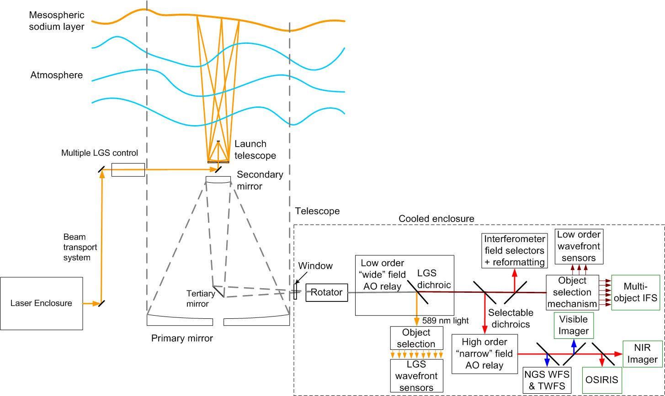
Figure 8. NGAO Block Diagram.

Within the cooled enclosure, the light from the telescope passes through an image de-rotator. A “moderate” field low order AO relay incorporating a single DM provides low order AO correction (where low order refers to the order of AO correction provided by the existing Keck AO systems). This DM operates in a closed loop in conjunction with the LGS wavefront sensors. Just after the DM, a dichroic beamsplitter is used to send the 589 nm light from the constellation of LGS to the LGS wavefront sensor assembly, which includes an object selection mechanism. In the absence of a selectable dichroic the light from the low order relay is then transmitted directly to the object selection mechanism for the d-IFS and the low order wavefront sensors (i.e., the NIR TT and TTFA sensors and a NIR truth wavefront sensor (TWFS)). A fold mirror or dichroic can be inserted to feed light to the Keck interferometer.

To use the “narrow” field science instruments a selectable dichroic is inserted to send the light through a “narrow” field high order AO relay. High order refers to three times the DM actuator spacing of the low order DM. This relay provides AO corrected light to a visible light NGS wavefront sensor and TWFS assembly, and three science instruments.

For NGS AO observations only the NGS WFS is required. For LGS AO observations, the LGS wavefront sensors, three tip-tilt sensors and one of the TWFS are required. A schematic representation of the location of the LGS beacons and the various sensors for both narrow and wide field science is shown in Figure 9. A variable LGS asterism with one LGS on-axis and five LGS in a pentagon is shown. This asterism can be expanded or contracted for the particular science case and atmospheric conditions. Three additional LGS are used to point near the tip-tilt (TT) NGS to maximize their image sharpening.

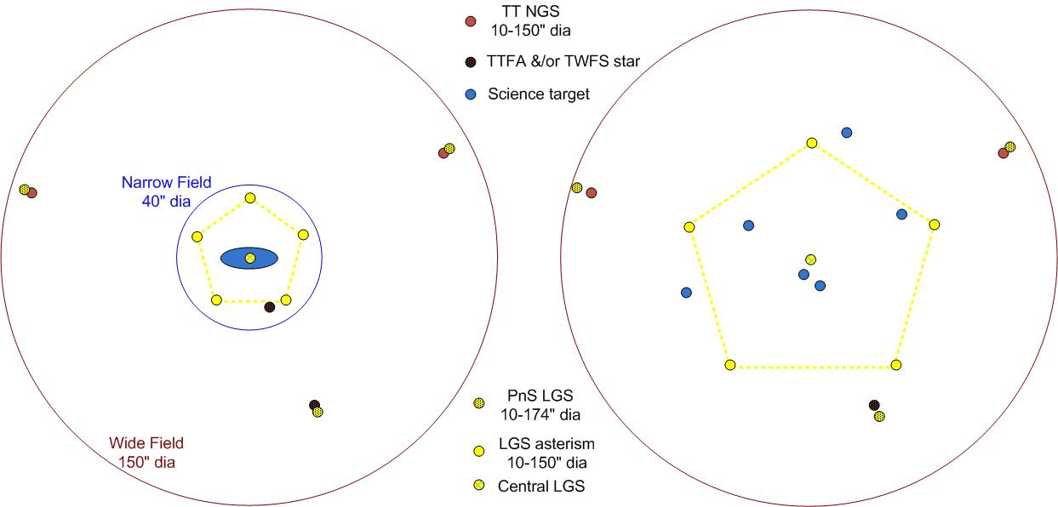
Figure 9. Narrow-field (left) and wide-field (right) LGS asterisms.

Optical (Zemax) and mechanical (Solid Works) models of the AO bench have been produced. Figure 4, presented earlier, is a view of the mechanical model.

AO Controls
Figure 10 and Figure 11 provide schematic overviews of the NGAO controls system infrastructure.. The NGAO control architecture is distributed among several subsystems: science instruments, AO system, telescope interface, laser system, data server, atmospheric tools and laser traffic control system. The overall system is operated through the science operations tools box at the top of Figure 10. This consists of a user interface and operations tools (pre-observing, operation control tools and post-observing tooels

Figure 10. NGAO system distributed controls system block diagram.

Figure 11 presents a block diagram of the AO infrastructure where the control systems are represented by a hierarchy. At the top level are the main interfaces to the various subsystems. The science operations tools control the AO facility through a high level sequencer (the multi-system sequencer) as shown at the top of Figure 11. The multi-system sequencer sends parallel commands to each of subsystem sequencer. The sequencing is performed at the lowest possible levels allowing for parallel (time efficient) observing sequences. The middle level of the hierarchy represents the basic control functions for that subsystem. Some users will access the system at this middle level for engineering or troubleshooting purposes. Finally, at the bottom level of the hierarchy are the devices controlled by the control system themselves.

Figure 11. Expanded view of the controls system block diagram.

The Real-Time Control (RTC) element of Figure 11 is central to the success of the NGAO system. The multi-guide star tomography data flow and the required parallel processing are shown in Figure 12Figure 12. The RTC is a specialized computer system designed to perform all of the wavefront sensing, tomography calculations, and deformable mirror control processing at rates that keep up with atmospheric turbulence induced optical aberrations. The RTC data flow and computer architectures have been designed to achieve the tomography precision, noise suppression, and bandwidth requirements implied by the science-case driven wavefront error budgets.

An equally important consideration in the RTC design is the need to keep the cost and complexity manageable. Simply scaling earlier implementations of single conjugate AO RTC reconstructors using traditional central processing units (CPUs) is infeasible because of the multiplying effect of multi-guidestars and multiple deformable mirrors on computer speed requirements. To address this issue, we have taken advantage of the parallelizability of wavefront reconstruction and tomography algorithms and mapped them on to a massively-parallel processing (MPP) compute architecture. This architecture scales in size and complexity much more favorably than doing the same calculations on CPUs, and can be readily implemented with commercial off the shelf technology building blocks called field programmable gate arrays (FPGAs).

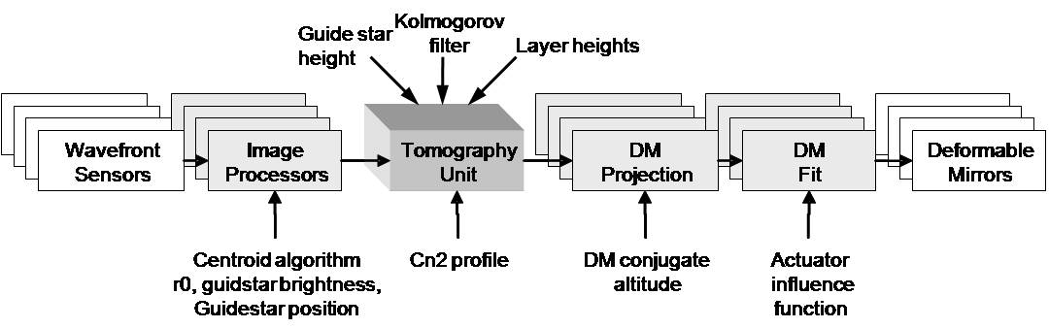
Figure 12. Multi-guide star tomography data flow and parallel processing.

As shown in the Figure 12 schematic, large chunks of compute tasks are associated with either wavefront sensors or DMs and thus can be parallelized across them. Thus some of the dedicated processing units will be assigned specifically to hardware. Furthermore, algorithms within the subunits, as well as within the tomography unit itself, are highly parallelizable when implemented in the Fourier domain, and thus will each map onto an MPP architecture as described earlier.
The RTC algorithm computes the statistical minimum variance solutions for wavefronts at each science instrument, given the measured wavefront data from the guide stars. The minimum variance solution depends on certain a-priori data, which the RTC accepts as parametric input, which include Cn2 profile discretized at layers, number of layers of turbulence, brightness of guide stars and wind speeds at layers.
Truth wavefront sensors will provide long-term average wavefront data designed to normalize out systematic biases due to either non-common path optical aberration or Hartmann sensor biases due to variations in the sodium layer thickness and altitude. The RTC will process these wavefront sensor data like any other wavefront sensor and use the results to adjust zero-set points in the overall reconstructor.
In a like manner, prior measurements will have determined calibration set points for each wavefront sensor, giving the definition of a “flat” wavefront for each sensor. The set points for LGS wavefront sensors will depend on field position and zenith angle. Thus the multi-system command sequencer, with knowledge of the telescope and AO system configuration, will periodically update the RTC wavefront sensor sub-processors as to which parameter set to apply to the wavefront reconstruction.
The processing units and algorithm will be made reconfigurable to allow for each of the observing modes envisioned for NGAO. Configuration parameters include number and field-positions of laser guide stars, tip/tilt guide stars and deployable science wavefront correctors.
Furthermore, the scalloped pupil of the Keck primary mirror will rotate with respect to the wavefront sensors and DMs in some science observing scenarios. The wavefront and tomography reconstructors utilizes a model pupil as a “valid data” mask, so this model will be set and updated at the appropriate rate within the RTC.

  - Performance Budgets

Systems Engineering Management Plan
A SEMP (KAON 574) has been produced for the remainder of the project. The project plan includes a work breakdown structure with task definitions, cost estimates, management plans including risk management, major milestones, and an MS Project plan.

Some key excerpts from the SEMP are summarized here:
- Organization. A modified organization structure has been proposed for the preliminary design phase to make more efficient use of the team’s talents and to allow for more efficient decision making.
- A Work Breakdown Structure and Product Structure have been defined for the project. The high level WBS is shown in Figure 13. The top level structure reflects the transition from Design (1.0) through Full Scale Development (4.0 to 7.0) to Delivery and Commissioning (8.0 and 9.0). WBS 8.0 includes Science Verification and WBS 9.0 covers the handover to Facility Class Operation. Management (2.0) and Systems Engineering (3.0) are ongoing items through both Full Scale Development and Delivery and Commissioning. A detailed WBS dictionary can be found in KAON 583.
- A high level project milestone schedule is shown in Table 1. The schedule is at least initially driven by the availability of funding, as reflected in the 22-month duration of the preliminary design phase. The 24-month detailed design phase is driven by the need to allow time to significantly increase the number of personnel at the start of this phase. Eighteen months between the end of the detailed design and the start of lab I&T will be adequate if long lead procurements can be placed during the detailed design. The laser procurement in particular will likely need to be placed during the preliminary design. The telescope integration and test schedule will need to be carefully coordinated with the observing semester schedule and decision dates in order to minimize the down time for AO (AO will however be available on the Keck I telescope during this period). In this schedule NGAO shared-risk science would begin in semester 15A.
- A very detailed bottoms-up cost estimation process was performed, modeled on the TMT process. This process produced over 300 cost sheets, which include WBS dictionary definitions, deliverables, labor, non-labor, travel and contingency estimates along with their bases of estimation. These costs were also compared to the costs for similarly complex systems. As a result we have a high level of confidence in the cost estimate for this early in the project. The bottom line estimate is $34.5M plus $7.7M in contingency in FY08 dollars. A summary of this cost estimate by major phase, and cost estimation category, is provided in Table 2.
- We have evaluated and documented the programmatic (KAON 566) and technical (KAON 510) risks to NGAO and our proposed mitigation approaches. Our approach to risk evaluation follows the model used at JPL where risks are ranked according to likelihood and consequence.
- An approach to requirements management using a database management tool has been defined and is in use (as described in KAON 573).
- An approach to integration and test has been defined (KAON 581) and is integrated with our WBS and schedule.
- A preliminary design phase MS project schedule has been produced that is consistent with the cost estimate and with the available Observatory budget. Personnel assignments have been made to each task in the schedule.
- We have not yet dedicated time to the issues of phased implementation approaches or descope options, although we certainly have considerable relevant experience to address these issues.
- A brief summary is provided of how the team performed during the SD phase in terms of deliverables, schedule and budget.

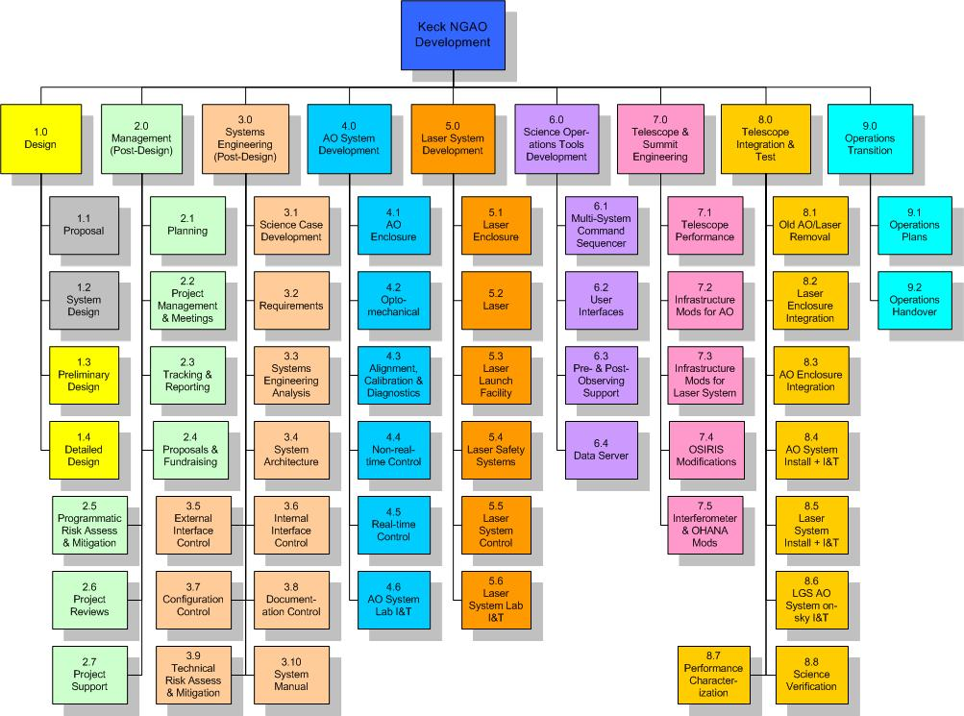
Figure 13. NGAO Work Breakdown Structure (WBS).

Year | Month | NGAO Project Milestone
2008 | April | System Design Review
2010 | February | Preliminary Design Review
2012 | February | Detailed Design Review
2013 | February | Full Scale Development Intermediate Review
2013 | August | Pre-Lab I&T Readiness Review
2014 | February | Pre-Ship Readiness Review
2014 | May | NGS First Light
2014 | July | LGS First Light
2014 | August | 15A Shared-Risk Science Availability Review
2014 | December | Operational Readiness Review
Table 1. NGAO Project milestones.

Phase | Labor (PY) | Cost Estimate (FY08 $k) |  |  |  |  |  | % of NGAO Budget
Phase | Labor (PY) | Labor | Non-Labor | Travel | Sub-Total | Contin-gency | Total | % of NGAO Budget
Preliminary Design | 21.0 | 2,582 | 216 | 224 | 3,022 | 458 | 3,479 | 8%
Detailed Design | 43.6 | 5,516 | 1,827 | 354 | 7,697 | 1,403 | 9,100 | 22%
Full Scale Develop | 50.5 | 5,661 | 14,510 | 626 | 20,797 | 5,234 | 26,031 | 62%
Delivery/ Commission | 22.4 | 2,287 | 250 | 478 | 3,015 | 602 | 3,617 | 9%
Total = | 138 | 16,045 | 16,804 | 1,681 | 34,531 | 7,697 | 42,227 | 100%
% = |  | 38% | 40% | 4% | 82% | 18% | 100%
Table 2. NGAO cost estimate by project phase, in FY08 $k.

- Conclusion
We believe that we have successfully completed the SD phase and that we have established a design approach that meets the scientific and user requirements established for the system, as required for the conclusion of the System Design phase. We have also developed a viable technical and management path forward to the realization of a very powerful scientific capability: NGAO for the Keck Observatory. We are looking forward to continuing into the Preliminary design phase and beyond.

Appendix A. NGAO Keck Adaptive Optics Notes (KAONs)

Appendix B. Science Case Requirements Summary

