

Keck Adaptive Optics Note 575

Keck Next Generation Adaptive Optics
System Design Report

Authors: P. Wizinowich, R. Dekany, D. Gavel, C. Max

March 26, 2008

Keck Adaptive Optics Note 575

Keck Next Generation Adaptive Optics
System Design Report

Table of Contents

Table of Acronyms Used in This Report 3
1. Introduction 4
2. Recommended Reading and Background Information 4
3. Motivation for the Development of NGAO 4
4. System Design Phase Proposal and Management 7
4.1 Proposal 7
4.2 System Design Phase Plan 7
4.3 System Design Phase Objectives and Deliverables 8
4.4 Project Reports 8
5. Requirements 8
5.1 Science Case Requirements Document 9
5.1.1 “Key Science Drivers” and “Science Drivers” 9
5.1.2 Derivation of Requirements from Science Cases: Illustrative Examples 10
5.2 Science Case Requirements Summary 13
5.2.1 Physical Requirements 13
5.2.2 Performance Requirements 14
5.2.3 Operational Requirements 14
5.3 System Requirements Document 15
5.4 Functional Requirements 15
6. System Design Manual 15
7. Systems Engineering Management Plan 16
8. Conclusion 16
Appendix A. NGAO Keck Adaptive Optics Notes (KAONs) Sorted by Categories 17
Appendix B. Science Case Requirements Summary 19

Table of Acronyms Used in This Report

AO Adaptive Optics
EC Executive Committee
FRD Functional Requirements Document
IBRD Instrument Baseline Requirements Document
IFU Integral Field Unit, a spectrograph that is spatially resolved in two dimensions
KAON Keck Adaptive Optics Note
LGS Laser Guide Star
NGAO Keck Next Generation Adaptive Optics
NGS Natural Guide Star
PSF Point Spread Function
SSC W. M. Keck Observatory Science Steering Committee
SD System Design
SDM System Design Manual
SEMP Systems Engineering Management Plan
SCRD Science Case Requirements Document
SDR System Design Report (this document)
SRD System Requirements Document
UC University of California
UCO University of California Observatories
WFE Wavefront Error
WMKO W. M. Keck Observatory

Introduction
This document provides an overview of the work accomplished during System Design phase for the Keck Next Generation Adaptive Optics System. The System Design phase is the initial design phase for all W. M. Keck Observatory development projects. Successful completion of this phase will allow the project to move into the Preliminary Design phase.

Recommended Reading and Background Information
The current document provides a high-level overview. We recommend that the System Design Phase reviewers also read the following key Keck Adaptive Optics Notes (KAONs):

- Science Case Requirements Document (KAON 455)
- System Requirements Document (KAON 456)
- Functional Requirements Summary (KAON 573)
- System Design Manual (KAON 511)
- Summary of NGAO Trade Studies (KAON 495)
- Technical Risk Evaluation (KAON 510)
- Programmatic Risk Evaluation (KAON 566)
- Systems Engineering Management Plan (KAON 574)

A list of all the NGAO-related KAONs produced through the system design phase can be found in Appendix A or at http://www.oir.caltech.edu/twiki_oir/bin/view/Keck/NGAO/NewKAONs. This web page is located within a Twiki shared website
(http://www.oir.caltech.edu/twiki_oir/bin/view.cgi/Keck/NGAO/WebHome) that we established early in the System Design phase to serve the functions of management, information exchange, document sharing and document maintenance. The NGAO Twiki site continues to be very actively used by the project team, and has been an important factor in uniting researchers from the W. M. Keck, UC Observatories, and Caltech Optical Observatories.

Motivation for the Development of NGAO
Keck 1 and Keck 2 are the world’s largest optical and infrared telescopes. Because of their 10-m apertures, they offer the highest potential sensitivity and angular resolution currently available on the ground. WMKO has demonstrated true scientific leadership in high angular resolution astronomy. Keck deployed the first natural guide star and laser guide star (Figure 2) AO systems on 8-10 meter diameter telescopes. The two Keck AO systems have amassed an impressive series of refereed science publications whose number is still growing strongly from year to year (Figure 1). The importance of achieving the full potential of the Keck telescopes is recognized in the Observatory’s Strategic Plan, which identifies continued leadership in high angular resolution astronomy as a key long-term goal.

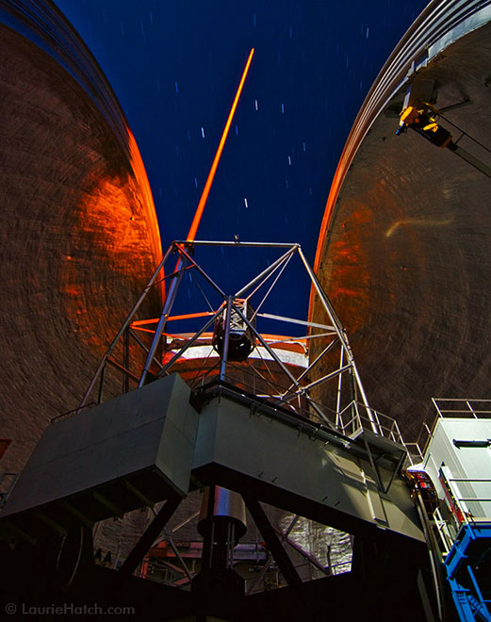

Figure 2 The Keck 2 laser guide star. Photo by Laurie Hatch.
Figure 1 Publication history of Keck AO systems. The annual rate of growth remains high.

The current Keck AO systems on Keck 1 and Keck 2 are more than 9 years old (commissioned in 1999 and 2001, respectively). They are functioning well. Their ageing wavefront control computers and cameras recently underwent a successful upgrade, and Keck’s record of scientific publications with AO continues to be excellent. However, it has been more than a decade since these systems were originally designed. Dramatic progress had been made in AO concepts and implementation since then. Concepts for tomographic wavefront reconstruction have been strongly developed. Integral field spectroscopy (spatially resolved in two dimensions) has made major strides. New kinds of small MEMS deformable mirrors have been built and thoroughly tested in the laboratory. Further, the rest of the world has ambitious plans to implement new AO systems, many of which take advantage of multi-laser-guide-star tomography. To maintain leadership we must pursue new AO systems and the science instruments to exploit them.

We have examined, and are continuing to examine, a broad range of key science goals to identify the most compelling high angular resolution science priorities of our community, and to determine what new AO characteristics are needed to realize these goals. We have determined that Keck’s Next Generation AO (NGAO) system should provide the following capabilities:

- Dramatically improved performance at near infrared wavelengths.
  - Significantly higher Strehls (≥ 80% at K-band, shown in Figure 3) and lower thermal backgrounds will result in improved infrared sensitivity.
  - Improved point spread function (PSF) stability and knowledge will result in more precise photometry and astrometry, and in higher companion sensitivity.
- Increased sky coverage and a multiplexing capability, enabling a broader range of science programs.
  - AO correction of infrared tip/tilt stars will result in improved sky coverage than possible otherwise.
  - Multiplexing via a deployable integral field spectrograph will provide dramatic improvements in science throughput for applications such as high-redshift galaxies and research on dense star clusters such as the one in the Galactic Center.
- AO correction in the red portion of the visible spectrum, 0.7-1.0 µm (Figure 3).
  - Strehls of 10 to 25% at 750 nm will result in the highest angular resolution of any existing filled aperture telescope, and are adequate for some very interesting applications.
- A suite of science instruments that will facilitate the powerful range of astronomical programs envisioned for NGAO.
  - The instrument suite will include diffraction-limited imagers in the visible and near-infrared, a narrow-field integral field spectrograph similar to OSIRIS, a unique multiplexed imaging spectroscopy instrument with half a dozen deployable integral field units, each fed by its own MEMS AO system, and the Keck Interferometer.

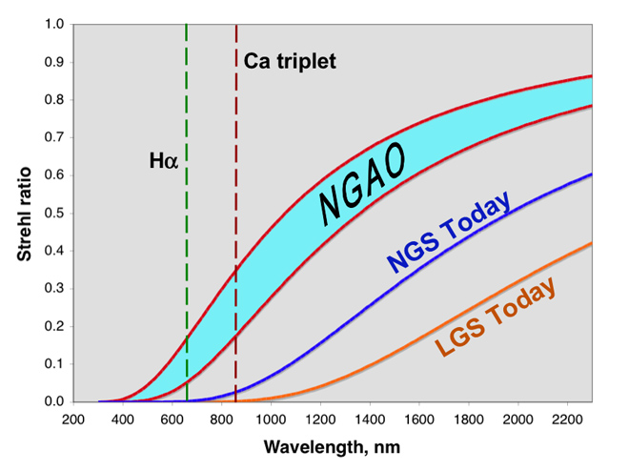
Figure 3 Predicted Strehl ratio versus observing wavelength for NGAO, compared with current Keck AO.
The turquoise NGAO range shown here is bounded by curves with wavefront errors of 140 and 180 nm. Current Keck NGS and LGS curves are shown with 260 nm and 340 nm of wavefront error respectively. The predicted NGAO Strehl at the calcium triplet lines (850 nm) is approximately equal to today’s NGS Strehl at H band and today’s LGS Strehl at K band.

To meet these goals we have developed an innovative AO architecture, the cascaded relay, and an opto-mechanical implementation shown in Figure 4 that we believe is indeed feasible and can meet the science NGAO requirements. We have analyzed NGAO’s computer software and hardware needs, and find them feasible as well. Details will be discussed in the sections to follow, where references to the relevant KAONs will also be found.

NGAO will be a broad and powerful facility with the potential to achieve major advances in astrophysics. It will provide dramatic gains in high-Strehl Solar System and Galactic science, where narrow-field AO has already demonstrated a strong scientific impact. NGAO will facilitate extraordinary advances in multiplexed wide-field-of-regard AO, e.g. for extragalactic astronomy of high-redshift objects, far beyond the initial gains made with the Observatory’s current AO systems.

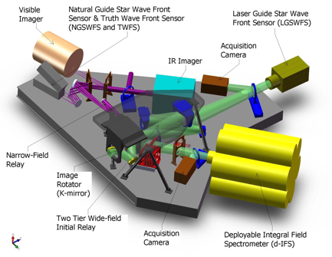

Figure 4 AO system optical layout, perspective view (SolidWorks).
The optical path through the low order “wide” field relay and the high order “narrow” field relay are shown in green and purple, respectively. Light from the telescope enters through the image rotator.

The NGAO proposal (KAON 400) and its Executive Summary (KAON 399) provide more background on the motivation for the development of NGAO. Further scientific motivation is provided in the NGAO Science Case Requirements Document (KAON 455).

System Design Phase Proposal and Management

Proposal
A proposal (KAON 399 and 400) for NGAO was presented at the June 2006 Keck Science Steering Committee meeting. This proposal was approved to proceed through System Design (SD) phase. The Directors of W. M. Keck Observatory (T. Armandroff and H. Lewis), Caltech Optical Observatories (S. Kulkarni), and the University of California Observatories (M. Bolte) subsequently set up an Executive Committee (EC) to manage the NGAO SD phase. The EC consists of P. Wizinowich (chair), R. Dekany, D. Gavel and C. Max (Project Scientist).

System Design Phase Plan
Subsequent to the approval of the NGAO proposal, the Executive Committee prepared a Systems Engineering Management Plan (SEMP) for the NGAO System Design Phase (KAON 414). This plan was approved by the Directors and work began on the System Ddesign phase in October, 2006. Two scheduled re-planning activities were included in the System Design phase plan. The results of the two re-plans are documented in KAONs 481 and 516.

System Design Phase Objectives and Deliverables
The objectives and deliverables for the System Design phase are defined in KAON 414. The primary objective of the System Design phase is to establish a design approach that meets the scientific and user requirements established for the system.

The four major System Design phase deliverables are: the System Requirements Document, the System Design Manual, the Systems Engineering Management Plan for the remainder of the project, and the System Design Report (SDR – this document). The purpose and status of the first three of these deliverables is discussed in sections of this document to follow.

Project Reports
The Executive Committee issued NGAO progress reports versus our project plans prior to each Keck Science Steering Committee meeting (KAONs 459, 473, 494, 512, 514 and 557).

Requirements

There are three main requirements documents:
- The Science Case Requirements Document (SCRD): KAON 455.
- A 1-page summary of the science case requirements (KAON 548) is attached here as Appendix B.
- The System Requirements Document (SRD): KAON 456.
- The Functional Requirements Document (FRD): KAON 573 and the Contour Database.

There is a fourth requirements document that is referenced by the SRD. This is the Instrument Baseline Requirements Document (KAON 572) which contains Observatory standard requirements for any instrument.

The requirements process can be summarized as follows:

- The science case requirements are developed in the SCRD.

- The science case requirements from the SCRD, and additional requirements imposed by the Observatory, are tabulated in the Overall Requirements section of the SRD. These overall requirements are then flowed down to discipline based requirements in the SRD. The requirements are divided between performance, implementation and design requirements. The disciplines are Optical, Mechanical, Electronic/Electrical, Safety, Software, Interface, Reliability, Spares, Service and Maintenance, and Documentation. Note that the SRD avoids prescribing specific design or implementation solutions.

- The FRD flows down the requirements from the design-independent SRD to requirements on a few high level subsystems. The flow down of the SRD requirements to the FRD requirements is frequently a design choice that could be revisited. The subsystems are chosen to divide the NGAO system into functions that would be required independent of the selected architecture. At minimum these subsystems include the AO system, laser facility, science operations facility, and science instruments, with further subdivision as appropriate. For each subsystem there is a section in the FRD describing the architectural assumptions, followed by a breakdown of the requirements by the same disciplines as used in the SRD.

The FRD provides the criteria against which the subsystems will be evaluated. The SRD provides the criteria against which the NGAO system as a whole will be evaluated.

In the remainder of this section we give an overview of the science case requirements and of the requirements for the NGAO system that flow down from the science requirements.

Science Case Requirements Document

“Key Science Drivers” and “Science Drivers”
The Science Case Requirements Document (SCRD) defines and analyzes two classes of science cases: “Key Science Drivers” and “Science Drivers. “Key Science Drivers” are those science cases that place the strongest or most technologically challenging demands on the performance of the NGAO system and its science instruments. These are the science cases that we have used to drive the performance requirements for the AO system and instruments. “Science Drivers” (not “Key”) are included to assure that the NGAO system is sufficiently flexible to deal with the broad range of science that users will demand over the lifetime of the NGAO system. Typically, “Science Drivers” do not strongly push the state of the art of the AO system itself; rather they require specific types of coordination between the AO system, the instruments, and the telescope, or they help define parameters such as the full wavelength range or the required field of view of the instruments. The SCRD defines and analyzes 5 “Key Science Drivers” and 9 “Science Drivers.” These cases were selected because they represented important astrophysics that would clarify the requirements on the NGAO system from different perspectives.

The “Key Science Drivers” that we analyzed are as follows, in order of distance from Earth:
- Galaxy Assembly and Star Formation History
- Nearby Active Galactic Nuclei
- Precision Astrometry: Measurement of General Relativistic Effects at the Galactic Center
- Imaging and Characterization of Extrasolar Planets around Nearby Stars
- Multiplicity of Minor Planets in our Solar System

The additional “Science Drivers” that we analyzed are as follows:
- Quasar Host Galaxies
- Gravitational Lensing
- Astrometry Science in Sparse Fields
- Resolved Stellar Populations in Crowded Fields
- Debris Disks and Young Stellar Objects
- Size, Shape, and Composition of Minor Planets
- Characteristics of Gas Giant Planets, their Satellites, and Rings
- Characteristics of Ice Giant Planets and their Rings
- Backup Science

Derivation of Requirements from Science Cases: Illustrative Examples
For each science case, the SCRD contains a description of the scientific goals, the proposed target set, and the observing methods and preferred instruments. From these are derived a set of more formal science requirements which are complied in a Table customized for each science case. The items in these Tables are then incorporated into the System Requirements Document and the Functional Requirements database.

In the remainder of this section we shall highlight requirements derived from two “Key Science Drivers”, to illustrate the thought processes used to define NGAO Science Requirements. Full details of the origin of these and other requirements will be found in the Science Case Requirements Document.

“Galaxy Assembly and Star Formation History:” Requirements on Thermal Background and on the Deployable IFU Instrument

At redshifts z ~ 1 – 3, galaxies are thought to have accumulated the majority of their stellar mass, the rate of major galaxies mergers appears to peak, and instantaneous star formation rates and stellar masses range over two decades in value. Given the major activity at these redshifts transforming irregular galaxies into the type of galaxies familiar in the local universe, it is of strong interest to study high-redshift galaxies in an attempt to understand the overall processes of galaxy formation and evolution.

Major rest-frame optical emission lines such as Hα, [N II], and [O III] are redshifted into the observed-frame near-infrared, for galaxies at redshifts z = 1 - 3. In order to study the evolution of galaxies across this range of cosmic times, it is thus important to have spectroscopic wavelength coverage extending from 1 to 2.4 microns. Hα line emission from the well-studied redshift z ~ 2 - 3 galaxy sample falls in the K band, emphasizing the importance of optimizing observations at these wavelengths by reducing thermal backgrounds and increasing system throughput. The requirement agreed upon is as follows: the total background seen at the focal plane of all spectrographs being fed by NGAO shall be less than 130% of the current unattenuated sky plus telescope background (at 2209 nm and at a spectral resolution λ/Δλ = 5000, which falls between OH emission lines from the sky).

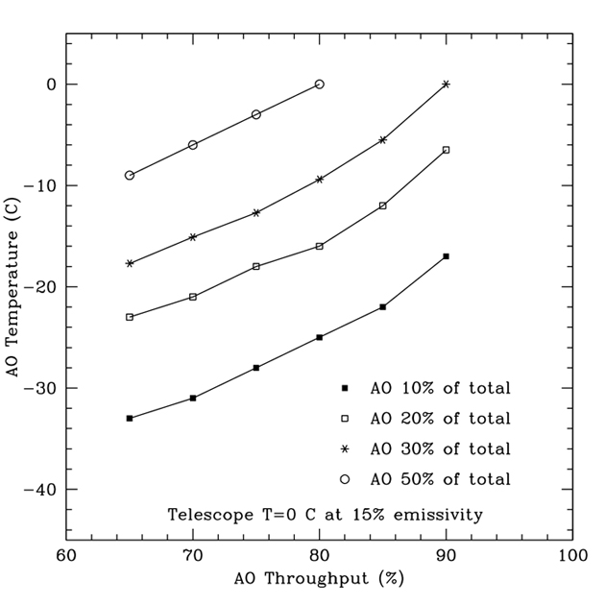
This requirement was derived by asking what thermal background in K band was needed in order to reduce the integration time for integral field spectroscopy of a redshift 2.6 galaxy to 3 hours, from the current > 6 hr integration time required with the OSIRIS spectrograph and the existing AO system. Figure 5 shows that for an NGAO system throughput of 70%, this will require cooling the AO system to about -18C. Our design of the AO enclosure and operations is taking this cooling requirement into account.
Figure 5. Required cooling of the NGAO system for varying values of its throughput.

A second consideration is what the requirements should be for NGAO’s deployable integral field spectrograph instrument. The spectrograph concept is illustrated schematically in Figure 6.

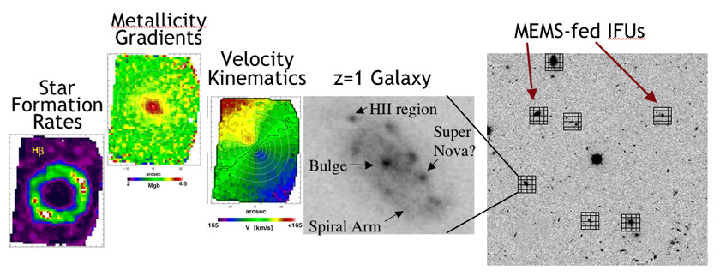
Figure 6 Schematic operation of a multiplexed deployable integral field spectrograph.

High-redshift galaxies have areal densities on the sky ranging up to ~20 galaxies per square arc minute. If light from each galaxy is sent into a MEMS-AO-fed spatially resolved spectrograph, one can obtain crucial information about internal galaxy morphology, kinematics, metallicity gradients, and star formation rates for many galaxies simultaneously. If one had 20 deployable “arms” one would effectively be observing with 20 Keck telescopes at a time! Realistically, however, this would be an entirely new kind of instrument, using several technologies for the first time “on the sky.” Considerations of both risk and cost have lead us to specify a requirement of at least 6 independently deployable “arms” patrolling a 5 square arc minute field on the sky for this pathfinding instrument. Potential follow-on instruments such as IRMOS on the Thirty Meter Telescope will benefit from the experience of the NGAO system with this type of instrument.

One must then specify the field of view of each individual spectrograph unit. High-redshift galaxies are typically about an arc second in size, though some sub-classes are larger. They are not true point sources and hence do not fully benefit from the so-called D⁴ scaling of sensitivity with telescope diameter D. Additionally, at the long-wavelength end of K band the sensitivity is decreased due to thermal background, and once must measure the “sky background” accurately in order to subtract its spectrum from that of the galaxy. Balancing all of these considerations has led to a required field of view of 1” x 3” for each spectrograph unit, so that the spectrum of the “sky background” can be measured on one end of the field while the spectrum of the galaxy is measured on the other end. This assures that valuable telescope time will not be wasted by teh requirement to nod off to “blank sky” in order to perform adequate background subtraction. For the high-redshift galaxy science case, the optimum spatial sampling is larger than the diffraction limit (e.g. of order 0.07 arc sec up to 0.1 arc sec, depending on the galaxy’s surface brightness and internal structure). We have specified 70 mas spaxels for each spectrograph unit.

Next one must ask what fraction of a given field of high-redshift galaxies can be observed with the required AO correction and hence spatial resolution. For the high-z galaxy science case, the sky coverage at a given level of AO performance is limited by the availability of tip-tilt stars. Given the distribution of infra-red tip-tilt stars on the sky, our calculations indicate that the as-designed NGAO system should be able to put 50% of the energy of a point source within a 0.07 arc sec region, with 30% or more sky coverage fraction. This is sufficient, for example, to perform a survey of 200 galaxies in 3 years or less, assuming a realistic telescope time allocation for the project and 4 galaxies observed per square arc minute over a 5 square arc minute patrol field.

“Measurement of General Relativistic Effects at the Galactic Center”: Requirements on Astrometric and Radial Velocity Accuracy
The proximity of our Galaxy's center presents a unique opportunity to study a massive black hole and its environs at much higher spatial resolution than can be brought to bear on any other galaxy. In the last decade, near-infrared observations with astrometric precisions of < 1 mas and radial velocity precision of 20 km/s have enabled the measurement of orbital motions for several stars in orbit around the black hole near the Galactic center, revealing a central dark mass of 3.7 x 10⁶ M_{Sun} These observations provide the most definitive evidence for the existence of massive black holes in the centers of galaxies. Due to the crowded stellar environment at the Galactic Center and the strong line-of-sight optical absorption, tracking stellar orbits requires the high angular resolution, near-infrared imaging and spectroscopy capabilities of adaptive optics on telescopes with large primary mirrors, such as Keck. Though the current orbital reconstructions are consistent with pure Keplerian motion, with improved astrometric and radial velocity precision deviations from pure Keplerian motion are expected, due in part to the effects of General Relativity.
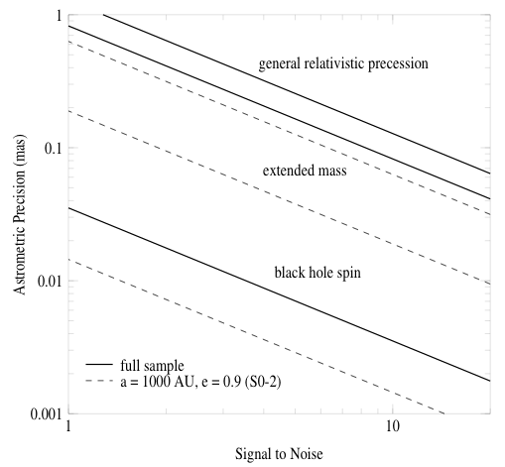

Figure 7 Required astrometric precision for detecting General Relativistic effects at the Galactic Center.
The lines indicate (top to bottom) effects due to prograde precession, extended mass, and frame-dragging due to black-hole spin. Radial velocity measurement errors of 10 km/s are assumed. The precession effect can be measured with signal-to-noise of 10 if astrometric accuracies of 0.12 mas can be achieved with NGAO.

With Keck NGAO, stellar orbits can be monitored with sufficient precision to enable a measurement of post-Newtonian General Relativistic effects associated with the black hole. This includes the prograde precession of orbits. As Figure 7 illustrates, the General Relativistic prograde precession can be measured even for single orbits of already-known stars if we have an astrometric precision of ~ 100 μas coupled with radial velocity precision of 10 km/s. This sets the science requirements for the Galactic Center General Relativity science case. Calculations to date indicate that NGAO can meet the required spatial resolution if it delivers a wavefront error of 170 nm at the position of the Galactic Center. In the PDR phase we will analyze the implications of the radial velocity and astrometry requirements for the AO system and instrument suite.

Science Case Requirements Summary
A summary table of the science requirements can be found in Appendix B. This summary table groups the requirements by three categories: physical, performance, and operational. Requirements are reported for each science instrument: visible imager, visible spectrograph, near-IR imager, near-IR spectrograph, near-IR deployable IFU, and the Keck Interferometer. The science cases that drive each requirement are listed at the bottom of each column; these are defined in the table at the lower left of the page. In the current section, a high-level overview of the requirements is provided.

Physical Requirements
- Wavelength range.
  - Visible instruments require a transmitted wavelength range of 0.7 to 1.0 µm, with a goal of rest-frame Hα (0.6563 µm).
  - Near-IR instruments require a transmitted wavelength range from 1.0 to 2.4 µm, with a goal of including the Y and z-bands (0.98-1.20 µm).
  - The interferometer requires a transmitted wavelength range from J through L-band, with a goal to N-band.
- Field of view diameter
  - Based on the specific science cases considered to date, the field of view requirement (15" field diameter) for the narrow-field instruments is relatively modest. A decision was made, in consultation with the Keck AO Working Group, to require a 30" diameter field to allow for science cases not considered, as well as for dithering and for finding a point source to use as a PSF reference.
  - The field of view requirement for each deployable IFU unit is 1”x3”.
  - The interferometer’s field of view requirement is ≥ 1” diameter.
- Field of regard diameter
  - The requirement for the deployable IFU heads is ≥ 120” diameter.
  - The requirement for the interferometer is ≥ 60” diameter, for simultaneous observation of an on-axis phase referencing star and an off-axis science target.
- Minimum number of IFUs
  - Six or more independently positionable IFUs heads.
- AO background
  - The total background seen at the focal plane of all spectrographs being fed by NGAO shall be less than 130% of the current unattenuated sky plus telescope background (at 2209 nm and at a spectral resolution λ/Δλ = 5000, which falls between OH emission lines from the sky).

Performance Requirements
Performance requirements must be met under median seeing conditions (defined in KAON 503 and summarized in the bottom right corner of the spreadsheet): r₀ = 18 cm and θ₀ = 2.9”.

- Sky coverage
  - In all cases with the exception of the interferometer, the following performance criteria are required to be met over ≥ 30% of the sky.
- High order wavefront error (WFE) for ≤ 5” field of view
  - The requirement on residual rms WFE after correction is ≤ 170 nm as delivered to the science focal plane of the narrow field imagers and spectrographs. High order refers to all terms higher than tip and tilt.
- Tip/tilt error
  - The requirement on residual rms tip/tilt error is ≤ 15 mas as delivered to the science focal plane of the narrow field imagers and spectrographs for the ≥ 30% sky coverage case. For the special case of the Galactic Center the requirement is ≤ 3 mas.
- 50% ensquared energy
  - Ensquared energy was determined to be a more relevant requirement for the NIR deployable IFU (the corresponding high order and tip/tilt errors can be derived from this requirement). The requirement is for 50% of the energy to be enclosed in an area of ≤ 70 x 70 mas when the sky coverage is 30%.
- Companion sensitivity
  - This requirement is relevant only to the visible and NIR imagers. The requirement is written for different filters and different angular separations according to the relevant science case. For example, for planets around low mass stars ΔJ ≥ 11 at 0.2” separation from the primary star.
- Photometry
  - The relative photometry requirement is ≤ 0.05 magnitudes for both imagers.
- Astrometry
  - The requirement is relative astrometry ≤ 100 μas in the near-infrared for the Galactic Center science case; for other science cases it is ≤ 5 mas for both imagers.

Operational Requirements

- Point Spread Function (PSF) estimation
  - An estimate of the PSF, for post-processing purposes, is required for both imagers and is a goal for both spectrographs. The accuracy required is to be studied and defined during the PDR phase.
- Differential tracking
  - For solar system science there is a requirement to be able to use a sidereal rate object for tip/tilt correction of a solar system object.
- Acquisition accuracy
  - The acquisition system should be able to position the science object on the science field to the indicated accuracy without taking a science exposure. Generally, the requirement is ≤10% of the field size. However for placing an object on a slit the requirement is more stringent (≤ 0.25λ/D).
- Science image drift
  - This defines the requirement on the stability of the science field with respect to the AO system. The requirement is to have this drift be ≤ 5 mas per hour.
- NGS mode
  - Generally speaking it is a requirement to have access to an NGS observing mode, for backup purposes. In the case of the NIR deployable IFU only one of the IFUs is required to do science in NGS mode.
- AO instrument switching
  - This requirement is driven by the desire to do both imaging and spectroscopy on the same night. The requirement is to be able to switch between the visible imager and spectrograph during observing (in a TBD time), and similarly be able to switch between the NIR imager and spectrograph.
- Other
  - The interferometer requirements must be met by an NGAO mode including matched fields, polarization, etc. from both telescopes.
  - Both fixed field and fixed pupil modes are required to be supported.
  - The acquisition system must provide a means of acquiring the tip/tilt stars and the LGS beacons.

System Requirements Document
The System Requirements Document (SRD), KAON 456, includes the science requirements from the SCRD as well as user and Observatory requirements. The SRD also includes the technical requirements organized by engineering discipline as flowed down from the science and user requirements.

Incorporate the key user/Observatory requirements?

Functional Requirements
The functional requirements have all been input into a requirements database tool (JAMA software’s Contour) to support long term requirements tracking and maintenance. A summary of the functional requirements can be found in KAON 573.

System Design Manual
Our approach to the design process was to break it into the following phases with appropriate iteration between these phases, as well iterations with the system requirements:
- Development of performance budgets, including determining the best model assumptions and validating the modeling tools.
- Performance of trade studies to support future design choices.
- Development of a system architecture.
- Performance of a technical risk analysis.
- Development of the functional requirements.
- Development of the subsystem designs.

The results of this work are summarized in the System Design Manual (SDM – KAON 511). The SDM references a significant number of KAONs where more details can be found.

SDM material to be incorporated.

Systems Engineering Management Plan
A SEMP (KAON 574) has been produced for the remainder of the project. The project plan includes a work breakdown structure with task definitions, cost estimates, management plans including risk management, major milestones, and an MS Project plan. A more detailed set of milestones and MS Project plan is provided from the preliminary design phase. This SEMP also includes a summary of how the team performed during the SD phase in terms of deliverables, schedule and budget.

SEMP material to be incorporated.

Conclusion
We believe that we have successfully completed the SD phase and that we have established a design approach that meets the scientific and user requirements established for the system, as required for the conclusion of the System Design phase. We have also developed a viable technical and management path forward to the realization of a very powerful scientific capability: NGAO for the Keck Observatory. We are looking forward to continuing into the Preliminary design phase and beyond.

Appendix A. NGAO Keck Adaptive Optics Notes (KAONs) Sorted by Categories

Appendix B. Science Case Requirements Summary

