

Keck Adaptive Optics Note 574

Next Generation Adaptive Optics:
Systems Engineering Management Plan

Version 0.2
March 25, 2008

Author List
Name | Function
Peter Wizinowich | NGAO Executive Committee (EC) Chair
Richard Dekany | EC Member
Don Gavel | EC Member
Claire Max | EC Member & NGAO Science Team Chair

Contributors: .Sean Adkins, Erik Johansson, Elizabeth McGrath, David Le Mignant, Chris Neyman, Viswa Velur

Approval Control
Control | Name | Function
Revised by:

Approved by:
Authorized by:

Document Change Record
Issue | Date | Change Description
Version 1.0 | October 31, 2007

1 Introduction 3
2 Project Plan 3
2.1 Organization Structure 3
2.2 WMKO Design Phases and Deliverables 5
2.3 Work Breakdown Structure (WBS) 7
2.3.1 Design WBS 8
2.3.2 Management WBS 8
2.3.3 Systems Engineering WBS 9
2.3.4 AO System WBS 10
2.3.5 Laser System WBS 10
2.3.6 Science Operations Tools WBS 11
2.3.7 Telescope and Summit Engineering WBS 11
2.3.8 Telescope Integration and Test WBS 11
2.3.9 Operations Transition WBS 11
2.4 Product Structure 11
2.5 Project Milestones 12
2.6 Cost Estimate 13
2.7 Schedule 13
2.8 Risk Assessment and Risk Management 13
Configuration Management 13
2.9 13
2.10 Requirements Management 13
2.11 Component Failure and Spares Approach 13
3 Preliminary Design Phase Plan 14
3.1 PD Phase Management 14
3.2 PD Phase Overview and Deliverables 14
3.3 PD Phase Work Breakdown Structure 15
3.4 PD Phase Planning Assumptions 15
3.5 PD Phase Schedule 15
3.6 PD Phase Budget and Contingency 20
3.7 PD Phase Milestones 20
3.8 PD Phase Risk Assessment and Risk Management 20
3.9 PD Phase Personnel and Core Team 21
3.10 PD Phase Management 22
4 System Design Phase Summary 23
5 Appendix: Preliminary Design Phase Work Breakdown Structure Dictionary 24
6 Appendix: Preliminary Design Phase Schedule 25

Figure 1. NGAO Preliminary Design Phase Management Structure. 4
Figure 2. The WMKO Development Process. 6
Figure 3. NGAO Work Breakdown Structure. 7
Figure 4. NGAO AO System Opto-Mechanical Work Breakdown Structure. 10
Figure 5. NGAO Product Structure. 12
Figure 6. PD phase Management schedule. 16
Figure 7. PD phase Systems Engineering schedule. 17
Figure 8. PD phase AO System schedule. 18
Figure 9. PD phase Laser System schedule. 18
Figure 10. PD phase Science Operations Tools schedule. 19
Figure 11. PD phase Telescope and Summit Engineering schedule. 19
Figure 12. PD phase Telescope Integration and Test schedule. 20
Figure 13. PD phase Operations Transition schedule. 20

Table 1. WMKO Development Process Deliverables. 6
Table 2. NGAO Project milestones. 12
Table 3: Milestones 20
Table 4. PD phase personnel assignments versus Fiscal Year (FY). 21
Table 5. Core PD phase team members. 22

Introduction
A Systems Engineering Management Plan (SEMP) is a standard part of the project documentation for W.M. Keck Observatory (WMKO) development efforts. This SEMP represents a key deliverable from the system design phase for the WMKO Next Generation Adaptive Optics (NGAO) project. This document will be updated as a product of the NGAO preliminary and detailed design phases.

The following sections document the proposed management process, schedules and budgets for the remainder of the NGAO project.

Project Plan

Organization Structure
The System Design phase management structure setup by the Observatory Directors (i.e., Armandroff, Bolte, Kulkarni and Lewis) consisted of a four member Executive Committee (EC) with one person identified as EC Chair and another as Project Scientist. The participants represented the three institutions collaborating on the NGAO System Design. We believe that the members of the EC worked well together and the structure also supported good involvement of the three institutions.

For the Preliminary Design phase we propose a more efficient version of the EC structure. The Chair of the EC, Peter Wizinowich, will become the overall Principal Investigator (PI) / Project Manager and the two other EC technical leads, Rich Dekany and Don Gavel, will become Co-Investigators / Project Managers responsible for the work at their respective institutions. This will allow us to spend less time in joint management of the overall project and more time on management and technical leadership of specific parts of the Preliminary Design.

The proposed organization structure including other senior leadership roles is shown in Figure 1. All items highlighted in blue represent part of the NGAO preliminary design phase project for which this SEMP is written. The NGAO project continues to be led by the EC members but now in more defined roles. The NGAO Project Scientist will be assisted by a TBD NGAO Science Advisory Team.

The NGAO science instruments are separately managed under the direction of the WMKO Instrument Program Manager (IPM), Sean Adkins. The dashed links between the science instruments and the AO facility Principal Investigator, Project Scientist and Systems Engineering reflect the need for close collaboration in the design and development of these systems. The requirements for both the AO facility and science instruments flow down from the NGAO science case requirements. These requirements and the interface definitions between systems are maintained by the NGAO Systems Engineering team.

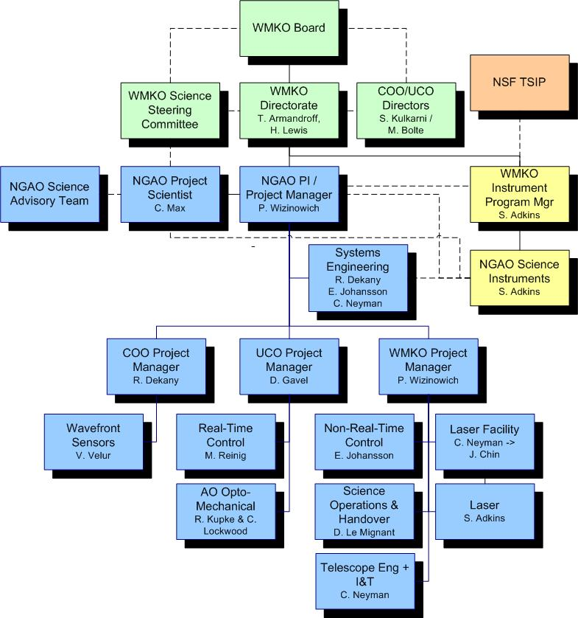
Figure 1. NGAO Preliminary Design Phase Management Structure.
Solid lines are direct reports. Dashed lines are advisory or collaborative.

WMKO’s top-level management structure is highlighted in green in Figure 1. Both the NGAO PI and the WMKO IPM report directly to the WMKO Director, Taft Armandroff, and Deputy Director, Hilton Lewis. They in turn report to the WMKO Board. There is a close collaboration between the WMKO Directorate and the Directors of the University of California Observatories (UCO), Mike Bolte, and the Director of the Caltech Optical Observatories (COO), Shri Kulkarni. A similar collaboration exists with the WMKO Science Steering Committee co-chaired by Jean Brodie and Tom Soifer.

Due to the collaborative inter-Observatory nature of the NGAO project and the EC System Design phase mandate, the EC provided regular reports to the Observatory Directors during the System Design phase and looked to them for guidance. In order to ensure clear direction during the Preliminary Design the NGAO PI will meet regularly with the WMKO Directorate (at least bi-weekly) and the NGAO senior management (Dekany, Gavel, Max and Wizinowich) will have four scheduled telecoms with the Directors.

The NGAO EC provided updates at each of the SSC meetings during the NGAO System Design. The PI and PS will plan to provide updates at each SSC meeting during the Preliminary Design. The NGAO project looks for the community science input primarily through the NGAO Project Scientist. The Project Scientist seeks guidance from the TBD NGAO Science Advisory Team and the SSC.

The NGAO Preliminary Design is partially funded by the NSF’s Telescope Systems and Instrumentation Program (TSIP). The WMKO IPM has been responsible for interactions with and reporting to this program for other TSIP funded projects. The NGAO PI will collaborate with the WMKO IPM to provide monthly updates to the TSIP.

This organization structure will need to be modified at some level as we move from Preliminary to Detailed Design phase. Two specific changes are planned: 1) As noted in Figure 1 the laser facility management will be transitioning from Chris Neyman to Jason Chin during the preliminary design as Jason frees up from the Keck I LGS AO implementation project management role. 2) The amount of NGAO activity will increase significantly with the start of the Detailed Design. We plan for Paul Stomski to play a significant project management support role to Wizinowich starting in the Detailed Design as he frees up from a similar role on Keck I LGS AO implementation.

WMKO Design Phases and Deliverables
WMKO’s standard development process is shown in Figure 2. This document is being written as a product of the NGAO System Design and presents the SEMP for the remaining development phases starting with the Preliminary Design and ending with the transition of NGAO into Facility Class Operation. Table 1 lists the standard deliverables for each of the development phases.
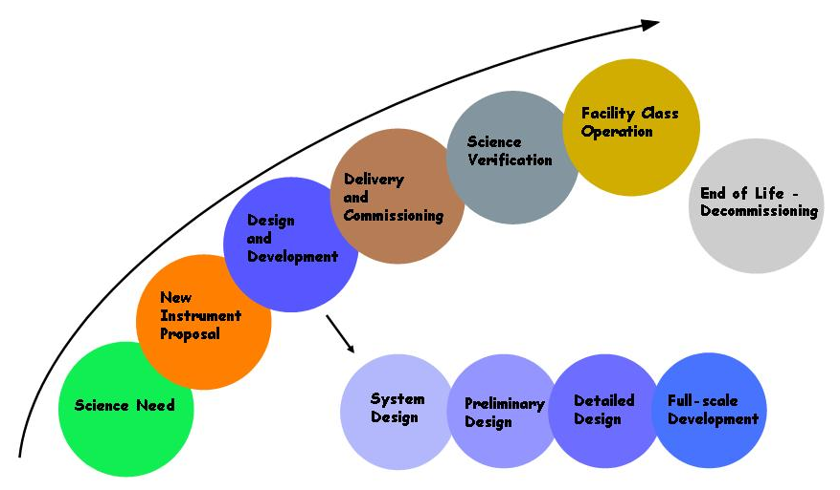
Figure 2. The WMKO Development Process.

The deliverables for the AO portion of the NGAO project consist of documentation and the actual AO Facility, Laser Facility and related interfaces. Major documentation items include:

Table 1. WMKO Development Process Deliverables.
System Design: | Preliminary Design:
Science Case Requirements Document | Requirements Documents for Key Subsystems
System Requirements Document | Operations Concept Document
System Design Manual | Preliminary Technical Specifications
Systems Engineering Management Plan | Interface Control Documents
System Design Report | Preliminary Design Report
Detailed Design:
Detailed Design Drawings and Bills of Material
Final Technical Specifications
Acceptance Test Plans
Detailed Design Report
Full Scale Development:
Hardware and Software Manuals and Maintenance Documentation
Pre-ship Review Reports
Installation/Commissioning:
Acceptance, Operational Readiness and Science Verification Review Reports

Work Breakdown Structure (WBS)
The NGAO Project Work Breakdown Structure (WBS) is shown schematically in Figure 3. The top level structure reflects the transition from Design (1.0) through Full Scale Development (4.0 to 7.0) to Delivery and Commissioning (8.0 and 9.0). WBS 8.0 includes Science Verification and WBS 9.0 covers the handover to Facility Class Operation. Management (2.0) and Systems Engineering (3.0) are ongoing items through both Full Scale Development (FSD) and Delivery and Commissioning (DC).

Each of the top level WBS elements is briefly described in the following section. A full WBS dictionary can be found in Appendix __.

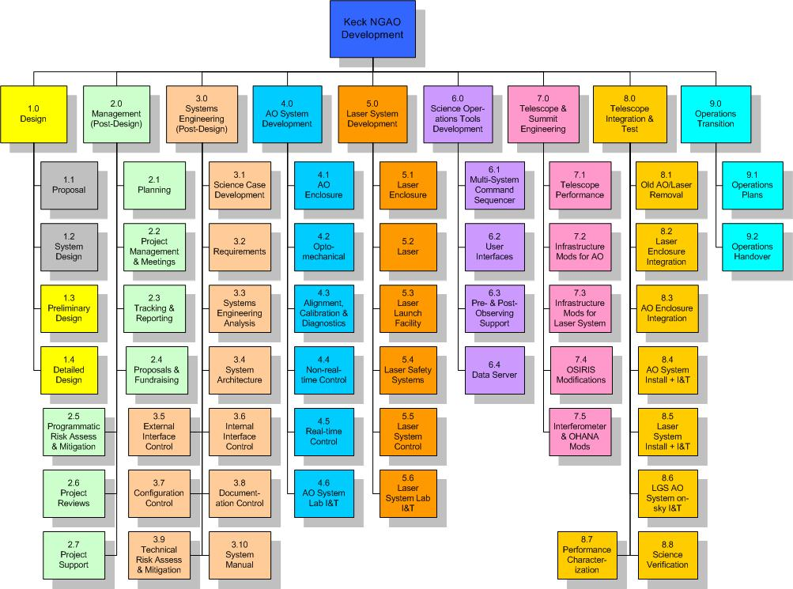
Figure 3. NGAO Work Breakdown Structure.

Design WBS
The two gray highlighted boxes in Figure 2 are intended to represent design phases completed prior to the start of the Preliminary Design. The WBS structure for the Preliminary Design is identical to this WBS numbering except that each WBS element number is preceded by “1.3” and there is no WBS 1.3.1. For example, WBS 1.3.2 is the Preliminary Design Phase Management and WBS 1.3.4.1 is the preliminary design of the AO enclosure. This approach to the design phase WBS numbering was chosen to allow a separate budget and plan for the design phases. Once the design phases are complete the WBS numbering shown in Figure 3 can be directly used.

Management WBS
The management WBS has seven major elements:
- Planning. This WBS includes the normal adjustments to the plan during a development phase, supporting the Observatory’s fiscal year planning process and preparing the Systems Engineering Management Plan (SEMP). The SEMP, the document you are currently reading, will be updated during the Preliminary and Detailed Design phases.
- Project Management and Meetings. This category includes management telecoms and team meetings and telecoms. During the preliminary design phase for example management telecoms will occur weekly and team telecoms monthly with four face-to-face team meetings.
- Tracking and Reporting. Monthly status reports will be provided throughout the project and regular reporting will be made quarterly at WMKO SSC meetings. During the Preliminary Design phase the monthly reports will be provided to the TSIP and the Observatory Directors and monthly telecoms will be held with the TSIP representatives.
- Proposals. The NGAO team will need to write proposals and support fundraising. This is primarily a schedule item here since the WMKO labor for these activities is covered outside the NGAO budget.
- Programmatic Risk Assessment and Mitigation. This WBS covers analysis of the programmatic risks and some mitigation activities. Some mitigation activities are covered under the appropriate development WBS.
- Project Reviews. Project reviews corresponding to major milestones are covered under this WBS. These include:
  - Preliminary Design Review.
  - Detailed Design Reviews.
  - An intermediate Full Scale Development Review as a checkpoint during development (we may revisit the need for this review).
  - A Pre-lab I&T Review to determine that the subsystems are ready for lab I&T.
  - A Pre-ship Review to determine that the system and telescope infrastructure are ready for telescope I&T.
  - An Operability Review to determine that NGAO is ready for shared-risk science.
  - An Operations Readiness Review to determine that NGAO and the operations team are ready for Facility Class Operation.
- Project Support. This category includes administrative and contract support, the procurement of shared infrastructure for development and/or testing purposes, and research time for postdocs and scientists working on the NGAO project.

Systems Engineering WBS
The Systems Engineering WBS has ten major elements:
- Science Case Development. This WBS is the primary home for the Project Scientist and Science Advisory Team activities. These include science case and requirements development, science observing planning, science performance input to the performance budgets, science operations tools and Operations Concept Document, understanding and updating the case for NGAO’s science competitiveness and liaising with the science community. This will continue to be an active area during the Preliminary Design and should move to more of a supporting role until we reach the telescope I&T and science verification phase.
- Requirements. This category includes the development and maintenance of the Operations Concept Document, System Requirements Document, Functional Requirements database, and the software and component standards that we select for NGAO. The System and Functional Requirements were developed during the System Design phase and will require updating during the remaining design phases. The initial Operations Concept and Standards Documents will be developed during the Preliminary Design.
- Systems Engineering Analysis. This is where all the performance budgets and the modeling and analysis tools are developed and maintained. There is a close connection with the Science Case Development WBS activities.
- System Architecture. Four high level architectural views are developed and maintained in this WBS: system hardware, software, control systems and operations sequences. These architectures are the high level views that reach across the various subsystem (i.e., they reach across WBS 4.0 to 7.0). The system hardware architecture is the cascaded relay architecture developed during the System Design.
- External Interface Control. This WBS covers the development and maintenance of the interface definitions to the Observatory and to the NGAO science instruments. One or more Interface Control Documents will be produced.
- Internal Interface Control. This WBS covers the development and maintenance of the interface definitions between NGAO subsystems. One or more Interface Control Documents will be produced.
- Configuration Control. Initially this will cover the definition of the configuration control process and subsequently the configuration control activity.
- Documentation Control. Initially this will cover the definition of the document control process and subsequently the configuration control activity.
- Technical Risk Assessment and Mitigation. This WBS covers analysis of the technical risks and some mitigation activities. Most mitigation activities are covered under the appropriate development WBS.
- Design Manual. A System Design Manual was produced during the System Design phase. This Manual will be updated during the Preliminary and Detailed Design phases. It will ultimately be further updated to reflect the as-built system in order to provide the operations team with a good design reference.

AO System WBS
WBS 4.0 includes all of the elements related to the AO system itself. One of the larger WBS elements, WBS 4.2 is shown at another level of detail in Figure 5, and one of its component elements, WBS 4.2.7 Low Order Wavefront Sensor Assembly, is shown at a further level of detail.

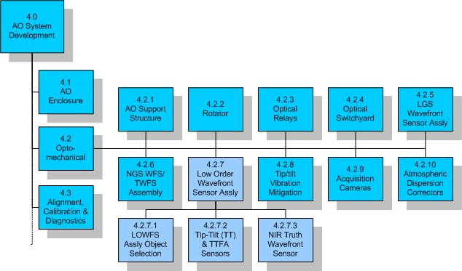
Figure 4. NGAO AO System Opto-Mechanical Work Breakdown Structure.

All of the subsystems are expected to be completed, including testing and demonstration of compliance at the subsystem level, within their WBS element. These subsystems, as well as the subsystems from WBS 6.0, are then delivered to WBS 4.6 AO system lab I&T. The output of WBS 4.6 is an AO system demonstrated to be ready for telescope I&T.

Laser System WBS
WBS 5.0 includes all of the elements related to the laser facility itself. All of the subsystems are expected to be completed, including testing and demonstration of compliance at the subsystem level, within their WBS element. These subsystems, as well as appropriate elements of WBS 6.0, are then delivered to WBS 5.6 laser system lab I&T. The output of WBS 5.6 is a laser system demonstrated to be ready for telescope I&T.

Science Operations Tools WBS
The science operations tools provide the high level coordination between the AO system, laser system, telescope and science instruments. These are the tools used to operate the NGAO system for science. The user interfaces provide the operator and astronomer interfaces to NGAO and the multi-system command sequencer provides the high level coordination. The pre- and post-observing tools are intended to support optimal observation planning and the generation of the data needed by the astronomer to make their observations scientifically useful. The data server collects and temporarily stores the required data.

Telescope and Summit Engineering WBS
This WBS covers the modifications needed to the telescope and summit facilities, and some existing science instruments, needed to integrate with NGAO. Currently there is no effort in the area of telescope performance, but we have left WBS 7.1 as a placeholder in case we find that it would be more cost effective to implement some changes to the telescopes performance than to achieve some performance aspect with NGAO.

Telescope Integration and Test WBS
This WBS covers the installation through performance characterization and science verification of NGAO.

Operations Transition WBS
This WBS covers the development of operations plans and training of operations personnel. These activities will overlap in time with elements of other WBS elements, especially integration and test. The cost of operations personnel to be trained is covered by the Observatory.

Product Structure
A view of the Product Structure is provided in Figure 6. MS Project was chosen as the tool to maintain the product structure since it allows easy roll-up of the structure. The view shown in Figure 6 allows you to see the lowest product structure level for the rotator. heis product structure was developed in parallel with the WBS.

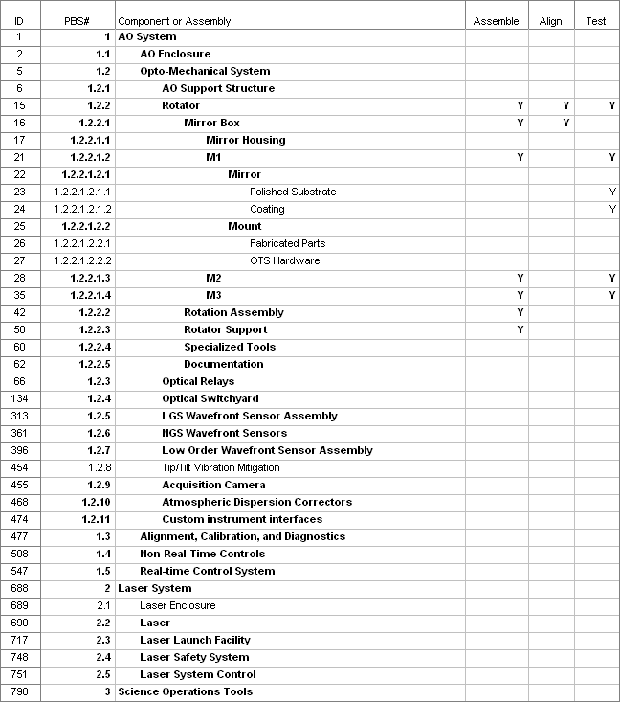
Figure 6. NGAO Product Structure.

Project Milestones
The major project milestones are shown in Table 3. Our ability to meet these milestones will strongly depend on the availability of funding. It will also depend on advance knowledge of when funding will become available since it takes time to ramp up personnel and to set up contracts.

Table 2. NGAO Project milestones.
Year | Month | NGAO Project Milestone
2008 | April | System Design Review
2010 | February | Preliminary Design Review
2012 | February | Detailed Design Review
2013 | February | Full Scale Development Intermediate Review
2013 | August | Pre-Lab I&T Readiness Review
2014 | February | Pre-Ship Readiness Review
2014 | May | NGS First Light
2014 | July | LGS First Light
2014 | July | 15A Shared-Risk Science Availability Review
2014 | December | Operational Readiness Review

Cost Estimate

Schedule

Risk Assessment and Risk Management
A programmatic risk assessment was performed and documented in KAON 566.

. NGAO Project milestones.

Configuration Management

Requirements Management

Component Failure and Spares Approach
Two component failure issues need to be addressed: failures during development and failures during operations. The impact of failures during development and operations are different. Spares are one way to address failures and need to be considered in this context. Highly reliable components should be the standard.

The impact of a component failure depends on the development phase, its criticality to the subsystem and overall system, and the required time to troubleshoot, repair or replace the component. The failure of a key component during subsystem development could potentially result in the late delivery of a subsystem and the delay of system integration and test. The failure of a key component during lab or telescope integration and test could result in significant cost and schedule impacts.

A component failure during a science night must be addressed immediately preferably by having a back-up mode of the instrument that does not require this component. It is important to have good tools and procedures for quickly identifying and repairing or replacing the failed component. The failed component should be able to be replaced or repaired prior to the next night or in the worst case before the next observing run.

A preventative maintenance program is required during operations to minimize the chance of component failures and to ensure the early detection of components that are starting to fail.

Failures can be addressed by a combination of troubleshooting and repair procedures, good component documentation, proper sparing, team expertise and vendor support (potentially including maintenance contracts).

Some component failures are more likely to happen during development than operations. Infant mortality is most likely to happen during subsystem development, where more time is potentially available to replace it. An optic is more likely to be broken as it is being shipped or integrated during subsystem, lab or telescope integration.

For cost reasons not everything can be spared. We must therefore focus on the most critical components and the limited lifetime components. The likelihood and impact of a failure needs to be considered.

A
partial list of key components and their recommended sparing was developed during the SD phase and was incorporated in the cost estimate. This list will be further defined during the remaining design phases. The sparing recommendation needs to include the number of units in the system, and some analysis of the consequence and likelihood of failure during both development and operations. This list could be integrated into the Product Structure MS Project tool.

Preliminary Design Phase Plan

PD Phase Management
The Preliminary Design (PD) Phase management structure was shown in Figure 1.

Leadership responsibilities for specific parts of the system design are indicated in the MS Project Plan in section 5.8.

PD Phase Overview and Deliverables
The PD phase is the second design phase for WMKO development projects. This phase follows the system design and precedes the detailed design phase.

In the Observatory’s development program, the preliminary design phase has two primary objectives. The first objective is to deliver documented designs for each system, subsystem and component, hardware or software, of sufficient detail to establish through inspection and analysis the feasibility of the proposed design, and the likelihood that the design will meet the requirements. The second objective is to present the project plan to completion, including a detailed schedule and budget.
The principal activities of the preliminary design phase are design, prototyping, simulation and analysis. The key deliverables are preliminary technical specifications, requirements for subsystems, a preliminary Operations Concept Document, Interface Design document(s), and a Preliminary Design report.

PD Phase Work Breakdown Structure
The WBS structure for the Preliminary Design is identical to this WBS numbering in Figure 3 except that each WBS element number is preceded by “1.3” and there is no WBS 1.3.1. For example, WBS 1.3.2 is the Preliminary Design Phase Management and WBS 1.3.4.1 is the preliminary design of the AO enclosure. This approach to the design phase WBS numbering was chosen to allow a separate budget and plan for the design phases.

PD Phase Planning Assumptions
The following assumptions were used in producing the preliminary design phase plan:

The collaboration between WMKO, COO and UCO would continue in the PD phase.

- The NGAO Preliminary Design is funded by the NSF TSIP at $2M.
- The remainder of the NGAO Preliminary Design is funded by WMKO.
- The available funding profile is $455k in FY08 (starting May 1) and $2M in FY09.
- To the extent that the Preliminary Design costs exceed $2.455M the project will need to extend into FY10.

The estimated PD phase cost when combined with the above funding profile resulted in a 22 month PD schedule, with a Preliminary Design Review date of February 22, 2010, as shown in the next section.

PD Phase Schedule
The level three version of the PD schedule (ignoring the initial “1.3”) is shown in Figure 7 through Figure 14. The complete PD schedule can be found in __. The schedule includes WBS numbers, task names, initials of the task lead, number of work hours and start and end dates.

The approach to developing this schedule was to: 1) develop the WBS and product structure, 2) incorporate this structure into an MS project plan, 3) apply the work hours from the cost estimation work sheets, 4) apply resources to the MS project plan, 5) iterate to produce a realistic schedule and 6) iterate to produce a realistic budget. Links have only been used sparingly so far in this schedule due to their tendency to move tasks in unusual ways. Some non-PD phase tasks are included with zero hours in order to maintain WBS numbering for future phases.

We will track performance versus this baseline schedule. We will also update this schedule, with the original baseline maintained, as needed during the PD phase (three scheduled replan activities are included in the plan) to ensure we achieve the PD goals within schedule and budget.

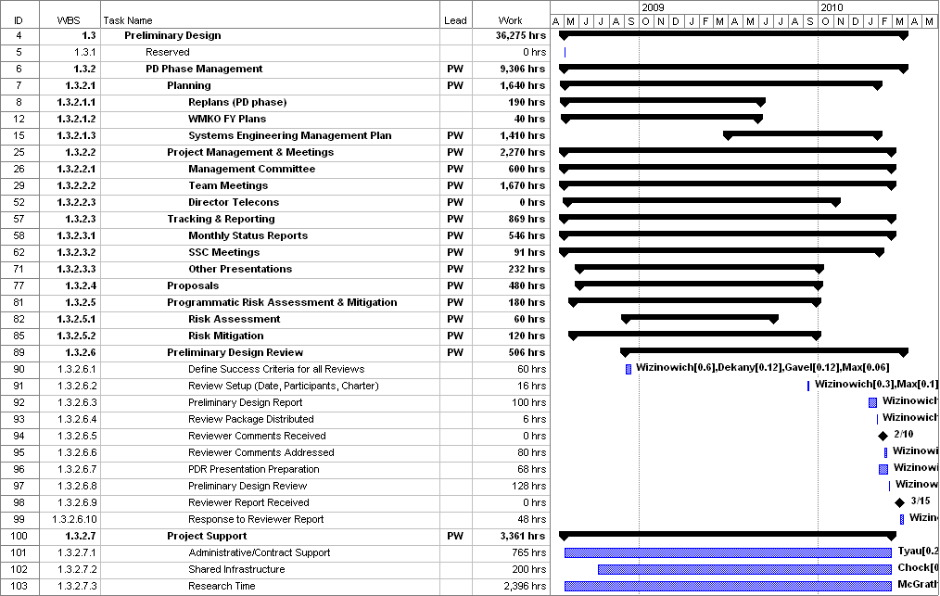
Figure 7. PD phase Management schedule.

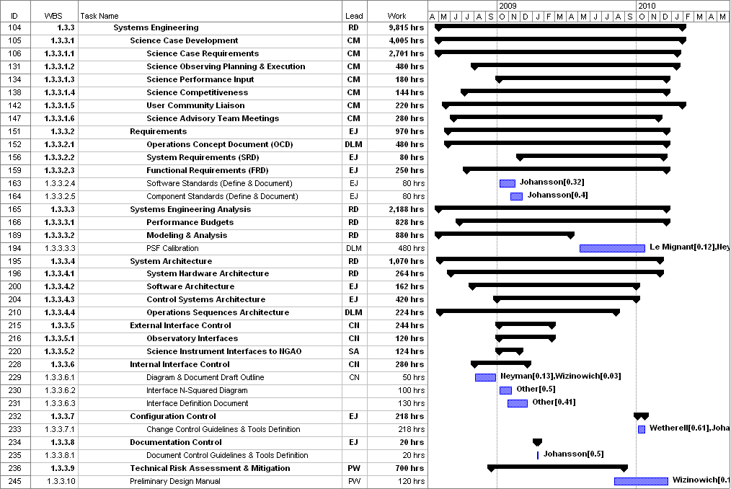
Figure 8. PD phase Systems Engineering schedule.

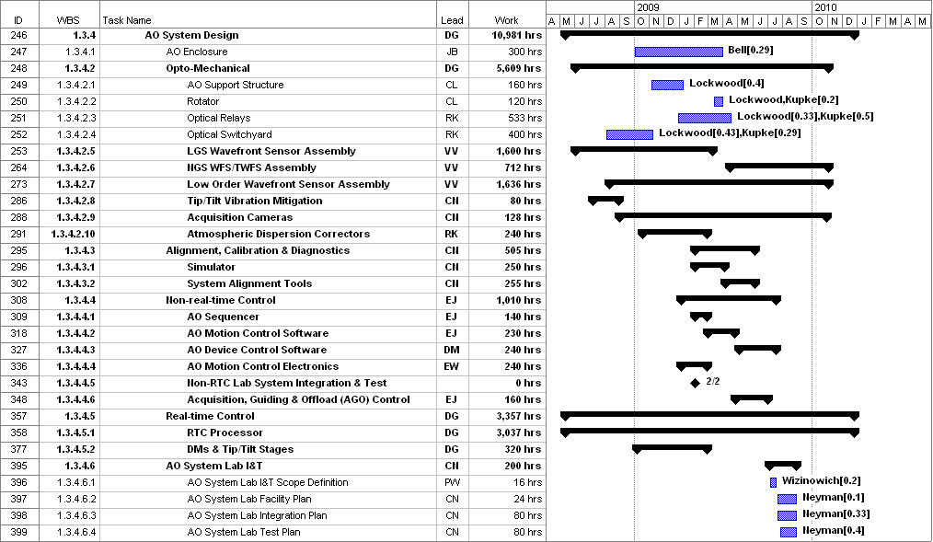
Figure 9. PD phase AO System schedule.

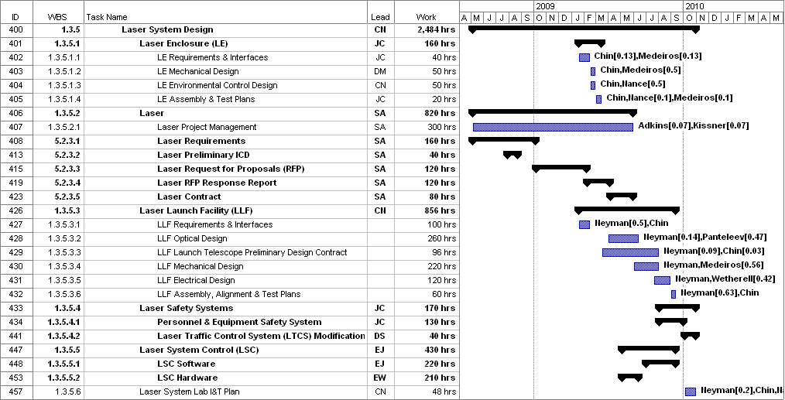
Figure 10. PD phase Laser System schedule.

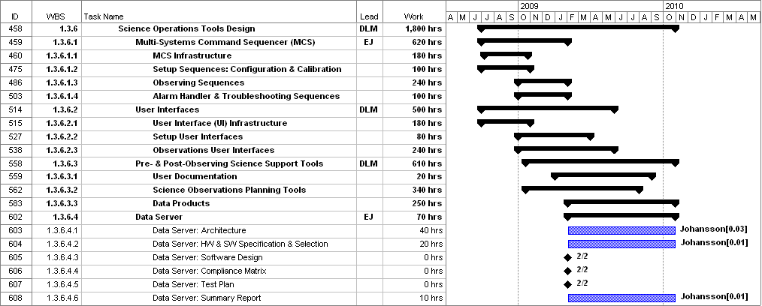
Figure 11. PD phase Science Operations Tools schedule.

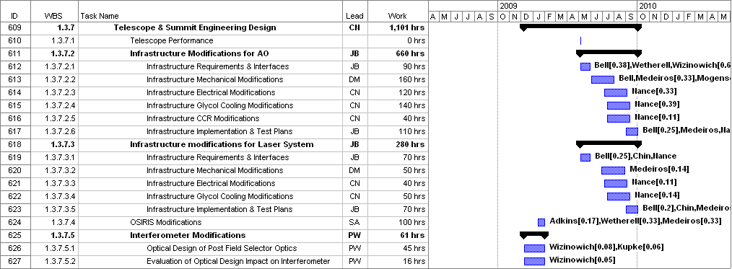
Figure 12. PD phase Telescope and Summit Engineering schedule.

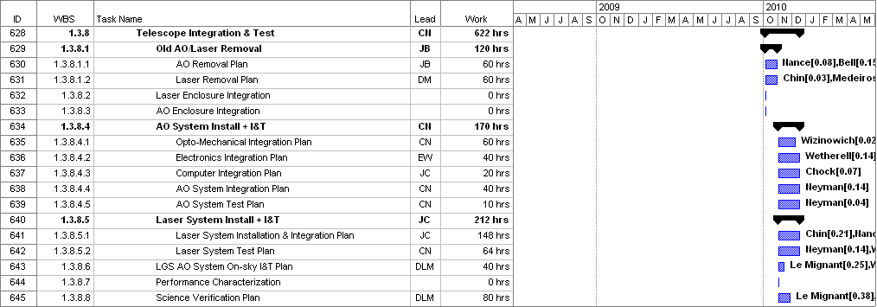
Figure 13. PD phase Telescope Integration and Test schedule.

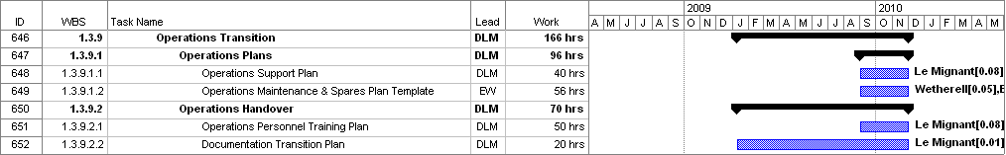
Figure 14. PD phase Operations Transition schedule.

PD Phase Budget and Contingency

The PD phase budget estimate is $k in FY08 dollars. The dollars by WBS and fiscal year are summarized in the following table.

The breakdown of work (hours) and personnel costs by institution and fiscal year is shown in the following table (excluding the travel and contingency shown in the previous table).

PD Phase Milestones
Major milestones for the NGAO PD phase are shown below in Table 5. These milestones are derived from the project schedule shown in section 5.8.

Table 5: Milestones

PD Phase Risk Assessment and Risk Management

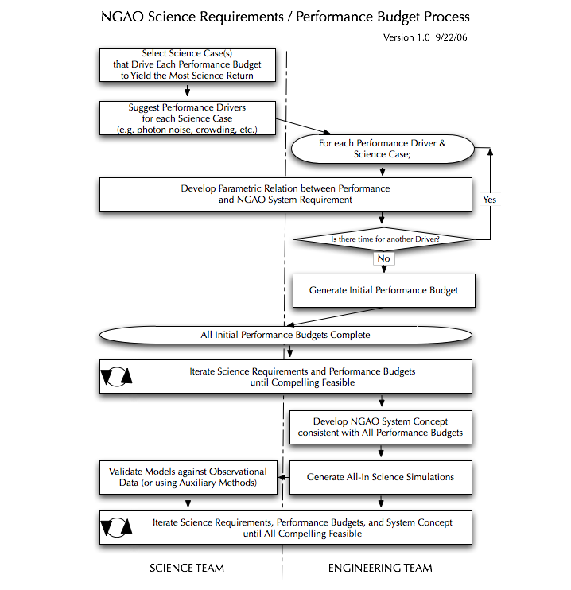

PD Phase Personnel and Core Team
Table 7 was used as a modified output of the MS Project Plan to help balance individuals and the hours per fiscal year. This table lists the names of all of the PD phase personnel. The work hours do not include any contingency time. Some cases of over assigning work to an individual are highlighted in red. These will be addressed by a combination of transferring work to others or moving work into another FY.

Table 7. PD phase personnel assignments versus Fiscal Year (FY).
Name | Work (hrs) by FY |  |  | Work | Work %
Name | FY08 | FY09 | FY10 | PY | FY08 | FY09 | FY10 | Total
Adkins | 292 | 524 | 45 | 0.48 | 39% | 29% | 6% | 26%
Bell |  | 608 | 143 | 0.42 | 0% | 34% | 19% | 23%
Bouchez |  | 80 |  | 0.04 | 0% | 4% | 0% | 2%
Britton | 235 | 559 | 23 | 0.45 | 31% | 31% | 3% | 25%
Brown |  |  | 40 | 0.02 | 0% | 0% | 5% | 1%
Chin |  | 218 | 80 | 0.17 | 0% | 12% | 11% | 9%
Chock | 29 | 121 | 70 | 0.12 | 4% | 7% | 9% | 7%
Contract Administrator | 18 | 44 | 18 | 0.04 | 2% | 2% | 2% | 2%
Dekany | 399 | 849 | 467 | 0.95 | 53% | 47% | 62% | 52%
Doyle |  |  | 16 | 0.01 | 0% | 0% | 2% | 0%
EE / Programmer | 422 | 1897 | 365 | 1.49 | 56% | 105% | 49% | 81%
Free | 20 | 400 |  | 0.23 | 3% | 22% | 0% | 13%
Gavel | 190 | 367 | 342 | 0.50 | 25% | 20% | 46% | 27%
Grace |  |  | 16 | 0.01 | 0% | 0% | 2% | 0%
Hale | 53 | 534 | 55 | 0.36 | 7% | 30% | 7% | 19%
Johansson | 432 | 2050 | 422 | 1.61 | 58% | 114% | 56% | 88%
Kissner | 57 | 141 |  | 0.11 | 8% | 8% | 0% | 6%
Kupke | 105 | 713 | 56 | 0.49 | 14% | 40% | 7% | 26%
Le Mignant | 603 | 1875 | 643 | 1.73 | 80% | 104% | 86% | 95%
Lockwood | 153 | 980 | 118 | 0.70 | 20% | 54% | 16% | 38%
Macintosh |  | 160 |  | 0.09 | 0% | 9% | 0% | 5%
Max | 272 | 668 | 203 | 0.63 | 36% | 37% | 27% | 35%
McGrath | 728 | 1950 | 622 | 1.83 | 97% | 108% | 83% | 100%
Medeiros |  | 508 | 40 | 0.30 | 0% | 28% | 5% | 17%
Mogensen |  | 30 |  | 0.02 | 0% | 2% | 0% | 1%
Morrison | 55 | 440 |  | 0.28 | 7% | 24% | 0% | 15%
Nance |  | 488 | 77 | 0.31 | 0% | 27% | 10% | 17%
Neyman | 609 | 1854 | 402 | 1.59 | 81% | 103% | 54% | 87%
Other |  | 280 | 50 | 0.18 | 0% | 16% | 7% | 10%
Panteleev |  | 200 | 16 | 0.12 | 0% | 11% | 2% | 7%
Reinig | 110 | 289 | 174 | 0.32 | 15% | 16% | 23% | 17%
Student | 227 | 933 |  | 0.64 | 30% | 52% | 0% | 35%
Summers |  |  | 40 | 0.02 | 0% | 0% | 5% | 1%
Tyau | 69 | 430 | 176 | 0.38 | 9% | 24% | 23% | 20%
Velur | 217 | 1452 | 269 | 1.08 | 29% | 81% | 36% | 59%
Wetherell |  | 875 | 196 | 0.60 | 0% | 49% | 26% | 32%
Wizinowich | 376 | 933 | 633 | 1.08 | 50% | 52% | 84% | 59%
Zolkower | 229 | 1033 | 73 | 0.74 | 31% | 57% | 10% | 40%
Total (hrs) = | 5901 | 24483 | 5891
Total (PY) = | 3.3 | 13.6 | 3.3 | 20.2

Table lists the 16 core team members and their roles during the PD phase. These include all individuals assigned to the plan at a level ≥ 25%. In most cases the percentages for these core personnel are significantly higher in FY09 and another four people also exceed 25% in FY09.

These core team members bring a great deal of relevant experience to the project. Overall they represent 79% of the PD phase labor.

Table 8. Core PD phase team members.
Name | Inst | Role | %
Adkins, Sean | WMKO | Laser procurement, instrument interfaces | 26
Britton, Matthew | COO | Wavefront sensor design, performance budgets | 25
Dekany, Rich | COO | COO project management, systems engineering | 52
EE / Programmer (tbd) | UCO | Real-time control | 81
Gavel, Don | UCO | UCO project management, technical overview | 27
Johansson, Erik | WMKO | Non-real time controls & software, systems engineering | 88
Kupke, Renate | UCO | AO optical design | 26
Le Mignant, David | WMKO | Science operations tools, operations concept | 95
Lockwood, Chris | UCO | AO mechanical design | 38
Max, Claire | UCO | Project Scientist, science requirements development | 35
McGrath, Elizabeth | UCO | Postdoc for Project Scientist, science development | 100
Neyman, Chris | WMKO | Systems engineering, laser & AO facility design | 87
Velur, Viswa | COO | Wavefront sensor design | 59
Wetherell, Ed | WMKO | Non-real time control electronics | 32
Wizinowich, Peter | WMKO | PI and project manager, technical overview | 59
Zolkower, Jeff | COO | Wavefront sensor design | 40

PD Phase Management
The NGAO PI will be responsible for maintaining the PD phase budget and schedule for the PD phase.

Cost accounting and other financial and administrative matters will be done by WMKO. WMKO will be issuing contracts to CIT and UC to fund personnel at these institutions to participate in the PD phase, as was done for the SD phase. COO and UCO will provide monthly financial reports to WMKO by the 15th of the following month. The PD phase actual expenditures will be tracked at the 1.3.X level of the WBS (i.e., 1.3.2 Management through 1.3.9 Operations Transition).

A monthly written project report will be provided to the Observatory Directors and the TSIP. The same, or similar, format to the MOSFIRE monthly reports to TSIP. The project leads will be expected to provide monthly status reports for inclusion in the monthly report. This input will also be used to give quarterly updates at the WMKO SSC meetings. The management team will meet with the Observatory Directors four times during the PD phase to ensure

In order to ensure clear direction during the Preliminary Design the NGAO PI will meet regularly with the WMKO Directorate (at least bi-weekly) and the NGAO senior management (Dekany, Gavel, Max and Wizinowich) will have four scheduled telecoms with the Directors.

The team will have monthly teleconferences throughout the PD phase and four face-to-face multi-day meetings. The NGAO senior management will alternate between weekly and bi-weekly telecoms depending on the issues that need to be addressed.

Email will be used as a primary means of intra-project communications. Working documents will be continue to be posted on the NGAO Twiki site, http://www.oir.caltech.edu/twiki_oir/bin/view/Keck/NGAO/WebHome, which proved to be a very productive shared work environment during the SD phase. Documents will continue to be archived as Keck Adaptive Optics Notes on the KeckShare site at http://keckshare.keck.hawaii.edu/dsweb/View/Collection-218.

A Preliminary Design Review (PDR) will be held as the culmination of this design phase. This review will be conducted in accordance with WMKO standards. To the extent practical we are expecting the same reviewers as for the System Design Review.

System Design Phase Summary
A SEMP was produced for the system design phase (KAON 414). The purpose of this section is to provide a brief overview of the schedule and budget actuals versus the plan, and management lessons learned. More details on the actuals versus the plan can be found in KAON ___.

Appendix: Preliminary Design Phase Work Breakdown Structure Dictionary

Appendix: Preliminary Design Phase Schedule

