

Keck Adaptive Optics Note 574

Next Generation Adaptive Optics:
Systems Engineering Management Plan

Version 0.1
March 23, 2008

Author List
Name | Function
Peter Wizinowich | NGAO Executive Committee (EC) Chair
Richard Dekany | EC Member
Don Gavel | EC Member
Claire Max | EC Member & NGAO Science Team Chair

Contributors: .Sean Adkins, Erik Johansson, Elizabeth McGrath, David Le Mignant, Chris Neyman, Viswa Velur

Approval Control
Control | Name | Function
Revised by:

Approved by:
Authorized by:

Document Change Record
Issue | Date | Change Description
Version 1.0 | October 31, 2007

1 Introduction 3
2 Project Plan 3
2.1 Project Management 3
2.2 Project Overview 5
2.3 Project Funding and Planning Assumptions 5
2.4 Project Work Breakdown Structure 5
2.5 Product Structure 7
2.6 Project Cost Estimation 8
2.7 Project Schedule 8
2.8 Project Budget 8
2.9 Project Milestones 8
2.10 Project Risk Assessment and Risk Management 9
2.11 Configuration Management 9
2.12 Requirements Management 9
2.13 Component Failure and Spares 9
3 System Design Phase Summary 11
4 Preliminary Design Phase Plan 11
4.1 PD Phase Management 11
4.2 PD Phase Overview 11
4.3 PD Phase Planning Assumptions 12
4.4 PD Phase Work Breakdown Structure 12
4.5 PD Phase Schedule 12
4.6 PD Phase Budget 13
4.7 PD Phase Milestones 13
4.8 PD Phase Risk Assessment and Risk Management 13
4.9 PD Phase Work Flow and Decision Points 13
4.10 Science Requirements Development and Performance Budget Process 14
4.11 PD Phase Core Team 16
4.12 PD Phase Contracts 16
4.13 PD Phase Scope of Authority 16
4.14 PD Phase Reviews 16
4.15 PD Phase Performance Management and Reporting 16
4.16 PD Phase Coordination 17
5 References 17
5.1 Keck Adaptive Optics Notes (KAON) 17
5.2 Other Documents 17
6 Appendix: Preliminary Design Phase Work Breakdown Structure Dictionary 18
7 Appendix: Preliminary Design Phase Schedule 37

Figure 1. NGAO Preliminary Design Phase Management Structure. 4
Figure 2. NGAO Work Breakdown Structure. 6
Figure 3. NGAO AO System Opto-Mechanical Work Breakdown Structure. 7
Figure 4. NGAO Product Structure. 8
Error! No table of figures entries found.
Table 1. NGAO Project milestones. 9
Table 2. NGAO key components and recommended sparing. 10
Table 3: Milestones 13

Introduction
A Systems Engineering Management Plan (SEMP) is a standard part of the project documentation for W.M. Keck Observatory (WMKO) development efforts. This SEMP represents a key deliverable from the system design phase for the WMKO Next Generation Adaptive Optics (NGAO) project. This document will be updated as a product of the NGAO preliminary and detailed design phases.

The following sections document the proposed management process, schedules and budgets for the remainder of the NGAO project.

Project Plan

Project Management
The System Design phase management structure setup by the Observatory Directors (i.e., Armandroff, Bolte, Kulkarni and Lewis) consisted of a four member Executive Committee (EC) with one person identified as EC Chair and another as Project Scientist. The participants represented the three institutions collaborating on the NGAO System Design. We believe that the members of the EC worked well together and the structure also supported good involvement of the three institutions.

For the Preliminary Design phase we propose a more efficient version of the EC structure. The Chair of the EC, Peter Wizinowich, will become the overall Principal Investigator (PI) / Project Manager and the two other EC technical leads, Rich Dekany and Don Gavel, will become Co-Investigators / Project Managers responsible for the work at their respective institutions. This will allow us to spend less time in joint management of the overall project and more time on management and technical leadership of specific parts of the Preliminary Design.

The proposed organization structure including other senior leadership roles is shown in Figure 1. All items highlighted in blue represent part of the NGAO preliminary design phase project for which this SEMP is written. The NGAO project continues to be led by the EC members but now in more defined roles. The NGAO Project Scientist will be assisted by a TBD NGAO Science Advisory Team.

The NGAO science instruments are separately managed under the direction of the WMKO Instrument Program Manager (IPM), Sean Adkins. The dashed links between the science instruments and the AO facility Principal Investigator, Project Scientist and Systems Engineering reflect the need for close collaboration in the design and development of these systems. The requirements for both the AO facility and science instruments flow down from the NGAO science case requirements. These requirements and the interface definitions between systems are maintained by the NGAO Systems Engineering team.

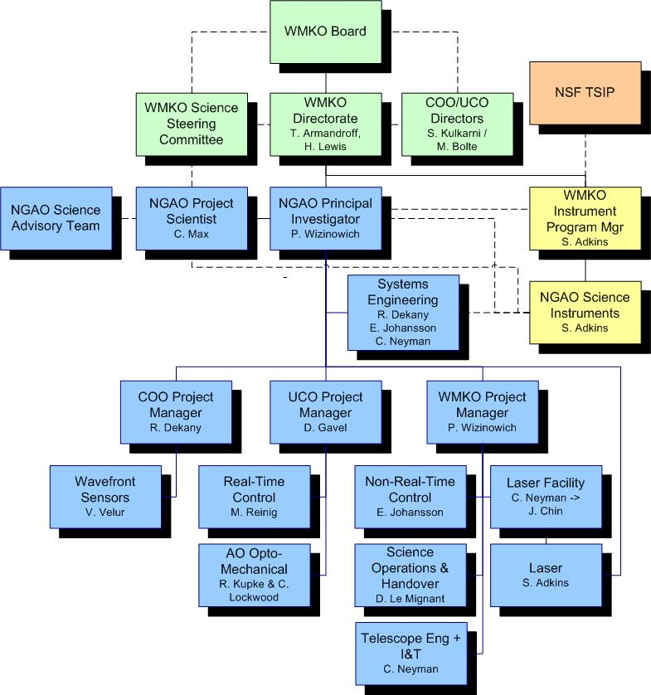
Figure 1. NGAO Preliminary Design Phase Management Structure.

WMKO’s top-level management structure is highlighted in green in Figure 1. Both the NGAO PI and the WMKO IPM report directly to the WMKO Director, Taft Armandroff, and Deputy Director, Hilton Lewis. They in turn report to the WMKO Board. There is a close collaboration between the WMKO Directorate and the Directors of the University of California Observatories (UCO), Mike Bolte, and the Director of the Caltech Optical Observatories (COO), Shri Kulkarni. A similar collaboration exists with the WMKO Science Steering Committee co-chaired by Jean Brodie and Tom Soifer.

Due to the collaborative inter-Observatory nature of the NGAO project and the EC System Design phase mandate, the EC provided regular reports to the Observatory Directors during the System Design phase and looked to them for guidance. In order to ensure clear direction during the Preliminary Design the NGAO PI will meet regularly with the WMKO Directorate (at least bi-weekly) and the NGAO senior management (Dekany, Gavel, Max and Wizinowich) will have four scheduled telecoms with the Directors.

The NGAO EC provided updates at each of the SSC meetings during the NGAO System Design. The PI and PS will plan to provide updates at each SSC meeting during the Preliminary Design. The NGAO project looks for the community science input primarily through the NGAO Project Scientist. The Project Scientist seeks guidance from the TBD NGAO Science Advisory Team and the SSC.

The NGAO Preliminary Design is partially funded by the NSF’s Telescope Systems and Instrumentation Program (TSIP). The WMKO IPM has been responsible for interactions with and reporting to this program for other TSIP funded projects. The NGAO PI will collaborate with the WMKO IPM to provide monthly updates to the TSIP.

Project Overview

Project Funding and Planning Assumptions
The NGAO Preliminary design is funded by the NSF TSIP at $2M and up to $1.455M of additional WMKO funds. The available funding profile is $455k in FY08 (starting May 1), $2M in FY09 and $1M in FY10.

Project Work Breakdown Structure
The NGAO Project Work Breakdown Structure (WBS) is shown schematically in Figure 2. The top level structure reflects the transition from Design (1.0) through Full Scale Development (4.0 to 7.0) to Delivery and Commissioning (8.0 and 9.0). Management (2.0) and Systems Engineering (3.0) are ongoing items through both Full Scale Development (FSD) and Delivery and Commissioning (DC).

The two gray highlighted boxes are intended to represent design phases completed prior to the start of the Preliminary Design. The WBS structure for the Preliminary Design is identical to this WBS numbering except that each WBS element number is preceded by “1.3” and there is no WBS 1.3.1. For example, WBS 1.3.2 is the Preliminary Design Phase Management and WBS 1.3.4.1 is the preliminary design of the AO enclosure. This approach to the design phase WBS numbering was chosen to allow a separate budget and plan for the design phases. Once the design phases are complete we can directly use just the WBS numbers shown in Figure 2.
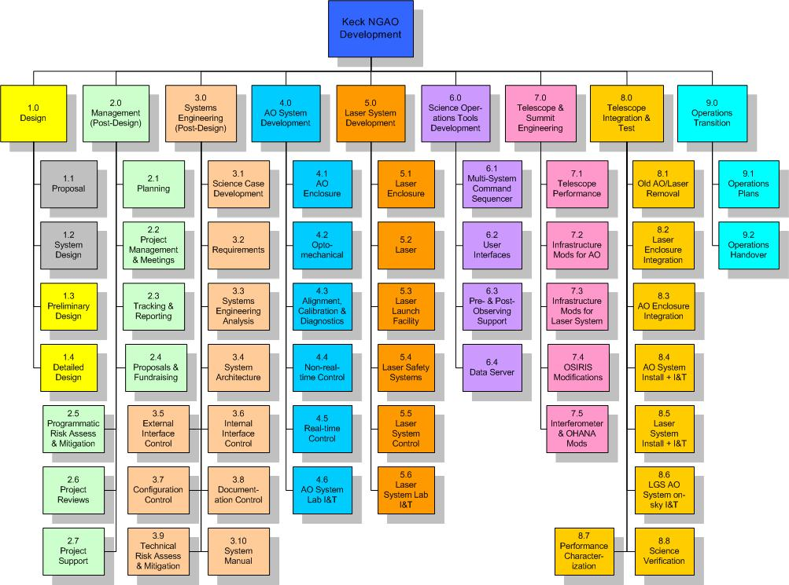
Figure 2. NGAO Work Breakdown Structure.

One of the larger WBS elements, WBS 4.2 is shown at another level of detail in Figure 3, and one of its component elements, WBS 4.2.7 Low Order Wavefront Sensor Assembly, is shown at a further level of detail.
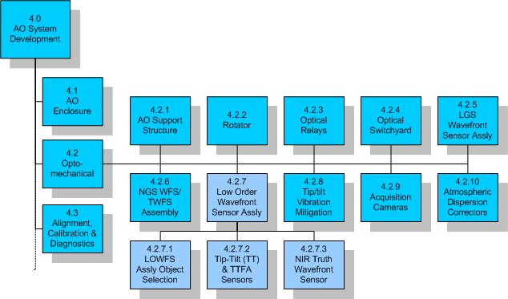
Figure 3. NGAO AO System Opto-Mechanical Work Breakdown Structure.

Product Structure
A view of the Product Structure is provided in Figure 4. MS Project was chosen as the tool to maintain the product structure since it allows easy roll-up of the structure. The view shown in Figure 4 allows you to the lowest level for the rotator. The product structure was developed in parallel with the WBS.

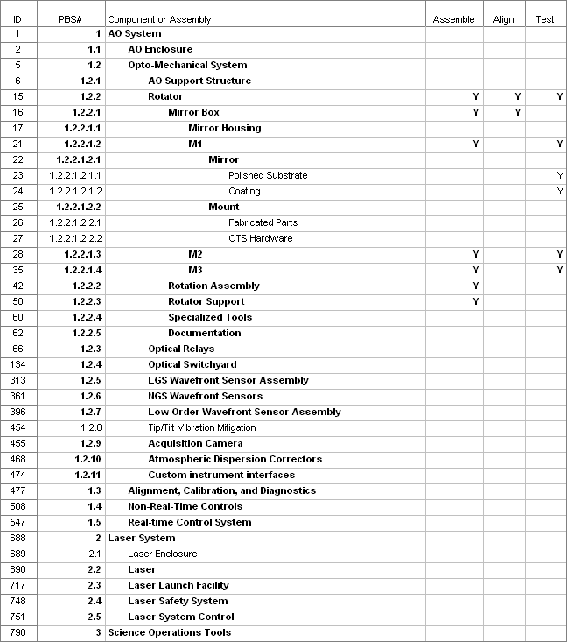
Figure 4. NGAO Product Structure.

Project Cost Estimation

Project Schedule

Project Budget

Project Milestones
Major project milestones are shown inTable 4 Table 1. These milestones are derived from the project schedule shown in section __..

Table 1. NGAO Project milestones.
Year | Month | NGAO Project Milestone
2008 | April | System Design Review
2010 | February | Preliminary Design Review
2012 | February | Detailed Design Review
2013 | February | Full Scale Development Intermediate Review
2013 | August | Pre-Lab I&T Readiness Review
2014 | February | Pre-Ship Readiness Review
2014 | May | NGS First Light
2014 | July | LGS First Light
2014 | July | 15A Shared-Risk Science Availability Review
2014 | December | Operational Readiness Review

Project Risk Assessment and Risk Management
A programmatic risk assessment was performed and documented in KAON 566.

Configuration Management

Requirements Management

Component Failure and Spares
Two component failure issues need to be addressed: failures during development and failures during operations. The impact of failures during development and operations are different. Spares are one way to address failures and need to be considered in this context. Highly reliable components should be the standard.

The impact of a component failure depends on the development phase, its criticality to the subsystem and overall system, and the required time to troubleshoot, repair or replace the component. The failure of a key component during subsystem development could potentially result in the late delivery of a subsystem and the delay of system integration and test. The failure of a key component during lab or telescope integration and test could result in significant cost and schedule impacts.

A component failure during a science night must be addressed immediately preferably by having a back-up mode of the instrument that does not require this component. It is important to have good tools and procedures for quickly identifying and repairing or replacing the failed component. The failed component should be able to be replaced or repaired prior to the next night or in the worst case before the next observing run.

A preventative maintenance program is required during operations to minimize the chance of component failures and to ensure the early detection of components that are starting to fail.

Failures can be addressed by a combination of troubleshooting and repair procedures, good component documentation, proper sparing, team expertise and vendor support (potentially including maintenance contracts).

Some component failures are more likely to happen during development than operations. Infant mortality is most likely to happen during subsystem development, where more time is potentially available to replace it. An optic is more likely to be broken as it is being shipped or integrated during subsystem, lab or telescope integration.

For cost reasons not everything can be spared. We must therefore focus on the most critical components and the limited lifetime components. The likelihood and impact of a failure needs to be considered.

Table 3 provides a partial list of key components and their recommended sparing. This list will be further defined during the remaining design phases. This list could be integrated into the Product Structure MS Project tool.

Table 3. NGAO key components and recommended sparing.
Component | Number in System | Dev Failure Conse-quence | Ops Failure Conse-quence | Failure Like-lihood | Lead time (mos) | Cost ($k) | Discussion | Recom-mended Spares Cost ($k)
Window | 1 |  |  |  |  |  | None | 0
Image rotator | 1 |  |  |  |  |  | Rotator & all 3 mirrors are long lead | 0
Science path optics | many |  |  |  |  |  | Many items long lead, especially OAPs | 0
Woofer DM + TT stage | 1 |  |  |  |  |  | Spare 2 TT actuators
32x32 MEMS + TT stage | 3 |  |  |  |  |  | Spare one unit
64x64 MEMS + TT stage | 1 |  |  |  |  |  | Spare two actuators
Dichroics/Mirrors | many |  |  |  |  |  | Identify one or two key dichroics
LGS WFS | 9 |  |  |  |  |  | Spare 1 assembly
NGS WFS | 1 |  |  |  |  |  | None | 0
Object Selection Mechanism | 1 |  |  |  |  |  | Spare 1 mechanism
TT Sensors | 2 |  |  |  |  |  | Spare 1 camera (detector & housing)
TTFA Sensor | 1 |  |  |  |  |  | None | 0
NIR Truth Sensor | 1 |  |  |  |  |  | None | 0
Vis Truth Sensor | 1 |  |  |  |  |  | None | 0
Acquisition Cameras | 2 |  |  |  |  |  | Observatory standard so spares in-house. | 0
RTC Hardware System | 1 |  |  |  |  |  | Spare some key boards | 0
DM driver electronics | 5 |  |  |  |  |  | Spare some key boards
Non-RTC Hardware System | 1 |  |  |  |  |  | Spare standard components
Infrastructure |  |  |  |  |  |  | Misc spares
Laser | 3 |  |  |  |  |  | Spare standard components
Beam Transport | 1 |  |  |  |  |  | Spare standard components
Launch Telescope | 1 |  |  |  |  |  | None | 0
 |  |  |  |  |  |  | Total =

System Design Phase Summary
A SEMP was produced for the system design phase (KAON 414). The purpose of this section is to provide a brief overview of the schedule and budget actuals versus the plan, and management lessons learned. More details on the actuals versus the plan can be found in KAON ___.

Preliminary Design Phase Plan

PD Phase Management
The NGAO preliminary design phase will be managed by the NGAO Executive Committee established by the Observatory Directors (WMKO, UC and CIT). This committee consists of Rich Dekany, Don Gavel, Claire Max (chair of the NGAO science team) and Peter Wizinowich (Executive Committee chair).

Leadership responsibilities for specific parts of the system design are indicated in the MS Project Plan in section 4.5. Additional discussion of science and engineering management can be found in sections 4.10 and 4.11.

PD Phase Overview
The preliminary design (PD) phase is the second design phase for WMKO development projects. This phase follows the system design and precedes the critical design phase.

In the Observatory’s development program, the preliminary design phase has two primary objectives. The first objective is to deliver documented designs for each system, subsystem and component, hardware or software, of sufficient detail to establish through inspection and analysis the feasibility of the proposed design, and the likelihood that the design will meet the requirements. The second objective is to present the project plan to completion, including a detailed schedule and budget.
The principal activities of the preliminary design phase are design, prototyping, simulation and analysis. The key deliverables are preliminary technical specifications, requirements for subsystems, a preliminary Operations Concept Document, Interface Design document(s), and a Preliminary Design report.

PD Phase Planning Assumptions
The following assumptions were used in producing the preliminary design phase plan:

PD Phase Work Breakdown Structure
The following is the top level Work Breakdown Structure for the system design phase. Each level one WBS element has a key deliverable indicated with italics:

Further WBS detail, including a WBS dictionary can be found in section _.

PD Phase Schedule
Below is the level three version of the PD schedule. Our approach to developing this schedule has so far been: 1) understand the PD phase deliverables, 2) define the WBS, 3) appropriately phase the WBS elements, 4) apply resources to the MS project plan, 5) iterate to produce a realistic schedule and 6) iterate to produce a realistic budget. We will continue to update this schedule through the PD phase of the project. The complete PD schedule can be found in section 7.

The bottom line is a preliminary design review date of December 15, 2009.

Note that the total labor estimate is .

PD Phase Budget

The budget estimate for the preliminary design phase of the NGAO project is $k in FY08 dollars. The dollars by WBS and fiscal year are summarized in the following table. The costs in the four WBS rows are for labor and correspond to the actual cost of the work in the “Work” column of the schedules shown in the previous section.

The breakdown of work (hours) and personnel costs by institution and fiscal year is shown in the following table (excluding the travel and contingency shown in the previous table).

PD Phase Milestones
Major milestones for the NGAO PD phase are shown below in Table 4. These milestones are derived from the project schedule shown in section 4.5.

Table 4: Milestones

PD Phase Risk Assessment and Risk Management

PD Phase Work Flow and Decision Points
During the proposal and system design phases we made several passes through the following design process loop to demonstrate the feasibility of achieving the science requirements. This resulted in an initial architecture or “system design.” This process will begin anew and complete several iterations during the preliminary design phase.

Science Requirements
Technical Implications
Initial Concept

Performance Assessment

Using this design process, the overall approach during the preliminary design phase will be the following:
- The initial focus will be on the requirements and performance budgets to ensure that we understand the largest levers on the design. (See Section 4.10)
- We will then make an initial attempt at defining the AO system architecture and then draft the first version of the functional requirements for the major systems (AO, LGS facility, operations tools and science instruments).
- In parallel with items 1 and 2 we will work on a number of trade studies to better understand the appropriate design choices.
- A process of iteration and refinement will lead to the final version of the AO architecture and major systems requirements. This will include continue development of performance budgets and functional requirements.
- We will then develop cost estimates and the plans for the remainder of the NGAO project.

The MS project schedule and the team meeting schedule (section Error: Reference source not found) will be used to assess the progress and timeliness of the project’s activities. The team meetings will allow regular review of work to ensure that the objectives are being met.

Where possible and appropriate we will seek opportunities to leverage other ongoing work or previous design work. Potential examples include: benefiting from priorities and facilities at the UCSC Lab for Adaptive Optics; reviewing and utilizing the TMT NFIRAOS conceptual design study; keeping NGAO in mind during the construction of the Keck I LGS AO system; and benefiting from experiments and experience at Palomar, Lick and Keck.

Science Requirements Development and Performance Budget Process
The Project Scientist will be responsible for development of science requirements in three major areas: Solar System, Galactic, and Extragalactic Astronomy. Science team leaders for these areas are F. Marchis (Solar System), M. Liu (Galactic), and C. Max (Extragalactic); the team leaders will be assisted by specialists in specific topics as needed. A Science Advisory Committee will provide advice and guidance to the NGAO Team.

Performance budgets (error budgets) will be a key interface between the science team and the AO design team. Within each of the three science areas, early emphasis will be placed on the developing that subset of science cases which provides the strongest drivers for AO system performance. For example, imaging of substellar and planetary companions will be the strongest driver for the contrast error budget, which in turn will constrain the allowable static optical aberrations in the AO system.

When a first version of the science requirements and their corresponding performance budgets has been assembled, the AO engineering design team will consider the implications for AO systems architecture and design. The design team will develop an NGAO system concept that is as nearly as possible consistent with all of the performance budgets. The science requirements, performance budgets, and system concept will then be iterated between the science team and the design team until a design is arrived at that is both scientifically compelling and technically feasible.

This process is illustrated in further detail in the following figure.
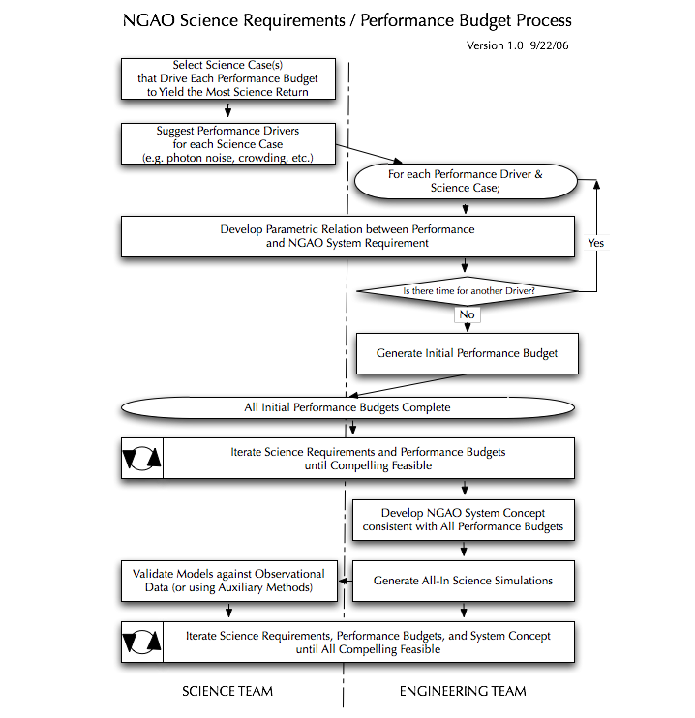
Detailed performance budgeting during the system design phase will begin with development of parametric representations of each of the major error terms that our science team believe currently limit the corresponding science performance. For example, it is believed that tilt anisoplanatism significantly contributes to the astrometric precision of the current Keck LGS system. We will understand how this error is diminished as a function of the number of low-order wavefront sensors (independent of other effects). Similar parametric relationships will allow the system architecture to emerge from an understanding of a global optimization of performance. Because this process is constrained by available time and resources, it will not be possible to parametrically understand every performance limitation. In some cases, allocations in the performance budget will be made, imposing further requirements onto, for example, the science instruments and as yet unselected individual NGAO components.

This approach represents a new level of design maturity, expanding upon the traditional metric of adaptive optics residual wavefront error (or, correspondingly, Strehl), to consider the science-based astrometric, high-contrast, photometric, and other performance metrics.

PD Phase Core Team
In addition to the EC we have identified a limited number of individuals as part of a core science and engineering team for the NGAO SD phase. These individuals bring a great deal of relevant experience to the project. In general they will be devoting a significant fraction of their time to NGAO during the PD phase; overall they represent % of the PD phase labor. They will represent the tasks for which they have leadership in the plan and the input of other participants working on these tasks. They are in general expected to attend the NGAO team face-to-face meetings. Other individuals will be invited to these meetings on an as needed basis. The core team members and their areas of expertise relevant for the NGAO PD phase are listed in the following table.

PD Phase Contracts
WMKO will be issuing contracts to CIT and UC to fund personnel at these institutions to participate in the PD phase. This process was used during the SD phase.

PD Phase Scope of Authority
Deviations from the NGAO project objectives must be approved in writing by the NGAO EC.

Decisions regarding schedule and budget are the responsibility of the NGAO EC. The NGAO EC must approve in writing all deviations from statements of work affecting the NGAO project objectives.

Cost accounting and other financial and administrative matters will be done by WMKO.

PD Phase Reviews
A Preliminary Design Review (PDR) will be held as the culmination of this design phase. This review will be conducted in accordance with WMKO standards. To the extent practical we are expecting the same reviewers as for the System Design Review.

PD Phase Performance Management and Reporting
The EC will be responsible for maintaining a task plan, budget and schedule for the PD phase of the NGAO project.

A monthly written project report will be provided to the Observatory Directors and the TSIP. We will continue to use the guidelines in the document Management Guideline for the Preparation of Monthly Reports, version 1.2, Sean Adkins, July 7, 2003, in preparing our reports.

PD Phase Coordination
The schedule (sections 4.5 and Error: Reference source not found) calls for various meetings and teleconferences to be held during the course of the project.

The NGAO EC will have weekly telecons throughout the PD phase of this project.

E-mail will be used as a primary means of intra-project communications.

A working document area has been set up at http://www.oir.caltech.edu/twiki_oir/bin/view/Keck/NGAO/SystemDesignPhasePlanning.
Documents will be archived as Keck Adaptive Optics Notes on the KeckShare site at http://keckshare.keck.hawaii.edu/dsweb/View/Collection-218.

References

Keck Adaptive Optics Notes (KAON)
All of the documents listed below are available on the KeckShare site at http://keckshare.keck.hawaii.edu/dsweb/View/Collection-218.

Other Documents
- Management Guideline For the Preparation of Monthly Reports, version 1.2, Sean Adkins, 7/7/2003

Appendix: Preliminary Design Phase Work Breakdown Structure Dictionary

- Preliminary Design Phase Management
- Management of the PD Phase of the NGAO project, including budget and schedule, and regular reporting to the Observatory Directors, TSIP and the SSC. The Executive Committee (EC) has overall responsibility for the delivery of the key products of the PD Phase.
  - Planning & Contracting
    - SD Phase Contracts Generated
- WMKO intends to issue contracts to Caltech and UCSC, and possibly elsewhere, to provide funding for these groups to support the SD phase. This WBS element covers the effort to prepare contract documentation, including statements of work, and to implement these contracts.
    - Director Approval
- SD SEMP Plan Endorsed
    - SD Partner Contracts Issued
- SD phase partner contracts issued by CARA and signed by partner institutions
    - Mid-year Replan
- The EC assess progress against the SD plan and incorporate new information generated by the science requirements, performance budget development process, and technical trade studies. This is an opportunity to realign SD phase tasks toward the key science drivers identified early in the SD phase.
    - FY08 Replan
- The EC will replan the SD phase for FY08 in light of the prospect of increased SD phase funding, in response to new technical information generated during FY07, and in order to align FY08 work toward the construction phase WBS (though adoption of the new WBS is expected at the completion of the SD phase).
  - Project Meetings
- Effort in support of regular project meetings.
    - Executive Committee Telecons
- The EC will have regular telecons to manage the SD phase. This WBS covers the effort to participate in these telecons.
    - Science Advisory Committee Telecons
- The Project Scientist will hold regular telecons with the other members of the SAC. This WBS covers the effort to participate in these telecons.
    - Team Meetings
- Team meetings will be held every ~ 6 weeks during the SD phase. These meetings will alternate between 8 hr in-person meetings and 4hr teleconferences. The in-person meetings will generally be held at either Caltech, UCI or WMKO in an alternating fashion.
  - Tracking & Reporting
- We will be reporting on the SD phase status and plans at each SSC meeting. This WBS covers the effort to prepare for these meetings, including tracking our progress, and to present at these meetings.
- We will also be providing more global overviews of the SD progress at the Keck Science Meetings. This WBS covers the effort to prepare for these meetings.
  - Funding Proposal(s)
- Generation of proposals for funding. The current assumption is that no work will be needed in this area during the SD phase.
- Systems Engineering Management Plan
- Note that this document (KAON 414) represents a simplified version of the SEMP that will need to be prepared under this WBS for the entire NGAO project.
  - Project Plan
- A task definition, cost estimation, list of major milestones, WBS structure and an MS project plan will be prepared for the entire NGAO project (excluding the SD phase).
    - WBS and Task Definition
    - Develop a work breakdown structure (WBS) for the remainder of the NGAO project following the system design phase. Organize around a corresponding Product Breakdown Structure (PBS). Team members must have significant input to this development. Document the WBS using a detailed WBS dictionary and can also serve as the initial basis for an construction cost estimate.
    - Cost Estimation
    - Generate an initial cost estimate for completion of the work in the WBS. Document the basis for the cost estimate, including methodology for estimating management contingency.
    - Major Project Milestones
    - Based on the logical sequencing and connection of work packages in the WBS, identify key project milestones for the remainder of the NGAO project. These should be verifiable accomplishments that facilitate project tracking and controls, possibly described as clear points for the reporting of Earned Value.
    - MS Project Plan
    - Develop a schedule using tools designed to facilitate project tracking and controls. Identify critical path and flag early investments that can accelerate project completion.
  - Risk Assessment & Risk Management Plan
- The risk assessment prepared as Section 17 of the NGAO proposal can be used as a starting point.
  - Preliminary Design Phase Plan
- A detailed project plan for the PD phase of the NGAO project.
    - Version 1 to Support Observatory FY08 Planning
    - PD phase plan Ver 2
    - PD phase plan Ver 3
  - Integration & Test Plans
    - Subsystem Integration & Test Plans
- Initial project plans for each subsystem’s integration and test.
      - AO System Test Plan
- Initial testing plan for adaptive optics system laboratory integration and testing, including validation of the calibration unit, closed-loop testing for both NGS and LGS modes, and verification of functionality such as effective closed-loop bandwidth.
      - Laser System Test Plan
- Initial testing plan for all aspects of the laser system, including verification of laser performance, beam transfer efficiency, safety systems, diagnostics, and active systems such as high-speed pointing control
      - Science Operations Test Plan
- Initial testing plan for science operations, including verification of observation planning tools and verification of observing efficiency performance budgets.
      - Science Instruments Test Plan
- Initial testing plan for science instrument interfaces to NGAO. Includes verification of NGAO data products (e.g. telemetry) required to meet science and user requirements for NGAO. Does not include any testing of science instrument performance or functionality.
    - System Integration & Test Plans
- Initial project plan for overall system integration and test.
  - Configuration Management Plan
  - Project Management Plan
- This section of the SEMP provides additional information on the management structure, including communications, reporting, oversight, and the role of external reviewer and advisors.
  - Systems Engineering Management Plan
- Document summarizing the products produced in WBS 4 including a description of the project objectives and major milestones, a description of the project organization, a description of the project management process, a description of the project decision process and major decision points, a risk assessment and a risk management plan, and configuration management plans for hardware, software and documentation.

  - System Design Review
    - System Design Report
- Provides a high level summary of the work done during the SD phase and makes a proposal for the preliminary design phase of the project including a plan for the remainder of the project.
    - System Design Review Activities
- This WBS covers the following activities: identifying reviewers, distributing the four SD phase documents to the reviewers, responding to the reviewer questions, preparing and presenting at the SDR and responding to the SDR reviewer report.

- Systems Engineering
  - Systems Engineering
    - Performance Budgets
- Development of systems level engineering budgets for a variety of astronomical performance metrics, organized around key observing scenarios. The level of detail available to each budget will depend on the state of the art, the resources dedicated to budget generation during the SD phase, and astronomical user experience. All performance budgets should parameterize the performance behavior versus the corresponding sky coverage fraction. (when appropriate, coverage levels of 5, 30, and 90% should be assumed).
      - Model Assumptions
- The goal of this WBS is to document the assumptions (and rationale) for the key parameters to be adopted for the development of all performance budgets, including such items as the median C_{n}²(h), sodium column density and Keck telescope optical performance. In some cases work will be required to acquire and evaluate data to determine the appropriate assumptions to be used.
        - TMT Site Monitoring Data Mining
- Develop tools for data mining from the database of TMT Mauna Kea site survey data. Analyze such data to determine for example, nominal, 10, 25, 75, and 90 percentile seeing conditions (r0, theta0, Cn2, wind, etc.) and publish in a form usable as input to system performance simulation models. Work with system modelers to assure appropriately interpreted data is being used and provide metrics of data integrity and/or reliability.
        - Telescope Dynamic Performance Data
- Improve/document our understanding of the actual primary mirror wavefront errors.
        - Telescope Static Wavefront Errors
- Improve/document our understanding of the actual primary mirror wavefront errors.
        - Sodium Return versus Laser Format
- Improve/document our understanding of the actual sodium return versus various laser formats. Should base this on experience with the Keck, Gemini, Palomar and Subaru lasers.
      - Model/Tool Validation
- Execution of a series of quantitative checks on the validity of key NGAO models and development tools, as compared to results obtained from various laboratory and sky tests with existing AO systems.
        - Agreement between Tomography Codes
- Understand the differences between tomography codes in use at WMKO and UCSC, modify the codes as appropriate and document the result that should be used.
        - Agreement between Sky Coverage Codes
- Understand and document methods of making sky coverage calculations. Validate/compare codes using sample data sets and resolve discrepancies.
        - Anchor to Keck II LGS AO PSFs
- Demonstrate the ability to produce PSFs that are adequately similar to PSFs obtained with the Keck II LGS AO PSFs. Understand and make changes to the models to achieve this result. Document the result and use the result in updating the appropriate performance budgets.
        - Anchor to On-sky MGSU Experiments
- Use the results of the Palomar (and possibly MMT) MGSU experiments to validate and/or correct the tomography model and its assumptions.
        - Anchor to LAO Lab Experiments
- Determine what high leverage experiments should and can be performed at LAO to validate our models and tools, perform these experiments, and use the results to update the appropriate models, tools and performance budgets. Tomography and MOAO demonstrations are likely to be performed.
      - Throughput
- Development of optical transmission budgets for each of the science path(s), HOWFS, LOWFS(s), and slow WFS.
      - Background
- Development of thermal background budget for the IR science and wavefront sensor instruments.
      - Wavefront Error
- Development of residual wavefront error budgets for a set of key observational scenarios. The first step is to document the budget and tool used in the proposal.
      - Encircled Energy
- Development of encircled energy budgets for a set of key observational scenarios.
      - Photometric Accuracy
- Development of a deviation budget for differential photometric precision for a set of key observational scenarios. To be manageable, this budget should assume statistical independence among the key physical sources of degradation of photometric precision. Physical effects to be considered may include wind-induced PSF anisoplanatism, photon noise, read noise, flat-fielding variations, field-dependent optical aberrations, imperfect estimation of the anisoplanatism contribution to PSF shape, atmospheric scintillation, filter bandpass uncertainty, transparency waves in the atmosphere, imperfect atmospheric color correction, PSF sampling issues, and nonlinear detector response. Investigation of the impact of certain terms in the budget may require detailed AO performance simulations. Calculation of other terms may be beyond the scope of the SD phase, resulting in a top-level allocation to the performance budget until otherwise updated.
      - Astrometric Accuracy
- Development of a deviation budget for differential astrometric precision for a set of key observational scenarios. To be manageable, this budget should assume statistical independence among the key physical sources of degradation of astrometric precision. Physical effects to be considered may include atmospheric tilt anisoplanatism, wind-induced PSF anisoplanatism, field-dependent optical aberrations, photon noise, read noise, flat-fielding variations, PSF sampling issues, telescope plate scale fluctuations, and nonlinear detector response. Investigation of the impact of certain terms in the budget may require detailed AO performance simulations. Calculation of other terms may be beyond the scope of the SD phase, resulting in a top-level allocation to the performance budget until otherwise updated.
      - Polarimetric Accuracy
- Develop polarmetric accuracy performance budget. Develop methods of assessing optical designs for polarimetric accuracy and stability and fold these into the process of system design analysis so that important impacts are identified early.
      - Companion Sensitivity
- Development of a companion sensitivity performance budget, based on a strawman coronagraph approach meeting the science requirements. Develop a contrast-driven spatio-temporal wavefront error budget that includes not just AO performance but realistic values for static/internal effects, so that we can see what instrument design choices (e.g. optics quality) are important now.
      - Observing Efficiency
- The purpose of this performance budget is to determine what will be required to meet the Observing Efficiency requirement. Also, report on the lessons learned with current LGS AO systems (Keck, Gemini, ESO, etc). A list of all the items contributing to the loss of LGS AO-corrected integration time will be produced along with reasonable allocations of the observing efficiency budget amongst these items.
      - Observing Uptime
- The purpose of this performance budget is to determine what will be required to meeting the observing uptime requirement. This budget is only intended to cover the NGAO facility and science instruments (and not the telescope or facility). A list of all the items contributing to downtime will be compiled along with a distribution of the uptime budget amongst these items.
      - Performance Budgets Summary
- This document will capture in one location the several performance budgets generated during the SD phase and will be a convenient reference for engineering team / science team iterations.
      - Science Products
- We will generate a set of science products based upon the emerged NGAO system design in order to verify science suitability and to document predicted performance for use during the commissioning phase
        - All-in Science Simulations
    - The engineering team will provide field-dependent PSFs to the respective science team subgroups, simulating the delivered median condition performance of the NGAO system design concept. If time and resources allow, variations of performance with different seeing conditions will be investigated.
      - Additional Science Characterization Results
- Based on the system design, we will generate other science characterization products that capture key views of the NGAO system performance.
Point Source Sensitivities
- The purpose of this WBS is to produce a summary table of predicted point source sensitivities based on the relevant performance budgets.
PSF Uniformity and Stability
    - The purpose of this WBS is to produce a document, including sample PSFs, summarizing the predicted PSF stability based on the relevant performance budgets. The appropriate timescales of interest for PSF stability should be determined and used in this evaluation (i.e., 3 seconds, 3 minutes, 3 hours and 3 days).
    - Trade Studies
- The system engineer in charge of trade studies shall assure that trade studies are cohesively coordinated, that results are published at a consistent level of accuracy relevant to the system design at this phase, that the appropriate interfaces/interactions are made with other system engineering efforts, and that the studies are being performed efficiently in view of the system design phase schedule.
      - System Architecture Trade Studies
        - MOAO & MCAO
- This trade study is intended to build our expertise with Multi Object and Multi Conjugate AO. The existing MOAO and MCAO design studies should be reviewed. The product should be a summary of the issues related to these two approaches, including an understanding of the potential risks, technical challenges, limitations, advantages and room for improvement with each of these approaches.
        - NGAO versus Keck AO Upgrades
- Consider the feasibility of upgrading one of the existing Keck AO systems incrementally to meet NGAO science requirements. Consider opto-mechanical constraints & upgradeability of embedded & supervisory control systems. Consider impact on science operations during NGAO commissioning. Complete when option assessment documented.
        - Adaptive Secondary Mirror Option
- Consider relative performance, cost, risk & schedule of an NGAO implementation based on an ASM. Quantify the benefit of an ASM to both NGAO and non-NGAO instruments. Complete when NGAO baseline architecture selected.
        - K & L-band Science
- Consider the relative performance, cost, risk, and schedule of different strategies for K and L-band science optimization. Compare a Nasmyth relay, an ASM & a separate lower-order Nasmyth AO cryo-system. Complete when performance estimates & strategy for K- & L-band observing documented.
        - Keck Interferometer Support
- Consider the relative performance, cost, risk & schedule of feeding KI with NGAO or a repackaged version of the current AO system. Decoupling of NGAO from interferometer support may simplify & improve performance of NGAO. The feasibility of maintaining a version of the two current AO systems for KI use should be evaluated. Complete when NGAO baseline architecture selected.
        - Instrument Balance
- Consider the relative merit of installing NGAO on Keck I vs Keck II. This must take into account the long-term instrumentation strategy for Keck, available laser infrastructure, and impact on operations. Complete when architecture and location requirements documented.
        - GLAO for non-NGAO Instruments
- Consider the relative performance, cost, risk, and schedule of GLAO compensation using an ASM as a wide-field optical relay for non-NGAO instruments. Complete when expected performance benefit for each instrument documented.
        - Instrument Reuse
- Consider the cost/benefit of reuse of existing Keck AO instruments, particularly OSIRIS and NIRC2, versus the benefit of design freedom for an all-new instrument suite. Complete when Observatory strategy adopted.
        - Telescope Wavefront Errors
- Review new data on the telescope static and dynamic wavefront errors. Determine how and whether NGAO can correct for these errors. Determine the performance benefit of a large LOWFS patrol field to enable use of the brightest possible NGS. Consider whether a separate sensor outside the NGAO FOV would be useful for measuring/correcting the telescope errors. Complete when impact on current Keck LGS AO system understood and impact on NGAO reviewed.
        - Observing Model
- Report on the relative merits of various observing models (classic, queue, service) for the NGAO science cases. In particular, include the possible impact from weather, space command approval, laser traffic control, instrument inefficiency and time on target to achieve a desired science performance (i.e., SNR).
      - Adaptive Optics System Trade Studies
- The following are the medium and high priority trade studies identified in an Appendix of the NGAO proposal. Low priority trade studies have been deferred.
        - AO Enclosure Temperature
- Consider the performance, cost, risk, reliability & maintainability of cooling a Nasmyth NGAO enclosure. Calculate sensitivity impact as function of waveband (V through L-band). Complete when enclosure operating temperature selected.
        - Optical Relay Design
- Consider the relative performance, cost & risk of OAP, general 2-mirror & Offner relays. Consider image quality vs. FoV, pupil image quality & the flowdown of requirements onto the (variable distance) LGS wavefront sensor(s). Evaluate science path and wavefront sensor paths to 150” radius, while optimizing the design over a 90” radius (after confirming that these are the correct radii to consider). Complete when an NGAO baseline optical design is selected.
        - Field Rotation Strategy
- Consider the relative performance, cost, reliability & maintainability of compensating field rotation using 1 or more K-mirrors vs using 1 or more instrument rotators. Complete when baseline approach & instrument requirements documented.
        - Dichroics and Beamsplitters
- Determine the observation requirements for all beam directing dichroics and beamsplitters, configured into 1 or more motorized dichroic changers. Different observing programs may desire different distributions of light among HO WFS, LO WFS & science light paths. Complete when dichroic changer requirements documented.
        - Rayleigh Rejection
- Evaluate the impact of unwanted Rayleigh backscatter to NGAO system performance. Consider the relative performance, cost, risk & schedule of various strategies for mitigation of LGS Rayleigh backscatter. Techniques include background subtraction, modulation & optimizing projection location. This issue is closely coupled to laser pulse format, with pulsed lasers generally providing more options for Rayleigh mitigation than CW lasers. Complete when NGAO baseline architecture selected.
        - LGS Wavefront Sensor Type
- Consider alternative WFS designs (e.g. Shack-Hartmann vs. pyramid) for different laser pulse formats. Evaluate and compare the advantages of e.g. short pulse tracking using radial geometry CCDs and mechanical pulse trackers. Complete when LGS WFS requirements have been documented.
        - LGS Wavefront Sensor Number of Subapertures
- Consider the cost/benefit of supporting different format LGS wavefront sensors (e.g. 44 subaps across, vs. 32, vs 24.) Consider the operational scenarios required to meet science requirements in poor atmospheric seeing or cirrus conditions?
        - Slow Wavefront Sensor
- Determine the requirements, if any, for slow wavefront sensor for tracking of non-common-path aberrations between the HOWFS and science instruments. Determine potential waveband for slow WFS operation. Consider if a single NGS HOWFS can be pressed into service for this purpose (with another lenslet array)? Consider impact of dark current in longer exposures. Complete when Slow WFS requirements are documented.
        - Low Order Wavefront Sensor Architecture
- Consider the cost/benefit and technical maturity of MEMS-based correction within the LOWFS, using MOAO control techniques. Include consideration of additional metrology systems required, if any. Compare with cost/benefit of MCAO system to provide tip/tilt star sharpening. Complete when LOWFS requirements and sky coverage estimates have been documented.
        - Number and Type of Low Order Wavefront Sensors
- Perform a cost/benefit analysis for the optimal type, waveband, and number of tip/tilt and tip/tilt/focus low-order WFS. Complete when LOWFS requirements and sky coverage estimates have been documented.
        - Centroid Anisoplanatism
- Consider the impact of centroid anisoplanatism (e.g. the tip/tilt error due to coma in the low-order WFS) and mitigation strategies, if necessary. Evaluate the difference between Zernike (z-tilt) and centroid tilt (g-tilt) for NGAO sensors. Complete when documented and mitigation strategy adopted.
        - Deformable Mirror Stroke Requirement
- Determine required DM stroke based on performance, cost, risk, reliability & maintainability. Consider both global & inter-actuator stroke & quantify the performance penalty for different levels of actuator saturation. Determine DM stroke offloading requirements to other NGAO system elements. Complete when DM stroke, stroke offloading & related system requirements documented.
        - Stand-alone Tip/Tilt Mirror versus DM on Tip/Tilt Stage
- Consider the performance, cost, risk, reliability, and maintainability of a stand-alone tip/tilt mirror vs. mounting an otherwise necessary mirror (e.g. a DM) on a fast tip/tilt stage. Note that high BW correction is difficult with a large or heavy mirror. Complete when tip/tilt approach selected.
        - Correcting Fast Tip/Tilt with DM
- Consider the performance, cost, risk, reliability, and maintainability of performing the highest bandwidth tip/tilt correction using DM actuators. Note that allocation of some time/tilt control to the DM complicates the control system, may increase the stroke requirement & thus the DM cost. Complete when control system & DM stroke requirements determined.
        - Focus Compensation
- Consider cost/benefit of different approaches to focus compensation due to sodium layer motion. Include consideration of the proper combination of LGS focus, LOWFS focus and Slow WFS focus. Complete when focus tracking strategy has been documented and reflected in error budgets.
      - Laser Facility Trade Studies
        - Laser Pulse Format
- Consider the performance, cost, risk, reliability, and maintainability of different sodium laser pulse formats, including usability under various weather scenarios, infrastructure and beam transport issues, and commercial readiness. Complete when laser pulse format requirements have been documented.
        - Free Space versus Fiber Relay
- Consider the performance, cost, risk, upgradability, reliability & maintainability of free-space guide star laser transport vs hollow core fiber transport. Complete when a beam transport system has been selected.
        - LGS Asterism Geometry and Size
- Find the simplest LGS asterism geometry meeting the performance budget goals (e.g. quincunx, ring, 1+triangle, or hex) and the asterism radii. Consider optimization of the Strehl of the tip/tilt stars and the resultant sky coverage as well. Complete when LGS asterism, HO WFS, and LO WFS requirements have been documented.
        - Variable versus Fixed LGS Asterism Geometry
- Consider the cost/benefit of continually varying the LGS asterism radius vs. a fixed number of radii (e.g. 5", 25", 50"). Complete when LGS asterism requirements have been documented.
    - System Architecture
- Produce strawman system architectures in consideration of input from the system/science requirements, performance budgets and trade studies, and iterate with these efforts. Provide top-level guidance on architectural choices that meet project goals, in order to allow the designs of the major systems (AO system, LGS facility, science operations and science instruments) to proceed. Document the system architecture considerations, trade-offs and decisions. Participate in the writing of the system design manual.
      - System Architecture Document Version 1
- This document will be integrated into the SDM – it may, but need not, be stand alone.
      - System Architecture Document Version 2
      - Functional Requirements
- Based on the system requirements, performance budgets and the system architecture choices, develop functional requirements for the AO system, laser system, science operations and science instruments. A second iteration will be performed late in the SD phase after the system design concepts are better understood.
        - AO System Functional Requirements Version 1
- Based on the system requirements, performance budgets and the system architecture choices, develop functional requirements for the AO system.
        - AO System Function Requirements Version 2
- Based on the AO system (WBS 3.2) design results provide updates and more detail on the functional requirements for the AO system.
        - Laser Facility Functional Requirements Version 1
- Based on the system requirements, performance budgets and the system architecture choices, develop functional requirements for the laser facility.
        - Laser Facility Functional Requirements Version 2
- Based on the Laser system (WBS 3.3) design results provide updates and more detail on the functional requirements for the AO system.
        - Science Operations Functional Requirements Version 1
- Based on the system requirements, performance budgets and the system architecture choices, develop functional requirements for the operations tools.
        - Science Operations Functional Requirements Version 2
- Based on the Laser system (WBS 3.4) design results provide updates and more detail on the functional requirements for the AO system.
        - Notional Allocation of Function to Science Instruments Version 1
- The AO system requirements, performance budgets and the system architecture choices will imply allocation of function to the science instruments. This will be considered and documented here. Establishment of functional requirements for the instruments will not be possible because a system design phase will not have been performed for the instruments at this time.
        - Notional Allocation of Function to Science Instruments Version 2
- Based on the Laser system (WBS 3.4) design results provide updates and more detail on the functional requirements for the AO system.
      - Technology Drivers Summary
- Identify the technologies that are key determinants of the performance budgets. Identify the technologies that are critical to meeting the functional requirements.
      - Technical Risk Analysis Document Version 1
- Perform the technical risk assessment on meeting the performance budgets and functional requirements.
      - Technical Risk Analysis Document Version 2
- Perform the technical risk assessment on meeting the performance budgets and functional requirements, as well as assessment of component-level risks. Identify areas of likely early investment for risk mitigation.
  - AO System
    - AO System Architecture
- Based on system requirements, develop a design concept for the opto-mechanical configuration and specify components for the optical paths of the receiver system (“receiver” means guidestar, tip/tilt star, and science beam handling and diagnostics; as distinguished from “transmitter” which indicates the laser transport and launch system).
    - AO Enclosure
- Based on system requirements and performance budgets, develop a design concept for an enclosure to control air flow, temperature, humidity, scattered light, etc. as required. Input to this process are results of a trade study determining optical surface temperatures required to meet emissivity requirements. Also input to this process is a determination of humidity requirements for certain components such as DMs. The work includes interaction with the optical designer to assess scattered light issues and to design appropriate baffles and beam blocks. Output is an enclosure system design with specifications for components of this system along with recommendations for vendor sources.
    - Opto-Mechanical
- Based on system requirements and performance budgets, develop a design concept for the optical relays and specify optical components for the optical paths of the receiver. Perform analyses to verify performance consistent with system error budgets (terms assigned to static and non-common path wavefront errors, temperature induced drifts, and optical component tolerances) and modify design accordingly to meet these error budgets. Perform similar analyses and rectifications for meeting throughput, emissivity, and stability budget requirements.
      - Field Rotation
- Based on system requirements and performance budgets, determine the optimal approach to addressing field rotation for the science instruments and NGAO system, and provide a conceptual design. Different approaches can be considered for the rotational needs of the science instruments, the wavefront sensors and the laser launch asterism.
      - Optical Relay
- Based on system requirements and performance budgets, develop a design concept for the optical system layout that supports the optical design for the receiver. Perform analyses to verify performance consistent with system error budgets: terms assigned to mechanical drift, flexure, temperature, and machine tolerances.
      - Optical Switchyard
- Based on system requirements and performance budgets, develop a design concept for the optical switchyard that will distribute light between the various wavefront sensors, acquisition cameras and science instruments, and determine the requirements on this system and its components.
      - Optical Support Structure
- Based on system requirements and performance budgets, design the mechanical system that supports the optical and electronic components of the receiver. Perform analyses to verify performance and rectify as necessary
      - Wavefront Sensors
- Develop a design concept for each of the required NGAO wavefront sensors.
        - High Order LGS Wavefront Sensors
- Given the functional and performance requirements, develop a design concept for the laser guide star high order wavefront sensors. Take into consideration the possible need for both open and closed loop wavefront sensing.
        - High Order NGS Wavefront Sensor
- Given the functional and performance requirements, develop a design concept for the natural guide star high order wavefront sensor(s). Take into consideration the possible need for both open and closed loop wavefront sensing. Include consideration of ADC packaging (ADC design is covered in WBS 3.2.3.8).
        - Low Order NGS Wavefront Sensors
- Given the functional and performance requirements, develop a design concept for the low order natural guide star wavefront sensors for the purpose of determining tip/tilt and other low order modes in laser guide star observing mode. Take into consideration the possible need for both open and closed loop wavefront sensing. Include consideration of ADC packaging (ADC design is covered in WBS 3.2.3.8).
        - Calibration Wavefront Sensor
- Given the functional and performance requirements, develop a design concept for the calibration wavefront sensor which will use natural guide star light as a truth wavefront. This sensor will be periodically used to reset the references of the high order wavefront sensors in laser guide star mode. Include consideration of ADC packaging (ADC design is covered in WBS 3.2.3.8).
      - Wavefront Correctors
        - Tip/Tilt
- Given the functional and performance requirements, develop a design concept or specify the tip/tilt wavefront correction elements for the AO system (receiver).
        - Deformable Mirror
- Given the functional and performance requirements, develop a design concept or specify the high order wavefront correction element(s) for the AO system (receiver).
      - Acquisition Cameras
        - NGS Acquisition Camera
- Develop a design concept for acquiring the natural guide stars and providing a means of transferring their coordinates to the natural guide star and low-order wavefront sensors. Develop a design concept or specify this camera system.
        - LGS Acquisition Camera
- Develop a design concept for acquiring the laser guide stars and providing a means of giving coordinates so as to be able to steer them into the laser guide star wavefront sensors. Develop a design concept or specify this camera system.
      - Atmospheric Dispersion Correction
- Given the functional and performance requirements, develop a design concept that addresses atmospheric dispersion including pointing corrections between the wavefront sensing and science wavelengths, and as appropriate visible and IR ADC optical prescriptions for the science instruments and wavefront sensors. ADC packaging within the wavefront sensors are contained in WBS 3.2.3.5.2 to 4.
      - Alignment, Calibration, Diagnostics, Metrology and Monitoring
- Define the tools needed to support routine alignment and calibration and to provide the required routine metrology and diagnostics. Monitoring tools that are not part of the AO system, such as an external MASS/DIMM should be included under this category. Alignment, calibration and diagnostics tools will likely include a telescope simulator with multiple NGS and LGS sources and a means of simulating turbulence, as well as arc lamps for science instrument calibration.
    - Non-Real-Time Control
      - Non-RTC Software Design
- Based on system and operations requirements develop a software architecture and maintenance plan for all remote and automatic real time control software. Also, develop data collection and management systems.
      - Non-RTC Electrical Design
- Based on system requirements and in collaboration with the optical and mechanical designers, develop the electrical system requirements for supporting the optical bench including motors, shutters, filter wheels, and other robotic or remotely operable control stages and devices. Also, determine requirements for drive electronics and control boxes for these stages and the associated cabling, connectors, and interfacing. Also, determine the power requirements and design the control signal and power routing to meet overall system noise requirements (this is exclusive of real-time control and wavefront sensing, which is covered in a separate description). Collaborate with the software team to determine computer interface and operability requirements. Output is an electronic/electrical component and wiring layout, control box placement (in corroboration with the mechanical designer), power load analyses, specifications for components, and review/summary of vendor sources for the components.
    - Real-time Control
- Based on system requirements, operations requirements, and error budgets, develop an architecture for the real-time controller, including both hardware and software configuration. Input to this process includes candidate wavefront sensing, tomography, tip/tilt, and DM control and signal processing algorithms as provided by the system engineering group as a result of trade studies. Design work includes specification of hardware interface requirements, hardware processor speed, data rate, and storage requirements, design of the data flow, design of the algorithm implementation software, and design of the diagnostic and telemetry streams. Work includes analysis and modeling of performance at the low-level of implementation, e.g. taking into account data transmission delays, processor delays, and data resolution.
      - RTC Architecture Analysis and Design Study
- Based on system requirements, operations requirements, and error budgets, develop an architecture for the real-time controller, including both hardware and software configuration. Input to this process includes candidate wavefront sensing, tomography, tip/tilt, and DM control and signal processing algorithms as provided by the system engineering group as a result of trade studies. Output of this process is an analysis of candidate architectures, simulations of expected real-time performance, and guidance (in the form of strawman designs) for the RTC software module definition and RTC hardware module definition tasks.
      - RTC Software Module Definition
- Given the architectural design and results of the RTC design study, specify the software development environment tools required (& analyze vendors of such), develop a software top level block diagram, define software data structures and data flow paths, define software command language for interface to the system controller/user interface, design diagnostic and telemetry streams, specify software module functions at a detailed level. Develop a real-time software implementation and test plan.
      - RTC Hardware Module Definition
- Given the architectural design and results of the RTC design study, perform a rough initial specification of the hardware platform (or platform options, through PDR phase), the hardware interfaces and the required cabling. In consideration of real-time data flow and diagnostic/telemetry streams, determine the overall size, mounting, and power requirements. If specifying custom processor boards (likely, with a transputer/FPGA architecture) design the board layout in conformance with fab-house design rules, specify the component processors and all other components needed to enable assembly of the boards. Develop a hardware acceptance test plan. Specify test equipment needed.
  - Laser Facility
    - Laser System Architecture
- Based on system requirements and the error budgets, develop a system for producing laser beacons sufficient for NGAO. An input to this process is the result of a trade study determining the field of view, number of guide star beacons, and constellations for various science observing conditions. Produce as output: the system architecture and design/specifications for creating and projecting the guide stars, controlling the pointing, maintaining output beam quality, diagnostics, and user control.
    - Laser Enclosure
- Develop a design concept for an enclosure to house the laser and its electronics and to control air flow, temperature, humidity, etc. as required.
    - Laser
- Based on system requirements and error budgets, specify a laser or set of lasers to produce guide stars. Take into consideration the current state of the art and availability of lasers. An input to this process is the result of a trade study determining the desirable pulse format or formats and power per guide star. Produce as output: a summary of the laser options versus requirements.
    - Laser Launch Facility
- Based on system requirements and error budgets, develop the design concept for the systems required for delivering the laser power from the laser to the sky. Consider potential future upgrades to laser power or changes to laser pulse format.
      - Laser Beam Transport
- Develop the design concept for the system for delivering the laser power from the laser to the launch telescope. Consider potential future upgrades to laser power or changes to laser pulse format.
      - Laser Pointing and Diagnostics
- Develop the design concept for the system for determining and controlling the alignment and pointing of the laser beams. Develop the system concept for regular monitoring the beam quality, laser power, and health of the laser launch system. Consider potential future upgrades to laser power or changes to laser pulse format.
      - Laser Launch Telescope
- Develop the design concept or specify the telescope needed to launch multiple laser beacons. Consider potential future upgrades to laser power or changes to laser pulse format.
    - Laser Safety Systems
- Design safety systems for the laser to protect aircraft, satellites, personnel and equipment.
      - Personnel and Equipment Safety Systems
- Identify the required safety interlock systems. Identify means of protecting equipment from inadvertent damage during operation. Specify the top-level safety interlock systems logic sequences and specify hardware components that provide these functions.
      - Aircraft, Satellite & Laser Traffic Control Safety Systems
- Develop the design concept or specify the safety systems needed to protect aircraft pilots (eye safety) and spacecraft from the laser beacons. All telescopes on Mauna Kea are currently required to participate in the Laser Traffic Control System. Determine what changes will be needed to accommodate NGAO in this system.
3.3.6 Laser System Control System
- Identify the requirements and design concept for laser system control, for example wavelength control, mode behavior maintenance, and a system to tune off wavelength for Rayleigh background exposure. Identify key parameters for monitoring laser status and develop design concepts for such measurement and monitoring.
3.3.6.1 Laser System Software
- Design the architecture for the laser system control and diagnostics software, including laser, beam transport, and launch system. Software must be integrated with the laser safety system, AO system, science instruments, and the telescope operating system.
3.3.6.2 Laser System Electronics
- Specify and develop the design concept for the electronics systems needed to provide laser control and diagnostics functions.
  - Science Operations
    - Astronomical Observations Operations
- Identify the requirements and a design concept for software tools & infrastructure requirements for the science operations for the astronomer / observer, including:
      - Pre-Observing Interfaces
- Specify and design the software tools and interfaces that the observer will require to prepare for the science observations.
        - AO Guide Star Interface
- Specify and design the Method and Interfaces to search for suitable Guide Star given a science field, the isoplanatic (isokinetic) patch, and position angle requirements. Explore the requirements on parameters and format for the Guide Star information (proper motion, color, extended, etc), to be used for space command submission and the science operations.
        - Science Observations Simulation Tools
- Define Method and design Interfaces to Simulate Science Observations scenarios, including image performance (SR, EE) as a function of observing conditions (seeing, elevation, etc); throughout; background emission and calibrations requirements. Explore the ability to compare various possible scenarios and conditions and save the output parameters.
      - Observing Interfaces
- Specify and design the software tools and interfaces that the observer will require to perform the observations, including:
        - Acquisition
- Define method, information and design interfaces for acquiring guide stars and science object/field. Particularly, look into the requirements for the nature of the AO guide stars (extended objects?), the space command and laser traffic control clearance for the target, and for using telescope or other sub-system pointing information to register the science frames within the field of regard.
        - Observing Sequences
- Define method and design interfaces to acquire science data (target, background emission and calibrations) including the ability to plan various observing sequences, save them and then execute them at the telescope.
        - Instrument, AO & Telescope Observer Interfaces
- Define the methods and design the interfaces required by the observer to perform and monitor the observations and observing conditions. This topic has to be addressed very closely with the science instrument design.
        - Science Data Quality Monitoring
- Define method and design interfaces to estimate, record and monitor the quality of science data including suitable image quality metric (WF residual, EE, etc) at the science detector, seeing, photometry, astrometry, etc based on the NG AO science use cases.
      - Post-Observing Interfaces
- Define the method & interfaces required for an efficient use of the science data.
        - Generic Data Products
- Define top-level data product outputs from a generic science instrument: raw, reduced and calibrated.
        - Science Data Quality Assessment
- Define method and design interface for a-posteriori quality metric estimate from the recorded data (see 1.2.4), including science PSF reconstruction.
        - Science Data Archiving
- Define the method and design interfaces required to archive the data. Particularly, define which calibrations would be required to be archived depending on the science use cases and explore various options for data archive quality.
    - AO-Instrument Operations
- Define the software tools and design infrastructure for the operations of the AO-fed instrumentation for the observatory / support.
      - AO-Instrument Operations Architecture
- Define the overall architecture, the method and design the interfaces for operating the sub-systems of the NG AO-instrumentation. Here AO-instrument refer to AO, laser, SC, science instrument, etc.
        - AO-Instrument Observing Modes
- Define top-level observing modes and design interfaces given the the NG AO science use cases requirements for rotator modes; telescope pointing accuracy; closed loop(s) pointing accuracy, field registration and astrometry (including the effect of differential atmospheric refraction); science acquisition, field rotation, dither/nodd/chopping modes for the various AO modes. Particularly, study the requirements on the observing time overheads using the various science use cases and the current and future AO science instruments at Keck. Also report on the lessons learned with current observing methods at Keck, Gemini and other places.
        - AO-Instrument Operations Support
- Define the personnel required to support AO operations. Clearly establish the level of AO-expertise for operating the sub-systems and the overall instrument (configuration, setup, calibrations, science readiness, nighttime operations). Particularly, anticipate for the nature of plausible common problems and the level of expertise for troubleshooting them.
        - AO-Instrument Configuration & Setup
- Define the method and design interfaces required for configuring the AO-instrument with a detailed description on the requirements for the various sub-systems from cold startup to science readiness.
        - AO-Instrument Calibrations
- Define the method and design interfaces required for calibrating the AO-instrument, including requirements on calibrations stability and a detailed description on the management of the calibrations files.
        - AO-Instrument Nighttime Operation Modes
- Define the method and design interfaces required for operating the AO-instrument in the various possible configurations (NGS AO, SLGS AO, MLGS AO) and switching from one configuration to another.
        - AO-Instrument Science Acquisition & Control
- Define method and design interfaces required to acquire the Natural and Laser Guide Star(s) for a science field, close the control loops on the various sub-systems, check and optimize AO performance, adjust telescope parameters (pointing and focus offload), etc. Explore the possibility of executing these commands in parallel. Also, consider management of situations where some of the control loops would have to be open automatically and the science paused/resumed due to marginal sky transparency or other events.
        - AO-Instrument Health Monitoring & Automated Recovery
- Define the method and design interfaces required for a generic monitoring of the health (primarily hardware and software) and describe in a generic way, the method to troubleshoot the problem. Explore the requirements to recover automatically from most common problems.
        - AO-Instrument Laser Traffic Control
- Define the methods and design the interfaces for a laser traffic control system that will take into account observing parameters from other telescopes, and possible new policies from the MK LGS TWG.
        - AO-Instrument User Interfaces
- Define the method and design the interfaces required to build a user/operator friendly interface that will include all above operations aspects.
        - AO-Instrument Maintenance Plan
- Define the requirements, the method and the interfaces to establish a maintenance plan. Explore the resources required for the Observatory.
      - AO-Instrument Operations Optimization
- Define the requirements, the method and the interfaces to ensure optimal science data quality and science observing efficiency as a function of the science program.
        - AO-Instrument Performance Prediction
- Define method and interfaces to predict instrument performance in a given parameter space, given a set of observing parameters. This should include the AO performance (SR, EE, etc) as well as observing efficiency (open-shutter time, dither, read-out). Particularly, explore the possibility of using these tools on the science use cases, characterizing the tools during the commissioning phase and using them to monitor the system performance (see below).
        - AO-Instrument Real-time Optimization
- Define method and interfaces required to ensure a constant monitoring of the AO performance metrics and optimize this metrics as a function of observing and atmospheric conditions (seeing, elevation, Na density, GS brightness) and the science drivers (SR, EE). This process is to be real-time, automated and the tune-up parameters should be saved for each target.
        - AO-Instrument Environment Monitoring
- Define the method and design the interfaces to record and monitor environment data which would impact directly and indirectly the science operations and the science data quality, including Na density and profile, relevant atmospheric turbulence parameters, sky transparency, % humidity, instrument optics and outside temperatures, etc
  - System Design Manual
- Summary of the products produced in WBS 3 including definitions of the functional requirements, descriptions of the design approach for major subsystems, a summary of technology drivers and the associated research needs, performance budgets and error budgets and a technical risk analysis.

Appendix: Preliminary Design Phase Schedule

[This page intentionally left blank.]

