KAON 570
NGAO Laser fAcility system design

Christopher Neyman, Sean Adkins, Jason Chin, Richard Dekany, Drew Medeiros,
Erik Johansson, Steve Shimko, and Viswa Velur
March 31, 2008

Version 0.3

Revision History

Revision | Date | Author (s) | Reason for revision / remarks
0.1 | March 23 2008 | CN | Initial release
0.2 | March 27,2008 | CN | Modification to laser, enclosure and beam transport sections
0.3 | March 31, 2008 | SA | Edits to laser requirements and laser section, and other sections

TABLE OF CONTENTS
Revision History 2
TABLE OF CONTENTS 3
1 Introduction 4
2 Acronyms and Abbreviations 6
3 Functionality, requirements, and systems engineering 7
3.1 Laser Facility and Wavefront Sensor Requirements Flow Down. 7
3.2 LGS Asterism 7
3.3 LGS Power 8
3.4 Polarization 9
3.5 LGS Image Quality 9
3.6 Maintenance 9
3.7 Requirements summary 9
3.8 Laser Requirements 11
4 Laser facility Optical design 11
4.1 Laser Systems 11
4.2 Laser Switchyard 11
4.3 Beam Transport Optics 14
4.4 Laser Launch Telescope 14
4.5 Asterism Generator 14
4.6 Diagnostic System 15
4.7 Safety System 15
4.8 Polarization 15
5 Laser Facility Mechanical Design 16
5.1 Location 16
5.2 Laser Mechanical Issues Specific to Keck I & Keck II 16
5.3 Laser Enclosure 16
6 Laser Facility Control Software 19
6.1 NGAO Non-Real-Time Control Overview 19
6.2 Laser System 19
6.3 Laser Motion Control (Beam Transport Control) 20
7 Laser Facility Safety System 21
7.1 Safety Considerations for NGAO Power Levels and Number of Beams 21
7.2 Aircraft Detection System 22
7.3 Satellite Avoidance 22
7.4 Mauna Kea Laser Traffic Control System 22
8 Upgrades and Advanced Technology 23
8.1 Dual Wavelength Sodium Laser 23
8.2 Fiber Lasers 23
8.3 Pulsed Lasers 23
8.4 Uplink AO 24
9 Laser Facility Risks 25

Introduction
The NGAO project will require up to as many as nine sodium laser guide stars. This document describes possible architectures for optical, mechanical, electrical, safety, and software support systems to meet this requirement. The laser systems needed to produce the guide stars are discussed in KAON 582.

References
1. P. Wizinowich et al., “Next Generation Adaptive Optics: System Design Manual”, Keck Adaptive Optics Note 511, (W. M. Keck Observatory, Kamuela, Hawaii, 2007).
2. R. Dekany, et al., “NGAO System Architecture Definition”, Keck Adaptive Optics Note 499, (W. M. Keck Observatory, Kamuela, Hawaii, 2007).
3. R. Dekany, “Cascaded Relay Requirement Flowdown and Open Issues”, presentation at NGAO team meeting #9, see power point presentation at: http://www.oir.caltech.edu/twiki_oir/pub/Keck/NGAO/070824_Remote_NGAO_Meeting_9/070824_Open_Issues.pdf.
4. V. Velur, “NGAO laser guide star wavefront sensor: Type and number of sub-apertures trade study”, Keck Adaptive Optics Notes 465, (W. M. Keck Observatory, Kamuela, Hawaii, 2007).
5. V. Velur, et al., “Keck Next Generation Adaptive Optics WFS sub-system conceptual study report”, Keck Adaptive Optics Notes 551, (W. M. Keck Observatory, Kamuela, Hawaii, 2008).
6. R. Flicker, “NGAO trade study report: LGS asterism geometry and size”, Keck Adaptive Optics Note 429, (W. M. Keck Observatory, Kamuela, Hawaii, 2006).
7. D. Gavel and C. Neyman, “Tomography Codes Comparison and Validation”, Keck Adaptive Optics Note 475, (W. M. Keck Observatory, Kamuela, Hawaii, 2007).
8. V. Velur, “Fixed vs. variable LGS asterism cost/benefit study for NGAO”, Keck Adaptive Optics Notes 427, (W. M. Keck Observatory, Kamuela, Hawaii, 2006).
9. P. Wizinowich et al., “System Configurations Spreadsheet”, Keck Adaptive Optics Notes 550, (W. M. Keck Observatory, Kamuela, Hawaii, 2008).
10. Drummond, et al., “The Sodium LGS Brightness Model over the SOR”, Advanced Maui Optical and Space Surveillance (AMOS) Technologies Conference, 2007.
11. C. Denman, et al., “Two-Frequency Sodium Guidestar Excitation at the Starfire Optical Range, FASOR: Frequency-Addition Source of Optical Radiation”, presentation at the Center for Adaptive Optics Fall Retreat 2006, November 19, 2006.
12. S. Adkins, “Keck Next Generation Adaptive Optics Guide Star Laser Systems”, Keck Adaptive Optics Notes 582, (W. M. Keck Observatory, Kamuela, Hawaii, 2008).
13. W. Hackenberg, M. Zaehringerb and A. Silbera, “Resonant electro-optical modulator for high laser-power single-mode fiber relay”, Proc. SPIE 6272, pp. 62724D, 2006.
14. Laboratory for Adaptive Optics TWiki page on Sodium laser guide stars see: http://lao.ucolick.org/twiki/bin/view/CfAO/SodiumLaserGuidestars.
15. E. Johansson, “Keck Next Generation Adaptive Optics System Design Report, Non-Real-Time Controls”, Keck Adaptive Note 569, (W. M. Keck Observatory, Kamuela, Hawaii, 2008).
16. R. Campbell, “US Space Command Changes and the Affects on Keck LGSAO Operations”, Keck Adaptive Note 578 in preparation, (W. M. Keck Observatory, Kamuela, Hawaii, 2008).
17. D. Gavel and V. Velur, “NGAO Trade Study: Uplink Compensation”, Keck Adaptive Optics Note 509 (W. M. Keck Observatory, Kamuela, Hawaii, 2007).
18. C. Denman, Personal communication, November, 2006.
19. V. Velur, et al., “Rayleigh Rejection Trade Study Report”, Keck Adaptive Optics Note 490 (W. M. Keck Observatory, Kamuela, Hawaii, 2007).
20. S. Adkins, O. Azucena, and J. Nelson, “The design and optimization of detectors for adaptive optics wavefront sensing”, Proceedings of the SPIE, Volume 6272, pp. 62721E (2006).

Acronyms and Abbreviations
The acronyms and abbreviations used in this document.
Acronym/Abbreviation | Definition
ANSI | American National Standards Institute
AO | Adaptive Optics
CW | Continuous Wave
ESO | European Southern Observatory
FWHM | Full Width at Half Maximum
LOWFS | Low Order Wavefront Sensor
LGS | Laser Guide Star(s)
LGS AO | Laser Guide Star Adaptive Optics
LSE | Laser Service Enclosure
NFPA | National Fire Protection Association
NGS | Natural Guide Star
OSHA | Occupational Safety and Health Administration
RH | Relative Humidity
SBS | Stimulated Brillouin Scattering
SOR | Starfire Optical Range
SRS | Stimulated Raman Scattering
TBD | To Be Determined
WMKO | W. M. Keck Observatory

Functionality, requirements, and systems engineering

Laser Facility and Wavefront Sensor Requirements Flow Down.
The NGAO error budget modeling by Dekany [1] assumes that sodium laser returns typical of what has been demonstrated at Starfire Optical Range (SOR) can also be achieved for NGAO. During the development of the NGAO system design, the various factors affecting the rms measurement noise and the rms temporal error on the wavefront sensor were analyzed and a combined specification [2 through 5] for the laser guide star (LGS) wavefront sensor and LGS facility were developed. The NGAO error budget WFS measurement noise accounts for the standard photon and read noise sources. In addition, it also includes errors from the spot elongation of LGS beacons, lenslet diffraction, lateral diffusion in the CCD, and the level of AO correction provided by the deformable mirror in the first relay of the NGAO system. The error budget also accounts for the optical and atmospheric transmission, the beam quality of the laser, and the wavefront error of the entire laser transport optics. The NGAO laser system requirements are based on an assumed return efficiency from the sodium layer of 150 photons/cm²/s/W. The FWHM of the resulting spot at the sodium layer must correspond to 1.1 arc seconds in standard NGAO seeing conditions (r₀ = 16.0 cm, θ₀ = 2.7 arc seconds). The laser launch telescope must be 50 cm in diameter and the laser transport optical system must have a rms wavefront error of 40 nm rms or less.

LGS Asterism
As part of the system design process, the NGAO team made a detailed trade study of the tomography error associated with various arrangements or asterisms of LGS. The results of this study by Ralf Flicker are documented in reference [6] and the results were confirmed in another study [7] by comparison to two other AO computer simulations. These studies concluded that the original NGAO five LGS asterism, 4 at the corners of a square plus one in the center, was not sufficient to meet the error budget requirement for tomography error in the case of wide field d-IFU science observations. A new baseline was adopted with 6 LGS, 5 in a regular pentagon and one at the center; see reference [2]. In order to be optimized for both wide field and narrow field science cases, it was proposed that the LGS asterism should be able to be contract and expand about the central beacon. The implications of this feature on wavefront sensor performance show a preference for an asterism that is continuously variable in radius over one that can only be varied in discrete steps, this effect is most pronounced as the LGS asterism size increased over 40 arc seconds in radius [8]. Based on studies of sky coverage, Richard Dekany proposed [3] that three LGS be dedicated to AO correction or “sharpening” of the three LOWFS natural guide stars. These three LGS were christened “point-and-shoot” laser guide stars. Because of these studies, a 9 LGS asterism was adopted [2,3] as the baseline for NGAO architecture. The LGS were arranged as shown in Figure 1. The 6 LGS are dedicated to the correction of the science targets while the 3 “point-and-shoot” LGS are placed adjacent to the LOWFS natural guide stars.
Based on the current understanding of LGS tomography error the performance of the NGAO system is a relatively weak function of the LGS asterism. Some experimentation will likely occur during the initial on-sky testing of the LGS tomography system to explore performance based on several LGS configurations.
Another design decision was to have the LGS constellation projected such that the orientation of the central asterism and the “point-and-shoot” LGS remains fixed with respect to the sky during most observational scenarios [9]. Most observations occur in a “field-fixed” mode with the AO K-mirror keeping natural stars fixed in the AO field of view (FOV). In this mode, the LGS projection system must rotate the LGS asterism as it is projected in order for the asterism to appear stationary in the AO FOV. A less used mode of the AO system is a “pupil-fixed” mode, where the AO K-mirror keeps the telescope pupil fixed in the AO FOV. The projected LGS are also kept fixed with respect to the telescope in this mode. However, as seen in the AO FOV the natural star will appear to rotate to relative to the LGS asterism. The “point-and-shoot” LGS will not remain fixed relative to the LOWFS stars, this is acceptable because the science cases that require “pupil-fixed” mode are narrow field and in most cases, the science object is bright enough to use as a tip tilt reference source. In the “pupil-fixed” mode, the projected LGS and the LGS wavefront sensors maintain the same orientation during an observation; therefore the LGS wavefront sensors can remain fixed with respect to the AO bench in both observing modes. This design choice requires that the LGS projector can rotate the uplink laser beams as needed.

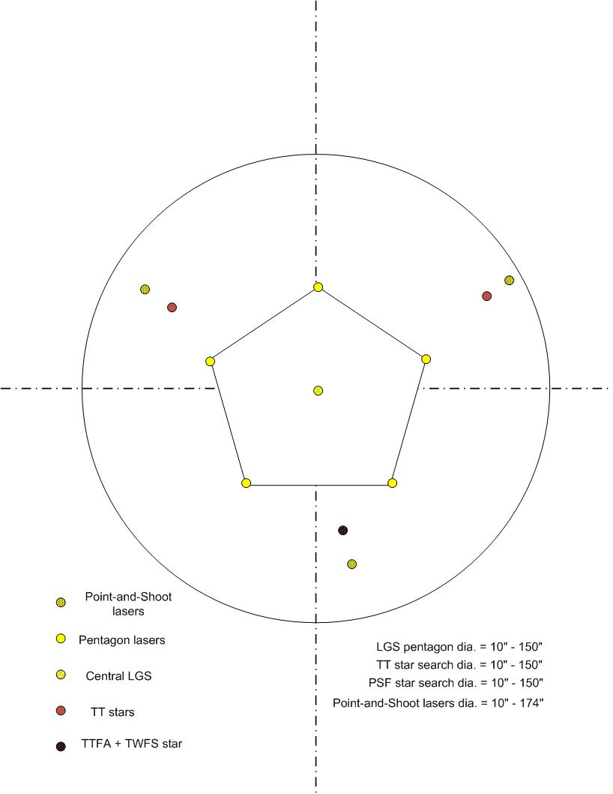
Figure 1: LGS asterism configurations, a wide field configuration is shown on the left and a narrow field configuration is shown on the right

LGS Power
Using the assumption of a return efficiency of 150 photons/cm²/s/W, plus reasonable assumptions about the transmission of the atmosphere and the laser transport beam train optics, we developed a specification for the laser power needed per guide star. The return efficiency assumed by NGAO is similar to that reported [10] for a narrow spectral bandwidth (~10 kHz) circularly polarized CW laser system. The resulting laser facility must be capable of producing 16.6 W per LGS beam, and with 9 LGS beams the total laser power is 150 W. Based on costs, availability of lasers, and other programmatic issues the ‘first light’ laser facility will have 100 W of narrow bandwidth CW laser power as the baseline, with the ability to upgrade to 150 W. The baseline calls for the ability to produce the 9 LGS asterism of section 3.2 when the third 50 W laser becomes available. With only 100 W of laser power, the asterism will be a setup of 6 LGS in a configuration with an inner triangle of 3 LGS and outer triangle of 3 “point-and-shoot” LGS. In this configuration the LGS beams will have equal power at 16.6 W. With 100 W the laser facility will also support an 8 LGS asterism with 12 watts per beam. This will allow configuration into several wide field LGS asterisms including 5 LGS in a “box plus center” or quincunx arrangement with 3 “point-and-shoot” LGS. Other 8 LGS asterisms are possible the exact ones offered by NGAO will be determined during the preliminary design phase. It very likely that NGAO will want to keep as much flexibility as possible in asterism and determine the exact LGS configuration during on-sky testing in the commissioning phase.

Polarization
The use of circular polarization [10,11] has been shown to result in a higher return flux due to optical pumping of the sodium atoms. Either right-handed or left-handed helicity is acceptable, but polarization purity must be maintained to ~98%. The exact specification requires further on sky test data.

LGS Image Quality
The NGAO wavefront error budget [1,5] specifics that the laser spot produced at the sodium layer should be 1.1 arc seconds (FWHM). The specification on the uplink laser spot is the combinations of intrinsic laser beam quality, wavefront errors of the uplink optics, and the atmospheric conditions.

Maintenance
Based on K2 laser operations, the laser facility shall achieve an uptime of 97% or higher. One of the considerations for achieving a high uptime is to minimize the requirements on maintenance. The highest maintenance item will be the laser systems themselves. Minimizing the impact of maintenance will require designs with high reliability and components that can be serviced or replaced in an efficient manner.

Requirements summary
The previous requirements and other major requirements for the laser facility are given in Error: Reference source not found. These requirements are preliminary in nature and will change as the project design matures.

Table 1: Summary of laser facility requirements for NGAO
Parameter | Requirement
Asterism | 6 LGS and 8 LGS asterisms with 100 W total laser power, configurations are TBD (see Table 3)  Asterism must rotate to track stars  Change asterism in 2 minutes or less  6 LGS asterism, pentagon +1 center, pentagon size variable between 5-75 arc seconds and 3 Point-and-shoot LGS with 150 W total laser power
LGS power | 11-17 W per LGS channel
Total laser power | 100 W of narrow bandwidth (spectral bandwidth ≤ 10 MHz) CW (upgrade to 150 W)
Polarization | ≥ 98% circular, single helicity (either right or left handed)
LGS image quality | ≤ 1.1 arc seconds FWHM on the sky
Upgrade power | Must be able to upgrade from 100 W to 150 W total laser power
Maintenance | Uptime of 97% or higher
Safety system | Satisfy standards for class 4 lasers including injury to personnel, damage to the observatory, illumination of aircraft or satellites, and must not interfere with observations at other telescopes
Diagnostics | Provide software and hardware for diagnosing problems and calibrating laser system
Interface | Support hardware and software standards at the observatory

Laser Requirements
The guide star laser systems are a key subsystem of the NGAO project. Issues of technologies, photon return efficiency, design and procurement are discussed by Sean Adkins in KAON 582 [12]. This document also details the requirements for the NGAO laser systems. A partial summary of the laser requirement from KAON 582 is given in Table 2.
Table 2: High level requirements for NGAO guide star laser systems
Parameter | Requirement
Total power | 50 W (per laser)
Nominal central wavelength | 589 nm
Spectral bandwidth | 10 MHz
Beam quality | M² < 1.2
Power stability | Sufficient to support Rayleigh background subtraction
Compact | Physical envelope ≤ 1.5 m³ per laser
Environmentally robust | Sealed against particulates
Modular construction | Facilitates service
Integrated electronics | Standard control interface with simple supervisory controls
Self diagnostics | Facilitates service
Reliability | Routinely capable of >12 hours continuous operation without user intervention
Service downtime | < 1 day mean time to repair

Laser facility Optical design

Laser Systems
As noted above, the baseline system will utilize two 50 W laser systems, with options to upgrade to 150 W total laser power. The two laser systems and associated electronics will be installed in the Laser Service Enclosure (LSE) mounted to the extended Nasmyth platform of the Keck telescope (see section 5.3). The LSE provides the laser systems and associated optics a clean, temperature-controlled environment with provision for removing heat generated by the laser systems and electronics. More details of the enclosure are given in section 5.3. An overview diagram of laser facility optics is shown in Figure 2. This diagram is schematic in nature and reflects the conceptual state of the optical design. For simplicity only the 3 lasers beams are shown traveling from the laser enclosure to the secondary socket and the laser launch telescope in Figure 3, although the system would be designed to support up to 9 laser beams.

Laser Switchyard
The required LGS asterisms are summarized in Table 3. Based on assumed availability of only 2, 50W lasers at first light the LGS asterisms must be configurable as discussed in section 3.2, suggested asterism for the LGS are given in Table 3. The formatting of the laser beams is accomplished by motorized beamsplitters and mirrors that accept the 50 W input beams from the two laser systems and direct them to the proper outputs at the desired power. One can generate 4 12.5W beams using two sets of three 50/50 beamsplitter to produce Asterism 1 of Table 3. A second set of beam splitters can be used to produce Asterism 2 of Table 3 using a 33/66 beamsplitter followed by a 50/50 beamsplitters will produce three 16.7 W beams. These same splitters can be used with a 3, 50 W, laser system to produce the 9 LGS asterism 3 of Table 3. Shutters on each beam are used to permit diagnostic measurements of any individual output beam. The switchyard will also have a low-power HeNe “surrogate” lasers that can be switched into the optical path to provide 594.1 nm laser beams, an inexpensive wavelength that is resonantly close to 589 nm, to permit testing of the beam transfer optics without requiring the high power laser systems.
Table 3: Asterisms for NGAO as available laser power is increased
 | Asterism 1 | Asterism 2 | Asterism 3
Total laser power | 100 W | 100 W | 150 W
Laser systems | 2 x 50 W | 2 x 50 W | 3 x 50 W
Main asterism | “Box plus one” or quincunx | Triangle | Pentagon plus one
Point and Shoot lasers | 3 | 3 | 3
Total number LGS | 8 | 6 | 9
Watts per guide star | 12.5W | 16.7 | 16.7
Beam splitters | 3 50/50 splitters per laser system output | 33/66 + 50/50 per laser system output | 33/66 + 50/50 per laser system output

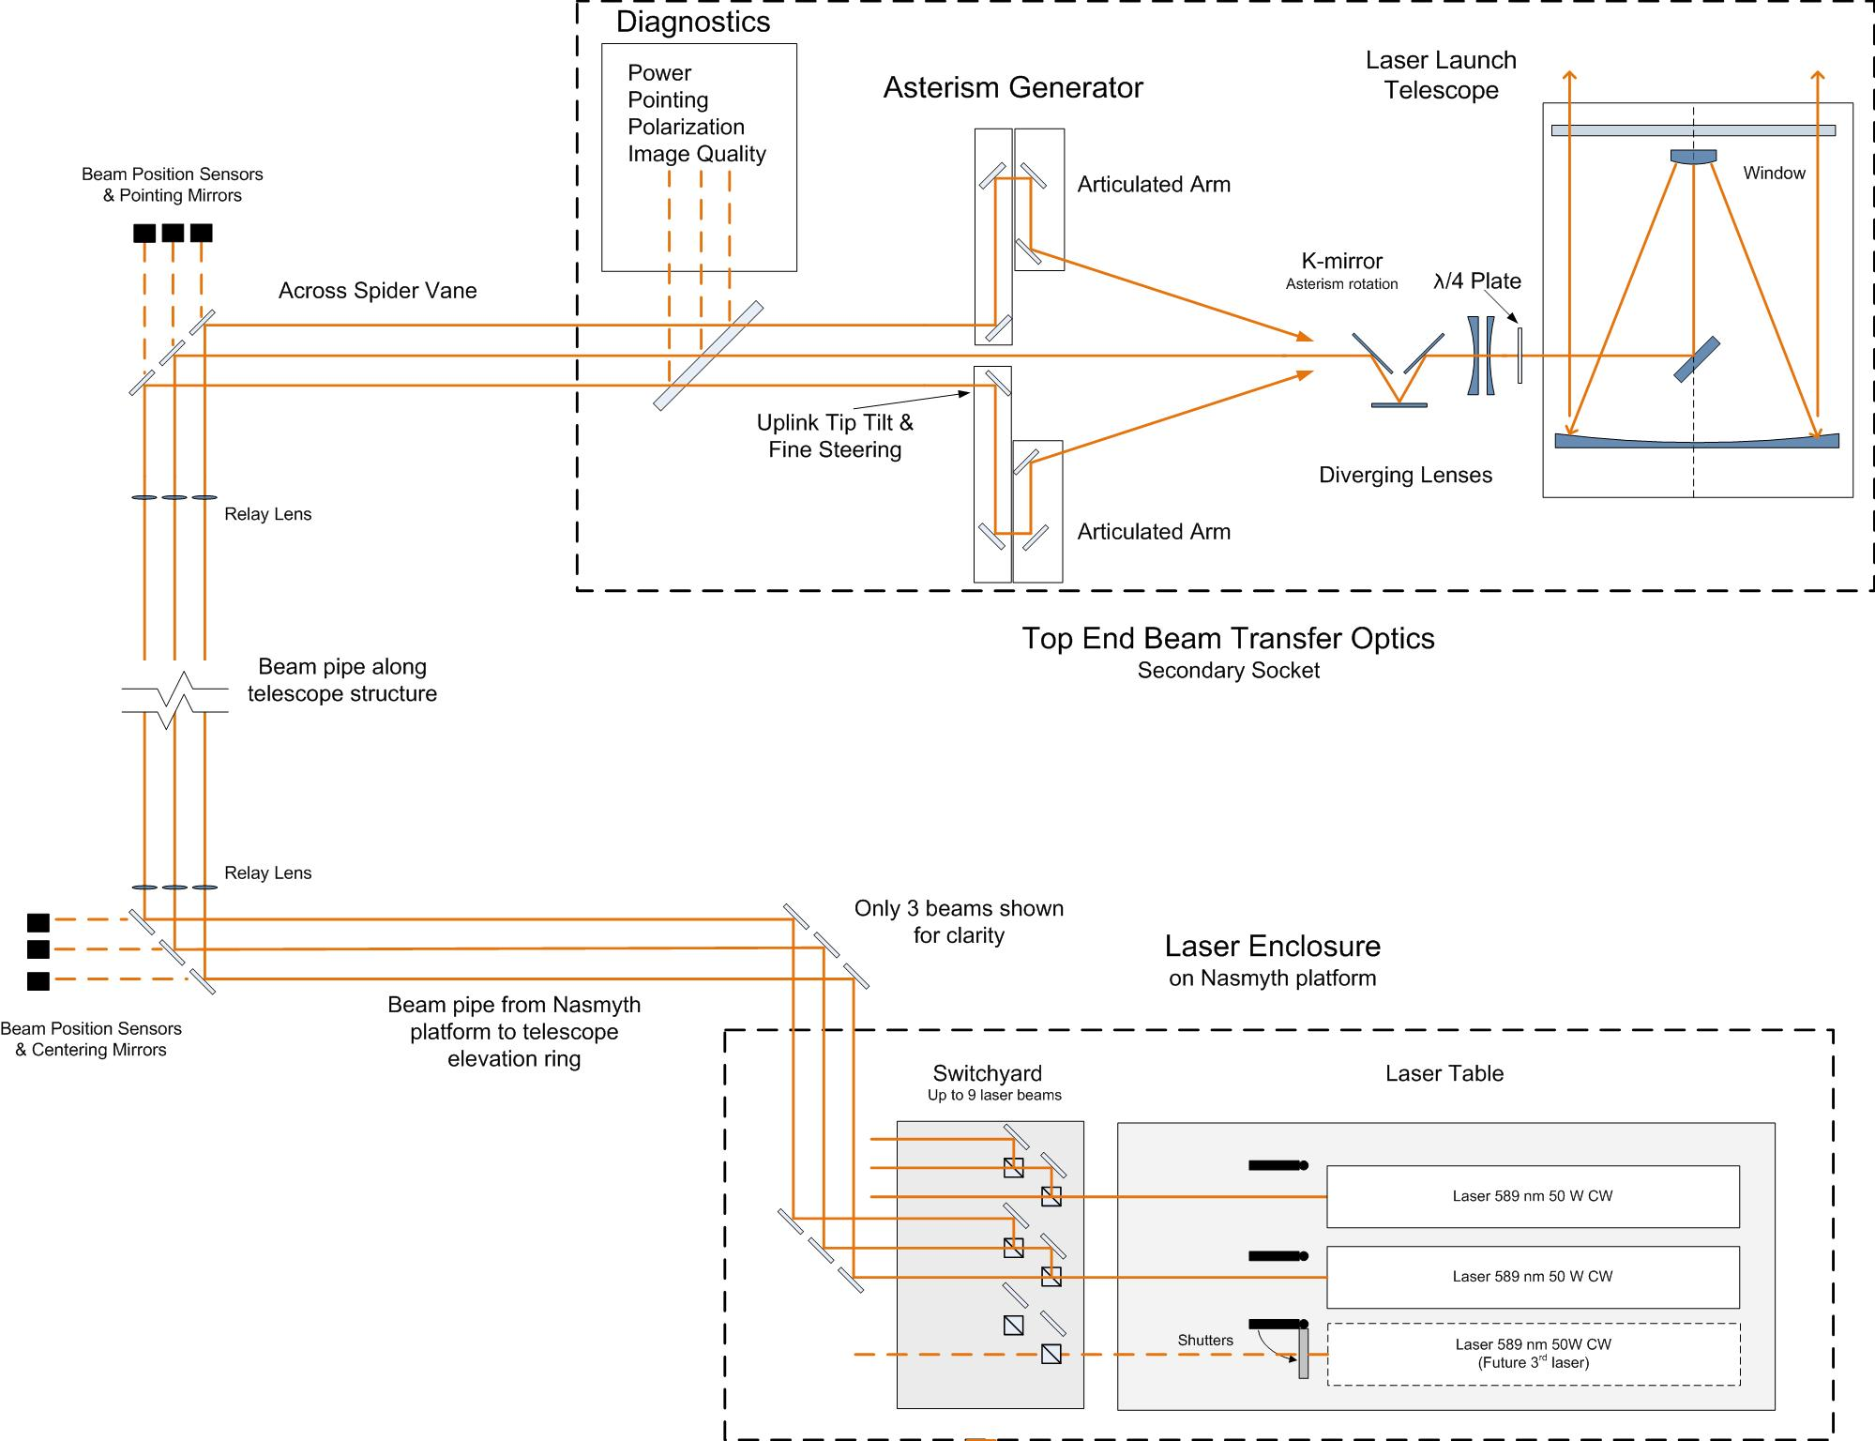
Figure 2: Schematic diagram of the laser facility optics (not drawn to scale)

Beam Transport Optics
After the laser beams are reformatted to produce the desired asterism they will transported from the Nasmyth platform enclosure to the telescope structure and up the side of the telescope tube. For both safety and cleanliness, the entire optical train of the laser facility must be enclosed in a light and dust proof mechanical structure. The proposed location for these folds optics and the beam pipes are shown in the figures of section 5.3. The tube structure is outside the footprint of the primary mirror and crosses behind the secondary mirror support structure. The Keck telescope top end is significantly larger than the primary mirror, which affords space for location of fold optics at the top end of the telescope.
A unique feature of the proposed optical design is that the fold mirrors at the bottom and top of the telescope structure must track as the telescope moves in elevation. In addition the beam tube running parallel to the telescope Surrier truss must change length as the telescope move in elevation as well. It has been suggested that this tube can be a series of several nested tubes in a “telescoping” arrangement, similar to an architect’s blueprint storage tube or a sailor’s spyglass. If such an arrangement is not possible, the tracking mirror can be moved from the top of the telescope to a location on the telescope tube just above the tracking flat located on the roof of the AO enclosure, a much more compact tube could be fitted over these mirrors, this appears mechanically feasible with the possible draw back of requiring more fold mirrors.
After the folds at the top end of the telescope the beams will travel over the top of one of the secondary mirror supports or “spiders”. Next the beams will travel down into the secondary mirror structure and into the launch telescope. Beams will be arranged to pass along the spider in a compact fashion inside a tube so that laser light does not scatter into the telescope. Relay lenses along the path will maintain the beam diameter and exit pupil. Two of the mirror in each beam will be controllable in tip and tilt these mirrors will maintain the centering and pointing of the beams at the input to optics located behind the telescope secondary. A slow update control loop will be responsible for correcting for the flexure of the telescope structure with elevation. The update may be done exclusively with look-up tables or with feedback from position sensitive photo-diodes or imaging cameras.
The use of fibers would greatly simplify the design of the beam transport optics. Although the Keck I laser system will be using fibers to transport powers comparable to the power per guide star in Table 3, the Keck I laser will use a mode-locked laser that is not affected by Stimulated Brillouin Scattering like a narrow width CW laser source would be when passing through a single mode fiber. The European Southern Observatory [13] has used a narrow line CW laser with a single mode optical fiber at powers as high as 10 W. This is accomplished by first passing the laser through an electro-optical modulator, making it no longer a narrow line width source. The purpose of the phase modulator is to broaden the laser line width before the laser is injected into the single-mode relay fiber. Based on numbers at the Laboratory for Adaptive Optics web page [14] the ESO laser would produce about half the return of an equivalent power narrow bandwidth CW laser. This appears to be an unacceptable loss for the NGAO system. Future advances in the efficiencies in fiber throughput should be considered as well. Crystal Fibers from Denmark has developed a 589 nm capable fiber with an 8 db/km loss. Current fibers losses are 10 db/km.

Laser Launch Telescope
The laser launch telescope is a Cassegrain reflecting telescope when used in combination with the diverging lenses in Figure 2 it functions as a Keplerian afocal telescope with a magnification of about 60. This high total magnification allows a reasonable separation from the asterism generator optics.

Asterism Generator
In order to produce the LGS asterisms required in section 3.2 and section 4.2 the 9 laser beams must be steerable about the field of view of the laser launch telescope in a flexible way. In particular the “point-and-shoot” concept requires the laser beam to be pointed at arbitrary locations about the field of view. Given the small image (plate) scale of any practical laser launch telescope the laser beams must be positioned fairly close to each other if they are brought to focus before being transmitted out of the launch telescope. Although a steering mirror array, similar to a MEMs deformable mirror was proposed as an asterism generator its location close to focus makes it susceptible to laser damage. In addition bringing the laser beams to focus can produce problems with air breakdown unless the optics work at very slow focal ratios or the area around focus is evacuated. As a means of avoiding these problems the laser launch telescope is used in combination with a diverging lens so that the laser beams do not go through focus.

We suggest using a series of steering arms to position the laser beams about the field of view; the steering arm would be similar to the probe arms proposed for the laser guide star wavefront sensor [5]. The asterism generator would have 8 arms using theta-phi mechanisms and would be arranged in a 3 by 3 grid with the center being empty to allow the on axis laser to pass straight through. These eight mechanisms can be made to achievable mechanical tolerances by using a magnification for the laser launch telescope of about 60. The down side of this arrangement is that the asterism generator and the laser launch telescope must be separated by about 2 meters. This will likely require folding the beam inside the secondary socket in order to make the optical system fit in the available space. The feasibility of this design will be determined during preliminary design phase.

Diagnostic System
The diagnostic system directs a small fraction (1%) of each of the laser beams through a beamsplitter into a diagnostics package that will include power meters, polarization sensor, point diagnostics and laser wavefront quality diagnostics. The exact design of the subsystem will be completed during preliminary design.

Safety System
The laser facility will be equipped with shutters as necessary to block the laser beam when triggered by any of the laser safety systems. Shutters will be placed closed to the each laser head and also in each of the channels on the laser switchyard. These shutters interface to the safety system software, which continuously monitors for a variety of safety hazards and immediately closes the shutters if an event is detected.

Polarization
The linearly polarized output of the laser systems is converted to circularly polarized light prior to projection by the laser launch telescope to maximize the efficiency of exciting the sodium in the atmosphere. This is accomplished by quarter-wave plates in each beam. The wave plate rotation must be adjustable to account for variations in polarization as the laser beams are directed through the optical elements in the beam train. The wave plates should be located inside the secondary optics module

Laser Facility Mechanical Design

Location
Current laser systems capable of generating the required power are too large to be located on the telescope tube or elevation ring as they cannot withstand a changing gravity vector and still meet performance requirements. Mounting the lasers on a Nasmyth Platform or other part of the telescope azimuth structure is an alternative that can support the weight of the lasers but offer a simplified optical beam train compared to location mounted completely off the telescope utilizing a coude beam train. In either case the beam transport optical system will provide additional optics to transfer the beam from the laser head to the secondary module. Possible “azimuth moving” locations are the right and Nasmyth Platforms and the Cassegrain Platform. There are significant advantages for the laser system, if it is installed in a fixed location that moves only in azimuth, since it does not have to be stiffened to operate with a varying gravity vector. By being off the telescope tube, there is less of a constraint to minimize the size of the laser system. It is reasonable to assume a large enough structure will be fabricated to house the lasers specified in section 3.8. The ability to use optical fibers for beam transport would greatly reduce the complicated beam train needed for the Nasmyth mounted laser platform. However, this appears unfeasible with the SOR type narrow-line CW lasers that we have selected as the baseline design, as discussed in section 4.3.

Laser Mechanical Issues Specific to Keck I & Keck II
A major consideration for Keck I vs. Keck II is the ability to access the optical axis for the beam transfer optical system. In Keck I, the HIRES spectrograph is fixed in place on the right Nasmyth Platform optical axis making it difficult to access this location. Keck II right Nasmyth Platform uses moveable instruments, which allow access to the optical axis on the Nasmyth Platform not used by NGAO. This availability makes Keck II right Nasmyth Platform more suitable for the NGAO system. A possible idea to consider also is the possibility to repackage HIRES so it is not directly on the optical axis. The Keck I telescope has the existing laser service enclosure that can be used to house a laser system if it can be sized to fit into this enclosure. This room is a clean room and is suitable for the LMCTI Keck I laser requirements. The Keck 1 telescope had its Nasmyth Platform extended for the laser service enclosure. If Keck 2 requires a similar sized enclosure at the same location, the Nasmyth Platform will also need to be extended. Although each telescope presents unique challenges, either telescope can provide a suitable location for the NGAO lasers. On the basis of all programmatic decisions, not just the laser, the NGAO design team favors the Keck II telescope over Keck I at the present time. We assume that the NGAO laser facility is installed in Keck II in the remaining parts of this document.

Laser Enclosure
Because the exact size, weight and number of lasers is still to be determined at this time, as a worst case we have assumed the need to construct a new platform and laser enclosure between the existing left Nasmyth and Cassegrain platforms, as shown in Figure 3,4, and 5, to house the NGAO lasers. It appears that sufficient room exists in this area to contain several lasers and that it can be supported from below by the existing telescope azimuth bearing structure. This is only a preliminary conclusion and will be scrutinized in greater detail during the NGAO preliminary design phase.
The enclosure will house all support equipment for the laser including such items as the heat exchangers and power supply racks for the laser as well as the optics for the beam transport system. It will also house the safety system and the beam transport control system electronics. Since the heat exchangers, electronics rack, and the beam control system will put sizeable amounts of heat into the environment, the laser enclosure will need to be thermally isolated and temperature controlled. Provisions must also be made for personnel to operate in this environment. From a safety point of view, the interior of this room will be exposed to laser radiation. This enclosure must be light tight with proper engineering controls to not allow laser radiation to escape.
A second enclosure will reside within the telescope secondary module. The laser launch telescope will interface to this module for mechanical support and receive the laser beams and project them to the sky. The enclosure’s functions are to provide a suitable environment for the beam splitters and beam steering systems that format the beams into the appropriate LGS asterism, see Figure 2. The enclosure also provides a mechanism to contain the laser light from these subsystems. This enclosure will need to be thermally isolated since it is in the secondary module and is likely to produce more than the allowed 100 W radiated into the dome environment. This heat can be reduced via glycol cooling. Vibration mitigation is not expected to be needed at this location since liquid cooling is expected to be the primary heat removal element.
Laser Enclosure
& Platform
AO Enclosure
Existing Dye Laser Enclosure & Launch Telescope
Figure 3: Proposed location for laser enclosure behind existing Keck II AO enclosure. The existing dye laser enclosure and launch telescope are shown on the left.

Figure 4: Side view of proposed laser enclosure, laser beam transport tubes are shown in red.

Figure 5: Front view of proposed laser enclosure, laser beam transport tubes are shown in red.

Laser Facility Control Software

NGAO Non-Real-Time Control Overview
This section describes the laser related software system in the context of the overall NGAO software design. Further details are provided in the NGAO non-real-time software design in KAON 569 [15]. A block diagram of the NGAO software infrastructure is shown below in Figure 6.

Figure 6: A block diagram of the AO controls infrastructure.

The control systems are represented by a hierarchy in Figure 6. At the top level are the main interfaces to the various subsystems (some of these interfaces are referred to as sequences in the diagram). All user commands to the subsystems pass through these top level interfaces. The middle level of the hierarchy represents an abstraction of more complex lower level control tasks, namely the basic control functions for that subsystem. Users do not access the system at this level except for engineering or troubleshooting purposes. Finally, at the bottom level of the hierarchy are the devices controlled by the control system themselves. Laser specific systems are shown in orange. The laser traffic control system (LTCS) is responsible for making sure that the lasers at all observatories on Mauna Kea do not interfere with each other’s observations.

Laser System
A block diagram of the control hierarchy for the laser system is shown below in Figure 7. The laser system controls are responsible for controlling the laser optical devices (beam transport control), the laser device itself, the laser cameras, environmental and power control, and possibly, depending on its architecture, the laser safety system as well.

Figure 7: A block diagram of the laser system controls hierarchy.

Laser Motion Control (Beam Transport Control)
The high-level motion control sequences are a set of state machines that implement the complex coordinated control required by some of the assemblies in the laser system. They accept high level commands from the laser sequencer and issue the appropriate commands to the low-level motion control block. The sequences will be implemented using a state machine compiler (e.g., EPICS State Notation Language or the generic state machine compiler developed at Keck). The high level motion control sequences identified thus far are:

- Pointing and centering: coordinated control of the 9 laser beams to compensate for flexure due to the changing gravity vector when the telescope moves in elevation.
- Constellation generator: coordinated control of the 9 laser beams to position the lasers as required in the asterism.
- Constellation rotator: coordinated control of the overall rotation of the asterism to keep it fixed on the sky or rotating with the telescope pupil as required by the particular observing mode.
- Polarization waveplate control: coordinated control of the polarization waveplates to provide polarization control for each of the 9 laser beams.
- Shutter control: coordinated control of the many shutters in the laser switchyard.

Laser Facility Safety System
The safety system will assure the entire laser system and its components will operate to maintain a safe environment for personnel, as well as equipment. The safety system is shown in Figure 8; highlighted items are the deliverables for this system. To make the determination to shutter laser light, the safety system will sense environmental changes or user commands from the Laser System Interface. Termination of laser radiation will be done at different locales depending on the threat of laser radiation. At the laser, it will close the laser shutters prior to the beam relay system or turn off power to the entire laser system. At the beam steering system, it will close a final shutter prior to launching of the beam into the beam telescope. To make proper determination, the safety system will sense inputs from the laser, beam steering system, glycol system, laser enclosures, aircraft detection and spotter system, and user inputs via the Laser System Interface.
In addition to terminating laser radiation, the safety system will also provide laser status for personnel entering laser zones that may be hazardous. This will ensure laser or summit personnel will not accidentally walk into exposed laser radiation. The safety system controller is expected to be a programmable logic device (PLC) located in the Right Nasmyth Platform. It will sense inputs from multiple subsystems on and off the telescope, as well as commands via the network from the Laser System interface.

Figure 8: Safety system.

Safety Considerations for NGAO Power Levels and Number of Beams
The Keck safety officer, Steve Shimko, has made a preliminary analysis of the increased safety hazards with the NGAO lasers. The increase in power from current systems with 10-20 W to a future system with three 50W lasers means that the potential for property damage and personnel injury is increased proportionally. In addition, the power of IR pump beams will also be increased over corresponding beams in the current lasers. The NGAO lasers will be class 4 lasers, the same as the current Keck lasers. As such, the laboratory engineering controls and procedures are the same as any class 4 laser controlled area. Measures include door interlocks, lighted signs, laser protective eyewear, written procedures, and training. For the large diameter beams leaving the laser launch telescope, the Nominal Hazard Zone (NHZ) for diffuse reflections is essential zero. In contrast, specular reflections would have a very long Nominal Ocular Hazard Distance (NOHD) for the NGAO lasers. As with any sodium Laser Guide Star in navigable airspace, the beam(s) are a threat to aircraft. This will require safety observers and annual request to the FAA for a letter of no-objection. These are currently the standard practices at the observatory for LGS operations. A complete safety analysis would be completed as part of the planning for the laser installation.

Aircraft Detection System
The aircraft detection system uses human aircraft spotters as recommended by the FAA. This practice is currently implemented on the Keck 2 laser system with long term plans to minimize the use of spotters. An alternative to human spotter is the All Sky Camera (ASCAM). ASCAM is expected to survey the entire sky above Mauna Kea and detect aircrafts with their position sent to the laser traffic control system (LTCS). The LTCS system can then shutter the laser. Until this implementation comes to fruition, the Keck I and Keck II lasers will continue to use spotters as a baseline practice.

Satellite Avoidance
NGAO will address the potential risk of satellite illumination using the same procedures now implemented at Keck Observatory. Target lists for LGS observations must be prepared several days in advance and sent to the USAF Laser Clearing House (LCH) to determine the times and durations of “predictive avoidance” shutdowns.
In November of 2007, U. S. Space Command modernized its predictive avoidance software from SPADOC to Spiral 3. With the SPADOC system, Keck rarely had a closure but the new Spiral 3 now produces many closures per target on every night. Randy Campbell, a Keck support astronomer, has been working closely with U. S. Space Command to mitigate the situation. The full details of his analysis will be document in KAON 578 [16], which is still a work in progress. An advanced copy of that note is summarized in the next paragraph.
The WMKO LGSAO run in late November - early December 2007 was severely impacted by the new LCH system and rendered many objects unobservable. Over the following months, the Keck Observatory has worked with space command to improve the satellite avoidance parameters used by the Spiral 3 software. Keck petitioned the LCH to work with Air Force Research Labs/Satellite Assessment Center to “normalize” the laser parameters for use with satellite susceptibility data. This process decreased the number of satellites that the predictive avoidance runs protects, creating what is known as a unique projection list (UPL). We have been asked to re-register our laser once per year with the LCH. Also, the LCH reduced the avoidance half angle to 1.5º. The combination of the UPL and the reduction in the avoidance half angle has reduced the closures in number and duration. The Keck statistics show that the reduction in number of closures was on the order of 40% and that the closure duration decreased by about 60% for a typical object. As of February 2008, we estimate an average of 30 minutes of lost science time per night, including start/stop overheads, when compared to the zero closure condition that we operated under for 4 years, with the previous software.
It is recommended that the NGAO project monitor these developments closely and determine with the Laser Clearing House the potential impacts of higher laser power and multiple beams of the proposed NGAO laser facility.

Mauna Kea Laser Traffic Control System
The software for the LTCS will be minimal as it will be a copy of the existing K2 device. The current LTCS server is capable of handling the additional resources required to operate the NGAO lasers, but it is recommended that an upgrade to this server be provided to improve its performance.

Upgrades and Advanced Technology
In this section, we briefly discuss technologies that could provide large performance gains for NGAO. But because of their uncertain performance and, in some cases, unproven nature, the NGAO project has not chosen them. The NGAO team will determine which of these technologies may be appropriate to purse further during the preliminary design phase of the project.

Dual Wavelength Sodium Laser
Researchers at the SOR [11] have demonstrated that when the sodium D2a line is pumped with one laser and the D2b line by another, there is an additional increase in guide star brightness over the simple sum of the two laser intensities. This occurs because electrons are made available from the ground state sub-level associated with the D2b transition and shifted into the ground state sub-level associated with the D2a transition, thus providing more electrons for optical pumping with circular polarization. While there are theoretical reasons to suggest that simultaneous pumping of the two frequencies results in approximately a 60% increase in guide star return flux, the difficulty in overlapping the two lasers likely results in lower values. Researchers at the SOR [11] have demonstrated this effect in on-sky tests using two separate lasers separated by about 20 meters. The SOR team reported a measured increase of approximately 40%-50%. It is not clear at this time if this technique will develop further [18] into a single package dual laser system with collinear output of the D2a and D2b beams.

Fiber Lasers
It is worth mentioning the recent gains in the development of fiber lasers. Organizations such as CfAO and ESO are putting both effort and money into the development of fiber lasers. Fiber lasers have the advantage of high efficiency, compact size, and cost. The technical challenge of fiber lasers is its ability to produce sufficient power; particularly because of non-linear optical effects such SRS and SBS.

Pulsed Lasers
To date, the single frequency narrow bandwidth CW lasers at the SOR have shown the highest photon return per watt of laser power. However, pulsed lasers are particularly desirable to eliminate fratricide and reduce or eliminate the guidestar elongation that increases laser power requirements. The NGAO team undertook a trade study to understand the effect of Rayleigh backgrounds on AO performance. The authors of this study [19] note that fratricide due to Rayleigh scatter is a serious issue for a multi-laser beacon AO system. It is ideal to use a 1 to 3 µs pulsed laser to mitigate this problem. Pulsed lasers with pulse repetition frequency of about 1 kHz may also be used with range-gated wavefront sensors to eliminate the Rayleigh background. In the event of this not being available and a CW laser being the only option, appropriate background subtraction, projection location, baffles, and stops will be used. The authors of reference 19 note that the effect of fratricide still needs to be quantified more accurately via detailed simulations, although their study developed a preliminary model of this effect. A laser with pulses of the order 1 to 3 µs would enable a LGS WFS with dynamic refocusing capability to eliminate LGS elongation by tracking the pulses across the 10 km width of the atmospheric sodium layer.
An AODP contract, lead by Sean Adkins, is now developing a CCD array pixel geometry [20] that could be used in combination with a microsecond pulsed laser to for pulse tracking. This “radial” CCD will consist of an array of 60×60 strips of approximately 16×4 pixels each, with the strips aligned radially to match the envelopes of the elongated LGS images. This geometry reduces the number of pixels to be read and processed, thereby minimizing read-out noise and improving the performance. The device provides dynamic refocusing by shifting charge along the radial CCD pixel strips to track each laser pulse as it crosses the sodium layer. Keck and NGAO will continue to support and monitor the AODP radial CCD project.

Uplink AO
NGAO team members Don Gavel and Viswa Velur studied [17] the utility of uplink AO. The purpose of this research was to explore the advantages and disadvantages of adaptive optics wavefront control of the outgoing laser in order to correct for atmospheric aberrations on the laser uplink path. The main advantage of uplink correction is the possibility of obtaining a laser guide star that is smaller in angular extent than one without compensation. Since the wavefront sensor is to first order dependent only on surface brightness of the guide star, the smaller spot needs less total brightness, which in turn implies less laser power is required to create it. With each watt of laser power having a high marginal cost in the overall AO system, improvements that reduce the required power must be taken seriously.
It appears that if one takes pains to use the type of wavefront sensor that can take advantage of it, there is a potential for a very significant reduction of required laser power if the uplink beam is AO corrected. However, the total package, which involves the success of more than one untested technology, is of reasonably high technical risk. Still the potential benefits suggest that even if the more conservative approach is taken during initial design phases, development and testing of the new technologies should proceed.

Laser Facility Risks
The following risks have been identified for the laser facility system, excluding the laser systems that are considered in KAON 582. The risks are given a ranking on a consequence scale (5- server, 1-moderate) and a likelihood of occurrence scale (1-unlikely, 5-highly probable).

Table 4: Risks for laser facility
# | Consequence | Likelihood | Description | Status | Mitigation
1 | 3 | 3 | Laser asterism is not complete defined | See this report | 1) Determine LGS asterism during preliminary design
2 | 3 | 3 | Laser asterism generator design is incomplete | See this report | 1)Complete design of asterism generator during preliminary design
3 | 4 | 3 | Laser launch telescopes have historically been costly and had performance problems | A problem for ESO, Subaru, Palomar and Gemini North | 1) Address during preliminary design
4 | 4 | 3 | Laser enclosure support structure design is incomplete | See this report | 1) Address during preliminary design
5 | 4 | 3 | “Telescoping” beam tube design is incomplete | See this report | 1) Address during preliminary design
6 | 4 | 3 | Space Command shutdowns have increased dramatically in the last | Keck staff working with US Space Com. to mitigate problem | 1) Continue to monitor situation

This arrangement is referred to as a quincunx in some NGAO reports, see http://en.wikipedia.org/wiki/Quincunx

