

Keck Adaptive Optics Note 511

Next Generation Adaptive Optics:
System Design Manual

Version 1.2
March 11, 2008

Author List
Name | Function
Peter Wizinowich | NGAO Executive Committee (EC) Chair
Richard Dekany | EC Member
Don Gavel | EC Member
Claire Max | EC Member & NGAO Science Team Chair
Sean Adkins | Instrument Program Manager

Contributors: Antonin Bouchez, Brian Bauman, Jim Bell, Matthew Britton, Jason Chin, Ralf Flicker, Erik Johansson, Renate Kupke, David Le Mignant, Chris Lockwood, Elizabeth McGrath, Anna Moore, Chris Neyman, Marco Reinig, Viswa Velur.

Approval Control
Control | Name | Function
Revised by:

Approved by:
Authorized by:

Document Change Record
Issue | Date | Change Description
Version 1.0 | October 31, 2007

1 Introduction 1
2 References 1
3 Design Overview 1
3.1 AO System Overview 1
3.2 Telescope and Facilities 3
3.2.1 Telescope Model 3
3.2.2 Facilities 5
3.2.3 Interfaces 5
3.3 AO System Description 5
3.3.1 AO Opto-Mechanical Design 5
3.3.1.1 Rotator and Wide Field Relay 8
3.3.1.2 LGS Wavefront Sensor Assembly and LGS Acquisition Camera Pickoff 10
3.3.1.3 Interferometer Pickoff 11
3.3.1.4 NGS Acquisition Camera Pickoff 12
3.3.1.5 Low Order Wavefront Sensor Assembly 12
3.3.1.6 Narrow Field Relay 12
3.3.1.7 Natural Guide Star and Truth Wavefront Sensors Pickoff 14
3.3.1.8 Narrow Field Science Instrument Pickoffs 14
3.3.1.9 Summary of Required Dichroics and Mirrors 15
3.3.1.10 Atmospheric Dispersion Correctors 16
3.3.1.11 Optics Bench Structure 16
3.3.2 Wavefront Sensor Opto-Mechanical Design 17
3.3.2.1 Low Order Wavefront Sensor Object Selection Mechanism 19
3.3.2.2 Tip-Tilt (Focus and Astigmatism) Sensors 23
3.3.2.3 Truth Wavefront Sensors 23
3.3.2.4 PSF Monitoring Camera 24
3.3.2.5 LGS Wavefront Sensor Object Selection Mechanism 24
3.3.2.6 LGS Wavefront Sensors 24
3.3.2.7 NGS Wavefront Sensors 25
3.3.3 AO Optical Performance 25
3.3.3.1 Wide Field Relay Optical Performance 26
3.3.3.1.1 Optical Performance to the Deployable Integral Field Spectrograph 26
3.3.3.1.2 Optical Performance to the Low Order Wavefront Sensors 26
3.3.3.1.3 Optical Performance to the Interferometer Field Selectors 27
3.3.3.1.4 Optical Performance to the Laser Guide Star Wavefront Sensors 28
3.3.3.2 Object Selection Mechanism Optical Performance 28
3.3.3.3 Narrow Field Relay Optical Performance 29
3.3.3.4 Atmospheric Dispersion Correction 30
3.3.3.5 Pupil Distortion 31
3.3.4 AO Enclosure 34
3.3.5 Alignment, Calibration and Diagnostics 35
3.3.5.1 Simulator 35
3.3.5.2 System Alignment Tools 35
3.3.5.3 Atmospheric Profiler 35
3.4 Laser Facility Description 36
3.4.1 Laser 36
Laser Enclosure and Beam Transport 37
3.4.2 37
3.4.3 Laser Beam Transport 42
3.4.4 Beacon Projection System 42
3.5 Control Electronics and Software 43
3.5.1 Non-real-time Control 44
3.5.2 Real-Time Control 44
3.5.2.1 Massively Parallel Processing 45
3.5.2.2 Tomography 46
3.5.3 Laser Safety System 46
3.6 Science Operations 46
3.6.1 Science Operation Model 46
3.6.1.1 System Configuration 47
3.6.1.2 System Calibration 47
3.6.1.3 System Operation 47
3.6.2 System Control 47
3.6.2.1 Multi-System Command Sequencer 47
3.6.2.2 User Interfaces 47
3.6.2.3 AO-Instrument Interfaces 47
3.6.3 Data Server 47
3.6.4 Pre and Post-Observing Tools 47
3.7 Science Instruments 47
3.7.1 Visible and NIR Imagers 48
3.7.2 Visible and NIR Spectrographs 48
3.7.3 NIR Deployable IFU 49
3.7.4 Interferometer 49
3.7.5 ‘OHANA 49
3.7.6 Thermal NIR Imager 49
4 Performance Budgets 49
4.1 Background and Transmission 49
4.2 Wavefront Error and Ensquared Energy 50
4.3 Photometric Precision 53
4.4 Astrometric Precision 53
4.5 Companion Sensitivity 54
4.6 Polarimetric Precision 54
4.7 Observing Efficiency and Uptime 54
5 Requirements Compliance 54
6 Alternate System Architectures 54
7 Trade Studies 55
7.1 MOAO and MCAO Trade Study 55
7.2 NGAO versus Keck Upgrade Trade Study 57
7.3 Adaptive Secondary Mirror Options Trade Study 58
7.4 Keck Interferometer Support Trade Study 58
7.5 GLAO for non-NGAO instruments Trade Study 59
7.6 Telescope Wavefront Errors Trade Study 59
7.7 Observing Model Trade Study 60
7.8 Rayleigh Rejection Trade Study 60
7.9 LGS Wavefront Sensor Type and Number of Subapertures Trade Study 61
7.10 Low Order Wavefront Sensor Sky Coverage Trade Study 61
7.11 Low Order Wavefront Sensor Architecture Trade Study 62
7.12 LGS Asterism Geometry and Size Trade Study 62
7.13 Variable versus Fixed LGS Asterism Trade Study 63
7.14 Instrument Reuse Trade Study 63
7.15 Up-link AO Trade Study 64
8 Glossary 64

Figure 1: NGAO Block Diagram 3
Figure 2 Telescope Solidworks model. 4
Figure 3 View from below of the telescope Nasmyth platform. 4
Figure 4: AO system optical layout perspective view (SolidWorks). 6
Figure 5 Elevation and plan views of the AO bench, including general dimensions (mm). 7
Figure 6 AO system optical layout (Zemax). 8
Figure 7. The image rotator and low order “wide” field relay. 10
Figure 8. Laser Guide Star Wavefront Sensor and Interferometer Pickoffs. 11
Figure 9. Narrow Field Relay. 13
Figure 10. Optics Bench Structure. 17
Figure 11. The LOWFS assembly. 20
Figure 12. LOWFS OSM probe arm. 20
Figure 13. Four configurations of the LOWFS OSM arms. 21
Figure 14. (a) Zemax model of LOWFS probe arm. (b) Probe arm patrol field. 22
Figure 15. Plan view of the LGS object selection θ/φ pickoff scheme. 24
Figure 16. Schematic of a single LGS WFS channel. 25
Figure 17. Spot diagrams delivered to the LOWFS focal plane showing lateral color without a wedged dichroic. 27
Figure 18. Spot diagrams delivered to the LGS WFS at 180 km conjugate. 28
Figure 19. Spots at the on-axis and extreme field angles to the NGS WFS. 29
Figure 20. RMS wavefront error to the NGS WFS versus field. 30
Figure 21. Residual dispersion of f/15 ZnSe linear ADC at 60º zenith angle. 30
Figure 22. F/45 ZnSe linear ADC rms wavefront error. 31
Figure 23. Grid distortion at the woofer DM location, magnified by 100. 32
Figure 24. Spot diagrams for 5 locations on the primary mirror imaged onto the woofer DM. 33
Figure 25. Pupil grid distortion at the tweeter DM position, magnified by 100. 33
Figure 26. Spot diagrams for 5 positions on primary mirror imaged onto the tweeter DM. 34
Figure 27. TMT seeing monitor superimposed on proposed site for Mauna Kea facility seeing monitor. 36
Figure 28. Existing Keck II Telescope and laser location case 1. 37
Figure 29. Laser location case 2. 39
Figure 30. Laser location case 3. 40
Figure 31. Laser enclosure location on the Keck I right Nasmyth platform. 41
Figure 32. Keck I laser enclosure. 42
Figure 33. Secondary mirror module and the laser launch telescope being implemented for Keck I LGS AO. 43
Figure 34: NGAO electronics and software subsystems 44
Figure 35: Multi-guidestar AO processing architecture 46
Figure 36: Tomography algorithm 46

Table 1. Summary of Required Dichroics and Mirrors. 15
Table 2. Baseline design parameters for the NGAO wavefront sensors. 18
Table 3. Other wavefront sensor parameters. 18
Table 4. Required WFS detector characteristics. 18
Table 5. Optical performance to the d-IFS 26
Table 6. Optical performance to the LOWFS in simultaneous J and H-bands. 27
Table 7. Optical performance to the LGS WFS versus conjugate height. 28
Table 8. Performance to the narrow field instruments. 29
Table 9. Characteristics of the pupil image on the deformable mirrors. 31
Table 10: NGAO real time control requirements 45
Table 11: NGAO instrument priorities 48
Table 12: NGAO imager requirements 48
Table 13. The NGAO error budget tool accurately models the current Keck II AO performance with the NGWFC upgrade. The tool has also been used to predict the expected performance from the Keck I LGS AO upgrade. 50
Table 14: Wavefront error budget summary 52
Table 15. List of trade studies performed. 55
Table 16. Glossary of Terms 64

Introduction
This document describes the system design for the Next Generation Adaptive Optics (NGAO) system to be built for the W. M. Keck Observatory (WMKO). This document is one of the key system design phase deliverables as discussed in the System Design Report (KAON 575). It is intended to provide an overview of the system design, while referencing the appropriate documents which contain the details. We begin with an overview of the system design. Next, a discussion of the flow down of the science and system requirements to the functional requirements in discussed. This is followed by summaries of the performance budgets.

References
A list of all Keck Adaptive Optics Notes for NGAO can be found in an Appendix to the System Design Report (KAON 575). These documents are available at http://www.oir.caltech.edu/twiki_oir/bin/view/Keck/NGAO/NewKAONs.

Design Overview

AO System Overview
All of the NGAO science cases require essentially diffraction limited performance (Strehl > 0.6) in the near-IR. A number of Solar System and Galactic science cases have requirements for at least modest Strehl in the visible wavelengths. All of the science cases also require high sensitivity with most of the targets of interest being too faint to use as references for wavefront sensing in the AO system. This high Strehl, faint object performance is required with reasonable (≥ 30%) sky coverage.

The requirements for sky coverage and high sensitivity are both met by using a laser of 589 nm wavelength to illuminate the mesospheric sodium layer, producing an artificial laser guide star (LGS) for AO wavefront sensing. Achieving the desired level of Strehl performance leads directly to a requirement for an AO system that can overcome the effect of focus anisoplanatism (the “cone effect”), a requirement that is met through use of multiple laser beacons producing a constellation of LGS’s. A high order wavefront sensor is required for each LGS, and the wavefront information from these sensors is combined to produce a three dimensional description of the atmospheric turbulence over the telescope aperture using tomographic reconstruction techniques. We have concluded that a variable diameter constellation of LGS with one in the center and five equally spaced around a circle provides the optimal sampling of the atmosphere above the telescope with respect to tomography error. The radius of the circle is set at 11" for the narrow field case, and optimized between this radius and 90" depending on the deployment of the Integral Field Spectrograph (IFS) heads (see section 3.7 for a description of the science instruments) within a 120" diameter field of regard and the specific availability of tip-tilt field stars on a target-by-target basis.

Tilt anisoplanatism is removed using three NGS tip-tilt sensors operating in the near-IR. Three tip-tilt sensors are sufficient for correction of the wavefront error modes associated with tilt anisoplanatism in multiple-LGS systems and to reduce the quadratic mode estimation errors in the LGS tomography. Three additional LGS beacons are used to provide image sharpening for each of the tip/tilt stars.

The Solar System and Galactic science cases all require single object observations over modest to narrow fields of view, ranging from 2" to 30". This single line of sight could be AO corrected using a single deformable mirror (DM). However, many of the extragalactic science cases require multi-object, spatially resolved spectroscopic observations; using a number of small (1" x 3") AO corrected fields selected within a larger “field of regard”. In addition, based on a combination of limiting magnitude and off axis distance for natural tip-tilt stars, an object selection mechanism is required for these stars, and such a mechanism could operate in a very similar way to the object selection mechanism (OSM) for the multi-object deployable IFS (d-IFS). A block diagram of the AO system architecture that we have selected to deliver both high Strehl and access to multiple objects over a wide field is shown in Figure 1. We refer to this design as the “cascaded relay” because it uses two AO relays in series.

Starting at the lower left hand side of the figure, an environmental enclosure is provided to house lasers generating a total of ~150 watts in a CW format (or a pulse format with comparable sodium layer return flux). The output from these lasers is transferred (via fibers or a free space beam transfer system) to a multiple beam pattern generator and controller located at the top end of the telescope. The output of this beam pattern generator is projected onto the mesospheric sodium layer by a laser launch telescope located behind the telescope secondary mirror as shown just to the left of center in Figure 1.

Light collected by the Keck telescope is directed to the AO system shown in the lower right in Figure 1. The AO system and instruments are located on the telescope’s left Nasmyth platform at the f/15 focus. The AO system is enclosed in an enclosure cooled to about -15C below ambient (~260 K) to reduce the thermal emissivity of the optical surfaces. A window is provided to isolate the enclosure from the dome environment.

Within the cooled enclosure, the light from the telescope passes through an image de-rotator. A “moderate” field low order AO relay incorporating a single DM provides low order AO correction (where low order refers to the order of AO correction provided by the existing Keck AO systems). This DM operates in a closed loop in conjunction with the LGS wavefront sensors. Just after the DM, a dichroic beamsplitter is used to send the 589 nm light from the constellation of LGS to the LGS wavefront sensor assembly, which includes an object selection mechanism. In the absence of a selectable dichroic the light from the low order relay is then transmitted directly to the object selection mechanism for the d-IFS and the low order wavefront sensors (i.e., the three NIR tip-tilt sensors and a NIR truth wavefront sensor (TWFS)). A fold mirror or dichroic can be inserted to feed light to the Keck interferometer.

To use the “narrow” field science instruments a selectable dichroic is inserted to send the light through a “narrow” field high order AO relay. High order refers to three times the DM actuator spacing of the low order DM. This relay provides AO corrected light to a visible light NGS wavefront sensor and TWFS assembly, and three science instruments.

For NGS AO observations only the NGS WFS is required. For LGS AO observations, the LGS wavefront sensors, three tip-tilt sensors and one of the TWFS are required.

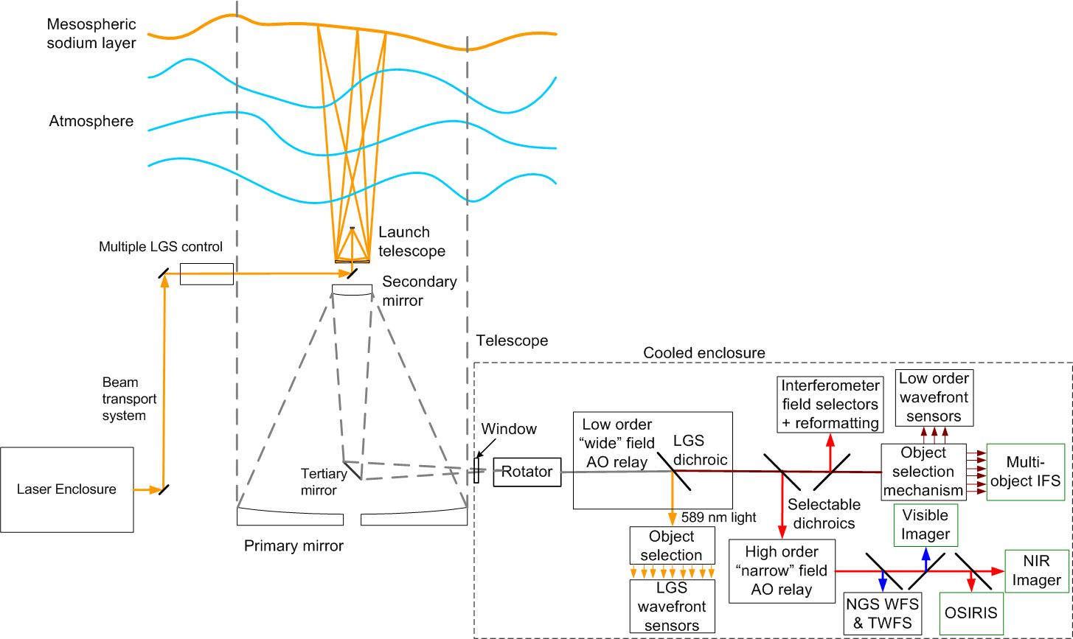

Figure 1: NGAO Block Diagram

Telescope and Facilities
The NGAO systems must utilize and interface to the existing Observatory infrastructure. This infrastructure includes the telescope and related control systems as well as mechanical and electrical services. In some cases this existing infrastructure may need to be modified.

The NGAO design and plan currently assumes implementation on the Keck II telescope, although it would be relatively straightforward to modify the design for implementation on Keck I. The design and plan also assume that the existing Keck II AO and laser systems will be removed from the summit facility to make room for the NGAO system. In addition to providing physical space for the system this will also free up power and cooling capacity, as well as cable wrap space.

Telescope Model
A Solidworks model of the Keck II telescope has been generated in order to clearly define the available space and interfaces for the NGAO system. A perspective view of this model is shown in Figure 2, with a possible AO enclosure on the left Nasmyth platform. This tool can be used to provide the details of areas like the Nasmyth platform or secondary mirror socket, as shown in Figure 3, which the NGAO system will need for interface purposes. The details of this model are suitable for preliminary design. Critical dimensions will need to be field verified before detailed design.

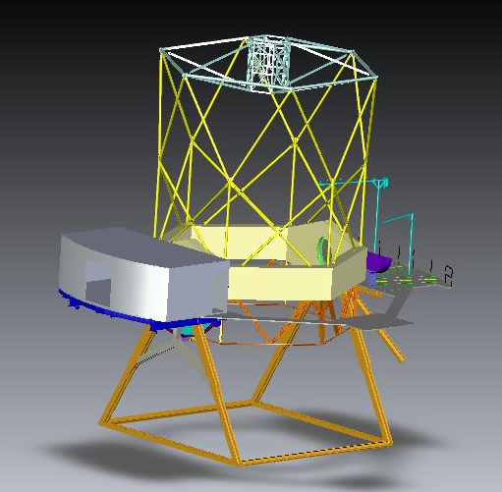
Figure 2 Telescope Solidworks model.

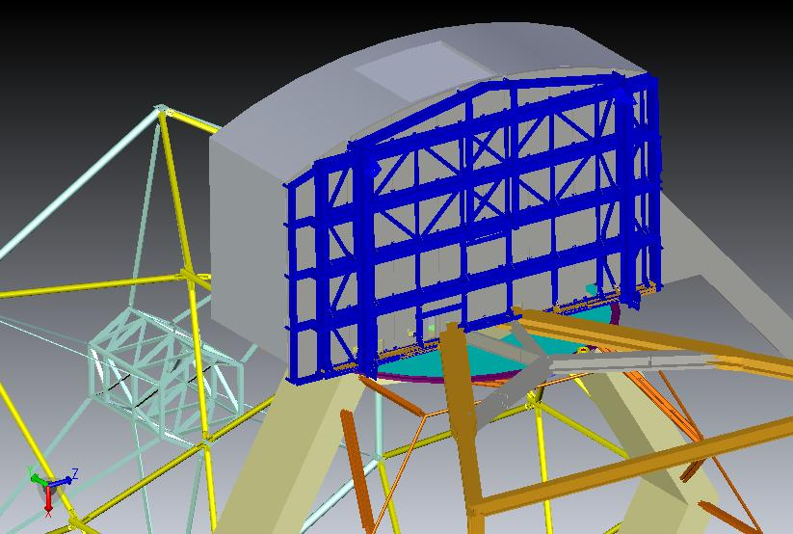
Figure 3 View from below of the telescope Nasmyth platform.

Facilities
The total required facility power and cooling is TBD, but several elements of these requirements have had some initial determination.

Interfaces
The AO system must interface to the existing telescope Drive and Control System (DCS); for example, to offload pointing and focus corrections or to request a telescope move.

AO System Description

AO Opto-Mechanical Design
The opto-mechanical design for the cascaded relay (see KAON 549) is summarized in this section. The AO bench, as modeled in Solidworks, is shown in Figure 4 and Figure 5. These Figures include the d-IFS, visible imager and IR imager science instruments as well as a fold to OSIRIS (the interferometer feed cannot be seen in these views). They also include the wavefront sensors and acquisition cameras. For comparison the current Keck AO benches extend 2.4 m from the bulkhead shown in Figure 3. The final dimensions of the bench are TBD and may need to be extended to support the LGS WFS and visible imager.

The optical design, as modeled in Zemax, is shown in Figure 6. In order to follow this design it is easiest to step through the pieces beginning with the rotator and first relay. We discuss all the systems fed by the first relay before proceeding on to the second relay and the systems fed by it. The object selection mechanisms and wavefront sensors opto-mechanics are discussed in section 3.3.2.

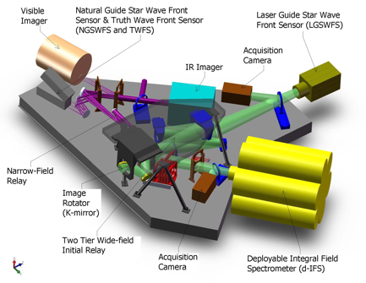

Figure 4: AO system optical layout perspective view (SolidWorks).
The optical path through the low order “wide” field relay and the high order “narrow” field relay are shown in green and purple, respectively. Light from the telescope enters through the image rotator.
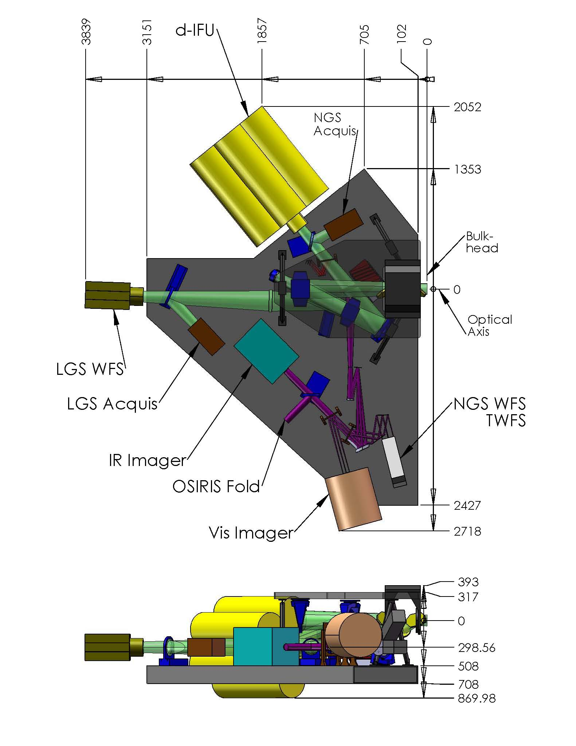
Figure 5 Elevation and plan views of the AO bench, including general dimensions (mm).
Light from the telescope enters from the right along the optical axis.

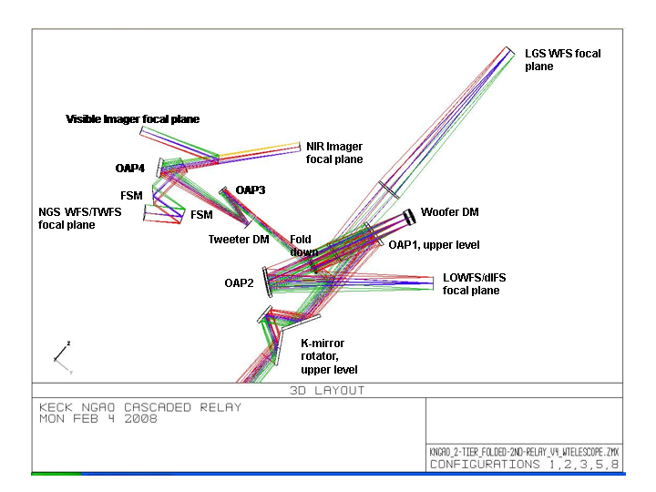
Figure 6 AO system optical layout (Zemax).
Light from the telescope enters from the bottom through the rotator.

Rotator and Wide Field Relay
The rotator and first relay are shown in shown in Figure 7. The rotator and first relay are intended to pass a wide field for the LGS and NGS and for the d-IFS science field. The relay includes a DM to provide low order wavefront correction.

The rotator is a K-mirror that can be used to either keep the field or pupil fixed. The Keck telescope’s f/15 Nasmyth focal plane is located ~270 mm past the telescope’s elevation bearing. The first and second rotator mirrors are located 150 mm before and after the focus, respectively. It is still to be determined whether having a focal plane close to these two mirrors will add thermal background effects or performance issues for high-contract science (for reference the first mirror of the existing Keck AO rotator is located 110 mm after the telescope focus). The 3-mirror rotator is sized to accommodate a 150" diameter NGS field of view (FOV) and a 175" diameter LGS FOV (for the case of an LGS at 80 km). The first and third mirrors are at 60º angles of incidence while the second mirror has a

The first relay is a one-to-one relay consisting of an off-axis parabola (OAP) to collimate the light and reimage the primary mirror onto the DM, a flat fold mirror, the DM and a second identical OAP to converge the light with the same focal ratio as the telescope and a telecentric pupil.

The third order optical aberrations can be minimized by two approaches using a collimated beam between two identical OAPs. Of these the off-centered pupil approach was chosen since it maintains a non-tilted focal plane (Korsch, Reflective Optics, p. 171, 1991).

The focal length of the OAP was selected to map the primary mirror to a 5 mm (d_{DM}) pitch DM with 20x20 actuators. The OAP off-axis angle of 25º was chosen as the minimum angle to provide adequate space for the subsequent optics.

The rotator, OAP1 and a flat, fold mirror are all mounted to an upper tier that sits above the AO bench. The fold mirror on the upper tier and the DM on the AO bench form a periscope that changes the beam height. In both cases the beam is parallel to the surface of the AO bench, with the beam on the upper tier ~ 300 mm above the beam on the AO bench. The two tier approach was chosen for packaging reasons. The angle of incidence on both the fold mirror and the DM is 9.125º. This fold mirror offers the possibility of a future multi-conjugate AO option since it is conjugate to an altitude of ~9 km.

The DM is placed at a conjugate to the primary mirror and is mounted on a fast tip-tilt mount. The second OAP is located its focal length from the DM in order to project the pupil to infinity and hence a telecentric output beam.

The output of the first relay goes directly to the object selection mechanism (OSM) that feeds the d-IFS and low order wavefront sensors (LOWFS). Dichroics and fold mirrors can be inserted into this beam to feed the NGS acquisition camera, the interferometer and the second “narrow” field relay.

Some key design numbers:
- Telescope parameters (from KOTN 163 or KAON 107).
  - Telescope focal length, f_{Tel} = 149.583 m.
  - Telescope entrance pupil diameter D_{Tel} = 10.949 m
  - Telescope exit pupil diameter, D_{EP} = 1460 mm.
  - Distance from telescope exit pupil to focus, t_{EP} = 19948 mm.
  - Telescope f/#_{Tel} = f_{Tel}/D_{Tel} = 13.66.
  - Telescope plate scale, PS = 0.727 mm/".
- Chosen design parameters.
  - NGS field of view diameter, Φ_{NGS} = 150".
  - Telescope primary mirror subaperture size, d_{PM} = 562.5 mm (the same as for the existing Keck AO system).
  - Rotator mirror angles of incidence are 60º for mirrors 1 and 3, and 30º for mirror 2.
  - OAP1 and OAP2 off-axis angle = 25º (corresponding to a decenter of 605 mm from the parent parabola) to provide adequate space for subsequent optics.
  - Fold mirror distance from OAP1, t_{fold} = 650 mm.
  - Fold mirror and DM angles of incidence are α_{DM} = α_{Fold} =9.125º.
  - DM conjugate to the telescope primary mirror.
  - DM subaperture size, d_{DM} = 5 mm.
  - Output pupil from 1st relay at infinity.
- 1st order calculated parameters.
  - LGS field of view diameter, Φ_{LGS} = 175" (for the case of an LGS at 80 km).
  - OAP focal length, f_{OAP} = (d_{DM}/d_{PM}) f_{Tel} = 1329.6 mm
  - Required OAP diameter to accept the pupil and field, d_{OAP} = (f_{OAP}/t_{EP})d_{EP} + (f_{OAP}+t_{EP})Φ_{NGS}*PS/t_{EP} = 214 mm.
  - Fold mirror conjugate height, h_{fold} = -1/{[f_{Tel}+f_{OAP}+(1/t_{fold}-1/f_{OAP})⁻¹]⁻¹ – 1/f_{Tel}} = 8.75 km.
  - Distance of DM from OAP1 in order to be conjugate to the primary, t_{DM} = [1/f_{OAP} – 1/(t_{EP}+f_{OAP})]⁻¹ = 1418 mm.
  - Pupil distortion on the DM due to the angle of incidence, % distortion = [1-cos(α_{DM})]*100% = 1.3%.
  - Distance of OAP2 from the DM in order to project the pupil to infinity, t_{OAP2} = f_{OAP} = 1329.6 mm.
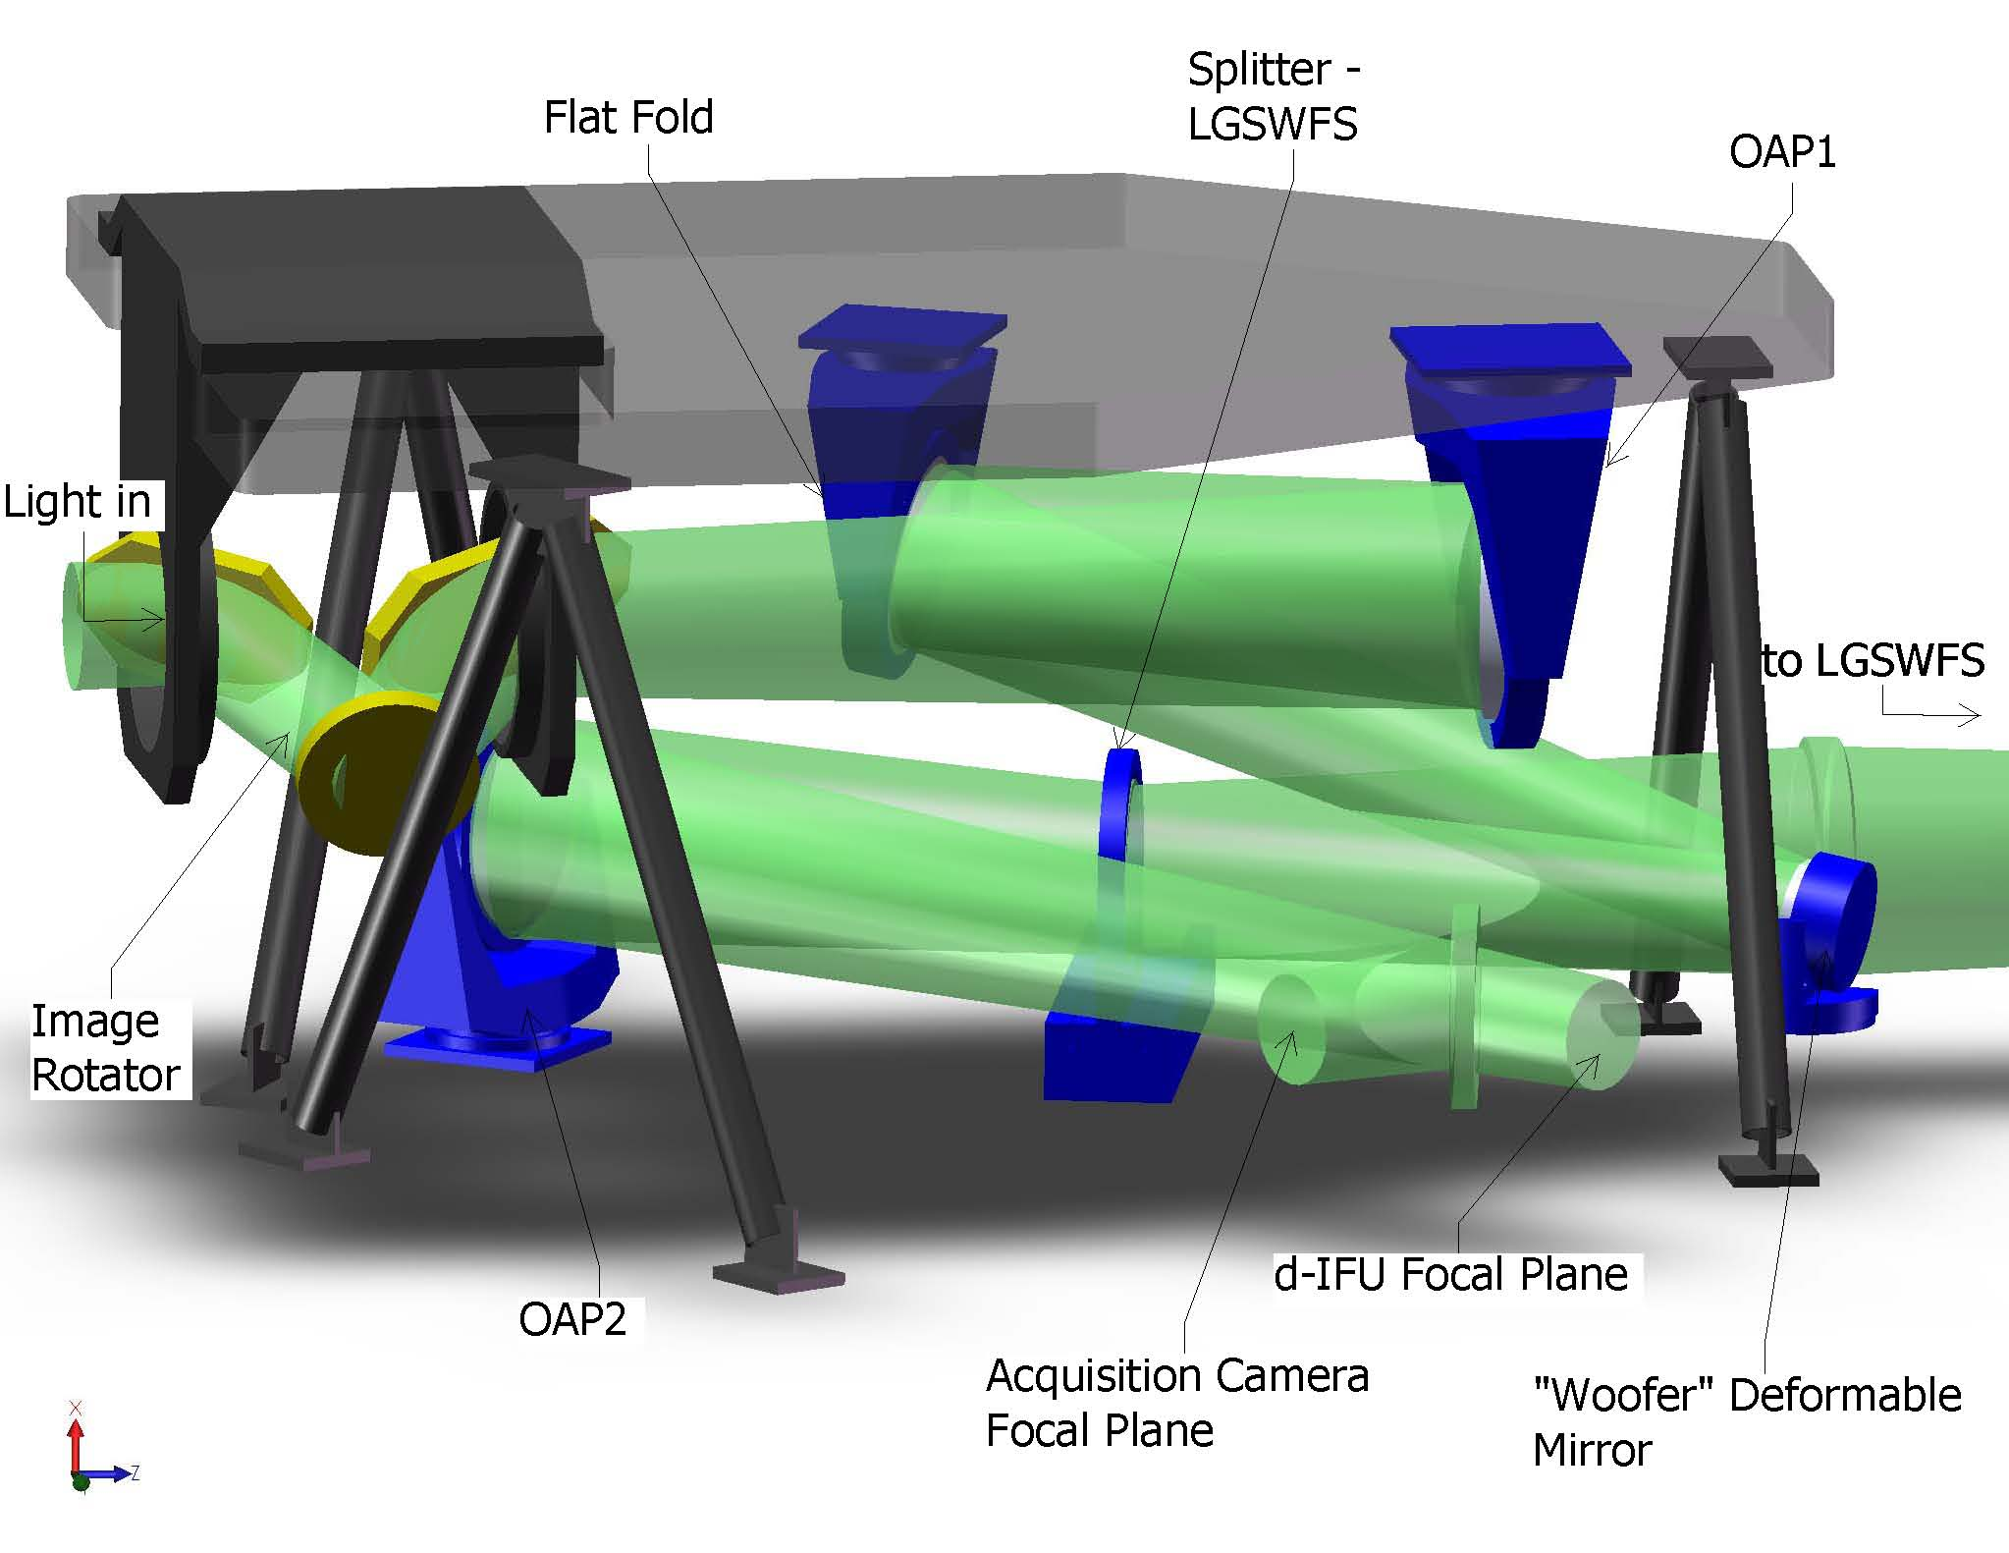
Figure 7. The image rotator and low order “wide” field relay.
Light from the telescope enters from the left and travels through the rotator to OAP1, the flat fold, the “woofer” DM. A dichroic splitter reflects the 589 nm light to the LGS WFS and transmits the remainder of the light to OAP2. A retractable mirror to feed the NGS acquisition camera is shown just before the focus.

LGS Wavefront Sensor Assembly and LGS Acquisition Camera Pickoff
A sodium reflective dichroic (i.e., retractable LGS WFS pickoff) is inserted in the collimated beam between the DM and OAP2 to send the sodium wavelength light to the LGS wavefront sensor as shown in Figure 6. A bi-convex lens is used to play the role of OAP2 and converge the light to the LGS WFS assembly. The lens’ focal length and distance from the DM are the same as those for OAP2 in order to minimize aberrations and project the pupil to infinity. A retractable mirror (i.e., retractable acquisition camera pickoff) can be inserted to send light to the LGS acquisition camera. Both the acquisition camera and LGS WFS must translate in focus to be conjugate to the sodium layer.

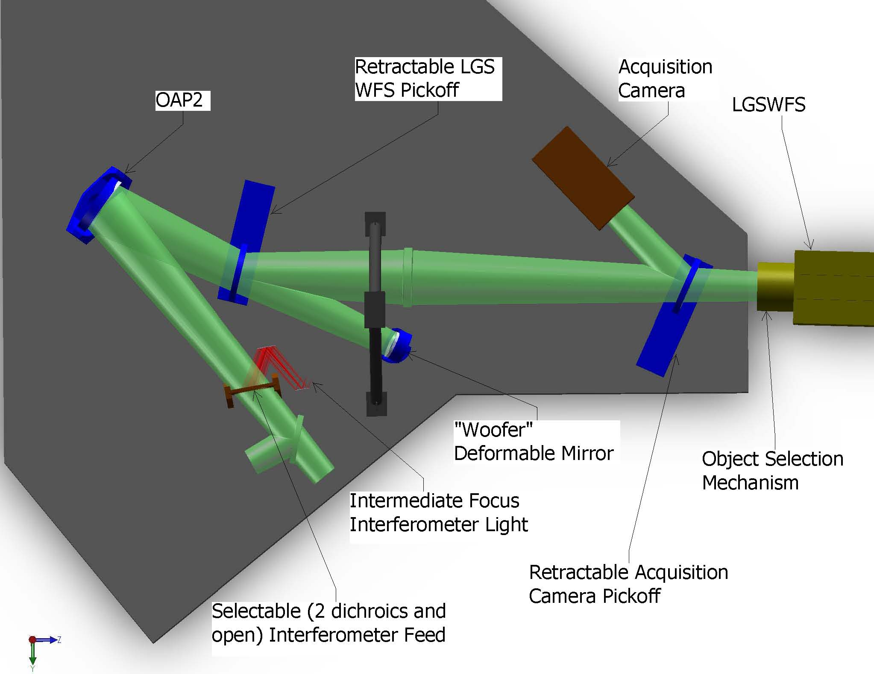
Figure 8. Laser Guide Star Wavefront Sensor and Interferometer Pickoffs.

The LGS WFS assembly consists of an Object Selection Mechanism (OSM) and nine LGS WFS. Each arm of the OSM picks up the light from a single LGS and transports this light to a single LGS WFS.

Interferometer Pickoff
Figure 6 also shows a dichroic pickoff to the Keck interferometer. This is located after the narrow field pick-off in order to most closely match the existing Keck AO system where the future interferometer pick-off is located after an IR transmissive dichroic.

The dichroic sends a 60" diameter field to a pair of field selector mirrors. The first of these mirrors is located near the focus and has a hole in it to transmit a small on-axis field. The first field selector steers the desired off-axis point to the center of the second field selector mirror, which in turn steers the off-axis field along the desired axis (parallel to the on-axis field). Similar field steering mirrors are used in the existing Keck AO system and this approach has been selected for the ASTRA upgrade to the Interferometer (ASTRA-0017).

Two options are being considered for transporting the interferometer beam to the basement. The first is to use a dual star module where OAPs are used to collimate the light and fold mirrors are used to steer the beam to the existing coude train. The second and preferred option is to insert both the on-axis and off-axis objects into single mode fibers for transport to the basement.

NGS Acquisition Camera Pickoff
A removable 45º incidence angle mirror folds the entire 150" diameter wide field relay output to the NGS acquisition camera. This option is shown in the event that a NIR acquisition camera might be required. We have determined (KAON 567) that a visible camera is adequate. In this scenario the LGS acquisition camera discussed in the previous section will also be used for NGS acquisition.

Low Order Wavefront Sensor Assembly
The light reflected by OAP2 goes directly to the NIR imager (in the absence of any fold mirrors or dichroics between OAP2 and the d-IFS). The Low Order Wavefront Sensor (LOWFS) Assembly is located directly in front of the d-IFS and consists of an Object Selection Mechanism (OSM) and four LOWFS. Two arms of the OSM feed tip-tilt (TT) sensors. A third arm feeds a tip-tilt-focus-astigmatism (TTFA) sensor and truth wavefront sensor (TWFS). A beamsplitter splits the light between the TTFA and TWFS.

Narrow Field Relay
A choice of several dichroics can be inserted in the beam between OAP2 and the d-IFS in order to send light into the narrow field relay as shown in Figure 9. This relay is intended to provide a high order of correction for the narrow field science instruments. It also provides a magnification of ~3 in order to provide separation between the instruments and an optimal plate scale for the science instruments.

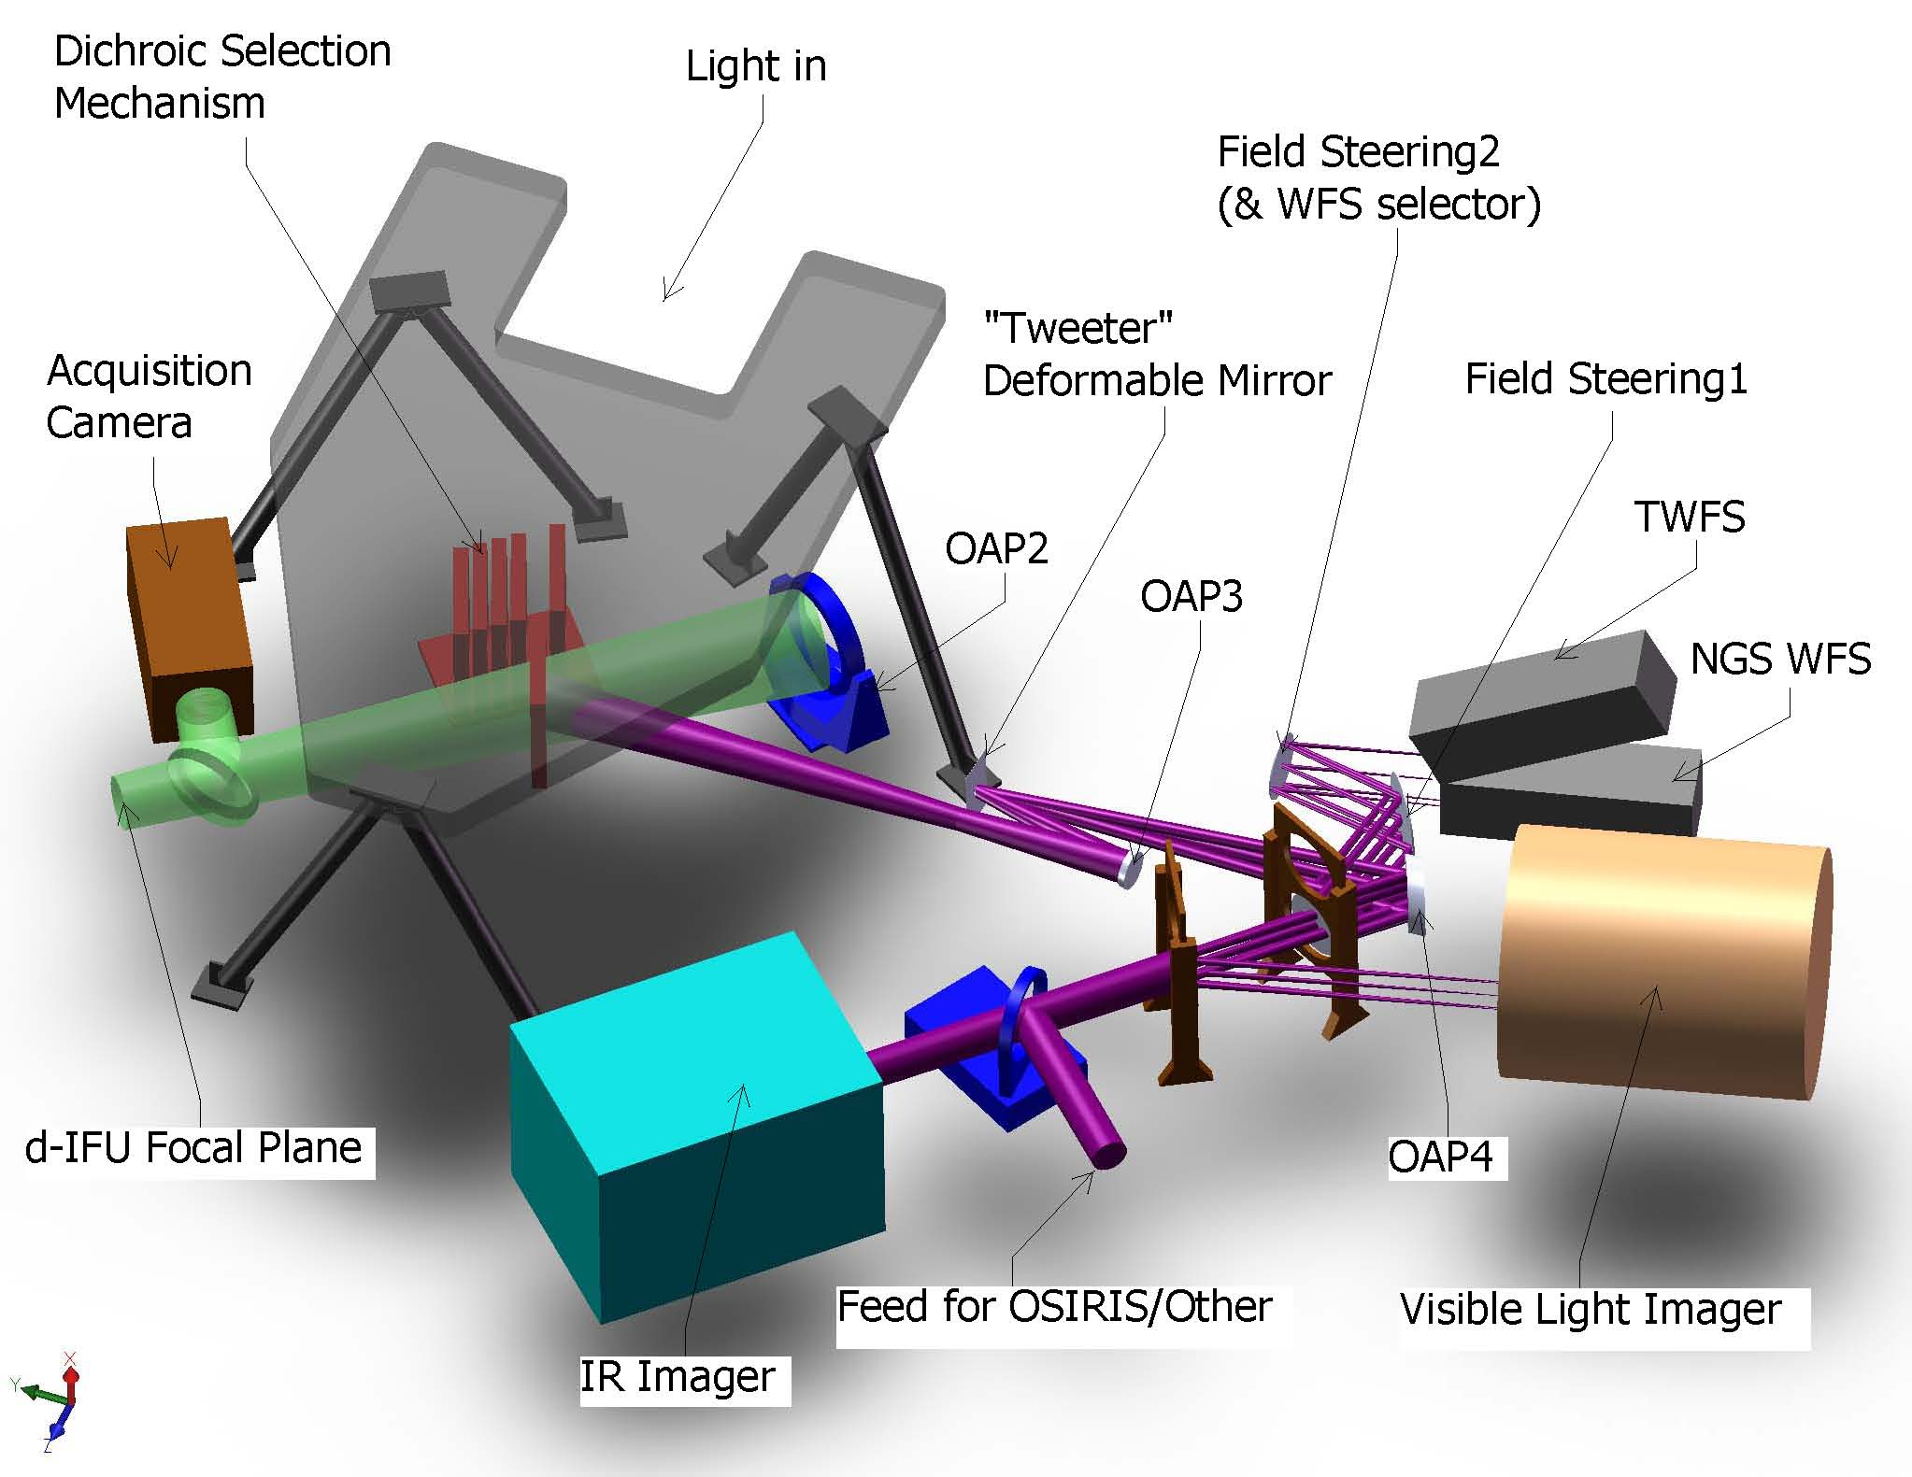
Figure 9. Narrow Field Relay.

The light reflected by the dichroic passes through focus to OAP3 which collimates the light and reimages the telescope primary mirror onto a 64x64 MEMS DM. The DM is mounted on a fast tip-tilt platform. OAP4 is chosen to provide a factor of three magnification and is located its focal length from the MEMS in order to project the pupil to infinity.

- Chosen design parameters.
  - NGS field of view diameter, Φ_{NGS,narrow} = 60" for NGS WFS and 30” for science instruments.
  - OAP3 off-axis angle = 13º.
  - Telescope primary mirror subaperture size, d_{PM2} = 176.0 mm.
  - MEMS angle of incidence, α_{MEMS} = 10º.
  - MEMS conjugate to the telescope primary mirror.
  - MEMS subaperture size, d_{MEMS} = 0.40 mm.
  - 3x magnification (f/15 input becomes f/45 out).
  - OAP4 off-axis angle = º.
  - Output pupil from 2nd relay at infinity.
- 1st order calculated parameters.
  - OAP focal length, f_{OAP3} = (d_{MEMS}/d_{PM2}) f_{Tel} = 340.0 mm
  - Required OAP3 diameter to accept the pupil and field, d_{OAP3} = f_{OAP3}/f/#_{Tel} + Φ_{NGS,narrow}*PS = 69 mm.
  - Distance of MEMS from OAP3 in order to be conjugate to the primary, t_{DM} = f_{OAP3}.
  - Pupil distortion on the DM due to the angle of incidence, % distortion = [1–cos(α_{MEMS})]*100% = 1.5%.
  - Focal length of OAP4 for a 3x magnification, f_{OAP4} = 3f_{OAP3} = 1020 mm.
  - Distance of OAP4 from the DM in order to project the pupil to infinity, t_{OAP4} = f_{OAP4}.
  - Required OAP4 diameter to accept the pupil and field, d_{OAP4} = f_{OAP3}/f/#_{Tel} + Φ_{NGS,narrow}*3PS = 134 mm.

Natural Guide Star and Truth Wavefront Sensors Pickoff
The dichroic pickoff immediately following OAP4 feeds both the NGS WFS and TWFS. The dichroic is at an angle of incidence of 17º. The nominal 30" diameter field required for the science instruments was deemed to be scientifically inadequate for the NGS WFS and TWFS. The current design has a slightly offset field that extends 57" perpendicular to the bench and 54" parallel to the bench due to vignetting by the tweeter and OAP4.

A pair of field selector mirrors, similar to those discussed in section will be used. In this case the first mirror will not have a hole in it and the second mirror is mounted on a two position rotation stage in order to provide light to one of either the NGS WFS or TWFS.

An alternate location for the NGS WFS and TWFS, in the visible imager path, will likely be implemented during the preliminary design. This location has the advantage of a shared ADC with the visible imager and only one dichroic in the beam to the IR imager when simultaneous NIR and visible observations are being performed in NGS mode.

Narrow Field Science Instrument Pickoffs
Three science instruments are fed by the narrow field relay as shown in Figure 9. The light reflected by OAP4 goes directly to the NIR imager (in the absence of any fold mirrors or dichroics between OAP4 and the NIR imager). A dichroic fold can be inserted in this path to feed the visible imager or a fold mirror can be inserted to feed the light toward OSIRIS.

In order to reuse the existing OSIRIS with NGAO, optics must be inserted in the path to convert the beam back to the initial telescope focal ratio with the pupil at the same position as provided by the telescope. This design is TBD, however similar reimaging optics were designed to use NIRSPEC with the existing AO system (KAON 201). This design consisted of two spherical mirrors and two flat mirrors and provided a magnification of 10.6 (versus only 3 in demagnification required in this case).

The interfaces to the instruments are defined in KAON 555.

Summary of Required Dichroics and Mirrors
The above sections only described the location of the required pickoffs. Table 1 provides a summary of the required dichroics and mirrors and their properties. The numbers in the NGS and LGS columns refer to the system configurations that will be discussed in a later section.

Table 1. Summary of Required Dichroics and Mirrors.
Dichroic or Fold | # | Options | NGS | LGS | Transmit | Reflect | R (extra) | Notes
LGS dichroic | 1 | Out | All |  | All | None |  | Notch filter ideal. ≥ 600nm an option
LGS dichroic | 2 | In |  | All | 0.4-L | 589 nm |  | Notch filter ideal. ≥ 600nm an option
LGS Acquis Fold | 1 | Out | n/a | 1-6 | All | None
LGS Acquis Fold | 2 | Mirror | n/a | 11 | None | 589 nm
Post Relay 1 Dichroic = Narrow Field Pickoff | 1 | IR transmit / vis reflect | 2,3 | 5 | JH | ≤ 1 µm | K
Post Relay 1 Dichroic = Narrow Field Pickoff | 2 | Mirror | 4-8 |  | None | All
Post Relay 1 Dichroic = Narrow Field Pickoff | 3 | Out |  | 1-3 | All | None
Post Relay 1 Dichroic = Narrow Field Pickoff | 4 | JH transmit / K reflect |  | 4ab, 6ab | JH | K | ≤ 1 µm | Address with #1 (if can do R (extra))
Post Relay 1 Dichroic = Narrow Field Pickoff | 5 | J transmit / H reflect |  | 4cd, 6cd | J | HK | ≤ 1 µm
Post Relay 1 Dichroic = Narrow Field Pickoff | 6 | H transmit / IJ reflect |  | 4ef, 6ef, 7ef | H | < H | K
Post Relay 1 Dichroic = Narrow Field Pickoff |  | JH transmit / IK reflect |  | 7ab |  |  |  | Address with #1 (if can do R (extra))
Post Relay 1 Dichroic = Narrow Field Pickoff |  | J transmit / IH reflect |  | 7cd |  |  |  | Address with #5 (if can do R (extra))
Interfer-ometer Fold | 1 | Mirror | 2,3 |  | None | All
Interfer-ometer Fold | 2 | Out | 10 | 1,4-6 | All | None
Interfer-ometer Fold | 3 | J transmit / HKL reflect |  | 2,3 | J | HKL
NGS Acquis Fold | 1 | Out | 2,3 | 1-6 | All | None |  | May need to replace mirror w/ a beamsplitter or to provide a 3rd position
NGS Acquis Fold | 2 | Mirror | 10 | 10 | None | All
NGS WFS Dichroic | 1 | IR transmit / vis reflect | All | 5 | Y-K | 0.4-0.95µm
NGS WFS Dichroic | 2 | I transmit / < I reflect |  |  | ≥ 0.7 µm | 0.4-0.7µm
NGS WFS Dichroic | 3 | Out |  | 4,6 | All | None
Visible Imager Dichroic | 1 | IR transmit / vis reflect |  |  | ≥ 1 µm | 0.7-1.0µm
Visible Imager Dichroic | 2 | Out |  |  | All | None
Visible Imager Dichroic | 3 | Mirror |  |  | None | 0.7-1.0µm |  | If #1 good then may not be needed.
OSIRIS Fold | 1 | Out | 4,7 | 4 | All | None
OSIRIS Fold | 2 | Mirror | 6 | 6 | None | z-K

Atmospheric Dispersion Correctors
The baseline for Keck NGAO has the following Atmospheric Dispersion Corrector (ADC) needs:
- NIR ADC in the narrow field path to the NIR imager and OSIRIS.
- Visible ADC in the narrow field path to the visible imager.
- Visible ADC in the narrow field path to the NGS WFS/TWFS.
- NIR ADC (J+H) for each LOWFS.
- NIR ADC for each d-IFS (it is TBD whether this is really required).

ADCs 2 and 3 could potentially be combined if the NGS WFS/TWFS are moved into visible imager path as discussed in section 3.3.1.7.

The atmospheric dispersion corrector (ADC) design has only been taken far enough to demonstrate that suitable ADCs can be designed. During the system design both single glass and two glass linear ADCs were evaluated. In addition there is a two glass counter rotating Amici prism design documented in KAON 134 that was developed for the existing AO system.

Optics Bench Structure
The optics bench structure is shown in Figure 10. The upper and lower tiers are both expected to be typical honeycomb core optical tables. The optimal thickness of both tiers will be determined in subsequent design phases. The separation of the two tiers is accomplished with three bipod struts. If necessary, there is clearance to make these tripod struts, allowing kinematic mount detail for the upper tier.

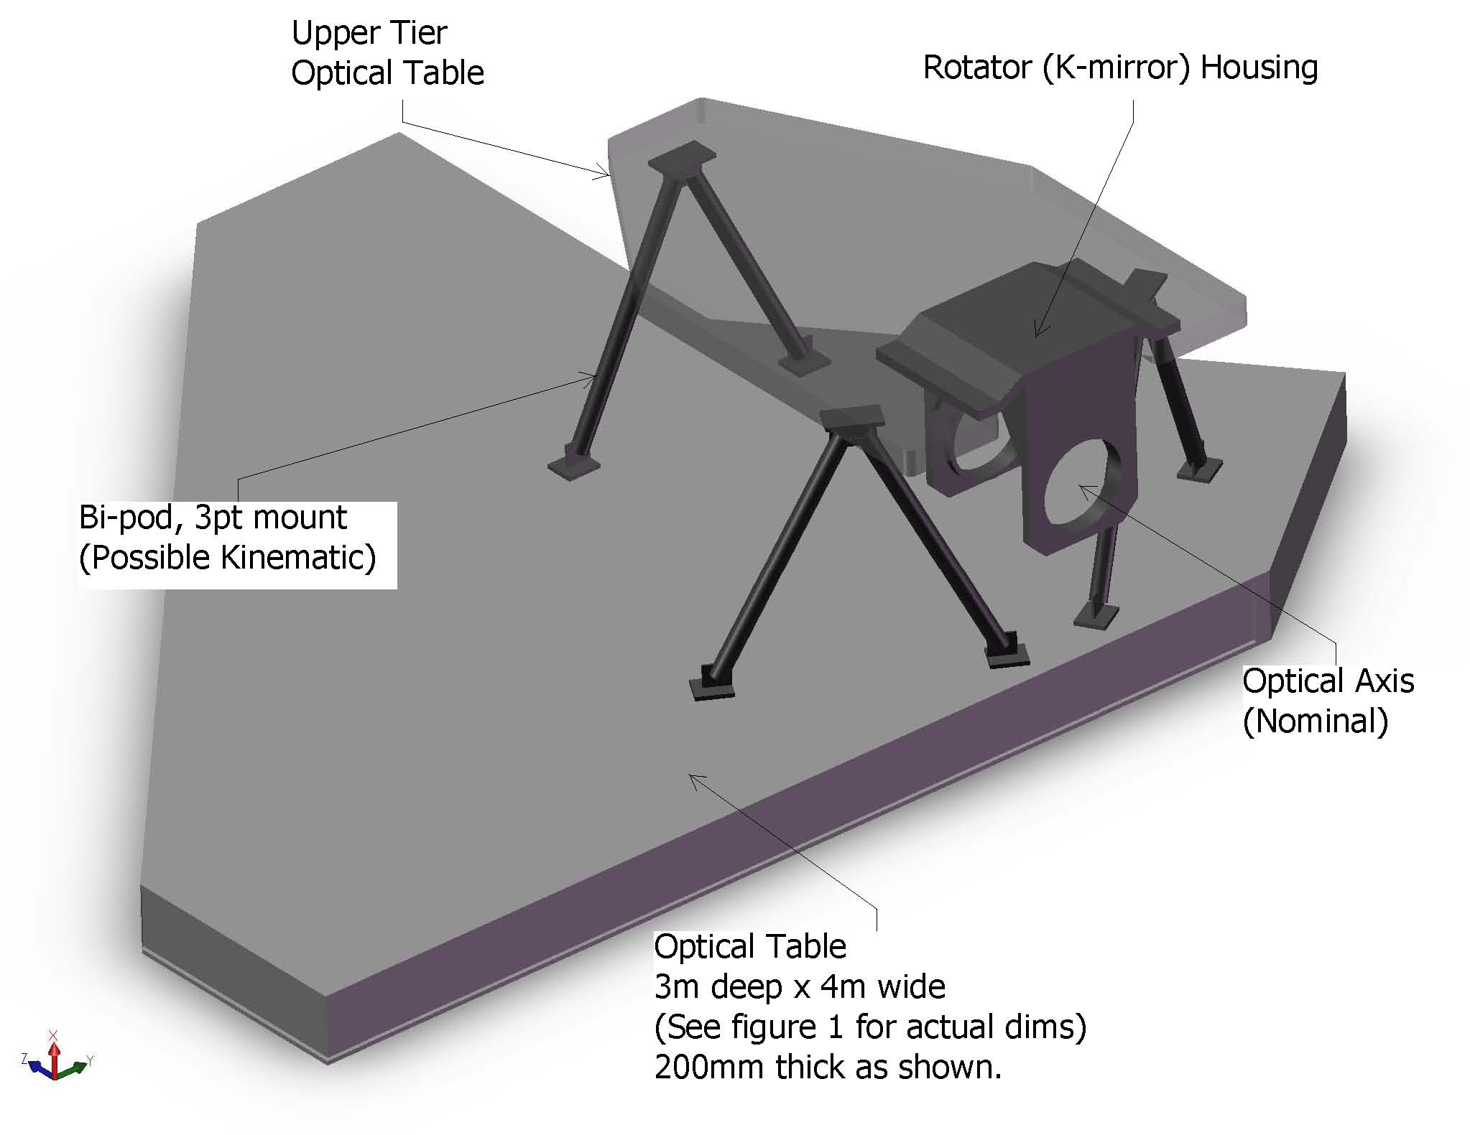
Figure 10. Optics Bench Structure.

Attachment of the optics bench to the Nasmyth platform is TBD, but will likely be similar to the mounting of the existing Keck AO benches. The clearance between the bottom of the bench and the Nasmyth platform is ~ 500 mm less than for the existing AO benches, which will make access under the bench more challenging (than for the existing benches).

Wavefront Sensor Opto-Mechanical Design
Two wavefront sensor assemblies are fed by the wide field optical relay: the LGS wavefront sensor assembly and the low order wavefront sensor (LOWFS) assembly. The NGS and Truth wavefront sensor assembly is fed by the narrow field relay. Each of these assemblies includes an object selection mechanism that selects the appropriate NGS or LGS and feeds the light to the appropriate wavefront sensor(s). Two versions of the same multi-target mechanism have been chosen for the LGS and LOWFS object selection mechanisms, while a different single-object selection approach has been taken for the NGS/Truth wavefront sensor assembly as described in section 3.3.1.7. The LGS wavefront sensor assembly includes nine LGS wavefront sensors. The LOWFS assembly includes five NIR sensors: two tip-tilt sensors, a tip-tilt-focus-astigmatism sensor, a truth wavefront sensor and a PSF monitoring camera. The NGS/Truth wavefront sensor assembly includes an NGS wavefront sensor and a visible truth wavefront sensor. The conceptual design reports for the multi-target object selection mechanism and all of the wavefront sensors can be found in KAONs 562 and 551, respectively.
The design parameters for the wavefront sensors and detectors are summarized in Table 3, Table 4 and Table 5.

Table 3. Baseline design parameters for the NGAO wavefront sensors.
WFS type | Location | Sensing wavelength (µm) | Input PS (µm/”) | # of sub-apertures | Detector PS ("/pixel) | Filters | Object Selection
NGS WFS | near NF sci. inst. | (0.40- or) 0.60-0.90 | 2254 | 32x32, 64x64 | 1.5 | None | field steering mirrors
LGS WFS | In WF relay | 0.589 | 727 | 16x16, 32x32, 64x64 | 1.45 | none | OSM pickoff
TT | After WF relay | 1.16 – 1.33 | 727 | 1x1 | 0.030 | J, H & JH | OSM pickoff
TTFA | After WF relay | 1.16 – 1.33 | 727 | 2x2 | 0.030 | J, H & JH | OSM pickoff
Truth sensor | 1 in NF;  1 after WF | 0.4-0.9(NF); 1.0-2.4(WF) | 2254;  727 | 5x5 | 0.65; 0.200 | none | field steering;  OSM pickoff

Table 4. Other wavefront sensor parameters.
WFS type | FoR dia. | Baseline detector choice | Pixels/subap | Guard bands? | spot size delivered to the sensor | linearity | Comments
NGS WFS | 50" | Visible CCID56 | 4 | none at 64x64 | NF relay output @ 400-1000 nm | spot size ~ pixel size | Assumes Peltier
LGS WFS | 174" | Visible CCID56 | 4 | none at 64x64 | WF relay output @ 589 nm | Based on an avg. spot size | Assumes Peltier
TT | 150" | IR detector with selectable pixels & RG capability | 4-many | NA | MOAO corrected @ 1-1.7 um |  | many pixels for extended objects
TTFA | 150" | IR detector with selectable pixels & RG capability | 4-many | at least a few pix. | MOAO corrected @ 1-1.7 um
Truth sensor | 50" 150" | Low dark current visible detector;  IR det. with selectable pixels & RG capability | 4 | few pixels | High order corrected at 0.40-1.0 µm;  MOAO corrected @ 1-1.7 um

Table 5. Required WFS detector characteristics.
Detector | Characteristics | # of units | Comments
CCD | 128x128 pixels. RON ≤ 3e- at 2 kHz frame rate  & DN ≤ 500 e-/sec @ operating temp. | 10 | 9 LGS WFS + 1 NGS WFS
Truth sensor (visible) | 10x10 active pixels. RON ≤ 3e- at 0.01-200 Hz  & DN ≤ 0.001 e-/pix/sec DN | 1 | truth sensor NF
Truth sensor (IR) | 10x10 active pixels. RON ≤ 5e- at 0.01-200 Hz  & DN ≤ 0.001 e-/pix/sec | 1 | truth sensor WF
IR detector | 128x128 pixels? Must be able to read in PoI mode. RON ≤ 7e- with 16 Fowler samples & 500 Hz data rate for the entire chip; DN ≤ 0.001 e-/sec @ 73K. | 3 | 2 TT and 1 TTFA sensors

Low Order Wavefront Sensor Object Selection Mechanism
A design for an interim LOWFS OSM has been developed in KAON 562. This interim OSM may be implemented prior to the fielding of the d-IFS. A similar OSM may be selected for the d-IFS and the two designs could potentially be integrated into a single OSM.

The Low Order Wavefront Sensor (LOWFS) assembly is located at the focus of the first relay and contains two Tip-Tilt (TT) WFS, one TTFA WFS, one TWFS WFS and one PSF monitor (the PSF monitor is currently deferred and may be provided as one channel of the d-IFS). The NGAO LOWFS assembly is a critical part of the NGAO system as it initiates acquisition and all subsequent observation modes such as on and off-chip dithering, including sub-pixel dithering, and non-sidereal tracking at exquisite levels of performance.

The LOWFS assembly shown in Figure 11 attaches directly to the AO bench. The assembly can be viewed as two separate entities: the OSM consisting of a stable structural plate that supports the4four roaming probe arms and the4four beam-fed units located behind the structural plate that are fixed during an observation.

The LOWFS OSM probe arm is a compact 2-motor device shown in Figure 12. The 2 degrees of freedom probe arm consists of 2 individual arms: a crank arm and a lever arm, driven by 2 corresponding rotation motors: the crank and lever motors.

The crank motor is secured to the main structural plate. It rotates the crank arm, and all hardware attached to it that includes the lever arm and lever arm motor, precisely about the rotation axis of the crank motor (θ rotation). The lever arm motor provides the necessary second degree of freedom by rotating the lever arm and all associated optics (φ rotation).

The lengths of the crank and lever arms were chosen to provide full coverage of the LOWFS OSM field of view. Any position in the LOWFS OSM field of view can be acquired by calculating appropriate values for θ and φ, noting that due to a mirror reflection there are always two possible solutions. Four basic configurations of the LOWFS OSM probe arms are shown in Figure 13, including (a) the non-LGS observing mode; (b) a probe arm at full range; (c) “home position” where all probe arms are outside the field and (d) a random configuration for LGS mode. The probe arm tips can be designed to approach very closely; this design allows the positioning of two probe arms on two NGS with only 5" separation.

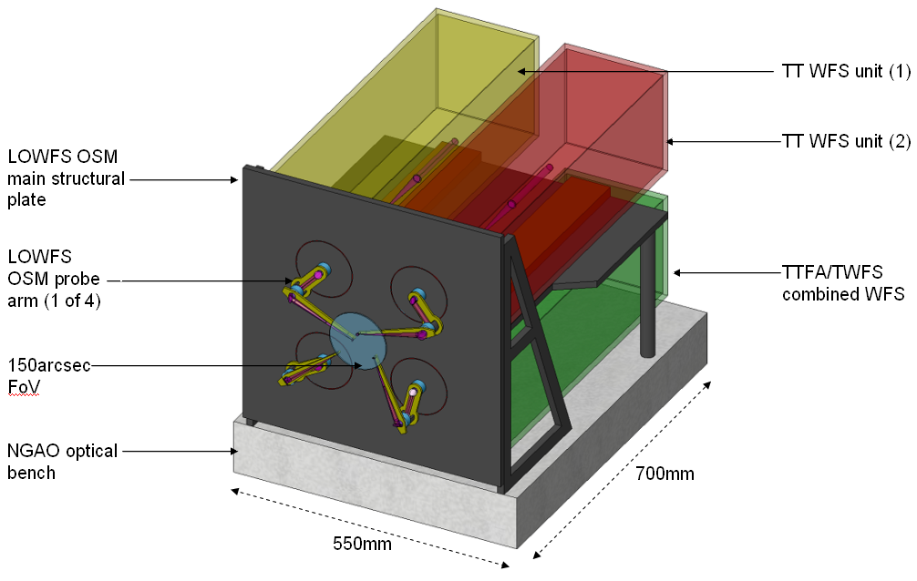
Figure 11. The LOWFS assembly.

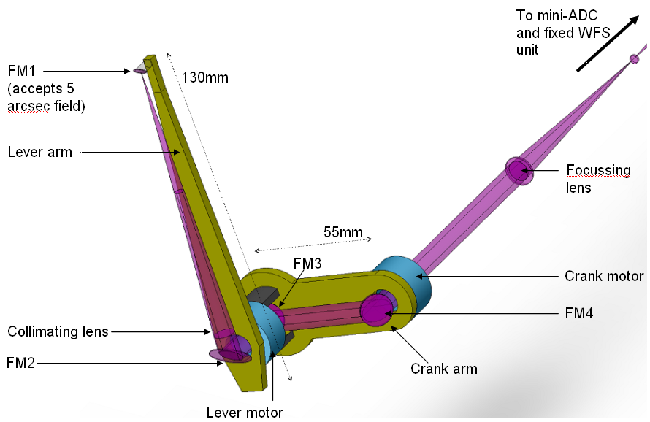
Figure 12. LOWFS OSM probe arm.

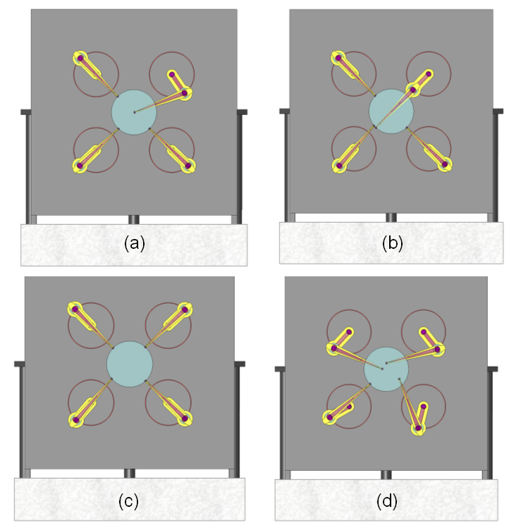
Figure 13. Four configurations of the LOWFS OSM arms.
(a) one TT on-axis with the remaining 3 probes unused; (b) one probe arm fully extended; (c) all probe arms at the home position at the edge of the 150" diameter field; and (d) a random field with all 4 probes in operation.

The telecentric feed from the AO system makes the LOWFS optical design relatively simple. The immediate benefit of this to a focal surface probe arm design is that the probe arms can patrol a flat field and not require any tilt of the optics to compensate for changing angle.

The LOWFS OSM focal surface is curved with a radius of -1320mm. As the probe arm moves from the center to edge of the field, this results in a defocus of approximately 1 mm. The broadening of the beam at the probe arm is negligible however the focus position of the re-imaged star at the WFS unit will change by a corresponding amount. Note that this focus change is a smaller issue than the ~7 mm of focus change when a dichroic is inserted or removed from in front of the LOWFS assembly.

A solution to the focus issue is to position all four LOWFS units on linear slides. The units are moved to the correct focus position at the start of an acquisition procedure and do not need to be tracking devices. An alternative solution is to keep the LOWFS units completely fixed and to place the probe arm focusing lenses on linear stages. This may be preferable and will be evaluated during preliminary design.

Optically the probe arm could be a simple relay, as shown in Figure 14, with a collimator, to produce a pupil, and a focusing lens. The design to incorporate a MEMS DM, and possibly a pupil stop, at the reimaged pupil is TBD.

A 5" diameter field of view was chosen as a reasonable size of field to be large enough to always hit the target, but small enough to allow close positioning of the probe arms. The field can be stopped at the WFS if required. The focal length of the focusing lens will be determined as part of the WFS design.
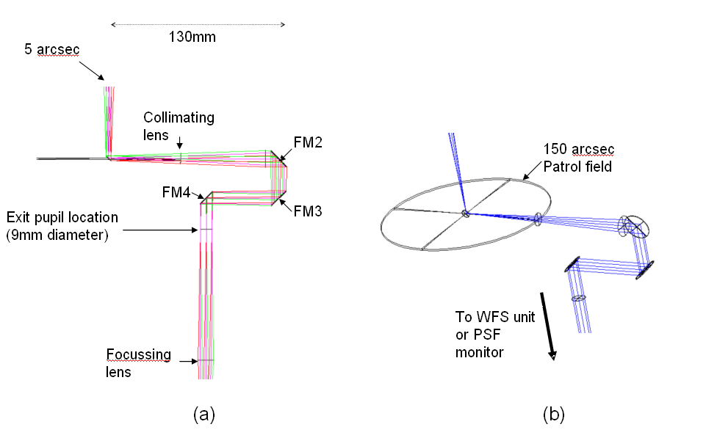
Figure 14. (a) Zemax model of LOWFS probe arm. (b) Probe arm patrol field.

The advantages of a θ/φ probe arm design for this application are:

- The optical pathlength is naturally and accurately preserved as a function of field position.
- As only four pick-offs are required one can allow larger mechanisms than otherwise allowed, resulting in readily available off-the-shelf rotary mechanisms using conventional worm gears rather than custom piezo or hybrid devices.
- The theta/phi arm naturally allows for a fixed feed to the non-tracking WFS unit.
- The arms can be balanced about the center of mass for each arm if this is needed for fine positioning.

There are two disadvantages of a theta/phi mechanism:

- The pupil rotates as a function of field position, by ±180º. This creates a varying rotation of the woofer DM with respect to the DM and lenslet arrays inside the TTFA and TWFS unit. The TT and PSF monitor units contain no lenslet arrays and the effect can be calibrated in software. A solution to this is to include an extra non-tracking rotation mechanism in the WFS unit that rotates the entire unit about the z axis as a function of field position. However, the low order nature of the TTFA and TWFS units is most likely sufficient that this mechanism is not required in the LOWFS assembly, and we therefore propose the effect to be calibrated in software.
- In general, linear motors are more accurate than rotary.

Tip-Tilt (Focus and Astigmatism) Sensors
The three Low Order Wavefront Sensors (LOWFS) operate at near-IR wavelengths to improve the availability of suitable stars of sufficient brightness. Optimal performance is obtained using combined J and H band light, but a selectable beam splitting dichroic will allow sending one or more near-IR bands in combination to the tip-tilt sensors with the remainder of the near-IR and the visible light passing to the narrow field instruments. At least one sensor will be of at least order 2 x 2 subapertures to provide sensing of focus and astigmatism. Each tip-tilt star will be AO corrected using a MEMS DM with a pointable LGS beacon positioned near each tip-tilt star to maximize this correction.

Truth Wavefront Sensors
The Truth Wavefront Sensor (TWFS) is used to calibrate biases that arise when using LGS in an AO system; we refer to this as the Low Bandwidth Wavefront Sensor in the existing Keck AO system. The biases are principally caused by the elongated nature of the LGS when viewed by sub-apertures of the LGS wavefront sensor and the changing sodium layer density profile. The truth wavefront sensor measures these biases by sensing the wavefront from a NGS. These biases are slowly varying and are of a low spatial order. So, a NGS WFS using long exposures and only measuring the lowest spatial wavefront error is sufficient.

The truth sensor has been estimated to be a 5x5 sensor with detailed error budgets for the same still in the works. The baseline design will have two truth sensors as these sensors are to be placed as close as possible to the science instrument. The wide field TWFS sensor will be a NIR sensor while the narrow field TWFS is conceptualized to be a visible sensor.

The NIR TWFS will share ~5% of the light to the TTFA sensor. The plate scale for the NIR TWFS is the same as the TT sensors (0.2"/pixel). The Strehls are ~20% in H-band and 10% in J-band; well within the range to be able to sense TT on the core of the PSF.

The visible TWFS plate scale was chosen based on a median seeing limited spot size of 0.65". Current estimates suggest that the visible TWFS can go down to 21.5 mag with a 10 second integration time and achieve 35 nm of total TWFS error.

PSF Monitoring Camera

LGS Wavefront Sensor Object Selection Mechanism
There are a total of nine LGS wavefront sensors in the baseline NGAO design. The asterism is novel in the sense that there is a fixed central guide star with a 5 star asterism around it on the vertices of a regular pentagon and there are 3 additional point and shoot lasers that can be pointed anywhere in the field of regard to MOAO sharpen the 3 TT(FA) stars. The asterism diameter can be varied between 20" and 174".

Figure 15 shows one of the eight LGS θ/φ pickoff probe arms. These are intended to be very similar to the LOWFS object selection mechanisms described in section 3.3.2.1.

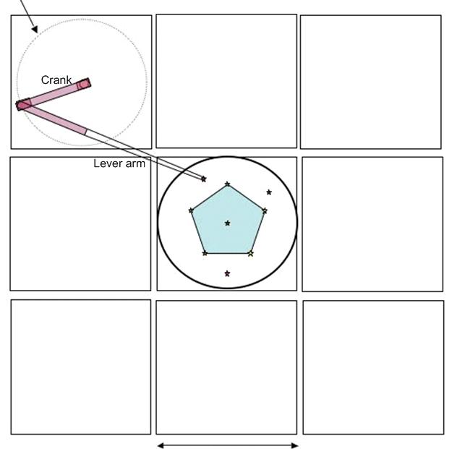
Figure 15. Plan view of the LGS object selection θ/φ pickoff scheme.

Note that the LGS are always maintained fixed with respect to the LGS WFS OSM. When the AO rotator is used in fixed field mode this is accomplished by the laser launch facility maintaining the LGS asterism fixed on the sky via its own rotator. When the AO rotator is used in fixed pupil mode this is accomplished by not having the LGS asterism rotate on the sky.

LGS Wavefront Sensors
The LGS wavefront sensors are Shack-Hartmann (SH) sensors with up to 64 x 64 subaperture sampling of the pupil. For the LGS wavefront sensor detectors we anticipate using a very low noise CCD based on the CCID-56 to minimize the laser power required in each beacon. This detector is nominally 128x128 pixels with 3 electrons read noise at 2 kHz frame rates and < 500 electrons/sec of dark current at the operating temperature.

A single LGS WFS channel is shown schematically in Figure 16. This is very similar to the existing Keck AO WFS design (the existing optical design is documented in KAONs 137 and 375). The WFS is positioned such that the LGS image is located at the field stop. The entire mechanism, including object selection mechanism, must translate in focus to remain conjugate to the sodium layer. Pupil reimaging optics reimage the telescope pupil (i.e., woofer DM) onto the lenslet array and relay optics relays the images produced by the lenslet onto the camera with the required magnification. A lenslet switching mechanism allows multiple pupil sampling scales and a translation stage allows the relay lens and camera to refocus for different lenslets.

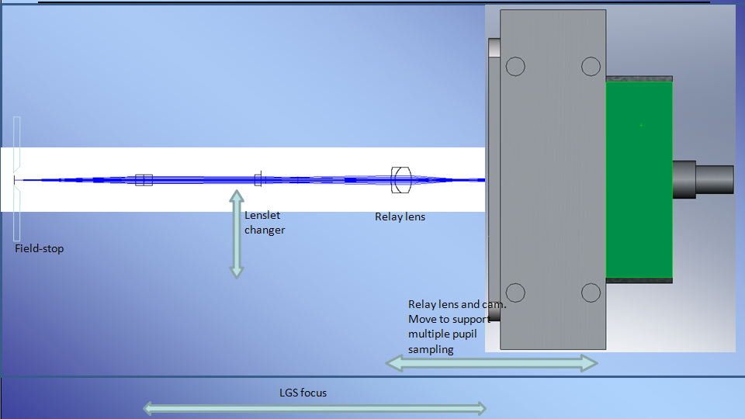
Figure 16. Schematic of a single LGS WFS channel.

NGS Wavefront Sensors

AO Optical Performance
To determine the performance of the optical system, several sources of optical degradation were analyzed using Zemax in the wavelength passbands used by the individual science instruments and wavefront sensors. The passbands are defined in KAON 530.

The optical relay was modeled in conjunction with the Keck primary and secondary mirrors, to ascertain the combined effects of the two optical systems.

Field points used were the maximum off-axis fields defined for each instrument. The wavefront errors and RMS spot radii quoted are the worst-case for the field points analyzed.

According to Zemax, the working f/# of the wide-field relay is f/13.66 and of the narrow-field relay is f/46.89. Airy disk sizes are defined by
and the depth of focus (DOF ) is defined by.

In Zemax, both the woofer and tweeter DMs were defined as “Zernike Fringe” surfaces. This allowed a placement of Zernike terms on the mirror surface, to mimic the correction capabilities of an actual DM and derive an “uncorrectable” wavefront error (errors which could not be corrected with a DM). Examination of the Zernike Fringe Coefficients and spot diagrams indicated that the bulk of the wavefront error was due to astigmatism and coma, therefore the Zernike fringe surfaces were optimized only for those coefficients (optimizing in Zemax with too many variables is slow and sometimes fails to converge in a realistic fashion).

Wide Field Relay Optical Performance

Optical Performance to the Deployable Integral Field Spectrograph
It is assumed that the d-IFS is used in MOAO mode, and that the DM in each arm can apply low-order correction optimized for that field position. Thus field-dependent aberrations can almost completely be removed.

When the d-IFS is in use, there will be no dichroic in the converging beam ahead of the instrument. Lateral color and chromatic focal shift are therefore very close to null (with a negligible contribution from the tilted LGS WFS dichroic in collimated space). Image analysis results are shown in Table 6.

Table 6. Optical performance to the d-IFS
Instrument | λ bands | F/# | FOV (″) | Field Curvature (mm) | RMS WFE (nm) | Spot Size (μm) at J | Spot size (mas) | Airy radius (μm) at J
dIFS | J, H, K | 15 | 150 | 1430 | 8.6 | 1.25 | 1.7 | 19.5

Optical Performance to the Low Order Wavefront Sensors
The LOWFS optical selection mechanisms share a focal plane location with the d-IFS science instrument. Because the LOWFS must also be used with the imagers located in the narrow-field relay, it will often be the case that the dichroic splitter for the second relay, or the interferometric dichroic, are inserted between OAP2 and the LOWFS focal plane.

This dichroic location introduces several issues. When the ~ 20 mm thick dichroic is removed or installed, the focus will shift by ~7 mm along the optical axis and ~1.5 mm in the direction of the dichroic tilt. The OSM probe arm will reposition to adjust for this gross movement.

The insertion of the dichroic also leads to lateral color (see Figure 17) and a chromatic focal shift. The lateral color will be minimized by introducing a small wedge angle to the second surface of the dichroic (on the order of tenths of a degree; see KAON 107 for how this was done with the existing Keck AO system dichroics). The tilted dichroic will introduce astigmatism which can be removed by the LOWFS DM.

Table 7 gives aberrations during simultaneous observations in J and H bands, the largest bandpass the LOWFS is likely to utilize. No wedge angle has yet been included on the second surface of the dichroic.

Table 7. Optical performance to the LOWFS in simultaneous J and H-bands.
Instrum  (mode) | λ (μm) | F/# | FOV ″ | Field curv.  (mm) | RMS WFE (nm) | RMS Spot Radius (μm) | RMS Spot Radius (mas) | Airy radius  (μm) | Lateral color (μm) | Chrom. Focal shift (μm) | Depth of focus  (mm)
LOWFS | 1.17-1.78 | 15 | 150 | 1320 | 15.6 | 18.6 | 10.7 | 19.5 | 24.4 | 70 | 0.9
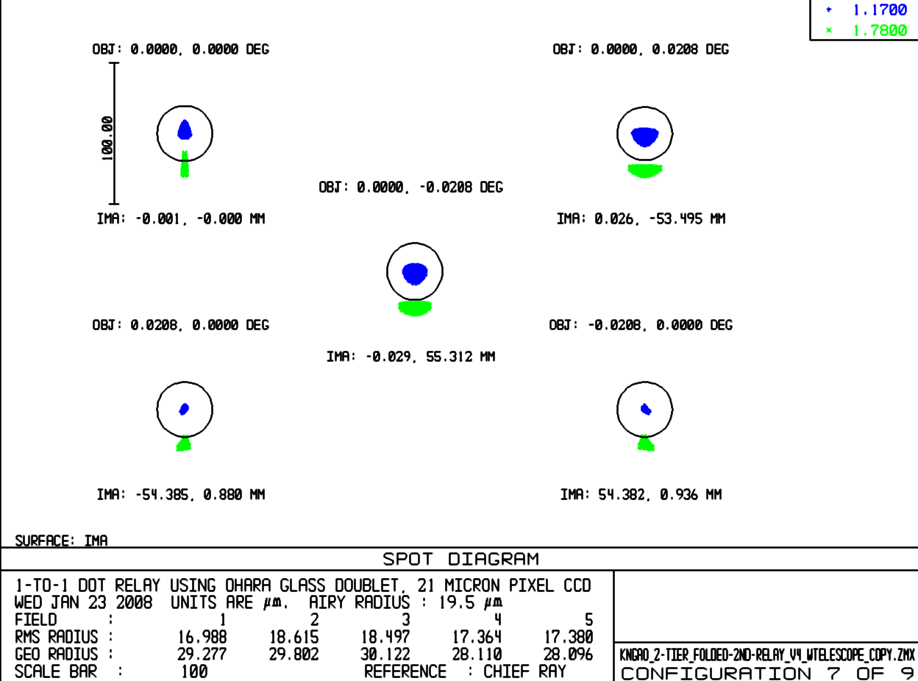
Figure 17. Spot diagrams delivered to the LOWFS focal plane showing lateral color without a wedged dichroic.

Optical Performance to the Interferometer Field Selectors
When the interferometer is in use, there will be a dichroic in the converging beam ahead of the instrument similar to the existing Keck AO system (although this is not necessary in LGS mode). The narrow field performance should be comparable to the existing Keck AO systems. The impact on the polarization has not yet been evaluated. Relatively shallow angles have been chosen in the wide field relay in order to minimize polarization effects.

Optical Performance to the Laser Guide Star Wavefront Sensors
The LGS WFS dichroic pick-off is located in the collimated space between the woofer DM and OAP2. The current simple design reimages the LGS, over their 174" diameter field, using a 1-glass biconvex lens. The lens chosen need only work at the sodium wavelength, so chromatic aberrations are not an issue. This lens was optimized for 90 km, but other zenith angles may be considered in future optimizations (the performance varies by only 10s of mas between 90 and 180 km, so this is not seen as a huge potential improvement). Table 8 details the performance of the LGS WFS relay.

Table 8. Optical performance to the LGS WFS versus conjugate height.
Conjugate height | FOV, arcsec | Field Curvature (mm) | RMS WFE (μ) | RMS Spot Radius (mas)
90 km | 174 | 650 | 2.8 | 415
180 km | 162.5 | 650 | 3.1 | 440
Of concern are the almost half-arcsec spot sizes of the LGS WFS (see Figure 9). This is a significant fraction of the 1.5 arcsec pixels proposed for the LGS WFS. These aberrations stem from using OAP1 at a finite conjugate. An Alvarez-style corrector plate has been suggested as a solution.

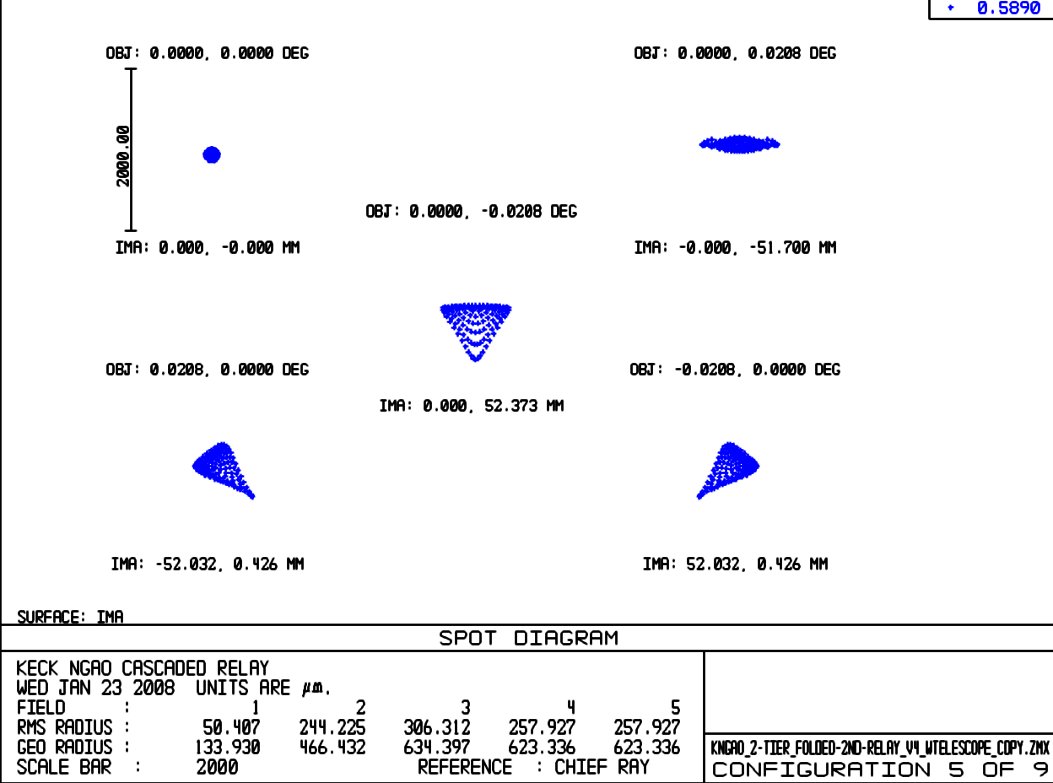
Figure 18. Spot diagrams delivered to the LGS WFS at 180 km conjugate.

Object Selection Mechanism Optical Performance

Narrow Field Relay Optical Performance
It is assumed for the narrow-field instruments that the tweeter DM applies correction across the entire 30" diameter field of view. The performance values in Table 9 assume that the NGS/TWFS dichroic is in place. RMS spot radius takes lateral color into account, but like the LOWFS, this can be minimized by putting a wedge angle on the second surface of the NGS/TWFS dichroic.

Table 9. Performance to the narrow field instruments.
Instrument  (mode) | λ (μm) | F/# | FOV ″ | Field curv.  (mm) | RMS WFE (nm) | RMS spot radius (μm) | RMS spot radius (mas) | Airy radius  (μm) | Lateral color (μm) | Chrom. Focal shift (μm) | Depth of focus  (mm)
NIR im, Y-band | 0.97-1.07 | 46 | 30 | 277 | 15.6 | 17.5 | 7.8 | 55.1 | 4 | 11.8 | 8.4
NIR Im, J-band | 1.17-1.33 | 46 | 30 | 277 | 15.6 | 18.3 | 8.2 | 66.4 | 5.5 | 17 | 10
NIR Im, H-band | 1.49-1.78 | 46 | 30 | 277 | 15.6 | 20.9 | 9.4 | 84.6 | 10.78 | 34 | 13
NIR Im, K-band | 2.03-2.37 | 46 | 30 | 277 | 15.8 | 24 | 10.8 | 115.3 | 17 | 53 | 18
Vis. Im, | 0.7-0.97 | 46 | 30 | 277 | 15.8 | 22.2 | 10.0 | 39.7 | 12.8 | 42 | 6
NGS/TWFS | 0.4-0.7 | 46 | 54 | 277 | 36 | 32.3 | 14.5 | 22.7 | 0 | 0 | 3.5

Lateral color is well inside the Airy radius for all instruments in this f/46 beam, so a wedge on the NGS/TWFS dichroic may not be necessary. Chromatic focal shift is negligible compared to the depth of focus. Note that the NGS/TWFS encounters only reflective optics, and therefore does not suffer from chromatic aberrations. Note, also, that none of the analyses include the effects of the ADC which will be required in each instrument’s beam path.

The second relay OAP performance degrades with field angle. The large field of the NGS WFS/TWFS therefore exhibits much more wavefront error, as seen in Figure 19 and Figure 20, over its 54" diameter field than the science instruments over their 30" diameter field.

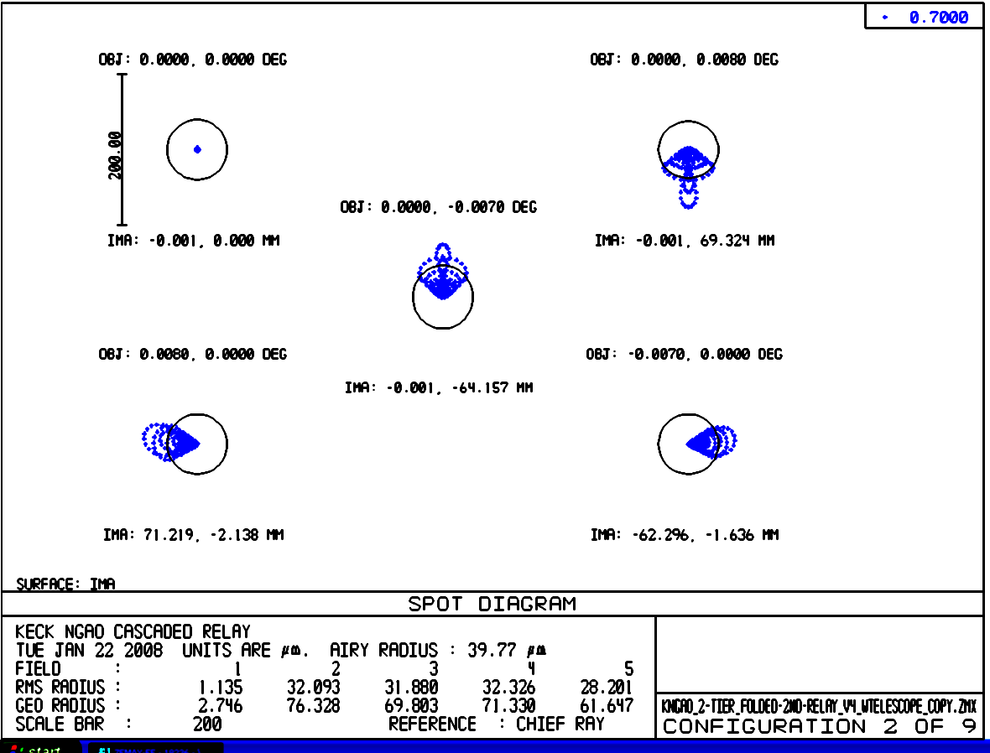
Figure 19. Spots at the on-axis and extreme field angles to the NGS WFS.
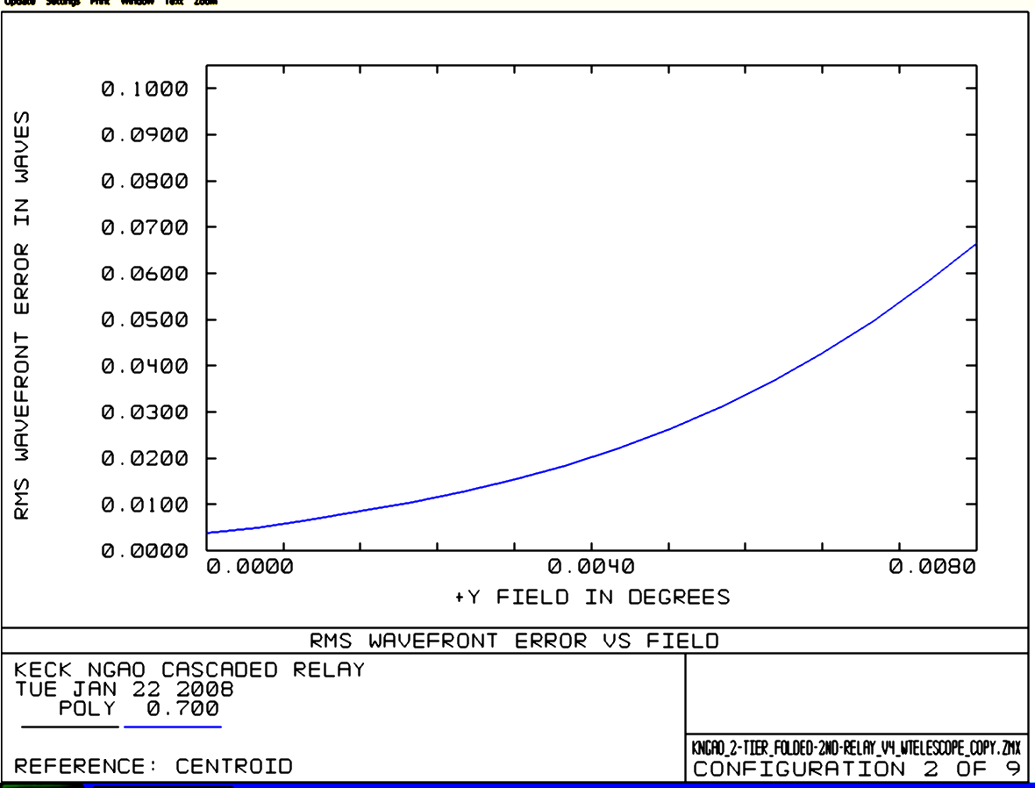
Figure 20. RMS wavefront error to the NGS WFS versus field.

Atmospheric Dispersion Correction
As mentioned in section 3.3.1.10 the ADC design has only been taken far enough to demonstrate feasibility. As shown in Figure 21 an f/15 ZnSe linear ADC can have < 10 mas or residual dispersion for λ= 0.9-2.5 µm. The rms wavefront error for this design is < 40 nm over this wavelength range. An f/45 version of this ADC has better rms wavefront performance, as shown in Figure 22, and can be shorter because of the slower beam (100 mm long in this example). A two-glass linear ADC generally has better performance, but at the cost of transmission due to the extra surfaces and glasses.

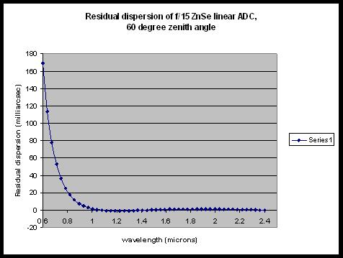
Figure 21. Residual dispersion of f/15 ZnSe linear ADC at 60º zenith angle.

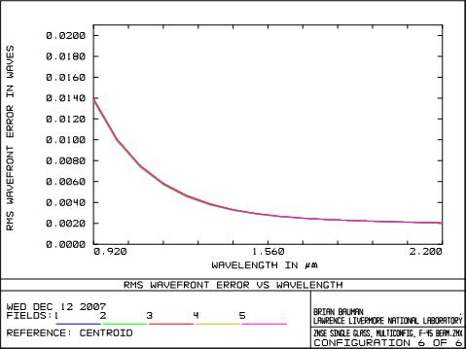
Figure 22. F/45 ZnSe linear ADC rms wavefront error.

Pupil Distortion
Pupil distortion in the NGAO cascaded relay manifests itself in several ways. The first two of these are evaluated in this section: the degree to which a grid of points on the primary mirror maps to a square grid on the DM and the field dependent pupil aberrations.

Two other factors (not evaluated here) are: pupil tilt on the DMs (this manifests itself not only as an uncertainty in the conjugate height of the correction, but also in plate scale errors that can degrade the astrometric accuracy) and DM-to-lenslet mis-registration and scale errors (these are dependent on the pupil reimaging optics chosen for the wavefront sensors).

In the analysis, the telescope primary became the “object”, and field points were defined on the edges of the primary mirror. Observed field angle was set by adjusting the “stop” size placed at the Nasmyth focus to accommodate a 150" diameter field for the woofer, and a 30" diameter field for the tweeter in the narrow-field relay. Results are shown in Table 10. Figure 23 and Figure 24 and display grid distortion and the pupil PSFs for the woofer DM. Figure 25 and Figure 26 show the same things for the tweeter DM.

Table 10. Characteristics of the pupil image on the deformable mirrors.
 | Diameter (mm) | Field (″) | # actuators | Curvature (mm) | Max Grid Distortion | Pupil PSF (μm)
DM1, woofer | 100 | 150 | 20x20 | 5500 | 0.4% | 400
DM2, tweeter | 25 | 30 | 64x64 | 500 | 0.2% | 38

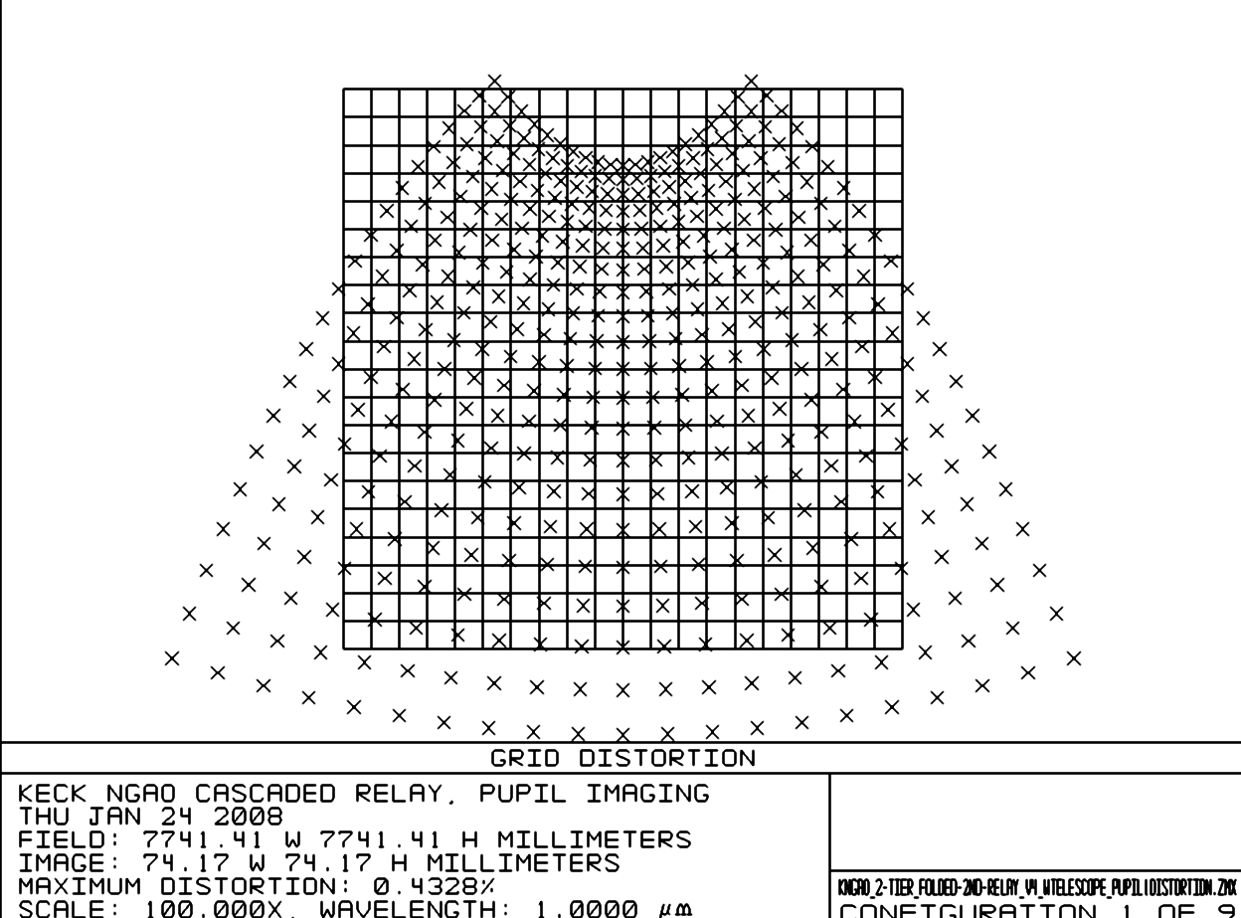
Figure 23. Grid distortion at the woofer DM location, magnified by 100.
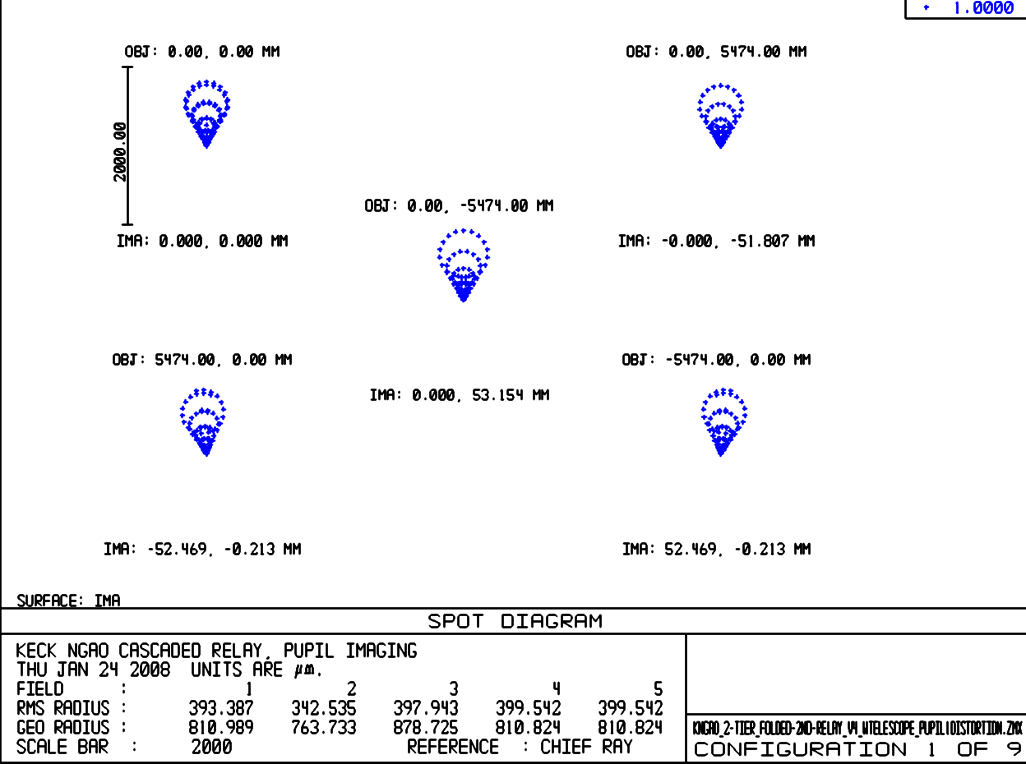
Figure 24. Spot diagrams for 5 locations on the primary mirror imaged onto the woofer DM.
Field considered is 150" diameter. Chief rays from the on-axis field angles make up the point of the comatic pattern, while chief rays for75" off-axis field angles make up the outer “radius” of comatic points.

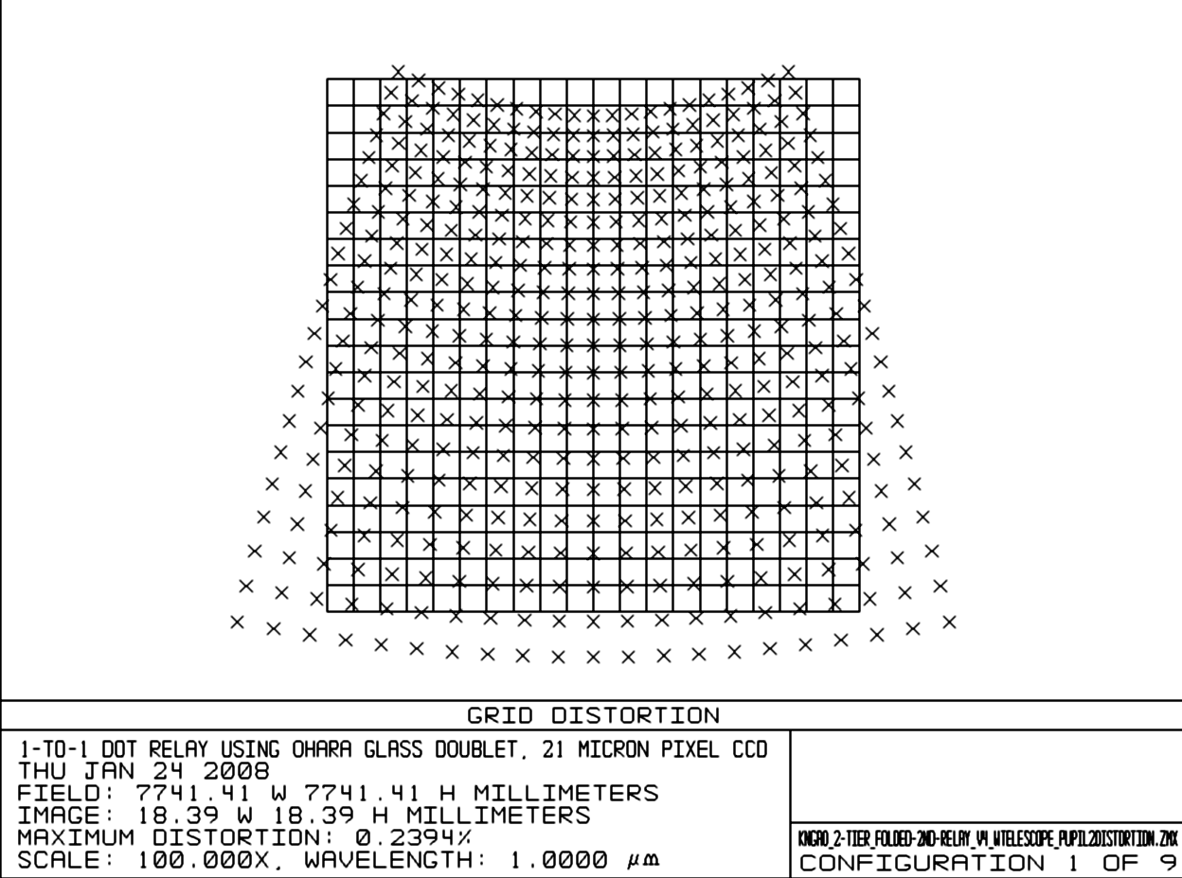
Figure 25. Pupil grid distortion at the tweeter DM position, magnified by 100.

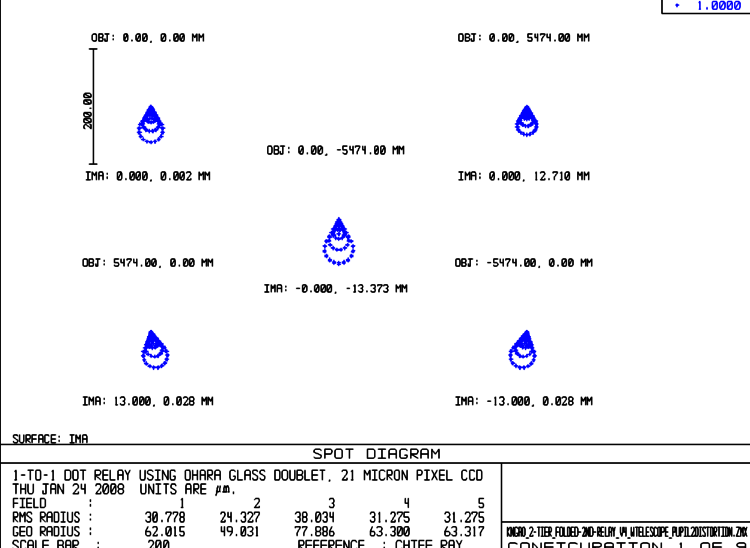
Figure 26. Spot diagrams for 5 positions on primary mirror imaged onto the tweeter DM.

AO Enclosure
The AO enclosure conceptual design is documented in KAON 563. The 3D model shown in Figure 2 was developed to support this design. The current design makes full use of the entire left Nasmyth platform and covers an area of 6.1 x 9.1 m. A working height of 2.59 m is provided with an overall working height of 3.35 m.

The cold room requirements include ≥ -20º C operating temperature, class 10,000 clean room and humidity ≤ 50%. Entrance to the main room will be via an ante-room (2.4x2.4x3.35m).

A proposal for feasibility and budgetary cost was solicited from a commercial supplier of cold/clean rooms, Harris Environmental Systems, Inc. The equipment supplied as part of the proposal includes all floors, walls, ceiling, redundant cooling and clean room process equipment, piping from the Keck machinery room and installation. A number of issues have been identified that will need to be addressed during the preliminary design, including extending the enclosure into the elevation bearing and identifying azimuth wrap space for the refrigeration system.

An alternate approach, which may need to be selected for cost reasons, is to only cool the AO bench itself. The visible and NIR imagers would be inside this enclosure and the fronts of the d-IFS and OSIRIS might mate to this AO bench cold area.

Alignment, Calibration and Diagnostics

Simulator

System Alignment Tools

Atmospheric Profiler
The initial requirements and design for an atmospheric profiler are KAON 552. A profiler was deemed to be useful for NGAO for the following reasons:

- Acceptance testing and performance verification (in order to know the performance versus the current conditions).
- Diagnostic tool during observing.
- Aid to planning observations.
- Improve accuracy or speed up the convergence of the laser tomography algorithm.
- Useful as an aid in estimating the AO PSF across the instrument field of view.

The highest level requirements were determined to be:

- Measure atmospheric profile at low resolution in six or more altitude bins between 1 km and 20 km altitude.
- Measure the profile once every 2 minutes.
- Measurement accuracy of 10% or better for r₀.
- Operate automatically when conditions are suitable for operating the Keck telescopes.
- Small physical size.

A brief overview of the available technologies for optical measurement of atmospheric turbulence is given in KAON 552. A MASS/DIMM system was recommended as the best system to meet the NGAO requirements. The NGAO team has significant experience utilizing and interpreting the data from the TMT MASS/DIMM that is located on Mauna Kea (KAONs 415, 420 and 496). Continued use of this TMT system and/or of a joint Mauna Kea facility are being pursued. The proposed location for the Mauna Kea facility is shown in Figure 27.

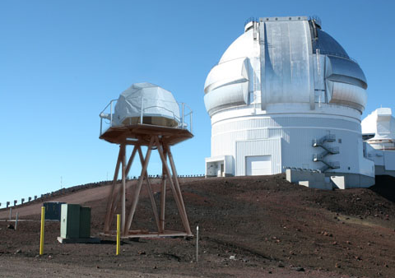
Figure 27. TMT seeing monitor superimposed on proposed site for Mauna Kea facility seeing monitor.

Laser Facility Description

Laser
A comparison of lasers currently in use at various facilities can be found at http://lao.ucolick.org/twiki/bin/view/CfAO/SodiumLaserGuidestars. A laser choice has not yet been made, however two types of solid state sum-frequency lasers are the most likely candidates for consideration:

- The Starfire Optical Range (SOR) laser in use at SOR. This laser has the highest measured return per Watt and the highest power of the existing lasers. A second generation, two frequency laser is currently under development for improved sodium efficiency.

- The LM/CTI laser. The first generation of this laser is in use at Gemini-North. In a combined Keck/Gemini experiment the Gemini-North laser was demonstrated to have twice the return of the Keck dye laser. The second generation of this laser is currently being fabricated for Gemini-South and Keck I. This is the only commercially available laser that could meet our needs.

We also intend to monitor the progress of fiber lasers. ESO is working with Volius to develop a Raman fiber laser and LLNL also continues to develop their fiber laser. Volius is currently building a low power sodium wavelength laser for Keck. The LLNL fiber laser will be demonstrated in the VILLAGES experiment at Lick.

Laser Enclosure and Beam Transport

The laser enclosure conceptual design is documented in KAON 564. Since the laser has not yet been selected three cases were considered during the system design. In general, if fiber beam transport is feasible for the selected laser then this would be the preferred method to transport the laser light from the laser enclosure to the launch telescope located behind the secondary mirror (note that this approach is currently being implemented for the Keck I LGS AO system). The three cases considered include beam transport concepts that do not rely on fibers. For reference, the Keck II telescope including the existing AO and laser enclosures and laser launch tube are shown in Figure 28.

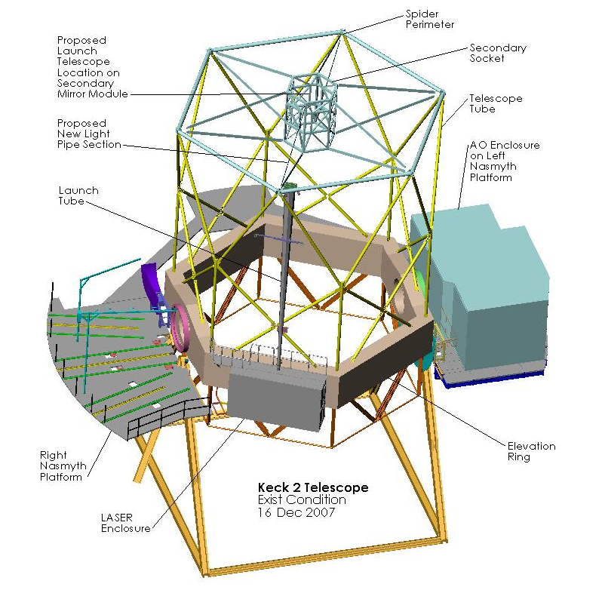
Figure 28. Existing Keck II Telescope and laser location case 1.

The first case considered is for a laser that can operate with a changing gravity vector. In this case the laser could be mounted on the elevation ring of the telescope. One option would be to house the laser in the existing laser enclosure on the right-front wall of the elevation ring (assuming it meets the size and weight restrictions). The laser electronics that do not have to be co-located with the laser could be housed in an electronics enclosure on or below the left Nasmyth platform, similarly to the existing auxiliary laser electronics and cabling would run through one of the existing elevation cable wraps. The laser transport optics and beam path could be enclosed in a tube running up the telescope tube to the perimeter of the spider (similar to the existing launch tube) and across to the launch telescope behind the secondary mirror.

If the laser cannot be tilted then it needs to be housed on the part of the telescope that moves in azimuth. Two options were considered for this scenario. The ideal option of transporting the laser beam onto the elevation portion of the telescope along the elevation axis was not considered since this axis is blocked by the AO system on the left Nasmyth platform and NIRSPEC and DEIMOS on the right Nasmyth platform.

One option would be to house the laser in the existing AO electronics or a new room at this location as shown in Figure 29. The NGAO electronics could then be housed in a new enclosure under the Nasmyth platform. The laser beam could then be directed out through the enclosure roof and folded toward a gimbaled mirror at the elevation ring edge of the enclosure roof. This mirror would track as a function of telescope elevation to maintain the beam centered on a gimbaled mirror at the top of the spider which would in turn track to maintain the beam direction toward the launch telescope behind the secondary mirror. A telescoping tube between the two gimbaled mirrors could be used to enclose the beam as the distance between the gimbaled mirrors changed versus elevation.
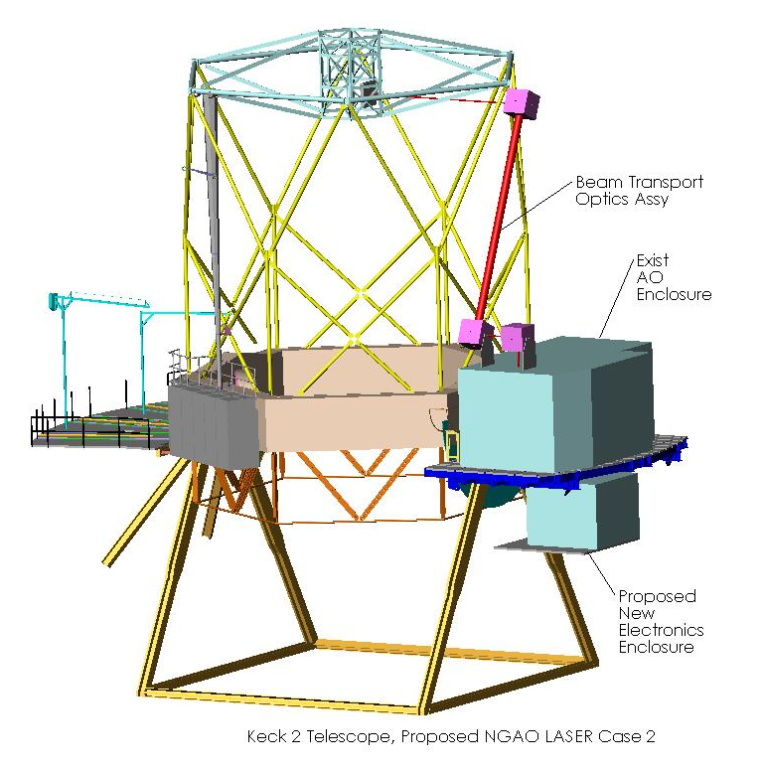
Figure 29. Laser location case 2.

The second option considered would be to build a new platform and laser enclosure between the existing left Nasmyth and Cassegrain platforms as shown in Figure 30. The beam transport system in this case could be similar to that proposed in case 2 with the addition of an extra fold mirror on the top of the new laser enclosure to fold the beam to a fold mirror on top of the AO enclosure.

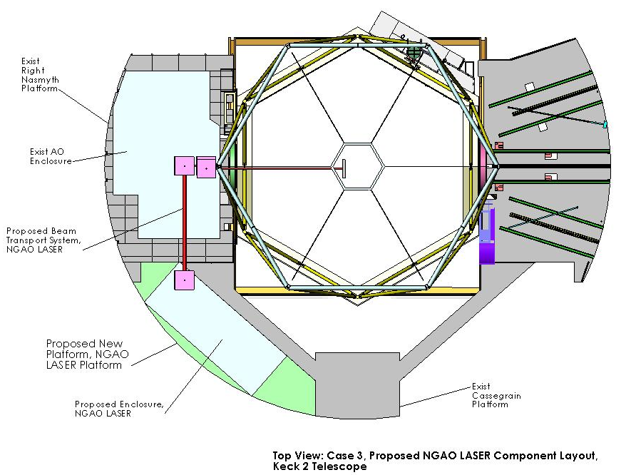
Figure 30. Laser location case 3.

If the laser were to be mounted on Keck I instead of Keck II the same options as above would exist, except that for case 1 there is no existing laser enclosure on the elevation ring. In addition, a laser enclosure has been implemented on the right Nasmyth platform of the Keck I telescope as shown in Figure 31 and Figure 32 that could potentially be reused for the NGAO lasers. The laser bench accommodates a 20W LMCT laser.

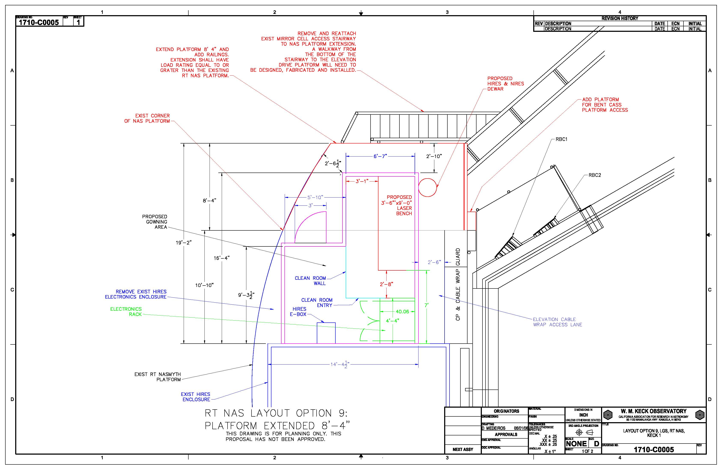
Figure 31. Laser enclosure location on the Keck I right Nasmyth platform.

Figure 32. Keck I laser enclosure.

Laser Beam Transport
Two options will be considered for transporting the laser light from the laser to the top end of the telescope. The favored approach because of its simplicity, especially if the laser cannot be on the elevation ring of the telescope, is to use single mode hollow core photonic crystal fibers. These are being used with the VLT, Subaru and Keck I lasers. Alternatively, a multiple mirror based beam transport system similar to what has been done for Gemini would be considered.

Beacon Projection System
The LGS beacon projection system consists of a beam pattern generation and pointing system and a launch telescope. The launch telescope will incorporate a tip-tilt mirror for correction of the laser uplink tip-tilt and the beam pattern generator may incorporate a beam splitting arrangement so that fewer laser beams will need to be transferred to the top end of the telescope. The beam pattern generator will provide one fixed on-axis LGS beacon, a variable diameter pattern of five LGS beacons from a radius of 11” to 90”, and three additional, pointable, LGS beacons over a range from some tbd minimum radius to a maximum radius of 101”.

An evaluation was performed of the benefits of uplink compensation in KAON 509. For the moment we have decided to proceed without uplink compensation.

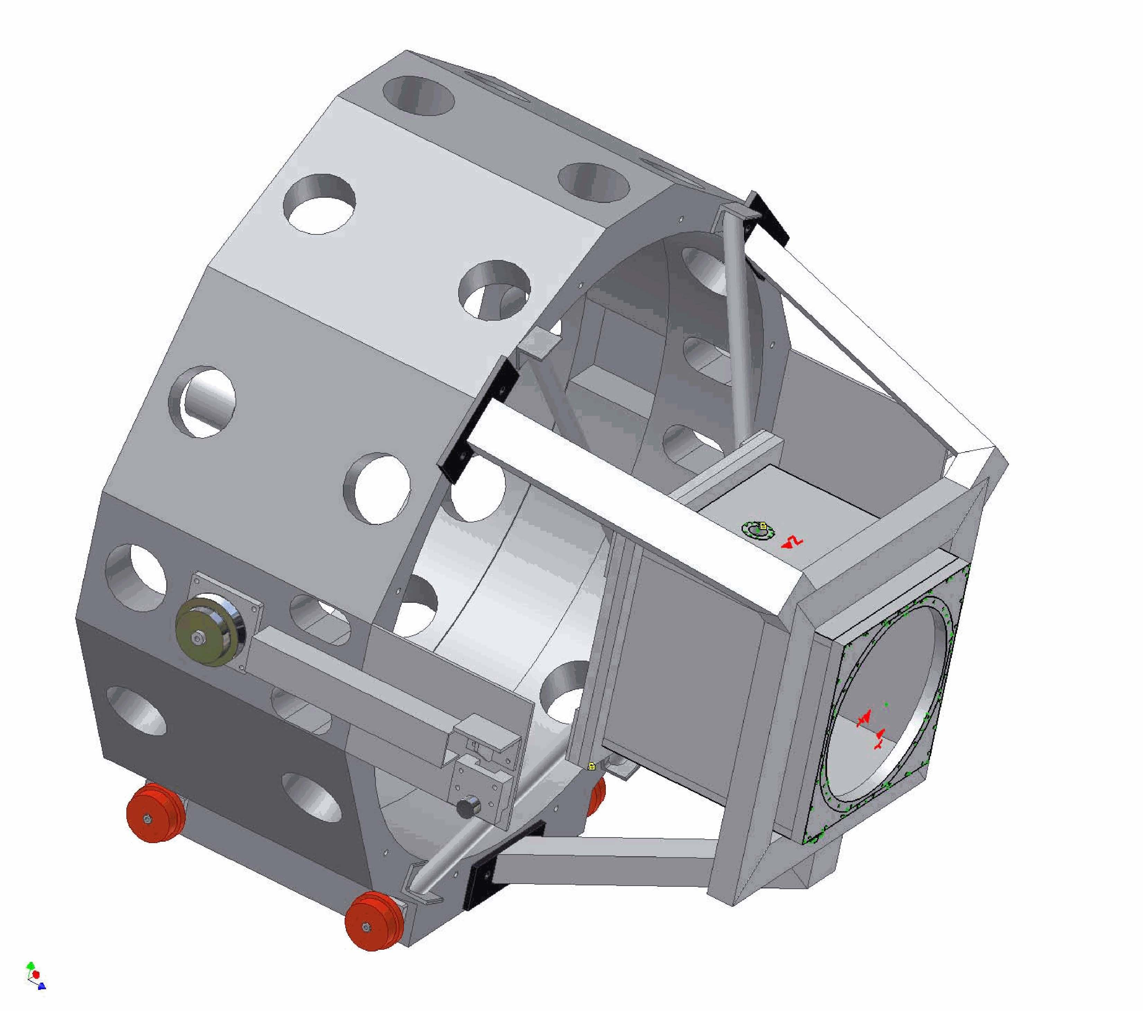
Figure 33. Secondary mirror module and the laser launch telescope being implemented for Keck I LGS AO.

Control Electronics and Software
Electronics and software subsystems are associated with each of the major components of the NGAO system. A block diagram of the NGAO electronics/software subsystems and related external subsystems is shown Figure 34.

Communications between the various subsystems are represented by four control and data paths shown in the figure. The real time data flow (magenta) between the wavefront sensors and the DMs is isolated from other communications flow to provide maximum performance. The “AO Configuration and Status” control path (light blue) is used by the AO sequencer to orchestrate the operation of the AO system. The sequencer establishes configurations for each observation and provides status and control for the non-real time subsystems to the AO host computer via the “Supervisory Control and User Interface” (green). This interface also provides the AO host computer with control and status for the various supervisory controls. The AO sequencer coordinates AO operations with the external subsystems, the instrumentation, telescope drive and control and the primary mirror control system via the “Auxiliary Configuration, Offloading and Status” interface (purple). This includes tip-tilt offloading to the telescope secondary and control of telescope tracking during an observation.

The majority of the AO electronics subsystems will be straightforward designs based on heritage systems, particularly for supervisory controls such as AO enclosure environmental and laser safety. Similarly, instrument electronics will be based on the most current heritage designs from the OSIRIS and MOSFIRE instruments at WMKO. The sensors for the tip-tilt stars will also be based on existing detector technology and readout systems. LGS wavefront sensing electronics will be based on the AO wavefront sensing systems being developed for the TMT through the AODP.

Figure 34: NGAO electronics and software subsystems

The main challenges in the design of the NGAO electronics and software are the demanding real time control requirements for AO in a multi-guidestar system employing tomographic wavefront reconstruction techniques and multiple DMs. Our investigation of the algorithms and data flow needed for AO real time processing and control has suggested that a massively parallel architecture using current state-of-the-art field-programmable gate arrays (FPGAs) can readily accomplish this task.

Non-real-time Control

Real-Time Control
The conceptual design of the real-time control system is documented in KAON 553. The real-time control requirements for NGAO are summarized in Table 11.

Massively Parallel Processing
The proposed massively parallel processing (MPP) system pipeline architecture depicted in Figure 35 implements a three step process: wavefront measurement, tomography, DM fitting. Multiple wavefront sensors, corresponding one to each LGS and tip-tilt star, feed data to a centralized tomography unit. These are inherently parallel operations. Calculation is further parallelized across the spatial dimensions (two dimensions x and y for wavefront sensor and deformable mirrors, and three dimensions x, y, and z for tomography, where z is the vertical direction). For algorithmic reasons, data in x, y planes parallel to the aperture are represented by their Fourier coefficients. Calculations are spread out among processors dedicated to pieces of the x-y Fourier space, slices in the z vertical space, individual wavefront sensors, and individual DMs.

The tomography unit determines an estimate of the differential optical path differences within volume elements of a model atmosphere. This information is then used in a process of determining the desired phase correction at each DM, given a tomographically determined estimate of differential phase aberrations over the atmospheric volume. For MOAO this is the line integral of the turbulence estimate through the volume in the direction of interest. Since the DMs commonly have inter-actuator influence functions, a deconvolution and/or lookup table access must be done for the actuator commands so that the resulting DM shape best fits the new wavefront estimate. Fitting involves deconvolving the DM’s unit response function so that a voltage command can be determined given the desired surface shape. In the case of MEMS in open loop operation, it is necessary to use an additional cascade of two non-linear lookup tables.

The MPP architecture described above has a distinct advantage over a traditional single CPU implementation in that it can scale with the number of guide stars, number of DMs, and number of subapertures by simply adding processor cards without affecting the data throughput rate or the software program significantly.

Control bandwidth | >90 Hz
Wavefront sensor frame rate | 1.5 to 2 kHz
Number of LGS wavefront sensors | 9
Number of tip-tilt sensors | 3
Number of deformable mirrors | Narrow field mode: 1 20 x 20 “woofer” DM, 1 64 x 64 “tweeter DM”, 3 32 x 32 DMs for MOAO correction of the tip-tilt stars.  Wide field mode: 1 20 x 20 “woofer” DM, 3 32 x 32 DMs for MOAO correction of the tip-tilt stars, 6 32 x 32 DMs for MOAO correction in the multi-object deployable IFU.
Reconfigurable for number of guide stars and DMs. Allows differing asynchronous data rates from various wavefront and tip-tilt sensors
Adapts and optimizes for changing seeing and signal-to-noise conditions and incorporates information from external measurements of the C_{n}² profile
Full telemetry and diagnostics streams
Table 11: NGAO real time control requirements

Figure 35: Multi-guidestar AO processing architecture

Tomography
Tomography is accomplished with an iterative back-propagation algorithm depicted in Figure 36 (Gavel 2004, Gavel et al. 2005). The method is analogous to the filtered-back-projection techniques used in modern medical tomography 3-d data analysis. These calculations can be mapped to the massively parallel computer architectures described earlier. During processing, each iterative correction is along a conjugate-gradient direction, resulting in convergence in only a few iterations. Overall, the MPP implementation combined with the fast converging algorithm enable the process to be repeated at the very demanding frame rates of real-time adaptive optics, about once per millisecond .

Figure 36: Tomography algorithm

Laser Safety System

Science Operations
This section discusses the hardware and software needed to control the overall NGAO facility for science operations at both the operator and astronomer levels and the pre- and post-observing support tools.

Science Operation Model
A trade study of possible observing models was performed in KAON 476.

Observing scenarios are documented in the SCRD.

System Configuration
Each science case defined in the Science Case Requirements Document (SCRD) has been mapped to an AO system configuration. This was done to ensure that the NGAO system had all the required functionality and to help map requirements to components. Describe …

System Calibration

System Operation
Several approaches to dithering and offsetting were proposed and discussed in KAON 558. The selected approach …

System Control

Multi-System Command Sequencer

User Interfaces

AO-Instrument Interfaces

Data Server

Pre and Post-Observing Tools

Science Instruments
The philosophy for the NGAO instrument compliment is to address the large parameter space offered by NGAO with specialized instruments, while keeping them as simple as possible. By separating wavelength ranges along natural breakpoints based on optical and thermal design considerations and by providing spectroscopy with IFU’s we can meet the science needs without requiring multimode instruments. The major exception is a multi-object deployable near-IR IFU spectrograph that is of necessity a more complex instrument.

All of the proposed instruments are based either on currently available detector technology or on anticipated evolutionary developments of current technology that we believe will become available within the NGAO development timeframe. Instrument control software and data reduction requirements are expected to be evolutionary developments of current instruments and data reduction tools. It will be important to emphasize close integration with the AO system control software. Features that promote efficient AO observing will be an integral part of the software for every NGAO instrument.

Each of the major science areas has somewhat different instrument priorities. These must be reconciled in order to arrive at a useable priority list. Two important additional inputs to the setting of instrument priorities are the need for appropriate instrumentation for first light commissioning of the AO system, and the relative timescales required for development of the various instruments. Based on the science priorities and these other considerations we have identified the instrument priorities shown in Error: Reference source not found.

Single object Instruments |  | Multi-object Instruments
Name | Priority | Name | Priority
Near-IR imager | 1 | Deployable near-IR IFU | 1
Visible imager | 2
Near-IR IFU (OSIRIS?) | 3
Visible IFU | 4
Table 13: NGAO instrument priorities

The near-IR imager will be the first-light commissioning instrument for NGAO. The multi-object deployable near-IR IFU is a high priority instrument, but because of its complexity, it will also have the longest development timeline. Therefore, it is important that its development be started as soon as possible. In view of the development timeline for the deployable near-IR IFU, the single object near-IR IFU is ranked third because of the clear importance of near-IR spectroscopy.
Initial requirements for the imagers are summarized in Error: Reference source not found.

Visible and NIR Imagers

Instrument |  | Wavelength coverage (µm) |  | Field of view |  | Sampling
Visible Imager | 0.7 to 1.0 |  | 20” x 20” |  | Nyquist (6 mas)
Near-IR Imager | 1.0 to 2.45 |  | 20” x 20” |  | Nyquist (10 mas)
Table 15: NGAO imager requirements

Visible and NIR Spectrographs
The initial requirements for the single object near-IR IFU are as follows:

Wavelength coverage: 1.0 to 2.45 µm | Spectral resolution: R ~4,000
IFU Spatial sampling:  - 80 x 50 samples in a broad band mode  - 160 x 50 samples in a narrow band mode | Spectral sampling:  - ~2,000 pixels/spectra in broad band mode  - ~1,000 pixels/spectra in narrow band mode
Optional selection of sampling scales: 100, 50, 20 mas

With the exception of the field of view, OSIRIS meets many of the requirements for this instrument. See KAON 493 for a discussion of the possible reuse of OSIRIS with NGAO.

The initial requirements for the single object visible IFU are as follows:
Wavelength coverage: 0.7 to 1.00 µm | Spectral resolution: R ~3,000
IFU Spatial sampling:  - 60 x 68 samples in a broad band mode  - 120 x 68 samples in a narrow band mode | Spectral sampling:  - ~2,000 pixels/spectra in broad band mode  - ~1,000 pixels/spectra in narrow band mode
Optional selection of sampling scales: 50, 35, 20 mas

NIR Deployable IFU
The initial requirements for the multi-object deployable near-IR IFU are as follows:

Wavelength coverage: 1.0 to 2.45 µm | Sampling scale: 50 mas
Multiplex: minimum of 6 deployable IFU heads | Spectral resolution: R ~4,000
Spatial sampling per IFU head: 60x20 samples minimum | Spectral sampling: ~2,000 pixels/spectra

Interferometer
It is a requirement for the Interferometer to be supported by AO on both telescopes in the NGAO era. This could be a direct feed from NGAO, most likely after the first relay, or by a separate AO system, which imposes a requirement on being able to exchange AO systems. A trade study was performed on the issue of Keck Interferometer support which is documented in KAON 483. The primary requirements are to achieve at least the current level of performance while maintaining a common field orientation and polarization from both telescopes.

‘OHANA
Both existing Keck AO systems accommodate an ‘OHANA fiber injection module at the output of the AO systems. NGAO should provide an output port where this or a similar fiber injection module could be located, and whose output could be successfully interfered with the light from another telescope.

Thermal NIR Imager
A thermal NIR imager has not been given a high priority and therefore no significant evaluation has occurred for this instrument. An evaluation of the reuse of NIRC2, which extends out to L and M-bands, was performed as part of KAON 493.

Performance Budgets
Eight performance budgets have been addressed as part of the system design.

Background and Transmission
The background and transmission performance budget is developed in KAON 501.

Both AO relays must efficiently transmit the science wavelength light from 0.7 to 2.4 μm (with a goal of 0.656 to 2.4 μm, so as to include Hα). The first relay must also efficiently transmit sodium wavelength light (589 nm) and the additional L-band light (3.4 to 4.2 µm) for the interferometer. This wavelength range must be efficiently divided between the various sensors (LGS and tip-tilt) and the instruments.

Near-IR light will be shared between the tip-tilt sensors and the narrow field instruments. This will require the near-IR beamsplitter for the OSM to be a set of selectable dichroics. This will send some of the near-IR light (for example J and H bands) to the tip-tilt sensors while sending the balance to the narrow field instruments (visible and K band for example). Excellent coatings will be required for all surfaces

The design choice to achieve the K-band background requirement is to cool the AO optics to 260 K.

The sensitivity delivered by the NGAO system is significantly affected by the total background seen by the instruments. In the present Keck telescope AO systems background is recognized as a significantly limiting sensitivity, particularly for the K band.

Part of the solution to reducing background is the control of scattered light through careful design and implementation, and the use of hexagonal, rotating cold stops matched to the shape of the telescope pupil in the near-IR instruments. However, thermal emission is a significant factor for near-IR observations, particularly longward of 2 µm. Using data from the current Keck II telescope AO system we have developed a model of the background contributed by sky + telescope + AO system that indicates the AO system optics should be cooled to 260 K.

Wavefront Error and Ensquared Energy
Should be inserted somewhere in this section: A detailed assessment of the Keck II AO performance and expected improvements for the NGWFC, Keck I LGS AO upgrade and NGAO is given in KAON 461. The following table shows the current NGWFC performance and the expected Keck I LGS performance developed using the NGAO error budget tool.

Table 17. The NGAO error budget tool accurately models the current Keck II AO performance with the NGWFC upgrade. The tool has also been used to predict the expected performance from the Keck I LGS AO upgrade.
Error Term | KII Baseline | K I (linear pol.) | KI (circular pol.)
Atm. Fitting | 118 | 118 | 118
Tel. Fitting | 66 | 66 | 66
Camera | 110 | 110 | 110
DM Band | 125 | 96 | 88
DM Measure | 152 | 104 | 96
TT band | 102 | 102 | 102
TT measurement | 23 | 23 | 23
LGS focus error | 46 | 19 | 19
Focus Aniso. | 164 | 164 | 164
LGS HO error | 80 | 50 | 50
Miscellaneous | 70 | 70 | 70
Calibrations | 30 | 30 | 30
Total Wavefront Error | 348 | 312 | 306
K band Strehl | 0.37 | 0.45 | 0.46

The wavefront error budget is described in KAON 471. The primary tool is an excel spreadsheet (current version Wavefront Error Budget Tool v1.26.xls). This budget is supported and anchored by a number of KAONs. The atmospheric assumptions summarized in KAON 503 are based on previous seeing studies (KAON 303) and new TMT site monitoring data (KAON 415 and 496). The sodium return assumptions are based on sodium density from Keck LGS photometry (KAON 416), long term LIDAR measurements on Haleakala (KAON 417) and comparisons to measured returns from Gemini and Keck (KAON 419). The wavefront error budget tool has been anchored to the performance of the existing Keck AO system in KAON 461. The contribution of Keck telescope segment figure errors is determined in KAONs 468 and 469, and the overall contribution of the telescope to the wavefront errors is determined in KAON 482. Finally, several tomography codes were compared (KAON 475) in order to validate the tomography assumptions used in the wavefront error budget and the null and quadratic mode tomography errors were evaluated (KAON 492).

Related analyses include sky coverage modeling (KAON 470) and performance versus field of view for low order wavefront sensor guide stars (KAON 504).

The AO system architecture is driven by the required wavefront error to incorporate a number of innovative subsystems that work together to overcome specific effects that limit the quality of the AO correction provided by the system. These include multiple LGS beacons and a corresponding number of LGS wavefront sensors, multiple tip-tilt stars, a tomographic wavefront reconstructor and high order correction.

A minimum of 64 x 64 actuators is required over the telescope pupil to meet the most demanding narrow field residual wavefront error requirement of 140 nm. Such high actuator counts are only practical with MEMS DMs. The multiple LGS require a larger technical field of view than what can practically be accommodated with the very small actuator spacing of MEMS DMs. This would lead to operating the LGS wavefront sensors entirely in open loop, a risky design approach. To address the problem a two DM design is employed, with the first DM with 20 x 20 actuators providing low order correction for the LGS in a closed loop. The second DM is a MEMS DM operated in a feed forward or “go to” control mode. Multiple MEMS DMs are used, one for the narrow field relay, and one for each of the tip-tilt sensors, and for each head of the multi-object deployable near-IR IFU.

A wavefront error budget for NGAO has been developed using Excel spreadsheet tools developed over several years for the engineering evaluation of AO system performance. The primary purpose of the spreadsheet is to compute AO and instrumental wavefront error budgets for different architectures and science cases, along with Strehl ratios computed using the Marechal approximation. The spreadsheet also computes ensquared energy fractions using a core/halo model for the point spread function, and calculates sky coverage estimates for tip-tilt guide stars employed in LGS architectures from common star density models. The spreadsheet has been validated by comparing the spreadsheet predictions to the current performance of the Keck II LGS AO system with good agreement.

Our study of the performance of the selected AO system architecture shows that it is quite flexible, permitting optimization of the residual wavefront error for a wide range of observing conditions. The spreadsheet tool was configured to optimize the H band Strehl ratio, and certain parameters such as LGS constellation radius, high order update rate, and tip-tilt update rate were allowed to vary within appropriate constraints in order to optimize the Strehl ratio. Examples from this study of the wavefront error budget are shown in Error: Reference source not found. It should be noted that these examples are based on an earlier relay design using a single 64 x 64 actuator DM, a single tip-tilt star and an LGS constellation consisting of just the central LGS and the four equally spaced LGS in a variable radius. No additional LGS were deployed to sharpen the tip-tilt star.

Observation | Int. time | TT reference | LGS diameter, " | TT error, mas | Sky coverage | High order wavefront error, nm | Total wavefront error, nm | Strehl (1.65 μm)
Io | 10 s | Science target | N/A | 1.7 | N/A | 96 | 98 | 87%
Kuiper Belt | 300 s | Field star | 41 | 6.2 | 10% | 150 | 184 | 61%
Exo-Jupiter | 300 s | Science target | 12 | 3.3 | N/A | 124 | 137 | 76%
Extragalactic | 1800 s | Field star | 90 | 18.5 | 30% | 159 | 329 | 25%
Galactic Center | 30 s | IRS 7 | 11 | 2.0 | N/A | 170 | 174 | 64%
Table 18: Wavefront error budget summary

The first column of the table indicates the observing scenario. The second column indicates the integration time assumed for the science exposure. The third column indicates the tip-tilt reference used, and the fourth column gives the diameter of the LGS variable radius constellation. The fifth column indicates the tip-tilt error that results from the assumed angular offset of the tip-tilt star. The sixth column gives the sky coverage fraction over which the tip-tilt error will be less than or equal to the error given in column five. This estimate results from the use of common sky coverage models (Spagna and Bachall-Soneira). The last three columns give the high order wavefront error, the total wavefront error with tip-tilt errors, and the H band Strehl. For the extragalactic case, the figure of merit is ensquared energy rather than residual wavefront error, for the 50 mas spatial sampling of each head of the multi-object deployable IFU the ensquared energy is 37%.

These results show that the variable radius LGS constellation and the performance levels assumed for the tomographic wavefront reconstruction, LGS wavefront sensors and near-IR tip-tilt sensors are capable of providing performance that is generally at the level required by the science cases. Initial estimates of NGAO system performance based on laser tomography AO resulted in the adoption of three representative values of residual wavefront error for the science case simulations: 140 nm, 170 nm and 200 nm. This has led to further work to develop additional techniques for performance improvement including the additional three freely positionable LGS (see §Error: Reference source not found) and the additional tip-tilt sensors.

The sky coverage fractions required by the extragalactic and Galactic science cases requires optimizing the offset and brightness of the tip-tilt stars. This is accomplished by increasing the faint magnitude limit for tip-tilt stars through the use of tip-tilt sensors operating at near-IR wavelengths combined with MOAO correction using deployable LGS beacons specifically for tip-tilt reference sharpening, and by providing a 180" field of view for tip-tilt star selection.

Photometric Precision
Requirements for photometric measurements in the NGAO science cases range from 0.05 to 0.1 magnitudes in relative photometry, and ≤ 0.05 magnitudes for absolute photometry. The fundamental condition for high photometric accuracy is stability of the PSF. Because of the high Strehl delivered by the NGAO system, a more stable PSF is expected. Many of the science cases that require the highest photometric accuracy are observing a science target of sufficient brightness (H < 16) to permit use of the science target as an on-axis tip-tilt reference, further improving Strehl performance.

Analysis of NGAO photometric accuracy requirements also leads to a number of other technical requirements related to the PSF. These include obtaining precise knowledge of the AO system PSF through provisions for PSF calibration and monitoring. NGAO may need to provide a PSF monitoring imager deployable over the AO system technical field of view to allow simultaneous PSF imaging during observations. Recent work at Palomar (Britton 2006) has shown that real time turbulence monitoring giving C_{n}² data during the observation is also useful in improving the results of PSF post processing. This post processing will also be supported by facility PSF deconvolution software.

Astrometric Precision
Astrometry is important for a number of the Galactic and Solar System science cases. The most demanding requirements are for observations of the Galactic Center where precision of 100 μas is required. The current Keck II LGS AO system with the NIRC2 instrument is able to achieve best-case precision of 250 μas. The high Strehl of the NGAO system (~3 times that of the current LGS AO system under similar conditions) will make a significant contribution to the accuracy of astrometric measurements by reducing source confusion. In addition, studies of the astrometric precision of the current Keck II LGS AO system indicate that geometric distortion, differential tilt anisoplanatism between the science target and off axis tip-tilt stars (increasing with increasing distance between the two), and differential atmospheric refraction all contribute to the error in astrometric measurements.

The same features provided to monitor the PSF and monitor atmospheric turbulence for photometric accuracy would contribute to NGAO astrometric precision. Geometric distortion in the AO system and instruments will be minimized during design and facilities will be incorporated for mapping residual distortion during commissioning. Improved mechanical stability is also a fundamental part of the design of the NGAO system and instruments.

The NGAO system will incorporate an ADC to reduce the effects of atmospheric refraction, and differential tilt anisoplanatism will be reduced by the use of multiple, optimally located tip-tilt stars. Alignment tools for these multiple tip-tilt stars will minimize plate scale changes due to the AO correction.

Companion Sensitivity
Another important area for NGAO science is high contrast observations. The Strehl proposed for NGAO is lower than extreme AO systems such as the Gemini Planet Imager, but at the same time, NGAO will provide higher sensitivity and sky coverage that greatly exceeds that of an NGS-only extreme AO system. While our analysis of the contrast performance needed indicates that a conventional occulting spot coronagraph with an apodized (hexagonal, rotating) Lyot stop will meet the needs of the majority of the NGAO high contrast science cases, we are also investigating the use of more advanced techniques such as non-redundant aperture masking.

The level of contrast achieved with NGAO will also depend on the control of systematic errors such as non-static, non-common path aberrations, servo lag error and various sources of speckle. Speckle suppression techniques including spatially resolved spectroscopy will be available for NGAO observations.

Polarimetric Precision

Observing Efficiency and Uptime
KAON 463 discusses the observing efficiency and uptime of the existing Keck LGS AO system for reference.

Requirements Compliance

Alternate System Architectures
During the selection of the system architecture described in this document several alternate architectures were also evaluated including:

- Split relay. The LOWFS, NIR deployable IFU and LGS wavefront sensor are fed directly from the telescope (and therefore must rotate). The narrow field science instruments are fed by a refractive AO relay including a K-mirror and ADC. Some technical evaluation details for this architecture are discussed in KAON 506.
- Adaptive secondary mirror. All of the science instruments and wavefront sensors are fed directly by the telescope. An adaptive secondary trade study was performed in KAON 485. The existence of an adaptive secondary could potentially improve the performance on seeing limited instruments, and would offer the optimal approach to a ground layer AO system (see KAON 472).
- Large relay. A large rotator and AO relay feed all of the science instruments and wavefront sensors. This is the architecture that was described in the NGAO proposal (KAON 400).
- Keck I upgrade. Quite similar to the selected cascaded relay approach. The NIR deployable IFU and LGS WFS both follow the existing AO relay. A second, higher order relay feeds the narrow field science instruments. The difference is that this is an upgrade to the existing system, rather than a fresh start. KAONs 500 and 502 describe this upgrade in some detail.

Each of these architectures, along with the cascaded relay, are described and evaluated in KAON 499.

Trade Studies
A number of trade studies were performed early in the system design phase to inform the system architecture down select and design choices. A list of these trade studies is provided in Table 20.

Table 20. List of trade studies performed.
Trade Study Title | KAON #
MOAO & MCAO | 452
NGAO Versus Keck AO Upgrades | 462
Adaptive Secondary Mirror Option | 485
Keck Interferometer Support | 483 (& 428)
GLAO for non-NGAO Instruments | 472
Instrument Reuse | 493
Telescope Wavefront Errors | 482
Observing Model | 476
Rayleigh Rejection | 490
LGS Wavefront Sensor Type & number of subapertures | 465
Low Order Wavefront Sensor number & type | 470
Low Order Wavefront Sensor Architecture | 487
LGS Asterism Geometry and Size | 429
Variable Versus Fixed LGS Asterism Geometry | 427
Uplink Compensation | 509

MOAO and MCAO Trade Study
This trade study lists the following top-level conclusions.

The science advantages of MCAO are:
1) Contiguous AO-corrected field of view
a. Choice of PSF stars in the field
b. Higher packing density of IFU pickoffs
c. Very extended objects: Jupiter, Saturn, Uranus rings
d. Long exposure of hi-Z field galaxies
2) DMs in closed loop, eliminating DM calibration error and drift

The science disadvantages of the MCAO architecture are:
1) Higher field-dependent anisoplanatic error than a MOAO system
2) Extra surfaces in the relay contribute to background emission and reduce throughput.
3) DMs in series could distort the contiguous field randomly resulting in higher astrometric error.
4) Front-end relay adds field and zenith dependent distortion and aberration into the LGS beams, which even if pre-calibrated, will introduce some amount of wavefront error to the science beams via the closed loop.

The science advantages of MOAO are:
1) Lower isoplanatic error at the science field points
2) MOAO units are deployable on a wider field of regard than MCAO, sky coverage is enhanced by correcting tip/tilt stars with their own MOAO units, allowing dimmer tip/tilt stars than with MCAO.
3) Reduced number of optical surfaces for AO correction that minimizes emissivity and optimizes throughput
4) No field distortion introduced by DMs in series.

Science disadvantages of the MOAO architecture are:
1) Discontinuous field of view hampers crowded field studies, e.g. contamination by nearby stars’ seeing halos, which are not imaged and so, cannot be PSF subtracted.
2) Cannot image large extended objects
3) DMs are open loop controlled and are thus subject to calibration and drift error.

The MCAO architecture has the following implementation advantage:
1) AO control of DMs is closed-loop, allowing feedback of mirror shape to the control system.

MCAO has the following implementation disadvantages:
1) Powered relay optics and DMs not conjugate to the ground must be larger diameter than a DM at a pupil.
2) The AO relay introduces non-common-path aberration and pupil distortion and may force custom design of the wavefront sensor optics to compensate. The custom optics may need to have moving components in order to track sodium layer distance change with zenith angle.
3) Pupil size has a lower limit set by physical optics. This size is larger than MEMS DMs produced today

The implementation advantages of MOAO are:
1) MEMS are small, enabling the AO systems to be tucked into instruments, making them ideally suited for compact MOAO units.
2) MEMS are low cost. The marginal cost of scaling to high actuator counts is considerably lower than that for large DMs. For the BMC devices, this number today appears to be around $200-300 per actuator as compared to about $1500 per actuator on a piezoelectric deformable mirror. The low cost makes it practical to have a spare on hand.
3) “Go-to” repeatability – A major advantage of an electrostatic actuation over piezoelectric actuation is the absence of hysteretic effects in the displacement to voltage response curves. This implies that the devices could be driven open loop to given surface deflections.
4) The low cost and small size of MEMS DMs opens up the possibility of “ubiquitous MEMS,” i.e. devices sprinkled throughout the system to elegantly solve tough optical problems.
a. MEMS DM in each wavefront sensor: This creates a mini closed loop AO system in which the wavefront detector is kept near null, where its linearity properties are best. The predictable voltage response of the MEMS allows it to be used as the probe of the grosser portion of the wavefront shape, which would be added to the wavefront sensor’s residuals to complete the wavefront measurement. A variant of this is to use MEMS DMs to correct for the slowly varying but known non-common path aberrations of LGS wavefronts.
b. MEMS in the tip/tilt sensors: If there are enough degrees of freedom to form diffraction limited cores at the sensing wavelength, fainter guide stars can be used to sense tip/tilt to a given accuracy because centroid error is proportional to the spot size and inversely proportional to square root of brightness. The ability to use fainter guide stars would give us higher sky coverage.

Practical disadvantages of MOAO are:
1) MEMS stroke dynamic range may not be adequate to correct the whole atmosphere, leading to a requirement for dual-mirror “woofer-tweeter” MOAO units. The latest generation of MEMS mirrors under development (a 4000 actuator mirror for the Gemini Planet Imager AO system) should have just enough mechanical stroke to cover 5-σ wavefront variation for the Keck 10 meter tip/tilt removed wavefront.
2) MEMS mirrors have not been shown to work yet in astronomical instruments (this is a risk issue)
3) High-order MEMS are presently available from only one manufacturer (another risk issue)

NGAO versus Keck Upgrade Trade Study
The authors concluded that a Keck AO upgrade was worth further consideration. Implementation options range from an incremental approach, delivering new science capabilities along the way, to a single implementation effort without the interim disruptions to science.

The pros and cons for a Keck AO upgrade include:
1) Pro - Potentially a lower cost. However, as the costs are further evaluated, they would likely increase.
2) Pro - The interferometer’s needs are addressed. This will be a difficult problem for NGAO and might require a complete reconfiguration or AO systems.
3) Con - Likely lower performance ultimately than NGAO
4) Con - Only two science instruments (possibly 3) could be available at any one time, unless the other telescope is also upgraded. Unclear yet how many simultaneous instruments could be offered by NGAO.

A Keck AO upgrade would allow for an incremental approach. The pros and cons for an incremental approach include the following.
1) Pro - Some performance improvements could be available sooner.
2) Pro - The system could be improved as funds became available.
3) Pro - It also might allow for and address the need for periodic replacement and maintenance (and the funds to support these) that could be done as the same time as the upgrades.
4) Pro - This approach doesn’t require as much of an all or nothing risk. Although this risk could be mitigated for NGAO, there is the risk that we would not have the funds to complete the system.
5) Con - Periodic shutdowns would be required which would make the system unavailable for science, although a one-time shutdown might take a substantial amount of time if NGAO is installed in one step.
6) Con - Increases the risk to operations due to a system always under development.
7) Con - Increases the risk to the development team schedule from potentially needing to support an operational system.
8) Con - Adds a constant stress to the development team.

Adaptive Secondary Mirror Options Trade Study
The author of this study noted the following points regarding the use of an adaptive secondary mirror.

1) An ASM offers the lowest emissivity and highest throughput option to the science instrument since it is no longer necessary to have a separate tip/tilt mirror or to re-image the telescope pupil onto a deformable mirror (at least 4 reflections are saved).
2) An ASM combines the tip/tilt, DM, and chopping roles all on the same mirror and therefore provides a more stable thermal background that is easier to subtract.
3) An ASM could potentially be used to replace one or more of the tip/tilt mirror, chopping, and DM roles for the existing AO systems (replace the DM with a flat?) if a Keck AO upgrade path were chosen.
4) There will still be the issue of picking off light for wavefront sensing and dealing with field rotation. A new issue is that the DM (ASM) will be rotating with respect to the wavefront sensing.
5) Space for a laser launch telescope behind the secondary mirror could be built into the ASM design, as opposed to design it into the existing secondary mirror module.
6) The use of an ASM could also allow the AO system to be physically smaller which might allow small field AO systems and science instruments to be placed at Cassegrain. This could also allow the existing AO systems to be left at Nasmyth to feed the Interferometer. Cassegrain would also be the best location for the near-IR deployable IFU since low emissivity is a critical requirement for the extragalactic science.

Keck Interferometer Support Trade Study
The authors of this study state that no ideal solution has been found for supporting the interferometer with NGAO. The following points are noted about each option:

1) Swapping Keck I/II with NGAO
a. Hardware costs relatively low, compared to building new AO systems
b. Cost of moving NGAO is higher than fixed NGAO. This assumes the final design is similar to the proposal design.
2) Matching NGAO to Keck
a. Challenging to match polarization states
b. Likely requires NGAO relay with K-mirror and in plane optics
c. No broad wavelength solution found
d. Lower cost compared to other options, approximately 100K compared to millions
3) Two AO systems
a. AO secondary on each telescope
Elegant solution, but costly
Utility of a shared capability could offset higher costs
b. MEMs AO for each IF arm
Relatively inexpensive
Small footprint allows more mounting/packaging options

The lowest cost option but perhaps the most technically challenging will be matching NGAO to a legacy AO system. A more formal consultation with the Keck Interferometer team was recommended as a next step.

GLAO for non-NGAO instruments Trade Study
The author of this KAON noted that it is clear that there are potential benefits, ranging from modest to significant, to non-NGAO instruments from a GLAO implementation. If a GLAO system for Keck was pursued (independently of NGAO), such a system would require the existence of an ASM and at least 4 LGS. These might be acquired as part of NGAO or as a separate project. Following the design of these subsystems, the next technical study should investigate the most efficient WFS implementation and look into the technical solutions that have the best cost/capability trade. New WFS modules could be built exclusively for each non-NGAO instrument that wanted to use GLAO. A simpler alternative might be building a single GLAO WFS module that could make GLAO available to all instruments at a given focus, e.g. all Nasmyth instruments or all Cassegrain instruments.

Telescope Wavefront Errors Trade Study
The main results of this trade study can be summarized as:
1) Full aperture tip tilt errors could dominate the tip/tilt error budget.
a. Resulting in poor sky coverage
b. “Encircled Energy Science” might be impacted less
2) Segment motion
Acceptable error, comparable to NGAO June 2006 proposal and current error budget
3) Segment figures
Acceptable error, comparable to NGAO June 2006 proposal and current error budget
4) Segment phasing
Small, needs to be added to NGAO budget, interaction with figure errors not tested
5) Fast guiding on stars outside NGAO corrected field of view appears feasible

The trade study authors’ recommendations would be
1) Perform additional analysis of the gains in tracking beyond the simple PI controller considered in this study. Examples would be parametric oscillator and Kalman filters.
2) Understand what might be done to reduce 29 Hz vibrations in telescope segments, secondary, and tertiary.
3) Continue to investigate ways to improve the segment figures. NGAO should leverage information from the TMT study of warping harness at Keck.

Based on this study, it appears that full aperture tilt needs to be given higher priority in the NGAO design and in mitigation efforts with the current Keck AO system. Other telescope wavefront errors appear to be accounted for correctly in the NGAO error budget. It would be advantageous to reduce 29 Hz vibration drivers such as pumps and motors even further, as this is cost effective compared to the cost of an additional “fast guider” for NGAO. The possibility of using seeing limited guide stars outside the corrected field of NGAO appears feasible and should be studied further than the simple scaling law analysis included in this report.

Observing Model Trade Study
The authors presented a trade study for the NGAO observing models by first defining top-level goals for NGAO science operations. They then reviewed and discussed the existing classical and queue-service models from the published data. They have presented three case-study observing models to further assess a range of possibilities for NGAO. The authors recommend that the NGAO observing model be neither the lean-classical observing model nor the queue-service observing model and they recommend working with the Keck science community to develop a new flexible observing model (possibly phased) for NGAO.

The authors further recommend that the NGAO science operations strongly support the top-level goals that emphasize the need for high quality data products and our given estimate for that effort. They note that this will require designing and building an extensive suite of simulation and observing tools for the AO and the science instruments. It additionally requires the development of reliable and accurate calibrations methods for photometry and astrometry. This implies knowledge of the PSF across the science field of view. The authors note that a great deal of potential synergy exists between the Observatory and the community to support the science goals and minimize the implementation costs of observational tools.

Rayleigh Rejection Trade Study
The authors of this study note that fratricide due to Rayleigh scatter is a serious issue for a 5 laser beacon AO system. It is ideal to use a 1-3 micro-sec pulsed laser to mitigate this problem. In the event of this not being available, and mode-locked CW laser being the only option, appropriate background subtraction, projection location, baffles, and stops are to be chosen. The authors note that the effect of fratricide still needs to be quantified more accurately via detailed simulations, though the current study has developed a preliminary model of this effect. The authors advise that NGAO use a center projection method for the LGS. The authors recommend that a safety margin must be included in the error budget to account for the short and long term fluctuations in Rayleigh scatter caused by variations in the atmosphere. Although laser collisions, which is observing through the laser beam projected from another telescope, are to be avoided, it does not actually render the data useless. The effect of a collision is comparable to the sky background at Mauna Kea in the V-band.

LGS Wavefront Sensor Type and Number of Subapertures Trade Study
The authors of this study recommended that if NGAO chooses to use a CW laser it is best to work with a Shack Hartmann WFS and a radial geometry CCD. Both technologies are mature (as compared to counterparts) and the advantage of pyramid WFS is only a few (less than 5 nm) nm in WFE as presented by current models. In the wide field cases, the majority of the error (288 nm) comes from tomography.

The authors of this study performed a benefit vs. cost (laser power) analysis using Rich Dekany’s WFE spreadsheet with the general assumptions described in the report. Additional assumptions and parameters were used to simulate the science observing scenarios: the atmosphere used was based on KAON 303 and pixel charge diffusion was assumed to be 0.3 pixels for the Shack-Hartmann WFS case. With a pyramid WFS, the charge diffusion was assumed to be zero. The Shack Hartmann wavefront sensor charge diffusion and the AO spot size summed in quadrature was used instead of the lenslet diffraction spot size. No MEMS mirror based active correction of the spot size at the WFS was considered.

Low Order Wavefront Sensor Sky Coverage Trade Study
Based on the results obtained within this study, the authors made the following observations, notes and caveats:

1) Near IR sensing is preferable to visible for the NGS WFS. In particular, a combination of J+H bands gives the best performance.
2) Multiple TT stars can significantly improve the tilt estimate. A further improvement can also be achieved if one of the NGS WFS also measures focus, which aids in estimating the combinations of quadratic null modes.
3) A 2 arc min diameter patrol field for finding NGS is sufficient. There is little benefit to making the field larger due to the reduced partial correction and tilt anisoplanatism from being so far off-axis.
4) The radius of the LGS asterism affects the partial correction of the NGS and hence the sky coverage. The LGS asterism radius needs to be optimized as a function of a weighted sum of the tomography error over the science field and the residual TT error from the partially corrected NGS.

Low Order Wavefront Sensor Architecture Trade Study
The authors made the following recommendation based on this study and the previous one (see section 7.10).

1) 2 near-IR (J+H) tip/tilt sensors with built-in MEMS DM for image sharpening. These sensors may employ a STRAP type optical design adapted to a near-IR detector.
2) 1 near-IR (J+H) pyramid sensor with at least 2x2 sub-apertures and with a built-in MEMS DM for image sharpening.
3) At least 1 LGS dedicated to the LOWFS system for image sharpening.

The STRAP sensor (System for Tip/Tilt Removal with Avalanche Photodiodes) is mentioned here because it is a well documented and routinely used device that has optical properties in common with a pyramid sensor, making it interesting for the current study. It can be regarded as a lenslet-based 1x1 pyramid sensor without modulation. Given the superiority of the PWFS compared to the Shack-Hartmann implementation observed in simulations in the report, even in the 1x1 tip/tilt-only case, the authors recommended a near-IR version of a STRAP type sensor as a preliminary option that could make a good candidate for the tip/tilt LOWFS. With a 2x2 PWFS in slope mode, the configuration listed above gives a total of 12 measurements which is enough to reliably resolve the first nine tomography null-modes (and the authors of this study believed this to be sufficient, compare to KAON 470).

Although it drives up the cost somewhat, in the cost/performance trade-off it seems to make sense to provide for at least one LGS dedicated to the LOWFS system, in order to be always ensured of decent performance of at least one of the sensors. For each observing scenario, based upon the high order WFS asterism and the geometry of candidate low order WFS NGSs, one would direct the low order WFS dedicated LGS to the NGS that would benefit the scenario the most and have the remaining two low-order sensors drive their MEMS DMs from high order WFS telemetry using MOAO reconstruction algorithms. How such a decision matrix might look is beyond the scope of this study, but to a zero-order approximation, although potentially over-simplifying the situation, it might be an acceptable strategy to always use the low order WFS dedicated LGS for the 2x2 PWFS in order to ensure a minimum level of performance by this sensor.

LGS Asterism Geometry and Size Trade Study
The authors of this study state that based on the science cases it seems clear that the quincunx asterism (5a) will be unable to deliver the required LGS tomography performance in all cases under the given seeing conditions. Barring relaxed requirements from the science cases or a substantial improvement of the average seeing on Mauna Kea, the NGAO system will most likely need to look to alternative asterism that can deliver higher performance levels. Taking into account the points made in sections 2.1, 2.2, and 2.3 of the full report, as well as the realism of having a finite budget for building the instrument, it seems like a reasonable recommendation that future studies and iterations on the NGAO performance budgets should look at asterisms having in the range of 7-9 LGS. The final choice should be deferred until much more comprehensive simulations have been conducted using a tool like e.g. LAOS, but as a starting point, this trade study nominates the three asterisms 7a, 8a, and 9c in the nomenclature of the original report.

Variable versus Fixed LGS Asterism Trade Study
The authors of this study conclude that for a continuously variable laser guider star asterism:

1) There is little performance benefit in narrow field performance.
2) There is a significant performance benefit for d-IFU science when the mismatch between asterism and target radius exceeds 20 arc sec.
3) Cost overhead in optomechanical hardware is small.
4) Real-time and supervisory control software costs will dominate.
5) In addition, any laser launch costs that may arise due to a continuously variable asterism should be evaluated, as this was not part of the study.

Software and laser launch costs allowing, NGAO should assume a continuously variable asterism in the system design.

Instrument Reuse Trade Study
The authors made the following conclusions from their study.

NIRC-2 as the NGAO Near-IR imager:

1) This NGAO instrument requires excellent RWFE leading to exquisite imaging quality across the field of view. The NIRC-2 camera optics for all plate scales are not sufficiently high enough quality for this application.
2) Upgrading one or all of the camera channels is not sufficient or cost effective over designing a fixed plate scale imager from scratch.
3) The OSIRIS offset imager is an intriguing alternative and may be suitable for a first light Near-IR imager, especially in J and H, where the oversized pupil stop has less detrimental effect to sensitivity.

NIRC-2 as the L/M band imager:

1) With an approximate 500k optics upgrade to the middle channel of NIRC-2, in addition to upgraded detector electronics, NIRC-2 could satisfy the requirements for the NGAO L and M band imager.
2) The optimum solution for this specific instrument is to incorporate a deformable secondary mirror feeding a Cassegrain mounted imager, designed from scratch.
3) The current M band performance of the Keck telescope combined with the AO system, including K-mirror de-rotator, is poor.

OSIRIS as the Near-IR IFU:
1) As it currently stands OSIRIS does not fulfill the maximum field of view requirements of this instrument, nor the K band background performance requirements at any of the pixel scales, nor the required resolution especially at the largest pixel scale (100mas).
2) If only the fine scales are required for OSIRIS it is possible to consider pupil stop improvements that reduce the amount of contaminating radiation that increases the measured sky background. A replacement of the grating may help increase throughput.
3) Designing an IFU spectrograph offering the large range of plate scales that is found in OSIRIS is technically quite challenging. Considering the incorporation of the coarse scale in the d-NIRI instrument, the science team is asked to justify the requirement of both the fine and coarse scales for the Near-IR IFU and therefore clarify the maximum field of view. If the 100mas scale is not required, or does not need to satisfy the requirements of background and resolution stated, then OSIRIS can be considered as a candidate for this NGAO instrument.
4) There may be some issue with implementing OSIRIS without a K-mirror de-rotator in NGAO.

Up-link AO Trade Study
The purpose of this trade study was to explore the advantages and disadvantages of adaptive optics wavefront control of the outgoing laser in order to correct for atmospheric aberrations on the laser uplink path. The main advantage of uplink correction is the possibility of obtaining a LGS that is smaller in angular extent than one without compensation. Since the wavefront sensor is to first order dependent only on surface brightness of the guide star, the smaller spot needs less total brightness which in turn implies less laser power is required to create it. With each Watt of laser power having a high marginal cost in the overall AO system, improvements that reduce the required power must be taken seriously.

It appears that if one takes pains to use the type of wavefront sensor that can take advantage of it, there is a potential for a very significant reduction of required laser power if the uplink beam is AO corrected. However, the total package, which involves the success of more than one untested technology, is of reasonably high technical risk. Still the benefit potential suggests that even if the more conservative approach is taken during initial design phases, development testing of the new technologies should proceed.

Glossary
Table 21. defines the acronyms and specialized terms used in this document.

Table 21. Glossary of Terms
Term | Definition
ACS | Active Control System
ADC | Atmospheric Dispersion Corrector
AO | Adaptive Optics
DCS | Drive and Control System
DM | Deformable Mirror
FAA | Federal Aviation Administration
FOV | Field Of View
FPGA | Field Programmable Gate Array
FRD | Functional Requirements Document
FWHM | Full Width at Half Maximum
HOWFS | High Order WaveFront Sensor
IBRD | Instrument Baseline Requirements Document
IFU | Integral Field Unit
KAON | Keck Adaptive Optics Note
KI | Keck Interferometer
KOTN | Keck Observatory Technical Note
LGS | Laser Guide Star
LOWFS | Low Order WaveFront Sensor
mas | milli-arcsecond
MEMS | Micro Electro-Mechanical System
MTBF | Mean Time Between Failures
NGAO | Next Generation Adaptive Optics
NGS | Natural Guide Star
NIR | Near InfraRed
NIRC2 | NIR Camera 2
NIRSPEC | NIR SPECtrometer
OAP | Off-Axis Parabola
‘OHANA | Optical Hawaiian Array for Nanoradian Astronomy
OMU | Opto-Mechanical Unit
OSIRIS | OH-Suppression InfraRed Integral field Spectrograph
OSM | Object Selection Mechanism
PSF | Point Spread Function
rms | root mean square
SCRD | Science Case Requirements Document
SRD | System Requirements Document
TBC | To Be Completed
TBD | To Be Determined
WFE | WaveFront Error
WFS | WaveFront Sensor
WMKO | W. M. Keck Observatory

