

Keck Adaptive Optics Note 511

Next Generation Adaptive Optics:
System Design Manual

Version 0.2
September 12, 2007

Author List
Name | Function
Peter Wizinowich | NGAO Executive Committee (EC) Chair
Richard Dekany | EC Member
Don Gavel | EC Member
Claire Max | EC Member & NGAO Science Team Chair
Sean Adkins | Instrument Program Manager

Contributors: Antonin Bouchez, Brian Bauman, Jim Bell, Matthew Britton, Jason Chin, Ralf Flicker, Erik Johansson, David Le Mignant, Elizabeth McGrath, Anna Moore, Chris Neyman, Viswa Velur.

Approval Control
Control | Name | Function
Revised by:

Approved by:
Authorized by:

Document Change Record
Issue | Date | Change Description
Initial offering

1 Introduction 1
2 References 1
2.1 Related Documents 1
3 Background 1
3.1 Motivation for the Development of NGAO 1
3.2 Design Phases and Management 2
4 Design Overview 2
4.1 AO System Overview 2
4.2 Science Instruments 4
4.3 AO System Description 6
4.3.1 Optical Design 6
4.3.2 LGS Beacon Projection System 7
4.3.3 LGS Wavefront Sensors 8
4.3.4 Tip-tilt Sensors 8
4.3.5 Object Selection Mechanisms 8
4.4 Mechanical Design 9
4.5 Electronics and Software 10
4.5.1 Real-time Control Requirements 11
4.5.1.1 Massively Parallel Processing 11
4.5.1.2 Tomography 12
5 Requirements 13
5.1 Requirements Documents 13
5.2 Performance Requirements 14
5.2.1 AO System 14
5.2.1.1 Wavelength Range 14
5.2.1.2 Sensitivity 14
5.2.1.3 Wavefront Error 14
5.2.1.4 Field of View 16
5.2.1.5 Background 16
5.2.1.6 Contrast 17
5.2.1.7 Photometric Accuracy 17
5.2.1.8 Astrometric Precision 17
5.2.1.9 Sky Coverage 18
6 Performance Budgets 18
6.1 Performance 18
6.2 Performance 18
7 Technical Risk Analysis 18
8 Glossary 18
9 NGAO Keck Adaptive Optics Notes Sorted by Categories 1

Figure 1: NGAO Block Diagram 4
Figure 2: AO system optical configuration 6
Figure 3: NGAO focal plane 8
Figure 4: NGAO opto-mechanical configuration 10
Figure 5: NGAO electronics and software subsystems 11
Figure 6: Multi-guidestar AO processing architecture 12
Figure 7: Tomography algorithm 13

Table 1: NGAO instrument priorities 5
Table 2: NGAO imager requirements 5
Table 3: NGAO real time control requirements 12
Table 4: Wavefront error budget summary 15
Table 5 Glossary of Terms 18

Introduction
This document describes the system design for the Next Generation Adaptive Optics (NGAO) system to be built for the W. M. Keck Observatory (WMKO). It is intended to be used as an overview for the system design, while referencing the appropriate documents which contain the details. The background section contains some background material on the NGAO project. This is followed by a discussion of the design philosophy and an overview of the system design. Next, a discussion of the flow down of the science and system requirements to the functional requirements in discussed. This is followed by summaries of the performance budgets and prioritized technical risks,

References

Related Documents
- KAON 399. NGAO Proposal Executive Summary.
- KAON 400. NGAO Proposal.
- KAON 455. Science Case Requirements Document.

Background

Motivation for the Development of NGAO
The Keck telescopes are the world’s largest optical and infrared telescopes. Because of their large apertures they offer the highest potential sensitivity and angular resolution currently available. WMKO has already demonstrated scientific leadership in high angular resolution astronomy with the first natural guide star (NGS) and laser guide star (LGS) AO systems on 8-10 meter diameter telescopes. The importance of achieving the full potential of the Keck telescopes is recognized in the Observatory’s strategic plan which identifies continued leadership in high angular resolution astronomy as a key long-term goal.

In order to maintain our leadership in this field we must pursue new AO systems and the instrumentation to exploit them. We have examined, and are continuing to examine, a broad range of key science goals in order to identify the most compelling high angular resolution science priorities of our community and to determine what is needed to realize these goals. As a result we have identified that NGAO should provide the following suite of capabilities:

- Near diffraction-limited performance at near infrared wavelengths, producing a point spread function with unprecedented precision, stability and contrast;
- Increased sky coverage and a multiplexing capability, enabling a much broader range of science programs; and
- AO correction in the red portion of the visible spectrum (0.6-1.0 µm), delivering the highest angular resolution images available for filled aperture telescopes.

NGAO will be a broad and powerful facility with the potential to achieve major advances in astrophysics. It will provide dramatic gains in solar system and galactic science where AO has already demonstrated a strong scientific impact. NGAO will also allow for extraordinary advances in extragalactic astronomy, far beyond the initial gains being made with the Observatory’s current AO systems.

The NGAO proposal (KAON 400) and NGAO proposal executive summary (KAON 399) provide more background on the motivation for the development of NGAO. Further scientific motivation is provided in the NGAO science case requirements document (KAON 455).

Design Phases and Management
NGAO is currently in the System Design phase with the System Design Review (SDR) planned for mid-FY08. The Systems Engineering Management Plan (SEMP) for this phase of the NGAO project is documented as KAON 414; changes to this plan from a mid-year replan are documented as KAON 481. Project Reports have been regularly issued (see KAONs 459, 473, 494).

As part of the System Design phase a SEMP will be prepared for the remainder of the NGAO project. Additional design phases include the preliminary and detailed design phases.

Design Overview
The objective of the system design phase is to establish a design approach that meets the scientific and user requirements established for the system. To do this we have initiated an iterative process that starts with the high level scientific and user requirements, proposes a design concept and then evaluates the ability of the concept to meet the requirements. Throughout this process we have performed trade studies in order to guide the system design process and select the best design concepts and later guide the allocation of function to subsystems and components. When the design approach emerges that appears best able to meet the science requirements an architecture is established that defines the required subsystems or components. The same iterative process is then applied to each subsystem until the design is understood well enough to allow writing the system’s requirements for performance, implementation and design. These system requirements are derived or “flowed down” from the scientific and user requirements.

AO System Overview
All of the NGAO science cases require essentially diffraction limited performance (Strehl > 0.6) in the near-IR. A number of Solar System and Galactic science cases have requirements for at least modest Strehl in the visible wavelengths. All of the science cases also require high sensitivity with most of the targets of interest being too faint to use as references for wavefront sensing in the AO system. This high Strehl, faint object performance is required with reasonable (≥ 30%) sky coverage.

The requirements for sky coverage and high sensitivity are both met by using a laser of 589 nm wavelength to illuminate the mesospheric sodium layer, producing an artificial laser guide star (LGS) for AO wavefront sensing. Achieving the desired level of Strehl performance leads directly to a requirement for an AO system that can overcome the effect of focus anisoplanatism (the “cone effect”), a requirement that is met through use of multiple laser beacons producing a constellation of LGS’s. A high order wavefront sensor is required for each LGS, and the wavefront information from these sensors is combined to produce a three dimensional description of the atmospheric turbulence over the telescope aperture using tomographic reconstruction techniques. We have concluded that a variable diameter constellation of LGS with one in the center and five equally spaced around a circle provides the optimal sampling of the atmosphere above the telescope with respect to tomography error. The radius of the circle is set at 11" for the narrow field case, and optimized between this radius and 90" depending on the deployment of the IFU heads within a 120" diameter field of regard and the specific availability of tip-tilt field stars on a target-by-target basis.

Tilt anisoplanatism is removed using three NGS tip-tilt sensors operating in the near-IR. Three tip-tilt sensors are sufficient for correction of the wavefront error modes associated with tilt anisoplanatism in multiple-LGS systems and to reduce the quadratic mode estimation errors in the LGS tomography.

The Solar System and Galactic science cases all require single object observations over modest to narrow fields of view, ranging from 2" to 20". This single line of sight could be AO corrected using a single deformable mirror (DM). However, the extragalactic science cases require multi-object, spatially resolved spectroscopic observations; using a number of small (1" x 3") AO corrected fields selected within a larger “field of regard”. In addition, based on a combination of limiting magnitude and off axis distance for natural tip-tilt stars, an object selection mechanism is required for these stars, and such a mechanism could operate in a very similar way to the object selection mechanism (OSM) for the multi-object deployable IFU spectrograph. A block diagram of the AO system architecture that we have selected to deliver both high Strehl and access to multiple objects over a wide field is shown in Figure 1.

Starting at the lower left hand side of the figure, an environmental enclosure is provided to house lasers generating a total of ~150 watts in a CW format (or a pulse format with comparable sodium layer return flux). The output from these lasers is transferred (via fibers or a free space beam transfer system) to a multiple beam pattern generator and controller located at the top end of the telescope. The output of this beam pattern generator is projected onto the mesospheric sodium layer by a laser launch telescope located behind the telescope secondary mirror as shown just to the left of center in Figure 1.

Light collected by the Keck telescope is directed to the AO system shown in the lower right in Figure 1. The AO system and instruments are located on one of the telescope’s two Nasmyth platforms. The AO system is enclosed in an enclosure cooled to about -15C below ambient (~260 K) to reduce the thermal emissivity of the optical surfaces.

Within the cooled enclosure, the light from the telescope passes through an atmospheric dispersion corrector (ADC) and then through a “K-mirror” image de-rotator. A moderate field low order AO relay incorporating a single DM provides partial AO correction to the incoming wavefront. This DM operates in a closed loop in conjunction with the LGS wavefront sensors. At the output of the relay, a dichroic beamsplitter is used to send the 589 nm light from the constellation of LGS’s to the LGS wavefront sensors. A second dichroic beamsplitter is used to send near-IR light to the object selection mechanism (OSM) for the tip-tilt stars and the multi-object deployable integral field unit (IFU) spectrograph. Several dichroic beam splitters will be available for selection at this second location to determine which near-IR bands are sent to the OSM and which bands are passed on to the second narrow field AO relay. The second AO relay provides high order correction for the narrow field / single object visible and near-IR instruments.

Figure 1: NGAO Block Diagram

Science Instruments
The philosophy for the NGAO instrument compliment is to address the large parameter space offered by NGAO with specialized instruments, while keeping them as simple as possible. By separating wavelength ranges along natural breakpoints based on optical and thermal design considerations and by providing spectroscopy with IFU’s we can meet the science needs without requiring multimode instruments. The major exception is a multi-object deployable near-IR IFU spectrograph that is of necessity a more complex instrument.

All of the proposed instruments are based either on currently available detector technology or on anticipated evolutionary developments of current technology that we believe will become available within the NGAO development timeframe. Instrument control software and data reduction requirements are expected to be evolutionary developments of current instruments and data reduction tools. It will be important to emphasize close integration with the AO system control software. Features that promote efficient AO observing will be an integral part of the software for every NGAO instrument.

Each of the major science areas has somewhat different instrument priorities. These must be reconciled in order to arrive at a useable priority list. Two important additional inputs to the setting of instrument priorities are the need for appropriate instrumentation for first light commissioning of the AO system, and the relative timescales required for development of the various instruments. Based on the science priorities and these other considerations we have identified the instrument priorities shown in Table 1.

Single object Instruments |  | Multi-object Instruments
Name | Priority | Name | Priority
Near-IR imager | 1 | Deployable near-IR IFU | 1
Visible imager | 2
Near-IR IFU (OSIRIS?) | 3
Visible IFU | 4
Table 1: NGAO instrument priorities

The near-IR imager will be the first-light commissioning instrument for NGAO. The multi-object deployable near-IR IFU is a high priority instrument, but because of its complexity, it will also have the longest development timeline. Therefore, it is important that its development be started as soon as possible. In view of the development timeline for the deployable near-IR IFU, the single object near-IR IFU is ranked third because of the clear importance of near-IR spectroscopy.
Initial requirements for the imagers are summarized in Table 2.

Instrument |  | Wavelength coverage (µm) |  | Field of view |  | Sampling
Visible Imager | 0.7 to 1.0 |  | 20” x 20” |  | Nyquist (6 mas)
Near-IR Imager | 1.0 to 2.45 |  | 20” x 20” |  | Nyquist (10 mas)
Table 2: NGAO imager requirements

The initial requirements for the multi-object deployable near-IR IFU are as follows:
Wavelength coverage: 1.0 to 2.45 µm | Sampling scale: 50 mas
Multiplex: minimum of 6 deployable IFU heads | Spectral resolution: R ~4,000
Spatial sampling per IFU head: 60x20 samples minimum | Spectral sampling: ~2,000 pixels/spectra

The initial requirements for the single object near-IR IFU are as follows:
Wavelength coverage: 1.0 to 2.45 µm | Spectral resolution: R ~4,000
IFU Spatial sampling:  - 80 x 50 samples in a broad band mode  - 160 x 50 samples in a narrow band mode | Spectral sampling:  - ~2,000 pixels/spectra in broad band mode  - ~1,000 pixels/spectra in narrow band mode
Optional selection of sampling scales: 100, 50, 20 mas

With the exception of the field of view, OSIRIS meets many of the requirements for this instrument.

The initial requirements for the single object visible IFU are as follows:
Wavelength coverage: 0.7 to 1.00 µm | Spectral resolution: R ~3,000
IFU Spatial sampling:  - 60 x 68 samples in a broad band mode  - 120 x 68 samples in a narrow band mode | Spectral sampling:  - ~2,000 pixels/spectra in broad band mode  - ~1,000 pixels/spectra in narrow band mode
Optional selection of sampling scales: 50, 35, 20 mas

AO System Description

Optical Design
The optical configuration for the AO portion of the NGAO system is shown in Figure 2. We refer to this design as the “cascaded relay” because it uses two AO relays in series. The partially corrected wavefront provided by the first low order AO relay improves the performance of the LGS wavefront sensors and the near-IR tip-tilt sensors. This relay also provides the low order correction for the multi-object adaptive optics (MOAO) mode used in the multi-object deployable IFU. After consideration of both MCAO and MOAO architectures for the wide field requirement NGAO has adopted the MOAO architecture. In this design, each head of the multi-object deployable IFU will use a 32 x 32 MEMS (or equivalent) DM operating in open loop to provide high order AO correction. A MEMS DM will also be incorporated in each of the tip-tilt sensors in order to improve the sensitivity and accuracy of these sensors.
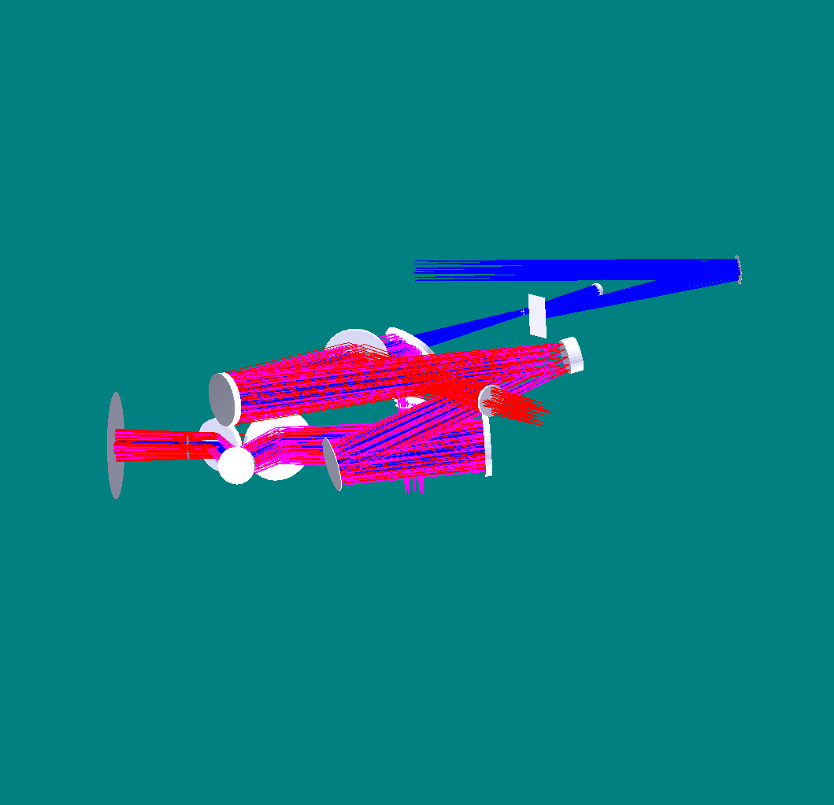
K-mirror
Fold mirror
OAP 1
Woofer DM
OAP 2
LGS dichroic
MEMS DM
f/45 output
LGS coma corrector plates
OAP 3
OSM dichroic
Nasmyth focus
Outside of telescope elevation bearing
To OSM (near-IR tip-tilt and multi-object instrument) input
LGS WFS input
OAP 4

Figure 2: AO system optical configuration

The Keck telescope f/15 Nasmyth focal plane is located ~270 mm past the telescope’s elevation bearing. The AO system optics are enclosed in a cooled enclosure, and a window (not shown) is provided to isolate the enclosure from the dome environment. The light then passes through a “K-mirror” image de-rotator into the first AO relay. This is a one to one relay composed of off-axis parabola (OAP) 1, a fold mirror, the first DM with 20 x 20 actuators, and a second OAP. From the second OAP the light (now at f/15 again) travels to the first dichroic beam splitter located at a 45º angle of incidence. 589 nm light is reflected by this dichroic to the LGS wavefront sensors while the remaining light travels on to the second dichroic beam splitter. This dichroic is also located at a 45º angle of incidence but rotated 90º to fold the beam down to the OSM for the tip-tilt sensors and the multi-object deployable IFU. A benefit of this arrangement is that the astigmatism introduced into the transmitted beam path by the two dichroics is cancelled.

The first DM is conjugated to the telescope’s pupil. Between the two OAPs the collimated beam is ~100 mm diameter, resulting in a 5 mm actuator spacing for the first DM. The fold mirror is located conjugate to ~10 km altitude providing a location where a second DM could be retrofitted to implement a MCAO mode. This first AO relay provides a 120" science field and a 180" technical field to the OSM. The fold mirror and the first DM form a periscope that changes the beam height to allow a second layer in the opto-mechanical packaging of the system.

The second dichroic beam splitter will be realized as a set of selectable beam splitters in order to share the near-IR wavelengths between the tip-tilt sensors and the narrow field instruments. A second corrector plate is included in the beam path to the OSM to correct the astigmatism in this path introduced by transmission through the first dichroic.

The light that passes through the second dichroic continues on to a second AO relay. OAP3 collimates the f/15 beam to 25.6 mm diameter resulting in a 0.4 mm actuator spacing for the second DM. This is a MEMS DM with 64 x 64 actuators. OAP4 forms a one to three relay with OAP3 resulting in an f/45 output beam for the narrow field instruments.

The optical path to the LGS wavefront sensors results in a tilted image plane where the tilt changes as a function of zenith angle, requiring that each LGS wavefront sensor be independently focused. For the LGS images, the first AO relay is also not operating at the designed conjugates, resulting in aberrations that look like astigmatism but are field position dependent. These aberrations are cancelled by a pair of spherical aberration plates that are translated laterally with respect to each other as a function of zenith angle. This correction results in very small residual LGS image aberrations (~ 30 mas) that are largely independent of zenith angle. An OSM is also required for the LGS wavefront sensors covering a 202" technical field of view.

This configuration will be more compact than the current AO systems on the Keck telescopes. The pupil size is ~30% smaller, and results in a correspondingly smaller area occupied by the complete optical path (~50% less than each of the current systems). None of the instruments is required to rotate, and the location options and configurations for the instruments, including the multi-object deployable near-IR IFU, do not have particularly tight constraints.

LGS Beacon Projection System
The LGS beacon projection system consists of a beam pattern generation and pointing system and a launch telescope. The launch telescope will incorporate a tip-tilt mirror for correction of the laser uplink tip-tilt and the beam pattern generator may incorporate a beam splitting arrangement so that fewer laser beams will need to be transferred to the top end of the telescope. The beam pattern generator will provide one fixed on-axis LGS beacon, a variable diameter pattern of five LGS beacons, and three additional, freely pointable, LGS beacons using tip-tilt mirrors for beam pointing.

LGS Wavefront Sensors
The LGS wavefront sensors are Shack-Hartmann (SH) sensors with up to 64 x 64 subaperture sampling of the pupil. For the LGS wavefront sensor detectors we anticipate using a very low noise CCD based on the CCID-56b/d, developed for AO wavefront sensing through a project funded by the Adaptive Optics Development Program (AODP), to minimize the laser power required in each beacon in order to achieve the required SNR.

Tip-tilt Sensors
The three tip-tilt sensors operate at near-IR wavelengths to improve the availability of suitable stars of sufficient brightness. Optimal performance is obtained using combined J and H band light, but a selectable beam splitting dichroic will allow sending one or more near-IR bands in combination to the tip-tilt sensors with the remainder of the near-IR and the visible light to 0.7 μm passing to the narrow field instruments. At least one sensor will be of at least order 2 x 2 subapertures to provide sensing of focus and astigmatism. Each tip-tilt star will be AO corrected using a MEMS DM with a pointable LGS beacon positioned near each tip-tilt star to maximize this correction.

Object Selection Mechanisms
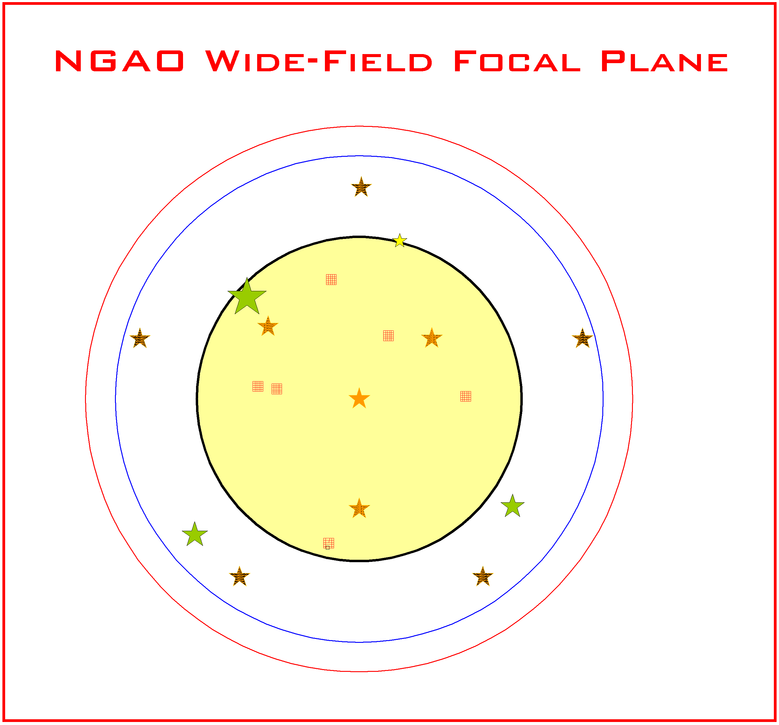
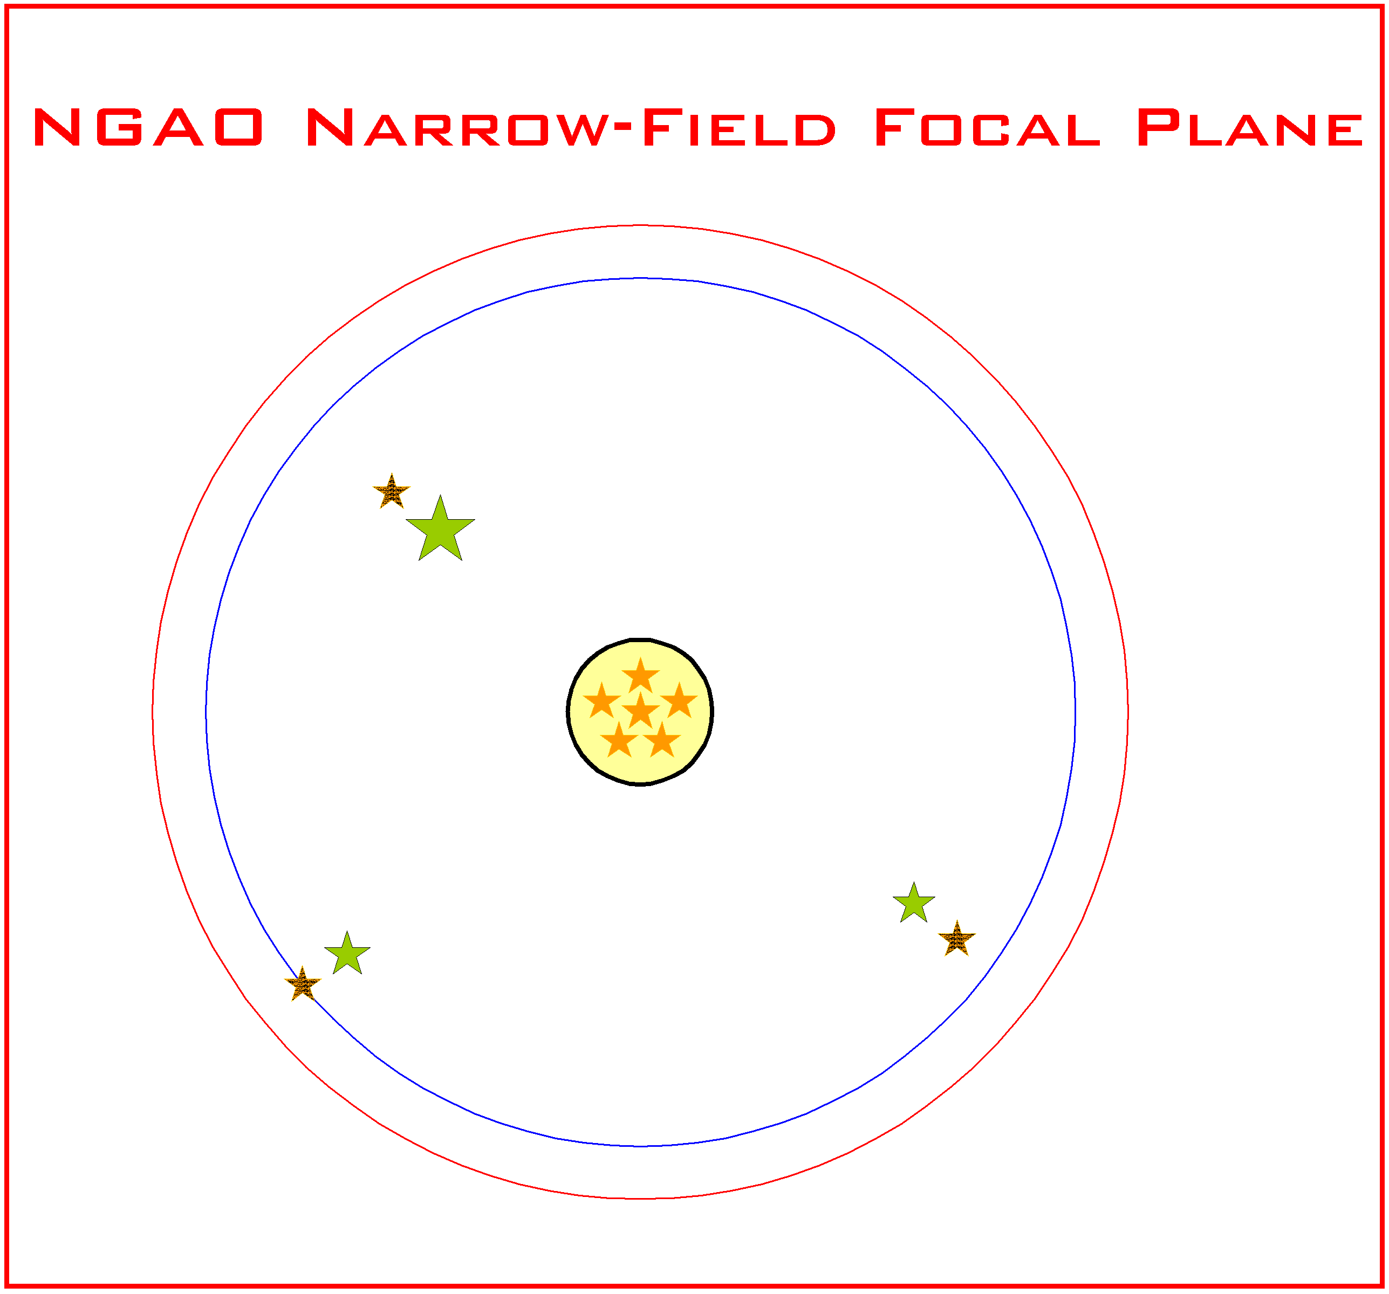
NGAO has two object selection mechanisms, one for the LGS and one for the tip-tilt stars and target selection for the multi-object deployable IFU. A cartoon of the NGAO focal plane for these two modes is shown in Figure 3.
5 LGS in variable radius constellation
1 of 3 tip-tilt stars
202" LGS patrol range
180" technical FOR for tip-tilt star selection
120" FOR for multi-object target selection
Center LGS
1 of 3 freely positionable LGS to optimize wavefront quality
MOAO Multi-object deployable IFU head
30" diameter narrow field
5 LGS variable radius constellation at 22" diameter
1 of 3 tip-tilt stars
1 of 3 freely positionable LGS to sharpen tip-tilt star

Figure 3: NGAO focal plane
The wide field mode for multi-object observations is shown on the left and the narrow field mode for single object observations is shown on the right. Each mode uses a total of 9 LGS beacons.

In wide field mode the NGAO focal plane consists of a 120" diameter field of regard (FOR) for the selection of targets for the multi-object deployable IFU. This is surrounded by a 180" technical FOR used for selection of tip-tilt stars, and a slightly larger 202" field for LGS acquisition. In wide field mode the variable radius constellation of 5 LGS is deployed to a diameter selected to optimize the wavefront error across the 120" science FOR. A sixth LGS is located in the center of the FOR. Three freely positionable LGS are deployed in the FOR to optimize image quality, with respect to either the multi-object field of views or the tip-tilt stars.

In narrow field mode the NGAO science field is 30" in diameter. The variable radius constellation of 5 LGS is reduced to 22" diameter and the three freely positionable LGS are used to sharpen the selected tip-tilt stars.

Mechanical Design
The opto-mechanical configuration of the NGAO system on a Keck telescope right Nasmyth platform is shown in Figure 4. For reference the floor of the existing Keck II AO enclosure is indicated by the surface with the red outline. The AO system optical components will be further enclosed to allow cooling to 260 K, the exact configuration of this enclosure is to be determined.
Starting just above the center of the figure on the left side the 9 LGS wavefront sensor units are shown. Each wavefront sensor is mounted on an independently controlled focus stage. LGS field selection is performed by the OSM located just to the right of the LGS wavefront sensor assembly. At the center of the figure the two AO relays are shown mounted on the opto-mechanical unit (OMU) bench. The K-mirror and OAP 1are mounted below this bench, and the beam then passes up to the first and second AO relays mounted above the bench.
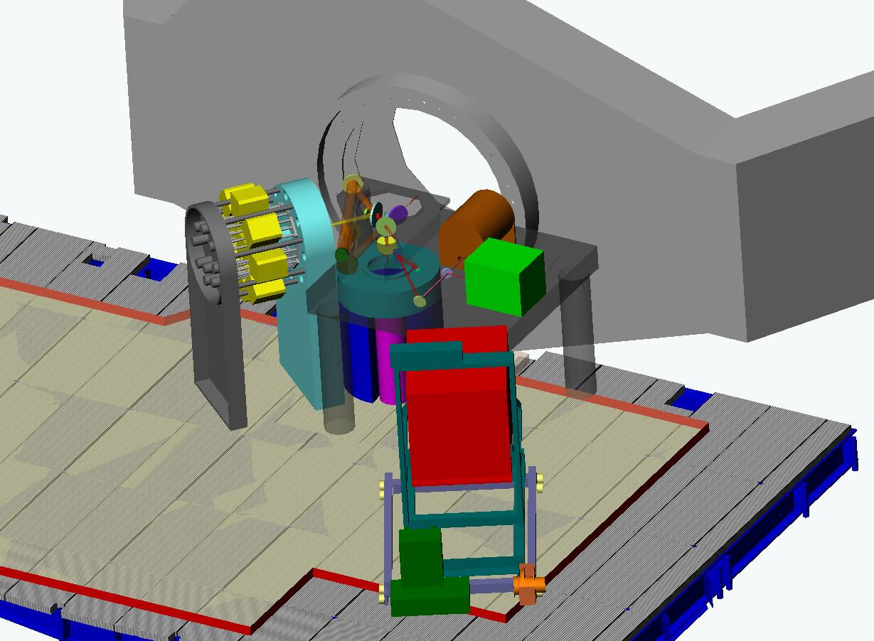
Visible imager
Near-IR imager
Near-IR IFU (OSIRIS)
Telescope elevation bearing
Keck I or II right Nasmyth platform
LGS OSM
LGS wavefront sensors on focus stages
Woofer DM
589 nm Light
f/45 narrow field AO relay
Narrow field selection mirror
IFU and tip-tilt OSM
2 channel IFU spectrograph (1 of 3)
Tip-tilt sensor (1 of 3)
K-mirror image
de-rotator
f/15 AO Relay
OMU Bench

Figure 4: NGAO Opto-mechanical Configuration

The OSM for the multi-object deployable IFU spectrograph is located beneath the bench and feeds the 3 tip-tilt sensors and the IFU. The IFU spectrographs are contained in three identical cryostats, each providing two IFU spectrographs. The tip-tilt sensors are also enclosed in cryostats.

Just to the right of center, above the OMU bench the f/45 narrow field relay output is directed to a selection mirror used to switch the beam between the single object near-IR IFU and the near-IR imager. The mirror is translated out of the beam for the visible imager. The two imagers are mounted on the OMU bench. The near-IR IFU is mounted on a separate service cart, in this illustration the OSIRIS instrument is shown for the near-IR IFU.

Electronics and Software
Electronics and software subsystems are associated with each of the major components of the NGAO system. A block diagram of the NGAO electronics/software subsystems and related external subsystems is shown Figure 5.

Communications between the various subsystems are represented by four control and data paths shown in the figure. The real time data flow (magenta) between the wavefront sensors and the DMs is isolated from other communications flow to provide maximum performance. The “AO Configuration and Status” control path (light blue) is used by the AO sequencer to orchestrate the operation of the AO system. The sequencer establishes configurations for each observation and provides status and control for the non-real time subsystems to the AO host computer via the “Supervisory Control and User Interface” (green). This interface also provides the AO host computer with control and status for the various supervisory controls. The AO sequencer coordinates AO operations with the external subsystems, the instrumentation, telescope drive and control and the primary mirror control system via the “Auxiliary Configuration, Offloading and Status” interface (purple). This includes tip-tilt offloading to the telescope secondary and control of telescope tracking during an observation.

The majority of the AO electronics subsystems will be straightforward designs based on heritage systems, particularly for supervisory controls such as AO enclosure environmental and laser safety. Similarly, instrument electronics will be based on the most current heritage designs from the OSIRIS and MOSFIRE instruments at WMKO. The sensors for the tip-tilt stars will also be based on existing detector technology and readout systems. LGS wavefront sensing electronics will be based on the AO wavefront sensing systems being developed for the TMT through the AODP.

Figure 5: NGAO electronics and software subsystems

The main challenges in the design of the NGAO electronics and software are the demanding real time control requirements for AO in a multi-guidestar system employing tomographic wavefront reconstruction techniques and multiple DMs. Our investigation of the algorithms and data flow needed for AO real time processing and control has suggested that a massively parallel architecture using current state-of-the-art field-programmable gate arrays (FPGAs) can readily accomplish this task.

Real-time Control Requirements
The real-time control requirements for NGAO are summarized in Table 3.

Massively Parallel Processing
The proposed massively parallel processing (MPP) system pipeline architecture depicted in Figure 6 implements a three step process: wavefront measurement, tomography, DM fitting. Multiple wavefront sensors, corresponding one to each LGS and tip-tilt star, feed data to a centralized tomography unit. These are inherently parallel operations. Calculation is further parallelized across the spatial dimensions (two dimensions x and y for wavefront sensor and deformable mirrors, and three dimensions x, y, and z for tomography, where z is the vertical direction). For algorithmic reasons, data in x, y planes parallel to the aperture are represented by their Fourier coefficients. Calculations are spread out among processors dedicated to pieces of the x-y Fourier space, slices in the z vertical space, individual wavefront sensors, and individual DMs.

The tomography unit determines an estimate of the differential optical path differences within volume elements of a model atmosphere. This information is then used in a process of determining the desired phase correction at each DM, given a tomographically determined estimate of differential phase aberrations over the atmospheric volume. For MOAO this is the line integral of the turbulence estimate through the volume in the direction of interest. Since the DMs commonly have inter-actuator influence functions, a deconvolution and/or lookup table access must be done for the actuator commands so that the resulting DM shape best fits the new wavefront estimate. Fitting involves deconvolving the DM’s unit response function so that a voltage command can be determined given the desired surface shape. In the case of MEMS in open loop operation, it is necessary to use an additional cascade of two non-linear lookup tables.

The MPP architecture described above has a distinct advantage over a traditional single CPU implementation in that it can scale with the number of guide stars, number of DMs, and number of subapertures by simply adding processor cards without affecting the data throughput rate or the software program significantly.

Control bandwidth | >90 Hz
Wavefront sensor frame rate | 1.5 to 2 kHz
Number of LGS wavefront sensors | 9
Number of tip-tilt sensors | 3
Number of deformable mirrors | Narrow field mode: 1 20 x 20 “woofer” DM, 1 64 x 64 “tweeter DM”, 3 32 x 32 DMs for MOAO correction of the tip-tilt stars.  Wide field mode: 1 20 x 20 “woofer” DM, 3 32 x 32 DMs for MOAO correction of the tip-tilt stars, 6 32 x 32 DMs for MOAO correction in the multi-object deployable IFU.
Reconfigurable for number of guide stars and DMs. Allows differing asynchronous data rates from various wavefront and tip-tilt sensors
Adapts and optimizes for changing seeing and signal-to-noise conditions and incorporates information from external measurements of the C_{n}² profile
Full telemetry and diagnostics streams
Table 3: NGAO real time control requirements

Figure 6: Multi-guidestar AO processing architecture

Tomography
Tomography is accomplished with an iterative back-propagation algorithm depicted in Figure 7 (Gavel 2004, Gavel et al. 2005). The method is analogous to the filtered-back-projection techniques used in modern medical tomography 3-d data analysis. These calculations can be mapped to the massively parallel computer architectures described earlier. During processing, each iterative correction is along a conjugate-gradient direction, resulting in convergence in only a few iterations. Overall, the MPP implementation combined with the fast converging algorithm enable the process to be repeated at the very demanding frame rates of real-time adaptive optics, about once per millisecond .

Figure 7: Tomography algorithm

Requirements

Requirements Documents
There are three main requirements documents:
- The Science Case Requirements Document (SCRD). KAON 455.
- The System Requirements Document (SRD). KAON 456.
- The Functional Requirements Document (FRD).

There is a fourth requirements document that is referenced by the SRD. This is the Instrument Baseline Requirements Document (IBRD) which contains Observatory standard requirements for any instrument.

The requirements process can be summarized as follows:

- The science requirements are developed in the SCRD.

- The science requirements from the SCRD, and additional requirements imposed by the Observatory, are tabulated in the Overall Requirements section of the SRD. These overall requirements are then flowed down to discipline based requirements in the SRD. The requirements are generally divided between performance, implementation and design requirements. The disciplines are Optical, Mechanical, Electronic/Electrical, Safety, Software, Interface, Reliability, Spares, Service and Maintenance, and Documentation. Note that the SRD avoids prescribing specific design or implementation solutions.

- The FRD flows down the requirements from the design-independent SRD to requirements on a few high level subsystems. The flow down of the SRD requirements to the FRD requirements is frequently a design choice that could be revisited. The subsystems are chosen to divide the NGAO system into functions that would be required independent of the selected architecture. At minimum these subsystems include the AO system, laser facility, science operations facility and science instruments with further subdivision as appropriate. For each subsystem there is a section describing the architectural assumptions, followed by a breakdown of the requirements by the same disciplines as used in the SRD.

The system design phase schedule allows for the development of four versions each of the SCRD and SRD. Two versions of the FRD are scheduled. The first was produced as part of the system architecture activity. The second is to be produced as a result of the subsystem design process.

The FRD provides the criteria against which the subsystems will be evaluated. The SRD provides the criteria against which the NGAO system will be evaluated

Performance Requirements

AO System
The science requirements drive a number of key technical requirements including cooling of all optical surfaces to 260 K to reduce the background in the near-IR, a desire to minimize transmission losses, a need to efficiently use the laser light for the multiple LGS, and providing access to the field of view for multiple LGS wavefront sensors, multiple tip-tilt stars, narrow field on-axis science instruments, and a multi-object deployable near-IR IFU.

Wavelength Range
The first AO relay in the system must efficiently transmit light over a 0.58 to 2.5 μm wavelength range. This broad range must be efficiently divided between the various sensors (LGS and tip-tilt) and the instruments. The design needs to be optimized to minimize aberrations introduced by transmission through dichroics, and excellent coatings will be required for all surfaces.

Near-IR light will be shared between the tip-tilt sensors and the narrow field instruments. This will require the near-IR beamsplitter for the OSM to be a set of selectable dichroics. This will send some of the near-IR light (for example J and H bands) to the tip-tilt sensors while sending the balance to the narrow field instruments (visible and K band for example).

Sensitivity
Observation of faint targets is essential. The point source limiting magnitude estimates are supported by maximizing the transmission of the telescope and AO system (≥ 60%) and providing high Strehl. Sensitivity is also impacted by instrument characteristics, notably the instrument’s transmission, spatial sampling, detector QE and noise and the instrument’s contribution to the total background. Values given for these parameters are based on experience in the design of current WMKO instruments.

Wavefront Error
The AO system architecture is driven by the required wavefront error to incorporate a number of innovative subsystems that work together to overcome specific effects that limit the quality of the AO correction provided by the system. These include multiple LGS beacons and a corresponding number of LGS wavefront sensors, multiple tip-tilt stars, a tomographic wavefront reconstructor and high order correction.

A minimum of 64 x 64 actuators is required over the telescope pupil to meet the most demanding narrow field residual wavefront error requirement of 140 nm. Such high actuator counts are only practical with MEMS DMs. The multiple LGS require a larger technical field of view than what can practically be accommodated with the very small actuator spacing of MEMS DMs. This would lead to operating the LGS wavefront sensors entirely in open loop, a risky design approach. To address the problem a two DM design is employed, with the first DM with 20 x 20 actuators providing low order correction for the LGS in a closed loop. The second DM is a MEMS DM operated in a feed forward or “go to” control mode. Multiple MEMS DMs are used, one for the narrow field relay, and one for each of the tip-tilt sensors, and for each head of the multi-object deployable near-IR IFU.

A wavefront error budget for NGAO has been developed using Excel spreadsheet tools developed over several years for the engineering evaluation of AO system performance. The primary purpose of the spreadsheet is to compute AO and instrumental wavefront error budgets for different architectures and science cases, along with Strehl ratios computed using the Marechal approximation. The spreadsheet also computes ensquared energy fractions using a core/halo model for the point spread function, and calculates sky coverage estimates for tip-tilt guide stars employed in LGS architectures from common star density models. The spreadsheet has been validated by comparing the spreadsheet predictions to the current performance of the Keck II LGS AO system with good agreement.

Our study of the performance of the selected AO system architecture shows that it is quite flexible, permitting optimization of the residual wavefront error for a wide range of observing conditions. The spreadsheet tool was configured to optimize the H band Strehl ratio, and certain parameters such as LGS constellation radius, high order update rate, and tip-tilt update rate were allowed to vary within appropriate constraints in order to optimize the Strehl ratio. Examples from this study of the wavefront error budget are shown in Table 4. It should be noted that these examples are based on an earlier relay design using a single 64 x 64 actuator DM, a single tip-tilt star and an LGS constellation consisting of just the central LGS and the four equally spaced LGS in a variable radius. No additional LGS were deployed to sharpen the tip-tilt star.

Observation | Int. time | TT reference | LGS diameter, " | TT error, mas | Sky coverage | High order wavefront error, nm | Total wavefront error, nm | Strehl (1.65 μm)
Io | 10 s | Science target | N/A | 1.7 | N/A | 96 | 98 | 87%
Kuiper Belt | 300 s | Field star | 41 | 6.2 | 10% | 150 | 184 | 61%
Exo-Jupiter | 300 s | Science target | 12 | 3.3 | N/A | 124 | 137 | 76%
Extragalactic | 1800 s | Field star | 90 | 18.5 | 30% | 159 | 329 | 25%
Galactic Center | 30 s | IRS 7 | 11 | 2.0 | N/A | 170 | 174 | 64%
Table 4: Wavefront error budget summary

The first column of the table indicates the observing scenario. The second column indicates the integration time assumed for the science exposure. The third column indicates the tip-tilt reference used, and the fourth column gives the diameter of the LGS variable radius constellation. The fifth column indicates the tip-tilt error that results from the assumed angular offset of the tip-tilt star. The sixth column gives the sky coverage fraction over which the tip-tilt error will be less than or equal to the error given in column five. This estimate results from the use of common sky coverage models (Spagna and Bachall-Soneira). The last three columns give the high order wavefront error, the total wavefront error with tip-tilt errors, and the H band Strehl. For the extragalactic case, the figure of merit is ensquared energy rather than residual wavefront error, for the 50 mas spatial sampling of each head of the multi-object deployable IFU the ensquared energy is 37%.

These results show that the variable radius LGS constellation and the performance levels assumed for the tomographic wavefront reconstruction, LGS wavefront sensors and near-IR tip-tilt sensors are capable of providing performance that is generally at the level required by the science cases. Initial estimates of NGAO system performance based on laser tomography AO resulted in the adoption of three representative values of residual wavefront error for the science case simulations: 140 nm, 170 nm and 200 nm. This has led to further work to develop additional techniques for performance improvement including the additional three freely positionable LGS (see §4.3.5) and the additional tip-tilt sensors.

Field of View
The NGAO science cases include a number of narrow field cases for Solar and Galactic science, and moderate to wide field cases for extragalactic multi-object observations. The needs of these cases are met by using the MOAO architecture to provide a moderate (comparatively wide in AO terms) field of view. AO correction for both the moderate and narrow fields is optimized by providing a wider field of regard for the selection of tip-tilt stars and the positioning of LGS beacons. A wider field of regard for the selection of tip-tilt stars also improves sky coverage by increasing the probability of finding stars of adequate brightness.

Background
The sensitivity delivered by the NGAO system is significantly affected by the total background seen by the instruments. In the present Keck telescope AO systems background is recognized as a significantly limiting sensitivity, particularly for the K band.

Part of the solution to reducing background is the control of scattered light through careful design and implementation, and the use of hexagonal, rotating cold stops matched to the shape of the telescope pupil in the near-IR instruments. However, thermal emission is a significant factor for near-IR observations, particularly longward of 2 µm. Using data from the current Keck II telescope AO system we have developed a model of the background contributed by sky + telescope + AO system that indicates the AO system optics should be cooled to 260 K.

Contrast
Another important area for NGAO science is high contrast observations. The Strehl proposed for NGAO is lower than extreme AO systems such as the Gemini Planet Imager, but at the same time, NGAO will provide higher sensitivity and sky coverage that greatly exceeds that of an NGS-only extreme AO system. While our analysis of the contrast performance needed indicates that a conventional occulting spot coronagraph with an apodized (hexagonal, rotating) Lyot stop will meet the needs of the majority of the NGAO high contrast science cases, we are also investigating the use of more advanced techniques such as non-redundant aperture masking.

The level of contrast achieved with NGAO will also depend on the control of systematic errors such as non-static, non-common path aberrations, servo lag error and various sources of speckle. Speckle suppression techniques including spatially resolved spectroscopy will be available for NGAO observations.

Photometric Accuracy
Requirements for photometric measurements in the NGAO science cases range from 0.05 to 0.1 magnitudes in relative photometry, and ≤ 0.05 magnitudes for absolute photometry. The fundamental condition for high photometric accuracy is stability of the PSF. Because of the high Strehl delivered by the NGAO system, a more stable PSF is expected. Many of the science cases that require the highest photometric accuracy are observing a science target of sufficient brightness (H < 16) to permit use of the science target as an on-axis tip-tilt reference, further improving Strehl performance.

Analysis of NGAO photometric accuracy requirements also leads to a number of other technical requirements related to the PSF. These include obtaining precise knowledge of the AO system PSF through provisions for PSF calibration and monitoring. NGAO may need to provide a PSF monitoring imager deployable over the AO system technical field of view to allow simultaneous PSF imaging during observations. Recent work at Palomar (Britton 2006) has shown that real time turbulence monitoring giving C_{n}² data during the observation is also useful in improving the results of PSF post processing. This post processing will also be supported by facility PSF deconvolution software.

Astrometric Precision
Astrometry is important for a number of the Galactic and Solar System science cases. The most demanding requirements are for observations of the Galactic Center where precision of 100 μas is required. The current Keck II LGS AO system with the NIRC2 instrument is able to achieve best-case precision of 250 μas. The high Strehl of the NGAO system (~3 times that of the current LGS AO system under similar conditions) will make a significant contribution to the accuracy of astrometric measurements by reducing source confusion. In addition, studies of the astrometric precision of the current Keck II LGS AO system indicate that geometric distortion, differential tilt anisoplanatism between the science target and off axis tip-tilt stars (increasing with increasing distance between the two), and differential atmospheric refraction all contribute to the error in astrometric measurements.

The same features provided to monitor the PSF and monitor atmospheric turbulence for photometric accuracy would contribute to NGAO astrometric precision. Geometric distortion in the AO system and instruments will be minimized during design and facilities will be incorporated for mapping residual distortion during commissioning. Improved mechanical stability is also a fundamental part of the design of the NGAO system and instruments.

The NGAO system will incorporate an ADC to reduce the effects of atmospheric refraction, and differential tilt anisoplanatism will be reduced by the use of multiple, optimally located tip-tilt stars. Alignment tools for these multiple tip-tilt stars will minimize plate scale changes due to the AO correction.

Sky Coverage
The sky coverage fractions required by the extragalactic and Galactic science cases requires optimizing the offset and brightness of the tip-tilt stars. This is accomplished by increasing the faint magnitude limit for tip-tilt stars through the use of tip-tilt sensors operating at near-IR wavelengths combined with MOAO correction using deployable LGS beacons specifically for tip-tilt reference sharpening, and by providing a 180" field of view for tip-tilt star selection.

Performance Budgets

Performance

Performance

Technical Risk Analysis
A preliminary risk analysis has been documented as KAON

Glossary
Table 5 defines the acronyms and specialized terms used in this document.

Table 5 Glossary of Terms
Term | Definition
ACS | Active Control System
AO | Adaptive Optics
DCS | Drive and Control System
FAA | Federal Aviation Administration
FOV | Field Of View
FWHM | Full Width at Half Maximum.
IFU | Integral Field Unit
KAON | Keck Adaptive Optics Note
KI | Keck Interferometer
LGS | Laser Guide Star
MTBF | Mean Time Between Failures
NGAO | Next Generation Adaptive Optics
NGS | Natural Guide Star
NIR | Near InfraRed
NIRC2 | NIR Camera 2
NIRSPEC | NIR SPECtrometer
OAP | Off-Axis Parabola
‘OHANA | Optical Hawaiian Array for Nanoradian Astronomy
OSIRIS | OH-Suppression InfraRed Integral field Spectrograph
TBC | To Be Completed
TBD | To Be Determined
WMKO | W. M. Keck Observatory

NGAO Keck Adaptive Optics Notes Sorted by Categories

