 Keck Adaptive Optics Note 502

Next Generation Adaptive Optics:
Keck Adaptive Optics Upgrade Engineering Costs

P. Wizinowich
August 23, 2007

Introduction

Five system architectures were evaluated during the July/07 system architecture retreat as documented in KAON 499. The Keck I upgrade architecture was ranked second technically and third programmatically as a result of this retreat.

Action items were identified at the retreat that might significantly change an architecture’s ranking. The purpose of this KAON is to address one of these action items, specifically to provide a more careful analysis of the engineering costs associated with an upgrade. Actual cost estimates are not included in this KAON. However, this KAON does provide a summary of the components that would need to be changed or upgraded.

We begin by reviewing the existing system and what could be reused, what needs to be upgraded or replaced and what is completely new. Section 3 then describes the laboratory system that would be used for lab integration and test.

Proposed Changes to Existing System

AO Infrastructure
The following figure shows a schematic of the AO enclosure on the Nasmyth platform.

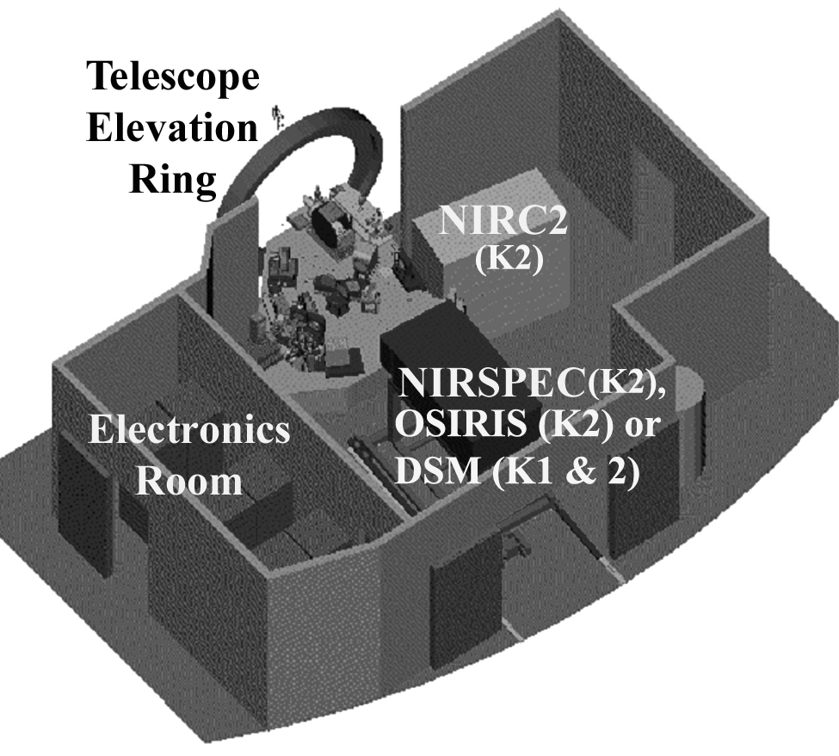

The following table lists each of the major components of the AO infrastructure and what would need to be changed or modified for the NGAO AO upgrade architecture. If the component can be reused as is then a Y or Yes is placed in the “Reuse at Summit” column. If the component will not be part of the NGAO upgraded system, but could be used to support the lab system a Y is placed in the “Reuse in Lab System” column. If the component requires an upgrade to support the NGAO system a Y is placed in the “Upgrade” column. Finally if this is a new feature for NGAO or the component needs to be completely replaced this is indicated by a Y in the “New” column.

An assumption is that DNIRI would go at the NIRC2 location and the near-IR and visible science instruments would move in on rails to the NIRSPEC/OSIRIS/DSM location. The near-IR and visible science instruments might need to be offset somewhat from the AO bench to allow room for a cascaded relay.

Item | Reuse at Summit | Reuse in Lab System | Upgrade | New
Enclosure | Y = Yes
Enclosure extension into El ring |  |  | Y
Enclosure removal floor panels |  |  | Y
Electrical distribution | Y
Glycol distribution | Y
CCR distribution | Y
Lighting | Y
Ventilation system for personnel | Y
HEPA filters | Y
Electronics room heat exchanger | Y
Personnel entry ante-room | Y
AO bench room heat exchanger | Not needed?
NIRC2 location defining pts |  |  | For DNIRI
SHARC, NIRC2 or OSIRIS | Y (initially) | Y (SHARC)
Instrument exchange rails | Y
Instrument exchange defining pts | Y
Instrument interface panels | Y |  | If necessary
Dual star module | Y |  | If necessary
AO bench | Y
AO bench roof | Y
AO bench covers |  |  | Y (for easier access)
AO bench HEPA filter | Y
Window to enclosure |  |  |  | Y
AO bench room thermal control |  |  |  | Y
AO bench room humidity control |  |  |  | Y
DM electronics rack |  | Y |  | Y
RTC electronics rack |  |  |  | Y
Motion control rack |  | Y |  | Y
Communications rack |  | Y |  | Y
Laser rack |  |  |  | Y
Interferometer rack | Y
Cable routing trays | Y
Cabling from electronics to AO bench | Y | Y |  | Y

As can be seen from the above table a great deal of the existing AO infrastructure can be reused. The new features have to do with cooling the AO enclosure, and with replacing the five AO electronics racks. The removed racks could be upgraded as appropriate to be used with the lab system.

Note that parts of the AO infrastructure, especially the enclosure could potentially also be used with other NGAO architectures.

In terms of costs all (or most) of the above features will need to be provided for the other architectures. The extent to which they can be reused represents a cost savings.

This reuse also represents a savings in terms of AO downtime, since the existing AO system and infrastructure would need to be removed before installation of a new system and its infrastructure. Any modifications to the telescope itself required for a new system, including such things as modifications to the platform or pulling new cables will require restrictions on the daytime use of the telescope. Utilization of the existing infrastructure discussed in this section.

AO Bench
The following figure shows all of the current hardware on the AO bench. The following table lists each of the components indicated in the figure and what changes are recommended to be made for the NGAO upgrade architecture.

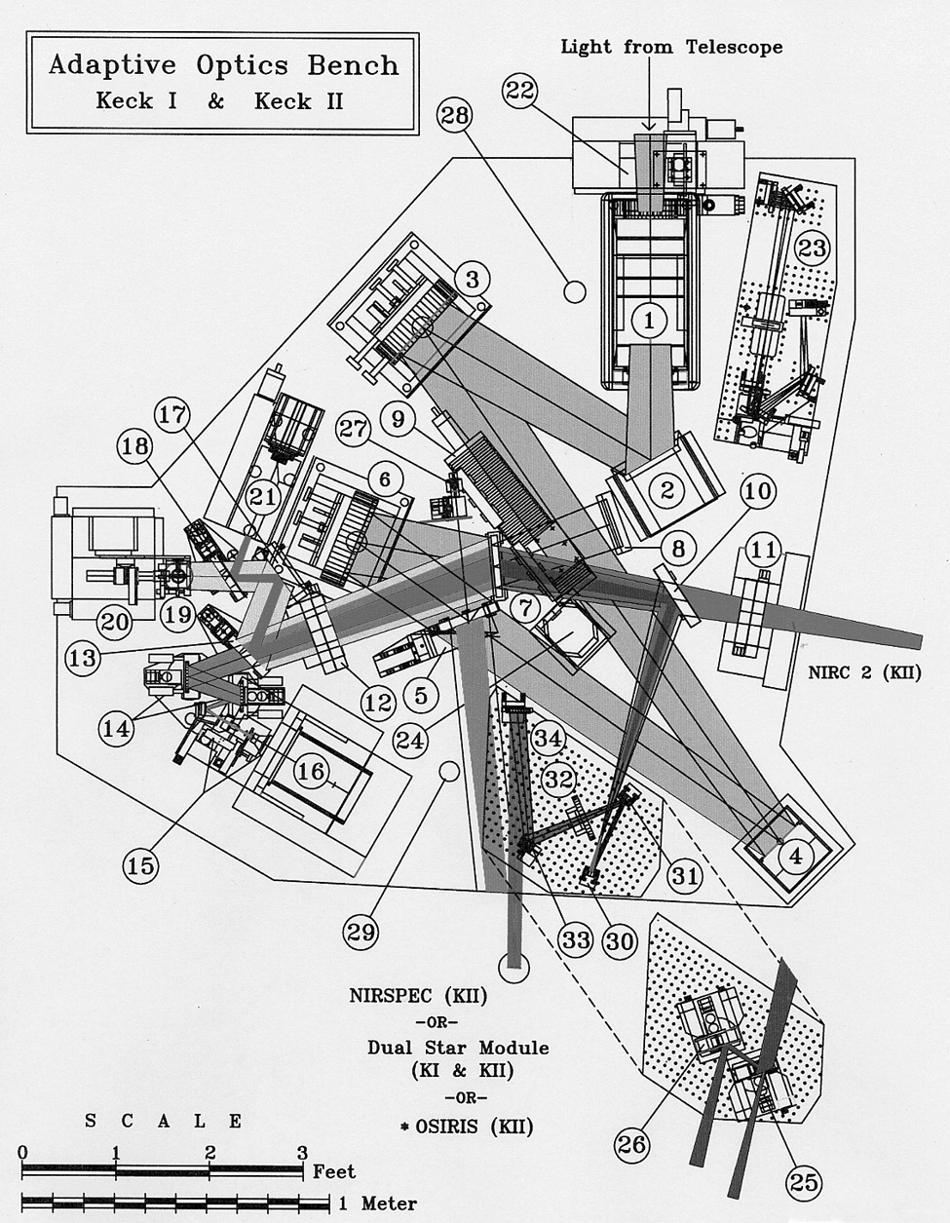

Item | Reuse at Summit | Reuse in Lab System | Upgrade | New
1. Image rotator | Yes | Option exists if new rot built | With new 1st mirror | Option exists to build 3rd rot
2. Tip/Tilt mirror |  | Y |  | Y
2. Tip/Tilt mount |  | Y |  | Y
3. OAP1 |  | Y |  | Y
3. OAP mount | Y
4. DM |  | Y |  | Y
5. DSM dichroic fold | Y
5. DSM stage | Y
6. OAP2 |  | Y |  | Y
6. OAP mount | Y
7. IR dichroic |  | Y |  | Y
8. IR dichroic mount |  | Y |  | Y
9. OSIRIS fold mirror | Y
9. OSIRIS fold mirror stage | Y
10. Science fold mirror | Y
10. Science fold mirror stage | Y
11. IR ADC & stages | Y
12. Vis ADC (not implemented)
13. Dichroic/beamsplitter changer & stage |  |  | Possibility
14. Field steering mirrors |  | Possibility
15. Wavefront sensor optics |  | Possibility
16. Wavefront sensor camera |  | Possibility | Y (if CCID56)
17. Intermediate fold mirror | Y
18. Acquisition fold mirror | Y
19. LBWFS |  |  | Possibility
20. STRAP |  | Possibility
21. Acquisition camera |  |  | Y (to MAGIQ)
22. Simulator fiber positioner |  | Possibility |  | Y
23. Telescope simulator |  | Possibility |  | Y
24. Wyko fold mirrors |  |  | Y
25,26. DSM field separator |  |  | Possibility
27. Boresite retroreflector | Y
28,29. Accelerometers | Y
30-34. NIRSPEC reimaging optics (only on K2)
Wyko |  |  | Y
LOWFSs (new) |  |  |  | Y
LGS WFSs (new) |  |  |  | Y
Cascaded relay (new) |  |  |  | Y
Software: Optics bench/motion control | Y |  | Y
Software: UI & Ops Tools |  |  | Y
Software: Supervisory Control |  |  |  | Y
Software: Real-Time |  |  |  | Y

As can be seen from the above table many of the existing components can be reused and some, like the tip/tilt mount, should be replaced. The new features would be required for any of the NGAO architectures. A number of the replaced components could be reused in the lab system subsequent to the telescope install of their replacements.

Laboratory System to Support Lab I&T
An upgraded AO system requires a lab system, which would not be required for a new system, on which to test the upgrades. During and after NGAO implementation of any architecture there would be significant benefits to having an identical, or very similar, lab development system to support debugging initially and further development longer term.

The following table lists the elements of a lab system that would support lab I&T of an AO upgrade to NGAO. The first column lists the components of the initial lab system. Most of this system would move to the telescope as described in KAON 500. Many of the components from the existing AO system could then be used in the lab system. The final lab system that would be used for ongoing developing and operational support is detailed in the second column of the table. The final column lists the components in the lab system that could be used as spares for the operational system.

Lab System (initial) | Lab System (final) | Spares in Final Lab System
Clean room (exists) | Same
Bench Options: two non-custom 4x8’ benches or custom bench | Same
Telescope Simulator 1 (new) | Telescope Simulator 2 (new) | Telescope Simulator 2
Fold from Simulator (new) | Same
Rotator options: nothing, folds or build a 3rd image rotator | Same or summit image rotator | Image rotator if 3rd unit built
Tip/tilt mirror & stage (new) | Tip/tilt mirror & stage (summit) | T/T mirror
2x OAPs (new) | 2x OAPs (summit) | OAPs
DM + electronics (new) | DM + electronics (summit) | DM as temporary solution
Dichroics & changers (new) | Dichroic (summit) | Dichroic as temporary solution
Acquisition camera/stage (new) | Acquisition cam/stage (summit) | Acq cam/stage
LGS WFSs (new) | LGS WFSs (spare units) | Spare LGS WFSs
NGS WFS (new) | NGS WFS (spare) | Spare NGS WFS
LOWFS (new) | LOWFS (spare) | Spare LOWFS
LBWFS (new) | LBWFS (old upgraded)
Real-time ctrl system 1 (new) | Real-time ctrl system 2 (new) | RTC 2
Motion control rack (old/new) | Motion ctrl rack (summit/new) | Motion control hardware
Motion control cables (new) | Same, but reduced number | Cables
Communications rack (new) | Comms rack (summit) | Comms rack hardware
Supervisory ctrl system (old/new) | Supervis ctrl sys (summit/same)
User tools (old/new) | Same
Wyko (lab unit) | Wyko (lab unit)
SHARC (old) → NIR camera (new) → Cascade + Vis camera → DNIRI | SHARC (old)

Note that the costs of a long-term lab development system have not been included in the costs of any of the NGAO architectures. The upgrade path allows for the cheapest lab system since it reuses components from the existing AO system. However, the extent to which these reused components are not the same as the summit system will reduce the value of the lab system. These costs are minimized by utilizing similar approaches to those used in the current system, for example in adopting the same motion control architecture.

Conclusion

This KAON has attempted to partially address the engineering costs concerns with the Keck AO upgrade architecture raised at the July/07 system architecture meeting. It does so by listing the components that would be reused, upgraded or replaced. This description can be used as a basis for generating cost estimates.

The choices made in this document were intentionally made to minimize costs while still allowing the achievement of most of the NGAO requirements. Clearly NGAO operations would benefit if more of the components were upgraded both for maintenance and performance reasons.

References

Dekany, R. et al., NGAO System Architecture Definition, KAON 499 (July, 2007).

Wizinowich, P., NGAO Keck AO Upgrade Programmatic Feasibility (Aug, 2007).

