Keck Adaptive Optics Note 1003
Near-Infrared Tip-Tilt Sensor System
Packing & Shipping Review Report
R. Dekany, R. Smith, D. Hale, J. Fucik, H. Rodriguez, J. Cromer
August 15, 2013

Draft Version 0.2

Introduction:
The purpose of KAON1003 is to summarize and assess the shipping of the Near-Infrared Tip/Tilt Sensor (NIRTTS) to the observatory completely assembled with the dewar backfilled with a partial pressure of dry nitrogen. The pedestal and electronics will be freight shipped in a different shipping container, as well as, the ARS Mixed Refrigerant Cryo-Cooling System (compressor and 2 cooling lines). The detector assembly and cold head will remain in the dewar and shipped as part of the complete dewar assembly. Because the detector will be shipped inside the dewar, an anti-static foam cutout will be installed on the connector and held in with receptacle protection cap.
All components have been designed to withstand accelerations up to 4 g. The instrument will be transported via an “air ride” truck to an airport in the Southern California area, and then boarded onto a cargo plane for the trip to Hawaii. Another “air ride” truck will be used to complete the trip to the observatory on the summit of Mauna Kea. Past experiences of shipping instruments (LRIS and Mosfire) have indicated shocks of up to 22g for short periods (milliseconds) during the transportation. The highest shocks can happen during the loading and unloading of the instrument at the site. In order to dampen the shocks to below 4 g, a shipping crate will be designed and constructed which will include ester based polyurethane foam between the instrument and the crate, and between the external peripherals and the case. A detailed analysis has been created for the required rigidity of foam used in the shipping crate, and can be found at: http://www.oir.caltech.edu/twiki_oir/bin/viewfile/Keck/NGAO/NIRTTSPreShipReportWorkingPage?rev=1;filename=Mathcad_-_Shipping_analysis_for_TRICK.pdf
Furthermore, a thin polyethylene membrane will be installed in the crate to further protect the instrument from the environment will be implemented. The design of the shipping crate will successfully and safely transport the complete assembly of NIRTTS to Keck Observatory in Hawaii.

Shipping Specifications:
The purpose of the shipping specifications is to provide sufficient protection and safety to NIRTTS during transportation. The specifications will cover shock and vibration isolation plus cost analysis of the shipping material, weather resistance, temperature sensing, and a packing list.
The shock isolation will reduce the shocks encountered during ground and/or air transportation to levels that will not damage the optics on the pedestal or the optics in the dewar, the H2RG detector, and any of the peripheral external equipment. The crate will dampen any vibrations caused by the transportation of the instrument by ground and/or air.
The crate will also be supplied with a method of protecting NIRTTS from the environment during the transportation by ground and/or air. The instrument and the external peripheral components will be vacuum sealed and bags of desiccant will be placed inside the vacuum sealed bags. In addition, the inside of the external crate will be sealed with a plastic membrane to further protect the internal crate.
A thermal couple will be used as a sensor inside the crate and attached to the dewar and monitor the temperature in the vicinity of the optics on the pedestal. This is to ensure that the temperature inside the crate has equilibrated to the dome temperature before exposing the optics to the colder temperatures of the dome.

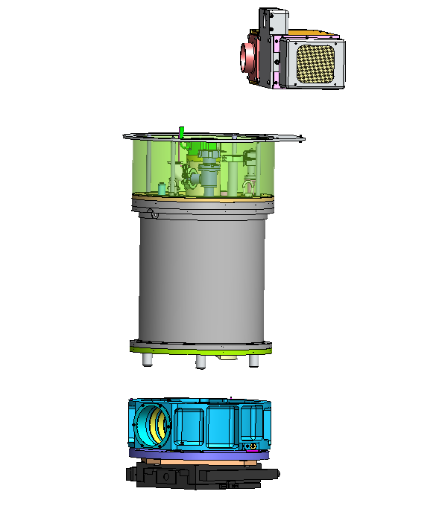
Electronics
Dewar Assembly
Focus Stage Assembly

Figure 1: Components that are being shipped to Keck Observatory.

Table 1: Transportation and Shipping Conditions
Parameter | Max. g Level | Comments
Shock | 15 | 0.015 second half-sine, all axes
Acceleration due to transport | 4 | All axes.
Acceleration due to seismic activity | 2

Shock and Vibration Isolation Specifications:
Foam Specifications:
Anti-Static Open Cell Foam – Anti-Static foam is good-quality foam with a medium feel. Its unique properties allow the foam to slowly dissipate electro-static charges.
Table 2 Technical Anti-Static Foam Information
Property | Test Method | Values
Density (lb/cu.ft.) | ASTM D 3574 (all) | 1.4
25% IFD (lb.) |  | 35
Support Factor (65%/25% min. |  | 1.90
Tensile (PSI) min. |  | 13.0
Elongation (%) min. |  | 200
Tear (PPI) min. |  | 1.30
Resiliency (%) min. |  | 35
Anti-Static |  | yes

Table 3: Anti-Static Foam Cost Analysis
Anti-Static Foam
Sheets | Full Sheet  80” x 72” | Half Sheet  72” x 40” | Third Sheet  72” x 24”
Anti-Static Foam  2” Thick | $101.99 | $51.99 | $34.99
Anti-Static Foam  Foam 2 ½”” Thick | $127.99 | $64.99 | $43.99
Anti-Static Foam  Foam 3” Thick | $152.99 | $76.99 | $51.99

Charcoal-R Foam is good quality foam with a medium feel. Common applications include cost-effective acoustics, cases and packaging.

Table 4: Technical Charcoal Regular (R) Foam Information
Property | Test Method | Values
Density (lb/cu.ft.) | ASTM D 3574 (all) | 1.4
25% IFD (lb.) |  | 35
Support Factor (65%/25% min. |  | 1.90
Air Flow (CFM) min. |  | 3.00
Tensile (PSI) min. |  | 14.0
Elongation (%) min. |  | 200
Tear (PPI) min. |  | 1.50
Resiliency (%) min. |  | 40
Fire Retardant Classification |  | UL900, Class 2, Non Fire Retardant

Table 5: Charcoal R Foam Cost Analysis
Charcoal Regular Foam
Sheets | Full Sheet  80” x 72” | Half Sheet  72” x 40” | Third Sheet  72” x 24”
Charcoal Regular Foam 2” Thick | $59.99 | $30.99 | $20.99
Charcoal Regular Foam 2 ½”” Thick | $73.99 | $37.99 | $25.99
Charcoal Regular Foam 3” Thick | $88.99 | $44.99 | $30.99

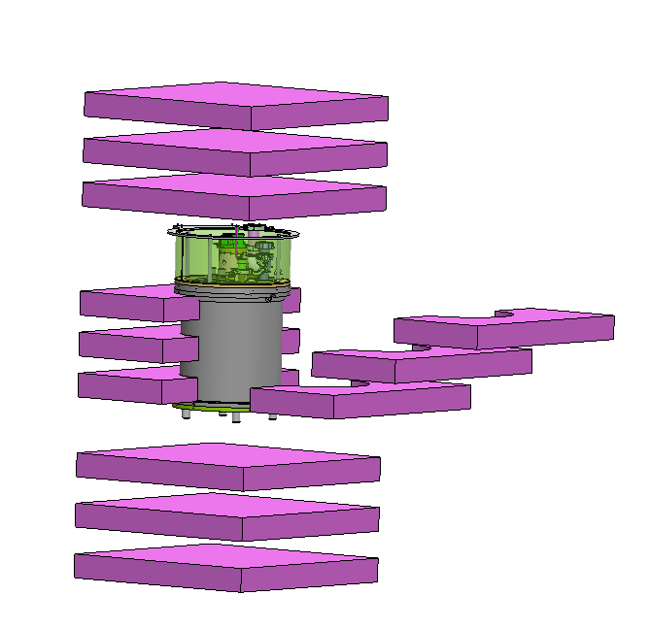
3” x 27” Foam
Figure 2: NIRTTS assembly with foam.

Vacuum Sealing Specifications:
The purpose for vacuum sealing specifications is to help protect NIRTTS and its external peripheral equipment from moisture and dust during transportation to Keck Observatory via ground and/or air. The vacuum sealing specification will cover vacuum bagging and moisture control.
Vacuum Bags:
To increase the protection on NIRTTS from the environment while transporting it to the summit Keck Observatory via ground and/or air, the instrument and its peripherals will each be placed in an appropriate sized Space Bag and vacuum sealed. This will provide the needed barrier against moisture and dust on the optics and external components. The price of the Space Bags will be under $15.99 per bag. The following components will be bagged with a Space Bag:
- Dewar assembly
- Pedestal and focus mechanism
- Electronics
- (2) 25’ high pressure cryogen lines

Desiccant Bags:
Desiccant bags will be placed inside each evacuated bag, and inside the crate to help keep the environment dry. The desiccant bags already exist at Caltech.
Crate Membrane:
The purpose of the membrane is to add an extra layer of protection inside the crate to protect the instrument from moisture and dust while transporting it to the Keck Observatory via ground and/or air. A sheet of polyethylene plastic between 0.1 to 0.25 mm will be used as a liner around the inside perimeter of the crate to act as another vapor and dust barrier.

Thermal Couple:
The purpose of the thermal couple is to measure and compare the difference between the temperature inside the crate and the temperature inside the dome protecting the optics from thermal shock. Temperatures inside the dome normally range between -2°C to +5° C. The probe of a Type J thermal couple will be attached to the surface of front dewar cover adjacent to the window.

Packaging:
Quality pallets of either wood or plastic will be used for ease of freight movement. The crate will not be overhanging the pallet edges and will be strapped with metal bands to avoid any damage to the instrument. Each crate will also have the appropriate fixed labels for identification and handling purposes and shock indicating labels to know if the crate has incurred a shock greater than 2g.
Crate #1: Various wooden crates already exist at Caltech, and dimensions of crates will be determined as needed. The crate will be attached to appropriate sized pallet to facilitate the shipment. These will need to be returned to Caltech after use. Packaging needs to be purchased.
- Dewar Assembly
  - Purchased Tools
    - (3) Cryo-cooler open end wrench set (1 1/8”, 1 3/16”, 1 ½”)
    - (3) Crowfoot open end wrenches (1 1/8”, 1 3/16”, 1 ½”)
    - Extended T-handle allen wrenchs
      - 3/32” 5/64”, 7/64”, 9/64”, 5/32”, 3mm
  - Documentation
  - Minimum crate size: 27” x 27” x 33”

Crate #2: The focus stage assembly will be shipped via air (FedEx) ahead of time for testing. The case already exists at Caltech, and will need to purchase the packaging. The case is to be returned to Caltech.
- Focus Stage Assembly
  - Pedestal
  - Focus Mechanism
  - (2) Keck Adapter Plates
  - Electronics
  - Crate size: 28” x 37” x 18”

Crate #3: The compressor and cryogen lines are under pressure with a gas, the crate may need to be shipped via ground. Crate and packaging already exists at Caltech.
- Cryo-Cooler Assembly
  - ARS Mixed Refrigerant Cryo-Cooling System (Compressor)
  - (2) 25’ High Pressure Cryo-Cooling Lines
  - Crate size: 24” x 26” x 25” plus wooden pallet

