Keck Adaptive Optics Note xxx

Near-Infrared Tip-Tilt Sensor

Cryostat Assembly

Version 0.1

March 26, 2013

Authors:

David Hale

Document Revision History
Revision Number | Revision Date | Summary of Changes | Author
0.1 | 03/26/2013 | first draft | D. Hale

Table of Contents
1 Overview 5
1.1 Key Components 5
1.2 Macro-Level Assembly Steps 5
1.2.1 Assemble Inner Structure 6
1.2.2 Assemble Bench 6
1.2.3 Assemble Filter Wheel 6
1.2.4 Install Bench+Filter Assembly 6
1.2.5 Install Filters 6
1.2.6 Install Filter Wheel Cover 6
1.2.7 Install Lower Radiation Shield 6
1.2.8 Install Dewar Bottom Cover Plate 6
1.2.9 Install Dewar Window 6
1.2.10 Install on Base – TBC ?? 6
1.2.11 Install G10 Tube 6
1.2.12 Install Lens Tube 6
1.2.13 Install Temperature Sensors 6
1.2.14 Install Upper Radiation Shield 7
1.2.15 Install Upper Shaft Coupler 7
1.2.16 Install Temperature Sensor Connector in Top Cover Plate 7
1.2.17 Install Dewar Top Cover Plate 7
1.2.18 Install Vacuum Valve 7
1.2.19 Install Ion Pump 7
1.2.20 Install Desiccant 7
1.2.21 Install Pressure Relief Valve 7
1.2.22 Install Cryo-Cooler Head 7
1.2.23 Install Detector 7
1.2.24 Install Filter Motor Assembly 7
1.2.25 Index Filter Motor 7
1.2.26 Install Lifting Rings and Shroud 8
1.2.27 Install Detector Controller 8
2 H2RG Infrared Detector Array 9
2.1 Installing Detector Onto Mount 9
2.2 Installing Detector Mount Assembly Into Dewar 9
3 Cryo-Cooler 9
3.1 Copper Cold Head Tip 9
3.2 Temperature Sensor 10
3.3 Cryo-Cooler Installation 10
3.3.1 Loosen Cooler Interface Clamp 10
3.3.2 Connect Temperature Sensor 10
3.3.3 Install Cryo-Cooler 10
3.3.4 Attach Cryo-Cooler to Top Dewar Cover 10
3.3.5 Bench Clamp 10
4 ARC Detector Controller 12
4.1 Installation 12
4.2 External Cabling 12
4.3 Hardware Summary 12
4.4 Internal Cabling 13
4.5 ARC Controller Configuration 13
4.5.1 Video Board 13
4.5.2 Clock Driver Board 14
4.5.3 Timing Board 15
5 Desiccant 15
6 Gamma Vacuum Ion Pump 15
6.1 Installation 15
7 Filter Motor Assembly 16
8 Cabling 16
8.1 Ion Pump 16
8.2 Lakeshore Temperature Controller 16
8.3 ARC Detector Controller 16
8.4 Filter Motor 16
8.5 Cryo-Cooler 16

Overview
The purpose of this document is to describe key points of the assembly procedure for the Keck NIR Tip Tilt Sensor instrument built by Caltech.

Key Components
For reference, the mechanical configuration of the NIR TTS is shown in Figure 1. [NB. Consider a more appropriate figure? or an additional figure?]
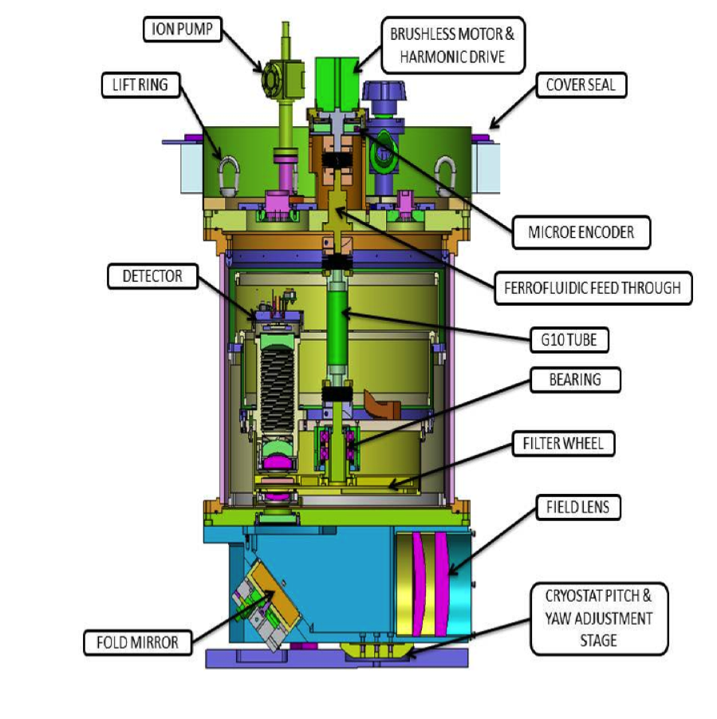
Figure 1. NIR TTS Mechanical Overview (from KAON 890).

Macro-Level Assembly Steps
This section describes the overall assembly process, in order of proper assembly sequence. Beginning with Section 2 there is a dedicated section for each major component that describes special handling and procedures for those components.

Assemble Inner Structure
The inner structure consists of two concentric fiberglass cylinders held together with aluminum rings. With the top and bottom covers removed from the dewar, the inner structure is fastened to the inside of the dewar with XXX.

Assemble Bench
Onto the top of the cold bench install the cooler interface, copper thermal link, heater resistors, and the filter wheel index pin assembly.

Assemble Filter Wheel
- Attach the filter wheel bearing assembly onto the filter wheel.
- Attach the filter wheel to the bottom of the bench by means of the bearing assembly.

Install Bench+Filter Assembly
With the dewar upside-down, the entire cold bench + filter wheel assembly can be installed onto the middle ring of the inner structure, which is already inside the dewar.

Install Filters
The filter optics can be installed in the filter wheel.

Install Filter Wheel Cover
Install the filter wheel cover over the filter wheel, attaching it to the bottom of the bench.

Install Lower Radiation Shield
The lower radiation shield plate is installed over the filter wheel cover, attaching it to the bottom ring of the inner structure.

Install Dewar Bottom Cover Plate
The bottom cover plate of the dewar is held onto the bottom of the dewar (which is still presented as the top, since the dewar is still upside-down) using XXX socket head cap screws. The cover plate is pinned, so there is only one possible orientation.

Install Dewar Window

Install on Base – TBC ??
Presumably at this point the dewar is turned upright and installed on something other than what we are using in the lab.

Install G10 Tube
With the dewar upright, reaching in through the top, install a shaft coupler on the filter wheel shaft protruding through the top of the bench. The coupler is not keyed and is held in place only by friction so the clamping force must be great; tighten this clamp securely! Install the G10 tube into the top of this lower shaft coupler and tighten that as well. Do not install the upper shaft coupler at this time.

Install Lens Tube
The lens tube is secured to the bench with XXX socket head cap screws.

Install Temperature Sensors
Si diode temperature sensors, mounted in aluminum blocks, should be attached now. Refer to FIGURE_XXX as a guide for installation locations.

Install Upper Radiation Shield
The top of the radiation shield may be lowered into place. Carefully feed the temperature sensor and heater wires through the notch in the edge of the radiation shield cover. Fasten to the middle ring of the inner structure with XXX socket head cap screws.

Install Upper Shaft Coupler
The upper shaft coupler may be installed onto the top of the G10 tube, but do not tighten the coupler to the shaft at this time.

Install Temperature Sensor Connector in Top Cover Plate
The connector is fed through the hole in the plate from the bottom and held in place with a nut on the top. It need only be finger-tightened at this time.

Install Dewar Top Cover Plate
The top cover plate of the dewar is held onto the dewar using XXX socket head cap screws. The cover plate is pinned, so there is only one possible orientation.

Install Vacuum Valve
See FIGUREXXX for proper orientation.

Install Ion Pump
The ion pump is attached to the top of the dewar with a KF16 flange and 6 socket head cap screws. Orient the high voltage BNC connector so that it is on a tangent line with the dewar. See also Section 4.

Install Desiccant
The desiccant container is attached to the top of the dewar with a KF16 flange and 6 socket head cap screws. See also Section 4.

Install Pressure Relief Valve

Install Cryo-Cooler Head
Please see Section 3.3 for installation details.

Install Detector
Please see Section 2.2 for installation details.

Install Filter Motor Assembly
The filter motor assembly is held to the top of the dewar with XXX. The screw hole pattern is asymmetric so there is only one orientation possible that allows all fasteners to be installed. After installing, tighten the shaft couplers.

Index Filter Motor
Current status:
- Filter index pin is installed
- Motor is firmly coupled to upper shaft coupler inside the dewar through Ferro fluidic bearing
- Upper shaft coupler inside the dewar is NOT clamped to the G10 post, and thus free to turn; motor movement will not move the G10 post.
Command the motor to index. After indexing is complete, firmly clamp the upper shaft coupler to the G10 post. Access to the shaft coupler screw is through the side of the dewar by removing the XXX bolt. Use the XXX T-handle wrench. Remove the index pin. Re-install XXX bolt. See also XXX.

Install Lifting Rings and Shroud
The lifting rings are installed through the bottom of the shroud (TBC) and the shroud installed on the top dewar plate with XXX screws.

Install Detector Controller
The ARC detector controller is installed onto the shroud using the four captive screws in the shroud. The 100-pin hermetic connector faces in towards the center of the dewar.

H2RG Infrared Detector Array
The H2RG is a specialized device that must be handled with extreme care. The intention of this section is not to be a “how-to guide” for one unfamiliar with the installation and handling of the detector. This section serves more as a reminder of the proper sequence for those already possessing the training and experience that is required. Installation of the H2RG will be broken down into two parts, installing the detector onto its mount and installing the mount assembly into the dewar.

Installing Detector Onto Mount
- Prepare the work area with two bench clamps.
- Install the molybdenum detector mount in one of the bench clamps. Remove the front piece of the aluminum Hirose connector clamping fixture.
- With the detector still in its shipping container, remove the shorting connector. Install the flex circuit with Hirose connector on the detector.
- Loosen the fasteners from the shipping container and install the detector carrier in the other bench clamp.
- For each nut that holds the detector to its carrier, replace them, one at a time, with a handling rod.
- Remove the detector from its carrier, by means of the handling rods, and install in the molybdenum detector mount, using the handling rods as guide rods. Carefully feed the flex circuit through the mount.
- For each handling rod on the detector, replace them one at a time with a spacer, washer and nut. A 0.425 inch thick stainless steel spacer is installed first, which fits around the detector post and into the recess in the mount. A spring or Bellville washer is next, followed by a nut.
- Mate the flex circuit Hirose connector to the Hirose PCB in the aluminum mount. Affix the cover with the two captive screws.

Installing Detector Mount Assembly Into Dewar
This part requires completion of the previous Section (2.1) and that lens tube be installed in the dewar.

- Install the two guide rods into the top of the lens tube.
- Carefully fit the detector mount assembly first over the tallest guide rod then over the other guide rod. Slide the assembly down the guide rods.
- Tighten the four captive screws to hold the detector assembly onto the top of the lens tube.
- Remove the guide rods.
- Remove the wing nut that holds the shorting plug to the detector assembly handle.
- Loosen the wing nuts that hold the all-thread rods to the handle, unscrew the rods from the detector mount, and remove the handle, leaving behind the shorting plug. Take care! The hermetic connector is now balanced atop the fiberglass spacing rods.
- Align the hermetic connector ring with the holes in the hermetic connector and the holes in the top of the dewar and insert flat head screws to hold the ring to the hermetic connector. This requires lifting up the hermetic connector from the detector mount base by approximately 0.1 inch. This should be done with care and without dropping or rotating the connector once it has been lifted.
- Insert XXX socket head cap screws to hold the hermetic connector ring to the top of the dewar.

Cryo-Cooler
The Advanced Research Systems (ARS) Orca™ brand cryo-cooler consists of three components, the compressor that sits in a room separate from the AO optics room, the Joule-Thompson cooler head that mounts atop the NIRTTS cryostat, and the compressed refrigerant lines that connect the two.

Copper Cold Head Tip
On the cold tip of the JT cryo-cooler is mounted a copper “hat” assembly. This copper tip is affixed with a piece of indium foil; it should not be removed. Removal of the copper tip may result in the indium foil being damaged, requiring replacement; replacement indium foil has not been purchased. There is no need to remove the copper tip under normal circumstances.

Temperature Sensor
There is a Si diode temperature sensor mounted (in an aluminum block) to the backside of the cold head (see FIGURE_XXX). One of the screws holding the copper tip to the cold head is longer than the others, so that it protrudes beyond the cold head; the temperature sensor slides over this screw and is held in place against the back of the cold head with a nut. While the sensor may be removed, it should not normally need to be removed. Instead, in order to be able to separate the JT cryo-cooler from the dewar and not be tethered by the temperature sensor, there is an in-line connector in the constantan wire for the temperature sensor.

Cryo-Cooler Installation
The JT cryo-cooler head should be installed in the dewar after all of the dewar’s internal components have been installed and the top of the dewar has been attached. The filter motor assembly must not be installed however; the Ferro fluidic bearing may be installed. Although there may appear to be interference between the nut on the Ferro fluidic bearing and the JT cooler, the nut does not need to be turned to allow installation of the cryo-cooler (see Figure 2). There is a clamping fixture on the cooler interface attached to the bench (see Figure 3) that completes the thermal connection between the cold head tip and the bench. This clamp must be loose in order for the cryo-cooler head to be fitted into the cooler interface. The installation sequence is as follows:

Loosen Cooler Interface Clamp
Access to the cooler interface clamp is achieved through the pressure relief valve access hold in the top dewar cover. Use a XXX T-handle wrench.

Connect Temperature Sensor
Before installing the cryo-cooler, the temperature sensor leads must be fished out through the corresponding opening in the top of the dewar. Although it is not necessary to remove the detector assembly for this, if the detector assembly is not yet installed then this is made easier because one can reach inside the dewar to facilitate getting the temperature sensor leads outside. Connect the cold head temperature sensor leads to the cold head temperature sensor.

Install Cryo-Cooler
Through the hole in the top dewar cover and the hole in the radiation shield, lower cryo-cooler into the cooler interface on the bench. This may require some slight twisting and tipping of the cryo-cooler, as the copper tip to cooler interface is a snug fit. Take care that the o-ring is properly seated and that the o-ring mating surfaces are clean.

Attach Cryo-Cooler to Top Dewar Cover
Ensure proper alignment of the screw holes between the cryo-cooler and the top of the dewar and fasten with XXX socket head cap screws. There is a preferred rotational orientation of the cold head in order to aid in the clearance of the compressed refrigerant lines. Refer to FIGURE_XXX for the proper orientation.

Bench Clamp
After the cryo-cooler cold head has been installed on top of the dewar, this clamp must be tightened. The clamp is tightened by reaching inside the dewar through the pressure relief valve access hole with a XXX T-handle wrench. (The pressure relief valve access hole is the hole located immediately counter-clockwise from the cryo-cooler when viewed from above.) There is a corresponding access hole in the radiation shield (Figure 4).

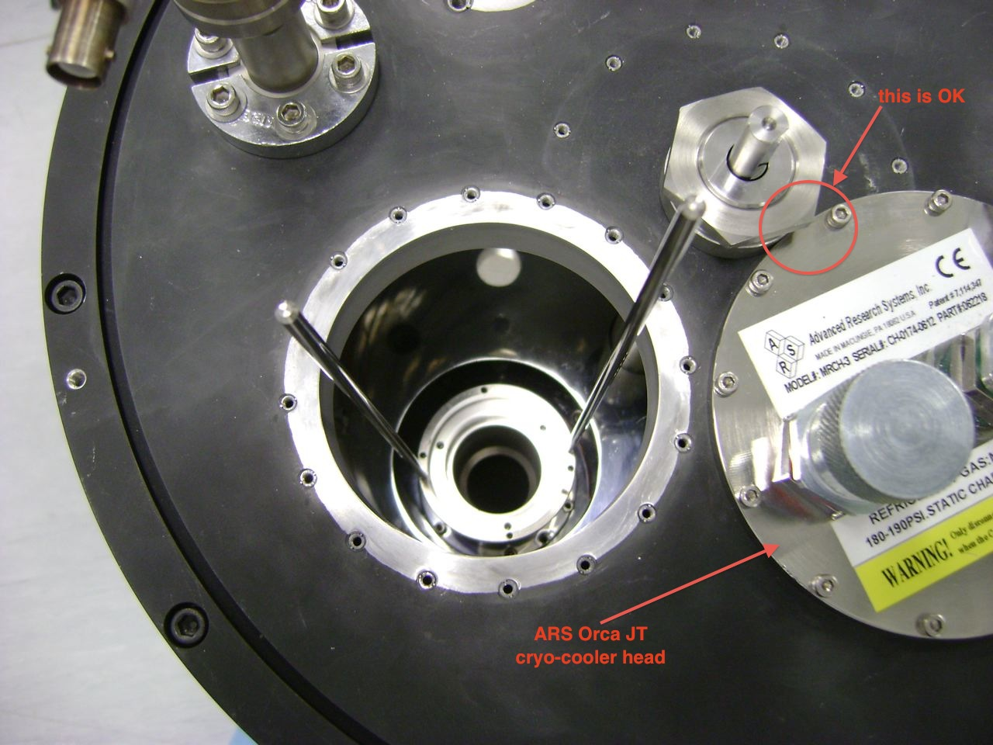
Figure 2. ARS Orca JT cryo-cooler head installed in dewar. Note that the nut from the Ferro fluidic bearing appears to overlap but the cooler head may be installed in spite of this appearance, without adjusting the nut. The filter motor assembly has been removed out of necessity.

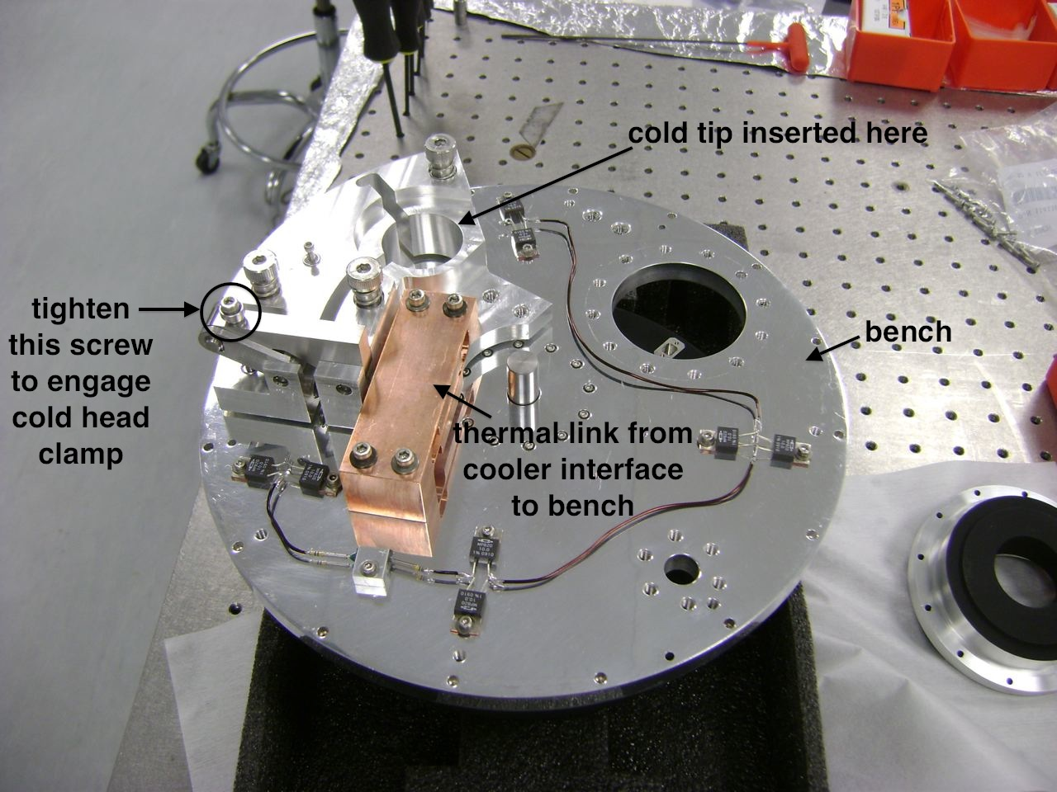
Figure 3. View of bench showing cooler interface and thermal link; other components removed for clarity.

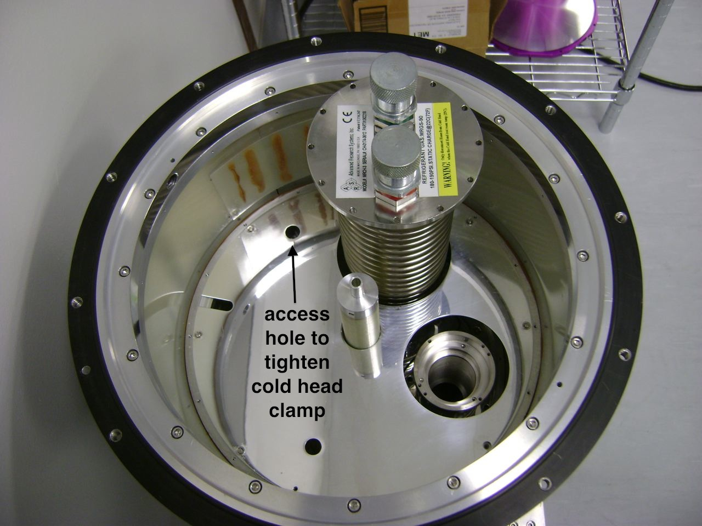
Figure 4. When the bench is installed in the dewar there is a hole in the radiation shield (left of the cryo-cooler) which provides access to the cooler interface clamping screw. The hole at the bottom provides access to the filter wheel locating pin. The notch at left provides access for wiring. The top of the lens tube is shown at right.

ARC Detector Controller

Installation
The Astronomical Research Cameras (ARC) Detector Controller Chassis mounts to the top of the shroud using four captive screws that remain with the shroud. The controller may be affixed to the shroud whenever the latter is in place on the cryostat. Prior to affixing the controller to the cryostat, it should be configured as described in Section 4.5.

External Cabling
The external connections to the detector controller are as follows:
- Power supply cable
- Fiber optic cables (two between chassis and host computer, and one from chassis to Microgate controller)
- Temperature control cable #1 (one cable from side of chassis to Lakeshore inputs A,C and heater #2)
- Detector cable (100-pin cable from chassis to hermetic connector on top of cryostat)

Power supply and detector connections should be made with the power off.

Hardware Summary
The following boards are installed in the ARC-70 Detector Controller Chassis:
- ARC-46 8-channel IR video board
- ARC-32 clock driver board
- ARC-22 (modified) fiber optic timing board

The chassis does not require any special placement of the boards (they can be inserted in any slot and will operate normally) however, due to the nature of the cabling between the boards and the patch panel, there is a preferred board placement so that the board is installed nearest to its corresponding connector on the patch panel. Numbering the slots from the bottom of the chassis, the timing board should be installed in the first, bottom slot (slot 1). The next slot up (slot 2) should carry the clock board. Slots 3, 4 and 5 are empty, reserved for the future expansion of additional video boards. The top slot (slot 6) carries the IR video board #1. To summarize, from top to bottom,
6. Video Board #1
5. Empty (future video board #2)
4. Empty (future video board #3)
3. Empty (future video board #4)
2. Clock Board
1. Timing Board

Internal Cabling
Fiber optic patch cables labeled TX1, TX2, RX are connected according to matching labels on the chassis and the patch cables (see Figure 5). These fiber optic patch cables connect to the rear panel of the chassis. A DB15 cable is also connected between the timing board and the patch panel. A DB37 cable should be connected between the clock board and the corresponding clock connector on the patch panel. A DB50 cable connects between the video board and the corresponding video connector on the patch panel.

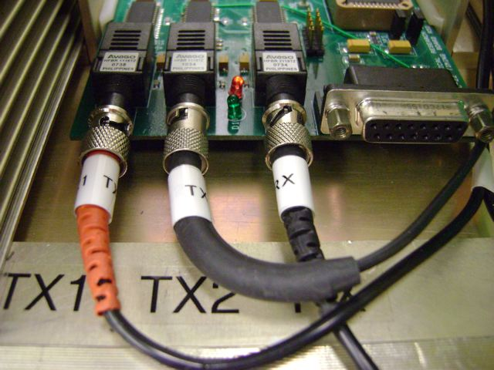
Figure 5. Fiber optic patch cables from rear panel of chassis to front of timing board. The DB15 cable has been removed for clarity.

ARC Controller Configuration
The following sections describe the configurations of the ARC hardware, which are not necessarily as the manufacturer ships them. Any future replacements should be checked against these descriptions.

Video Board
User-installed optional resistors were installed at the non-inverting inputs; see the left panel of Figure 6. The values installed were 10k ohm 1% in R21, R60, R103, R157, R223, R272, R316, R367. Please refer to the manufacturer’s schematic and layout diagrams for details on resistor placement. Note that we are using the current revision 3B; there was a reversal in the names of these resistors between the current Rev.3B and the previous Rev.2C versions of this board.

The original “as-shipped” board (SN 264) had a damaged resistor, R26 (1.0k). This was replaced with R346 from the same board, since R346 is on a channel that is not currently used. R346 was replaced with a similar value (1.2k).

Video bias output 7 is assigned to VBIASPOWER (3.3V) and jumper JP11 (Figure 6) is connected to pins 1+2, in order to tie the video inputs to VBIASPOWER through 10k pull-up resistors. JP9 and JP10 are configured as shown in the right panel of Figure 6.

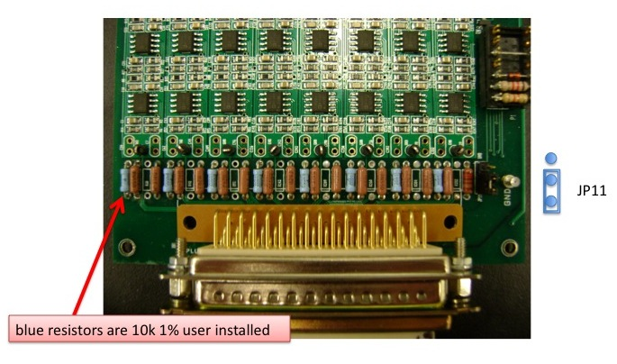 | 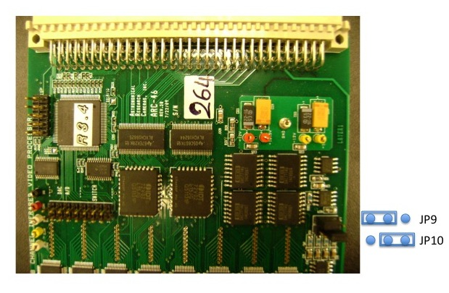
Figure 6. ARC-46 Video board configuration, showing user installed resistors and jumper JP11 (left), and jumpers JP9 and JP10 (right). The blue resistors are 10k 1% user-installed.

Clock Driver Board
The clock driver board is configured with the following jumper settings (see also Figure 7):
- JP1: open
- JP2: closed
- JP3: open
- JP4: open
- JP5: closed
- JP6: open
- JP7: open
- JP8: H
- JP9: G

Note that there was a jumper polarity reversal between the current board revision 6A and earlier revisions (see Figure 8).

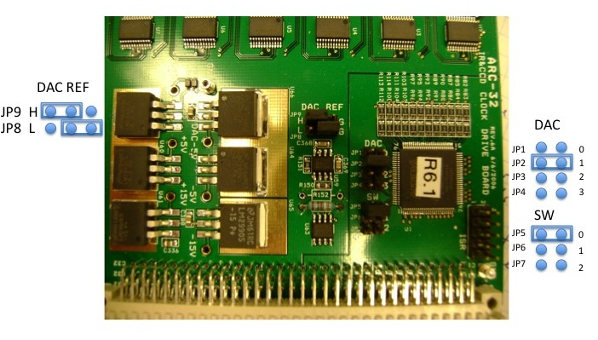
Figure 7. ARC-32 Clock driver board jumpers.

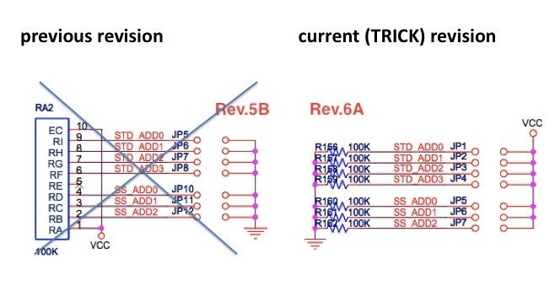
Figure 8. Clock driver board jumper polarity.

Timing Board
ARC modified the ARC-22 timing board for the secondary fiber transmitter. The secondary transmitter is an option, allowed for on the board layout, not normally included. The modification requires not only the insertion of an additional fiber transmitter but also board wiring modifications and a special PAL. No jumpers were modified. See Figure 9.

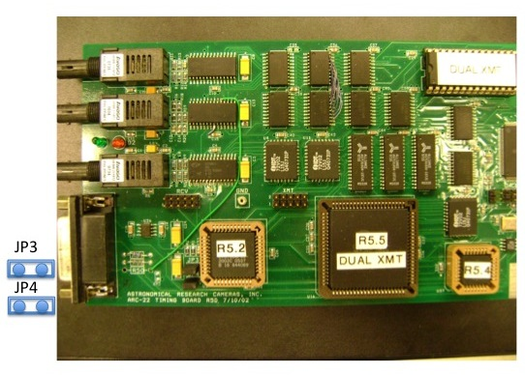 | 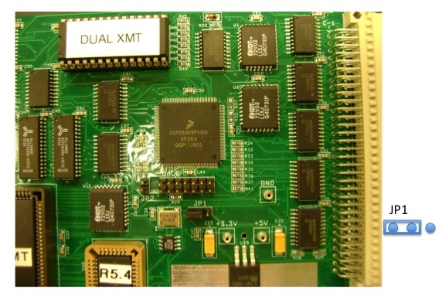
Figure 9. ARC-22 Timing board jumper configuration.

Desiccant
The desiccant consists of a cylinder of molecular sieve material, held in place by a screen, which serves to absorb water vapor at room temperature. It should be removed every XXX months and baked at XXX degrees for XXX minutes. Atop the desiccant container is a pressure relief valve. The entire assembly uses standard KF flanges and requires no special assembly.

Gamma Vacuum Ion Pump

Installation
The ion pump itself terminates in a 1.33 inch (DN16) conflat flange and there is a conflat to KF16 flange adapter. The KF16 flange is then affixed to the top of the dewar. One should not separate the conflat flange joint because this uses a crushable copper gasket that cannot be reused. There is no need to separate this joint. If the ion pump needs to be removed from the dewar then it should be released at the KF16 flange interface.

Rotational orientation of the ion pump is not very critical but should be oriented such that the high voltage coaxial connector is approximately aligned with the tangent line of the dewar, so that the high voltage coaxial cable does not interfere with the shroud. The green ground wire attaches to the nut on top of the ion pump.

Filter Motor Assembly

Cabling
This section lists the external cabling required for the NIRTTS instrument.

Ion Pump
Connect the HV (high voltage) coaxial cable between the BNC connector on the ion pump and the ion pump controller. Connect the green ground wire from the stud on the ion pump to the chassis of the controller. The controller has a small AC/DC external power supply which plugs into a standard 120VAC NEMA 5-15 wall outlet.

Lakeshore Temperature Controller
There are two temperature control cables between the Lakeshore 336 and the instrument. Temperature Control Cable #1 connects to the side of the ARC detector controller and terminates in inputs A, C and heater output #2. Temperature Control Cable #2 connects to the top of the dewar and terminates in inputs B, D and heater output #1. Each temperature controller cable contains a ground wire that should be attached to the ground screw on the back of the Lakeshore. The Lakeshore connects directly to 120VAC using a standard NEMA 5-15 equipment power cable.

ARC Detector Controller
The dewar side of the detector controller has a 100-pin hermetic connector; this is attached to the mating connector on the top of the dewar using a short 100-pin cable. The opposite side of the controller has a connector for a temperature control cable to the Lakeshore (see also Section XXX). The end of the controller has an input connector for power; the 8 m power cable from the ARC power supply connects here. TX1 and RX connect to the RX and TX ports of the host PCI board using single mode fiber optic cable. TX2 connects to the Microgate controller. The fan connector provides power to an auxiliary fan, for use only when the instrument is not mounted on the AO bench. The AO bench provides air ducting for cooling. If the instrument is to be tested apart from the AO bench and this cooling duct, then the duct flange is to be replaced with a DC fan; the DC fan receives power from this LEMO connector on the controller.

Filter Motor
A cable connects between the filter motor and the filter controller. The filter controller connects to Ethernet with a standard cat5 cable and to 120VAC using a standard NEMA 5-15 equipment power cable.

Cryo-Cooler
The cryo-cooler head has two compressed refrigerant lines marked with red and green tape. Connect the corresponding refrigerant line by matching the colors on the cooler head. The other ends of the refrigerant lines connect to the compressor. The compressor requires 250VAC single-phase 15A and uses a NEMA L6-15 power connector.

