

Next Generation Adaptive Optics System

Operations Maintenance Plan
(Draft)

May 15, 2009
VersionV1.0

Prepared By Jason Chin

Revision History

Revision | Date | Author (s) | Reason for revision / remarks
1.0 | May 14, 2009 |  | Initial release

TABLE OF CONTENTS
Revision History 2
TABLE OF CONTENTS 3
1 Introduction 4
2 References 5
2.1 Referenced Documents 5
2.2 Acronyms and Abbreviations 5
3 Maintenance Definition and Types 6
3.1 Preventative Maintenance 6
3.2 Calibrations/Performance Maintenance 6
4 Maintenance System Support 6
4.1 WMKO Maintenance Management System (MMS) 6
4.2 WMKO Instrument Maintenance Program 8
5 Maintenance Responsibilities within the NGAO Operations Team 8
5.1 Adaptive Optics System 9
5.2 Instrumentation System 9
5.3 Laser Guide Star Facility 9
5.3.1 Laser 9
5.3.2 Laser Launch System (LLS) 9
5.4 Facilities and Infrastructure 9
5.5 Software 9
5.6 Computer Servers and Network 9

Introduction
As part of the NGAO Operations Plan, the operations team assumes responsibilities for maintenance of the system after the Operations Readiness Review (ORR). The operations team will ensure NGAO maintenance is completed timely and efficiently. In KAON 473 NGAO Function Requirement Report, a key discipline for each subsystem is “Service and Maintenance”. Each subsystem shall have as a deliverable a list of maintenance items with sufficient details for the operations team to carry out.
This document outlines a plan that describes how the maintenance will be carried out. The actual maintenance required is not discussed in this document. The plan is developed for the Preliminary Design Phase of the project. In the subsequent phases of the project, the designs will be firmer where more details will be provided on the maintenance tasks themselves. The final goal of this plan will be to ensure all maintenance tasks will be identified and the effort required for the tasks to be defined. The effort estimates are included in the NGAO Operations Support Plan.

References

Referenced Documents
Documents referenced are listed in Table 1. Copies of these documents may be obtained from the source listed in the table.
Ref. # | Document # | Revision or Effective Date | Source | Title
1 | KAON xxx | 1.0 | WMKO | NGAO Operations Support Plan
2 | KAON 473 | March 25, 2008 | WMKO | NGAO Requirements Management and Functional Requirements
Table 1: Reference Document

Acronyms and Abbreviations
Table 2 defines the acronyms and abbreviations used in this document.
Acronym/Abbreviation | Definition
AO | Adaptive Optics
AOE | Adaptive Optics Systems Engineer
AOS | Adaptive Optics Scientist
CPfM | Calibration/Performance Monitoring
GUI | Graphical Users Interface
IPMP | Instrument Preventative Maintenance Project
KAON | Keck Adaptive Optics Note
LGS | Laser Guide Star
LGSF | Laser Guide Star Facility
MMS | Maintenance Management System
NGAO | Next Generation Adaptive Optics System
OID | Operations and Infrastructure Department
ORR | Operational Readiness Review
PDA | Personal Digital Assistant
PvM | Preventative Maintenance
SA | Support Astronomer
TBD | To Be Determined
WMKO | W.M.K. Observatory
Table 2: Acronyms and Abbreviations

Maintenance Definition
Maintenance is completed to keep equipment operating or extend the life of equipment to meet operational performance. Maintenance generally includes tests, measurements, adjustments, replacement, and corrective actions due to system monitoring. Maintenance is performed periodically to prevent faults as well as to maintain an acceptable level of performance. Troubleshooting is not considered maintenance.
The primary goal is to avoid a failure condition that reduces down time. Although not considered down time, performance degradation must also be considered in the equation as to the importance of the maintenance. Because of this, maintenance will be separated into three categories.

Preventative Maintenance
Preventative Maintenance (PvM) tasks are generally related to maintenance of a specific component or hardware system. For example, the HEPA filters need to be replaced to prevent particulates from damaging the laser. A task can be generated to replace the filters periodically per the manufacturer. Lubrication of a stage is another example. Tasks such as these can extend the life of the system and prevent failures.

Calibrations/Performance Monitoring
Calibration/Performance Monitoring (CPfM) tasks are associated with the overall performance of a system. Calibrations are done to peak performance while performance monitoring can assist in determining failures. The term predictive monitoring is also used to measure performance to predict failures.
Performance degradations may not be associated with a single component; but should be examined at the system level. It may be associated with misalignments or increase in noise in the system or changes in temperatures or combination of multiple items. By measuring the performance of the system periodically, systems personnel are able to start identifying areas of concerns and perform additional tests to isolate problems.

Maintenance System Support
WMKO’s OID is currently operating multiple platforms for maintenance of its subsystems. The most popular is the Maintenance Management System (MMS) used to for facility maintenance. The MMS has been operating successfully and developed within the observatory by the facilities team. OID is also working on a maintenance program for its instruments called the “Instrument PM Project” (IPMP). In addition to basic PvM, the IPMP is heavily geared toward the performance aspect of the instrument which is not dealt with by the MMS. The IPMP is also written on a UNIX platform to more readily communicate with existing instrument computers.
For now, both the MMS and IPMP or a combination will be considered for use with the NGAO system.

WMKO Maintenance Management System (MMS)
The MMS is a database used by OID for maintenance and can be accessed within the WMKO network. The MMS also has a bonus feature which allows personnel to use a palm size unit such as a PDA to access and enter information. The system generates work orders based on the maintenance requirements and logs the work that was completed. It has some limitations as far as data exploitation; but it does keep track of basic performance parameters such as minimum, nominal and maximum.
Generated work orders are then provided to the summit crew for execution. Figure 1 shows the GUIs of the system. The left screen shot shows the categories in the MMS. The middle screen shot shows the tasks within the categories, and the right screen shot shows details of the individual task. Priority is also assigned for tasks to ensure the highest priority tasks are completed first.

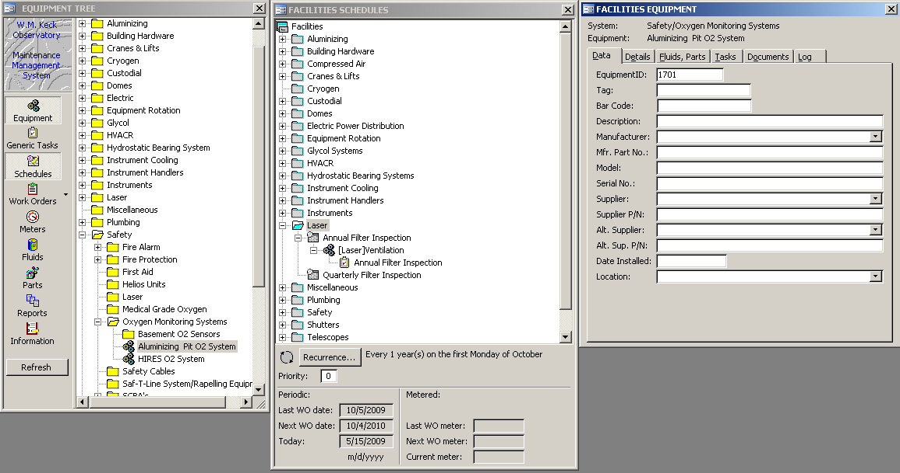
Figure 1: WMKO Maintenance Management System

Figure 2 shows the screen shot for each task’s details. The horizontal tabs provide information of each task. The Data tab includes hardware information such as model, serial numbers, manufacturer and supplier information for purchase. The Detail tab provides specific information of this task related to this system. Fluids, parts tab specifies materials required to perform the task. Note the MMS is used throughout the facility which has many systems requiring specific fluids. The Tasks and Document tabs provide the information regarding the periodicity, procedure, measurements and documents that support the tasks. The Tasks tab also provides details on manpower and duration of the task. Finally, the Log tab provides information of when the maintenance was done and by whom.
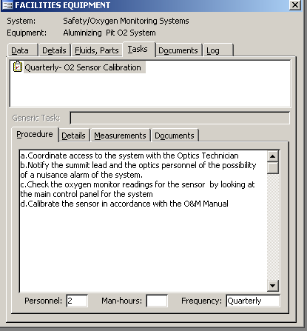
Figure 2: Task Details
It is envisioned that each subsystem’s PvM tasks will be entered into this database once experience is gained on what needs to be maintained.

WMKO Instrument Maintenance Program
The Instrument Maintenance Program will support maintenance tasks related to performance of the NGAO System. Once this system is better defined by OID, details on its implementation for NGAO will be presented. Current information can be found at the instrument Twiki page: http://www/TWiki/bin/view/Instruments/InstrumentPM.

Maintenance Responsibilities within the NGAO Operations Team
The NGAO Operations Team lead will be responsible for maintenance and performance of the NGAO System. Each subsystem or type of maintenance will be led by a person in the operations team.

Adaptive Optics System
Maintenance of the AO System will be lead by the AO Systems Engineer (AOE). The AOE will acquire support as necessary from operation team which includes disciplines from the electronics, mechanical, facility, optics, observing, and software groups. The AOE will work closely with the AO scientist (AOS) and instrument team to ensure system performance is maintained.

Instrumentation System
Maintenance of the Instrumentation System will be lead by the instrument engineer or the support astronomer (SA). This group shall ensure the instruments themselves are optimized and working to peak performance with the AO and LGSF systems.

Laser Guide Star Facility

Laser
The maintenance of the laser system and their performance will be led by the laser engineer, who will be responsible for all maintenance as recommended by the laser manufacturer.

Laser Launch System
Similar to the AO system, the Laser Launch System will be led by the AOE with support from other disciplines.

Facilities and Infrastructure
Facilities and Infrastructure maintenance will be lead by the Operations and Infrastructure Department (OID). The facilities group will work closely with the AOE and LE to ensure maintenance tasks are carried out. Daily maintenance items such as cryogenics will also be carried out by OID.

Software
All software in the system including user tools will be the responsibility of the Operations Software Engineer. The OSE will work closed with the AOS and the SA regarding user tools. It is likely many of the user tools will be developed closely with the AOS and SA.

Computer Servers and Network
Computer and network maintenance will be led by WMKO Administration group. They will be responsible for maintaining the network, backups, and rebooting of servers as needed.

