 May 4, 2010

Keck Next Generation Adaptive Optics

System Monthly Report for J. Chin

April, 2010 Completed Activities

The following are activities completed for this period.

General: Significant effort to complete PDR design and documentation in preparation for PDR.

1.3.2 Management & Planning
1.3.3 System Engineering
1.3.3.5 External Interfaces (Complete)
1.3.3.5.1.5 Telescope to LGSF Software ICD
The ICD will stand as is for the DD phase and will undergo review in the DD phase as part of the design.

1.3.3.5.1.5 Acquisition Guider System to LGSF Software ICD (Complete)
The ICD will stand as is for the DD phase and will undergo review in the DD phase as part of the design.

1.3.3.6 Internal Interfaces (Complete)
1.3.3.6.2 AO to LGSF ICD
The ICD will stand as is for the DD phase and will undergo review in the DD phase as part of the design.

1.3.5 Laser Guide Star Facility

The following document has been completed in support of the PDR. Document is on Keckshare and Twiki.

1. KAON 751 LGSF Subsystem Control Sequencing

1.3.5.1 Laser Enclosure (Complete)

The following document has been completed in support of the PDR. Relevant docs still need to be placed on the Twiki and Keckshare. Cost estimates and MS project plan provided to Project Manager.

1. KAON 749 Laser Enclosure Design

2. Laser Enclosure MS project plan

3. Laser Enclosure Cost Estimates

1.3.5.2 Laser ( Complete for PDR)

The following document has been completed in support of the PDR. Relevant docs still need to be placed on the Twiki and Keckshare. Cost estimates and MS project plan provided to Project Manager.

1. KAON 750 Laser Systems Support Design

2. Laser Systems Support MS project plan

3. Laser Systems Cost Estimates

A final quote was completed with vendor to support the MRI Next Generation Proposal. Additional discussions will be needed to support the final design going into the June Delta Preliminary Design Review for the laser.

1.3.5.3 Laser Launch Facility(90% complete)

Management:

Effort Estimates and MS project plan completed. Updating design documents for the PDR.

System:

Updating Laser Launch Facility System Performance for PDR. Diagnostics documentation generated in support of PDR. Final LLF Budget and Error Tolerances updated for PDR.

Beam Generation System: Updating design documents for the PDR.

Beam Transport Optics: Updating design documents for the PDR.

Switchyard: Updating design documents for the PDR. New SolidWorks model completed in support of the PDR.

Launch Telescope: Twiki website has been established for the Project Management. Design documents as well as weekly reports are on the password protected Twiki. The following milestones have been set for the PD phase. Initial monthly project report completed and posted on Twiki.

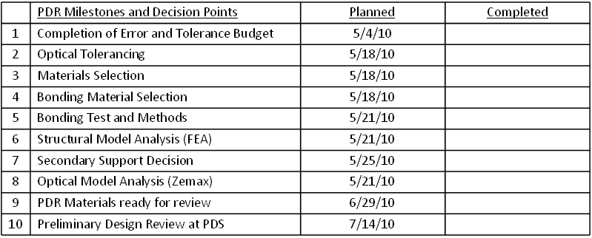

1.3.5.4 Safety System Design (95%Complete)

The following document has been completed in support of the PDR. Relevant docs still need to be placed on the Twiki and Keckshare. Cost estimates and MS project plan provided to Project Manager.

1. KAON 752 Safety System Controller,

2. KAON 753 NGAO Safety System Interface Control Spreadsheet

3. KAON 754 Laser Traffic Control System.

4. KAON 755 NGAO Laser Clearing House Planning

5. KAON 756 NGAO Aircraft Safety System

6. Laser Systems Support MS project plan

7. Laser Systems Cost Estimates

1.3.5.5 Laser System Lab I&T Plan (Complete)
Cost estimates and MS project plan provided to Project Manager.

1.3.8.2 Infrastructure Mods for the Laser (Complete)
Cost estimates and MS project plan provided to Project Manager. Mods for laser are described in KAON 750 Laser Systems Support Design.

1.3.8.5 Common Infrastructure Mods for NGAO (90% complete)
Cost estimates and MS project plan provided to Project Manager. KAON 759 NGAO System Facility and Cooling has been completed in support of the PDR. Document is on Keckshare and Twiki.

1.3.9 Telescope Integration and Test
1.3.9.1 Old AO/Laser Removal (100% complete for laser only).
KAON 578 NGAO Keck II Laser Removal Plan uploaded to Twiki. Cost estimates and MS project plan provided to Project Manager.

1.3.9.4 Laser System Integration (50% complete)
Cost estimates and MS project plan provided to Project Manager.

