 August 18, 2009

Keck Next Generation Adaptive Optics

Meeting Minutes

Laser Launch Facility

Attendees: J. Chin, C. Neyman, J. Bell, E. Wetherell, T. Stalcup

Agenda:

1. Review action items from previous meeting

a. Review pushback on requirements with R. Dekany.

b. Update on smaller devices on BTOB

c. Updates on BGS models in the secondary

2. Jim to present his latest models of the Beam Transport Optics on the telescope

3. Set goals for completion of documents

1. Review of Action Items

Push back on Requirements
There were two items to review with R. Dekany. The throughput requirement of 75% is on the edge of meeting based on current design using standard optical components. Custom components and ensuring cleanliness can improve this to 86% throughput. RD does not want to reduce this requirement. Thomas will determine where it makes sense to use custom components and take into consideration of the design to ensure cleanliness to meet the 75% requirement.
The second item is the wavefront error requirement. In the previous model, consideration of focusing the beam was applied. By doing so and staying within the depth of focus for changes to the sodium distance, this requirement should be easily met.
Therefore, no changes to current requirements will be implemented.

Update on smaller stages
JB had a discussion with PI on possibly smaller piezo stages for the three PNS lasers. The previous design uses Newport stages that were bulky and would not meet the weight and volume requirements. The new PI stages may need to be modified by the manufacturer to increase the shaft from 50mm to 100mm travel. These stages have feedback and will have sufficient speed performance and resolution. The concern is the control interface using custom PI controllers. EW will take action item to examine these controllers and their compatibility with overall motion control.

The cost of these stages will be >$7K per stage; we need six. The cost to design and fabricate them will be higher per JB. JB and EW to follow up to ensure PI can provide stages at the required lengths.

The use of these new stages would allow the devices to meet the size and weight specification.

Updates of BGS models in the f/15 secondary
JB inserted the previous design/model into the existing K1 LGS model for the f/15 module. The design fits in the allowed space if the new PI motion control devices are used. These models are in solid works and JB invited all to view it on his computer.

Requirements for BGS
Discussions were held by JB, TS, CN, and RD on the requirement for full 360 degrees coverage for the PNS. It is impacted by the WFS in the AO system as well. The short answer is yes, this is a requirement. CN will ensure the requirement is represented.

New Items

Beam Transport Optics Design
TS presented the design and path of the BTO on the telescope from the laser enclosure to the secondary socket (BTO_Design 17aug09.ppt). The design has been modeled by JB.
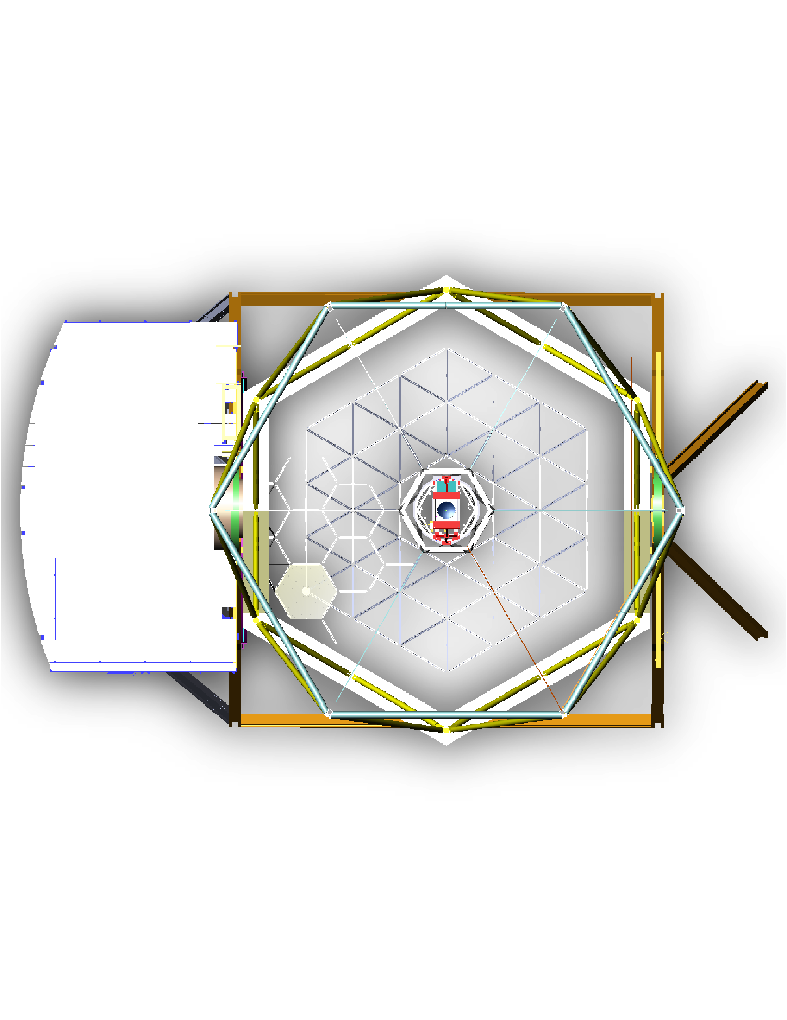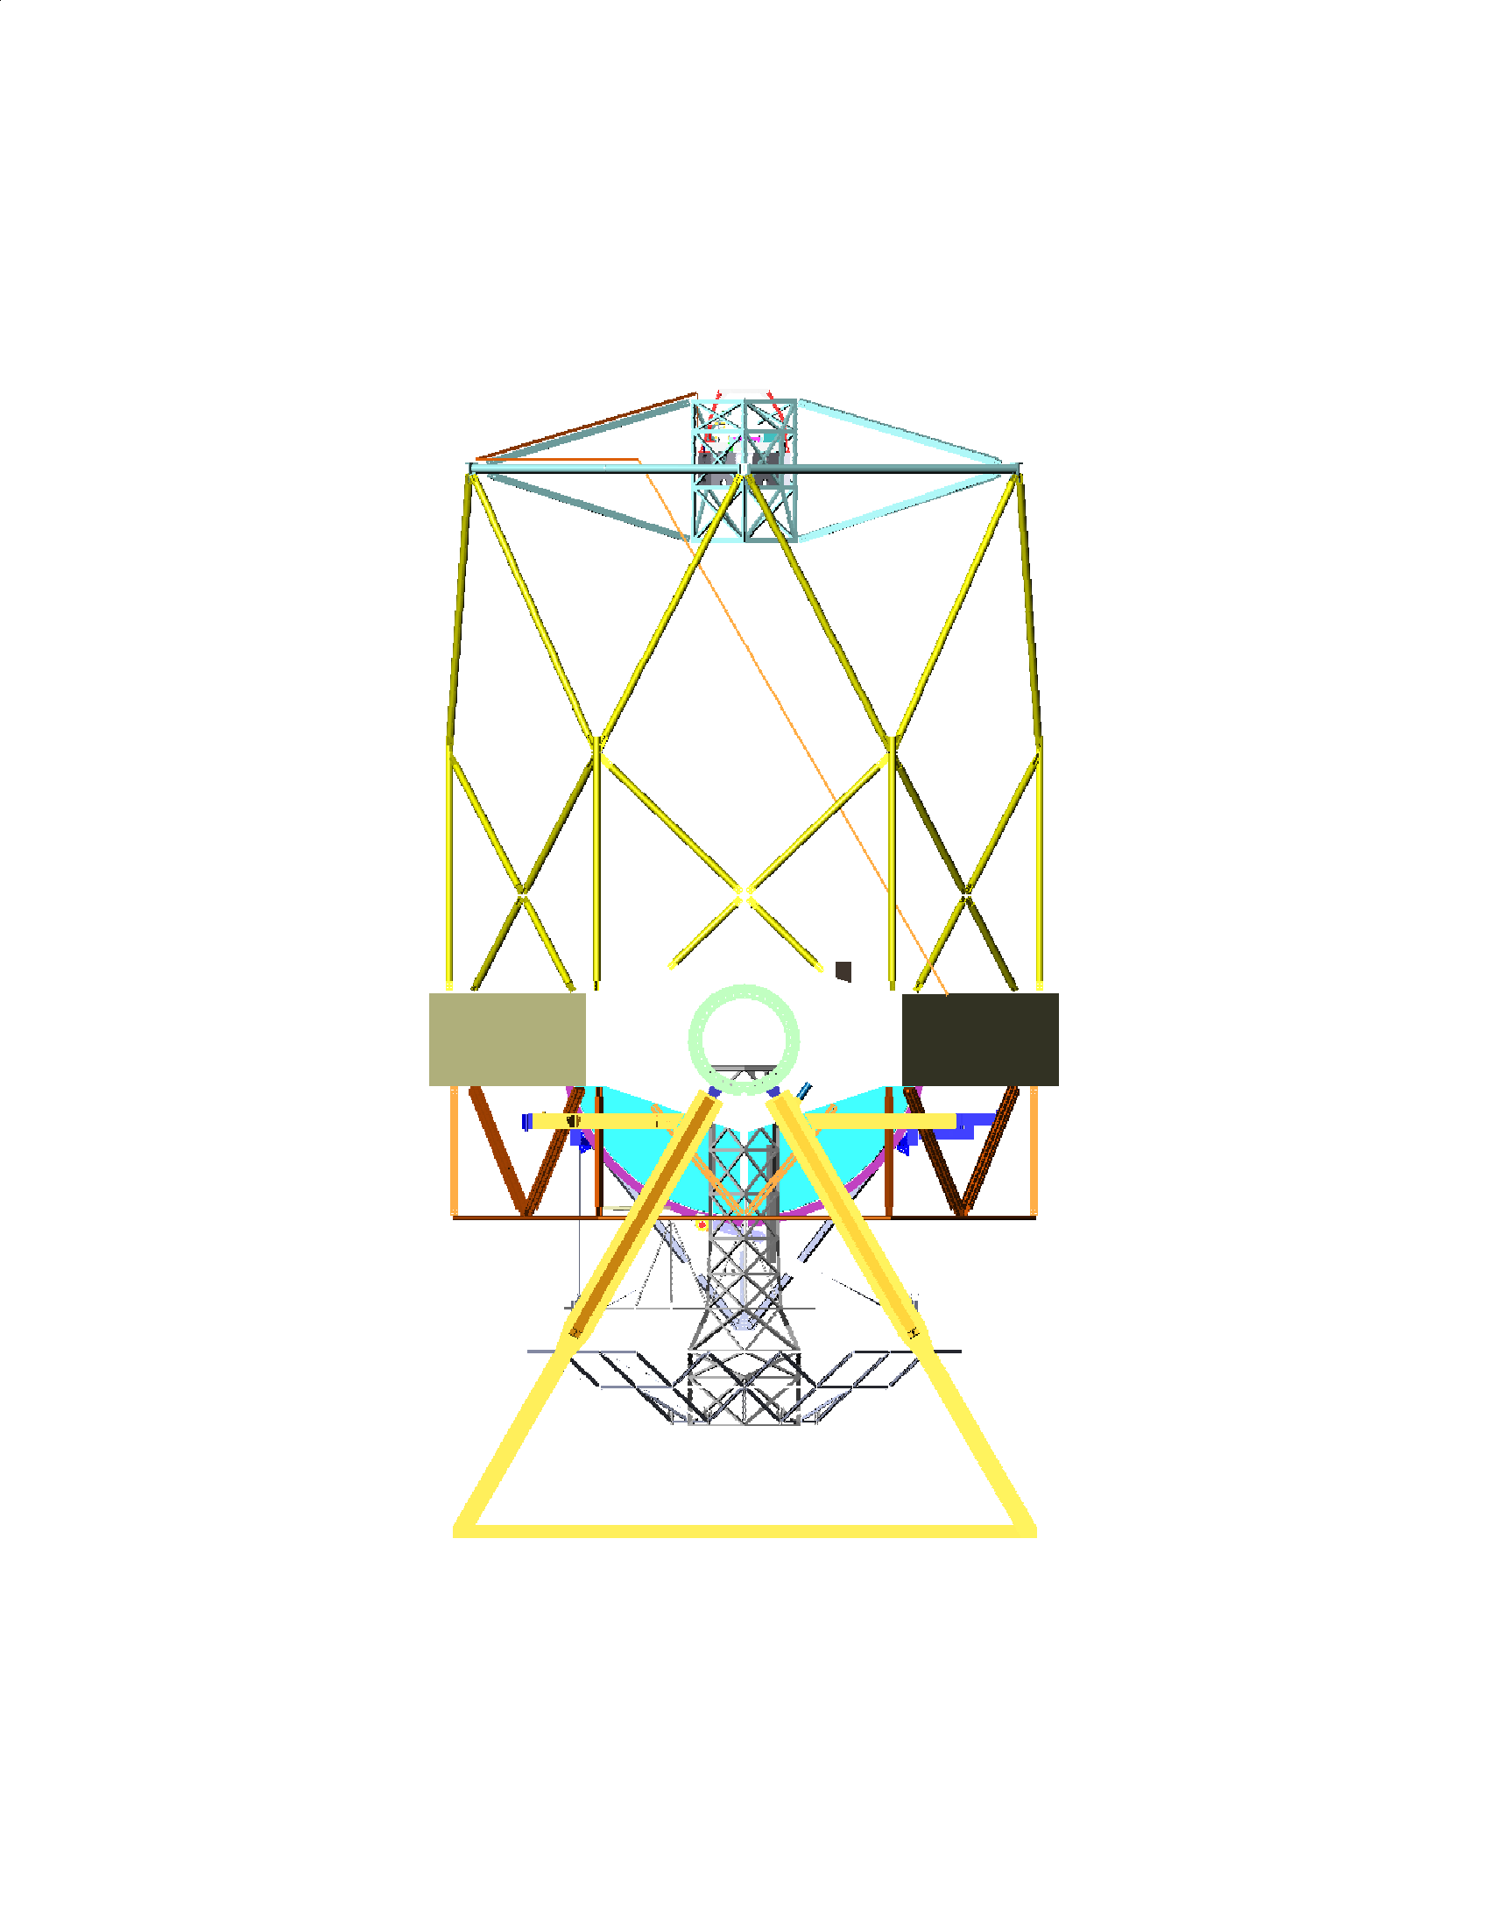

Design choices included:
1. Minimizing the number of optics by using the “top” part of the telescope where the beam can walk directly into the secondary without additional folds to go around telescope socket structure. The beam does not do directly out of the existing K2 laser enclosure to avoid additional reflections to go around the “knuckle” on the lower part of the telescope. Structure cannot be on the outside of this lower “knuckle” due to interference with the Nasmyth Deck.
2. TS to document decision choices in the PDR documentation.
Design considerations:
1. CN wants to ensure the angle of incidences due to the irregular angles is not an issue. TS does not think this is an issue.
2. JC wants to ensure the design can support possibly another enclosure on the RBC area in case we need it for an extra laser. TS to verify the design is capable of an additional beam from another source either in the BTO or BTOB.
3. JC questions the possibility of a laser beam size change and its impact. TS suggests the design will have to be modified to account for this beam size; but it’s a sizing issue and not an entire new design.
4. Care must be taken in the mechanical design to ensure the mechanical tubes do not impact telescope performance. Tubes must be compliant.
5. TS and JB to agree upon interior surface of the tubes.

Motion control: Based on the current bluebook estimate of the flexure, TS’s model shows only a signal stage is needed at the laser enclosure. The design will have provision for a second stage at the bottom right corner of the figure above. The resolution will require a piezo type motion control. EW will review the motion requirements, in addition to ensuring the devices will work over the long distances.

MRI Proposal’s Relevance

BTO
The BTO will apply since we are using the start of the BTO from the laser enclosure. TS requested existing K2 laser beam specification to ensure no issues with divergence.

BTOB
The baseline is to use the K1 BTOB with slight modifications for use with the BTO instead of fiber. TS questions whether we can use more of the NGAO design in the BTOB. This will have to be determined based on cost and effort. As a first guess, the answer is no, we do not want to make significant changes to the BTOB design from K1; this is what was estimated in the proposal.

Management
JC will review the efforts and determine where it makes sense to start charging to MRI proposal instead of NGAO. JC to confer with PW with plan.

Documentation
Due to the lack of time, JC will contact members individually to get inputs for the documentation. Now that we have concrete designs, we should start the documentation process.

For next meeting: 09/01/09

Follow up on action items
Action Items are throughout document in Italics.

Determine flexure of telescope
TS to provide plan on testing flexure of telescope. This is a big piece of information to assure the current designs can meet specification.

Switchyard Design
TS to provide switchyard design to mate with laser enclosure.

Documentation
Please either update preliminary design document on Twiki or provide inputs to JC on design docs. Any design material should be on Twiki.

Prior to next meeting, please send PPTs or models to JC in PDF for discussion in advance.

