

Next Generation Adaptive Optics System

Laser Guide Star Facility
Laser Enclosure Preliminary Design

April 10, 2010
VersionV1.0

Prepared By J. Chin

Revision History

Revision | Date | Author (s) | Reason for revision / remarks
1.0 | April 10, 2010 | All | Initial release

TABLE OF CONTENTS
Revision History 2
TABLE OF CONTENTS 3
1 Introduction 4
2 References 5
2.1 Referenced Documents 5
2.2 Acronyms and Abbreviations 5
3 Overview 6
4 Laser Enclosure Layout 8
4.1 Existing Layout 8
4.2 Layout of NGAO Laser System 10
4.3 Mass Allocation 11
4.4 Laser Enclosure support 11
4.4.1 Laser Installation and Servicing 11
4.4.2 Temperature, Particulates and Humidity 12
4.4.3 Lighting and Ventilation 12
4.4.4 Electrical Power 12
4.4.5 Cooling 13
4.4.6 Communications 13
4.5 Safety 13
4.5.1 Eye Safety 13
4.5.2 Fire Safety 14
4.5.3 Operational Safety 14
4.6 External Interfaces 14
4.6.1 Mechanical Interface to the elevation ring for the LE 14
4.6.2 Infrastructure Interfaces 14
4.7 Internal Interfaces within the LGSF 14
4.7.1 Mechanical Interface for the Laser and SYD 14
4.7.2 Mechanical Interface to the Beam Transfer Optics 15
4.7.3 Electronic Interfaces 15
5 Operations 16
5.1 Maintenance and Service 16
6 Development & Test 16
7 Requirements Compliance Verification 16
8 Risk and Risk Reduction Plan 16
8.1 Laser System Cooling 17
9 Deliverables 17
10 Management 18
11 Plans for the next Phase 18

Introduction
As part of the Next Generation Adaptive Optics System (NGAO), a Laser Enclosure (LE) is required to house the NGAO lasers (3) as well as the Switchyard (SYD). These two subsystems are housed in a LE that is attached to the Keck II telescope elevation ring. During the system design phase as documented in KAON 511, the requirements for the LE were a major concern due to the lack of knowledge of the NGAO lasers. Since the Systems Design Review, significant effort has been spent to address the NGAO lasers and their requirements. With a better understanding of these requirements, the LE design has been significantly simplified to a point where a new LE is unnecessary. Instead of providing a new design during the preliminary design phase, this document provides the justification for reusing the existing Keck II LE. This simplification will also reduce the overall resources required by the NGAO project. Following the justification, the document will go into each requirement and address its compliance.

References

Referenced Documents
Documents referenced are listed in Table 1. Copies of these documents may be obtained from the source listed in the table.
Ref. # | Document # | Revision or Effective Date | Source | Title
1 | KAON 511 | 0.3 | WMKO | NGAO System Design Manual
2 |  | 1.0 | WMKO | LE Requirements Compliance Document
3 |  | 1.0 | WMKO | Safety System ICD Spreadsheet
4 |  | 1.0 | WMKO | NGAO LGSF LE DD (MS Project)
Table 1: Reference Document

Acronyms and Abbreviations
Table 2 defines the acronyms and abbreviations used in this document.
Acronym/Abbreviation | Definition
AO | Adaptive Optics
BTO | Beam Transfer Optics
ICD | Interface Control Document
KAON | Keck Adaptive Optics Note
LE | Laser Enclosure
NGAO | Next Generation Adaptive Optics System
SYD | Switch Yard
WMKO | W.M.K. Observatory
Table 2: Acronyms and Abbreviations

Overview
The current LGSF layout is shown in Figure 1 which is similar to the layout presented in the NGAO System Design Review (KAON 511) except for the location of the laser enclosure. The System Design layout assumes all three laser systems and the SYD can fit in a single large enclosure on the Nasmyth platforms or a new platform between the AO Enclosure and the Cassegrain platform (Figure 2). The advantage of this design is that there isn’t a changing gravity vector requirement for the laser systems; the difficulty is to transport the laser beams from a fixed gravity location to a gravity dependent location on the elevation ring. In the current design, the beam transport system is made simpler by locating the laser enclosure on the elevation ring. The drawback of this layout is the requirement that the laser must function in a moving gravity environment.

Figure 1: Laser Guide Star Facility

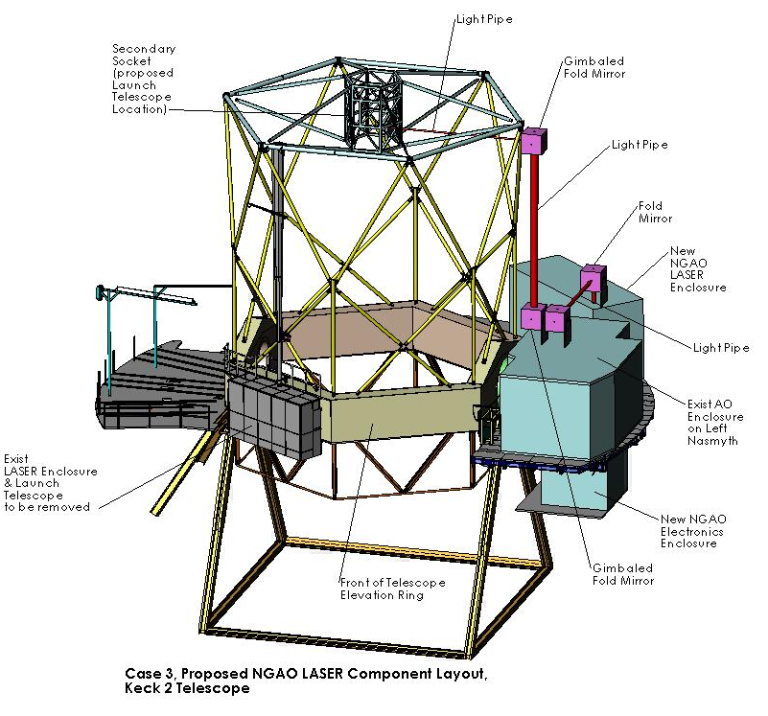
Figure 2: New Laser Enclosure Design
The current laser design is sufficiently advanced that it will be possible to locate them with a changing gravity vector making the current LE design attractive. To make this possible, the lasers themselves must be small enough to fit in an area similar to the existing Keck II laser table. Each laser has been separated into two assemblies called the Split Relay System. The pump lasers/control system provides the laser diodes generating the pump lasers, the seed laser, and the overall control system are located in the AO electronics vault. The laser head that produces the 589nm laser beam and is located in the LE. The interface between the two systems is comprised of control signals, fibers that transmit the pump light, and the cooling lines. The distance between the two systems is expected to be less than 40 meters. The laser layout is shown in Figure 3.

Figure 3: Lasers Layout

Laser Enclosure Layout

Existing Layout
The existing Keck II LE is shown in Figure 4. The room is light tight except for a small window for output of the current Keck II laser. The room is access via the right Nasmyth platform when the telescope is rotated to the zenith position. At the zenith position, the current laser table located within the LE, can be serviced and maintained.
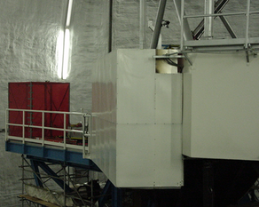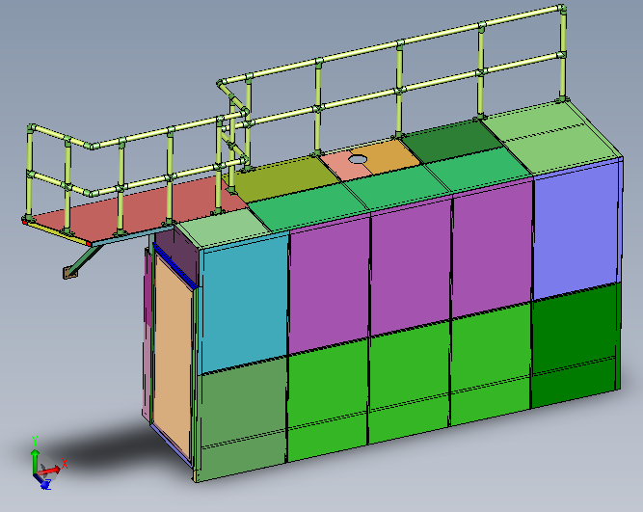
Figure 4: Laser Service Enclosure
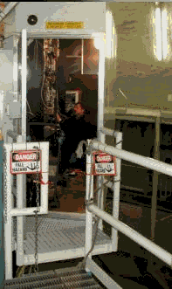
Figure 5: Laser Service Enclosure and Optical Bench for the Keck II Laser System
Figure 6 shows the existing laser table (purple) within the LE. The LE exterior panels have been made transparent in this figure to facilitate viewing. On the right of the laser table is an electronics rack that supports the mechanisms within the laser table. In the new LE layout, the existing laser table and supporting electronics will be replaced with a new structure supporting the three new laser heads and SYD.
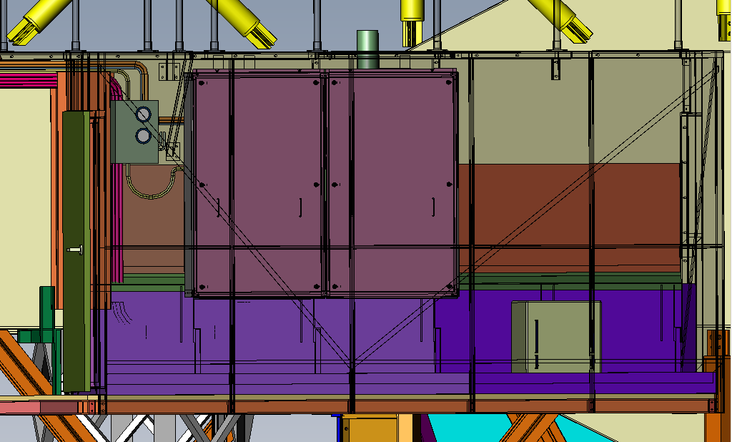
Figure 6: Existing Laser Bench inside LE

Layout of NGAO Laser System
Figure 7 shows the new layout of three lasers within the existing LE. The size of the laser heads (yellow) has been chosen based on the laser manufacturer’s PDR. The blue area is the SYD which formats the three beams and relays them onto the Beam Transport Optics (BTO). To minimize flexure, all three lasers heads and the SYD opto-mechanical components will be mounted onto a single rigid frame. This frame will be attached to the elevation ring similar to the existing Keck II laser design. The frame will be stiffened at the mating points to the lasers and SYD as well as the six attachment points to the elevation ring. The attachment points are shown in green in Figure 8 and Figure 9 (Additional bracing will be added over these pads).
The existing laser table will be removed as a single unit and the new laser assembly will be attached as a single unit. Once installed, the laser unit and the SYD can be removed individually for maintenance and servicing as needed. Additional hardware mechanisms will be required to insure alignment repeatability and accuracy. Any misalignment can be removed by the tip-tilt stages within the SYD.
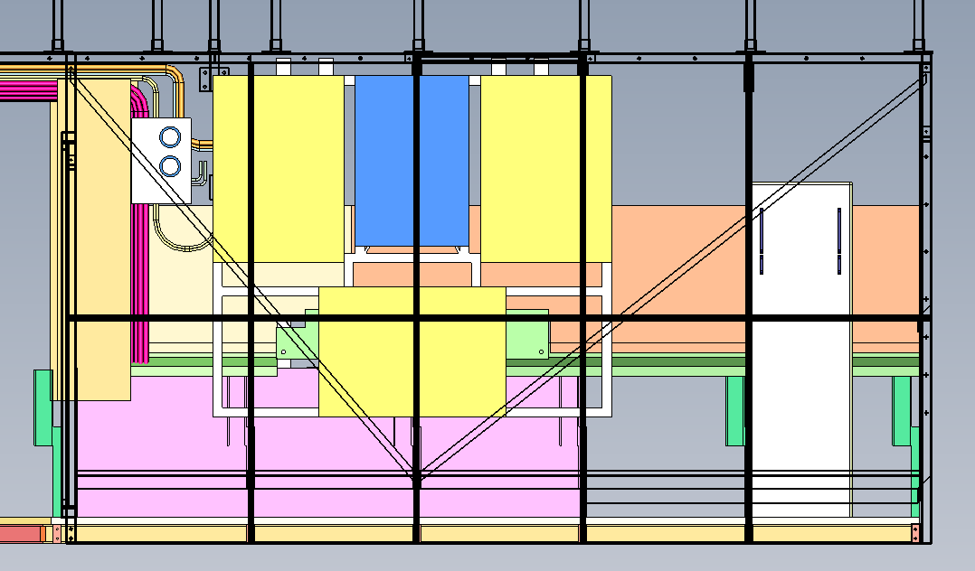
Figure 7: New Laser Enclosure Layout

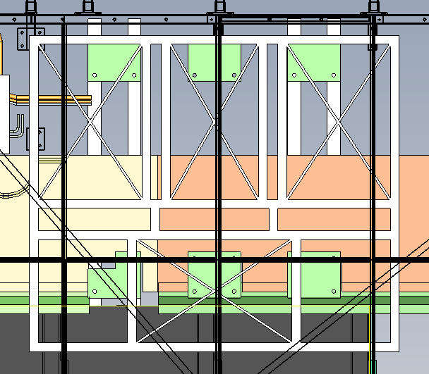
Figure 8: Lasers and SYD Support Frame

Mass Allocation
To minimize any impact to the telescope, the design of the lasers and the SYD should not exceed the weight of the existing laser table and auxiliary equipment. Table 3 shows the estimated mass of the components based on the laser PDR data. The new system will weigh 585 Kg less than the existing laser table. This reduction in weight may have a doubling impact on the telescope as an additional 585 Kg may be removed from the back of the elevation ring for balance purposes.
 | Keck 2 Laser (Kg) | New Laser (x3) (Kg)
Laser Table | 1136 | 536
Mounting Bracket | 75 | 125
Laser Cabinets | 60 | 60
Dye lines/fittings/Cooling | 30 | 30
Cabling | 50 | 15
Total | 1351 | 766
Table 3: Estimated mass for laser and auxiliary equipments

Laser Enclosure support

Laser Installation and Servicing
Although the existing laser enclosure does not have to be replaced, some modifications will be necessary to support the new lasers. The laser(s) and the SYD will be installed similarly to the method completed for the Keck II laser. The Keck II laser table was installed as a single unit (Figure 9) prior to installation of the LE. The NGAO laser(s) and SYD will require the LE exterior to be removed first prior to installing the laser(s) and SYD. It is reasonable to assume that not all three NGAO lasers will be installed at the same time. In which case, the panels above the LE will be removed for access with the 5-ton jib crane once the initial system is in place. This will require modifications to the top of the LE. The modifications will be determined once the lasers and SYD are located to match the BTO.
The estimated distance between the lasers/SYD and the LE panel wall is 24”. This will allow personnel to be standing in front of the units for any alignments and service.
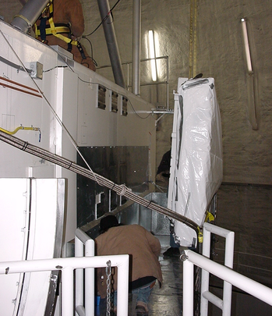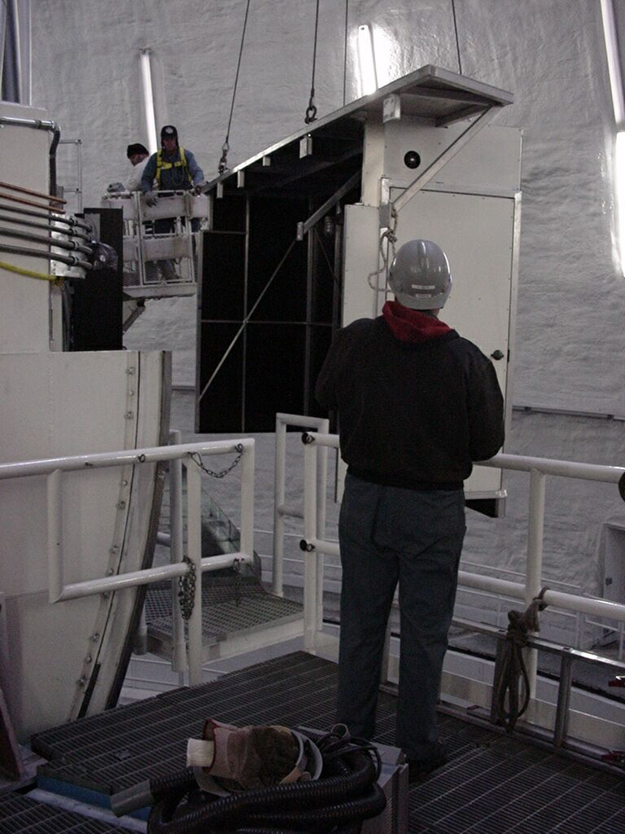
Figure 9: Laser Mounting onto Elevation Ring

Temperature, Particulates and Humidity
The individual laser heads will be treated as black boxes and will have their own internal environmental controls. The LE will not require additional temperature and humidity control to support the lasers. However, it is prudent to provide diagnostic monitoring of the interior to ensure the LE is within the expected the operational parameters. An existing ACKP humidity and temperature sensor can be reused if necessary. This sensor is already interfaced into the observatory’s EPICs control system. The data will be used for monitoring as well as possible in-situ servicing of the lasers. However, a particulate sensor is not available. A new particulate sensor including humidity and temperature can be purchased for ~$3K. WMKO currently owns the Met-One GT-521 unit. The advantage of this unit is that it has a serial port for data capture and remote control if necessary.

Lighting and Ventilation
The LE has existing lighting and will not require additional modifications. An existing fan on the LE provides makeup air for personnel in the LE. The fan will activate only when the lights are on. During normal night time observations, the lights and fan are off to not impact the telescope.

Electrical Power
The laser heads will receives its power from the laser controller inside the AO e-vault. The remaining power requirement for the SYD and lighting will not exceed the 120AC 20A circuit already existing in the current LE. All electrical connections will remain within the LE.
 | Required (W)
Environmental Sensor | 20
Lighting as need | 100
Test Equipment as needed | 300
HEPA filtration as needed | 100
Total | 520
Table 4: AC Power Requirements

Cooling
Each laser will be insulated to minimize its heat transfer impact to the LE. Based on the estimated temperature analysis by the laser manufacturer, the surface of the laser head will be 1.5°C. Assuming a 0.5 meter² surface, the heat transfer to the ambient will be approximately 4.5W per laser if the ambient is 0°C. Assuming worst case conditions of -5°C, each laser will transfer 19.5W into the LE environment. Three lasers will total 58.5W, above the 50W threshold. To reduce this heat load slightly, a cold plate can be added to the mounting frame structure or near the laser heads using existing instrument glycol at the LE.
The SYD will require instrument glycol cooling for the beam dumps. 75W of laser power will be transferred to the glycol with an additional 25W of cooling for the SYD electronics. There may also be additional electronics heat in support of the control system and safety system. An estimate of 100W is added to support these functions. The total cooling requirements is shown in Table 5.
 | Cooling (W)
Laser Head x 3 | 59
Laser Power x 3 | 75
SYD electronics | 25
Control and Safety System Electronics | 100
Total | 259
Table 5: Instrument Cooling Requirements

Communications
The current Keck II LE has both CAT5 and phone communications available. No additional resource will be necessary.

Safety

Eye Safety
The existing LE is a Class IV laser enclosure and has the proper interlocks in support of the Keck II laser as well as the NGAO lasers and SYD. These include door switches and LED status for incoming personnel. The lasers and the SYD will have independent covers or shielding to prevent stray light from exiting the LE. All existing safety features will be reused and tied into the new NGAO Laser Safety System. These include E-Stops, door interlocks, and panel interlocks..
Laser status indicators shall be provided at entry point to the LE as well as its interior. The indicators will be represented in Table 6. The indicators already exist on the exterior of the current LE. Interior indicators will provide status to the operator when opening laser and SYD panels. The existing Keck I laser panel design can be replicated.
 | Status Level | Status Description
1 | Green | No hazardous radiation in the LE
2 | Orange | Hazardous Radiation exists in the LE and it is contained; proceed with caution
2 | Red | Hazardous radiation exists in the LE; do not enter
Table 6: Laser Status Indicator Definition

Fire Safety
A portable Ansul Cleanguard® type fire extinguisher shall be provided similar to the Keck I LE. The technology of the NGAO lasers does not require an automatic type fire extinguishing system as implemented on Keck I. In addition, an extinguishing system may not operate effectively in a changing gravity vector situation. A smoke detector will be available as part of the safety system.

Operational Safety
Either for service or in case of emergency, a switch shall be located at the LE to disable the laser shutters. The switch will be an input to the safety system and will remove the hardware shutter permissive to the laser systems. This will prevent any laser beams from entering the SYD optics during servicing. The Emergency Stops located inside and outside of the LE will terminate any laser radiation.

External Interfaces

Mechanical Interface to the elevation ring for the LE
No new interfaces are necessary as the current LE has an interface in place.

Infrastructure Interfaces
Existing interfaces will be used for glycol, electrical, pneumatics, and phone; which are in place at the current Keck II LE. An existing dry air purge will be reused to keep a positive pressure in the room. A number of infrastructure connections will pass through the LE; but not connected to the LE. These include cabling for the lasers and the SYD.
Ref # | Device  Types | Connection | Connection | Quantity | From | Note | Format
1 | Glycol | Supply  Return | Copper | 1 | Telescope Instrument Cooling | In place | Glycol
2 | Electrical | 5-wire | Duplex | 3 | Elevation Ring Breaker Panel | In place | AC 120
3 | Pneumatics | Supply  Return | Copper | 1 | Telescope  Pneumatics | In place | Dry Air
4 | Phone | 8 wire | RJ-45 | 1 | Keck II Mechanical Room | In place | Low DC Voltage Analog
Table 7: Infrastructure Interfaces

Internal Interfaces within the LGSF

Mechanical Interface for the Laser and SYD
The mount for the SYD and lasers will be attached to the elevation ring. This bracket will be delivered as part of the LE. It will include mounting interfaces for the laser, SYD and itself to the six elevation ring mounting pads as shown in Figure 10.
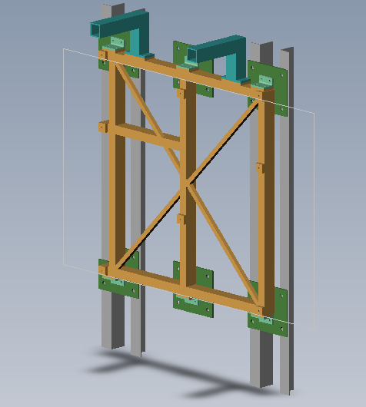
Figure 10: Current Keck 2 mounting support structure

Mechanical Interface to the Beam Transfer Optics
A new interface with the Beam Transport Optics will be necessary. The interface will be similar to the existing L4 tube in Keck II (Figure 11). The new interface will be smaller since the beams are 1mm in diameter. The tubes will be metal tube structures sized 4” x 1”. A window will be implemented similar to the existing Keck II design to prevent turbulence due to the chimney effect. It may be possible to reuse the existing window; depending on the configuration of the lasers leaving the LE.
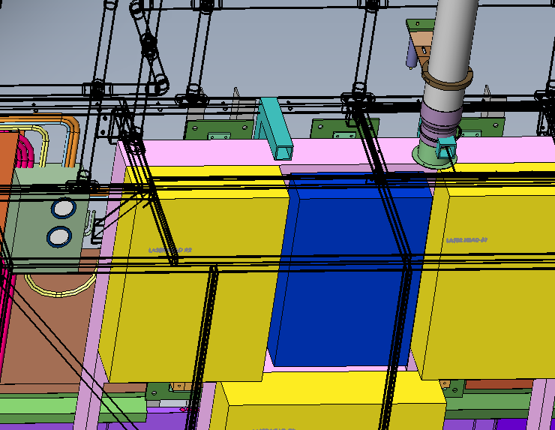
Figure 11: Launch Tube Interface

Electronic Interfaces
The LE primary electronics interface will be with the safety system in the AO electronics vault. A number of cables will pass through the LE; but not connected to the LE. These include cabling for the lasers and the SYD. For the LE itself, an interface unit for two Mil-Spec connectors will be provided. One connector will be for input and one connector will be for outputs to the safety system. The signals are listed in the Safety System ICD Spreadsheet.
In addition to the safety system, environmental devices will be used to monitor the health of the LE. The LE is expected to have a particulate monitoring system and a temperature/humidity system. These monitors will require a RS232 and CAT5 interfaces.

Ref # | Device  Types | Connection | Connection | Quantity | From | Note | Format
1 | CAT5 | 8 wire | RJ-45 | 4 (2 spare) | AO E-vault | In place | Low DC Voltage Digital
2 | Digital I/O | Multi- wire | Mil-Circular,  DB | 2 | Safety  System | Interlocks | Low Voltage Digital
3 | Digital I/O | 15-wire | DB-15 | 1 | AO E-vault | RS-232 | Low Voltage Digital
Table 8: Electronic Interfaces

Operations

Maintenance and Service
Standard maintenance at the LE includes cleaning and/or replacing of filters for the pneumatics, HEPA system and environmental sensing system, cleaning of the exit window to the BTO, and a bi-annual wipe down of the inside of the LE. The environmental sensor will need a re-calibration every two years. Safety related checks will be covered by the safety system. The effort required for this is in the order of 1 person-day per year and a procurement of $400. The telescope must be in the zenith location to allow this maintenance.

Development & Test
This section will be presented at the Detailed Design Review.

Requirements Compliance Verification
The compliance matrix is presented in Appendix A. All requirements are in compliant except for those that are no longer applicable based on the requirements of the laser systems.

Risk and Risk Reduction Plan
A major risk that was brought up during the mini-review regarding the size of the laser systems has been put to rest. The current NGAO laser systems are sufficiently small that all three lasers will fit in the existing LE. One new risk arose based on the requirements from the laser manufacturer.
Table 9 shows individual risks within LE in accordance with KAON 510.
Table 9: Risk Matrix

# | Consequence | Likelyhood | Description | Status | Mitigation
1 | 2 | 2 | Laser System cooling | A design is in place to support this requirement; however, more study is needed to ensure there is no major impact to the telescope. | During DDR, the current design will be vetted to ensure it will not be detrimental to the telescope or observing.
Table 10: Risk Analysis

Laser System Cooling
The current lasers require 18°C at the laser heads in order for it to operate. Within the laser head, sufficient insulation is provided to ensure this heat is not an impact for the environment. However, 18°C glycol lines can be a problem and if not insulated properly emit heat into the dome. The current design of such a system is in the laser design document. During DDR, a more thorough investigation shall be made to ensure the system will be sufficiently insulated to not radiate heat into the dome and the LE.

Deliverables
Figure 12 shows the deliverables for the LE.
Figure 12: Laser Enclosure Deliverables

Management
Budget and schedule estimates can be found in NGAO LGSF LE DD.mpp.

Plans for the next Phase
In the Detailed Design phase, the designs listed in the deliverables will be completed with technical drawings to support the Full Scale Development Phase. Integration and Test Plans will also be provided to verify the fabricated designs.
Appendix A. Compliance Matrix
Green items are in compliance; white or clear items are Not Applicable; yellow items are possible compliant; red items are not in compliance.
Short Name | ID | Description | Compliance
General Instrument Requirements | FR-2072 | The Laser Service Enclosure shall be delivered in compliance with Observatory Standards as outlined in KAON 572 "Instrument Baseline Requirements Document". Areas of non-compliance must be agreed upon by NGAO System Team. | Compliant; using existing infrastructure
Overall | FR-2423 | This folder contains overall requirements that span multiple engineering disciplines | N/A
Optical | FR-2424 | This folder contains optical requirements | N/A
Mechanical | FR-2425 |  | N/A
Volume constraint | FR-1223 | The size of the laser enclosure shall be similar to the existing K2 laser enclosure attached to the elevation ring. 12' W x 7' H x 4' D (TBR). There may be a need for two such enclosures on the elevation ring to support the number of needed lasers. The volume should be consistent with ESO RFQ designs. | Compliant; using existing infrastructure
Enclosure temperature | FR-1283 | The acceptable laser enclosure operating temperature is -10° to +10°C. Based on the current ESO laser proposals, the ambient dome temperature is acceptable for laser operations. However, the optical switchyard and laser supporting equipment cooling requirements must be evaluated for operation in this temperature range. | Compliant; using existing infrastructure
Mass limit for Laser Service Enclosure | FR-1287 | The Laser Service Enclosure mass shall conform to allowed requirements for the Laser Launch Facility. | Compliant; using existing infrastructure
Ventilation | FR-1290 | The laser enclosure ventilation requires 20 cfm/person of makeup air, for a maximum of 3 people. | Compliant; using existing infrastructure
Ventilation | FR-1290 | The ventilation laminar flow must be directed such that it does not impact laser system performance. | N/A. The laser systems are sealed.
Ventilation | FR-1290 | The ventilation may be turned down when personnel are not in the enclosure; however, there shall be a minimum of 5 cfm to maintain a positive pressure in the enclosure. | Compliant; using existing infrastructure
Doors | FR-1292 | The laser service enclosure shall equipped with openings to allow personnel entry and egress without emitting hazardous radiation into the dome environment. Hazardous radiation will be defined by the maximum permissible exposure limit as set by the Laser Safety Officer. The door shall have a magnetic lock to prevent accidental opening. However, the lock shall be fail-safe and can be overcome. | Compliant; using existing infrastructure. The door has a standard knob-set so it does not accidentally open. There is no lock.
Glycol cooling | FR-1293 | The laser service enclosure shall provide glycol to remove heat generated by equipment inside the Laser Service Enclosure. The glycol mixture shall be 50% water and 50% coolant (either ethylene glycol or propenol). The pressure and flow depend on the requirements of the laser and supporting equipment in the Laser Service Enclosure. Existing K2 glycol pressure is between 45-100 psi and 0-5° C. The flow rate is 20 lit/min. TBR. This requirement may not be necessary as the requirement may be placed on individual subsystems in the Laser Service Enclosure. It's likely the total amount of heat that must be removed will be 6KW for two ESO laser units. (TBR) | Compliant; using existing infrastructure
Weight load on floor | FR-1294 | Laser Service Enclosure shall be able to support 40 lbs/in^2 floor load. Calculations should be verified with Mechanical Personnel. | Compliant; using existing infrastructure
Point load | FR-1295 | The Laser Service Enclosure shall be able to support TBD lbs/in^2 point load. Calculations should be verified with Mechanical Personnel. | Compliant; using existing infrastructure
Equipment access | FR-1298 | The laser service enclosure shall provide sufficient space for maintenance of the lasers and supporting equipment. Such space shall also include area for auxiliary equipment such as computer monitors and keyboards. This will depend on the maintenance requirements of the laser. General practice is to provide 20" of space around equipment for servicing. TBR depending on laser requirements. | Compliant; there is 24" in front of lasers and Switchyard
Auxiliary equipment | FR-1299 | The laser service enclosure shall provide auxiliary equipment such as dry nitrogen for cleaning of optical components or vacuum equipment rated with the proper filters. TBD depending on laser requirements. | N/A. Not required by laser. Use standard Ultra-Pure Nitrogen bottles as currently done on K2.
Exterior laser status lights | FR-1302 | The laser service enclosure shall provide status indicators on the outside of the enclosure. These indicators are for personnel to determine the laser status prior to entry. The indicators shall be momentary if any light source is used so as to not contaminate the dome environment. | Compliant; using existing infrastructure
Access for laser installation into enclosure | FR-1303 | The laser service enclosure shall provide access allowing the installation of the laser. This is dependent on the laser requirements. Access may include removable ceilings, floor contact points or supports. | Compliant
Output for laser beam | FR-1304 | The laser service enclosure shall provide a proper output optical interface to the beam transport optics to relay the beam from the enclosure to the secondary. | Compliant
Telephone | FR-1309 | Phone communications: The laser service enclosure shall provide a telephone line for operation of the laser. The telephone interface shall be compatible with the Keck summit phone system. | Compliant; existing
Lighting | FR-1310 | Lighting: The laser service enclosure shall provide lighting at a minimum of 2 watts / sq ft. | Compliant; existing
Fall restraints | FR-1315 | Mechanical: The laser service enclosure shall provide restraint railings, if necessary, to meet OSHA requirements. | Compliant; existing
Yield strength | FR-1316 | Mechanical: The laser service enclosure shall be designed and constructed to a minimum safety factor of 4 on yield strength for all structural elements. | Using existing infrastructure that seems adequate
Ladder | FR-1317 | Mechanical: The laser service enclosure shall provide a ladder to the roof if access to the roof of the enclosure is necessary. The ladder may require additional caging to protect personnel during ascent and descent if deemed necessary by the Safety Officer. May not be necessary if there is some other means to get on the roof. TBD. | N/A; using existing infrastructure
Weight load on roof | FR-1318 | Mechanical: The roof of the laser service enclosure shall be able to support 2 people and its environmental controller (e.g., HVAC), as required. TBD. | N/A; using existing infrastructure
Light tight | FR-1320 | Class IV laser: The laser service enclosure shall be light tight to contain a class IV laser environment. | N/A; using existing infrastructure
Interior finish | FR-1321 | Class 4 laser: The inside of the Laser Service Enclosure shall be fabricated with properly finished surfaces that come in contact with the laser and viewed by personnel. The surfaces shall comply with nominal hazard zones for the laser. | Compliant; using existing infrastructure
Smoke detectors | FR-1324 | Environmental: The laser service enclosure shall provide smoke detectors with an audible alert located on the exterior of the enclosure. The smoke detectors shall be tied to safety system to terminate the laser. | Compliant
Fire extinguishers | FR-1325 | Environmental: The laser service enclosure shall provide appropriate fire extinguishers inside and outside of the laser room. "Cleanguard" agent is a possibility. TBD based on recommendation of laser manufacturer. | Compliant
Video Camera | FR-1327 | Environmental: The laser service enclosure may provide a camera inside the enclosure to be viewed remotely if deemed necessary by the Safety Officer. | Compliant; existing
Positive pressure and pneumatics | FR-1329 | Mechanical: The Laser Service Enclosure shall be positively pressured with dried filtered air to minimize particulates. The flow rate will be TBD. The output flow shall be distributed for laminar flow and not a point source. Also will depend on the requirements of the ESO lasers. | Compliant; existing
Laser mounting interface | FR-1865 | This requirement is a placeholder to indicate that requirements are needed to describe the modifications to the elevation ring to provide a mechanical interface for mounting the laser. TBD | N/A; using existing infrastructure
Mechanical interface | FR-1875 | The elevation ring must provide a mechanical interface for mounting of the laser service enclosure. | N/A; using existing infrastructure
Installation | FR-1876 | The laser service enclosure shall be installed as a single unit onto the elevation ring. | Compliant; using existing infrastructure
Electrical | FR-2426 |  | N/A
AC Power format | FR-1296 | The laser service enclosure shall provide sufficient power for the laser, laser electronics, diagnostics, lights, internal HVAC equipment to maintain routine operation. The power shall be 3 phase, 208 VAC, 60 Hz. The power factor shall be no less than 0.85. | N/A; the main power usage for the laser has been moved to the AO e-vault.
AC Power | FR-1297 | The laser service enclosure shall provide 6 KW of 3-phase, 208V, 60Hz. (TBR). This assumes 2 lasers in each enclosure plus supporting equipment. | N/A; the main power usage for the laser has been moved to the AO e-vault.
Environmental Controls | FR-1300 | The laser service enclosure shall provide control of temperature and humidity to meet the requirements of the laser and supporting equipment. | N/A. The laser system is sealed and will operate in the current K2 LE environment.
Environmental Controls | FR-1300 | The normal operating temperature range shall be TBD.
Environmental Controls | FR-1300 | The maximum rate of temperature change shall be no greater than TBD.
Environmental Controls | FR-1300 | The normal operating humidity range shall be TBD.
Environmental Controls | FR-1300 | Based on ESO laser proposals, the lasers do not require environmental control.
Environmental monitoring | FR-1301 | The laser service enclosure shall provide environmental monitoring for the following:
Environmental monitoring | FR-1301 | Particulates | Complaint
Environmental monitoring | FR-1301 | Temperature | Compliant
Environmental monitoring | FR-1301 | Relative humidity | Compliant
Environmental monitoring | FR-1301 | These could be stand alone devices or sensor inputs to the Laser Safety System or the laser environmental control system. (TBR) | Standalone devices that are tied into the control system for data capture
Status output to laser safety system | FR-1311 | Hardware Status: The laser service enclosure shall provide status of doors, access ports, emergency stops in a suitable format to the laser safety system for interlocking the laser beam. | Compliant; using exiting infrastructure
Electrical outlets | FR-1312 | Electrical Outlets: The Laser Service Enclosure shall provide TBD outlets for the laser and auxiliary equipment. Will depend on the laser and supporting equipment requirements. | Compliant; using existing infrastructure
Cable routing | FR-1314 | Cable routing: The laser service enclosure may provide cable chases to support cable and wire routing. | Compliant; once all cable is know for best routing
Emergency lighting | FR-1322 | Electrical: The laser service enclosure shall have emergency lighting for egress in case of power failure. | Existing infrastructure does not provide for this; but glow in the dark signs do exist
Emergency laser stop | FR-1323 | Electrical: The laser service enclosure shall provide emergency stop buttons to terminate laser light. Could be part of safety system. | Compliant; using existing infrastructure
Electrical panel | FR-1330 | Electrical: The laser service enclosure shall have a single electrical panel on the outside of the enclosure for all power entering the enclosure. This panel shall provide the properly sized breakers for individual connections within the enclosure. The panel shall provide a shunt trip for emergency shutdown of all power. | Since AC power to the laser is moved to the AO e-vault. This requirement needs to move there. This is no longer as severe a requirement based on the current laser selection. The amount of power used by the laser is significantly less and the E-Stop mechanism is able to shut down laser power. J. Chin
Uninterruptable Power | FR-1907 | The laser service enclosure shall provide 2 KW of 3-phase, 208V, 60Hz. uninterruptable power (TBR). This assumes 2 lasers in each enclosure plus supporting equipment. | N/A; Since AC power to the laser is moved to the AO e-vault. This requirement needs to move there.
Software | FR-2427 |  | N/A
Safety | FR-2428 |  | Compliant with safety officer input
General Safety Requirements | FR-2071 | The Laser Service Enclosure shall be delivered in compliance with ANSI standards for laser safety. Areas of non-compliance must be agreed upon by NGAO System Team. | Compliant
Interface | FR-2429 |  | Considered
Reliability | FR-2430 |  | Considered
Service and Maintenance | FR-2431 |  | Considered
Documentation | FR-2433 |  | Drawings will be delivered as part of DDR
Table 11: Compliance Matrix

