

Next Generation Adaptive Optics System

Interface Control Document between Guider and Laser Guide Star Facility
(Draft)

May 12, 2009
VersionV1.0

Prepared By Jason Chin

Revision History

Revision | Date | Author (s) | Reason for revision / remarks
1.0 | May 12, 2009 | J. Chin | Initial release

TABLE OF CONTENTS
Revision History 2
TABLE OF CONTENTS 3
1 Introduction 3
2 References 4
2.1 Referenced Documents 4
2.2 Acronyms and Abbreviations 4
3 Primary functions 5
3.1 Constellation Beam Steering 6
3.2 Rotator Control 7
3.3 Focus Control 7
3.4 General Health and Status 7
4 Hardware Interface 8
5 Software interface 8
5.1 Acquisition Guider System to LGSF 8
5.2 LGSF to AGS 8

Introduction
In the Next Generation Adaptive Optics System (NGAO), an interface exists between the Acquisition Guider System (AGS) and the Laser Guide Star Facility (LGSF). This interface is used to synchronize control and status between the two subsystems. The primary function of this synchronization is to provide properly pointed laser beams onto the Adaptive Optics System’s wavefront sensors. This document describes the content of that is provided by each system to ensure proper operations for the NGAO Preliminary Design Phase. This document will not provide the detail as to the type/format of the data; this will be provided in the detailed design phase.

References

Referenced Documents
Documents referenced are listed in Table 1. Copies of these documents may be obtained from the source listed in the table.
Ref. # | Document # | Revision or Effective Date | Source | Title
1 | KAON 511 | 0.3 | WMKO | NGAO System Design Manual
2 | KAON 264 | 6/2004 | WMKO | Focus and Pointing Adjustments Necessary for Laser Guide Star Adaptive Optics at the W. M. Keck  Observatory
3 | KAON 642 | 3/13/2009 | WMKO | NGAO Design Changes in Support of the Build-to-Cost Guidelines
Table 1: Reference Document

Acronyms and Abbreviations
Table 2 defines the acronyms and abbreviations used in this document.
Acronym/Abbreviation | Definition
AGS | Acquisition Guider System
AO | Adaptive Optics
FWHM | Full Width Half Maximum
IM | Image Plane
KAON | Keck Adaptive Optics Note
LGSF | Laser Guide Star Facility
LSeq | Laser Sequencer
NGAO | Next Generation Adaptive Optics System
WMKO | W.M.K. Observatory
Table 2: Acronyms and Abbreviations

Primary functions
The primary function between the AGS and the LGSF is to assist in laser pointing during manual alignments. If the laser pointing models are correct, the acquisition cameras should not be needed. From our experience in Keck 2, it is often necessary to provide a manual alignment mode. The NGAO hierarchical structure is shown in Figure 1 (KAON 511). A secondary function for the acquisition camera is to provide a low order estimate of the beam size. From this, the laser focus can be adjusted to provide the smallest on-sky spot. Figure 2 provides the functions between the LGSF and the AGS. The Laser Sequencer (LSeq) is the server in the LGSF and is the main interface for the LGSF system.
It is useful to point out that the AS sits below the telescope interface in terms of control hierarchy. This document makes no reference as to whether the information from the acquisition system flows directly between it and the LSeq or through the telescope interface. This decision will be made once the control system is designed.
Figure 1: NGAO Infrastructure Diagram

Figure 2: Basic Functions between AGS and LGSF

Constellation Beam Steering
KAON 264 provides an explanation of what pointing inputs are needed for the Keck 2 laser system steering model. The same concepts were applied to the Keck 1 laser except for the changes due to a central projection versus an off-axis projection in Keck 2. For NGAO, the expected projection will be identical to the centrally projected system in Keck 1, except for multiple lasers instead of one. From KAON 642, the new Laser Guide Star Asterism after the build to cost study is shown schematically in Figure 3.
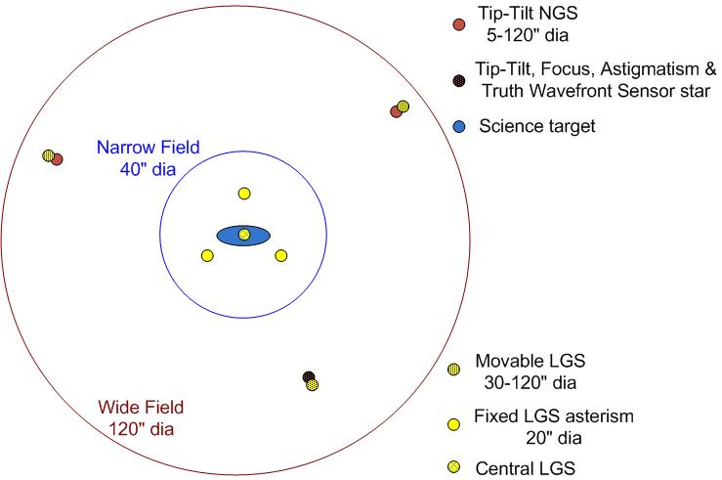
Figure 3 LGS “3+1” asterism for tomography of the science field, plus three point and shoot lasers for image sharpening of the tip-tilt stars

The four lasers in the center of the asterism will be fixed and will not require steering except for flexure compensation. The other three lasers will be movable and will require steering. The laser pointing function using the steering mirrors in the LGSF and the uplink tip tilt mirrors will maintain the laser beams on the wavefront sensors. Often, the laser beams do not land directly onto the wavefront sensors and a manual acquisition is needed. The Multi-System Command Sequencer will command this mode.
During this acquisition mode, the location of the laser beams on the guider(s) is provided to the LSeq. With this information, the LSeq will remove the offset and place the laser beams onto the wavefront sensors.

Rotator Control
It is also possible the entire field is rotated causing the laser beams to not land on the wavefront sensors. The rotation will be dependent on both the AO rotator which impacts the laser beam positions on the guider(s) and the LGSF rotator. With the centroid information from each beam, the LSeq will de-rotate the error and place the laser beams onto the wavefront sensors.

Focus Control
In order to produce the smallest spot on the sky, the focus of the laser beams may be calibrated. To provide this function, the FWHM of the laser spot from the AGS will need to be provided to the laser system. The LSeq will adjust the focus of the laser beam to collimate the laser beams. This collimation should not be confused with the adjustment of the sodium altitude.

General Health and Status
The AGS and LGSF will provide general health and status to each other. Currently, it is planned that each system will “publish” a record of system health and status. The user who needs this information will consume this information. Additional information such as internal heartbeats/status will be part of this information to ensure proper operations.

Hardware Interface
The only hardware interface required between the LGSF and AS is a network for transfer of data. No other hardware interface is planned.

Software interface
Based on the current plans for the control architecture, each subsystem will “publish” information that is needed by other subsystems. The subsystem requiring the data will “subscribe” to it. In the following section, the data to be published is listed.

Acquisition Guider System to LGSF
= publish { Movable laser beam 1 guider centroids (IMx, IMy), ; pixels
Movable laser beam 1 guider FWHM (IMx,IMy), ; pixels
Movable laser beam 2 guider centroids (IMx, IMy), ; pixels
Movable laser beam 2 guider FWHM (IMx,IMy), ; pixels
Movable laser beam 3 guider centroids (IMx, IMy), ; pixels
Movable laser beam 3 guider FWHM (IMx,IMy), ; pixels
On-axis laser beam 1 guider centroids (IMx, IMy), ; pixels
On-axis laser beam 1 guider FWHM (IMx,IMy), ; pixels
On-axis laser beam 2 guider centroids (IMx, IMy), ; pixels
On-axis laser beam 2 guider FWHM (IMx,IMy), ; pixels
On-axis laser beam 3 guider centroids (IMx, IMy), ; pixels
On-axis laser beam 3 guider FWHM (IMx,IMy), ; pixels
On-axis laser beam 4 guider centroids(IMx, IMy), ; pixels
On-axis laser beam 4 guider FWHM (IMx,IMy), ; pixels
AGS Status (mode)} ; 0=faulted, 1= not faulted
The guider(s) may also publish the Flexible Image Transport System or similar headers that may contain the above information.

LGSF to AGS
For simplicity, the Laser Server will publish system health to the AS.
= publish { Laser Subsystems Status (mode)} ; 0=faulted, 1 = not faulted

