

Next Generation Adaptive Optics System

Interface Control Document between Adaptive Optics System and Laser Guide Star Facility
(Draft)

May 06, 2009
VersionV1.0

Prepared By Jason Chin

Revision History

Revision | Date | Author (s) | Reason for revision / remarks
1.0 | May 06, 2009 | J. Chin | Initial release

TABLE OF CONTENTS
Revision History 2
TABLE OF CONTENTS 3
1 Introduction 3
2 References 4
2.1 Referenced Documents 4
2.2 Acronyms and Abbreviations 4
3 Primary functions 6
3.1 Constellation Beam Steering 7
3.2 Rotator Control 8
3.3 Polarization Control 8
3.4 Focus Control 8
3.5 Beam Transport Optical System 8
3.6 Shutters 8
3.7 General Health and Status 8
4 Hardware Interface 9
5 Software interface 9
5.1 AO Server to LGSF 9
5.2 LGSF to AO Server 10

Introduction
In the Next Generation Adaptive Optics System (NGAO), an interface exists between the Adaptive Optics System and the Laser Guide Star Facility. This interface is used to synchronize control and status between the two subsystems. The primary function of this synchronization is to provide properly pointed laser beams onto the Adaptive Optics System’s wavefront sensors. This document describes the content of the controls and status that is provided by each system to ensure proper operations for the NGAO Preliminary Design Phase. This document will not provide the detail as to the type/format of the data; this will be provided in the detailed design phase.

References

Referenced Documents
Documents referenced are listed in Table 1. Copies of these documents may be obtained from the source listed in the table.
Ref. # | Document # | Revision or Effective Date | Source | Title
1 | KAON 511 | 0.3 | WMKO | NGAO System Design Manual
2 | KAON 642 | 3/13/2009 | WMKO | NGAO Design Changes in Support of the Build-to-Cost Guidelines
3 | KAON 264 | 6/2004 | WMKO | Focus and Pointing Adjustments Necessary for Laser Guide Star Adaptive Optics at the W. M. Keck  Observatory
4 | Paper submitted for AMOS conference | 9/10/04 | SOR | Sodium Guidestar Radiometry Results from the SOR’s 50W Fasor
Table 1: Reference Document

Acronyms and Abbreviations
Table 2 defines the acronyms and abbreviations used in this document.
Acronym/Abbreviation | Definition
ACAM | Acquisition Camera
AGS | Acquisition Guider System
AMOS | Advanced Maui Optical and Space Surveillance
AO | Adaptive Optics
AOSeq | AO Sequencer
IM | Image Plane
KAON | Keck Adaptive Optics Note
LGS | Laser Guide Star
LGSF | Laser Guide Star Facility
LSeq | Laser Sequencer
MCS | Multi-System Command Sequencer
NGAO | Next Generation Adaptive Optics System
NGS | Natural Guide Star
SOR | Starfire Optical Range
UTT | Uplink Tip Tilt
WMKO | W.M.K. Observatory
Table 2: Acronyms and Abbreviations

Primary functions
With the removal of the uplink tip tilt requirement from the LGSF (KAON642), only a minimal set of parameters will be needed between the AO system and the LGSF system. The NGAO hierarchical structure is shown in Figure 1 (KAON 511). The driver for most of the Laser Sequencer (LSeq) functions will come from the Multi-Systems Command Sequencer (MCS) with required information feeding from the other subsystems such as AO. The LSeq provides the main control for the LGSF. The information presented in this document is between the two highlighted subsystems.
Figure 1: NGAO Infrastructure Diagram

The functions requiring an interface between the AO sequencer (AOSeq) and LSeq are data to support the pointing of the beam on-sky and subsequently onto the wavefront sensors in the AO system. These functions are shown in Figure 2. The AOSeq does not necessary need to control these devices, but ensure they are in their proper position prior to closing the AO system loops.
Figure 2: Basic Functions between AO and LGSF

Constellation Beam Steering
KAON 264 provides an explanation of what pointing inputs are needed for the Keck 2 laser system steering model. The same concepts were applied to the Keck 1 laser except for the changes due to a central projection versus an off-axis projection in Keck 2. For NGAO, the expected projection will be identical to the centrally projected system in Keck 1, except for multiple lasers instead of one. From KAON 642, the new LGS asterism after the build to cost study is shown schematically in Figure 3.
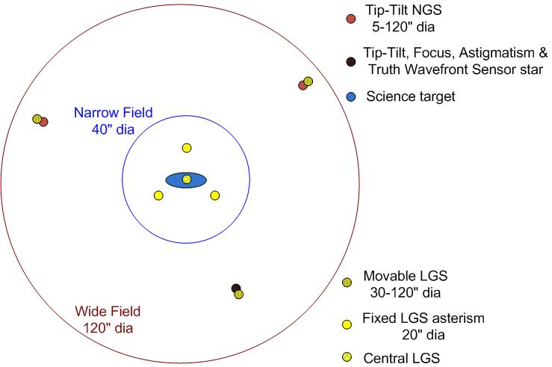
Figure 3 LGS “3+1” asterism for tomography of the science field, plus three point and shoot lasers for image sharpening of the tip-tilt stars

The four lasers in the center of the asterism will be fixed and will not require steering. The other three lasers will be movable and will require steering. The entire asterism will require flexure compensation. During the course of keeping these laser beams on the wavefront sensors, the uplink tip tilt will required to be offloaded. The AO system shall provide the commands to the laser beams to maintain their position on the wavefront sensors. These commands may be in the coordinates of az/el arcsec with respect to the launch system or image plane motion. The command to offload will come from the MCS.
From our experiences in Keck 2, the laser beams may not land on the wavefront sensors when we move to a new position. A calibration mode is assist in the steering of the beams. This will require guider centroid information such as ACAM to guide the laser beam onto the wavefront sensors. The uplink tip tilt is also used but has significantly less range.

Rotator Control
During laser beam(s) acquisition, the laser beams may not land directly onto the wavefront sensors. The Acquisition Guider System (AGS) will provide offsets to the LSeq to correct their positions. However, the entire asterism may need to be de-rotated. Since the AGS examines the beams after the AO rotator, the LSeq needs this information in addition to the AGS centroids.

Polarization Control
Along with the polarization diagnostics in the LGSF, the AO system will control the polarization of the laser beams to maximize the sodium returns onto the wavefront sensors. Based on data submitted by SOR at the 2006 AMOS Conference, maximum return can be gained with circular polarized laser beams. The gain of circular polarized light versus linear polarized light varies with the beam’s alignment to the magnetic field but can be as high as a factor of two. The polarization of the output laser beams will be affected by the angle of incidences on the subsequent mirrors from the lasers. As a first step, polarization control will be done for each laser beam to maximize circular polarization at the output end within the laser system. A quarter waveplate will be used to convert the linear polarization into circular polarization. It is possible that some additional calibration can be done by measuring the intensity of the wavefront sensors with respect to the quarter waveplate angle.

Focus Control
In order to produce the smallest spot on the sky, the focus of the laser beams may be calibrated. To provide this function, the FWHM of the laser spot from the acquisition camera will need to be provided to the laser system. For now, the guider is assumed to be part of the AO system. The LSeq will adjust the focus of the laser beam to collimate the laser beams. This collimation should not be confused with the adjustment of the sodium altitude.

Beam Transport Optical System
In order for the laser beams to be properly aligned on-sky, the beam transport optics must be in their proper position and tracking as the telescope is moving. The AOSeq will need this information in order to close its loops.

Shutters
The AOSeq will need to know the status of the shutters to determine if laser beams are on the wavefront sensors to close the loops.

General Health and Status
The AO and LGSF systems will provide general health and status to each other. Currently, it is planned that each system will “publish” a record of system health and status. The user who needs this information will consume this information. Additional information such as internal heartbeats/status will be part of this information to ensure proper operations.

Hardware Interface
Without the UTT function in the LGSF, the only hardware interface is the network for transmission of information between the Laser Server and the AO Server. All information between the two systems is expected to be transferred over the network. The AO Server will provide information to support pointing and polarization. The Laser Server will support status to the AO Server in situations where the loops need to be opened. It is possible to assume fault status will travel up to the MCS and back down to the lower level via the network as well.
Figure 4: Hardware Interface between AO System and LGSF

Software interface
Based on the current plans for the control architecture, each subsystem will “publish” information that is needed by other subsystems. The subsystem requiring the data will “subscribe” to it. In the following section, the data to be published is listed.

AO Server to LGSF
= publish { Wavefront Sensor 1 UTT Control (IMx, IMy), ; arcsec
Wavefront Sensor 2 UTT Control (IMx, IMy), ; arcsec
Wavefront Sensor 3 UTT Control (IMx, IMy), ; arcsec
Wavefront Sensor 1 Intensity (Intensity), ; counts
Wavefront Sensor 2 Intensity (Intensity), ; counts
Wavefront Sensor 3 Intensity (Intensity), ; counts
AO Rotator Position (angle), ; radians
AO Server Status (mode)} ; 0=faulted, 1= not faulted

LGSF to AO Server
For simplicity, the Laser Server will publish system readiness to the AO Server. The AO Server will determine whether to close its loops based on laser beam status. The determination may also be done by the MCS. For now, the data below either goes directly to AO or through the MCCS.
In a simplistic view, only the following information needs to be published to the AO server. The AO server mainly needs to know when the laser beam is ready to be sample. The states will be locally determined based on system faults, shutter and motion devices in their proper location.
= publish { Laser Central Asterism Status (mode), ; 0 = not ready, 1 = ready
Laser Beam 1 Status (mode), ; 0 = not ready, 1 = ready
Laser Beam 2 Status (mode), ; 0 = not ready, 1 = ready
Laser Beam 3 Status (mode), ; 0 = not ready, 1 = ready
Laser Subsystems Status (mode)} ; 0=faulted, 1 = not faulted
However, it may also be reasonable to assume that during demanding motion rates for motion devices such as at higher elevations that devices may jump out of tracking modes for brief periods, at which other loops may be able to compensate. Other possibilities include offloading that may cause one device to be not “IN POSITION” during observations. These cases will have to be considered for close loop allowances. If the AO server needs additional information other than ready or not ready, devices may have to provide states for AO to determine whether it is acceptable to close its loops. If this is necessary, devices may need to publish lower order information such as this:
= publish { Motion Device 1 (mode), ;0,1,2,3,4,5,6
Motion Device 2 (mode), ;0,1,2,3,4,5,6
…....Motion Device N (mode), ;0,1,2,3,4,5,6
Shutter Device 1 (mode), ;0,1,2
Shutter Device 2 (mode), ;0,1,2
…...Shutter Device N (mode), ;0,1,2
Subsystem 1 Status (mode), ;0,1
Subsystem 2 Status (mode), ;0,1
…..Subsystem N Status (mode)} ;0,1
Typical motion devices mode definitions are the following:
0 = standby
1 = initializing
2 = halted
3 = slewing
4 = in position
5 = tracking
6 = faulted
Typical shutter devices mode definitions are the following:
0 = Open
1 = Close
2 = Faulted

