

Next Generation Adaptive Optics System

Laser Launch Facility Switchyard
Preliminary Design
KAON 661

Oct 20, 2009
VersionV1.1

Prepared By J. Chin, T. Stalcup, J. Bell, D. Medeiros, E. Wetherell

Revision History

Revision | Date | Author (s) | Reason for revision / remarks
1.0 | Oct 19, 2009 |  | Initial release
1.1 | 20 Oct. 09 | EW | Add KAON number (was TBD)

TABLE OF CONTENTS
Revision History 2
TABLE OF CONTENTS 3
1 Introduction 5
2 References 6
2.1 Referenced Documents 6
2.2 Acronyms and Abbreviations 6
3 Overview 7
4 Requirements 8
5 Design 8
5.1 Methodology 8
5.2 Layout of Laser System 9
5.3 Opto-Mechanical Design 10
5.3.1 Opto-Mechanical Layout 11
5.3.2 Optical Bench 12
5.3.3 Optical Design 12
5.3.4 Error Budget and Tolerances (Thomas) 12
5.4 Motion Control 12
5.5 Diagnostics 14
5.6 Safety 14
5.6.1 Laser Containment 14
5.6.2 Laser Status Indicators 14
5.6.3 Laser Shutter Disable 15
5.7 Interfaces 15
5.7.1 External Interfaces 15
5.7.2 Internal Interfaces within the LGSF 16
6 System Performance 17
6.1 Optical 17
6.1.1 Transmission 17
6.1.2 Wavefront Error 17
6.2 Mechanical 18
6.2.1 Mass 18
6.2.2 Pneumatics 18
6.2.3 Heat Dissipation and Glycol requirements 18
6.2.4 Electrical 19
7 Operations 19
7.1 Mode 19
7.1.1 Operational Mode 19
7.1.2 Alignment Mode 19
7.2 Procedures 19
7.2.1 Alignment Procedure 19
7.2.2 Cleaning Procedure 19
7.3 Operational Resources and Preventative Maintenance 19
8 Development and Testing 20
9 Requirements Compliance Verification 20
10 Risk and Risk Reduction Plan 20
10.1 Laser Configuration 21
10.2 Polarization Variations 21
11 Deliverables 21
12 Management 22
12.1 Budget 22
12.2 Schedule 22
13 Plans for the next Phase 22

Introduction
As part of the Next Generation Adaptive Optics System (NGAO), a Laser Launch Facility (LLF) System is needed to propagate the laser beam. One component of the LLF System is the Switchyard (SYD). The SYD is located within the Laser Enclosure attached to the elevation ring. It receives the beams from the laser systems, formats them and sends them on to the Beam Transport Optics (BTO). The SYD ensures the laser beams are properly formatted and aligned to the BGS. The SYD compensates for pointing errors due to the gravity vector as the telescope moves in elevation. This document provides the preliminary design of the SYD. Some sections of the document have not been completed to the level required for PDR; these sections will be modified prior to the PDR. The layout of the document is such that the context of the sections will remain the same; but more details will be provided as the project progresses from PDR to DDR.

References

Referenced Documents
Documents referenced are listed in Table 1. Copies of these documents may be obtained from the source listed in the table.
Ref. # | Document # | Revision or Effective Date | Source | Title
1 | KAON 510 | 1.0 | WMKO | NGAO Preliminary Technical Risk Evaluation
2 | KAON 511 | 0.3 | WMKO | NGAO System Design Manual
3 | TBD | 1.0 | WMKO | LLF Requirements Document
4 | TBD | 1.0 | WMKO | LLF Requirements Compliance Document
Table 1: Reference Document

Acronyms and Abbreviations
Table 2 defines the acronyms and abbreviations used in this document.
Acronym/Abbreviation | Definition
BGS | Beam Generation System
BTO | Beam Transport Optics
CW | Continuous Wave
DDR | Detailed Design Review
KAON | Keck Adaptive Optics Note
LGSF | Laser Guide Star Facility
LLF | Laser Launch Facility
NGAO | Next Generation Adaptive Optics System
PDR | Preliminary Design Review
PSD | Position Sensing Diodes
SYD | Laser Switchyard
TBD | To Be Determined
WMKO | W.M.K. Observatory
Table 2: Acronyms and Abbreviations

Overview
The LLF layout is shown in Figure 1 which was presented in the NGAO System Design Review (KAON 511). The SYD will encompass the opto-mechanical assembly that receives the laser beams and the structure supporting the three laser heads. The assumption is that lasers can be configured so only the laser heads will be supported in the Laser Enclosure. The main function of the Switchyard is to properly format the outputs from the three lasers into a pattern of appropriate size for transport by the Beam Transport Optics. It will also provide polarization controls, safety shutters, and a switchable element to dump most of the beam power to produce a low power alignment beam.

Figure 1: Laser Launch Facility Layout
The location of where the Switchyard fits into the overall NGAO System is shown in Figure 2. The Switchyard will have a mechanical interface to the telescope elevation ring and to the BTO for attachment of the tube structure.
Figure 2: Laser Launch Facility Switchyard (shaded in red) within the NGAO System

Requirements
The requirements for the Switchyard are presented in the LLF Requirements Document. The Switchyard is part of the Laser Launch Facility and will apply the requirements as outlined by the LLF and the LGSF.
The main requirements or flow down of requirements for the Switchyard are as follows:
- The SYD will format the three laser beams from the laser systems and properly align them for entry into the Beam Transport Optics system.
- The SYD will provide a means to control the power of the laser beams for alignment purposes.
- The SYD will support the control of polarization for the laser beams with the goal of circular polarization at the output of the launch telescope.
- The SYD will support installation of the three laser systems onto the elevation ring.

Design
The design of the SYD is somewhat undetermined at this time due to the uncertainty of the laser system configuration. The solutions brought forth in this document are based on what is currently known about the competing laser designs. The laser designs are expected to be completed prior to the NGAO Detailed Design Review which will allow the SYD design to be finalized.

Methodology
The current switchyard design is based on using the same infrastructure that is currently available on the Keck II telescope. The re-use of existing infrastructure will minimize cost for supporting the SYD. It will also minimize risks associated with new infrastructure on the telescope. The SYD and the new lasers will replace the current laser table on the Keck II telescope.
The current Keck II laser enclosure on the telescope is expected to be reused. This enclosure attaches to the elevation ring where it houses the Keck II laser table. The elevation ring has been stiffened as part of the Keck II design to ensure minimal flexure of the existing laser table. Figure 3 shows the enclosure and its location with respect to the elevation ring with the telescope pointed at zenith. The enclosure provides an environment for personnel to service and maintain the lasers and the SYD.
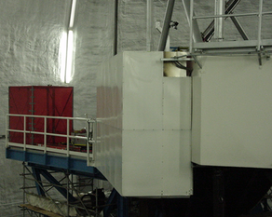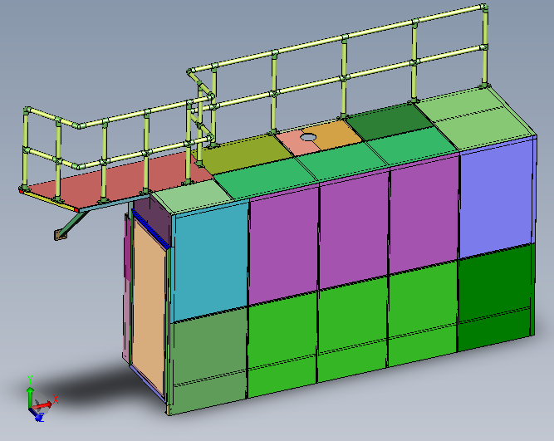
Figure 3: Laser Service Enclosure

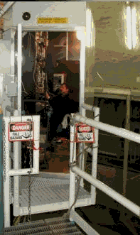
Figure 4: Laser Service Enclosure and Optical Bench for the Keck II Laser System

Layout of Laser System
Figure 5 shows a possible layout of three 25W CW lasers within the SYD in the enclosure. The assumption is that there will be a need for 3 identical lasers to meet the 75W CW NGAO requirement. To minimize flexure, all three lasers heads and the SYD opto-mechanical components will be mounted on the same platform for stability. A distinction is being made that only the laser heads themselves will be required to be located on this platform. The electronics and possibly pump lasers can be located off of this platform or even off the elevation ring.
Figure 5: Possible Laser Heads Layout in Existing Laser Enclosure
The new laser heads, along with the SYD components, auxiliary hardware, and the enclosure will be required to weigh no more than 1700 Kg. This mass was removed from the telescope as part of the overall balance for the Keck II subsystems on the elevation ring. The existing laser table is shown in Figure 6 as it is mounted onto the elevation ring. Having the three lasers and the SYD components mounted to the same structure will simplify installation and minimizes independent motions between the lasers and the SYD components.
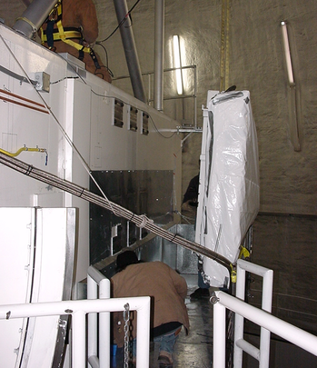
Figure 6: Laser Mounting onto Elevation Ring

Opto-Mechanical Design

Opto-Mechanical Layout
The layout of the SYD is shown in Figure 7. There are four main sub-assemblies, the polarization control, low power mode optics, reimaging optics, and the tip/tilt pattern forming mirrors. Currently it is assumed that there will be three 25W CW lasers entering the switchyard from three sides.
The first sub-assembly in each beam will be the polarization controller. This will consist of a half-wave and a quarter-wave plate in independent rotation mounts to allow generation of an arbitrary elliptical polarization from the linearly polarized laser head output. The requirement is to produce a circularly polarized output beam from the launch telescope, however if the beam at the switchyard is circularly polarized the output will not be since the optics between the laser heads and the launch telescope output will change the polarization state of the beam as it transits the system. To produce a circularly polarized output from the launch telescope, the input beam to the system must have a certain elliptical polarization to counteract the added polarization effects. As this would be difficult to determine empirically and may change over time, the input polarization state will be empirically chosen to maximize the return from the sodium layer.
The next sub-assembly will be a beam expander which reimages the laser output to form a waist size and location as specified by the BGS design. To minimize the field required and the wavefront error for the beam expander each laser will have its own set of reimaging optics.
Following the beam expander will be one or two mirrors as needed to form the output beam pattern. The exact arrangement of mirrors will depend on where the outputs from the laser heads are located on the table. The final mirror will be a high resolution piezoelectric steering mirror as specified in the BTO design. This will be controlled by sensors located on the BGS assembly to stabilize the beam location at that point. This stabilization will correct for both telescope flexure and jitter and drift in the laser output. The BTO design document has a detailed analysis of the steering requirements.
The next assembly is a mirror that will reflect an alignment laser. If the 589nm lasers are unavailable, the alignment laser and its optic can be manual put in place allowing for LLF alignment or it can be used as a quite means to check alignment.
The final sub-assembly is a mirror and beam dump to create a low power mode for optical alignment of the whole laser launch system. This is an engineering only mode that will only be used during daytime alignment. The mirror will be a high reflectivity dielectric model. When moved into the beam pattern, the mirror will reflect more than 99.5% of the laser beams into a beam dump. The remaining 0.5%, or approximately 125 mW, will be transmitted through the mirror and will form the low power alignment beams. To counteract the offset produced from the plane parallel plate, a second uncoated window of the same material and thickness will be mounted behind the mirror at the opposite angle. There will be some residual astigmatism and other aberrations in the alignment beams, but the alignment mode will not be used to measure wavefront error, only centration and angle alignment. This stage will be remotely controlled and the mirror assembly will be large enough to cover all three beam simultaneously. The beam dump will be made from an appropriately sized calorimeter for measuring the power of the combined three laser beams as an additional diagnostic. The beam dump will also include glycol cooling to remove the heat.
Figure 7: Switchyard Opto-Mechanical Layout

Optical Bench
If the laser heads are small enough, the preferred arrangement is to mount all three laser heads and all of the SYD components onto the same optical bench. Alternatively, some or all of the SYD components for each laser could be mounted directly to each laser head, with the beam combining optics on a separate, common mount. The strong preference is for all items to be mounted on a common bench for mechanical stability.

Optical Design
The design input to the BGS is a 1.14 mm diameter waist located 22.69 m from the laser enclosure. This results in a required output beam size at the laser enclosure of 14.7 mm diameter. An afocal beam expander telescope with a magnification of 4.9 will be required to create this beam from the 3mm diameter output from the laser heads.
The output beam arrangement will consist of all three lasers in a line, separated by approximately 25 mm. This will result in a 25 mm x 75 mm pattern.

Error Budget and Tolerances (Thomas)

Motion Control
The SYD will require motion control to support the polarization adjustment, tip/tilt for beam steering into the BTO/BGS, and insertion of the beam splitter for low power mode. Of the three, only the tip/tilt beam steering will require a high level of precision. This stage will require a gimbal mounted mirror with a piezoelectric actuator to achieve the resolution needed for beam steering. The expected 3 mm of flexure motion may be greater than the range of the position sensing devices used in the BGS. To ensure that the lasers are always within the dynamic range of the PSDs in the BGS, the steering mirrors will use an open-loop lookup table to calculate their position whenever the PSD signal is invalid.

 | Device | DOF per stage | No Each | TL DOF | Type | Axes | Range | Accuracy / Repeatability | Tracking Device | Tracking Rate | Slew Rate | Notes
1 | Tip/tilt Laser1 | 2 | 1 | 2 | Tip/tilt | x,y | 3.5  mrad | 0.05urad | Yes | Slow; Elevation | 17urad/s | PI tip/tilt mirror S330  Tracking to correct telescope flexure
2 | Tip/tilt Laser2 | 2 | 1 | 2 | Tip/tilt | x,y | 3.5  mrad | 0.05urad | Yes | Slow; Elevation | 17urad/s | PI tip/tilt mirror S330  Tracking to correct telescope flexure
3 | Tip/tilt Laser3 | 2 | 1 | 2 | Tip/tilt | x,y | 3.5  mrad | 0.05urad | Yes | Slow; Elevation | 17urad/s | PI tip/tilt mirror S330  Tracking to correct telescope flexure
4 | Half-wave plate Laser1 | 1 | 1 | 1 | Rotational | θ | 360 deg | Urad | No | Slow; Rotator Motion | 10 deg/s min, 30 deg/s preferable
5 | Half-wave plate Laser2 | 1 | 1 | 1 | Rotational | θ | 360 deg | Urad | No | Slow; Rotator Motion | 10 deg/s min, 30 deg/s preferable
6 | Half-wave plate Laser3 | 1 | 1 | 1 | Rotational | θ | 360 deg | Urad | No | Slow; Rotator Motion | 10 deg/s min, 30 deg/s preferable
7 | Quarter-wave plate Laser1 | 1 | 1 | 1 | Rotational | θ | 360 deg | Urad | No | Slow; Rotator Motion | 10 deg/s min, 30 deg/s preferable
8 | Quarter-wave plate Laser1 | 1 | 1 | 1 | Rotational | θ | 360 deg | Urad | No | Slow; Rotator Motion | 10 deg/s min, 30 deg/s preferable
9 | Quarter-wave plate Laser1 | 1 | 1 | 1 | Rotational | θ | 360 deg | Urad | No | Slow; Rotator Motion | 10 deg/s min, 30 deg/s preferable
10 | Alignment Mode Beam-  Splitter | 1 | 1 | 1 | Linear | x | 50mm | 1mm | No |  | 1mm/sec
Table 3: Switchyard Motion Devices

Diagnostics
Table 4 shows the diagnostics for the SYD. Since the lasers themselves will include a significant array of diagnostics, the SYD will have only a diagnostic for measuring power. Measurements such as wavefront quality, power, far and near field beam diagnostics are expected to be available from the lasers. An alignment laser along with a manually located optic will be used to align the LLF. This laser will be used for rough alignment as well as alignment verification when the 589nm lasers are not available. The 589nm lasers will be required to have their own shutters; thus none are required in the switchyard.
Ref # | Item Name | Component Description | Accuracy/Requirement
1 | Beam dump | Beam dump / calorimeter for laser when in alignment mode | 0.1 Watts
2 | Alignment laser/optic | One to three lasers for alignment the LLF without the use of the 589nm lasers | 125mW
Table 4: Switchyard Diagnostics

Safety
The SYD will be considered a Class IV laser facility since the power at this location is above 500mW. The ANSI Standard Z136.1 will be used to ensure proper precautions are followed. Since the SYD is only one segment of the LLF, the entire LLF should be examined as a whole for safety concerns and mitigation. The discussion in this document will address the mitigations that are part of the Switchyard.

Laser Containment
The SYD will include an enclosure similar to the Keck 2 laser table enclosure (Figure 8) to contain any stray beams and also provide dust protection during normal operations. For alignment purposes, this cover will need to be removed. In this mode, the hazards will be contained by the Laser Enclosure. The cover will include limit switches that will be incorporated into the safety interlock chain in the safety system. This unit can also be used to contain the heat dissipated by the laser system. The heat in the unit can be removed by a liquid heat exchanger.
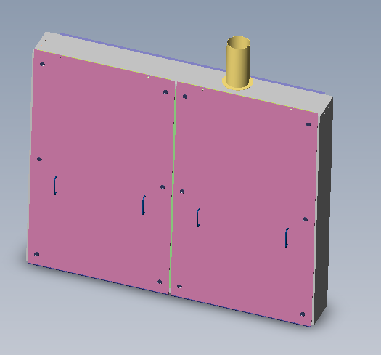
Figure 8: Switchyard Enclosure

Laser Status Indicators
Laser status indicators shall be provided at entry point to the SYD. The indicators will be represented in the following tables.
 | Status Level | Status Description
1 | Green | No hazardous radiation in the Switchyard
2 | Red | Hazardous radiation in the Switchyard
Table 5: Laser Status Indicator Definition

Laser Shutter Disable
Either for service or in case of emergency, a switch shall be located at the SYD to lock the laser shutters in a closed position. The switch will be an input to the safety system and will remove the hardware shutter permissive to the laser systems. This will prevent any laser beams from entering the SYD optics during servicing.

Interfaces

External Interfaces

Mechanical Interface to the elevation ring / laser enclosure
The optical bench supporting the SYD will be attached to the elevation ring using a mounting bracket. The bracket used currently for the Keck II laser table can be re-used for the SYD if the weight is comparable. The bracket (tan color) is shown in Figure 9. The bracket has 8 contact points and is currently supporting 1700Kg in the Keck II System. During mounting, the bracket is attached to the SYD as an assembly. The entire assembly would be attached to the green pads attached to the stiffened elevation ring. See Figure 6.
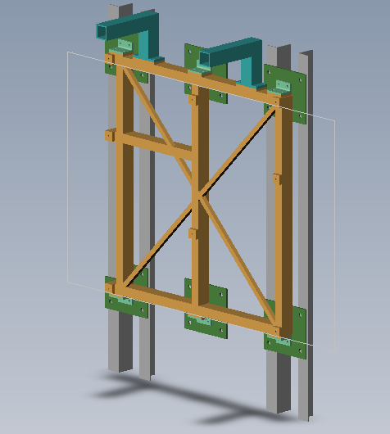
Figure 9: Switchyard support structure

Infrastructure Interfaces
The SYD will have an interface to the pneumatic and instrument glycol interfaces at the elevation ring. Both of these interfaces are currently available on the elevation ring and are being used by the Keck II laser table. No new infrastructure is needed to support the SYD. This does not include infrastructure necessary to operate the laser systems. The infrastructure required to operate the laser will be part of the Laser Enclosure design.

Internal Interfaces within the LGSF

Mechanical Interface to the BTO
The interface between the SYD and the BTO shall be dust- and light-tight with a clear aperture greater than 25 mm x 75 mm. The interface shall be compliant to ensure that as the BTO flexes with temperature or telescope motion, stresses are not transferred to the SYD optical bench.

Optical Interface to the Lasers
The lasers shall provide a linearly polarized beam with a 1/e² size of 3mm diameter to the SYD.

Electronic Interfaces
The SYD shall have an electrical interface with the Motion Control System for motion devices as well as diagnostics. Diagnostics will interface with the Safety System for safety related impacts and/or the Laser Control System. Table 6 describes the physical interfaces of the SYD with the Motion Control System or the Safety System.
Ref # | Device  Types | Cabling | Connection | Quantity | From | Description | Format
1 | Servo Motion | 25 wire | Mil-Circular | 4 | Motion Control System | DC Servo System; drive, encoder, limits | Low DC Voltage Analog
2 | Piezo  Motion | 6 wire | Mil-Circular,  LEMO | 3 | Motion Control System | High voltage piezo control; feedback | High DC Voltage Analog
3 | Digital I/O | 2 wire | Mil-Circular,  DB | 2 | Safety  System | Cover Switches | Low Voltage Digital
4 | Calorimeter | 2 wire | Mil-Circular, DB | 1 | Safety  System; Laser Control System | Beam Dump | Low Voltage Analog
Table 6: Electronic Interfaces

System Performance

Optical

Transmission
Based on the accepted NGAO guidelines, a base reflectivity of 0.995 is assumed for mirror coatings and a transmissivity of 0.996 for AR coated surfaces. An additional factor of 0.995 is incorporated to account for dust or other surface imperfections.
With these guidelines, the overall throughput of the SYD is 91.2% for the beams. *The transmission throughput requirement will be considered in the LLF System Performance Document. shows a listing of the surfaces in the path for the SYD beams.
Element Name | Number of Surfaces | Trans. per Surface | Dirt/scatter | Total Element Transmission
Waveplates | 4 | 99.6% | 0.50% | 96.46%
Reimaging Optics | 4 | 99.6% | 0.50% | 96.46%
Tip/Tilt Mirror | 2 | 99.50% | 0.50% | 98.01%
TOTAL Transmission Throughput* |  |  |  | 91.2%
*The transmission throughput requirement will be considered in the LLF System Performance Document.
Table 7: SYD Transmission

Wavefront Error
Most catalogue optics are specified by peak to valley wavefront error, however it is actually the RMS wavefront error that is used in calculating system performance. All custom elements will use an RMS wavefront specification directly. For the stock catalogue items used in the system, a conversion factor can be applied to convert the PV error into RMS; however this is not exact and varies with the nature of the surface errors. Generally accepted conversion factors range from 1/3 to 1/5 depending on what assumptions are made about the surface. This analysis will adopt a conservative approach that RMS = PV/3.
A value of 21 nm RMS was used for the lens and beam splitter surfaces, while a better value of 11 nm was used for the flat mirror surfaces. The expected wavefront error of the SYD is shown in Table 8.
Element Name | Number of Surfaces | PV error (waves @ 632.8 nm) | RMS WFE (nm, per surface) | RMS WFE (nm, per element)
Waveplates | 4 | 0.050 | 10.5 | 21
Reimaging Optics | 4 | 0.050 | 10.5 | 21
Tip/Tilt Mirror | 2 | 0.050 | 10.5 | 14.85
Total RMS WFE * |  |  | 33.2 | nm
*The wavefront error requirement will be considered in the LLF Systems Performance Document.
Table 8: Switchyard wavefront error

Mechanical

Mass
Table 9 shows the total mass of the SYD and associated electronics. As a comparison, 1,700 Kg was removed from the front face of the Keck II telescope to compensate for the addition of the laser table, associated electronics, and the laser enclosure on the telescope. Table 9 shows the weight of the SYD, lasers, and assorted hardware. The value does not include the laser enclosure which will increase the mass to the 1,700Kg allowance. There should be additional savings in weight as the existing launch tube and L4 optic will be removed from the telescope and replaced with smaller and lighter structures for the Beam Transport Optics.
 | Item | Mass (Kg)
1 | Optical Breadboard | 195
2 | SYD Opto-Mechanics | 20
3 | Laser Mounting Hardware | 100
4 | Lasers | 600
5 | Cover | 50
6 | Auxiliary Equipment for Lasers | 200
7 | Diagnostics | 10
 | Total | 1175
Table 9: Switchyard mass including lasers and electronics

Pneumatics
Dried and filtered air will be used in the Switchyard at a rate of 1 CFM to keep dust and particulates out of the enclosure.

Heat Dissipation and Glycol requirements
The three laser beams will require a beam dump at the SYD during low power operations. The total power dissipated will be 75W or greater; thus requiring a liquid cooled unit. In addition, the lasers located within the SYD will dissipate 50W each into the surrounding area. The total heat dissipated into the area will require an additional heat exchanger to remove the ambient heat. Glycol is already available at the laser enclosure in Keck II; no significant additional work will be needed to support the SYD.
 | Item | Power (W)
1 | Beam dump for lasers | 75
2 | Motor Control (6 DoF) | 5
3 | Diagnostics | 15
4 | Lasers | 150
 | Total | 245
Table 10: SYD Heat Dissipation

Electrical
Commercial and clean power is already available at the existing laser enclosure location. The required power not associated with the laser themselves is expected to be significantly less than the existing 120VAC 20 amp circuits. All SYD related requirements will be fed by other systems within the Switchyard such as the lasers, motion control, and the safety system.

Operations
This section will be further developed and presented at the PDR.

Mode

Operational Mode
During normal operations, the Switchyard shall operate at full laser power with three laser beams operating at 25 watts each. The Switchyard, along with the entire LLF, will maintain the beam to within TBD arcsec tolerance.

Alignment Mode
During alignment mode, the Switchyard will reduce the power of each laser beam to 0.125 watts. The BTOS will be aligned at this lower power. Once the system is aligned, the Switchyard will return laser power to its operational level.

Procedures
The following procedures shall be provided as part of future phases for the Switchyard.

Alignment Procedure
An alignment procedure shall be provided to set up the Switchyard on the telescope. The Switchyard shall align the laser beams to an entrance aperture of the BTO/BGS. The inclusion of an alignment laser will minimize the need of the 589nm lasers. This will allow testing and integration of the alignment tools if the 589nm lasers are not available. This was found to be quite useful during Keck 2 laser pointing integration. This procedure shall be provided during DDR.

Cleaning Procedure
The Switchyard shall be designed for a 10 year life time. The Switchyard shall be designed as a sealed unit to minimize particulates contamination. However, considerations shall be made in the design to clean the optics in the Switchyard and possibly recoat as necessary. Witness samples may be used in the switchyard for reflectivity measurements to determine the periodicity for the cleaning.

Operational Resources and Preventative Maintenance
Additional information shall be provided during DDR on required operational resources. Outside of troubleshooting of the Switchyard, Operations team will be required to support maintenance procedures in 7.2. Cleaning will require both personnel and the telescope as resources due to accessibility to components. The cleaning of the optics (dozen) is expected to take no more than 2 hours in-situ.

Development and Testing
This section will be presented at the DDR.

Requirements Compliance Verification
The compliance matrix will be presented as a whole for the entire LLF in the LLF Requirements Compliance Matrix document.

Risk and Risk Reduction Plan
Table 11 shows individual risks within BGS in accordance with KAON 510.
Table 11: Risk Matrix

# | Consequence | Likelyhood | Description | Status | Mitigation
1 | 2 | 3 | Laser System does not fit onto the Switchyard bench | This particular risk will not be fully understood until the design of the laser is complete. Once the lasers are designed with their physical layout, this risk can mitigated | The addition of a second laser enclosure at the Right Bent Cassegrain location and and associated Switchyard
2 | 1 | 2 | Polarization changes requiring additional waveplate | The requirement for the laser is a 200:1 linear polarized laser beam. The polarization will be impacted by the angles of the BTO, Switchyard, and BGS. | If the polarization becomes elliptical, an additional waveplate may be necessary to achieve a circular polarized beam at the output of the launch telescope
Table 12: Risk Analysis

Laser Configuration
The current design of the Switchyard is heavily dependent on the laser configuration. The assumption of this design is based on the laser manufacturer able to produce a laser with a three 25W laser heads that can be mounted onto an optical bench similar in size to the existing Keck II laser table. This assumption is based on knowledge currently available in the current laser designs in support of the NGAO lasers. If the lasers are larger than expected, the fallback position is to place only two of the three lasers at the current location occupied by the Keck II laser table. The third laser will required to be placed elsewhere on the telescope. This third location can be the Right Bent Cassegrain; but will have to be cleared by the Observatory. An additional SYD will be required to be fabricated to support this new location. The Right Bent Cassegrain is chosen for its location with respect to the BTO. The beam from the Right Bent Cassegrain can join the BTO since the BTO is design to be directly above the RBC when the telescope is at its zenith location. The design of the laser system will be solidified prior to the DDR.

Polarization Variations
The current requirements for the laser system output are 200:1 linearly polarized laser beams. The polarization will likely change as the laser beams are transported through the Switchyard, BTO, BGS, and the launch telescope. If the ratio of the linear polarization is not well maintained, becoming elliptical, an additional waveplate will be required to maintain the circular polarization at the launch telescope output. This will impact the throughput and wavefront error as an additional optic is inserted in the beam.

Deliverables
Figure 10 shows the deliverables for the Switchyard.
Figure 10: Switchyard Deliverables

Management

Budget
This section will be presented at the PDR.

Schedule
This section will be presented at the PDR.

Plans for the next Phase
This section will be presented at the PDR.

