

The Next Generation Adaptive Optics System
at the
W. M. Keck Observatory

A Proposal for Design and Development

Date
Version

1 Introduction 6
2 Executive Summary 6
3 Science 6
3.1 Introduction 6
3.2 The Competitive Landscape 6
3.3 Solar System Science 6
3.4 Galactic Science 6
3.5 Extragalactic Science 6
3.6 Science Requirements 6
4 Technical 6
4.1 Introduction 6
4.2 Requirements and Flow Down to Technical Specifications 6
4.3 Wavefront Error Budgets 6
4.3.1 Narrow-field science with LGS and tip/tilt NGS stars (KBO science program) 7
4.3.2 Moderate-field science with LGS and bright tip/tilt NGS star (Galactic Center program) 10
4.3.3 LGS with off-axis tip/tilt guide star (Extragalactic assembly and evolution science) 12
4.3.4 NGS (Titan science) 12
4.4 Technical Approach 12
5 Management 13
5.1 Project Organization 13
5.2 Project Plan and Schedule 13
5.3 Risk Assessment and Risk Management Plan 13
6 Budget 13
6.1 System Design Phase 13
6.2 Preliminary and Detailed Design through Full Scale Development 13
6.3 Science Instruments 13
6.4 Operations 13
7 References 13
8 Appendix XXX: Error Budget Terms 13
8.1 High-order WFS Measurement Error 14
8.2 LGS Tomography Error 15
8.3 Asterism Deformation Error 15
8.4 Scintillation Error 15
8.5 WFS Scintillation Error 16
8.6 Static WFS Zero-point Calibration Error 16
8.7 Dynamic WFS Zero-point Calibration Error 16
8.8 Go-To Control Errors 17
8.9 Residual Na Layer Focus Change 17
8.10 Residual Centroid Anisoplanatism 18
8.11 Residual Atmospheric Dispersion 18
8.12 Science Instrument Mechanical Drift 18
8.13 Long Exposure Field Rotation Errors 19
8.14 Residual Telescope Pointing Jitter 19
8.15 Other Terms Not Considered Here 19

Figure 1. Error budget summary for LGS mode having an on-axis tip/tilt reference source, corresponding to an observation of a KBO having m_{H} = 15.75, for median seeing conditions. Error terms highlighted in light blue are allocations; other terms are based on point design parameter choices. 8
Figure 2. NGAO point design performance vs. KBO target brightness. For compact narrow-angle targets brighter than about m_{H} = 17, it is favorable to use the target itself for low-order wavefront information. For fainter targets, use of field NGS stars is preferred. The excellent performance for large sky fraction relies on MOAO compensation of the low-order guide stars and variable control of the LGS asterism radius (between 10 and 50"). 9
Figure 4. Error budget summary for Galactic Center observations, using a single NGS tip/tilt/focus/astigmatism star IRS 7, for median seeing conditions. Error terms highlighted in light blue are allocations; other terms are based on point design parameter choices. 11
Figure 3. GC wavefront error performance vs. Fried's parameter, r₀, for constant turbulence-weighted wind speed of 14.9 m/s and other parameters as above, with optimal choice of HOWFS and LOWFS camera rates. 12

Table 1. Performance summary for the Keck NGAO point design for several key Keck NGAO science cases. 7

Introduction

Executive Summary

Science

Introduction

The Competitive Landscape

Solar System Science

Galactic Science

Extragalactic Science

Science Requirements

Technical

Introduction

Requirements and Flow Down to Technical Specifications

Wavefront Error Budgets
The flow down of residual wavefront error performance requirements to system and subsystem design parameters is facilitated through the use of residual wavefront error budgets. Increased understanding of current laser guide star adaptive optics systems, gained through extensive experimentation and analysis of on-sky performance, has refined the development of wavefront error budgets in practical applications. For NGAO planning purposes, we have developed a number of wavefront error budgets as guidelines for the design trade studies to be performed in the System Design phase.

We choose here is organize the discussion of wavefront error budgets into high spatial frequency (high-order) and low spatial frequency (low-order) error terms, because the impact of these terms on AO system performance differ. High-order terms typically scatter light away from the diffraction-limited core of the point spread function (PSF), whereas low-order aberrations blur the core, but retain useful science information within a narrow angular radius around the target. Tip/tilt aberrations are the lowest order aberrations and typically have the effect of blurring the diffraction limited core by 5-50 milliarcseconds (the natural diffraction limit at a wavelength of 1.65 microns is 31 milliarcseconds.) Details regarding the calculation of each of the high- and low-order error budget terms are described in Appendix XXX.

The applicability of NGAO over the viewable sky is determined by the availability of natural guide stars (NGS) capable of providing low-order wavefront information with sufficient fidelity to maintain overall performance. NGAO, like all LGS AO systems, will be usable over the entire viewable sky. However, it's delivered performance will vary as a function of the specific NGS constellations available in the direction of each science target. Thus, we will typically quote the percentage of sky correctable at a particular performance level, as the sky fraction.

In each of the specific error budget cases described below, we take the liberty, on a point by point basis, of independently optimizing the high-order and low-order wavefront sensor sample rates to find the optimal balance between quality of wavefront measurement and latency in the application of the AO system correction. While truly continuous optimization of detector sample times is usually not available, experience with existing systems has shown that a finite set of 5-10 sample rates is sufficient to run near peak performance levels.

The bottom-line results of the following sections are summarized in Table 1.

Science Case  (typically under median conditions) | AO mode | Seeing | Field of View (arcsec) | Wavefront Error  (nm, rms) | Corresponding Guide Star Brightness or Sky Fraction
Io | 1 NGS | Median | 1" | 105 | m_{V} = 5.5
"Best-conditions" narrow-field | 5 LGS | Superior | 2" | 97 | 20%
KBO | 5 LGS | Median | 2" | 141 | m_{H} = 15.75
Galactic Center | 5 LGS | Median | 10" | 194 | m_{H} = 8.8 (IRS 7)
Field Galaxies | 10 LGS | Median | 2" | 329 | 30%

Table 1. Performance summary for the Keck NGAO point design for several key Keck NGAO science cases.

Narrow-field science with LGS and tip/tilt NGS stars (KBO science program)
NGAO will support multiple sources of low-order wavefront information, augmenting the higher-order wavefront aberration estimate provided by the laser guide star beacon asterism. In the simplest observing mode, the science target itself is used to determine the missing tip/tilt and focus information. In this case, there is no anisokineticism to degrade the value of the tip/tilt measurement and no angular anisoplanatism to compromise the sharpening of the low-order aberration source. A typical error budget for this case, assuming a target having m_{H} = 15.75 and science field of view of only 2 arcsec (e.g. OSIRIS observations), is shown in Figure 1.

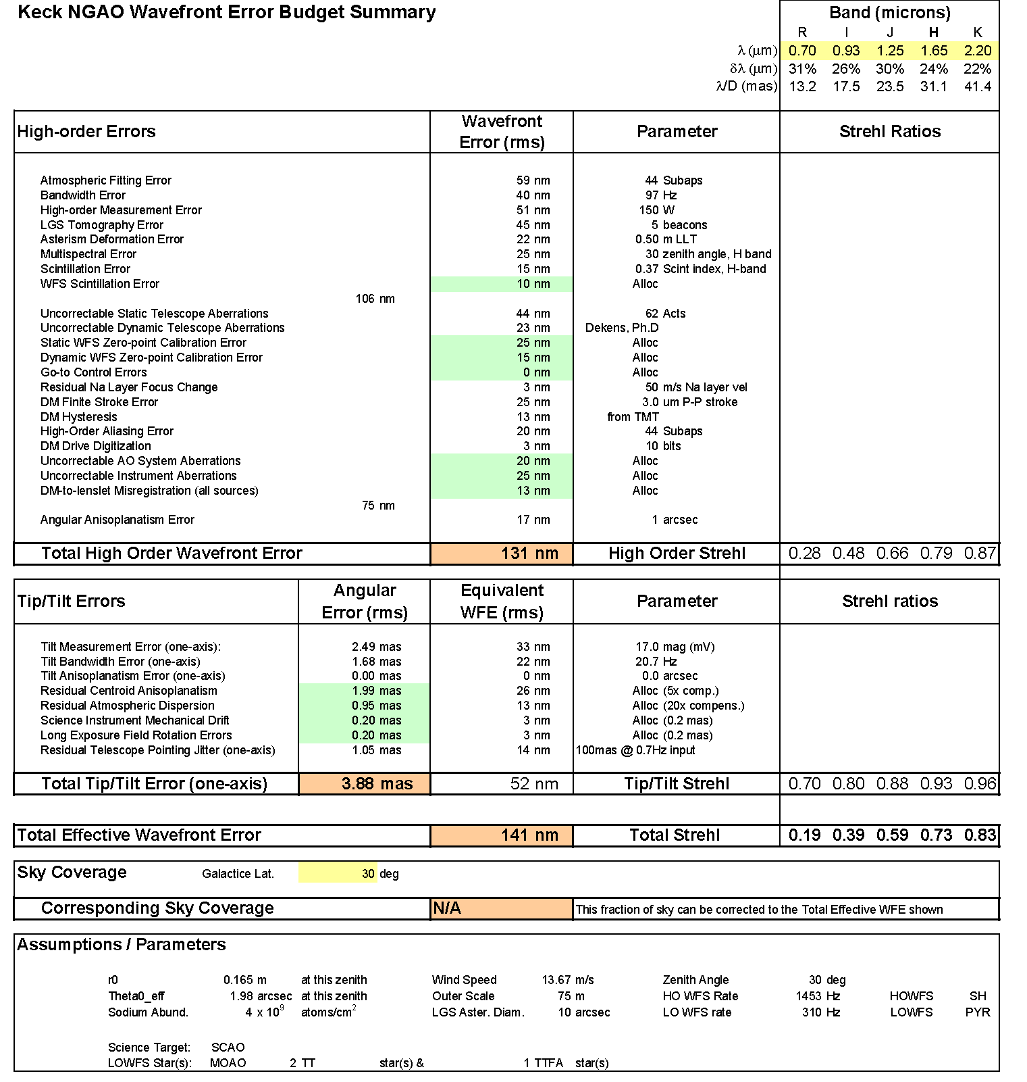
Figure 1. Error budget summary for LGS mode having an on-axis tip/tilt reference source, corresponding to an observation of a KBO having m_{H} = 15.75, in median seeing conditions. Error terms highlighted in light blue are allocations; other terms are based on point design parameter choices.

When the science target is fainter than approximately m_{H} = 17, it is often better to use natural field stars to provide low-order wavefront information. The performance behavior of the NGAO point design, making the optimal choice of target or field star, is shown in Figure 2 for a variety of sky fractions. We assume the use of 2 MOAO-compensated tip/tilt stars and 1 MOAO compensated tip/tilt/focus/astigmatism star for these results.

A classically scheduled KBO observing program (e.g. one in which telescope allocations are made in quanta of full-nights), would like follow the behavior of the 30% sky coverage curve. Although multiple targets would need to be observed during any one night, some optimization within the night to catch favorable target appulses with field stars could be arranged (A. Bouchez, private communication).

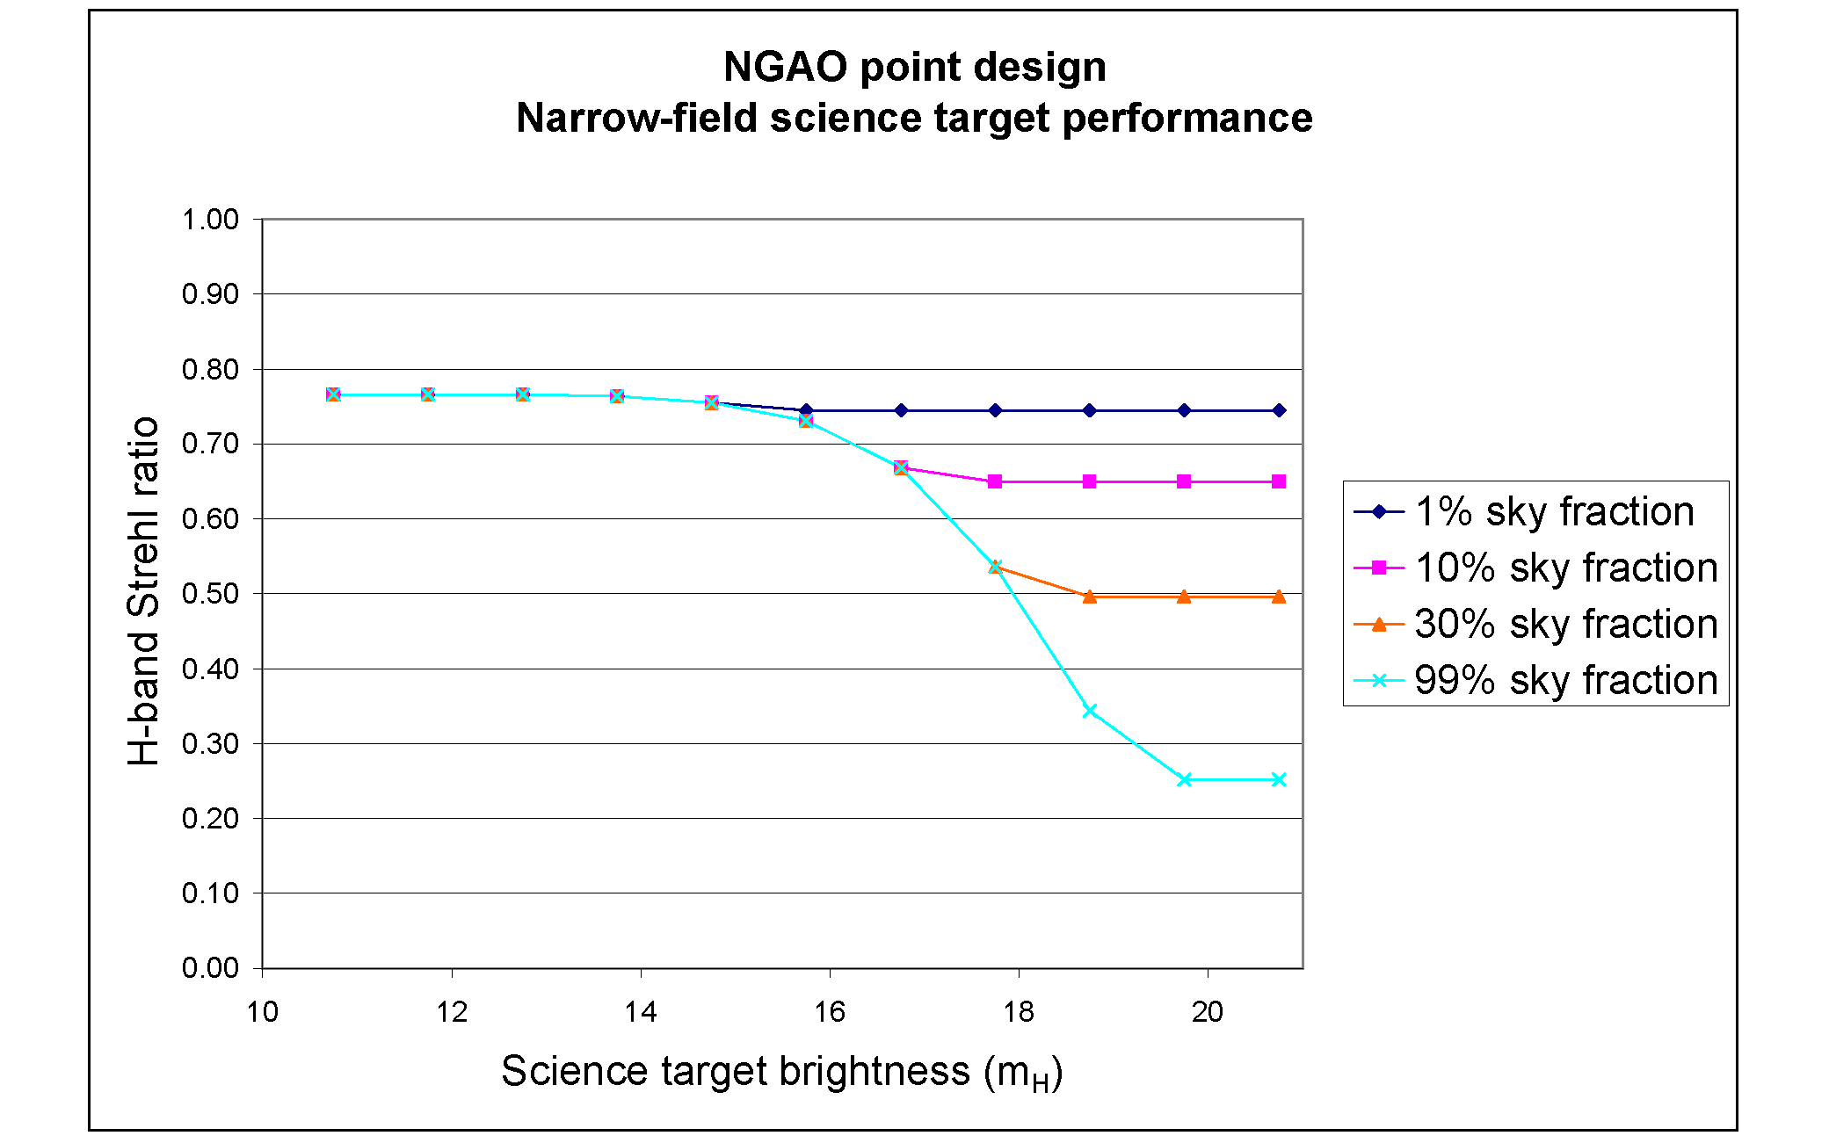
Figure 2. NGAO point design performance vs. KBO target brightness. For compact narrow-angle targets brighter than about m_{H} = 17, it is favorable to use the target itself for low-order wavefront information. For fainter targets, use of field NGS stars is preferred. The excellent performance for large sky fraction relies on MOAO compensation of the low-order guide stars and variable control of the LGS asterism radius (between 10 and 50").

Moderate-field science with LGS and bright tip/tilt NGS star (Galactic Center program)
The Galactic Center (GC)offers a different challenge than that posed by the KBO observations. For the GC case, we have a more challenging geometry, with observations from Keck not climbing higher than zenith angle = 48 degrees. Furthermore, we are interested in science field of view of 10 arcsec, which increases the anisoplanatism in a single-conjugate AO system correction. (A dual-conjugate MCAO corrected field of view would have similar performance to the following SCAO science results, with a reduced value of the angular anisoplanatism error term. In the case shown below, this would reduce the total WFE from 192 nm rms to 172 nm rms. The detailed trades between SCAO and MCAO for GC science will be performed during the NGAO System Design phase.)

On the other hand, the GC has as a resource an extremely bright and nearby infrared low-order wavefront guide star, IRS 7. Using IRS 7 with the NGAO point design infrared pyramid low-order wavefront sensor essentially eliminates the tip/tilt error contribution to the overall error budget, as shown in Figure 3.

The performance on the GC in the presented case of median seeing conditions is dominated by high-order wavefront measurement error. GC observations in these conditions are being limited by our point design choice of 150W of sodium laser power. Figure 4 presents the variation in H-band Strehl ratio as a function of seeing conditions, as indicated by the Fried parameter, r₀. As the seeing improves, the contribution to the error due to finite laser guide star power falls, so that in good conditions, performance comparable to that nearer to zenith in median conditions is obtained (as low as 135nm rms error in 0.33 arcsec seeing conditions (r₀ = 30 cm)).

Wide-field deployable IFU science with LGS with off-axis tip/tilt guide star (GOODS-N program)
The study of the assembly and evolution of field galaxies in the GOODS-N field poses yet another challenge to the NGAO system. GOODS-N has been chosen specifically to avoid bright natural stars, making high Strehl ratio performance over large sky fraction difficult. This is compounded by GOODS-N relatively large zenith angle as seen from Mauna Kea.

We present in XXX an example error budget for deployable integral field unit (d-IFU) imaging and spectroscopy in the GOODS-N field, in this case invoking a total of 10 laser guide star beacons having changeable asterism diameter. Again, the large angle away from zenith hurts the overall performance. To better understand this behavior, we have plotted in XXX the J-band performance as a function of sky fraction, for three different zenith angles, 10, 25, and 45 degrees (the last corresponding to a GOODS-N zenith angle as viewed from Keck).

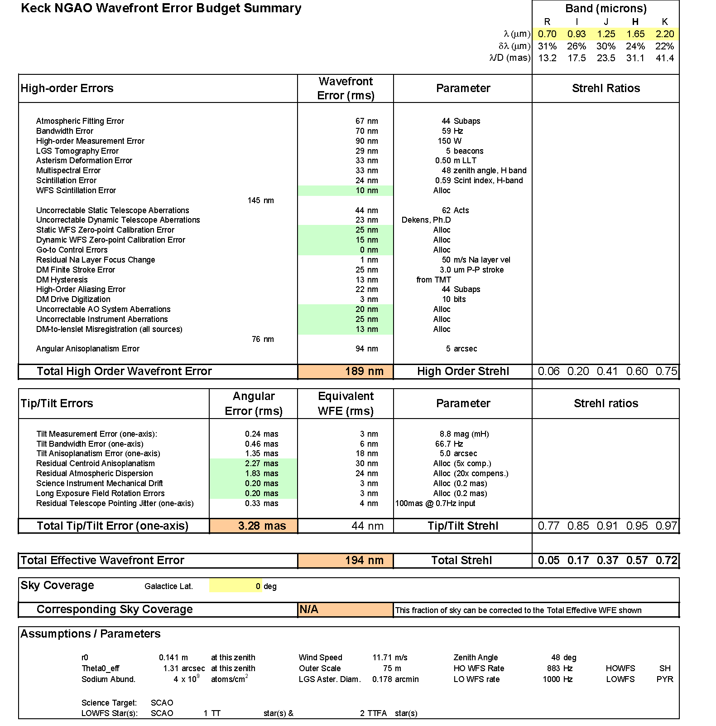
Figure 3. Error budget summary for Galactic Center observations, using a single NGS tip/tilt/focus/astigmatism star IRS 7, in median seeing conditions. Error terms highlighted in light blue are allocations; other terms are based on point design parameter choices.
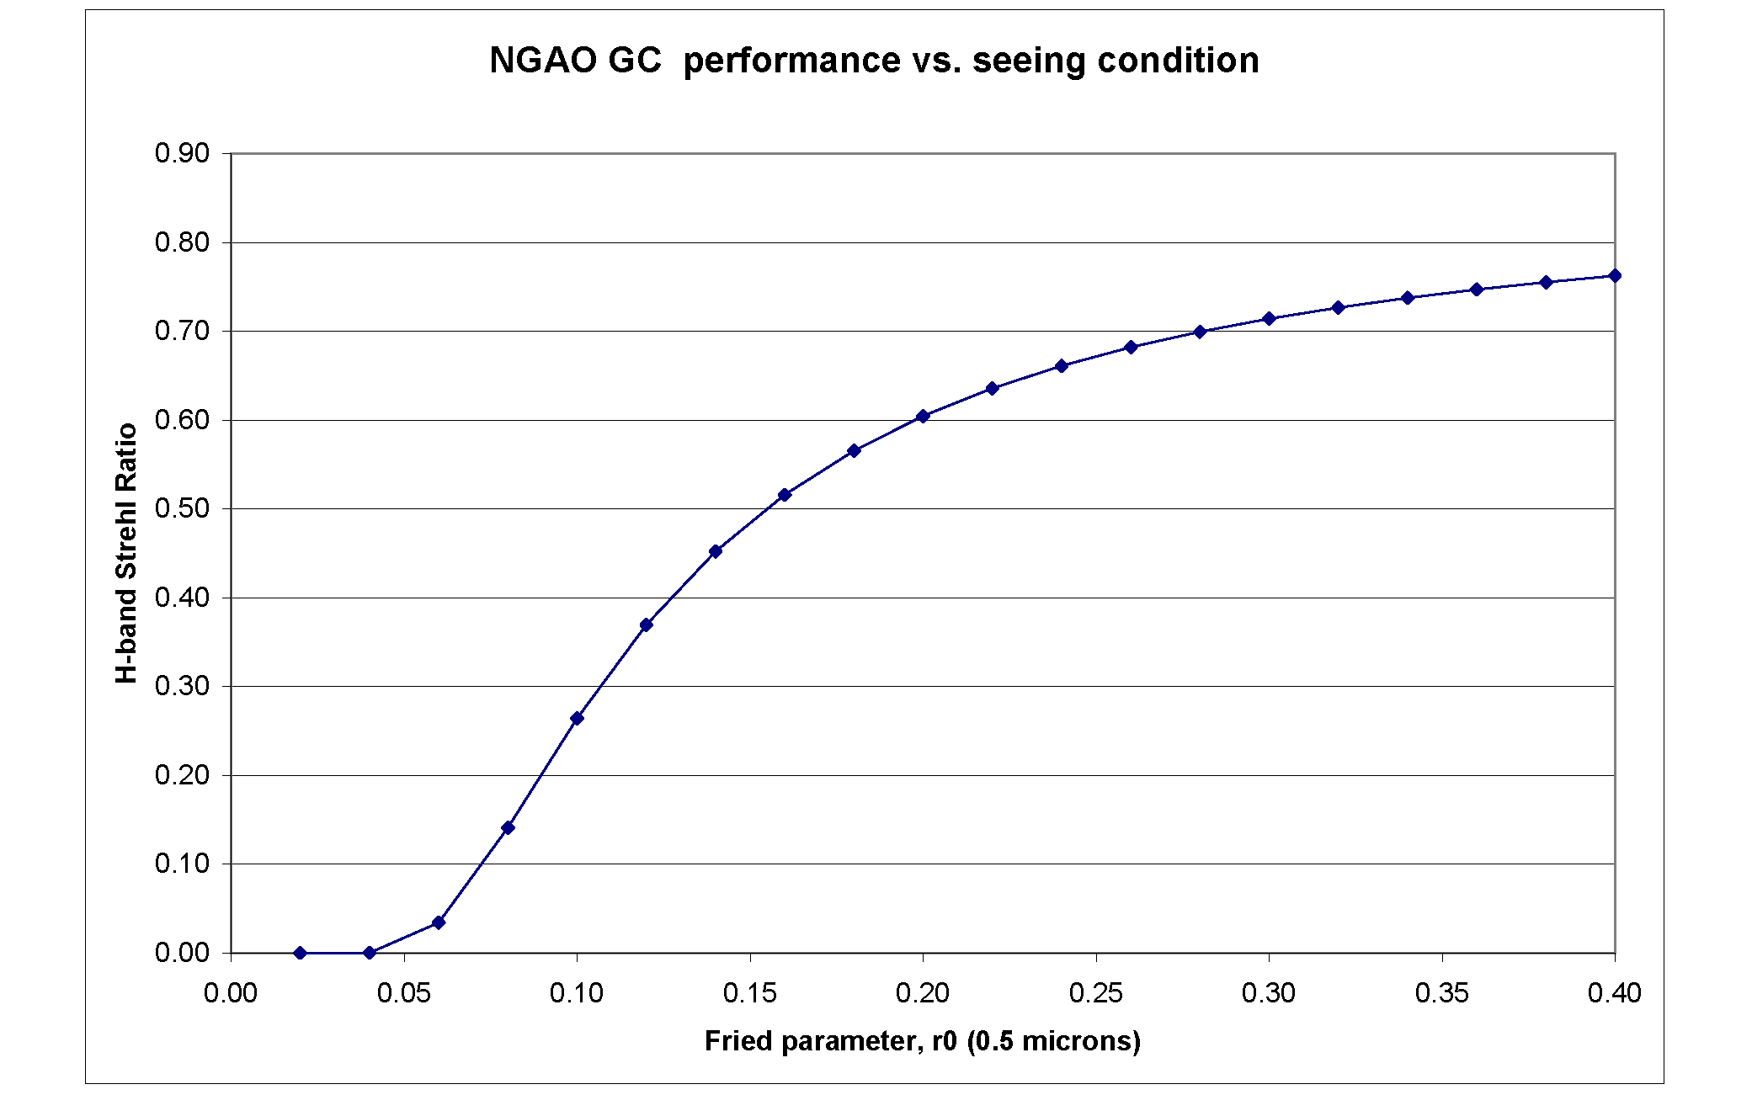
Figure 4. GC wavefront error performance vs. Fried's parameter, r₀, for constant turbulence-weighted wind speed of 14.9 m/s and other parameters as above, with optimal choice of HOWFS and LOWFS camera rates.

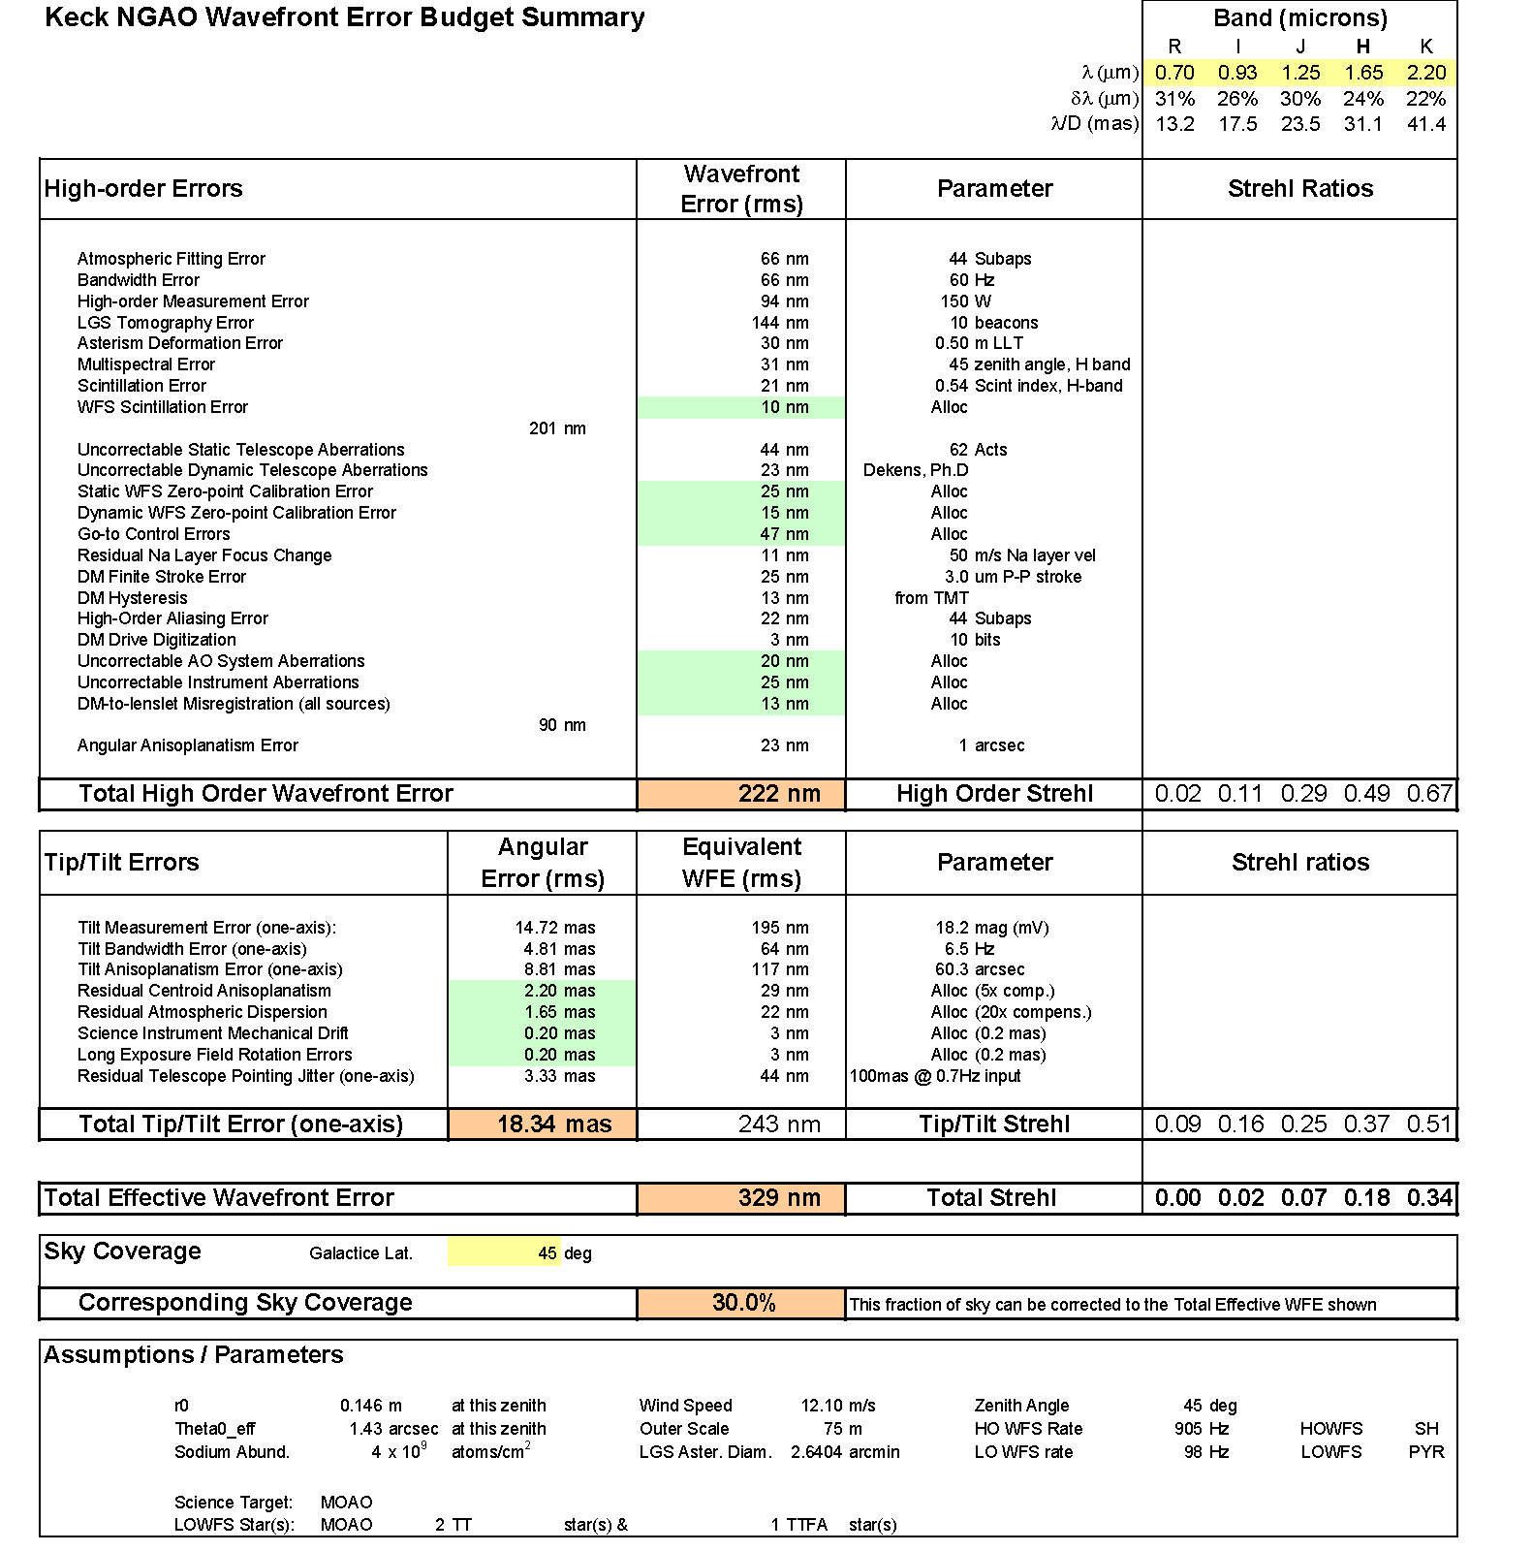
Figure 5. Error budget summary for the particularly challenging GOODS-N field with 30% sky fraction, using a two NGS tip/tilt stars and one tip/tilt/focus/astigmatism star in median seeing conditions. In this particular case, optimum performance is found by distributing the 10 LGS beacons over an asterism of diameter 2.6 arcmin. This helps the performance of the MOAO correction on the tip/tilt stars, at the cost of large tomography error for the science target itself. For smaller desired sky fraction (even for 20%), the optimal asterism diameter is less, improving science target tomography (see Figure 6).

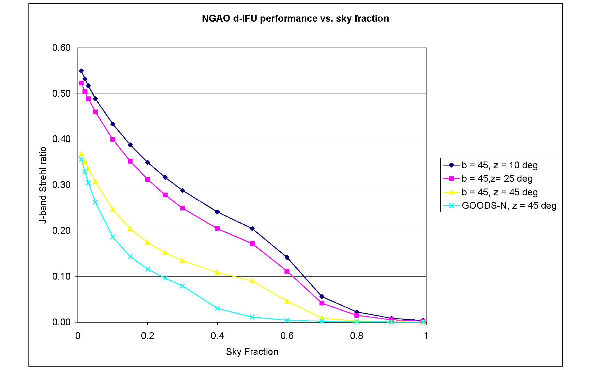
Figure 6. Deployable IFU imaging performance vs. sky fraction, for different zenith angles. NGAO point design J-band Strehl ratio in normal zenith = 10 degree extragalactic fields would be expected to be thrice the Strehl obtained in GOODS-N, for ~30% sky fraction.

Narrow-field science under the most favorable conditions
Until now, we have generally considered the performance of the NGAO point design in median seeing, wind speed, and sodium abundance conditions for practical observing geometries. It is informative, however, to consider the very best performance to be expected in the most favorable conditions, as both a reflection of the potential 'discovery space' of NGAO and to understand the issues Keck NGAO will face as it follows an upgrade path toward better visible-light performance. In Figure 7 we present just such an 'idealized' error budget, assuming 0.25 arcsec seeing, 1/3 the median wind speeds, high sodium abundance, zenith angle = 5 degrees, and galactic latitude = 10 degrees. While this is admittedly a rare coincidence of superior conditions and benign target distributions, these conditions are known to occasionally occur on Mauna Kea.

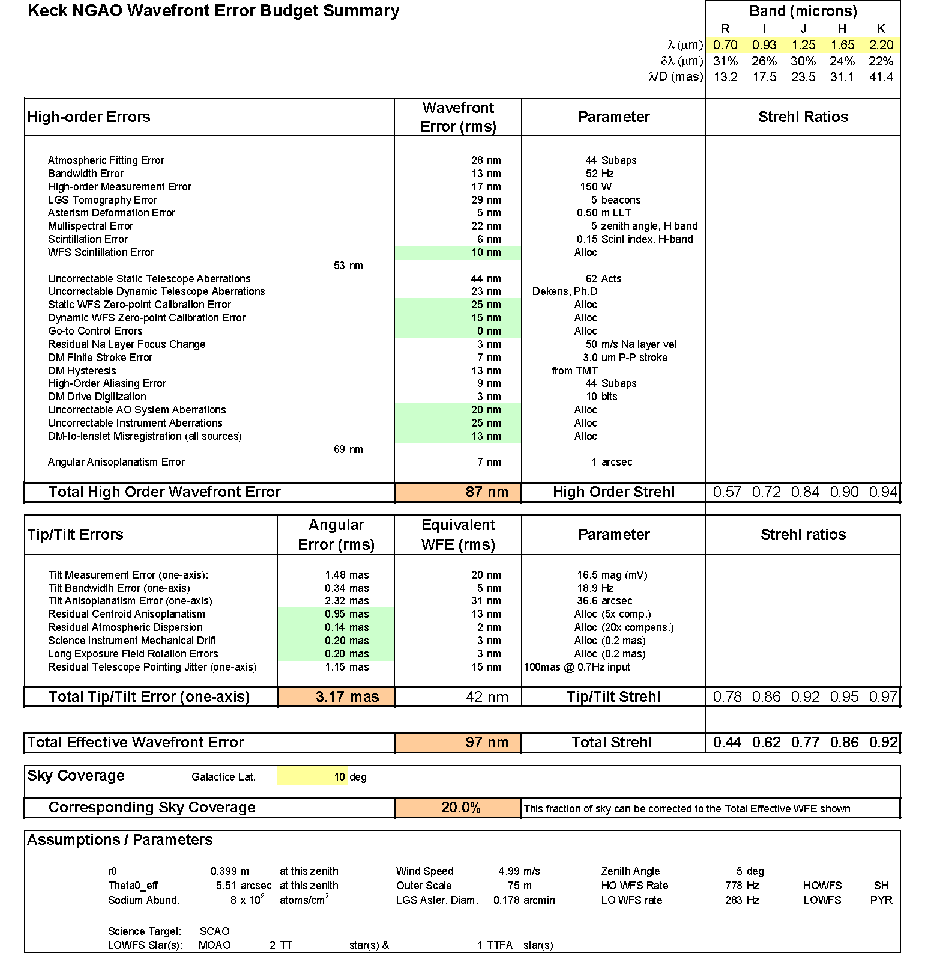
Figure 7. "Best-case" error budget under the most favorable conditions on Mauna Kea. Uncorrectable telescope, instrument, and NGAO aberrations dominate, followed by several flavors of calibration error. In the absence of these implementation errors, the entire visible-light spectrum of science wavelengths opens up to diffraction-limited discovery science.

In the best-case error budget, we see that NGAO's ability to correct static telescope aberrations is the largest single contributor (at 44nm rms), greater than all sources of tip/tilt error combined. Next in contribution are the combination of uncorrectable internal aberrations in the science instruments and NGAO system itself, followed by zero-point calibration errors, and, in this model of the telescope, uncorrectable dynamical aberrations. In almost all ways, the atmospheric contributions to the error budget have dropped out, leaving us with a system limited by our own instrumentation and the Keck Telescope itself. Currently, we known of certain cases, e.g. NIRC2's mid-scale camera, where internal aberrations are in fact the limiting factor in wavefront error performance.

This raises a key question for the System Design phase of the NGAO project, namely 'what is the extent to which the NGAO program requires facility upgrades to the telescope and existing instruments to realize it's potential?' Ensuring that the performance of NGAO is not unduly degraded will require consideration of questions such as 'can existing instruments be appropriately upgraded for NGAO, or is an entirely new suite of instruments necessary?' Similarly, we will consider whether improved diagnostics and, potentially, improved control of the Keck primary mirror is justified and/or necessary to meet the NGAO science goals.

Narrow-field NGS Observations of Io
Natural guide star (NGS) adaptive optics, first instantiated at Keck Observatory in 1999, remains an interesting mode of operation for both scientific and engineering purposes. Scientifically, the NGAO performance guiding on bright NGS will exceed that available in any foreseen LGS observing mode. The crossover brightness between NGS and LGS, the star brightness at which these two modes are comparable, is today about m_{V} = 11. In other words, for NGS fainter than m_{V} = 12, today's observer would typically obtain better performance in LGS mode. With the brighter laser return expected for NGAO, this crossover brightness will likely rise to m_{V} = 8, making the use of NGS mode more specific to bright stellar targets and the brightness compact solar system objects (such as the Galilean satellites of Jupiter).

To explore the potential performance on relatively bright NGS, we present an error budget for Jupiter's moon Io in Figure 8, returning to our median atmospheric conditions and guiding both high-order and tip/tilt information from Io itself. Again, the NGAO performance is expected to be excellent, reliably providing good Strehl ratio for R-band observations. Unlike the previous case of LGS operating in excellent seeing, the Io case considered here benefits from the (expected) absence of several LGS-related terms in the error budget. This is offset by the finite diameter of Io, but we assume here good calibration of the high-order wavefront sensor so that no significant degradation due to e.g. unknown centroid gains, is induced.

This particular example allows NGAO to utilize all N=62 subapertures available in the point design. During the System Design phase, we will consider fainter NGS performance and consider issues such as the case for optimizing NGAO for faint (e.g. m_{V} = 12-15) NGS.

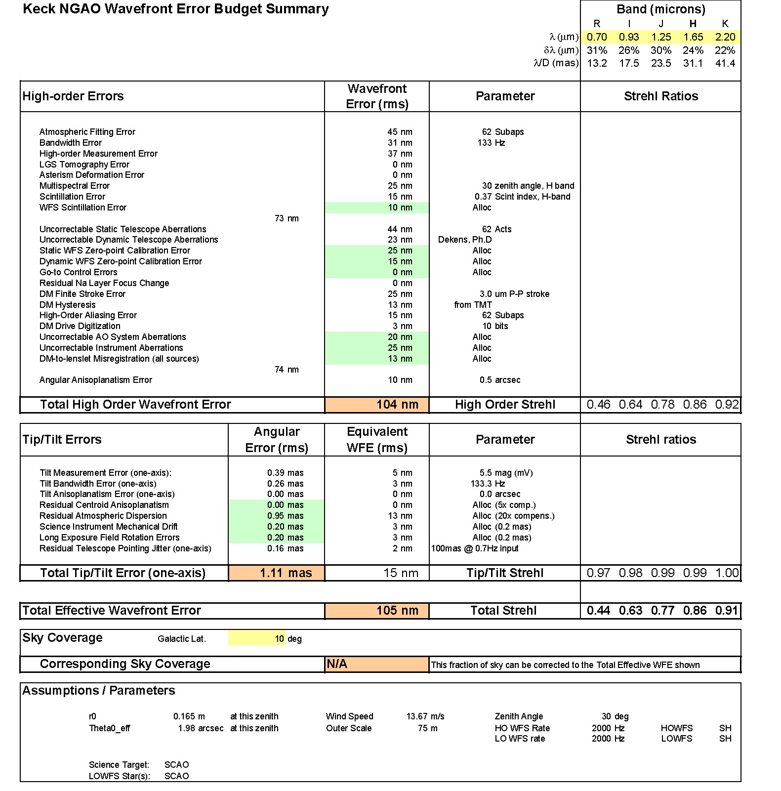
Figure 8. Error budget for NGAO observations of Io in N=62 subaperture NGS mode and median seeing and wind speed conditions.

Technical Approach

Management

Project Organization

Project Plan and Schedule

Risk Assessment and Risk Management Plan

Budget

System Design Phase

Preliminary and Detailed Design through Full Scale Development

Science Instruments

Operations

References

Appendix XXX: Error Budget Terms
The wavefront error budgets developed for the NGAO point design incorporate the following physical sources of residual high-order (non-tip/tilt) wavefront error:

Atmospheric Fitting Error
Bandwidth Error
High-order Measurement Error*
LGS Tomography Error*
Asterism Deformation Error*
Multispectral Error
Scintillation Error*
WFS Scintillation Error*
Uncorrectable Static Telescope Aberrations
Uncorrectable Dynamic Telescope Aberrations
Static WFS Zero-point Calibration Error*
Dynamic WFS Zero-point Calibration Error*
Go-to Control Errors*
Residual Na Layer Focus Change*
DM Finite Stroke Error
DM Hysteresis
High-Order Aliasing Error
DM Drive Digitization
Uncorrectable AO System Aberrations
Uncorrectable Instrument Aberrations
DM-to-lenslet Misregistration (all sources)
Angular Anisoplanatism Error

and the following terms pertaining to tip/tilt errors:

Tilt Measurement Error
Tilt Bandwidth Error
Tilt Anisoplanatism Error
Residual Centroid Anisoplanatism*
Residual Atmospheric Dispersion*
Science Instrument Mechanical Drift*
Long Exposure Field Rotation Errors*
Residual Telescope Pointing Jitter*.

Most of these error terms are described in detail in the excellent text by J. W. Hardy, Adaptive Optics for Astronomy, and will not be described here. Some terms, however, require special description in this Appendix because they are either non-standard, or because critical assumptions have been made in their estimation. These terms are indicated with asterisks above and described in detail in the following sections.

High-order WFS Measurement Error
Our NGAO error budget incorporates the following physical effects in the determination of wavefront estimates in our model Shack-Hartmann wavefront sensor system:

Photon noise
Read noise
Dark current noise
Sky background
Rayleigh background
CCD charge diffusion
LGS perspective elongation
Laser beam quality
Uplink compensation (as an optional switch)
Shack-Hartmann vs. pyramid sensor (an optional switch)
Error propagation

we have, where appropriate, incorporated real-world values for these parameters, as measured in existing LGS AO systems, and/or noted 'next generation technology' in our discussion of risk areas central to System Design phase consideration.

LGS Tomography Error
Estimation of the residual wavefront error arising from incomplete or incorrect tomographic wavefront sensing has been explored in detailed covariance code models (D. Gavel, private communication) and through Monte Carlo simulations (C. Neyman, private communications). The input parameters are the atmospheric turbulence profile, the laser guide star asterism beacon count and geometry, the field of view over which wavefront estimation is to be made, and certain assumptions regarding the mode of AO operation (e.g. single- vs. double-conjugate correction) and auxiliary sources of sensing information (e.g. concurrent measurement of certain wavefront spatial modes (such as focus and astigmatism) using natural guide stars).

For the purpose of the point design, we have selected a specific asterism for narrow-field science applications and conducted a small trade study for wider-field science applications to identify the key areas for further investigation. For the corresponding error budgets, we have entered the estimated wavefront error determined from these detailed codes.

[??? insert example trade study result here???]

Asterism Deformation Error
Tomographic reconstruction of multiple LGS wavefront measurements typically requirements an assumption on the actual geometry of the laser asterism on the sodium layer. However, due to tilt indeterminacy of the individual beacons, the true sampling of the volume of atmosphere above the telescope is instantaneously variable. For example, the nominal square geometry of an asterism is at any given time in reality a general quadrilateral. Independent of blind modes in the reconstruction process, this unknown asterism deformation will lead to additional residual wavefront errors.

We estimate the magnitude of this error by supposing that the wavefront reconstruction is diabolically bad, representing a volume of atmosphere in which the entire asterism has (unknowingly) conspired to shift in the same direction. In this case, the upper limit to the error is equivalent to an angular anisoplanatism error corresponding to the angular variance of the uplink laser tip/tilt, typically 0.2 to 0.3 arcsec, depending on zenith angle. The equivalent wavefront error in this case, for the CN-M2 atmospheric model, is typically 15 to 30 nm rms.

Scintillation Error
Via propagation, phase errors imparted on the wavefront at high altitudes in the Earth's atmosphere couple into amplitude errors generating the phenomenon of scintillation. We assume only phase compensation for the NGAO point design, resulting in a residual Strehl ratio degradation even for a system performing perfect phase conjugation. Standard formulae are therefore used to estimate the impact to Strehl in H-band and from this (via the Marechal approximation), an equivalent rms wavefront error in nanometers is determined.

Note, this error budget term is chromatic and is most accurately presented in our point design budgets for wavelengths around H-band. More detailed analysis of this effect will be undertaken in the System Design phase.

WFS Scintillation Error
Just as scintillation directly degrades the delivered science image quality of NGAO, it also indirectly introduces wavefront compensation errors via coupling of phase and amplitude terms in our high-order wavefront sensors. Across the dimension of one WFS subaperture, scintillation of the wavefront would have no impact on a pure local tilt error alone. However, in the presence of local focus and other aberrations within a subaperture, amplitude fluctuations can be misinterpreted by the sensor as false tip/tilt signal, resulting in reconstruction errors.

The magnitude of this error is typically small, but grows as subaperture dimension is reduced. We use estimates generated from diffractive wave-propagation Monte Carlo simulations of Shack-Hartmann wavefront sensor AO systems (Matt Britton, private communication) as the basis for a wavefront error estimate for the NGAO point design.

Static WFS Zero-point Calibration Error
Static WFS zero-point calibration errors represent the difference between the physically obtainable internal wavefront calibration errors (e.g. those not outside the spatial bandwidth of deformable mirror actuator correction) and the actual internal calibration error.

Dynamic WFS Zero-point Calibration Error
Static zero-point calibration errors can be accentuated in the presence of changing atmospheric and other conditions. The centroid offset values, for example, representing the closed-loop desired target point for the AO system depend on the subaperture centroid gain function mapping true wavefront tilt to measured centroid tilt (all slope sensors are to some degree non-linear meters of the instantaneous wavefront state). Shack-Hartmann sensor systems design to operate away from strict 'quad-cell' centers are particularly susceptible to this error.

For the NGAO point design, we estimate this error based on our experience with existing LGS AO systems that use Shack-Hartmann sensing in the presence of changing seeing and potentially changing laser beam quality. Interpreted as an allocation to the error budget, this would set an acceptable level of static wavefront errors and/or reference centroid positions.

Go-To Control Errors
Multi-Object AO (MOAO) implementations considered in the NGAO point design require operation of individual high-order deformable mirrors in a go-to control mode. By this, we mean that no wavefront sensor witnesses the effects of the correction, rather it is imprinted upon the astronomical science light alone.

Experiments are underway at UCSC's LAO (D. Gavel, private communication) to establish the practical residual errors imparted by go-to AO systems. For the NGAO point design error budgets, we have assumed that the root-sum-squared total of each of:

Incorrect measurement of woofer DM - 30nm rms
Incorrect calibration of WFS - 20 nm rms
Incorrect actuation of MEMS DMs - 2 nm rms

or equivalently 36 nm rms in all. Note, this applies only to the wide-field science modes of NGAO, as the narrow-field laser beacons do, in fact, witness compensation (if only partially). The detailed performance of go-to control systems will be further investigated in the System Design phase, including feedback from concurrently planned experimental verification.

Residual Na Layer Focus Change
The altitude of the Earth's sodium (Na) layer is ever-changing, resulting in the impression of an unpredictable focus error into the high-speed LGS wavefront sensor signal. The effect of these focus changes can be measured in the low-order WFS system, where focus is continually and concurrently being measured using natural guide stars. The focus information necessary to compensate for Na layer altitude changes, however, can only be provided at the closed-loop correction bandwidth of the LOWFS, resulting in a residual Na layer focus error.

Experimentally, we have data tracking the Na layer fluctuations over Mauna Kea (Antonin Bouchez, private communication). For the NGAO point design error budget, we assume conservatively an unpredictable sinusoidal altitude variation of 50 meters/sec vertical. This results in an input error of 37 nm rms per second, which is then reduced by the compensation provided by the LOWFS bandwidth (e.g. 5x reduction for 5 Hz -3db bandwidth).

Residual Centroid Anisoplanatism
Ideally, tip/tilt sensors would measure wavefront tilt but in practice they usually measure centroid motion as a surrogate to true tilt in the Zernike sense. Because other wavefront aberrations (notably coma) can also move the wavefront centroid, a centroid anisoplanatism error is introduced. A number of techniques have been proposed to mitigate this potentially significant effect (Dekens, F., Ph. D. thesis, University of Irvine). Current LGS systems typically rely on averaging of effects that arise because of the high characteristic frequency of coma and higher-order aberrations, relative to wavefront tilt.

For the NGAO point design error budget, we make an allocation corresponding to a 5x reduction in the intrinsic centroid anisoplanatism error, as measured by Dekens using ultra-fine-screen data from the Keck Phasing Camera System (PCS). This allocation can be realized via a number of techniques, but will require further analysis in the System Design phase before a particular strategy can be recommended.

Residual Atmospheric Dispersion
Atmospheric dispersion becomes an increasingly difficult problem as NGAO moves Keck science both to shorter wavelength and higher Strehl ratio. Atmospheric dispersion is a chromatic effect, wherein one cannot easily represent the error via the Marechal approximation. Still, we do just this in our error budgets, adopting the residual atmospheric dispersion that would be present across the J-band. (The import of this effect grows with shorter science wavelength.)

For the NGAO point design, we have assumed that the natural atmospheric dispersion can be reduced by a factor of 10x, setting an infrared design target for the System Design phase. Visible light science will need detailed analysis to determine the practical limits of compensator design, in the context of more highly developed visible-light science cases.

Science Instrument Mechanical Drift
Due to typical non-common optical paths between the science focal plane and the NGAO tip/tilt sensor, slow thermal or gravitational drifts can cause blurring on the long-exposure science image.

For the NGAO point design, we assume 0.2 milliarcseconds as an allocation for the allowable non-common-path mechanical drift for short exposures (e.g. 10 seconds) and 2 milliarcseconds for the long exposures (e.g. 4 hours). Meeting these allocations may or may not require active metering of the non-common path.

Long Exposure Field Rotation Errors
Imperfect field derotation of the alt-az provided science field relative to the science focal plane will result in a blurring. We allocate 0.2 milliarcsec for short exposure and 2 milliarcsec for long-exposures, as above, to these effects. Note, long-exposure in this case can represent any exposure that undergoes significant field derotation, including relatively short duration exposures need the keyhole.

Residual Telescope Pointing Jitter
Telescope windshake and other disturbance sources result in an equivalent solid-body pointing jitter. Work conducted on Keck Interferometer in recent years has significantly reduced the global vibration environment for the telescopes, but some pointing jitter remains.

For NGAO, we assume a sinusoidal model of jitter in which an initial disturbance having 0.1 arcsecond peak-to-peak amplitude and 0.7 Hz frequency is rejected at the NGAO tip/tilt -3db closed-loop bandwidth.

Other Terms Not Considered Here
For completeness, we note that our error budget development currently does not include the following error terms, almost always because we believe the impact to the system performance can be made negligible through appropriate design choice:

Non-linear DM Actuator Superposition Error (can addressed via proper reconstructor)
Tilt Sensor Scintillation Error (effect is small in IR w/ large subaps)
Blind (e.g. Waffle) Modes (can be controlled via servo law)
Non-Common-Path Air Turbulence
Non-Common-Path Mechanical Vibrations
Temperature Dependent DM Gain Changes (realized as a servo gain change)
LGS Finite Altitude Error (negligible for Na beacons)
Errors due to incorrect control of 'guard ring' DM actuators
Reconstructor Round-off Error

Some of these terms may be added to the design error budgets during system development, though none is currently envisioned to contribute a term larger than 10nm rms to be added in quadrature to the overall wavefront error budget.

