

The Next Generation Adaptive Optics System
at the
W. M. Keck Observatory

A Proposal for Design and Development

Date
Version

1 Introduction 5
2 Executive Summary 5
3 Science 5
3.1 Introduction 5
3.2 The Competitive Landscape 5
3.3 Solar System Science 5
3.4 Galactic Science 5
3.5 Extragalactic Science 5
3.6 Science Requirements 5
4 Technical 5
4.1 Introduction 5
4.2 Requirements and Flow Down to Technical Specifications 5
4.3 Technical Approach 5
5 Management 6
5.1 Project Organization 6
5.2 Project Plan and Schedule 6
5.3 Risk Assessment and Risk Management Plan 6
6 Budget 6
6.1 System Design Phase 6
6.2 Preliminary and Detailed Design through Full Scale Development 6
6.3 Science Instruments 6
6.4 Operations 6
7 References 6

Error! No table of figures entries found.

Error! No table of figures entries found.

Introduction

Executive Summary

Science

Introduction

The Competitive Landscape

Solar System Science

Galactic Science

Extragalactic Science

Science Requirements

Technical

Introduction

Requirements and Flow Down to Technical Specifications

Technical Approach

Thermal Emissivity
To reduce the thermal background seen by the infrared instruments, the point design includes an insulated enclosure cooled to -15ºC (258 K). Below this temperature, the K band background due to emission and scattering within the AO system falls below the sum of the sky and telescope, limiting the utility of further cooling (see Figure 1). While cooling below -15ºC may benefit observations at wavelengths longer than 2.5 µm, the question of whether the increased operational complexity would be justified will be addressed by a trade study in the next phase. The total emissivity of the point design NGAO system, from the AO entrance window to the infrared science instrument entrance window, is 0.37 (see Table 1).

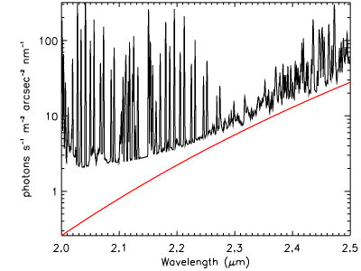
Figure 1: Background in the K band due to point design NGAO system cooled to 258 K (red) compared to that due to the sky plus telescope (black), assuming a total telescope emissivity of 0.10.

Component | Effective emissivity | Temperature
CaF₂ window bulk emission | 7.5 x 10⁻⁴ | 273 K
CaF₂ window reflection | 0.02 | 258 K
Rotator mirrors (3) | 0.03 x 3 | "
Off-axis parabolas (2) | 0.03 x 2 | "
Deformable mirror | 0.03 | "
IR/visible dichroic bulk emission | 5 x 10⁻⁴ | "
IR/visible dichroic reflection | 0.05 | "
ADC prisms bulk emission (2) | (1.5 x 10⁻³) x 2 | "
ADC prism reflections (2) | 0.02 x 2 | "
IR dichroic reflection | 0.05 | "
Science camera CaF₂ window | 5 x 10⁻⁴ | "
Total | 0.37
Table 1: Emissivity and temperature of each element in the IR science path.

Management

Project Organization

Project Plan and Schedule

Risk Assessment and Risk Management Plan

Budget

System Design Phase

Preliminary and Detailed Design through Full Scale Development

Science Instruments

Operations

References

