Dichorics required for NGAO:

Requirements as suggested by point design of splitter farm (http://www.astro.caltech.edu/twiki_oir/bin/view.cgi/Keck/NGAO/SystemsEngineering):

1st dichroic: (IR Vis. splitter)
Diameter = 34 cms.

R 400-900 nm
R 400-1000 nm
mirror

2nd dichroic:(IR LOWFS and science)
Diameter = 25 cms

R J band
R H band
R K-H band
[R Z band]
open

3rd dichroic: (LGS, SWFS and Vis. science)
Diameter = 20 cms.
R I band
R R band
[R V band]
R < 100 nm

The OAP design of the optical relay is shown below:

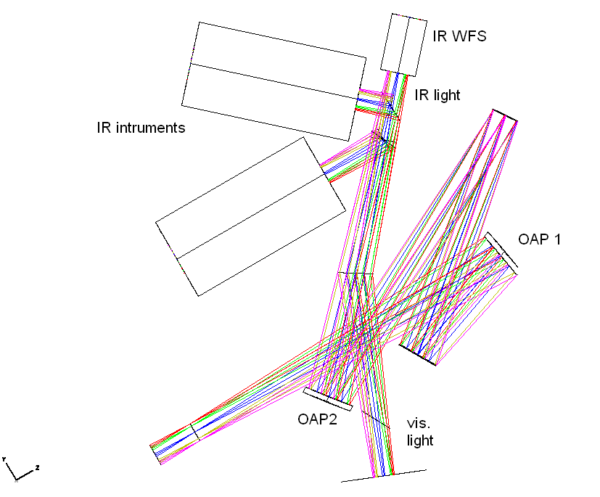

Specifications of dichroics for RFQs

1. Name: Infra-red - visible light splitter 1
Diameter of optic = 33 cms
Angle of incidence = 10 degrees
Reflects 400-900 nm and transmits all IR wavelengths

2. Name: Infra-red - visible light splitter 2
Angle of incidence = 10 degrees.
diameter of optic = 33 cms
Reflects 400-1000 nm and transmits all IR wavelengths
-----------------------------------------------------------------
(To first IR instrument)

3. IR LOWFS and Science splitter A1
Angle of incidence = 22.5 degrees
Diameter of optic = 25 cms
Reflects 1.13-1.37 microns (J-band) and transmits over 1.37 microns

4. IR LOWFS and Science splitter A2
Angle of Incidence = 22.5 degrees
Diameter of optic = 25 cms
Reflects 1.5-1.80 microns (H-band) and transmits over 1.80 microns

5. IR LOWFS and Science splitter A3
Angle of incidence = 22.5 degrees
Diameter of optic = 25 cms
Reflects 1.5-2.42 microns (k and H-band) and transmits over 2.42 microns

6.IR LOWFS and Science splitter A4
Angle of incidence = 22.5 degrees.
Diameter of optic = 25 cms or greater
Reflects .6-.99 microns (R to Z-band) and transmits over 1 micron

- - - - - - - - - - - - - - - - - - - - - - - - - - - - - -
(To second IR intrument)

7. IR LOWFS and Science splitter B1
Angle of incidence = 45 degrees
Diameter of optic = 25 cms
Reflects 1.13-1.37 microns (J-band) and transmits over 1.37 microns

8. IR LOWFS and Science splitter B2
Angle of Incidence = 45 degrees
Diameter of optic = 25 cms
Reflects 1.5-1.80 microns (H-band) and transmits over 1.80 microns

9. IR LOWFS and Science splitter B3
Angle of incidence = 45 degrees
diameter of optic = 25 cms
Reflects 1.5-2.42 microns (k and H-band) and transmits over 2.42 microns

10.IR LOWFS and Science splitter B4
Angle of incidence = 45 degrees.
Diameter of optic = 25 cms or greater
Reflects .81-.99 microns (Z-band) and transmits over 1 micron

-------------------------------------------------------------------
LGS, SWFS and Vis. science splitters

8. LGS, SWFS and Vis. science splitter 1
Angle of incidence = 45 degrees
Diameter of optic = 20 cms
Reflects .7-.9 microns (I-band) and transmits over .9 micron

9. LGS, SWFS and Vis. science splitter 2
Angle of incidence = 45 degrees
Diameter of optic = 20 cms
Reflects .58-.66 microns (R-band) and transmits over .66 micron

10. LGS, SWFS and Vis. science splitter 3
Angle of incidence = 45 degrees
Diameter of optic = 20 cms
Reflects .49-.59 microns (V-band) and transmits over .9 micron

11. LGS, SWFS and Vis. science splitter 4
Angle of incidence = 45 degrees
Diameter of optic = 20 cms
Reflects < .1 microns and transmits over .1 micron

