

K1 Laser Guide Star Adaptive Optics System
PRELIMINARY Launch Telescope Assembly
REquirements

Prepared By Jason Chin, Drew Medeiros, Stephan Kellner, Roger Sumner
April 6, 2006

VersionV1.0

Revision History

Revision | Date | Author (s) | Reason for revision / remarks
1.0 | April 6, 2006 | JC, SK, RS, DM | Initial release

TABLE OF CONTENTS
Revision History 2
TABLE OF CONTENTS 3
1. Introduction 5
2. ACKNOWLEDGEMENT 5
3. Requirements DEFINITION 6
4. References 6
4.1. Referenced Documents 6
5. telescope references 8
5.1. location 8
5.2. Definitions and conventions 8
6. deliverables 10
6.1. Major component list 10
6.2. Keck furnished property list to GA 11
7. REQUIREMENTS 11
7.1. Performance characteristics 11
7.1.1. Modes of operation 11
7.1.2. Input Laser characteristics 11
7.1.3. Optical characteristics 12
7.1.4. Optical quality and alignment accuracy 12
7.1.5. Coatings and throughput 13
7.1.6. Alignment Tool 14
7.2. Physical characteristics 14
7.2.1. Allowable design volume 14
7.2.2. Interfaces 15
7.2.3. Mass and Centre of Gravity 17
7.2.4. Dynamic performance 17
7.2.5. Dry N₂ tightness 17
7.2.6. Quasi-static analysis 18
7.3. Reliability 18
7.4. Maintainability 18
7.4.1. Maintenance frequency 18
7.4.2. Preventive maintenance 18
7.4.3. On-site repair 18
7.5. Environmental conditions 19
7.5.1. Transportation conditions 19
7.5.2. Operational & Maintenance conditions. 20
7.5.3. Transportability 20
8. Design and construction 20
8.1. Materials, parts and processes 20
8.1.1. LTA interior surface 20
8.1.2. LTA exterior surface 20
8.1.3. Surface treatment on mechanics 21
8.1.4. Optics re-coating compatibility 21
8.1.5. Measurement units 21
8.2. Name plates and product marking 21
8.3. Workmanship 22
8.4. Safety 22
8.4.1. Mechanical Safety 22
9. Documentation 22
9.1. Language 22
9.2. Overview of System 22
9.3. Alignment Manual 22
9.4. Maintenance Manual 22
9.5. Mechanical Drawings 22
9.6. Delivered Documentation 23
9.7. Spares 23
10. Maintenance 23
10.1. General CARA maintenance approach 23
10.2. Recommendation by contractor 23
10.3. Repair on condition 24
10.4. Personnel and training 24
11. Major components characteristics 24
11.1. Optical components 24
11.1.1. Micro-roughness of optical surfaces ( REQ-LTA- 71). 24
11.1.2. Cleanliness of optical surfaces (scratches, pits and sleeks) 24
11.2. Alignment mechanisms 25
11.3. Transport Container (REQ-LTA- 78). 25
11.4. Handling tool (REQ-LTA- 79). 26
12. Specific test / end item inspection requirements 26
12.1. Optical characteristics 26
12.1.1. Optical prescription 26
12.1.2. Optical quality 26
12.1.3. Throughput 27
12.2. Alignment mechanisms 27
12.3. Gravity testing 27
13. Preparation for storage/transport 28
13.1. Cleaning 28
13.2. Enhanced environmental protection 28
13.3. Protective covers 28
14. Compliance Matrix 29
Appendix 1. 33
14.1. Mechanical_1.html 33
14.1.1. Basic Requirements 33
14.2. Mechanical_2.html 35
14.2.1. Parametric Requirements 35
14.3. Mechanical_3.html 36
14.3.1. Mechanical Drawing Requirements 36

Introduction
The Keck Observatory is procuring a Lockheed Martin – Coherent Technology 20W quasi-CW sodium laser system for the Keck 1 Telescope located on the top of Mauna Kea, Hawaii. The laser will provide an artificial beacon or guide-star by exciting sodium atoms in the mesosphere, 90km to 100km above sea level. This artificial guide-star is used by the K1 Adaptive Optics System to improve astronomical observations by removing distortion from atmospheric turbulence. The LGSAO system will require a laser launch telescope assembly to expand the laser beam to its required diameter for propagation onto the sodium layer. The launch telescope assembly is part of a larger system called the K1 Laser Guide Star Adaptive Optics System. The document provides the requirements for the launch telescope assembly that will support the Laser Guide Star Adaptive Optics System.

ACKNOWLEDGEMENT
Since Galileo Avionica has produced 2 Launch Telescope Assemblies, significant portions of this document have been taken from ESO’s Specification VLT-SPE-ESO-11841-2514, which was used to build the first assembly. The authors wish to acknowledge the work done by their colleagues at ESO: P. Dierickx, E. Brunetto, D. Bonaccini.

Requirements DEFINITION
Throughout this document a unique number in the form “REQ-LTA-XX” for ease of reference usually identifies requirements. However, the absence of such a number shall not be construed as meaning that something is not a requirement if it otherwise appears to be mandatory. An index to the requirement numbers may be found starting on page TBD of this document.

References

Referenced Documents
Documents referenced in the requirements are listed in Table 1. Copies of these documents may be obtained from the source listed in the table.

Ref. # | Document # | Revision or Effective Date | Source | Title
1 | GEM00417_B_CTI_Req.v02.91.pdf | 2.91 | Gemini | Requirements for Gemini South and Keck 1 Laser Systems
2 | VLT-SPE-ESO-11841-2514 | 3 | ESO | VLT Laser Guide Star Facility
3 | VLT-DWG-GAF-11841-000101_1.dwg | Nov 03 | GA | Face Definitions for LTA
4 | MIL-STD-810F |  | Department of Defense | Test Method Standard for Environmental Engineering Considerations and laboratory Tests
5 | Title 29 CFR Part 1910 |  | OSHA | Occupational Safety And Health Standards
6 | Y14.5M-1994 (R1999) | 1994 | ANSI | Dimensioning and Tolerancing
7 | Y14.1-1995 (R2002) | 2002 | ANSI | Decimal Inch Drawing Sheet Size And Format
8 | Y14.34-2003 | 2003 | ANSI | Parts Lists, Data Lists, And Index Lists: Associated Lists
9 | Y14.3M-1994 | 1994 | ANSI | Multi And Sectional View Drawings
10 | Y14.18M-1986 | 1986 | ANSI / ASME | Optical Parts (Engineering Drawings and Related Documentation Practices)
11 | HPS-2003 | 2003 | ASME | High Pressure Systems
12 | Y14.100-2000 | 2000 | ASME | Engineering Drawing Practices
13 | Y32.10-1967 (R1994) | 1994 | ASME | Graphic Symbols for Fluid Power Diagrams
Table 1. Reference Documents

Acronym/Abbreviation | Definition
ANSI | American National Standards Institute
AO | Adaptive Optics
ASME | American Society of Mechanical Engineers
CARA | California Association for Research in Astronomy
CW | Continuous Wave
EIA | Electronic Industries Alliance
ESO | European Southern Observatory
GA | Galileo Avionica
LGS | Laser Guide Star
LGS AO | Laser Guide Star Adaptive Optics
LTA | Launch Telescope Assembly
NGS | Natural Guide Star
OSHA | Occupational Safety and Health Administration
REQ-LTA-XX | Requirement Keck 1 Launch Telescope Assembly
RH | Relative Humidity
TBD | To Be Determined
UL | Underwriters Laboratories Inc.
WMKO | W. M. Keck Observatory

Table 2 Acronyms and Abbreviations

telescope references

location
The LTA will be installed behind the secondary mirror in the M2 unit on the K1 telescope.
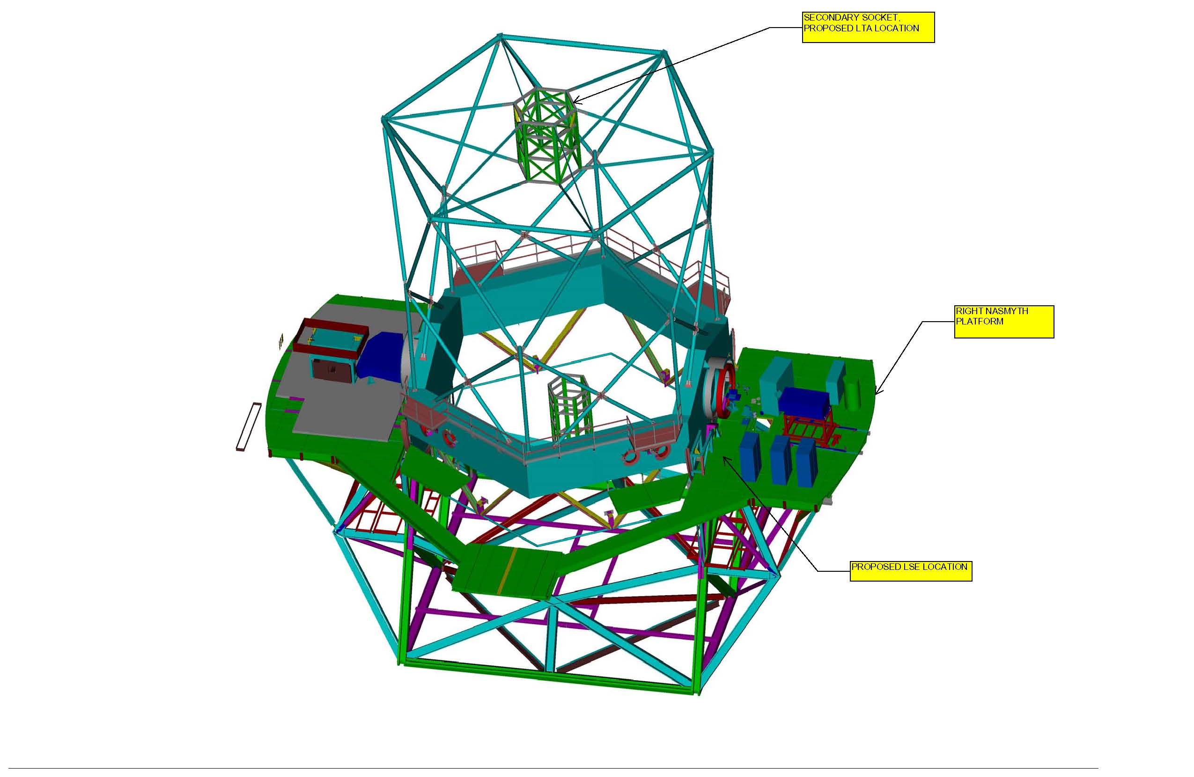
Figure 1 LTA Location

Definitions and conventions
Mirrors are conventionally numbered the same way as in an astronomical telescope i.e., the Launch Telescope primary mirror (M1) is concave, the secondary mirror (M2) convex, and the tertiary mirror (M3) is a flat relay (see also Figure 1).
The co-ordinates system is shown in Figure 2 LTA References in Secondary Module.. The z-axis coincides with the nominal optical axis of the telescope tube. The x-axis is parallel to the nominal elevation axis. The y-axis is perpendicular to the x- and z-axes according to the right-hand rule and points downwards when the z-axis is horizontal. This correlates to the entrance window pointing upward when the telescope is at horizon. Figure 3 LTA Location in Secondary Module. shows the relative position of the LTA in the secondary module.
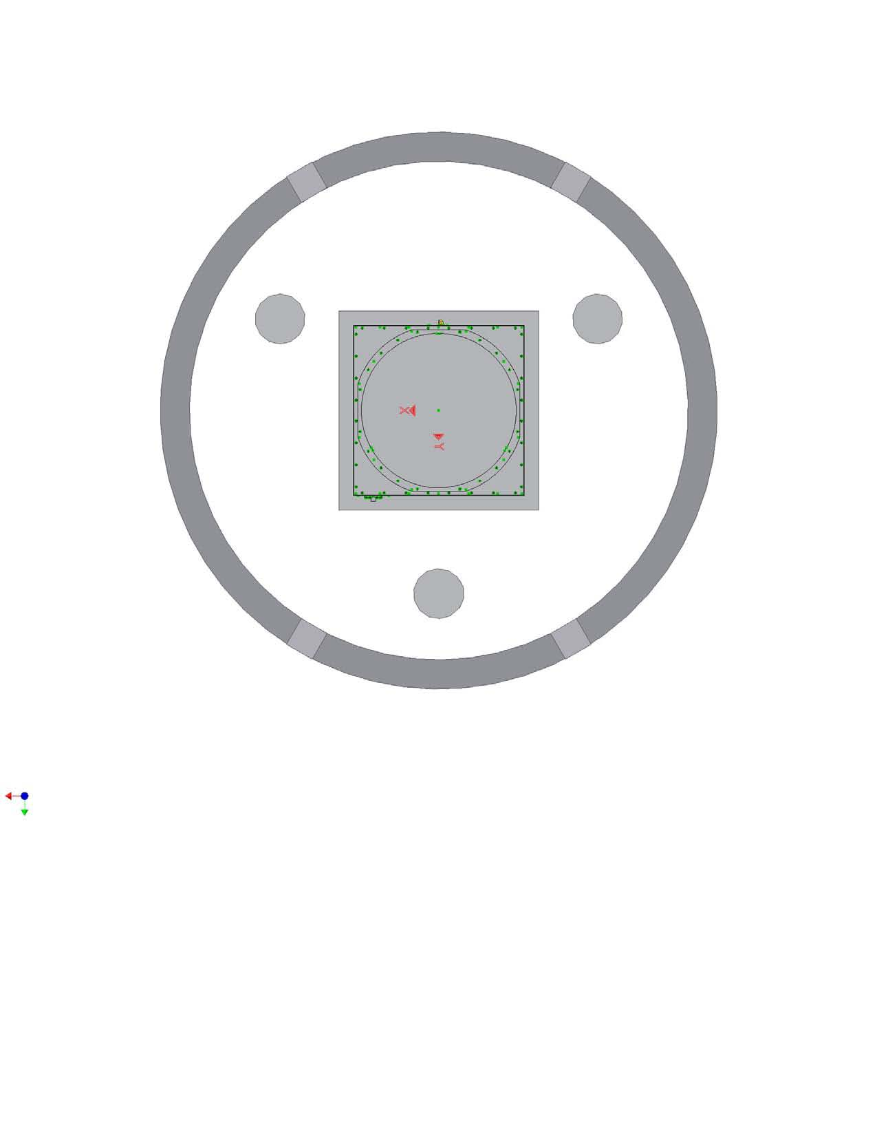
Figure 2 LTA References in Secondary Module.
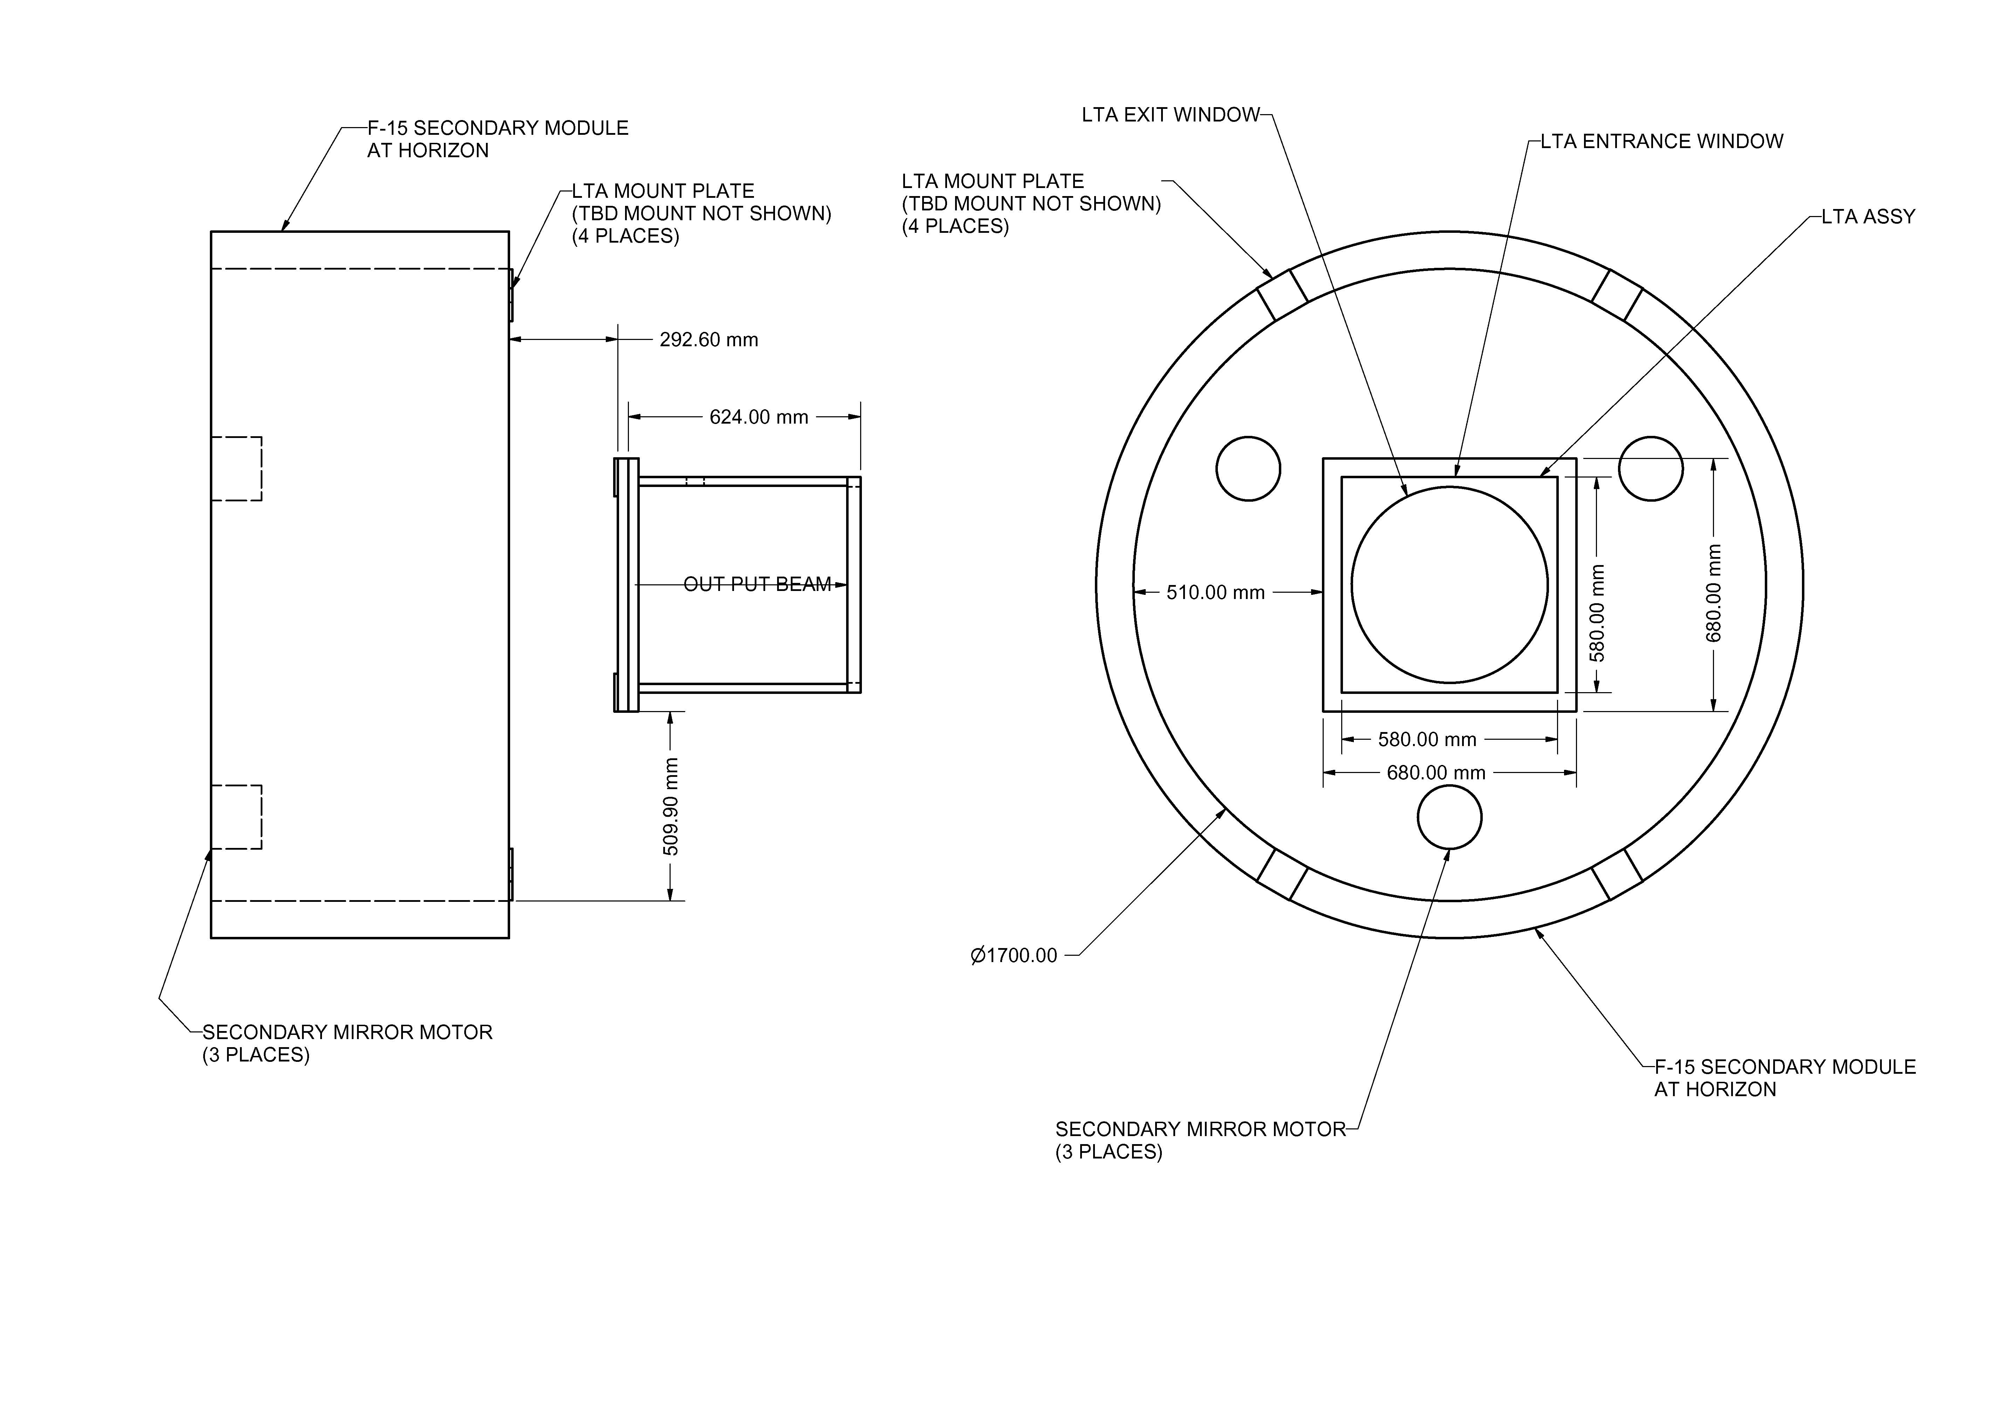
Figure 3 LTA Location in Secondary Module.

deliverables

Major component list
(REQ-LTA- ). A simplified hardware tree of the deliverables is shown in Figure 4. Launch telescope hardware tree

Figure 4. Launch telescope hardware tree

Keck furnished property list to GA
Quarterwave Plate CVI Model QWPO-589-20-4 to be used as LTA entrance window.

REQUIREMENTS

Performance characteristics

Modes of operation
Functional modes are described in Sections 7.1.1.1 to 7.1.1.2 here below.

Operational (REQ-LTA- )
• Telescope elevation angle: 20° to 90.5°
• Environmental conditions: see section 7.5.2
• Percentage of lifetime 25%

Stand-by (REQ-LTA- ).

The stand-by mode typically corresponds to the Launch Telescope mounted onto the telescope, not in use.
• Telescope elevation angle: -5° to 90.5°
• Environmental conditions: see section 7.5.2
• Percentage of lifetime 74%

Storage & transport modes (REQ-LTA- ).
These modes correspond to transport from manufacturer premises to the Observatory site and to on-site storage. The launch telescope is assumed to be packed in its transport box. Percentage of lifetime is assumed to be 1%.

Input Laser characteristics
The Contractor may assume that the following characteristics for the input laser beam:
REQ-LTA-
- Input laser power up to 50W CW
- Input laser wavelength 589.15 nm
- Beam waist diameter on M1 360 mm
- The laser input beam is assumed to be free of aberrations
- The 1/e² intensity point is at 0.72 relative pupil radius, i.e. at 180mm radius.

Optical characteristics
- REQ-LTA-. Useful diameters shall guarantee an image field of view of 2 arcminutes diameter, unvignetted on axis.
- REQ-LTA-..The telescope shall be operational over an extended FoV up to 3 arminutes. The wavefront error and vignetting for the extended FoV shall not exceed values as defined in section 7.1.4 and 7.1.5
- REQ-LTA- . The entrance pupil shall be on the secondary mirror.
- REQ-LTA- . The exit pupil diameter shall be equal to or larger than 500 mm.
- REQ-LTA- . The central obscuration of the output beam shall be less than 45 mm.
- REQ-LTA- . Spiders holding the secondary and/or tertiary mirror shall have a cross-section (thickness) of not more than 1/125th of the diameter of the beam(s) they obscure.
- REQ-LTA- . No obscuration other than central and spider obscuration’s is permitted on axis.
- REQ-LTA- . The angular magnification shall be 1/12.5 ± 0.2
- REQ-LTA- . The shape of the exit surface of the LTA window has not been defined yet. It has to be either a flat or a wedge by 1.5 arcminutes within an error margin of ±20 arcseconds.
- REQ-LTA- . The exit surface of the window shall be perpendicular within 15 arc seconds to the LT optical axis.
- REQ-LTA- . The LTA exit window shall have a wedge of either 1.5 or 3 arc minutes ± 20 arc seconds, with the thinnest edge of the prism oriented towards the positive x-axis ± 5 degrees (see figure 3.1.1.2-1 for the orientation of the x-axis).
- REQ-LTA- . The overall flexure, including effects from the exit window and the mounted diagnostics, with respect to the nominal optical axis of the LTA defined under 7.1.4.6 shall not exceed ±5 arc seconds within the operational range, defined under 7.1.1. To support the analysis by the contractor, CARA will provide a detailed description on the overall mass and mass distribution of the diagnostics.

Optical quality and alignment accuracy
- The optical quality requirements apply under operational mode.
- The optical quality specification applies to the entire field of view of 2 arc minutes.
- REQ-LTA- . The optical quality specification takes into account the fact that the output beam has a Gaussian profile. Quality is expressed in terms of output RMS wavefront error (single pass), for different diameters of centered output beam. The optical quality defined in the following table shall apply for a FoV of 2 arc minutes.
Beam diameter Maximum allowable wavefront RMS variation
360 mm 50 nm
420 mm 55 nm
Full aperture 60 nm
Table 3. Optical quality specification

This optical quality specification does not include tilt and focus.
- REQ-LTA- . The static wavefront focus error shall not be more than ±2.5 μm P-V. In addition, temperature-induced defocus shall be less than or equal to 0.75 μm P-V at 589 nm.
- REQ-LTA- . The effect of decentering coma shall not exceed 40 nm wavefront RMS, taking into account the combined effect of initial alignment accuracy and of environmental loads.
- REQ-LTA- . Output beam tilt shall not exceed ±10 arc seconds with respect to the nominal axis of the primary mirror, taking into account the combined effect of initial alignment accuracy and of environmental loads. Compensation of this static error may be done via the input beam alignment on M3 during assembly.
- REQ-LTA- . The optical quality for the extended FoV of 3 arcminutes shall not exceed the maximum allowable wave front error -specified in table 3- by more than 15%.

Coatings and throughput
- REQ-LTA- . The total throughput at Sodium Laser wavelength (see Section 7.1.2) shall be larger than or equal to 95% (p and s polarization states, full pupil) over the full FoV of 2 arcminutes.
- REQ-LTA- . The loss of total throughput at Sodium wavelength caused by vignetting within the extended FoV of 3 arc minutes shall not exceed more than 20% with respect to the specification defined in 7.1.51.
The above-specified throughput does not take into account the effect of obscuration.
- REQ-LTA- . The above throughput is specified under the assumption that the telescope mirrors are made of conventional glass or glass-ceramic materials. A solution providing >90% throughput and relying on siliconized Silicon Carbide for the primary and secondary mirrors may be proposed, as an option. Other composite materials may also be proposed.
Such option may be considered by CARA insofar as it would yield attractive cost savings and/or allow other key requirements to be exceeded, such as:
- optical quality (see Section 7.1.4),
- beam tilt (see Section 7.1.4),
- focus and decentering coma (see Section 7.1.4), alignment free system
- overall mass (see Section 7.2.3),
- interfaces stiffness (see Section 7.2.2),
- Eigen frequency of the M1-M2-M3 subassembly (see Section 7.2.4)
- system durability (see Section 7.3),
- ease of maintenance (see Section 7.4),
- performance degradation under environmental loads.
- REQ-LTA- . The choice of reflective coatings (mirrors) and anti-reflective coatings (window) are the responsibility of the Contractor.
- REQ-LTA- . Coating durability shall comply with MIL-C-675C.
- REQ-LTA- . If coatings lifetime under the dry N₂ atmosphere, pressure and temperature ranges identified in Section 7.5.2, cannot be guaranteed to be equal to or larger than 15 years, removal of the coatings shall be possible without repolishing.
- REQ-LTA- . The LTA window shall have AR coatings centered at 589nm, with R<0.2% on the input laser beam side, and 1.2% on the output side (window exit surface). To minimize condensation on the exit surface, the coating shall be transmissive at 589nm but have low emissivity in the infrared. The contractor has the option of providing a different strategy of preventing condensation on the exit window. It will have to be cleared with CARA prior to fabrication. The shape of the window exit surface has to be defined yet. Its retro-reflected beam has to be suitable for an interferometric diagnostic of the LTA. For this reason, the window exit surface reflectivity at 532nm and 633 nm shall be >5%, the higher the better. By using a R=1.2% monolayer coating on the exit window, surface re-coating shall be possible without need for optical repolishing. All coatings shall not suffer loss in durability or in lifetime when exposed to the dry nitrogen environment.
- REQ-LTA- . The thickness of the exit window shall guarantee a limited dynamic flexure as specified in 7.1.3.11
- REQ-LTA- . The Contractor shall provide witnessed samples coated together with the delivered components mounted in the instrument to CARA.

Alignment Tool

REQ-LTA- . To assist alignment of the LTA with respect to the input beam transfer optics, CARA shall supply an optical assembly (mirror) to the Contractor. The Contractor shall provide the mechanism to install the assembly in front of the entrance window to within ±10 arc seconds perpendicular to the optical axis on the entrance window. The assembly shall be centered within 0.1mm±0.025mm of the optical axis of the retro-reflected beam from the exit window surface. The alignment shall be repeatable even if assembly is removed and reinstalled. ➔ Check with Roger

Physical characteristics

Allowable design volume
REQ-LTA- . The LTA shall be sized so it can fit within the secondary module of the K1 telescope. See Table 4. Envelope for LTA.for reference.

Parameter | Min. | Typ. | Max. | Units | Notes
X, Y directions | - | - | 610 | mm | 1
X, Y directions, base plate | - | - | 680 | mm | 1
Z direction | - | - | 635 | mm
Table 4. Envelope for LTA.
Note 1. Exception is mounting base plate area.

Interfaces
REQ-LTA- .
- Keck 1 M2 unit (see faces E, C and section A-A).
- 24 threaded hole M6, with 6 mm minimum thread depth.
- 8 threaded holes M4, with 4 mm minimum thread depth, for the auxiliary support fixations.
- Collimator and Diagnostic (see face C and D). The interface are 2 rectangular surfaces with the following characteristics:
- Face C
- Width 580 mm
- Height 610 mm
- 25 threaded blind holes M 6, with 6 mm minimum thread depth, to attach the aluminium diagnostic breadboard, the latter having a mass of 30 kg at 300 mm from the M2 interface flange, at 60 mm from face C and centred symmetrically on the M1-M2 optical axis.
- 24 threaded holes M 5, with 5 mm minimum thread depth, to attach the external cover
- Entrance window to be embedded on face C, with the following characteristics:
- Vendor: CVI Laser Corp.
- Part no.: QWPO-589-20-4
- Diameter: 50,80 mm +0,00 mm, -0,25 mm
- Thickness: 1,75 mm +/-0,25 mm
- Position tolerances:
- X and Z axes ± 0.1 mm
- Rot X and Rot Z ± 5' TBC
- Rot Y ± 1° TBC
The entrance window shall be accessible for alignment and maintenance from face C. It shall be mounted with a Rot X tilt offset angle of 1 degree with respect to the axial input beam optical axis.
- Face D
- Width 580 mm
- Height 610 mm
- 6 threaded holes M 6, with 6 mm minimum thread depth for penetrator fasteners.
- 5 through (from face D to the optical Path) holes diameter 12 mm H7.
- 10 threaded holes M 3, with 3 mm minimum thread depth.
- 2 threaded through (from face D to the optical Path) holes Gj ¼. These threaded holes shall hold the connectors for inlet and outlet air and dry nitrogen. They shall be located as closed as possible to the Keck 1 M2 unit interface (face E).
- Handling (see face A and F)
- Width 580 mm
- Height 610 mm
- 8 threaded holes M 6, with 6 mm minimum thread depth. The handling device shall be attached to these 8x2 threaded holes.
- Aperture shutter (see faces A, B,E and F)
- Face A and F
- Width 580 mm
- Height 577 mm
- 8 threaded holes M 5, with 5 mm minimum thread depth.
- 12 threaded holes M3, with 3 mm minimum thread depth.
- Face B
- Width 580 mm
- Depth 580 mm
- 14 threaded holes M 3, with 3 mm minimum thread depth.
- Face E (TBD) based on changes to the CARA design.
- Width 680 mm
- Depth 680 mm
- 14 threaded holes M 3, with 3 mm minimum thread depth. The threaded holes numbered with 1, 2, 3 and 4 serve also for the auxiliary support fixations.

Mass and Centre of Gravity
- REQ-LTA- . The maximum allowed mass of the Launch Telescope Assembly to be delivered is 116 kg.
- REQ-LTA- . The centre of gravity shall be located at 310mm + 10 mm maximum distance from the Keck 1 M2 unit interface flange and on the M1-M2 optical axis ± 10 mm.

Dynamic performance
REQ-LTA- . The whole LTA including the mass of the diagnostics (30kg), attached to the face C and specified in Section 7.2.2 shall have the following dynamic performance:
80 Hz first eigenfrequency, when the X, Y and Z translation degree of freedom are constrained only on the24 Threaded holes M6 described in section 7.2.2 Face E.
- 24 threaded holes M6, minimum thread depth 6 mm.

120 Hz first eigenfrequency, when additional 4 auxiliary supports are generated, by constraining the Z translation degree of freedom of the 12 threaded holes described in Face E, and in sections 7.2.2:
- 8 threaded holes M4
- 4 threaded hole M3 numbered 1, 2, 3 and 4

Dry N₂ tightness
REQ-LTA- . The optical path will be under controlled atmosphere using dry nitrogen at pressure and temperature specified in Section 7.5.2. The LTA shall be gas tight from the entrance window (diameter 40 mm see face C of Ref #3) to the exit window (see section A-A of Ref #3)

Quasi-static analysis
REQ-LTA- . A quasi-static analysis shall be performed on the whole LTA including the mass of the diagnostics (The contractor may assume a total mass of the total diagnostics up to 30kg), attached to the face C of Ref #3 and specified in Section 7.2.2, using 5 g acceleration, applied simultaneously on the X, Y and Z axes. The generated stresses shall complied with the mechanical safety specified in section 8.4.1.

Reliability
REQ-LTA- . The Launch Telescope shall be designed for a minimum lifetime of 10 years in operational and standby modes specified under Sections 7.1.1 and 7.1.2 and under the operational conditions of Section 7.5.2.

Maintainability
The maintenance activities for Launch Telescope shall follow the general approach to CARA maintenance described in Section 10.0.

Maintenance frequency
- REQ-LTA- . All components must be designed to be maintenance free for a period of at least three years, except for cleaning of the exit surface of the exit window.
- REQ-LTA- . Maintenance operations shall preferably not require the Launch Telescope to be dismounted from atop the Keck 1 M2 unit (the protective cover, however, can be assumed to be removed upon preventive maintenance).
- REQ-LTA- . Not more than 2 CARA technicians and 8 working hours shall be required to perform routine maintenance of the Launch Telescope per month.

Preventive maintenance
- REQ-LTA- . Preventive maintenance consists of tasks such as visual inspections and cleaning of the exit surface of the exit window.
- REQ-LTA- . Preventive maintenance shall be carried out at time intervals no shorter than 6 months, given the sealed, dust-free environment of the Launch Telescope opto-mechanical assemblies.

On-site repair
REQ-LTA- . All normal repair activities shall be accomplished by a maximum of two trained technicians with a minimum of special equipment or tools in a maximum time of 4 hours, excluding the time required to dismount the launch telescope.

Environmental conditions

Transportation conditions
REQ-LTA- . When packaged as required in Section 11.3, all components of LTA shall continue to meet all of the performance requirements defined in Section 7 without repair after a single shipment to the delivery location by any combination of air or surface transportation. For information, the expected conditions to be encountered during shipping are given in Table 5.

Parameter | Min. | Typ. | Max. | Units | Notes
Altitude | 0 | - | 4,572 | m | 1
Temperature | -33 | - | 71 | ºC | 2, 3
Temperature shock | -54 | - | 70 | ºC | 4
Humidity | 0 | - | 100 | % | 5
Gravity orientation | - | - | - | NA | 6
Wind | - | - | 67 | m/s | 7
Vibration | - | - | 0.015 | g²/Hz | 8, 9
Shock | - | - | 15 | g | 10
Acceleration
Due to transport | - | - | 4 | g | 11
Due to seismic activity | - | - | 2 | g | 12

Table 5: Transportation and Shipping Environment
Notes:

    - See MIL-STD-810F Method 500 §2.3.1. Ref #4.
    - Maximum is for induced conditions, see MIL-STD-810F Method 501 Table 501.4-I. Ref #4.
    - Minimum is for induced conditions, see MIL-STD-810F Method 502 Table 502.4-II. Ref #4.
    - See MIL-STD-810F Method 503. Ref #4.
    - Relative, condensing.
    - Packaged equipment may be subjected to all possible gravity orientations during transportation and shipping.
    - Based on possible cargo helicopter air lift of a transport container.
    - 10-40 Hz, -6dB/oct. drop-off to 500 Hz, all axes.
    - See MIL-STD-810F Method 514. Ref #4.
    - 0.015 second half-sine, all axes.
    - All axes.
    - 0.5 Hz to 100Hz, all axes.

Operational & Maintenance conditions.
The Launch Telescope shall meet all performance requirements under the following conditions, which refer to maintenance and operation modes:
Maintenance conditions: REQ-LTA- .
- Air pressure: 535 mb ± 50mb or 4300m. elevation equivalent.
- Air density: 0.80 kg/m3 typical average or 4300m. elevation equivalent.
- Temperature: Full range –10 to +30 C with temp. gradient of ±0.4 C/h
Performance degradation will be acceptable >0C and >15 C.
- Rel. Humidity: 5 % to 20 %, except exit surface of exit window, for
which a range of 5% to 90%, non-condensing, shall apply.
Operation conditions inside LTA: REQ-LTA- .
- Gas type: Dry N2
- Pressure: 535 mb ± 50mb or 4300 m. elevation equivalent.
- Temperature: Full range –10 to +30 °C with temp. gradient of ±0.4 °C/h
Performance degradation will be acceptable outside -5 to +5 °C.

Transportability
See Section 11.3 Transport Container and Section 11.4 Handling Tool.

Design and construction

Materials, parts and processes
REQ-LTA- . All equipment, materials and components selected for the Launch Telescope Assembly shall be suitable for continuous operation over a useful lifetime of 10 years and with maintenance operations intervals specified in Section 7.4 and under the operational environmental conditions referenced in Section 7.5.
In particular, the selection of materials and equipment shall take into consideration the requirements for operation in dry conditions, at an altitude of 4300 m above sea level.
Wire thread inserts (HeliCoils) shall be used for the Threaded holes specified in section 7.2.2.

LTA interior surface
REQ-LTA- . The interior surface of the LTA shall be anodized to minimize scattering.

LTA exterior surface
REQ-LTA- . The exterior surface of the LTA shall be high reflective by using a low emissivity paint or similar substrate.

Surface treatment on mechanics
REQ-LTA- . The surfaces of the LTA shall be protected according to the following requirements:
• All parts shall be corrosion-protected according to DIN 55928-TO5
• All painted parts shall be suitable for protection of the structure for 10 years
• No surface treatment is required for the inner surfaces of complete sealed hollow parts.
• Machined interface surfaces, such as bolted joints and flanges, shall be protected according to DIN 55928-T05, chapter 3.1.
• All surfaces surrounding the optical path shall have a mat black surface treatment suitable for the type of material concerned.
• The colour of the outer surfaces will be defined by Keck at a later date. They shall be painted.

Optics re-coating compatibility
REQ-LTA- . Permanent (i.e. not dismountable) fixations of opto-mechanical units (primary, secondary, tertiary mirror and window units), whose coating lifetime cannot be guaranteed to be equal to or larger than 25 years, shall be vacuum-compatible (compatible materials, outgasing holes where necessary) in order to undergo re-coatings of the optics. Such fixations shall also be compatible with cleaning and coating stripping procedures to be provided by the Contractor.

Measurement units
REQ-LTA- .
The following units shall be used in the documents exchanged between Keck and the Contractor:
- Linear dimension: millimeter; mm
- Angular dimension: degree/minute/second; °/'/"
- Cross-section: square millimeters; mm²
- Mass: kilogram; kg
- Force: Newton; N
- Torque: Newton-meter; N-m
- Stress: Newton/square millimeter; N/mm²
- Temperature: degrees Celsius; °C
- Wavefront data nm wavefront

Name plates and product marking
REQ-LTA- . The Launch Telescope Assembly and Auxiliary Equipment shall be labelled or engraved with nameplates visible after installation of said Assembly or Equipment. The labels shall contain the following information:
- Assembly/component name and sequential number wherever applicable
- Manufacturing month and year
- Name of manufacturer
- Keck logo
- Labels to guide disassembly or handling, if deemed necessary

Workmanship
- REQ-LTA- . The methods and procedures used by the Contractor shall reflect the state of the art in the fields of opto-mechanics design, development, manufacturing, alignment and testing.

Safety
REQ-LTA- . The LTA shall comply in all respects with the applicable requirements of the Occupational Safety and Health Administration (OSHA) as established by CFR 29 Part 1910 “Occupational Safety And Health Standards”, particularly subpart O, section 1910.212 and subpart S sections 1910.302 through 1910.304. Ref #5.

Mechanical Safety
REQ-LTA- . A minimum safety margin of 1.5 with respect to sigma 0.2% has to be used in the design of all mechanical components which, in case of failure, would lead to an unacceptable or undesirable hazard risk.
Transportation, lifting, hoisting, handling devices, and similar, shall be approved by an officially recognised agency (e.g. TÜV or similar agency).

Documentation
In addition to the required test reports, the following documentation requirements are to be delivered by the Contractor.

Language
REQ-LTA- . The language to be used in all documentation shall be English.

Overview of System
REQ-LTA- . Contractor shall provide a system overview of the unit as well as optical prescriptions for the overall system and individual optical components.

Alignment Manual
REQ-LTA- . The Contractor shall provide an alignment manual on any possible alignments that are necessary for unit operation.

Maintenance Manual
REQ-LTA- . The Contractor shall provide a maintenance manual with recommended maintenance and their intervals.

Mechanical Drawings
REQ-LTA- . All mechanical and optical drawings required are specified in and shall meet the standards in Appendix A.

Delivered Documentation
REQ-LTA- . The Contractor shall provide two sets of documentation as hard copy and 2 sets of documentation on CD-ROM.

Spares
REQ-LTA- . The Contractor shall provide a list of recommended spares and their associated sources and cost.

Maintenance

General CARA maintenance approach
The LTA shall by design minimize the effort required to perform regular maintenance tasks including but not limited to, cleaning of optics or replacement of limited lifetime or consumable components. A trained opto-mechanical technician of average skill and 3 years experience dealing with opto-mechanical systems, using commonly available tools and any specialized tools provided by the contractor, shall be able to perform the required maintenance.

Recommendation by contractor
REQ-LTA- . The Contractor shall provide recommendations for the tools and equipment needed to perform regular maintenance and service on the LTA system.
REQ-LTA- . The Contractor shall provide recommendations with respect to the environmental conditions required to service the LTA system.
REQ-LTA- . The Contractor shall provide recommendations with respect to the supplies required to perform regular maintenance and service on the LTA system

Repair on condition
REQ-LTA- . If major repair to the Launch Telescope Assembly is necessary, it will be dismounted from the Keck 1 M2 unit and repaired at the supplier premises or on location. Details to be agreed upon by both parties.

Personnel and training
REQ-LTA- . During the assembly and tests of the Launch Telescope Assembly at the Contractor's premises, Keck technicians may be present in order to follow and learn the assembly procedures to be provided by the Contractor.

Major components characteristics

Optical components
In the following, the term “optical components” refers to the exit window and to the primary, secondary and tertiary mirrors.

Micro-roughness of optical surfaces ( REQ-LTA- ).
- The micro-roughness of the optical surfaces is specified in Table 6: Micro-roughness of optical surfaces.
- All optical surfaces except M2 and M3 shall have a micro-roughness equal to or less than 4 nm. M2 and M3 shall have a micro-roughness equal to or less than 2nm.
- The above specification applies after coating.
- The above micro-roughness is specified under the assumption that the telescope mirrors are made of conventional glass or glass-ceramic materials. A solution providing higher micro-roughness for the primary and/or secondary mirrors and relying on other materials such as siliconized Silicon Carbide or composites, for these mirrors may be proposed, as an option (see also Sections 7.1.5, § 2).

 | Micro-roughness (nm)
Primary Mirror M1 | 4/6
Secondary Mirror M2 | 2
Tertiary mirror M3 | 2
Entrance window EnW | 2
Exit window ExW | 2
Table 6: Micro-roughness of optical surfaces.

Cleanliness of optical surfaces (scratches, pits and sleeks)
- REQ-LTA- . All optical surfaces shall be pitch polished.
- REQ-LTA- . Surface finish of all optical surfaces shall be Scratch/Dig as listed in Table 7: Scratch/Dig of optical surfaces.

 | Scratch /Dig
Primary Mirror M1 | 40-20
Secondary Mirror M2 | 20-10
Tertiary mirror M3 | 20-10
Entrance window EnW | 20-10
Exit window ExW | 40-20
Table 7: Scratch/Dig of optical surfaces

Alignment mechanisms
A solid Launch Telescope in Silicon Carbide or other composite materials, without the need to adjust the pre-aligned optical components machined to the required precision, would be an asset. In case alignment mechanisms are necessary,
- REQ-LTA- . Alignment mechanisms shall be provided for the secondary and tertiary mirrors.
- REQ-LTA- . These alignment mechanisms shall have the degrees of freedom, range, accuracy and reliability necessary for the mounted Launch Telescope Assembly to comply with the requirements of this specification.
- REQ-LTA- . These alignment mechanisms shall not vignette the laser beam.
- REQ-LTA- . The Contractor may propose a design whereby alignment would be performed in laboratory environment. The Launch Telescope would be subsequently packed and carefully transported in its Transport Container, on an unpaved road over a distance of 75 km, unpacked from its Transport Container, handled by crane and eventually mounted onto the Keck 1 M2 unit. In this case, alignment must remain within specifications, taking into account lab alignment accuracy and subsequent packing, smooth transport and integration loads.

Transport Container (REQ-LTA- ).
- The contractor shall be responsible for the design and construction of the Launch Telescope Transport Container.
- There shall preferably be a single Transport Container accommodating the assembled Launch Telescope, together with its associated maintenance, handling and integration tools, if any.
- The Transport Container shall be reusable.
- The Transport Container shall be designed for airfreight and road transport (including unpaved dirt road) from the Contractor premises to the Keck Observatory site on Mauna Kea, Hawaii.

Handling tool (REQ-LTA- ).
The Contractor shall provide a handling tool for the crane handling and the mount/dismount on the Keck 1 M2 Unit (horizontal position), of the Launch Telescope Assembly.
The handling tool shall rotate the LTA from horizontal to vertical position and back. The centre of rotation of the Handling tool shall be aligned with the centre of gravity of the LTA ± 20 mm.
The handling tool shall lock the rotation of the LTA in vertical and horizontal positions.
The allowable design volume of the handling tool is specified TBD.

Specific test / end item inspection requirements

Optical characteristics

Optical prescription
The optical prescription shall be verified by
- Measuring each optical surface’s useful dimensions, radius of curvature (spherometry for primary and secondary mirrors, testing against a flat reference for the window and the flat mirror).
- Calculating conicity errors of the conic surfaces (as deduced from the spherical aberration term in the individual mirror’s wavefront maps obtained by interferometry), if any.
- Measuring the mirrors separation (e.g. primary to secondary, secondary to tertiary or primary to tertiary)
- Build a computer model by entering the above data in an optical design code (e.g. internationally recognised code such as CODE V or Zemax) and listing the system properties.

Optical quality
  - The Contractor shall provide to CARA copy of the Acceptance Protocol of the window blank, as supplied to it by his subcontractor.
  - Optical quality of each optical surface will be measured by interferometry in visible light, full aperture, according to the requirements of Table 8. Optical test requirements, individual surfaces.
Surface | Sampling | Absolute accuracy  (nm wavefront RMS) | Test condition
Window, front | 100 | ≤ 8 | Against flat reference
Window, back | 100 | ≤ 8 | Against flat reference
Primary mirror | 200 | ≤ 10 | Against flat reference or through nulling system
Secondary mirror | 100 | ≤ 10 | Test set-up to be selected by the Contractor
Tertiary mirror | 100 | ≤ 8 | Test set-up to be selected by the Contractor
Table 8. Optical test requirements, individual surfaces.

  - Optical quality of the mounted Launch Telescope Assembly shall be verified by a full aperture interferometric test in visible light, on-axis and 1 arc minute off-axis. The interferometric test set-up shall comply with the following requirements:
    - Minimum number of points across full aperture: 200
    - Absolute accuracy 10 nm wavefront RMS or better
    - Test set-up To be selected by the Contractor

Throughput
The total throughput shall be deduced from individually measured reflectivity of the mirrors and transmission of the window, at the specified laser wavelength.

Alignment mechanisms
- The vendor has to provide a detailed procedure for the initial alignment oft the LTA. Such alignment proceudre has to be verified and accepted by authorized CARA personal.
- The alignment mechanisms for the mirrors of the Launch Telescope Assembly, if any, shall be used for fine alignment prior to the interferometric test specified under Section 12.1.2, § 3.
- A second (on-axis) interferometric test shall be performed under the same conditions as those specified in Section 12.1.2, § 3, after cooling the Launch Telescope Assembly to –0ºC and warming it up again to ambient laboratory temperature. The variation of the on-axis third order coma term between the first and second interferometric tests will be used to verify that the alignment stability is within the range predicted by the Contractor on the basis of his design.
- If alignment is not possible with the Launch Telescope integrated on top of the Keck 1 M2 unit, this second interferometric test shall be performed after an additional blank packing/unpacking and crane handling of the Launch Telescope Assembly.

Gravity testing

Testing shall be done for the full travel of the elevation access as specified in Section 7.1.1. Testing will include the optical axis of the entrance window to be in both the + and – y direction of the Keck 1 M2 unit.

Preparation for storage/transport
The Launch Telescope (incl. major components) shall be packed with its accompanying documentation, including as-built documents and handling procedures. (REQ-LTA- ).

Cleaning
The Launch Telescope, including auxiliary equipment, shall be cleaned before packing (for storage or transport, as appropriate) into their transport container. Emphasis is put on:
1 grease and lubricants
- corrosive, abrasive and polishing dust or powders.
- dust on the optical surfaces

Enhanced environmental protection
It shall be taken into account that the Launch Telescope will have to be transported by dirt road in a desert environment. Sealed, watertight, bump absorption packing is mandatory.

Protective covers
Protective covers of the LTA exit window surface and of the holes of the mechanical assembly, which give access to the optical surfaces, shall be provided by the contractor and used during transport.

Compliance Matrix
The following methods of verification shall be applied to demonstrate that requirements of the LTA are met prior to delivery. Highlighted items are those CARA feels are significantly different from those if Ref #1. The contractor is responsible for meeting all requirements regardless of whether they are highlighted or not.
I. Verification by design check
The requirement shall be demonstrated by a proper design. The vendor has to provide a detailed documentation and the results of the performed design check to CARA wherever indicated in the compliance matrix before manufacturing the LTA. The manufacturing process may only be initiated after acceptance of these documents be authorized CARA staff.
II. Verification by analysis
The requirement shall be demonstrated by appropriate analysis (calculations, finite element analysis, thermal modeling, etc.). The vendor has to provide a detailed documentation on the performed analyis including considered error margins wherever indicated in the compliance matrix. Manufacturing the LTA may only be initiated after the documents have been reviewed and approved by authorized CARA personal.
III. Design verification by test
Compliance shall be done via item/assembly/subassembly testing. As long as not defined in this document, the vendor has to provide a description of the performed test wherever it is stated in the compliance matrix. Manufacturing of the LTA may only be initiated after documents have been reviewed and approved by authorized CARA personal.
IV. Inspection
The compliance of the hardware with the design documentation shall be demonstrated by in-manufacturing and end item inspections.

Table 9. Compliance Matrix shows the method(s) to be applied for the verification of each requirement for the LTA.
 |  | Verification Method
Requirement | Description | Design | Analysis | Test/Inspection
REQ-LTA-01 | Deliverables |  |  | X
REQ-LTA-02 | Operational Mode | X |  | 12.3
REQ-LTA-03 | Standby Mode | X |  | 12.3
REQ-LTA-04 | Storage Mode | X
REQ-LTA-05 | Optical Prescription | X |  | 12.1.1
REQ-LTA-06 | Useful diameters | X |  | 12.1.1
REQ-LTA-07 | Extended FoV | X |  | X
REQ-LTA-08 | Entrance pupil on secondary mirror | X
REQ-LTA-09 | Exit pupil diameter | X |  | X
REQ-LTA-10 | Central obscuration | X |  | X5
REQ-LTA-11 | Spider obscuration | X |  | X5
REQ-LTA-12 | Other obscuration | X |  | X
REQ-LTA-13 | Angular magnification | X
REQ-LTA-14 | Exit window shape flatness | X |  | X
REQ-LTA-15 | Exit window alignment | X |  | X
REQ-LTA-16 | Exit window wedge | X |  | X
REQ-LTA-17 | Optical axis dynamical flexure | X | X | X, 12.1.2
REQ-LTA-18 | Optical quality in operational mode and RMS variation |  | X | 12.1.2
REQ-LTA-19 | Static/temperature-induced wave front focus error | X |  | 12.1.2
REQ-LTA-20 | Decentering coma |  |  | 12.1.2
REQ-LTA-21 | Output beam tilt |  | X | X
REQ-LTA-22 | Optical quality of extended FoV | X |  | 12.1.2
REQ-LTA-23 | Total throughput |  |  | 12.1.3
REQ-LTA-24 | Vignetting (throughput) at extended FoV | X |  | 12.1.2
REQ-LTA-25 | Optional mirror material |  | X
REQ-LTA-26 | Reflective coatings | X
REQ-LTA-27 | Coating durability | X
REQ-LTA-28 | Coating Lifetime | X
REQ-LTA-29 | Coating characteristics | X |  | X
REQ-LTA-30 | Exit window thickness | X |  | X
REQ-LTA-31 | Witness samples |  |  | X
REQ-LTA-32 | Alignment Tool | X |  | X
REQ-LTA-33 | Allowable volume | X |  | X
REQ-LTA-34 | Interfaces | X |  | X
REQ-LTA-35 | Maximum Mass | X |  | X
REQ-LTA-36 | Center of Gravity | X |  | X
REQ-LTA-37 | Dynamic Performance |  | X | X if verification by analysis fails or not satisfactory
REQ-LTA-38 | Dry N2 Tightness | X |  | X
REQ-LTA-39 | Quasi-Static Analysis |  | X
REQ-LTA-40 | Reliability |  | X
REQ-LTA-41 | Maintenance free period | X
REQ-LTA-42 | Maintenance on M2 | X
REQ-LTA-43 | Manpower and Time requirement | X
REQ-LTA-44 | Preventative maintenance | X
REQ-LTA-45 | Preventative maintenance intervals | X
REQ-LTA-46 | On site repair | X
REQ-LTA-47 | Transport Conditions |  | X
REQ-LTA-48 | Maintenance conditions |  | X
REQ-LTA-49 | Operational conditions |  | X
REQ-LTA-50 | Equipment & material selection | X |  | X
REQ-LTA-51 | Interior Surface Treatment |  |  | X
REQ-LTA-52 | Exterior Surface Treatment |  |  | X
REQ-LTA-53 | Surface Treatment | X |  | X
REQ-LTA-54 | Recoating compatibility | X
REQ-LTA-55 | Measurement Units | X |  | X
REQ-LTA-56 | Name plates & markings |  |  | X
REQ-LTA-57 | Workmanship | X |  | X
REQ-LTA-58 | OSHA | X
REQ-LTA-59 | Safety Margin |  | X
REQ-LTA-60 | Language |  |  | X
REQ-LTA-61 | System overview documentation |  |  | X
REQ-LTA-62 | Alignment manual |  |  | X
REQ-LTA-63 | Maintenance Manual |  |  | X
REQ-LTA-64 | Mechanical Drawings |  |  | X
REQ-LTA-65 | Delivered documentation Format |  |  | X
REQ-LTA-66 | Spares documentation |  |  | X
REQ-LTA-67 | Recommended tools & equipment |  |  | X
REQ-LTA-68 | Recommended environmental conditions |  |  | X
REQ-LTA-69 | Recommended supplies |  |  | X
REQ-LTA-70 | Major Repair | X
REQ-LTA-71 | Personal Training |  |  | X
REQ-LTA-72 | Micro-roughness of optical surface |  |  | X
REQ-LTA-73 | Pitch polished surfaces | X
REQ-LTA-74 | Scratch/Dig |  |  | X
REQ-LTA-75 | Alignment mechanisms | X
REQ-LTA-76 | Degrees of freedom |  | X | 12.3.2
REQ-LTA-77 | Non vignetting of alignment tools | X |  | X
REQ-LTA-78 | Alternative alignment | X | X | 12.3.2
REQ-LTA-79 | Transport container | X | X
REQ-LTA-80 | Handling Tool | X | X | X
REQ-LTA-81 | Transport Preparation |  |  | X
Table 9. Compliance Matrix.

Appendix 1.

Standards Related Design Requirements
- Drawings for optical and mechanical components should conform to American National Standards Institute (ANSI) / American Society of Mechanical Engineers International (ASME) standard Y14.18M-1986 “Optical Parts (Engineering Drawings and Related Documentation Practices)”.
Drawings for optical components shall conform to ANSI/ASME standard Y14.18M-1986 “Optical Parts (Engineering Drawings and Related Documentation Practices)”.

- Mechanical drawings shall conform to ANSI Y14.5M-1994 (R1999) “Dimensioning and Tolerancing” and ASME standard Y14.100-2000 “Engineering Drawing Practices”.

- Each sheet shall conform to ANSI Y14.1-1995 (R2002), “Decimal Inch Drawing Sheet Size and Format”. Drawing size shall be determined on an individual basis.

- Each drawing shall have a title block with at least the following information:
- Development group
- Drawing number
- Title
- Designer
- Draftsman
- Scale
- Method for determining next higher assembly.

- All drawings shall include parts and materials lists in accordance with ANSI Y14.34-2003, “Parts Lists, Data Lists, And Index Lists: Associated Lists”. All items shall be identified with an item number or other label (with reference to the drawing number if one exists) for each part or component with all information required for procurement.

- Assembly drawings shall include all relevant views required to clearly define the assembly including isometric and exploded views.

- All detail drawings shall include all views, geometry, dimensions and feature controls required to duplicate the part in accordance with ANSI Y14.5M-1994 (R1999) “Dimensioning and Tolerancing”.

- Multi and sectional view drawings shall be developed in accordance with ANSI Y14.3M-1994 “Multi and Sectional View Drawings”.

- Fluid power system schematics shall be drawn in accordance with ASME Y32.10-1967 (R1994) “Graphic Symbols for Fluid Power Diagrams”.

- Dimensions and tolerances shall be indicated in accordance with ANSI 14.5M-1994 (R1999).

- Surface finishes shall be described in accordance with ANSI 14.5M-1994 (R1999).

Required Drawings
All drawings must be provided as specified in the formats listed above and in the native format if translated to one of the specified formats.

The following drawings should be provided:

- As-built detailed mechanical drawings for all components not commercially available. Drawings shall provide sufficient detail to fabricate the components to original design intent.

- As-built detailed drawings for all optical components not commercially available. Drawings shall provide sufficient detail to fabricate the components to original design intent.

- As-built assembly drawings for all assemblies not commercially available along with appropriate detail drawings and assembly tolerances and procedures.

By pickup truck, at reduced speed e.g. 20 km/h.
In minimum number of point across useful dimensions
Quality of reference flats shall be documented in Certificates to be provided by the Contractor
In case of aspheric window, test setup to be defined by the Contractor
Measured and noted prior to integration
Finite Element Analysis
Measured at three randomly chosen locations on each optical surface
Test method to be established by Contractor; but has to be agreed upon by CARA.
Testing of handling tool may be included in Section 10.4 “Personnel and Training”.

