AO Laser Guide Star Wavefront Sensor Subsystem Functional Requirements
The main function of laser guide star wavefront sensor (LGSWFS) is the measurement of atmosphere turbulence using several laser guide stars as reference sources. Each LGS is measured with its own wavefront sensor channel; the sensor channels and laser guide stars are in a one to one correspondence. The wavefront information measured by the multiple channels of the LGSWFS is combined with NGS wavefront sensor measurements from the low order wavefront sensor (LOWFS) and the truth wavefront sensor (TWFS) (see section 7.4) to create an estimate of the three-dimensional atmospheric turbulence above the telescope. This estimation is carried out by the NGAO real-time control (RTC) system (see section 7.7).

The current NGAO architecture assumes 6 lasers arranged in a regular pattern or constellation on the sky. Of these lasers, one is located at the center of the field of view and the other five are arranged in a regular pentagon around the central star. This pentagon can be increased or decreased in size by moving the five lasers in and out along a radius from the central LGS. The pickoff mechanism for the corresponding wavefront sensor channels will move in synchronization with these stars. Besides the six LGS constellation, three additional lasers can be directed as each natural guide star being used by the LOWFS. These three additional lasers are used in the so-called “point and shoot” mode. The three “point and shoot” lasers are used in combinations with the MOAO corrections elements inside the LOWFS channels to sharpen these natural guide stars resulting in better tracking performance and sky coverage for NGAO. These three LGS wavefront sensors will be positional anywhere in the field of view.

The range to the sodium layer will vary as the telescope elevation changes; the LGS WFS must have a focusing mechanism that can track these changes. The LGS light will pass through the telescope and the first optical relay out of focus. Both optical systems are designed to work an infinite conjugate (focused at infinity). As a result, large aberrations will be present in the LGS wavefronts. These aberrations will change as the range to the sodium layer changes. The LGS wavefront sensor design must either provide a means to calibrate the wavefront sensors for this aberration and have enough dynamic range to tolerate this large wavefront offset or the LGSWFS must have a mechanism to correct these aberrations. This correction could be done with either conventional optics or with deformable mirrors located inside each wavefront sensor channel.

As part of the NGAO system design process, a preliminary architecture selection was made during the months of July and August 2007. The result of this process was a two-staged AO system known as the “Cascaded Relay”. A sketch of the optical relay is included in Figure 1. More details of the Cascaded Relay can be found in KAON 499. The exact location for the TWFS and NGS WFS were not selected in this KAON. The LOWFS was placed in front of the d-NIRI instrument.

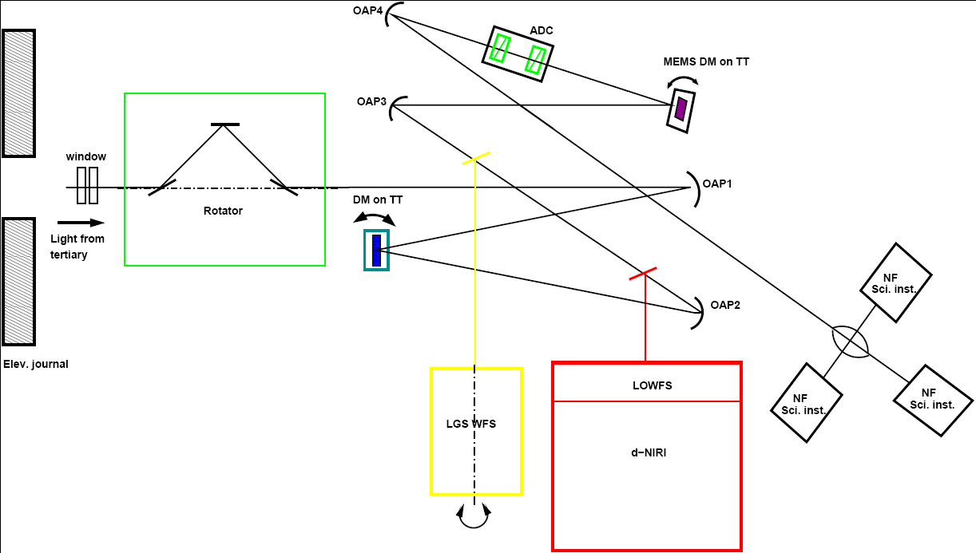

Figure 1: A schematic representation of the NGAO Cascaded Relay

Architectural Assumptions and Overall Requirements

LGS Wavefront sensor performance:
The exact performance level of the LGS wavefront sensor system is TBD.

Location:
The NGS wavefront sensor will be located at the back of the high Strehl relay (OAP4), before the narrow field science instruments.

Cooling:
The optical components of the NGS wavefront sensor are located inside the AO enclosure, which will be cooled to -20 C (see KAON 501). If needed, parts of the NGS WFS, such as electronics that do not require a direct interface to the optical path, might be located in nearby housing and kept at a warmer temperature.

LGS range related focus correction:
The LGSWFS will provide a means to focus its sensors on the sodium layer. This mechanism must compensate for slow range changes in the sodium layer distance. These changes arrive both from structural changes in the sodium density profile and zenith dependent changes as the telescope elevation changes. This mechanism will be driven by commands from the TWFS and LOWFS that have been processed by the AO RTC.

LGS range related higher order aberration mitigation:
The LGSWFS will provide a means (calibration or correction) for range dependent aberrations created by the LGS traveling through the telescope and first stage optical relay at the incorrect optical conjugate (i.e. defocused).

The following is a list of architectural assumptions for the NGS WFS:

Variable wavefront sensor configuration for current laser guide star constellation:
The wavefront sensor optical channel will be positional about the field of view. The mechanical interference between channels should be kept to a minimum.

LGS on rotator stage:
The LGS sensor will be mounted on a rotating stage in order to track the motion of the LGS spots on the sky.

Type of sensor and geometry:
The LGSWFS will be composed of nine wavefront sensors of a Shack-Hartmann configuration, utilizing square lenslets in a rectangular array.

Pupil sampling:
The pupil sampling for the LGS NGS wavefront will have one mode that has 64 subapertures across the Keck (10.949 m) pupil. Options for other pupil sampling values is a goal, exact values are TBD, but might include 48, 32, and 20 subapertures across the Keck telescope pupil.

Deployable about the field of view:
The LGSWFS will be able to make measurements on any LGS that is in the field of view passed by the second stage of the Cascaded Relay.

Elevation distance:
The LGSWFS will meet its performance goals at elevations of 30 degrees and higher. Requirement for atmospheric dispersion compensation (ADC) is TBD.

LGS uplink tip tilt compensation:
The current design calls for compensation of the atmospheric tip tilt on the LGS beams to occur on the uplink just before the LGS light leaves the launch telescope. This compensation could also occur on the down link with tip tilt mirrors inside each LGSWFS channel.

Natural guide star mode:
As a goal, the channels of the LGSWFS will be able to sense light from natural guide stars for testing purposes. There is no requirement on minimum NGS brightness. There is no requirement on measurements from multiple natural guide stars simultaneously.

Optical Requirements

Wavelength of operation:
The LGSWFS will be optimized to work with light from the sodium D2a line.

Transmission:
The transmission will be TBD %, it should be optimized for the D2a line as much as possible.

Input focal ratio:
The optical input to the LGSWFS will be from the first stage of the Cascaded Relay:

Static calibration errors:
The static wavefront calibration errors are TBD.

Pupil distortion:
The level of pupil distortion on the lenslet array is TBD.

WFS dynamic range:
The dynamic range of the wavefront sensor is TBD.

Athermalization:
The optical relay shall be able to satisfy its optical requirements at both cooled (-20 C) and ambient temperatures (0 C).

Mechanical Requirements
Packaging:
The optics, mechanisms, and electronics of the LGS WFS will be compatible with the AO enclosure and main optical relays (see section 7.2).

Mechanisms:
The LGSWFS will have mechanisms for the exchange of optics for the purpose of configuring the pupil sampling and dynamic range (plate scale). Control of these mechanisms will under direction of the AO non-real time control software.

Thermal:
The LGSWFS shall have a method for removal of waste heat from its mechanisms and electronics located inside the AO enclosure. This should be part of an overall cooling design for the AO enclosure.

Vibration:
The LGS WFS, its mechanisms, and associated system must be consistent with observatory vibration standards. Additional standards for NGAO are TBD.

Motion control:
For devices that must track paralactic angle changes, the rate of compensation will be consistent with the zenith “dead zone” of Keck telescope’s maximum azimuth tracking rate. Requirements on other motion control aspects of the NGS WFS are dependent on the detailed optical design of the wavefront sensor, which is not completed at this time.

Mechanism motions:
Number and type of mechanisms is TBD.
Speed of mechanism motions is TBD.
Accuracy of the mechanism motions is TBD.

No mechanism vignetting of optical beam:
Mechanical systems inside and around the AO enclosure will not obscure the optical beam from a 180 arc second transferred field of view from the first relay and a 40 arc second transferred field of view from the second relay.

Electronic/Electrical Requirements
Focal plane array control:
The basic readout function of the LGS WFS focal plane will be controlled by a set of dedicated electronics. These electronics will interface to the AO RTC system. See interface requirements section7.3.3.4.

Mechanism controller:
As determined from the optical design, the LGS WFS will provide a means of controlling all mechanisms inside the WFS subsystem. This controller may or may not be common to the rest of the NGAO system.

CCD requirements:
The exact requirements on CCD pixel size, dark current, read noise, and quantum efficiency are TBD at this time.

Safety Requirements
These requirements are TBD

Software Requirements
Mechanism control software:
The mechanism control software for the LGS WFS will be part of AO non real-time control system (see section 7.8).

Real time control:
The focal plane arrays that are part of the LGS WFS will have a means to be externally controlled and send pixel data streams to the AO system RTC.

Interface Requirements
Interface to AO non real-time control:
The mechanism control and other status information (temperate, humidity, etc.) will be reported to the AO non real-time control system. The input optical pickoff will be controlled by the AO non real-time control system. The mechanism and optics for LGS focus and higher order aberration correction will interface with the AORTC for control commands.

Interface to AO acquisition system:
The LGSWFS will interface to the AO acquisition system, the subsystem of the AO control software that is responsible for coordinating this task between AO subsystems, and the telescopes.

Interface to AO real-time control system:
The LGS WFS will be interfaced to the AO real-time control system. The AO RTC will be able to set the readout rate and other parameters of the detector focal plane. The pixel data from the focal plane will be interface to the RTC for the purpose of reconstruction the wavefront

Thermal management:
The waste heat generated by the LGS WFS focal plane, electronics, and mechanism will be removed from the NGAO optical path.

Reliability Requirements
Downtime:
The LGS WFS shall be designed to minimize downtime.

Operational readiness:
The LGS WFS system shall be designed for operation on a TBD basis.

The system shall be designed to be deployed at night with TBD hours of preparation for setup and calibration, so that it can support both classical and semi queue scheduled modes.
Setup and preparation times:
Daytime prep time is TBD.
Nighttime setup time is TBD.
Object setup time is TBD.

Spares Requirements
TBD pending results of failure analysis of system.

Service and Maintenance Requirement
TBD pending results of failure analysis of system.

Documentation
Standard documentation provided including:
Mechanical drawings
Electrical schematics
Optical design prescription
Optical alignment plan

