AO Enclosure and Optical Relay Subsystem Functional Requirements
The AO enclosure and optical relay subsystem includes the optical elements that relay the input beam from the Keck telescope to both visible and infrared instrument ports and to other AO optical subsystems such as wavefront sensors and tip tilt sensors. This subsystem also includes all mounts and supporting structures such as optics mounts, optical tables, and mechanical support structures.

It is envisioned that the system may be configured into several different modes; the optics to accomplish this and their motion control are also part of this subsystem. Currently, the system will be mounted at one of the Nasmyth focal stations currently occupied by an AO system, (Keck I or Keck II TBD). The optical system will be enclosed in a room or other suitable container that can be maintained at temperatures below ambient temperature to reduce thermal background. If needed, parts of the system, such as electronics that do not require a direct interface to the optical path, might be located in nearby housing and kept at a warmer temperature.

As part of the NGAO system design process, a preliminary architecture selection was made during the months of July and August 2007. The result of this process was a two staged AO system known as the “Cascaded Relay”. A sketch of the optical relay is included in Figure 1. More details of the Cascaded Relay can be found in KAON 499.

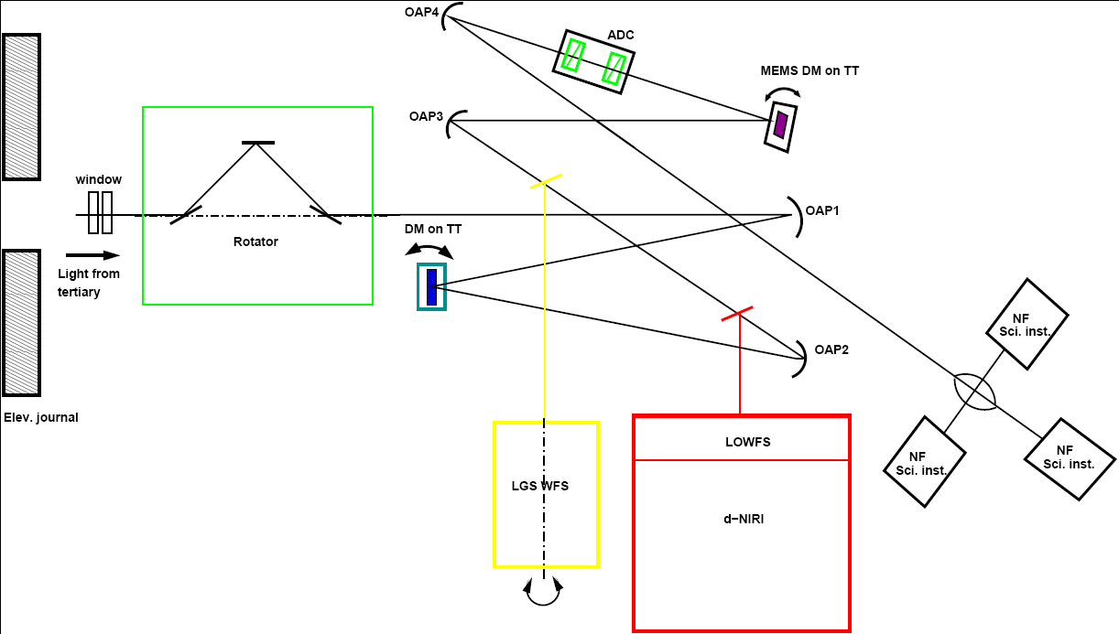

Figure 1: A schematic representation of the NGAO Cascaded Relay

Architectural Assumptions and Overall Requirements

The architectural assumptions are as follows:

Location:
AO system is located on the Nasmyth platform.

Cooling:
The optical components are enclosed and cooled to -20 C (see KAON 501). If needed, parts of the system, such as electronics that do not require a direct interface to the optical path, might be located in nearby housing and kept at a warmer temperature.

Input window:
Because the system is cooled an input window or windows are required to reduce condensation on optical surfaces.

Input K-mirror:
The AO system will have an input k-mirror to remove the effects of field rotation caused by the AO system being located on a Nasmyth platform of an altitude over azimuth mounted telescope.

Optical relay: The optical relay is composed of following parts:
- A main relay that contains a deformable mirror “seen” by all the optical subsystems located after it
- A second stage relay that is operated with a second deformable mirror located after the first stage in a “cascaded” mode where the second DM corrects the incoming wavefront to levels consistent with the science requirements for high Strehl narrow field instruments
- A wide field output from the main relay provides an interface for up to 3 NGS low order wavefront sensors (LOWFS)
- A wide field output from the main relay also directs light into the optical inputs of multiple deployable integral field spectrographs (this instrument is referred to as d-NIRI)
- A narrow field output from the second relay directs light into one of five possible instruments located in a stacked configuration. Three instruments are show in the plane of Figure 1; the other two locations are symmetrically located above and below the plane of the diagram.
- The optical relay will also provide for optical interfaces to the following subsystems that are not shown in figure 1:
  - Acquisition sensors
  - Truth wavefront sensor
  - NGS wavefront sensor

Optical Requirements

Transferred field of view:
The first stage of the optical relay will pass a circular unvignetted field of view of 180 arc seconds. The second stage of the relay will pass a circular unvignetted field of view of 20 arc seconds with a goal of 40 arc seconds. (These fields are referenced to the sky)

Static optical quality of first relay:
The static optical quality of the first AO relay should be as high as possible over the entire 180 arc second field of view of the AO system. Static aberration that fall in the spatial frequency range of the deformable mirror correction will have an rms wavefront error of TBD nm rms or less over the 180 arc second field of view. Static wavefront errors that are beyond the spatial frequency range of the deformable mirror will have an rms wavefront error of TBD nm rms or less.

Static optical quality of second relay:
The static optical quality of the second AO relay should be as high as possible over the entire 20 arc second field of view of the AO system. Static aberration that fall in the spatial frequency range of the deformable mirror correction will have an rms wavefront error of TBD nm rms. Static wavefront errors that are beyond the spatial frequency range of the deformable mirror will have an rms wavefront error of TBD nm rms.

Chromatic aberration:
Allowable chromatic aberrations are TBD

Chromatic focal shift:
Allowable chromatic focal shift is TDB

Curvature of output focal planes:
Output focal surface shall be flat to within the static optical quality of the first and second relays respectively.

Field distortion:
The optical distortion shall be TBD percent across the field of the first relay and TBD percent across the field of the second relay when used in combination with the first relay.

Transmission:
Transmission in the IR Science wavebands will be TBD %
Transmission in the Visible Science wavebands will be TBD %
Transmission in the LGS waveband will be TBD%
Transmission in the NGS wfs sensing bands will be TBD %

Output focal ratio:
The output focal ratio of the NGAO relays should match the output focal ratio of the telescope when used with its f/15 secondary.

Output pupil location:
The optical relays will provide pupil locations that match the Keck telescope when used with its f/15 secondary.
(see http://www.oir.caltech.edu/twiki_oir/bin/view.cgi/Keck/NGAO/OpticalDesign
for exact specification of telescope)

Pupil image size internal to the first relay:
The pupil image size of the first relay will be 100 mm (see section 7.9).

Pupil image size internal to the second relay
The pupil image size of the second relay will be 25 mm (see section 7.9).

Pupil distortion:
The allowable pupil distortions will less than 0.1 %. (Requirement is based on tenth of a subaperture registration error and 64 subapertures across the pupil).

Atmospheric dispersion compensation:
Optical relay will include atmospheric dispersion compensation for the output of the 2nd optical relay, i.e. the narrow field science output path.

Athermalization:
The optical relay shall be able to satisfy its optical requirements at both cooled (-20 C) and ambient temperatures (0 C).

Alignment:
The alignment of the optical relay should be maintained whenever possible by accurate machining of static fixtures.

LGS background light in other sensors:
Filters or other attenuation methods will limit the background light from LGS in other legs of the optical relay to a TBD level.

Optical interface for instruments and other AO subsystems:
See overall requirements and architectural assumptions.

Mechanical Requirements
Location:
AO enclosure shall be located on the Nasmyth platform

Size:
AO enclosure will be located within the boundary of the already existing Nasmyth platform and will not extend about the roof line of the current AO enclosure.

Weight:
AO enclosure, AO facility, instruments, and support equipment will not exceed the weight limit of the current Keck I and II left Nasmyth platforms.

The following is a point of information not a requirement: The weight limit is currently estimated at 22,000 lbs and 40 pounds per square foot (CN: must verify this and convert to SI units)
Access requirements:
The enclosure and its associated mechanism and optics shall be situated on the Nasmyth platform in such a way so as to not preclude access to the telescope elevation bearing and the Nasmyth “basement” for normal telescope maintenance functions.

Cooling and waste heat removal:
The AO enclosure shall have a method for removal of waste heat from the AO facility and support system located on and around the AO enclosure. Waste heat can not be vented directly to the Keck dome environment.

Vibration:
AO enclosure, AO relay, and associated system must be consistent with observatory vibration standards. Additional standards for NGSO are TBD.

Motion control:
- For devices that must track paralactic angle changes, the rate of compensation will be consistent with the zenith “dead zone” of Keck telescope’s maximum azimuth tracking rate.
- The input K mirror must provide image or pupil rotation compensation, which is selectable by the AO control software.
- A moving optical element will select between the five instruments located at the output of the second stage relay.
- The atmospheric dispersion compensator will be removable from the second relay.
- The atmospheric dispersion compensator will be driven based on the telescope elevation and the direction of the Keck zenith on the AO bench.
- The LGS dichroic will be removable.
- The LOWFS and d-NIRI pickoff will be selectable between one of several optical elements in order to optimize LOWFS performance and scientific instrument throughput.

Mechanism motions:
Speed of mechanism motions is TBD
Accuracy of the mechanism motions is TBD

No mechanism vignetting of optical beam:
Mechanical systems inside and around the AO enclosure will not obscure the optical beam from a 180 arc second transferred field of view from the first relay and a 40 arc second transferred field from the second relay.

Instrument handling:
The AO enclosure will be equipped with a suitable mechanism for the installation and replacement of TBD instruments. This mechanism could be a crane, cart, or other mechanism.

Electronic/Electrical Requirements

Power consumption:
Allowable power consumption is TBD

Azimuth cable wrap:
Electrical connections between the NGAO systems on the Nasmyth platform to other location in the observatory will be through the azimuth cable wrap

Diagnostics and monitors:
- The AO enclosure will provide diagnostics and sensors for vibration. (Accelerometers)
- The AO enclosure will provide diagnostics for cooling system flow rate. (Glycol flow)
- The AO enclosure will provide temperature sensors.
- The AO enclosure will provide humidity sensors.
- The AO enclosure will provide particle count monitors and control the cleanliness of the AO environment.
- The AO enclosure will provide video cameras for remote monitoring of the AO enclosure from the summit control rooms and by remote observers (Hawaii and mainland United States).
- The AO enclosure will be able to monitor the background light levels in and around the AO bench.

Background light and stray light:
The encoders and other electronics will have no visible or IR light sources such as LEDs or optical encoders, etc. inside the optical path of the AO system and instruments.

Safety Requirements
These requirements are TBD

Software Requirements
Motion control software requirements for the AO enclosure and relay are covered under section non real-time control section.

Interface Requirements
Optical interface for telescope: see optics section 7.2.1
Optical interface for instruments: see optics section 7.2.1
Optical interface for other AO subsystems: see optics section 7.2.1
Optical interface for diagnostics: see optics section 7.2.1

Mechanical interfaces to telescope: see mechanical section 7.2.2

Software interface for AO enclosure and optical relay subsystem are covered under section Non-real-time control section 7.8

Reliability Requirements
Downtime:
The enclosure and optical relay shall be designed to minimize downtime.

Operational readiness:
The system shall be designed for operation on a TBD basis. The system shall be designed to be deployed at night with TBD hours of preparation for setup and calibration, so that it can support both classical and semi queue scheduled modes.
Setup and preparation times:
Daytime prep time TBD
Nighttime setup time TBD
Object setup TBD

Spares Requirements
TBD pending results of failure analysis of system

Service and Maintenance Requirement
TBD pending results of failure analysis of system

Documentation
Standard documentation provided including:
Mechanical drawings
Electrical schematics
Optical design prescription
Optical alignment plan

