Introduction
This document describes the functional requirements for W.M. Keck Observatory’s (WMKO) Next Generation Adaptive Optics (NGAO) system. The Functional Requirements Document (FRD) flows down the requirements from the design-independent System Requirements Document (SRD) to a few high level systems. These systems were chosen to divide the NGAO system into functions that would be required independent of the selected architecture. Two versions of the FRD are scheduled during the system design phase of NGAO. The first is to be produced as part of the system architecture activity. The second is to be produced as a result of the subsystem design process. The FRD provides the criteria against which the subsystems will be evaluated. The SRD provides the criteria against which the NGAO system will be evaluated.

Further development of the requirements will take place in the next phase of the project (preliminary design). In particular, parametric performance requirements given at this stage are intended to indicate the scope and format of the requirements, but do not in all cases establish final values for the specified parameters. In some cases, values for these parameters have yet to be established and are given as to be determined (TBD).

It is important to understand that at this stage of development the requirements provide a basis for identifying the parameters that will be part of the instrument’s specifications, but the values given are subject to change as the development of the instrument design continues. During the next phases of the project (preliminary and detailed design), work will be done to refine the instrument’s specifications into the final specifications that will be reviewed at the detailed design review. In addition, the final specification will be the basis for construction contracts for subsystems at both member institutions and outside vendors. The final specifications will also form the basis for the acceptance test criteria for the instrument.

As part of the NGAO system design process, a preliminary architecture selection was made during the months of July and August 2007. The result of this process was a two staged AO system known as the “Cascaded Relay”. A sketch of the optical relay is included in Figure 1. More details of the Cascaded Relay can be found in KAON 499.

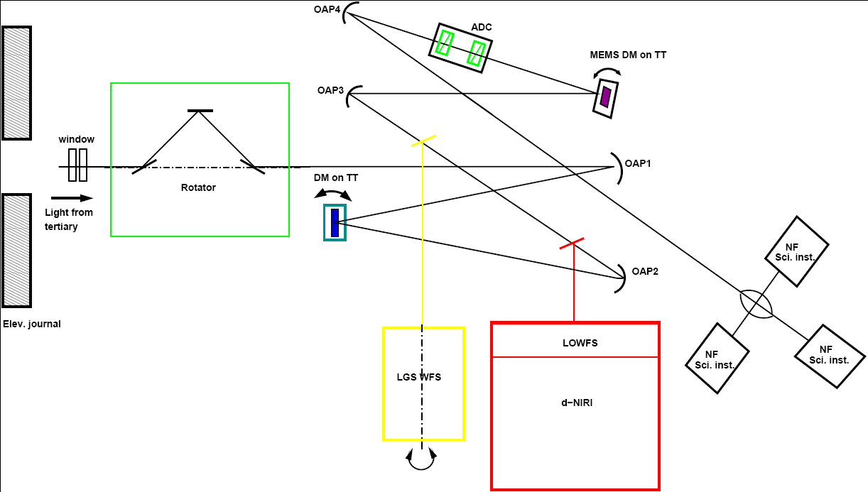

Figure 1: A schematic representation of the NGAO Cascaded Relay

Scope and Applicability
This document establishes functional requirements for all of the AO system aspects of NGAO. (See notes on this draft below)

IMPORTANT NOTE: This draft version of the FRD considers only the AO system and laser facility. The Telescope, science facility, and instrument requirements will be detailed in subsequent drafts.

The scientific and technical requirements for NGAO result in the following basic systems:

- AO system: The AO system will likely consist of an AO enclosure, an opto-mechanical system, and software and electronics for both non real-time and real-time control.
- Laser facility: The laser facility will likely consist of a laser enclosure, the laser(s), the launch facility including a beam transport system and launch telescope, safety systems, and laser system control electronics and software.
- Science operations facility: The science operations facility will primarily include the software and computers required to support operation of the AO system and science instruments. This includes operating the systems for nighttime observing as well as pre- and post-observing activities.
- Science instruments: The three highest priority instruments are currently a near-IR imager, a visible imager, and a deployable near-IR integral field unit (IFU). Three lower priority instruments have also been identified including a near-IR IFU, a visible IFU, and an L and M-band imager. There is also a requirement that the NGAO project be designed so as to allow the continued AO support of the Keck Interferometer and the fiber injection module used for the ‘OHANA (Optical Hawaiian Array for Nanoradian Astronomy) project.
- Telescope facility.

AO system requirements are further sectioned by subsystem in the following breakdown:
(CN: Somewhat arbitrary)

- AO enclosure and optical relay: includes AO enclosure, AO optical relay, optical switch yard, common rotators, AO bench, and enclosure
- LGS WFS: all sensors that use laser guide stars
- NGS WFS: all sensors that use natural guide stars including high order, low order, tip and tilt, and truth
- Diagnostics: including calibration, built-in-test, vibration mitigation, telemetry, PSF knowledge, weather, and atmospheric profile
- Acquisition: systems for the acquisition of LGS, NGS, and science targets
- Real Time Control system: including tomography, temporal control, and high speed telemetry information
- Non Real Time Control system: including motion control and process control for observations, configuration, acquisition, calibration, and diagnostics
- Wavefront correctors: including tip/tilt and higher order wavefront correcting elements

Laser system requirements are sectioned by subsystem in the following breakdown.
(CN: Somewhat arbitrary)
- Laser: including laser head, enclosure, and room and associated systems
- Diagnostics: for the laser and beam transport system including M², beam profile, power, position, size, etc.
- Beam transport optics: including optical relay and controls for laser
- Launch Telescope Assembly: including the asterism forming optics, uplink TT, and uplink AO
- Safety: including interlock requirement for personnel, air-traffic, satellites, and collisions with other telescopes

References

Related Documents
- Instrumentation Baseline Requirements Document
- KAON 456. NGAO System Requirements Document
- KAON 455. NGAO Science Case Requirements Document
- KAON 499. NGAO System Architecture Definition
- NGAO Wavefront error budget tool version 1.26 (Excel spreadsheet)

Referenced Drawings
Table X lists the drawing numbers, revisions and date, source and title for all drawings referenced in this document.

Revision History
Version | Date | Author | Reason for revision / remarks
0.1 | September 2007? | Neyman & Velur | Initial version: AO system and laser facility only

Overall System Architecture & Assumptions

Operational Conditions

Atmospheric Conditions
Median values for r₀, theta₀, wind, f_{G}, outerscale, isoplanatic angle (infinite aperture), and C_{n}² profile

Vibration Environment
Wind, 29 Hz and other vibrations

Telescope Wavefront errors
Phasing, segment figures, and stacking. Dynamic segment vibrations

Sodium Layer Conditions
Na density and variability

Environmental Conditions
See also draft “Instrument Baseline Requirements”
Altitude, temperature and humidity
Operating altitude: sea level to MK summit
Operating temperature range
Worst case temperature range
Operating humidity
Worst case humidity
Transportation

Overall System Architecture & assumptions

Science/System Requirements Summary
The following is a brief summary of the overall system and scientific performance requirements. Ideally, this document would be completely consistent with the Science Case Requirements Document (KAON 455) and System Requirements Document (KAON). In case of conflict, these other documents should be taken as the final authority.

(CN note: consult the multi color chart for now)
Some things to include are:

- Wavefront error at key wavelength 0.5-5 microns
- Sky coverage at wavefront error xx
- PSF stability
- Wavelength coverage (science)
- Field of regard or technical field
- Transmission (science)
- Through put (science)
- Emissivity (science)
- Astrometric errors
- Photometric “flat field”
- Zenith angle performance
- Performance during off nominal conditions
- Atmospheric dispersions (science)
- PSF estimation
- Time between science observations
- Diagnostics
- Data archive
- High contrast
- Polarization
- Number of NGS
- Background light (ghost and scatter)

Standards
All major disciplines shall conform to best practices and standards at Keck for the major disciplines optical, mechanical, electrical, and software. General requirements for new instruments at Keck are collated in: Sean Adkins, “Instrument Baseline Requirements”, version 0.1 January 15, 2007.

http://www.oir.caltech.edu/twiki_oir/pub/Keck/NGAO/WorkProducts/Baseline_Requirements_Document.doc

