Optical and mechanical issues with acquisition for NGAO

Chris Neyman’s notes from a conversation with Don Gavel and Reni Kupke October 9, 2007

Three suggested locations for acquisition cameras in the cascaded relay design
- In front of AO system, at the telescope Nasmyth focus.
- Behind first stage of AO relay
- In front of the dNIRI/LOWFS pickoff.

See Figure 1, all three locations would receive the full technical field of view of 202”.

The first option (1) is probably ruled out by:
- Space consideration with the bearing.
- The large number of non common path optics between the acquisition sensor and the other sensors that are part of NGAO.
Location (2) is less favorable than location (3) because of:
- Non common path between the dNIRI/ LOWFS pickoffs and the output of the 1st stage relay. As currently understood the dNIRI/LOWFS pickoff (kickbot’s mirrors) will have a very small FOV of order 3” so the acquisition will be the most challenging for IR tip tilt stars and faint galaxies, respectively.

These consideration tend to make option (3) appear the most attractive.

Current optical layout per the TSIP proposal (see figure 1) will have the LGS dichroic first, this will be a notch filer around 589 nm and pass visible and IR light through the rest of the optical path. The OSM dichroic will likely be a changeable optic having at least the following options
- a mirror
- transmit K reflect J and H dichroic
- transmit H and K and reflect J dichroic

A wide field IR sensor is a likely option for the acquisition sensor with optical input option 3. A small sketch is shown in Figure 2.

Other ideas consider:
- Tiled focal plane ala TMT TiPi concept (also serves as the pickoff for dNIRI/LOWFS).
- If the ideas in Figure 2 cannot fit the available space, rotation of the OSM to a convenient orientation such as out horizontal at 90 degrees or straight up is another option. This complicates the dichroic changer and also makes for more non-common path optics.

LGS acquisition:

Another issue for acquisition is realignment of the wavefront sensor after an LGS constellation change. We also will have the option to move 3 LGS close to the 3 natural tip tilt stars in the point and shoot mode. If we have an IR acquisition camera it will likely not see the LGS and a separate LGS acquisition sensor (likely CMOS or CCD) will be needed.

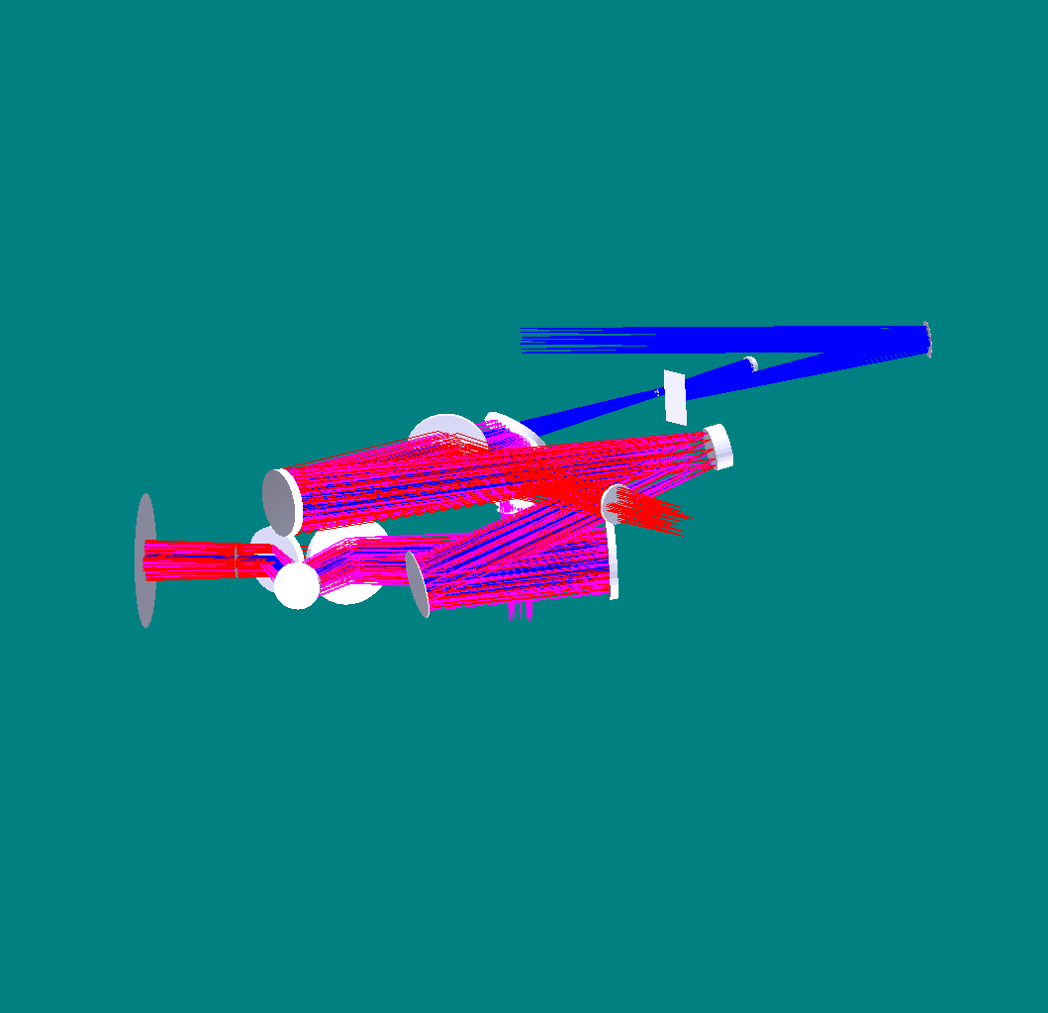
K-rror
Fold mirror
OAP 1
Woofer DM
OAP 2
LGS dichroic
MEMS DM
f/45 output
LGS coma corrector plates
OAP 3
OSM dichroic
Nasmyth focus
Outside of telescope elevation bearing
To OSM (near-IR tip-tilt and multi-object instrument) input
LGS WFS input
OAP 4
Acquisition (1)
Acquisition (3)
Acquisition (2)

Figure 1: A working layout of the cascaded relay.

OSM
dNIRI
LOWFS
LOWFS
Camera Optics
IR Detector Optics
Field Lens/Field Flattener
Pickoff for LOWFS and dNIRI
Pickoff for
IR acquisition
Figure 2: Possible pickoff scheme, not to any scale.
Consider location behind second relay
Rene Kupke comments:

Hi Chris,

I've taken a look in Zemax at expanding the field all the way back to the end of the 2nd relay, to put an acquisition camera there. There's a problem of beam clearance between the beam near the focus of the first relay and the tweeter. If I expand the beam to 180 arcsec, it is vignetted by the tweeter (take a look at where OAP3 folds back to the tweeter - it lies very close to the input beam).

We don't want to change the angle coming off of OAP3 - this will introduce aberrations.

I think both Acquisition #2 and Acquisition #3 from your original proposal would be easier to implement.

Reni

