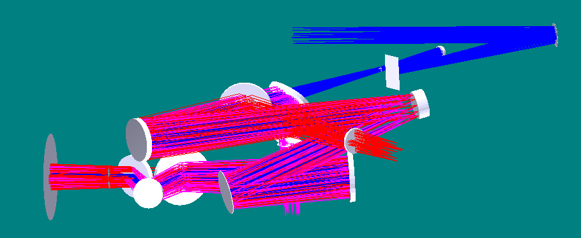
Blue=narrow field path
K-mirror
Fold mirror
OAP 1
woofer
OAP 2
LGS dichroic
MEMS
OAP 4
f/45 output
LGS coma corrector plates
OAP 3
d-NIRI/LOWFS dichroic
Nasmyth focus
Outside of bearing
d-NIRI/LOWFS input
Red = LGS path
LGS WFS input
Magenta=d-NIRI path

