

Keck Adaptive Optics Note 551

Keck Next Generation Adaptive Optics
WFS sub-system conceptual study report

V. Velur¹, A. Moore¹, R. Dekany¹, D. Gavel³, C. Neyman², R. Flicker², C. Lockwood³, R. Kupke³, and J. Bell²

¹Caltech Optical Observatories
²W. M. Keck Observatory
³UCO Lick Observatories and the Lab for Adaptive Optics

July 29, 2026
Contents
1. Introduction 4
2. Work scope definition (as written before the NGAO system architecture meeting, the strikethroughs indicate changes due to decisions made during the architecture selection process): 4
3. NGAO wavefront sensors primer 6
4. NGAO LGS wavefront sensors: 12
1.1 LGS spot size: 14
1.2 Motion control of mechanisms in the LGS sensor 18
1.3 LGS wavefront sensor registration and calibration 19
5. Tip-tilt (Focus and astigmatism) sensor: 21
6. Truth or Calibration WF sensors: 27
7. NGS HOWFS sensor: 28
Appendix I 33
Glossary: 33
Appendix II 34

Figure 1 Annotated NGAO opto-mechanical layout. The first relay has a 20x20 woofer DM with 100 mm pupil and the second (narrow field relay) has a 64x64 MEMS tweeter DM with 25.6 mm pupil. 7
Figure 2 Annotated NGAO optical design². 8
Figure 3 NGAO guide stars in a typical wide field observing scenario with point-and-shoot lasers just outside of tip-tilt stars. Yellow stars are LGS’s; red, blue and shaded red stars are natural stars (figure not to scale). 10
Figure 4 NGAO guide stars in narrow field observing scenario. Yellow stars are LGS’s; red, blue, green and shaded red stars are natural stars (figure not to scale). 11
Figure 5 Plan view of the pick-off scheme showing the theta-phi mechanism. The 8 sensors that are around the central star will need to have rotation stages that ensure that the lenslet array, the woofer DM and the corresponding detector pixels stay mapped to one-another at all times. 12
Figure 6 Schematic of the LGS WFS assembly enclosure showing 1 pick off beam path. 12
Figure 7 Schematic that unravels the theta-phi mechanism with f/13.66 beam input and 13
Figure 8 Lenslet switching scheme to facilitate multiple pupil sampling scales. Each lenslet has the same focal length and the pupil diameter at the lenslet for all pupil sampling scales is the same. 14
Figure 9 LGS spots delivered by the optical design at LGS pick off plane with the LGS’s at 90 km (zenith); the box size is indicative of a single 4x4 pixel (at 1.45”/pixel) sub-ap. 16
Figure 10 LGS spots delivered by the optical design at LGS pick off plane with the LGS’s at 180 km altitude; the box size is indicative of a single 4x4 pixel (1.45”/pixel) sub-ap. 16
Figure 11 LGS WFS preliminary optical design. 17
Figure 12 Shack-Hartmann spots on the LGS HOWFS detector; the box shows the outline of a 256x256 pixel detector with 13um pixels. 18
Figure 13 Schematic of a single LGS WFS channel on which 1st order design was based on. 20
Figure 14 Image fixed observing scenario – K mirror keeps the stars fixed on the AO focal plane(s) and hence on the WFS channels. NGAO keeps the LGS stars fixed with respect to the sky and at the detector at all times when observing in WF mode. 21
Figure 15 Pupil fixed observing scenario – K mirror keeps pupil fixed. This helps calibrate out speckles in high contrast imaging. 21
Figure 16 LOWFS assembly showing four pick off arms. One arm feeds the TTFA/ TWFS assembly, 2 more arms feed the TT sensors and one arm feeds a PSF monitor (not part of the baseline design, so this is a place holder) 22
Figure 17 Schematic of the TTFA showing the cold stop and cryogenic part and the (-20 deg C) front end (there is a window between the cold and the cryogenic chamber). The lenslet and the DM are both at a pupil in the above configuration. 24
Figure 18 Schematic of the TT sensor design (there is a window between the cold and the cryogenic chamber). 25
Figure 19 Schematic of WF TWFS. This TWFS channel is similar to the TTFA channel, except for the fact that there is a 5x5 lenslet rather than a 2x2 lenslet. The TWFS is envisioned to work at 0.1-10 Hz and needs only 5% of the light from the brightest star in the field (the TTFA gets to use the brightest star since it’s a 2x2 sensor). 27
Figure 20 NF TWFS is fed using light from a field star using the same articulated mirror pair as the NGS sensors. 27
Figure 21 5 milli-arcsecond diameter LOWFS reference source. 35
Figure 22 200 milli-arcsecond LOWFS reference source. 35

Introduction
The Next Generation Keck Adaptive Optics system is a multiple guide star Adaptive Optics system with a two stage reflective OAP relay designed to work at wavefront errors as low as 90 nm. The system is envisioned to have four kinds of wavefront sensors, namely, one NGS WFS, 9 LGS WFS's, 3 TT(FA)s (2TTs and 1 TTFA), and two truth sensors. This is a report of a conceptual study of these wavefront sensors undertaken to provide input to the system design manual. Both the 1-tier and the 2-tier optical designs considered while developing concepts, this report deals with the down selected 2-tier optical design alone. The main work products of this WBS element are basic conceptual design and feeding into the functional requirements document, opto-mechanical design and error budget.

Work scope definition (as written before the NGAO system architecture meeting, the strikethroughs indicate changes due to decisions made during the architecture selection process):
3.2.3.5 Overall WBS Dictionary definition: Develop a design concept for each of the required NGAO wavefront sensors

3.2.3.5.1 High Order LGS Wavefront Sensors: Given the functional and performance requirements, develop a design concept for the laser guide star high order wavefront sensors. Take into consideration the possible need for both open and closed loop wavefront sensing.

3.2.3.5.2 High Order NGS Wavefront Sensor: Given the functional and performance requirements, develop a design concept for the natural guide star high order wavefront sensor(s). Take into consideration the possible need for both open and closed loop wavefront sensing. Include consideration of ADC packaging (ADC design is covered in WBS 3.2.3.8).

3.2.3.5.3 Low Order NGS Wavefront Sensors: Given the functional and performance requirements, develop a design concept for the low order natural guide star wavefront sensors for the purpose of determining tip/tilt and other low order modes in laser guide star observing mode. Take into consideration the possible need for both open and closed loop wavefront sensing. Include consideration of ADC packaging (ADC design is covered in WBS 3.2.3.8).

3.2.3.5.4 Calibration Wavefront Sensor (Called truth sensor in this document): Given the functional and performance requirements, develop a design concept for the calibration wavefront sensor which will use natural guide star light as a truth wavefront. This sensor will be periodically used to reset the references of the high order wavefront sensors in laser guide star mode. Include consideration of ADC packaging (ADC design is covered in WBS 3.2.3.8).
Inputs to the study:
    - Optical design of the Cascaded relay.
    - FRD
      - Type of each WFS (SH/ PYR)
      - What order/ # of sub-apertures.
      - The position each sensor in the Optical Relay.
      - The FoR for each sensor
      - Positioning accuracy
      - Choice of detector(s) for each WFS (pixel size).
      - Pixel geometry specifics like guard bands, pixel geometry and spot size (for LGS with appropriate elongation) for each WFS
      - Centroiding accuracy, dynamic range, and linearity specifications from FRD for each WFS
      - The Field Stop/ Spatial filter specification
      - TT sensor specification (FoV, dynamic range, etc.)
    - SRD (specifically input of the type of sources on which tip-tilt sensor needs to work and performance margin for binaries, elongated/ asymmetric sources.
    - NGAO System Architecture Definition (KAON 499)
    - Mechanical drawing(s) w/ space constraints and packaging issues clearly stated for the of Cascaded relay.
    - Specification on pick-offs for the WFSs (including the ones shared by the TT(FA) sensors inside the d-NIRI) and rotation if necessary. (input must come from 3.2.3.11)
    - Wavefront sensor error budget spreadsheet.

3. Products:

- Conceptual optical design(s).
- Feed into relevant sections of FRD version 2.0 (in particular update TT sensor requirements and performance based on the type of source).
- LGS pick off mechanism concepts.
- Conceptual designs and first order optical design for the LGS WFSs, TT(FA) sensors.
- First order Mechanical packaging.
- Preliminary mechanical design and 3D model (at least a cartoon showing the envelopes occupied by the WFSs).
- Acceptance and completeness of concepts and conceptual design with information on what needs to be done during the preliminary design phase.
- Update the terms in the error budget spreadsheet based on conceptual design.
- Documentation for all the above.

4. Methodology:

- Liaise with opto-mechanical team to understand the optical and mechanical constraints.
- Based on the inputs from section 2, a first order optical design shall be worked out and shared with the rest of the WFS team for scrutiny. This will be documented and sent to the EC for further inputs.
- Conceptual designs for LGS pick offs will be worked out based on work done by the IWG, other projects like Gemini MCAO, and other MOS pick off options and Palomar Tomograph. Mechanism(s) for registering each LGS sensor to the DM will be conceptualized.
- One day meeting to understand risks and look at the acceptance of the work and design with the WFS design team. (this was subsumed by comprehensive NGAO team meeting, opto-mechanical teleconferences and ad-hoc phone conversations)
- Documentation of the designs with design risks stated.
- Update the FRD and Error Budget Spreadsheet as and when they need updating based on how the conceptual design evolves.

NGAO wavefront sensors primer
The NGAO sensors measure wavefronts from natural and sodium guide stars to provide AO corrected images to a 150” (science) wide field instrument and a 40” (science) narrow field instrument suite. Figure 1 and Figure 2 show the overall NGAO cascaded relay. Figure 3 and Figure 4 schematically show the geometry of the wide field and narrow field observing scenarios. The TT star search radius is 150”.

NGAO baselines its design on 9 laser beacons that are imaged through the AO relay on to a focal plane located at the output of the 1st WF field relay. Five of the nine beacons are used to generate a variable size asterism with stars on vertices of a regular pentagon with an additional central stationary beacon. NGAO also uses 3 natural stars within the 150” FoV to provide absolute tilt and focus information. To selectively sharpen these 3 natural guide stars; we employ 3 dedicated point-and-shoot (PnS) laser beacons that are positioned approximately 10” outside of each of TT star radii; thus making their deployable radius 175”.

The method of picking off these synthetic and natural stars is discussed in detail in KAON 562. Some background for the pick-off mechanisms is also provided in this report. The pick-off or object selection mechanism is designed to conform to dithering requirements, PnS laser requirements, clustering requirements and in general all relevant FoR requirements The LGSF SD report (KAON 570) describes the uplink of the lasers and the means to generate the asterism.

Figure 3 shows the WF observing scenario wherein 6-8 (TBD) objects within the 150” FoV are channeled into a deployable integral field spectrograph. The 6 LGS asterism along with the 3 MOAO corrected TT stars and the 3 PnS lasers provide tomographic information to drive AO systems in each of the spectrograph channels. The WFS conceptual design does not preclude inclusion of a PSF monitor camera in the system, but this element has not been appraised in this phase. There is also a dedicated truth or calibration wavefront sensor at the WF output that accounts for any LGS related calibration/ bias errors. Table 1 lists the basic input parameters for the WFS conceptual design; some of them are flown down from the science case directly, while others were derived based on architecture choice (c.f. KAON 499 – Architecture definition and KAON 573- Functional requirements document).

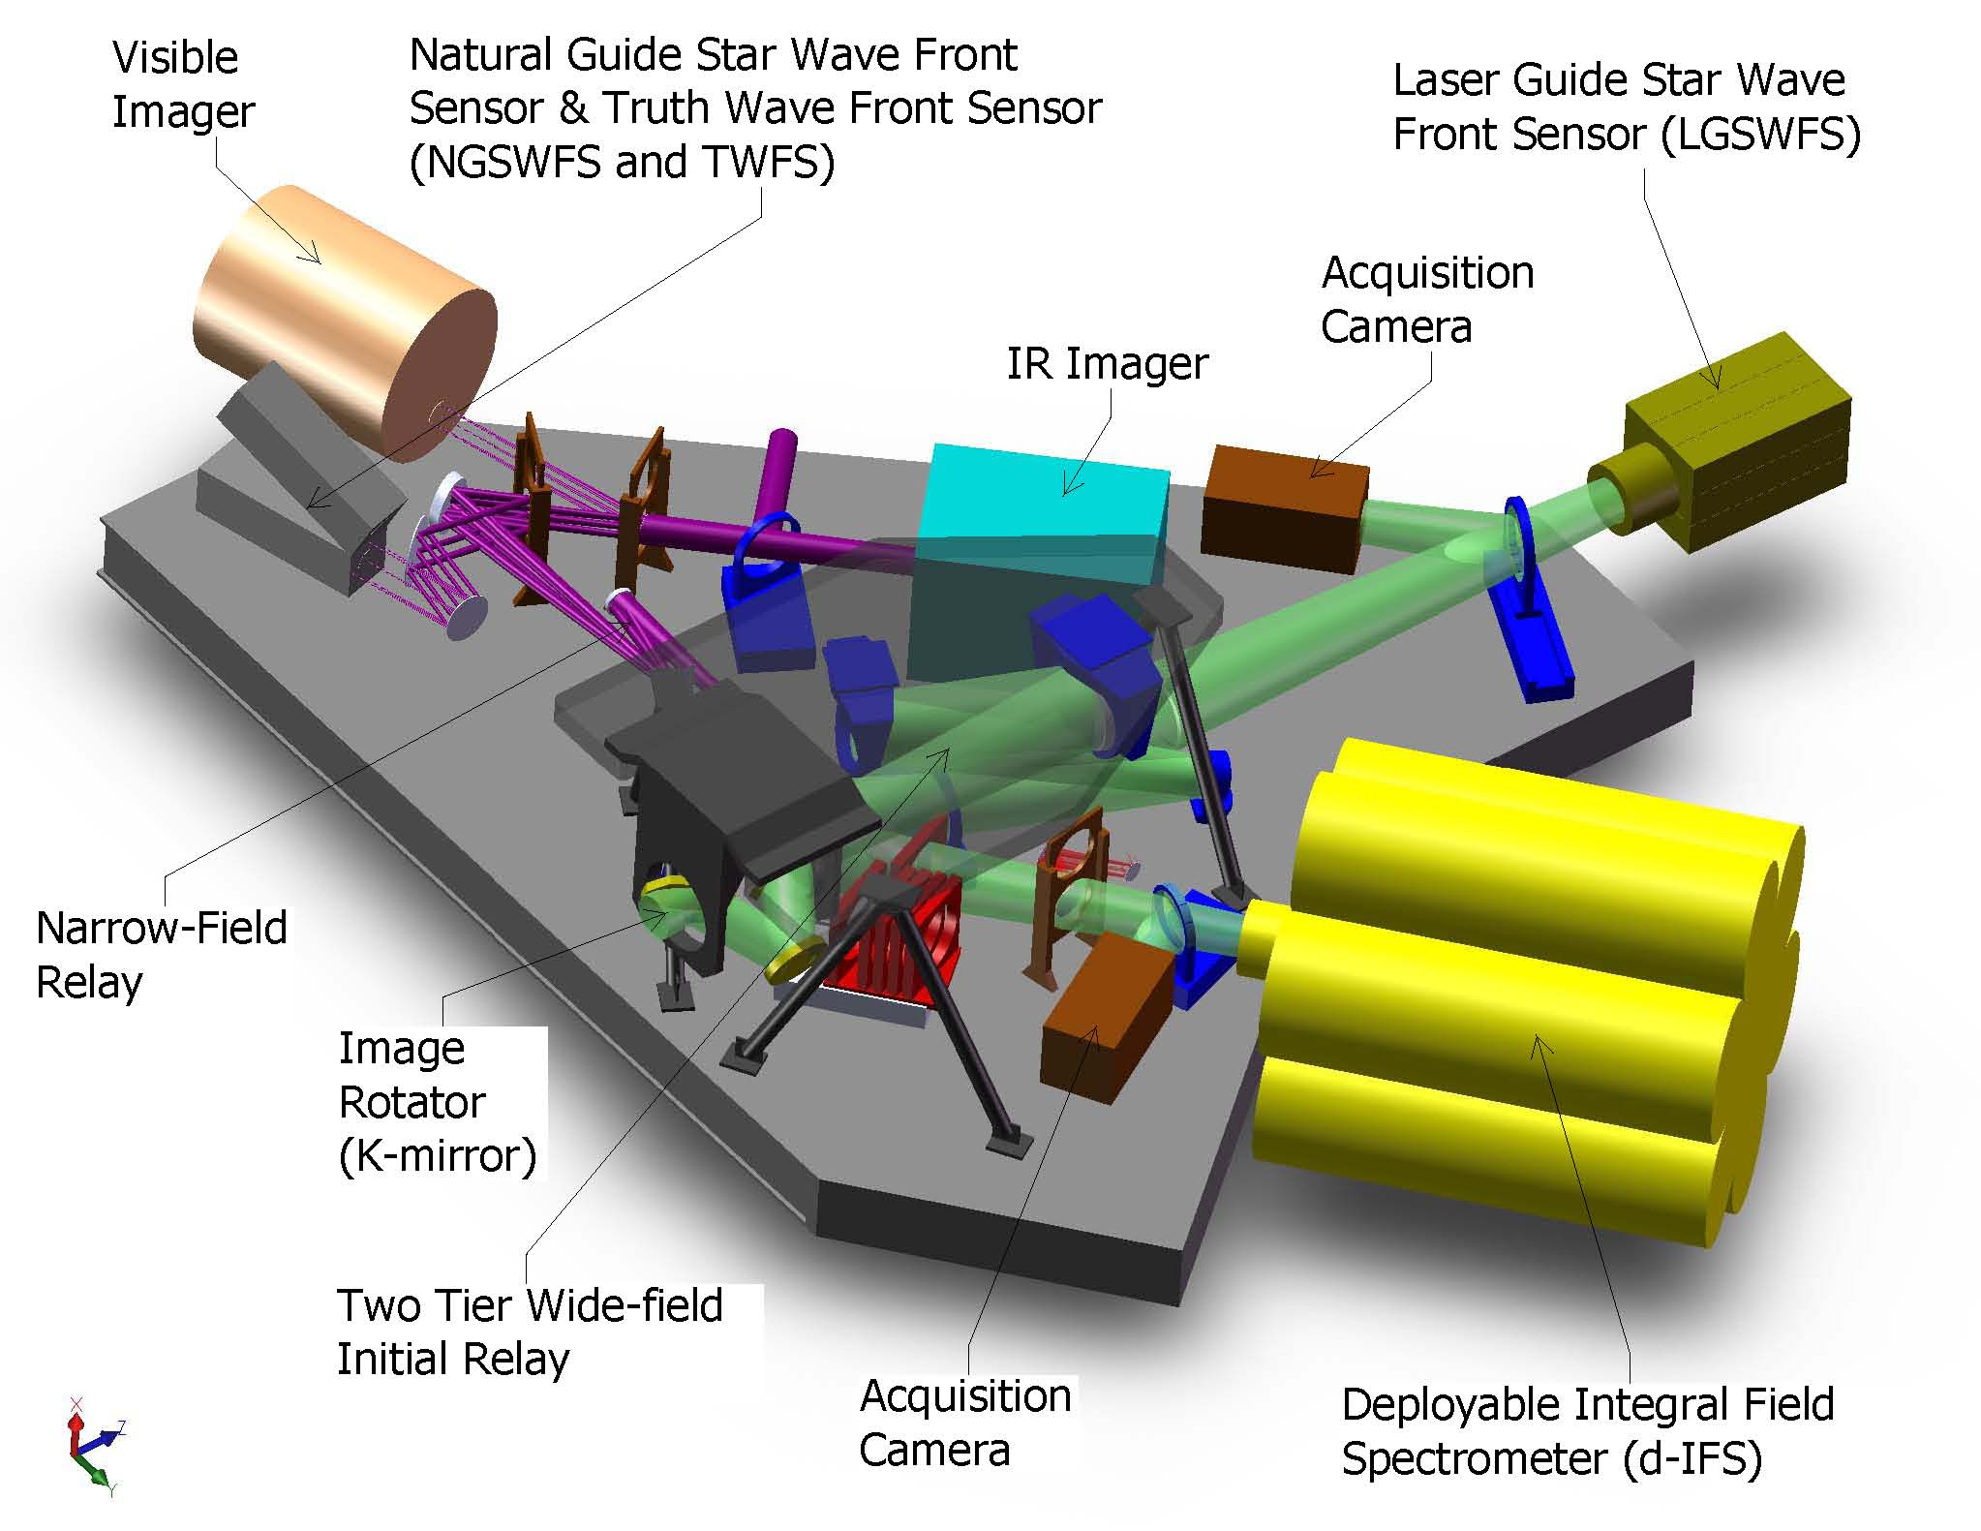
Figure 1 Annotated NGAO opto-mechanical layout. The first relay has a 20x20 woofer DM with 100 mm pupil and the second (narrow field relay) has a 64x64 MEMS tweeter DM with 25.6 mm pupil.
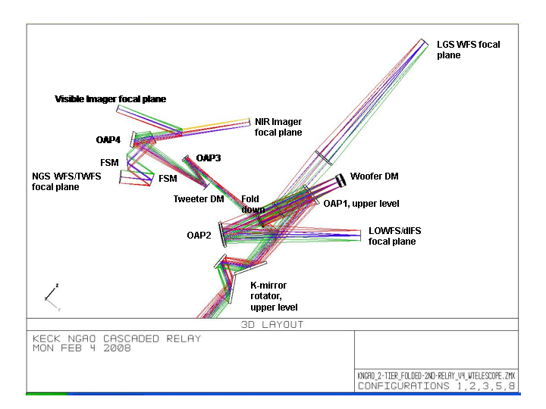
Figure 2 Annotated NGAO optical design².

WFS type (# of sensors) | Location | Sensing wavelength (nm) | Input platescale (um/") | # of sub-apertures | Detector platescale("/pixel) | Filters | Pupil sampling | Field of regard (arcsec) | Comments
NGS HOWFS* (1) | After NF relay | 400-1000 | 2254 | 32x32, 64x64 | 1.5 | no filter | 64x64, 32x32 | 50 | Steering mirrors for OSM
LGS HOWFS (9) | after WF relay | 589 nm | 727 | 16x16, 32x32, 64x64 | 1.45 | no filter | 64x64, 32x32, 16x16 | 174 | Theta-phi OSM
TT* (2) | After WF relay | 1000-1800 | 727 | 1x1 | 0.03 | J & H band pass | quad-cell | 150 | Theta-phi OSM
TTFA* (1) | After WF relay | 1000-1800 | 727 | 2x2 | 0.03 | J & H band pass | 2x2 | 150 | Theta-phi OSM
NF truth sensor* (1) | after NF relay | 400-1000 | 2254 | 5x5 | 0.65 | Na rejection filter | 5x5 | 50 | shares steering mirror pick offs with the NGS WFS
WF truth sensor (1) | after WF relay | 1000-1800 | 727 | 5x5 | 0.2 | J & H band pass | 5x5 | Same star as TTFA | Theta-phi OSM
Table 1 Keck NGAO wavefront sensor parameters: Location, sensing wavelength and input platescale, was based on design down select process and are architecture specific. The pupil-sampling and filter choices are based on extensive work done in calculation the SNR in the error budget. The detector plate scale numbers are also derived from the error budget spread sheet based on various parameters like source size(galaxies, extended objects etc.) , lateral charge diffusion, lenslet diffraction, level of AO correction at the corresponding wavelength and LGS spot elongation (if applicable).
*-These have the ability to guide on certain extended natural sources (see NGAO science case summary for details).
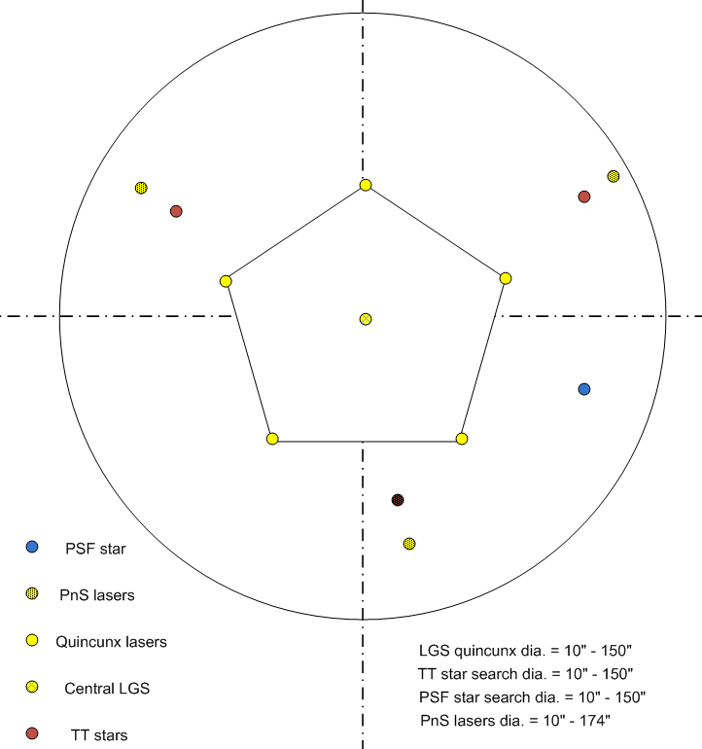

Figure 3 NGAO guide stars in a typical wide field observing scenario with point-and-shoot lasers just outside of tip-tilt stars. Yellow stars are LGS’s; red, blue and shaded red stars are natural stars (figure not to scale).

Figure 4 shows a typical NF observing mode wherein the quincunx diameter is ~10”. The visible truth sensor in the NF shall be used in a similar fashion as the IR WF truth sensor.

In an effort to maintain the current capability and cater to bright guide star narrow field science and imaging planetary sources between 9-10 mag.; NGAO will support NGS observation with 64x64 and 32x32 pupil sampling over a 40” science field.
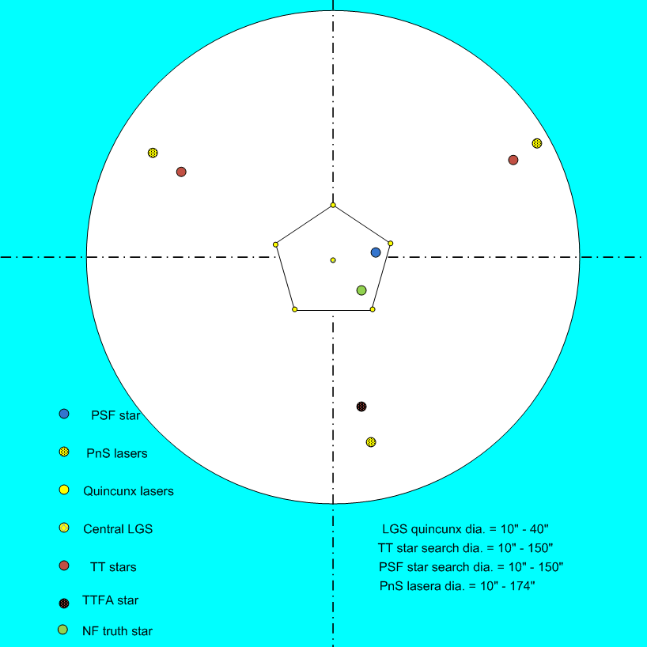
Figure 4 NGAO guide stars in narrow field observing scenario. Yellow stars are LGS’s; red, blue, green and shaded red stars are natural stars (figure not to scale).

NGAO LGS wavefront sensors:
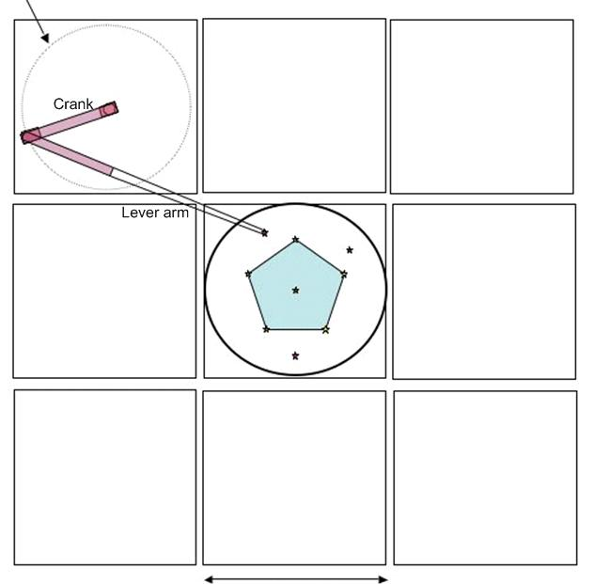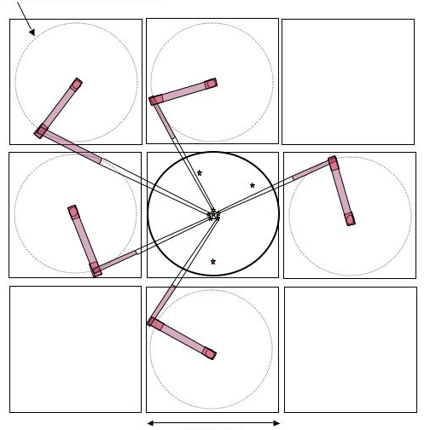
Figure 5 Plan view of the pick-off scheme showing the theta-phi mechanism. The 8 sensors that are around the central star will need to have rotation stages that ensure that the lenslet array, the woofer DM and the corresponding detector pixels stay mapped to one-another at all times.
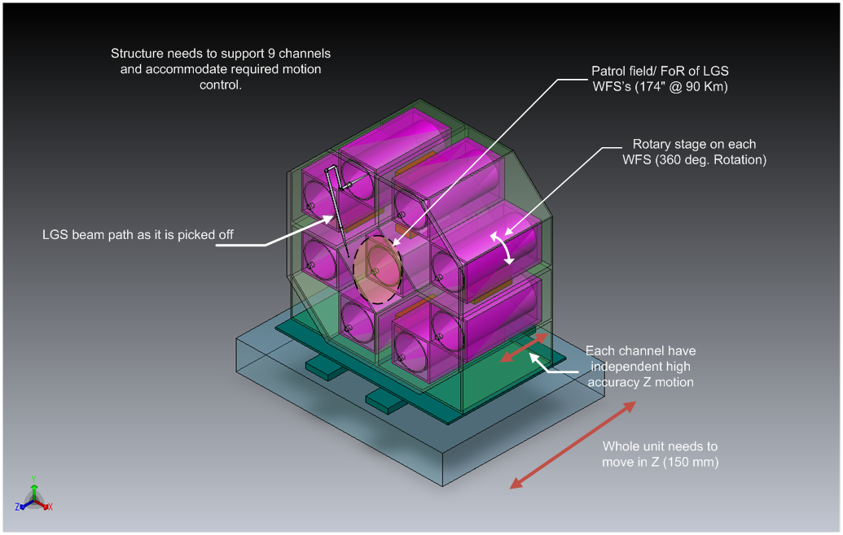
Figure 6 Schematic of the LGS WFS assembly enclosure showing 1 pick off beam path.

Figure 7 Schematic that unravels the theta-phi mechanism with f/13.66 beam input and

There are a total of 9 LGS wavefront sensors located at the output of the WF relay; the position of the LGS WFS assembly is schematically depicted with annotations in Figure 2. The quincunx asterism diameter can be varied between 10” and 174”. We envision supporting 64x64, 32x32 and 16x16 pupil sampling scales using a lenslet switching mechanism; a schematic of the same is shown in Figure 8. The lenslet switching mechanism uses a set of 3 custom lenslets to minimize the motion control required to achieve the multiple pupil sampling scales. There is economy in numbers since there are nine WFS channels the NRE costs of making 3 custom lenslets to produce a total of 27 lenslets to populate the nine sensors is minimal. The pupil size at the lenslet is the same for all pupil sampling scales and the spot separation at the detector focal plane varies from 4 to 8 to 16 pixels as we go from 64 to 32 to 16 sub-apertures across the pupil. Variable pupil scales are envisioned to help, de-scope or staging options. Multiple pupil-sampling also facilitates operation when one or two of the three 50W lasers are not operational.
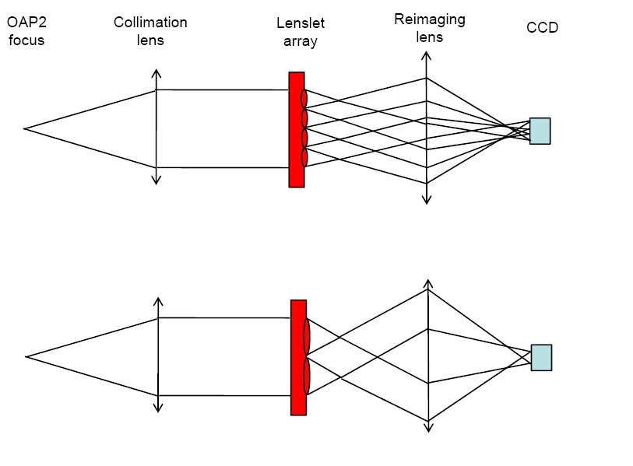
Figure 8 Lenslet switching scheme to facilitate multiple pupil sampling scales. Each lenslet has the same focal length and the pupil diameter at the lenslet for all pupil sampling scales is the same.

LGS spot size:
The LGS spots delivered to the LGS pick-off focal plane by the NGAO optical relay are shown in Figure 9 and Figure 10. The box around the spot shows the footprint of the FoV of a sub-aperture at the detector focal plane. The NGAO error budget accounts for the spot elongation, in addition to apparent size of LGS beacons, lenslet diffraction, lateral diffusion, the level of AO correction obtained by the first relay in the NGAO cascade etc. Table 1 shows the apparent spot size contributions from various sources. Each sub-aperture in the LGS sensor sees a 5.6” x 5.6” area; this makes each LGS spot remain within the confines of the sub-aperture.

Laser Guide Star Size Calculation
Finite Object Size
Intrinsic guide star diameter |  |  |  |  | 0.00 | arcsec
Uplink formation of the beacon(s)
Perfect Uplink AO? |  |  |  | NO
Inherent aberrations in the uplink beam: |  |  |  |  | 0.90 | arcsec
Beam movement contribution to uplink |  |  |  |  | 0.33 | arcsec
Residual seeing contribution to uplink |  |  |  |  | 0.60 | arcsec
Diameter of point source laser at Na layer: |  |  |  |  | 1.08 | arcsec
Seeing
Natural seeing FWHM at GS wavelength |  |  |  |  | 0.58 | arcsec
Subaperture Tip/Tilt corrected FWHM |  |  |  |  | 0.47 | arcsec
Contribution due to seeing |  |  |  |  | 0.47 | arcsec
Elongation
Distance from LLT to telescope axis: |  |  |  |  | 0.00 | m
Use Max. Elongation? |  |  |  | NO | 1.27 | arcsec
Avg. Elongation |  |  |  |  | 0.85 | arcsec
Contribution due to elongation |  |  |  |  | 0.85 | arcsec
System Aberrations
Aberrations in AO thru to WFS |  |  |  |  | 0.25 | arcsec
Atmospheric Dispersion
ADC in HOWFS? |  |  |  | NO
RMS blurring due to atmospheric dispersion |  |  |  |  | 0.000 | arcsec
Total size of detected return beam: |  |  |  |  | 1.47 | arcsec
Sensing Approach
Pyramid WFS? |  |  |  | NO
Charge Diffusion
Charge Diffusion |  |  |  |  | 0.25 | pixels
Contribution due to Charge Diffusion |  |  |  |  | 0.40 | arcsec
Subaperture Diffraction
Lambda/d (for sensing) |  |  |  |  | 0.66 | arcsec
Spot size used for centroiding |  |  |  |  | 1.66 | arcsec

Table 2 Sample LGS spot size calculation for NGAO

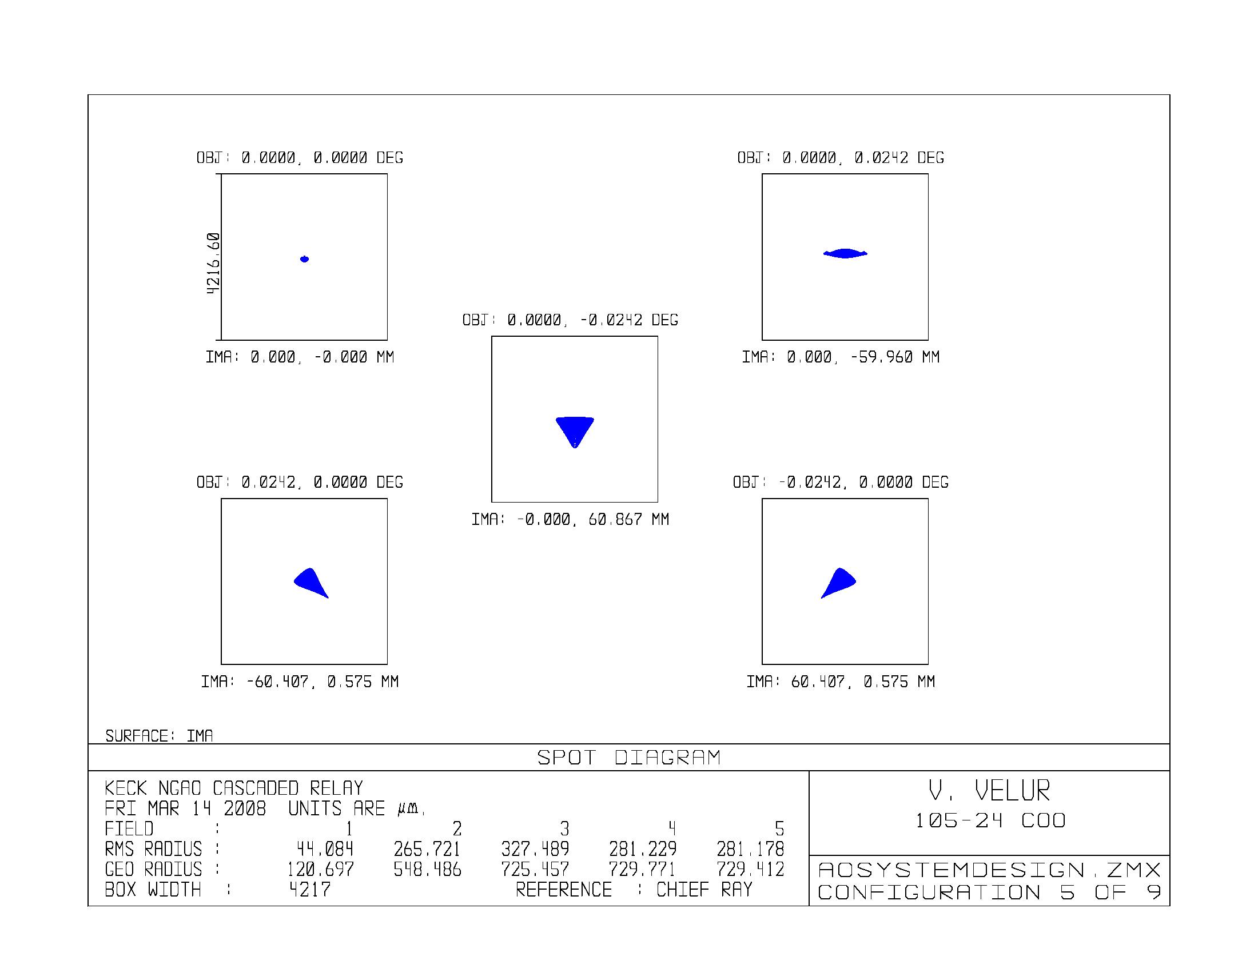
Figure 9 LGS spots delivered by the optical design at LGS pick off plane with the LGS’s at 90 km (zenith); the box size is indicative of a single 4x4 pixel (at 1.45”/pixel) sub-ap.
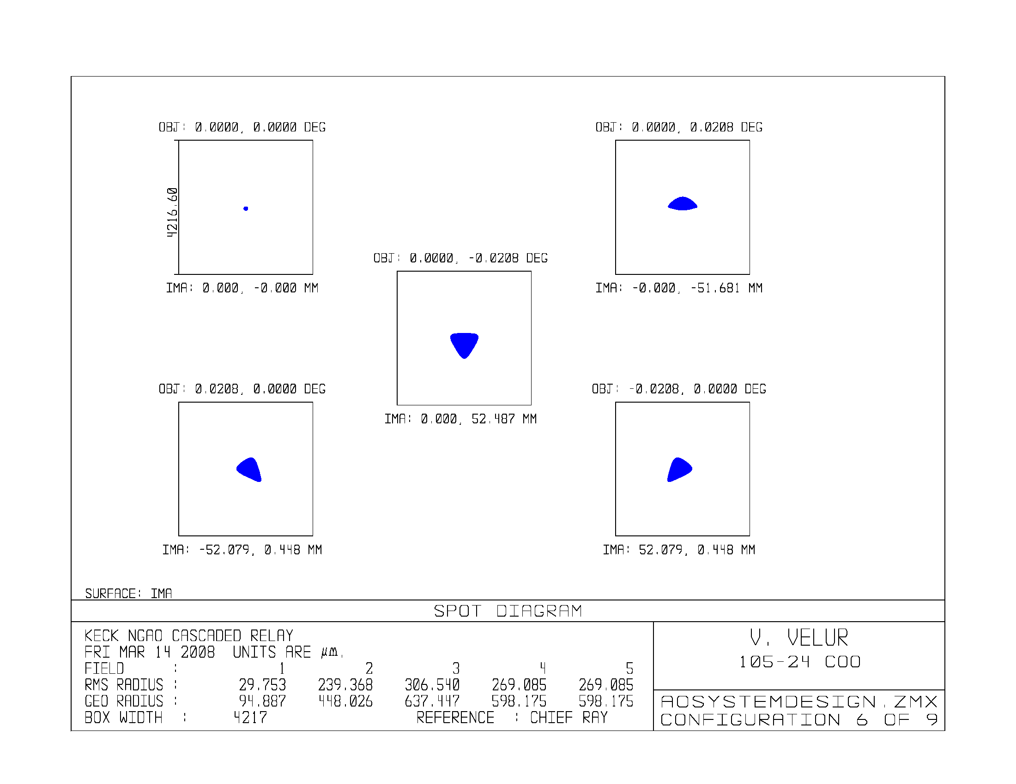
Figure 10 LGS spots delivered by the optical design at LGS pick off plane with the LGS’s at 180 km altitude; the box size is indicative of a single 4x4 pixel (1.45”/pixel) sub-ap.

A preliminary optical design for a 64x64 LGS sensor fed by an f/13.66 beam is shown in Figure 11 and Figure 12. The focal spots at the detector are separated by 4 pixels. This geometry is in accordance with the development of JFET based low-noise fast frame readout CCD development at MIT/LL in collaboration with Keck Observatory. A 256x256 pixel rectilinear CCD detector is the nominal choice with read out speeds up to 2000 Hz with a 3-stage Peltier cooler. Commercial detectors with 240x240 pixels are already available, this making a graceful de-scope to a maximum of 60x60 sub-apertures a viable option. Each sensor occupies a volume of 850 x 150 x 150 mm.

WFS/ parameter | # of subaps | Relay demag. | Pixel size (mm) | Detector Plate scale (arcsec) | pupil size at lenslet (mm) | lenslet pitch (mm) | lenslet FL (mm) | Collimator focal length (mm)
LGS | 64 | 4 | 0.0130 | 1.45 | 13.312 | 0.208 | 8.9938 | 181.84
LGS | 32 | 4 | 0.0130 | 1.45 | 13.312 | 0.416 | 8.9938 | 181.84
LGS | 16 | 4 | 0.0130 | 1.45 | 13.312 | 0.832 | 8.9938 | 181.84
Table 3 LGS HOWFS parameters with 1.45”/pixel with 13 um pixels.

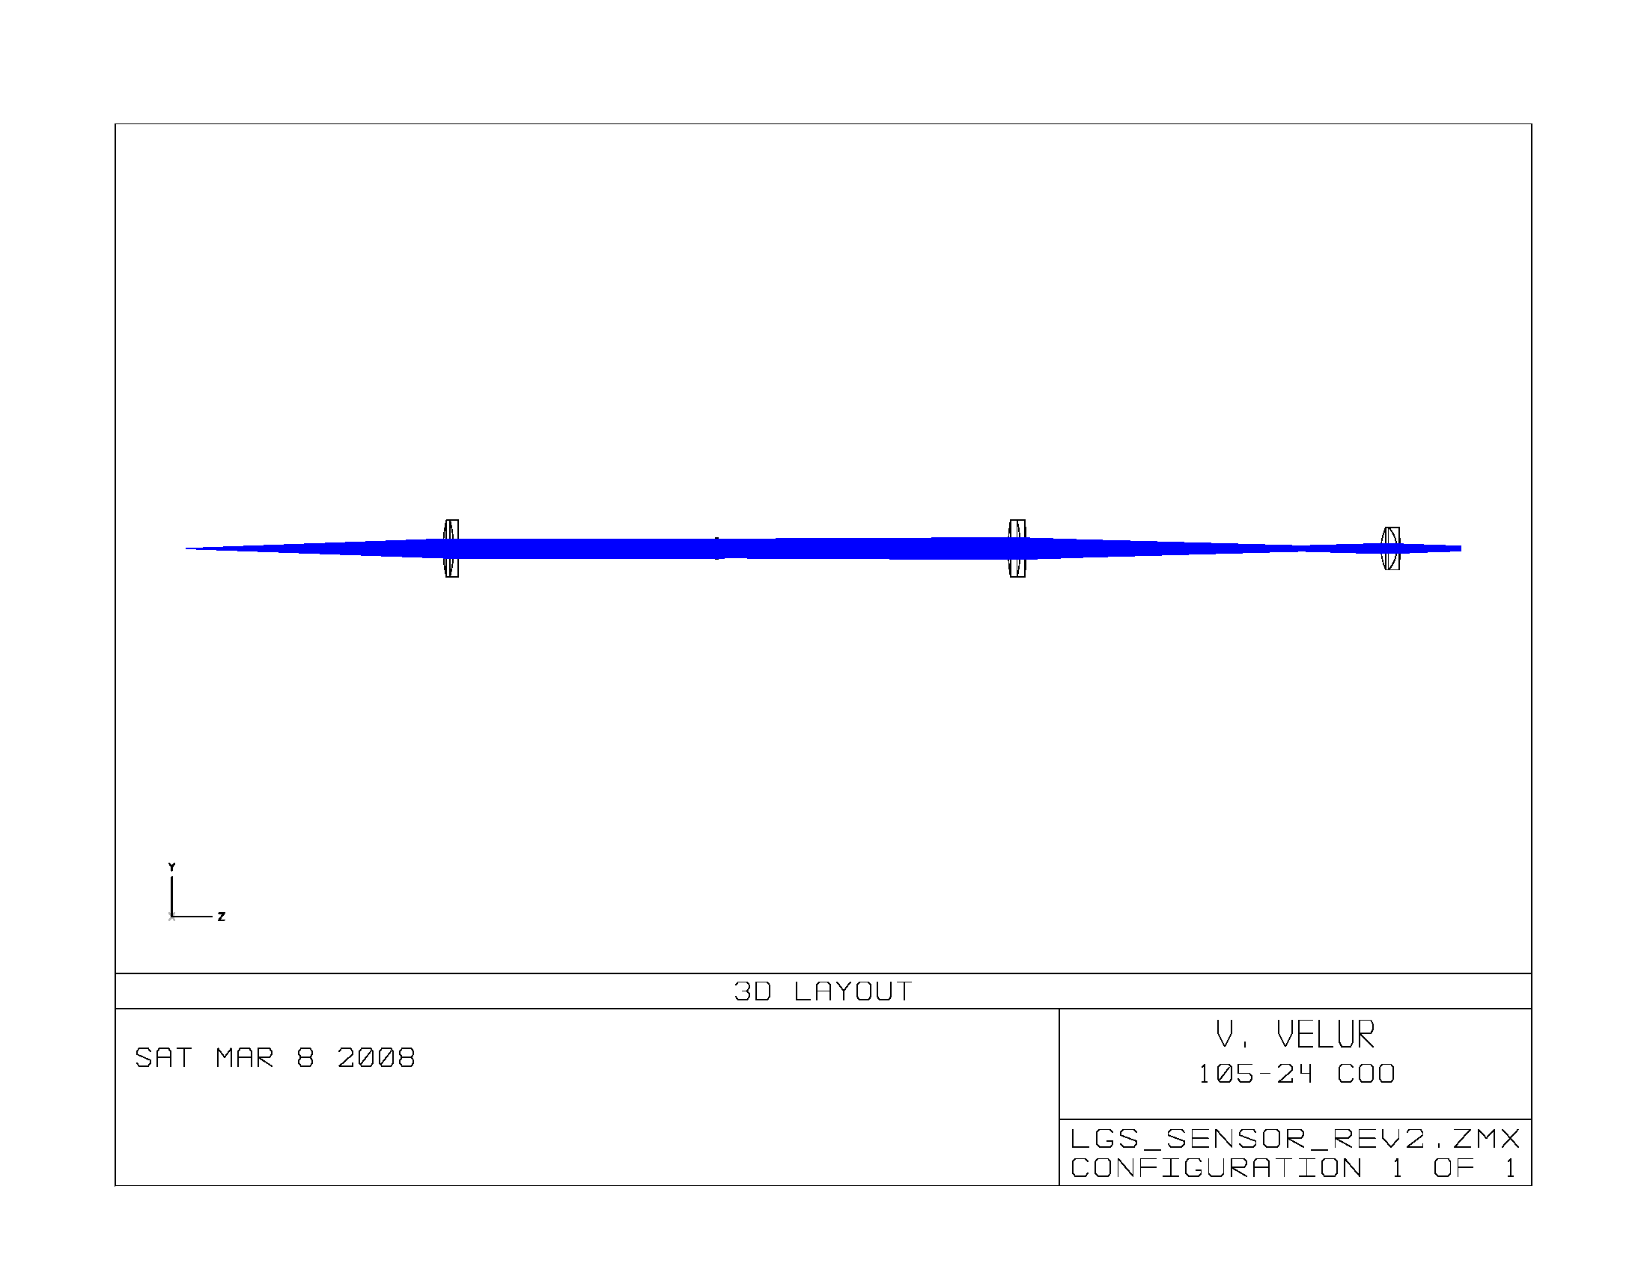
Figure 11 LGS WFS preliminary optical design.
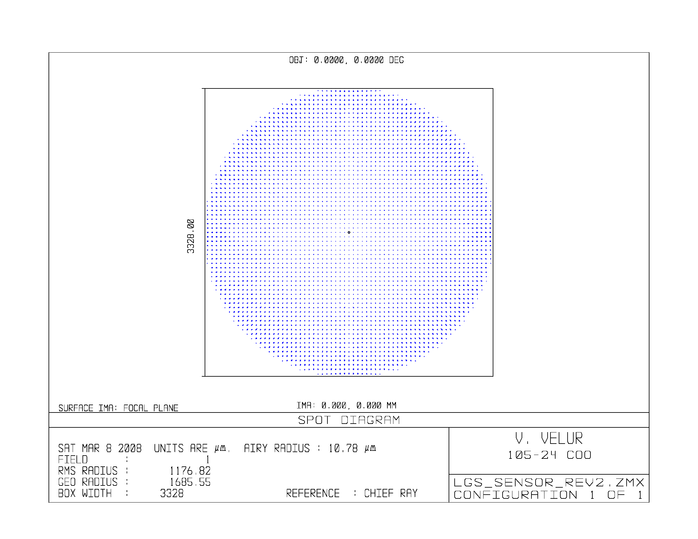
Figure 12 Shack-Hartmann spots on the LGS HOWFS detector; the box shows the outline of a 256x256 pixel detector with 13um pixels.

Motion control of mechanisms in the LGS sensor
The motion control required for a single LGS channel is shown in Figure 13. The list of motion control and tolerances are listed in Table 4. The LGS focal plane as prescribed by the optical design has the following characteristics:
The whole LGS WFS assembly is designed to move to compensate for focal shifts with the 90-180Km mesospheric distance variation (LGS overall travel). This is achieved with a cheap, but heavy duty stage with a high resolution absolute encoder on it. The encoder gives the position of the stage even though it needn’t be controlled very accurately. To account for the curvature of the LGS focal plane with changing asterism radius, each WFS is enabled with individual de-focus of 10 mm with 1 um accuracy, this high resolution stage can deal with the inaccuracies in the overall LGS assembly motion. Multiple pupil sampling scales require a linear stage to exchange lenslets; the smallest lenslet pitch is 0.2 mm so with a 1um absolute resolution stage we can get the lenslet to 0.5% of a sub-aperture. The X and Y stage on the lenslet facilitates both multiple pupil-sampling and aligning lenslet spots to detector crosshairs alignment easier. The absolute resolution of the X Y mechanism on the lenslet changer is set 0.1 um; this is about 0.5% of the finest sub-aperture. The LGS pick offs are depicted in Figure 5, Figure 6 and Figure 7. The orientation of the LGS field WRT to the DM rotates because of using a theta-phi pick off mechanism; a rotary stage is employed to undo this effect and keep the DM and the lenslets registered all the time. This rotation of each WFS channel is dependent on the position of the theta-phi mechanism and is envisioned as a onetime adjustment for each observation. There are 8 pick-offs that facilitate the nine WFS to guide on stars. KAON 559 elaborates on the pick-offs and their working detail. Please refer to LGSF conceptual design report for details on scheme to realize the flexible LGS asterism. The accuracy for the LGS acquisition is 40 mas (TBC); this # has to be accounted for in the error budget.

LGS wavefront sensor registration and calibration
We have a rotation stage that keeps the woofer DM, NF tweeter DM and each lenslet registered at all times. Since the system is telecentric, field dependent mis-registration is minimal. This effect will be quantified in the PD phase. A detailed procedure to ensure registration between the tweeter, woofer and the lenslets will be documented in the next phase of the project.

The back-up option if telecentricity or other effects make the chief going into the LGS WFS channel tilt:
- The mirrors in the pick-off arm could be used as a pair of periscope mirrors to align pupil and the focal plane.
- We could augment the WFS design to pivot about the focus of each sensor/
- Provide X, Y adjustment for the camera in addition to the lenslet to achieve both registration and alignment to pixel crosshairs. This comes at the cost of being ever-so-slightly off axis on the rest of the WFS optics.

As part of the calibration steps when aligning the instrument in the FD phase, it is advised that a pupil imaging device be built that images the pupil as seen by the lenslet on to a camera and move it around the field to actually measure the pupil shear over the 174” FoV. A method to image the WFS pupil to a detector and mapping the pupil shear over the 174” field from a simulated LGS shall be performed in the DD phase to measure the actual pupil shear and the associated error due to the phenomenon.

More work needs to be done to ensure that each LGS WFS lenslet pupil is aligned to the woofer and tweeter DM and stays aligned in the next phase.

Smart reconstructors that can deal with rotation between the lenslet and the DM will also be investigated in the later stages of this project to understand the noise propagation effects to see if cost reductions can be obtained without compromising performance.
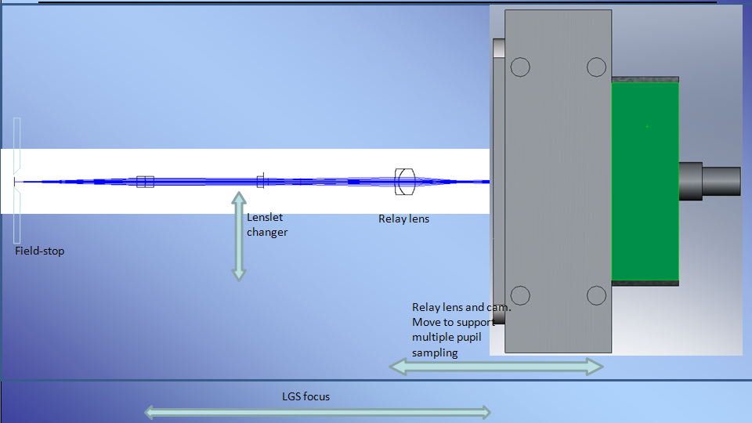
Figure 13 Schematic of a single LGS WFS channel on which 1st order design was based on.

Location | Type | Range of travel | Min. step size (est.)
LGS channel (individual unit focus) | delta Z | ~10 mm | 10 um
LGS lenslet changer | deltaX, Y | delta X = 20 mm, delta Y = 2 mm | 1 um
LGS channel relay and camera focus for pupil sampling change | delta Z | 5 mm | 0.1 um
Pick off (theta mech) | delta theta | 360 deg. | 0.2 (UP)/ 115" (LA)
Pick off (phi mech.) | delta phi | 360 deg. | 0.2" (UP)/ 300" (LA)
LGS WFS unit overall travel | delta Z | 130 mm | 1 mm
Rotation of the WFS (sans the central WFS) | delta (theta-phi) | 360 deg. | 100"
Table 4 Motion control parameters for the LGS WFS. Please refer to OSM KAON for the theta-phi mechanism travel range and tolerance details.

The NGAO LGSF design is expected to keep the lasers fixed with respect on the sky. So in wide field mode, where the K-mirror keeps the stars fixed on the focal plane there is no need to rotate the entire LGS WFS assembly. And in case of high-contrast imaging applications, wherein the pupil is kept fixed at the pupil-stop using the K mirror, in this case the natural stars (or sky) rotates at the AO focal plane. The laser uplink scheme is designed to keep the LGS beacons fixed at the focal plane even during a pupil fixed observing mode. This enables narrow-field high contrast observations. Hence there is NO need for the whole LGS WFS assembly to rotate to track stars in any scenario.

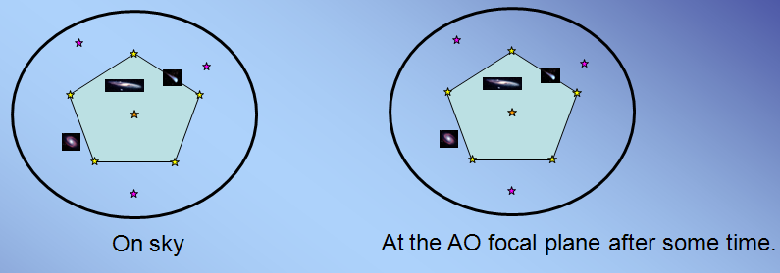Figure 14 Image fixed observing scenario – K mirror keeps the stars fixed on the AO focal plane(s) and hence on the WFS channels. NGAO keeps the LGS stars fixed with respect to the sky and at the detector at all times when observing in WF mode.
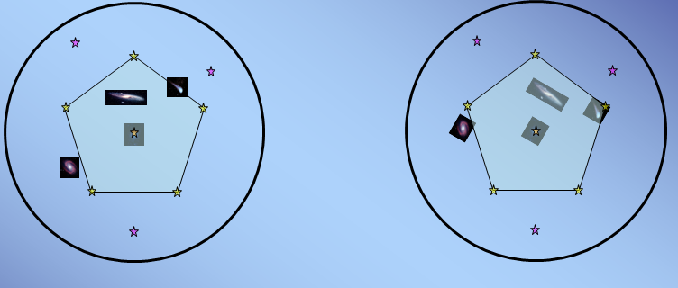Figure 15 Pupil fixed observing scenario – K mirror keeps pupil fixed. This helps calibrate out speckles in high contrast imaging.

Tip-tilt (Focus and astigmatism) sensor:

Figure 16 LOWFS assembly showing four pick off arms. One arm feeds the TTFA/ TWFS assembly, 2 more arms feed the TT sensors and one arm feeds a PSF monitor (not part of the baseline design, so this is a place holder)

Low Order Wavefront Sensors (LOWFS) use natural stars to sense low order modes of the wavefront that are poorly sensed by the multiple LGS. These modes include tip, tilt, focus and astigmatism when the goal is optimizing on axis science performance. When the goal is optimizing science performance averaged over a larger field of view the LOWFS is used to estimate tip, tilt and tilt anisoplanatism modes. A more complete discussion of this issue is included in KAON 492. In both cases these sensors account for the vertical motion of the sodium layer. A trade study was conducted to determine the LOWFS architecture.

There are a total of 2 tip-tilt sensors and one TTFA sensor that are fed by the NGAO wide-field relay. The LGS WFSs and the TT(FA) sensors use the same principle for object selection though their specification and requirements vary. The truth sensor is housed in the same assembly but is discussed later in this report.

TT(FA) acquisition precision is 200 mas by the OSM. The high resolution TT stage on each channel will be used to center the beam on a pixel cross-hair.

Figure 17 shows the schematic of the TTFA sensor. In this scheme both the DM and the lenslet are at the same conjugate as the primary mirror. A variant that has better transmission has also been considered where the DM is at ~20Km conjugate and the lenslet at a pupil. The propagation effects due to scintillation will be studied for this configuration in the preliminary design phase. The OSM design provides a pupil that is accessible to add a pupil stop and make the entire MOAO and WFS channel cryogenic, this option needs to be explored in more detail in the PD and DD phases. Other tests include running the DM on a tip-tilt stage in a cryogenic environment. Figure 18 shows a schematic of the tip-tilt sensor.

The TT(FA) sensors use IR detectors with variable detector read-out zone (c.f. Appendix II of this document). This scheme allows us to deal with extended objects. Some preliminary simulations have been performed to test the validity of our TT(FA) sensing scheme with the plate scale chosen. This study was done as by augmenting the work done in KAON487 with 50 mas/pixel plate scale and extended objects. The concept allows the AO system to guide on MOAO corrected point sources as well as corrected extended objects.

TT(FA) plate scale choice : 50 mas/pixel has been chosen for this design based on optimizing performance by minimizing sky background. The algorithm for centroiding will start off with a larger set of pixels/sub-aperture at the start of closed loop operation and shrinks to a2x2 pixels/subap if and when enough correction is achieved. The level of shrinkage will depend on the amount of correction and the size of the object.

Further work on this LOWFS configuration is being planned for as part of the risk reduction measures for NGAO and this will be followed by more involved system characterization by simulations in the preliminary design phase. Since a lot of the proposed ideas for NGAO’s Low-order WFS are novel, we have allocated funds to perform some prototyping and mitigate risks. KAON 565 elaborates on the prototyping effort to mitigate risks.

Detailed schemes for all required dithering have been identified and the OSM/ WFS concepts have been developed with the input from the science team to accommodate the dither requirements. All the dither requirements and methods of accomplishing the dithers are documented in section 2.3.2 of KAON 562.

TT(FA) registration: With changing field position the OSM rotates the pupil as in the LGS WFS assembly. But, here the woofer DM provides minimal correction and most of the correction is done using the MEMS DM. The lenslets and the detector focal plane mapping doesn’t change. The pupil rotation between the tweeter and the woofer is known quite accurately by means of absolute radial encoders on the OSM motors. Moreover the effect of mis-registration due to pupil rotation is much smaller as all the NGS sensors see a MOAO corrected beam and the optical design is built (wrt conjugates) for NGS light. This effect will be taken into account for generation of the reconstructors. A new reconstructor will be needed for each target.

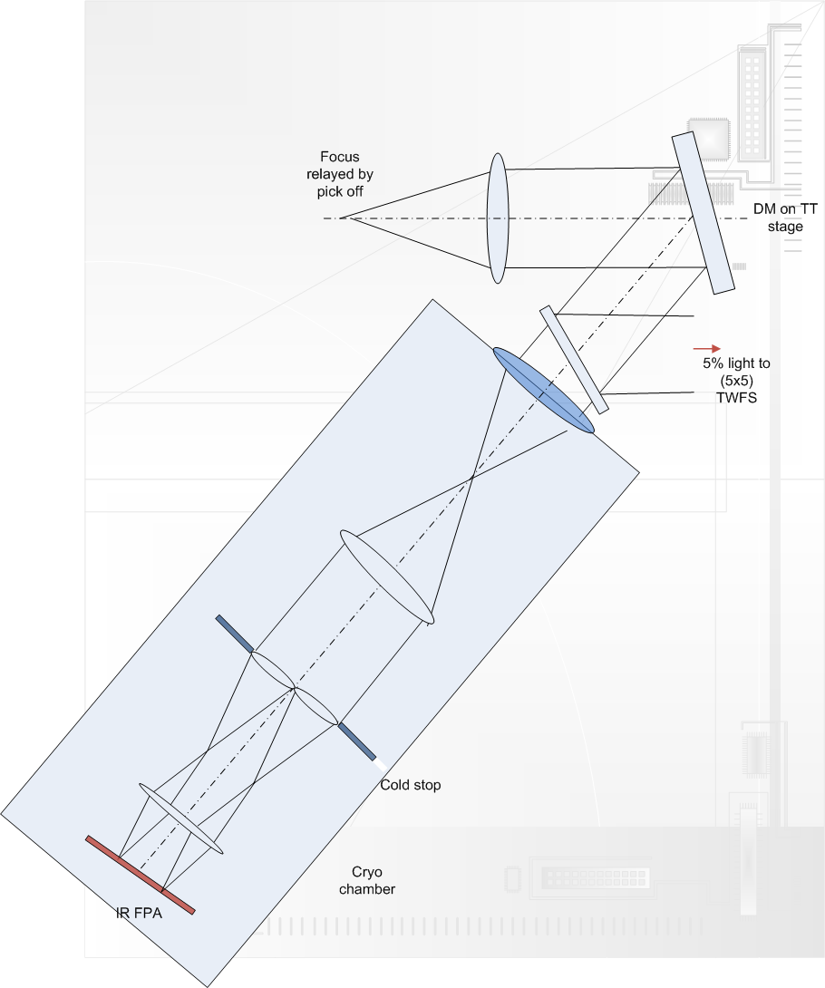
Figure 17 Schematic of the TTFA showing the cold stop and cryogenic part and the (-20 deg C) front end (there is a window between the cold and the cryogenic chamber). The lenslet and the DM are both at a pupil in the above configuration.

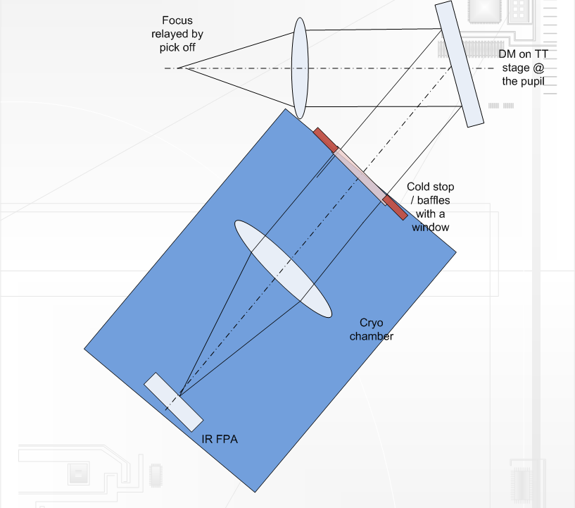

Figure 18 Schematic of the TT sensor design (there is a window between the cold and the cryogenic chamber).

WFS/ parameter | # of subaps | Relay demag. | Pixel size (mm) | Detector Plate scale (arcsec) | pupil size at lenslet (mm) | lenslet pitch (mm) | lenslet FL (mm) | Collimator focal length (mm)
TTFA | 2 | 2.07 | 0.0180 | 0.05 | 12.7 | 6.35 | 177.8515 | 173.05
TT | 1 | 1 | 0.0180 | 0.05 | 12.7 | 12.7 | 85.45 | 173.482
Table 5 TT(FA) WFS 1st order design parameters. TT sensor volume envelope is 500x200x200 mm, TTFA WF sensor’s volume envelope is 900x200x200 mm.

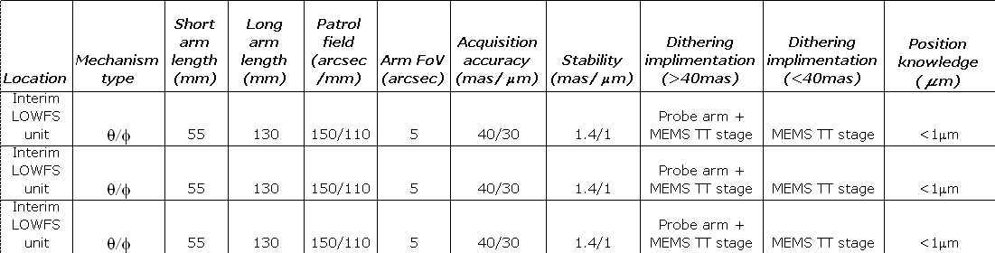
Table 6 Pick off arm specification
"Stability" refers to the movement of a probe arm when the motors are switched off and/or are not moving

Truth or Calibration WF sensors:

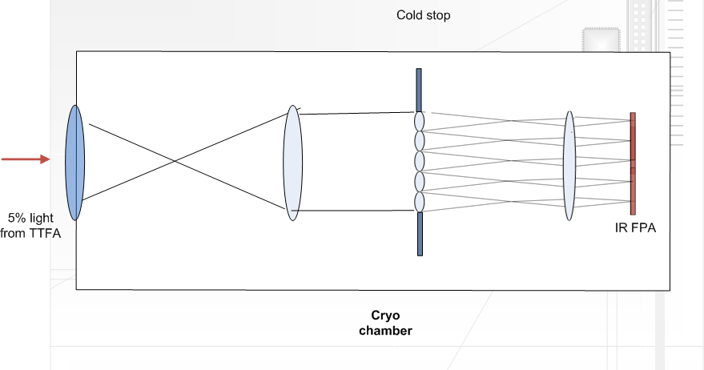
Figure 19 Schematic of WF TWFS. This TWFS channel is similar to the TTFA channel, except for the fact that there is a 5x5 lenslet rather than a 2x2 lenslet. The TWFS is envisioned to work at 0.1-10 Hz and needs only 5% of the light from the brightest star in the field (the TTFA gets to use the brightest star since it’s a 2x2 sensor).
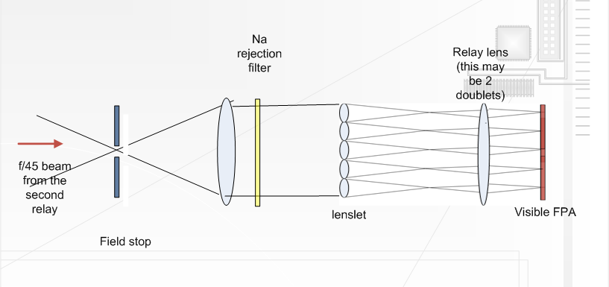
Figure 20 NF TWFS is fed using light from a field star using the same articulated mirror pair as the NGS sensors.

Truth or Calibration Wavefront Sensor is used to calibrate biases that arise when using LGS in an adaptive optics system. The biases are principally caused by the elongated nature of the LGS when viewed by sub-apertures of the laser guide star wavefront sensor and the changing sodium layer density profile. The truth wavefront sensor measures these biases by sensing the wavefront from a point source (a natural star). These biases are slowly varying and are of a low spatial order. So, a natural guide stars WFS using long exposures and only measuring the lowest spatial wavefront error is sufficient.

The truth sensor has been estimated to be a 5x5 sensor with detailed error budgets for the same still in the works. The baseline design will have 2 truth sensors as these sensors are to be placed as close as possible to the science instrument. The WF truth sensor will be an IR sensor while the NF field truth sensor is conceptualized to be a visible sensor. The truth WFS plate scale is estimated to be 0.65”/pixel for the visible sensor and 200 mas /pixel for the IR TWFS. These plate scales are chosen based on spot size calculations in the error budget spreadsheet.

Since the 20x20 woofer mirror won’t deliver a diffraction limited image over the 150” field, theWF TWFS can either be enabled with a separate MOAO relay to guide on a faint star or split (5%) light from the TTFA sensor. The later scheme is attractive since the TWFS is a slow sensor and needs only a fraction of the light feeding the TTFA sensor, at the same time it saves on the cost of the AO relay and the real-time computation hardware/ software to correct in yet another direction. The latter scheme also helps acquire stars faster and is the preferred option for the NGAO system design. The plate scale for the WF TWFS is the same as the TT sensors. The Strehls are estimated at 20% in H-band and 10% in J-band; well within the range to be able to sense TT on the core of the PSF. The design choice is to use feed the WF TWFS using light from the MOAO relay that feeds the TTFA sensor.

The EB tool is being revamped to include the TWFS in the control loop. Currently, a new spreadsheet to evaluate truth sensor SNR and centroiding error has been made. Current estimates suggest that the visible TWFS can go down to 21.5 mag with 10 sec. integration time and achieve 35 nm of total TWFS error.

WFS/ parameter | # of subaps | Relay demag. | Pixel size (mm) | Detector Plate scale (arcsec) | pupil size at lenslet (mm) | lenslet pitch (mm) | lenslet FL (mm) | Collimator focal length (mm)
IR Truth WFS | 5 | 4 | 0.0180 | 0.05 | 14.4 | 2.88 | 390.65 | 196.704
Visible truth WFS | 5 | 4 | 0.0130 | 0.65 | 14.4 | 2.88 | 30.05 | 648
Table 7 Truth WFS 1st order design parameters. Visible TWFS volume envelope is 1600x200x200 mm, IR TWFS’s volume envelope is 1200x200x200 mm.

NGS HOWFS sensor:

The NGS sensor is to be positioned in the narrow field and will be equipped to pick off stars using a field steering mirrors/ dichroics over a 40” field of regard. The dichroic for splitting light the NGS sensor will be the same as that for splitting light for the TWFS. Since the TWFS and the NGS sensor are never to be used simultaneously, it is easiest to use the same articulated dichoric as the first field steering mirror. The NGS WFS and the TWFS are envisioned as separate cameras, instead of the TWFS being a role played by a 5x5 lenslet option of the NGS HOWFS, for the following reasons:

1. NGS sensors are built for speed (low RON but significant dark current). Even though they are at -20 deg. C ambient, this will be an issue. We don't have exact DC #s for the CCID56 detectors.
2. The current Scimeasure control architecture implements CDS method of reading out detectors using a clamp and filter based circuit. This circuit is optimized to work with a finite number of programs (gains, speed with optimized filter and clamp settings) for speeds between 25-2000+ Hz. The TWFS will typically need to run very slowly, 0.01-10 Hz and will need optimized circuitry for that particular application.

WFS/ parameter | # of subaps | Relay demag. | Pixel size (mm) | Detector Plate scale (arcsec) | pupil size at lenslet (mm) | lenslet pitch (mm) | lenslet FL (mm) | Collimator focal length (mm)
NGS WFS | 64 | 2 | 0.0130 | 1.5 | 6.656 | 0.104 | 2.1735 | 299.52
NGS WFS | 32 | 2 | 0.0130 | 1.5 | 6.65 | 0.208 | 2.1735 | 299.52
Table 8 NGS WFS 1st order design parameters. NGS WFS volume envelope is 1000x200x200 mm

WFS type | Length in Z [mm] | Breadth X [mm] | Width Y [mm] | # of sensors | Pick off mech. | Cooling
LGS WFS | 850 | 150 | 150 | 9 | LGS theta-phi | 3 stage Peltier
NGS WFS | 1700 | 150 | 150 | 1 | Chris and Reni's dichroic and steering mirror mech. | 3 stage Peltier
NF truth sensor | 800 | 150 | 150 | 1 | Chris and Reni's dichroic and steering mirror mech. | 3 stage Peltier
WF truth sensor | 1200 | 150 | 150 | 1 | TT/ Truth theta-phi | Cryotiger
TT | 900 | 150 | 150 | 2 | TT/ Truth theta-phi | Cryotiger
TTFA | 900 | 150 | 150 | 1 | TT/ Truth theta-phi | Cryotiger
Table 9: WFS volume table

NGAO WFS parts | Charecteristics | # of units | Comments
CCD detectors | 256x256 pixels, read out @ 2000 Hz with <3 e- RON and <500 e-/pix/sec DN @ operating temp. | 10 | 9 LGS WFS + 1 NGS WFS
Truth sensor (visible) | 240x240 pixels read out at 0.01-200 Hz with 0.001 e-/pix/sec DN and <3 e- RON | 1 | truth sensor NF
Truth sensor (IR) | H1RG read out at 0.01-200 Hz with 0.001 e-/pix/sec DN and 7 e- RON (after 8 Fowler samples). We only need one quadrant of the detector | 1 | truth sensor WF
IR detectors | H1RG with <7 e- RON with 8 Fowler samples, data rate = 500 Hz at this RON spec for the entire chip, DC = 0.001 e-/pix/sec @ 73K. # of active pixels = 256x256 continuous. We only need one quadrant of the detector | 3 | 2 TT and 1 TTFA sensors
Stages | See table 3 | see table 3 | separate table
Pick off arms | See KAON 562 | 8 LGS pick offs + 3 TT pick offs
Optics | See table 5
Table 10: List of the major components required for the WFS subsystem.
- *-Teledyne does sell H1RGs that have a quadrant working perfectly, costing for these chips are usually done by the fractional area that works.

WFS optics table (preliminary) | Optic | Quantity
NGS WFS | Collimator | 1
 | Lenslet array (64x64, 32 x 32) | 2
 | Relay lens | 1
 | Focusing lens | 1
 | Field stop | 1
LGS WFS | Collimator | 9
 | Lenslet array (64x64, 32 x 32, 16x16) | 3*9
 | Relay lens | 9
 | Focusing lens | 9
 | Field stop | 9
TTFA sensor | Collimator | 1
 | MEMS mirror | 1
 | TT stage (on which MEMS mirror is mounted) | 1
 | lenslet array (2x2) | 1
 | Relay lens | 1
 | Focusing lens | 1
 | Cryo chamber | 1
 | Cold pupil stop | 1
TT sensor | Collimator | 2
 | MEMS mirror | 2
 | TT stage (on which MEMS mirror is mounted) | 2
 | Relay lens | 2
 | Focusing lens | 2
 | Cryo chamber | 2
 | Cold pupil stop | 2
truth sensor (WF) | Collimator | 1
 | TT stage (on which MEMS mirror is mounted) | 1
 | lenslet array (5x5) | 1
 | Relay lens | 1
 | Focusing lens | 1
 | Cryo chamber | 1
 | Cold pupil stop | 1
truth sensor (NF) | Collimator | 1
 | Lenslet array (5x5) | 1
 | Relay lens | 1
 | Focusing lens | 1
Table 11: Table of optics required for the different WFS channels

Appendix I

Glossary:
Invisible modes Invisible modes: Some part of the modal content of atmospheric turbulence falls into a category called invisible modes, signifying that they are registered as zero measurements by all the WFSs, but in between the WFS beacons they are non-zero and contribute to the wavefront error seen by a science instrument. In the case of laser guide star (LGS) beacons, these modes also become non-zero for beams focused at infinity in the direction of the LGSs. These modes are by necessity three-dimensional, and are rendered invisible to the AO system by a conspiracy in which modes at different altitudes cancel out within the beam print to leave only piston in each beam, which is not sensed.

Null-modes (also Blind-modes) Null-modes (also Blind-modes): A special case of invisible modes are the so-called null-modes, which are particular to a LGS-based tomography system (as opposed to NGS-based). The null-modes arise from combinations of modes that only cancel out partially and leave, in addition to piston, also linear (i.e. tip/tilt) terms in the beam. When these terms are filtered in a LGS system, due to the tilt determination problem with LGSs, the result is a loss of information that renders the system blind to these modes as well. These differential tilt modes (sometimes called plate-scale modes because of their effect, or null-modes because they belong to the null space of the LGS interaction matrix) are produced by a combination of quadratic modes (e.g. focus, astigmatism) occurring at different altitudes. Hence, in the Kolmogorov model of atmospheric turbulence, these modes have relatively large weights in the turbulence power spectrum, and the impact of not correcting them can be severe

DM Tilt Anisoplanatism Modes The DM Tilt Anisoplanatism Modes are (typically) three modes of deformable mirror commands in an MCAO system that compensate for tilt anisoplanatism over an extended FoV without introducing higher-order wavefront errors. The real time control system controls these modes based upon tip, tilt, focus, and astigmatism measurements from natural guide star (NGS) wavefront sensors (WFS), and possible the focus and astigmatism modes of laser guide star (LGS) WFS measurements.

Object selection Mechanism is a contraption that helps the Multi-object Deployable Near-IR IFU and TT(FA) select field stars/ objects.

Appendix II
LOWFS simulation additions – an addendum to KAON 487

Ralf Flicker (rﬂicker@keck.hawaii.edu)
Abstract:
This is a memo summarizing the detector and guide star modifications that have been implemented in the LOWFS simulation code since the NGAO LOWFS architecture trade study. The simulation was described in more detail in KAON 487; this brief note only outlines a few additional features.

- Extended reference source
A simple model for extended reference sources was implemented by a flux-preserving convolution with a uniform disk of a given diameter. In incoherent imaging, the image in the far field can be described by the PSF of the imaging system convolved with the source intensity distribution. This was implemented in the LOWFS code by multiplying the instantaneous speckle OTF in each sub-aperture with a jinc function, being the Fourier transform of a disk:
Where, θ is the radius of the disk, λ is the wavelength, and ρ is the radial spatial variable.

- Variable detector read-out zone
Instead of designing the LOWFS sub-aperture detectors with a fixed read-out zone, the number of pixels in a square box can be varied. The idea is that this will allow one to design a smaller plate scale than traditionally for Shack-Hartmann sensors, which will take better advantage of the partially corrected spot provided by the high-order AO system. Example figure 1 shows a simulation where the pixel size is 50 mas, and the the initial (maximum) read-out region is a 8x8 pixels. The fact that the plate scale is small makes the sky noise negligible, and the performance is entirely read-noise limited. Initially the LOWFS detector read-out zone has to be large, while the high-order system is closing the loop. After convergence, the LOWFS detector read-out region can be shrunk down to increase sensitivity and SNR. In the case of extended reference sources, as in example figure 2, the read-out zone can be adjusted to match the size of the object in order to optimize SNR.

- Variable centroiding algorithm
In addition to varying the read-out zone, the centroiding method can also be adjusted in real-time. When the read-out zone is larger than 2x2 pixels, one can choose between a weighted center-of gravity calculation or the simple quad-cell formula (for 2x2 pixel read-out they are equivalent). The quad-cell formula bins the quadrants in software if there is no on-chip binning facility. This means that we still get the full contribution of read-noise in each pixel. For extended sources and large read-out zones, however, it seems likely (to be verified) that the quad-cell formula will work better since it does not amplify read-noise in along the perimeter of the detector region, but instead averages the read-noise from all pixels in a quadrant evenly weighted. The purpose of using the weighted COG formula is to extend the linear response of the sub-aperture, a function which only is valuable when the excursions are large and the noise in the outer rings of the detector read-out zone is small.

Figure 21 5 milli-arcsecond diameter LOWFS reference source.

Figure 22 200 milli-arcsecond LOWFS reference source.

KAON 499 - NGAO Architecture definition, Aug. 2007.
KAON 546 Opto-mechanical design for the Keck NGAO cascaded relay
NGAO error budget spreadsheet
KAON 569 – NGAO non-real time controls
KAON 559 - NGAO object selection mechanism conceptual design report
KAON 570 – NGAO laser guide star facility conceptual design report.
KAON 492 - Null-modes and quadratic mode tomography error in LGS-based multi-beacon tomography AO systems
KAON 487 – NGAO trade study report for LOWFS architecture.
KAON 562 - NGAO object selection mechanism conceptual design report
KAON 565 - Prototyping for the NGAO LOWFS assembly

