Optical Bench Mechanical Layout

Overview
The mechanical layout for the optical design of NGAO is described in the following section. The final product, aside from this write up, is a Solidworks Assembly CAD model. The model files reside on the Caltech PDMWorks server. Some of the model development was done using Autodesk Inventor and then imported into Solidworks.
This mechanical design effort was primarily a packaging and clearance study using light path volumes exported from the optical design, and estimated volumes for the instruments, optical mounts and mechanisms that make up the system.

No detailed component design/selection was undertaken in this phase, and it follows that flexure and vibration analysis are intended for subsequent design phases. Also, some of the optical elements in the model are surrounded by ample clearance for whatever mount requirements might be necessary. Often in these cases, no further mount envelope was explored. For this reason, however, the reader may see components of the model “floating” above the level of the base table. Figure 1 below shows the overall layout and identifies the primary components of the system. Figure 2 shows the overall dimensions of the current model.

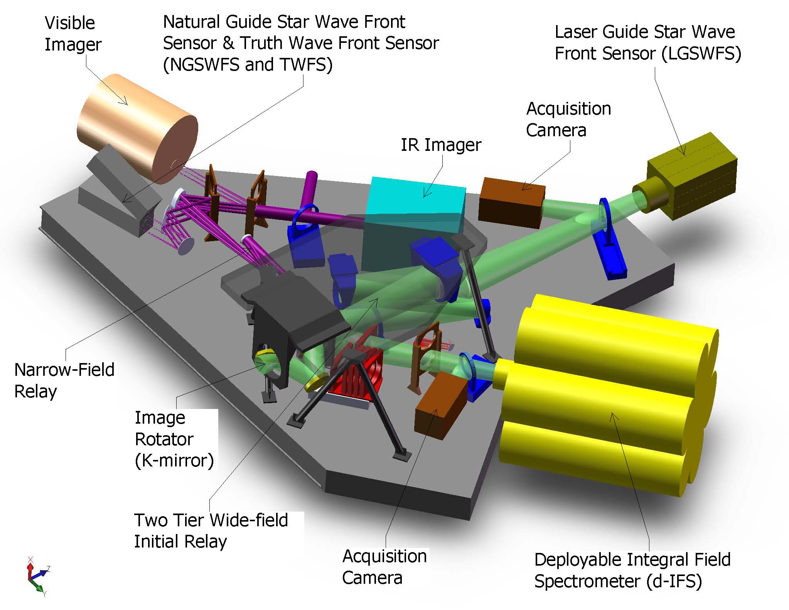
Figure 1: NGAO Overall Layout

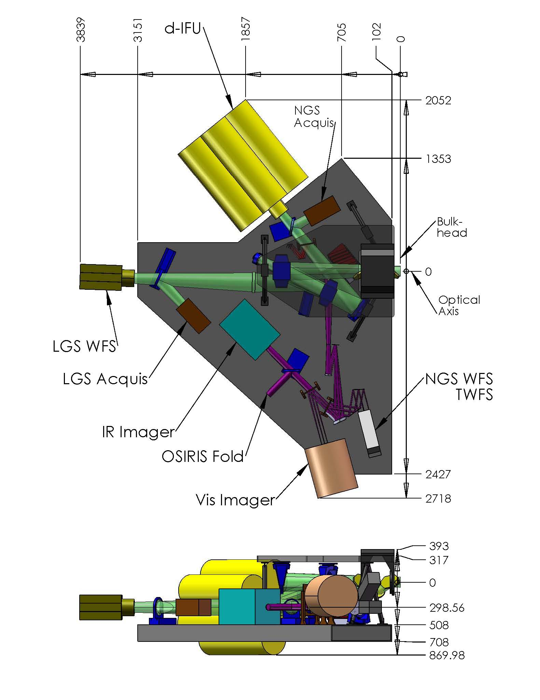
Figure 2: Bench General Dimensions. Shown above are elevation and plan views of the NGAO bench. Dimensions are millimeters. The datum is the intersection of the optical axis and the bulkhead. All “boxes” that receive light have been labeled for reference. It can be seen in the elevation view that the table resides at roughly 700mm below the optical axis – or about half the clearance to the Nasmyth Deck. (Note: table thickness is only 200mm and will likely increase.)

Two-Tiered Initial Relay
Several optical designs were attempted in order to produce un-vignetted light paths, acceptable locations for focal planes, and clearance for supports and mechanisms. The 1st relay of the two-relay NGAO system is similar to the existing Keck AO system. And probably in a similar evolution, it became apparent that without a fold in the 1st relay of the new system the various foci would end up in difficult and in some cases impossible positions.
This fold mirror along with the low-order deformable mirror allow for a periscope type split level relay. Solutions were explored for both in-plane, and split-level (or two-tiered) solutions. The least difficult configuration to package was a two-tier design shown below in Figure 3.
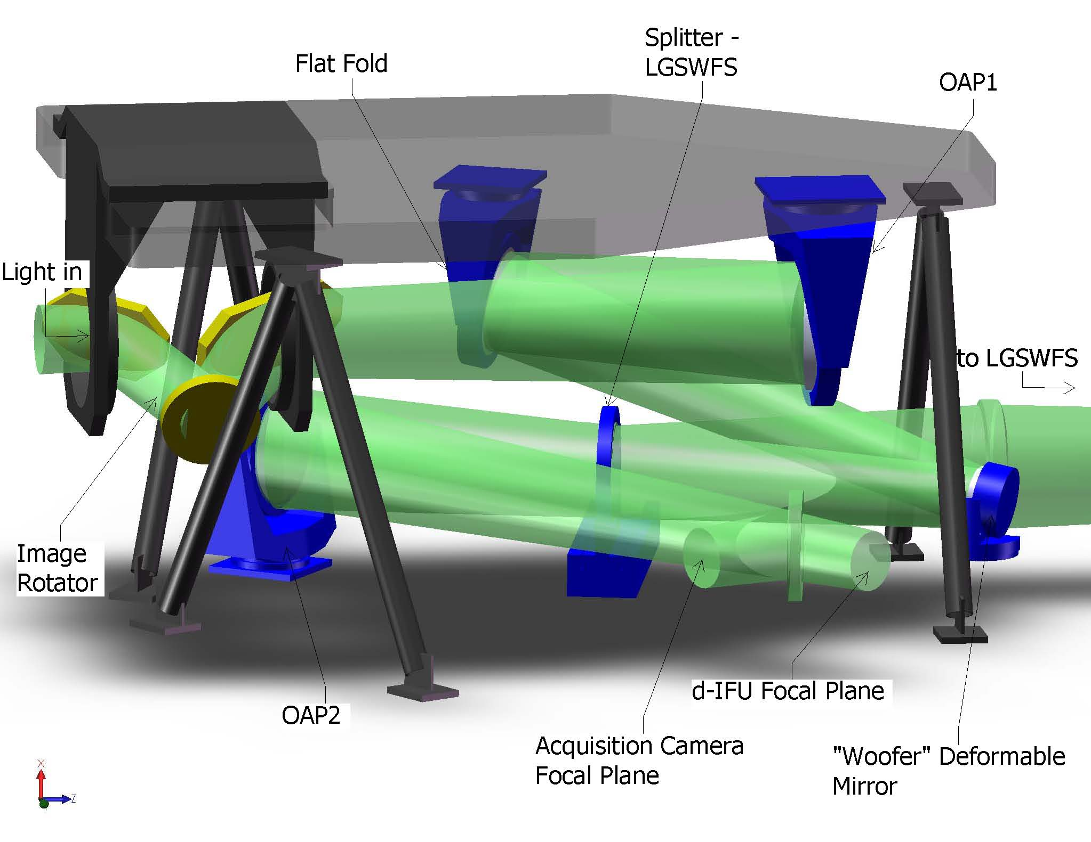
Figure 3: 1st Relay – Isolated. This figure shows the elements of the Two-Tiered 1st relay. Light enters from the telescope at left, travels through the rotator to OAP1, to the flat fold, to the Woofer DM at the pupil. It proceeds to a dichroic that splits light to the LGSWFS and OAP2. From OAP2 it travels to the d-IFU focus. A (retractable) mirror is also shown just prior to this focus to steer the light into an Acquisition Camera for NGS mode.

This configuration requires three components – the rotator, the flat fold and OAP1 – be suspended above the main table. (The rotator is mounted on the top tier to make clearance for the narrow-field dichroic changer discussed in the next section.)
The motion control required in this portion of the system is as follows. The K-mirror rotates. The LGSWFS splitter must move in and out. First order corrections occur by tip/tilt control of the mount on which the woofer deformable mirror sits. And finally the acquisition camera pickoff mirror must also move in and out. Motion control requirements are also captured in Table 1.

Narrow Field Science Light
Not shown in Figure 3 above, directly after OAP2, is a multiple-dichroic changer. This splits light off to the NGAO narrow field, high-order relay and instruments. Light travels from this dichroic, though an intermediate focus to OAP3. It proceeds to the “tweeter” MEMs deformable mirror, to OAP4. The corrected output from the relay is then split off in various combinations to wave front sensors and instruments. This is shown in Figure 4 below.
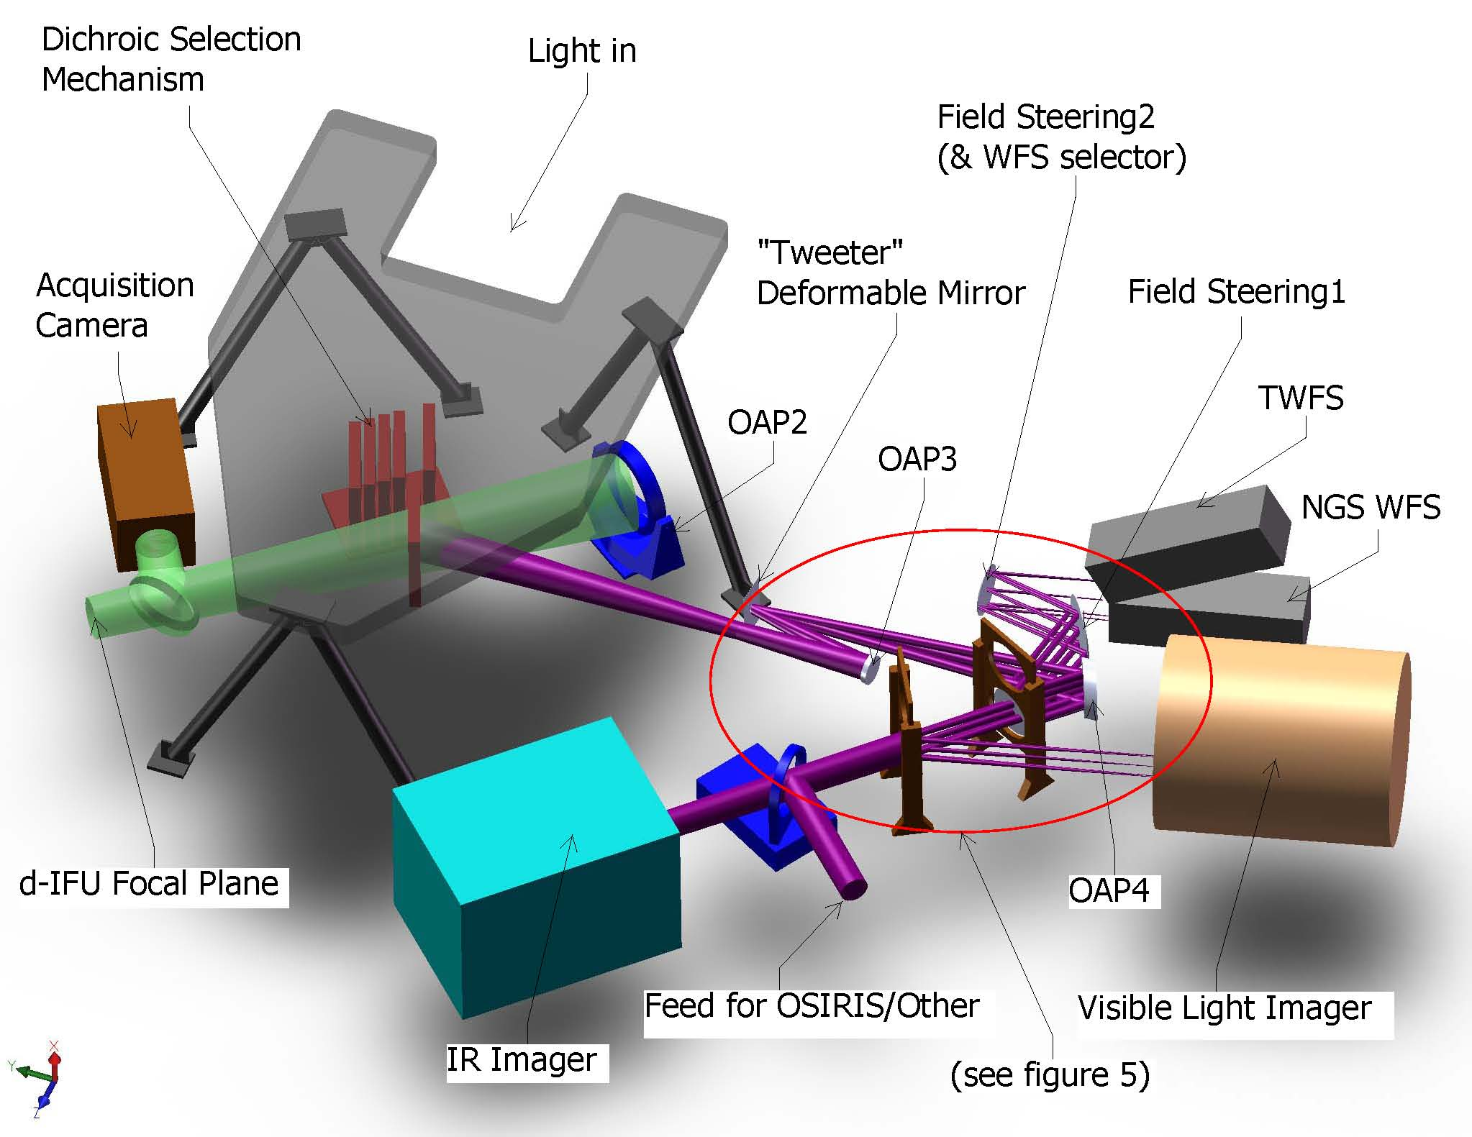
Figure 4: Narrow Field Path- Isolated with 1st Relay Output, Dichroic Changer and Acquisition Camera. Note that the 2nd steering mirror – Field Steering2 – is also used to select between the TWFS for LGS mode and the NGS WFS for NGS mode.

The central portion of the narrow field relay around the OAPs is fairly crowded. Figure 5 is an enlarged view of this region. Note that the light paths shown are a combination of full envelopes (created in CAD) and field bundles (exported from ZEMAX). This was necessary due to some ZEMAX entities not exporting as valid solids. Hopefully this is not too confusing.
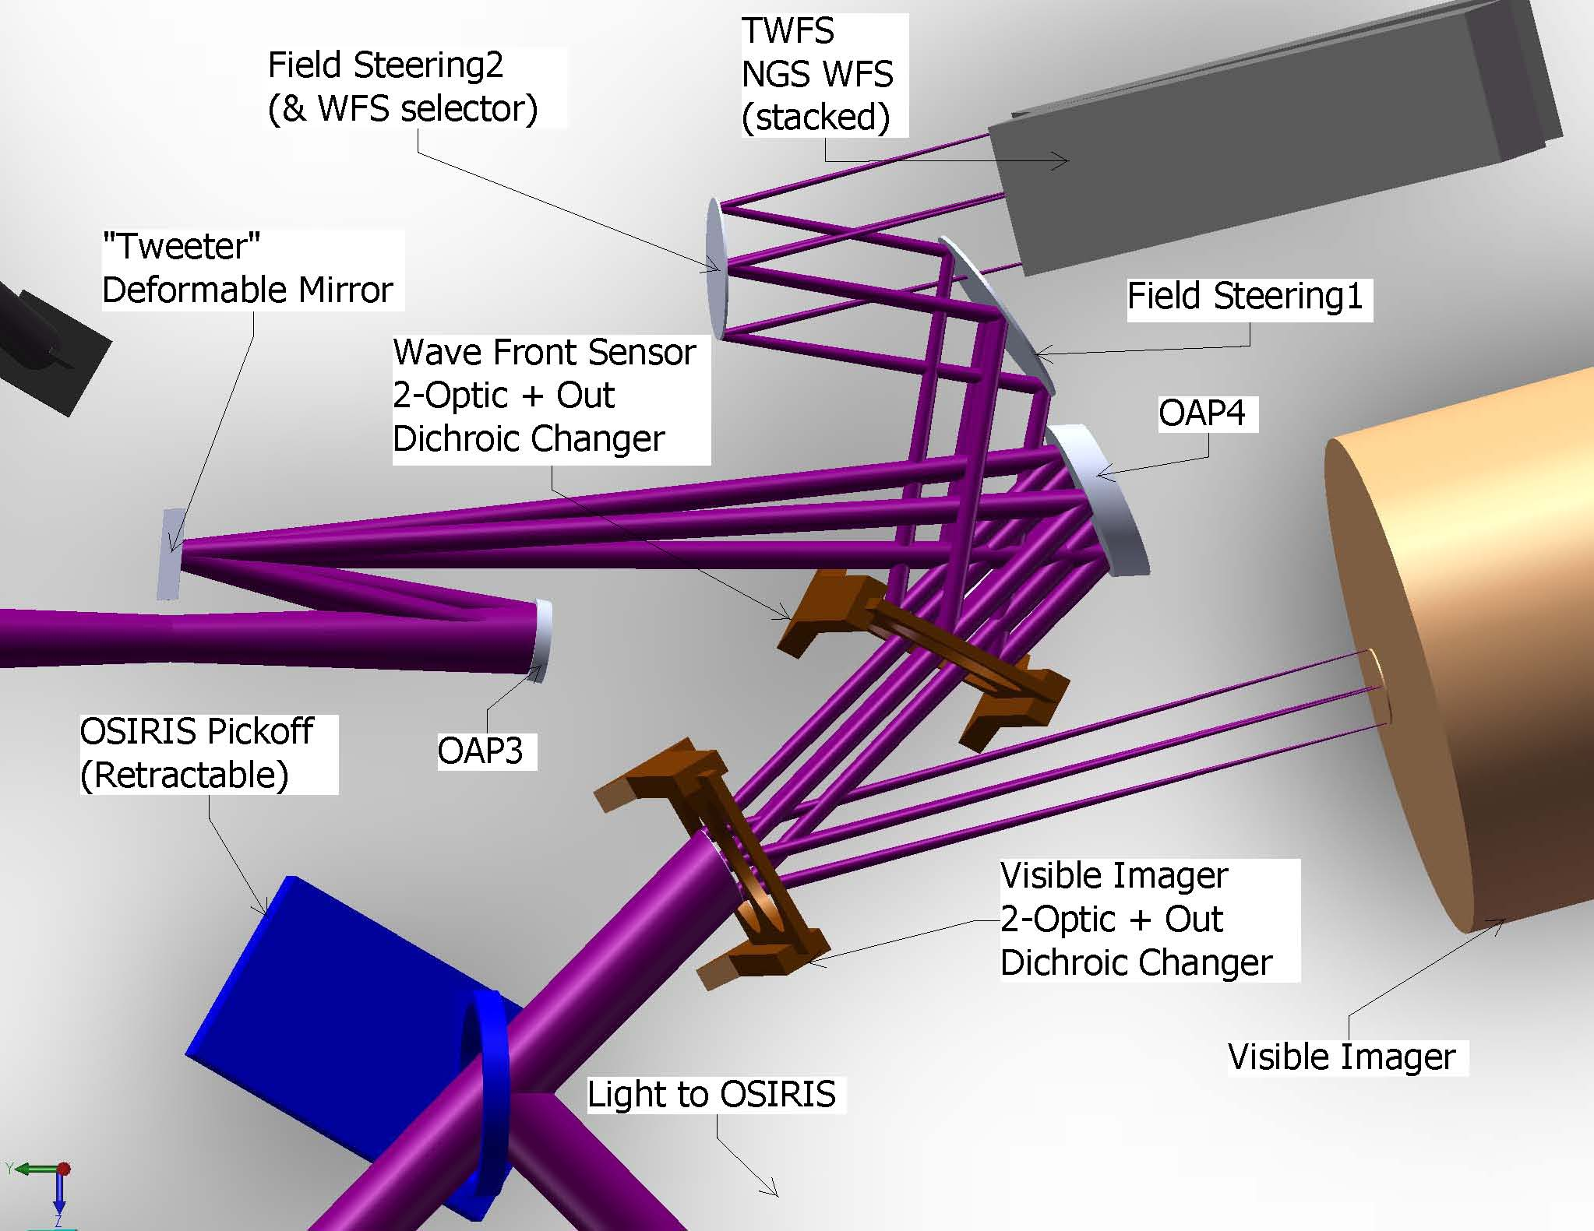
Figure 5: Narrow Field Path Output detail. Note that it appears that Field Steering1 mirror vignettes the light traveling to the wave front sensors. This is however, the available field for natural guide stars – not the field required for the wave front sensors. The wave front sensors accept a much smaller field.

Motion control in this portion of NGAO is as follows. The MEMs deformable mirror also has real-time 1st order correction via a tip/tilt mount. The splitter for the wave front sensors has 3 positions – two optics and one open. This is also the case for the visible imager splitter. A fold mirror can be inserted to redirect light from the IR imager to OSIRIS or its successor. (Note that this leg terminates at a focus as the requirements here are not yet fully defined.) And finally a pair of field steering mirrors, each with tip/tilt control, feeds and selects one of two wave front sensors.

Laser Guide Star Wave Front Sensor & Interferometer Pickoffs
The Laser Guide Star Wave Front Sensor (LGSWFS) pickoff is a splitter, inserted (and retractable) into the collimated beam between the woofer deformable mirror and OAP2. This is shown in Figure 6 below.

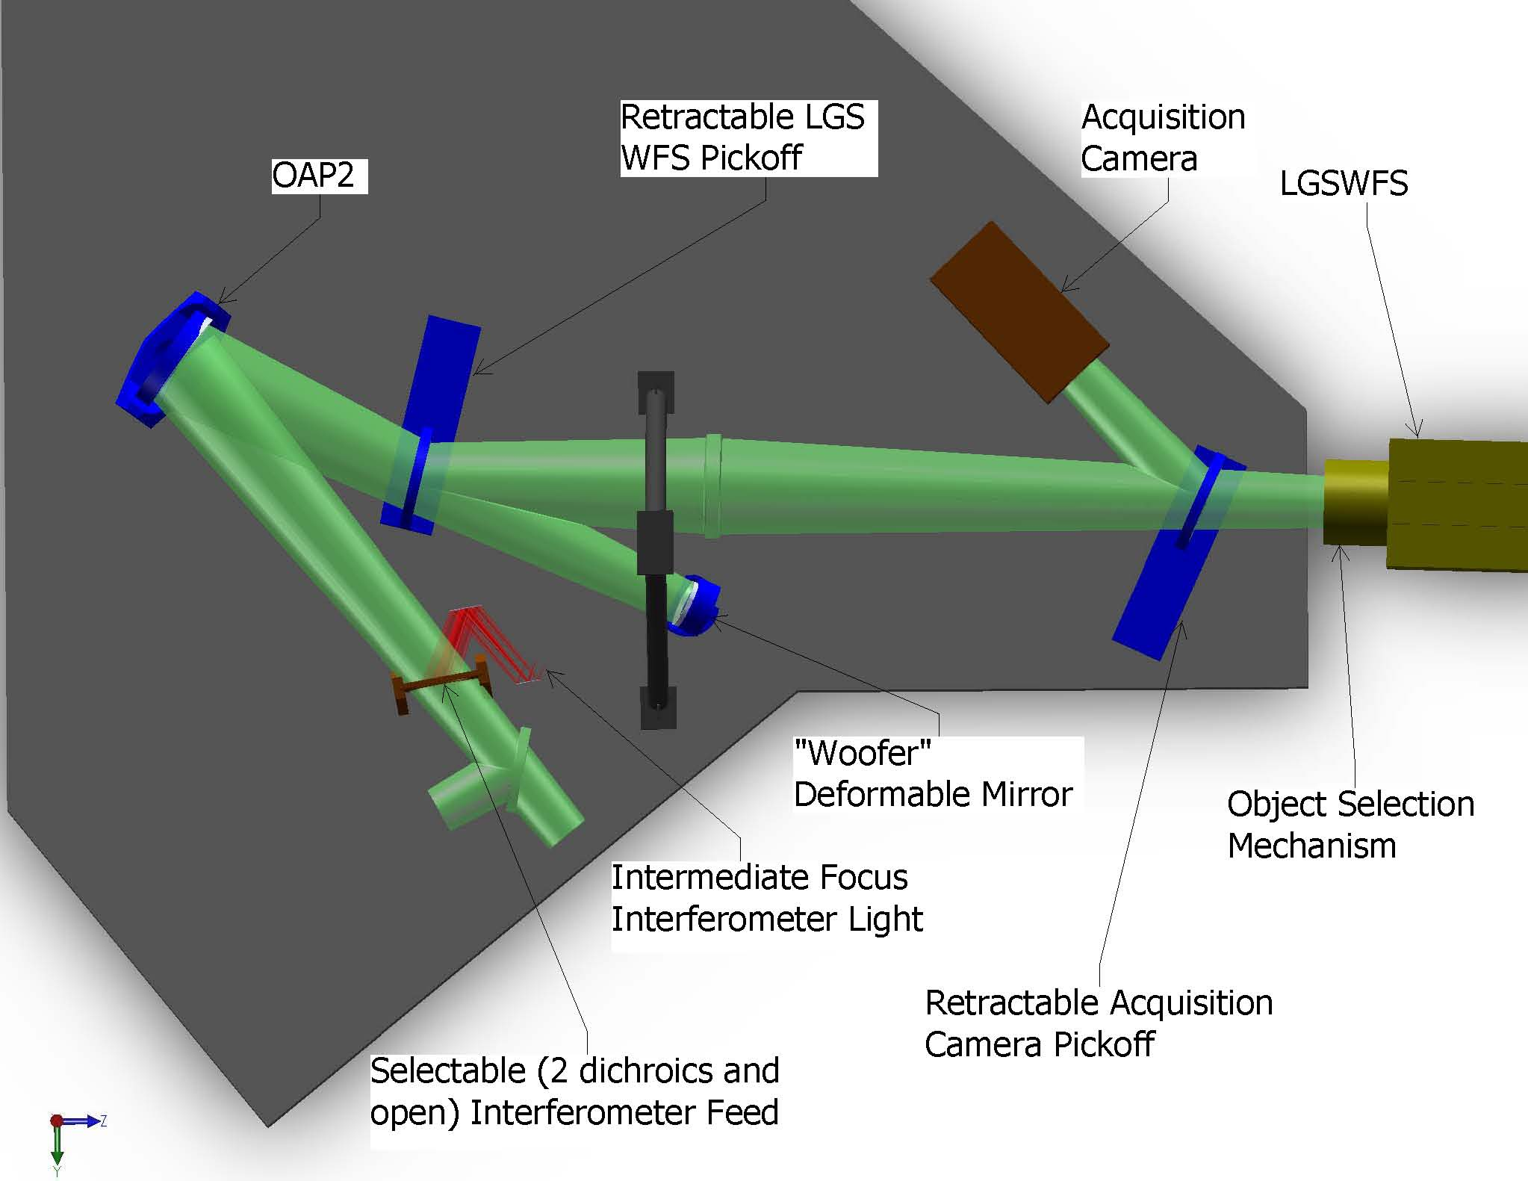
Figure 6: Laser Guide Star Wave Front Sensor & Interferometer Pickoffs

The Interferometer pickoff can also be seen in Figure 6 above. As with the OSIRIS pick of previously discussed, this leg terminates at an intermediate focus as the requirements here are not yet fully defined.
Motion control requirements here are two retractable optics (in or out) and a 3-position selectable dichroic for the interferometer feed.

Structure
The two-tier 1st relay requires a platform elevated above the level of the main optical table. Three components are suspended from the under side of this platform: OAP1; flat fold mirror; and the image rotator (K-mirror). This was shown previously in Figure 3. The structure is shown by itself below in Figure 7.
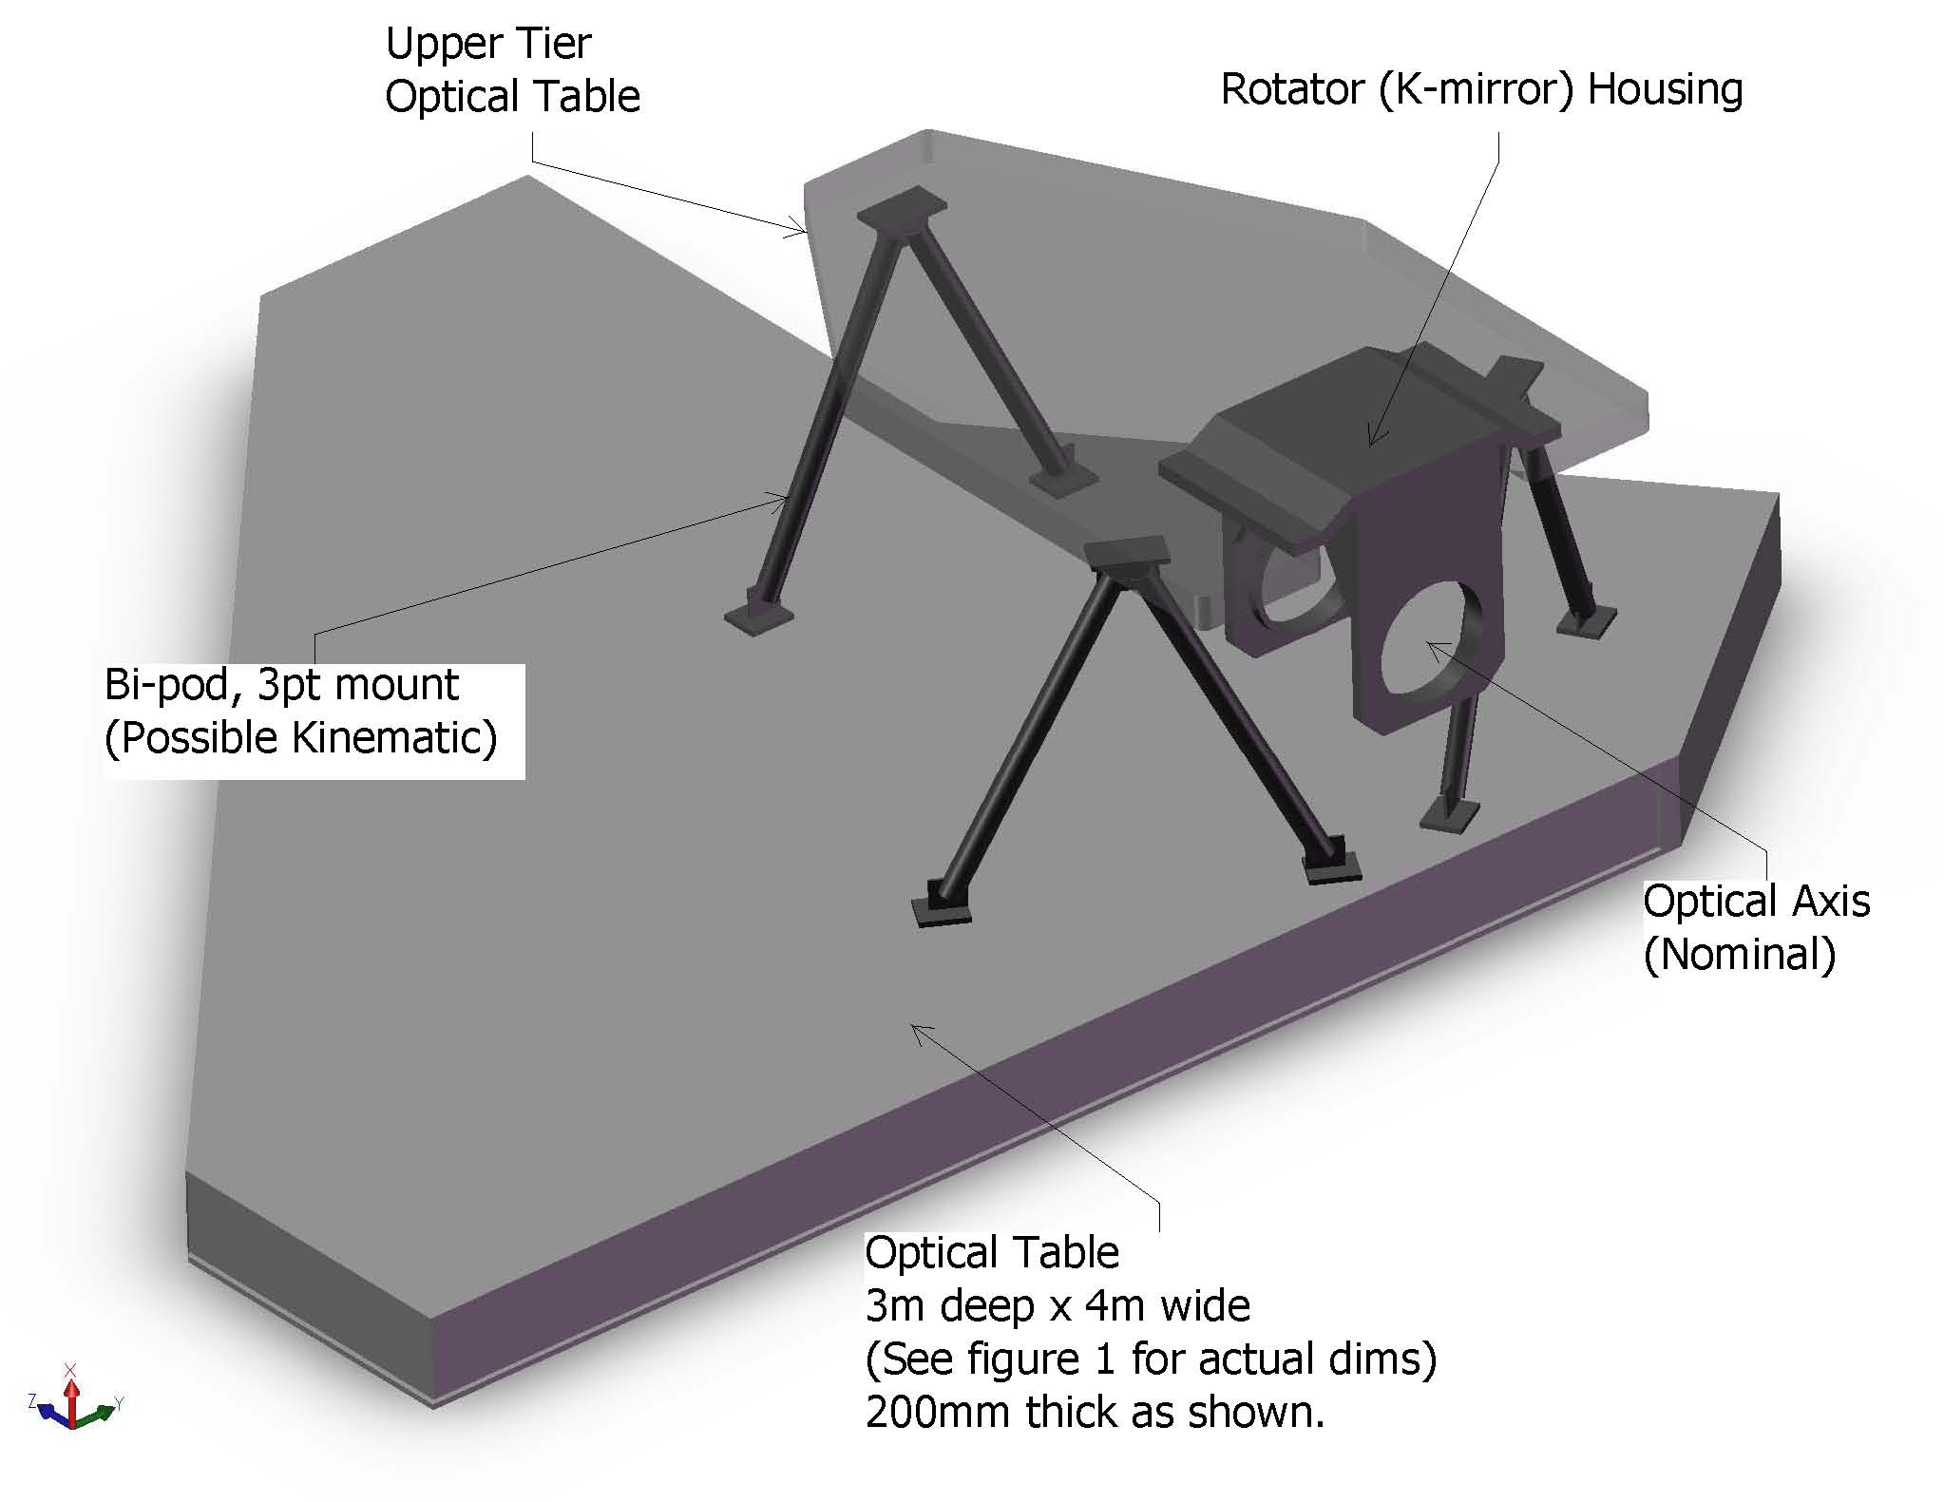
Figure 7: Structural Components of NGAO

The upper and lower tiers are expected to be typical honeycomb core optical tables of custom plan form. Thickness determination will occur is subsequent design phases. The separation of these two is accomplished with three bi-pod struts. If necessary, there is clearance to make these tripod struts, allowing kinematic mount detail for the upper tier.

Attachment to the Nasmyth deck is covered in the Enclosure section, but will likely be a similar approach to that just described. Note that the elevation of the top of the main table, above the Nasmyth deck is approximately 1 meter. Therefore the gap between the underside and the deck is likely to be around 700mm. This is not a lot of surplus clearance. Close attention will be paid this issue in the next design phase.

Component Breakdown
Table 1

