Conceptual Design of the Keck NGAO Relay

Brian Bauman and Don Gavel
August 21, 2007

DG added the following drawing, a “side view” concept of the first relay, based on the conversation with BB:

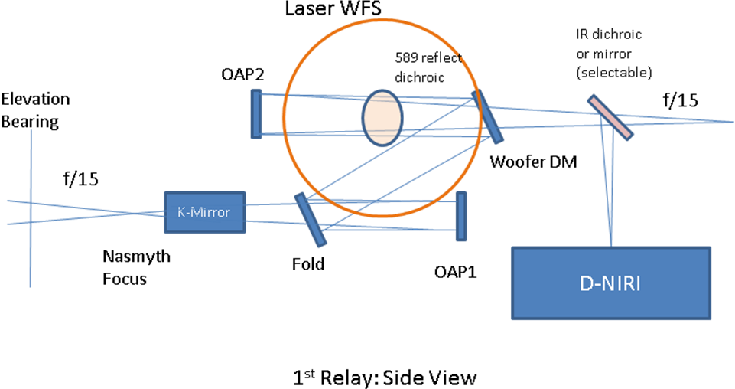

Brief description of the optical path:

Tertiary to K-mirror derotator

The f/15 light comes in from the telescope tertiary to Nasmyth focus. There is a window (not shown) through which the light passes into the cold optics space (containing all the optics shown here). A K-mirror field derotator is just after focus. An option would be to put this before focus but would require a snout into the elevation bearing area. This front space (ahead of focus but in the cold chamber) is also where the ADC prism would be located (Brian to provide further drawing refinement showing this). Ahead of the front window is a deployable mirror which can be used to split in a calibration source.

First relay (K-mirror to the second f/15 focus)

After going through the K-mirror, the first OAP collimates the beam when it reaches a size of 100 mm diameter. After this is a first fold mirror and second flat mirror. The second is located at a pupil, which the nominal position of a woofer DM. The first fold flat is roughly at 10km conjugate, which allows retrofitting a second DM for MCAO operation if this is called for at some future date. The two flats act together as a periscope to bring the beam out of plane. The second drawing shows a side perspective. (This drawing is notional and probably not exactly to scale). The beam is brought up to a second level and the remaining optics are parallel with the first level (and to the optics table). The second OAP focuses the light to a second f/15 focus. On the way to focus are two dicroic spliters in the path, one to selectively feed 589 nm light to the laser guidestar wavefront sensors and one to feed selected infrared light to D-NIRI and the natural guide star tip/tilt sensors. The second dichroic will be deployable according to the science observing mode.

Second relay

The second f/15 beam is fed to OAP3 which collimates the light at 25mm beam size and forms a pupil image at a MEMS DM. OAP4 then focuses the output light at f/45 which allows room for a switchyard into multiple science instruments.

Notes from Brian Bauman:

Attached is a ZEMAX file showing several paths in the cascaded relay layout. This is a 1:1 OAP-based woofer relay followed by a 1:3 (f/45 out) OAP-based tweeter relay. There are several configurations, numbered as follows:
1. narrow field (30 arcsec)
2. 120 arcsec, no dichroics (reference only)
3. LGS WFS, 90 km range
4. LGS WFS, 180 km range
5. d-NIRI/LOWFS
Narrow-field performance is <25-30 nm rms across a 30 arcsec field. The d-NIRI/LOWFS field is <50 nm rms for 120 arcsec diameter, and degrades with the square of the field (astigmatism dominated). The system can pass a 180 arcsec field, but performance (both in imaging and pupil aberration senses) is not covered by the warranty.
Packaging is accomplished here by bringing beaming to a second level, using the fold mirror (that follows OAP1) and the woofer as a periscope pair (this is not meant to be gospel in how to package the instrument, of course). The d-NIRI/LOWFS dichroic/mirror is at 45 deg AOI so that kickbots can be used. The LGS dichroic is also at 45 deg AOI, but oriented at 90 degrees to the first one so that astigmatism cancels on paths going through both dichroics. Since the d-NIRI path does not have a transmissive second dichroic, the astigmatism would not cancel at this point--so I've added an identical plate in the d-NIRI path to cancel the astigmatism. May not be necessary, but it's one answer.
The LGS WFS path is relatively exciting. First, the LGS image plane (at the output of the LGS path) is tilted, and the tilt changes with zenith angle (first-order optics)--this implies that LGS WFS units are individually focused (although the focus adjustment can be known ahead of time). The fact that the OAP relay is not working at the designed conjugates (for LGS light) produces aberrations, of course. The aberrations look like astigmatism, but the field dependence is atypical. Most of the aberrations can be eliminated with a common comatic corrector plate, and this can be made with two spherical aberration plates that slide laterally with respect to each other in an Alvarez-lens sense; the amount of lateral shift varies with zenith angle. One such realization of these plates is included in the file. The residuals in the WFS path are <30 milliarcsec (I've used this figure of merit since it describes the offsets in the WFS), and so are much smaller than any of the other interesting dimensions of the LGS spot. The residuals also appear to be more-or-less independent of zenith angle. Without the corrector plates, the aberrations would be up to ~250 milliarcsec.
The keen-eyed will notice that I've allowed small amounts of aberration (perhaps 10 nm rms) to be placed on DM's, which I've done in other designs. This is the residual coma from the dichroic plates (they don't exactly cancel each other). Since the residual coma is almost constant across the field, the DM is logical place to put it. It's not really a cheat to do so because this is just part of the calibration procedure.
If you download the ZEMAX .SES file and click the "Use Session Files" option under File, then you can see the shaded layout view that is in the attached word file.
Some notes from the ZEMAX file (this is located under the General dialogue box):
"30 arcsec narrow field, 120 arcsec technical/dNIRI field. Probably can pass greater field if desired. 100 mm woofer, 25.6 mm tweeter (400um * 64), common K-mirror, aperture on tweeter is size of MEMS card for GPI, dichroics at 90 degrees to each other to cancel astigmatism, LGS WFS path has Alvarez-style coma corrector (laterally-shifting spherical ab plates), also adjustable focus on WFS's. Note that tilt on LGS image plane changes with zenith angle, as predicted by first-order optics (due to OAP off-axis angles; effects can be reduced with smaller off-axis angles). LGS images not stunning, but required offsets are less than 40 milliarcsec rms. ADC not included, but planned; it will correct the residual lateral color from the dichroics (about 50 milliarcsec). Could be linear ADC upstream of Nasmyth focus."

