Conceptual Design of the Keck NGAO Relay

Brian Bauman and Don Gavel
August 21, 2007

DG added the following drawing, a “side view” concept of the first relay, based on the conversation with BB:

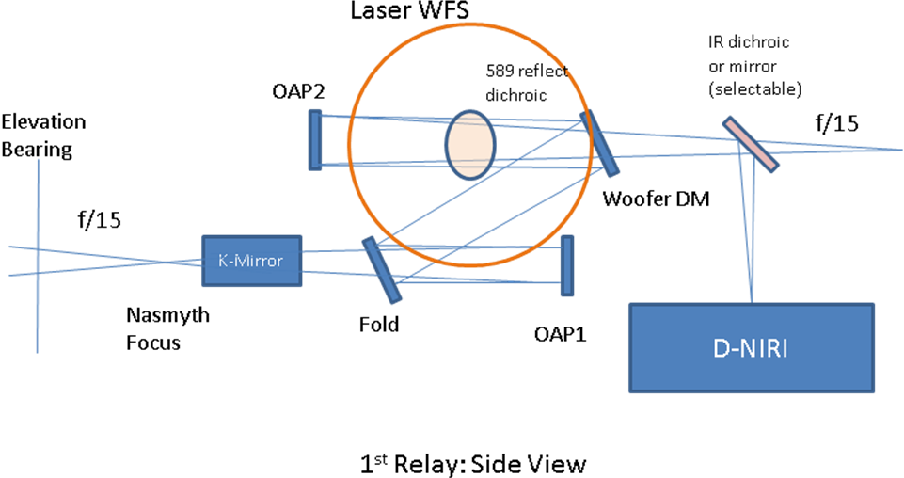

Brief description of the optical path:

Tertiary to K-mirror derotator

The f/15 light comes in from the telescope tertiary to Nasmyth focus. There is a window (not shown) through which the light passes into the cold optics space (containing all the optics shown here). A K-mirror field derotator is just after focus. An option would be to put this before focus but would require a snout into the elevation bearing area. This front space (ahead of focus but in the cold chamber) is also where the ADC prism would be located (Brian to provide further drawing refinement showing this). Ahead of the front window is a deployable mirror which can be used to split in a calibration source.

First relay (K-mirror to the second f/15 focus)

After going through the K-mirror, the first OAP collimates the beam when it reaches a size of 100 mm diameter. After this is a first fold mirror and second flat mirror. The second is located at a pupil, which the nominal position of a woofer DM. The first fold flat is roughly at 10km conjugate, which allows retrofitting a second DM for MCAO operation if this is called for at some future date. The two flats act together as a periscope to bring the beam out of plane. The second drawing shows a side perspective. (This drawing is notional and probably not exactly to scale). The beam is brought up to a second level and the remaining optics are parallel with the first level (and to the optics table). The second OAP focuses the light to a second f/15 focus. On the way to focus are two dicroic spliters in the path, one to selectively feed 589 nm light to the laser guidestar wavefront sensors and one to feed selected infrared light to D-NIRI and the natural guide star tip/tilt sensors. The second dichroic will be deployable according to the science observing mode.

Second relay

The second f/15 beam is fed to OAP3 which collimates the light at 25mm beam size and forms a pupil image at a MEMS DM. OAP4 then focuses the output light at f/45 which allows room for a switchyard into multiple science instruments.

