KAON 549

Opto-Mechanical Design for the Keck NGAO Cascaded Relay
Renate Kupke, Chris Lockwood, Brian Bauman, Don Gavel, Peter Wizinowich, Chris Neyman, Anna Moore, Viswa Velur, Jim Bell
February 5, 2008

- Introduction
We present here conceptual optical and mechanical designs for the Keck Next Generation Adaptive Optics Relay. This design expands on the concept of the Cascaded Relay, the architecture chosen as the baseline design for the optical relay during the July, 2007 Architectural Retreat (KAON 499).
- Requirements
The design of the NGAO relay was driven by requirements derived from the science objectives of the NGAO. The requirements are descrbed in KAONs 455, 456 and the Functional Requirements spreadsheets. These include, but are not limited to:
- Location
- The AO system will reside on the Nasmyth Platform
- Field and Pupil Rotation
- The optical relay will have a K-mirror upstream of the science instruments, wavefronts sensors, and tip-tilt sensors.
- Field of View
- A high Strehl science relay with a field of view (FOV) of between 20″ and 40″ diameter.
- A 150″ diameter FOV interfacing to a deployable IFU device.
- A 175″ diameter FOV at the laser guide star (LGS) focus, feeding the LGS high-order wavefront sensors (HOWFS).
- A 150″ diameter FOV at the natural guide star (NGS) focus, providing NGS for tip-tilt, and low-order wavefront sensing (LOWFS)
- Pupil Diameter
- The first relay shall contain a low-order “woofer” mirror, conjugate to the telescope primary, with a diameter of 100mm.
- The second relay shall contain a high-order, MEMs “tweeter” mirror, conjugate to the telescope primary, with a diameter of 25mm.
- Output Pupil Location
- The exit pupil for the first relay will be telecentric to simplify design of the pick-off mechanisms and wavefront sensors for the LOWFS and HOWFS.
- Output Focal Relays
- The output focal ratio of the first relay shall match the focal ratio of the f/15 telescope Nasmyth focus.
- The output focal ratio of the second relay shall be greater than f/45 to allow for the optical switchyard.

- First-Order Optical Layout
An annotated optical layout of the relay can be seen in Figure 1, alongside a Solidworks drawing of the mechanical structures needed to support and move the optics, as well as the locations of wavefront sensors and instruments, in Figure 2. The sections below describe each part of the optical relay in detail. In Section 7, at the end of this document, you will find preliminary lists of the mechanical and optical components.

  - K-mirror Rotator
The first mirror of the K-mirror rotator, which provides field or pupil rotation to the downstream instruments and wavefront sensors, is located 150mm before the Nasmyth focus. The science focus thus lies between the first and second mirrors of the rotator. It is still to be determined whether having a focal plane in the vicinity of two reflecting surface will add undesirable thermal background effects for infrared observations, or performance issues for high-contrast science. The existing Keck AO system has the first element of the K-mirror positioned after focus.

The K-mirror consists of three mirrors, sized to accommodate a 150 arcsecond diameter NGS FOV, and a 175 arcsecond diameter LGS FOV at a height of 80km. The 80km height was chosen to pass unvignetted rays from the bottom of the sodium layer, assuming a mean height of 85-90km.

  - First Relay
Following the K-mirror is the first Off-Axis Parabola (OAP1). OAP1 has a focal length determined to meet the requirement of a 100mm pupil on the woofer DM by the following equation:

where and are the diameters of the deformable mirror (100mm) and the telescope primary (10.949m), respectively, and is the focal length of the telescope (149.583m). . This gives a focal length for OAP1 of 1366.2mm.

The off-axis tilt angle of 25° degrees was the minimum required to provide adequate space for subsequent optics. A decenter of 605mm from the parent parabola results.

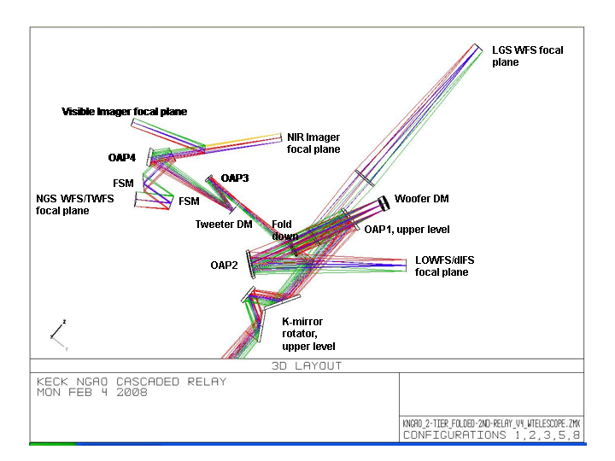
Figure 1 Optical layout, Cascaded Relay

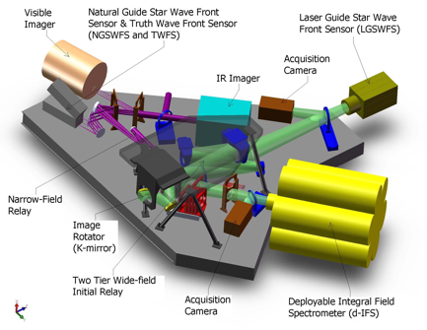
Figure 2 Overall layout, Cascaded Relay
The beam is folded downward, in a periscope fashion at an angle of 9.125° to a lower tier which resides on an optical bench. This fold mirror is at a conjugate height of approximately 10km, and offers the future option of a high altitude DM in a multi-conjugate AO system. At the bottom of the periscope resides the woofer DM, at a distance from OAP1 conjugate to the telescope primary mirror:
Equation gives a total OAP1 to woofer DM distance of 1603mm.

The woofer DM is nominally 20x20 actuators (5mm pitch), and will be mounted on a real-time, tip-tilt platform. Due to the incident angle of 9.125° the pupil will be elongated by 1.3%.

Following the woofer DM is OAP2, an off-axis parabola whose parameters exactly match those of OAP1 to minimize aberrations at infinite conjugate. It is located one focal length (1366mm) away from the pupil located on the woofer DM, projecting the pupil to infinity and providing a telecentric beam for the second relay and the deployable Infrared Field Spectrograph (dIFS) and Low Order Wavefront Sensor (LOWFS) relays. A telecentric system was chosen to simplify the design of the LGS WFS and LOWFS pick-off mechanisms and wavefront sensors. A telecentric system does not require tilt with field to keep the chief ray constant on entering the wavefront sensor. There are also no pupil scale changes with conjugate distance for the LGS WFS.

  - Laser Guide Star WFS
Shown in Figure 1 between the woofer DM and OAP2 is a dichroic pick-off for the LGS wavefront sensors, in collimated space. This dichroic pick-off will ideally be a notch filter, reflecting only the sodium (Na) laser guide star wavelength of 589nm. A notch filter was chosen to allow visible light below 600nm to be available to the visible truth wavefront sensor (TWFS) located in the second relay (described in section…). This dichroic will be removable, when NGS HOWFS is preferred or necessary. The dichroic has an incidence angle of 12°. The optical layout for only the LGS WFS section of the AO relay is shown in Figure 3.

The object selection mechanism (OSM) for the LGS WFS requires an image plane, thus the collimated light after the dichroic pick-off is focused using a simple, one glass (of somewhat high incidence to minimize thickness and therefore reduce aberrations), bi-convex lens. A bi-convex lens was chosen over a plano-convex lens because of better behavior over a large field (in the on-axis case, a plano-convex would be superior). The focal length of the lens is 1366mm, to maintain the 1:1 magnification of the first relay. The lens is located one focal length away from the woofer DM, to provide a telecentric beam for the LGS OSM and relays. The lens has been optimized for a 90km conjugate, but it may be prudent to reexamine this optimization at a 20 or 30° zenith angle.

In the converging beam following the lens, there will be located a removable mirror at 45° incident angle to feed a visible acquisition camera for the LGS WFS.

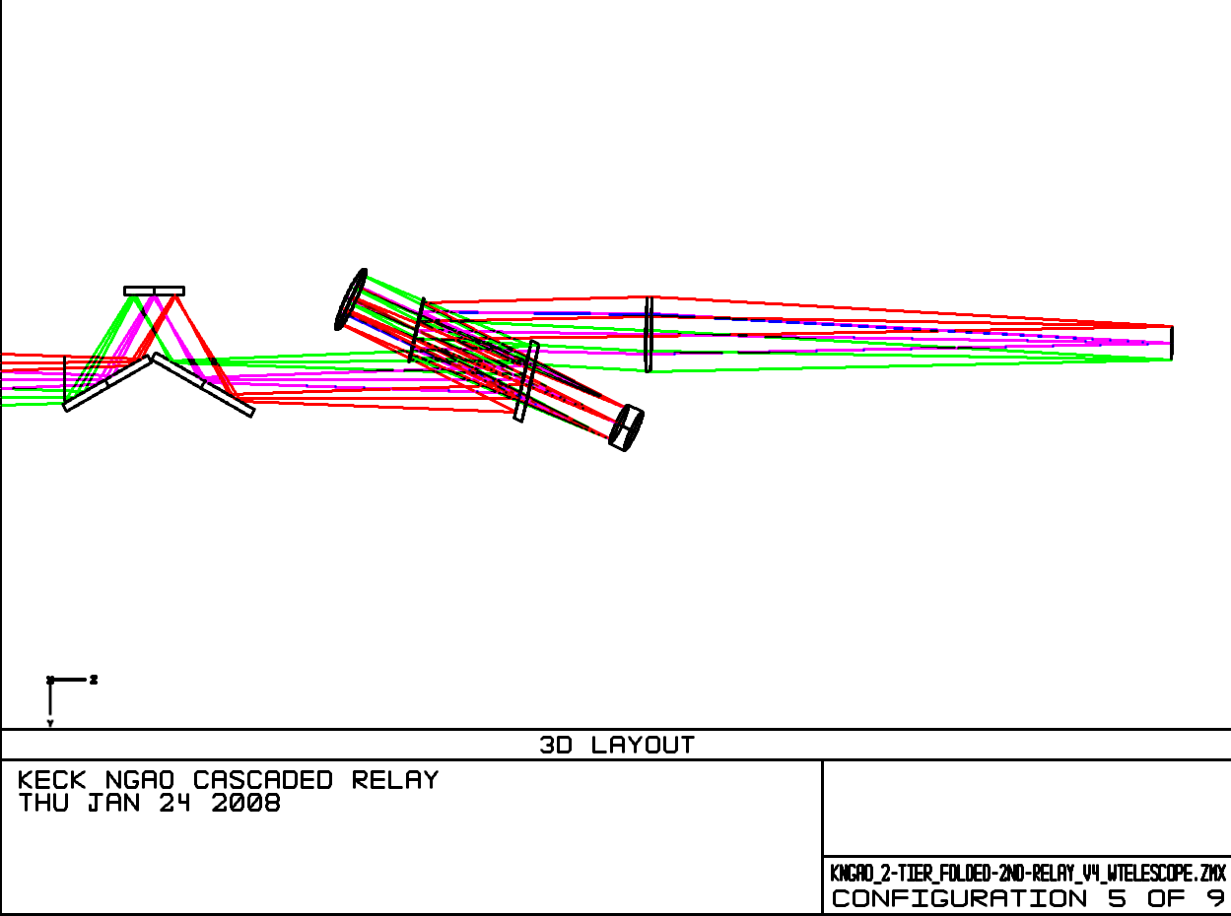
Figure 3 LGS WFS Optical Path

  - Interferometer Feed
The Keck interferometer, working in Dual Star Mode, will require a pick-off in the converging f/15 beam to acquire a 60 arcsecond diameter field. Following the pick-off will be two field-steering mirrors (FSMs), the first of which will be near the focal plane of the f/15 beam, and have a hole in its center to pass the light of one star to an OAP, which will collimate the light. The remaining field will be steered onto a second steering mirror, and will be sent by this mirror, parallel to the beam emanating from the hole in the first FSM to a second OAP which will collimate its light. This collimated light will then be steered to holes in the floor of the Nasmyth platform. The beam must be at least 100mm in diameter to avoid diffraction effects along its path.

The pick-off, ideally, will be located after the dichroic feed to the narrow field relay, to most closely match the existing Keck AO system where the interferometer pick-off is located after an infrared dichroic.

  - Wide-Field Relay to Acquisition Camera, LOWFS, and dIFS
In the f/15 converrging beam following OAP2 lies the dichroic bank which will either reflect light into the High Strehl, Narrow Field science relay, transmit to the Wide Field LOWFS/Tip-tilt sensors and dIFS instrument, or both. The dichroics were specified based on the science requirements. Please see Table 8 for a list of the six dichroics, as well as the other dichroics used in the NGAO relay.

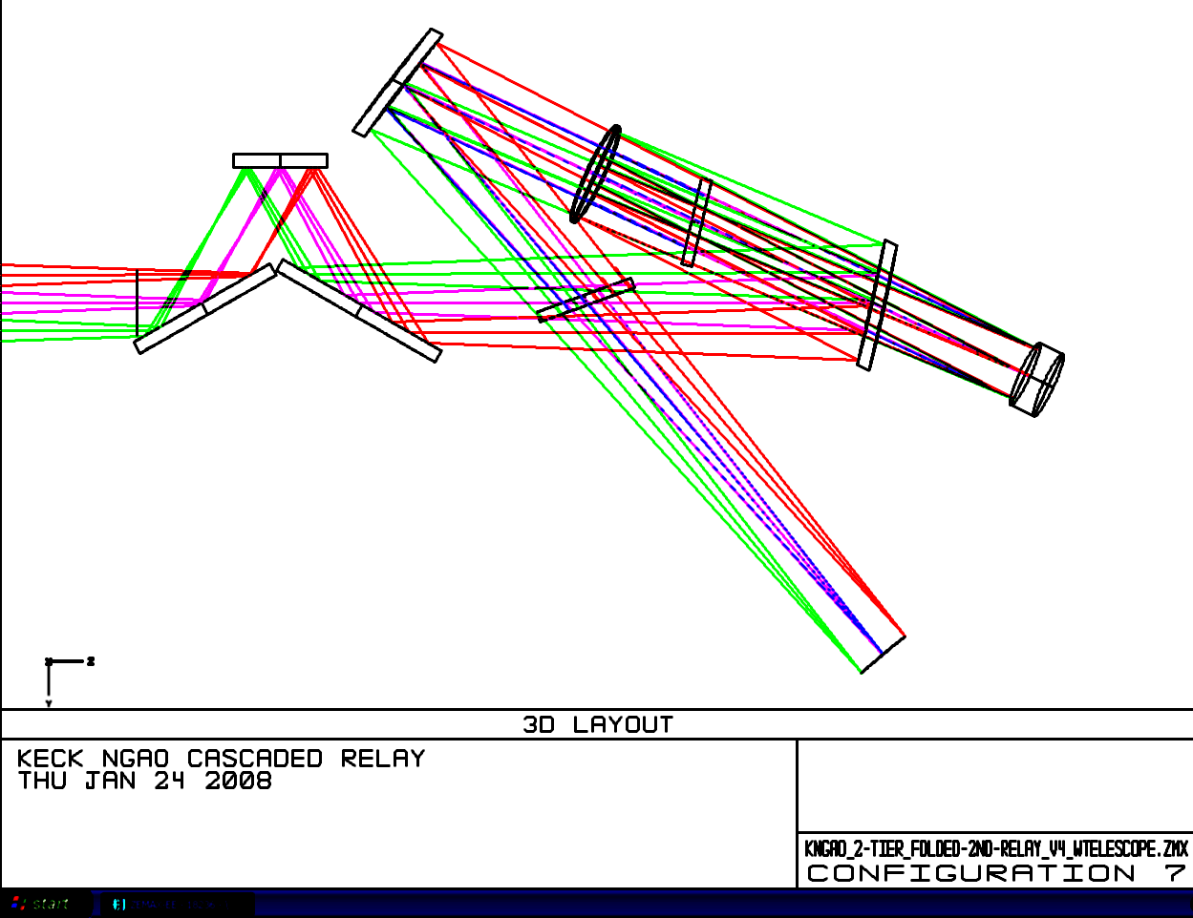
Figure 4 Optical path to LOWFS, Tip-tilt and dIFS instrument.
Located between the dichroic bank and the OSM for the LOWFS and dIFS is a removable, 45° incidence angle pick-off mirror to the NGS acquisition camera. The NGS acquisition camera will obtain images of the entire 150 arcsecond diameter field and allow acquisition of the science objects and natural guide stars. When the science objects are too faint, as will often be the case for the dIFS, the acquisition camera will provide a coordinate reference to acquire science objects.

There are two removable dichroics located before the LOWFS/dIFS OSM: the interferometer and narrow-field relay. The LOWFS will need to operate simultaneously with either one or neither of these dichroics in place. The OSM or proceeding optics will need to be able to accommodate for the focal plane shift along the optical axis and perpendicular to the tilt axis of the dichroic when the dichroics are inserted or removed. The dIFS will be operating only when all the dichroics are removed, so no compensation is needed for that instrument.

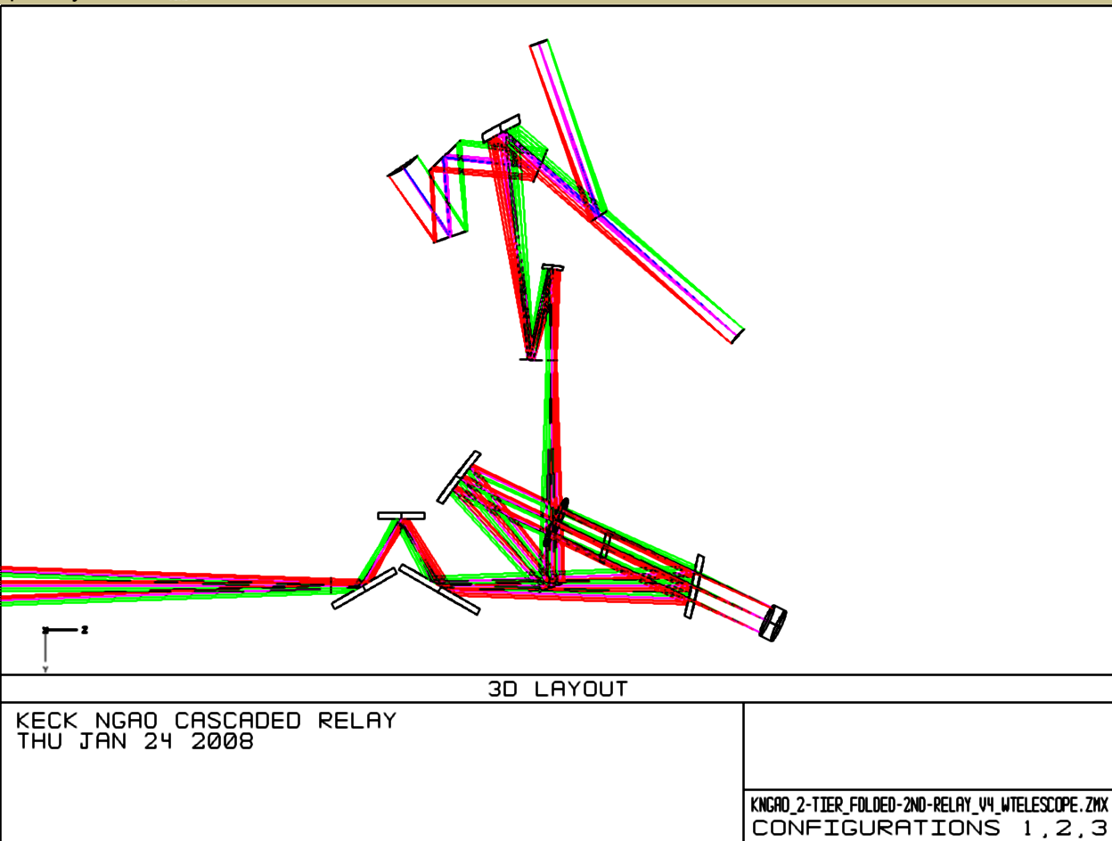
Figure 5 Narrow-field relay, optical path.

  - Narrow-field, High Strehl Relay
The narrow-field relay, shown in Figure 5 feeds a suite of instruments, including the visible imager, the NIR imager, the visible IFS, the NGS wavefront sensor and a TWFS.
There will also be optics to accodate a change in f/# to feed the existing OSIRIS instrument with an f/15 beam. This relay also contains a high order, tweeter DM at a 25mm pupil. The 64x64 actuator MEMs device will be mounted on a real-time tip-tilt platform.

Using Equation (1), we can determine the focal length of the OAP needed to collimate a beam that will produce a 25mm pupil image on the tweeter DM. In this case, we substitute for and for , to get .5mm, or exactly th the focal length of OAP1. The pupil, at the end of the first relay, is telecentric, so the tweeter DM lies roughly away from OAP3. The requirements dictated a focal ratio greater than f/45 for the beam exiting the relay, in order to provide space for the instrument switchyard. is thus 3 times larger than , or 1024.5mm. It is located exactly one focal length away from the tweeter mirror, to provide a telecentric beam for the instruments. The tweeter mirror has an incidence angle of 10°.
  - Natural Guide Star Wavefront Sensor (NGS WFS) and Truth Wavefront Sensor (TWFS)
The dichroic pick-off immediately following OAP4 feeds both the NGS WFS and the TWFS. This dichroic is at an angle of 17° to the incident beam. The nominal 30 arcsecond diamter field required for the narrow field science instruments was deemed to be scientifically inadequate for the NGS WFS and TWFS. The NGS and TWFS have thus been designed to have access to an asymmetric field which is 57 arcseconds across in the direction perpendicular (the “x” direction in the Zemax design) to the bench, and 54 arcseconds across in the direction parallel (the “y” direction) to the bench. In the y-direction, the field extends 29 arcseconds in the direction away from the tweeter, and only 25 arcseconds in the direction toward the tweeter mirror. This is to avoid interference with both the tweeter mirror and OAP4, after the pick-off.

A second possibility for the NGS WFS/TWFS dichroic location is in the visible imager path (see section 3.8). This position would have the advantage of requiring only one ADC for both the visible imager and the NGS/TWFS sensors (assuming the ADC can operate over the entire 0.4 – 0.97μ bandpass). In science cases which require simultaneous imaging with both the NIR camera and the visible camera, the NIR camera will see only one dichroic (the pick-off for the visible imager) instead of two. This design option is not implemented in the current layout because of the desire for low-incidence angles on what might have been the OSIRIS dichroic pick-off, and an uncertainty of the space requirement of the OSIRIS reformatting optics. It has since been decided that OSIRIS will not be fed with a dichroic, but only with a mirror. No simultaneous observations with OSIRIS and the NIR imager are being supported. This increases the attractiveness of the alternate NGS WFS/TWFS dichroic location, and this possibility will be explored in the next design phase.

The field for both the NGS WFS and the TWFS can be acquired using two field-steering mirrors (FSMs) locate between the dichroic pick-off and the wavefront sensor optics. The second FSM can be rotated to select whether the NGS WFS or TWFS received the light (there are no configurations in which they are used simultaneously). An ADC will be required in the NGS path to correct atmospheric dispersion.

  - Visible Imager Path
The visible imager is fed by a dichroic located down stream from the NGS WFS pick-off. An ADC lies between the reflecting dichroic and the visible imager.

If the dichroic pick-off for the NGS/TWFS is removed from the beam, the focal plane will shift in directions along the optical axis and perpendicular to the tilt axis of the dichroic. These effects can be compensated with a repointing and refocusing of the telescope. The focal plane of the imager will have a finite curvature (see table 3 for the optical characteristics of the instrument focal planes).
  - Near-IR Imager
The NIR instrument is fed directly by the f/46 narro-field relay output. In the beam between OAP4 and the dichroic imager are two removable dichroics. As these dichroics are removed, the focal position of the beam will shift both laterally and along the optical axis. The lateral shift can be compensated with a repointing of the telescope, while the shift in focal plane may be taken up with the telescope focus (each 20mm thick dichroic, tilted at 20°, causes roughly 7mm of focal plane shift).

Like the visible imager, the focal plane of the NIR imager will be curved (see table 3 for the optical characteristics of the narrow-field instruments).

- Performance
To determine the performance of the optical system, several sources of optical degradation were analyzed using Zemax in the wavelength passbands used by the individual science instruments and wavefront sensors. The passbands are defined in KAON 530.

The optical relay was modeled in conjunction with the Keck primary and secondary mirrors, to ascertain the combined effects of the two optical systems.

Field points used were the maximum off-axis fields defined for each instrument. The wavefront errors and RMS spot radii quoted are the worst-case for the field points analyzed.

According to Zemax, the working f/# of the wide-field relay is f/13.66 and of the narrow-field relay is f/46.89. Airy disk sizes are defined by
and the depth of focus (DOF ) is defined by.

In Zemax, both the woofer and tweeter DMs were defined as “Zernike Fringe” surfaces. This allowed a placement of Zernike terms on the mirror surface, to mimic the correction capabilities of an actual DM and derive an “uncorrectable” wavefront error (errors which could not be corrected with a DM). Examination of the Zernike Fringe Coefficients and spot diagrams indicated that the bulk of the wavefront error was due to astigmatism and coma, therefore the Zernike fringe surfaces were optimized only for those coefficients. Optimizing in Zemax with too many variables is slow and sometimes fails to converge in a realistic fashion.

- Science Instrument dIFS, Wide-field Relay
It is assumed that the wide-field dIFS is used in MOAO mode, and that a DM can apply low-order correction optimized for each field position. Thus field-dependent aberrations can almost completely be removed.

When the dIFS is in use, there will be no dichroic in the converging beam ahead of the instrument. Lateral color and chromatic focal shift are therefore very close to null (with a negligible contribution from the tilted LGS WFS dichroic in collimated space). Image analysis results are shown in Table 1.

Table 1 Performance of the dIFS relay.
Instrument | λ bands | F/# | FOV (″) | Field Curvature (mm) | RMS WFE (nm) | Spot Size (μ) at J | Spot size (mili ″) | Airy radius (μ) at J
dIFS | J, H, K | 15 | 150 | 1430 | 8.6 | 1.25 | 1.7 | 19.5

- LOWFS
The LOWFS optical selection mechanisms share a focal plane location with the dIFS science instrument. Because the LOWFS must also be used with the imagers located in the narrow-field relay, it will often be the case that the dichroic splitter for the second relay, or the interferometric dichroic, lies between OAP2 and the LOWFS focal plane.

This dichroic location introduces several issues. When the 20mm-thick dichroic is removed, the focus will change by roughly 7mm along the optical axis and 1.5mm perpendicular to the direction of the axis of dichroic tilt. The OSM must have the capability to adjust for this gross movement.

The insertion of the dichroic also leads to both lateral color (see Figure 6) and chromatic focal shift. Chromatic aberrations are uncorrectable (cannot be removed with a DM), but the lateral color can be minimized by introducing a small wedge angle to the second surface of the dichroic (on the order of tenths of a degree). This wedge angle will introduce astigmatism in the wavefront of the LOWFS beam, which can be removed by the DMs located on each natural guide star’s optical path (see KAON 551, Wavefront Sensor System Design Report).

Table 2 gives aberrations during simultaneous observations in J and H bands, the largest bandpass the LOWFS is likely to utilize. No wedge angle is included on the second surface of the dichroic.

Table 2 Performance of the LOWFS optical relay in simultaneous J and H bands.
Instrument  (mode) | λ (μ) | F/# | FOV ″ | Fld curv.  (mm) | RMS WFE (nm) | RMS Spot Radius (μ) | RMS Spot Radius (mili-″) | Airy radius  (μ) | Lateral color (μ) | Chrom. Focal shift (μ) | Depth of focus*  (mm)
LOWFS | 1.17-1.78 | 15 | 150 | 1320 | 15.6 | 18.6 | 10.7 | 19.5 | 24.4 | 70 | 0.9

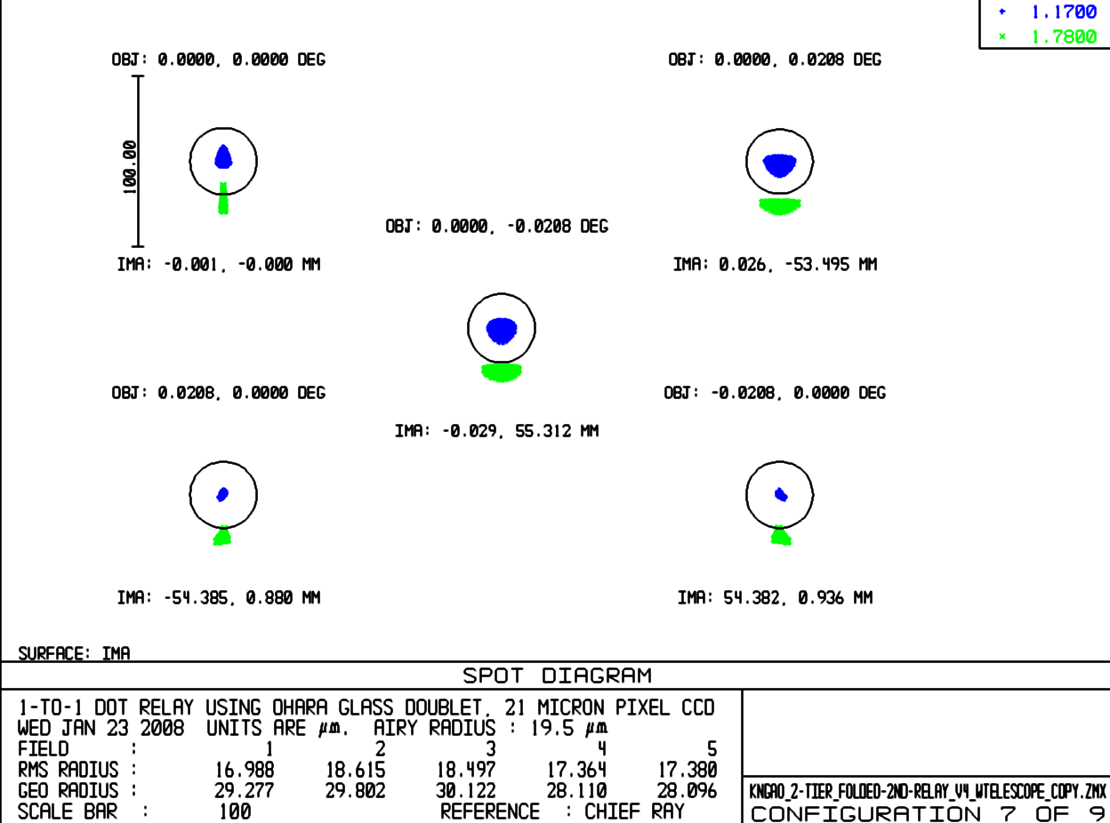
Figure 6 Spot diagram of LOWFS focal plane, showing lateral color (without wedged dichroic).
- Science Instruments, Narrow-field Relay
It is assumed for the narrow-field instruments that a DM can apply correction across the entire 30 arcsecond diameter field of view.

Values for the NIR imager in Table 3 assume that the NGS/TWFS is in place. RMS spot radius takes lateral color into account, but like the LOWFS, this can be minimized by putting a wedge angle on the second surface of the NGS/TWFS dichroic.

Table 3 Performance of the Narrow-field relay instruments.
Instrument  (mode) | λ (μ) | F/# | FOV ″ | Fld curv.  (mm) | RMS WFE (nm) | RMS Spot Radius (μ) | RMS Spot Radius (mili-″) | Airy radius  (μ) | Lateral color (μ) | Chrom. Focal shift (μ) | Depth of focus*  (mm)
NIR im, Y-band | 0.97-1.07 | 46 | 30 | 277 | 15.6 | 17.5 | 7.8 | 55.1 | 4 | 11.8 | 8.4
NIR Im, J-band | 1.17-1.33 | 46 | 30 | 277 | 15.6 | 18.3 | 8.2 | 66.4 | 5.5 | 17 | 10
NIR Im, H-band | 1.49-1.78 | 46 | 30 | 277 | 15.6 | 20.9 | 9.4 | 84.6 | 10.78 | 34 | 13
NIR Im, K-band | 2.03-2.37 | 46 | 30 | 277 | 15.8 | 24 | 10.8 | 115.3 | 17 | 53 | 18
Vis. Im, | 0.7-0.97 | 46 | 30 | 277 | 15.8 | 22.2 | 10.0 | 39.7 | 12.8 | 42 | 6
NGS/TWFS | 0.4-0.7 | 46 | 54 | 277 | 36 | 32.3 | 14.5 | 22.7 | 0 | 0 | 3.5

Lateral color is well inside the Airy radius for all instruments in this f/46 beam, so a wedge on the NGS/TWFS dichroic may not be necessary. Chromatic focal shift is negligible compared to the depth of focus. Note that the NGS/TWFS encounters only reflective optics, and therefore does not suffer from chromatic aberrations. Note, also, that none of the analyses include the effects of the ADC which will be required in each instrument’s beam path.

The performance of the OAPs used in the second relay degrade with field angle, therefore the large field of the NGS WFS/TWFS exhibits much more wavefront error over its 54 arcsecond field than the science instruments over their 30 arcsecond diameter field .

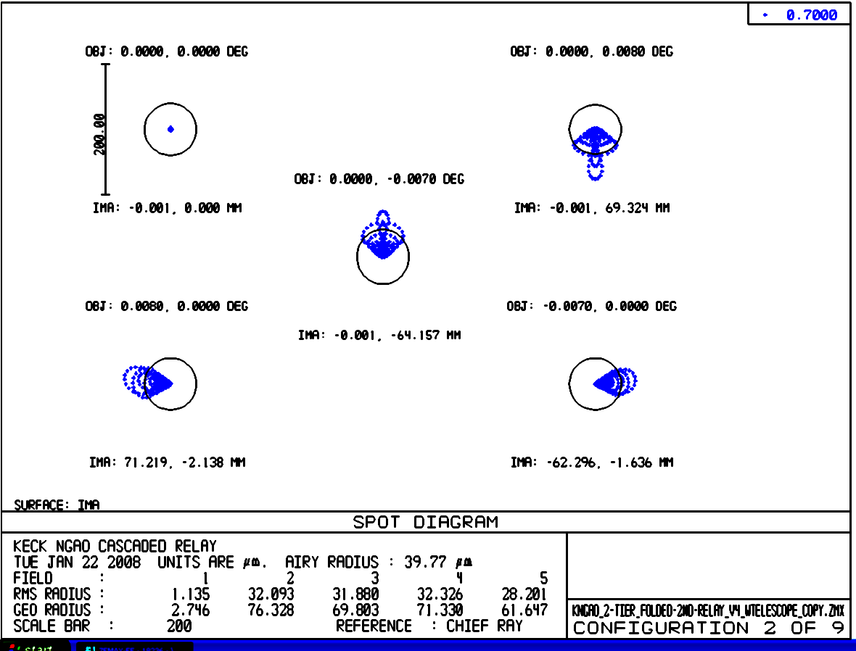
Figure 7 Spots at the on-axis and extreme field angles of the LGS WFS.
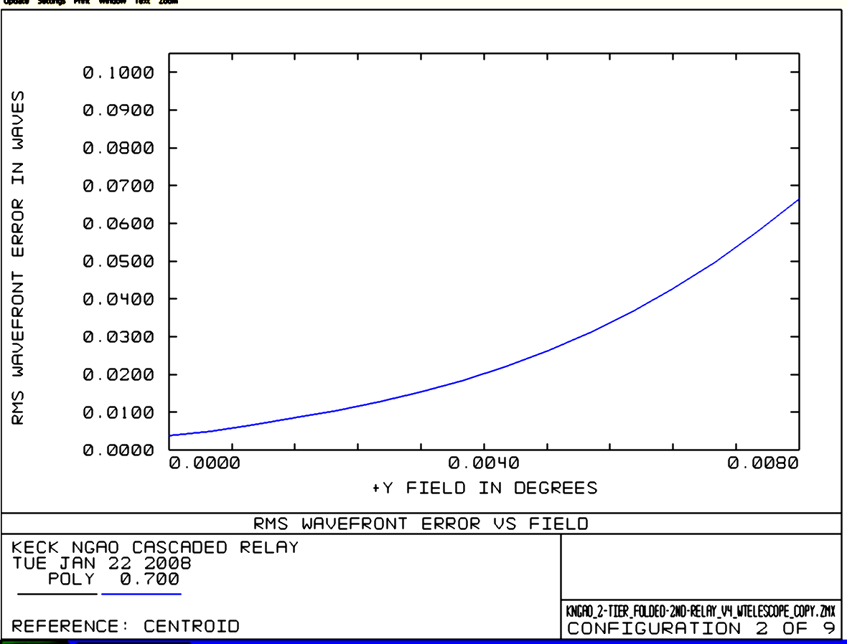
Figure 8 Wavefront error as a function of field at the NGS WFS

- Laser Guide Star Wavefront Sensor (LGS WFS)
The LGS WFS dichroic pick-off lies in the collimated space between the woofer DM and OAP2. The LGS, over their 174 arcsecond diameter field, are re-imaged using a 1-glass biconvex lens, as described in section 3.3. The lens chosen need only work at the wavelength of the sodium line (589nm), so chromatic aberrations are not an issue. This lens was optimized for 90km, but as mentioned in section 3.3, other zenith angles may be considered (the performance varies by only 10s of mas between 90 and 180km, so this is not seen as a huge potential improvement). Table 4 details the performance of the LGS WFS relay.
Table 4 Performance of the LGSWFS optical system with conjugate height.
Conjugate height | FOV, arcsec | Field Curvature (mm) | RMS WFE (μ) | RMS Spot Radius (milli-″)
90km | 174 | 650 | 2.8 | 415
180km | 162.5 | 650 | 3.1 | 440

Of concern are the almost half-arcsecond spot sizes of the LGS WFS (see Figure 9). This is a significant fraction of the 1.5 arcsecond pixels proposed for the LGS WFS. These aberrations stem from using OAP1 at a finite conjugate. An Alvarez-style corrector plate has been suggested by Brian Bauman as a solution if the WFE is deemed too large.

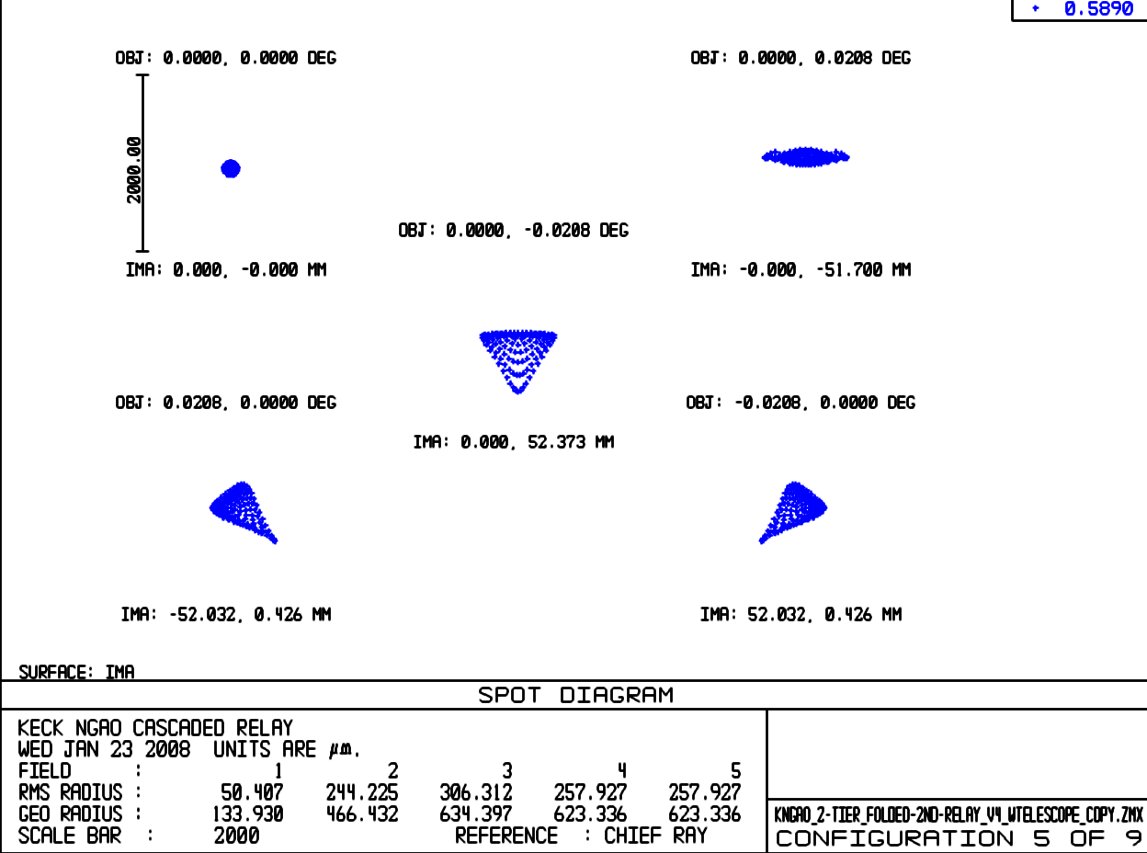
Figure 9 Spots formed at focal plane of LGS WFS relay, 180km conjugate.

- Pupil Distortion
Pupil distortion in the NGAO Cascaded relay manifests itself in at least three ways. The first is the degree to which a grid of points on the primary mirror maps to a demagnified, but square grid on the DM. Another consideration is the field dependent pupil aberrations. This effect causes the chief rays from the various field angles to not all pass through the center of the pupil (paraxially, the chief rays all pass through the center of the pupil, by definition, but for real rays, this is not generally true). In other words, the pupil (i.e., the DM and the correction it applies to the wavefront) is shifted with respect to the telescope primary by an amount depending on the field angle—this is similar to anisoplanatism caused by atmospheric aberrations at an altitude not conjugate to the DM. Finally, a third effect is DM-to-lenslet misregistration and scale errors. These are not covered in this document, and are dependent on the pupil reimaging optics chosen for the wavefront sensors.

In the analysis, the telescope primary became the “object”, and field points were defined on the edges of the primary mirror. Observed field angle was set by adjusting the “stop” size placed at the Nasmyth focus to accommodate a 150 arcsecond diameter field for the woofer, and a 30 arcsecond diameter field for the tweeter in the narrow-field relay. Results are shown in Table 5 and the figures on the following pages.

Table 5 Characteristics of pupil image on deformable mirrors.
 | Diameter (mm) | Field (″) | # actuators | Tilt (meters on sky, peak) | Curvature (mm) | Max Grid Distortion | Pupil PSF, (μ)
DM1, woofer | 100 | 150 | 20x20 | 240 | 5500 | 0.4% | 400
DM2, tweeter | 25 | 30 | 64x64 | 928 | 500 | 0.2% | 38

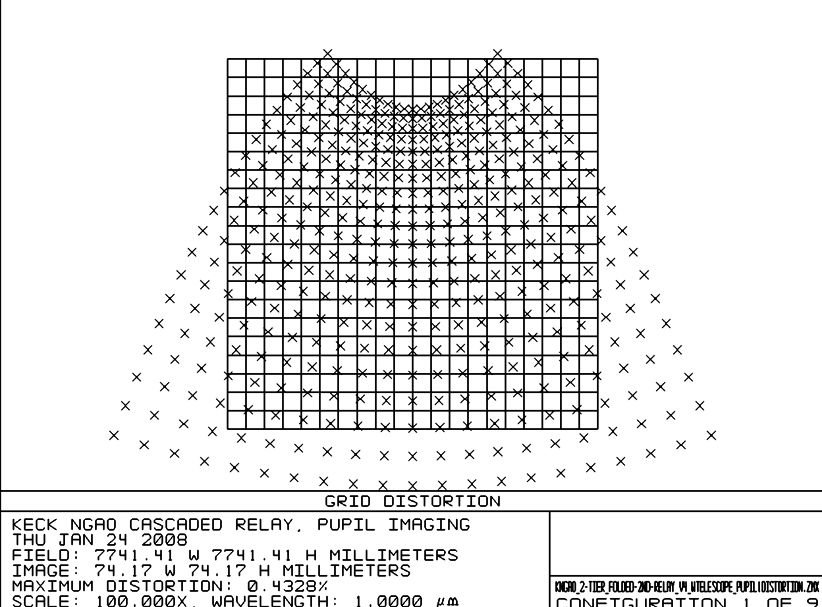
Figure 10 Grid distortion at the woofer mirror pupil location, magnified by a factor of 100 to emphasize shape.
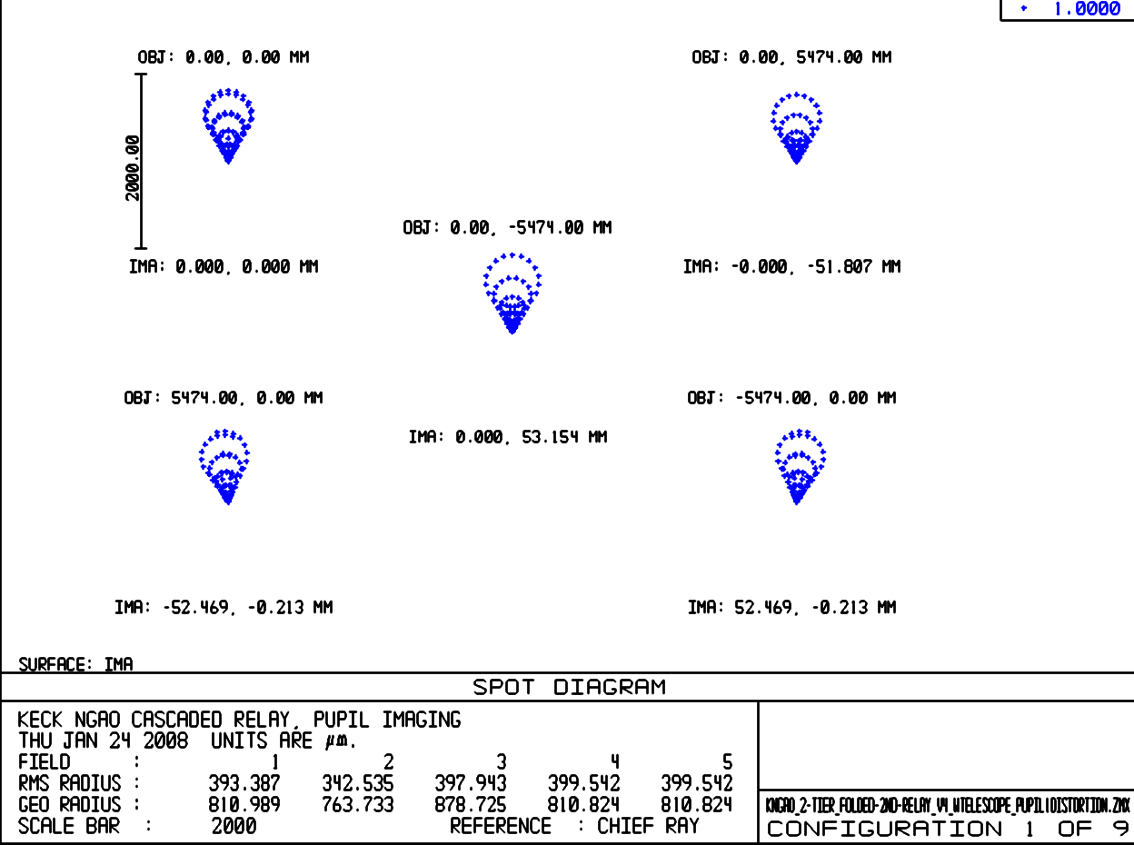
Figure 11 Spot diagrams for 5 places on the primary mirror, as imaged onto the woofer DM. Field considered is 150 arcsecond diameter. The chief rays from the on-axis field angles make up the point of the comatic pattern, while the chief rays for field angles of 75 arcseconds off axis make up the outer “radius” of points on the comatic pattern.

Figures 10 through 13 display grid distortion and the pupil PSFs for the 100mm woofer and 25mm tweeter mirrors. The grid distortion is magnified by a factor of 100 in figures 10 and 12.

Another factor which can degrade the performance of the AO system, and covered in Table 5, is pupil tilt on the DMs. This manifests itself not only as an uncertainty in the conjugate height of the correction, but also in noticeable plate scale errors that can degrade the astrometric accuracy. Consider a pupil re-imaged by a single parabolic mirror. That pupil image will have a curvature depending on the power of the parabola. When using a single off-axis parabola to image the pupil, you are utilizing a small part of the parent parabola’s focal plane, and thus the curvature over the entire parent’s focal plane appears as a tilt over the OAP’s focal plane. In the case of the NGAO optical relay, this component of tilt is larger than that contributed by the incident angles on the DMs.
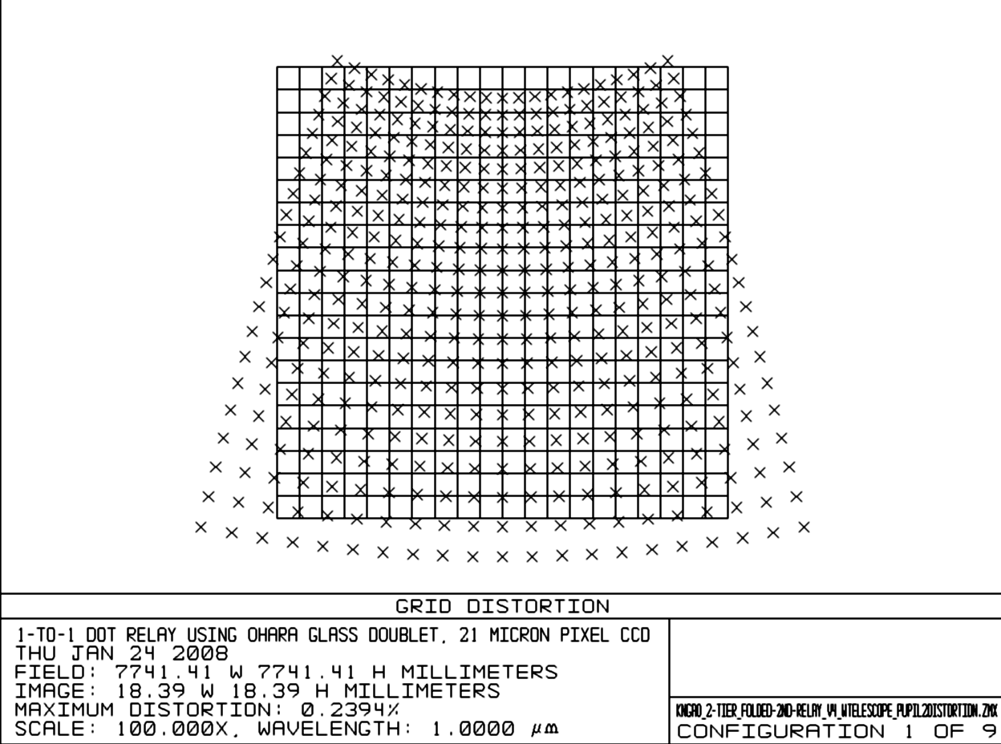
Figure 12 Pupil grid distortion at the tweeter DM position, magnified by a factor of 100 temphasize shape.
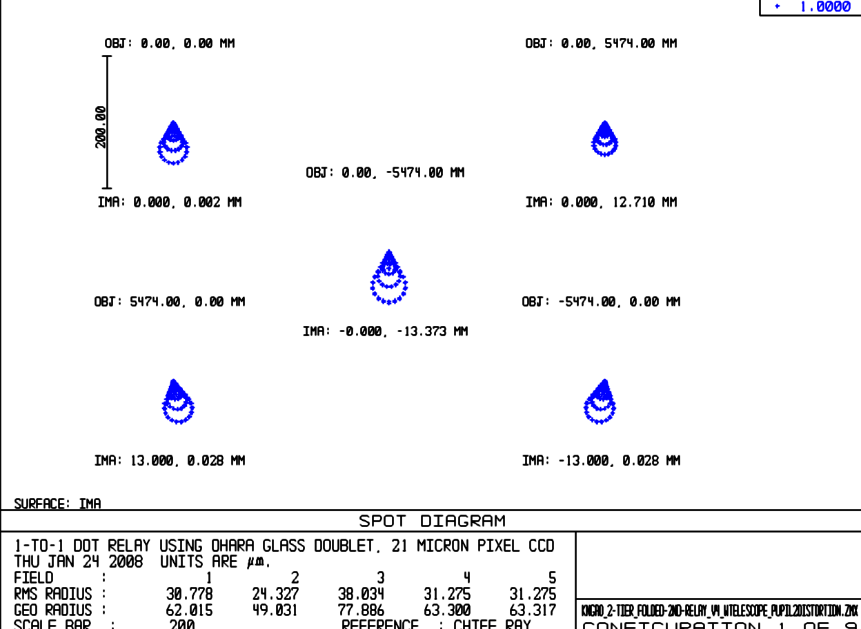
Figure 13 Spot diagrams for 5 positions on primary mirror, as imaged onto tweeter DM. See Figure 11 for full explanation.
- Remaining Work, Optical Design

Work still to be accomplished includes the exact nature of the feed to the interferometer and its effect on the phase of the P and S polarizations of the incoming beam. The reformatting optics for the OSIRIS instrument must also be designed and included in the optical and mechanical layouts. Investigation of the Alvarez-style corrector plate will probably also be necessary to meet the requirements for wavefront error on the laser guide stars.

- Optical Bench Mechanical Layout
- Overview
The mechanical layout for the optical design of NGAO is described in the following section. The final product, aside from this write up, is a Solidworks Assembly CAD model. The model files reside on the Caltech PDMWorks server. Some of the model development was done using Autodesk Inventor and then imported into Solidworks.
This mechanical design effort was primarily a packaging and clearance study using light path volumes exported from the optical design, and estimated volumes for the instruments, optical mounts and mechanisms that make up the system.

No detailed component design/selection was undertaken in this phase, and it follows that flexure and vibration analysis are intended for subsequent design phases. Also, some of the optical elements in the model are surrounded by ample clearance for whatever mount requirements might be necessary. Often in these cases, no further mount envelope was explored. For this reason, however, the reader may see components of the model “floating” above the level of the base table. Figure 14 below shows the overall layout and identifies the primary components of the system. Figure 15 shows the overall dimensions of the current model.

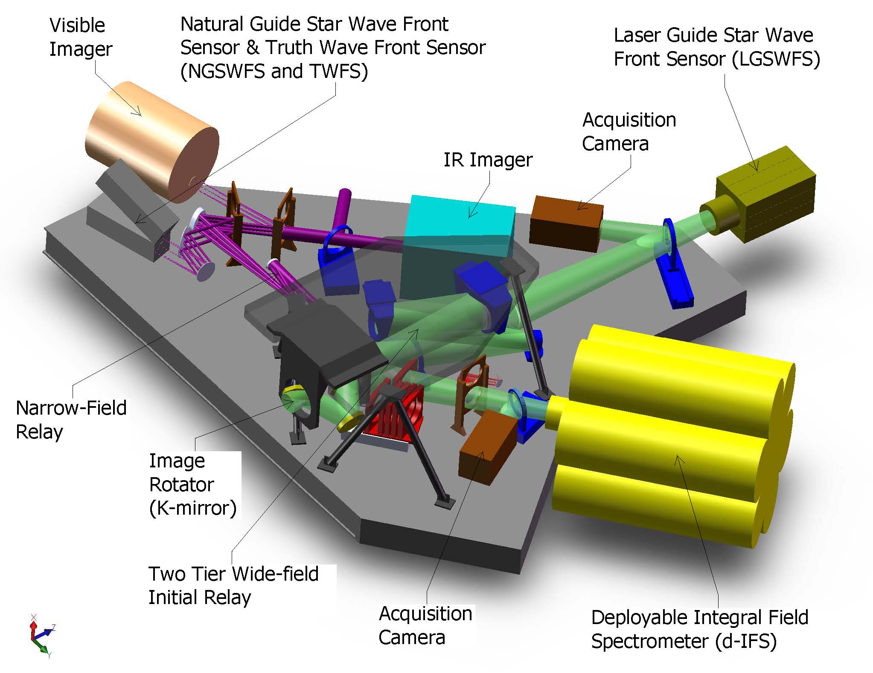
Figure 14: NGAO Overall Layout

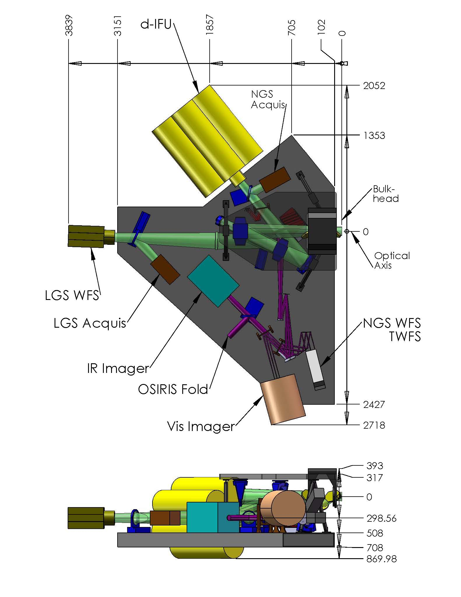
Figure 15: Bench General Dimensions. Shown above are elevation and plan views of the NGAO bench. Dimensions are millimeters. The datum is the intersection of the optical axis and the bulkhead. All “boxes” that receive light have been labeled for reference. It can be seen in the elevation view that the table resides at roughly 700mm below the optical axis – or about half the clearance to the Nasmyth Deck. (Note: table thickness is only 200mm and will likely increase.)

- Two-Tiered Initial Relay
Several optical designs were attempted in order to produce un-vignetted light paths, acceptable locations for focal planes, and clearance for supports and mechanisms. The 1st relay of the two-relay NGAO system is similar to the existing Keck AO system. And probably in a similar evolution, it became apparent that without a fold in the 1st relay of the new system the various foci would end up in difficult and in some cases impossible positions.
This fold mirror along with the low-order deformable mirror allow for a periscope type split level relay. Solutions were explored for both in-plane, and split-level (or two-tiered) solutions. The least difficult configuration to package was a two-tier design shown below in Figure 16.
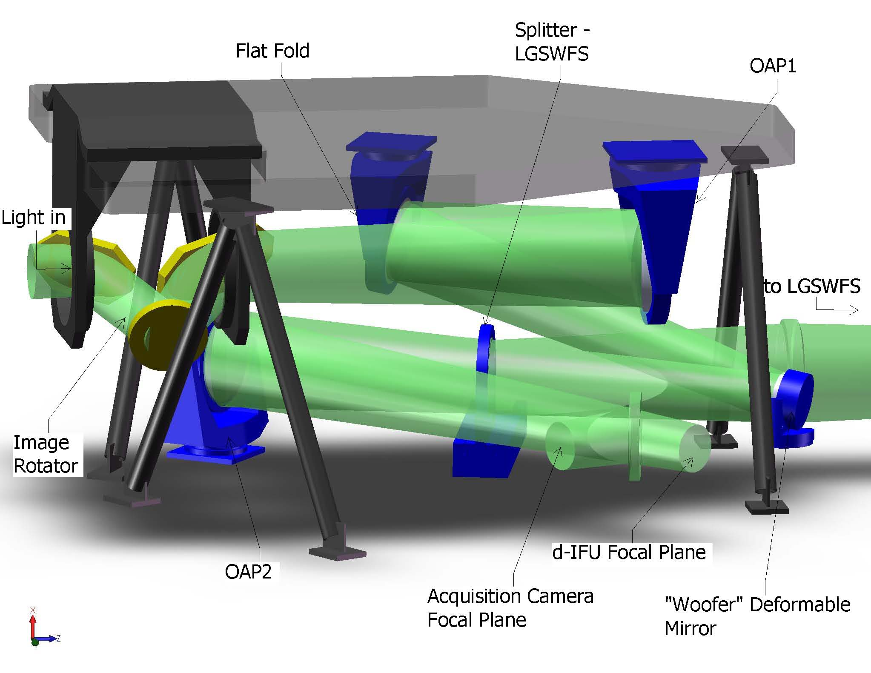
Figure 16: 1st Relay – Isolated. This figure shows the elements of the Two-Tiered 1st relay. Light enters from the telescope at left, travels through the rotator to OAP1, to the flat fold, to the Woofer DM at the pupil. It proceeds to a dichroic that splits light to the LGSWFS and OAP2. From OAP2 it travels to the d-IFU focus. A (retractable) mirror is also shown just prior to this focus to steer the light into an Acquisition Camera for NGS mode.

This configuration requires three components – the rotator, the flat fold and OAP1 – be suspended above the main table. (The rotator is mounted on the top tier to make clearance for the narrow-field dichroic changer discussed in the next section.)
The motion control required in this portion of the system is as follows. The K-mirror rotates. The LGSWFS splitter must move in and out. First order corrections occur by tip/tilt control of the mount on which the woofer deformable mirror sits. And finally the acquisition camera pickoff mirror must also move in and out. Motion control requirements are also captured in Error: Reference source not found.
- Narrow Field Science Light
Not shown in Figure 16 above, directly after OAP2, is a multiple-dichroic changer. This splits light off to the NGAO narrow field, high-order relay and instruments. Light travels from this dichroic, though an intermediate focus to OAP3. It proceeds to the “tweeter” MEMs deformable mirror, to OAP4. The corrected output from the relay is then split off in various combinations to wave front sensors and instruments. This is shown in Figure 17 below.
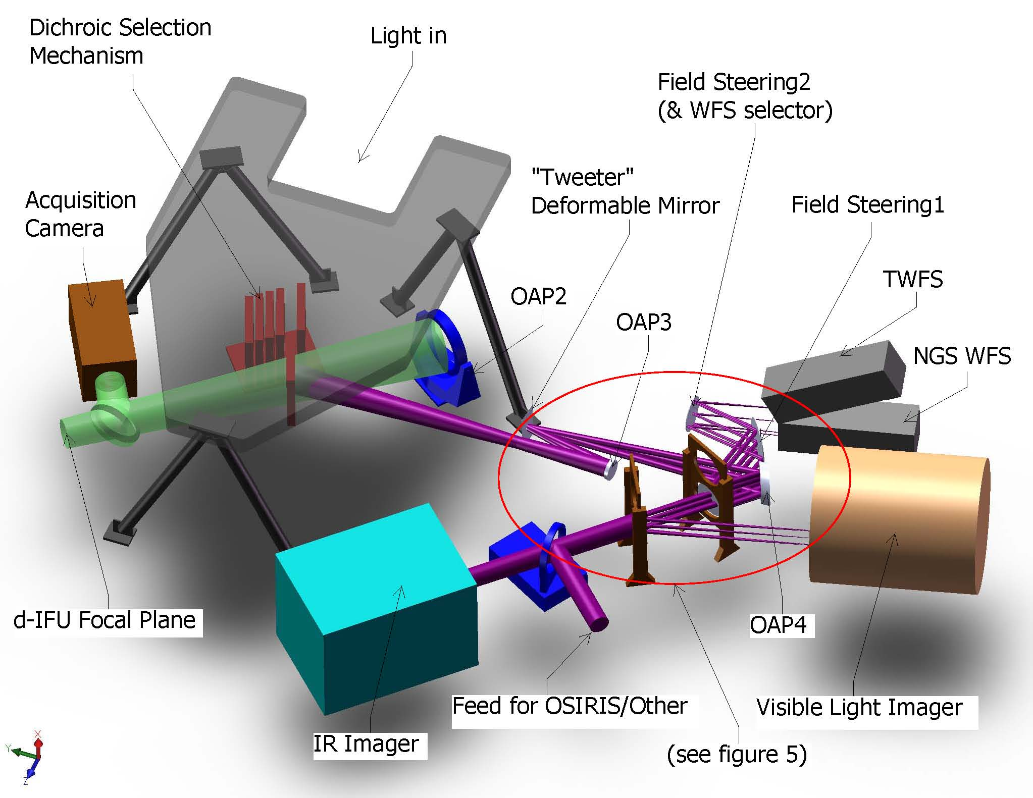
Figure 17: Narrow Field Path- Isolated with 1st Relay Output, Dichroic Changer and Acquisition Camera. Note that the 2nd steering mirror – Field Steering2 – is also used to select between the TWFS for LGS mode and the NGS WFS for NGS mode.

The central portion of the narrow field relay around the OAPs is fairly crowded. Figure 18 is an enlarged view of this region. Note that the light paths shown are a combination of full envelopes (created in CAD) and field bundles (exported from ZEMAX). This was necessary due to some ZEMAX entities not exporting as valid solids. Hopefully this is not too confusing.
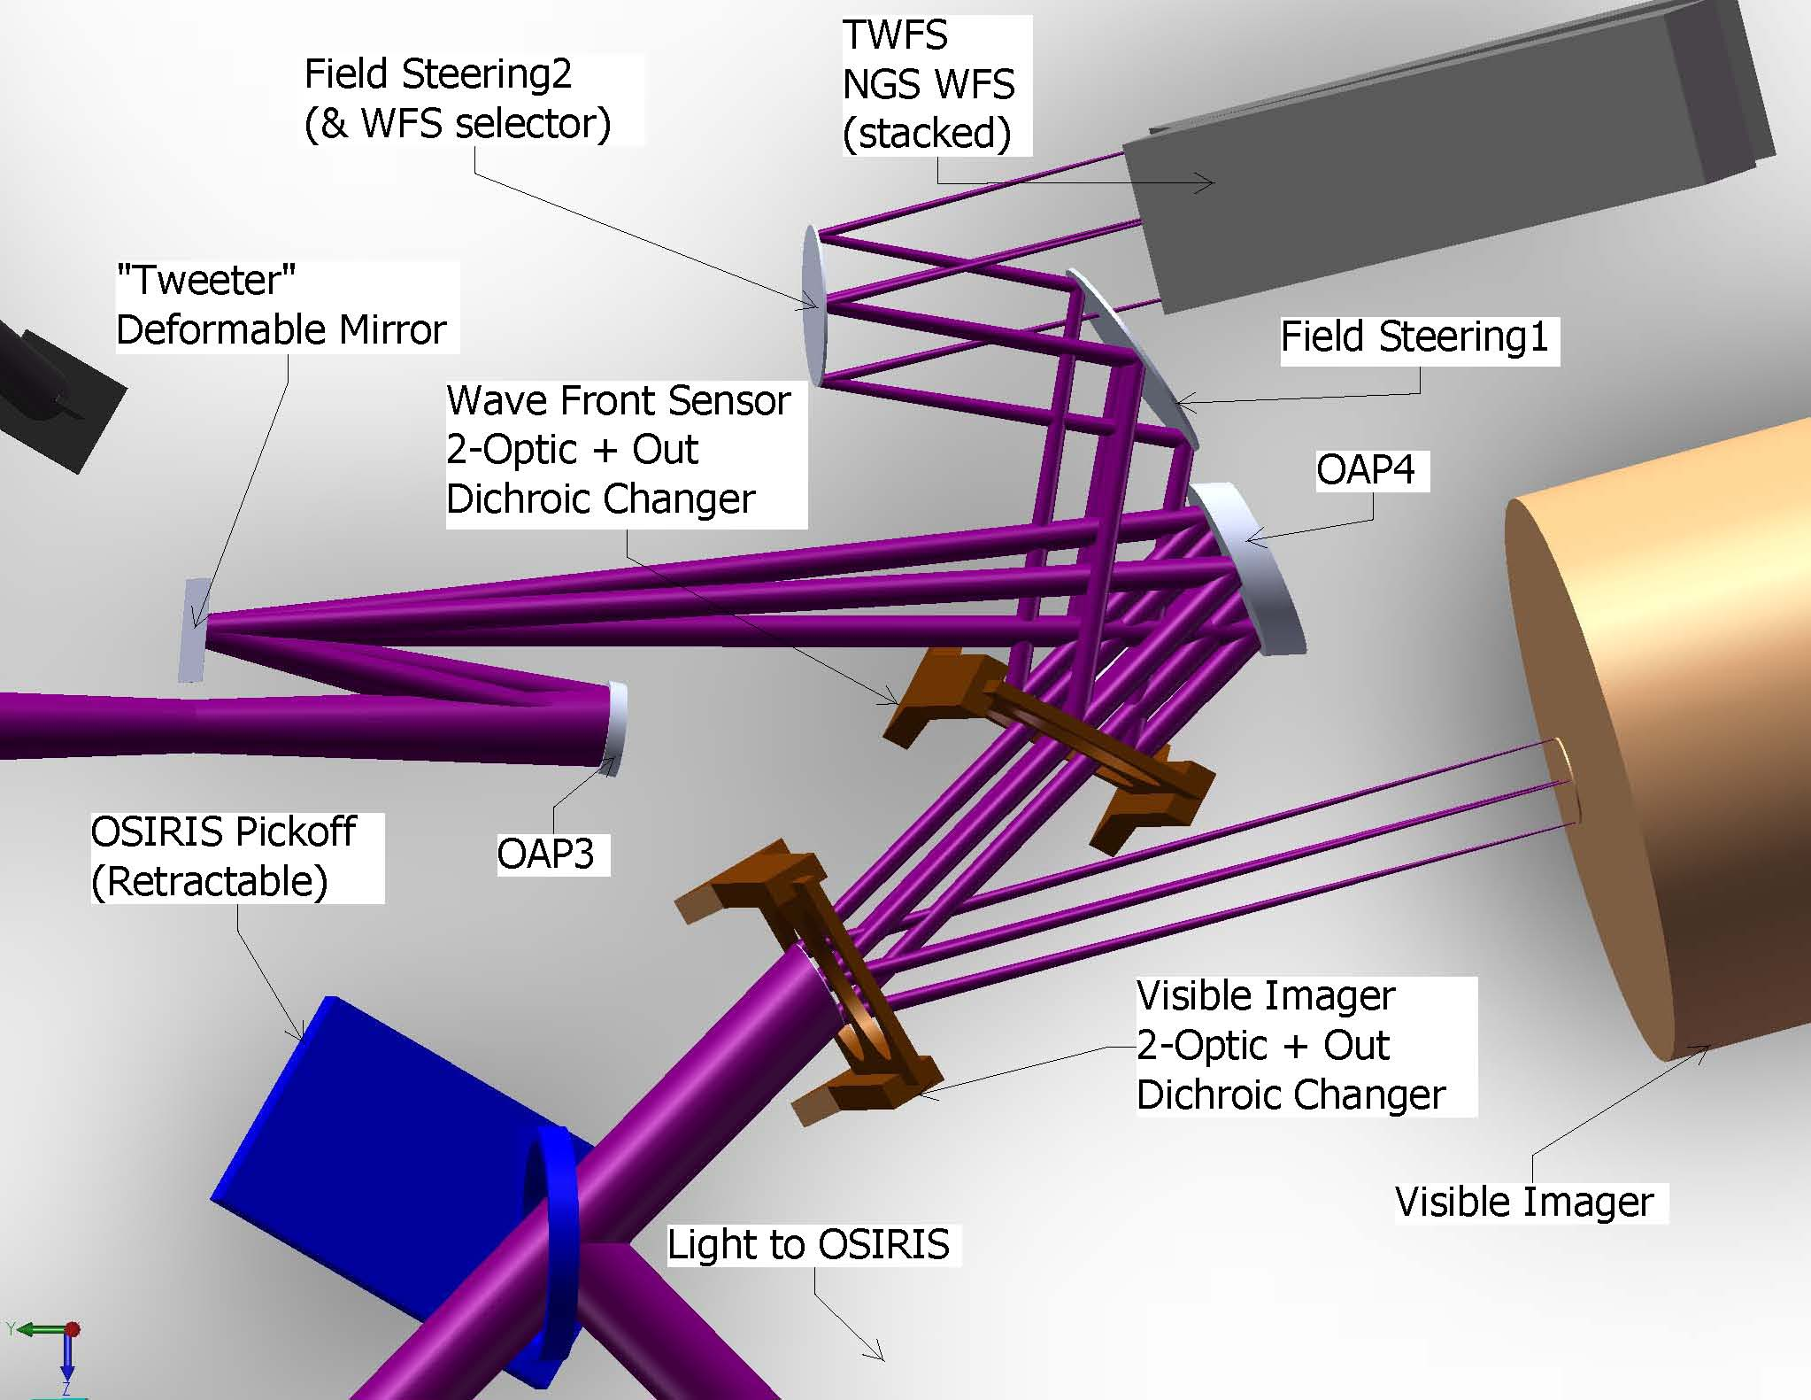
Figure 18: Narrow Field Path Output detail. Note that it appears that Field Steering1 mirror vignettes the light traveling to the wave front sensors. This is however, the available field for natural guide stars – not the field required for the wave front sensors. The wave front sensors accept a much smaller field.

Motion control in this portion of NGAO is as follows. The MEMs deformable mirror also has real-time 1st order correction via a tip/tilt mount. The splitter for the wave front sensors has 3 positions – two optics and one open. This is also the case for the visible imager splitter. A fold mirror can be inserted to redirect light from the IR imager to OSIRIS or its successor. (Note that this leg terminates at a focus as the requirements here are not yet fully defined.) And finally a pair of field steering mirrors, each with tip/tilt control, feeds and selects one of two wave front sensors.

- Laser Guide Star Wave Front Sensor & Interferometer Pickoffs
The Laser Guide Star Wave Front Sensor (LGSWFS) pickoff is a splitter, inserted (and retractable) into the collimated beam between the woofer deformable mirror and OAP2. This is shown in Figure 19 below.

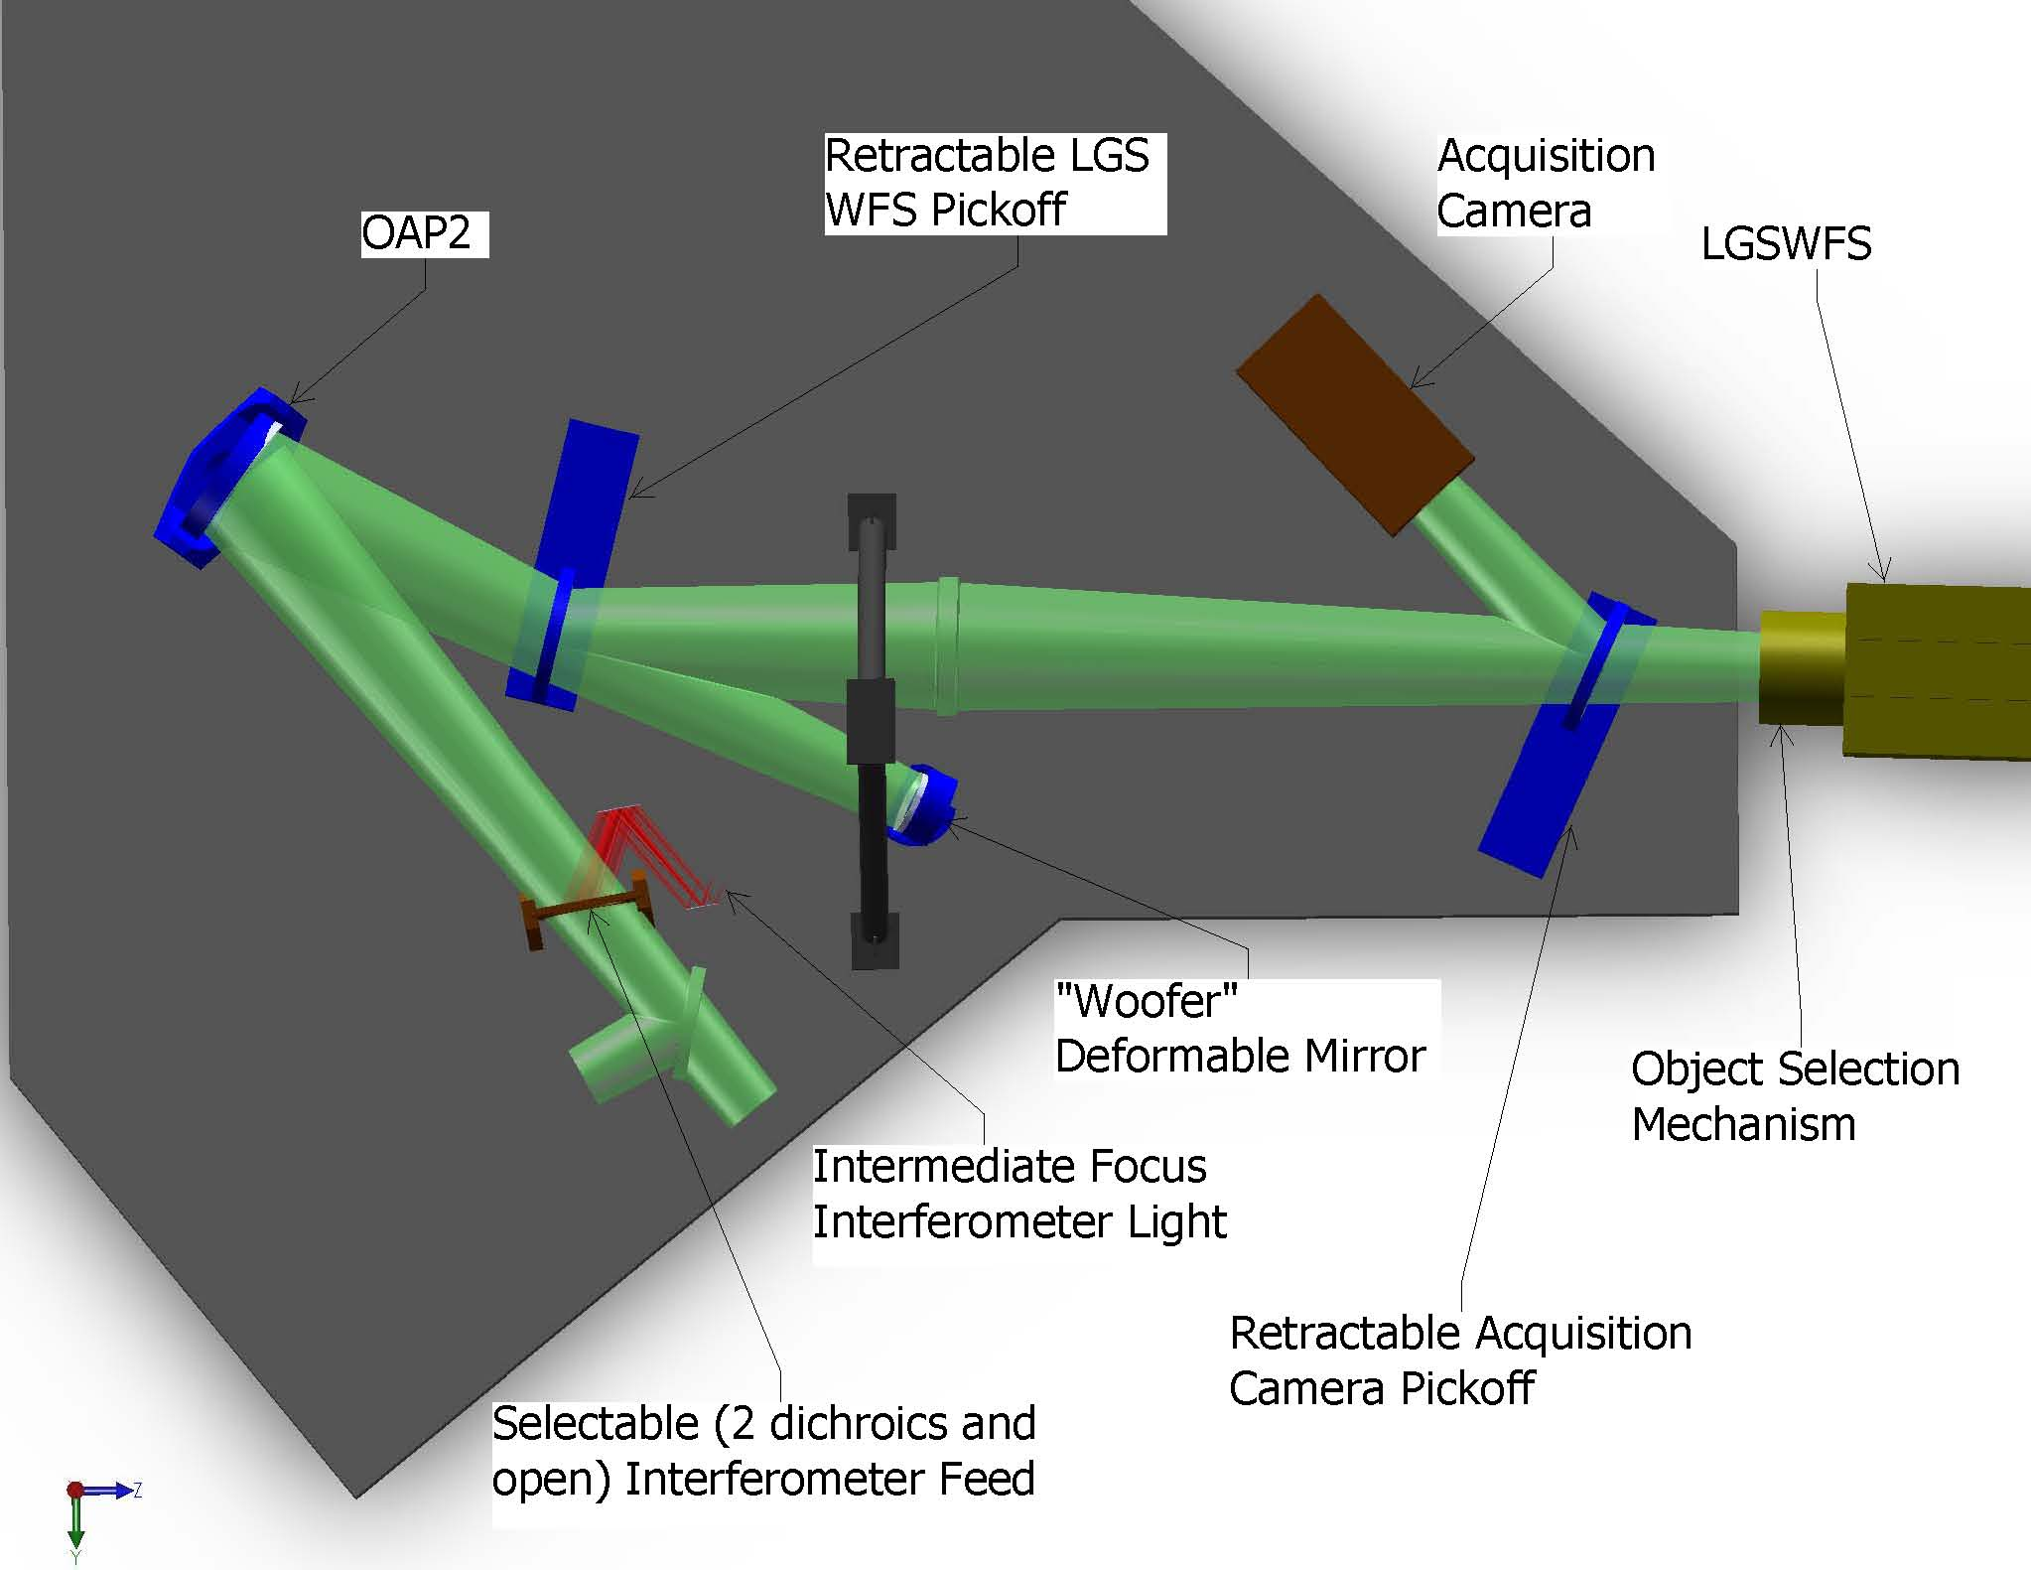
Figure 19: Laser Guide Star Wave Front Sensor & Interferometer Pickoffs

The Interferometer pickoff can also be seen in Figure 19 above. As with the OSIRIS pick of previously discussed, this leg terminates at an intermediate focus as the requirements here are not yet fully defined.
Motion control requirements here are two retractable optics (in or out) and a 3-position selectable dichroic for the interferometer feed.
- Structure
The two-tier 1st relay requires a platform elevated above the level of the main optical table. Three components are suspended from the under side of this platform: OAP1; flat fold mirror; and the image rotator (K-mirror). This was shown previously in Figure 16. The structure is shown by itself below in Figure 20.
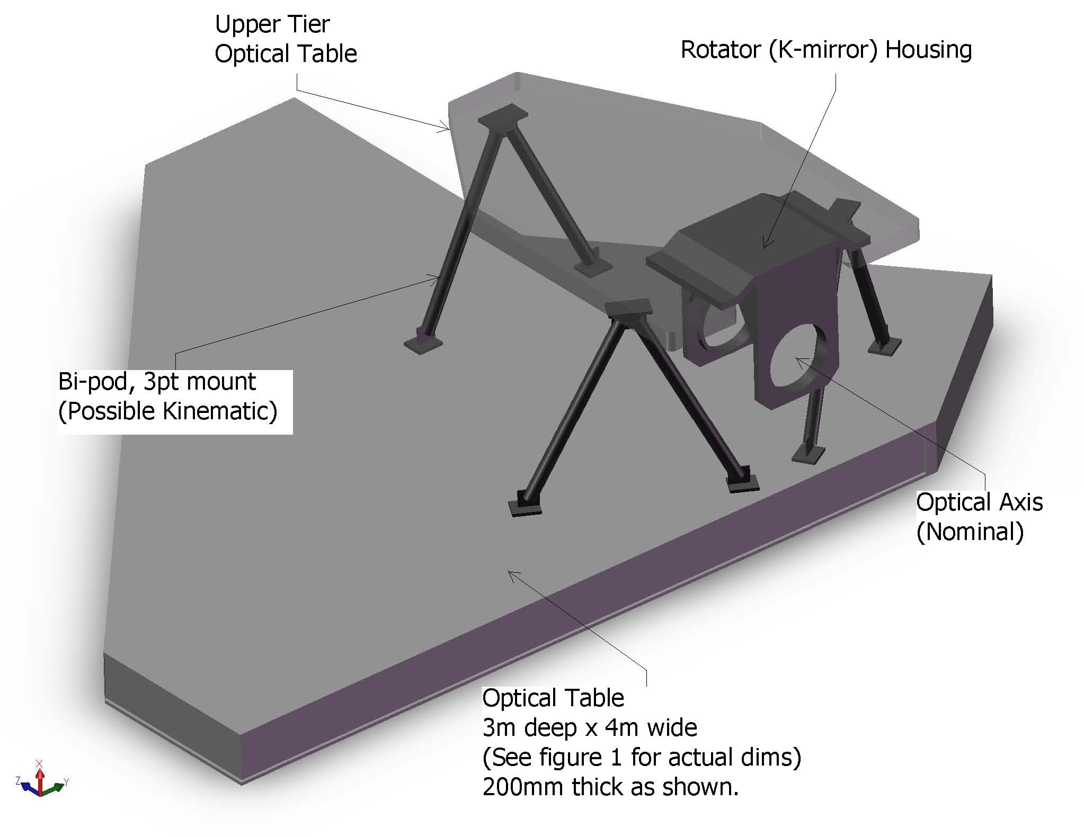
Figure 20: Structural Components of NGAO

The upper and lower tiers are expected to be typical honeycomb core optical tables of custom plan form. Thickness determination will occur is subsequent design phases. The separation of these two is accomplished with three bi-pod struts. If necessary, there is clearance to make these tripod struts, allowing kinematic mount detail for the upper tier.

Attachment to the Nasmyth deck is covered in the Enclosure section, but will likely be a similar approach to that just described. Note that the elevation of the top of the main table, above the Nasmyth deck is approximately 1 meter. Therefore the gap between the underside and the deck is likely to be around 700mm. This is not a lot of surplus clearance. Close attention will be paid this issue in the next design phase.
- Component Breakdown

Table 6 Mechanical Component Breakdown
Table 7 List of Optics, Not Including Dichroics and Pick-off Mirrors
Table 8 Dichroics and their bandpasses.

