Accomodating a 180 arcsecond NGS, 202 arcsecond LGS field with the Cascaded Relay

Reni Kupke

Note: The distances quoted in this memo are from the Zemax spread sheet. They may not correspond to actual distances on the bench, since Zemax measures from the center of the parabola when using an OAP.

These are all considerations in the optical design – we haven’t considered the mechanical constraints yet.

The original cascaded relay design proposed by Brian assumed a 120 arcsecond tip/tilt, LOWFS field-of-view. It has been suggested that there are sky-coverage advantages to increasing this to 180 arcseconds. This memo discusses the implications to the original cascaded relay optical design of increasing the field of view to 180 arcseconds.

The image plate scale at the Keck f/13 focal plane is 0.727 mm/arcseconds. For a 120 arcsecond field, this corresponds to a field radius of 43.6mm, while for a 180 arcsecond field it increases to 65.4mm. The size of the first K-mirror must therefore be increased by roughly 50%. To provide clearance for the larger diameter #1 K-mirror, the distance between K-mirrors #1 and #2, and #2 and #3 must also be increased. K-mirror #3 must then be increased in size more than 50% to accommodate both the larger field and greater distance from the f/13 focus.

The K-mirror package obviously becomes larger by more than 50%. More importantly, the distance after the K-mirror assembly to the first OAP (OAP1) is shortened by over 20%, from 556mm to 416mm. Remember that the placement and focal length of OAP1 is set by the beam diameter desired on the woofer mirror of 100mm.

The OAP1 folds back to the first fold mirror, which sends the beam up out of the plane of the Nasmyth beam to an upper level. This first fold mirror must be moved closer to the OAP1 in order to make room for the larger K-mirror assembly and make up for the shorter distance between K-mirror and OAP1. It’s distance from OAP1 changes from 650mm to 575mm. This will change the conjugate height of that first fold, if in the future it is decided to place a deformable mirror at that height. The original design had the first mirror placed at 10km. My calculations show that it now lies near 10.5km. There is, however, not much room for a deformable mirror in this tighter space.

The first fold mirror folds up to the 100mm pupil, where the woofer is located. In order for the wider beam to clear OAP1 on its way to the second level (especially since the distance between OAP1 and the first fold is shorter), the angle of the first fold was increased from 9.125 to 12 degrees. This will increase the difference in the X and Y mappings on the woofer. Brian believes this is a small effect, since the woofer is meant to be coarsely-sampled.

The dichroics for the LGS and dNIRI pick-offs will be larger. More of a problem, though, is the fact that the increased angle of the first fold mirror puts the second level higher. The dNIRI beam, which was to go straight down below the AO-bench to the dNIRI pick-offs (which, I believe, want to be at a focal plane), now focuses within the AO-path. The focus has moved upwards. With the present cascaded-relay design, dNIRI would either have to be moved to the top or side of the AO path – can dNIRI be upside down? Alternatively, the dichroics for the LGS and dNIRI could be moved closer to OAP2, but would then have to be larger diameter (at the moment they are LGS dichroic 280mm and dNIRI dichroic 220mm ), and interference with the K-mirror is a problem.
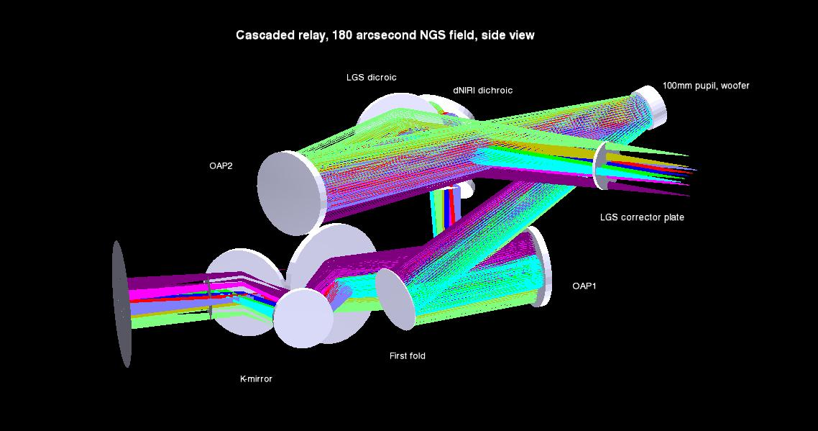
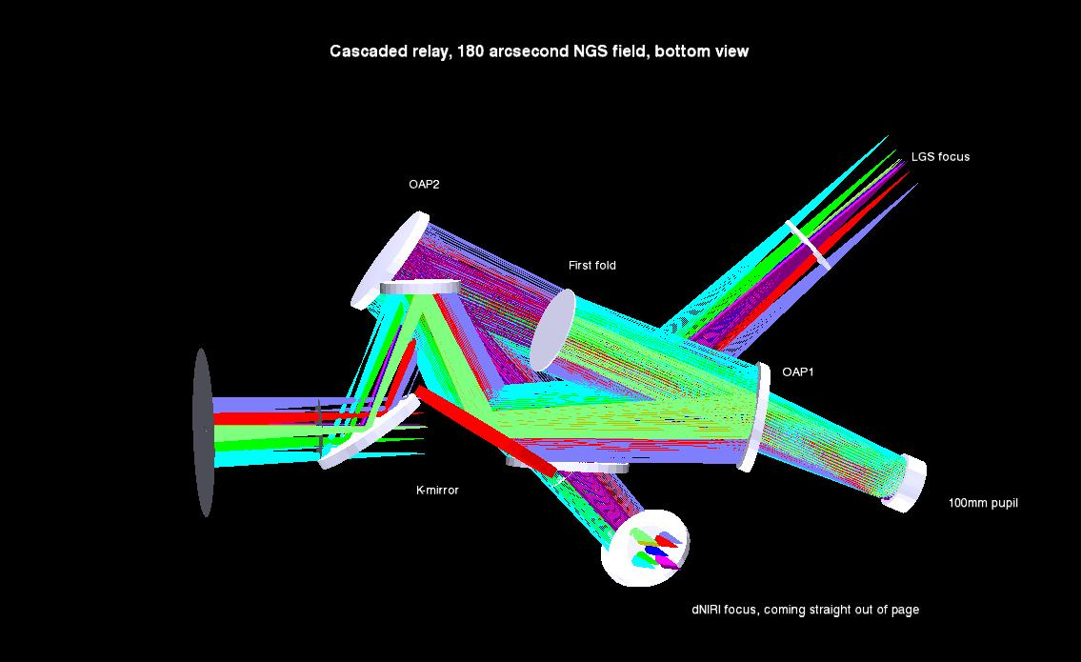

Possible solutions – moving the rotator to the other side of focus (towards the bearing will give us more room for the relays. Brian has no problem with putting the ADC downbeam of focus. We could also make the second tier below the first, in stead of above. This would take up some of dNIRI’s space. Another option is steepening the off-axis angles of the OAPs, but Brian recommended keeping those as small as possible.

