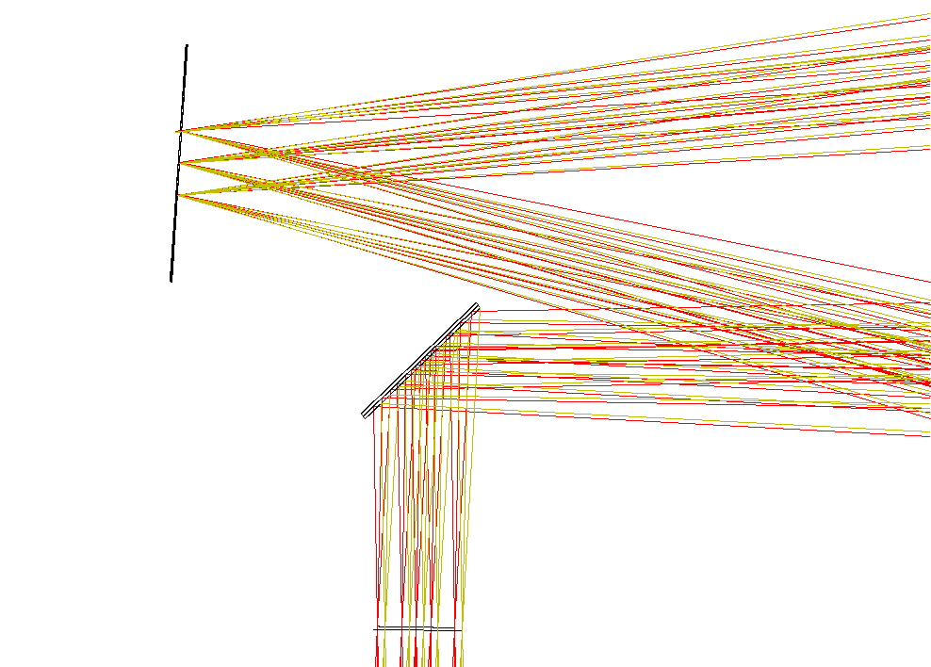
OAP3

Insertion of the interferometer dichroic causes a 7mm focal shift, 6mm lateral shift at the f/13.66 focus (LOWFS pick-off plane), and a 0.2mm shift at the HODM pupil plane.

