 Keck Adaptive Optics Note

Next Generation Adaptive Optics:
Phased Implementation Report -- DRAFT

P. Wizinowich, R. Dekany, D. Gavel, C. Max
June 12, 2008

1. Introduction

KAON 594 described the NGAO team’s plans to investigate phased implementation and descope options in response to the recommendation to do so by the Observatory Directors, SSC and NGAO System Design Review (SDR) Panel. The purpose of this KAON is to report on the results of this investigation.

2. SDR Proposed System

This option is considered to be the optimal approach in both cost and schedule to achieving the NGAO requirements.

2.1 Science Case Drivers

The science case and resultant requirements for NGAO are defined in KAON 455. The science cases drive the NGAO performance requirements in four primary areas: high Strehl, PSF stability, high sky coverage and low backgrounds. The science cases require four science instruments: a deployable Integral Field Spectrograph (d-IFS), a near-infrared (NIR) Integral Field Unit (IFU), a NIR camera and a visible camera. Table 1 summarizes the required capabilities for each science driver (required items are shown with green fill).

Table 1: Performance and science instrument requirements for each science case.
Science Case | Performance Requirements |  |  |  | Science Instruments
Science Case | High Strehl | PSF Stab-ility | High Sky Cover. | Low Back-gnd | d-IFS | NIR IFU | NIR Cam | Vis Cam
Galaxy Assly & Star Formation
Nearby AGNs
Galactic Center - Relativity
Galactic Center - Stellar Pop'ns |  |  |  |  | narrow
Extrasolar Planets
Minor Planet Multiplicity
QSO Host Galaxies
Gravitational Lensing by Galaxies
Gravitational Lensing by Clusters
Astrometry Science
Resolved Stellar Populations
Debris Disks
YSOs
Minor Planet Size, Shape, Comp.
Gas Giant Planets |  |  |  |  | narrow
Ice Giant Planets |  |  |  |  | narrow

2.2 NGAO System
A block diagram of the NGAO system presented at the SDR, and discussed in the System Design Manual (KAON 511), is shown in Figure 1. This system satisfies the science requirements discussed in KAON 455 with the partial exception of the galaxy assembly and star formation science case which requires 150 W of laser power to meet its full requirements (only 100 W was included in the SDR cost estimate).

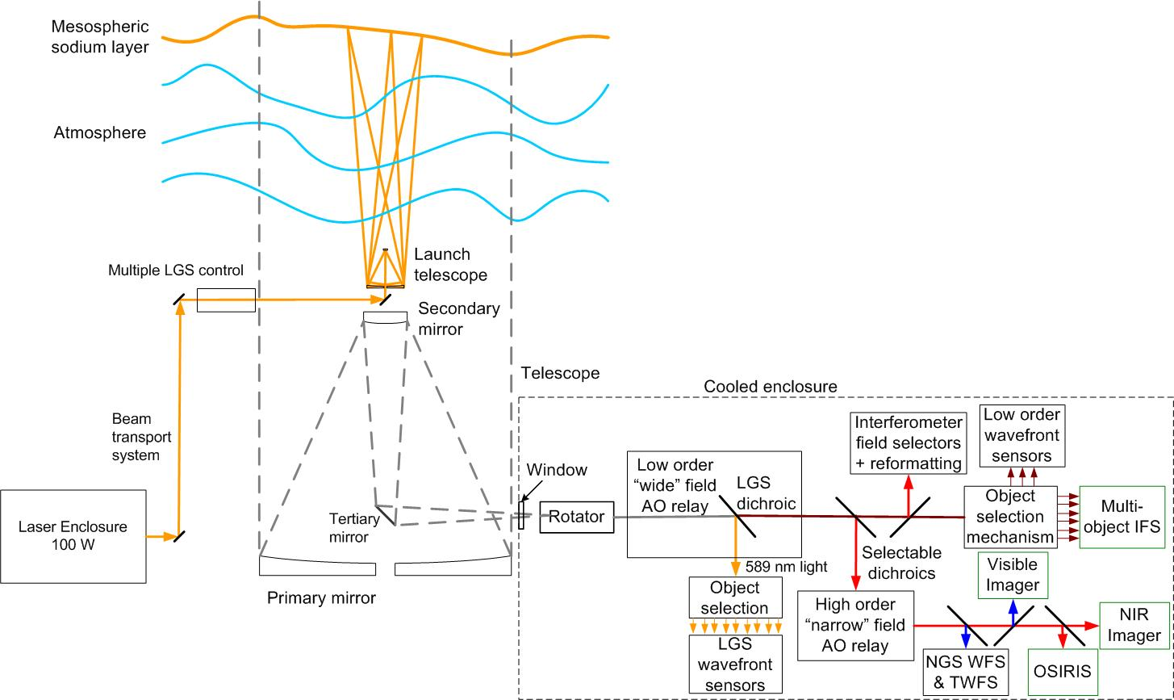
Figure 1: NGAO block diagram.

3. Staged Implementation of SDR Proposed System

This section defines and describes a staged implementation of NGAO that would ultimately achieve the science requirements defined in the previous section. The ultimate goal of achieving the same requirements is an important statement because it keeps us with the NGAO architecture proposed at the SDR. Since the SDR-proposed architecture was a down-select from several possible architectures (as described in KAON 499) it represents our best approach to achieving the science requirements. Significantly changing the requirements could result in the selection of a different architecture.

An assumption is that the NGAO system will be installed on the Keck II telescope to replace the dye laser system and the older of the two AO systems.

3.1 Base System Implementation

3.1.1 Laser Base System

The laser base system would provide 50 W of laser power in a single beacon. The laser enclosure, launch facility, safety system and system control would be all sized for 150 W, but the system would only be populated for the control of 50 W of laser power and a single beacon. This would provide a performance improvement when combined with the existing AO system on either telescope due to the higher power laser; the performance gain would be most significant on Keck II since we would also be changing from a side launched beacon to a center launched system.

Due to the significantly higher conversion efficiency of a solid state laser the required laser power and cooling should be less than for the existing Keck II laser. Therefore no increase in facility cooling capability would be required for this base system.
Note that only NIRC2 and NIRSPEC would be available on Keck II initially.

The following is a list of the items in the full system not present in the base system:
- 50 to 100 W of laser power.
- The above items will reduce the requirements on the Observatory infrastructure.
- LGS asterism generator.
- The laser safety system will be fully operational, but missing the aspects for additional lasers.
- The laser system control will not be fully populated.

3.1.2 Interim Keck AO Upgrade

This interim upgrade option comes at some additional cost but would allow an incremental improvement to the existing Keck AO system performance as well as allowing some on-sky testing of NGAO hardware. This upgrade would take advantage of the increased laser power provided by the NGAO laser base system in order to reduce the largest term in the error budget.

This upgrade would require the following:
- Implement the LGS asterism generator (at least for three fixed LGS).
- Implement three LGS wavefront sensors and object selection mechanisms. Extra work may include folds to allow this system to fit on the AO bench. The likely location of the LGS WFS assembly would be on a removable kinematic plate that could be placed on the bench instead of the NIRSPEC reimaging optics or OHANA fiber injection module.
- Implement the LGS dichroic and dichroic changer mechanism to pickoff LGS light in the collimated beam after the DM.
- Implement an initial version of the new RTC system. Extra work includes interfacing to the existing NGS WFS, STRAP and DM; it will likely be necessary at least initially to allow switching back to the old RTC. Signals from the three LGS wavefront sensors would be used to do tomography of the atmosphere in order to more optimally control the existing DM.

The AO base system described in the next section would provide similar performance to this interim upgrade. Therefore, if this upgrade were implemented it would be better to keep the AO base system in the lab longer in order to allow integration of one or more of the additional NGAO features prior to moving the NGAO system to the telescope.

3.1.3 AO Base System

The base system described in this section is the initial system that we would propose implementing at the telescope. Since we have decided to stay with the same architecture to achieve the science requirements we looked for a base system that would be a subset of the final system and provide the lowest initial cost consistent with providing a more powerful science capability than the system that would be replaced. Ease of upgradeability is an important factor since this would minimize AO system downtime.

Our recommended minimalist approach provides the skeleton for the full NGAO system as shown in Figure 2. This system would provide higher Strehl than the Keck I LGS AO system as a result of higher laser power (50 W versus 20 W) and reduced focal anisoplanatism. The complete laser enclosure and beam transport system including the launch telescope is included in this baseline, however only 50 W of laser power is provided. The complete AO enclosure would be provided however initially it would not be cooled. A partially populated AO bench would be provided. The low order “wide” field relay would be complete. Only three, instead of nine, LGS wavefront sensors (WFS) would be provided. The existing Keck AO NGS WFS, tip-tilt sensor (STRAP) and low bandwidth WFS (LBWFS) would be slightly re-engineered and used instead of new NIR tip-tilt or truth wavefront sensors. Overall only two WFS would have been added to the real-time control system versus the existing Keck AO system. The existing Keck AO RTC could be upgraded to accept input from additional two new LGS WFS and to perform the required tomography. Everything in this base system would be closed loop. No new science instruments would be present in this first phase. OSIRIS would be reused but in a different location, after the first relay instead of after the second relay, in order to reduce the number of surfaces.

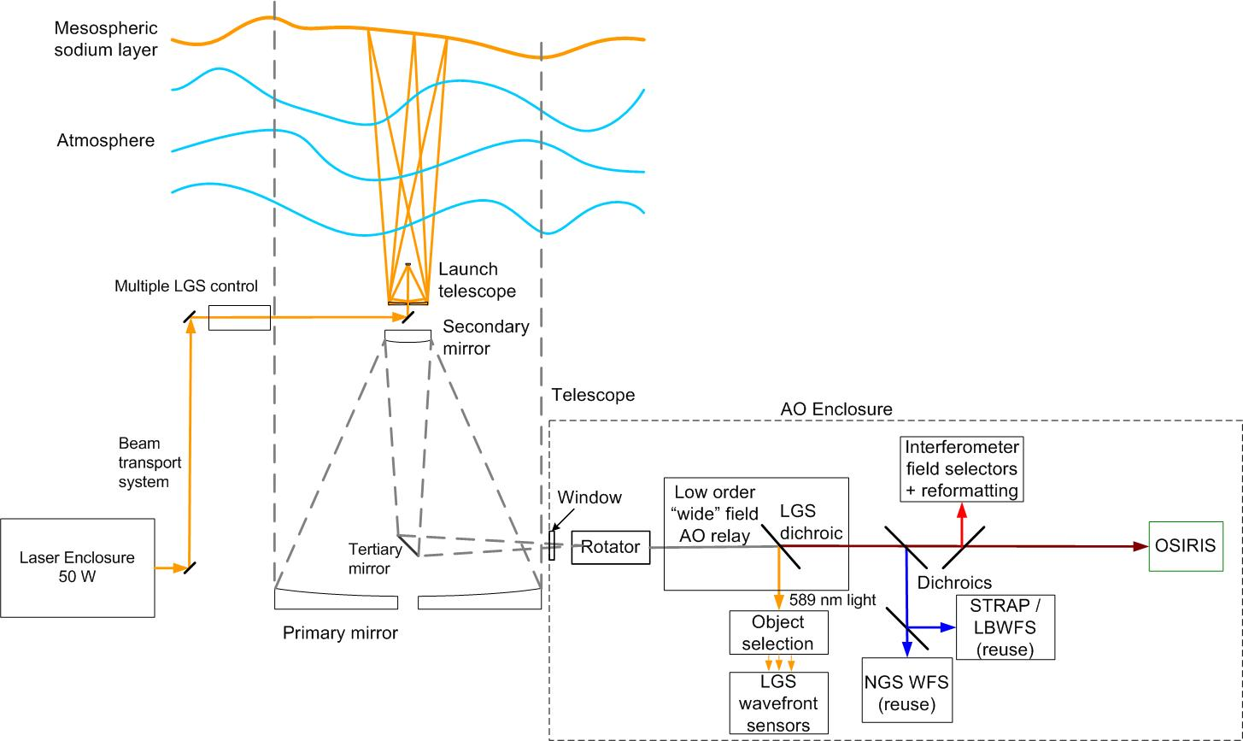
Figure 2: NGAO base system block diagram.

The following is a list of the items in the full system not present in the base system:
- Cooling of the AO enclosure. This reduces the requirements on the Observatory infrastructure.
- One or both of the AO enclosure entrance windows (may need to implement for future access reasons).
- Six LGS wavefront sensors and their associated object selection mechanisms.
- Three IR reflective dichroics and a mirror in the dichroic changer reflecting light to the “narrow” field relay.
- Two NIR tip-tilt sensors and one NIR tip-tilt-focus-astigmatism sensor and their associated object selection mechanisms, ADCs and MEMS. One tip-tilt sensor replaced with reuse of existing Keck AO STRAP.
- NIR and visible truth wavefront sensors (TWFS). One TWFS replaced with reuse of existing Keck AO LBWFS.
- D-IFS and associated object selection mechanisms, ADCs and MEMS.
- “Narrow” field relay including high order MEMS and tip-tilt stage.
- Dichroics and changers for NGS WFS (just a fixed mirror in base system), visible imager and OSIRIS.
- Visible ADCs for NGS WFS and Visible camera.
- NGS WFS. Replaced with existing Keck AO NGS WFS (appropriate for low order relay).
- IR ADC for NIR camera and OSIRIS.
- Visible camera.
- OSIRIS reimaging optics.
- NIR camera.

3.1.4 Decision Tree for an NGAO Base System

Figure 3 shows the decisions leading to the implementation of the NGAO base system, or equivalent AO upgrade, described above on one of the two Keck telescopes. A decision to implement NGAO on Keck I would result in following the tan colored path in Figure 3. Reuse of the existing launch telescope might be possible, and possibly the installation of a new laser enclosure could be deferred until later. The end result unfortunately is that we would still have the side launched dye laser system on Keck II. The blue colored boxes in Figure 3 show the path to implement the NGAO base on Keck II. On either path an option exists for an interim upgrade of the AO system to implement three LGS beacons and wavefront sensors in order to reduce focal anisoplanatism.
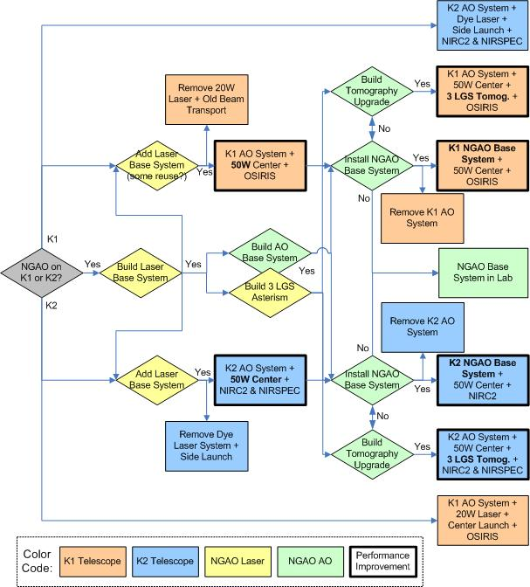
Figure 3: Decisions leading to an NGAO base system.

The end result from Figure 3 is one of the following scenarios:
- NGAO laser base system implemented on Keck I and Keck II AO system unchanged.
- NGAO laser base system implemented on Keck II and Keck I AO system unchanged.
- NGAO laser and AO base systems implemented on Keck I and Keck II AO system unchanged.
- NGAO laser and AO base systems implemented on Keck II and Keck I AO system unchanged.
- NGAO AO base system in lab and neither Keck AO system changed.
- NGAO laser base system and tomography upgrade implemented on Keck I and Keck II AO system unchanged.
- NGAO laser base system and tomography upgrade implemented on Keck II and Keck I AO system unchanged.
- NGAO laser base system and tomography upgrade implemented on Keck I, Keck II AO system unchanged and NGAO AO base system in lab.
- NGAO laser base system and tomography upgrade implemented on Keck II, Keck I AO system unchanged and NGAO AO base system in lab.

3.2 Phase II Upgrades – Adding to the NGAO Base

3.2.1 Sky Coverage

The sky coverage upgrade would include implementation of the following items:
- Two NIR tip-tilt sensors and one NIR tip-tilt-focus-astigmatism sensor and their associated object selection mechanisms.
- The ADCs and MEMS would ideally be included at this point, but could potentially be deferred.
- Second 50 W laser and three more LGS beacons and LGS wavefront sensors.

3.2.2 Narrow Field Relay

The narrow field relay is required for the near IR camera, visible camera or OSIRIS (if OSIRIS is to be used with this relay). There is no performance return from implementing this relay unless one of these science instruments is also implemented. This implementation would include the following:
- “Narrow” field relay including high order MEMS and tip-tilt stage.
- At least one dichroic (selected for first instrument) and changer for NGS WFS.
- Visible ADC for NGS WFS (could be deferred initially).
- NGS WFS.
- Visible truth wavefront sensors (TWFS).

3.2.3 Near Infrared Camera

The NIR camera implementation would include the following:
- Narrow field relay needs to be in place.
- IR ADC for NIR camera.
- NIR camera.

3.2.4 Deployable Integral Field Spectrograph

The d-IFS implementation would include the following items:
- Cooling of the AO enclosure (if not already implemented; not necessarily required immediately).
- Both AO enclosure entrance windows (if not already implemented).
- Six LGS wavefront sensors and their associated object selection mechanisms (if not already implemented).
- Sky coverage upgrade (if not already implemented).
- NIR truth wavefront sensors (TWFS) (could continue to use existing Keck AO LBWFS if narrow field relay not implemented yet).
- D-IFS and associated object selection mechanisms, ADCs and MEMS.
- Move of OSIRIS or NIRC2 from d-IFS location.
- Third 50 W laser.

3.2.5 Visible Camera

The Visible camera implementation would include the following:
- Narrow field relay needs to be in place.
- Dichroic(s) and changer for visible camera.
- Visible ADC for visible camera.
- Visible camera.

3.2.6 OSIRIS or NIRC2

Which of these two science instruments should be used with NGAO and which, if any, should be left with the other AO system? Our analysis to date has indicated that OSIRIS is more suitable for use with NGAO. Is there enough physical room for both of these instruments with NGAO? If NGAO is implemented on Keck II and we want to use OSIRIS then this instrument will need to be moved to Keck II and potentially NIRC2 moved to Keck I.

3.2.7 Decision Tree for Adding to the NGAO Base

3.3 Summary of Phases and Required Subsystems

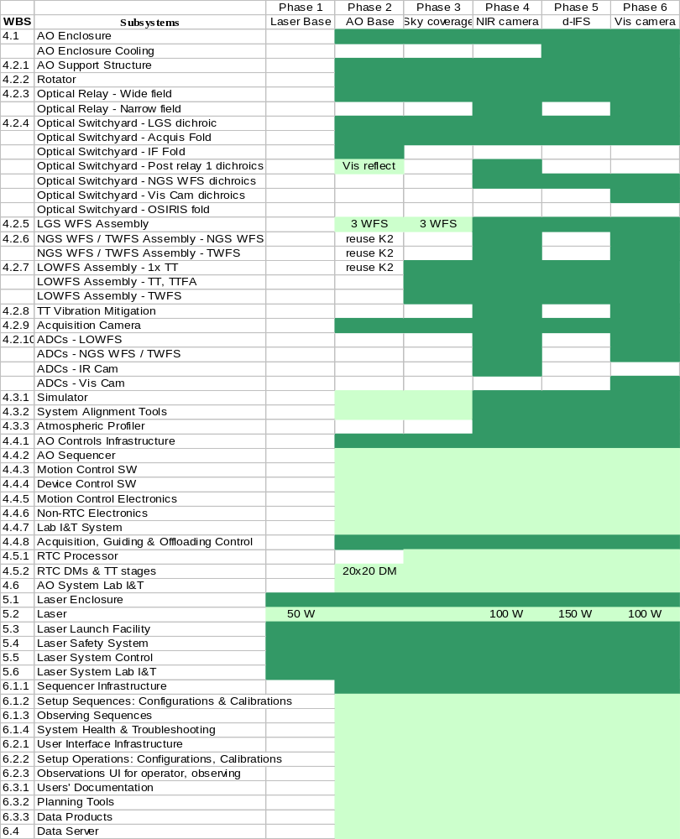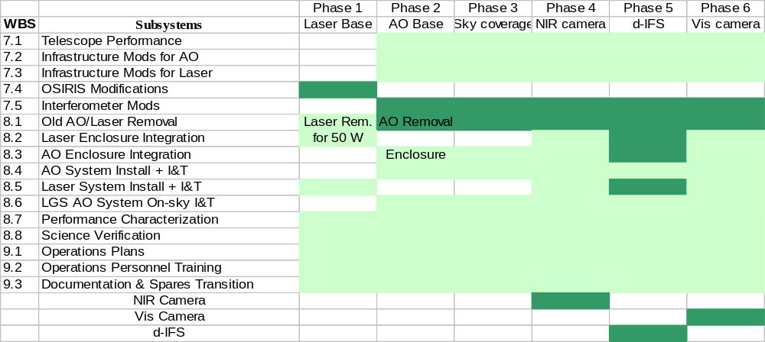
3.4 Recommended Implementation Sequence

4. Keck AO Upgrade Options

5. Descope Options

5.1 Number of d-IFU Units

6. Cost Savings Options

7. Cost Estimates

8. Summary

# | Capability | Science Enabled | Cost | Schedule | Complexity
1 | NGAO Laser Base (50 W)
2a | #1 + NGAO AO Base (3 LGS) + NIRC2
2b | #1 + Keck AO Tomography Upgrade (3 LGS) + NIRC2 & NIRSPEC
2c | #1 + NGAO AO Base (3 LGS) + OSIRIS
2d | #1 + Keck AO Tomography Upgrade (3 LGS) + OSIRIS
3a | #2a + Sky Coverage
3b | #2a + NIR Camera

9. Conclusions
Appendix: Rich’s Phasing Option Thoughts 4/10/08

I wanted to document a few thoughts on possible phasing options for NGAO. It's a little complicated and so probably needs a couple read-throughs, but I was looking for an approach with a significant implementation staging point at 'about half' the total NGAO cost. I didn't find one at quite that low a cumulative cost, but think there are approaches with palatable science capability at $26.5M or $31.5M (both w/ contingency), each of which starts with 50W of sodium laser power and no MOAO control in the LOWFS. I outline the implementations below as a step 1), followed by a branching option 2), when then reconverges at steps 2a4) and 2b4) and is the same for steps 3) and 4).

The premise I've gone back to is that Keck wishes to have a platform for future expansion of AO and instrument capabilities and that, while near term improvements to Keck 1 LGS are potential aspects of a program, we are really looking for phasing of a new expandable system. I think item 1) below is usable with the alternative 'Keck 1 Upgrades' architecture, but by item 2) I think we will have needed to decide on K1 Upgrade vs. Cascaded Relay for real.)

Implementation concepts
----------------------------------
1) The first thought is that for any future generation of AO system, the observatory will need a robust and configurable laser launch system. One approach would be to pull out the LGSF as a separate project of modest cost (only $3.5M, without new lasers themselves). This would be a permanent, real benefit to the observatory, even if development of new AO instruments undergoes funding-related gyrations. (It could also in theory enable multi-LGS tomography tests at Keck, which could be a significant risk mitigation (albeit at additional cost not in our plan.))

Next, choose between two approaches to a 'first light' NGAO system that surpass performance of K1 LGS, depending on science priority:

2a1) If science priority is high sky coverage with good correction, start by building both 1st and 2nd relays, but use only 3 science beacons (50W), no MOAO in IR LOWFS, and defer implementation of 2nd relay MEMS and MOAO control. 2a1) defers $3M lasers, $1M LGS ass'ly, $1.5M LOWFS ass'ly, $3M for 2nd relay MEMS, science MOAO, and 1st relay DM metrology), maybe $1M in RTC, and $1M of SE & management deferment. So about $42M - $10.5M = $31.5M (w/ contingency). Design LGS WFS ass'ly and RTC to be expandable to final configuration. OSIRIS could go in the wide-field port, or it could just go behind the 2nd relay (with slightly lower transmission).
2a2) Upgrade to 3+3 beacons (100W), and MOAO in the LOWFS. This step adds $3M in lasers + $1.5M in LOWFS ass'ly + $1M in RTC + $0.5M SE+management = $6M increment.
2a3) Over time, implement the 2nd stage MOAO. This is another $3M + $0.5M SE+management = $3.5M increment.
2a4) Upgrade to 6+3 beacons (100W). This is a $1M LGS WFS increment.

2b1) If science priority is superior correction with modest sky coverage, then first implement the 2nd relay (60" FoV) using a MEMS DM of sufficient stroke and as many actuators as practical. Use 3 beacons (50W) without MOAO in the LOWFS (whether to use discardable visible or final IR LOWFS is a separate decision - over the 60" FoV IR NGS would be quite well sharpened). Design LGS WFS assl'y to be usable in final configuration 2b3). Design RTC to be expandable to final configuration. 2b1) defers $3M lasers, $1M LGS ass'ly, $1.5M LOWFS ass'ly, $4M(?) for 1st relay, $2M for science MOAO and 1st relay metrology, $1M in RTC, and another $3M in misc deferments (incl. SE, management) from it being such a small relay, leaving $42M - $15.5M = $26.5M (w/ contingency).
2b2) Increment to 3 science beacons (100W), still in the narrow FoV. This step adds $3M in lasers.
2b3) When high-sky-coverage or dIFS demands, upgrade via construction of the 1st AO relay, moving the narrow relay to its final position (and potentially upgrading its DM to smaller stroke 64x64 actuators.) Add MOAO in the LOWFS, and go to 3+3 beacons (100W). This gets the system back to the configuration of 2a2), but goes through the initial, scientifically usable 2b1) configuration. This increments $1.5M LOWFS ass'ly + $4M 1st relay + $2M science MOAO and 1st relay DM metrology + $1M RTC + $3M SE & management = $11.5M.
2b4) Upgrade to 6+3 beacons (100W). This is a $1M LGS WFS increment.

3) Upgrade to 6+3 beacons (150W). This is a $3M increment (not part of our $42M).

4) Add more instruments, with science priority on dIFS if funding allows. Increments of $4-$14M each. This could occur, of course, in place of any of the above steps (following 2a1) or 2b1)).

Performance considerations
--------------------------------------
Assuming 2b1) uses a 5 um stroke MEMS DM, and can achieve N=20 across actuators (N=12 across with this stroke exists today), performance of 2b1) is similar to that of 2a1), order of 195 nm rms both with low sky coverage. Given that 2b2) could be reached for less cost than 2a1), however, it would seem to me that superior narrow-field correction could be obtained at 2b2), 170nm, than with 2a1) 195nm at similar cost. Good sky coverage with 195nm rms is achieved at 2a2) for $34.5M, while 2b3) gives 170nm rms with the same sky coverage at $37.5M. Here it is in a table:

Implement. HO WFE Sky coverage Cumul. Cost (see I&T costs note below)

2a1 195 nm Low $31.5M
2b1 195 nm Low $26.5M
2b2 170 nm Low $29.5M
2a2 195 nm High $37.5M
2a3 170 nm High $41M
2b3 170 nm High $41M
2a4/2b4 170 nm High + WF Sci $42M $42M

Note: I have invoked a new assumption, that we could defer $1M in the LGS WFS ass'ly by not fully populating it initially (start w/ 3 channels, growing to 6 in 2a4/2b4)). It is not entirely clear to me that this is a good idea, or that my optimistic 33% cost deferment is realistic.)

I&T Costs
-------------
I think it fair to assume that either incremental approach 2a1-4) or 2b1-4) would increase I&T costs (and probably Mngmt costs by increasing schedule). Compared to full funding upfront, it's probably a net increase of $2M(?) to follow either path. The table above does not reflect this, but the cost of multiple implementations is real.

Summary
-------------
I've described here two implementation phasings that allow flexibility to funding uncertainty. Both require significant investment to surpass K1 LGS performance, but they differ in prioritizing high-precision, low-sky-coverage vs. good-precision, high-sky-coverage. The former, it seems to me, can be achieved at potentially lower initial cumulative cost (implementation 2b2) at $29.5M) at the cost of bundling together all the wide-field upgrades (PnS lasers, MOAO LOWFS, and wide field relay) into a larger ($11.5M vs. $6M major implementation stage.)

Final thought
------------------
I don't think last August we considered it, but if we implemented via 2b1), one could image an alternative approach to subsequently attaining high-sky-coverage (and dIFS science). Each Point-and-Shoot LOWFS sensor could have it's own local AO loop (which could look very similar (identical?) to the narrow field MEMS relay in 2b1)), and dIFS could implement full MOAO as well (albeit over a smaller-than-120" FoV). While very speculative, this approach would organize the system into a series of narrow-field AO systems (one for narrow instruments, one each for LOWFS, and one each for dIFS IFU channel.) This is a little different than our 'Split Relay' architecture (in that here the LGS would pass through a 60" FoV relay and not be fully-open loop as in Split Relay), but many of the packaging issues we worried about then would still apply. Still, with a 2b1) implementation point on the way to Cascaded Relay, we'd have gained a much better understanding of the packaging issues.
Appendix: Science Cases vs. AO Capabilities and Instruments
Claire Max, April 13 2007

1) Galaxy assembly and star formation history: wide field, d-NIFS, cooled AO system very important, high sky coverage needed

2) Nearby AGNs: Narrow field, OSIRIS-like IFUs (capabilities from 850 nm to K band), EE < 35 mas, high sky coverage
J band and longer: stellar vel. dispersions from CO bandhead (2.3 microns), gas velocity dispersions from [S III] (9533 A), [Fe II] (1.26 μm), Pa β (1.28 μm), H2 (2.12 μm), Br γ (2.17 μm)
Ca triplet (850 nm): stellar vel. dispersion (higher spatial resolution), measure lower BH masses
Tip-tilt stars: use HII regions or super star clusters in the AGN host galaxy in addition to regular TT stars. This needs further analysis.

3) Galactic Center: High Strehl, high PSF stability, sky coverage doesn’t matter
Relativity: Narrow Field IR Imager plus OSIRIS for radial velocities, K band, high Strehl
Stellar populations: d-IFS in close-packed mode

4) Extrasolar planets: Narrow field, high Strehl, new IR imager with coronagraph. J and H bands. Sky coverage not an issue.

5) Minor planet multiplicity: Narrow field, high Strehl, high sky coverage for KBOs and Trojans, I and J band
NIR and visible imagers, would benefit from coronagraph if J band Strehl is high enough

6) QSO Host Galaxies: High narrow-band Strehl, high sky coverage, low backgrounds
High Strehl and very good PSF knowledge in K band
Cooled AO system very important

7) Gravitational lensing by galaxies: Narrow field, high Strehl, high sky coverage, low background,
NIR imager and OSIRIS, EE radius < 50 mas at J over 30% of sky

8) Gravitational lensing by clusters: wide field, high sky coverage, low background, d-IFS
Need to get images of full cluster before using high-Strehl AO. Might use MOSFIRE or ability to mosaic narrow-field images over ~ 1 arc min

9) Astrometry science: Too many different science cases to make clear statement of needs yet

10) Resolved stellar populations: photometry and CMDs
High Strehl, low PSF variation, total imager area on the sky as high as possible
Sky coverage not important, as cluster stars can be used for TT
Cooling needed for fields that are not confusion limited

11) Debris disks: narrow field, high Strehl, sky coverage not an issue, visible and near-IR wavelengths, cooling important for the IR
Narrow field visible and IR imagers

12) Young Stellar Objects:
Narrow field, high Strehl, optical and near IR, sky coverage not an issue
Cooling important in K band
Narrow field visible and IR imagers
IFU spectroscopy but want higher dispersion and larger field than OSIRIS. Not clear if 10-20 km/sec (OSIRIS) is adequate

13) Size, shape, composition of minor planets: narrow field, high Strehl
High sky coverage
Low backgrounds in K band (e.g. for KBOs, Trojans)
Visible and near-IR imagers

14) Gas giant planets:
Io: R or I band images
Jupiter and Saturn, I band thru near IR, as wide a field as possible.
Jupiter and Saturn: Can benefit from d-IFS, packed as closely as possible.

15) Ice giant planets:
Rings: cooled AO system, K band, either narrow field or multiple IFU units

16) Backup science: narrow field NGS
Appendix: Claire’s Phasing Plan(s): An alternative to Rich’s plan.
Motivation: Higher sky coverage is key to getting truly broad use of AO by the astronomy community. This plan right away gives higher sky coverage than today for both the narrow and wide fields, and gives better high order AO performance than today. Later phases increase sky coverage further using point and shoot lasers, increase high order correction by installing the 64x64 MEMS and its WFS for the narrow relay, and increase multiplexing by installing more d-NIFS arms. This approach lets us implement a cooled AO system right away for both relays, very important for many science cases.
1) Build both relays including 20x20 high-stroke DM in first relay, and full laser launch facility. Both relays in cooled enclosure.
2) Do tomographic WF measurement but don’t implement point and shoot yet. Put MEMS in LOWFS’s. Implement wide and narrow fields. Both have higher sky coverage, and better HO correction than today because of no cone effect and more actuators.
- Buy 100 W of laser power, use in 6 science beacons. [Note: could be fewer – we’d need to do the error budget trade-offs to see what the minimum number is.]
- Build ~ 3 arms of d-NIFS with 32x32 MEMS in them
- Put MEMS DMs in each LOWFS and use tomographic solution to tell them what to do
- Put OSIRIS behind narrow relay but only using the 20x20 high-stroke DM (closed loop). Could use OSIRIS imager for commissioning if new IR imager not yet available [what is current wavefront error for OSIRIS imager?].
- Cost savings: 50 W of laser power (already assumed in baseline), don’t do point-and-shoot, no 64x64 MEMS for narrow relay, only ~3 arms of d-NIFS, can live with delay in new IR imager if necessary.
3) Improve Strehl of narrow-field near-IR AO:
- Install 64x64 DM and its WFS to complete the narrow-field AO system
- Install new NIR diffraction-limited imager (if not done in previous phase)
- Lack of point and shoot will mean that tip-tilt correction won’t be as good over as large an area of the sky. But sky coverage for the narrow field instruments will still be better than today.
4) Either:
a) Install another 50W of laser power and 3 32x32 MEMS in LOWFS’s to add point-and-shoot TT correction, or
b) Install 3 more arms of d-NIFS, or
c) Install visible imager
5) and 6) Do whatever parts of 4) you chose not to do first
Appendix. NGAO SDR Cost Estimates associated with each Performance and Science Instrument Capability.

Columns 1 and 2 list the WBS number and subsystem description. The next three columns list the dollars ($k) for labor, other (non-labor and travel) and contingency from the NGAO SDR cost estimate for all post-SDR phases of the project. The fraction of these dollars associated with the base system and with each of the additional capabilities is shown in the remaining columns (columns 6 to 14 always add up to 1.0). Not shown are the costs associated with project management (WBS 2) and systems engineering (WBS3).


