AO enclosure and optical relay subsystem functional requirements

Architectural Assumptions and Overall Requirements
The AO enclosure and optical relay subsystem includes the optical elements that relay the input beam from the Keck telescope to both visible and infrared instrument ports and to other AO optical subsystems such as wavefront sensors and tip tilt sensors. This subsystem also includes all mounts and supporting structures such as optics mounts, optical tables, and mechanical support structures.

It is envisioned that the system may be configured into several different modes; the optics to accomplish this and their motion control are also part of this subsystem. Currently the system will be mounted at one of the Nasmyth focal stations currently occupied by an AO system, (Keck I or Keck II TBD). The optical system will be enclosed in a room or other suitable container that can be maintained at temperatures below ambient temperature to reduce thermal background. If needed, parts of the system, such as electronics that do not require a direct interface to the optical path, might be located in nearby housing and kept at a warmer temperature.

As part of the NGAO system design process, a preliminary architecture selection was made during the months of July and August 2007. The result of this process was a two staged AO system known as the “Cascaded Relay”. A sketch of the optical relay is included in Figure 1. More details of the Cascaded Relay can be found in KAON 499.

CN: Add more comments about selected architecture (Cascade)
CN: define Visible, Near IR, IR, photometric bands J, H, K, etc.

Optical Requirements

Transferred field of view:
The first stage of the optical relay will pass a circular unvignetted field of view of 180 arcseonds. The second stage of the relay will pass a circular unvignetted field of view of 20 arc seconds with a goal of 40 arc seconds. (These fields are referenced to the sky)

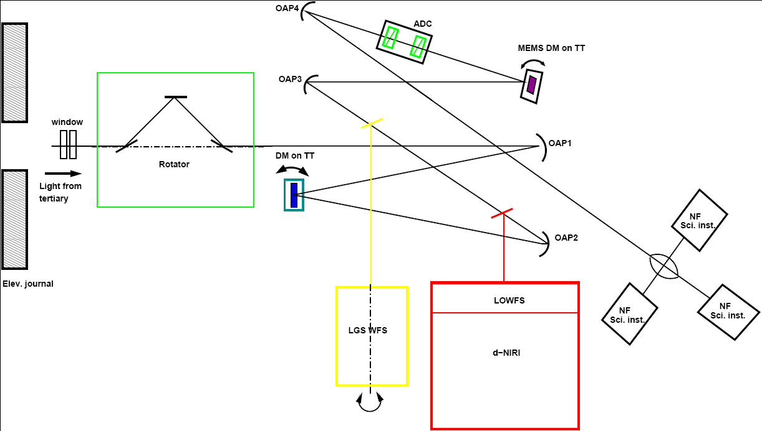

Figure 1: A schematic representation of the NGAO cascaded relay

Static optical quality of first relay:
The static optical quality of the first AO relay should be as high as possible over the entire 180 arc second field of view of the AO system. Static aberration that fall in the spatial frequency range of the deformable mirror correction will have an rms wavefront error of TBD nm rms or less over the 180 arc second field of view. Static wavefront errors that are beyond the spatial frequency range of the deformable mirror will have an rms wavefront error of TBD nm rms or less.

Static optical quality of second relay:
The static optical quality of the second AO relay should be as high as possible over the entire 20 arc second field of view of the AO system. Static aberration that fall in the spatial frequency range of the deformable mirror correction will have an rms wavefront error of TBD nm rms. Static wavefront errors that are beyond the spatial frequency range of the deformable mirror will have an rms wavefront error of TBD nm rms.

Chromatic aberration:
Allowable chromatic aberrations are TBD

Chromatic focal shift:
Allowable chromatic focal shift is TDB

Curvature of output focal planes:
Output focal surface shall be flat to within the static optical quality of the first and second relays respectively.

Field distortion:
The optical distortion shall be TBD percent across the field of the first relay and TBD percent across the field of the second relay when used in combination with the first relay.

Transmission:
Transmission in the IR Science wavebands will be TBD %
Transmission in the Visible Science wavebands will be TBD %
Transmission in the LGS waveband will be TBD%
Transmission in the NGS wfs sensing bans will be TBD %

Output focal ratio:
The output focal ratio of the NGAO relays should match the output focal ratio of the telescope when used with its so-called f/15 secondary

Output pupil location:
The optical relays will provide pupil locations that match the Keck telescope when used with its so-called f/15 secondary.
(see http://www.oir.caltech.edu/twiki_oir/bin/view.cgi/Keck/NGAO/OpticalDesign
for exact specification of telescope)

Pupil image size internal to the first relay:
The pupil image size of the first relay will be 100 mm (see section 7.9)

Pupil image size internal to the second relay
The pupil image size of the second relay will be TBD mm (see section 7.9)

Pupil distortion:
The allowable pupil distortions will less than 0.1 %. (Requirement is based on tenth of a subaperture registration error and 64 subapertures across the pupil)

Atmospheric dispersion compensation:
Optical relay will include atmospheric dispersion compensation for the output of the 2nd optical relay, i.e. the narrow field science output path.

Athermalization:
The optical relay shall be able to satisfy its optical requirements at both cooled (TBD) and ambient temperatures (0 C)

Alignment:
The alignment of the optical relay should be maintained whenever possible by accurate machining of static fixtures.

LGS background light in other sensors:
Filters or other attenuation methods will limit the background light from LGS in other legs of the optical relay to a TBD level.

Optical interface for instruments and other AO subsystems:
These requirements are TBD

Mechanical Requirements
Location:
AO enclosure shall be located on the Nasmyth deck

Size:

Weight:

Access for elevation bearing servicing and other telescope maintenance functions:
The enclosure and its associated mechanism and optics shall be situated on the Nasmyth deck in such a way so as to not preclude access to the telescope elevation bearing and the Nasmyth “basement” for normal telescope maintenance functions.

Package for other subsystem in enclosure and instruments:

Glycol cooling:

Other Cooling:

Vibration:

Thermal output:

Motion control:

Rotator compensation:
Max image motion, wander, drift, and nutation
Max pupil motion, wander, drift, and nutation
Rate of compensation consistent with zenith “dead zone” of telescope tracking

Mechanism motions:
Speed of mechanism motions is TBD
Accuracy of the mechanism motions is TBD

No mechanism vignetting of optical beam:
Mechanical systems inside, and around the AO enclosure will not obscure the optical beam from a 180 arc second transferred field of view from the first relay and a 40 arc second transferred field from the second relay.

Instrument handling:
The AO enclosure will be equip with a suitable mechanism for the installation and replacement of TBD instruments. This mechanism could be a crane, cart or other mechanism.

Electronic/Electrical Requirements

Power dissipation:

Electronics vault heat dissipation:

Static discharge:
Grounding:
Shielding:

Power consumption:
Allowable power consumption is TBD

Azimuth cable wrap:
Electrical connections between the NGAO systems on the Nasmyth deck to other location in the observatory will be through the azimuth cable wrap

Safety Requirements
These requirements are TBD

Software Requirements
Motion control software requirements for the AO enclosure and relay are covered under section Non-real-time control.

Interface Requirements
Optical interface for telescope: see optics section 7.2.1
Optical interface for instruments: see optics section 7.2.1
Optical interface for other AO subsystems: see optics section 7.2.1
Optical interface for diagnostics: see optics section 7.2.1

Mechanical interfaces to telescope: see mechanical section 7.2.2

Software interface for AO enclosure and optical relay subsystem are covered under section Non-real-time control section

Reliability Requirements
Downtime:
The enclosure and optical relay shall be designed to minimize downtime.

Operational readiness:
The system shall be designed for operation on a TBD basis (continuous basis?).

Classical and Queue operation:
The system shall be designed to be deployed at night with TBD hours of preparation for setup and calibration, so that it can support both classical and semi queue scheduled modes

Setup and preparation times:
Daytime prep time
Nighttime setup time
Object Setup
Telescope slew time is a fixed overhead of TBD seconds
ACS settling time is a fixed overhead of TBD seconds
Tip/tilt acquisition is TBD
AO settling time is TBD
Dithering time is TBD

Spares Requirements
TBD pending results of failure analysis of system

Service and Maintenance Requirement
TBD pending results of failure analysis of system

Documentation
Standard documentation provided including:
Mechanical drawings
Electrical schematics
Optical design prescription
Optical alignment plan

