LGS Wavefront Sensor Preliminary Design
KECK ADAPTIVE OPTICS NOTE 692
Version 2.0
Viswa Velur, Alex Delacroix, and Richard Dekany
Caltech Optical Observatories
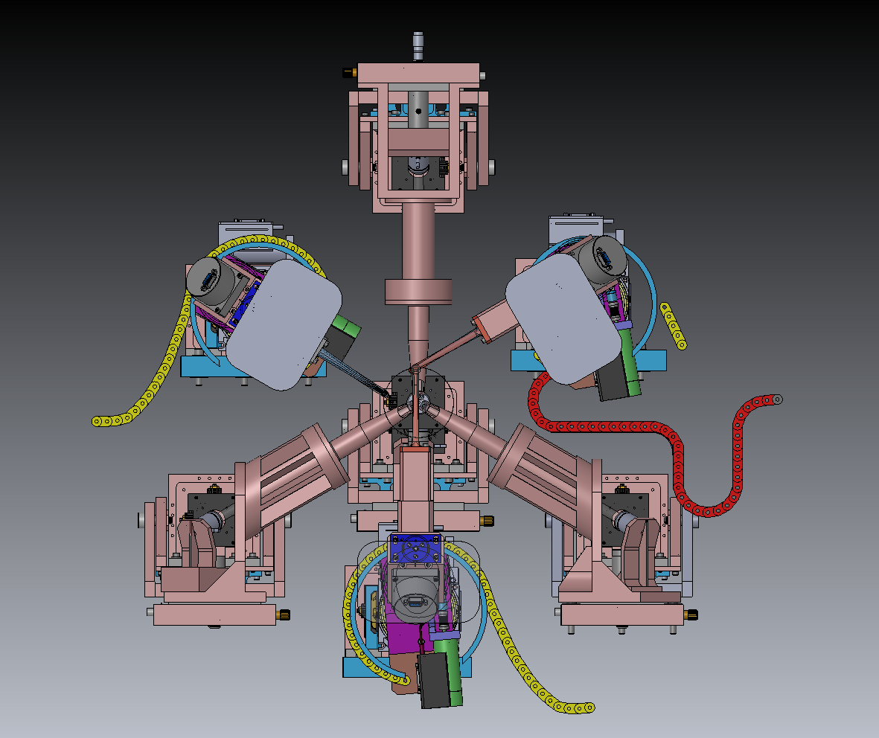

Revision History
Version | Comments
0.9 | Velur’s first draft
1.0 | Velur and Dekany’s draft
1.5 | Changes based on comments from reviewers prior to review
1.6 | Document updated after Velur-Gavel-Kupke meeting at Lick Observatory
2.0 | PDR version with Pupil Nutation compliant designs

Introduction

Scope
This document describes the preliminary design of the Laser Guide Star Wavefront Sensors (LGS WFS) for Keck’s Next Generation Adaptive Optics (NGAO) system. It concentrates on key sensor design choices, the optical and mechanical preliminary design, and initial matters pertaining to calibration. It does not cover LGS WFS detector technology, camera operation, reliability, interfaces, or prototyping.

Architecture changes since the System Design Review
The LGS WFS subsystem design for NGAO has evolved considerably from the design presented at the NGAO System Design Review (SDR), driven primarily with the requirements and
architecture changes flowing from Build-to-Cost (B2C) exercise (KAON 642). Most importantly, the original 5″ – 50″ radially scalable quincunx LGS asterism was set aside in favor of (Figure 1) the combination of a fixed LGS asterism, consisting of one LGS on-axis and three other LGS equally spaced at 10” radius, and a reconfigurable, or patrolling, LGS asterism whose purpose is not to provide high-order tomographic information, but rather to improve the science direction tip-tilt error indirectly, via sharpening of the NGS providing the science path tip-tilt measurement. The field of view (FoV) of the three Patrolling Asterism LGS WFS was also reduced during B2C from 150″ to 120″ diameter, corresponding to a similar reduction in LO WFS NGS field of regard (FoR).
To further simplify the architecture and ease implementation, the wavefront measurements from the Patrolling Asterism LGS WFS were also explicitly removed from the science-direction tomography solution and will be used exclusively to run three separate AO systems that sharpen the LO WFS NGS via a modified Multi-Object Adaptive Optics (MOAO) control strategy. (Further details on the Patrolling Asterism AO systems will be described in an upcoming KAON.)
Another significant post-SDR change is architectural decision to implement the LGS-stabilizing tip-tilt (TT) loop internal to the LGS WFS themselves, and not via an uplink TT mirror as is done for the current Keck AO systems. This approach provides for better control bandwidth as the time-delay between a measurement and TT correction is reduced by the round-trip propagation time of light traveling up and down to the Earth’s mesospheric sodium layer.
Finally, the concept of a point spread function (PSF) monitoring camera in the Low Order Wavefront sensor (LO WFS) was abandoned for B2C, which implicitly transferred additional importance for linear and stable LGS WFS calibration for purposes of telemetric AO PSF post-processing.

Reference documents
KAON 551 Wavefront Sensor System Conceptual Design Report
KAON 511 - System Design Manual v2.1 (doc), dated March 30th, 2008
Preliminary Design Manual (as of November 12th, 2009)
KAON 685 - Opto-mechanical Design Document
KAON 666 - Fixed Pupil Mode
Flowdown Error Budget
KAON 642 - Design Changes in Support of Build-to-Cost
KAON 562 - LOWFS and LGS OSM conceptual study report DRAFT v3 (doc) (pdf)

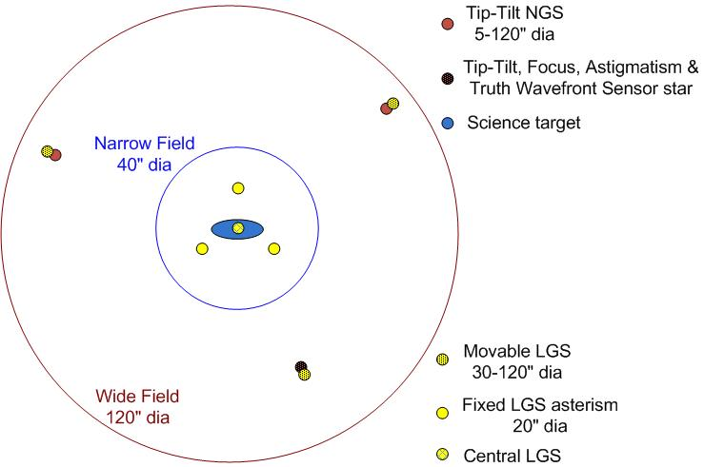
Figure 1- The Fixed LGS asterism consists of a 10″ radius “3+1” configuration on-axis providing tomographic information for an on-axis science target, and three Patrolling LGS providing high-order wavefront information for image sharpening of the LO WFS NGS.

LGS WFS architecture
The basic functional relationships between the LGS WFS subsystem and other subsystems within the NGAO system are presented in Figure 2.
The basic function of the LGS WFS is to make wavefront phase measurements of the aberrations seen by the set of seven 589 nm LGS as they propagate downward back to Earth. The LGS WFS sends this data to the NGAO real-time-control (RTC) subsystem. The RTC uses the fixed asterism data to drive the low-order deformable mirror (LODM) and the high-order deformable mirror (HODM). Each patrolling LGS WFS data is used to drive the 32x32 actuator MEMS DM in the corresponding LOWFS channel. The tip-tilt information from each of the 7 LGS WFS is used to drive the corresponding fast TT mirror in the LGS WFS itself. The AO control computer controls the position of the Patrolling Asterism LGS WFS in order to acquire return light from these movable LGS. It also provides configuration commands to the LGS WFS camera controllers, such as bias levels, gains, and frame rates. The LGS WFS camera controllers will provide in return status signals to the supervisory computer as a status monitor.
A more detailed schematic of the LGS WFS assembly is shown in Figure 3, divided into the three unique types of LGS WFS, namely a Patrolling WFS, an on-axis Fixed WFS, and a 10″ radius Fixed WFS.
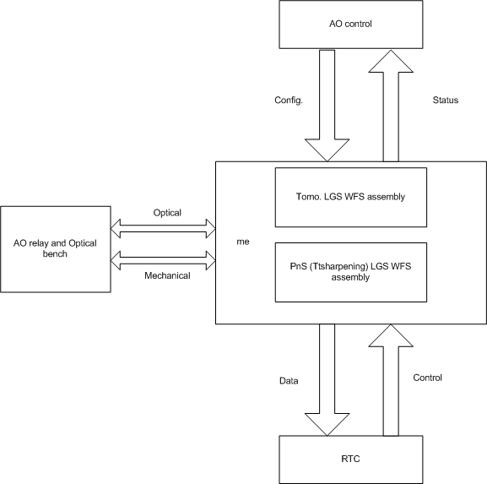
Figure 2- Context diagram of the LGS WFS showing the basic mechanical, optical and control interfaces to the AO system
The Patrolling WFS consists of a deployable theta-phi pick-off mechanism which includes the fast TT stabilization mirror, followed by an optical relay that provides slow pupil registration control as a function of patrol position in the field, followed by a Shack-Hartmann WFS. There is no need for any pupil derotation mechanism (erroneously suggested in KAON 562 and repeated in KAON 551).
The theta-phi Object Selection Mechanism (OSM) is preferred over an “R-phi” approach for NGAO LGS WFS because the naturally stable optical path length to the WFS is expected to reduce non-common-path (NCP) wavefront errors, and for commonality with the LO WFS OSM.
The two flavors of Fixed Asterism LGS WFS differ only in the detailed ordering of components in the optical train, driven by packaging constraints on the on-axis LGS WFS. These sensors utilize a set of three fixed, but otherwise identical to the Patrolling LGS, pick-off assemblies for the off-axis Fixed Asterism WFS, but not for the on-axis Fixed Asterism WFS.
The corresponding Zemax raytrace layouts of a Fixed Asterism LGS WFS and a Patrolling LGS WFS are shown in Figure 4 and Figure 5 respectively.
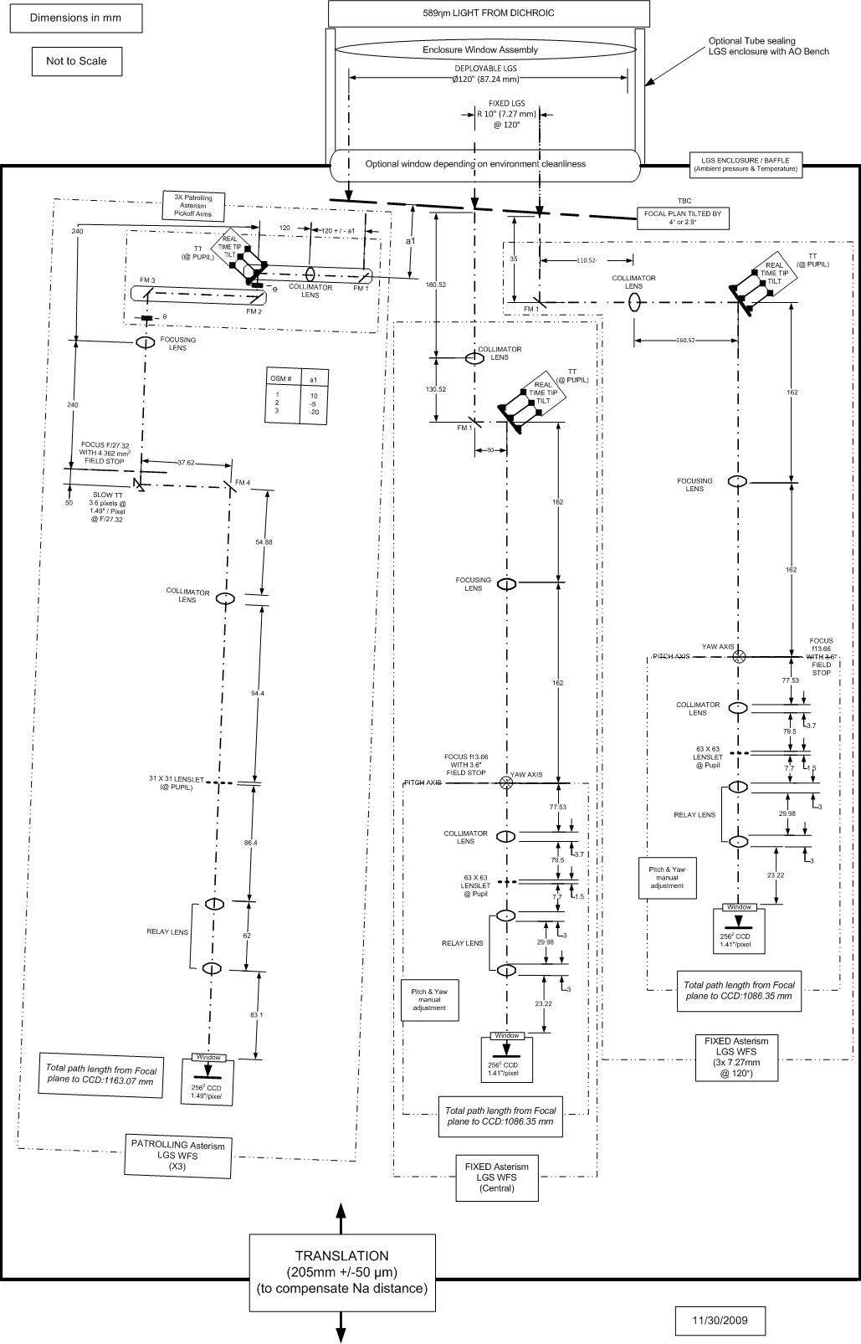
Figure 3 - Schematic of the LGS WFS assembly showing detail of one Patrolling WFS channel,the fixed central WFS channel and one fixed 10″radius channel.
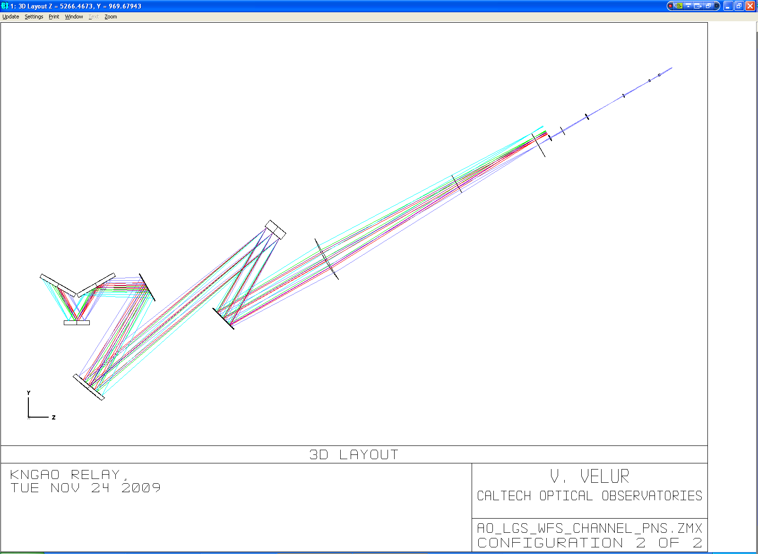
Figure 4 - Zemax layout of the entire optical train to a 10″ radius Fixed Asterism LGS WFS CCD focal plane.
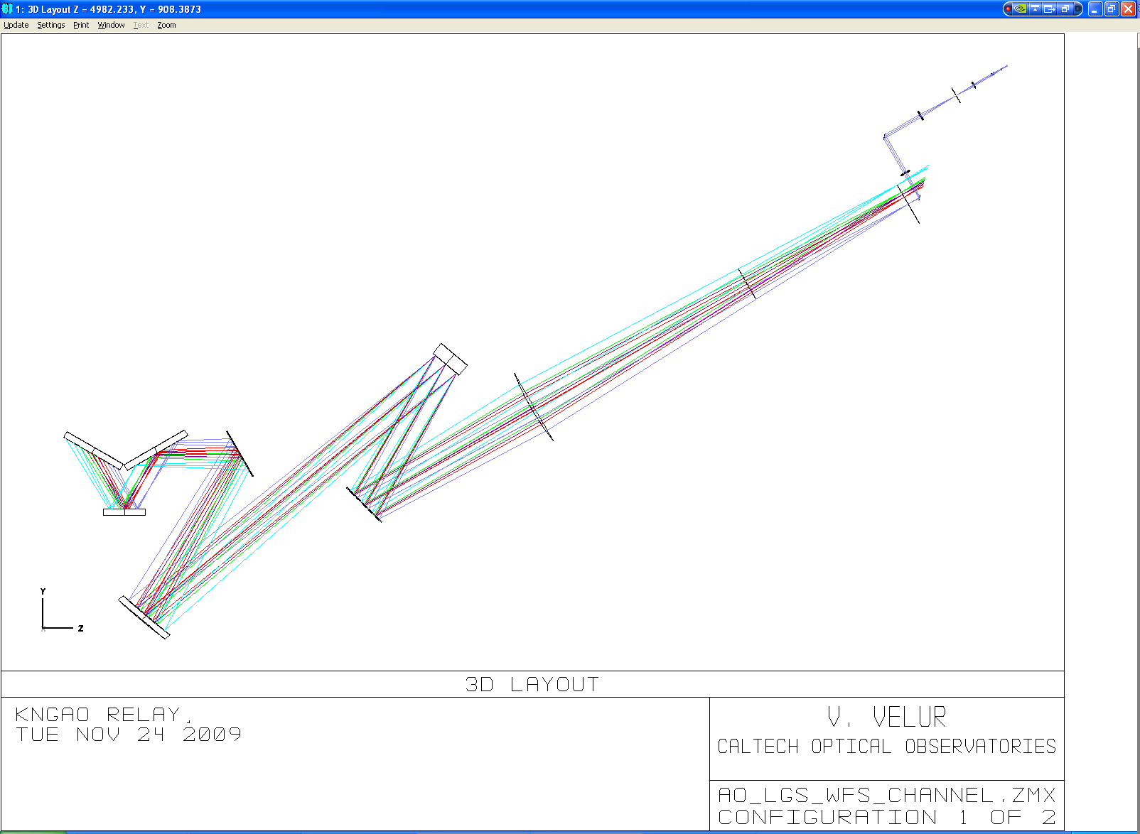
Figure 5 Zemax layout of the entire optical train to a Patrolling Asterism LGS WFS CCD focal plane (shown at full 60″ field radius).

LGS WFS Support Structure
As shown in Figure 8, the LGS WFS is outside the NGAO optical relay’s cold enclosure and so does not enjoy the structural support of the AO relay optical bench in the current design concept, and so must provide its own stable structural support, mounting interface to the Nasmyth platform, and thermal stability with respect to optical components within the cold enclosure on the AO relay optical bench. Figure 6 and Figure 7 describe the support structure. The truss is made out of 1-3/4” aluminum plates with eye-bolts for lifting the ~90 Kg structure. This 860 x 875 x 616 mm truss houses the seven LGSWFS’s. The truss is mounted to a three point beam support structure that has two Deltron slide bearings and a motorized Newport MTM250CC stage to provide focus adjustment. The three point beam support has eye-bolts which secure the whole assembly to the Nasmyth platform so as to avoid earthquake damage. The optical alignment KAON (KAON 719) describes how the structure is aligned to the NGAO bench.
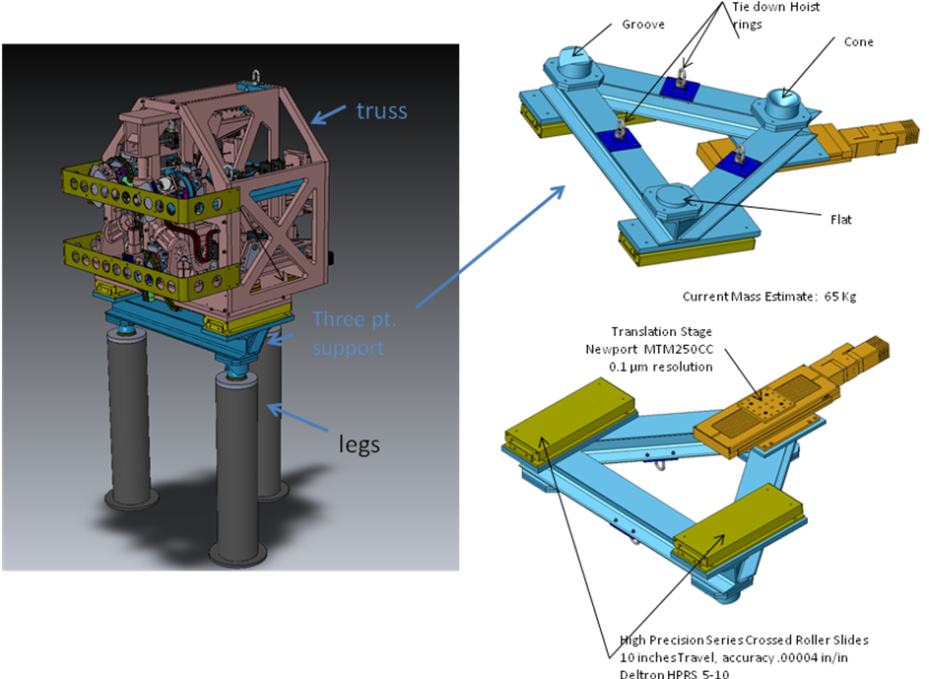
Figure 6 - LGSWFS assembly with support structure showing the truss structure holding the seven individual sensors as an assembly, the three point support and the LGS translation mechanism. The legs are described in Figure 7.
We have conceptualized a composite leg assembly with minimal thermal expansion over the operating temperature range made out of an inner aluminum shell a titanium core and a outer SS shell with a 1.35 um/deg co-efficient of thermal expansion. This design will be further refined in the DD phase of the project. Further information about the mechanical structure can be found at LGS WFS mechanical design presentation.

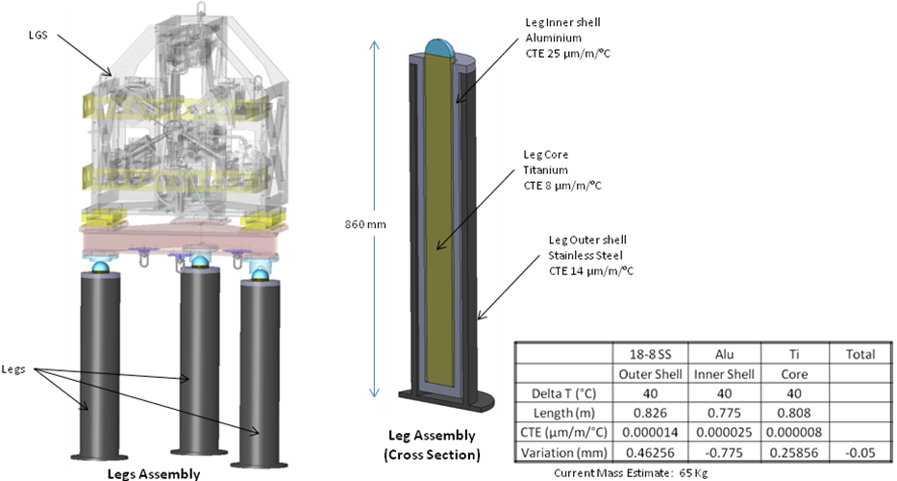
Figure 7 LGSWFS structural support showing the legs that attach the sensor assembly to the Nasmyth platform. The legs are made of three different materials (Al, Ti, 18-88 SS) to ensure that the LGSWFS and the NGAO relay are aligned in Z-direction over the temperature range experienced inside the Keck dome. There is a 50 um change in length of the legs over a 40 deg temperature fluctuation.

LGS WFS Fore-optics
The LGS light path through the NGAO wide-field relay is shown in Figure 9. Sodium light from the telescope traverses through the entrance window (not shown), the K mirror and the fold followed by the 1st off-axis-paraboloid (OAP), after which it is incident on the LODM. Following the LODM it is folded out of collimated space by a notch dichroic onto (nominally) a 1-m focal length plano-convex lens that focuses the beam. There is also a window, which along with the lens provides a thermal seal for the cold NGAO optical relay.
.
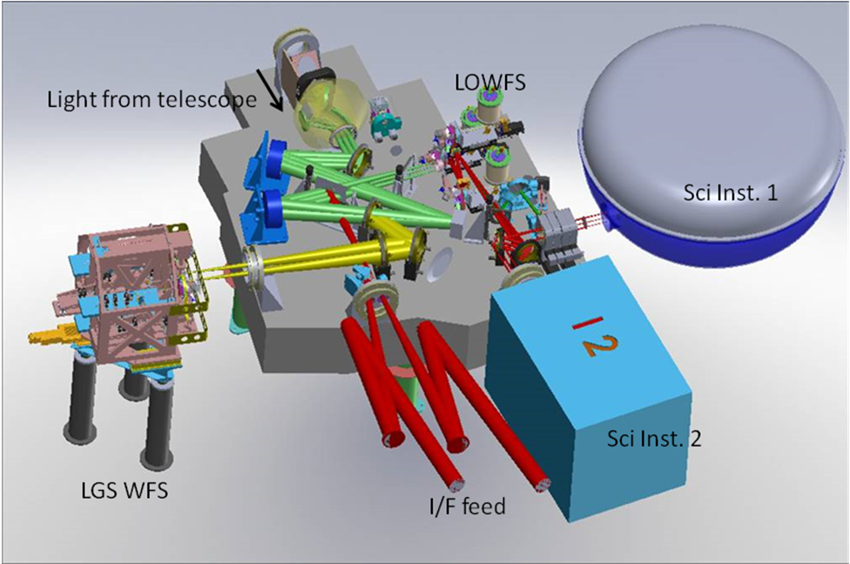
Figure 8 - NGAO optical layout showing the location of the LGS WFS assembly with respect to the rest of the system

Input Optical Aberrations
Laser light, passing through the wide-field relay at conjugate distances markedly different than the design-optimized infinite distance for science light, suffers considerable optical aberration. Figure 10 shows the optical spot diagrams for LGS beams delivered by the AO relay originating at a Na layer distance of 90 km. The Fixed LGS spots delivered by the AO relay have RMS radii between 26 and 45 um at the LGS pick-off plane, while the Patrolling LGS spots sizes range between 130 and 150 um RMS radius.
As the working F/# at the LGS pick-off is 13.56 at 22 degrees off zenith, one arcsecond of angle on-sky corresponds to 720 um at the LGS focal plane (based on NGAO optical design), indicating contributions to sensor subaperture PSF FWHM (which are 2.355 times larger than the spot diagram RMS radius) as follows:

 | On-sky field point | Full-beam RMS spot size radii (from Zemax) | Corresponding Full-beam FWHM | LGS WFS Subaperture RMS spot size radii (from Zemax) | Corresponding LGS WFS Subaperture FWHM
Fixed Laser Asterism WFS | 10 arcsec | 26 to 45 um | 83 to 147 mas | negligible | negligible
Patrolling Laser Asterism WFS | 60 arcsec | 130 to 150 um | 425 to 491 mas | < 6 um | < 20 mas
Table 1. Contribution to image quality degradation at the LGS WFS input focal plane and at the back-end WFS subaperture focal plane.
Although the entire beam has large aberrations, the image quality functional requirement is that the optical relay and WFS combination not induce more than of 0.25″ FWHM to image width in the subaperture. As was discussed in KAON 685 “NGAO Optical Relay Design”, the degradation in a subaperture is considerably less than over the entire beam, as much of the aberration in the beam leads to subaperture spot displacement and not image blurring within the subaperture.
As an independent check on the effect of large input aberrations, we evaluated the performance of a single subaperture 1/31st of the diameter of the primary mirror and de-centered this aperture using Zemax to look at the resulting impact on spot size. One can see RMS spot radius of almost 6 um (corresponding to 6/720*2.355 = 20 mas FWHM) at the worst-case field angle as is shown by Figure 11 and Figure 12, and summarized in Table 1. This is a small compared to the 250 mas FWHM allocation to subaperture image quality degradation.
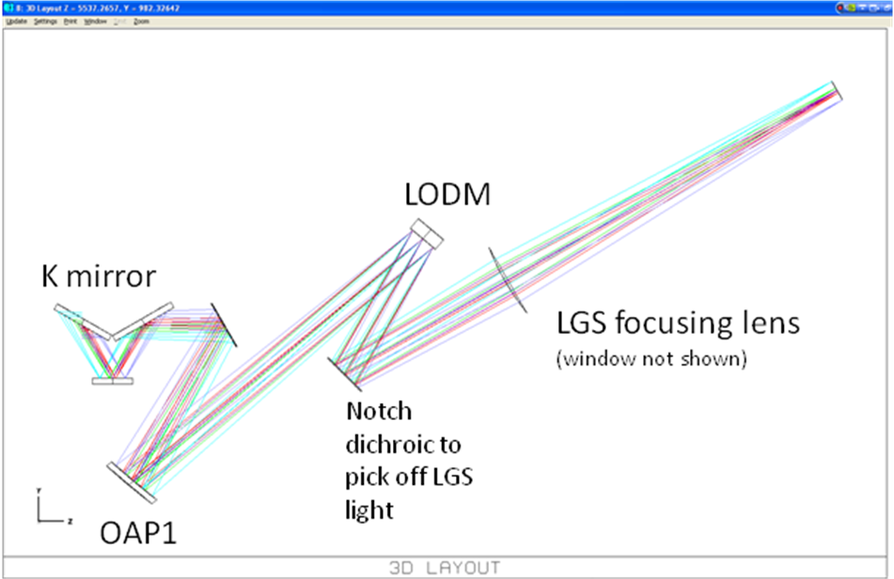
Figure 9 - Laser guide star light path starting from the K mirror to the LGSWFS pick-off focal plane.
It is useful to note that the LGS input focal plane delivered by the AO system is both curved and tilted. The curvature of the focal plane varies between 883 mm and 2604 mm as the distance to Na-layer varies from 90 to 180 km (we will commonly quote 90 km and 180 km distances, though the requirements for LGS distance can vary between 81 and 282 km (TBC)).
In summary, the optical quality of the combination of the wide-field optical relay (as described in KAON 685, dated Nov 17, 2009) and the LGS WFS designs presented here meet the allocated degradation to image quality, in terms of design aberrations. A more detailed error budget flowdown that includes design, alignment, and fabrication tolerances, however, is still needed.
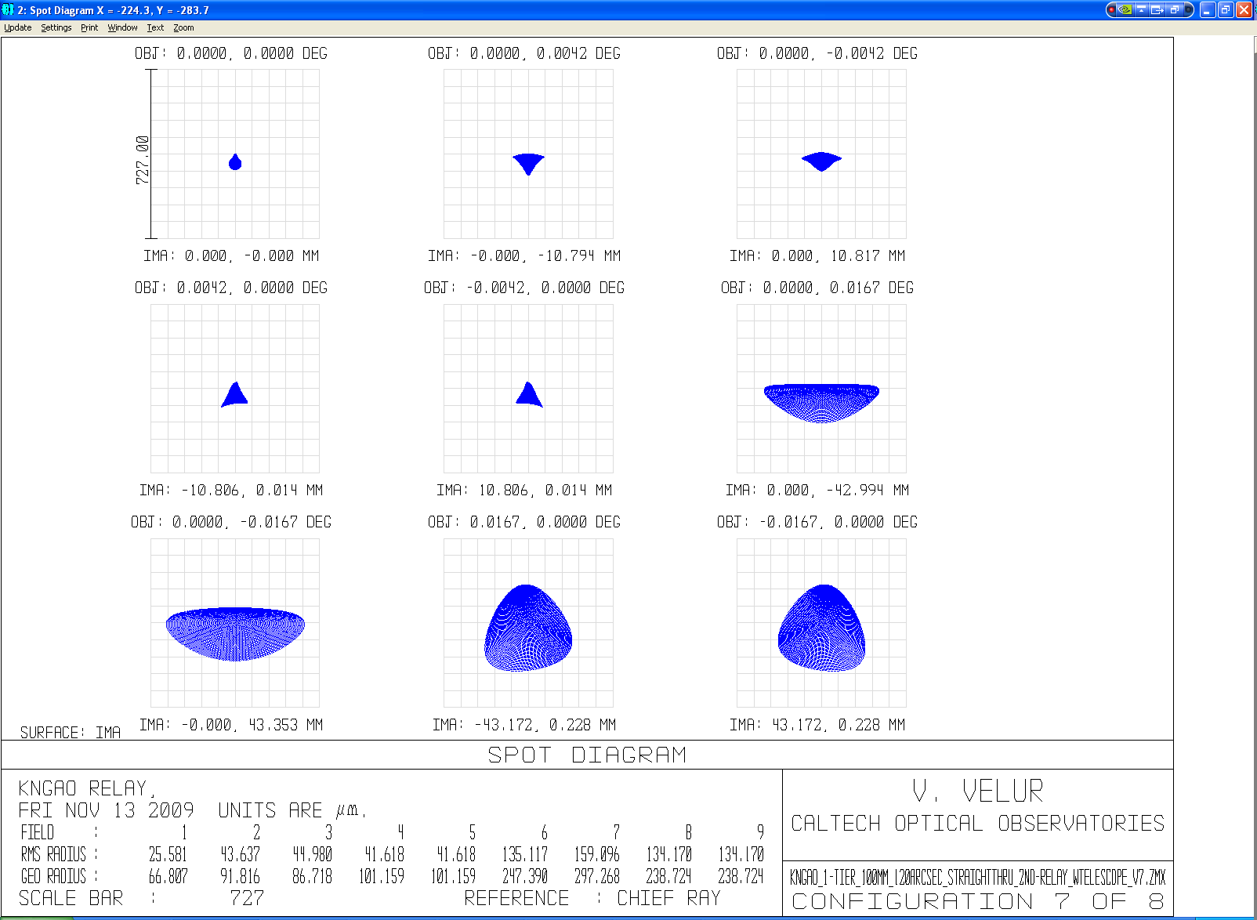
Figure 10 - LGS WFS spots when the telescope is pointing at zenith, indicating relatively large relay errors over the Patrolling WFS 120″ FoR. The first spot is the on-axis spot diagram followed by spot diagrams at the X and Y extremities of the narrow science field. The last 4 points show the spots as seen at the X and Y extremities of the 120” diameter LGS FoR [For reference – 66.8 um and 297 um RMS spot sizes correspond to 91 and 409 mas .]
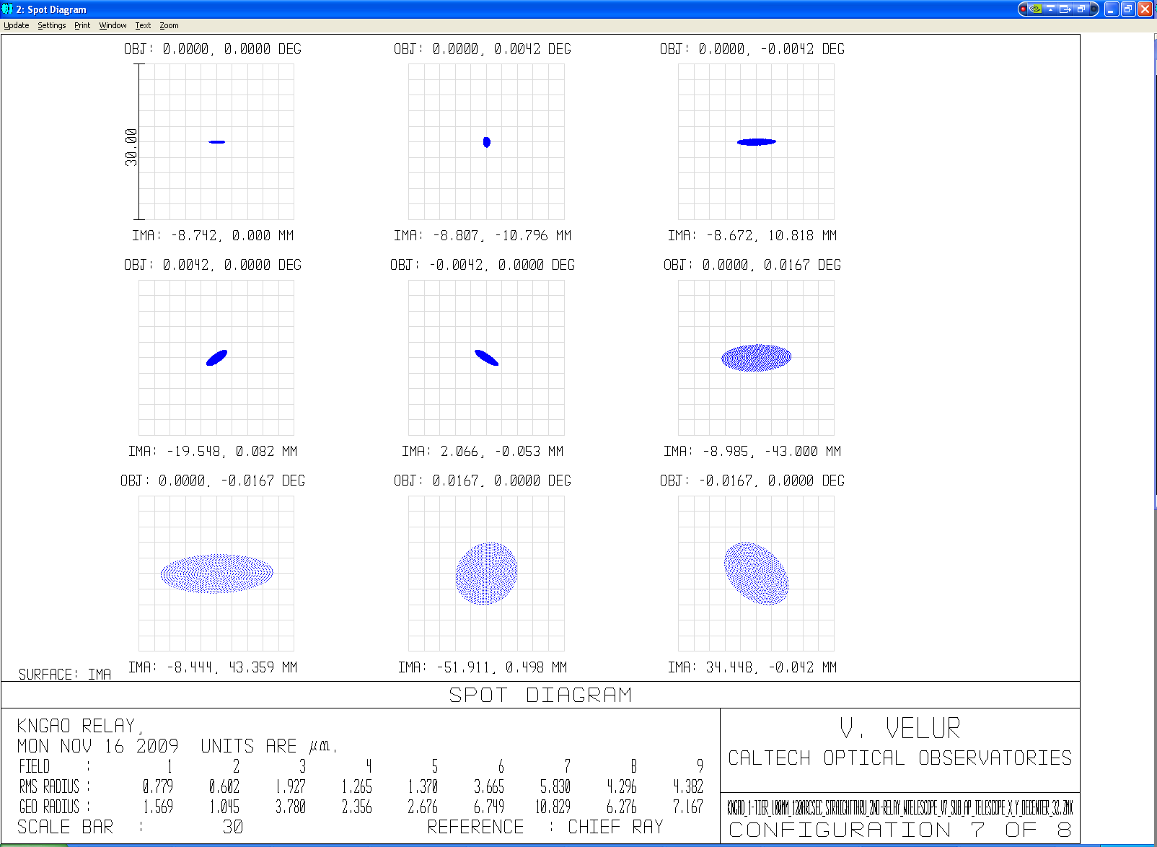
Figure 11 - LGS spots as seen by a single Patrolling LGS WFS sub-aperture. The spots diagram was generated by creating a de-centered aperture that is 1/31st the size of the Keck primary mirror and making the entrance pupil the size of a single sub-aperture. The aperture parameter in the Surface Property Menu was set to the primary mirror radius (5297.9 mm) to accommodate ray tracing. The worst case sub-aperture spots see a 6 um (RMS) radius. [For reference – 1.569 um and 10.029 um geometric spot sizes correspond to 2.14 and 14.8 mas .]
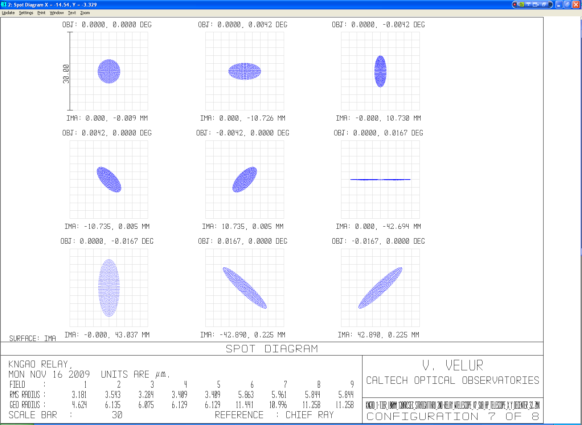
Figure 12 - LGS spots as seen by a Patrolling Asterism LGS WFS sub-aperture (de-centered in the orthogonal direction with respect to Figure 11). Worst case sub-apertures are 6 um (RMS) radius. [Note that the fixed asterism spots have little aberration at the sub-aperture level.]
In conclusion, there is adequate leeway for a LGSWFS design within the error budget allocation for both the fixed and the patrolling LGSWFSs as the sub-aperture level aberrations are small compared to what the sub-aperture is capable of measuring. The worst case subaperture level spot shift due to aberration from the AO optical train in the fixed LGS WFSs is 15 mas and that in the Patrolling LGSWFS’s is 15.5 mas.

Shack-Hartmann WFS Design

Analysis that drives the design

WFS Pixel Angular Scale
From experience we know that characterizing and calibrating each sub-aperture of the seven LGS WFS for non-linearity is non-trivial and hence we choose plate-scales to ensure that each sensor operates in its linear regime. Pixel scale is chosen based on the apparent spot size FWHM expected to be realized within each of the WFS (sans charge diffusion). Figure 13, extracted from the WFE Budget v1.48, shows the apparent spot size for the tomographic WFS (left column) and WFS (right column). For the fixed LGS asterism, the 1-D tilt error is 50 mas and the diffraction limited sub-ap spot size is 699 mas (this corresponds to one wave of tilt in the sub-aperture).We choose p = 0.5 from Table 2 to accommodate capture range and linear operating regime. The central fixed LGS guide stars have little differential tilt and so the RMS 1D tilt of each beacon is small, with p = 0.5, the sub-aperture is capable of measuring +/- 1.5 waves (or 1.05arcsec) with negligible loss in linearity. P < 0.5 was considered to aggressive a design parameter and not considered. For the variable asterism the 1D tilt error is ~100 mas and the sub-aperture diffraction limited spot size is 343 mas (this corresponds to one wave of tilt in the sub-aperture).We choose P=1.0 for this sensor based on Table 2 to be able to measure +/-2.5 waves (+/- 0.86 arcsec) of tilt.
Based on work done by Thomas the p-value selection seems reasonable. The LGSWFS sensor team will send the exact NGAO LGSWFS parameters to Ms. Thomas for verification of p-value selection.
Detector size per subaperture | Pixel Size/ spot size (p) | Useful tilt range +/- waves | Departure from linearity (waves)
2x2 | 1.0-1.5 | 0.5 | 0.024
2x2 |  | 1.0* | .13*
4x4 | 0.5 | 1.5 | 0.019
4x4 | 0.67 | 2 | 0.085
4x4 | 1 | 2.5 | 0.19
* - nonlinear response
Table 2 - Dynamic range and linearity of Shack-Hartmann quad-cells (this is same as Table 5.3, Pg. 149 of Hardy). NGAO Patrolling LGS WFS’s use a 4x4 pixel sub-aperture with p=1; while we choose p= 0.5 for the Fixed LGS WFS’s. [Note – 0.019 waves of non-linearity corresponds to 11 nm of systematic error in the WFS, 0.085 waves corresponds to 47 nm and is unacceptable for the (tomography) LGS WFS. The allocation for the systematic error due to non-linearity for the fixed LGS sensors is 20 nm(?)]

Fixed LGS spot size calc. Patrolling LGS spot size calc.
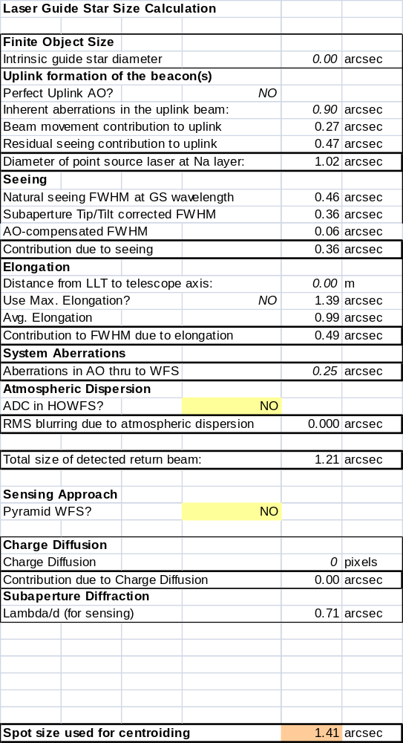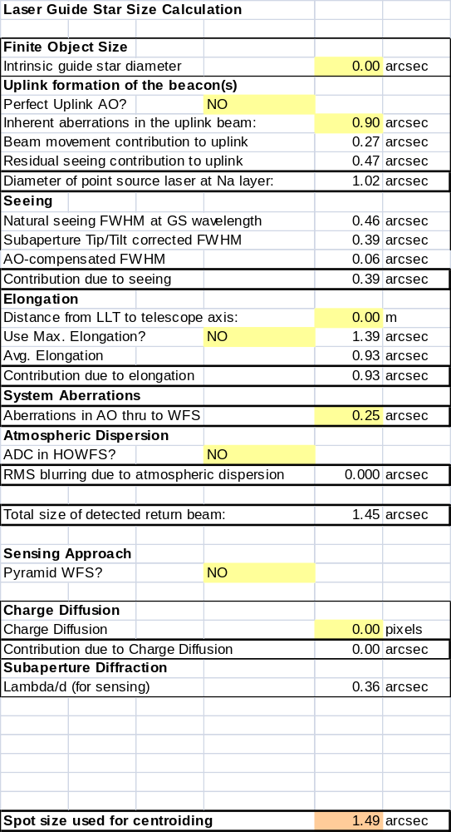
Figure 13 - Apparent spot size at the detector due to various effects for the fixed tomographic LGS WFS spots (left) and the apparent spot size at the detector of Patrolling WFS (TT sharpening) LGS WFS spots (right). Charge diffusion term is set to 0 here in order to make an optical estimate of FWHM, which is appropriate for determining the detector pixel scale. [The EBS models charge diffusion and so will the final system when transfer curve calibration is performed on the as-built system.]

Stabilization TT Mirror Specification
To determine the TT mirror of choice, we need to specify the resolution and the throw required for the mirror given the bandwidth requirement from the requirements database.
Pupil de-magnification at the TT mirror = 10.949 m /(12.5 mm /1000 mm/m) = 875.92
TT resolution on sky = 1 milliarcsec [The RMS 1D tilt error is 95 milliarcsec (c.f. EBS Version 1.48)]
Hence, TT mirror resolution = 0.001 (arcsec) * 875.92 = 0.875 arcsec = 42 microradians
Capture range required is 2 arcsec or 2 *875.92 “ /206265 (“/rad) = 8.49 millirad (we can position the laser beacons with slow moving mirrors to 2 arcsec precision on sky)
Based on the resolution and the capture range we choose OpticsinMotion’s mirror for the patrolling WFS’s and a Physik Instrumente’s mirror for the fixed asterism LGSWFS’s. The OpticsInMotion mirror (OIM101) has 2 urad resolution with +/- 1.5 degrees of angular travel while the PI S-330 has a 0.5 um radian resolution with 10 mrad travel. The Optics-in-Motion and tip-tilt mirror operate at 850 Hz and 1 KHz respectively with a typical 0.25” thick 1” diameter mirror.

Evaluation of Differential Focus & Impact of Single LGS WFS Focus Stage
Individual LGS WFS channels see differential focus due to two effects; viz. change in radius of curvature (RoC) of the LGS focal plane with change in distance to the sodium layer (c.f.Error: Reference source not found) and due to the finite size of the LGS asterism on sky. The physical distance between the innermost and outermost laser beacons on-sky vary with zenith angle as shown in Figure 14Error: Reference source not found; this effect is quantified in Table 4 Error: Reference source not found. Both effects, though not negligible, are entirely deterministic given the position and geometry of the LGS asterism and so the defocus can be calibrated away by the RTC. So the preferred design choice is to use a single focusing stage for the entire LGS WFS assembly, while noting that this requires additional requirement(s) on the RTC to apply this calibration as a changing function of zenith angle.
Dist. To Na layer | ROC of focal plane (mm) | FoR size (mm) | Sag (um) | Delta sag (um) | Error (in waves) after splitting the difference
Patrolling asterism
90 km | 883.20 | 87.24 | 1077.82
180 km | 2064.00 | 87.24 | 460.98 | 616.84 | 0.5236
Fixed LGS asterism
90 km | 883.20 | 7.27 | 7.48
180 km | 2064.00 | 7.27 | 3.20 | 4.28 | 0.0036
Table 3 - Radii of curvature of the LGS focal plane as delivered by the NGAO optical relay at 90 and 180 km Na layer object distance and the change in focus due to the changing RoC.
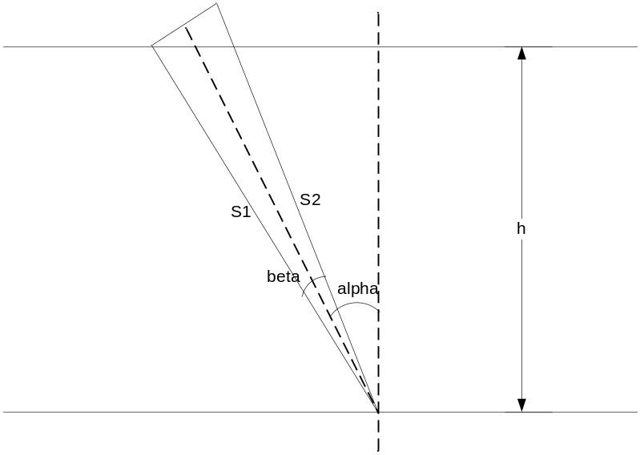
Figure 14 - Schematic showing defocus between the innermost and outermost LGS due variation in physical distance of those with zenith angle.
Figure 14 shows a simplistic representation of LGS beacons being created at the sodium layer from a central launch telescope:
α = 1.22 radians (with the telescope pointing 70 degrees off-zenith pointing)
β = 9.70E-05 to 5.82E-04 radians (for 20-120 arcsec LGS asterism diameter)
b = h/cos(α) * β
x = b * tan(α)
Where, α is the telescope zenith angle.
β is the angle subtended by the LGS asterism
h is the Na layer height at zenith (e.g. 90 km)
b is the physical diameter of the asterism (ignoring tilt anisoplanatism) at the Na layer
x is the object distance shift between the nearest and furthest LGS beacon.
x/2 is the object shift of an outermost LGS relative to the central LGS.
Guide star asterism diameter | Defocus error due to geometry of the asterism (um), x/2 | Error in waves (220 um corresponds to λ/4 depth of focus)
10 | 6.5 | 0.006 waves
120 | 68 | 0.0773 waves

Table 4 - Error due to change in focus between the innermost and outermost LGS with zenith angle. For reference λ/4 depth of focus is 147 nm of WFE and 219 um of defocus (as given by 2*λ*F/#2). The difference between S1 and S2 in figure in is seen as a defocus at the LGS focal plane and this difference is evenly split between the innermost and outermost beacons.

LGS WFS Relay Optical Aberration Specification
Total aberration allocation for the NGAO relay and LGS WFS is, according to WFE Budget v1.48, a FWHM of 0.25″. Internal WFS aberration allocation as part of this total error budget has not been allocated via the Performance Flowdown process. For the remainder of this document, therefore, we will assume an allowable contribution from the LGS WFS itself of the entire 0.25″ FWHM, and will revise this document as warranted.
The LGS spots delivered by the OSM are 3 and 8 times smaller in radii (RMS) than the input spots from the AO wide-field relay for the Fixed and Patrolling LGS WFS’s respectively. The OSM’s contribution corresponds to an FWHM of ~0.05″. Hence, the LGS WFS relay performance needs to have:
Geometric spot size (RMS as indicated by Zemax) at the detector =
Error budget allocation (in arcsec/ FWHM) / 2.355 (FWHM/RMS) * 21 (um/pixel) / 1.49 (arcsec/pixel) = 0.25 / 2.355 * 21 / 1.49 = ~1.5 um
Where we’ve assumed the plate scale from the Patrolling Asterism WFS (using the Fixed Asterism WFS plate scale (0.705 arcsec/pixel, the spec would be ~3.2 um)

Field Stop Specification
The FoV of the Fixed and Patrolling WFS sub-apertures are 2.82 and 5.64 arcsecs respectively. A square- field stop that is 2.8 arcsec and 5.64 arcsec on edge will be positioned at the respectively at each of the fixed and Patrolling LGSWFS focus to prevent cross-talk of LGS spots at the detector. The potential advantage of this field stop to also serve as a wavefront anti-aliasing filter will also be explored during the PD phase.

Optical Design and Performance
As discussed in Section 3.1 of the NGSWFS KAON and shown in Figure 15 the Keck pupil nutates on the DM and hence the pupil size on the DM has to be undersized. Since the WFS’s and the DM actuators are mapped using Fried geometry, less than 63 or 31 subapertures are lit at a time in the fixed and patrolling LGSWFS’s.
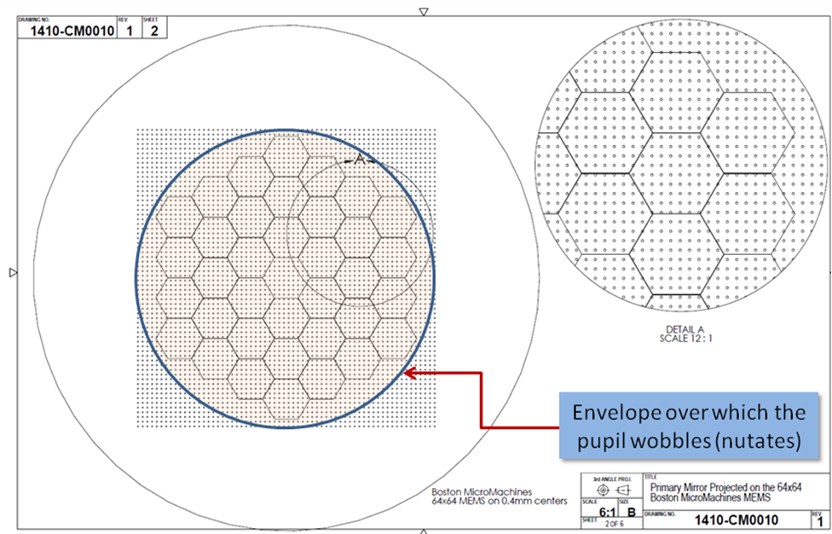
Figure 15 The mapping of the Keck pupil on the 64x64 HODM (in its ideal position). The blue circle shows the envelope over which the Keck primary pupil wobbles.

Fixed LGS WFS

Fixed Asterism WFS Design Parameters
As indicated in Section 5.1.1, the p-value of the Fixed LGS WFS is 0.5, making the pixel size/spot size = 0.5. Hence, 1.41″ on-sky corresponds to two detector pixel (42 um). From the NGAO optical design, we know that 720 um at the LGS focal plane corresponds to 1″ on-sky.
Plate Scale Ratio (PSR) = f_{collimator}/f_{lenslet} * 1/m =
Input plate (um/asec) / Detector plate scale (um/asec) = 719/29.61 = 24.30,
where, m is the de-magnification between the lenslet spots and the detector.
We choose a commercial collimator (JML Optical’s 80 mm best-form lens) instead of a commercial lenslet as the Fresnel Number (FN) of the lenslet is an invariant in the design and any commercial lenslet needs to have the exact required FN to be used in NGAO. The limited lenslet database we have didn’t have any match for the required lenslet FN. In the future, we intend to look at the cost savings vs. performance impact of selecting a non-optimal, but commercially off-the-shelf lenslet array.
The pitch of the lenslet array is given by, d _{each lenslet} = f_{collimator}/f# * 1/(# of sub-aps) = 80/12.519 * (1/63) = 101.43 um [the effect of the pupil nutation can be seen as mapping a bigger telescope pupil to the WFS detector plane, which makes the beam faster, hence the f/# is 12.51 rather than 13.56]
The de-magnification, m = 0.084/0.1014 = 0.828
The focal-length of the lenslet is, f_{lenslet} = f_{collimator}/m * (29.78/719) = 3.97 mm. The f/# of the lenslet = 39.17.
The Fresnel # (FN#) of the lenslet array is FN#_{lenslet} = (d _{each lenslet} /2)²/(f*λ) = 1.1.
The FN#_{lenslet} term isan invariant in the design given plate-scales, the number of subapertures, and centroiding geometry. It can also be expressed as 1/(4* λ) * (D_{telescope}/# of subaps) * (spot sep. in radians).

Fixed Asterism Pick-off Relay
To accommodate mechanical packaging constraints and provide an internal stabilization tip-tilt mirror pupil location, while keeping the optical surfaces to a minimum, a 1:1 relay was chosen to transfer the native output focal plane from the NGAO wide-angle relay to an intermediate internal focus position within the LGS WFS. Figure 16 and Figure 17 show the optical layout of the relay (total optical length 640 mm) and spot diagrams they deliver. The pick-off relay has a FoV of 5″ and is designed to be telecentric in order to not introduce any spurious tilts in the beam due to the incidence position of the LGS light on the pickoff. The spots sizes are 16 um RMS compared to 40 um RMS spots that the AO relay generated. The design for the pick-off is available at:
http://www.oir.caltech.edu/twiki_oir/pub/Keck/NGAO/WFS/fixed_LGS_pick_off.ZMX
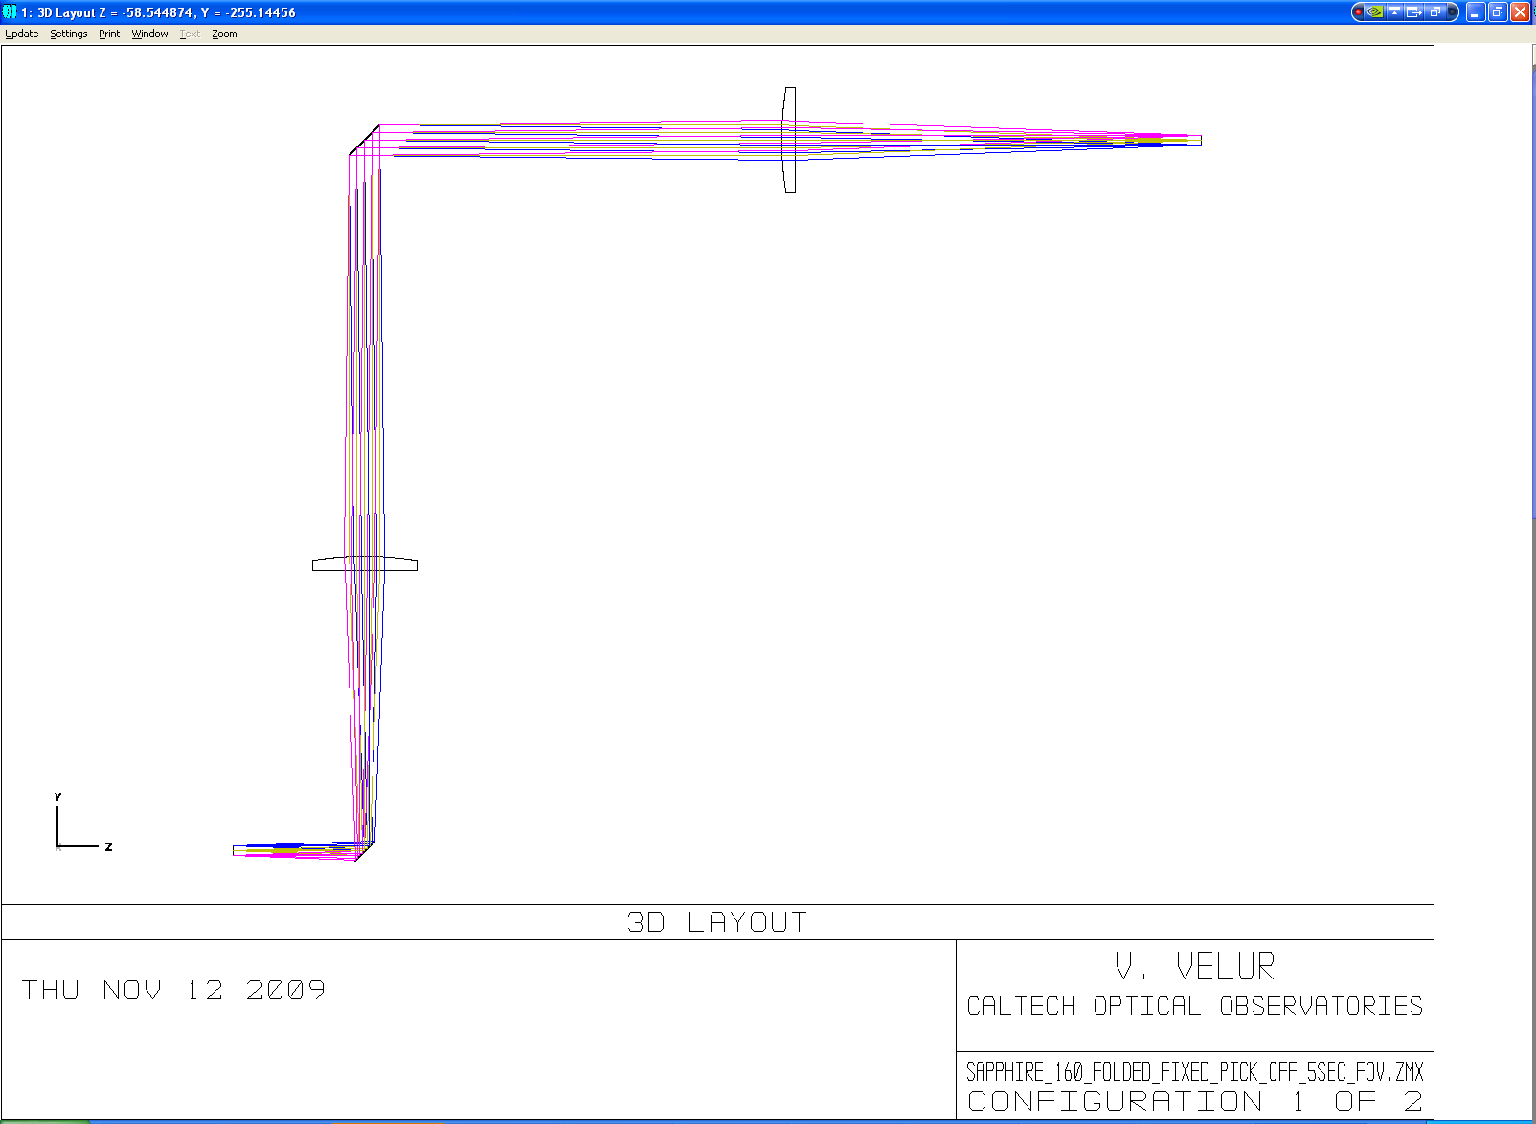
Figure 16 - Telecentric 1:1 Fixed LGS WFS pick off relay. The total length of the relay is 640 mm (limited by packaging constraints).
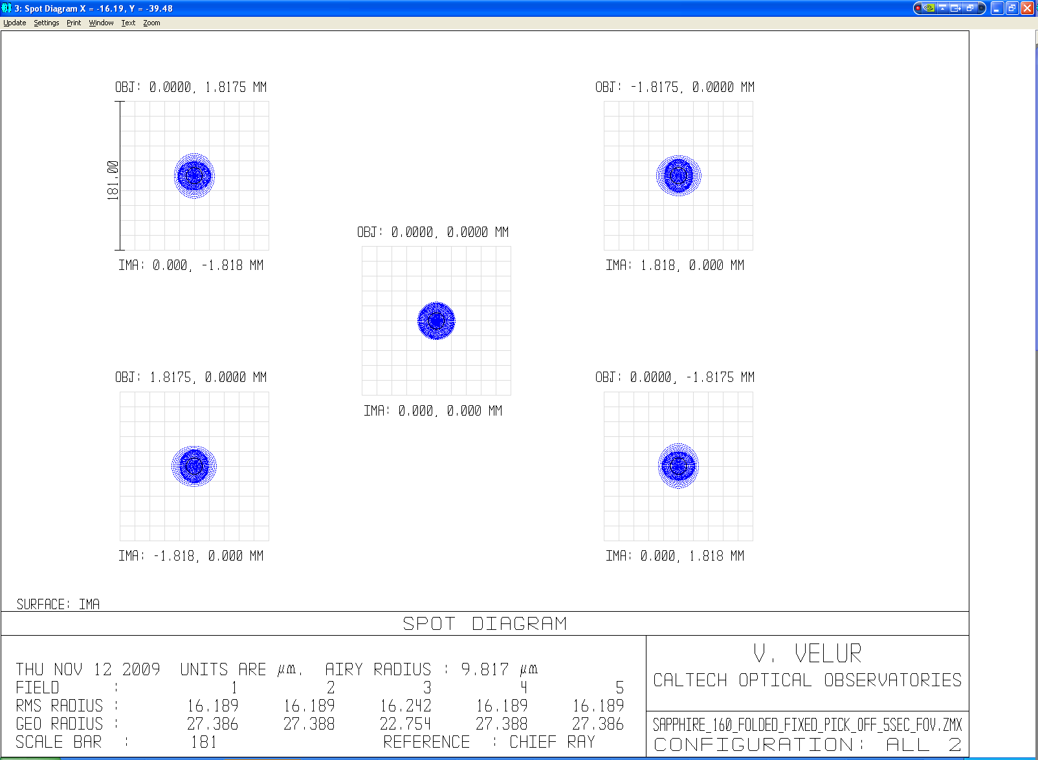
Figure 17 - Spot diagram showing the performance of the fixed LGSWFS pick-off over a 5 arcsec FoV (scale bar corresponds to ¼ arcsec.).
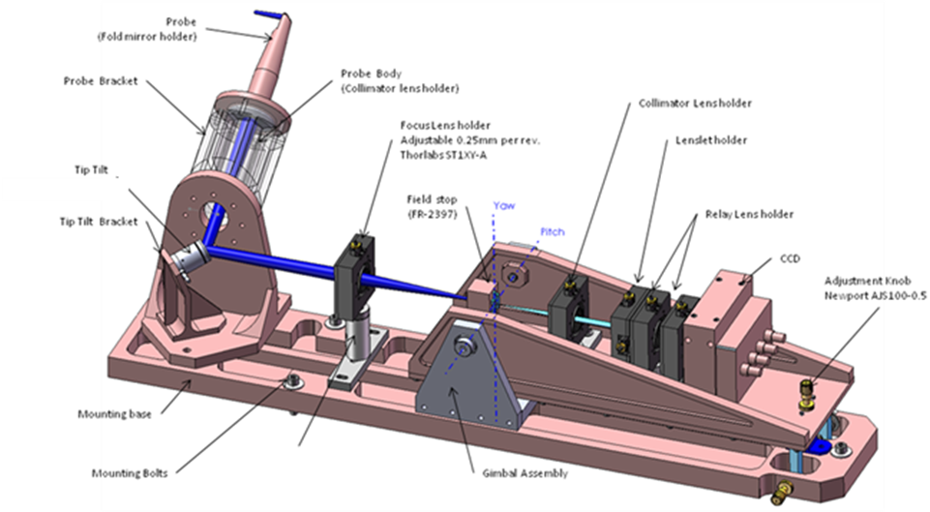
Figure 18 - Mechanical design of stationary Fixed LGS WFS channel showing the stationary 1:1pick-off relay with the downlink tip-tilt mirror at the relay’s pupil location. Each Fixed LGS WFS is equipped with yaw and pitch motion, which along with the downlink TT mirror can be used to align each channel to the incoming beam and keep the lenslet to LODM registration.
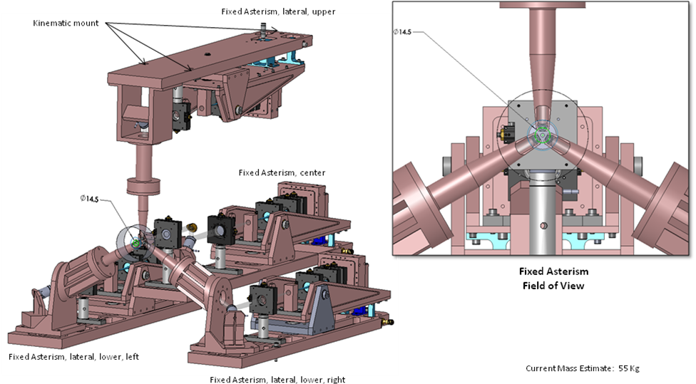
Figure 19 – Mechanical assembly of the fixed asterism pick offs and sensors assembly showing the 4 fixed LGSWFS’s with one located in the middle and other three located equidistant from each other on a 10 arcsec circle about the central axis.

Fixed Asterism Shack-Hartmann WFS without Dot Relay
The LGS WFS with fewest surfaces can be made with a best shape factor singlet collimator and a lenslet array directly imaging spots onto a detector without using a reimaging relay. Sensors directly bonding a lenslet array to the face of a CCD package have been previously proven by University of Arizona to meet tight tolerances and have appeared to be robust if care is taken to athermalize the lenslet / CCD interface. Such a WFS is compact and has excellent optical transmission, containing only 4 transmissive surfaces. In such an approach, either the collimator or the lenslet can serve as the detector window.
For the baseline NGAO LGS WFS CCD’s, having 21 um pixel pitch, such a design would require a lenslet pitch of 84 um, a lenslet focal length of 2.725 mm, and a collimator with EFL of 66.25 mm. Velur has designed such a sensor using a custom collimator and a custom lenslet, available at:
http://www.oir.caltech.edu/twiki_oir/pub/Keck/NGAO/WFS/fixed_lgs_wfs_norelay_pn.ZMX
Figure 20 and Figure 21 show the layout and spot diagram from this design.
The drawbacks of this approach are, potentially, the requirement for tight manufacturing tolerances for both the lenslet array and detector, elevated risk to the CCD due to additional exposed handling (and possible modification of existing packaging), and unknown long-term alignment stability and thermal-cycling behavior.
We believe it may well be worthwhile prototyping the fixturing and assembly process for such a design within the NGAO team early in the detailed design phase. However, until the identified risks are mitigated via prototyping, we have chosen to continue the PD phase design assuming the existence of a traditional “dot” relay that reforms the regular array of lenslet foci onto the CCD subapertures.
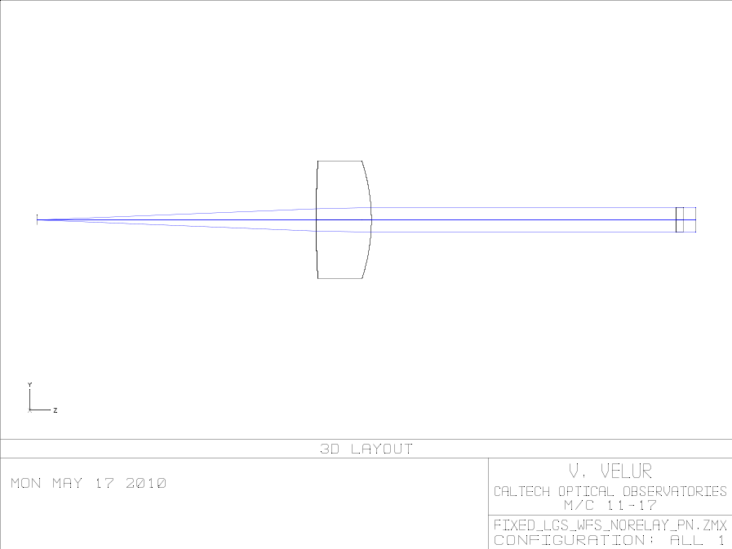
Figure 20 - Layout of the simplest possible Fixed LGS WFS (with just a singlet collimator and a lenslet) wherein the lenslet spots directly imaged onto the detector (a.k.a. design without a post-lenslet relay).
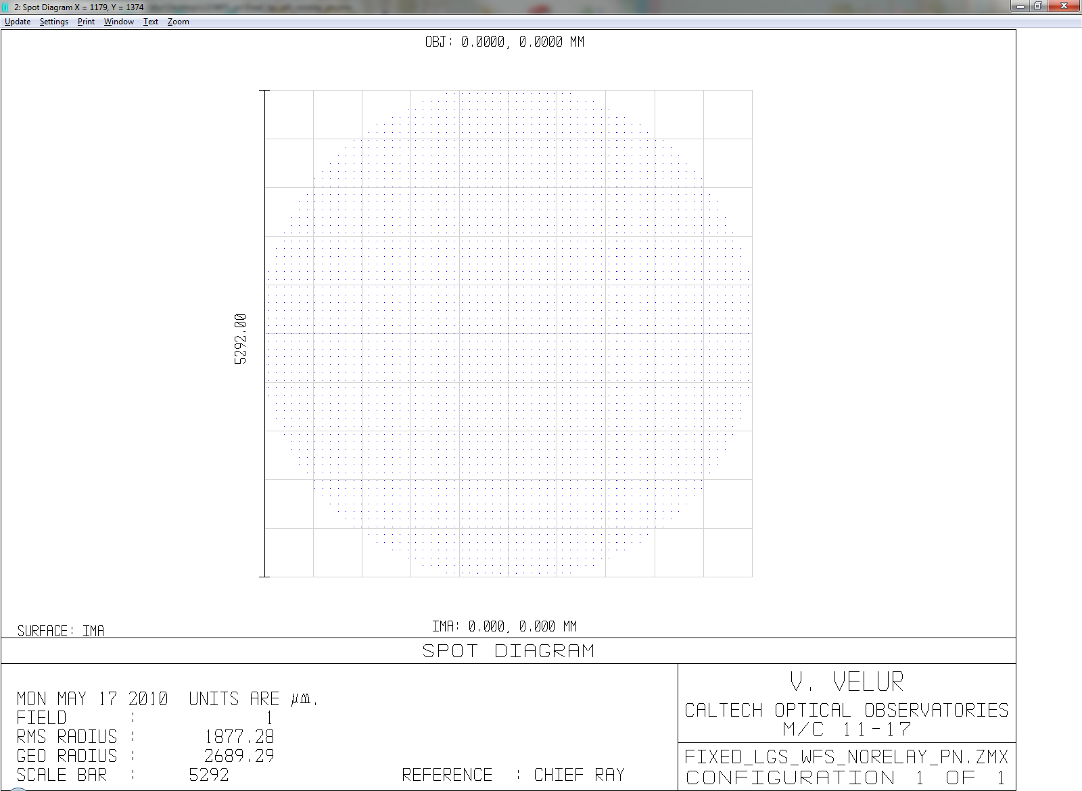
Figure 21 - Fixed LGS WFS spot diagram showing 63x63 sub-apertures from the simplest possible WFS.

Fixed Asterism Shack-Hartmann WFS with Dot Relay
The Fixed LGS WFS channels use a stock collimator, a custom lenslet and a set of two custom relay lenses. All optical components are singlets, giving rise to a total of 10 surfaces that need to be laser line coated at 589 nm. The transmission of this module is (99.6%)¹⁰ * 92.5% (lenslet scatter losses) = 88.86%. The transmission of the system with the pick off (2 folds + 2 lenses) is (99.6%)¹⁶ * 92.5% = 86.75%. The layout and the spot diagram from the WFS channel are shown in Figure 22 and Figure 23. The footprint diagram shown in Figure 24 indicates that the plate scale is accurate.
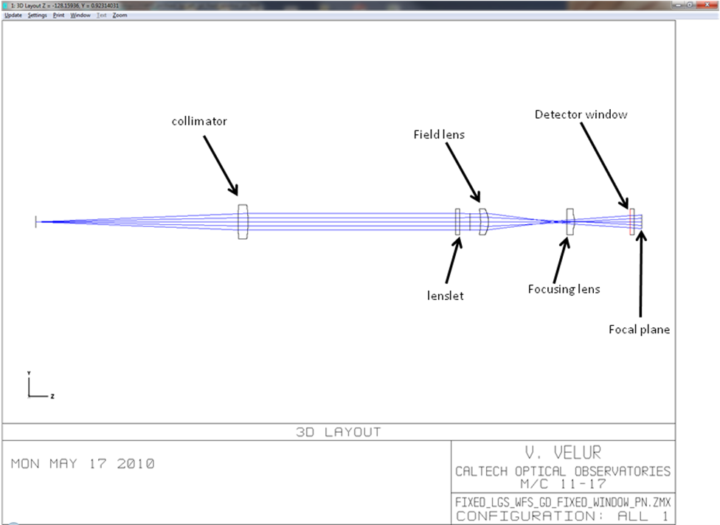
Figure 22 - Layout of Fixed LGS WFS, The total length of the sensor is 232 mm. The relay is composed of a best-form lens for a collimator, a custom lenslet array and a set of custom singlet relay lenses.
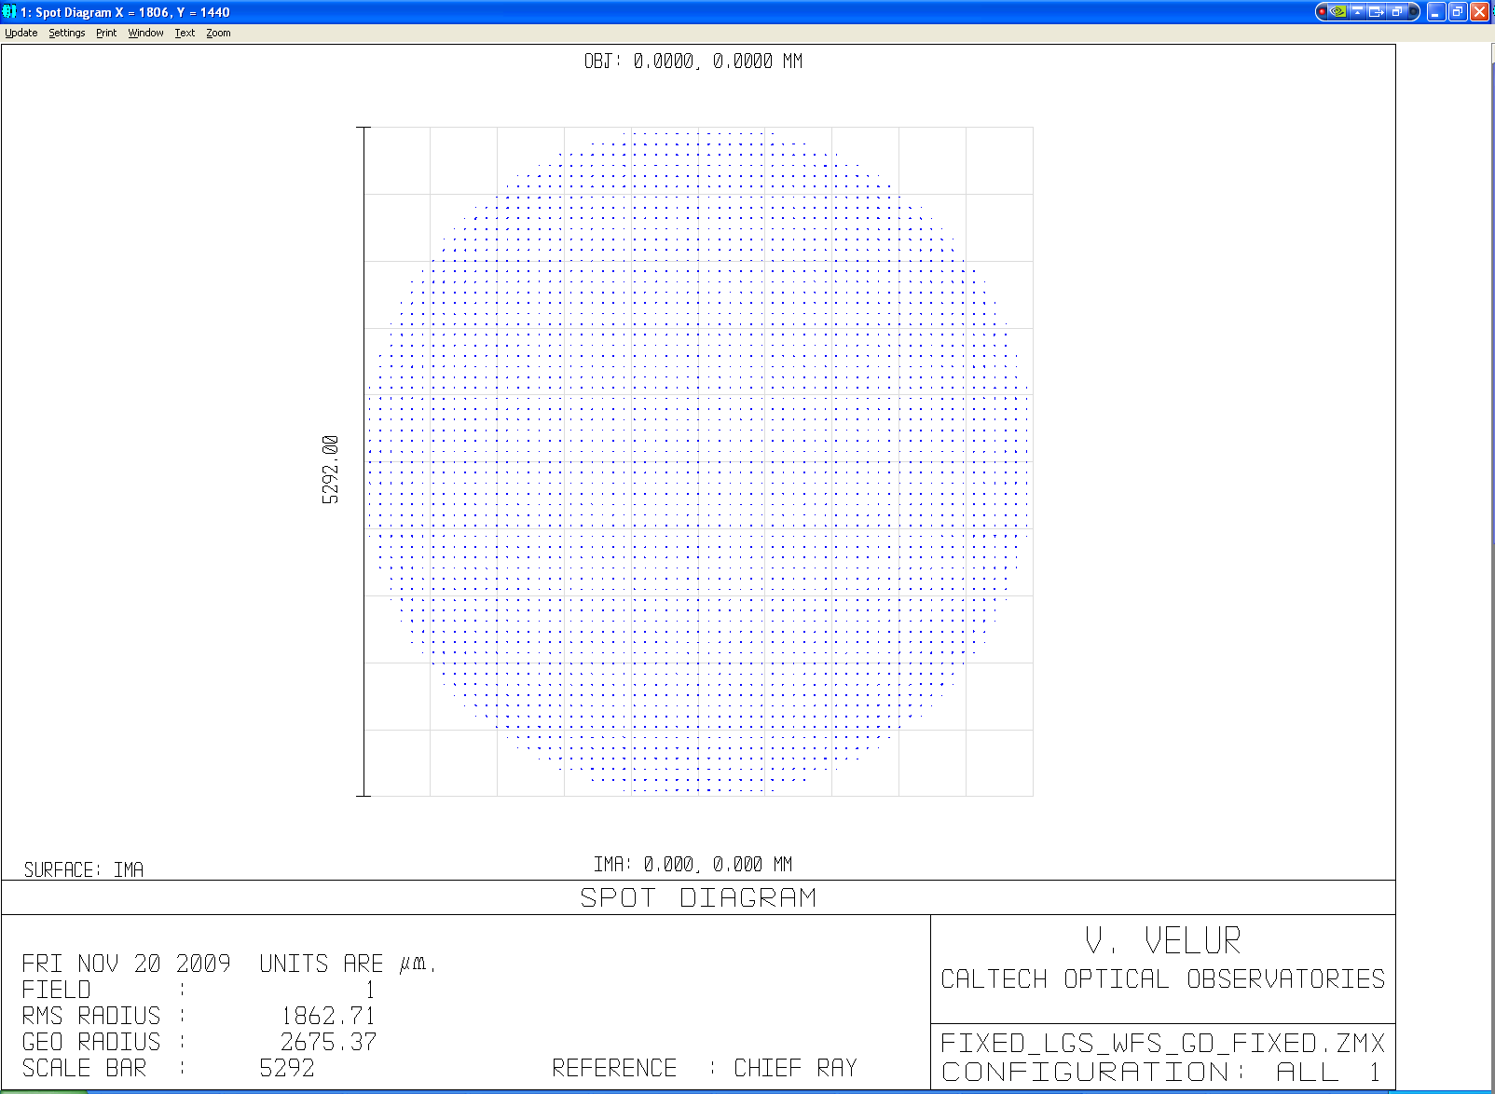
Figure 23 – Fixed LGS WFS spot diagram showing 64x64 sub-apertures
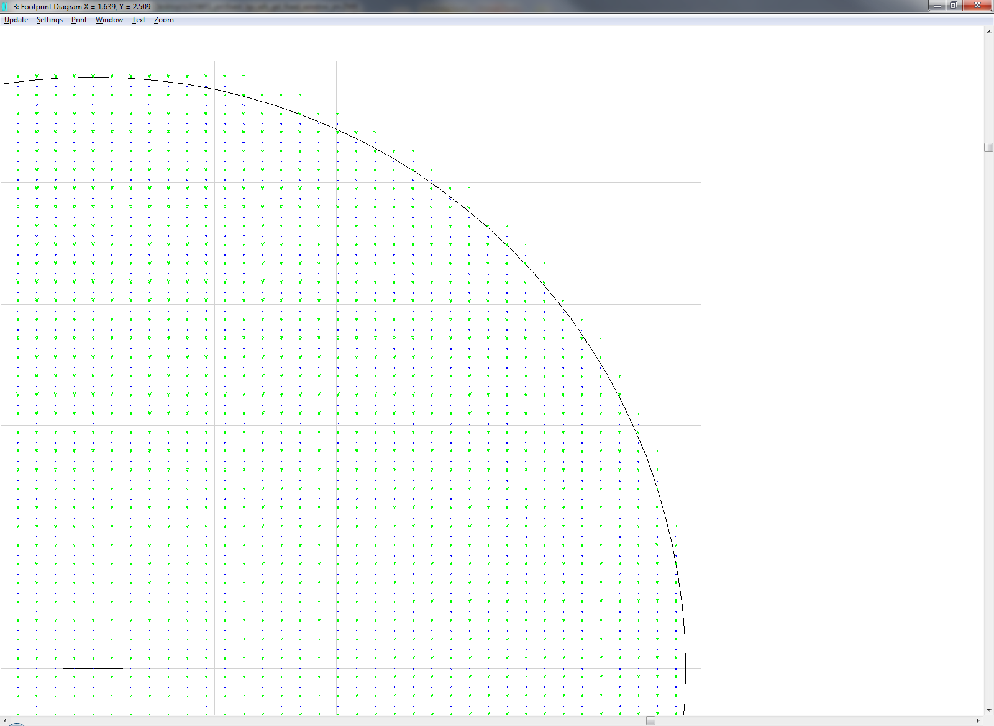
Figure 24 - Footprint diagram for a Fixed Asterism Shack-Hartmann WFS without Dot Relay, showing two field points per subaperture, one on-axis and one 1.41 arcsec (1205.7 um) away. The separation of these points confirms the plate scale at the detector is 0 .705arcsec/pixel.

Fixed LGS WFS Post-lenslet Relay
To ensure that the requirement on the wavefront quality delivered by the WFS relay, the relay was modeled separately and the image quality of the relay assessed independently. The layout of the relay is shown in Figure 25. The relay delivers sub 1um RMS spots with a 0.03% grid distortion at a de-magnification of 0.828.
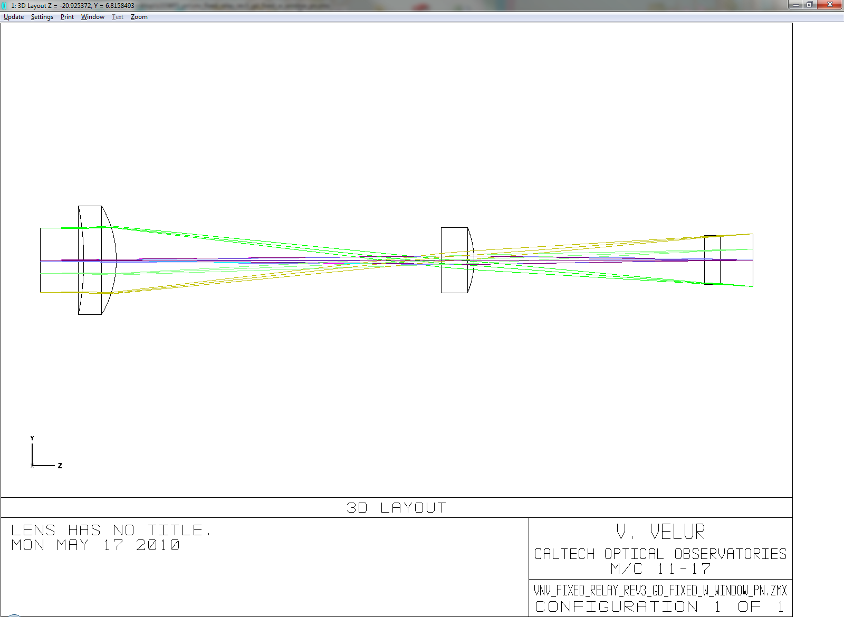
Figure 25 - Fixed LGS WFS post-lenslet WFS relay layout.
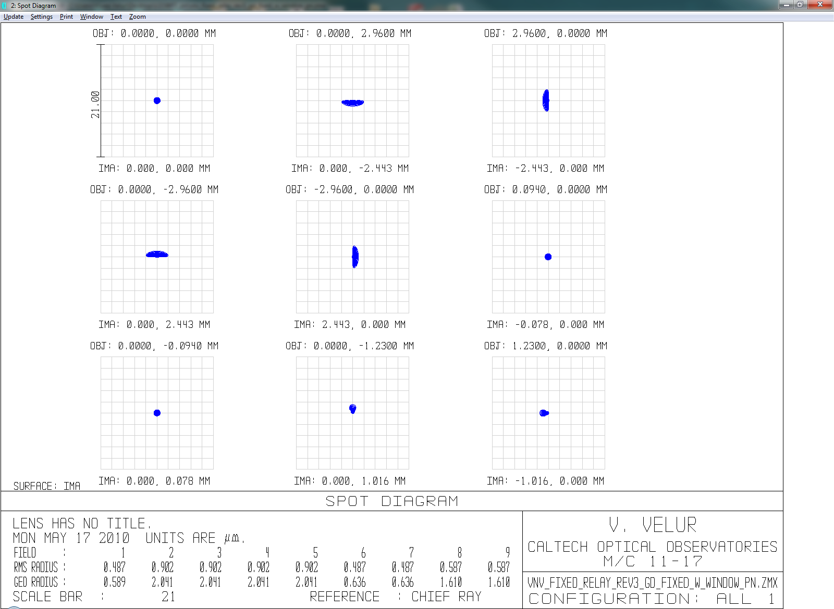
Figure 26 – Spot diagram showing an on-axis point and 4 extreme points of the lenslet spots with the worst case spot size being 0.95 um RMS radius. Detector pixel size is 21 um for reference. Field points 6 and 7 are one lenslet spot away indicating that the magnification is matched to 84 um spot separations at the detector. The grid distortion of the relay is 0.03%.

Patrolling LGS WFS

Patrolling Asterism WFS Design Parameters
As indicated earlier, the p-value (e.g. the ratio of pixel size to spot size) for the Patrolling LGS WFS is 1.0. Hence, 1.49 arcsecs on-sky corresponds to one detector pixel (21 um). From the NGAO optical design, we know that 720 um at the LGS focal plane corresponds to 1 arcsec on-sky. The Patrolling WFS pick-off is a 1:2 relay making the plate scale at the focus to the WFS 1440 um/arcsec.
Also, Plate Scale Ratio (PSR) = f_{collimator}/f_{lenslet} * 1/m = Plate scale at the input of the sensor (um/asec)/ Detector plate scale (um/asec) = 719*2/14.0939 = 102.14, where m is the de-magnification between the lenslet spots and the detector.
The pitch of the lenslet array is given by, d _{each lenslet} = (f_{collimator}/f#) * 1/(# of sub-aps)=95/25.03 * (1/31) = 122.4 um. [the effect of the pupil nutation can be seen as mapping a bigger telescope pupil to the WFS detector plane, which makes the beam faster, hence the f/# is 25.03 rather than 27.12]
The de-magnification, m = (spot separation at detector/ lenslet pitch) = (0.021*4)/0.122 = 0.686, we choose, f_{collimator} = 95 mm EFL from JML Optical’s catalog.
The focal-length of the lenslet is, f_{lenslet} = f_{collimator}/m * (PSR) = 95/0.74337 *(1/102.1714) = 1.355 mm. The F/# of the lenslet is = 11.07
The Fresnel Number (FN#) of the lenslet, FN#_{lenslet} = (d _{each lenslet} /2)²/(f*λ) = 4.69.

Patrolling Asterism Pick-off Relay
A 1:2 telecentric relay was designed to accommodate mechanical packaging of the theta-phi pick-off and the fast TT mirror located at the relay pupil. The total length of the relay is 528 mm Figure 28, Figure 29, Figure 30 show the spots from the relay and the mechanical assembly of the pick-off arm and the 3 channel Patrolling WFS assembly. The pick off mirror location is +10, -5 and -20 mm from the focal plane for the 3 Patrolling WFS. The light that is incident on the pick-off gets folded and collimated to form a pupil at fast TT mirror which folds the beam down to a pair of periscope mirrors. The pick-off mirror and the fast TT mirror are part of the rotatable lever and the periscope mirrors are part of a rotating crank. The combination of these two rotations facilitates positioning the pick-off anywhere in the field. The design of the pick-off relay can be downloaded from http://www.oir.caltech.edu/twiki_oir/pub/Keck/NGAO/WFS/pns_pick_off.ZMX.
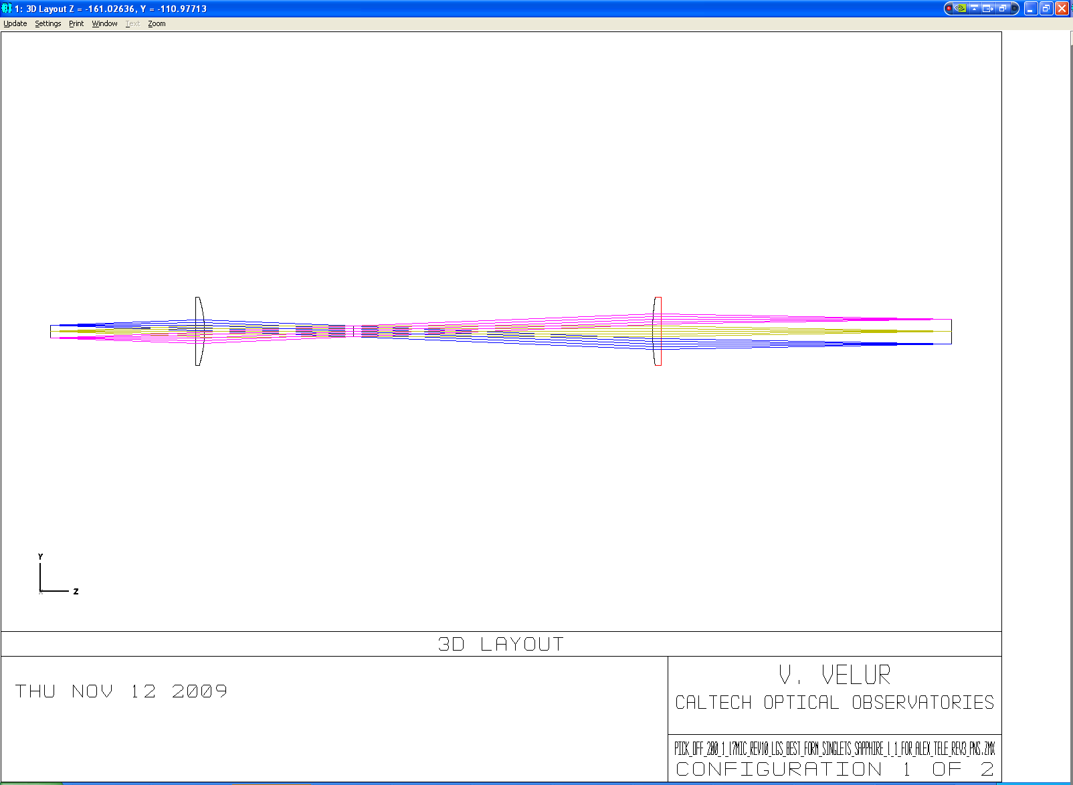
Figure 27 – Figure showing the telecentric unfolded layout of the Patrolling LGS WFS pick off. The relay is 1:2 due to packaging constraints (having to get these WFS out of the way of the interior Fixed Asterism WFS’s).
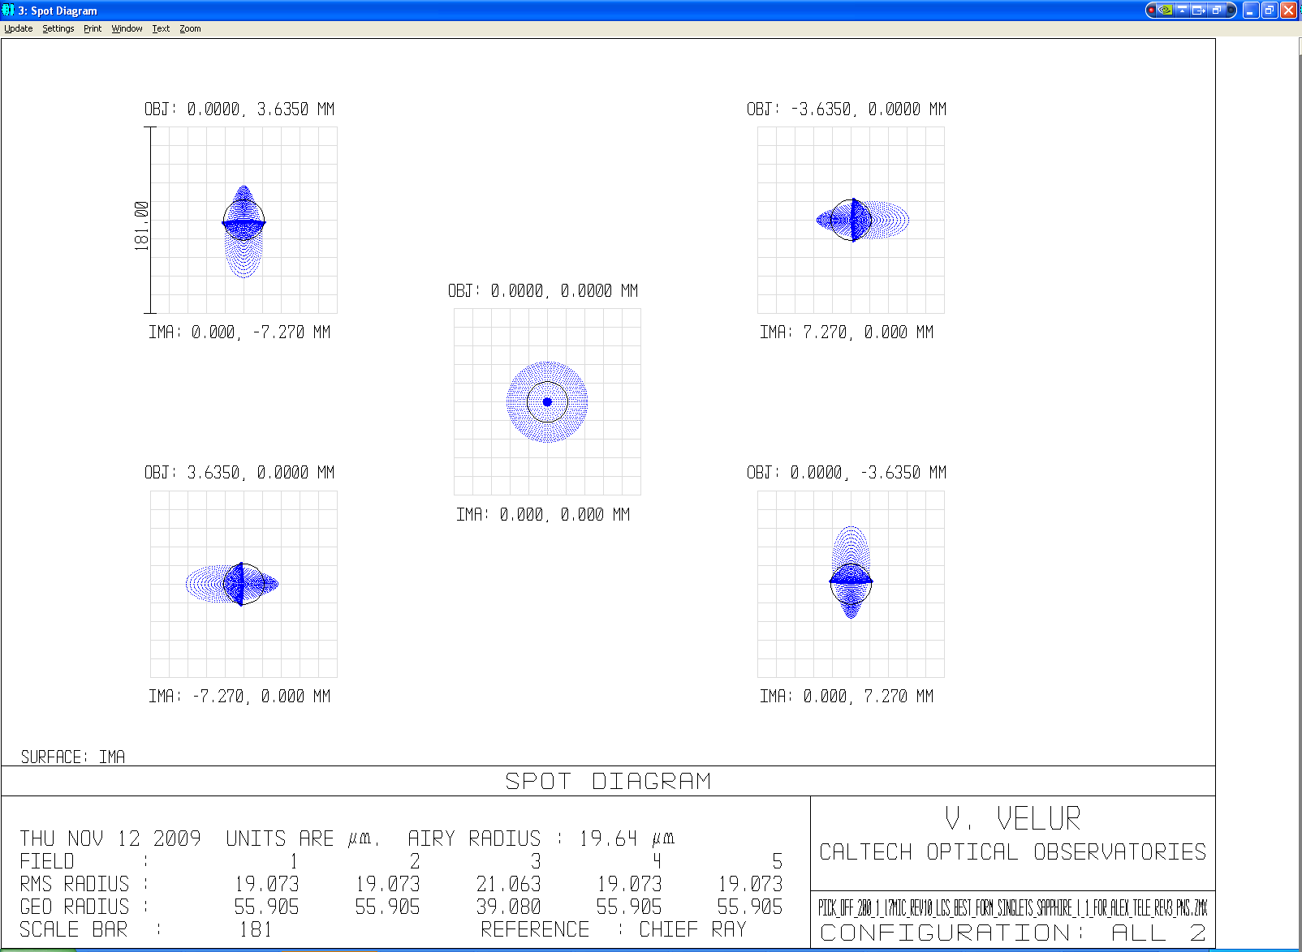
Figure 28 – Spot diagrams from the 1:2 Patrolling WFS pick-off relay showing spots with rms spot radius of 21 um as compared to 130um rms spots delivered by the AO relay. For reference 181 um is 1/4 arcsec.

Figure 29 - Mechanical assembly of a single Patrolling WFS pick-off OSM showing the theta-phi mechanism with a downlink TT mirror located at the pupil.
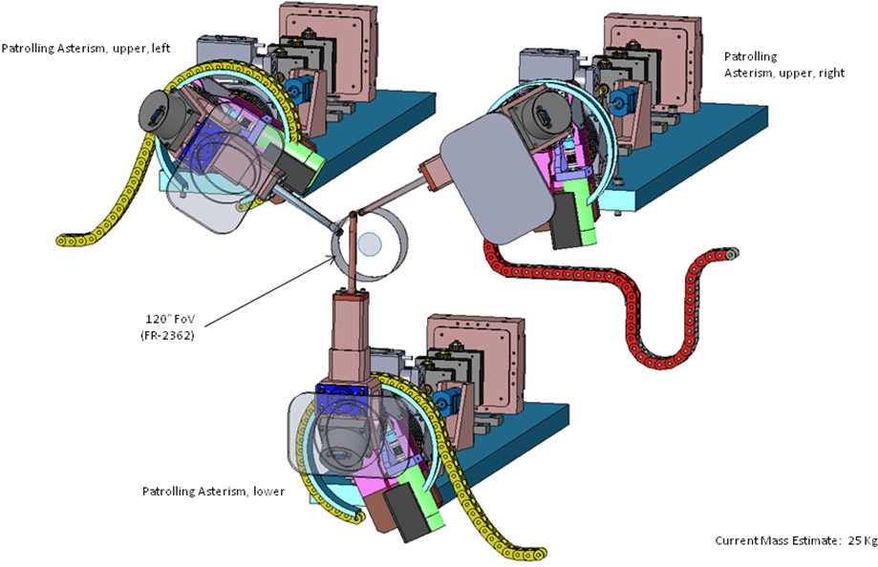
Figure 30 – Mechanical assembly of the Patrolling WFS channels showing the lenslet, the post-lenslet relay and the WFS CCD camera. Each of the Patrolling WFS channel is also equipped with a TT mirror near the focus of the pick-off relay to keep the DM pupil registered onto the lenslet; this is necessary to eliminate pupil wander as each OSM patrols the entire 120″ LGS FoR.

Patrolling Asterism Shack-Hartmann WFS without Dot Relay
A relay-less Shack-Hartmann WFS for the Patrolling Asterism would differ from the corresponding Fixed Asterism WFS only slightly, in order to optimize for the particular image FWHM expected in the Patrolling WFS. Such a WFS would have a lenslet pitch of 84 um and lenslet focal length of 0.638 mm with a 65.20 mm EFL collimator. For completeness, such a sensor was designed by Velur and the design is available at: http://www.oir.caltech.edu/twiki_oir/pub/Keck/NGAO/WFS/PnS_lgs_wfs_norelay_pn.ZMX
Figure 31 and Figure 32 show the layout of this sensor and the spot diagram at the detector plane.
For reasons described in Section 5.2.1.2, until risk can be mitigated for this approach, we will continue in the PD phase assuming a traditional design utilizing a post-lenslet array optical “dot” relay.
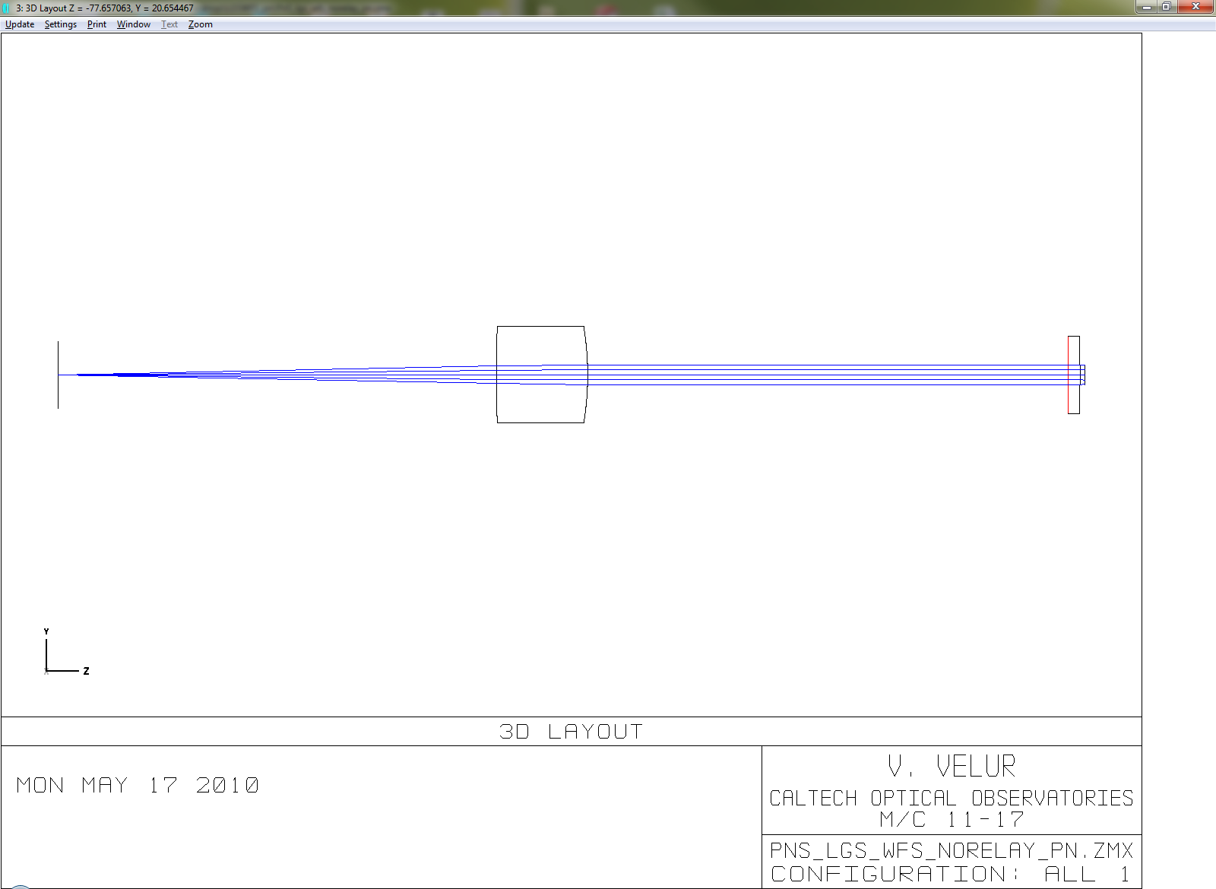
Figure 31 - Layout of the simplest possible Patrolling LGS WFS wherein the lenslet spots directly imaged onto the detector (i.e. design without a post-lenslet relay)

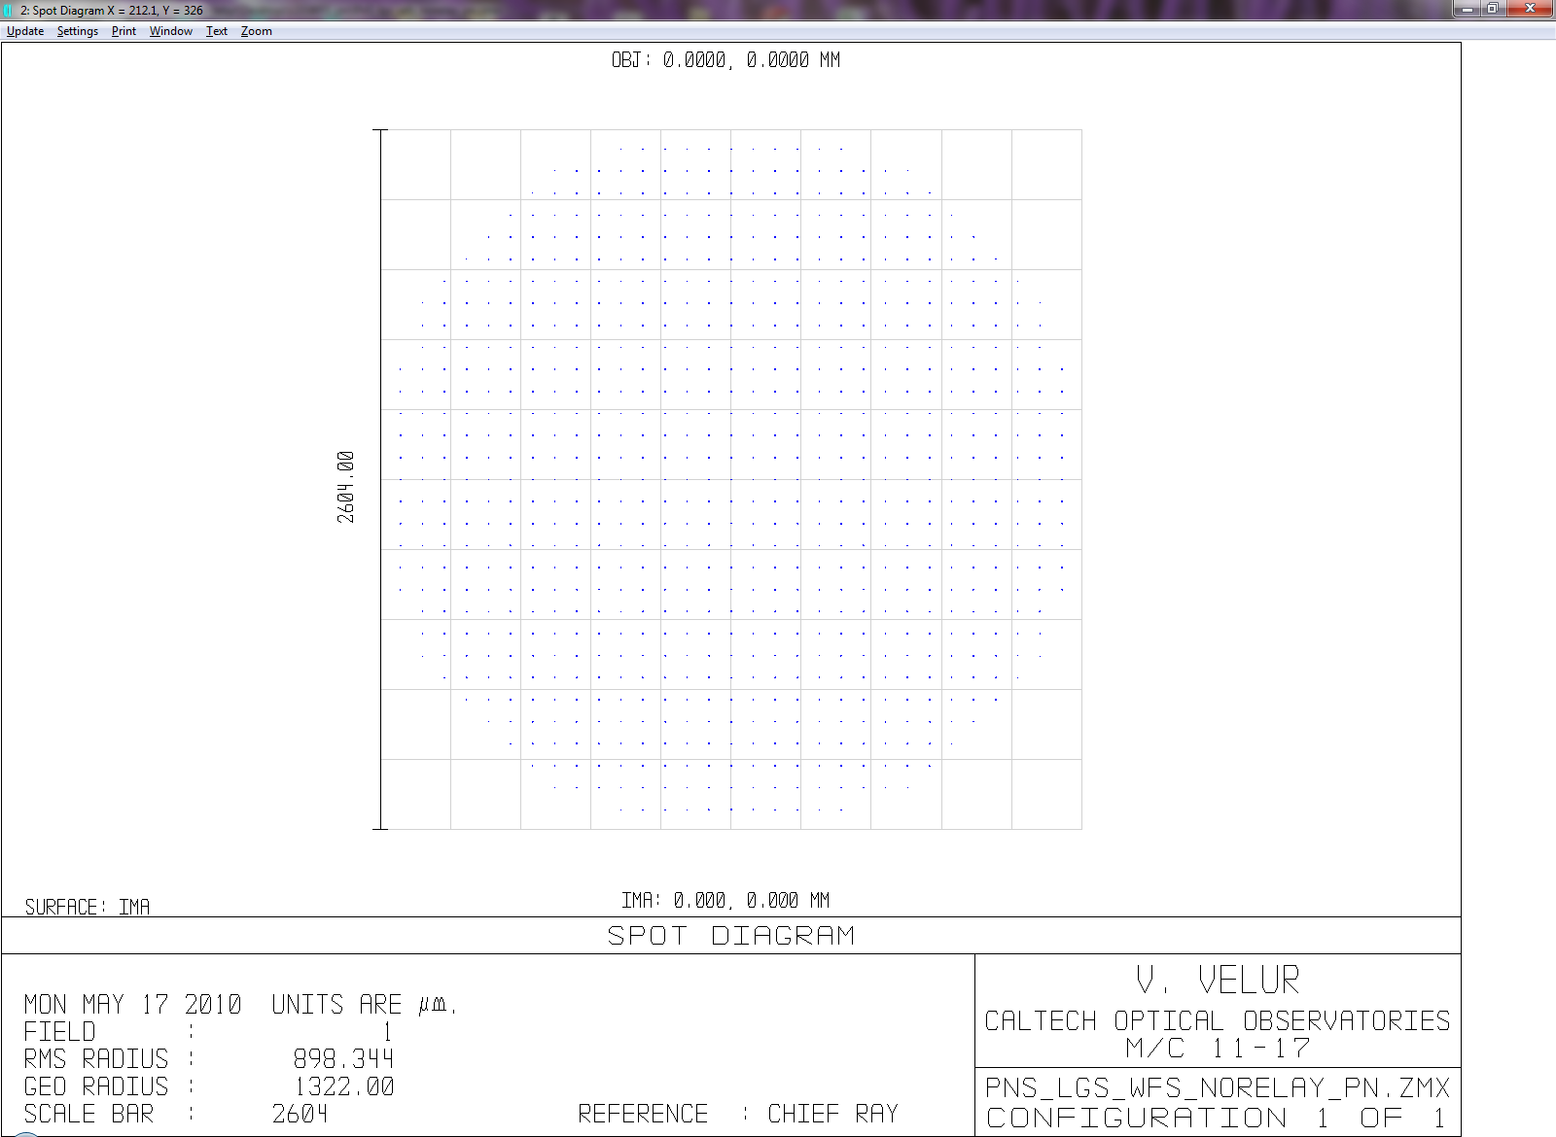
Figure 32 - Patrolling LGS WFS spot diagram showing 31x31 sub-apertures from the simplest possible WFS design.

Patrolling Asterism Shack-Hartmann WFS with Dot Relay
The Patrolling WFS also uses a commercial best-form collimator lens followed by a custom lenslet and relay lenses. The design of the WFS can be obtained from: http://www.oir.caltech.edu/twiki_oir/pub/Keck/NGAO/WFS/PnS_lgs_wfs_doublets_rev1_window_pn.ZMX. The WFS spots are shown in Figure 34 and a footprint diagram was used to verify the plate scale of the sensor. The total length of the sensor is 490 mm.
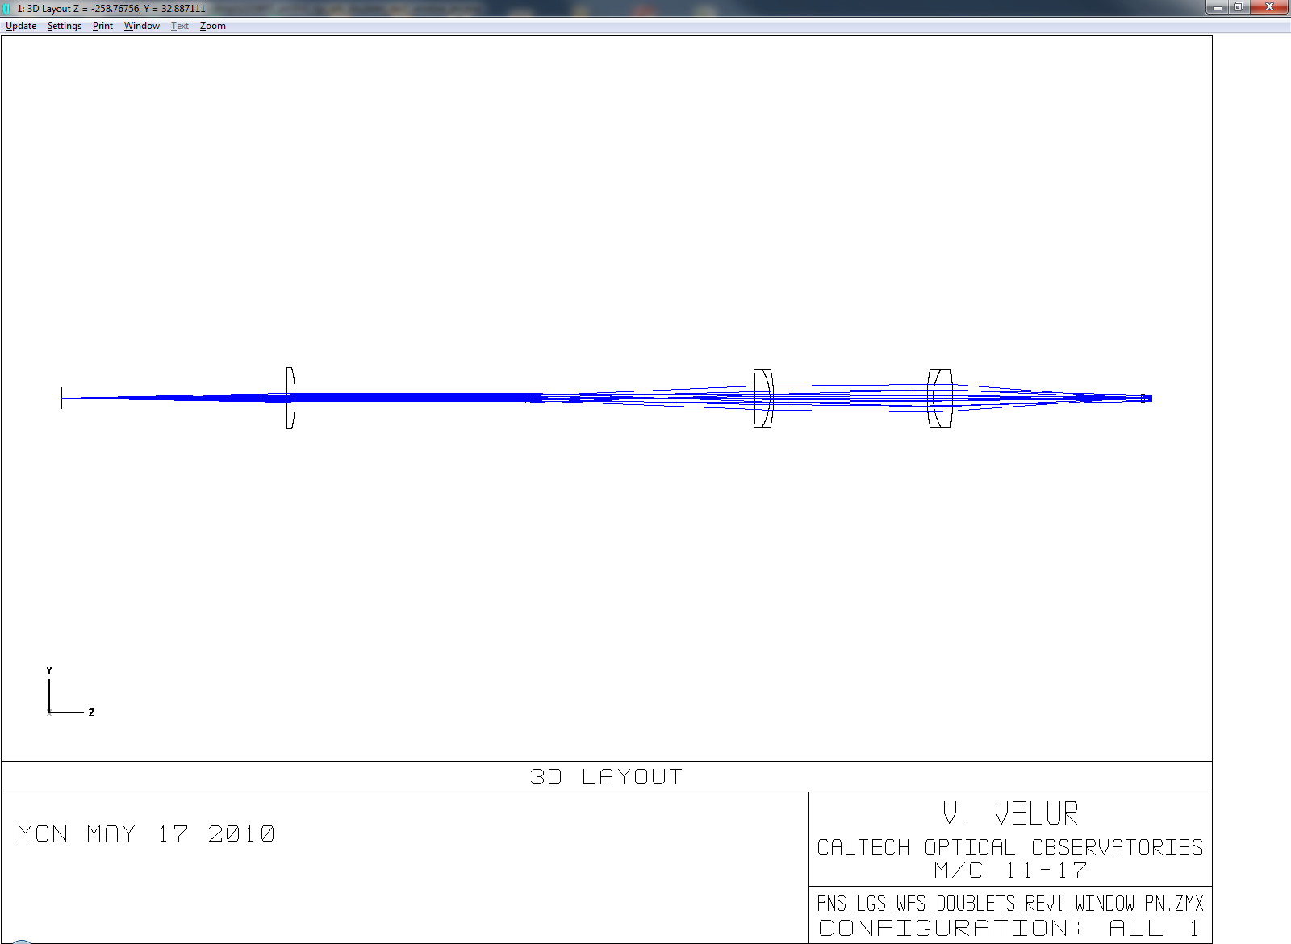
Figure 33- Layout of the Patrolling WFS; the total length of the sensor is 490 mm.
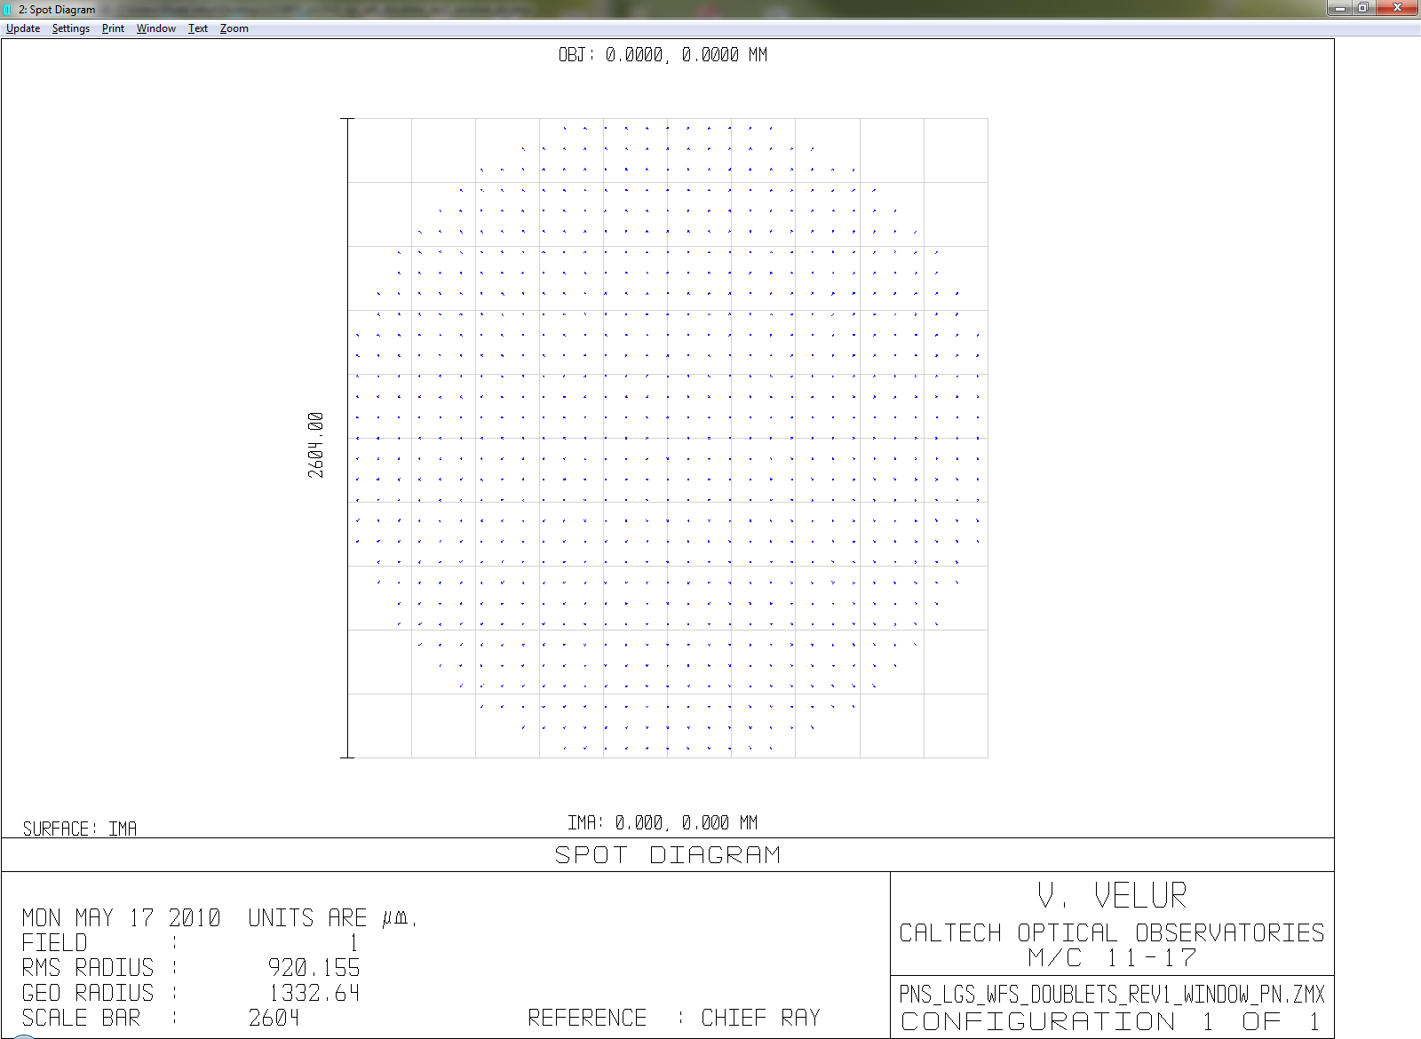
Figure 34 - Spot diagram at the detector

Patrolling LGS WFS Post-lenslet Relay
The post lenslet relay was modeled separately for the Patrolling WFS and the performance of the relay measured. Since the lenslet spots are f/11 the design required doublets rather than just a pair of singlets. Models were built with single doublet and a singlet field lens with unsatisfactory performance. The 2 doublet relay gives sub um (RMS) spots with negligible grid distortion.
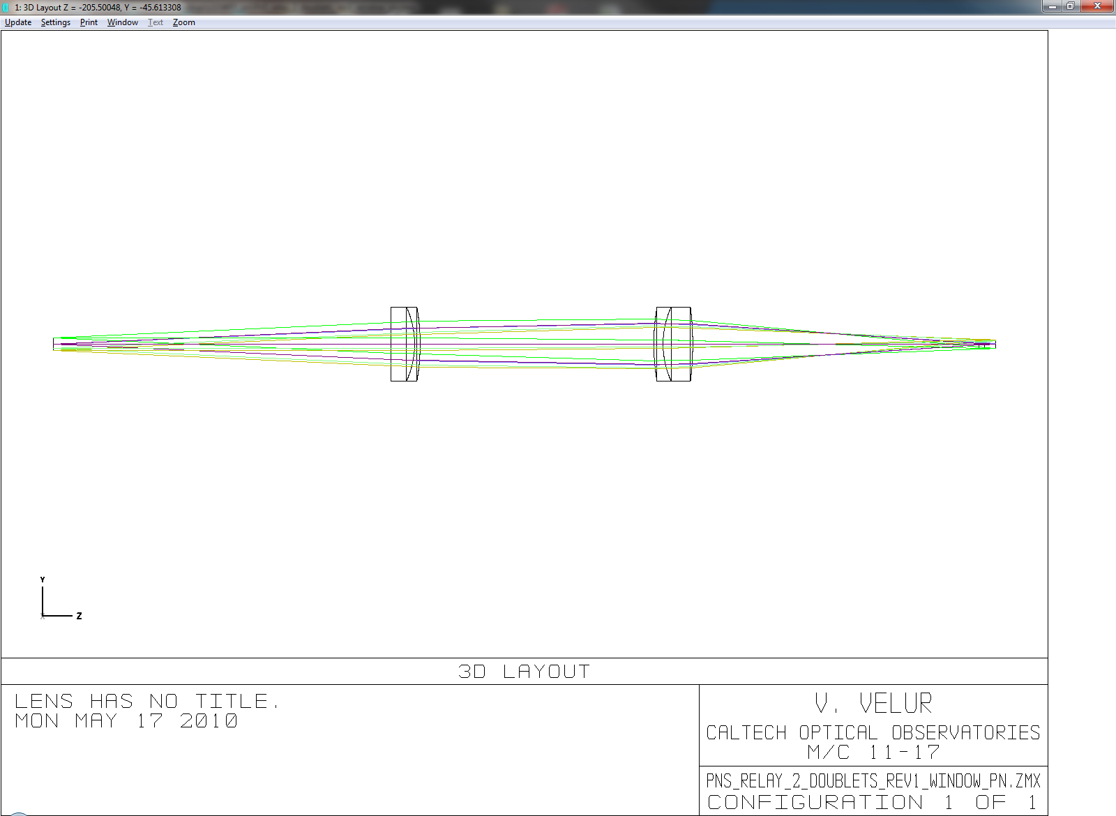
Figure 35 – Shows the layout of the post lenslet relay in the Patrolling LGS WFS. The length of the relay is 300 mm.
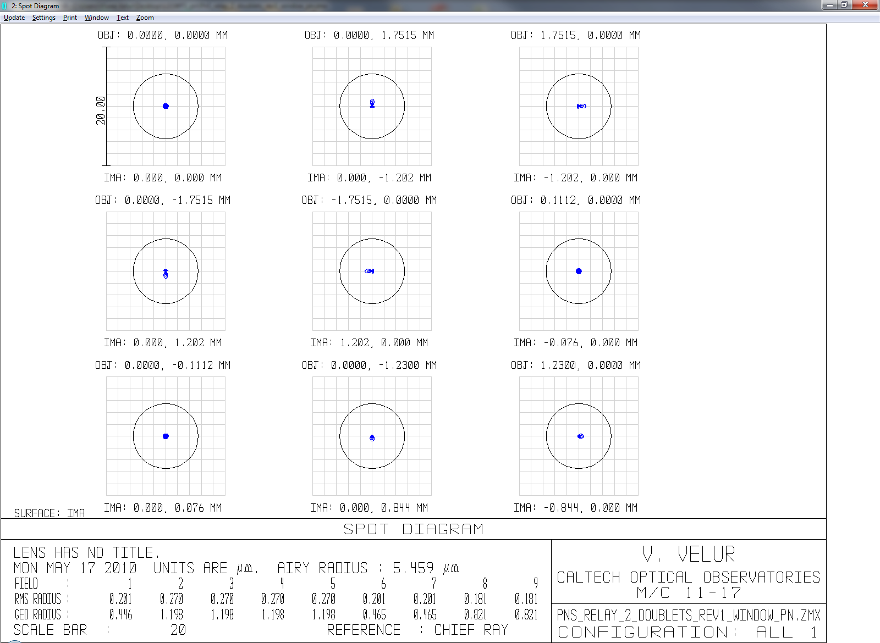
Figure 36 - Spot diagrams of the relay with on-axis and extreme field points (field #s 2 through 5). There are also 2 field points to indicate that the magnification (field #s 6 and 7) is correct and 2 more located at 1/√2 of the field size. The grid distortion of the relay is 0.001%.

Performance of the LGS WFS including the AO relay
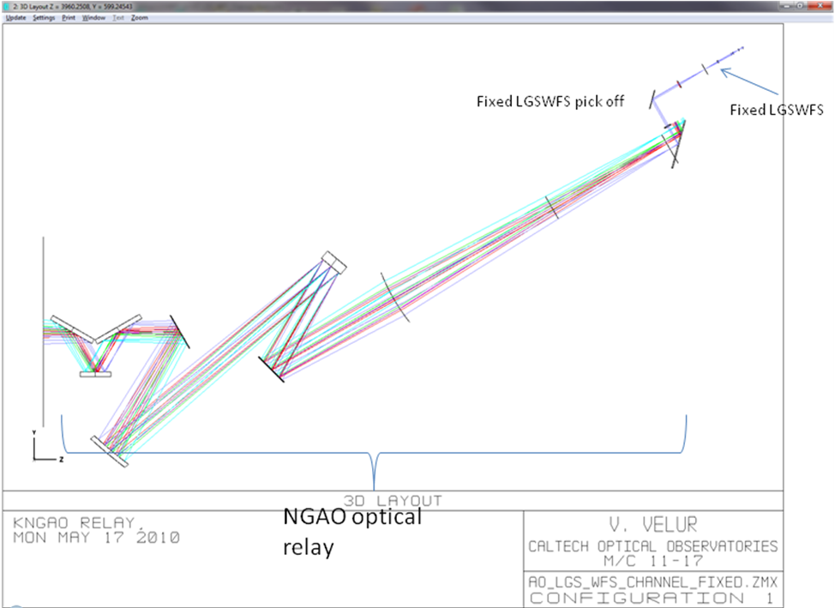
Figure 37 - NGAO optical path for Fixed Asterism LGS WFS [Note: all the fold mirrors have not been incorporated into this model]
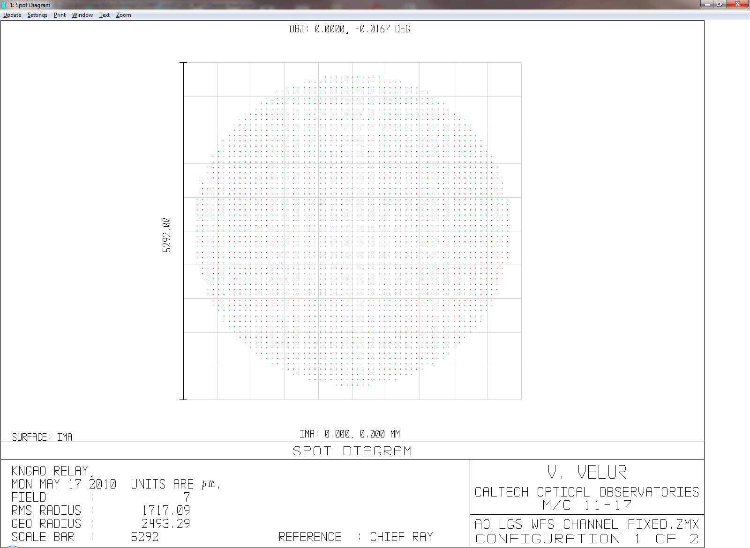
Figure 38 – Fixed LGSWFS spot diagram when the relay is positioned behind the AO relay showing 59 fully lit sub-apertures.
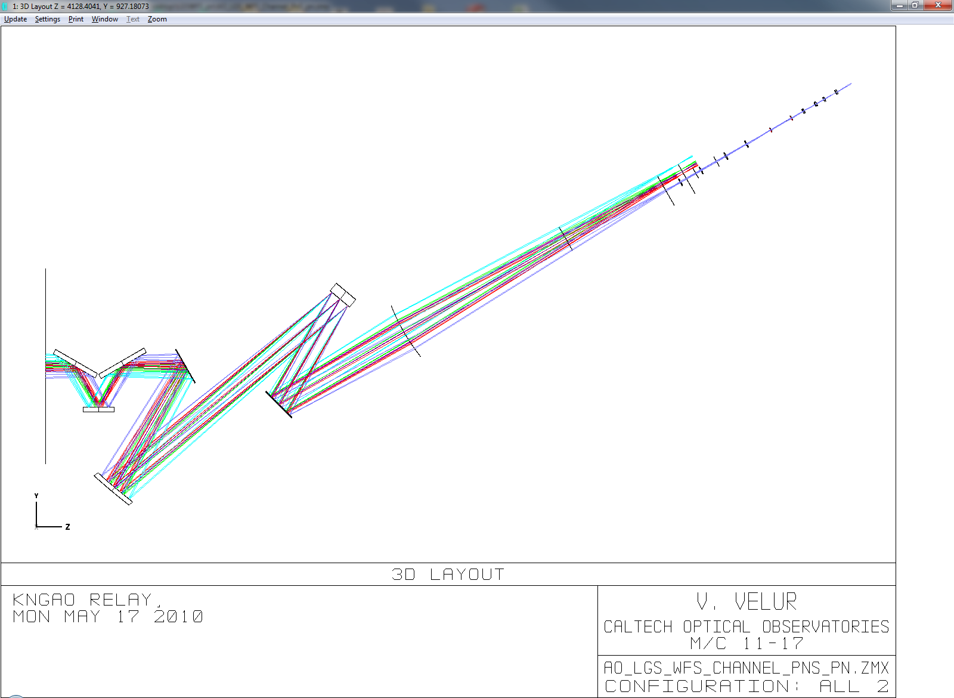
Figure 39 - NGAO optical path for Patrolling Asterism LGS WFS [Note: all the fold mirrors are not incorporated into this model].
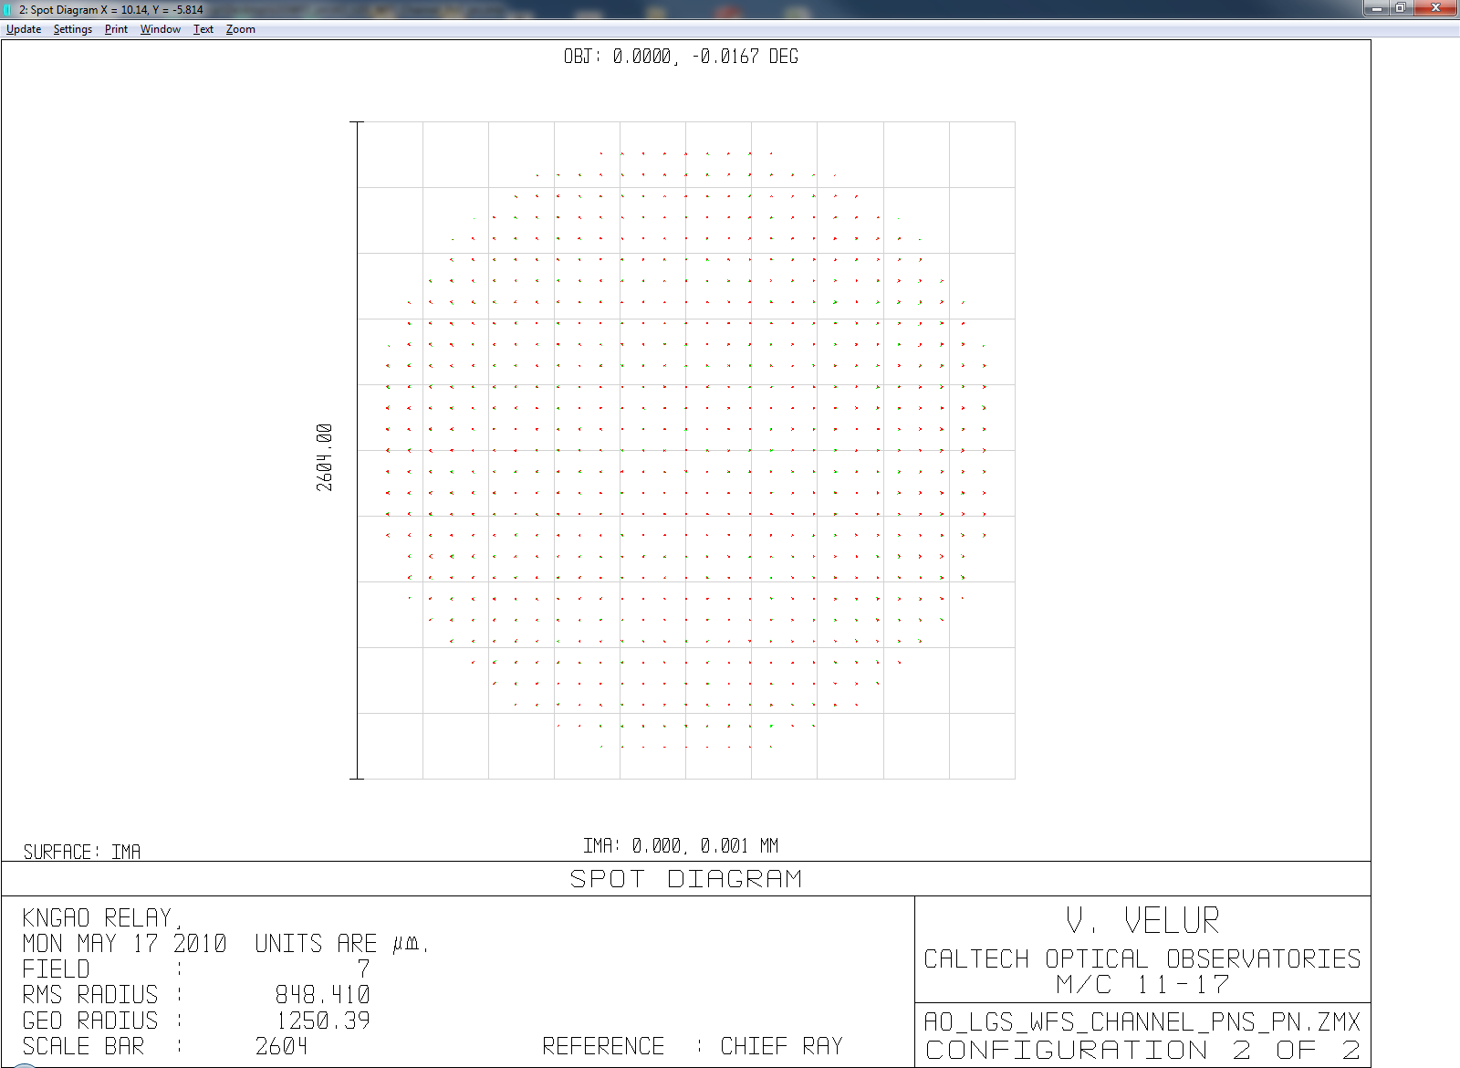
Figure 40 – Patrolling LGSWFS spot diagram showing 29 fully lit subapertures.
Table 5 and Table 6 show the overall error budget and design parameters of the fixed and patrolling LGSWFS’s.

Mechanical Design
The mechanical packaging of the seven wavefront sensor channels of the NGAO LGS WFS is made challenging by the tight packaging requirements for the selection of multiple LGS with a relatively small (< 90 mm) diameter wide-field relay output focal plane. To create space between different LGS channels, we have adopted a design based fundamentally upon the ‘fisherman-around-the-pond’ approach previously explored for deployable-IFU spectrographs and explored in the design of the four-Shack-Hartmann-channel Palomar multiple guide star wavefront sensor. The overall mechanical package for the LGS WFS is shown in Figure 41 and Figure 42. The overall mechanical structure has already been described in Section3 (Page9) of this document. Appendix II serves as a detailed mechanical design reference.

Fixed LGS WFS design
The three outer fixed LGSWFS channels employ a fixed pick off as shown in Figure 18 and the central fixed LGSWFS has a layout as indicated by Figure 43. Each channel is equipped with a dedicated TT mirror to keep the LGS spots stable on the sensor as NGAO doesn’t have fast uplink tip-tilt correction for the LGS’s on sky. Each Fixed LGSWFS channel is provided with lockable micrometer based manual pitch and yaw control using a gimbal about the WFS focus to enable easy alignment. Each LGSWFS channel has a three point mounting to the truss structure.

Figure 41 – Full mechanical assembly of the LGS WFS within a notional housing (feet are not shown and truss (support) structure has been made transparent)


Figure 42 - Full mechanical assembly of the LGS WFS with housing and overall translation stages removed.
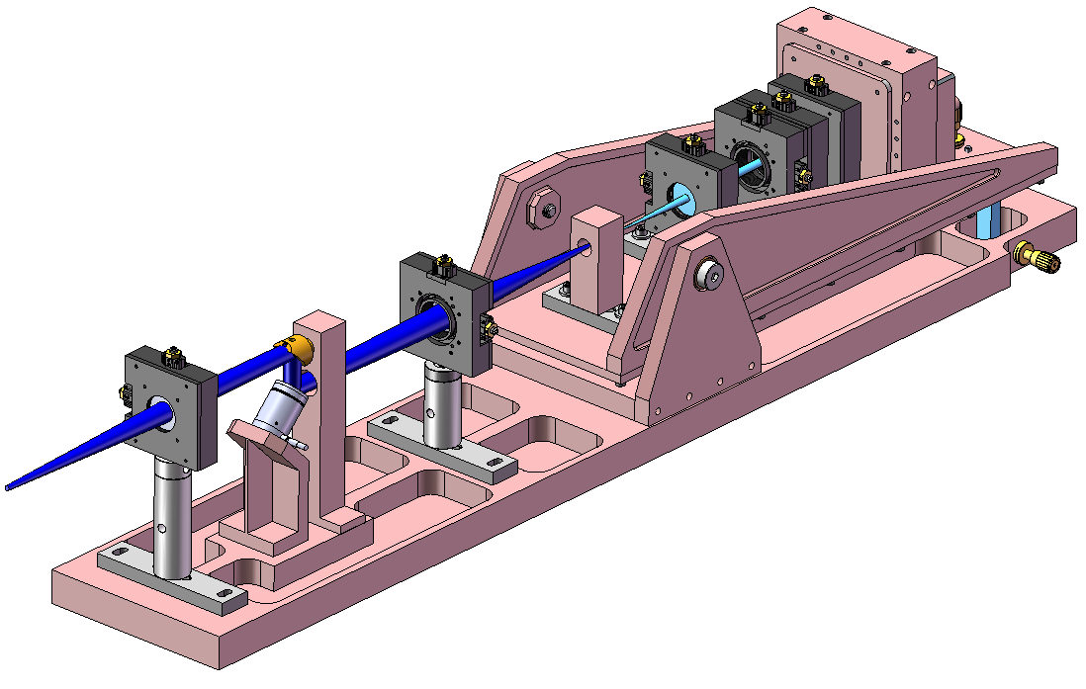
Figure 43 Central LGSWFS with pitch and yaw control (Figure 18 shows one of the other three fixed LGSWFS’s). Each of these channels has a 3 point kinematic mounting scheme.

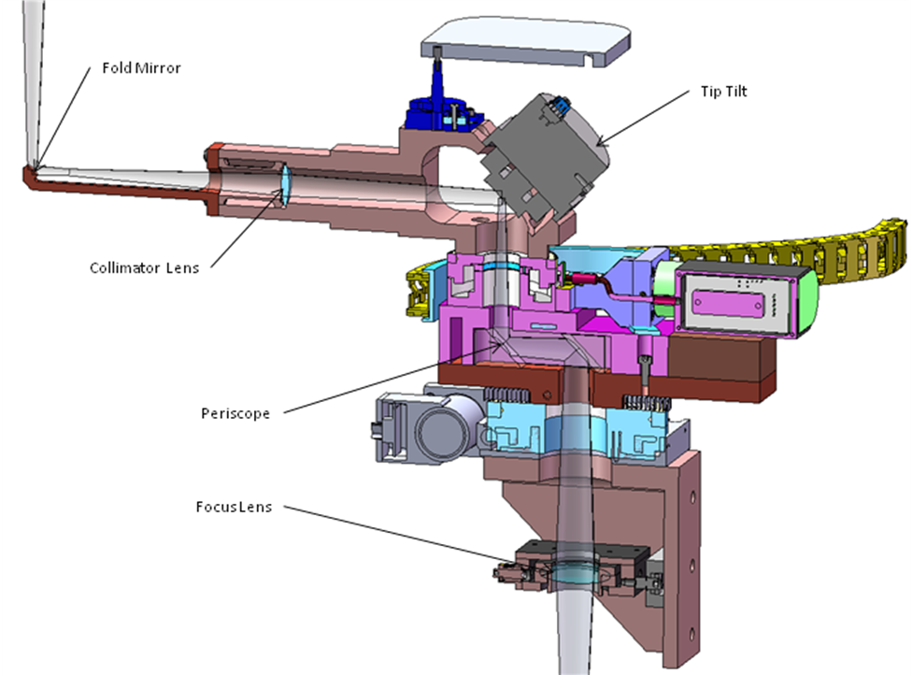
Figure 44 - Part cross sectional view of the Patrolling LGS OSM pick-off showing the crank and lever motors and arms. The optics consist of a pick-off mirror a collimating lens, a TT mirror at the pupil and reimaging lens following 2 other fold mirrors.

Patrolling LGSWFS design
The Patrolling LGSWFS’s have deployable pick-off mechanisms in each channel that can patrol a full 120” FoR; these pick-off mechanisms are described in the following section. The Patrolling LGSWFS channels all have an extra TT mirror that can ensure DM-lenslet registration in case there is pupil shear at off-axis pick off points.
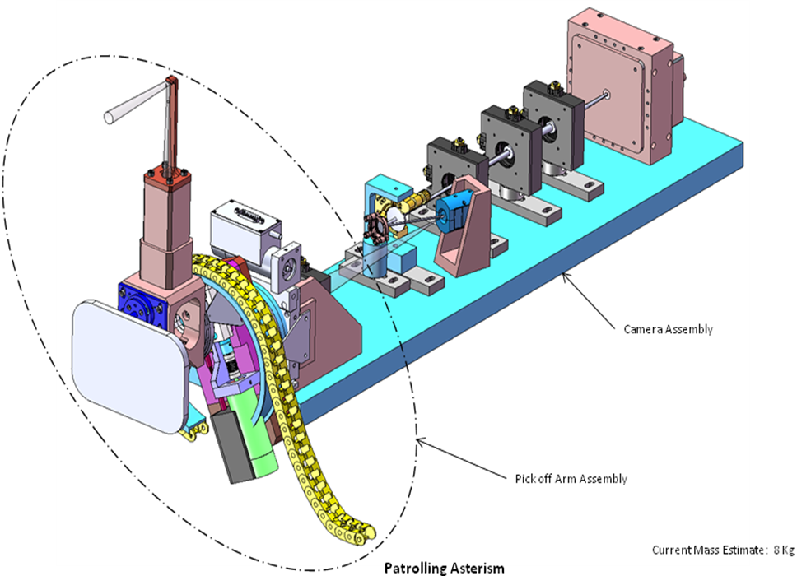
Figure 45 - Single channel of a Patrolling LGSWFS. Each of these channels has a 3 point kinematic mounting scheme.

LGSWFS’s Pick-off
Figure 44 shows a partial cross-sectional view of the Patrolling WFS pick-off. The theta-phi pick off is better than the r-theta as it doesn’t need refocusing (and there the pupil mapping geometry is maintained at all field positions). The crank arm and the lever arms are balanced about their axis of rotation and to prevent stray torque on the motors at any position of the arm. A Honeywell 8LS125 micro-switch and a custom contour milled track serve the purpose of a fail-safe system to prevent collision between pick-off arms. The crank and lever motors use PI’s M037 and M-038 drives. M-037 rotation stages are equipped with ultra-precise worm gear drives allowing unlimited rotation in either direction. Model M-037.DG is a closed-loop DC motor with shaft-mounted position encoders and precision gearheads providing 3.5 μrad at a design resolution of 0.6 μrad. Model M-038.DG1 is equipped with a closed-loop DC motor with shaft-mounted position encoder and precision gearhead providing minimum incremental motion of 3.5 μrad at a design resolution of 0.6 μrad. A frictionless high-precision flexure based Optics-In-Motion mirror is used to stabilize the LGS spots on the detector. There is a pair of periscope mirrors mounted on the crank motor and there is a focusing lens past the second periscope fold mirror. Appropriate jigs will be designed to mount the mirrors at the exact angle onto each surface on which it is to be held.
The fixed LGSWFS’s use a simple stationary pick-off using a snout-like part holds the pick-off mirror which folds the light into a barrel with a collimator followed by a TT mirror (c.f. Figure 18). There is a focusing lens following the TT mirror that feed light to the WFS optics.

Baffles, Enclosure and Linear Focus Stage
Each WFS will be baffled to reduce effects of Rayleigh backscatter effects by enclosing the whole WFS relay except for the field-stop. An enclosure made of sheet metal over the aluminum structure will be used to keep the LGS WFS clean. The whole WFS assembly shall be mounted on a 205 mm (focus required to track the sodium layer between 80 and 292 km distance from the telescope) travel linear stage. An Aerotech ABL20030 stage with 300 mm travel will be used to move the whole assembly to track the change in distance to the Na-layer. The specs for the stage can be found at http://www.aerotech.com/products/airbearing/abl2000specs.html. The stage is a fully-preloaded air-bearing stage with a brushless linear motor. The package is zero-maintenance.

Pupil Registration and TT Corrector
Because the LGS light path to the WFS is not perfectly telecentric it is necessary to register the DM actuators and the lenslet for each point in the field for the Patrolling WFS (if the effect is not measured and calibrated). For this process we have a slow TT mirror near the pick-off focus to register the LODM actuators to the lenslet. We also provide a pitch and yaw mechanism to align the fixed LGS WFS lenslets to the LODM. Each LGS arm has a downlink TT mirror, located at the pupil formed in the pick-off mechanism, to correct the differential motion LGS light with respect to the desired centroid location.

Tolerancing
Detailed tolerancing for the LGS WFS will be performed in the DD phase of the project. Appendix I shows the design performance WRT contour and error budget flowdown error budget allocation. Preliminary tolerance analysis was performed on the optical design using Zemax’s built in tolerancing in the optical design software and TEZI. Since, Zemax’s tools don’t work reliably when a lenslet in located in an optical relay, we tolerance the system as two separate systems default tolerance values in Zemax (0.2 mm tolerance on radius of curvature of the optics, 0.2 mm on thickness, 0.2 mm on X and Y decenter with 0.2 mm on tilt in X and Y) with no remarkable change in WFS performance when a Monte-Carlo based tolerancing analysis was run.

Requirements Compliance
The requirements compliance matrix can be found at:
http://www.oir.caltech.edu/twiki_oir/pub/Keck/NGAO/091207_LGS_WFS/1.2.7-LGS_WFS_Functional_Requirements_091121_v2.pdf

Risk Register and Risk Mitigation Plan
A risk register and mitigation plan can be obtained from:
http://www.oir.caltech.edu/twiki_oir/pub/Keck/NGAO/091207_LGS_WFS/091207_LGS_WFS_PD_Risk_Register_v1.pdf

Outstanding issues to consider during the detailed design phase

- Stray light (including Rayleigh scatter) analysis
- Simplification of the Optical Design of sensors if possible.
- Try to redesign the plano-(parabolic) convex lens to try and provide less aberrated LGS spots at the LGS assembly input.
- Cost reduction by finding more economical components for motion control.
- Draft interface documents between the LGSWFS assembly and the various other sub-systems.
- Liaise with Supervisory Control Team to choose motion control that is easy to implement and try to consolidate motor controllers wherever possible.

Appendix I

LGSWFS error budget
Blurring of Shack-Hartmann spot
Error source | Fixed LGS WFS spot size | Patrolling LGS WFS spot size
AO relay | 20 mas | 20 mas
Focal plane curvature | 0
OSM | 50 mas | 50 mas
WFS relay | 60 mas | 60 mas
Allocation | 250 mas | 250 mas
Diffraction spot size (for ref.) | 699 mas | 344 mas
Shift of the worst case sub-ap
Error source | Fixed LGS WFS spot size | Patrolling LGS WFS spot size
AO relay | 20 mas | 120 mas
Focal plane curvature | 22 mas | TBD
OSM | TBD | TBD
WFS relay | TBD | TBD
Allocation (10% of sub-ap.) | 300 mas | 600 mas
Diffraction spot size (for ref.) | 666 mas | 350 mas
Table 5 Overall design error budget of LGSWFS showing the sensors meet design allocations [Note overall distortion error budget will be done in the DD phase]

LGSWFS input parameters and design parameters:
 | Fixed LGS WFS | Patrolling LGS WFS | units
Sensor characteristics
P value | 0.5 | 1
Plate scale | 0.705 | 1.49 | "/pixel
Capture range | 1.5*2 | 2.5*2 | waves
lambda/d | 710 | 355 | mas
Capture range | 2.13 | 1.775 | arcsec
1d tilt (RMS) | 50 | 100 | mas
LGSWFS with post-lenslet relay design parameters
input f# | 12.52 | 25.04
Collimator focal length | 80.00 | 95.00 | mm
Diameter of the pupil at the lenslet | 6.39 | 3.79 | mm
Lenslet pitch | 101.43 | 122.39 | um
De-magnification | 0.83 | 0.69
Input plate scale | 719.79 | 1439.59 | um/"
Detector plate scale | 29.61 | 14.09 | um/"
Lenslet focal length | 3.97 | 1.36 | mm
Fresnel # at lenslet | 1.10 | 4.69
RoC of lenslet | -2.05 | -0.70 | mm
F# of lenslet | 39.18 | 11.07
NA of lenslet | 0.0128 | 0.0452
LGSWFS without post-lenslet relay design parameters
input f# | 12.52 | 25.04
Collimator focal length | 66.25 | 65.20 | mm
Diameter of the pupil at the lenslet | 5.29 | 2.60 | mm
Lenslet pitch | 84.00 | 84.00 | um
Input plate scale | 719.79 | 1439.59 | um/"
Detector plate scale | 29.61 | 14.09 | um/"
Lenslet focal-length | 2.73 | 0.64 | mm
RoC of lenslet | -1.41 | -0.33 | mm
Table 6 LGSWFS design and input parameters

Appendix II LGSWFS motion control
Qty | Component | Type | Purpose | Vendor | Part Number | Range | Resolution | Unit Price | Total Price
1 | Translation Stage | Motorized | Focus | Newport | M-MTM250CC | 250 mm | 0.1 um | $7,525 | $7,525
1 | Controller | Electronics |  | Newport | ESP301 |  |  | $2,350 | $2,350
2 | Linear Bearings | Motorized | Focus | Del-Tron | HPRS5-10 | 10 in | .00004 in/in | $1,025 | $2,050
7 | Tip Tilt | Motorized |  | PI | S330 | 10 mrad | 0.5 urad | $6,396 | $44,772
1 | Controller | Electronics |  | PI | E-616.SS0G |  |  | $6,270 | $6,270
3 | Rotation Stage | Motorized | Crank | PI | M038.DG1 | +/- 180 deg | 0.6 urad | $4,860 | $14,580
3 | Rotation Stage | Motorized | Lever | PI | M-037.DG | 360 deg | 0.59 urad | $4,297 | $12,891
6 | Controller | Electronics |  | PI | C-863.10 |  |  | $990 | $5,940
3 | Tip Tilt | Motorized |  | Optics in Motion | OIM101 | +/- 1.5 deg | 2 urad | $3,900 | $11,700
9 | Load Cells | Sensor | Guidance | Honeywell | BL912P | TBD | 1% | $200 | $1,800
8 | Knob Adjustment Screw | Manual | Pitch & Yaw | Newport | AJS100-0.5 | 1/2 in | 0.7 um | $25 | $200
29 | Lens Mount | Manual |  | Thorlab | ST1XY-A | 6.5 mm | 10 um | $313 | $9,077
 |  |  |  |  |  |  |  |  | $119,155
Table 7 –List of motion control components in the LGSWFS assembly. [Note – LGSWFS Team and the Supervisory control Team will refine the above list to consolidate motion controllers, refine choice of motors to facilitate easy software development in the DD phase]

Appendix III
Mechanical Design details presentation that goes into nitty-gritty details of the mechanical design.

Comparison of centroid computation algorithms in a Shack–Hartmann sensor, S. Thomas et. al, MNRAS 2006
Study of optimal wavefront sensing with elongated laser guide stars, S.J.Thomas et. al., MNRAS 2007
McGuire, P. C., et al., “Construction and testing of the wavefront sensor camera for the new MMT adaptive optics system”, Proc. SPIE TBD (TBD).

