

Keck Adaptive Optics Note ___

Next Generation Adaptive Optics:
Post-PDR Systems Engineering Management Plan

Version 1.0
April 22, 2010

Author List
Name | Function
Peter Wizinowich | NGAO Project Manager
Sean Adkins | NGAO Senior Manager
Richard Dekany | NGAO Senior Manager
Don Gavel | NGAO Senior Manager
Claire Max | NGAO Project Scientist

Contributors: Jason Chin, Chris Neyman, Kevin Tsubota, Viswa Velur

Approval Control
Control | Name | Function
Revised by:

Approved by:
Authorized by:

Document Change Record
Issue | Date | Change Description

1 Introduction 1
2 Project Plan 1
2.1 Organization Structure 1
2.2 WMKO Design Phase and Deliverables 3
2.3 Work Breakdown Structure 4
2.3.1 Design WBS 5
2.3.2 Management WBS 5
2.3.3 Systems Engineering WBS 6
2.3.4 AO System WBS 7
2.3.5 Laser System WBS 8
2.3.6 Science Operations Tools WBS 8
2.3.7 Telescope and Summit Engineering WBS 9
2.3.8 Telescope Integration and Test WBS 9
2.3.9 Operations Transition WBS 9
2.4 Product Structure 9
2.5 Project Milestones and Schedule 10
2.6 Cost Estimate 11
2.6.1 Introduction 12
2.6.2 Project Scope 12
2.6.3 Cost Estimation Process 12
2.6.3.1 Objectives 12
2.6.3.2 Project Phases 13
2.6.3.3 Costing Methodology 14
2.6.3.4 Resource Pricing 15
2.6.3.5 Labor Resources 15
2.6.3.6 Non-Labor Expenses 16
2.6.3.7 Travel 17
2.6.3.8 Shipping 18
2.6.3.9 Sales Tax 18
2.6.4 Cost Estimates 18
2.6.4.1 Estimate to Completion 18
2.6.4.2 Cost Comparison 18
2.6.4.3 Detailed Design Phase Cost Estimate 21
2.6.4.4 Key Cost Risks 21
2.6.4.5 Estimate Refinement 21
2.7 Risk Assessment and Management 21
2.8 Configuration and Documentation Management 21
2.9 Interface Definition 22
2.10 Requirements Management and Compliance 22
2.11 Integration and Test 23
2.12 Component Failure and Spares Approach 26
3 Detailed Design Phase Plan 27
3.1 DD Phase Management 27
3.2 DD Phase Overview and Deliverables 27
3.3 DD Phase Work Breakdown Structure 27
3.4 DD Phase Planning Assumptions 27
3.5 DD Phase Schedule 27
3.6 DD Phase Milestones 28
3.7 DD Phase Personnel and Core Team 29
3.8 DD Phase Budget and Contingency 29
3.9 DD Phase Risk Assessment and Risk Management 29
3.10 DD Phase Management 30
4 Phased Implementation and Descope Options 30
5 System Design Phase Summary 30
6 Appendix: Cost Estimation Worksheet Example (WBS 3.3.3 DD Phase) 35
7 Appendix: Cost Estimation Worksheet Example (WBS 4.2.4 FSD Phase) 36
8 Appendix: NGAO Cost Estimate Summary (in FY08 $K) 36
9 Appendix: NGAO Detailed Design Cost Estimate Summary (in FY08 $K) 37
10 Appendix: NGAO Full Scale Development Cost Estimate Summary (in FY08 $K) 38
11 Appendix: NGAO Delivery and Commissioning Cost Estimate Summary (in FY08 $K) 39
12 Appendix: Full NGAO Detailed Design Phase Schedule 39

Figure 1. NGAO Preliminary Design Phase Management Structure. 2
Figure 2. The WMKO Development Process. 4
Figure 3. NGAO Work Breakdown Structure. 5
Figure 4. NGAO AO System Opto-Mechanical Work Breakdown Structure. 8
Figure 5. Partial view of the NGAO Product Structure. 10
Figure 6. Modified V-diagram shown the requirements flowdown and relationship to testing. 28
Figure 7. NGAO Integration and Test Approach. 30
Figure 8. PD phase Management schedule (WBS2). 33
Figure 9. PD phase Systems Engineering schedule (WBS3). 34
Figure 10. PD phase AO System schedule (WBS4). 35
Figure 11. PD phase Laser System schedule (WBS5). 35
Figure 12. PD phase Science Operations Tools schedule (WBS6). 36
Figure 13. PD phase Telescope and Summit Engineering schedule (WBS7). 36
Figure 14. PD phase Telescope Integration and Test schedule (WBS8). 37
Figure 15. PD phase Operations Transition schedule (WBS9). 37
Figure 16. System Design cumulative percent complete for budget and work. 46
Figure 17. System Design work completed versus plan. 46
Figure 18. System Design actual labor costs by Institution and month. 47

Table 1. WMKO Development Process Deliverables. 4
Table 2. NGAO Project milestones. 11
Table 3. TAC notifications associated with NGAO milestones. 11
Table 4. NGAO Project phases and durations. 14
Table 5. Estimating Methodology 15
Table 6. Labor categories. 16
Table 7. Non-labor categories. 17
Table 8. Travel destination categories. 17
Table 9. Travel duration categories. 17
Table 10. NGAO cost estimate (in FY08 $k) by WBS 19
Table 11. NGAO cost estimate (in FY08 $k) by project phase. 19
Table 12. NGAO cost comparison to similarly complex AO systems. 20
Table 13. NGAO cost comparison notes. 21
Table 14. Preliminary Design phase cost estimate (FY08 $). 24
Table 15: Milestones 37
Table 16. PD phase personnel assignments versus Fiscal Year (FY). 38
Table 17. Core PD phase team members. 39
Table 18. PD phase work distributed by Institution. 40
Table 19. System Design phase actual $k versus plan. 44
Table 20. System Design phase actual hours versus plan. 44

Introduction
A Systems Engineering Management Plan (SEMP) is a standard part of the project documentation for W.M. Keck Observatory (WMKO) development efforts. This SEMP represents a key deliverable from the system and preliminary design phases for the WMKO Next Generation Adaptive Optics (NGAO) project. This document will be updated as a product of the NGAO detailed design phase.

The following sections document the proposed management process, schedules and budgets for the post-PDR phases of the NGAO project.

Project Plan

Organization Structure
The management structure proposed for the Detailed Design phase is shown in Figure 1.

All items highlighted in yellow represent part of the NGAO preliminary design phase project for which this SEMP is written. The NGAO project continues to be led by the same senior personnel as in the Preliminary Design phase. The NGAO Project Scientist will be assisted by an NGAO Science Advisory Team. The NGAO senior management group (Wizinowich, Adkins, Dekany, Gavel and Max) will provide project management.

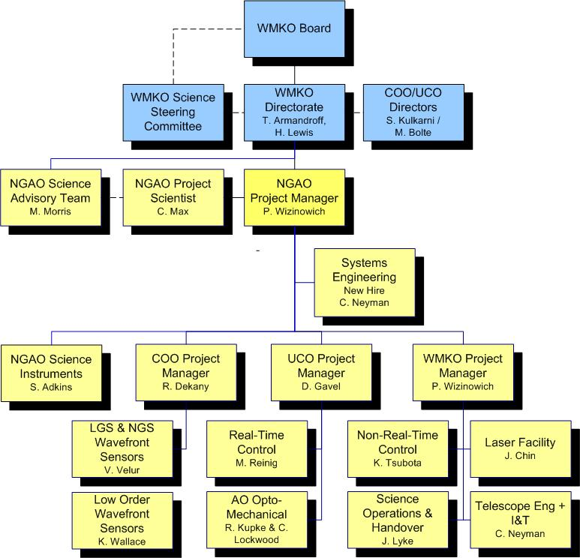
Figure 1. NGAO Detailed Design Phase Management Structure.
Solid lines are direct reports. Dashed lines are advisory or collaborative.

WMKO’s top-level management structure is highlighted in blue in Figure 1. The NGAO Project Manager reports directly to the WMKO Director, Taft Armandroff, and Deputy Director, Hilton Lewis. They in turn report to the WMKO Board. There is a close collaboration between the WMKO Directorate and the Director of the University of California Observatories (UCO), Mike Bolte, and the Director of the Caltech Optical Observatories (COO), Shri Kulkarni. A similar collaboration exists with the WMKO Science Steering Committee co-chaired by Chris Martin and X Prochaska.

WMKO Design Phase and Deliverables
WMKO’s standard development process is shown in Figure 2. This document is being written as a product of the NGAO Preliminary Design and presents the SEMP for the remaining development phases starting with the Detailed Design and ending with the transition of NGAO into Facility Class Operation. Table 1 lists the standard deliverables for each of the development phases.
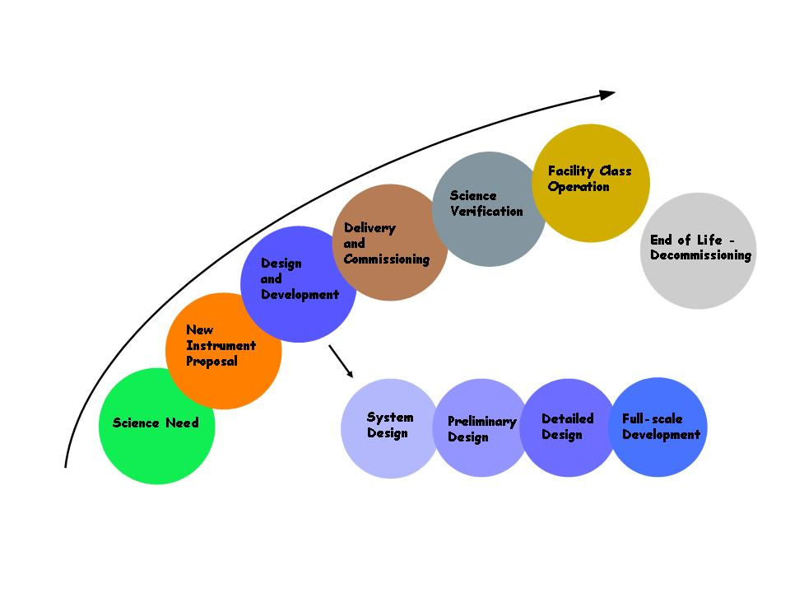
Figure 2. The WMKO Development Process.

The deliverables for the AO portion of the NGAO project consist of documentation and the actual AO Facility, Laser Facility and related interfaces. Major documentation items include:

Table 1. WMKO Development Process Deliverables.
System Design: | Preliminary Design:
Science Case Requirements Document | Requirements Documents for Key Subsystems
System Requirements Document | Operations Concept Document
System Design Manual | Preliminary Technical Specifications
Systems Engineering Management Plan | Interface Control Documents
System Design Report | Preliminary Design Report
Detailed Design:
Detailed Design Drawings and Bills of Material
Final Technical Specifications
Acceptance Test Plans
Detailed Design Report
Full Scale Development:
Hardware and Software Manuals and Maintenance Documentation
Pre-ship Review Reports
Installation/Commissioning:
Acceptance, Operational Readiness and Science Verification Review Reports

Work Breakdown Structure
The NGAO Project Work Breakdown Structure (WBS) is shown schematically in Figure 3. The top level structure reflects the transition from Design (1.0) through Full Scale Development (4.0 to 8.0 and 11.0) to Delivery and Commissioning (9.0 and 10.0). WBS 9.0 includes Science Verification and WBS 10.0 covers the handover to Facility Class Operation. Management (2.0) and Systems Engineering (3.0) are ongoing items through both Full Scale Development (FSD) and Delivery and Commissioning (DC). Each of the top level WBS elements is briefly described in the following section. More detailed WBS dictionary definitions are provided in the NGAO cost book.

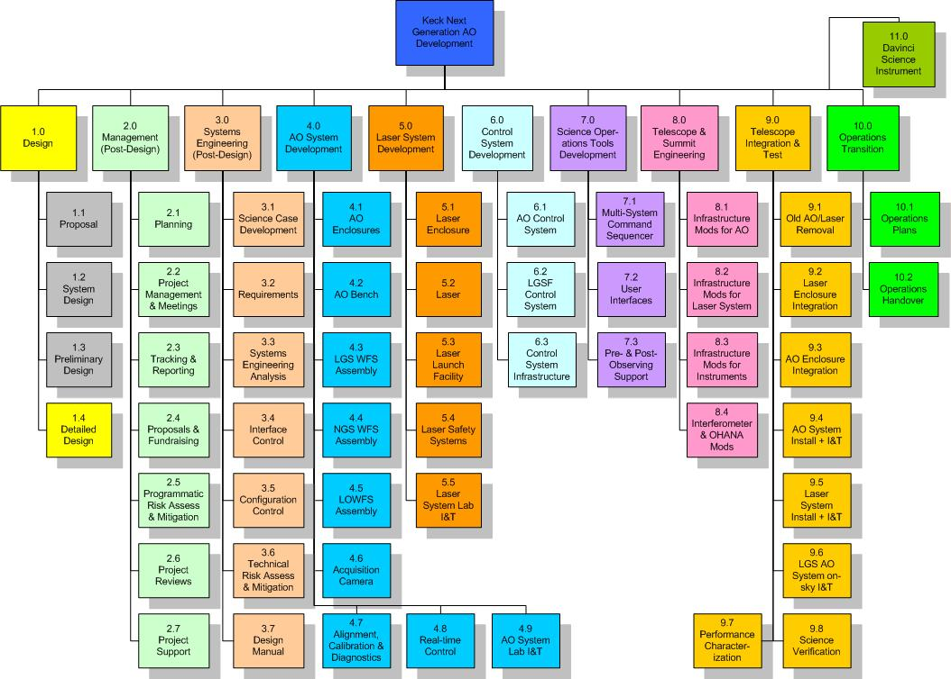
Figure 3. NGAO Work Breakdown Structure.

Design WBS
The three gray highlighted boxes in Figure 2 represent the project phases completed prior to the start of the Detailed Design. There is one remaining design phase, Detailed Design. In order to simplify the creation of separate project plans and budgets for each design phase a WBS numbering plan is used within each design phase WBS (1.3 and 1.4) that reflects the overall WBS numbering for each of the major elements shown in Figure 3. For example, the overall WBS contains an element number 4.0, named “AO System Development”. An identically named WBS element appears in each of the Preliminary Design and Detailed Design WBS outlines, but these elements are numbered 1.3.4 and 1.4.4 respectively. The WBS for the Detailed Design phase is shown in Figure 4. Note that the choice to have a separate WBS for each design phase was driven by the availability of funding only for 1 design phase at a time.

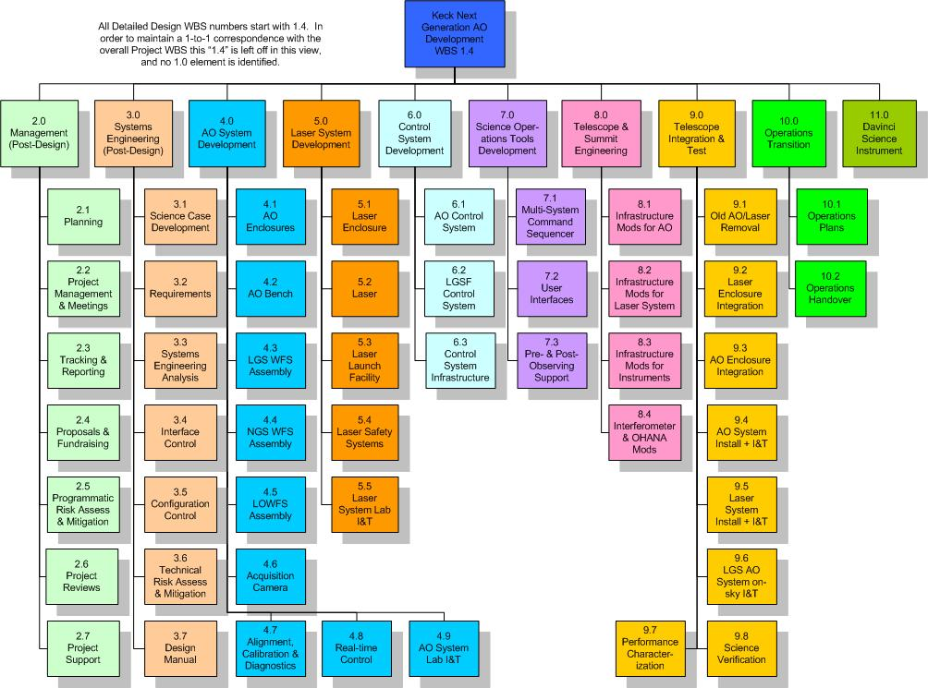
Figure 4. NGAO Detailed Design Work Breakdown Structure.

Management WBS
The management WBS has seven major elements:

- Planning. This WBS includes the normal adjustments to the plan during a development phase, supporting the Observatory’s fiscal year planning process and preparing the Systems Engineering Management Plan (SEMP). The SEMP, the document you are currently reading, will be updated during the Preliminary and Detailed Design phases.
- Project Management and Meetings. This category includes management telecoms and team meetings and telecoms. During the preliminary design phase for example management teleconferences will occur weekly and team teleconferences monthly with four face-to-face team meetings.
- Tracking and Reporting. Monthly status reports will be provided throughout the project and regular reporting will be made quarterly at WMKO SSC meetings. During the Preliminary Design phase the monthly reports will be provided to the TSIP and the Observatory Directors and monthly telecoms will be held with the TSIP representatives.
- Proposals. The NGAO team will need to write proposals and support fundraising. This is primarily a schedule item here since the WMKO labor for these activities is covered outside the NGAO budget. Some COO and UCO labor is covered here.
- Programmatic Risk Assessment and Mitigation. This WBS covers analysis of the programmatic risks and some mitigation activities. Some mitigation activities are covered under the appropriate development WBS.
- Project Reviews. Project reviews corresponding to major milestones are covered under this WBS. These include:
  - Preliminary Design Review.
  - Detailed Design Reviews.
  - An intermediate Full Scale Development Review as a checkpoint during development (we may revisit the need for this review).
  - A Pre-lab I&T Review to determine that the subsystems are ready for lab I&T.
  - A Pre-ship Review to determine that the system and telescope infrastructure are ready for telescope I&T.
  - An Operability Review to determine that NGAO is ready for shared-risk science.
  - An Operations Readiness Review to determine that NGAO and the operations team are ready for Facility Class Operation.
- Project Support. This category includes administrative and contract support, the procurement of shared infrastructure for development and/or testing purposes, and research time for postdocs and scientists working on the NGAO project.

Systems Engineering WBS
The Systems Engineering WBS has seven major elements:
- Science Case Development. This WBS is the primary home for the Project Scientist and Science Advisory Team activities. These include science case and requirements development, science observing planning, science performance input to the performance budgets, science operations tools and Operations Concept Document, understanding and updating the case for NGAO’s science competitiveness and liaising with the science community. This will continue to be an active area during the Preliminary Design and should move to more of a supporting role until we reach the telescope I&T and science verification phase.
- Requirements. This category includes the development and maintenance of the Operations Concept Document, System Requirements Document, Functional Requirements database, and the software and component standards that we select for NGAO. The System and Functional Requirements were developed during the System Design phase and will require updating during the remaining design phases. The initial Operations Concept and Standards Documents will be developed during the Preliminary Design.
- Systems Engineering Analysis. This is where all the performance budgets and the modeling and analysis tools are developed and maintained. There is a close connection with the Science Case Development WBS activities.
- Interface Control. This WBS covers the development and maintenance of the external interface definitions to the Observatory and to the NGAO science instruments, and the internal interface definitions between NGAO subsystems. One or more Interface Control Documents will be produced.
- Configuration Control. Initially this covers the definition of the configuration control process and subsequently the configuration control activity.
- Technical Risk Assessment and Mitigation. This WBS covers analysis of the technical risks and some mitigation activities. Most mitigation activities are covered under the appropriate development WBS.
- Design Manual. A System Design Manual was produced during the System Design phase. This Manual was updated during the Preliminary Design phase and will be updated again as a product of the Detailed Design phase. It will ultimately be further updated to reflect the as-built system in order to provide the operations team with a complete design reference.

AO System WBS
WBS 4.0 includes all of the elements related to the AO system itself. All of the subsystems are expected to be completed, including testing and demonstration of compliance at the subsystem level, within their WBS element. These subsystems, as well as the subsystems from WBS 6.0 and 7.0, are then delivered to WBS 4.9 AO system lab I&T. The output of WBS 4.9 is an AO system demonstrated to be ready for telescope I&T.

Laser Guide Star Facility WBS
WBS 5.0 includes all of the elements related to the laser facility itself. All of the subsystems are expected to be completed, including testing and demonstration of compliance at the subsystem level, within their WBS element. These subsystems, as well as appropriate elements of WBS 6.0, are then delivered to WBS 5.5 laser system lab I&T. The output of WBS 5.5 is a laser system demonstrated to be ready for telescope I&T.

Control System WBS
WBS 6.0 includes all of the elements related to non-real-time motion and device control within the AO and LGS facilities, as well as the control loops and offloads not provided by the real-time control system. The data server collects and temporarily stores the non-real-time data required to support science data reduction or system performance and diagnostics monitoring.

Science Operations Tools WBS
The science operations tools provide the high level coordination between the AO system, laser system, telescope and science instruments. These are the tools used to operate the NGAO system for science. The user interfaces provide the operator and astronomer interfaces to NGAO and the multi-system command sequencer provides the high level coordination. The pre- and post-observing tools are intended to support optimal observation planning and the generation of the data needed by the astronomer to make their observations scientifically useful.

Telescope and Summit Engineering WBS
This WBS covers the modifications needed to the telescope and summit facilities, and existing Keck II AO science instruments (NIRC2 and the interferometer, needed to integrate with NGAO. Currently there is no effort in the area of telescope performance.

Telescope Integration and Test WBS
This WBS covers all NGAO activities at the summit, from installation through performance characterization and science verification.

Operations Transition WBS
This WBS covers the development of operations plans and training of operations personnel. These activities will overlap in time with elements of other WBS elements, especially integration and test. The cost of operations personnel to be trained is covered by the Observatory.

Product Breakdown Structure
A partial view of the Product Breakdown Structure (PBS) is provided in Figure 5. MS Project was chosen as the tool to maintain the PBS since it allows easy roll-up of the structure. This PBS has been used to help develop the WBS and as a structure for the NGAO functional requirements database.

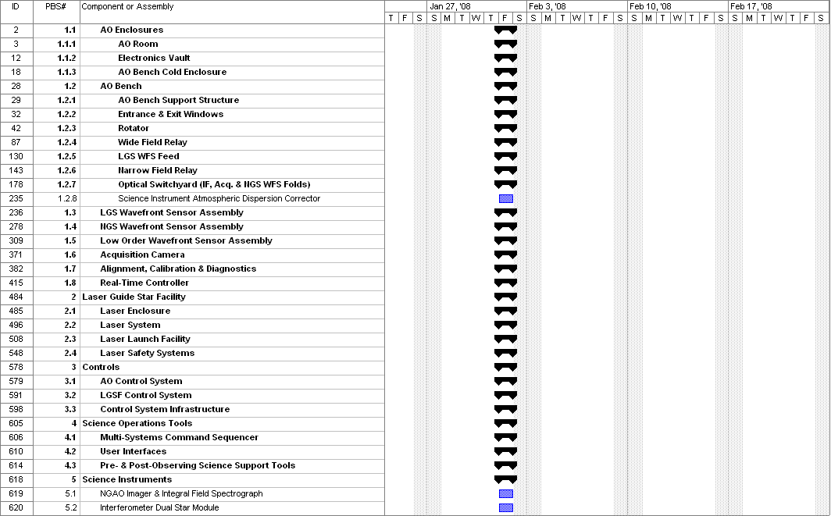
Figure 5. NGAO Product Structure.

Project Milestones and Schedule
The major project milestones are shown in Table 2. Our ability to meet these milestones will strongly depend on the availability and consistency of funding. It will also depend on advance knowledge of when funding will become available since it takes time to ramp up personnel and to set up contracts.

The 24 month Detailed Design, as discussed in section 3.4, is driven by the availability of funding, and by the need to allow time to significantly increase the number of personnel at the start of the Detailed Design phase. The 18 months between the end of the Detailed Design and the start of lab I&T will only be adequate if long lead procurements can be placed during the Detailed Design. The 1st laser procurement in particular will need to be placed during the Detailed Design.

Table 2. NGAO Project milestones.
Year | Month | NGAO Project Milestone
2008 | April | System Design Review
2010 | June | Preliminary Design Review
2010 | October | Detailed Design Phase Begins if Approved
2012 | September | Detailed Design Review
2013 | May | 1st AO Subsystem Acceptance Review
2013 | July | 1st Laser Pre-Telescope Readiness Review
2014 | January | 1st Laser First Light with Keck II AO
2014 | February | Last AO Subsystem Acceptance Review
2014 | March | DAVINCI Pre-ship Review
2014 | November | AO Pre-Ship Readiness Review
2015 | February | NGS First Light
2015 | June | LGS First Light
2015 | October | Operational Readiness Review

WMKO’s observing time is scheduled in six month increments beginning in February and August. Generally speaking WMKO notifies the Time Allocation Committees (TACs) of instrument availability at least five months prior to the next observing semester. The NGAO summit integration effort needs to be coordinated with this process. The successful completion of the later NGAO project milestones would therefore result in notifications of AO science availability, shown in Table 3, being sent to the TACs. For example, the project milestone of the pre-telescope readiness review just prior to August, 2013 would be the milestone at which we would notify the TACs that the Keck II AO system would not be available for science in semester 14A. We would be performing science verification science in semester 14B, but no AO system would be available on Keck II for TAC-allocated science for a full year in this scenario. The Keck I AO system would be available for science during this period but the Keck Interferometer would not be able to be used for a year, except for some limited science verification in semester 14B.

Table 3. TAC notifications associated with NGAO milestones.
Date | Milestone | TAC Notification for Semester
Feb, 2013 | Laser Factory Readiness Review | LGS AO unavailable 2nd half of 13B
Aug, 2013 | 1st Laser Pre-Telescope Readiness Review | New laser available for 14A shared-risk
Feb. 2014 | 1st Laser 1st Light with Keck II AO | New laser available for 14B shared-risk
Aug, 2014 | Good progress on AO Lab I&T | AO system unavailable Dec/14 thru 15A
Feb, 2015 | Shared-Risk Science Availability Review | NGAO available for shared-risk for 15B
Aug, 2015 | Science Availability Review | NGAO available for science for 16A

Cost Estimate

Introduction
The NGAO PD Phase Cost Estimate was developed through a controlled process over a period of __ weeks following, but somewhat overlapping the AO Preliminary Design work package element. Approximately __ work-weeks of effort went into the generation of the PD phase cost estimate, including generation of the full project WBS Dictionary, labor, non-labor, and travel estimation, science/technical performance iterations, and consistency verification. The estimate was conducted by a dozen estimators who are all technical experts and in most cases are expected to be involved in the execution of the NGAO project plan. Approximately half of the estimators have had extensive prior cost estimation experience on complex opto-electro-mechanical instrumentation projects. A full description of both the estimation process and estimator guidelines for our System Design phase cost estimate, which was repeated for the Preliminary Design phase, is provided in KAON 546.

Project Scope
The NGAO project includes a new Nasmyth-based AO instrument, comprised of a K-mirror-fed, wide-field optical relay followed by a laser guide star wavefront sensor assembly, a narrow-field science optical relay and high order NGS wavefront sensor, and a low-order natural guide star wavefront sensor assembly, and a science instrument. NGAO also includes a thermally-controlled AO instrument enclosure, an AO instrument diagnostics and calibration unit, and a “truth” wavefront sensor necessary to maintain precision wavefront control.

NGAO includes a new laser guide star launch facility, consisting of a baseline 75W of CW sodium D₂-line laser power divided into seven laser guide stars. This laser asterism and power are sufficient for all NGAO science goals.

The NGAO project includes the necessary modifications to the Keck Interferometer (KI) to enable use with NGAO.

Cost Estimation Process

Objectives
The primary objective of the PD phase cost estimation effort was set out to develop a comprehensive estimate of the total NGAO project cost, excluding science instruments. This includes the costs for engineering, design, analysis, procurement, fabrication, assembly, inspection, administration, installation, and commissioning of the telescope, instrumentation, and support facilities.

The cost estimates were prepared by responsible technical experts who are experienced in the various fields required to design, build, and commission the NGAO system. Vendor quotations, engineering calculations, analogies based on prior telescope programs, and parametric cost estimates were collected according the lowest level of full-project Work Breakdown Structure and by project phase. Approximately ___ BOE’s were generated by ~__ estimators and organized into the NGAO PD Phase Cost Book. This documentation will include the basic configuration information and list all critical assumptions used during the estimating process. Two sample cost estimation sheets can be found in the Appendices in Sections and 8.

Large, complex, and challenging projects entail uncertainty and cost risk. A contingency to cover anticipated costs resulting from this uncertainty has been developed using standardized risk analyses as established in the cost estimating plan. Contingencies have been developed at the same level of the WBS used to prepare the cost estimates.

NGAO costs will be monitored and controlled over the life of the project. The cost estimate has been integrated with the project schedule to establish a time phased budget baseline. This time-phased budget has been developed in detail for the Detailed Design phase and at an annual cost level for the full NGAO project. A more formal project management control system will be established in the DD phase to compare actual costs with the project’s budget baseline and the work accomplished.

The NGAO PD phase cost estimate is a detailed bottom-up estimate performed at the lowest reasonable level within available time. The estimate is based on the project Work Breakdown Structure (WBS), a product-oriented hierarchy that identifies all the elements of the NGAO project and their parent/child relationships. The scope of work for each WBS element will be described thoroughly in the NGAO WBS Dictionary. Each lowest-level WBS element has been estimated independently for each program phase including Detailed Design, Construction, and Commissioning. The cost estimate for each activity shall be based on the scope of work defined for the WBS element for each defined program phase. Where strong parametric relationships have been established for specific portions of the estimate, a Cost Estimating Relationship (CER) has been utilized and referenced in the BOE. All estimates are given in ___ dollars.

Project Phases
For each BOE, the full cost-to-completion will be subdivided into four project phases as shown in Table 4.

NGAO Project Phase | Phase Code | Duration
Detailed Design | DD | 24 months
Full Scale Development | FSD | 24 months
Delivery and Commissioning | DC | 18 months
Table 4. NGAO Project phases and durations.

The durations are tentative for the purpose of the System Design phase cost estimation task and will be updated for future revisions of the project cost estimate. The majority of the work in the DC phase will be expended in the first 12 months, but the DC phase allows for an 18-month phase to fully complete transition to routine science operations.

For guidance on the level of maturity of design, we adopt for this costing exercise the WMKO Instrument Development Program Definitions of project phases (Adkins, S., “An Overview of the WMKO Development Phases”, December 8, 2005). This is, in part, as follows:

Preliminary Design

The preliminary design phase has two primary objectives. The first objective is to deliver documented designs for each system, sub-system and component, hardware or software, of sufficient detail to establish through inspection and analysis the feasibility of the proposed design, and the likelihood that the design will meet the requirements. The second objective is to present the project plan to completion, including a detailed schedule and budget.

Detailed Design

The detailed design phase has two primary objectives. The first objective is to complete the design, fabrication and assembly documentation for the system and all components, hardware or software, and show that the final design complies with all specifications and applicable standards. The second objective is to present the project plan to completion, including a schedule and budget.

Full Scale Development

The full-scale development phase builds the hardware, codes the software and integrates the complete system and performs laboratory testing culminating in the completion of an acceptance test plan followed by a pre-ship review.

Delivery and Commissioning

The objective of the delivery and commissioning phase is to install the AO instrument on one of the Keck telescopes, verify the correct operation of all hardware and software, perform first light observations and gather the data needed to complete the Acceptance Test Plan.

Costing Methodology
Each WBS Estimator provided data for each activity within the WBS, categorized by specific labor category, non-labor category, or travel. Each item in the cost estimate was tagged with a descriptor that characterizes the method used to derive the estimate. The categories established for this project in decreasing order of general confidence, and the associated code for entry in the Cost Estimating Input Form, are shown in Table 5.

Estimating Methodology | Input Code
Direct Historical Data (“done before”) | DH
Catalog Prices | CP
Vendor Quotes | VQ
Cost Estimating Relationship | CER
Engineering Estimate | EE
Table 5. Estimating Methodology

Each methodology is defined in the following fashion:
- Direct Historical Data - The use of costs demonstrated in immediate, applicable history for the same product or service.
- Catalog Prices - A known, advertised price from a potential supplier for a specific product or service.
- Vendor Quote - A quote from a potential supplier within the program estimate. Note: although useful to refining our current cost estimates, a balance must be found that satisfies project needs while not alienating vendors who often commit considerable resources for the generation of detailed price quotes.
- Cost Estimating Relationship – An estimate based on parametric relationships, analogy to another program, or by “Rule of Thumb.”
  - Parametric Estimate – A statistical model based on characteristics and costs of multiple previous observations.
  - Estimate by Analogy - Scaling of costs demonstrated in previous observations using subjective or objective factors.
  - Rule of Thumb - General cost relationships demonstrated by informal studies of past programs.
- Engineering Estimate – An estimate based on the judgment of a recognized authority.

Resource Pricing
Labor, Non-Labor, and Travel costs have been based directly on information provided by the cost estimator. All Labor Resource estimates were provided in hours of direct effort required to complete the work package and/or perform the task; the cost of labor resource estimates was calculated within the cost estimating system utilizing the hours estimated. Non-Labor expenses such as materials, subcontracts, and non-travel direct costs were estimated based on the unit cost and number of units required. Travel costs were based on the number of trips, general trip location, and duration of the trip. A narrative rationale for each resource estimate was developed and included in the estimate BOE.

Labor Resources
Average NGAO labor rates for each labor category will be used when available for pricing direct labor. The labor categories used in the estimating process, the associated code for entry in the Cost Estimating Input Form, and comparable Salary Grade are provided in Table 6.

Resource | Input Code | Salary Grade
Technical Functions:
Post Doc | PostDoc | A
Technician | Tech | A
Junior Scientist / Engineer | JunSci | B
Associate Scientist / Engineer | AssoSci | C
Information Tech. Specialist | IT | C
Senior Scientist / Engineer | SrSci | D
Lead Scientist / Engineer | LdSci | E
Free Labor | FL | $0 / hr
Business Functions:
Administrative I | AsstAdmin | A
Administrative II | AssoAdmin | B
Management Functions:
Subsystem Manager | SubMgr | E
Project Manager | ProjMgr | E
Table 6. Labor categories.

All estimates were provided in hours of productive effort required to accomplish the task. The rates used to price labor hours have been adjusted to include paid leave such as sick leave, vacations, holidays, etc. For estimating purposes, the typical 2,080 hour working year has been reduced to 1,800 hours to account for the expected annual productive hours. The hourly labor rates have been adjusted such that 1,800 productive hours is priced at a full year of salary. In addition, all fringe benefits and other indirect costs have been included and applied by the cost estimating system utilizing demonstrated burdening factors.

NGAO salary grades A-E were converted into quantitative labor rates using a blending of known WMKO, COO, and UCO/Lick salary rates, corresponding to specific individuals classified in these categories, and in approximately equal contribution among the NGAO partner institutions. Detailed salary figures are not included here in order to protect privileged personnel information however, we can report this summary labor rate information:

- The weighted-average salary of all labor on the NGAO project equals FY08 $92,700 per annum without benefits burden or FY08 $116,800 per annum including a 26% burden.

This corresponds to an equivalent rate of $116,800 / 1,800 = $65 / productive work hour. Excluding free labor the equivalent rate becomes $75 / productive work hour.

Non-Labor Expenses
All non-labor and non-travel expenses that will be directly charged to NGAO have been included as a non-labor expense estimate. This includes, but is not limited to, all subcontracts, materials and equipment, and shipping costs. All non-labor estimates have been placed into the appropriate category to identify the type of activity that will take place. The categories, and the associated code for entry in the Cost Estimating Input Form, are provided in Table 7.

Category | Input Code
Equipment | EQP
Material | MAT
Subcontract | SUB
Shipping | SHIP
Other Direct Cost | ODC
Table 7. Non-labor categories.

Travel
All travel in support of an activity has been included as part of the input sheet submitted for that item. Travel estimates were performed by determining the number of trips that will be required based on the general location and duration. Travel destinations and durations, and the associated codes for entry in the Cost Estimating Input Form, are shown in Table 8 and Table 9, respectively.

Destination | Input Code
Intra - California | CALIF
Hawaii - California | HAWAII
International (Origination/Destination unspecific) | INTER
Other locations not included in above list | OTHER
Table 8. Travel destination categories.

Duration | Input Code
Extended: More than three weeks. | EXT
Long: Greater than one week but less than 3 weeks. | LONG
Mid: Greater than 3 days but less than 1 week. | MID
Short: Three days or under | SHORT
Table 9. Travel duration categories.

Travel applicable to conferences, project-wide reviews, outreach, and funding source meetings has been included as costs in the NGAO Project Management WBS 2 element and not as part of the input sheets submitted for a particular item.

Estimators assumed that entire Level 3 WBS elements (e.g. WBS 4.4) will be executed entirely within a single partnership organization. (I&T elements, of course, will require multiple institution participation and are expected to require considerable travel.)

We have included the labor costs for travel itself (e.g. time ‘sitting on a plane’) in the travel section of our cost summarizes, depending on the duration of each flight. Estimators therefore included in their WBS element labor resource estimates only the actual work hours spent at the destination site, and not labor hours while traveling.

Shipping
Shipping for each element to its integration point, assumed to be WMKO headquarters facility in Kamuela, HI, has been included with the estimate for that cost element. The cost of shipping integrated elements from WMKO to the summit has been estimated as a cost for the Integration and Test element of the WBS. Insurance costs for all shipments between California and Hawaii have not been specifically included, as each of WMKO, COO, and UCO/Lick typically self-insures.

Sales Tax
We assume the NGAO project will incur sales / use taxes on some but not all purchases, depending on the organization making the purchase, the location of the vendor, and other factors. Out-of-state procurements are charged sales tax in California but not in Hawaii. Based on a cursory assessment of a plausible procurement division between the NGAO partners, we have currently adopted an ‘effective’ sales tax rate of 3.00% which we apply to all non-labor EQP and MAT cost categories.

Cost Estimates

Estimate to Completion
Our Preliminary Design phase full project Estimate to Completion (ETC) based upon the above described methodology is summarized as a function of WBS in Table 10 and by NGAO project phase in Table 11.

We note that labor and non-labor costs (which includes some labor costs as subcontracts) are comparable to one another. Compared with previously built AO systems, this ratio overweights project labor, reflecting our belief that NGAO will require significant systems engineering, software development, I&T, and telescope commissioning to ensure satisfaction of all flow-down requirements to ultimately meet performance goals.

Table 10. NGAO cost estimate (in FY08 $k) by WBS

Table 11. NGAO cost estimate (in FY08 $k) by project phase.

Cost Comparison
In order to provide ourselves with an external check of our ‘bottom-up’ cost estimation methodology, we have tabulated the known, expected, or budgeted costs of several comparable AO systems, which we present in Table 12. The notes associated with this Table can be found in Table 13.

Table 12. NGAO cost comparison to similarly complex AO systems.

Table 13. NGAO cost comparison notes.

Although we believe our bottoms-up estimate to be solid, we gain additional confidence in our cost estimates by comparison with independent costing of similar recent and proposed AO systems, as shown in Table 12. Compared to the original Keck II LGS system, for example, our NGAO estimate has significantly increased, as expected, reflecting the greater technical challenge of achieving better wavefront control. Much of the additional cost for NGAO arises from the need for ~ 10 photons/cm²/millisecond returning from the sodium layer to the telescope aperture at zenith, more than 10 times that from the current Keck II LGS system. The approximately $27M greater cost for NGAO is roughly attributable to ~$9M more for lasers, ~$6M more for wavefront sensors, ~$3M more for the 2nd stage AO relay, approximately ~$5M more for increased labor due to greater systems engineering and I&T complexity, and ~$4M greater contingency.

Compared with Gemini GPI, which uses a similar MEMS DM to our baselined NGAO 2nd relay DM, our bottom-up NGAO cost estimate, excluding the laser system (WBS 5) for a fairer comparison with the NGS GPI system, is somewhat higher, reflecting the multi-instrument and multi-functional nature of NGAO. The approximately $23M greater NGAO cost, relative to GPI, can be attributed as ~$13M to the 100W laser system (including contingency), ~$5M to wavefront sensors, and ~$6M to greater system complexity.

Compared to the Gemini South MCAO system, GEMS, the incremental cost of NGAO is also attributable in a self-consistent way. The approximately $20M additional cost for NGAO is attributable to approximately ~$4M for greater laser costs (100W v. 50W), ~$4M for wavefront sensors, ~$1M for real-time-computer, ~$3M for the 2nd stage AO relay, $4M for greater system complexity, and $4M for increased contingency (all relative to the GEMS baseline budget.)

Compared with the TMT NFIRAOS budget, our NGAO cost estimate is significantly less, reflecting we believe an overall lower technical and cost risk, incorporating our understanding of costs incurred on the original Keck II LGS AO system. From a component perspective, NGAO saves cost on the laser guide star facility, less expensive piezostack DM(s) (requiring less stroke), less expensive LGS WFS detectors (offset by our need for nine vs. six sensor channels), less expensive LGS WFS optics and mechanics, and less expensive instrument structure and enclosure. We also project lower RTC costs relative to NFIRAOS, in part due to improved computing components and architecture, and in part due to a different development model. Moreover, the use of existing components in nearly all NGAO subsystems eliminates the need for component development. Finally, we have elected an approach to laser procurement that carries some risk, namely a collaborative laser development, as opposed to TMT’s commercial procurement strategy. Resolving this major project risk is a key goal for the preliminary design phase.

Detailed Design Phase Cost Estimate
A more detailed breakdown of costs during the detailed design phase is shown in Table 14. This table shows the WBS level at which the cost estimate was prepared. Similar tables for the other three project phases, and the overall total cost, are provided in the Appendices in Sections 9 to 12.

Table 14. Detailed Design phase cost estimate (FY08 $).

Key Cost Risks
NGAO programmatic risk also causes us to incur financial risk. The NGAO project is structured to rely on the successful raising of private instrument funding, as it is not expected to be feasible within the envelope of Keck Observatory operations and TSIP-generated instrumentation funds alone.

Estimate Refinement
In developing the next iteration of the cost estimate during DD phase, we will refine the estimate to include a more fulsome development of the lowest level WBS available. We will increase our direct communications with vendors and move a larger fraction of cost estimates into the Vendor Quote (VQ) category. We will also refine our labor rates to reflect actual rates of specific individuals identified as assigned to each WBS element and/or cost account. Finally, we expect to refine the bases of estimate to replace a substantial fraction of estimates classified as Engineering Estimate (EE) to our increasingly higher fidelity bases: Cost Estimating Relationship (CER), Direct Historical (DH), and Vendor Quote (VQ) respectively.

Risk Assessment and Management
A programmatic and technical risk assessment was performed and documented in KAON 720 along with proposed mitigation efforts. The JPL risk management approach of ranking risks by likelihood and consequences is used.

Configuration and Documentation Management
There are a number of configuration items that will need to be managed. These include requirements, interface definitions, designs, plans, spares inventory, etc.

Documentation management is performed with the following tools:
- All technical and programmatic notes to continue to be given a Keck Adaptive Optics Note (KAON) number. These documents will be maintained on the NGAO Twiki site and also on the more protected Keck Docushare site.
- Requirements to continue to be maintained in the Contour database (see section 2.9).
- Interface definitions to be input and maintained in the Contour database.
- SolidWorks mechanical models to be maintained in a shared repository. Mechanical drawings to ultimately be maintained within the Keck Mechanical group database using assigned numbers.
- Electronics drawings to be maintained within the Keck Electronics group database using assigned numbers.
- Spares inventory to be integrated within the Keck Electronics group spares inventory.
- Preventative maintenance tasks to be integrated within the Keck Facilities group preventative maintenance program database.

An NGAO Configuration Control Board (CCB) has been formed to review and approve changes to the requirements, interfaces, designs and drawings. The CCB will use similar tools and procedures as used by existing Keck CCBs (for example the AO CCB and the Interferometer CCB). Keck’s existing Engineering Change Request (ECR) and Field Change Notices (FCN) will be used to request approval for changes.

CCB responsibilities will be handed over to a Keck operation’s CCB at the time of the Operability Review.

Interface Definition
The approach to interface control is defined in KAON 741. An N-squared diagram is also presented in this KAON to show the interfaces between NGAO subsystems and external to NGAO.

Requirements Management and Compliance
KAON 573 describes our approach to requirements development and management. All requirements from the Science Case Requirements and System Requirements, as well as the Functional Requirements, are maintained in a requirements management software database (e.g., the Contour tool by JAMA software). This database is web accessible from each of our three institutions.

Compliance testing versus requirements will be performed at the subsystem, system and science levels, corresponding to the functional, systems and science requirements, respectively as shown in Figure 6.

Compliance matrices were compiled for each subsystem during the preliminary design.
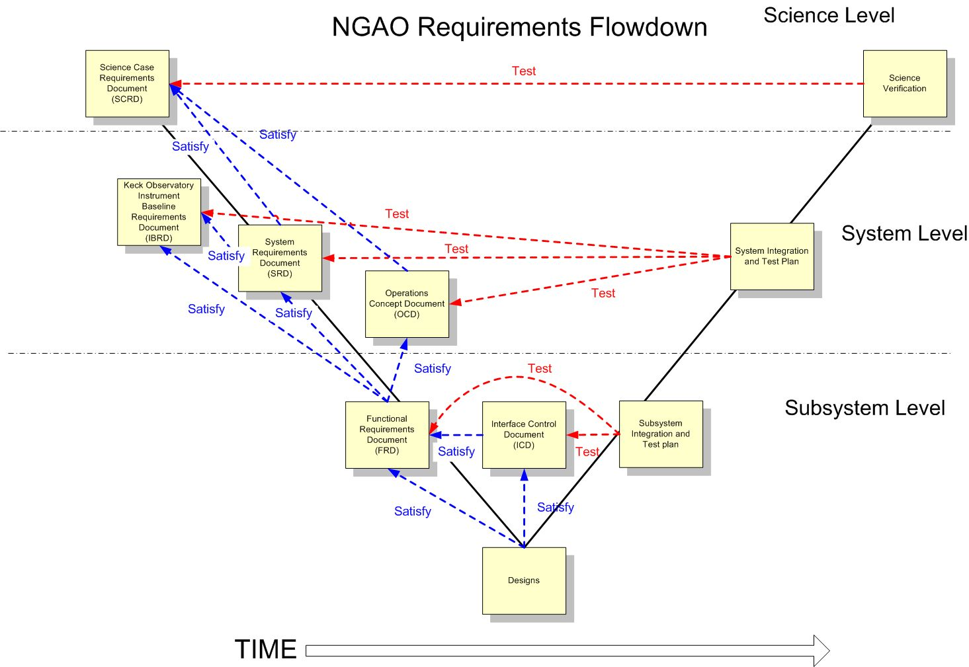
Figure 6. Modified V-diagram shown the requirements flowdown and relationship to testing.

Integration and Test
Our approach to integration and test is documented in KAON 581 and is shown schematically in Figure 7, along with the WBS numbers for each activity. This Figure is divided into subsystem development, lab I&T, summit preparation and telescope I&T sections. A philosophy that will be followed throughout this process is for subsystems and systems to be complete, including testing versus requirements, prior to transitioning to the next phase. This will be ensured by appropriate Reviews.

The subsystem development (WBS 4.0 to 6.0) and summit preparation (WBS 7.0) phase begins with the successful completion of the Detailed Design Review. These subsystems are intended to be complete and fully tested at the subsystem level prior to system lab I&T. Their readiness, as well as the readiness of the lab facilities, will be evaluated at a pre-lab I&T Readiness Review. The AO and laser systems undergo separate lab I&T efforts since they can largely be treated independently.

Readiness of the AO and laser systems, as well as the summit infrastructure to proceed to telescope I&T will be evaluated at a pre-ship review. Successful completion of this review will result in installation at the telescope followed by a sequence of I&T activities.

The pre-lab and pre-ship I&T Readiness Reviews will likely be separate events for the laser and AO system. Ideally the laser would have been implemented on the telescope prior to the AO system pre-ship review in order to minimize the time between decommissioning the existing AO system and implementing NGAO.

The Operability Review is a milestone intended to mark the point where the system and operations are ready to support shared-risk science observations. The system will continue to be characterized and optimized prior to the final handover to operations and regular science operations which will be marked by the Operations Readiness Review.

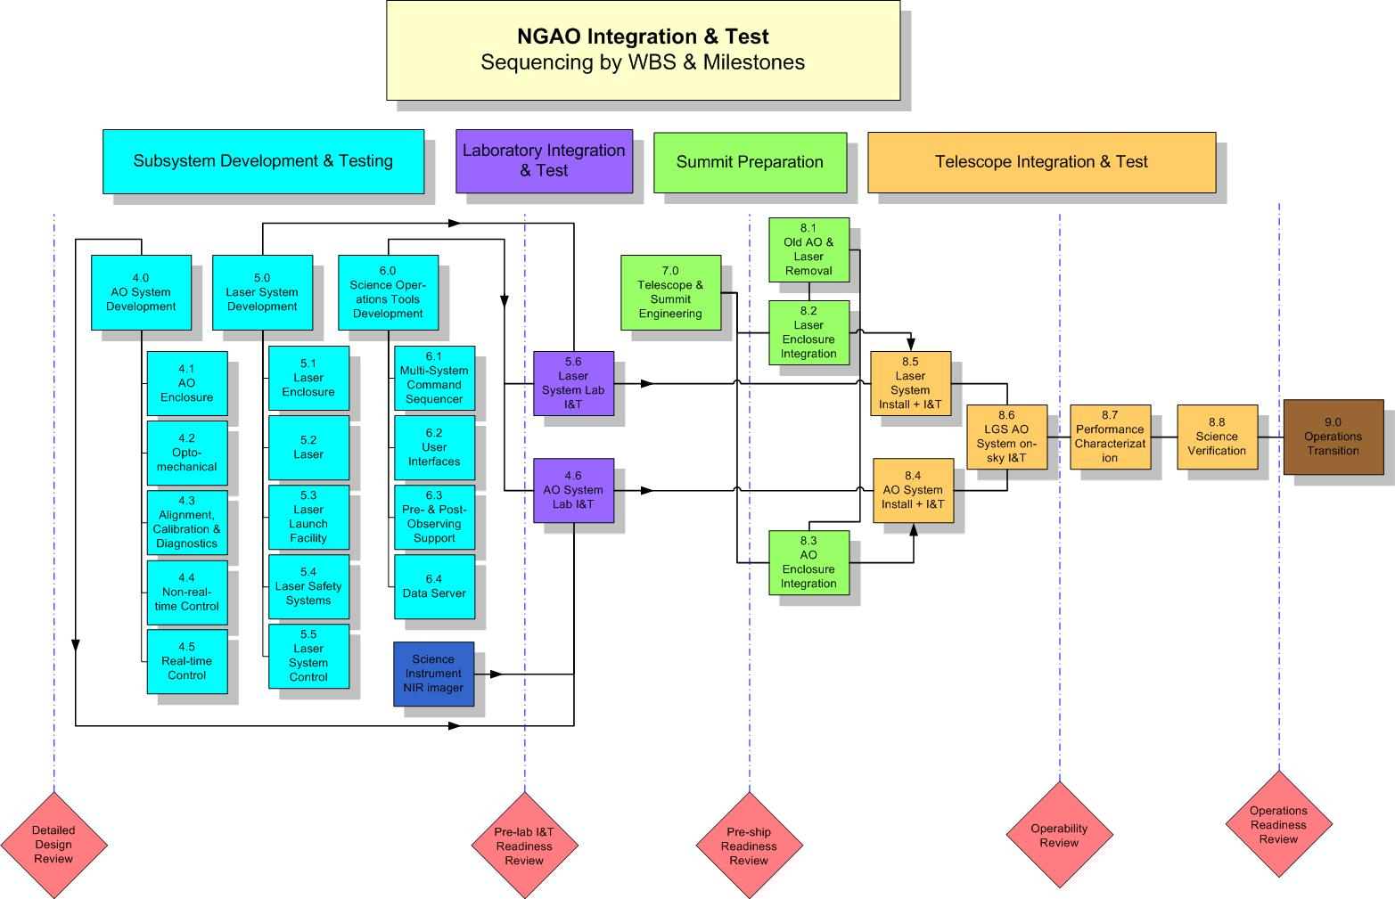
Figure 7. NGAO Integration and Test Approach.

Component Failure and Spares Approach
Two component failure issues need to be addressed: failures during development and failures during operations. The impact of failures during development and operations are different. Spares are one way to address failures and need to be considered in this context. Highly reliable components should be the standard.

The impact of a component failure depends on the development phase, its criticality to the subsystem and overall system, and the required time to troubleshoot, repair or replace the component. The failure of a key component during subsystem development could potentially result in the late delivery of a subsystem and the delay of system integration and test. The failure of a key component during lab or telescope integration and test could result in significant cost and schedule impacts.

A component failure during a science night must be addressed immediately, preferably by having a back-up mode of the instrument that does not require this component. It is important to have good tools and procedures for quickly identifying and repairing or replacing the failed component. The failed component should be able to be replaced or repaired prior to the next night or in the worst case before the next observing run.

A preventative maintenance program is required during operations to minimize the chance of component failures and to ensure the early detection of components that are starting to fail.

Failures can be addressed by a combination of troubleshooting and repair procedures, good component documentation, proper sparing, team expertise and vendor support (potentially including maintenance contracts).

Some component failures are more likely to happen during development than operations. Infant mortality is most likely during subsystem development, where more time is potentially available to replace it. An optic is more likely to be broken as it is being shipped or integrated during subsystem, lab or telescope integration.

For cost reasons not everything can be spared. We must therefore focus on the most critical components and the limited lifetime components. The likelihood and impact of a failure needs to be considered.

A partial list of key components and their recommended sparing was developed during the SD phase and was incorporated in the cost estimate. This list will be further defined during the remaining design phases. The sparing recommendation needs to include the number of units in the system, and some analysis of the consequence and likelihood of failure during both development and operations. This list could be integrated into the Product Structure MS Project tool.

Detailed Design Phase Plan

DD Phase Management
The Detailed Design (DD) Phase management structure was shown in Figure 1.

Leadership responsibilities for specific parts of the detailed design are indicated in the MS Project Plan in section 3.5.

DD Phase Overview and Deliverables
The DD phase is the third and final design phase for WMKO development projects. This phase follows the preliminary design and precedes the full scale development phase.

In the Observatory’s development program, the detailed design phase has two primary objectives. The first objective is to complete the design, fabrication and assembly documentation for the system and all components, hardware or software, and show that the final design complies with all specifications and applicable standards. The second objective is to present the project plan to completion, including a schedule and budget.

DD Phase Work Breakdown Structure
The WBS structure for the DD is identical to this WBS numbering in Figure 3 except that each WBS element number is preceded by “1.4” and there is no WBS 1.4.1. For example, WBS 1.4.2 is the Detailed Design Phase Management and WBS 1.4.4.1 is the detailed design of the AO enclosure. This approach to the design phase WBS numbering was chosen to allow a separate budget and plan for the design phases.

DD Phase Planning Assumptions
The following assumptions were used in producing the detailed design phase plan:

- The collaboration between WMKO, COO and UCO will continue in the DD phase.
- The DD phase will start on October 1, 2010 in order to allow time to receive approval to proceed to this phase (note that approval requires the identification of funding).
- The availability of funding will force the DD phase to take 24 months.
- The NGAO launch telescope MRI proposal was funded. This development effort is not included in the DD phase plan, but it is linked with milestones.
- The MRI laser proposal will be funded. A replan will be needed, taking elements of the plan from this proposal, if this proposal is not funded. This development effort is not included in the DD phase plan, but it is linked with milestones.
- We can hire two new full-time NGAO positions at WMKO with start dates of January, 2011.

DD Phase Schedule
The level three version of the DD schedule (ignoring the initial “1.3”) is shown in Figure 8 through Figure 15. The complete DD schedule can be found in section 13. The schedule includes WBS numbers, task names, initials of the task lead, number of work hours and start and end dates.

The approach to developing this schedule was to: 1) develop the WBS and product structure, 2) incorporate this structure into an MS project plan, 3) apply the work hours from the cost estimation work sheets, 4) apply resources to the MS project plan, 5) iterate to produce a realistic schedule and 6) iterate to produce a realistic budget. Links have only been used sparingly so far in this schedule due to their tendency to move tasks in unusual ways. Some non-DD phase tasks are included with zero hours in order to maintain WBS numbering for future phases.

We will track performance versus this baseline schedule. We will also update this schedule, with the original baseline maintained, as needed during the DD phase to ensure we achieve the DD goals within schedule and budget. Three potential replanning windows are included in the plan to address new information about the design or such issues as changing personnel availability or external constraints. Replanning activities not required will be returned to the contingency pool.

Figure 8. DD phase Management schedule (WBS2).

The WBS dictionary definitions and deliverables for the DD phase elements can be found in KAON __.

Figure 9. DD phase Systems Engineering schedule (WBS3).

Figure 10. DD phase AO System schedule (WBS4).

Figure 11. DD phase Laser System schedule (WBS5).

Figure 12. DD phase Science Operations Tools schedule (WBS6).

Figure 13. DD phase Telescope and Summit Engineering schedule (WBS7).

Figure 14. DD phase Telescope Integration and Test schedule (WBS8).

Figure 15. DD phase Operations Transition schedule (WBS9).

DD Phase Milestones
Major milestones for the NGAO DD phase are shown below in Table 15. These milestones are consistent with the DD phase schedule discussed in section 3.5.

Table 15: DD phase milestones

DD Phase Personnel and Core Team
Table 16 was used as a modified output of the MS Project Plan to help balance individuals and the hours per fiscal year. This table lists the names of all of the DD phase personnel. The work hours do not include any contingency time. Some cases of over assigning work to an individual are in italics. These will be addressed by a combination of transferring work to others and/or moving work into another FY.

Table 16. DD phase personnel assignments versus Fiscal Year (FY).

Table lists the 18 core team members and their roles during the DD phase. These include all individuals assigned to the plan at a level ≥ __%. These core team members bring a great deal of relevant experience to the project. Overall they represent __% of the DD phase labor. We consider __ and Neyman to be full-time on this project.

Table 17. Core DD phase team members.

DD Phase Budget and Contingency
The DD phase budget estimate is $__k in then-year dollars as previously shown in Table 14. The dollars by fiscal year are summarized in Table 18. This Table also shows the breakdown of work (hours) and personnel costs by Institution. The hours are from the MS Project Plan shown in Section 3.5. The last row compares the cost estimate to the available budget.

Table 18. DD phase work distributed by Institution.

As can be seen from Table 18 all of the contingency dollars are in FY11 and FY12 and as can be seen from the FY10 column of Table 16 we also have people available to use these contingency dollars on in FY10. To the extent that contingency is not needed we may therefore be able to complete the Detailed Design ahead of the current schedule. To the extent that contingency is required we have the people to perform the work.

DD Phase Risk Assessment and Risk Management
The cost risks for the DD phase were tabulated in the DD phase cost worksheets. Overall we have identified __% contingency for the DD phase. The estimated work is scheduled toward the beginning of the DD phase leaving contingency dollars at the end of the phase to cover work slippage. Problems will be handled as they arise but we will have funded schedule contingency at the end of the phase to ensure that the work is completed. We have also made sure that key personnel have some available time in the last few months of the project to be able to use these contingency dollars. To the extent that we can leave the contingency untouched we can also pull in the Detailed Design Review date.

DD Phase Management
NGAO management will be responsible for maintaining the DD phase budget and schedule for the DD phase.

Cost accounting and other financial and administrative matters will be done by WMKO. WMKO will be issuing contracts to CIT and UC to fund personnel at these institutions to participate in the DD phase, as was done for the SD and PD phases. COO and UCO will provide monthly financial reports to WMKO by the 15th of the following month. The PD phase actual expenditures will be tracked at the 1.3.X level of the WBS (i.e., 1.3.2 Management through 1.3.9 Operations Transition).

A monthly written project report will be provided to the Observatory Directors as was done during the PD phase. This input will also be used to give quarterly updates at the WMKO SSC meetings.

The team will have monthly teleconferences throughout the DD phase. Face-to-face meetings will be held on an as-needed basis. The NGAO senior management will alternate between weekly and bi-weekly telecons depending on the issues that need to be addressed.

Email will be used as a primary means of intra-project communications. Working documents will continue to be posted on the NGAO Twiki site:

http://www.oir.caltech.edu/twiki_oir/bin/view/Keck/NGAO/WebHome,

which proved to be a very productive shared work environment during the SD and PD phases. Documents will continue to be archived as Keck Adaptive Optics Notes on the KeckShare site at:

http://keckshare.keck.hawaii.edu/dsweb/View/Collection-218.

A Detailed Design Review (DDR) will be held as the culmination of this design phase. This review will be conducted in accordance with WMKO standards. To the extent practical we are expecting the same reviewers as for the Preliminary Design Review.

Full Scale Development and Delivery and Commissioning Phase Management

Phased Implementation and Descope Options

System Design Phase Summary
A summary of the system design phase performance versus plan (KAON 414) can be found in the preliminary design phase SEMP (KAON 574). The original schedule had the System Design Review on March 31, 2008. This review was held three weeks later on April 21, 2008. The system design phase plan had a total budget of $1170k (FY07 dollars) and was completed for $1234k (actual dollars); $739k in FY07 and $495k in FY08.

Preliminary Design Phase Summary

PD Phase Plan
The preliminary design phase SEMP, presented at the March, 2008 SDR, was documented in KAON 574. The PD phase cost estimate was $3479k in FY08 dollars, including $458k of contingency. The PDR date was February, 2010. This plan did not include any NGAO science instruments which were intended to be addressed separately.

Build-to-Cost
In August, 2008 the Directors requested the NGAO team to produce a new plan for a $60M NGAO cost cap (in then year $ from the start of the SDR to completion). Science instruments were to be included in this cost cap and were also added to the NGAO preliminary design task. A build-to-cost review was successfully completed in March, 2009. The revised PD phase cost estimate in FY08$ was $3284k including $441k of contingency. This did not include the cost to produce the instrument PDR (at that point we were still assuming separate instrument funding).

PD Funding
The original funding plan was to use $2047k of TSIP funding with the remainder of the PD budget coming from the Observatory. Due to financially difficult times a decision was made by the Directors to seek additional TSIP funding to complete the PD with a cap of $1228k. The September 2009 proposal to TSIP was successful. The result was that the total NGAO PD budget was reduced slightly (versus the build-to-cost budget) to $3275k. Unfortunately, the NGAO instrument ATI proposal was unsuccessful, so the TSIP funding was also needed to cover the instrument design work.

PD Actuals
Appendix: Cost Estimation Worksheet Example (WBS 3.3.3 DD Phase)

Appendix: Cost Estimation Worksheet Example (WBS 4.2.4 FSD Phase)

Appendix: NGAO Cost Estimate Summary (in FY08 $K)

Appendix: NGAO Detailed Design Cost Estimate Summary (in FY08 $K)

Appendix: NGAO Full Scale Development Cost Estimate Summary (in FY08 $K)

Appendix: NGAO Delivery and Commissioning Cost Estimate Summary (in FY08 $K)

Appendix: Full NGAO Detailed Design Phase Schedule

The notable exception is the 64x64 MEMS DM, but this is a critical development for GPI and expected by 2009.

